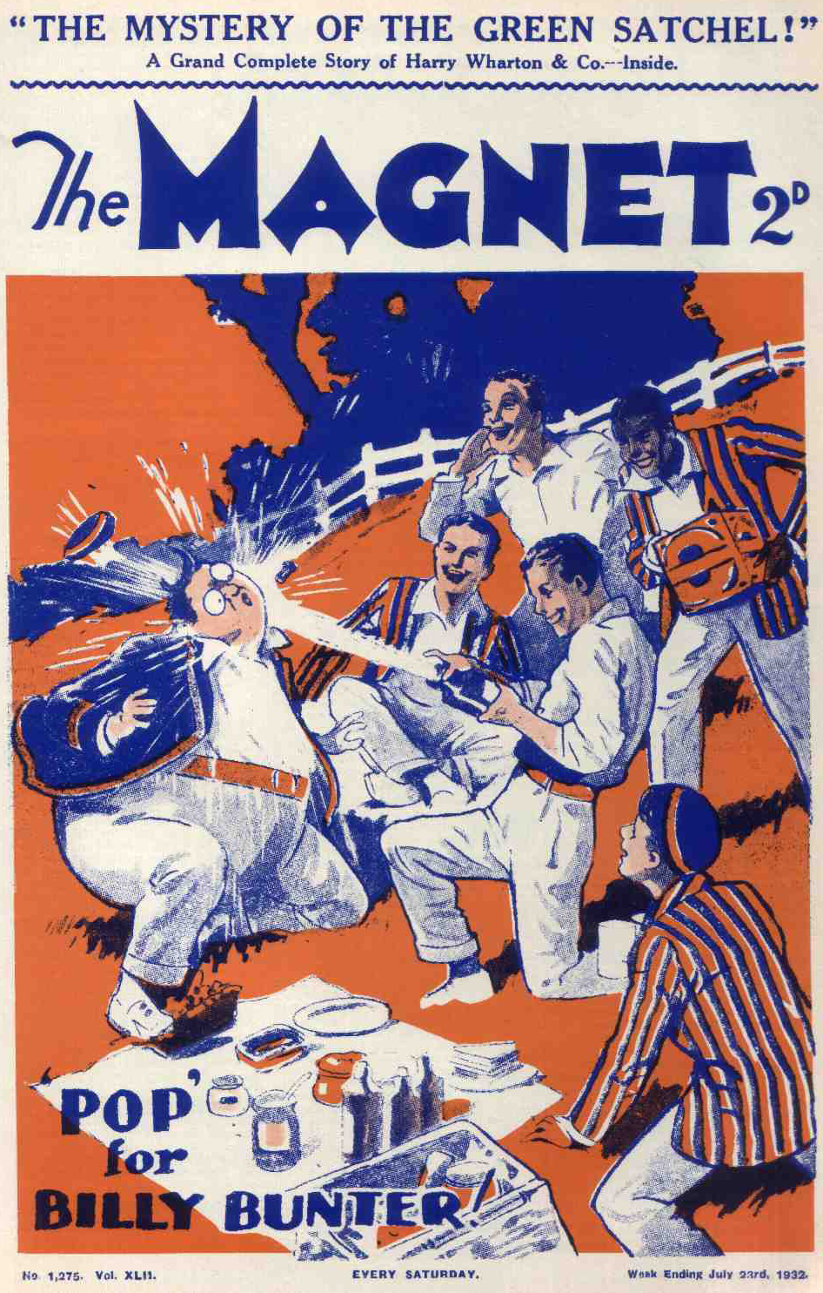
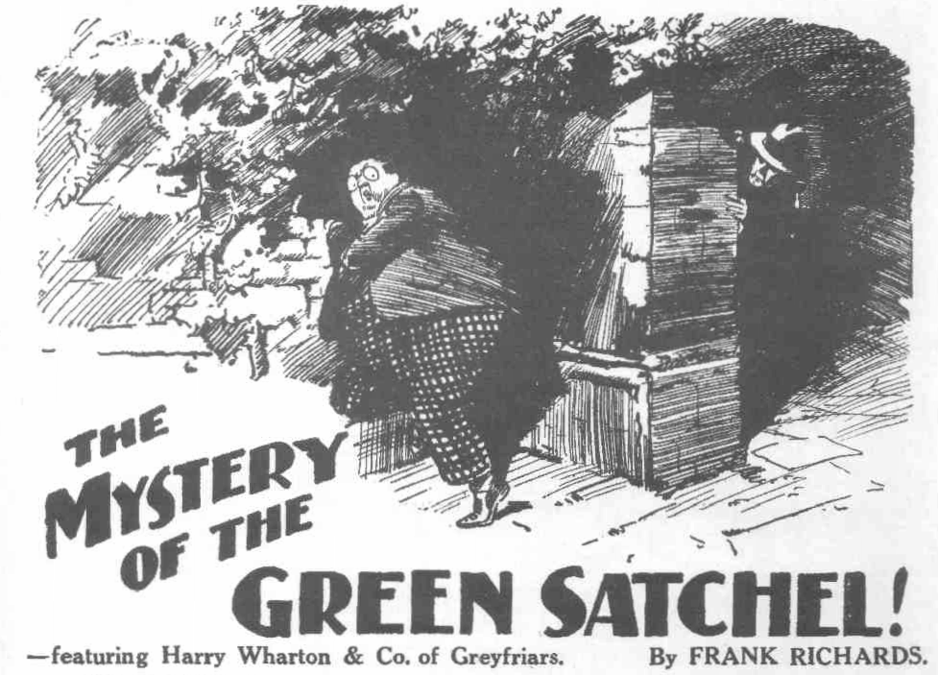
THE FIRST CHAPTER.
Not Bunter!
“HOLD on!”
“Bow-wow!”
“I siay, you fellows—”
“Rats !”
Five Greyfriars juniors were in the boat that rocked by the school raft. Harry Wharton sat at the lines, with a lunch-basket on the seat beside him. Frank Nugent and Johnny Bull, Bob Cherry and Hurree Singh, had picked up the oars. Bob was about to shove off when the fat figure of Billy Bunter arrived hot and breathless, on the edge of the raft.
And instead of delaying that shove to ask Bunter what he wanted, Bob accelerated it, and the boat rocked out into the Sark.
But it was not necessary to ask Bunter what he wanted. When fellows were going on a picnic, with a well, stocked lunch-basket, that was an easy one to guess.
Billy Bunter blinked at the receding boat and five grinning faces through his big spectacles.
“I say, you fellows, pull in! How am I to get into the boat?”
“Jump!” suggested Bob Cherry.
“Ha, ha, ha!”
With ten feet of glistening water between him and the boat, Billy Bunter was not likely to jump.
“Oh, really, Cherry—”
“Goodbye, Bunter!” said Bob. “Give way, you men!”
“If you fellows don’t want my company.” said Bunter, with dignity.
“Guessed it in one!” said Bob. “What a brain!”
“The brainfulness is terrific!” chuckled Hurree Jamset Ram Singh.
“I say, you fellows, Smithy asked me to go out in his car, but I turned him down for you!” said the fat Owl reproachfully.
“Turn him up again!” suggested Nugent.
“Yah! Who wants a whack in your measly picnic?” said Bunter scornfully. “I never knew you were going on a picnic. I didn’t see you packing that basket in the study. I came here to tell you that Quelch wants you, Wharton.”
“Oh, blow!” said Harry Wharton.
The oars were dipping, but the juniors rested on them now. If the head boy of the Remove was wanted by his Form master the pull up the river had to wait.
But the captain of the Remove looked very suspiciously at Billy Bunter. Billy Bunter was not like that unique American gentleman who could not tell a lie. Bunter could—and often did!
“Look here, you fat sweep, is that straight?” demanded Wharton. “If you’re pulling my leg I’ll burst you all over Greyfriars!”
“Oh, really, Wharton. He’s waiting for you in his study. I think it’s a licking.” added Bunter cheerfully. “He looked rather waxy.”
“Gammon!”growled Johnny Bull. “Let’s get off.”
“Look here, Bunter——”
“Yah!”
With that rejoinder Billy Bunter turned and rolled away. Harry Wharton frowned. A head boy’s time was not all his own, even on a half-holiday, and Wharton was a dutiful head boy. But he had a lingering doubt about the genuineness of that message.
“Better go and see, I suppose,” he said. ‘It won’t take long to cut up to the House.”
“It’s gammon!” grunted Johnny Bull.
“The gammonfulness is probably terrific!” remarked Hurree Jamset Ram Singh. “But the gofulness is the proper caper.”
The juniors pulled back to the raft and Wharton jumped out. Billy Bunter, loafing by the boathouse, blinked after him as he disappeared at a trot, and grinned. Then he rolled down to the raft again and blinked at the juniors in the boat.
“I say, you fellows—”
“Buzz off, you fat bluebottle!” grunted Johnny Bull.
“If you fellows would like me to steer for you—”
“Thanks!” said Bob Cherry sarcastically. “We don’t want to barge into every other craft on the river.”
“Look here, I’ll row, if you like!”
“We don’t want any crabs for tea. No need for you to catch any.”
“Beast! I mean, old fellow—”
“Ha, ha, ha!”
“I say, you fellows, make way for a fellow to get in. I turned dowu Mauly on your account when he asked me to go in his car—”
“As well as Smithy?” grinned Nugent.
“Eh? Oh! Yes. I hope you fellows don’t think I’m thinking about the picnic” said Bunter, “I’d like to come, because—because I like your company, you know. You’re such nice chaps!”
“Oh crumbs!”
“It’s a bit thick, you know, thinking that a fellow’s trying to scrounge a feed when all he wants is the company of fellows he really likes and—and admires!” said Bunter sorrowfully.
“Oh crikey!”
The Owl of the Remove had a fat hand on the gunwale now. Bob Cherry gave his comrades a comical look. Johnny Bull grunted, but Nugent and Hurree Singh grinned and nodded. And Billy Bunter clambered into the boat and dropped into the stern seat with a bump that made the light craft rock.
Bob held on to the raft, and the Co. watched the path by the boathouse for Harry Wharton.
“I say, you fellows, what about starting?” asked Bunter.
“Fathead! We’re waiting for Wharton.”
“Well, I shouldn’t wait,” said Bunter, shaking his head. “After all, you don’t want Wharton, you know.”
“What?”
“Rather an ill-tempered beast.” said Bunter. “The fact is, he’s not the sort of a fellow you want on a picnic. Bit of a wet blanket—what? You don’t want Wharton. You’ve got me.”
“The gotfulness is not a boonful blessing, my esteemed idiotic Bunter.”
“Oh, really, Inky! Look here, you fellows, it’s no good waiting for Wharton. I can tell you he will be a jolly long time. He won’t find Quelch in a hurry.”
“Why not, ass?”
“Oh, nothing. But you’re wasting my time, hanging about.” said Bunter. “You don’t want to waste your half-holiday—in this beautiful weather, too! I’m really thinking of you chaps. I say, let’s get off.”
“Fathead!”
Billy Bunter snorted. Having established himself as a member of the party the fat Owl of the Remove was anxious to get going.
“I say, you fellows, I tell you it’s no good waiting. The fact is, Quelch a otng to give Wharton a detention.”
“Did he tell you so?” grunted Johnny Bull.
“Yes. Exactly. He mentioned it. So you see---”
“Is he wound up?” asked Bob Cherry.
“Oh, really, Cherry! What’s the good of hanging on here while Wharton’s rooting all over the school looking for Quelch?”
“Looking for Quelch to give him a detention?”
“Oh! I—I—I mean—”
“Hallo, hallo, hallo! Here he comes!” gasped Bob Cherry.
“Oh!” gasped Bunter.
Billy Bunter turned his big spectacles, with a startled blink, on the captain of the Remove as that youth came down to the raft at a run. Apparently he had not expected Wharton to reappear so soon. There was wrath in Wharton’s brow as he arrived.
“That fat villain!” he exclaimed. “Oh! Here he is! Bunter, you podgy scoundrel—”
“Oh, really, Wharton! Jump in, old chap! I—I made these fellows wait for you—”
“What did Quelch want?” asked Nugent.
“Nothing. He’s gone out with Prout!” roared Wharton. “I knew that, fat villain was pulling my leg, and I asked Gosling—”
“I—I say, you fellows, I never knew Quelch had gone out!” exclaimed Billy Bunter. “I never watched him going off with old Prout. I never knew they were going out this afternoon and
didn’nt see them going up to the Courtfield road, and—and I hadn’t the faintest idea, that Wharton would be looking all over the school for Quelch and—and—yaroooooh!”
Four pairs of hands lifted Billy Bunter. He was not a light weight; but four sturdy juniors were equal to the task. The Owl of the Remove rolled on the raft, roaring.
Wharton paused a moment to grasp him by the collar and tap his bullet head on the planks, and then stepped into the boat. Bob Cherry picked up an oar to shove off.
“Ow! Wow! Beasts!” roared Bunter. “I jolly well won’t come now!” The fat Owl scrambled to his feet, and shook a podgy fist at the boat’s crew. “Yah! Rotters! Go and eat coke!”
Bob Cherry grinned. He had the oar ready to shove off from the raft; but Bunter was nicely placed to receive the shove, so he shoved off from Bunter instead.
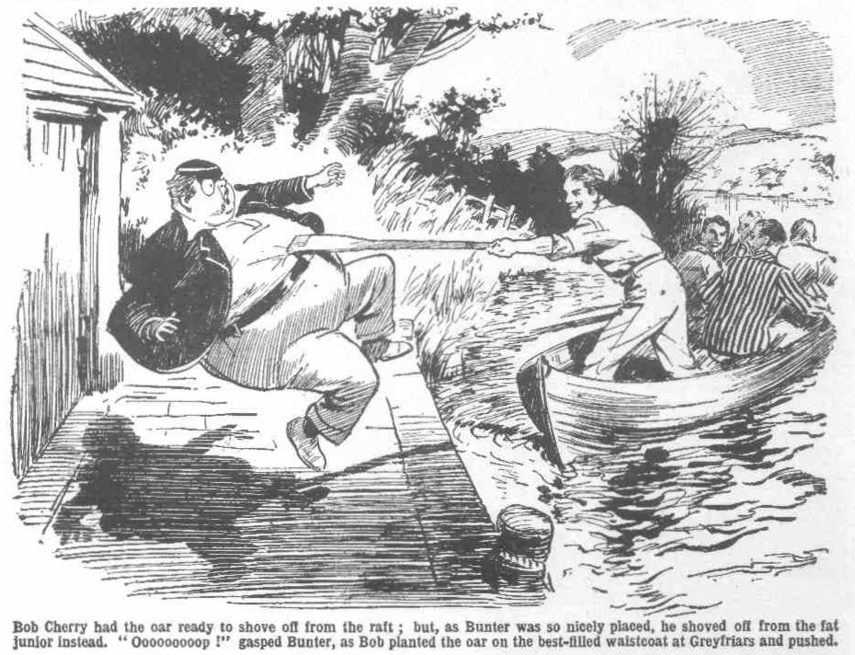 “Oooooooop!” spluttered Bunter, as the oar was planted on the best-filled waistcoat at Greyfriars School.
“Ha, ha, ha!”
It was a mighty shove. The boat rocked away in one direction; Billy Bunter rocked away in the other. The boat shot out on the river, and Billy Bunter sat down, with a bump that shook the raft.
“Ooooooooop!”
“Ha, ha, ha!”
Billy Bunter spluttered wildly. And the Famous Five pulled away cheerfully up the river, and left him to splutter.
THE SECOND CHAPTER.
Tracked Down!
“JOLLY “ said Bob Cherry.
“Topping!”
“The topfulness is terrific, my esteemed chums!”
Really, it was jolly! The summer had not been, so far, everything that a fellow could desire; but this particular afternoon in July was ripping. It was hot; even Hurree Jamset Ram Singh admitted that it was warm! But the oak-tree by the bank of the Sark, thick with foliage, cast a delightful shade.
Thick grass and ferns grew round the old oak, and the picnickers sat at their ease under the tree. Beyond the towpath the river rippled and sang through the tall bushes. The boat was tied up below the high bank. The chums of the Remove had landed—with the picnic basket. And there was no doubt that it was jolly under the shady tree, with the river rolling past, shining in the bright sunlight.
And if anything was needed to give the jolliness a finishing touch, it was the fact that Billy Bunter was not there!
Bunter certainly had a fixed belief that no picnic could be a real success without his fascinating presence. But he had that belief all to himself.
“Ripping!” said Johnny Bull. “ Get that basket open! I can do with a ginger-pop!”
“Hallo, hallo, hallo!” ejaculated Bob suddenly.
“What—”
“Look!”
Bob pointed down the towpath.
Far in the distance, along the river, a fat and perspiring figure came in sight!
“Oh my hat! Bunter!” ejaculated Harry Wharton.
“Jolly old Chingachgook on the trail!” chuckled Bob.
Bunter was far in the distance. His progress was slow, for the weather was hot, and he had a lot of weight to carry. But he came on steadily with his big spectacles flashing back the rays of the Sun.
Evidently the Owl of the Remove was still on the track of the picnic ! He was too far off as yet to see the camp under the oak-tree; Bunter’s range of vision was limited. But he was heading directly for the spot.
Johnny Bull gave a grunt.
“Let’s roll him into the river when he comes up!” he suggested.
“Good egg!” agreed Nugent. “ Bunter hasn’t washed yet this term; it will do him good!”
“Ha, ha, ha!”
“My esteemed chums,” murmured Hurree Jamset Ram Singh, with a glimmer in his dusky eyes, “ the esteemed and idiotic Bunter hats not seen us yet. It would he a terrific joke to let him pass on his way and follow the towpath milefully in search of us!”
“Fathead! He will see us when he passes!” said Johnny.
“Not if we climbfully ascend this estimable tree!”suggested the Nabob of Bhanipur. “ The excellent and execrable Bunter will pass on without knowing that we are here!”
“Ha, ha, ha!”
There was a chortle in the camp by the river.
Billy Bunter was tracking down the picknickers along the bank of the Sark, blinking to and fro in search of them as he came along.
They were a mile from the school boathouse, and a mile in July made the fat Owl pant and perspire. But there were plenty more miles in front of him if he passed the picnickers unknowingly.
Hurree Singh’s idea caught on at once. To the cheery chums of the Remove it seemed quite a “ wheeze” to let the fat Owl travel on to parts unknown, still hunting for them, while they enjoyed the picnic astern of him.
“ Let’s!” said Harry Wharton, laughing.
“Good!” chortled Bob. “He won’t see the boat; it’s right under the bank. And we’ll above the basket out of sight.”
“Ha, ha, ha!”
The picnic-basket was promptly hidden in a bank of ferns. The Famous Five swung themselves up actively into the branches of the oak.
There, comfortably perched on the massive boughs above the towpath, they watched the fat junior, through the interstices of the foliage, with grinning faces.
Billy Bunter came plugging on.
The sunshine caught his big spectacles, and they flashed back the light like electric lamps. His face was crimson, and perspiration trickled down it in streams.
As he drew nearer, the juniors could hear him panting. Bunter was as determined a trailer as Chingachgook, that celebrated chief of the Mohican, when there was a feed at the end of the trail. But a mile in a hot sun told on Bunter. He panted and gasped and puffed, and every now and then he smacked with a fat hand at some fly or gnat that took a fancy to his fat little nose.
He was still blinking about him warily, in search of his quarry, when he arrived at the oak tree. But the boat was out of sight, tied under the bank, the picnic-basket was equally invisible; and Bunter never even thought of blinking ut into the thick branches of the oak.
“Beasts!” gasped Bunter, as he came into the shade of the oak, and paused to mop his streaming brow. “Rotters! Dodging a chap, after all I’ve done for them! Beasts!”
The juniors overhead suppressed a chuckle.
“Oh crikey! It’s hot!” gasped Bunter.
He leaned on the trunk of the oak, mopping his brow. Now that he had reached a cool and shady spot the fat Owl stopped for a rest before proceeding on his way. Silent in the branches above, the juniors waited for him to proceed. As soon as Bunter had passed on they were safe, and the fat Owl was welcome to follow the bank of the Sark for another mile, or another ten miles, if he liked.
From the direction Bnnter had come another figure appeared in sight on the towpath.
It was that of a man with a pointed dark beard, rather foreign in look, and steely eye that glinted under the brim of a Homburg hat.
The juniors in the tree gave him no heed, neither did Bunter, leaning on the oak. The man was, or seemed to be, a stranger to them, and they were not concerned with him. But as the steely eyed man reached the shade of the big oak he stopped. The steely eyes were fixed on Billy Bunter, and the expression on the man’s face made the juniors, in the tree above, stare at him rather curiously. They could see that he was interested in the fat junior, though why it was not easy to guess.
“Master Bunter, I think!” said the steely eyed man.
Billy Bunter, thus made aware of his existence, blinked at him through his spectacles.
“Eh! Yes! I’m Bunter.” he answered.
“I thought so. I have had the pleasure of seeing you before.” said the steely eyed man.
“I don’t know you,” said Bunter, staring at him.
“Possibly not! But I know you, and that is sufficient!” said the man in the Homburg hat. “Remain where you are,” he added, as the fat Owl made a movement to detach himself from the oak.
“Eh ! I’m going on.” said Bunter, in astonishment. “I’m looking for some fellows who have gone up the river.”
“You will remain where you are, Master Bunter!”
There was a tone of menace in the cold, quiet voice, and it made Billy Bunter start and blink uneasily. It made the hidden juniors in the oak exchange curious glances.
The spot was a lonely one—no one was in sight on the towpath, in either direction and there was no building within a mile. On the other side of the river were thick, shady woods. It was just the spot where a footpad might have been glad to meet a solitary pedestrian. But it was scarcely possible that the man in the Homburg hat was a footpad. He was well dressed, and looked well-to-do. Yet there was no mistaking the threat in his voice, and the hard, grim look that came over his face. Obviously, he had no more suspicion than Bunter, that a bunch of Greyfriars fellows were hidden in the branches of the oak. He fancied that he was quite alone with the fat Owl in that solitary spot.
“I—I say,” stammered Bunter uneasily. “I say, I’m going on, you know. My friends are waiting for me—”
The steely eyes glanced quickly up the towpath.
“I see nothing of your friends, Master Bunter.
“They’re a good way ahead.”
“You will not rejoin them at present, my young friend. I have some business with you first.”
“Look here—”
Billy Bunter made a step from the tree. A glitter shot into the steely eyes as the man stepped in his way. Bunter jumped back, with a gasp of alarm.
“I—I—I say, wha-a-at do you want?” he gasped.
“I will tell you what I want! I have watched Greyfriars for several days to fall in with you, and I have followed you this afternoon, to corner you in a lonely spot, far from help!” said the steely eyed man coolly. “Now I have you exactly where I want you.”
“I—I say, I—I haven’t got any money!” stammered the fat Owl. “I— I was expecting a postal order, but— but it hasn’t come.”
The steely eyed man made a gesture.
“Do you think I want your pocket money, you young fool?”
“Well, what, do you want?” gasped Bunter.
“I will tell you.” The steely eyed man’s voice, low and distinct, came clearly to the ears of the astonished juniors in the branches above. “I want the loot of the Courtfield and County Bank!”
THE THIRD CHAPTER.
Awful for Bunter!
HARRY WHARTON & Co. stared down in amazement, through the foliage of the oak. What the man could possibly want with Billy Bunter, had been a mystery to them, though they were quite prepared to chip in if he meant the fat Owl harm. But if they had been surprised before, they were astounded now.
Billy Bunter was equalIy astonished. He blinked it the man—or, rather, goggled at him.
“The—the—the what?” he mutttered.
“Come, come,” said the steely eyed man “you can hardly expect to deceive me, Master Bunter! Every boy at Greyfriars knows about the lost loot; and you, I fancy, more than any other!”
“I—I—I don’t!” rasped Bunter. “What on earth should I know about it?”
“I warn you not to trifle with me, Master Bunter. I know how the matter stands!” said the man with the steely eyes. “Some weeks ago, Jerry the Rat raided the Courtfield Bank. He was chased by the police across the common, and dodged into the school. He was captured there, but he had time to hide the loot—seven thousand pounds in banknotes—in the chimney of a schoolboy’s study. I have searched for it there—”
“You!” gasped Bunter.
“But it had already been removed— by some Greyfriars boy who, instead of handing it over to the police, kept it!”
“I—I know Inspector Grimes thinks so!” gasped Bunter. “He’s always nosing about the school. But I don’t know anything about it. I jolly well wouldn’t tell you if I did.”
“What?”
“I—I—I mean, I—I’d tell you at once!” gasped Bunter. “That—that’s what I—I meant to say.”
“Some Greyfriars boy has that bag of banknotes.” said the steely eyed man quietly. “It has been found, and kept secret. I had reason to believe that another boy—a senior boy—was the finder. That turns out to be a mistake. You were the finder.”
“I—I—I wasn’t!” gasped Bunter.
“Fool! Do you think I do not read the newspaper?” snarled the man with the steely eyes. “The green leather satchel contained seven thousand pounds—among them were twenty fifty-pound notes, and sixty hundred-pound notes. One of the fifty-pound notes has now been recovered.”
“Oh!” gurgled Bunter.
He began to understand.
“That banknote for fifty pounds was found by you!” said the steely eyed man quietly. “Where you found one note, you found the rest. All the banknotes were in the bag together. According to the report I have read, you stated that you had picked up the fifty-pound note in Friardale Wood.”
“That’s true!”
“It is not true!” said the steely eyed man. “The loot was hidden in the school, and a single note could not become detached from the rest, and lost in the wood a mile away. That is impossible.”
“I—I don’t know how it happened.” stammered Buster. “ But I did find that banknote in the wood. I told Quelch so, and Inspector Grimes, and---”
“I have no doubt that you told them so, you lying young rascal! But you did not tell them the truth! You found the lost loot. And kept it. You helped yourself to a single note, which I have no doubt was discovered in your possession. I do not believe that you gave it up of your own accord. Being found in possession of a banknote, of such value, you pretended that you had picked it up in the wood, in order to keep the rest safe. Is not that the truth?”
“ Oh crikey!” gasped Bunter.
He blinked at the man in terror.
He knew now who the man was—who he must be—the confederate of Jerry the Rat, who was in search of the hold-up man’s loot. Billy Bunter’s terrified eyes roved up and down the towpath. But there was no one in sight. He was at the mercy of Dandy Sanders, crook and cracksman. The steely eyes watched him like a cat.
“ There is no help here for you, Master Bunter.” said Dandy Sanders, “and if you do not want me to drop you into the river——”
“ Ooooogh!”
“You had better tell me the truth.
“ Oh lor’ !” gasped Bunter.
He was not surprised at the man’s belief that he had found the loot. More than one fellow at Greyfriars suspected that Bunter knew more than he had told about that matter; and he knew that Inspector Grimes did. The fat Owl had really asked for it. It was true that he had picked up the fifty-pound note in Friardale Wood; but he had kept it on the principle that “findings were keepings”—and only the fact that Harry Wharton & Co. had made him hand it over to Mr. Quelch, had saved the fatuous Owl from a very unpleasant experience with the police.
When Bunter had first been seen in possession of fifty pounds, every fellow in the Remove had believed that he had found the lost loot, and helped himself to one of the notes. And there were still suspicious fellows like Skinner, who did not believe his explanation that he had picked it up in the wood.
Mr. Quelch, fortunately, believed him; and Inspector Grimes, of Courtfield, had had to accept his story—with some mental reservations. Since then, Billy Bunter had fallen in with Mr. Grimes a good many times; and obtuse as he was, he realised that the police inspector had a doubting eye on him.
Now he stood in the presence of the crook who was searching for his confederate’s plunder! Icy chills ran down Bunter’s podgy back, in spite of the warmth of the July afternoon, as he blinked at him.
The steely eyed man waited for him to speak. But Bunter did not speak. He only goggled at the crook in horrified dismay.
“I am waiting, Master Bunter!” said Dandy Sanders at last. “ You helped yourself to one of the notes, and it has passed into the hands of the police. 1 conclude that you have not ventured, so far, to help yourself to any more—perhaps you are waiting till the school breaks up for the summer holidays. That bag of banknotes will not go home with you, in your box, when the school breaks up, Master Bunter. You will hand it over to me.”
“Oh crikey!”
Had it been in Billy Bunter’s power, probably he would have handed over the bag of banknotes, and the Courtfield and County Bank along with it, to get away from Dandy Sanders. Fortunately, it was not in his power.
“I have followed several false scents, in searching for the loot,” went on the steely eyed man. “But I have found the right man at last. You have concealed the loot in some new hiding-place. Where?”
“I—I—I—”
The crook’s swift glance shot up and down the towpath again. It was still deserted.
“We are alone here, boy,” he said, in a tone of menace that almost curdled the fat Owl’s blood, and the river is close at hand. Speak!”
“I—I can’t tell you what I don’t know.” groanod Bunter. “I don’t know anything about the loot. I found that banknote in the wood—”
“Where you found one you found all. Tell me the truth, or—”
“Yaroooh!” roared Bunter, as a grasp of iron closed on his collar. “Oh crikey! Help! Yaroooh! Whooop!”
“The truth!” snarled the steely eyed man savagely. “The truth, or—”
He was suddenly interrupted.
In the thick branches above, Harry Wharton made a sign to his comrades. Evidently the time had come for the Famous Five to chip in.
Five figures dropped from the branches at once.
One of them—that of Bob Cherry—droppcd fairly on the head of the steely eyed man, squashing his Homburg hat over his ears, and with a startled yell the man went sprawling in the grass, with Bob sprawling over him.
“Oh crikey!” gurgled Bunter, after getting back against the tree, his eyes almost bulging through his spectacles.
“Pile in!” yelled Bob.
“What-ho!”
And Dandy Sanders, the most astonished and enraged crook in the world, struggled frantically in the grasp of the Famous Five.
THE FOURTH CHAPTER.
Hard Pressed!
“BAG him!” shouted Harry Wharton.
“Oh lor’ !” gasped Billy Bunter.
“Mop up the terrific scoundrel!” gasped Hurree Singh.
The Famous Five were all busy.
Dandy Sanders, sprawling, panting, gasping, rolled and struggled in the grasp of five pairs of hands.
The juniors did not know his name, and did not recognise him but they knew who he was—the crook who had come into contact with them several times already in his search for lost loot. They knew that he was the confederate of Jerry the Rat; they knew that he was the rascal who had penetrated several times into the school. And this opportunity of “bagging” him was too good to be lost. They collared him on all sides, grasping him energetically, and in the desperate struggle the pointed black beard came off, as well as the Homburg hat, revealing the hard, clean shaven face of the crook, now crimson with exertion and fury.
The crook, taken utterly by surprise by that unexpected attack from above, crumpled up in the grasp of the juniors. They were too many for him and he was down, with the schoolboys swarming and clambering over him. It looked as if the game was up for Dandy Sanders, in spite of his resistance.
Billy Bunter collapsed against the oak, watching the scene with starting eyes. He would have beaten a retreat, but his fat knees were knocking together and terror chained him to the spot.
Fiercely and savagely the crook struggled, striving to tear himself loose, but. in vain. He strove to drive a hand into his hip pocket, but Wharton had his right arm fast, and held it fast. He was not giving the rascal a chance to touch a weapon, if he could help it. In a mixed and whirling heap the crook and the schoolboys rolled over on the towpath, too wildly excited to notice that they rolled near the verge of the high bank over the water.
“Look out!” panted Bob Cherry suddenly.
Dandy Sanders, making a desperate effort, almost succeeded in tearing himself loose; but the juniors clutched him again, and as they did so, the crook slipped over the edge of the grassy bank, and the schoolboys went with him
Splash!
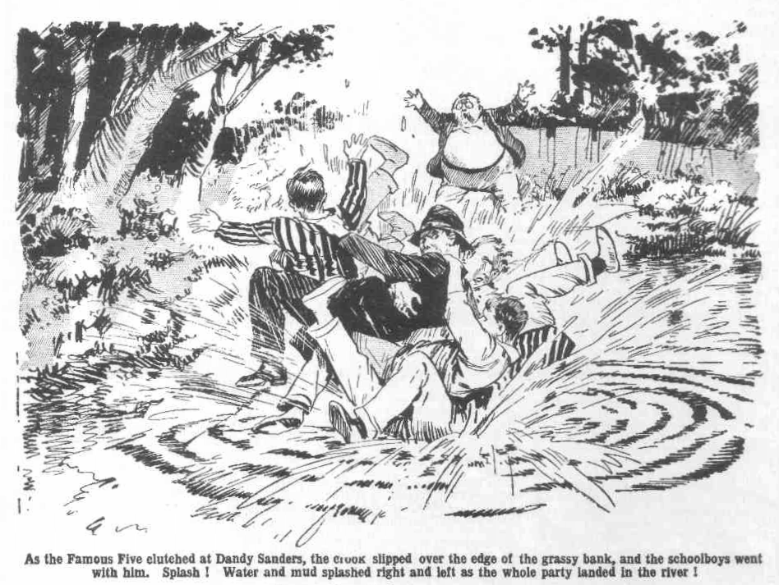
There was shallow water under the bank. Not much water close in, but plenty of mud. Water and mud splashed right and left as the whole party swamped in.
“ Oh crumbs!”
“Ooooogh!”
“Hold him!”
“ Oh, my hat!”
Involuntarily the juniors let go as they sprawled in mud and splashing water. Dandy Sanders rolled clear of them. He could not have scrambled up the bank without being instantly seized again, and he plunged out into deeper water at once.
The next moment he was swimming.
Harry Wharton & Co. scrambled up, wet, and muddy, and breathless. The desperate crook, out of reach, was swimming with long, swift strokes. Dandy Sanders was thinking only of escape now.
“After him!” roared Bob.
“The boat!” shouted Wharton. “Come on!”
The boat was tied to a trailing root under the bank. Wharton tore the
painter loose and gave the boat a shove out into the river, and the juniors scrambled headlong into it as it went.
They rocked away on the Sark with a rush.
“Oh crikey!” gasped Bunter, staring at them weakly from the high bank. “I say, you fellows--- Oh crumbs!”
Four of the juniors seized the oars and crashed them into the rowlocks. Nugent took the lines. With a swift dash of oars the boat shot across the river in pursuit of the swimming crook.
Dandy Sanders shot a glance back.
Probably he had not expected that prompt pursuit; he had seen nothing of the boat under the bank.
He gritted his teeth and swam on desperately, heading for the opposite bank and the cover of the sweeping woods.
“Pull, you beggars!” panted Bob Cherry.
“Go it!” panted Johnny Bull. “We’ve got the brute!”
“The gotfulness is terrific!”
The boat fairly skimmed after the swimmer, the four juniors pulling their hardest. It rushed down on the crook when he was hardly half-way across.
Bob Cherry shipped his oar and made a clutch at the swimmer’s hair; but it vanished, as the Dandy dived.
“Missed him!”
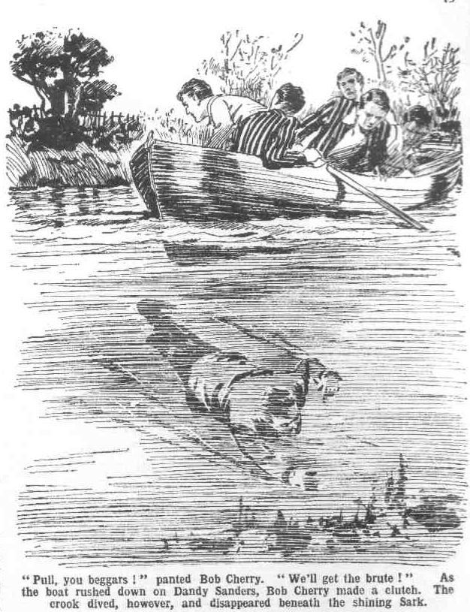
“We’ll get him—”
“There he is!” roared Johnny Bull.
The desperate man came up again, at a distance, swimming fiercely, and again the boat rushed down on him. Again the crook dived and disappeared beneath the shining Sark.
From up the river another boat came in sight, pulling down with the current. Three Fifth Form men were in it— Coker and Potter and Greene. Potter and Greene were rowing, and Coker was telling them how to do it while he steered. Coker stared at the Remove boat.
“What the thump are those fags up to, barging about!” he exclaimed. “ They’ll be into us next!”
Potter glanced round.
“Steer clear of them, old bean!” he said.
“I’ve a jolly good mind to run them down, barging about in that idiotic way all over the river,” said Coker crossly. “What do they think they’re up to!”
“ For goodness’ sake, steer clear!” exclaimed Greene. “We don’t want a collision, Coker!”
Horace Coker snorted.
“I know that, Greene. I’m going to steer clear.”
And Coker pulled the wrong line— which was one of Horace Coker’s ways when he was steering any craft, and before Potter and Greene knew what was happening, their bows were crashing into the Remove boat.
There was a yell from the Removites.
“ Look out, you fatheads!”
“Oh, my hat!”
The Remove boat rocked wildly, and shipped water. Two of the juniors rolled over, roaring. Bob Cherry, who was clutching at a head that had risen on the water, nearly pitched in, and barely saved himself—without getting hold of the Dandy.
“ What the thump—” gasped Bob
“ You clumsy young asses!” roared Coker of the Fifth, as his boat rocked off. “You silly young idiots! What are you up to?”
“You howling ass!“ yelled Wharton. “What did you barge into us for?”
“After him!” roared Bob. “He’s getting clear.”
Dandy Sanders was not losing a second. Thrice he had escaped by diving, but this time the pursuers would have had him, but for the unfortunate arrival of Horace Coker. They grasped the oars and got going again, but the desperate swimmer had now almost reached the bank.
“Put it on!” gasped Wharton.
The Remove boat shot after the crook. He had reached the bank and was grasping at grass and roots. For a second it looked as if the bows would crash into his back and pin him to the steep bank. Barely in time the escaping crook dragged himself up and scrambled ashore. The next moment the boat was thudding on the bank.
“After him!”
Bob Cherry leaped ashore. Dandy Sanders, dripping, muddy, panting, was on his feet, racing into the wood. Bob’s grasp missed him by hardly a foot as he dashed into the trees.
There was a rustling and crashing of breaking thickets as the crook disappeared from sight.
Bob Cherry ran a few paces into the wood, and stopped. The running man vanished into a wilderness of trunks and thickets, and it was hot much use to think of pursuing him farther. Bob turned back, panting, and joined his comrades on the bank.
“He’s gone!” he growled. “We should have got him, but for that idiot Coker! The howling ass—”
“Hi!” Coker stood up in his boat and shouted. “Hi! What game do you call this, you cheeky young sweeps—what?”
Harry Wharton & Co. crowded into their boat again. The crook had escaped—owing to Coker. But Coker of the Fifth was still there, and they were anxious to let him know what they thought of him. They pulled out to the Fifth Form boat.
“For goodness’ sake let’s get on!” said Potter uneasily.
“Shut up, Potter !“
“Look here, Coker—” said Greene.
“Shut up, Greene!”
Coker fixed a wrathful glare at the Removites. Coker had a short way with fags, and he had picked up a boat hook, apparently, with the idea of using it as an instrument of punishment.
“Now, you cheeky young scoundrels, what do you mean by barging in the way of my boat?” demanded Coker. “What were you after that man for? Can’t a man go for a swim without you fags ragging him—what? Barging all over the river, and—Whoooooop!”
The business end of an oar caught Horace Coker on his manly chest. He sat down suddenly, and the boat rocked. Another oar tapped on his head as he sat, and he yelled. Another jammed into his ribs, and Coker was distributed along the bottom of the boat, among the feet of Potter and Greene.
Potter and Greene laughed. Coker did not laugh. He raved.
“There!” gasped Wharton. “That will do for you, Coker! Come on, you fellows!”
The Remove boat pulled back to the spot where the picnickers had camped. Potter and Greene pulled away down the river, while Coker sat up dizzily, struggling for his second wind.
It was quite a long time before he recovered sufficient breath to ask Potter and Greene what the thump they were sniggering at and to tell them what he thought of them.
THE FIFTH CHAPTER.
Bunter’s Picnic!
“I SAY, you fellows!”
“You fat villain!”
“Oh, really, Cherry—”
The picnic had started!
Harry Wharton & Co. tied up the boat and clambered up the bank to the towpath, rather breathless and warm, and considerably wet and muddy. The crook had escaped; but it was some satisfaction to have dealt faithfully with Coker of the Fifth.
The picnic was the next item on the programme, and they found it already going on. The lunch-basket, which they had left concealed in the ferns, was now standing in full view, open, and Billy Bunter was sampling the contents.
Bunter had been left under the oak in a state of palpitating funk when the juniors pursued the escaping crook across the river. Evidently he had recovered!
He blinked at them cheerily through his big spectacles, with a jammy face, and a jam tart in either fat hand.
“You podgy pirate!” roared Johnny Bull.
“Oh, really, Bull! Jolly lucky my meeting you like this, wasn’t it?” said Bunter. “I say, you fellows, you look a muddy lot! He, he, he!”
“Roll him into the river!” said Nugent.
“Oh, really, Nugent! I thought you fellows would like me to begin.” explained Bunter. “What’s the good of standing on ceremony among pals? I say, did you let that beast get away?”
“He’s bolted!” grunted Bob Cherry.
“Well, you might have collared him!” said Bunter. “He’s a jolly dangerous character, you know. I really think you might have collared him! What did you let him get away for?”
“Idiot!”
“Well, you can call a fellow names,” said Bunter; “but he wouldn’t have got away from me! I say, you fellows, I’m rather glad you were on the spot— though, of course, I should have handled that villain all right if you hadn’t turned up! I was just going to knock him into the river when you fellows dropped on him—”
“ Fathead !”
“ What the thump were you doing in the tree?” asked Bunter. “I never saw you there! I might have passed on, you know, and never seen you at all!”
“ The mightfulness is terrific, my idiotic Bunter.”
“You never would have seen us, you frumptious chump, if we hadn’t had to get you away from that scoundrel!” growled Johnny Bull.
“If you mean that you were keeping out of sight because you were going to be mean about the picnic, I can only say I’m disgusted with you!” said Bunter. “But as you were here, I thought the basket wouldn’t be far away, and so I looked for it. He, he, he!”
“You fat, scrounging oyster—”
“Lucky I found it, wasn’t it, or I should have had to wait for you fellows, and I’m jolly hungry after that walk!” said the fat Owl.
“The luckfulness ws preposterous!”
“I say, you fellows, these are jolly good tarts! I’ve left you one each!”
“You’ve left us one each—out of two dozen?”
“Yes, old chap! Nothing greedy about me, I hope!”
“Oh crikey!”
“That looks a decent cake.” said Bunter. “If you fellows are going to have tarts, I’II have the cake—what? Fair play all round.”
“You think that will be enough for you?” asked Bob Cherry, with blighting sarcasm.
“Well, I can fill up on the bananas, if you fellows don’t want any. It’s not much I eat, as you know.”
Billy Bunter lifted the cake from the basket. It was rather a large cake, and there was a knife in the basket for cutting it. But Bunter did not need the knife. He took the cake in two fat hands, to gobble it. Bunter preferred that way of disposing of a cake. It saved time and trouble.
Before, however, the cake could reach his capacious mouth it was jerked away and tossed back into the basket. Somehow or other, the picnickers did not seem to relish picnicking on one tart each, while Bunter ate the cake and filled up on the bananas.
“Let that cake alone, you fat porker!” growled Johnny Bull, in a voice like that of the Great Huge Bear.
“Oh, really, Bull! [f you’re going to be mean about a cake---”
“We are!” grinned Nugent. “Frightfully mean!”
“The meanfulness is going to be terrific, my esteemed fat Bunter!” grinned the Nabob of Bhanipur.
“Rather lucky we didn’t follow that johnny any farther,” remarked Bob Cherry. “We shouldn’t have found much picnic left!”
“I say, you fellows—”
“Oh dry up, Bunter!”
“I was only going to ask you whether you want that bottle of ginger-pop,” said Bunter, with dignity. “ If you do, say so—don’t mind me!”
“You fat ass, there’s five bottles of ginger-pop, and you can have one of them if you like—”
“He’s had four already!” roared Johnny Bull.
“Oh, my hat!”
“I’ve left that bottle for you fellows.” said Bunter. “I was fearfully thirsty after that walk in the sun; but I left you a bottle. Still, if you don’t want it—”
The Famous Five gazed at Bunter. After a pull on the river on a hot after- noon they were all dry, and ginger-pop would have been grateful and comfort- ing. In the circumstances, they did not feel a deep appreciation of Billy Bunter’s kind consideration in leaving them one bottle!
“If you don’t want it, old fellows, you might open it for a chap!” said Bunter.
“I—I—I’ll open it for you!” gasped Bob Cherry.
“Thanks, old chap! I say, what about that cake?”
“Never mind the cake now—here’s the ginger-pop” said Bob, as he opened the bottle—a foot from Bunter’s fat little nose.
Pop!
Squish!
Swooooosh!
“Yarooooooop!” roared Bunter.
“Ha, ha, ha!”
“Urrrgu! You silly idiot! Groogh! You potty chump! Gurrrrgh!”
Billy Bunter sprawled over backwards in the grass, spluttering wildly, almost drowned in fizzing ginger-pop.
“Ow! Stoppit! Ooooch! Groooogh! Beast! Wow!”
“Ha, ha, ha!”
“Have the lot!” said Bob, up-ending the bottle over Bunter’s fat face. “Have the jolly old lot, old fat bean!”
“Urrrrgggghhh!”
“Ha, ha, ha!”
“Now brain him with the bott1e.” said Johnny Bull.
“Ow! Wow! Groooogh! Beast! Oooooch! I’m soaked! I’m drenched!
Yoooogh! Wurrrrzrrgh! Oh crumbs! Ooooooh!”
Billy Bunter scrambled up wildly. Ginger-beer clothed him like a garment. He stuttered and sputtered and spluttered.
“Sorry we haven’t any more ginger pop.” said Bob. ‘ But what about a tart? It was frightfully kind of you to leave us one each! You can have mine!”
“Gurrrrgh!”spluttered Bunter, as he received the tart—in the form of a plaster on his fat little nose.
“Ooooooogh!”
“ Ha, ha, ha!”
“He can have mine, too!” exclaimed Nugent. “Here you are, Bunter!”
“Ow! Beast!”
Billy Bunter jumped away. He did not seem to want any more tarts.
“I say, you fellows—grooogh—l’m all sticky— ”
“Ha, ha, ha!”
“The stickfulness is terrific!”
“Ow! Beasts! Wow!”
“Don’t you want another tart?”
“Ooooogh! Beast!”
The offer of tarts did not tempt Billy Bunter. He backed away in alarm, gouging at the jam on his fat face.
Harry Wharton & Co. sat down, chuckling, to what was left of the picnic. Billy Bunter washed jam from his fat face in the margin of the river, and dabbed ginger-beer from his large ears with a handkerchief. Then he eyed the picnickers warily from a safe distance.
“I say, you fellows---”
“Do you want another tart?” asked Bob.
“Nunno I—I don’t really care for tarts, old chap! I say, old chaps, if you’re going to be mean about that cake—”
Harry Wharton laughed.
“Here you are, you fat rhinocerous!” he said. “Catch!”
The cake had been divided into six parts. One portion was tossed to Bunter, and he caught it, and immediately transferred it to his mouth. It vanished in record time. Then his gaze lingered on the bunch of bananas, all that remained.
“I say, you fellows,” yelled Bunter suddenly. “There’s that man again!”
“What!”
The picnickers bounded to their feet.
“Look!” yelled Bunter.
He pointed past the oak trunk into the wood behind. Harry Wharton & Co. rushed round the oak, and dashed into the trees. Billy Bunter made a jump at the bananas,
“Nobody here!” growled Johnny Bull, after the juniors had rooted among the trees for three or four minutes. “That fat ass was dreaming! How could the man have got back across the river, and why?”
“Not here, anyhow!” said Harry.
The juniors came out of the wood again. It was only a false alarm. As they arrived under the oak-tree the last banana on the bunch was vanishing from sight.
Billy Bunter gave them a guilty blink. “I—I say, you fellows, d-d-did you find him?” he gasped.
The Famous Five did not reply to that question. They stared at the little heap of banana-skins.
“You—you—you!” gasped Bob Cherry. Why, the fat villain was pulling our legs while he scoffed the bananas!”
“Oh, really, Cherry, I—I never touched them!” gasped Bunter. “I—I wouldn’t, you know!”
“Where are they gone, then?” roared Johnny Bull.
“I—I—I think some—some animal came out of the wood and—and got them!” stuttered Bunter “A—a stoat, I think—”
“A stoat scoffed the bananas?” gurgled Bob.
“Yes, old chap! I—I saw him. A— a—a great big stoat——”
“And he peeled them?” yelled Bob.
“Ye-e-es, old chap! Stoats arc awfully clever animals, you know---”
“I don’t think we’ll look for the stoat,” said Bob. “I think we know the animal that got outside those bananas—a fat animal named Bunter.”
“Oh, really, old chap—”
“And the same animal that had the bananas is going to have the skins.” said Bob. “Hold him by the ears!”
“I—I say, you fellows! Oooop! Ow! Leggo! Don’t you stuff those skins down my back, you beast! Ow! Oooogh! Grooooogh!”
Billy Bunter wriggled frantically as a handful of clammy banana-skins was crammed down his neck. The bananas had seemed quite nice when they went down. But the banana-skins did not seem nice as they went down. They felt horrid!”
“Ow! Beast!” howled Bunter. “I tell you I never had the bananas! It was a fox—I saw him distinctly—”
“Ha, ha, ha!”
“Ooooooogh!”
“Time we got back,” remsrked Bob Cherry, and the chums of the Remove went down to the boat. “Coming, Bunter?”
“Ow! Beast! Wait till I get these beastly things out of the back of my neck!” howled Bunter.
“Shove off!”
“Beast! I’m coming!”
Billy Bunter plumped into the boat, his fat face red and wrathy. The chums of the Remove pulled down the river—what time Bunter wriggled and squirmed and struggled to extract clammy banana skins from the back of his fat neck. Judging by his looks and his remarks, Bunters picnic had not turned out quite so enjoyable as he had anticipated.
THE SIXTH CHAPTER.
Good News for Carne!
“NOT coming, Carne?”
“No!”
“Why not?” grunted Loder of the Sixth.
Carne made no reply.
Carne of the Sixth was loafing in the quadrangle, when Loder joined him. He was not looking merry or bright, and did not seem to be enjoying loafing
idly, with his hands in his pockets, and doing nothing. But he shook his head
decidedly, and Loder gave him an irritated look.
“Look here! What’s this game?” asked Loder. “It’s nearly a week, I believe, since you’ve been out of the gates at all. What are you afraid of?”
“Don’t be an ass! I don’t choose to go out.” answered Carne sullenly.
“If you’re afraid of meeting Joey Banks “—Loder towered his voice, though there was no one near at hand— “I can tell you that’s all right. He’s left Friardale. Races up north, I believe.”
“I’m not afraid of meeting him!” growled Carne. “I’ve fixed things up with him. He’s agreed to wait till next term for what I owe him. I can settle with him next term.”
“Well, then, what—”
“Nothing!”
“You’ve got some reason for sticking in gates,” said Loder. “Blessed if I can make you out, Carne!”
Arthur Carne did not answer. For a good many days now Carne of the Sixth had not set foot outside the precincts of the school. But he certainly was not, going to explain the reason.
How the confederate of Jerry the Rat had learned that it was he—Carne of the Sixth—who had “snaffled” the loot hidden in Study No.1 by the bank-raider, Carne could not imagine. But he knew that they knew it, or, at least, suspected it. He knew that they were watching for him, and he had fallen into their hands once, and was not taking the chance again. Not till the “lost loot” was recovered by the police would Carne of the Sixth venture outside the school. When that happened, the crooks would have no use for him, and he would be safe. But it had not happened yet.
It was irksome enough to remain “gated,” and it made his friends surprised and curious. But Carne was taking no chances of another meeting with the steely eyed man and his gang.
In his fear of Joey Banks’ threats he had taken a fifty-pound note from the bag of loot to pay the racing man. But Joey Banks, keen as he was to collect his money, was not fool enough, if he was rascal enough, to touch a bank- note which he shrewdly suspected did not belong to Carne. He had returned the note, with the excellent advice to Carne to put it back where he had found it—in some master’s desk, as Mr. Banks supposed.
All would have been clear for Carne— for, once relieved of his fear of Mr. Banks, he was only too anxious to get clear of the loot.
But the crooks had collared him on his way back to the school and he had flung the banknote away in the bushes to save it from them. No doubt he would have found it later, had not Billy Bunter found it first!
That banknote was hopelessly lost, but Carne had done all he could. The lost loot was to be found, but it had to be found in such a manner that no one could suspect that it had ever been in his hands. He had hidden the green leather satchel, with its contents, in a cavity under the ivy in the ancient wall of the Cloisters. Sooner or later it would be found there—by chance! No one could dream that Carne had put it there. But several days had passed and the discovery had not been made.
The fact was that the old Cloisters had been searched, and searched again, since when it never occurred to any one that the lost loot might possibly be there. The discovery had to depend on chance—and the chance had not yet materialised.
Since he had placed the loot in its now hiding-place, Carne had heard of the finding of the fifty-pound note in the wood by Bunter, and that it was now in the hands of the police. It was an immense relief to his mind, and he was feverishly anxious that the green leather satchel should be found and the whole miserable affair come to an end.
More than once he had gone into the Cloisters with the idea of removing the bag from its hiding-place and putting it somewhere where it might be found more easily. But every time his courage had failed him. Discovered or not, he was clear of it, and he dared not take the slightest risk of being seen near its hiding-place.
But so long as it remained where it was, the gang of crooks would remain in the belief that he had it, and he would be the object of their attentions
Day after day passed; and every day Carne longed to hear that some fellow, rummaging in the old Cloisters, had found the loot. But no such news reached his anxious ears, and he could only wait, meantime, taking care to keep out of the way of the confederates of Jerry the Rat. He had narrowly escaped them once, in Friardale Wood, but in the school he was safe from them. Once the loot came to light they would let him alone. Until then he had to keep on his guard.
Loder watched his moody face irritably. He wanted a companion for a run up to the Three Fishers, and Loder, at least, could see no reason why Carne should mooch about within gates. Carne stood with his hands in his pockets, moody and sullen. He would have been glad enough to join Loder in that excursion, but he was not going to take the risk.
His moody eyes fell on a cheery party of juniors coming in at the gates. He scowled at them. Carne didn’t like the Famous Five, and their bright and healthy cheerfulness was a contrast to his own worry and gloom. Billy Bunter was rolling in with the chums of the Remove, not looking quite so merry and bright as the cheery Co. Banana-skins down his back had not had an exhilarating effect on William George Bunter. Harry Wharton called out to Vernon-Smith, who was in the quad, as the juniors came up from the gates:
“Is Quelchy back yet, Smithy?”
“Yes, in his study” answered the Bounder.
“Good! We’d better go in and tell Quelch, you fellows.” said Harry. “He will have to report it to the police.”
“Anythin’ happened?” asked Smithy.
“Yes, rather! The jolly old sportsman who’s after the loot has happened.” said Bob Cherry.
Loder glanced at the juniors curiously and Carne gave a start. Carne had his own reasons—good reasons—for being keenly interested in the “sportsman” who was after the loot. He stepped quickly towards the Famous Five.
“What’s that?” he exclaimed.
The juniors glanced round at him.
“We’ve dropped on that blighter who is after the bank’s money, Carne.” answered Harry Wharton. “He was after Bunter, and we chipped in.”
“After Bunter?’’ repeated Carne. “What the thump was he after Bunter for?”
Harry Wharton laughed.
“The silly ass thinks Bunter has the loot up his sleeve.” he answered.
“And hasn’t he?” grinned the Bounder.
“Oh, really, Smithy---”
Carne broke in.
“What rot are you talking, Wharton? What the dickens do you mean? How can the man think Bunter has the loot? What’s put that into your head?”
“Well, he said so,” answered the captain of the Remove, “He grabbed Bunter, and goodness knows what would have happened if we hadn’t butted in. We jolly nearly nabbed him, but he got away. He thinks Bunter has the loot because of that fifty-pound note.”
“ That fifty-pound note?” repeated Carne.
“ The cheeky rotter, you know!” said Billy Bunter, with deep indignation, “I told him I picked up that banknote in Friardale Wood, and he didn’t believe me! Making a fellow out to be a liar, you know! Me!”
“That sportsman isn’t the only one.” chuckled the Bounder. “ I fancy old Grimey thinks the same. I’ve seen him eyeing you.”
“ Grimey’s an old fool!” said Bunter. “As if I’d touch the loot if I found it!”
“You touched that fifty-pound note.”
“That was different, you beast! How was I to know it was part of the loot when I picked it up in Friardale Wood? Besides, I handed it over to Quelch, didn’t I?”
“Not till you had to, you fat spoofer.”
“Beast!”
“ So that sportsman thinks Bunter’s got the loot and helped himself to one of the notes?” asked the Bounder.
“That’s it.” answered Wharton. “ According to what he said, he’s been hanging round the school, watching for a chance to get hold of Bunter; and he got him this afternoon. Luckily, we chipped in and got him away.”
“I was just going to knock him into the river—”
“Ha, ha, ha!”
“So the man thinks that Bunter’s got the loot, and he’s after Bunter?” said Carne, with a very strange look on his face.
“ That’s it.” said Harry.
“ Plenty of others think the same.” said Smithy.
“Beast!” roared Bunter.
“Oh, chuck it, Smithy, old man!” said Bob. “Bunter doesn’t know anything about the loot. Quelch believes be found that banknote in the wood.’
Smithy shrugged his shoulders,
“Bunter had better be careful after this.” said Carne. “You’d better stay in gates, Bunter.”
“Catch me going out again!” said Bunter. “ No fear!”
The juniors went on to the House, to report the happening of the afternoon to their Form master. Carne stood looking after them, breathing hard, a peculiar light in his eyes.
So they were after Bunter! They had been after Carne, but what had hap- pened now showed that the steely eyed man was on a new trail.
He had heard, evidently, that the fifty-pound note had been found by Bunter, and he was not likely to believe, as Carne realised, that the fat junior had found it in the wood, a mile from the school, when he knew that the bag of loot was hidden in Greyfriars. He believed—as more than one Greyfriars man suspected, that Bunter had found the lot and helped himself to one banknote, and had the rest still hidden away. In fact, the crook could hardly believe anything else, in the circumstances.
Carne felt himself breathe more freely.
The crooks had been switched off from him to Bunter, that was clear! They had believed that Carne had the loot. Now, evidently, they believed that Billy Bunter had it! Bunter was in danger from them, but Arthur Carne had nothing more to fear.
He glanced round at Loder. Loder was going down to the gates and Carne hurried after him.
“I think I’ll come, after all.” he said.
Loder stared at him.
“Changed your mind all of a sudden?” he asked.
“Yes; I’m sick of loafing about in gates. Let’s get off.”
“Blessed if I can make you out!” grunted Loder. “But come on!”
And they went out of gates together, Carne humming a tune as he went.
THE SEVENTH CHAPTER.
A Note for Bunter!
“I SAY, you fellows!”
“Poor old Bunter!”
It was the following day, after class.
Harry Wharton & Co. were sauntering down to the gates, with the intention of walking over to Cliff House, for tea with Marjorie Co. there. Billy Bunter rolled after them with a lugubrious fat face.
There was no tea at Cliff House for Billy Bunter!
It was true that Bunter was not included in the list of invitations, but that was a trifle light as air to the fat Owl! That trifling circumstance would not have bothercd him.
But Bunter was gated!”
Since his narrow escape the previous day Mr. Quelch had ordered him to remain within gates. That order Billy Bunter might have disregarded, but for his deep concern for the safety of his own fat skin. “Safety first” was Bunter’s motto. There was only one person in the wide world for whom Billy Bunter felt a really deep concern— and that person was to be found under Bunter’s hat!
The mere thought of meeting that steely eyed man again made the fat owl shiver. Mr. Quelch’s strict order was hardly needed. Wild horses would hardly have dragged Billy Bunter out of gates, while the confederates of Jerry the Rat were waiting for him.
But it was hard cheese! Tea at Cliff House was an attractive function. It was fairly certain that there would be a cake. Marjorie and her friends were attractive, too, though not, of course, so attractive as the cake!
“Poor old Bunter!” said Bob Cherry sympathetically. “It’s rather rotten for you to have to keep away when you’re not wanted.”
“Oh, really, Cherry——”
“But think how nice it will be for everybody else!” said Bob. “Isn’t that a consolation?”
“Ha, ha, ha!”
“After all, Bunter’s going to make this little party a success,” remarked Johnny Bull.
Bunter blinked at him.
“Eh! How am I going to make it a success if I’m not there, you ass?” he grunted.
“That’s how!”
“Beast! I say, you fellows, look here! I’m gated, you know, and when a fellow’s gated I don’t think his pals ought to go out and leave him in the lurch.”
“Hardly.” agreed Harry Wharton. “Not what I should call pally! Go and tell your pals so, old fat man!”
“Oh, really, Wharton! I say, that beast Toddy has gone out to tea, and there’s nothing in the study.” said Bunter.
“And so the poor dog had none!” said Bob sadly.
“Ha, ha, ha!”
“Well, look here, you fellows, what about giving it a miss?” asked Bunter. “You can go over to Cliff House some other day, you know. What about staying in? We’ll have tea in your study, Wharton, and I’ll come! Marjorie won’t mind, you know. She only asks you fellows because she thinks you’ll bring me with you, as you know.”
“Oh, my hat!”
“Think of her, you know,” urged Bunter. “Bit rotten for her when she expects to see me and only you fellows turn up, what?”
“Gentlemen chaps, and sportsmen,” said Bob Cherry, “who’s keen to stay in with Bunter instead of going over to tea Marjorie? Don’t all speak at once!”
“Ha, ha, ha!”
“I say, you fellows—”
“Good-bye, Bunter!”
The chums of the Remove walked on to the gates. They did not seem unduly depressed by the sad necessity of leaving Bunter behind. Indeed, to judge by appearances, they were rather bucked!
“I say, you fellows!” Bunter rolled after them. “I say, hold on a minute! It’s rather important. Don’t walk away while a chap’s talking to you, you beasts! I say---”
The juniors halted again.
“Well, what is it, fatty?” asked Harry Wharton. “Cough it up!”
“I believe I told you fellows I was expecting a postal order—”
“Oh crumbs! I believe you did!”
“Well, it hasn’t come—”
“Great Scott!” exclaimed Bob Cherry, in a tone of the greatest astonishment. “You don’t say so, Bunter!”
“Ha, ha, ha!”
“Blessed if I see anything to cackle at! It really hasn’t come, you fellows, and—”
“Really and truly?” ejaculated Bob.
“Yes, really and truly, old chap! I’m stony! Fancy that!” said Bunter sorrowfully.
“Only fancy!” said Bob. “It must be pretty rotten for a chap accustomed to enormous wealth to be stony! Any of you men got a note you don’t want— Bunter’s stony!”
“Rot!” grunted Johnny Bull.
“My dear chap. Bunter’s stony—for the first time in his life! If you’ve got a note you don’t want---”
“Fathead!”
“Well, luckily I’ve got one I don’t want.” said Bob, groping in his pocket. “It came this morning, and I don’t specially want it. If it would be any use to you, Bunter—till your postal order comes—”
“Yes, rather!” gasped Bunter. “I— I’ll settle out of my postal order, old chap ! My postal order will be here tomorrow. It’s from one of my titled relations, you know.”
“You silly ass, Bob!” exclaimed Johnny Bull. “Have you gone off our rocker ? You know that fat freak isn’t getting a remittance.”
“You shut up, Bull!”exclaimed Billy Bunter warmly. “ You jolly well mind your own business! Bob’s not so mean as you are, and he can take a fellow’s word! I say, old fellow, where’s that note?”
“I’ve got it in my pocket somewhere”
“Silly ass, carrying currency notes loose iny jour pocket.” grunted Johnny Bull. “Your own fault if you lost it. Still, you might as well lose it as lend it to Bunter.”
“Oh, really, Bull—”
“Oh, here it is!” said Bob. His hand came out of his pocket with something crumpled inside it. “ Here you are, Bunter—here’s the note I had this morn. ing, and I really don’t want it!”
Bob Cherry shoved the crumpled note into Billy Bunter’s fat hand and walked away with his friends. Billy Bunter blinked at his prize—and blinked again— and gasped.
What Bob had handed him was a slip of paper, headed in print:
“ BENSON’S BOOTSHOP, Courtfield.”
Typed under that heading were the words:
“We regret delay in returning boots left for repair, but the same will be delivered without fail on Friday.—Yours faithfully,
“Benson & Co.”
Billy Bunter blinked and blinked and blinked. Then he rushed after the chums of the Remove, out of the ancient gateway,
“I say, you fellows!” he yelled.
“Hallo,. hallo, hallo!”
“Hold on a minute!” howled Bunter.
“Oh, my hat! We shall never get over to Cliff House at this rate,” said Bob Cherry. “ But hold on a minute, you men!”
Bunter came panting up.
“You’ve given me the wrong paper!” he gasped. “Look at that!” He held up the missive from Benson & Co. “That ain’t a currency note, you ass!”
The juniors stared at it, and grinned.
“Currency note!” repeated Bob. “I never said it was a currency note, did
I?”
“Wha-a-at?” gasped Bunter.
“I said I’d had a note this morning that I didn’t want. That’s the note.”
“Ha, ha, ha!”
“Keep it, old bean.” said Bob. “ I don’t want it—I don’t, really!”
“Why, you—you—you—” gurgled Bunter.
Bob Cherry glanced at his comrades, who were yelling.
“Fancy Bunter thinking I was speaking of a currency note!” he ejaculated. “ I wonder what put that idea into his head! You fellows know?”
“Ha, ha, ha!”
“You—you—you idiot!” shrieked Bunter. “ Think I want a silly note from a silly bootmaker?”
“Do you mean you’d like me to give you another note instead of that one?” asked Bob.
“ Yes, of course, you chump!”
“Oh, all right! Anything to oblige! I’ve got another note here---”
“Oh, good!”
“From the Courtfield outfitter—”
“Wha-a-t?”
“It’s about five bob I owe him—”
“Ha, ha, ha!” yelled the juniors, quite entertained by the expression on Billy Bunter’s speaking countenance.
“You—you—you——’ gasped Bunter.
“You don’t want it?” asked Bob. “Well, let’s get on you men—we don’t want to be late at Cliff House.”
And the Famous Five got on.
“Beast!” roared Billy Bunter.
And he rolled back into gates—leaving in the road the note which Bob Cherry did not want—and which Bunter did not want, either!”
THE EIGHTH CHAPTER.
Fagging for Coker!
“MAULY, old chap!”
Lord Mauleverer of the Remove had been ambling under the old elms at a
leisurely, not to say a lazy, pace.
But as the dulcet tones of WilIiam George Bunter fell on his ears his lazy lordship woke to sudden energy.
He accelerated.
“Mauly, old fellow!” shouted Bunter.
Lord Mauleverer disappeared.
“Beast!”
Billy Bunter blinked round him disconsolately. Mauly had dodged him— actually dodged him! It was tea-time— past tea-time—and never had Bunter been so anxious to meet a friend—never had he felt so keenly the value of friendship. But with the selfishness he had so often met with, his friends were turning him down—not even seeming to realise that they possessed the inestimable boon of his friendship at all.
The Famous Five, with what Bunter could only regard as absolute heartlessness, had gone over to Cliff House to tea, regardless of the fat Owl. Peter Todd, his study-mate, was tea-ing out— and when Toddy tea’d out he never cared whether Bunter had any tea or not in Study No. 7. When he looked in at Study No. 4, where the Bounder and Redwing were at tea, Smithy had shied a Latin dictionary at him without even waiting for him to speak.
He had tracked Ogilvy and Russell to the school shop, where they had bought tarts; but the usual selfishness of human nature was displayed once more—they had eaten the tarts themselves! He had come on his minor, Sammy of the Second, devouring toffee under the elms. In the most unbrotherly manner Sammy had refused to whack out his toffee—and knocking Sammy’s head on the trunk of an elm was only a slight solace. Now Lord Mauleverer had dodged him—fairly run for it— just as if Bunter was not a fellow any fellow might have been glad to meet!
Bunter had tea’d in hall before it was too late; but one tea was a mere trifle to Bunter. Now he was looking for another—indeed, for as many more as might be available. And he looked in vain. Almost was Billy Bunter tempted to take his chance of meeting the steely eyed crook and roll over to Cliff House, after all. But not quite! He shivered at the thought of feeling once more the vice-like grip that had been laid on him on the towpath the previous day. Even a state of famine was better than a meeting with Dandy Sanders.
“I say, Skinner, old chap!” Skinner and Snoop were heading for the tuck-. shop, and Bunter joined them—but with only a faint hope; very faint indeed. There was not much, as a rule, to be got out of Skinner. “I say, old fellow— —”
“Had your tea, Bunter?” asked Skinner.
“Not yet.” answered Bunter hopefully.
“Like to tea with us?”
“Yes, rather, old chap!”
“Then wait till we ask you!” said Skinner agreeably, and he walked on with Snoop, both of them laughing.
Billy Bunter snorted. This was what Skinner thought funny! It did not appeal to Bunter as funny at all.
The fat Owl rolled on dismally. He began to realise how the Egyptians felt like in the lean years. With only one tca packed away in his spacious inside, Bunter could understand the feelings of shipwreckerd1 men in an open boat at sea. He leaned on the shady tree outside the school shop and blinked at fellows passing in and out, like a fat Peri at the gates of Paradise.
Coker of the Fifth came out of the tuck shop with a parcel in his hand. Bunter blinked at him sourly. That beast Coker had lots and lots of money, and he spent it with a lavish hand; but even Bunter did not think of trying to raise a little loan from a Fifth Form senior— he had felt the weight of Horace Coker’s boot more than once, and did not want to feel it again.
Coker of the Fifth glanced round, and called to him.
“Here, Bunter!”
Bunter did not stir from his reposeful attitude against the tree. He merely blinked at Coker.
“Take this to my study for me!” said Coker.
Bunter continued to blink without stirring.
The Remove did not fag, even for the Sixth! The Fifth did not have fags at all—though that, in Coker’s opinion, was sheer rot. When Coker had been a junior in the Remove he could have boiled with indignation at the bare idea of being called on to fag. But in the Fifth Form, Horace took quite different view. He saw no reason whatever why the scrubby little scoundrels should not fag for a Fifth Form man.
Coker had absolutely no right to call on any Lower boy to fetch and carry for him. But he had a heavy hand and a heavy foot, and one or the other frequently supplied the place of right. Thus it was on this occasion. Bunter was not, perhaps, a very creditable member of the Remove, but he was jolly well going to show Coker that a Remove man was not going to fag for the Fifth! Bunter was quite determined on that—till Coker came to close quarters. But with Coker at close quarters he saw reason to change his mind all of a sudden.
“I said take this to my study for me.” remarked Coker pleasantly, taking hold of a fat ear.
“Yow-ow-ow!”
“Sharp’s the word,” said Coker, exerting pressure.
“Wow! Beast! I---I mean, all right!” gasped Bunter.
He took the parcel.
“I shall be along in two ticks,” added Coker, and he walked away to look for Potter and Greene.
“Oh!” gasped Bunter.
His eyes glimmered behind his spectacles.
Bunter had supposed that he was to walk with Coker to the house, carrying the parcel. Hence his determination not to fag for the great Horace—which determination he had abandoned under pressure. Carrying the parcel under Coker’s eye was one thing. Carrying it out of sight of Coker’s eye was quite another! Out of sight of Coker’s eye Bunter was more than willing to carry Horace’s parcel of tuck—though it was improbable that he would land it in Coker’s study.
He blinked after the great Coker and grinned. Then he rolled away with the parcel.
He did not head for the House.
Coker would not be long after him—and if he did not find the parcel in his study he was sure to look for Bunter, and the first covert he would draw would be the Remove passage. There was no refuge there for Bunter! Leaving the House astern, Billy Bunter rolled away in search of a quiet and secluded spot. Coker and his parcel had happened just in time for tea ; and all Bunter needed was a solitary spot, far from the madding crowd—and especially far from Coker!
He rolled into the dim shades of the old Cloisters,
He stopped at the ancient ivy-clad wall that bordered that secluded spot, and sat down. He was out of sight now—and hoped that he would be out of mind ! He jerked the string of the parcel and unwrapped it.
“Oh!” gasped Bunter. “Prime!”
It was a cakc that was revealed—a large cake—one of Mrs. Mimble’s ten- shilling cakes! Coker of the Fifth was the fellow to “ blow” ten shillings on a cake! It was rather extravagant; but Bunter, at least, had no fault to find with Coker’s extravagance. Neither did he object to fagging for Coker—on these lines!”
His eyes and his spectacles gloated on that cake! It was a scrumptious cake, and it weighed several pounds—there was, in fact, almost enough for a meal
for Bunter! Swiftly a large chunk was broken off—and Bunter began to gobble.
For a whole minute Bunter enjoyed existence—life, as the poet has put it, was one grand, sweet song!
And then—with his mouth full—Bunter started, so suddenly that he almost choked.
There was a footstep in the Cloisters!
There was a voice!
It was the voice of Horace Coker!
“Sure you saw the fat scoundrel go into the Cloisters, Greene?”
“Quite!”
“I told him to take the parcel to my study.”
There was a doubtful tone in Coker’s voice. It seemed difficult for the great Horace to assimilate the fact that his lofty behest had been disregarded.
“Well, I saw him---”
“If that fat young scoundrel’s thinking of scoffing that cake---”
Coker’s voice trembled with wrath.
“I fancy he’s not thinking of it, Bunter heard Potter’s voice.
“ Oh, you fancy not, Potter!”
“No; I fancy he’s doing it!”
“If he’s not done it already.” said Greene.
“Well, he’s not had time yet.” said Coker. “If he’s here, we’ll jolly well root him out and smash him! Look for him!”
Billy Bunter trembled.
He had expected to be kicked, sooner or later, for annexing Coker’s cake. But he had hoped to dispose of the cake first. To be kicked without having had the cake was too much. The old stone pillars hid him as yet from the sight of Coker & Co. but he could hear their voices and footsteps, and it was only a matter of minutes before they unearthed him. With his mouth still full of cake, Bunter blinked round wildly for a hiding-place. But there was no hiding- place for Bunter. The thick ivy that mantled the wall might have concealed the smallest fag in the Second Form, but it would never have concealed Bunter.
But in these desperate moments Billy Bunter’s fat brain worked at unaccustomed pressure. If he could not hide himself he could hide the cake!
It was no sooner thought of than done.
He bounded to his feet, the cake in his hand. He blinked at the thick ivy on the wall. He remembered a cavity in the old wall under the ivy, where he had once hidden a bag of chocolates of which Herbert Vernon-Smith was in search. Swiftly he pulled aside a cluster of thick leaves and tendrils, and thrust the cake into the cavity in the wall. The ivy dropped back into its place.
Bunter gasped.
Footsteps were coming nearer, but the Fifth Form men had not seen him yet. Billy Bunter sidled along the wall. He was going to be found, but he wanted that to happen as far as possible from the parking-place of the cake. He rolled on swiftly, and there was a shout;
“I can hear him! This way!”
Bunter ran.
Heavy footsteps sounded behind him.
“There he is!”
“Bunter!”
“Stop!”
Billy Bunter did not stop till a grasp on the back of his collar stopped him. Then he had to stop. Coker of the Fifth gazed at him.
“Now, you fat sweep!”
“Ow!”
“Where’s that cake?”
“Wow! Leggo!”
“Where’s that cake?” roared Coker.
“Ooooogh!”
Bang!
Billy Bunter’s bullet came into contact with a stone pillar and a fiendish yell rang through the old cloisters.
“Yarooooooo! Ow! Help? Leggo! Help! Whoooop!”
THE NINTH CHAPTER.
Inspector Grimes to the Rescue!
INSPECTOR GRIMES, of Courtfield, gave quite a jump.
He jumped and stared up at the old stone wall.
Mr. Grimes was startled.
Outside the old cloister wall, which bordered the school precincts on that side, ran a narrow lane, which gave access from the road to the garage, to thø kitchen gardens, and other places with which the Greyfriars fellows had nothing to do. On the other side of the lane was a fir plantation. In that lane the portly inspector was pacing slowly, in the sunset of that warm July afternoon. It was in that spot that, weeks ago, “Jerry the Rat” had dodged into the school in his desperate flight which had ended in capture in the House. Mr. Grimes was perambulating that little lane with a thoughtful shade on his plump brow when wild yells from within reached his official ears.
Inspector Grimes, being in official charge of the bank robbery case, had been on the track of the lost loot ever since the day that Jerry the Rat had held up the Courtfield and County Bank. All the evidence was that the loot was still hidden somewhere inside the walls of Greyfriars, and Mr. Grimes had not the slightest doubt on that subject— though Dr. Locke and most of his staff doubted very much indeed.
The fact that a fifty-pound note, part of the loot, had been picked up in a wood a mile away convinced the Head, at least, that Mr. Grimes’ theory was unfounded—indeed, absurd.
The loot, it seemed, had been hidden in the school by the bank raider, but it had been removed since. Dr. Locke and most of the staff declined to believe, for one moment, that it had been taken by anyone belonging to Greyfriars. To their minds that seemed quite impossible—though Arthur Carne, of the Sixth Form, could have told them that it was far from impossible had he chosen to do so. Mr. Grimes kept to his own opinion.
He had questioned Billy Bunter about the finding of that banknote—not once but many times. He could not help having an impression that the fat Owl was telling the truth about it, but at the same time he could not help seeing that Bunter was habitually untruthful, and that he would have said anything and everything to get out of a scrape. And knowing nothing of Carne’s part in the affair, it seemed to Mr. Grimes highly improbable that a single banknote out of the bag of notes had somehow become detached from the rest and dropped in Friardale Wood.
It seemed more probable that a lying young rascal—which was his uncomplimentary opinion of Bunter—had found the loot and was keeping it secret, and had “spun a yarn” about picking up that banknote in the wood to account for his possession of it when it was discovered in his hands.
Now Mr. Grimes had learned that that was the belief of the unknown crook, the confederate of Jerry the Rat, who was in search of Jerry’s booty. Mr. Quelch had reported the happening on the towpath to him, and it left no doubt as to what the crooks believed. Naturally, that confirmed Mr. Grimes in
his suspicion of Bunter,
He did not feel sure in the matter, but he felt that it was very probable that the fat young rascal had the loot hidden away all the time intending to help himself later when it was safer to do so. The fact that Bunter had kept the fifty-pound note in his hands for a whole afternoon before handing it over to his Form master gave colour to that view. It looked as if Bunter had only given up the banknote because it was seen in his possession and he had no choice in the matter. He was being more careful with the result. That was how Mr. Grimes looked at it. Bunter’s word was worth nothing.
Seven thousand pounds was a large sum. The affair had made a tremendous sensation. The bank people were very urgent in the matter, and the recovery of the lost loot too, meant much to Mr. Grimes professiona1ly. Mr. Grimes was letting all other matters slide white he devoted his attention to finding that bag of loot. And for days and nights Mr. Grimes had been haunting the vicinity of the school.
It was a difficult task. Shadowing a schoolboy was next-door to impossible; yet if Bunter had the loot it was only by watching him that its hiding-place could be discovered. The green leather satchel was hidden in some nook or cranny in the school, or perhaps in some nook or cranny outside the walls, and at any time the young rascal might visit the place to see that his plunder was safe or to help himself from it. If an official eye was upon him at the time, all would be well. But it was extremely difficult to keep an official eye on a schoolboy at school.
Often, in his walks abroad, Bunter had fallen in with Mr. Grimes—so often, in fact, that even the obtuse Owl had realised that Mr. Grimes’ eye was suspiciously upon him. But now that Bunter was gated there were no more walks abroad.
Certainly, on the occasions when Mr. Grimes had ssen BilIy Bunter out of gates, the fat junior had shown no sign whatever of heading for some secret hiding-place. But that only confirmed the inspector’s suspicion that the loot was still within the walls.
It was intensely exasperating to a keen and capable police officer to be beaten by a fat and fatuous schoolboy—yet that was Mr. Grimes’ position if Bunter really was the guilty party. And all the time there was a lingering doubt in his mind as to whether Bunter was the guilty party at all. Mr. Grimes was growing quite annoyed, but his annoyance did not slacken his determination. He was after that loot like a dog after a bone.
He gave particular attention to the old Cloisters because that was a secluded and generally deserted spot— just the spot where a cunning young rascal would look for some cranny to conceal anything. Obviously the young rascal could not keep the bag of loot in his study, which he shared with other boys—anywhere in the House it would be in danger of discovery. The old Cloisters, with the ancient walls full of crannies covered by ancient ivy, was the very place he would select.
Mr. Grimes nourished a hope of spotting Bunter some time by day, or more likely by nights—sneaking into the dim old Cloisters to visit his hidden plunder. And he had no doubt that the mysterious crook, the confederate of Jerry the Rat, had the same idea in his mind. What Mr. Grimes half believed in connection with Bunter, it was clear that the crook fully and firmly believed—the attack on the towpath demonstrated that.
Several times as he ambled in that shady little lane the portly inspector had drawn himself up the wall and looked over into the Cloisters with a keen but cautious eye. He was unaware that only chance could favour him. But chance had not favoured him; he had not been looking over when Bunter arrived with Coker’s cake. Not, of course, that Mr. Grimes would have been interested in Coker’s cake! He was after bigger game than that.
But now—
From the other side of the old wall came a yelling voice, in the unmistakable tones of the fat schoolboy who at present occupied most of Mr. Grimes’
thoughts.
Mr. Grimes stared, jumped, and listened, and a glitter came into his eyes.
It was Bunter who was yelling! And he was yelling for help! Loud and
clear came the howl:
“Yooop! Beast! Leggo! Ow! Help! Help! Yarooooh!”
That the desperate crook, in search of the plunder, would make some fresh attempt to get hold of Bunter was a foregone conclusion. Mr. Grimes knew that as well as if Dandy Sanders had told him so.
That he would be unable to catch Bunter out of gates again was equally
certain. That he would make some attempt on Bunter within the school,
sooner or later, could hardly be doubted. By night was most probable, for which reason Mr. Grimes had taken to haunting the school by night like a grisly spectre. But that frantic yelling from the Cloisters hinted that the crook had made the venture in the daytime! For what other reason could Bunter be yelling for help?
All this flashed in a moment through Inspector Grimes’ keen and capable mind. In his mind’s eye he saw Bunter sneaking to the hiding-place of the loot; he saw the crook, lurking in the shadows of the Cloisters, springing upon him; he saw himself, Henry Grimes, clapping the handcuffs on the crook and recapturing the loot at one fell swoop! With such a prospect clear to his official eyes Mr Grimes was not likely to hesitate or waste time. He leaped to the Cloister wall, he made a spring that was very credible in a gentleman who was at least portly, if not decidedly plump; he caught the ecoping with his hands, he swung himself over, and he dropped into the old Cloisters like a bolt from the blue.
“Ow! Wow! Beast! Leggo!” yelled Bunter. “I don’t know where it is! I haven’t seen it! I don’t know anything about it. As if I’d touch it, you rotter! Leggo! Help!”
That voice from the other side of an old stone pillar was quite close at hand, and if Mr. Grimes had needed convincing how mattters stood these words would have convinced him. Naturally, Mr. Grimes was not thinking of cakes—he was not dreaming of cakes! Bunter evidently was in the hands of the crook—quite evidently! Fortunately, a keen and capable police officer was on the spot!
Mr. Grimes rushed round the stone pillar.
He burst on the scene quite suddenly. He burst on it so suddenly that he crashed into Bunter and Coker, and sent them both spinning. Billy Bunter crashed in one direction, yelling; Coker crashed in another, spluttering. Potter and Greene jumped back in great astonishment.
In another second the handcuffs would have clicked on Bunter’s assailant as he sprawled. But in that second, luckily, Mr. Grimes, hurried as he was, assimilated the surprising fact that Bunter’s assailant wasn’t—and obviously couldn’t be—a crook! His hands were already on Coker when he realised it; in time to leave his handcuffs where they were, in his official pocket.
“Wha-a-at?” stuttered Mr. Grimes, quite taken aback.
Billy Bunter sat up.
“Yooooop!” he roared.
“What the merry thump——” gaspcd Potter of the Fifth staring at Mr. Grimes, as if he had seen the ghost of a police inspector.
“What the dickens—” gasped Greene.
“What are you up to?” roared Coker, in great wrath and amazement. “What
—who the dooce are you, and what do you think you’re doing?”
“Oh!” gurgled Mr. Grimes. “Ah! Um!”
Never had a keen and capable police officer been taken so utterly aback. He fairly goggled at Coker of the Fifth.
Billy Bunter gained his feet.
Billy Bunter was not always quick on the uptake, but he realised that this was where he came in! How and why Mr. Grimes had butted in at that unexpected moment and in that unexpected manner Bunter could not begin to guess; neither did he stay to think it out.
Coker’s ferocious grasp was off him, and Billy Bunter fled along the Cloisters at a pace which looked as if he had a good chance for the school mile.
“lt’s Grimes!” gasped Pottter.
Coker struggled up.
“What’s this game?” he roared, looking at Mr. Grimes. “ What? What do you think you are up to, jumping in like a Jack-in-the-box and barging a fellow over! What?”
Mr. Grimes made no answer. He realised only too clearly that there were no crooks about! In the circumstances his surprising action was a little difficult to explain.
Coker glared round.
“Where’s that fat scoundrel?” he roared.
“Hooked it!” said Potter.
“Why didn’t you stop him, yon silly ass? Now he’s gone, and he’s hidden it somewhere here!”
“Hidden it!” Mr. Grimes felt a revival of hope. “Has that boy Bunter hidden something in those old Cloisters?”
“Yes, he jolly well has,” snorted Coker, “and. I’d have made him show us where he hid it if you hadn’t barged in!”
“Are you certain of this?” exclaimed Mr. Grimes.
“Eh? Of course I am! I don’t see that it matters to you, though.” said Coker, staring at the inspector.
“It matters very considerably to me, Mr. Coker,” said Mr. Grimes grimly. “If you are certain of what you say—”
“Of course I’m certain, though I’m blessed if I see what it matters to you! Potter saw him come here with it.”
“That’s so.” said Potter. “But I don’t see—” All three of the Fifth Form men we’re amazed by Mr. Grimes’ inexplicable interest in the cake.
“You saw him with it?” exclaimed Mr. Grimes.
“Yes.”
“You are sure that he hid it here?”
“We1l, he must have, as he hasn’t got it about him now.”
Mr. Grimes’ eyes gleamed. He had felt rather an ass when he found that Billy Bunter was in the hands, not of a desperate crook, but of a fat-headed. overgrown schoolboy! But it looked as if he was on the right track, after all!
“If that, is correct, the boy can be compelled to reveal the hiding-place.” he said. “If you are absolutely certain that——”
“Oh, quite!” said Potter. “He brought it here, and he certainly didn’t take it away with him when he bunked, and he hasn’t had time to eat it!”
“To—to—to what?”
“Eat it.”
“Eat it!” said Inspector Grimes blankIy. From Bunter’s looks he would have judged that the fat Owl would have eaten almost anything. But it was scarcely possible to suspect even Billy Bunter of having intended to eat the loot of the Courtfield and County Bank!
“He was going to eat it, if he’d had time.” said Cokcr. “I told him to to take it to my study, but Potter saw him sneaking into the Cloisters with it.
Inspector Grimes made a gasping sound.
“What—what is it you are speaking of?” he articulated.
“My cake, of course!” answered Coker.
“Kik-kik-cake!”
“Yes, cake!”
“Oh!” said Mr. Grimes.
He gave the Fifth-Formers one look, turned away without another word, and disappeared over the Cloister wall into the lane. Coker & Co. stared after him blankly.
“Is that man mad?” asked Coker in wonder.
“Must be!” said Potter.
“Mad as a hatter, I should think!” said Greene.
“Dash it all, his friends ought to look after him!” said Coker “Barging over the wall, bumping a fellow over, and asking a lot of questions about a cake! Does he think I want a policeman to look for my cake, or what? Fairly off his rocker, and no mistake! Here, come on, let’s get after that fat scoundrel Bunter!”
And Coker & Co. got after that fat scoundrel Bunter! But the fat scoundrel was lying very low by that time, and Coker & Co. did not find him. And that day there was no cake for tea in Coker’s study.
THE TENTH CHAPTER.
Rally Round!
HARRY WHARTON & CO. sauntered in at the school gates—and stopped suddenly.
They were rather surprised.
By the corner of Gosling’s lodge lurked a fat figure.
“Lurking” was the word! There was something extraordinarily surreptitious about the aspect of Billy Bunter. He was so excessively cautious, so exceedingly stealthy, that he could not have failed to draw the attention of any fellow who passed.
Bunter, apparently, was in cover! He was in hiding! He was about as effectually hidden as an ostrich with its head in the sand. The Famous Five regarded him with surprise. They were quite interested to learn what Bunter’s antics might possibly mean.
Bunter had his eyes on the quad and the house in the distance. But every now and then he blinked round at the gates.
Apparently he was watching for some fellow to come in at the gates, and at the same time watching for foes in the direction of the House. It was quite intriguing.
“Hallo, hallo, hallo!” roared Bob Cherry.
Bunter jumped.
“Oh!” he gasped
His eyes had been on the quad when the chums of the Remove came in, so he was unaware of their arrival till he was hailed in a voice that might have excited the envy of ancient Stentor.
He spun round.
“Oh! I say, you fellows, I was waiting for you to come in. I’ve been watching for you—”
“With your back to the gates?” asked Harry Wharton.
“Well, I had to keep an eye open for that other beast—”
“What?”
“I mean, that beast Coker of the Fifth, you know! I—I say, you fellows, can you see Coker?” asked Bunter anxiously.
“Not in the offing.” said Frank Nugent, laughing. “What have you been doing to Coker of the Fifth? Scoffing his tuck?”
“Oh, really, Nugent! I hope I’m not the fellow to scoff a fellow’s tuck! I say, keep an eye open for the beast, will you? I fancy he’s watching the Cloisters, but he might come this way. I say, stop a minute, you chaps! I want you.”
“Come on, fathead!” said Harry.
“We’ll see you safe to the House, if Coker’s on your track.”
“I don’t want to go to the House, old chap! I say, you fellows, did you have a good tea at Cliff House?”
“ Quite good! What the thump——”
“But I dare say you could do with some supper.” said Bunter, blinking at them. “Say, a cake—”
“ A cake ?” repeated Johnny Bull.
“Yes, old fellow. I’ve got a cake for you chaps. I left it till you came in, to whack it out with you.”
“My only hat!”
“The only-hatfulness is terrific!” ejaculated Hurree Jamset, Ram Singh. “The esteemed wonderfulness will never cease!”
“Nothing mean about me, I hope.” said Bunter. “As soon as the cake came—from Bunter Court, you know— I thought of you chaps. And 1 haven’t touched it yet—keeping it to hack out, you know.”
“We’re dreaming this!” said Bob Cherry, shaking his head.
“The dreamfulness is preposterous!”
“I mean it,” said Bunter. “I—I’ve left it in the Cloisters, so—so—because—I mean, somebody might have bagged it if I’d left it in the study. There are fellows in the Remove who would bag a fellow’s cake.”
“One, at least!” agreed Wharton.
“Is the fat chump pulling our leg, or what?” asked Johnny Bull.
“Honest Injun, old chap! The cake’s in the Cloister, and—and I want you chaps to come with me to fetch it.”
“Come on, then,” said Harry Wharton.
“Not that way!” exclaimed Bunter hastily, as the captain of the Remove made a movement to pass on. “Coker’s there. I’ve seen him two or three times, hanging about the Cloisters. The beast thinks I shall go there after the cake, you know, and he’s on the watch!”
“You fat villain!” roared Bob Cherry. “Is it Coker’s cake?”
“Ha, ha, ha!”
The Famous Five understood now.
“Oh, no! Nothing of the sort!” exclaimed Bunter, in a great hurry. “The beast’s after me for—for something else—nothing to do with a cake.”
“What is he after you for, then?”
“Because—because—the—the fact is, I—I knocked him down—”
“What!” yelled the Famous Five.
“He had the cheek to want to fag me.” explained Bunter. “Of course, I wasn’t going to fag for a Fifth Form cad. So I—I knocked him down—”
“Ha, ha, ha!”
The idea of Billy Bunter knocking down the biggest and heftiest man in the Fifth Form seemed to entertain the Famous Five. They shrieked.
“Knocked him spinning, you know.” said Bunter. “sent him fairly flying! He’s been after me ever since. 1t’s nothing to do with a cake—nothing whatever. The cake came from Bunter Court in a—a hamper. I say, you fellows, there’s nothing to cackle at!”
“Ha, ha, ha!” In spite of Bunter’s assurance, the Famous Five seemed to think there was something to cackle at, and they cackled.
“Well, what about it?” asked Bunter. “I’ve asked Toddy to fetch the cake already, and he made out that it isn’t my cake, or I shouldn’t have hidden it. Beastly suspicious mind, you know. Coker wouldn’t have noticed Toddy going into the Cloisters—it’s me he’s watching for. But the beast wouldn’t go ! I say, you fellows, you’re not suspicious like Toddy
“We are!” chuckled Bob Cherry.
“The suspiciosness is terrific, my esteemed, idiotic Bunter!”
“Oh, really, you fellows! Look here! There’s another way into the Cloisters.” said Bunter. “ My idea is to get in from outside—see? Coker can watch this side as long as he likes, so long as I get in from the other side. But I’m gated. That awful beast who got me yesterday may be watching for me for aIl 1 know. I’m not afraid of him, of course—”
“You could knock him down, as you did Coker!” suggested Bob.
“Ye-e-es, of course; but—but I’d rather you fellows came with me.” said the fat Owl. “ That’s why I’ve been waiting for you. I should be safe out of gates for a few minutes with my pals round me—see? I want you fellows to walk with me, and—and wait under the wall while 1 get the cake, see?”
The Famous Five “ saw.”
Coker’s cake, it was clear, was hidden in the Cloisters, and Coker was on the watch for Bunter to make an attempt to retrieve the plunder. By going out of the school and climbing into the Cloisters from outside, Billy Bunter would turn up at the enemy’s flank, as it were. But there was a lion in the path. Since his adventure the previous day Billy Bunter was too scared to venture out of the school on his own!
That was where the Famous Five came in. They were to escort Bunter on his expedition, and guard him from danger while he was out of gates. As a reward, they were to share Coker’s cake—if Billy Bunter did not gobble it to the last crumb as soon as it was in his fat hands, which was, perhaps, more probable.
The fat Owl blinked at them anxiously. Bunter had had only a mouthful of the cake so far. He was extremely anxious to deal with the remainder. It was, Bunter felt, a time for a fellow’s pals to rally round him.
“I say, you fellows, you’re going to back me up, ain’t you?” asked Bunter. “ It’s a ripping cake—ten bob cake, you know, full of plums! You know Mrs, Mimble’s ten-bob cakes—”
“I didn’t know they came in hampers from Bunter Court!” said Bob Cherry, shaking his head.
“Ha, ha, ha!”
“I—I—I mean—”
“We know what you mcan, old fat pippin! You’ve pinched Coker’s cake, and hidden it in the Cloisters, and jolly old Horace is after your scalp!” chuckled Bob.
“Nothing of the sort, old chap! Coker never had a cake that I know of, and Potter didn’t see me going into the Cloisters with it——”
“Ha, ha, ha!”
“Blessed if I see anything to cackle at!” I say, you fellows, it will be call- over soon, and then the gates will be shut, and I can’t go out!” said Bunter peevish1y. “And I’m gated, too, and I want to get it over before Quelch comes in—he would be waxy if he knew I went out of gates, see? You fellows come along with me, and I’ll whack out the cake fair and square——”
“You fat villain!” said Harry Wharton. “We’re not helping you pinch Coker’s cake!”
“1t’s my cake!” roared Bunter. “I keep on telling you it came from Bunter Court!”
“You’d better dig up that cake, and let Coker have it back!” said the captain of the Remove. “We’ll come with you to do that, if you like!”
“Why, you silly idiot!” gasped Bunter. “Might as well leave it where it is as let Coker have it! Think I’m giving Coker a cake that I paid ten bob for at Bunter Court—I mean, that came specially from the tuckshop in a harnper—that is, I mean--- I say, you fellows, don’t walk away while a fellow’s talking to you!” yelled Bunter.
But the Famous Five did walk away. They walked on, chuckling, and left William George Bunter to waste his sweetucss on the desert air.
THE ELEVENTH CHAPTER.
A Hot Chase.
BILLY BUNTER blinked out at the gates.
His fat heart was palpitating. He had to have the cake!
That, of course, was fixed and immutable, like the laws of the Medes and Persians. His pals had let him down, instead of rallying round him. Bunter had to depend on himself. And he was making up his fat mind to a desperate venture.
Getting into the Cloisters on that side of the school was impossible, without falling into Coker’s hands. Getting into the Cloisters on the other side meant venturing out of the school. And to Bunter’s terror, the roads and lanes and woods were thickly populated with dangerous crooks, all looking for Bunter. But he realised that it was neck or nothing. He had to have the cake! Bunter was not of the stuff that heroes are made of. But if there was anything that could screw up Bunter’s courage to the stickitig-point and make him ready to face deadly perils, it was a large plum cake.
He blinked anxiously into the road. It was near lock-up. But the bright sunshine of July streamed down. It was not going to be dark for a long time yet. Greyfriars fellows were coming in. If anything happened, there was really plenty of help at hand. It was not as if he had to go a long way. Five minutes at the most were required to reach the outer wall of the Cloisters, and some of the fellows would surely be within reach of a yell for help all the time. And even Bunter realised that it was improbable that even a desperate crook would collar him in broad daylight, with a lot of fellows a bout.
He made up his fat mind at last.
He rolled out of gates.
As swiftly as his uncommon weight allowed, he rolled along the road, towards the corner of the little lane that ran down between the fir wood and the Cloisters.
His fat heart thumped.
He would not have been surprised at any moment had the steely eyed man sprung on him from behind a buttress or from the paddock acoss the road. But he was for it now. He was read to yell on his top note if the crook appeared. Fortunately, the crook did not appear.
At the corner of the lane he gave a last uneasy blink round before he left the road. Several figures were to be seen in the distance—rather blurred to the shortsighted eyes of the Owl of the Remove. One of them, too far off for the Owl to recognise, was that of a tall and angular gentleman with gimlet eyes— no other than Mr. Henry Samuel Quelch, the master of the Remove. Mr. Quelch’s gimlet eyes had a much longer range of vision than Bunter’s little round ones.
Mr. Quelch stared grimly at Bunter from the distance. Bunter was gated:
and Mr. Quelch had returned from his walk just in time to spot him out of the gates. Mr. Quelch quickened his pace, with a glint in his gimlet eye.
Bunter turned the corner, and rolled down the lane. An anxious blink showed him that there was nobody in sight. Inspector Grimes had been there that afternoon; but Mr. Grimes was gone. The coast was clear—unless the shades of the fir wood hid a lurking crook! Billy Bunter’s plump heart beat unpleasantly. But like the deep and dark blue ocean in the poem he rolled
on. He stopped at the Cloister wall in a well-known spot where the ravages of time had broken away the ancient stones and made a climb easy—for anybody but Bunter. No climb was easy for a fellow wh had Bunter’s weight to lift. But Bunter had to negotiate that wall, and he lost no time. He blinked over his left shoulder—he blinked over his right shoulder—and the coast was still clear. Then he grabbed at the uneven stones and started to climb.
“Grooooogh!” gasped Bunter.
He gained ten or twelve inches up the wall and paused to rest and gasp for breath. When Bunter climbed, he had to take it in easy stages.
Meanwhile, Mr. Quelch had reached the corner of the side lane, and was standing there staring down the lane at Bunter’s podgy back.
Mr. Quelch was quite astonished.
Bunter was gated—and ought not to have been out of gates at all. Bunter was really not the fellow to take risks, and it was rather surprising that he had gone out, in the circumstances. But timid was not so surprising as his proceedings after he had gone out.
So far as Mr. Quelch could see the fat junior had deliberately walked out of gates, gone round the school wall for no purpose whatever, except to climb in again. Why a fellow should walk out of a gateway and climb in again over a wall was a mystery to the Remove master. Even a fellow who was keen on strenuous exercise would hardly be likely to do that. And Bunter was far from keen on exertion in any shape or form. It really was mysterious.
Mr. Quelch almost wondered whether Bunter was in his right senses. If he was his conduct was inexplicable.
He walkcd rapidly down the lane from the road after Bunter.
“Ooooogh!”
Bunter made another effort, gained three more inches, and slipped back. His feet landed on the earth again.
“Oh crumbs!” gasped Bunter.
He stood leaning on the wall, gasping for breath. Perspiration trickled down his fat face. And as he stood, a sudden grasp was laid on his shoulder from behind.
Bunter jumped as if he had been electrified.
In the effort of climbing he had alrnost forgotten his fear of the crook. But at that sudden grasp on his shoulder it rushed back into his mind.
He let out a yell that woke all the echoes of Greyfriars School and the adjacent parts of Kent.
“Yaroooooooh!”
Bunter, of course, had no eyes in the back of his head. He did not, therefore, see Mr. Quelch. And he had not the slightest doubt that the steely eyed crook was upon him.
“ Ow! Help! Leggo! Help! Murder! Fire!” shrieked Bunter. “ Police! Help ! Lemme alone! Murder!”
“Bunter!” gasped Mr. Quelch.
“Help, help, help!” roared Bunter. His own voice drowned Mr. Quelch’s. “Stoppit! Lemme alone! Help! Murder! Fire! Police!”
With a desperate wrench, Bunter tore his shoulder away from the grasp on it. He bolted up the lane towards the road, still yelling.
“ Bunter!” shrieked Mr. Quelch.
“ Help! Murder! Crooks! Burglars! Help!” yelled Bunter frantically.
He did not look back. He had no time to look back. He charged on frantically in desperate flight.
“Bless my soul!” gasped Mr. Quelch. “ The boy is inad—insane---utterly out of his senses! Upon my word! Bunter!”
“ Help! Murder! Help!”
Mr. Quelch dashed after him. Seldom or never did Henry Samuel Quelch so far forget the dignity of a middle-aged Form master as to run. In ordinary circumstances he would not have dreamed of such a thing. But these circumstances were not ordinary. A boy of his Form was evidently out of his senses, rushing and shrieking like a lunatic. And Mr. Quelch threw dignity to the winds and rushed after him.
The sound of running feet behind him spurred Bunter on to unheard-of efforts. In momentary expectation of feeling the clutch of a crook on his shoulder, Bunter fairly flew. He reached the corner, and rushed out into the road and tore along to the school gates. Greyfriars men, coming in for lock-up, stared at him in amazement— and stared in still greater amazement at the sight of Mr. Quelch streaking along after him.
“Bunter!” shrieked Mr. Quelch. “ Stop!”
If Bunter heard, he did not heed. He was not likely to stop.
He tore on frantically, yelling at the top of his voice. After him tore his alarmed Form-master. Bunter reached the gateway, well ahead. He rushed
in. It was sheer bad luck for Carne of the Sixth that he had come down to the gates to meet Walker coming in. He was expecting Walker—he was not expecting Bunter. It was the unexpected that happened. Billy Bunter did not even see Carne of the Sixth till he barged into him, and he struck like a battering ram.
“Woooooh!” gasped Carne.
He went over headlong, sprawling. Bunter reeled from the shock, but he recovered and ran on. Carne remained sprawling and gasping for breath. A moment later Mr. Quelch was coming in, at a pace very unusual for Mr. Quelch, or any Form master. Mr. Quelch, naturally, did not expect a prefect of the Sixth Form to be sprawling at full length just inside the gateway. No Form master could have foreseen such a thing. Before Mr. Quelch discovered Carne, he tripped over him and landed on his knees.
“Oh!” gasped Mr. Quelch.
Had Mr. Quelch’s elderly knees crashed on the hard earth they would have been hurt. It was fortunate for Mr. Quelch that Carne’s waistcoat was in the way. But from the unfortunate Carne there came a breathless howl of anguish as Mr. Quelch’ knees crashed on his waistcoat.
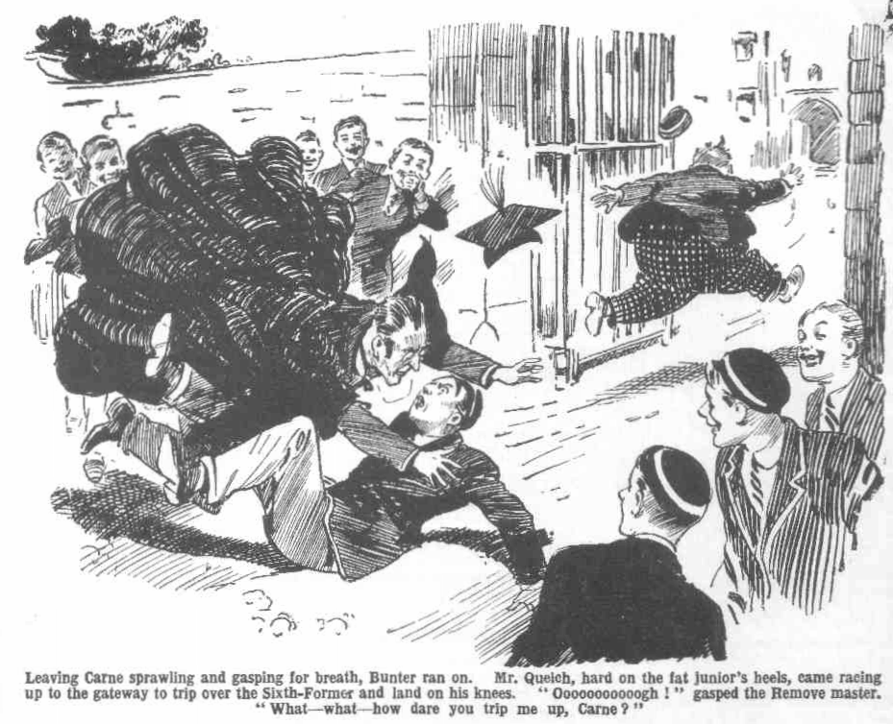
“Oooooogh!”
“Bless my soul!”
“Ha, ha, ha!” came a roar from about fifty fellows.
Mr. Quelch bounded up.
He glared at Carne.
“Carne! What—what--- How dare you trip me up?” he thundered. “What do you mean by it? What?”
“Urrrrrggh!”
“You—a Sixth Form prefect—”
“Wurrrrrgggh!”
“Such a prank—such a childish, infantile prank—!”
“Guggug-gug-gug!”
“Ha, ha, ha!”
Mr. Quelch remembered Bunter. Carne could wait! Leaving Arthur Carne gurgling spasmodically, with his hand pressed to his waistcoat, Mr. Quelch hurried on towards the House. Billy Bunter had gained ground in the wild race, add he had nearly reached the House, puffing and blowing wildly. Harry Wharton & Co., on the steps, stared at him blankly, as did a score of other fellows. Bunter panted on, yelling.
“I say, you fellows! Keep him off! Help! Fire! Murder! 1 say, you fellows Oh crikey! Help!”
“Mad!” gasped Bob Cherry. “Mad as a hatter!”
“Help! Help! Help!” roared Bunter. “He’s after me! Help!”
“The madfulness is terrific,” gasped Hurree Jamset Ram Singh. “It is the esteemed and ridiculous Quelch after him—”
“Bunter, you potty ass—”
“Help! Murder! Help!”
“Stop that boy!” Mr. Quelch shouted from the distance. “Wharton—Cherry! Stop that boy! Stop him!”
The Famous Five collared Bunter as he charged up the steps. They brought him to a halt struggling wildly.
“Ow! Leggo! He’s after me!” shrieked Bunter. “Help! Police! Murder! Keep him off! Oh crikey! Help!”
“You potty Owl!” roared Bob Cherry. “What’s this game?”
“He’s after me!” shrieked Bunter,
Mr. Quelch came panting up.
“Hold him!” he gasped. “Secure him! I fear that the poor boy is not in his right mind! Hold him securely.”
The Famous Five held Bunter securely enough. Two of them had hold of his fat ears, one his collar, one his hair, and one his nose. There was no escape for Bunter. But he wriggled and struggled frantically.
“I say, you fellows! Help! Lemme go! Leggo, you beasts! Let me get into the House! He’s after me!” shrieked Bunter “Keep him off!”
“Keep Quelch off!” gasped Wharton. “Eh? That crook—”
“That what? It’s Quelch—”
“Quelch!” gasped Bunter.
He blinked round. He jumped. There was no crook in the offing. But his Form master, crimson, breathless, was glaring at him, and about a hundred Greyfriars fellows were staring, and yelling with laughter. Billy Bunter’s eyes almost popped through his spectacles.
“Bunter! Calm yourself!” panted Mr. Quelsh. “Calm yourself, my boy! I will telephone for the doctor immediately. Calm yourself—”
“Oh crikey!” gasped Bunter. “W-was it you after me, sir?”
“What? What?”
“I—I thought it was that villain— that awful crook! He—he grabbcd me by the shoulder, behind. He—he—I—I—” stuttered Bunter.
“Ha, ha, ha!”
“Silence!” exclaimed Mr. Quelch. “Bunter, you—you— Is it possible? You utterly absurd boy, did you imagine—”
“Oh crikeyl”
Mr. Quelch had been prepared to be sympathetic, in the belief that that bright member of his Form had gone out of his mind. Now that he realised how matters stood, all signs of sympathy had vanished. He glared at Billy Bunter as if he could have bitten him.
“You—you fancied—you absurd boy! You—you—were you not aware that it was I?” gasped Mr. Quelch.
“Nunno! Oh dear! I—I thought—”
“Ha, ha, ha!”
“Silence! Bunter, follow me to my study! I shall cane you severely for going out of gates and for— Follow me at once!”
“Oh lor’ !”
Mr. Quelch whisked into the House— rather anxious to get out of the public view, as a matter of fact. He realised that tho affair was rather ridiculous. Billy Bunter rolled dismally after him. He was relieved of his terrors of the crook, but they had been replaced by terrors of the cane—terrors which proved to be well founded.
A crowd of Greyfriars fellows were left yelling. In Mr. Quelch’s study, Bunter was soon yelling, too—though in a different way. When Mr. Quelch had done with him’ Billy Bunter, for a time, forgot even Coker’s cake!
THE TWELFTH CHAPTER.
Nothing Doing!
“There’s one thing about you, Bob, old man—you’re plucky!”
“Eh!”
“Pluckiest chap at Greyfriars, and chance it!” said Bunter.
Bob Cherry stared at the Owl of the Remove.
It was after prep, and Bob Cherry had come out of Study No. 13 to joizi his friends and go down to the Rag. He found the Owl of the Remove in the passage, waiting for him. And Billy Bunter’s remark made him stare.
Bob was quite aware of being a plucky chap, but he had not expected to hear that flattering assurance from Billy Bunter. He wondered what the fat Owl was driving at.
If there’s a thing I admire,” went on Bunter, “it’s pluck!” And you being the pluckiest man in the school, old chap—”
“Passed unanimously, also nem con.” said Bob gravely. “And I’m sorry I’vc nothing to lend you, old fat bean.”
“Oh, really. Cherry—”
“Smithy had a remittance this morning, though. Better go and tell him he’s the pluckiest chap at Greyfriars!” suggested Bob.
“If you think I want to borrow anything, you beast—”
“Don’t you?” askd Bob, in astonishment.
“No!” roared Bunter. “I don’t!”
“Then what the thump are you giving me soft sawder for?”
“It’s rather thick, I think, that a fellow can’t say what he thinks about a chap he admires for his pluck without being suspected of having an axe to grind.” said Bunter reproachfully,
“Well, my only hat!” said Bob.
“Pluck’s your long suit, old fellow.” went on Bunter, “You’re not afraid of the prefects! Not you!”
“Not a small, little piece.” agreed Bob. “But what the thump---”
“You wouldn’t be afraid to get out of the House after lock-up, to oblige a pal !” went on Bunter. “Being so jolly plucky, you’d simply snap your fingers at the risk. I know you, you know.”
“Here, you men!” shouted Bob, as the rest of the Co. appeared in the passage from their studies. “Come and listen to this! Bunter’s telling me what a splendid chap I am—and I want you to know.”
“The knowfulness is already terrific, my esteemed and idiotic Bob.” said the Nabol of Bhanipur.
“But Bunter’s just found it out, and he’s full of it.” said Bob, “Go on, Bunter ! Pile it on! I’m just lapping it up!”
“Ha, ha, ha!”
“Oh, really, Cherry! Of course, I’m not just pulling your legs because I want you to go down to the Cloisters for me. I’m asking you to go because youre so jolly plucky—besides, I want you to have some of the cake.”
“Ha, ha, ha!” yelled the Co.
“Not that there’s a lot of risk.” said Bunter, blinking seriously at Bob’s grinninig face. “You can drop out of a window of a Form-room—easy as falling off a form! You cut across to the Cloisters—you see that beast Coker can’t be out of the House after lock-up, so its safe as houses. You get the cake
—I’ll tell you where to get it—and—and there you are! You won’t be spotted out of the House! Besides, il you’re spotted it’s only a lickinig—and what do you care for a licking, a plucky chap like you!”
“He’s not pulling my leg, you men.” said Bob. “He says so; but if he hadn’t said so, I might have fancied he was!”
“Ha, ha, ha!”
“Well, are you going, old fellow?” asked Bunter eagerly. “ Coker can’t possibly be there now—and even if he is, you’re not afraid of Coker—”
“Not a plucky chap like me!” grinned Bob. “But there’s one thing I’m afraid of, Bunter. I’m afraid it’s Coker’s cake!”
“Ha, ha, ha!”
“Not at all, old fellow! I keep on telling you it’s my cake! That’s all right! I’d go and fetch it in myself, only—only—”
“ Only the pluckfulness of the esteemcd Bunter is not so terrific as that of the ridiculous Bob!” chuckled Hurree Jamset Ram Singh.
“Well, a fellow doesn’t want to get licked for breaking House bounds.” said the fat Owl. “ I mean, there isn’t any danger of getting licked—”
“Ha, ha, ha!”
“Well, are you going, old fellow?” asked Bunter anxiously
“ No!” grinned Bob. “ I’m not going, old bean!”
“I say, Harry, old chap, what about you?” Billy Bunter turned his big spectacles on the captain of the Remove.
“ You’re not such a miserabIe, measly, shivering funk as Bob Cherry—”
“Your turn, Wharton.” said Bob. “You’re the pluckiest man at Greyfriars, and a fellow Bunter really admires, if you’ll help him pinch Coker’s cake.”
“Ha, ha, ha!”
“ Nothing doing!” chuckled Wharton.
“I say, Inky, you’ve not got cold feet like Wharton—”
“The coldfulness of my esteemed feet is still more terrific!” contradicted the Nabob of Bhanipur.
“Franky, old man—”
“Bow-wow!”
“What about you, Bull?” asked Bunter hopefully. “ You’re a really plucky chap—not like these rotten funks—Leggo my ear, you beast!”
“Ha, ha, ha!”
Billy Bunter jerked his ear away and rolled down the passage to the stairs, leaving the Famous Five laughing. “Soft sawder” had failed to serve his turn, and the fat Owl was still in want of a catspaw.
Really, it was hard cheese!” Until lock-up Bunter could not make an attempt to retrieve that cake, because Coker s eye was open and watchful. After lockup he could not make the venture, because a fellow was licked for breaking House bounds. it looked as if that cake would have to remain in its hiding-place in the cavity under the ivy in the Cloister wall until the morrow. That, however, was really impossible. Bunter was hungry—and the thought of the cake made him hungrier. Bunter was willing to whack it out with any fellow who would take the risk of fetching it in—but no fellow was available.
The fat Owl rolled along to Wingate’s study in the Sixth at last. With leave from a prefect a fellow could go out of the House after lock-up; though he had, of course, to give a good reason. Bunter was prepared to invent any number of the very best reasons
Wingate and Gwynne of the Sixth were talking cricket when the fat junior presented himself in the study of the captain of the school. They stared at Bunter.
“I—I say, Wingate, c-can I have leave out of the House?” asked Bunter. “I—I left my Latin dictionary on a seat under the elms this afternoon, and —and I’d like to fetch it in.”
“You can get it before prayers in the morning.” answered Wingate.
“The—the fact is, I—I’ve got some lines to do for Quelch—”
“Lines from a Latin dictionary?”
“I—I meant my Virgil!” explained Bunter hastily. “I left my Virgil on a seat under the Cloisters—I mean, under the elms—and—and I’ve got to get it to—to do my lines for Quelch—”
Wingate looked at him, and Gwynne chuckled. Bunter had an impression. from Wingate’s look, that he doubted the statements he had heard, and he hastened to add convincing details.
“You see, I was gated today, Wingate, and—and I was reading my Latin dictionary—I mean, my algebra— that is, my Virgil, under the elms, and
—and I left it there. It’s nothing to do with a cake.”
“A cake!” ejaculated Wingate.
“Yes—nothing at all! I haven’t left a cake out of doors—I shouldn’t, you know! It’s my Latin algebra—I mean, my Virgil dictionary—that is---”
“Gwynne, old man, there’s a cane on your side of the table.” said Wingate. “Hand it over, will you?”
“Here you are!”
“There’s a chair, Bunter” said the Greyfriars captain, as he took the cane. “Bend over it.”
“Oh lor’ !”
Whack!”
“Yaroooooooop!”
“I suppose you will never learn to tell the truth, Bunter.” said Wingate. “But that my help! Shut the door after you!”
“Yaw-ow-ow!”
Billy Bunter shut the door after him. There was no leave out of House bounds for Bunter! He wriggled his way out of the Sixth Form passage. In the silent Cloisters, Coker’s cake remained where Billy Bunter had parked it—in contact, though Bunter never dreamed of that, with the green leather satchel that contained the lost loot of the Courtfield and County Bank. And there it had to remain, when Billy Bunter, doleful and dismal, rolled off to the Rcmove dormitory to bed.
THE THIRTEENTH CHAPTER.
Bunter Out of Bounds!
HARRY WHARTON started suddenIy out of slumber.
What had awakened him he did not for a moment know.
Then he realised that something was closing over his face in the dark.
“Ooooooh!” gasped Wharton.
He was stratled. Any fellow might have been startled at such an awakening at midnight’s witching hour.
He fairly jumped.
Crack!”
“Yaroooop!” came a sudden howl.
Wharton’s head, as he started up in amazed alarm, came into violent contact with a face that was bending over him.
“What the thump!” gasped Wharton.
“Wooooh! You idiot! You’ve smashed my nose! Wow!”
“Is that Bunter?”
“Wow! My nose! My boko! Whooop!”
Wharton rubbed his head. It was a little hurt, though not, apparently, so severely as Bunter’s nose. He stared in the darkness at the gasping Owl.
“You blithering cuckoo!” gasped Wharton. “What the thump have you woke me up for? What are you up to, you silly, howling ass?”
“Yow-ow-ow!”
“Hallo, hollo, hallo!” came a sleepy voice. “What’s the row?”
“That burbling idiot Bunter—”
“I say, you fellows, shut up! Don’t wake the House! Ow! My nose! You’ve nearly banged my nose through the back of my head! Wow!”
“Blow your nose! What the dickens—”
“Ow! My boko! You silly idiot—”
“What is that howling ass doing out of bed?” asked Bob Cherry. “What on earth made Bunter wake up before rising-beIl?”
“It’s all your fault, you beast!”
“Mine?” ejaculated Bob.
“Yes, you beast! If you’d fetched in that cake for me—”
“That cake!” repeated Bob. “ You— you piffling, pie-faced porker, have you got up in the middle of the night to scoff Coker’s cake?”
“I’ve told you it’s not Coker’s cake! I’m too jolly hungry to sleep.” said Billy Bunter. “I’ve been dreaming of that cake—”
“ Ha, ha, ha!”
“I’ve woke up a dozen tines, and every time I was hungrier than the time before.” said Bunter pathetically. “ If you fellows are too beastly selfish to go out for a cake, I’m going, see? I want a fellow to help me in at the box-room window when I get back.”
“Is that why you’ve woke me?” asked Harry Wharton in deep, concentrated tones.
“Yes, old chap! You see, I can get out of the window all right, but I’d rather have somebody to help me in again—and—Yarooooh!”
Harry Wharton groped for his pillow, grasped it, and smote. There was a howl and a bump as Billy Bunter sat down beside the bed.
There, you potty porpoise!” gasped Wharton. “Now let a fellow go to sleep.”
“Whooooop!”
“Now shut up, or I’ll get out and give you another.”
“Yow-ow-wooop!”
“Ha, ha, ha!”
“Ow! Beast! Wow! Ow! Rotter! Wow!”
“If you don’t chuck that row, Bunter, I’ll get out with my bolster.” came the Bounder’s voice.
“Beast!”
“Go back to bed, you potty chump.” said Frank Nugent. “Coker’s cake will keep till to-morrow.”
Coker’s cake, no doubt, would have kept till the morrow, but Billy Bunter felt that he would not keep till the morrow without it! The cake had haunted his dreams, and again and again he had awakened to think of it. Thinking of it made his mouth water, and at long last he had turned out of bed. He simply had to have that cake. He was hungry—in fact, famished! After all, it was easy enough to get the cake. He had only to slip quietly out of the House and nip into the Cloisters and get it.
Breaking House bounds after lights-out was a more serious matter than breaking House bounds before lights out. But there was much less risk of being caught. Everybody else was in bed and asleep; there was no wakeful eye to fall on Bunter. In a quarter of an hour he would be baek in bed with the cake! He would be sitting up in bed with the cake—and such a prospect was not to be resisted.
Heedless of the voices that advised him to shut up and go back to bed, Billy Bunter rolled away to the door.
He would have preferred a fellow to let him in again at the box-room window; but once more he was up against the selfishness of human nature— nobody in the Remove was going to turn out of bed and lend aid in pinching a cake.
“Bunter, you howling idiot, come back!” called out Harry Wharton, as he heard the dormitory door open.
“Yah!”
The door closed.
“Has that piffling porpoise really gone?” exclaimed Peter Todd.
“The gonefulness is terrific!” chuckled Hurree Jamset Ram Singh.
“The fat chump!”
“Let him rip!” chuckled the Bounder. “Ten to one he won’t be able to get in again at the window—it’s a night out for Bunter.”
“Ha, ha, ha!”
Billy Bunter trod away cautiously by dark passages. The whole House was dark and silent, which was an advantage in its way; Bunter did not want to meet a master or a prefect. On the other hand, creeping about a sleeping House at midnight was not pleasant, and Bunter blinked uneasily at every shadow and started at every faint sound. Thoughts of burglars came into his uneasy fat mind, and several times his heart almost failed him, and he paused. But the thought of the cake drew him onwards, and he screwed up his courage and kept on.
With palpitating heart he crept into the box-room at the end of the Remove passage, and opened the window.
Outside glimmered bright summer starlight.
Leaving the window open, Billy Bunter clambered out. Getting out was quite simple, and he dropped on the flat leads under the window. From the leads an iron pipe clamped to the wall, and thick clustering ivy made the descent to the ground easy—for anybody but Billy Bunter. Bunter was halfway down when he slipped, lost his hold, and landed on the earth in a sitting position.
“Woooooooh!” gasped Bunter.
He scrambled up.
For two or three minutes he stopped to recover his breath. Then he started round the buildings and headed for the old Cloister.
The bright summer starlight was rather a comfort. But when he came to the ancient Cloisters, Billy Bunter’s podgy heart misgave him once more. He blinked uneasily into the dim shades among the old stone arches and pillars. Little starlight penetrated there, and the shadowy silence was unnerving.
But the fat Owl had not come so far to retreat now, without the cake. Taking his courage in both hands, as it were, he rolled into the dim shades of the Cloisters.
He trod softly and cautiously; not that he supposed that there was anyone to hear, so far from the House; but the sound of his own footfalls, in the deep silence alarmed him. The slightest sound seemed to fill the old place with echoes.
Bunter stopped suddenly.
Was it an echo that had reached his fat ears?
He listened, with terrified, palpitating heart!
Had a shadow moved under the old arches—had a footfall, not his own, sounded in the silence?
For a full minute he stood in a state of shuddering funk. If there was some body in that solitary spot, far from help—
The perspiration rolled down his fat face. Cake or no cake, he wished from the bottom of his podgy heart that he was safe back in bed in the Remove dormitory.
But there was no sound!”
It must have been echo—or imagination! Deep silence reigned round him as he stood listening with straining ears.
He stirred again at last! Almost on tiptoe he stole on through the shadows, and reached the old wall, where the thick, clustering ivy hid the cavity in which he had thrust the cake that afternoon.
He pulled the ivy aside and groped for the cavity: and then, for the moment, his terrors left him as his fat fingers closed on Coker’s cake.
THE FOURTEENTH CHAPTER.
At Last!
DANDY SANDERS breathed hard and deep.
Under the crook’s bushy brows the steely eyes glittered.
Weeks, long weeks, had passed since the day when Jerry the Rat had hidden his loot in the school, and failure after failure to lay his thievish hands on it might have discouraged a less determined scoundrel than Dandy Sanders.
But it seemed to the crook that fortune was favouring him at last.
Since the encounter on the towpath, when he had so narrowly escaped from Harry Wharton & Co., the crook had given up the hope of getting his hands on Billy Bunter outside the school. He had no doubt that what had happened then would cause the fat junior to be kept within gates. With the belief fixed in his mind that Bunter was the finder of the lost loot and that he could lay his fat fingers on it whenever he liked, the Dandy had no intention of allowing Bunter to escape him. But it was clear that if he was to get at the fat schoolboy he had to get at him in the school. By day that was impossible; by night it was far from impossible.
the darkness of the night the Dandy was there—for Billy Bunter. He had little doubt of success—or rather, none! He had judged Billy Bunter’s character quite easily, and he knew that with a grasp on his fat neck, and a threatening voice in his ears, the terrified Owl would tell all he knew—and he was quite unaware that Bunter knew nothing of the loot.
More than once already the crook had penetrated into thc school, and he knew his way about the buildings. When all Greyfriars slept it was easy enough for the crook to creep from room to room with a flashlight in his hand, and Bunter was easy enough to pick out from the rest. His plans were cut and dried. With a gag thrust into his mouth the fat junior would be hooked out of bed, taken out of hearing of the others, and then all would be plain sailing. It was not the Dandy’s intention to remove him from theo school. The loot was concealed in the school, and with a grip of iron on his neck Bunter would point out where it was hidden. That was all the Dandy wanted.
Had Bunter been, as the Dandy believed, the finder of the loot, certainly he would have babbled out all he knew, with the crøok’s grasp on him. Dandy Sanders was right in that, at least.
At midnight the Dandy had climbed over the wall into the Cloisters at the spot in the little lane where climbing was practicable. Standing under the old arches he watched the House in the distance to make sure that no light was still burning. He was in no hurry; he had the night before him..
And when his keen, steely eyes fell on a fat figure creeping in the starlight towards the Cloisters the Dandy could hardly believe in his own luck.
It was unnecessary, after all, to enter the House, to make that long and perhaps perilous search from room to room, and from bed to bed, in search of the fat schoolboy. For at that late hour of the night the fat schoolboy was out of bed and walking into his hands.
Dandy Sanders grinned.
Keeping carefully in cover in the dark shadows, he watched the Owl of the Remove roll cautiously into the Cloisters.
Bunter passed within a few feet of him, unseeing, and the crook could have seized him by stretching out his hand.
But the Dandy made no movement and no sound. With soft and stealthy footsteps he followed the fat schoolboy.
It was clear to his mind what Bunter was there for. What could he possibly be for at that hour except to visit the secret hiding-place of his plunder?
The old Cloisters, full of nooks and crannies, was exactly the place where he would have hidden it; and in the daylight it was unlikely that he would venture to go to the place, lest other eyes should fall on him.
It was clear enough to the cunning mind of the crook—and, indeed, in the circumstances, it was scarcely possible for the Dandy to think anything else! Even had he doubted whether Bunter was the finder of the loot, the fat junior’s present actions would have convinced him. And he did not doubt!”
Some faint sound seemed to reach the fat fellow’s ears—Sanders saw him stop and listen. He waited and watched silently. He had only to be patient while his unconscious guide led him to the hidden loot—and he was patient.
Bunter moved on again at last, and the Dandy followed him again, as silent as a creeping jackal.
When the fat junior stopped at the old ivied wall, Dandy Sanders was not two yards from him—silent, watching. A glimmer of starlight fell on Bunter, groping in the rustling ivy.
The crook felt his heart beat faster.
After long weeks of vain search and repeated diappointments, it was sucess at last. It was obvious that the fat schoolboy was groping into some hidden recess under the thick ivy—for what?
Certainly the crook was not likely to think of a hidden cake.
Like a hawk, from the shadows, he watched Billy Bunter—prepared to spring upon him, and grasp him, as he turned away from the spot, if he came with anything in his hands. If he was there to remove the loot, he would not remove it far!” If he was there to help himself to a banknote from the bundle, as seemed more probable to Sanders, he would not keep the banknote long!
If he were merely there to look at his booty and make sure that it was still safe and undiscovered, the Dandy was prepared to let him go as he had come, without an attack, without an alarm. He did not want Bunter: it was the loot he wanted.
With beating heart, the crook watched the fat Owl from the deep shadows.
Billy Bunter, in happy unconsciousness, pulled Coker’s cake out of the cavity under the ivy.
Standing with his face to the ivy, he had his back to Sanders, and the crook, with only a back view of him, was puzzled.
A sound of munching came to Sanders’ ears.
Bunter had started on the cake.
Bunter was hungry!
He was anxious to get out of that solitary quarter; but he could not resist the cake.
Bunter’s mouth was crammed, and he munched and munched.
Sanders watched and listened. He was puzzled, perplexed, more and more surprised.
Bunter turned away from the wall, and Sanders, in the glimmering starlight saw what was in his fat bands. But it was not a green leather satchel. It was a cake! He could see that it was a large cake—with several gaps in it! Dandy Sanders’ eyes fastened on that cake in sheer amazement.
Munch, munch, munch , munch!
It was a delicious cake, and Bunter was famished! He had intended to take a snack. But the snack was followed by another snack, and another, and another. Bunter’s jaws were busy— they were going like machinery,
The crook’s savage eyes glittered at him from the shadows, but he made no sound. Bunter munched and munched. After all, the easiest way of carrying the cake was to pack it away inside! It was difficult to climb back to the box- room window with a cake to carry! Carried inside, it presented no difficulties ! Bunter resolved to finish the cake on the spot!
He finished it, little dreaming of the steely eyes that watched him from the
shadow.
Dandy Sanders, watching him in savage silence, wondered. He realised now that the fat schoolboy had bad a cake hidden in that secret spot and that he had come there at this late hour to devour the cake.
That much was clear. But was the loot there also? Probably it was hidden in the same spot as the cake. It was a safe spot; if it was in Bunter’s hands at all, as the crook firmly believed that it was. He waited and watched.
Bunter moved at last—when the last crumb of the cake had vanished. He passed only three feet from the hidden crook, unsuspecting.
Sanders raised his hand—and lowered it again! He allowed Bunter to pass unsuspecting. It would take him but a moment or two, after the fat schoolboy was gone, to grope under the ivy and ascertain whether the loot was there. If it was there, he did not want Bunter. If it was not there, it would be easy to follow the fat junior, and seize him before he could get back into the House. Dandy Sanders remained still and silent, and the fat Owl passed on and disappeared.
A swift stride carried the crook to the spot where the fat junior had groped under the thick ivy on the wall.
He dragged aside the heavy cluster of ivy, and flashed an electric torch on the old stone wall underneath.
The beam of light flashed into a deep cavity in the old stones. Crumbs of the cake lay there among ancient dust, showing that this was the hiding-place from which the fat junior had taken the cake. Farther back in the cavity—unseen by Bunter, as he had had no light—lay a green leather satchel, and the
crook’s eyes blazed at the sight of it.
In another moment it was in his hands.
He slipped the electric torch into his pocket, and stepped into the starlight with the leather satchel, and opened it.
It was stacked with Bank of England notes!”
“Gad!” breathed Dandy Sanders.
The steely eyes glittered at the banknotes! It was the loot of the Courtfield and County Bank—snaffled at last by the confederate of Jerry the Rat.
Rapidly the crook ran his lingers through the wads of notes. They were in little bundles, still intact. Only one note was missing—the fifty-pound note that Bunter had pickcd up in Friardale Wood, and that was now in the hands of the police! In the crook’s greedy fingers was the sum of six thousand nine hundred and fifty pounds!
Carne of the Sixth, when he had placed the loot there to be found, had never dreamed who the finder would be. Billy Bunter, when he parked Coker’s cake on that spot, had never imagined that he would unconsciously guide a desperate crook to what he so long sought! Chance had favoured Dandy Sanders. What he fancied was due to his own cunning and astuteness, was due to chance; but the loot, at long last, was in his hands!
With a deep breath, he closed and fastened the green leather satchel, and placed it safely in an inside pocket. He was finished at Greyfriars now. He stepped back to the wall, and climbed lightly over, and dropped into the lane outside.
Click!
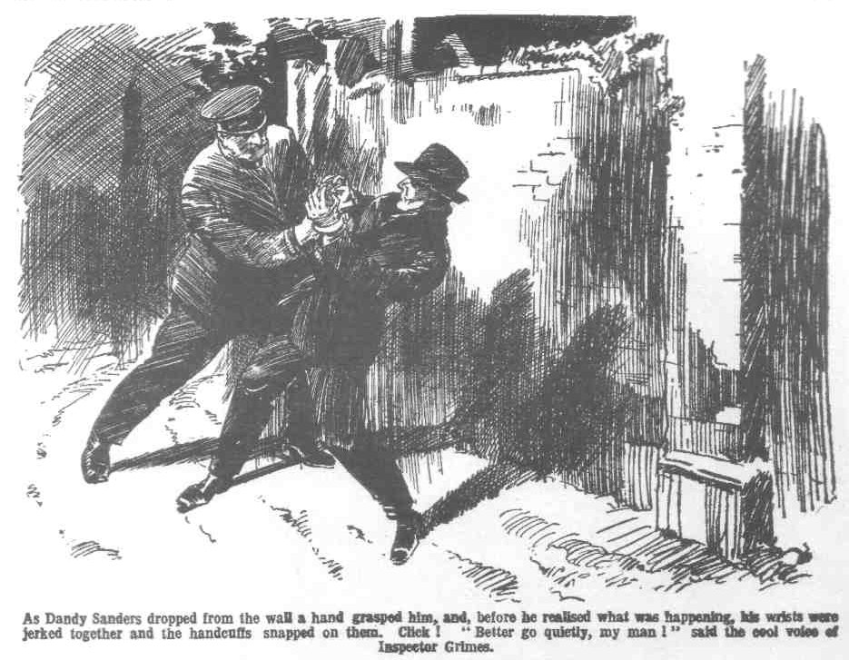
Dandy Sanders was a keen and wary crook; but he was taken utterly by surprise. As he dropped from the wall a hand was on him, and before he realised what was happening, his wrists were jerked together, and the handcuffs snapped on them. A yell of rage broke from the crook, and he spun round with blazing eyes on a dim, portly form.
“Better go quietly, my man!” said the cool voice of Inspector Grimes, of Courtfield.
And, with the steel handcuffs locked on his wrists, Dandy Sanders—having no choice in the matter—went quietly!
THE FIFTEENTH CHAPTER.
Great News!
BILLY BUNTER did not open his eyes when the rising-bell clanged out in the summer morning.
Bunter was sleepy.
He slept till the rising-bell ceased to clang, and he might have gone on sleeping till the bolt for prayer, had not Bob Cherry kindly taken the trouble to wake him up.
A wet sponge squeezed on his fat face woke Bunter up quite suddenly, and be yelIed:
“Ow! Wow! Beast!”
He sat up in bed and blinked.
“I say, you fellows, I’m not getting up yet! I say, Wharton, you tell Quelch I’m ill, will you, and I’ll be down after prayers! I’m frightfully sleepy!”
“Shall I tell him you went out last night after Coker’s cake?” inquired Wharton.
“Ha, ha, ha!”
“Beast!”
Billy Bunter rolled out of bed and rubbed his sleepy eyes. Coker’s cake, no doubt, had been worth it, but Bunter had lost a lot of sleep, and he had had a very fatiguing climb to get back into the House. Bunter could have done with a few more hours in bed. But there was no more bed for Bunter, and he yawned and grunted, and dressed himself, cuttings down his ablutions that morning even beyond the usual minimum.
After prayers that morning Coker of the Fifth strolled round by the Cloisters. Billy Bunter, spotting him from the distance, grinned
Coker was welcome to keep an eye on the Cloisters as long as he liked, so far as the fat Owl was concerned. Billy Bunter had no business in that quarter. His business there had been done overnight.
In morning break Coker was there again. He was rather surprised that Billy Bunter did not show up in the offing. But as Bunter did not show up Coker proceeded to look for him.
In break, Billy Bunter was taking a nap on a bench under the old elms. Coker of the Fifth found him there. For the second time that morning Billy Bunter was awakened with startling suddenness. This time it was not a wet sponge; it was a finger and thumb fastening like a vice on his fat ear that awakened Bunter.
“Yow-ow-ow!” roared Bunter.
“Now then, you fat scoundrel—”
“Yaroooh! Leggo! I say, you fellows--- Whooop!”
“Where’s that cake?”
“Beast! Help! I say, you fellows, rescue!” callcd Bunteir.
“Where’s that cake?” roared Coker.
“I say, you fellows—”
Harry Wharton & Co. came up. Coker gave them a glare.
“You fags sheer off!” he said. “Now, Bunter, you fat scoundrel---”
“1 say, you fellows, make him leggo!” wailed Bunter. “I never had his cake! I haven’t had a cake at all! I haven’t had your cake at all, you beast! I never put put it in the Cloisters. Besides it’s there now, if you like to look for it. I never got out of the dorm last night to fetch it. The fellows can tell you so—they saw me go— Yaroooh!”
“Ha, ha, ha!”
“My hat!” gasped Coker. “So you’ve scoffed that cake after all---”
“No!” yelled Bunter. “I keep on telling you I don’t know anything about your measly cake! Leggo my ear! Whoop!” Bunter roared. “I say, you fellows, I never touched his cake, as you know! And I should never have touched it if the beast hadn’t made me carry it for him—making out that he could fag a Remove man, you know! I say, you fel1ows—”
“Gentlemen, chaps and sportsmen!” said Bob Cherry. “That fat villain baggd Coker’s cake, but Coker asked for it. Coker can’t fag the Remove. You can consider that cake has been confiscated, Coker, for your cheek in fagging Remove men! Now chuck it!”
Instead of chucking it, Cokcr of the fifth jerked Bunter off the bench, by his fat ear and slewed him round. Billy Bunter yelled with horrid apprehension. He had felt the weight of Coker’s foot before, and he knew what it was like.
But Coker was not allowed a free kick! Fivc pairs of hands were laid on him at the same moment and Horace Coker smote the quadrangle with a heavy bump. He roared as he bumped.
Billy Bunter vanished into space as Coker scrambled up. But Coker forgot
Bunter. He hurled himself at the Famous Five, with the fell intention of strewing those cheeky juniors, in a wrecked and havocked state, all over the quad.
Instead of which, Coker, to his surprise, found himself strewn there, struggling to get his second it wind, when Harry Wharton & Co. strolled away and left him to it.
* * * * *
Later that day there was news at Greyfriars—startling news!
The whole school buzzed with it.
The lost loot had been found!
It appeared that the loot had, after all, been hidden somewhere in the school, for it had been found on a man whom Inspector Grimes had arrested as he was climbing out of the Cloisters after midnight.
Taken to the station that man had been identified as a solicitor with rather shady reputation, by name Sanders; and six thousand nine hundred and fifty pound in banknotes had been found in his pocket—identified as the stolen notes from the Courtfield and County Bank!
It was a great triumph for Inspector Grimes, and a great satisfaction to that official gentleman.
It was a great satisfaction to Creyfriars also; for, as Carne of the Sixth
pointed out rather emphatically—it proved that the loot had never been in the hands of any Greyfriars man!
Howsoever that might be, the mystery of the lost loot was a mystery no longer and all the Greyfriars fellows were glad to hear the end of it.
THE END.

