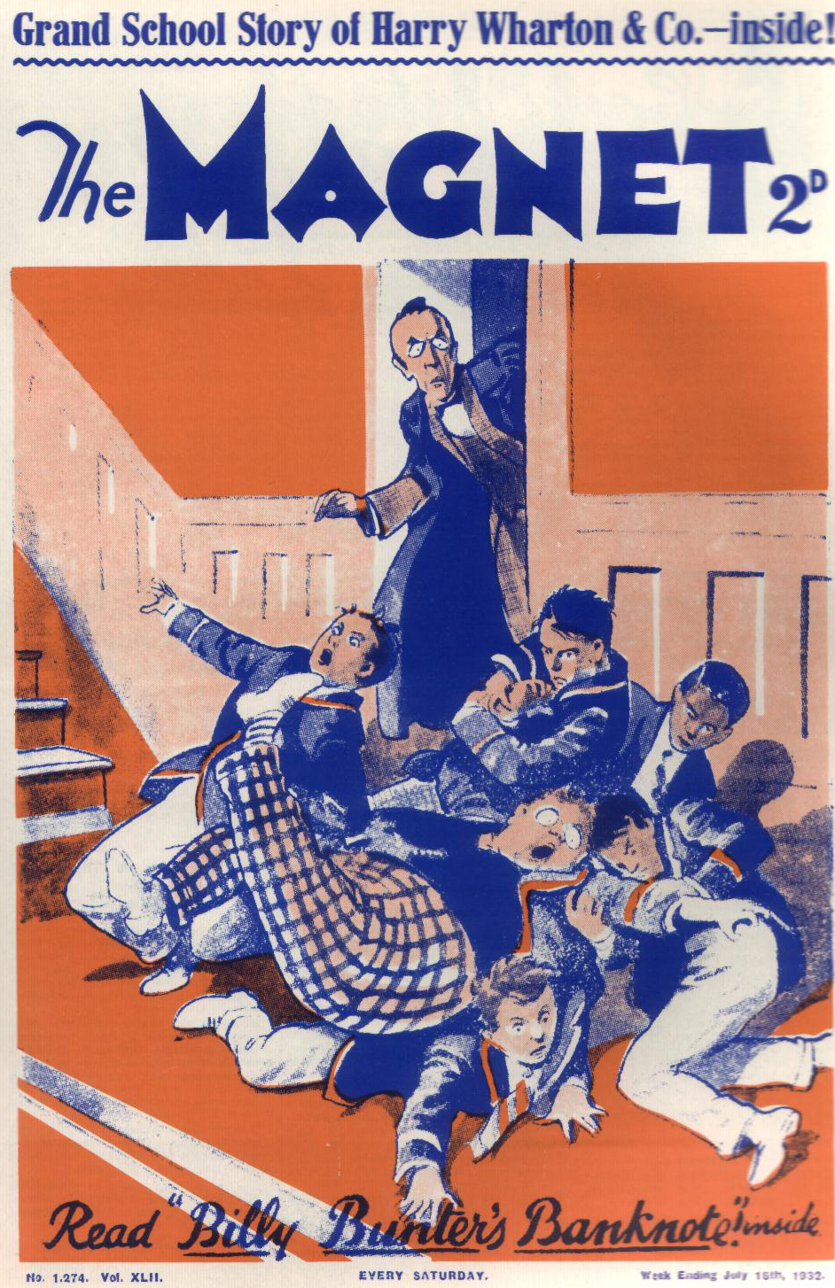

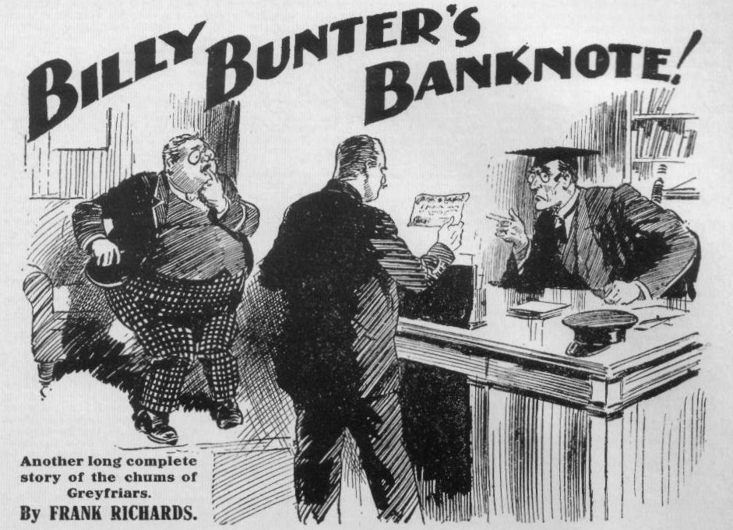
THE FIRST CHAPTER.
Mysterious!
“Too late!” chuckled Bob Cherry.
“What?”
“We’ve finished the cake!”
There was a chortle in Study No. 1 in the Greyfriars Remove.
Five juniors were seated round, or on, the table in that celebrated study. In the middle of the table was a cardboard box which had contained a cake. Now it contained only wrapping paper and a few crumbs. For which reason the Famous Five chortled as Billy Bunter rolled into the doorway and blinked into the study through his big spectacles.
“The too-latefulness is terrific, my esteemed fat Bunter!” grinned Hurree Jamset Ram Singh.
Billy Bunter sniffed.
“You might have told a fellow you had a cake!” he said. “You might have let a fellow have a mouthful!”
Harry Wharton shook his head.
“Couldn’t be done!” he answered.
“Why not?” demanded Bunter warmly.
“It was only a three-pound cake!” explained the captain of the Remove. “It wouldn’t have made a mouthful for you, old fat bean!”
“Ha, ha, ha!”
Snort! from Bunter.
It was true that Billy Bunter’s mouth was capacious. But even Bunter could not have taken in three-pound cake at one mouthful. That was an exaggeration.
“Oh, really, Wharton, I never knew you had a cake, or I’d have come up sooner—I mean, I don’t want any of your measly cake! Look here, I came here to speak to you and Nugent!”
“Fire away!”
“I didn’t know these fellows were here.” Bunter blinked at Bob Cherry, Johnny Bull, and Hurree Jamset Ram Singh. “They’d better clear off! What I’ve got to say is rather private!”
“Fathead!” answered Wharton politely.
“Hallo, hallo, hallo!” yawned Bob Cherry. “What’s the jolly old secret?”
“That’s telling!” said Bunter. “I say, you fellows, clear off, will you? Don’t be inquisitive, you know! If there’s anything I can’t stand, it’s inquisitiveness!”
“Oh, my hat!” ejaculated Bob.
“You silly owl!” exclaimed Harry Wharton. “If you’ve got anything to say, say it and go—or, better still, don’t say it and go!”
“Well, if you want these fellows to hear, it’s your look-out!” said Bunter. “I’m willing to keep it dark! I never was a man to give a pal away, as you know.”
“Mysteriouser and mysteriouser!” grinned Bob Cherry. “What have you two fellows been up to?”
“I suppose the fat duffer’s wandering in his mind,” said Wharton, staring at the mysterious Owl. Would you mind wandering in the passage Bunter ?”
“Yah!”
Bunter did not wander into the passage. He shut the study door carefully, apparently to keep extraneous ears from hearing what was said in Study No. 1. The chums of the Remove watched him in growing wonder.
“Now!” said Bunter, turning his big spectacles on the Famous Five again. “Mind, it’s your own fault, Wharton, if these fellows hear about it!”
“About what, you benighted ass?”
“Of course, you don’t know!” said Bunter, his fat lip curling sarcastically.
“Haven’t the foggiest!”
“Well, I’ll jolly well tell you, then! In the first place, I dare say you remember my mentioning that I was expecting a postal order?”
“Wha-a-t!”
“A postal order from one of my titled relations, you know.”
Harry Wharton stared blankly at the fat Owl of the Remove. Certainly he was aware that Billy Bunter was expecting a postal order. All Greyfriars was aware of that. Billy Bunter was in a perpetual state of expecting a Postal order.
“You frabjous ass!” ejaculated Wharton. “Is that what you’ve got to say?”
“We’ve heard that one!” remarked Bob Cherry.
“Ha, ha, ha!”
“Well, it hasn’t come said Bunter, blinking at the captain of the Remove. “We’ve heard that one, too!” said Bob.
Ha, ha, ha!”
“I’ve been disappointed about that postal order.” went on Bunter. “It’s left me in rather an awkward position. I’m stony!”
“For the first time in your life?” asked Bob Cherry sympathetically.
“I wish you wouldn’t keep on interrupting a fellow! What I mean, Wharton, I want you to lend me the pound till the postal order comes !” explained Bunter. “Or Nugent—I don’t mind which.”
“Bunter’s an accommodating fellow!” said Bob Cherry gravely. “He doesn’t mind which of you fellows lends him a pound. Don’t both speak at once!”
“Ha, ha, ha!”
“A pound isn’t much, considering what you’ve got!” said Bunter.
“What we’ve got!” repeated Frank Nugent.
“Yes. When fellows are stacked with money— ”
“I’m stacked with ninepence at the present moment!” said Nugent, laughing. “What on earth is the benighted ass driving at?”
“And I’ve a shilling,” said Harry Wharton, “and I’m keeping it! Ask next door, Bunter!”
“It’s only a temporary loan, of course.” said Bunter. “I shall hand you the postal order immediately it comes; otherwise, of course, I should not care to touch the money, considering how you got it.”
“How we got it!” repeated Wharton blankly.
“Yes. No need to go into details, said Bunter. “It’s not the sort of thing I care to discuss. In fact, I’d rather know nothing about it. You may be copped—”
“Copped?” yelled Nugent.
“Well, I shouldn’t wonder! I fancy old Inspector Grimes, at Courtfield, has got his eye on you!” said Bunter, shaking his head.
“Mad!” said Johnny Bull.
“The madfulness is terrific!” said Hurree Singh, staring in wonder at the Owl of the Remove.
“One good turn deserves another, you know.” said Bunter. “Some fellows, knowing what I do, would stick you for a whack in it.”
“In what?” shrieked Wharton.
“I’m not that sort, I hope! That kind of thing would be beneath me! Still as I said, one good turn deserves another! You can lend a fellow a pound out of thousands—”
“Thousands!” gurgled Nugent.
“Thousands!” gasped Wharton.
“Yes. What about it?” asked Bunter. “Mind, I’m not going to give you away. Whether you lend me the pound or not, I shall keep it dark. I’m not the man to sneak, though I must say, of course, that I despise you!” Billy Bunter shook his head again seriously. “It’s rather thick, you know—awfully thick! But you can rely on me not to say anything. I’m not going to get you run in!”
“Run in!” gasped Wharton.
“Think of the disgrace to the school, and all that!” said Bunter. “Well, what about that pound? You can spare a pound out of thousands, and I shall let you have it back to-morrow when my postal order comes.”
“Have you men been holding up a bank, or what?” inquired Bob Cherry.
Harry Wharton slipped from the corner of the table. Billy Bunter, apparently, had the belief fixed in his fat and fatuous mind that the chums of Study No. 1 were in possession of a huge sum of money from a questionable source. It was amazing, and it was also displeasing. There was a grim expression on the face of the captain of the Remove.
“I don’t know what you’re driving at, you benighted bandersnatch!” said Harry. “But that isn’t the sort of funny story we want to hear in this study! Now, then—”
“Here, you keep off, you beast!” exclaimed Billy Bunter, in alarm. “I say, you leggo my collar! Yarooooh!”
“Oh crumbs! Whoooooop! Bang!
A loud concussion rang through Study No. 1 as Billy Bunter’s bullet head smote the door. Louder still rang the yell of Billy Bunter, awakening every echo in the Remove passage.
— — —
THE SECOND CHAPTER.
Bunter Begs for It!
“YAROOOH!”
The voice of Billy Bunter, like that of the turtle of old, was heard in the land. It was heard on its top note.
“Now, you fat chump—”
“Yow-ow-ow!”
The fat junior jerked his collar free and jumped away. He stood rubbing his damaged head and glaring at the captain of the Remove with a glare that almost cracked his spectacles. He spluttered with wrath.
“Ow! Beast! Banging a fellow’s head when a fellow’s keeping your shady secrets out of pure friendship! Here, you keep off !“ yelled Bunter, dodging round the table as the captain of the Remove made a stride towards him. “1 say, you fellows, keep that beast off! I—I say, old chap, don’t be waxy, you know. I’m not going to tell anybody you’ve got a lot of stolen money hidden in this study. Honest Injun!”
“Why, you—you—you——” gasped Wharton.
“I’m keeping it dark, old chap!” spluttered Bunter. “Rely on me I I’m not giving you away to the peelers. I— I—I wouldn’t!”
“My only hat!” ejaculated Bob Cherry. “This is getting jolly interesting. If you men have got thousands parked in this study it will run to sausages for supper.”
“Ha, ha, ha!”
But Harry Wharton did not join in the laugh. His eyes fixed on Billy Bunter with an expression that was quite alarming to the fat Owl.
“What do you mean, you fat chump?” roared Wharton. “If you’re not off your idiotic rocker, what do you mean?”
“Oh, really, Wharton
“Hand me that cricket stump, Bob!”
“Keep off, you beast!” howled Bunter, dodging round the table again. “You whop mc with that stump and I’ll give you away! What are you getting your rag out for, you beast, when a chap drops in for a friendly chat?”
“Ha, ha, ha!” yelled the Co.
Apparently Bunter did not consider that an accusation of possessing stolen cash was a reason for a fellow getting his “rag “ out.
“You—you puffing porpoise!” gasped Wharton. “Tell me what you’re driving at, if you’re driving at anything, before I break this cricket stump on you!”
“You keep off!” said Bunter, eyeing him warily across the table. “You jolly well know what I mean, Wharton, and I must say I think you might be grateful to a chap for keeping it dark. Why, if it came out they’d turf you out of Greyfriars and send you to Borstal. Nugent, too! Sticking to seven thousand pounds—”
“ Seven thousand pounds!” repeated Wharton.
“I think you might lend a fellow a pound, when he’s been disappointed about a postal order, out of that.” said Bunter warmly. “It would leave you six thousand, nine hundred and ninety-nine—unless you’ve blowed some of it already! Not that I’d touch it myself, you know! But a temporary loan— merely temporary—”
“ Seven thousand pounds!” said Johnny Bull. “That’s the amount of the loot that was taken from the Courtfield and County Bank by the hold-up man, and never recovered. Is that what the potty pilferer means?”
It was clear now what the fat Owl was “driving” at. The mention of that precise sum was enlightening.
“Does the blithering idiot think we’ve got it in this study?” asked Frank Nugent blankly.
“Oh, really, Nugent! You jolly well know you have!”
“Oh crikey!”
“Think I don’t know all about it?” demanded Bunter. “Everybody knows that that hold-up man they call Jerry the Rat dodged into the school when he was getting away from the police and hid the money in this study chimney. Inspector Grimes came to search for it, as you jolly well know, and it was gone. Well, who had it?”
“Who had it?” repeated Wharton.
“They’ve got that hold-up man in chokey now,” went on Bunter. “ But he got word somehow to his friends, and they’ve been butting in, searching for the loot. They never got it.”
“And you think we’ve got it? shrieked Wharton.
Sniff from Bunter.
“I don’t think—I jolly well know!” he answered defiantly. “Who else could have bagged it except a fellow in the study? I can jolly well tell you that old Grimes will have his eye on you.”
“Oh, my hat!”
“Not that I’d give you away!” said Bunter generously. “I don’t want to see a pal sent to Borstal—”
“Ha, ha, ha!”
“ But one good turn deserves another —that’s what I mean. I don’t want to know where you’re keeping the loot. I’d rather know nothing at all about it, in fact. I’m rather more particular than some chaps. Still, I’ve been disappointed about a postal order, and I think you might lend a fellow a pound. There’s such a thing as gratitude.”
Wharton stared at the fat Owl.
What had become of the “lost loot” was a mystery at Greyfriars. It was known that the fleeing bank raider had concealed it in the chimney of Study No. 1 It was certain that his confederates knew it, and two of them had been arrested while searching for it, though the leader of the gang was still at large. It was known that the crooks had not got hold of it, and that the police had not recovered it. It had vanished from its hiding-place, and what had become of it was a mystery.
Inspector Grimes, of Courtfield, hardly made a secret of his belief that some Greyfriars fellow could have told him, had he liked, where to lay hands on it. That belief was shared by many at Greyfriars, for, really, there seemed nothing else to think. Billy Bunter, evidently, had been exercising his fat brain on the subject, and this was the result.
“You—you—you—” Wharton fairly stuttered.
“I suppose you’re not going to deny it?” said Bunter. “Tell the truth, old chap. You can trust me. Nobody but a fellow in this study could have found it hidden here. That stands to reason.”
“Do you think we ever went rooting up the chimney, you blithering owl?” yelled Nugent.
“Well, somebody did!” said Bunter. “The loot wouldn’t have been found if somebody hadn’t looked in the chimney for it. It must have been a fellow in the study. One of you two—or both. And when a fellow’s got seven thousand pounds in a lump
“You—you fat villain !“ roared Wharton. “Do you think we should keep stolen money if we found it?”
“Well, I shouldn’t have thought so” admitted Bunter. “You’re not so particular in such matters as I am. Still, I shouldn’t have thought that of you— if you hadn’t done it. But you have, you know!”
Evidently the fat Owl had thought it out to his own satisfaction,
Indeed, so far as Bunter could see, it stood to reason. It was fairly clear that some Greyfriars man had bagged the loot and kept it. Who could have done it except a fellow who used the study?
That fellows like Wharton and Nugent were incapable of touching anything that did not belong to them was a trifle that the fat Owl did not stop to consider. Every Greyfriars man was—or ought to have been—above suspicion. Yet some Greyfriars man must have yielded to the temptation of that huge sum of money.
Perhaps Bunter did not feel quite certain that, had he found the lost loot, he would have restored it instantly to the owner. And Bunter was aware that he was the most highminded and high- principled chap at Greyfriars. Nobody else was aware of it; but Bunter was.
“You’ve got it !“ said Bunter, while Wharton stared at him, at a loss for words. “You’ve got it all right! My advice to you is to take it back to the bank. Still, 1 think you might lend a fellow a pound —only till to-morrow!”
“My esteemed idiotic Bunter——”
“Don’t you jaw, Inky! You fellows had better keep this dark.” said Bunter, blinking at the Co. “Wharton would have it out before you, though I told him I wanted to speak to him in private. You heard me. If these fellow’s tattle it all up and down the Remove, Wharton, you’ve only got yourself to thank.”
“Ye gods!” murmured Bob Cherry.
“Making out you never had it!” said Bunter indignantly. “who else could have got hold of it, I’d like to know? Nobody else could come rooting about this study without you fellows knowing.”
“You silly owl!” said Bob Cherry. “Any fellow could. And I know one fat scoundrel who roots into any study where he thinks there’s any tuck.”
“Oh, really, Cherry—”
“Why, I remember, a week or two ago I came here to speak to Wharton and found Carne of the Sixth rooting about this study.” said Bob. “Any fellow could butt into the study when the chaps are out.”
“If you’re in this with Wharton, Cherry—”
“What?” yelled Bob.
“Don’t bellow at a chap!” said Bunter irritably. “You make a fellow jump. If you’re in this with Wharton and Nugent—”
“Why, you—you—you— I—I——” articulated Bob.
“I dare say you’re all in it, come to that!” said the fat Owl. “ Well, I can jolly well tell you, you’re a pretty rotten lot! Not Greyfriars style! Look here, Wharton, what about that pound? I’ve told you that it’s merely temporary— my postal order will be here first thing in the morning! If it happened to be delayed a little longer that wouldn’t hurt you—you’ve got plenty of money! He, he, he ! Now, what about it?”
Billy Bunter blinked inquiringly at the captain of the Remove.
“Are you handing out that pound?” he demanded.
“No,” gasped Wharton, “I’m not handing out a pound!” But I’m handing out something.”
“I think you might make it a pound, considering that you’ve got thousands. Look here, what are you handing out ?”
“Six with a stump!”
“Why, you beast—”
“Collar him!” shouted Nugent, as the fat Owl made a jump for the door.
“Ow! Leggo!” Many hands fell on William George Bunter, and he was hooked back. “Leggo! Beasts! I say, you fellows, I’ll make it ten bob! There!”
“Put him across the table!” said Wharton.
Bump!
Billy Bunter was plumped on the table, squashing the cardboard box that had contained the cake. Wharton flourished the cricket stump, and the fat Owl yelled in anticpation.
“Ow! Keep off! I say, old chap, what about five bob? I say—”
“Yaroooh!”
Swipe!
“Whooooo!”
Swipe! Swipe!
“Oh crikey! Oh crumbs! Help! Murder! Fire!” roared Bunter.
Swipe! Swipe!
The cricket stump fairly rang on Billy Bunter’s tight trousers. The captain of the Remove had plenty of beef, and he was putting all his beef into the swiping.
“Oh lor’! Oh scissors! Leave off!” yelled Bunter. “I say, you fellows leggo! I’ll jolly well go and tell Quelch you’ve got the loot ! I’ll jolly well go to the Head and say—Yarooooooooop!”
Swipe!
“That’s six!” said Wharton. “Now kick him out!”
“Yow-ow-ow-ow!”
Nugent opened the door. Billy Bunter was rolled off the table. He was whirled to the doorway. Five boots were planted on him, and he flew into the Remove passage. Ho roared as he landed. He continued to roar after the study door was slammed on him. Billy Bunter had not got what he wanted in Study No. 1, and though he had got what he deserved, that was no comfort to him whatever.
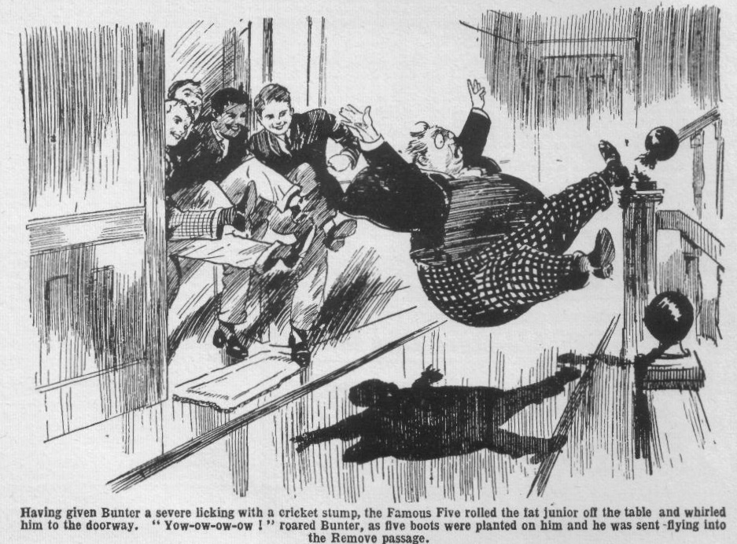
—
THE THIRD CHAPTER.
Beastly for Bunter!
“BUNTER
Wingate of the Sixth, standing in the doorway of the the prefects’ room, called to Billy as that fat youth appeared in the offing. Billy Bunter came unwillingly to a halt.
What the Greyfriars captain wanted Bunter did not know, but he could guess that Wingate wanted him to do something. On a hot July day Billy Bunter objected to doing anything. Although the Remove did not fag, almost any other Remove man would have been glad to fetch and carry for the popular captain of the school. Billy Bunter was not willing—he objected to exertion, on principle.
“I—I say, Wingate, I—I’ve got to go to Quelch!” said Bunter, in a great hurry. “He’s waiting for me.”
“Quelch is waiting for you!” ejaculated Wingate.
“Yes, waiting in his study——”
“Quelch went out half an hour ago, you young sweep!”
“Oh!” ejaculated Bunter. “D-d-did he? I—I mean the Head
“Y-you mean the Head?” stuttered Wingate.
“Yes, I have to see the Head, Wingate. He—he’s waiting for me in his study. C-c-can I go?” asked Bunter, blinking uneasily at the Sixth-Former. He had an impression from Wingate’s look that the Greyfriars captain did not believe him. “The—the Head doesn’t like to be kept waiting, Wingate.”
“I’ve left my ashplant in my study.” said Wingate regretfully. “If I had it here I’d give you six for lying, Bunter.”
“Oh!” gasped Bunter. He was glad that Wingate had left his ashplant in his study.
“Take fifty lines!” said Wingate. “Bring them to me after tea! Now cut off to Carne’s study, and tell him that a man is asking for him on the phone, and hanging on the line. Sharp’s the word!”
Billy Bunter rolled into the Sixth Form passage. It was not a heavy task that was required of him, after all— likely not to occupy more than two or three minutes of his valuable time.
“Beast!” murmured Bunter, as he went.
He arrived at the study belonging to Arthur Carne of the Sixth, knocked at the door, and opened it.
“I say, Carne—” he began.
At that point he discovered that the study was vacant. He blinked round the room through his big spectacles. Carne of the Sixth was not there.
“Beast!” murmured Bunter again.
Wingate, evidently, had supposed that the prefect was in his study. As somebody was “ hanging on”‘ the telephone in the prefects’ room, and as Carne was not there, it was obviously up to Bunter to go back and tell Wingate so. That, Bunter knew, was what he ought to have done. But between what Billy Bunter ought to have done and what he generally did, there was a great gulf fixed.
If he went back and told Wingate, the beast was fairly certain to tell him to look for Carne and find him. The man on the phone could not hang on for ever. But Billy Bunter had no desire whatever to go hunting Carne up and down the house on a hot afternoon. As for the man on the phone, Bunter did not care how long he hung on.
He rolled into Carne’s study.
“I’d better wait, I think.” murmured Bunter. “Most likely he won’t be a minute or two.”
He sat down in Carne’s armchair to wait. It was a deep and comfortable armchair—just what Bunter wanted, in fact. Sitting in that comfortable armchair, waiting for Carne, was ever so much better than rooting about the House looking for the fellow. Billy Bunter settled down with a sigh of relief.
Bunter had left the door open. Two or three minutes later there was a sound of voices as two Sixth Form men stopped outside the study.
“It’s a jolly queer business!” That was the voice of Gerald Loder. “It’s as plain as daylight that some Greyfriars man snaffled it.
“Rot!” growled Came.
“I’m jolly certain that old Grimes thinks so.”
“Grimes is a fool!”
Billy Bunter grinned. The two seniors were speaking of the topic that was rife in all the studies at Greyfriars—the mysterious disappearance of the hidden loot. That topic was not likely to die until the loot was found—if ever it was found.
“Well, he may be a fool.” said Loder, “but I fancy he’s rather keen. If the fellow who’s snaffled the loot was friend of mine I should jolly well advise him to cough it up—and cough it up quick.”
There was a peculiar significance in Loder’s tone, which struck Billy Bunter. He sat up and took notice. As the back of the armchair was towards the door, and as Bunter’s bullet head did not reach the top, the seniors in the doorway did not see him.
“I’m fed-up with the subject, Loder.” There was a husky tone in Carne’s voice. “Chuck it, for goodness’ sake! Look here, I’ve got some work to do.”
He came into the study and closed the door—almost on Loder’s nose. As he crossed the room he came into Bunter’s line of vision—and the fat junior blinked curiously at the lined, harassed expression on the Sixth-Former’s face. He rose from the armchair.
“I say, Carne
Carne spun round towards him with a cry. As he had not known that anyone was in the study he was naturally startled a little. But that did not account for the mingled alarm and rage in his face. He panted as he stared at the fat Owl.
“You young rotter! What are you spying in my study for?” he shouted.
“Oh, really, Carne! I came here to— Oh crikey!” gasped Bunter, as Carne grasped the ashplant from his table and made a stride at him.
Billy Bunter made a wild bound for the door. The look on Carne’s face was quite alarming; the whistling ash plant more alarming still. Bunter reached the door just as the ashplant reached him.
Whack!
“Whoooop!” roared Bunter.
He had a message for Carne, but he was not thinking of delivering messages now. He tore the door open and bounded into the passage.
Swish! The ashplant just niised him as he bounded. Bunter gave a yelp of terror and careered down the passage. Carne of the Sixth rushed after him.
Crash!
“Oh, my hat!” roared Wingate, as he met Billy Bunter in full career.
Wingate was coming up the passage as Bunter rushed down it. It was a terrific collision.
Wingate staggered against the wall, gasping. Billy Bunter sat down on the floor, roaring.
“Ow! Oooogh! Ow! Wow! Whoop!”
“You mad young ass!” panted Wingate. “What the thump—I sent you to tell Carne— What on earth’s the matter, Carne?” He stared at Carne of the Sixth. “What the thump arc you chasing that kid for?”
Carne checked himself.
“The young scoundrel was prying in my study!” he panted. “I—”
“Ow! I wasn’t!” yelled Bunter. “Ow! Keep him off! Wow!”
“I sent him to your study, Carne!” said Wingate gruffly.
“Oh!” ejaculated Carne. “I—I didn’t know.”
“You might have asked before you pitched into the kid You can cut, Bunter!”
Billy Bunter scrambled up, dodged round Wingate, and departed in haste. He was only too glad to cut. Wingate gave the bully of the Sixth a rather grim look. Carne, with the ashplant in his hand, stood breathing quickly, his face flushed.
“There’s a man wants you on the phone in the prefects’ room!” snapped Wingate. “I sent that kid to tell you, and, as you didn’t come, I was coming to tell you myself. You’d better go and take the call, if you want it.”
“Oh!” gasped Carne
Wingate stalked away, very much ruffled. A charge with Billy Bunter’s weight behind it was not a light matter, and the Greyfriars captain gasped as he went. Carne stared after him for a moment or two, and then he tossed the ashplant into his study and walked away to the prefects’ room.
THE FOURTH CHAPTER.
Unexpected!
GOSLING, the porter, stared curiously at Carne of tho Sixth as he went out of the gates about ten minutes later. Several fellows in the quadrangle had glanced at him, and Price of the Fifth had winked at Hilton of that Form and shrugged his shoulders. Monsieur Charpentier, the French master, had passed him, and given him a long, long look, and turned his head to look again. Carne seemed unconscious of it. Probably he did not know that he looked— as Price of the Fifth expressed it—like a fellow who was going to be hanged.
Harry Wharton & Co., who were adorning the ancient gateway, glanced at him as he passed them and stared after him. He did not even see them. He tramped down Friardale Lane and disappeared from tho sight of the Famous Five.
“ Gentlemen, chaps, and fellows,” said Bob Cherry, “ whose geegee do you think has come in eleventh?”
And the juniors chuckled.
There were rumours about Carne in the Lower School; he would have been surprised to learn how many fellows knew that he backed horses on the strict q.t.—a q.t. that was not so strict as he believed. Carne had never been a good-tempered fellow, and he was a good deal of a bully. But of late his temper had been very raw, and his fag, Gatty of the Second, hardly dared to go to his study. Plenty of fellows knew that there was something amiss with Carne of the Sixth, and plenty of fellows fancied that they could guess what it was. But none was likely to guess how deep were the waters in which the hapless sportsman of the Sixth was now submerged.
His pals, Loder and Walker, had given him the tip to pull himself togetheir before the beaks noticed something. It was good advice, and Carne meant to act upon it, but he could not. He was a bundle of nerves now. Fear haunted him by day, and terror was his bedfellow. Sometimes he felt that, like Cain of old, his burden was greater than he could bear. If his looks betrayed him he could not help it.
He went down the leafy lane with quick, jerky steps, his eyes on the ground, unseeing. He had not noticed the Greyfriars fellows who stared at him, and he did not notice a man in gaiters, with a stubbly bearded face, who was loafing in the lane, and who stared at him very hard indeed as he passed. He tramped on past the man, who detached himself from the tree against which he had been lounging and followed him at a short distance.
Carne reached the stile that gave on the footpath through Friardale Wood, swung himself over it, and tramped up the footpath. The man in gaiters arrived in his turn at the stile and stood there, leaning on it, watching the Greyfriars senior till the wood swallowed him from sight. Then he gave a low whistle and hurried away up the lane. Evidently he was deeply interested in Carne, though the Greyfriars man was quite unconscious of it, and, indeed, of his existence.
Some distance up the footpath Carne turned into the wood and trampled his way through hawthorns and bracken, stopping at last at a tall, ancient oak in the heart of the wood. Under the wide-spreading branches of the oak he sighted a stocky figure and a greasy face. Any Greyfriars fellow who had seen that greasy face would have known why Carne of the Sixth was meeting the man at a safe distance from the school. Mr. Joseph Banks, the disreputable bookmaker, was a well-known character.
Carne came to a halt.
“Well, I’m here!” he muttered. “I— I came at once! You must have been mad to ring mc up at the school! Mad, I say! Wingate took the call, and if he had suspected—”
“I never mentioned no names,” said Mr. Banks surlily, “ and I had to see you, Mr. Carne! I been waiting about for a chance to speak to you, but I ain’t seen you. I s’pose you didn’t want me to write to the school, and p’r’aps your ‘eadmaster open the blooming letter?”
Carne shuddered.
“No, no! But what do you want? I’ve paid you—you know I’ve paid you! I sent you the banknote in a letter, as I said I would! What do you want?”
Joe Banks eyed him grimly.
“ Last time I see you, sir, you told me you was getting a fifty-pound note as a birthday present from your people’ he said. “I didn half believe it, neither; but, sure enough, the next day the note came. I got it now.”
“WelI, then——” muttered Carne.
“ I was to see you and give you the change—twenty pun change,” said Mr. Banks. “You don’t seem to ‘ave wanted it.”
“Never mind that!” muttered Carne.
Mr. Banks’ look grew grimmer.
“I got the banknote,” hh said. “I ain’t changed it, 1 want to know more about that fifty-pun note before I change it, Mr. Carne. I ain’t keen to have the darbies on my ‘ands, if you are!”
Carne reeled against a tree. His face was like chalk.
“What—what—what do you mean?” he faltered.
“I’ll tell you what I mean,” said Mr. Banks in a low, distinct voice. “ I want to know where you got that banknote!”
Carne did not answer.
Every vestige of colour was drained from his face, and he looked almost wildly at the racing man. It seemed to him for the moment that he was going to faint.
Where had he got the banknote? At Greyfriars they were wondering who had found the bag of loot hidden in Study No. 1—the green-leather satchel that contained twenty fifty-pound notes and sixty hundred-pound notes. Least of all was a Sixth Form man, a prefect, likely to be suspected, though it haunted Carne’s mind that Bob Cherry of the Remove had come on him rooting about that study, and had asked him what the dickens he was up to there—certainly without guessing. He wondered dizzily whether Joe Banks guessed. In his mind’s eye, he saw himself shrinking under the grasp of a constable, and his brain reeled.
Mr. Banks watched him grimly. If he had doubted before, he was certain now that Carne never had received that banknote as a birthday gift from home. The racing man fumbled in his pocket.
“You ain’t telling me, Mr. Carne.” he said. “ Well, I reckon I know without you telling me! You found that banknote, you did, and you found it in a master’s desk—what?’
Carne panted. The man, after all, did not guess. He knew that the fifty-pound note had never belonged to Carne, but that was all he knew.
“Off your onion, I s’pose!” went on Banks. “It ain’t sense, Mr. Carne!” Banknotes are numbered; the coppers get after banknotes! Soon as it’s missed, what’s going to ‘appen to you— and to me?”
Carne could not speak. Mr. Banks fumbled with a greasy pocketbook, and drew out a crumpled banknote. Possibly Mr. Banks was rogue enough to receive a stolen note, but he was not fool enough.
“Ever since I got this by the post.” he said, “I’ve been looking for a chance to speak to you. I knowed that if it was square you would want the change on the nail. But you’ve kept away—”
“I—I—” stammered Carne.
His voice trailed away. Obviously a fellow who had paid a debt of thirty pounds with a fifty-pound note would want change. But Carne had not wanted it. He shuddered at the thought of touching it. In sheer desperation the wretched sportsman had taken the banknote from the satchel, hidden under the floor in his study, to satisfy Mr. Banks. But to keep any of the money was impossible to him. Somehow, so long as he did not keep any of it, the thing seemed less like what it was
He leaned, trembling, on the oak tree. It did not occur to him that Joseph Banks, too, was alarmed. The rascal’s threats had driven the hapless sportsman of the Sixth to that desperate act; but Joe Banks assuredly had not foreseen anything of this kind. Only his suspicious doubt had saved him from the danger of arrest as a receiver of stolen money. Joe Banks realised very clearly that ho had driven his dupe too hard.
“Ere you are, Mr. Carne,” he said, “you take this ‘ere banknote, and you put it back where you got it, afore it’s missed—if it ain’t been missed yet. Put it back, anyway!”
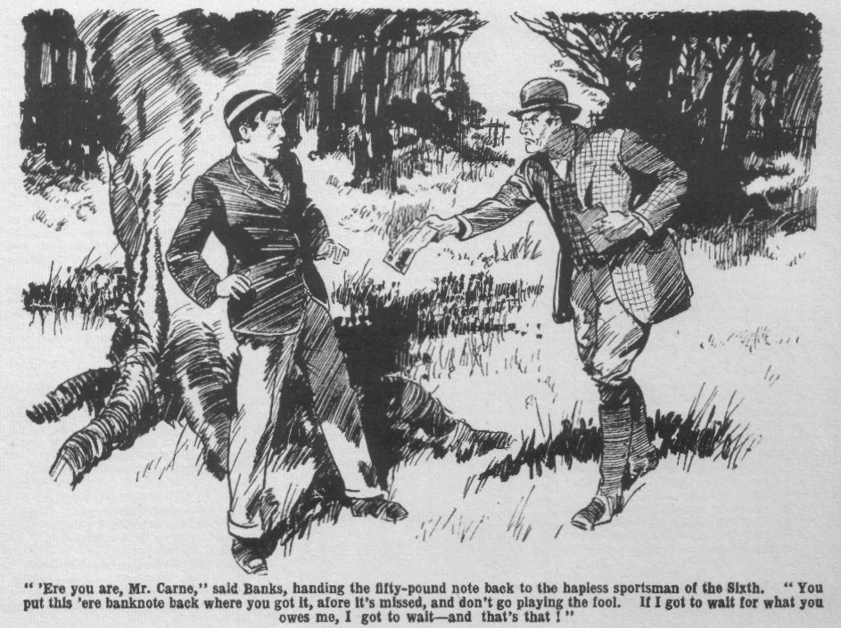
Carne’s trembling fingers closed almost convulsively on the banknote.
“You owe me money,” went on Mr. Banks. “You can’t say I haven’t given you time to pay. But don’t you go playing the fool, Mr. Carne! You’ll get yourself into bad trouble, and me, too! If I got to wait, I got to wait— and that’s that! But no more of this ‘ere game!”
“Next term!” muttered Carne, his heart suddenly light.
Mr. Banks grunted discontentedly. But he nodded. His narrow escape of having handled a stolen banknote had been a warning to him,
“Leave it at that!” he said.
And, with a nod, the racing man turned away, and went. Carne of the Sixth stood staring at the banknote in his hand, and then, in the sudden fear that other eyes might see it, even in that solitary spot, he thrust it into his pocket.
He wiped the perspiration from his brow.
It seemed to Arthur Carne that an immense weight had rolled from his heart and his mind. He was not a thief—not a thief! Even his fear of the rascally Mr. Banks was relieved now. He could settle with the man next term and have done with him. And he was not a thief—not a thief!
He had only to get back to Greyfriars, replace the banknote in the satchel with the rest, and place the green leather satchel somewhere where it might be found by chance, and the whole hideous nightmare would be at an end. The lost loot would be found, and no one would ever dream that it had been in his hands at all!
He would throw the satchel, stuffed with banknotes, into the old tower, or the Cloisters—anywhere, so long as it was found at a safe distance from his study only to have done with it would be sheer joy.
He left the oak at last. Fellows who had stared at his harassed face when he left the school would have stared harder now, at the change in his looks. He was not a thief—he was not a thief! The words seemed to sing in his ears. His face was bright, his step elastic, as he tramped back to the footpath—little dreaming of what was awaiting him.
THE FIFTH CHAPTER.
The Right Man!
DANDY SANDERS, crook and cracksman, and many other things, stood in the hawthorns, watching the shady footpath. His steely eyes glinted through the interstices of the bushes, as he watched and waited. By his side slouched the man in gaiters, with the stubbly, bearded face, who had followed Carne in Friardale Lane. The wood was silent, save for the twittering and whistling of birds in the thick branches of oaks and beeches. Dandy Sanders was listening for the sound of a footstep as he waited and watched.
“You’re sure of him, Hookey?” he muttered to the stubbly ruffian at his side, and Hookey nodded and grinned.
“He walked by, a yard from me, in the lane.” he answered. “ Never even looked at me, or see me, either. Looked as if he’d got ‘arf the troubles of the world on his shoulders. If I hadn’t knowed anything about him, I’d have said that that young cove had some- thing on his mind.”
Dandy Sanders nodded.
He had no doubt that Arthur Carne of the Sixth Form at Greyfriars had something on his mind. And his suspicion was strong that what was on Arthur Carne’s mind was the lost loot of the Courtfield and County Bank.
For weeks now the chief of the gang of crooks had been in quest of that elusive loot. He had not found it in the hiding place where “Jerry the Rat,” had left it, and for a time he had not doubted that the juniors in Study No. 1 had “snaffled” it. But he had satisfied himself on that point. He knew now that Harry Wharton and Frank Nugent knew nothing of it. It was the tattle of Billy Bunter, which he had overheard, which had put the crook on a new scent.
The Peeping Tom of Greyfriars had somehow found out that Carne of the Sixth had promised to pay some racing man a fifty-pound note, and Sanders had heard him telling Wharton and Nugent. That was enough for the keen-witted crook.
Billy Bunter had regarded it as “gammon,” for Carne was certainly never likely to be in possession of such a sum—honestly; and it did not occur to Bunter that he might be in possession of it dishonestly. But it occurred to Dandy Sanders, who knew that there had been twenty fifty-pound notes in the green-leather satchel.
Some Greyfriars fellow had the loot. That was a certainty. And any Greyfriars fellow who had a fifty-poind note was the fellow Dandy Sanders wanted to see!
Carne had been nothing but a name to him. He had never seen him or heard of him before. But several of his confederates had been on the watch since then, and it had not taken them long to pick out Carne of the Sixth. Hookey had had no doubt of his identity, when Carne passed him in Friardale Lane. And it had not taken him long to pass the word to the Dandy and bring him on the scene. Now they were watching the footpath for the Greyfriars prefect.
“He took this ‘ere path,” went on Hookey. “If he comes back the same way, we’ve got him, Dandy. Ten to one he will.”
Sanders nodded again.
They watched and waited.
As it happened, they had not long to wait. Hardly ten minutes had passed, when there was a step on the path, and a Greyfriars senior came in sight.
“Is that Carne!” whispered Sanders.
Hookey nodded and grinned.
“ That’s the bloke! My eye! He looks different to what he did when I saw him in the lane! I tell you, he looked like a cove that had taken the knock! What’s he grinning at now, I wonder?”
He stared curiously through the bushes.
Carne was swinging along the foot path with an elastic step, and there was a smile on his face. So far as the crooks knew, the Greyfriars senior had simply been for a walk in the wood. That walk seemed to have done him good, to judge by the change in his looks.
“Get him as he passes, and get him into the wood!” breathed Dandy Sanders. “Somebody else may pass—a good many people use this path.”
“You bet!”
Unconscious of the ambush in the hawthorns, Carne of the Sixth came swinging along. He was taken utterly by surprise when two figures suddenly leaped into sight, and grasped him by the arms. Almost before he knew what was happening Carne was whisked off the path into the trees.
“What the thump—” exclaimed Carne, in amazement. “Who the dickens—— What are you up to—what are—”
“ Keep quiet!” said Dandy Sanders. “Knock him on the head if he calls out!”
Carne gave one startled glance at the life-preserver in Hookey’s hand, and he did not call out. In utter amazement, with a grip like iron on either arm, the Greyfriars prefect was walked away into the wood, a hundred yards from the footpath.
There the two crooks halted, knee-deep in ferns, amid the thick bushes, under a spreading beech. Carne’s arms were released, and he staggered against the beech, staring at the two crooks in astonishment and alarm. Hookey lifted the life-preserver with a significant gesture.
“What?” stuttered Carne. “If you’re footpads, I’ve got nothing
He broke off as he remembered the fifty-pound note in his pocket. His hand slid into his pocket and clutched the crumpled note convulsively. Of his own, Carne had nothing, as he had said. He had been hard up for weeks. But he had the fifty-pound note that Joey Banks had handed back to him. This unexpected encounter could not have occurred at an unluckier moment for Carne.
The Dandy smiled faintly.
“We’re not footpads, Mr. Carne.” he answered.
“Then what do you want?”
“Your name is Carne?”
“Yes. That—
“What have you done with the loot of the Courtfield and County Bank?”
Carne stared at him, almost wildly.
That unexpected question took him utterly by surprise, as the Dandy intended that it should.
So far, the crook was acting on suspicion; and he wanted to make sure. He was sure now.
The sudden ghastly terror in Carne’s face betrayed him.
His eyes almost started from hs head as he stared at the crook.
For one terrible moment the terrifying thought was in his mind—that this man was a detective, that all was known, and that the handcuffs were about to snap on his wrists. And one of the stolen notes was in his pocket, and the rest were hidden under his study floor at Greyfriars—safe, but not from a search by the police. For the moment, it seemed, to the wretched Carne, like the end of all things.
The Dandy’s face set grimly. He was sure now—quite sure! Hookey grinned sardonically.
“We got the right man this time, Dandy!” he muttered.
Dandy Sanders nodded.
“Who—who—who are you?” Came found his voice, and it came in a husky whisper. “Who are you?”
“Never mind that!’ said Dandy Sanders. “I‘ve asked you a question! Where is the loot?”
Carne strove desperately to pull himself together. The man was not a detective! He realised that! Policemen would not have waylaid him in the wood and threatened him with a life preserver. And as Carne realised that, he realised, too, who this man with the glinting, steely eyes must be—the crook who was a confederate of Jerry the Rat, who was in search of the bankrobber’s plunder. It was not the police —it was not arrest—it was not the end of all things! Carne panted.
“I don’t understand you!”
He was already getting himself in hand, now that he understood that it was not the guardians of the law, but breakers of the law, with whom he had to deal.
“Don’t you?” said Dandy Sanders grimly. “I’ll make it clear, then! You’ve got hold of the loot—seven thousand pounds—that Jerry the Hat hid in a study chimney at Greyfriars.”
“It—it is false!” stammered Carne.
“Cut that out!” said the Dandy sharply. “I fancy you’ve got some of it about you at this moment; and you’ll tell me where to find the rest. You won’t be seen at your school again till it’s in my hands. And you — Hold him, Hookey!” he yelled.
Carne, in utter desperation, made a spring to escape. The life-preserver in Hookey’s hands missed him by an inch as he sprang away into the bushes. The Dandy was after him like a tiger. But Carne was desperate now, and he tore frantically through the bracken. He knew that he could not escape. He knew that he had only a few moments. His one thought was to save the bank-note.
it was clutched in his hand as he fled. He threw it into the bracken, and tore on. Later, some time—any time—he would search for it, and find it. All that he cared for now was to save it from thievish hands. He ran on frantically, with the two crooks panting after him, 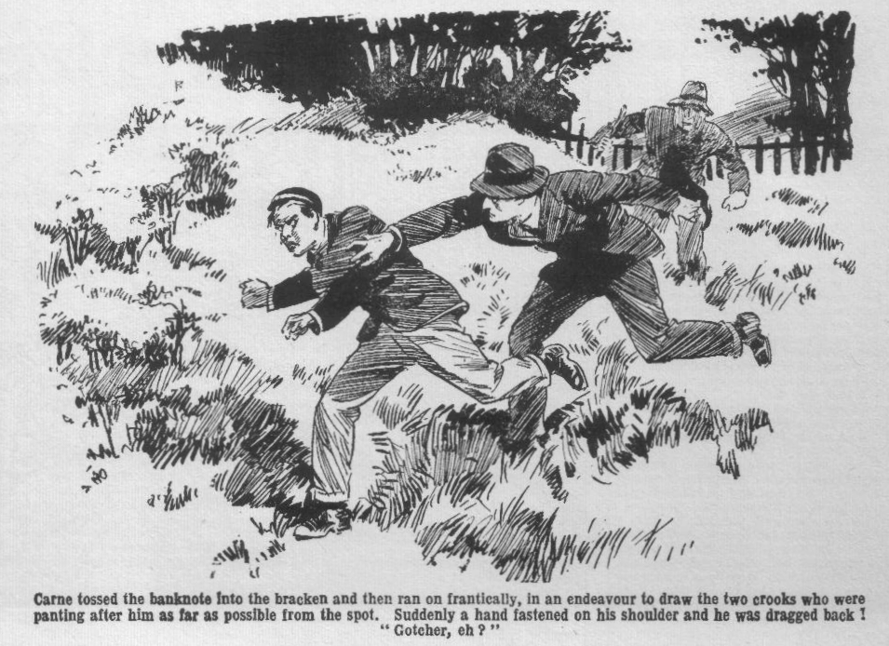
They had not seen him drop the note—the bracken was up to his shoulders as he ran and dodged and plunged away. He knew they would get him. He was seeking to draw them as far as possible from the spot. Twice a grasping hand barely missed his shoulder; at the third grasp it fastened, and he was dragged back.
“Gotcher—eh?”
Carne went down, sprawling in the bracken, the Dandy sprawling over him.
THE SIXTH CHAPTER.
Removites to the Rescue!
“HALLO, hallo, hallo!”
“What the dickens
Harry Wharton & Co. came to a halt on the footpath through Friardale Wood. The chums of the Remove were sauntering cheerily under the shady trees, with their hands in their pockets, when the sound of tramping footsteps and hurried brushing and rustling in the thickets came to their ears. They stopped, and stared in the direction of the sound. Someone was plunging wildly through the thickets towards the path, though still at a distance, tearing madly through hawthorns and ferns and bracken, regardless of thorns.
“Somebody in a hurry!” said Frank Nugent;
There was a sound of a heavy fall, and panting breath. Faintly through the bushes came a panting voice:
“Hands off, you villain! I tell you I’ve got nothing!”
“My only hat!” ejaculated Harry Wharton.
“Hold him!” came another voice, in a low, hard tone.
“I got him, Dandy!”
“I tell you I’ve got nothing!”
“Silence!”
“I tell you——”
“I got him, Dandy! Go through his pockets!”
“Keep him quiet!”
“We chip in here, you men!” said Harry Wharton, in a low voice.
“That was Carne speaking—Carne of the Sixth! Come on!”
“What-ho!” said Johnny Bull.
The Famous Five did not hesitate for a moment. They recognised the panting voice as that of Carne of the Sixth. They did not like Carne fact, they disliked him very considerably. But they were not the fellows to leave a Greyfriars man in the hands of footpads. And, so far as they could see, the two who had seized Carne in the wood could not be anything else.
The five juniors left the pit, and plunged through the trees towards the spot.
They could still hear Carne panting: and the bracken was swaying and rustling. They were not a score of yards from the spot where Carne had fallen into the hands of his pursuers.
With a rush they came on the scene. Carne, on the ground, almost hidden by ferns and bracken, was pinned down by a knee in his back—the knee of a stubbly faced man in gaiters. Another man was turning out his pockets. The rustling of the bushes as the juniors rushed on the scene startled him, and he turned his head, with a blaze in his steely eyes.
“Look out!” panted Hookey.
Dandy Sanders leaped to his feet.
At the same moment Bob Cherry, ahead of his comrades, reached him. The crook gasped, then as Bob’s hefty fist crashed on him, he reeled, and fell across Carne.
“Go for ‘em!” roared Bob.
Hookey leaped up, the life-preserver in his hand. The weapon was lifted, but before the ruffian could use it, Harry Wharton’s fist crashed in his stubbly face, and he staggered over, the life-preserver falling from his grasp.
“Give ‘em jip!” yelled Johnny Bull. “Give ‘em terrific jip!” panted the Nabob of Bhanipur.
Dandy Sanders sprang away. He yelled to his associate, and leaped into the wood and ran. Hookey was after him in a twinkling.
Carne sat up dizzily.
The Famous Five gathered round him. The two footpads—if they were footpads—were in full flight, vanishing through the thick wood.
“Oh!” panted Carne. He stared dazedly at the juniors.
“After them!” shouted Bob Cherry.
Carne panted.
“Stop!” he exclaimed. “It’s all right! Stop!”
“Oh, all right!” said Bob. “Not much chance of running them down in the wood, anyhow. Did they get anything from you, Carne? If they did, we’ll go after them—”
“No, no! It’s all right!”
Harry Wharton gave the panting Sixth-Former a helping hand, and Carne staggered to his feet. He stood leaning on a tree, panting for breath, the perspiration running down his face.
Help had come unexpectedly; but it had not come in time to save the banknote had it still been in Carne’s possession when the crook’s thievish fingers ran through his pockets. But it was safe, lying somwhere in the bracken near the old beech. Carne had only to hunt for it and find it. Whether the two unknown rascals escaped or not mattered little to him; but it mattered a good deal whether Greyfriars fellows learned what they had wanted with him.
“They were turning out your pockets when we came up.” said Harry Wharton. “Sure you’ve lost nothing?’
“Yes, yes; that’s all right!” panted Carne. “How—how did you happen to be here?”
He shot a suspicious glance at the juniors, with the fear in his mind that they might have heard something of what had been said under the old beech.
“We were on the footpath—”
“On the footpath—”
“Yes; going along to Pegg, when we heard them collaring you.” answered Wharton.
“Oh! I—I see!” Carne breathed more freely.
The juniors had not been in the wood; they had seen and heard nothing.
“Thank you for coming to my help!” he said. “You—you’d better clear off now—those rotters may be hanging about—”
“Right-ho!” answered Wharton.
The Famous Five walked back to the footpath and resumed their way to Pegg. Carne resumed leaning on the tree, breathing hard and deep. He listened intently when the juniors’ footsteps had died away in the distance. There was no sound in the wood. The two rascals were gone—they were far enough away by that time, and Carne was feverishly anxious to recover the banknote he had thrown into the bracken. But his nerves were on the jump, and he listened for long minutes before he stirred. If they came back—. But they could not guess that he had any motive for lingering on the spot where he had been attacked— they were not likely to come back.
He moved away at last in the direction of the old beech-tree deep in the wood, searching with anxious eyes among ferns and bracken and grass—with his ear on the alert while he searched.
But he searched in vain.
Somewhere among the ferns and bracken that crumpled banknote lay, but it was not easy to find. With feverish anxiety Carne hunted, almost forgetting his fear of the crooks in his intense anxiety to find it. But he did not find it, and it was long past the hour of call-over at Greyfriars when the falling darkness compelled him to abandon the search and to start for the school—without the £5O note!
THE SEVENTH CHAPTER.
Bunter In a Hurry!
“HALT!”
“Wha-a-t?”
“Stand and deliver!”
“Oh, really, Cherry—”
It was a half-holiday at Greyfriars, and the July sunshine streamed down on the old school and the playing-fields and the green old quad. Harry Wharton & Co. were debating how they were going to spend the half-holiday—no cricket match falling due that day, standing in a cheery group by the ancient stone gateway, when Billy Bunter came rolling down to the gates in hot haste.
On a July afternoon it was natural for Bunter to be hot, but it was far from natural for him to be in haste. Anyone who knew Bunter would have expected his movements to resemble those of an old and weary snail.
Instead of which, Bunter was travelling on his highest gear, so to speak—walking so quickly that he was almost trotting, just as if he was not the slackest and laziest fellow at Greyfriars or anywhere else.
The Famous Five as they glanced at Bunter grinned, guessing the reason. There was a bulge under Billy Bunter’s jacket—a suspicious bulge.
Bunter’s clothes fitted him rather tightly—indeed, he was packed in them rather like a sardine, and fellows often professed to wonder how on earth he got into them, and how the dickens he ever got out again.
So when Bunter crammed an object under his jacket to hide it there was not a lot of concealment about it. The object, certainly was unseen, but the bulge of the jacket would have caught the least watchful eye.
Whereat the chums of the Remove grinned, and Bob Cherry, jumping in Bunter’s way, presented a stick of toffee at him in the form of a highwayman’s pistol, and called upon him to stand and deliver! And the Co. chortled.
“ Hands up!” continued Bob playfully.
“Look here, you ass—”
Billy Bunter halted because he had to halt or walk over Bob Cherry. But though he stood, he did not deliver. He clapped a fat hand to the bulge in his tight jacket, as if he was afraid of some- thing slipping into view.
“I say, you fellows, no larks!” expostulated Bunter. “I’m in rather a hurry. I—I’ve got to see a chap.”
“ The boa-constrictor,” said Frank Nugent, “ crawls away to a solitary spot to devour his prey at his leisure.”
“Ha, ha, ha!”
“ Now, you fat boa-constrictor——”
“ Oh, really, Nugent! If you think I’ve got anything under my jacket you’re jolly well mistaken.” said Bunter. “I’m not going down to the wood to eat it—I’ve got nothing to eat. I’m not always thinking of eating, like some fellows I could name.”
“ Oh, my hat!”
“You’ve got nothing under your jacket?” asked Johmy Bull.
“Nothing at all, old chap!”
“And whose study did you bag it from?”
“Ha, ha ha!”
“You silly ass!” hooted Bunter. “I have’n’t got a box of chocolates here, and if you think they belong to Temple of the Fourth, it only shows that you’ve got a low, suspicious mind.”
“Ha, ha, ha!” yelled the juniors.
“ Blessed if I see anything to cackle at! Look here, let a fellow pass! I—I’m in a hurry to meet the postman! I mentioned to you chaps that I was expecting a postal order, I believe—”
“I believe you did!” gasped Bob. “I seem to remember something of the sort.”
“Well, it hasn’t come.” said Bunter, “and I’m going to meet the postman! I say, I’m in a hurry—”
“Must be in a frightful hurry as the postman isn’t due for three hours yet.” agreed Bob Cherry.
“I—I mean, I—I want to get out of gates because—because Wingate of the Sixth is going to make me fag at bowling!” gasped Bunter. “I want to get off before he spots me.”
“Ha, ha, ha! I can see Wingate letting you bowl to him!” chortled Bob. “Try again, old fat man!”
“ Beast!”
Billy Bunter blinked behind him through his big spectacles. It was obvious that he was in fear of pursuit, and that that accounted for his unusual haste on a hot afternoon. Then he blinked at the grinning juniors grouped in his way.
“I say, you fellows chuck larking!” he exclaimed anxiously. “He says that you’re the clumsiest lout at Greyfriars, Bob, old chap!”
“You fat villain!”
“He says you’re a milky-watery nincompoop, Nugent
“You pernicious porpoise!”
“He says you’re a black savage, Inky—”
“My esteemed idiotic Bunter—”
“Besides they’re not his chocolates.” explained Bunter. “I never saw him put them in his study, and never nipped in after them, and he wasn’t after me when I got out of the House! I haven’t any chocolates about me. And I’ll tell you what, you fellows—you collar Temple if he comes after me, and mop him up, and I’ll give you some of them!”
“Some of the chocolatcs you haven’t got!” gasped Bob.
“Yes—I—I mean no—yes—that— is—”
“Ha, ha, ha!”
“I say, you fellows, do let a fellow pass!” howled Bunter, almost in anguish. “That beast Temple may come along any minute—”
“I think we’d better keep you till he does!” chuckled Harry Wharton. “He may want his chocolates for himself.”
“I haven’t got his chocolates, you silly ass! I say, old chap, Temple says you’re a silly stuck-up ass——”
“You frabjous fathead—”
“Hallo, hallo, hallo! There’s jolly old Cecil Reginald!” exclaimed Bob Cherry, as the elegant figure of Temple of the Fourth appeared in the distance.
Bunter gasped.
“Oh crikey! I say, you fellows, if— if Temple asks you about me tell him I’ve gone to Courtfield, will you? Don’t mention anything about the wood. Say I’ve gone in the other direction. Don’t mention that I had anything under my jacket. I—I haven’t, you know.”
And Billy Bunter rolled on, the Famous Five mercifully allowing him to pass. Temple of the Fourth was looking round him as he came out of the House, evidently in search of somebody. The expression on his face hinted that there was a hectic time in store for that somebody when he found him.
Bunter broke into a run as he went out of gates and headed down Friardale Lane. The shady wood was a near and sure refuge, and Bunter knew what would happen to him if Cecil Reginald Temple ran him down with the evidence on him. He had a natural desire to remain out of sight until he had devoured the evidence.
But it was a case of more haste and less speed. Billy Bunter barged down the lane at a run, and barged fairly into the back of a Sixth Form man who was going in the same direction. Carne of the Sixth staggered forward with a howl.
“Oh crikey!” gasped Bunter.
Carne turned on him, with a furious face. Really, it was not a very serious accident but Carne was in a state of jumping nerves.
“You clumsy young sweep!” he roared.
“Yarooooh!”
Billy Bunter caught one smack, which made his head sing, and he did not wait for another. He rushed on, his fat little legs fairly twinkling as he flew.
Arthur Carne scowled and tramped on. He was bound for Friardale Wood that afternoon to make another search for the fifty-pound note. Billy Bunter, puffing and blowing, vanished ahead of him, and the Sixth Form man gave him no further thought.
But running, especially on a sultry afternoon in July, did not agree with Bunter. He turned into the first path he came to that led up into the wood, and slackened pace. It was a relief to get out of the blaze of sunshine into the shade of the trees, and a still greater relief to be safe out of sight of Temple of the Fourth, if that incensed youth was on his track. The fat junior dropped into a walk, and the walk slackened to a crawl, and he blinked about him through his big spectacles in search of a comfortable spot to sit down and rest his weary, fat limbs and devour the chocolates.
There was the sound of a footstep on the path behind him, and he gave a jump and blinked back. The winding path hid whoever it was from his sight; but he had no doubt that it was Temple.
The fat Owl accelerated again, and trotted on deeper into the wood. But it was useless to keep to the path if Temple was following that path, and he quitted it and plunged away through the bushes and bracken. He stopped at last under the wide-spreading branches of an old beech, and plumped down in the ferns, spluttering for breath.
For a few minutes Bunter sat and rested and spluttered. Billy Bunter was always short of wind, and what little he had had been expended. But as soon as he recovered his breath he opened the box of chocolates. A fat and happy grin overspread his podgy face. They were nice, big, fat chocolate creams—just what Billy Bunter liked! Whoever had sent that box to Temple of the Fourth had done Billy Bunter a good turn. His fat fingers and his podgy jaws were busy, and Temple’s chocolate creams went down like oysters. William George Bunter, happy and sticky, felt that life, after all, was really worth living.
THE EIGHTH CHAPTER.
“Findings Keepings!”
“OH lor’ !”
Billy Bunter gave a sudden gasp.
He pricked up his fat ears like a startled rabbit.
For five or six minutes he had been seated comfortably under the shady beech, leaning back on the trunk, devouring chocolate creams. Round him the deep woods were silent, save for the twittering of birds. But the silence was broken by a sound of rustling as someone came pushing his way through the thickets towards the beech tree.
The fat junior started and listened.
“Beast!” he breathed.
There were still some chocolate creams in the box. But the fat Owl forgot them now. Someone was coming through the wood directly towards the spot. He was at a good distance from any of the footpaths in the wood. Nobody was likely to come pushing through the tangled thickets, unless it was a fellow in search of something! Bunter had no doubt that it was a searcher—and no doubt of what was sought! It was clear to his fat mind that Cecil Reginald Temple, of the Fourth, had tracked him down!
“Oh crikey!” groaned Bunter.
The thickets still hid the fellow who was coming, but it was plain that he was heading for that beech-tree. Bunter scrambled to his feet. He clutched the chocolate-box and blinked in the direction of the sound of rustling. But he had no tine to waste ; the beast would be upon him in another minute!
Running for it was out of the question; Billy Bunter hadn’t a run left in his fat limbs. He had been tired when he flopped down under the beech, and since then he had taken aboard a cargo of chocolate creams. He blinked wildly for a moment, and then, dropping on his hands and knees, crawled away into the thickets. Round the old beech was a wilderness of bush and bramble and briar; cover enough for a whole tribe of Bunters. The fat Owl crawled away, fervently hoping that the beast would not hear him as he crawled.
Apparently the beast did not hear him, for there was no sound of pursuit. Six or seven yards from the beech Billy Bunter stopped, hot and breathless, and lay still and listened.
The unseen person had reached the beech-tree. Bunter could not see him, but he could hear faint sounds from him.
The fellow was lingering by the beech. Not for an instant did it cross Bunter’s fat mind that the fellow was Arthur Carne of the Sixth Form. He could have imagined no reason why Carne of the Sixth should be rooting about in the depths of the tangled wood. He had forgotten Carne’s existence—but he remembered Temple’s! He had not the slightest doubt that it was Temple of the Fourth hunting for him, and Billy Bunter lay very quiet! Like that sagacious animal, Brer Fox, he felt that it was a time to “lay low and say nuffin!”
There was a rustling again. The unseen one was moving slowly through the thickets; slowly and carefully, like a fellow who was in search of something— or somebody!”
Billy Bunter trembled as the rustling sound approached him. But it passed a couple of yards from him, and he breathed again.
He even grinned. The searcher had passed on, which meant that Temple had missed him and was going farther afield.
Relieved in his mind, the fat Owl sat up, still thickly screened by the bracken and brambles, and finished the chocolates. After his fright there was comfort in chocolate creams!
The last chocolate was going when Bunter gave a sudden start and almost choked! The rustling was coming back!
The beast, after all, was not gone! He seemed to be quartering the ground like a hunting dog!
“Oh lor’ !” breathed Bunter.
He squatted silent.
A mass of hawthorns only a yard from him swayed and stirred, and Bunter’s heart leaped into his mouth. But the searcher passed on, and the hapless Owl suppressed a gasp.
Again the rustling died away—again Bunter heard it! With an obstinate persistence he would never have suspected in a slacking dandy like Cecil Reginald Temple, the unseen fellow was searching and searching. It could only mean, it seemed to Bunter, that he knew that the fat junior was somewhere at hand. Otherwise he would have gone. Bunter crouched low in the bracken and quaked.
But at long last the rustling died away and was not renewed. The searcher had gone farther afield, in the direction of the main footpath through the wood, which led from Friardale to Pegg.
“Oh crumbs!” groaned Bunter.
It was hot in the thickets, and there were flies—plenty of flies. Nasty things were crawling over Bunter from the tangled roots, and tickling him in many places. But it was long before the fat Owl ventured to sit up again, and then he sat and listened and blinked about him uneasily. Once he was sure that the beast was gone Bunter was ready to go; but he wanted to be quite sure first.
As he sat blinking about him, a glimmer of white among the roots caught his eye. He took no notice of it at first; it was only a fragment of paper that lay there. Had he left the spot then he would have left it lying unheeded. But he was waiting, to make sure that the coast was clear, and again and again his eyes fell on that slip of paper. And something about it struck Bunter at last. It was not a torn fragment of a newspaper, as he had supposed; he discerned that it was an engraved slip of paper, and it dawned upon his fat mind that it was remarkably like a banknote in appearance. He stared at it, reached out for it and picked it up. And then he gasped !
“Oh crumbs!”
It was a banknote!
And it was not such a banknote as Bunter had often seen—a fiver or a tenner! The figures on it almost made Bunter’s little round eyes pop through his big round spectacles—£5O!
It was a fifty-pound Bank of England note!
Billy Bunter gazed at it! He blinked at it! He could scarcely believe his eyes or his spectacles.
Billy Bunter’s worldly wealth at that moment was limited to one penny, which was still in his possession because it was a French penny, and he had hitherto been unsuccessful in passing it on! And in his fat fingers was a banknote for fifty pounds!
“Oh crikey!” gurgled Bunter.
The note was crumpled and dirty and damp to the touch. The night dews in the wood had wetted it, and the heat of the day had not quite dried it yet. There were marks on it, as if it had been bandied by grubby, greasy fingers.
But it was a Bank of England note, and its value was fifty pounds!
Bunter gazed at it, dazzled.
He wondered dizzily how on earth it could have come there, lying lost among the roots and ferns. Someone had dropped it, or it had blown away from somewhere. It might have been there for weeks; it might have remained there until it mouldered away had not Billy Bunter been hunting cover within a dozen yards of the old beech- tree. Bunter had found it! To whom did it belong—if to anybody?
To do Billy Bunter justice, his first thought was that the banknote must belong to somebody, and that the owner must be found.
But second thoughts—not always the best,—came swiftly!
A bad old saying, which had often caused Bunter trouble, came into his fat mind : “ Findings keepings!”
The prospect of such a sum of money was positively dazzling. His fat mouth positively watered at the thought of the amount of tuck that it represented.
Findings keepings!
His fat fingers closed on the note.
Billy Bunter had a conscience, though it was a remarkably elastic one, and would stretch to almost any extent. Sitting in the bracken, clutching the banknote, Bunter argued it out with his conscience.
Whoever had lost that note had lost it, and, no doubt, had made up his mind to the loss. Must have been some frightfully rich fellow to have fifty-pound notes about him, and to be careless with them. Very likely so rich that he really wouldn’t miss it. Certainly, he would never have got it back if Bunter hadn’t found it. A chap who would drop a fifty-pound note and leave it where it fell must be some blessed millionaire! If he wanted that banknote he should be hunting for it; he couldn’t expect other people to find his banknotes for him. Besides, most likely it was impossible to find the owner at all! Might be dead and buried, for all Bunter knew. If the owner of lost property could not be discovered, the finder was entitled to keep it, after due search. If Bunter, on his way out of the wood, found a man looking for a lost banknote, he would be bound to hand it over. If he didn’t—and he didn’t really expect to—he would be entitled to keep it, as the owner was not discoverable!
Bunter was dimly conscious that he was humbugging himself, but he was not fully conscious of it, and didn’t want to be! Billy Bunter’s remarkable intellect had its own remarkable ways of functioning. Thinking the matter out, so far as Bunter was concerned, only meant thinking out reasons why he should keep the banknote he had found.
He rose to his feet at last. He had a notecase in his pocket, in which there were very seldom any notes. Now he tucked the fifty-pound banknotc in it.
There was no sound from the beast who had been hunting him—Bunter was still in the belief that it was Temple of the Fourth who had been rooting through the thickets. The coast was clear, and Billy Bunter took his departure. He rolled away through the wood to Friardale Lane, and rolled on to the school, with a fat and happy grin on his face.
Arthur Carne of the Sixth was still in the depths of the wood, searching desperately for the fifty-pound note!
He was not likely to find it now.
THE NINTH CHAPTER.
Wealthy Bunter!
SNIFF!
Peter Todd of the Remove looked round as that loud, emphatic, and contemptuous sniff was audible in the doorway of Study No. 7.
Tea was on the table in No. 7—and it was a frugal tea. Toddy was not a wealthy fellow, and though Billy Bunter, according to his own account, rolled in wealth, he never rolled in it at Greyfriars School. None of the immense riches of Bunter Court ever found their way as far as Greyfriars. So tea in Study No. 7 was generally rather frugal, much to the dissatisfaction of Billy Bunter, though, as Bunter seldom or never stood his “whack,” he really ought not to have been the fellow to grumble.
There was plenty of bread on the table ; that was supplied by the school: There was not plenty of butter ; and there was no jam at all. There were sardines but not a lot of them.
Billy Bunter blinked at the tea-table through his big spectacles and sniffed— and sniffed again. Toddy looked at him.
“Dutton’s teaing out,” he remarked. “Aren’t you, Bunter?”
“No.”
“I rather hoped you were!”
“Oh, really, Toddy—”
“ Well, you can help yourself to the sardines,” said Peter. “Go easy with the butter.”
Sniff!
“Got a cold?” asked Toddy.
“Eh? No.”
“What are you snorting for, then?”
Apparently Toddy did not recognise it as a sniff of lofty contempt.
“Who wants your measly sardines?” asked Billy Bunter derisively.
“You do,” answered Peter cheerfully. “And you want the lot, you fat cormorant, but you’re only going to have half.”
“Keep them!” said Bunter contemptuously.
Peter Todd stared at him blankly. It was possible that Bunter had tea’d already in some other fellow’s study, but that would have made no difference; he was always ready for another. If he had bagged two or three teas up and down the Remove passage he would, in ordinary circumstances, still have been prepared to take the lion’s share of what was going in his own study. So it appeared that the circumstances were not ordinary!
“Don’t you want any tea?” asked Peter, astonished.
“Not that measly stuff!” sneered Bunter. “We’re going to have something decent for tea for once, Peter. Don’t you worry—I’m standing it!”
“Gammon!” said Toddy.
“I’m in funds!” said Bunter, with dignity.
“Poor old Mauly!” said Peter com miseratingly.
“If you think I’ve been borrowing money from Lord Mauleverer, you cheeky beast—”
“Haven’t you ?”
“No!” roared Bunter.
“Don’t tell me your postal order’s come!” gasped Toddy. “Anything but that!”
“As a matter of fact, it has.” said Bunter calmly
“Great pip!”
“Not exactly a postal order,” added Bunter hastily. “You can’t get postal orders for fifty pounds, of course!”
“Fifty which?” gurgled Peter Todd. Peter gazed at him.
“Being such a large sum, the pater naturally sent me a banknote.” explained Bunter, “You make out that I never get big remittances from home, Toddy.”
“I don’t nake it out—I state a fact!” answered Toddy. “If you get big remittances from home, old fat bean, they’re never seen in this study.”
“Well, I’ve jolly well had one today!” said Bunter. “Precious few fellows get fifty pounds in a lump, Toddy!”
“Precious few,” agreed Toddy. “As Inky would say, the fewfuIness is terrific! And you’re not one of the few, you fat bounder. I believe Mauly had a fifty-pound note once. I’ve never heard of any other Greyfriars man who had one.”
“I’ve told you my people are rich often enough—”
“Too often!” said Toddy.
“Well, my uncle’s come down handsome this time.” said Bunter “‘Tain’t every chap’s uncle who would send him a fifty-pound note, Toddy.”
“Hardly! It was your pater a minute ago. Now it’s your uncle! But I haven’t seen the jolly old banknote— and don’t expect to.”
“Seeing is believing.” sneered Bunter.
“Oh, quite! I’ll believe it when I see it. You silly fat owl, what are you chattering out of’ the back of your silly neck for?”
“Look here, then!” roared Bunter.
He fumbled in his pocket and took out his notecase. Peter Todd watched him and grinned. It was quite usual for Billy Bunter to talk airily of fivers or tenners, but extremely unusual for him to produce any of those useful articles.
Toddy’s opinion was that his fat study-mate was telling a bigger “whopper” than usual, this time; and certainly he had not the slightest expectation of seeing the Owl of the Remove produce a banknote from the case. He gave a jump as a crisp slip of paper came into view in Billy Bunter’s fat fingers. He jumped again—or rather, bounded—when the fat Owl displayed it, and he saw its denomination.
He gazed at it with wide-open eyes.
“It—it—it’s for fifty pounds!” gasped Peter Todd.
“Nothing to me, old chap!” said Bunter airily. “I’ve told you that my people are rolling in money. My uncle—I mean my pater—thinks nothing of a fifty-pound note! A mere trifle, old fellow!”
“Great jumping Moses!” gasped Peter Todd, staring with fascinated eyes at the banknote. “Where did you get that, Bunter?”
“My pater—”
“Don’t be an ass! Where did you get it?” roared Toddy.
“My uncle—”
“You fat owl! You frabjous chump! Where did you get it?” shrieked Peter Todd. “Whose is it, you burbling bandersnatch?”
“Whose?” howled Bunter. “Mine, you beast! Think I’d pinch a bank-note? It came in—in my letter to-day, and—”
“You never had a letter to-day!”
“ I—I mean, my letter yesterday—”
“You fat, frabjous, foozling frump! Has that silly ass Mauly been dropping banknotes about, or what?”
“Why, you—you—you—” gasped Bunter, glaring at Peter with almost speechless indignation.
Even Billy Bunter was not capable of bagging a banknote that a Greyfriars fellow dropped about the school. Billy Bunter had his limit, though certainly it was a wide one!
“Whose is it, then?” yelled Toddy.
“Mine, you dummy! The—the fact is, it’s my birthday to-morrow—I mean, yesterday—that is, to-day, you know— and so my pater—I mean, my uncle— sent me this banknote as a birthday present. Think everybody’s people are hard up like yours, Toddy? Look here, leave those measly sardines alone, and cut down to the tuckshop and change this note for me
“Change it for you?” gurgled Toddy. “Yes, old chap! I’ll lend you a few pounds out of the change, too.” said Bunter generously. “Dash it all, you’ve lent me small sums at times, and one good turn deserves another! I’ll let you have a fiver, Toddy!”
“Thanks! I’d rather the owner had it, though!”
“You silly chump, I tell you it’s mine!” howled Bunter. “Mean to say you can’t take a fellow’s word! It’s a bit low to doubt a fellow’s word, Toddy! Look here, are you going down to the shop to change this note for me?”
“No fear! No skilly for me!” said Toddy emphatically. “When you go to chokey, old fat bean, you can go on your own!”
“Who’s going to chokey, you silly chump?” howled Bunter.
“Don’t you know that people are sent to chokey for pinching banknotes?” asked Peter Todd.
Billy Bunter gave Peter a glare through his big spectacles. Then, with a snort, he turned to the door.
“You cheeky beast!” he said, over a fat shoulder. “I jolly well won’t stand a feed in this study now! I jolly well won’t lend you a fiver You can go and eat coke, and be blowed to you!”
“Look here, Bunter—”
“Yah!”
Billy Bunter rolled out of the study, the fifty-pound note crumpled in his fat hand. Toddy stared after him, and called after him.
“Look here, Bunter—”
Bunter rolled on, unheeding. Toddy was left staring.
THE TENTH CHAPTER.
Mr. Grimes Wants to Know!
“JOLLY old Grimey!” remarked Bob Cherry.
The chums of the Remove smiled.
They werc sauntering back to Greyfriars for tea, after a ramble up the river, when they came on Inspector Grimes of Courtfield.
That plump and portly gentleman was ambling slowly along the leafy lane, with an expression of deep thought on his official features.
Harry Wharton & Co. thought that they could guess the subject of Mr. Grimes’ deep meditations.
Mr. Grimes was in official charge of the case of the bank robbers at Courtfield, now several weeks old.
The bank robber was safe in custody, which was satisfactory so far as it went. But the enormous sum of seven thousand pounds, which he had raided from the bank, was still missing, and that was a problem that Mr. Grimes had to solve— if he could.
It was up to Mr. Grimes and the portly inspector was intensely anxious to get hold of those missing banknotes. But with every passing day success seemed farther and farther off. It was a certainty that the fleeing bold-up man, who had dodged into Greyfriars in his flight, had “parked” his plunder there. Now that that circumstance was known, the recovery of the plunder ought to have been a simple matter. But it had proved to be far from simple.
It was fixed in Mr. Grimes’ mind that some Greyfriars fellow had laid his hands on the loot. In the circumstances, he could scarcely believe anything else. But in his discussion with the headmaster and various members of the staff Mr. Grimes had met with quite a cold reception. What appeared to his official mind a certainty appeared to the school authorities an utterly fantastic idca.
Dr. Locke had pointed out to him that if any Greyfriars boy found the lost loot, that Greyfriars boy’s first and immediate step would be to hand it over to his headmaster, to be returned to the bank.
This seemed to the head o obvious that he could not understand Mr. Grimes taking a different view.
No doubt Mr. Grimes’ professional experiences had robbed him of the simple faith which, according to the poet, shares with kind hearts the advantage of being superior to Norman blood.
Dr. Locke was a little offended, but really more amused than offended, at the suggestion that any Greyfriars fellow might have allowed stolen currency to stick to his fingers if he found it.
It was, the head told Mr. Quelch, too absurd for discussion. The Remove master agreed with the Head that it was too uttcrly absurd.
Far from seeming absurd to Mr. Grimes, it seemed an absolute certainty. He was keenly on the alert for the attempted passing of any of the stolen notes in the neighbourhood of the school.
So far there had been no such attempt. If a Greyfriars man had the banknotes he seemed to be hoarding them unspent. That, however, was easily accounted for in the inspector’s mind; the rascal was frightened, and had not yet ventured to make use of his booty. Sooner or later, no doubt—sooner or later—
In the meantime, Inspector Grimes was quite beaten. He could not get a search warrant and root over Greyfriars School from foundation to roof; and, really, there was no other way of getting at the loot if some young rascal had it hidden in the school.
He could only watch and wait, and keep his eyes and his ears open and hope for the best. Until the thief attempted to make use of his plunder nothing was likely to come out.
In the meantime, Jerry the Rat’s confederates were after the loot as keenly as Mr. Grimes himself. Two of them had fallen into the hands of the police. But there were others—several others, at least. Mr. Grimes’ only comfort was that if he had not found the loot, neither had the hold-up man’s confederates found it. But he was haunted by a dread that they might find it first.
Hence the expression of deep thought on Mr. Grimes plump, rosy face when the Famous Five met him in Friardale Lane. They smiled. Mr. Grimes was so deep in thought that he did not observe the Juniors till they were almost under his nose. Then he gave a little start as they “capped” him politely, and looked rather sourly at five smiling faces.
“Any luck, sir?” asked Bob.
Grunt! from Mr. Grimes.
“The luckfulness does not appear to be terrific!” remarked Hurree Jamset Ram Singh sympathetically.
“Hold on a minute, young gentlemen!” said Mr. Grimes.
“Certainly!” said Harry.
“There’s been no news of the missing money, Master Wharton.” said the inspector. “It’s still in the school somewhere.”
“I suppose it must be, Mr. Grimes.” said Wharton, rather uncomfortably.
It was not pleasant to a Greyfriars fellow to know that a police inspector believed that there was a thief in the school, especially as Wharton could hardly help sharing that belief.
“Anyone who learned anything on the subject would be bound by law to report it to the police.” said Mr. Grimes.
“Of course!” said Harry.
“Rely on us, Mr. Grimes!” said Bob, with a grin. “If we find any hundred-pound notes knocking about Greyfriars we’ll ring you up on the spot.”
“I fancy it’s pretty well hidden,” said Mr. Grimes. “But—” He paused. “Of course, the numbers of the notes are known. They would be traced if they were passed among tradespeople. But—”
He paused again.
The juniors waited, wondering what Mr. Grimes was driving at. Certainly they were only too willing to help if there was anything they could do. They would have been glad, like most of the fellows, to see the shadow of suspicion lifted from the school.
“ Luckily, there were no notes of small denomination in the bag,” went on Mr. Grimes, “ and it’s hot easy to pass fifty and hundred pound notes without discovery. But the thieyes, if they got hold of them, would send them to confederates abroad, most likely, to be put in circulation. A schoolboy could not do that.”
“Hardly!” agreed Wharton, with a smile.
“ But—” said Mr. Grimes, “ But, although it is not easy to pass such notes, there are ways and means—ways and means! A boy might have some aequaintance outside the school, perhaps—‘hem—some disreputable acquaintance who might he willing to take a risk for a large profit. No news has been received yet of the passing of any of the notes—but that does not prove that none have been disposed of. If any boy in the school happened to be in possession of unusually large amounts of pocket-money——”
Mr. Grimes paused once more.
The chums of the Remove exchanged uncomfortable glances.
Evidently Mr. Grimes was “pumping” them, in the hope of ascertaining whether they knew of any Greyfriars fellow who was in possession of any unusual financial resources.
Had Mr. Grimes heard of any such fellow, certainly his official eye would have fastened on that fellow, with the keenness of a hawk’s.
Wharton coloured a little.
“I quite understand, Mr. Grimes.” he answered. “ But so far as I’m concerned I’ve not heard of any fellow having a lot of money.”
“ Same here,” said Nugent.
“The samefulness is terrific.”
“Nobody in our Form, at any rate.” said Johnny Bull. “ Not that there’s a fellow in our Form who would touch what wasn’t his own !”
“Oh, quite, quite!” said Mr. Grimes, and, with a nod to the juniors, he went on in his meditative way.
Harry Wharton & Co. went in at the gates, no longer smiling. There was a cloud on Wharton’s face.
“This is pretty rotten, you fellows!” he said. “I—I—I suppose the man’s right—the money must be parked in the school somewhere. But—but it’s jolly hard to believe that any Greyfriars man knows anything about it. It’s beastly to have a detective nosing about the school like this, looking among Greyfriars men for a pincher!”
“The beastliness is preposterous, my esteemed chum. But it does look as if there is an excellent and execrable pinchcr somewhere.”
“It does,” grunted Johnny Bull.
“It’s rotten!” growled Bob Cherry. “Old Grimes is only doing his duty, of course, but it’s dashed unpleasant.”
There was no doubt that it was unpleasant — exceedingly unpleasant. The bare possibility of a Greyfriars man being taken by the police was too awful to contemplate. But that possibility, which was so horrifying from the Greyfriars point of view, was what Mr. Grimes was looking forward to with hope! It was the subject of his meditations as he walked on down the lane, past the shady wood. From one of the paths in the wood, as he passed, a Greyfriars senior emerged, and walked away towards the school. Mr. Grimes glanced at him carelessly, and noticed that he looked tired and dispirited. But he little dreamed, as he went on his way, of what Carne of the Sixth could have told him, had he liked.
THE ELEVENTH CHAPTER.
Loot!
“I SAY, you fellows!”
Bob Cherry shook his head.
“Nothing doing!” he answered.
“Eh! What do you mean, you ass?” asked Billy Bunter.
“Just what I say! Nothing doing! It’s tea in Hall to-day!” said Bob sadly. “Stony, old fat bean? Try Smithy — I heard that he had a remittance this morning.”
“I was going to ask you fellows to tea!” said Bunter, with dignity.
“Oh, my hat!”
That surprising information, naturally, made the Famous Five stare. They had supposed—knowing their Bunter— that he was going to ask himself to tea.
“The old order changeth, giving place to the new!” quoted Frank Nugent solemnly.
“Ha, ha, ha!”
“Oh, really, Nugent! I suppose I can ask my friends to tea, when I’m in funds?” said the fat Owl. “Nothing mean about me, I hope !”
“Has your postal order come, or have you found the lost loot?” inquired Bob Cherry.
“Oh, really, Cherry! The fact is, I’ve had a rather decent remittance from home.” said Bunter.
“Great pip!”
“The great pipfulness is terrific.”
“Gentlemen, chaps and fellows.” said Bob Cherry. “If Bunter has had a rather decent remittance from home, and wants to blow it on a study spread, it seems to me that Bunter ought to be encouraged !”
“Hear, hear!”
“But before we fall on his neck, and swear eternal friendship.” added Bob, “I think we’d better make sure! Let’s see the jolly old remittance!”
“Ha, ha, ha!”
“Hold on, though.” said Wharton gravely. “If Bunter’s postal order has come, I don’t think it ought to be spent. I think it ought to be framed, and hung up in the Remove passage!”
“Ha, ha, ha!” yelled the juniors.
“Oh, really, Wharton—”
It may be a bit out of date by this time, too!” remarked Nugent. “You see, Bunter’s been expecting it ever since he was a fag in the Second Form.”
“It will be worth seeing, anyhow!” declared Johnny Bull. “I fancy it’s grown whiskers by this time. Has it grown whiskers, Bunter?”
“If that’s the way you fellows thank a chap for offering to stand you a ripping spread in the study—” said Bunter.
“Well, it’s only an offer, so far!” explained Bob Cherry. “We’ll reserve the thanks till we see the spread.”
“Well, I mean it.” said Bunter. “Only there’s a slight difficulty—”
“Ah!” said Bob sadly. “I thought there was! I had a sort of feeling that there was a jolly old catch in it somewhere.”
“What I mean is—”
“My dear old bean, we know what you mean.” said Bob. “We’ve been there before, you know! What you mean is, that you want to stick us poor, simple souls for a study spread! But there’s nothing doing!”
“What I mean is, it’s such a whopping, big remittance, I haven’t been able to change it—”
“Wha-a-at?”
“That’s what I mean.” explained Bunter.
“You don’t mean that it’s such a whopping, small remittance that there’s nothing to change?” asked Bob.
“No.” roared Bunter, “I don’t!”
“Well, this is something new, anyhow.” chuckled Johnny Bull. “I remember Bunter had a fiver once, that his pater sent him by mistake. Has your pater sent you another fiver by mistake, Bunter?”
“It’s not a fiver!” said Bunter loftily. “Something rather more decent than a mere fiver!”
“Great Scott! Not a tenner!”
“Guess again!” sneered Bunter.
“More than a tenner?” grinned Bob. “Well, let’s feast our eyes on it!”
Bunter groped in his pocket. The Famous Five grinned as they watched him.
“Now he’s going to tell uis that he’s mislaid it.” said Bob. “He had it, you know—but he’s happened to leave it about somewhere !”
“Ha, ha, ha!”
“Well, you can jolly well look at that!” said Billy Bunter, holding up a rather grubby banknote for inspection.
The Famous Five looked—and looked again, for they could not believe their eyes at the first look. If Billy Bunter had had a postal order for ten shillings they would have been surprised. But surprise was not the word when they saw a fifty-pound banknote in his fat hand. They were astounded—amazed— petrified!
“What about that?” grinned Bunter.
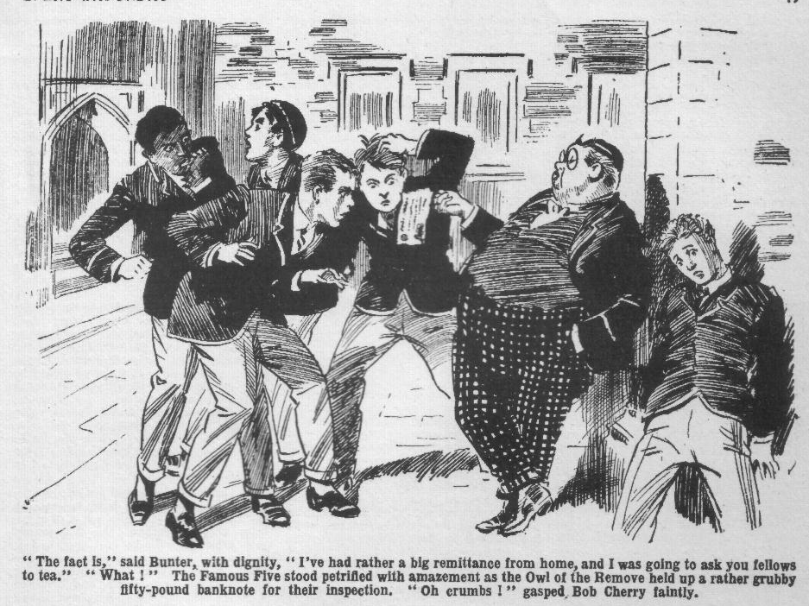
“Oh crumbs!” said Bob Cherry faintly.
“I’ve been to the school shop,” went on Bunter, blinking at the amazed juniors. “But Mrs. Mimble is an old fool, you know. She says she can’t change a fifty-pound note for a Lower boy. She says we ain’t allowed to have so much money, and the Head wouldn’t allow it. She says I’d better take it to my Form master and see. Well, I don’t want to take it to Quelch. He would be down on me like a ton of bricks. He was down on old Mauly when he found that he had forty pounds once—so he would be sure to kick up a fuss about this. But I’ve got to change it, you know!”
The Famous Five gazed at him speechlessly.
After their talk, only ten minutes ago, with Inspector Grimes, they saw a Greyfriars fellow in possession of a fifty-pound note!
If Mr. Grimes had been present at that moment they were well aware of what he would have thought.
“Bit awkward, isn’t it?” rattled on Bunter. “The pater never thought of that when he sent me this fifty-quid note. Of course, fifty pounds isn’t much to the pater—rolling in money, you know. But it’s rather awkward! Think I’d better take it down to the bank in Courtfield!”
Harry Wharton found his voice. “ Where did you got that banknote, Bunter?”
“ Oh, really, Wharton—”
“Where did you get it, you fat idiot?”
“That’s just what that beast Toddy asked!” exclaimed Bunter indignantly. “I say, you fellows, that beast Toddy actually made out that I’d pinched it. Me, you know!”
“Where’s the rest ? demanded Wharton.
Bunter blinked at him.
“The rest? What do you mean? I’ve only got one banknote, and that’s more than you ever get, Wharton—”
“You howling idiot! Where’s the rest of the loot, if you’ve found it?”
Bunter jumped.
“The—the—the loot?” he stuttered.
“ Yes, if you’ve found the loot—”
“ I haven’t found it!” yelled Bunter. “You know jolly well that you and Nugent found it, and you’ve got it somewhere—”
“Where did you get that banknote, then?”
“My uncle—I mean my pater—”
“Well, my hat!” said Bob Cherry, with a deep breath. “ So it was Bunter all along! We might have guessed it from the way he pinches a fellow’s tuck! But I thought even Bunter would draw a line at pinching money.”
“Why, you—you—you beast!” gasped Bunter. “Don’t I keep on telling you that this is a remittance from home—”
“Chuck it, you fat dummy!” howled Johnny Bull. “You’ve found the lost loot, and that banknote is part of it!”
“I haven’t!” shrieked Bunter.
“What have you done with the rest?” roared Bob Cherry.
“I don’t know anything about the loot! Think I’d keep it if I found it?” howled Bunter indignantly. “I believe you fellows have got it—”
“You—you—you—”
“As if I’d touch it!” gasped Bunter. “Why, you insulting beasts, I’d jolly well whop you, if—if—if I could! Making out that a fellow’s a thief! I don’t know anything about the loot, you rotters! Go and eat coke!”
“You fat duffler!” exclaimed Wharton. “Can’t you see—”
“Yah!”
“You’ve found it—”
“Beast—”
“That’s one of the stolen notes—”
“Rotter!”
“You howling ass, you must give it up at once! For your own sake—”
“Yah !”
“I tell you—”
“Beast!”
And Billy Bunter, crumpling the fifty-pound note into his pocket, rolled away, snorting with wrath and indignation, leaving the chums of the Remove rooted to the ground, in a state of utter consternation.
THE TWELFTH CHAPTER.
Smithy is Not Taking Any!
“SMITHY, old chap—”
Herbert Vernon-Smith was at tea with Tom Redwing, in Study No. 4 in the Remove. He picked up half a loaf from the table and took aim as Billy Bunter put a fat face in at the doorway.
Bunter dodged back.
“I say, Smithy—” he hooted from cover.
Really, it was hard lines on Billy Bunter!” Rolling in wealth, he was still being treated in the Remove like the impecunious Owl of old. Smithy had no doubt that the fat Owl had looked into his study at tea-time for tea. It was a natural supposition. But for once Bunter hadn’t!
“Shut that door!” snapped the Bounder.
“But, I say, old fellow, I haven’t come to tea!” roared Bunter. “I’ve come here because you’ve of lots of money, old chap.”
“Well, that’s candid, at any rate!” ejaculated Smithy, and Tom Redwing chuckled. “But I’ve got lots of sense to look after it, too, old fat slug! So roll away and don’t worry!”
“I’m not going to borrow any of your money, Smithy!”
“I’m taking jolly good care you don’t!” agreed the Bounder.
“What I mean is, I want you to change a banknote for me!” gasped Bunter, still in cover of the door. The Bounder still had the half-loaf in his hand, and Bunter knew that the Bounder’s aim was good. He had, as it were, been there before! “I say, Smithy, I’ve had a banknote from my uncle—I mean, my pater—and I can’t get it changed. I don’t want to take it to Quelch, because—”
“Because he might ask you whose it was?”
“Beast! Look here, old chap, I mean it!” Bunter emerged from cover and blinked in at the doorway. “If you can’t change the note let me have some thing on account, and the rest later. I’ll hand you the note at once.”
The Bounder stared at him. Bunter had drawn a slip of rustling crisp paper from his pocket. Smithy could not see the denomination marked on it, but could see that it was a banknote.
“My hat!” he ejaculated. “That looks like the goods! All right, old fat snail, I can change a fiver for you, if you like.”
“Tain’t a fiver, Smithy!”
“Great pip! Rolling in wealth— what?” said Smithy. “Well, I can change a tenner, if it comes to that.”
He slipped his hand into his pocket for his notecase. Smithy rather liked producing that notecase, wadded with currency notes. He was the only fellow in the Remove, except Lord Mauleverer. who could have changed a “tenner” on demand.
“I say, Smithy, it ain’t a tenner !“
“What? Don’t say it’s a ‘pony’ !” ejaculated Smithy; and he slipped his notecase back into his pocket.
It was not probable, but it was possible that Billy Bunter might possess a ten-pound note. But it was neither probable nor possible that he could possess a banknote for a larger amount than that.
“It’s fifty!” said Bunter.
“The pater’s shelled out rather decently this time, old chap.” said the fat Owl, blinking at him. “Of course, you can’t give me the whole lot; but, look here, give me ten quid on account,
see, and the rest later. I’ll let you have the banknote—don’t you worry!”
“I fancy I should worry an awful lot if I lot you give me a fifty-pound note!” chortled the Bounder, while Redwing stared at the fat Owl blankly. “What is it, you fat chump—a Bank of Elegance note, or what?”
“A Bank of England, you fathead!” answered Bunter. “ Look at it !”
The Bounder looked at it ! Redwing looked at it ! And their faces became very grave.
It had never even occurred to Bunter’s fat and fatuous brain that the fifty-pound note he had picked up in Friardale Wood was, or might be, a part of the missing loot from the Courtfield and County Bank. Why Harry Wharton & Co. had supposed so was a mystery—to Bunter!
The loot was, or was believed to be, hidden in the school, and there was a whole stack of it! Bunter had picked up a single note nearly a mile from the school! There was no connection— so far as Bunter could see.
But the other fellows jumped at the connection on the spot! Fifty-pound notes were too rare in the Lower School at Greyfriars not to cause some excitement.
Lord Mauleverer, who was a millionaire, might possibly have had a fifty-pound note of his own. Nobody else in the Remove was likely to possess such an article—not even the wealthy Bounder. Least likely of all was William George Bunter, who that very morning had been trying to “touch” Remove fellows for “bobs.”
Bunter had not found the lost loot! But every fellow who saw a fifty-pound note in his fat hands believed at once that he had. They could hardly believe anything else.
“You awful ass, Bunter!” said Redwing. “You’ll land yourself in fearful trouble! For goodness’ sake go to Quelch at once with that note!”
“He wouldn’t change it for me.” said Bunter, shaking his head. “He would make out that a Remove man couldn’t have so much money, you know! We ain’t allowed to, really! Quelch would be down on Smithy if he knew how much money he had, and Smithy hasn’t jolly well got fifty pounds!”
“Mad as a hatter!” said Vernon-Smith. “He really seems to think that fellows won’t know where he got that note.”
“For goodness’ sake, Bunter,” exclaimed Redwing, quite alarmed for the fatuous Owl, “take it to Quelch before it’s too late. Tell him where you found it, and where to find the rest.”
“You’ll never like skilly.” said Smithy. “That’s what they give you in chokey, Bunter!”
Billy Bunter blinked at the chums of Study No. 4. There was wrath and indignation in his fat brow.
“That’s what that beast Wharton said!” he exclaimed. “Making out that a fellow would pinch a banknote! Look here, Smithy, will you change this banknote for me, or won’t you?”
“No jolly fear!” chuckled the Bounder. “I don’t want to go to Borstal along with you, Bunter! The receiver’s as bad as the thief, you know.”
“Beast!”
Bunter clutched his banknote and rolled to the door. The Bounder laughed; but Redwing jumped up.
“Look here, Bunter—”
“Go and eat coke, you cheeky rotter!” snorted Bunter. “Don’t grab hold of me, you beast! Leggo!”
Redwing caught him by a fat shoulder.
“Don’t you understand that you can’t keep that banknote, Bunter ?” he exclaimed. “ If you’re found with it you’ll be arrested.”
“Oh, don’t be a silly ass!” snapped Bunter, and he jerked his shoulder away and rolled out of Study No. 4.
“Ha, ha, ha!” roared the Bounder. “We’re going to see the last of Bunter soon!” So it was Bunter found the loot, after all!”
“Looks like it.” said Tom. “But it’s not a laughing matter, Smithy ! The howling idiot doesn’t seem to see that it’s stealing——”
“None so blind as those who won’t see!” grinned Smithy. “ But it rather beats me why he’s kept it dark so long. He must have got hold of that loot a week or more ago; but I haven’t seen him with whacking big banknotes till to-day! And he thinks that fellows are going to believe that he got a fifty-pound note from home! Ha, ha, ha!”
The Bounder roared.
But Redwing did not laugh. He could not derive cynical amusement from the matter as Smithy did.
Billy Bunter rolled away, angry and indignant. Other fellows might be alarmed for Bunter; but he was not alarmed for himself. Other fellows might think that that fifty-pound note was a part of the lost loot; Bunter did not think so. What worried Bunter chiefly was the difficulty of getting the banknote changed! Immense quantities of tuck were represented by that slip of engraved paper; and Bunter was hungry! Hungry, and with a banknote for fifty pounds in his possession—a larger sum than most of the juniors had ever possessed And Billy Bunter was not aware—yet—that the luckiest thing that could possibly have happened to him was that very difficulty of getting the banknote changed!
THE THIRTEENTH CHAPTER.
Bunter’s Banknote!
“HERE he comes!”
“Here’s the jolly old burglar!”
“‘Ware coppers, Bunter!”
“Ha, ha, ha!”
There was a crowd of fellows in the Rag, and all eyes were turned on Billy Bunter as he rolled in.
Some of the fellows looked grave. Others seemed amused. All of them gave Billy Bunter their attention.
Bunter blinked at them morosely through his big spectacles.
Bunter was not enjoying life.
When he had picked up that banknote in the wood, and decided that “ findings were keepings,” the fat Owl had envisaged a series of glorious spreads.
But that dazzling vision had not been realised.
Mrs. Mimble, at the school shop, had refused to touch the banknote, and there had been a suspicious gleam in her eye, too, when she advised Bunter to take it to his Form master. For reasons of her own—probably good reasons—Mrs. Mimble would not even extend credit to Bunter on the strength of that banknote. The impecunious Owl was never a very welcome customer in the tuckshop; but, strange to relate, he seemed less welcome than ever with a fifty-pound note in his possession
Nobody in the Remove could, or would, change that note for Bunter! Nobody would advance him anything on it. Every fellow who saw it jumped to the conclusion that it was Bunter, after all, who had found the missing loot!
With fifty pounds in his pocket, Billy Bunter had had to “tea” in Hall! “Dishwater and doorsteps” were his portion, while he possessed such a sum as he had never possessed before! That was the unkindest cut of all!
Neither could Bunter understand the attitude of the Remove fellows. He knew, if they didn’t, that he hadn’t found the lost loot! He had expected surprise, admiration, envy, jealousy, when that banknote was displayed; but he certainly hadn’t expected this! Had Bunter found the lost bag of loot, even his fatuous and obtuse brain would have realised that “findings” were not “keepings” in such a case. The Removites really were misjudging Bunter—though undoubtedly he was asking for it.
All the Remove had heard of the banknote by this time. Such news was not likely to take long in spreading. The “lost loot” was still a live topic in the school; and no one doubted now that the lost loot had been found, and that William George Bunter was the finder.
“Mind you don’t go down into the kitchen, Bunter!” yelled Skinner.
“Eh! Why not?”
“There’s a copper in the kitchen!” explained Skinner,
“Ha, ha, ha!”
“Have you still got that banknote, Bunter?” asked Harry Wharton. The Famous Five had been in rather anxious consultation on the subject.
“Yes, old chap—I can’t get it changed.” said Bunter. “The bank’s closed now; I shall have to take it down to Courtfield to-morrow.”
“You’re going to take it to the bank at Courtfield!” roared Bolsover major. “The same bank that it was pinched from!”
“Oh, really, Bolsover! I keep on telling you fellows that this banknote is a birthday present from my uncle—”
“Did your uncle hold up the bank at Courtfield?” asked Skinner.
“Ha, ha, ha!”
“Is that fat idiot absolutely potty?” asked Lord Mauleverer in wonder. “Does he really think he can keep the loot now he’s found it?”
“Goodness knows what he thinks, with a brain like his!” said Peter Todd. “He will wake up when old Grimes taps him on the shoulder!”
“We shan’t hear Bunter snoring in the dorm to-night!” remarked Skinner. “They’ll have that pleasure at Courtfield Police Station!”
“Beast!” roared Bunter.
“All Greyfriars will know about that jolly old banknote before dorm.” grinned the Bounder. “Old Grimes will soon get on to it. Bunter will be run in to-morrow morning at the latest.”
“We’re not letting it come to that!” said the captain of the Remove. “If Bunter hasn’t sense enough to hand over that banknote, he’s going to be made to. Are you going to take it to Quelch, Bunter?”
“No!” roared Bunter.
“Then we’ll jolly well take you by your silly ears and walk you off to Quelch’s study with it!” said the captain of the Remove. “If you don’t know the difference between honesty and dishonesty, you fat villain, it’s time you learned.”
“You rotter!” yelled Bunter in great indignation. “Thank I’d pinch any of the loot if I found it? You fellows might! In fact, I believe you jolly well have! I’m not that sort, I hope!”
“Oh crikey!” gasped Bob Cherry.
“Don’t you know that it’s part of the loot, you frabjous owl?” roared Wharton. “Haven’t you the sense of a bunny-rabbit?”
“I know it jolly well isn’t, you silly fathead!” retorted Bunter.
“The loot’s hidden about the school somewhere, and this banknote has nothing to do with it. How could it have got a mile from the school if it was in the bag of loot?”
“What! Did you pick up that banknote a mile from the school?” exclaimed Wharton blankly.
“Well, Friardale Wood is nearly a mile.” said Bunter. “Not that I found the note there,” he added cautiously; “it came in a registered letter from my Uncle Herbert this morning.”
“You never had a registered letter this morning, you fat owl.”
“I—I mean yesterday—that is, the day before—you see, it’s my birthday.” explained Bunter. “I always get a jolly good tip from my Uncle Reginald on my birthday.”
“How many birthdays do you have in a year?” inquired Skinner. “You’ve had one already, you know.”
“Ha, ha, ha!”
“Oh!” gasped Bunter. “I mean—”
“We know what you mean.” chortled Skinnor. “You mean to stick to the loot till old Grimey drops a hand on your shoulders and says ‘Kummerlongerme.’ ”
“Ha, ha, ha!”
“I—I mean, it wasn’t exactly my birthday.” stammered Bunter. “What I mean is, my Uncle Arthur meant to send it on my birthday, but he sent it on later, see? And—and so I got it yesterday—I mean the day before! If you fellows don’t believe me —”
“Believe you!” gurgled Bob. “Oh, my hat!”
“The believefulness is not terrific.”
“As for finding it in the wood,” went on Bunter, “I didn’t, of course. I wasn’t in the wood—I never went there to keep away from Temple—you fellows can bear witness to that as you saw me going—”
“Oh, my only hat!”
Temple of the Fourth can tell you that I wasn’t there. He was rooting all over the place for me.” said Bunter. Besides, I shouldn’t have hidden because Temple was after me. I should have whopped him. I never saw the banknote lying there, and never picked it up. And besides that, findings are keepings. Nobody would ever have found that banknote lying about among the grass and roots.”
“You found it in Friardate Wood!” gasped Wharton. “Blessed if I understand! Wasn’t it in a bag with the rest?”
“No!” roared Bunter. Just that note by itself—crumpled in the roots! I—I—I mean, it—it wasn’t there, and—and I wasn’t there, and—and I never saw it. The actual fact is that it came by registered post the day before yesterday, with a letter from my Uncle George, and I’ve got the letter to show you, if you don’t believe me. Perhaps you’d like to see the letter from Uncle George ?” sneered Bunter, blinking at the staring Removites.
“Oh, Christopher Columbus!” gasped Bob Cherry. “I think I’d rather like to see the letter that came with a banknote lying in the roots in Friardale Wood!”
“Ha, ha, ha!”
“WelI, here’s the letter—no, I remember now I left it in my study. But it’s from my Uncle Joseph.”
“If Bunter picked up that banknote in Friardale Wood, it looks as if the loot isn’t parked in the school at all, and Grimey is a silly old ass.” said Bob Cherry. “lt’s part of the loot—that’s certain. It can’t be anything else.”
“Anyhow, the sooner Bunter hands it over to Quelch, the better,” said Harry Wharton. “I’ll come with you and see you do it, Bunter.”
“Yah!”
“And if you won’t come, I’ll take you by your collar, you fat idiot! We’re not going to have Remove man run in by the police.”
“Beast!”
Harry Wharton made a stride towards the Owl of the Remove. Billy Bunter blinked at him for a moment, and then made a bolt for the door.
“Collar him!”
“Stop him!”
“Bag him!”
There was a rush after Bunter.
The fat junior tore out of the Rag at top speed. Bunter did not want that banknote to meet the gimlet eyes of Henry Samuel Quelch. He did not believe that it was part of the lost loot. But he had no hope, none whatever, that his Form master would agree with him that findings were keepings. He charged out of the Rag in hot haste, with the juniors whooping after him.
Crash!
Bump!
“Mon Dieu!” shrieked Monsieur Charpentier, as Bunter established contact with his waistcoat, and he reeled from the shock. “Mon Dieu! Vat is zat? Vy for you rush at me, Buntair? Oooogh! I am knock over! I am wind! 1 have no more ze breff!”
“Oh crikey!” gasped Bunter.
He dodged round the French master and fled. The pursuers came to a sudden halt. Monsieur Charpentier spluttered and gasped and waved his hands at them. Harry Wharton & Co. retreated into the Rag. The banknote, for the present, had to be left in Billy Bunter’s possession. And Billy Bunter was the only fellow who did not know that he was in dire danger of passing that night in Courtfield Police Station, instead of the Remove dormitory.
———
THE FOURTEENTH CHAPTER.
Driven to the Wall!
ARTHUR CARNE threw himself wearily into the armchair in his study. He was tired out, dispirited, his nerves on the jump. For hours, in the hot July afternoon, he had rooted and rooted through the thickets and brambles in a wide radius round the old beech-tree in Friardale Wood. He had not been successful; and he had given up hope of success.
It had seemed to him when he threw the fifty-pound note away to save it from his assailants, that it would need only a patient search to find it again. No doubt that was the case. His close and careful search would probably have unearthed the banknote, had it been still there to be unearthed. Possibly it had fallen into some obscure nook where it had escaped his searching eyes. Possibly some tramp wandering in the wood had found it, and taken it. At all events, it was clear to him that he could not find it.
He sat, aching with fatigue, trying to think the matter out till his brain seemed to spin.
Now that he had had time to reflect, ho knew that Mr. Banks had been alarmed, and he realised that he had nothing more to fear from that disreputable sporting gentleman. Banks would wait, and next term he would be able to get clear of Banks. On that subject his mind was relieved. He was no longer worrying about Banks. But one problem had gone, only to leave another in its place. What was he to do with the bag of loot, hidden from sight under the screwed down board in his study floor?
Had the loot been still intact, had he never yielded to that mad temptation to “ borrow” one of the notes, had he been able to replace the fifty-pound note after Mr. Banks had returned it to him, all would have been well. He could have taken the green-leather satchel, with its contents, and dropped it somewhere—to be found later. And everyone would have supposed that where it was found was where it had been left by the bank robber. No one would have known that the contents had been meddled with.
That was impossible now.
If a single note was missing, the wretched matter would not come to an end. The recovery of the £6,950 would not end the matter. Inspector Grimes was hunting for £7,000, known to be contained in the green-leather satchel. He believed that there was a thief at Greyfriars who had the loot, and he would be confirmed in that belief by the loss of one of the notes.
But it was not of Mr. Grimes that Carne was thinking chiefly. The strange happening in the wood had terrified him to the marrow of his bones.
Two men, evidently crooks, and in the gang of which Jerry the Rat had been a member, knew that he, Carne, had the loot. How they knew it was a mystery—an impenetrable mystery to Carne. But they knew it—there was no doubt about that.
If they were arrested—and their arrest might happen any day—and told what they knew—what would happen then?
And if they were not taken, they would keep on questing for the loot. And instead of concentrating on Study No. 1 in the Remove, as before, they would concentrate on Carne.
He was in danger from them. Only his intense anxiety to find the lost banknote had nerved him to venture out of gates that day. He had seen nothing of them. They might have taken the alarm, and kept clear for a time, but sooner or later they would be after him again. He was in constant danger until the loot was found.
They would watch for him leaving the school, and if he remained within gates, sooner or later they would come. They would find out which was his room, and they would come. The rascals had proved already that they cared little for risks, in their search for the booty. Already, perhaps, some of the gang were spying and prying, finding out where to get at him in the House. That very night, perhaps—
He shuddered.
He had to let the loot be found, and the sooner the better. But if it was found with a single note missing, that would prove that it had passed through thievish hands since Jerry the Rat had left it there. Search would continue—for the fifty-pound note that was missing. If only he had been able to replace that wretched note! He realised that his thoughts were following a circle.
He gave violent start as a tap came at his study door, and it opened. His nerves were in rags. He would not have been surprised had the opening door revealed the steely eyed man who had searched him in the wood, or the portly figure of Inspector Grimes, with a warrant for his arrest. But it was only Loder of the Sixth who stepped into the study, and Carne panted with relief.
He tried to pull himself together, but he knew that his face was ghastly, and that his bands were trembling.
Loder closed the door carefully, came across the room, and seated himself on the corner of the table facing Carne. The expression on his face was grave. Carne stared at him without speaking.
“I’ve come here to speak plainly, Carne,” said Loder, in a low voice. “I’ve given you some hints already.”
“What do you mean?” muttered Carne, with dry lips.
“You know what I mean. I’ve told you before that I knew you were searching for the bag of money that bank thief parked in the school. Since then it’s been found, and taken from the place where that rogue hid it. All Greyfriars knows that.”
Carne did not speak.
“I saw the Head squinting at you in the Form-room this morning,” went on Loder. “And I’ve heard Hacker speaking about you to another beak. All the Sixth wonder what’s up with you. Nobody guesses—yet. How long do you think it will take them to guess, at this rate?”
“You—you rotter!” Carne’s voice cracked. “You—you dare to insinuate that—”
“Don’t be a fool!” said Loder roughly. “I’m speaking as your pal. Banks has got you under his thumb; but Banks isn’t as bad as a bobby with a pair of handcuffs. I know what you’ve done—Walker knows, too—and I fancy one or two other fellows know. I saw Price and Hilton of the Fifth looking at you in the quad yesterday and whispering together.”
Carne’s heart seemed to miss a beat.
“Your nerves are gone to shreds.” went on Loder. “You’re givin’ yourself away pretty thoroughly, Carne. I knew you were hunting for the loot, but I never thought you’d get your hands on it, because I didn’t believe that it was here at all. Since then, it’s turned out that it was here—and that it’s been found and kept dark. Do you think I can’t put two and two together?”
“You—you rotter!” breathed Carne.
“Cut that out! That loot’s got to be found.” said Gerald Loder. “Some fellow has it, and is keepin’ it dark! That fellow’s got to put it where the police can pick it up! Otherwise—”
“Well?” muttered Carne.
“Otherwise,” said Loder very distinetly, “you may be called upon to explain why you’ve screwed down that board in the corner of your study, where you used to keep your cigarettes, and why you’ve shifted your desk from the window, where it used to stand, to put it over that very spot.”
Carne leaned back in the chair, hardly breathing. It seemed to hirn, for the moment, that he was going to faint.
Loder slipped from the table.
“That’s what I came to say.” he said. “I’ve said it. I don’t want to see a pal sacked from this school. Take my tip, Carne, and do the sensible thing. I’m sayin’ nothin’—if the loot’s found! But I’m not standin’ in with a fellow who may be nobbled by the police any day—and you can’t expect me to! There’s a limit—and that’s the limit.”
Without waiting for an answer Loder of the Sixth left the study, and shut the door after him.
For long, long minutes Carne did not stir.
Terror chained him where he sat.
But he moved at last. He had not been able to decide—his dizzy, tormented mind had failed to grapple with the problem. But he knew now that it had been decided for him. When he rose from the armchair he locked the door, took a screwdriver from his desk, dragged the desk aside, and kneeled over the board in the corner.
Ten minutes later Arthur Carne left his study. And, stuffed in an inside pocket of his coat was something which, had it been discovered there, would have sent Carne of the Greyfriars Sixth to join Jerry the Rat.
THE FIFTEENTH CHAPTER.
At Last!
“I SAY, you fellows—”
“You fat chump—”
“Look here,” gasped Billy Bunter. “You mind your own
bizney, see?”
“I tell you—”
“‘Ware prefects!” murmured Bob Cherry.
The Famous Five had been looking for Billy Bunter, and they had found him in the quad. They gathered round him with grim looks that alarmed the fat Owl. Bunter’s podgy fingers clutched the banknote in his pocket, and he blinked at the chums of the Remove with mingled wrath and alarm and indignation.
It was, in Bunter’s opinion, sheer cheek of those fellows to butt in. It was no business of theirs, anyhow. But Harry Wharton & Co. could not help feeling that it was their business to save the egregious Owl from himself, as it were. That banknote had to be handed over, and they were going to see that Bunter handed it over, before worse befell him.
Carne of the Sixth, coming away from the house, passed near the group of juniors. And the Famous Five, about to collar Bunter, had to leave him uncollared. They did not want to draw a Sixth Form prefect’s attention to the state of affairs.
“You fellows mind your own bizney!” said Bunter warmly. “ This paltry jealousy of a wealthy fellow—”
“You benighted idiot!” hissed Johnny Bull.
“Yah! You sheer off, or I’ll jolly well yell to Carne!” said Bunter.
“You born dummy!” If a prefect sees that banknote, he will make you take it to the Head at once!” said Harry Wharton.
“Yah!”
With that elegant remark Billy Bunter rolled away, and he rolled in the direction Arthur Came had taken. He felt safer under the wing of a prefect.
“Well, my hat!” said Nugent. “ The potty porpoise is determined to ask for it! As soon as the beaks hear that he’s got fifty pounds —”
“The burbling idiot!” said Bob. “ The benighted bandersnatch! He will get sacked for this, even if he isn’t run in!”
“Serve him right!” growled Johnny Bull.
“Well, we don’t want a Remove man run in.” said Harry Wharton, “and that howling ass doesn’t understand. We’ll bag him at call-over.”
And, for the present, the Famous Five left the fatuous Owl to his own devices, and went down to Little Side for some cricket practice. Billy Bunter rolled after Carne, who was taking the direction of the old Cloisters. So long as there was a prefect in the offing the fat Owl astutely considered that he was safe from those cheeky, meddlesome rotters who couldn’t leave a fellow in peace with his own banknote. But as Arthur Carne approached the old Cloisters, he glanced round and spotted Bunter, and the fat junior was quite startled by the sudden, furious expression that came over his face.
Carne gave him one look, and came striding back at him.
Smack!
“Yarooooh!” roared Bunter, as a hefty smack on the side of his bullet head made him stagger.
Smack!”
A similar smite on the other side righted him again.
“Yooooop!” yelled Bunter.
And he bolted! Even Harry Wharton & Co. were better than this!
Why Carne of the Sixth smote him so unexpectedly and savagely, Bunter did not know, but he knew he did not want any more. His fat little legs fairly flashed as he fled.
Carne stared after him, with a black brow, and then went into the Cloisters. He was breathing in gasps.
The thought had been in his mind that the fat junior was spying on him—spying on him, when he was seeking a secluded spot to get rid of the burden that made his life a nightmare. His nerves were in rags. Spying or not, Bunter had vanished now, and Carne went into the dim old Cloisters.
There he paused.
He had thought of going outside the school precincts to conceal the bag of loot in some place where it might be found. But he realised that he dared not if he was watched for—if the two crooks who had seized him in Friardale Wood were at hand again—he trembled at the thought of falling in with them while the money was on him. He dared not take a step outside the walls of Greyfriars School with the green-leather satchel concealed in his pocket.
He was feverishly anxious to get rid of it. But where? In some obscure corner behind one of the old stone pillars of the Cloisters—it could not fail to be discovered there before very long. He moved along the Cloisters, towards the old wall that bordered the fir plantation—the spot where Jerry the Rat had entered on the day of his flight from the police. A scent of cigarette smoke came to him, and he started. His hand was already in his pocket to draw out the satchel, but he let it go, as if it had suddenly become red-hot. Someone was there!
He saw who it was the next moment. Leaning on the wall, screened by an old pillar, were Skinner and Snoop of the Remove, with cigarettes in their mouths!
“Oh gum!” gasped Snoop, as he saw Carne.
“Oh!” gasped Skinner.
The two young rascals had retired to that secluded spot for a quiet smoke. The cigarettes dropped from their mouths as they stared at Carne. They were startled by the expression on his face. Carne was shaking from head to foot, and, alarmed as they were, they could see that he was more alarmed. But for the scent of smoke that had warned him, the green-leather satchel would have been in his hand, in full view, as he came on Skinner and Snoop.
“You—you young rascals !“ Carne’s voice was husky and cracked. “Get out of this! I shall report you to your Form master!”
Skinner and Snoop got out of it in haste.
Carne leaned on the stone pillar as their footsteps died away, white and trembling. It was long minutes before he moved again. If they had seen the green-leather satchel—
His narrow escape almost dazed him.
That bag of loot, for which so many were seeking, seemed to the wretched Carne like some intolerable burden of which he could not get rid.
He gave up the idea of dropping it behind one of the Lone pillars. It must not be found too soon—not soon after he had been seen there! He listened intently. There was no sound—he had the place to himself at last. But he was in terror every moment of hearing a footstep.
He moved along the old wall at last. He remembered that in one spot, where a great mass of ivy grew, there was a cavity in the ancient wall hidden by the ivy. He had hidden cigarettes there long ago, when he was a fag in the Third Form. He remembered it now. Stepping on tiptoe, with guilty glances over his shoulder, he approached the spot and drew the thick cluster of ivy aside.
His hand went to his pocket. The perspiration was clotted on his brow. Alone as he was, safe from observation, he hardly dared draw the green-leather satchel out.
From the distance, in the direction of the quad, came the sound of a footstep!
In desperation Carrie dragged out the bag of loot, thrust it into the cavity in the wall, and let the cluster of ivy fall back into its place.
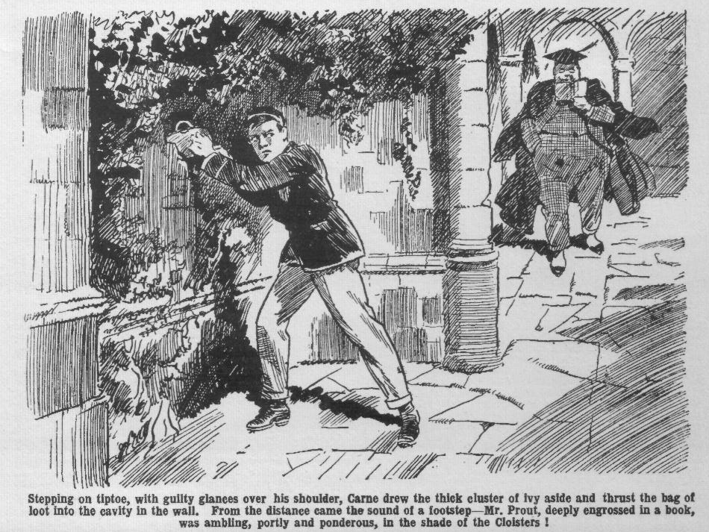
He hurried away, his heart beating in jumps.
A minute later he passed Mr. Prout, ambling, portly and ponderous, in the shade of the Cloisters. The Fifth Form master glanced at him curiously, noting the pallor of his face.
Carne hurried on.
Bunter, Skinner, Snoop, and now old Prout, had seen him there! But the hidden loot would not be found soon; when it was found no one would connect it with him. Sooner or later it would be unearthed. Likely enough, more than one Lower boy knew of that hiding-place behind the ivy—some young rascal might even hide smokes there, as Carne himself had done once upon a time. Sooner or later the loot would turn up—there was no doubt about that. And he would not—he could not—be suspected. In two or three days, perhaps!
It seemed to Carne that a mountain had been rolled from his mind. He was not a thief—he had done all he could. And now, at all events, he was clear of that nightmare! He was a good deal like his old self when Loder of the Sixth dropped into his study that evening.
Loder smiled sarcastically as he saw that Carne’s desk stood in its old place by the window.
“Got a smoke, old man?” he asked.
Carne nodded coolly. “
“You know where to find them.” he drawled.
Loder crossed to the corner and lifted the loose board. It was loose again now, though the screw-holes could be seen. Loder helped himself to a smoke from the hidden store, and gave Carne a nod and strolled out of the study. Nothing was said; but Loder knew that his “tip” had been taken.
THE SIXTEENTH CHAPTER.
Minding Bunter’s Business!
“ADSUM!”
Billy Bunter squeaked in answer to his name, when Mr. Quelch called the roll in Big Hall.
Nearly every fellow in the Remove was looking at Bunter, and the fat Owl was feeling extremely uneasy.
He had had to turn up for call-over, but in the midst of the Remove he was feeling a good deal like Daniel in the den of the lions.
He feared, and with good reason, that after call-over he would not be allowed to disappear again.
That £50 note, which had seemed such a boon and a blessing to Bunter, really seemed to be turning out more trouble than it was worth.
Fellows, it seemed, could not mind their own business on that subject. They were going to make the fat Owl “cough up” that banknote, as Bob Cherry expressed it.
Billy Bunter was far from realising that it was rather fortunate for him that the fellows would not mind their own business on that subject. As he could not get that banknote changed in the school, it was the fat Owl’s intention to take it to the bank at Courtfield on the morrow and ask for change.
What would happen to Bunter when he presented the banknote at the very bank from which it had been taken by a hold-up man was really awful to think of!
Billy Bunter expected to roll back to Greyfriars stacked with pound-notes and ten-shilling notes to the value of £50! All the other fellows expected that he would be detained at the bank while the police were sent for, and it was improbable that he would be allowed to return to Greyfriars at all.
It was, as Skinner remarked humorously, Borstal for Bunter!
Bunter was the only fellow who did not know it.
In these circumstances it was not likely that the other Remove fellows would mind their own business, as Bunter so earnestly desired.
So far from minding their own business they had their eyes on Bunter at call-over, and obviously intended to bag him when they left hall. He heard Harry Wharton whisper to the Co.:
“ Bag him as we go out, you men!”
“You bet!” murmured Bob Cherry.
“The bagfulness will be terrific.” grinned the Nabob of Bhanipur.
Billy Bunter gave the chums of the Remove a devastating blink through his big spectacles.
Mr. Quelch continued to call the roll. But every now and then his gimlet-eye glittered at the Remove. He was aware that something rather unusual was “on” in his Form. But he was very far from guessing what it was!
The school was dismissed at last, and immediately he reached the door Billy Bunter bolted.
There was a rush of feet after him.
“ Collar him!”
“Bag him!”
Hands gripped Bunter by either fat arm. Harry Wharton took him on one side, Bob Cherry on the other.
“Now, you fat Owl!” said the captain of the Remove.
“Beast!”
“Come on, old fat bean!” said Bob. “We’re taking you to see Quelch when he goes to his study!”
“Leggo!” yelled Bunter.
The two Removites did not let go. Billy Bunter was walked away with an iron grasp on his arms. He spluttered with indignant wrath.
“ I say, you fellows, if you don’t leggo I’ll jolly well lick you!” he gasped. “ I mean it!”
“Ha, ha ha!”
“ I’m jolly well not going to Quelch! I’m not going to show him my banknote! He—he mightn’t believe that it came from my Uncle Montague at all! Quelch has doubted my word before, as you know.”
“The knowfulness is terrific.” chuckled Hurree Jamset Ram Singh.
“You’re going to Quelch!” said Harry, “and you’re going to tell him where you got that fifty-quid note! Understand?”
“Shan’t!” howled Bunter.
“And you’d better tell him the truth.” said Johnny Bull. “It’s the only way to save your bacon.”
“I should tell him the truth if I told him anything, of course.” said Bunter. “I hope you don’t think I’m untruthful, like you chaps! I should tell him plainly that it came from my Uncle Rupert—”
“Oh, my hat!”
“Only, you see, we ain’t allowed to have such sums of money in the Remove.” explained Bunter. “That’s why I don’t want Quelch to see it. He would make me send it back to my pater—I mean my Uncle George—that is to say, my Uncle Montague—”
“You owl, he will ring up old Grimes to take it!” said Harry Wharton. “Can’t you get that into your silly head?”
“Beast!”
Billy Bunter wriggled in the grasp of the fellows who could not mind their own business, but persisted in minding Bunter’s. He wriggled and squirmed, but there was no escape for the fat Owl. The Famous Five had him fast, in a window recess near Masters’ passage, while Nugent kept an eye on that passage after Mr. Quelch. Ten minutes later the Remove master was seen to go to his study.
“All serene!” called out Frank. “Quelch has gone in! Bring him along!”
“Come on, Bunter!”
“I say, you fellows—”
“Come on, you blithering idiot!”
“Beast! Leggo!” roared Bunter.
“Hook him along!” said Bob.
The reluctant Owl was hooked along into Masters’ passage. He wriggled and squirmed his way down that passage towards Mr. Quelch’s study door, in the grasp of Wharton and Bob Cherry.
“You—you—you rotters!” wailed Bunter, as they arrived at the door. “I tell you I ain’t going in to Quelch! He—he—he wouldn’t understand that findings are keepings, you know. You know what silly asses these schoolmasters are!”
“Tap on the door, Franky! Now, then, Bunter, this is your last chance! Will you walk in or be chucked in?”
“Oh crumbs! Beast! I—I say, you fellows, chuck it!” implored Bunter. “I’ll tell you what—I’ll lend you a quid each out of my banknote when I get it changed! There!”
“Roll him in!”
The fat Owl was propelled towards the study door.
“Beasts!” he gurgled. “Leggo! I—I—I’ll walk in!”
“Go it, then!”
Frank Nugent tapped at the study door. Billy Bunter was released, to walk into the study. He approached the door as Mr. Quelch called out “Come in” from within. Then the fat Owl spun round suddenly and made a desperate rush up the passage to escape.
“Bag him!” yelled Bob.
Crash!
Harry Wharton went over as he received Bunter’s charge. He roared and sprawled. Hurree Jamset Ram Singh made a swift clutch, and caught Bunter by a fat ear. That ear was large enough to give a good hold, and the dusky junior gripped it hard.
“Yaroooh!”
Billy Bunter spun round like a fat humming-top. He stumbled over Wharton and joined him on the floor.
“Whooooop!”
“Oh, my hat!”
“Yarooooh!”
“You silly chump——”
Mr. Quelch’s door opened, and the Remove master looked out, with thunder on his brow.
“What—” he began.
“Wow-ow-ow! Leggo my ear!” yelled Bunter. “I won’t go to old Quelch, I tell you! Blow old Quelch! I say, you fellows——”
“Bunter!”
“Oh lor’ !” gasped Bunter. He sat up on Harry Wharton. “Oh, I—I didn’t see you, sir! I—I wasn’t calling you old Quelch, sir——”
“Gerroff!” gasped Wharton
Bob Cherry and Johnny Bull dragged the fat Owl off Wharton.
The captain of the Remove scrambled up breathlessly.
“What does this mean?” thundered Mr. Quelch. “What does this riot outside my study mean
“Oh,” stuttered Wharton, “we—we were bringing Bunter to see you, sir! Bunter’s got something to tell you—”
“I haven’t!” yelled Bunter.
“Bunter—what——”
“I—I haven’t anything to tell you, sir!” spluttered Bunter. “Nothing at all, sir! I haven’t got a fifty-pound note, and I never found it in the wood!”
“What?”
“It was a birthday present from my Uncle Cuthbert, sir! I never found it! Besides, I haven’t got it.”
“Bunter, come into my study!”
“Oh lor’ !”
Mr. Quelch’s hand fell on Bunter’s collar, and the fat Owl was jerked into his Form master’s study. Harry Wharton & Co. looked at one another. Then they departed. It was up to Quelch now.
THE SEVENTEENTH CHAPTER.
A Paintul Parting!
BILLY BUNTER stood before his Form master, quaking.
Never had Henry Samuel Queleh’s gimlet eyes seemed so much like gimlet as at this moment. They really seemed to be boring into the hapless Owl.
“Bunter!” said Mr. Quelch, in a deep voice.
“Oh crikey!” said Bunter.
“You have a banknote of large denomination in your possession ?”
Billy Bunter opened his lips for a reply in the negative. But that reply died on his lips. Under those penetrating gimlet eyes his fat heart failed him.
“Yes, sir!” he gasped.
“Place it on my table.”
Billy Buniter suppressed a groan. That dazzliug vision of a series of gorgeous feeds vanished from his gaze like a beautiful dream! It was borne in upon his fat mind that this was the last he was going to see of his fifty-pound note.
Slowly, reluctantly, he drew the crumpled banknote from his pocket and laid it on his Form master’s table.
His eyes and his spectacles lingered on it. But he realised only too clearly that his fat fingers would never touch it again. Quelch was only too certain not to understand that findings were keepings!
Mr. Quelch looked at the banknote! He gazed at it! He stared at it ! The ghost of a banknote could not have produced a more startling effect on the master of the Remove.
All through Greyfriars it was rumoured that some unknown fellow had found the lost loot and kept it. Mr. Quelch had rejected the idea with scorn. Still more scornfully would he have rejected the idea that the purloiner was a member of his own Form! But he knew that he was gazing at a part of the holdup man’s loot from the Courtfield and County Bank. There was a terrifying expression on his face when he turned his gimlet eyes on Bunter again. The Owl’s fat knees knocked together.
“Where did you obtain this banknote, Bunter?”
Mr. Quelch’s voice was like the rumble of thunder.
“I—I found it, sir!” gasped Bunter.
“When did you find it?”
“This afternoon, sir.”
“Where are the other banknotes?”
“There weren’t any others, sir!” groaned Bunter.
“Boy!”
“Oh lor’! I—I swear there weren’t any others, sir!” groaned the wretched Owl. “Only just this one, sir!”
“This,” said Mr. Quelch “is one of the banknotes that were stolen from the Courtfield and County Bank. There can be no doubt on that point. You were aware of that, Bunter.”
“Ow! No!” howled Bunter. “That’s what those beasts—I mean, those fellows —were saying. They all think so, but it ain’t, sir! I—I picked it up in Friardale Wood, and there was only this one!”
Mr. Quelch searched his terrified fat face. He could see that Bunter was telling the truth now; the wretched Owl was too terrified to do anything else.
“Tell me exactly where and when you found this banknote, Bunter.”
The miserable Owl babbled it out.
Mr. Quelch listened very attentively.
“And why, Bunter, have you kept this banknote, which was not your property, in your possession so long?”
“Fuf-fuf-fuf—”
“What?”
“Fuf-fuf-fuf-finding’s keeping, sir!” gurgled Bunter.
“Bless my soul! Is it possible, Bunter, that you were so unscrupulous as to intend to keep this banknote?” exclaimed Mr. Quelch.
“I—I—I—” Bunter’s voice trailed off.
“You may be deeply thankful, Bunter, that other boys in my Form forced you to bring this banknote to me.” said Mr. Quelch. “Had it been found m your possession you would have been arrested by a constable—”
“Oh crikey!”
“As the matter stands, I can deal with you myself.” said Mr. Quelch. “Fortunately, very fortunately, it has not passed out of my hands. You will remain here for the present, Bunter. You may sit down.”
Bunter fell rather than sat in a chair, while Mr. Quelch crossed to the telephone and rang up Courtfield Police Station. The fat Owl listened in quaking terror till the Remove master rang off. Mr. Quelch sat down at the table and began correcting a pile of papers, taking no further notice of the unhappy Owl. He was waiting for the arrival of Inspector Grimes; and Bunter waited, too, in a state of palpitating funk.
It was half an hour before the sound of a taxi was heard. It seemed like half a century to the Owl of the Remove.
Then Mr. Grimes was shown in by Trotter.
“C-can I go now, sir?” groaned Bunter.
“Silence!”
“Ow!”
In quiet tones Mr. Quelch explained to the Courtfield inspector, who looked at Billy Bunter with an expression in his eyes that almost made the fat junior’s flesh creep.
Mr. Grimes took the fifty-pound note, and consulted a list of numbers which he took from his pocket-book.
“This is one of the stolen notes, sir.” said Mr. Grimes. “I have all the numbers here,”
“Quite so,” said Mr. Quelch, “and as it was picked up in Friardale Wood, in a spot this boy can describe to you, no doubt a further search in the same place will reveal the remainder of the plunder.”
“Um!” said Mr. Grimes dubiously.
“There has been some suggestion,” added the Remove master, with a faint touch of sarcasm, that the bank robber’s plunder was still concealed somewhere in this school. Obviously that cannot be the case, as this bank note was found a mile from Greyfriars.”
“Um!” said the inspector again. “With your permission, sir, I will question this boy.”
“Certainly, sir.”
Mr. Grimes proceeded to question Bunter.
Perhaps there was a lingering suspicion in his official mind that Bunter had found the loot and had only produced, so far, one banknote from the bundle.
But it was easy for the keen police-inspector to see that he had elucidated from the fat junior all he knew by the time he had finished questioning him.
When Mr. Grimes took his leave he took the banknote with him, and he departed a very puzzled police-inspector.
Billy Bunter was glad to see him go. He was even glad to see the banknote go, now that his fat intellect had grasped the fact that it really was a stolen banknote. And he would have been glad to go himself, but, unfortunately, his Form master was not yet done with him.
After Mr. Grimes had gone, the Remove master picked up a cane.
Bunter eyed that cane apprehensively.
His apprehensions were well-founded.
“Bunter,” said Mr. Quelch, “possibly you realise by this time that you have had a very narrow escape! I trust, Bunter, that you will thank those boys who brought you to my study. Had that banknote not been handed over to me you would have been taken into custody when it was found in your possession.”
“Oh lor’!”
“It appears,” went on Mr. Quelch, “that your excuse for keeping that banknote in your possession for several hours was a belief that findings were keepings, as you express it. That is an erroneous belief, Bunter! I shall endeavour to impress upon you, Bunter, that findings are not keepings! You will bend over that chair!”
Billy Bunter bent over the chair, wriggling in anticipation.
Whack, whack, whack!
“Yow-ow-ow!”
Whack, whack, whack!
“Yarooooooop!”
“You may leave my study, Bunter!”
A dismal and dolorous Owl wriggled out of the study and wriggled away down the passage. He wriggled away to Study No. 7 in the Remove, and for an hour afterwards sounds of woe were heard from that study.
* * * * *
The mystery of the missing loot was still a mystery. Possibly Inspector Grimes still had a lingering suspicIon that Billy Bunter could have told him more had he liked. And a steely eyed man who read in the newspapers of the discovery of one of the missing banknotes by a Greyfriars boy named Bunter, immediately decided to give that Greyfriars boy named Bunter his very special attention. Unexpected developments were destined to follow the affair of Billy Bunter’s Banknote.
THE END.

