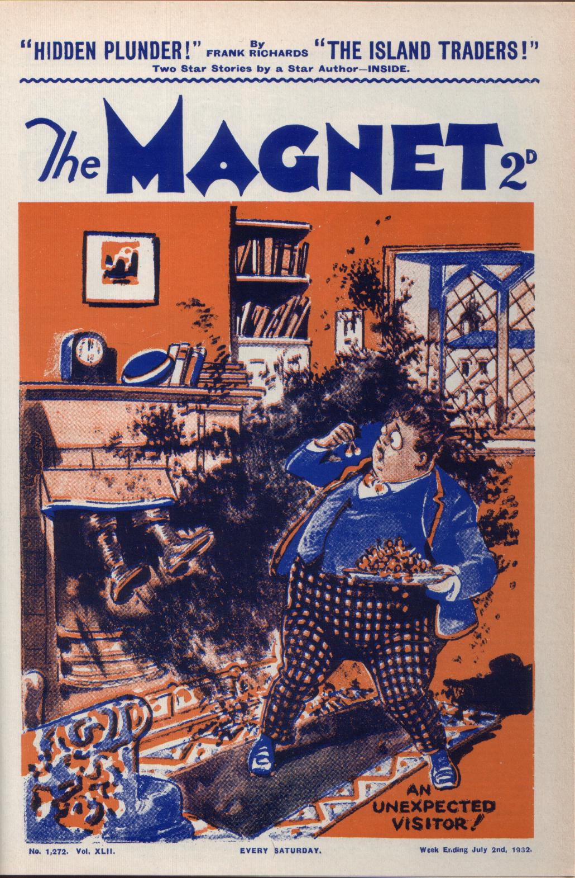

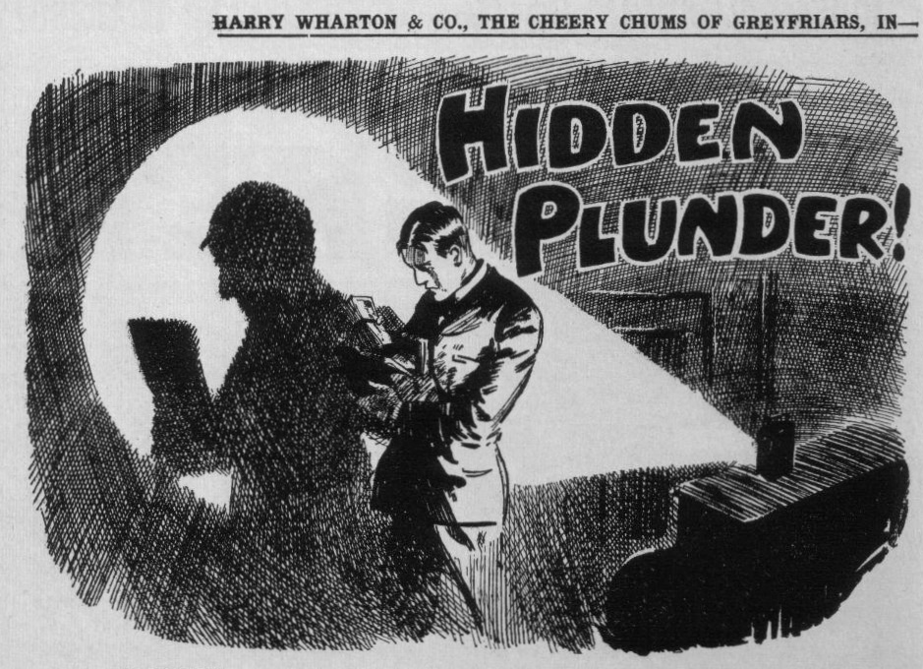
THE FIRST CHAPTER.
A Cricket Casualty!
BILLY BUNTER was tired.
It was hot, that summer’s afternoon. Even Hurree Jamset Ram Singh, who had been
born under a tropical sun, admitted that it was warm.
Hot as it was, Harry Wharton & Co. of the Remove were putting in some cricket practice before afternoon school.
Billy Bunter, leaning on a shady tree, blinked at them through his big spectacles, and wondered how any fellow could be ass enough to rush about in the blazing sunshine, when he might, if he liked, be sitting in the grass in the shade.
The strenuous life had no appeal for Billy Bunter.
The fattest and laziest fellow at Greyfriars School was thinking—not of cricket. He was thinking of the Form-room and Mr. Quelch and Latin prose, and debating in his podgy mind whether by any possible means he could dodge class that afternoon.
Plenty of fellows would have been glad to give class a miss that glorious June day. Cricket and the shining river and the scented woods called to them, and seemed infinitely more attractive than Latin prose with Quelch. But the open spaces did not call to Billy Bunter. A deep armchair and a bag of cherries or a plate of jam tarts called to him.
Billy Bunter felt that be really could not stand a stuffy Form-room and a stuffy Form master that drowsy afternoon. He turned over in his fat mind excuse after excuse for cutting class, but he realised, with a sigh, that Quelch was a downy bird, not to be caught with chaff. A fellow who was ill would be allowed to stop out, but it was useless to tell Quelch that he was ill when he wasn’t. Quelch was one of those suspicious masters capable of doubting a fellow’s word.
Only the other day a fellow who had had a hard knock from a cricket ball had been let off class. Bunter remembered that, and he thought of getting in the way of the ball that Bob Cherry was smiting round the horizon with mighty swipes.
But he shook his head at that idea.
He wanted to cut classes, and a hard knock from a cricket ball would have seen him through. But there was a strong objection to that method. He did not want a hard knock from a cricket ball.
For a quarter of an hour or more Billy Bunter had been thinking it out, only coming to the dismal conclusion that be could not possibly evolve a “whopper” that would be likely to satisfy Quelch.
And then the unexpected happened.
Hurree Jamset Ram Singh had sent down a ball to Bob Cherry, and Bob got it fair and square, putting all his beef into a terrific drive.
The round red ball shot away in the direction of the shady tree on which Billy Bunter was leaning.
It came like a bullet.
Bunter was out of danger from any ordinary batsman on Little Side; but Bob Cherry was a rather extraordinary batsman at times. This was one of the times.
That ball reached Bunter.
It was dropping as it reached him, and it clumped on his fat knee.
By that time its force was spent, and it gave the fat Owl’s podgy knee only a gentle tap, and rolled in the grass at his feet.
But Billy Bunter let out a yell that woke all the echoes of Little Side and Big Side and the parts adjacent.
“Yaroooh!”
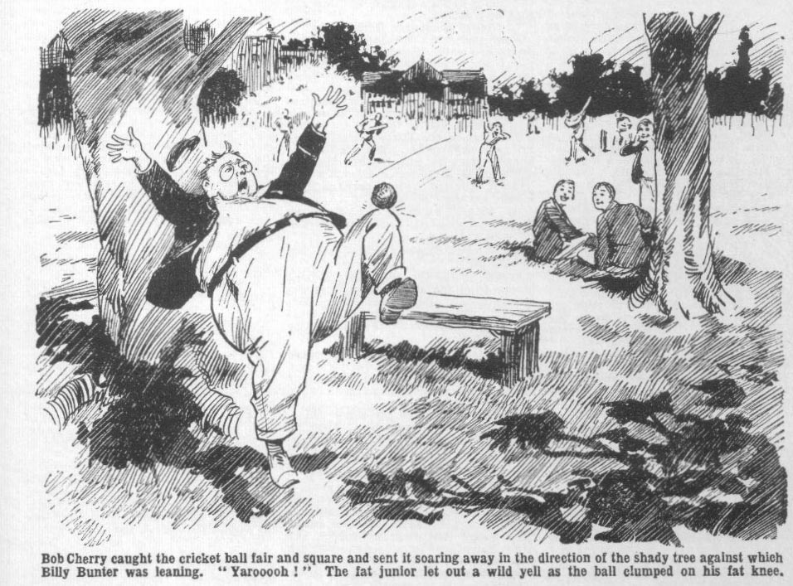
He was more surprised than hurt. Certainly he was not much hurt. But a very little damage was enough to draw a very big noise from Billy Bunter.
He roared.
“Send that ball in, Bunter!” shouted Harry Wharton.
Bunter did not send the ball in. He did not heed the ball. He hopped on one leg, clasping the other with both hands, roaring.
“Yaroooh ! Whoop! Yow-ow-ow! Whoop!”
“ You silly ass, send that ball in!” yelled Johnny Bull.
“Yooooop””
“ Bunter, you fathead !“ howled Frank Nugent.
“Whooop!”
Two or three of the juniors ran towards the tree.
By that time Billy Bunter had made the interesting discovery that he was not, after all, hurt.
But he did not cease his antics.
Billy Bunter’s fat brain did not often work swiftly. But now he had a real brain-wave. He had been thinking of that fellow who had got off class because of a knock from a cricket ball. Now Bunter had had a knock from a cricket ball. It was a happy coincidence. Like a flash it came into Bunter’s podgy brain that this was exactly what he wanted.
Instead, therefore, of ceasing his sounds of woe, he redoubled them. He roared, he yelled, and he howled.
The cricketers might really have supposed, from the uproar, that the Owl of the Remove had been hit by a bomb instead of a cricket ball.
“Yooop! Whooop! Oh, my knee! Oh, my leg! Oh, my bones! Yow-ow-ow!” roared Bunter. “ I say, you fellows, my knee’s broken—I mean my leg’s broken! Yarooh! Help ! Send for a doctor ! Whoop!”
“You frabjous ass!” howled Johnny Bull.
“Shut up that row!”
“Ow ! I’m killed—I mean nearly killed!” yelled Bunter. “I’m injured— frightfully injured! Yarooh!”
“Shut up!” shrieked Harry Wharton.
“Shan’t! I tell you I’m fearfully injured! The spinal column of my leg’s broken!”
“Oh crumbs!”
“I heard it crack!” gasped Bunter.
“Ha, ha ha!“
“Blessed if I can see anything to cackle at, when a fellow’s fearfully injured!” roared Bunter. “I tell you my leg’s broken!”
“ And you’re standing on a broken leg!” gasped Wharton.
“ Oh!” gasped Bunter ; and he immediately collapsed into the grass. “Ow! My leg’s given way! Wow! I’m crippled! Wow! Help me to the
House! Ow!”
“You silly chump!”
“Ow! Give a fellow a hand! Ow!”
“I’ll jolly well give you a foot, if you don’t shut up!” exclaimed Wharton; and he picked up the ball and turned away.
Billy Bunter gave a deep groan.
He remained in the grass in a state of collapse, groaning.
Harry Wharton tossed the ball to Nugent and turned back. He had taken it for granted that Billy Bunter was making a fuss about nothing. He knew his Bunter. But that deep, hair-raising groan made him doubt. He hurried back to the sprawling Owl.
“Look here, fatty, if you’re really hurt—” he said.
Groan!
“Get up, fathead! I’ll give you a hand!”
“I—I can’t,” said Bunter faintly. “My leg’s sprained! There’s a fearful bruise on it!”
“Let’s look at it, then!”
“I think it’s an internal bruise,” said Bunter hastily. “The pain’s fearful— awful, in fact! Frightful! Like burning daggers and—and things! Don’t touch me! I can’t get up!”
“Look here, you ass—”
Groan!
“You’re such a blessed fibber!” said Wharton doubtfully.
Groan!
“If you really can’t walk—”
Groan!
“Oh, bother!” said the captain of the Remove. “it will be class in ten minutes. We’ll help you to the House.”
Groan!
Harry Wharton called to two or three fellows, and they gathered round Billy Bunter and raised him up. Even four sturdy juniors did not find that task easy. Bunter was not a lightweight. His fat arms clutched Wharton and Frank Nugent round the neck.
“D-don’t let me fall!” moaned Bunter. “I—I can hop on one leg, if you take my weight. Ow!”
“Oh crikey!” gasped Frank Nugent. “We want a steam crane for this job!”
“Don’t drag us over, Bunter, you ass!” gurgled Wharton.
“Beast!”
“I jolly well believe he’s gammoning!” growled Johnny Bull.
“My own esteemed opinion,” remarked Hurree Jamset Ram Singh, “is that the gammonfulness is terrific.”
Groan!”
“Oh, get going!” gasped Wharton. “I can’t stand this long!” Roll him along!”
And Billy Bunter, leaning his whole terrific weight on his two unhappy victims, was helped away towards the house, groaning at every step—and groaning still more loudly and dismally when he sighted Mr. Quelch, the Remove master, on the steps.
THE SECOND CHAPTER.
Getting Away with It!
MR. QUELCH looked at the Remove juniors as they approached.
His look was concerned.
Henry Samuel Quelch was a rather severe gentleman, and he had a heavy hand with a cane. But he was not unkindly, and his face became grave and concerned immediately at the sight of a member of his Form groaning as he was helped along by two other members of his Form.
“What has happened, Wharton?” he exclaimed.
Bunter’s bearers paused at the foot of the steps. They gasped for ‘ breath. They were strong and sturdy, but they needed a brief rest before they negotiated the steps with Bunter’s weight to lift.
“ Bunter’s hurt, sir!” gasped Wharton. “Cricket ball hit him on the knee—he says he can’t walk—”
Groan from Bunter!
“Dear me!” said Mr. Quelch. “If there is a real injury it must be seen to at once—”
“It’s not so bad as that, sir!” gasped Bunter. “No bones broken, sir—only a fearful, awful excruciating pain, sir! I—I can bear it.”
Billy Bunter certainly did not want his injured knee to be examined. He had only too much reason to fear that no sign of injury would be perceptible.
“You had better rub the place with some embrocation, Bunter,” said the Remove master. “Take him to his study, my boys!”
“Yes, sir.”
With a long pull, and a strong pull, and a pull all together, as it were, Wharton and Nugent got Bunter up the steps.
They marched him into the House.
Bunter, from the corner of his eye, saw Mr Quelch glancing in after them, and no emitted a deep, hair-raising groan.
A Sixth Form man who was standing near the stairs, jumped att that horrid sound, and spun round.
“What’s that fearful row?” he exclaimed.
“It’s all right, Carne!” exclaimed Wharton hastily. “Bunter’s been hurt by a cricket ball—”
More likely malingering,” growled Carne of the Sixth, with a scowl at Bunter. “Shut up that row, anyhow, you fat rascal!”
“Oh, really, Carne—”
“I’ll give you something to groan for, if you don’t!” added the prefect, supping his ashplant down into his hand.
Carne of the Sixth did not seem in a good temper. But, as a matter of fact, both Wharton and Nugent shared his suspicion that Bunter was malingering. They were giving him the benefit of the doubt, but they did not trust their Bunter.
“Buck up!” muttered Wharton, and the fat Owl was borne on to the stairs—and while Carne was in the offing his bearers noted that he leaned less heavily upon them, and used both legs instead of one—which did not diminish their suspicions of malingering.
But on the staircase, with Carne of the Sixth and his ashplant left safely behind, Bunter put it on again. His weight hung heavy, and the two juniors really wondered how they were going to get up the stairs at all. And so long as he thought that his groans might reach Mr. Quelch below, the fat Owl groaned. After then, when he was sure that Quelch was out of hearing, he ceased to groan. It was now an unnecessary exertion.
“ Feeling better ?“ asked Wharton breathlessly, as they reached the Remove staircase above.
“ Ow! No, worse!”
“You’re not niaking so much row.” said Nugent.
“Well, Quelch can’t hear from here—”
“What? ”
“ I—I mean, I’m bearing it!” gasped Bunter. “ Bearing it like a man, you know! I’m not the fellow to make a fuss about a pain—not like some fellows I could name.”
“ Oh, roll him on!” growled Wharton. “ I believe he’s spoofing all the time, though I’m blessed if I know why.”
“Oh, really, Wharton—”
“Heave ahead!” gasped Nugent.
Billy Bunter was heaved into the Remove passage, and heaved along to his study, No. 7. Wharton kicked the door open, and Bunter was heaved into the study. A final heave landed himt in the armchair.
“There!” gasped Wharton, wiping his heated brow. “ Thank goodness thats over ! Does that fat sweep weigh one ton, or two?”
“ Three, I think,” gurgled Nugent. “Or four.”
“I say, you fellows! Gimme a chair to rest my broken leg on!” said Bunter. “ I can’t move, you know.”
“Oh, all right!”
Wharton tlaced a chair in front of the armchair for Bunter’s damaged leg to be rested on it. The fat Owl stretched out his right leg on that resting place— a proceeding that made the juniors stare. :It; was his left leg that had been tapped by the cricket ball, and that he had appeared to be unable to put to the ground during his progress from Little Side to the House. As there was no pain at all in his fat knee by this time, Bunter had forgotten which was his damaged leg.
“Why, you — you — you spoofing walrus!” yelled Wharton. “Is that your gammy leg?” up
“Yes—it pains fearfully
“ It was the other leg!” roared Nugent.
Bunter started.
“W-w-w-was it?” he gasped. “Oh, I—I forgot—I—I mean. I—I can’t move the other leg! See?”
“You fat Ananias!”
“Oh, really, Nugent! If that’s what you call sympathetic, when a fellow’s suffering feariul agony with manly fortitude—”
“I knew he was spoofing,” growled Wharton. “No need to get him any embrocation—there’s nothhig the matter with him. Come on!”
“I say, you fellows!” howled Bunter. “Get me some Elliman’s. Don’t be rotters, you know—get me some embrocation for my broken leg
“What the thunp do you want embrocation for when you’re not hurt?” roared Wharton.
“Well, Quelch might look in when I don’t come down to class, and he would expect—”
“Oh, my hat!” We’re to help you to spoof Queleh, are we?” exclaimed Wharton. “Go and eat coke!”
“Beast! I say, don’t walk away while a fellow’s talking to you!” howled Bunter. “I say, it’s class in a few minutes. If Quelch asks why I haven’t come into the Form-room tell him you left me in awful pain !”
“You can tell Quelch your own whoppers, you fat villain!”
“So it’s a dodge to get out of class, is it?” exclaimed Nugent, comprehending at last.
“No, nothing of the sort! I’m in awful agony—excruciating! I believe the bone’s broken in five pieces—or six —perhaps seven! Tell Quelch you left me unable to stir a step—”
“Rats!”
“Tell him I was lying absolutely helpless in this armchair—lying in awful anguish. Mind you tell him I was lying—”
“No need to tell Quelch you were lying. He will spot soon enough that you were lying.”
“Beast!” roared Bunter. “Look here, you tell Quelch—”
“Bow-wow!”
Wharton and Nugent left the study. Billy Bunter gave a snort and leaned back in the armchair, and replaced his right leg on the other chair with his left. He was ready in case Mr. Quelch looked in, and though Bunter was not a bright youth, even Bunter was bright enough to realise that his damaged leg had better be the same damaged leg. The most unsuspicious Form master might have grown suspicious had he discerned that the sufferer did not know which leg was injured.
It was close on time for class now, and fellows were coming into the House. Bunter waited. He had every hope of “getting by” with it; but ho was not sure yet. Quelch, fortunately, had seen him limping into the house in his injured state, but it was very probable that Quelch would give him a look-in when he did not turn up for class. In such matters Henry Samuel Quelch was not easily satisfied.
Billy Bunter listened with both fat ears for a sound of footsteps in the Remove passage. And as a footstep was heard he gave a deep, deep groan.
He was groaning deeply when Mr. Quelch glanced in at the study doorway. Bunter put in another groan and blinked at his Form master.
“I—I’m sorry I can’t get up, sir!” he moaned. “My knee rather hurts, sir—”
Mr. Quelch scanned him keenly. He did not trust that particular member of his Form very far. Bunter twisted up his fat face into an expression of anguish. But Quelch, though a wary bird, was not unduly auspicious; and he had Wharton’s word for it that the cricket ball really had hit Bunter.
“Very well, Bunter!” he said. “You may rest in your study for a time. As soon as you feel better—in fact, as soon as you can walk—come down to the Form-room.”
“Oh, certainly sir!”
Mr. Quelch, half satisfied, walked away, and the Owl of the Remove was left to himself. Billy Bunter winked at the door after it had closed on his Form master and grinned an expansive grin.
It was rather fortunate for him that Quelch did not reopen the door. Had the Remove master seen that wide, derisive grin on Bunter’s fat face, certainly his suspicions would have been aroused. But Mr. Quelch’s steps died away down the passage to the stairs, and the fat junior was left to grin in peace.
— —
THE THIRD CHAPTER.
Looking for Loot!
“MY hat!” murmured Gerald Loder, of the Sixth Form.
Loder of the Sixth had strolled into the old Cloisters, a rather secluded spot at a distance from the House. The Greyfriars fellows were in the Form-rooms now, excepting the Sixth Form, who were not due for C1ass for another half hour.
Wingate and Gwynne and Sykes, and other members of that Form, were at cricket ; but Loder, for reasons of his own—not unconnected with the smoking of a surreptitious cigarette—had strolled into the Cloisters. And his murmured ejaculation was caused by the sight of Carne of the Sixth, who was a pal of Loder’s and a fellow of his own peculiar tastes in banker, billiards, pool, and gee-gees.
Carne’s occupation was rather a curious one, and it naturally caused Loder’s eyes to fix on him.
He was moving along the shady Cloisters, peering to and fro in every nook and cranny, as if in search of something.
He could hardly have been looking for something that he had dropped, for his search included crannies in the old walls and recesses of the clinging ivy.
He did not see Loder, having his back turned to him, and for several moments Loder watched him with a grin on his face.
Arthur Carne, it was clear, was searching for something, and Loder fancied that he could guess what it was.
For some time past Carne of the Sixth had backed his favourite horse, not wisely but too well; and that elusive gee-gee had not only let him down, but let him down with a crash. Debts and difficulties were piled on the hapless sportstnan of the Sixth; and of late he had been seeking to “touch” every fellow he knew for a loan.
His friends, Loder and Walker, had their own little troubles in the sporting line to face, and had nothing left over for a “lame duck.”
And when Carne gave them a hint that if he could not raise the wind and keep his creditors quiet it might mean the “sack” for him, that hint only caused his dear pals to leave him more severely alone than before. On the present occasion Loder would not have strolled into the Cloisters had he known that Carne was there. But now that he saw Carne he stood and watched him, half contemptuously and half mockingly.
Carne, becoming suddenly aware of his presence, spun round, straightened up, and stared at him, the colour coming into his cheeks. He looked taken aback and confused.
“ Found it?” asked Loder sarcastically.
“ Eh! No! I—I’ve dropped my match-box!” stammered Carne. “ I—I’ve been looking for it—”
“ Had you dropped your matchbox yesterday when I saw you rooting about this spot?” asked Loder. “ And a couple of days ago, too, when I spotted you at the same game?”
Carne gave him a fierce look.
“What the dickens do you mean?” he blurted.
Loder came a little nearer to him, and the grin died off his face, replaced by a very serious expression.
“I mean this, old bean.” he said quietly—”chuck it!”
“Chuck what, you fool?” muttered Carne.
“ What you’re after!” said Loder.
“You—you ass! What do you think I’m after, then?”
“I don’t think—I know!” answered Loder, in the same quiet tone; “ and if you hard the sense of a bunny rabbit you’d know it wasn’t good enough! This is the third time I’ve spotted you rooting about the Cloisters ; and Walker saw you once and mentioned it to me. You’ll have the fags noticing it soon.”
“ The fags are in class! But what—”
“A couple of weeks ago,” said Loder, “ there was a bank hold-up at Courtfield. Some crook, who seems to be called Jerry the Rat, got away with a bundle of banknotes—seven thousand pounds.”
Carne started violently.
“What’s that got to do with me?” he muttered.
“Nothing, and the sooner you understand that the better!” said Loder. “Jerry the Rat is remanded for trial now, and, according to what he confessed to the police, he chucked away the bag of banknotes on Courtfield Common, while he was being chased by a crowd. Half the population of these parts went rooting over the common for the loot, but it has never been found. Old Grimes, at Courtfield, got an idea into his head that the crook may have chucked the plunder away after he dodged into the school to get away from the pursuit. They came over here to search one day. Since then—”
Carne me opened his lips and closed them again.
“ Since then,” repeated Loder, “you’ve been busy rooting about the Cloisters It was on this spot that Jerry the Rat dodged into the school. He dropped an automatic here, and it was picked up by a Remove kid. If he had dropped anything else it would have been found. He may have bunged something out of sight in some nook or cranny. But if he did Arthur Came, the less you see of it the better!”
Carne breathed hard.
“You rotter, Loder!” he muttered. “Do you dare to insinuate—”
“ I’m speakin’ as a friend,” answered Loder coolly. “You’re not exactly the chap to take a fearful lot of trouble to help the bank get its money back. You’ve been tellin’ us how you’re up against it till we’re sick and tired of the subject! Don’t be a fool, Carne!”
“You rotter!” repeated Carne.
“Banknotes are numbered.” went on Loder. “ Every number on every note in that bundle is circulated among the police and the banks. If a single note was passed, the police would be on to it like a shot—looking for the man who passed it! Are you mad, old bean?”
Carne clenched his hands.
“Do you think I was thinking—”
“I know you were!” retorted Loder coolly, “and I’m advisin’ you, as a friend, to chuck it! You owe Joe Banks money; but you can’t pay him with stolen notes. You’d get that, if you were cool. I think you must be rather off your head to dream of such a thing. Better the sack from Greyfriars than being walked off with a bobby’s hand on your shoulder.”
Carne shivered
“I—I never thought — I never meant——” he stammered.
“Cut it out!” said Loder. “You haven’t an earthly chance of finding the stuff, even if it is hidden about here, which I don’t believe for a moment. But there’s the off chance, and that’s why I’m givin’ you the tip! I said chuck it—and I mean chuck it!”
With that, and without waiting for a reply, Gerald Loder turned and walked out of the Cloisters, forgetful of the cigarette he had come there to smoke.
Carne stood as if rooted to the old stone flags, staring after him.
The flush died out of his cheeks, leaving him pale.
He leaned on one of the old stone pillars, his hands driven deep into his pockets, his face pale and harassed. -
Carne of the Sixth was in deep water. He owed more money than he could hope to pay, and his sporting friends at the Cross Keys were growing impatient and pressing. If the affair came out at the school Came was finished there; it was the “sack,” short and sharp, for a Sixth Form man, a prefect, who dabbled in gambling on races. It had to come out, if Came could not pay—and he could not pay.
Yet the hapless sportsman of the Sixth had not clearly realised how low he had sunk, till Loder’s words brought the unpleasant fact home to him.
He had been searching for the lost loot, with a faint hope of finding the bundle of banknotes that the holdup man had got rid of in his flight.
Seven thousand pounds lay hidden somewhere between Courtfield and Greyfriars—a sum that it was dazzling to think of. Some vague idea had been at the back of Came’s mind that if ho had the luck to find the loot, he might “borrow” a single banknote for a time
—twenty pounds or so—to see him through his pressing difficulties.
He would return it afterwards, when he was in funds—sending it anonymously to the bank, or something of that sort. But the idea had been vague, and, anyhow, it depended on discovering the lost loot
—which was improbable. Somehow, Came, in his harassed state of mind, had not clearly realised what he was really doing—till Loder’s words brought it home to him with a shock.
He realised it now. It came clearly into his mind that if he found the lost banknotes, if he “borrowed” a single pound among them, he was a thief—as much a thief as the crook who had raided the Courtfield and County Bank.
He shuddered.
Loder was gone, without a backward glance; but Carne did not rcoutne “rooting.” in the recesses of the old Cloisters. It was borne in upon his mind that if the lost loot really was hidden there it was better for him not to find it. He felt, with a shiver, that if once he had the banknotes rustling in his fingers he would not be able to resist the temptation.
He left the Cloisters at last, at the sound of a distant bell. He went into the Form-room with the Sixth for Greek with the Head. Loder gave him a rather curious look, and Carne scowled in response. But he was glad, at the bottom of his heart, that Loder had put it plain to him, and glad that he had had no luck in has search for the lost loot.
THE FOURTH CHAPTER.
The Man In the Chimney!
BILLY BUNTER opened the door of Study No. 7 in the Remove, and blinked along the passage.
It was, as he expected, quite deserted; but Bunter was cautious. Like Moses of old, he looked tins way and that way before he emerged from the study. All the fellows were in the Form- rooms, all the masters were occupied with their Forms, and there was not likely to be anybody hanging about the Remove studies. Still, a fellow who had been left out of class because he couldn’t walk had to be careful not to be seen walking about; so the fat Owl was very cautious.
For more than half an hour Bunter had lolled idly and luxuriously in Toddy’s armchair in Study No. 7, enjoying that happy repose all the more from the knowledge that the other fellows were grinding Latin with Quelch. Probably Bunter would have gone to sleep in the armchair and dozed away the drowsy afternoon, but for a slight sinking feeling in his podgy interior, which warned him that it was time for a snack. Half-way between dinner and tea Bunter was, of course, ready for an extra meal; and now he was going out into the Remove passage like a lion seeking what he might devour
The circumstances were peculiarly favourable for a grub raid. It was not often that Bunter was at liberty while the other fellows were in class. Now every study in the Remove was at his mercy, and in such matters as this William George Bunter was merciless.
Study No. 4 was his first port of call. Generally there was something good in Herbert Vernon-Smith’s study. But as he rolled in and blinked round, Bunter ejaculated “Beast!” in tones of utter disgust.
The cupboard door was locked.
Bunter blinked at it through his big spectacles in disgust. Probably there was something good there. But even Bunter did not think of breaking the cupboard door lock with the poker to get at it. Locking up a study cupboard showed, in Bunter’s opinion, a low, suspicious mind—just as if a fellow thought a fellow might be after a fellow’s tuck!
Study No. 4 having been drawn blank, the fat junior rolled on in search of a study belonging to some less suspicious fellow.
He remembered that he had seen Frank Nugent negotiating the purchase of cherries in the school shop. If those greedy fellows hadn’t wolfed the cherries yet, they would be in Study No. 1. Most likely some of them, at least, had been left over to grace the tea-table. Billy Bunter rolled into Study No. 1 in search of cherries.
He grinned with satisfaction in that study.
Wharton and Nugent, evidently, were not so distrustful as the Bounder. The cupboard door was not only unlocked, but ajar.
“Good!” murmured Bunter.
A moment more and the cupboard door was open, and Billy Bunter’s eyes and spectacles were fixed on a large plate stacked with cherries.
“Oh!” gasped Bunter. “Fine!”
It was like corn in Egypt in one of the lean years. Harry Wharton and Frank Nugent had evidently left those cherries for the tea-table, to whack them out among the other members of the famous Co. Nothing could have happened more fortunately, from Billy Bunter’s point of view.
He grabbed a handful, and stuffed them into his capacious mouth, as a preliminary. They were rich end red and luscious, and fairly melted in his mouth. Bunter’s fat face beamed as he guzzled.
Then he lifted the plate from the cupboard, rolled across to the study armchair, and sat down with the plate on his knees.
There were several pounds of cherries on the plate. The fat Owl proceeded to travel through them.
This was happiness!
Sprawling in an armchair, while the other fellows were in class, eating cherries while the other fellows absorbed Latin—it was something like!
Bunter could not feel too thankful that that cricket ball had tapped him on the knee. He could not help admiring his own wonderful presence of mind in making such astute use of the little acccident. Some fellows, Bunter reflected, would never have thought of it. Lots of fellows would never have dreamed of it. This was where a fellow’s brains came in useful. Bunter congratulated himself on being such a brainy chap.
Cherries disappeared at a great rate.
Cherry-stones fell round Bunter like leaves in Vallombrosa of old.
Cherry-juice streaked his fat hands and his fat face. It would not have needed a detective to discover clues to the mysterious disappearance of those cherries.
After disposing of a couple of pounds, however, Bunter slacked down a little. He began to take in cherries singly instead of in bulk.
But he was still enjoying himself, and the fate of those cherries was fixed. Nothing but cherry-stones would be left for the chums of the Remove, and even the stones would no have been left had they been edible.
“Prime!” murmured Bunter.
More and more cherries followed the downward path. Few remained on the plate; but Bunter was not the man to leave a single one. If a job was worth doing it was worth doing well; and there was no danger of interruption. The fellows were safe in class for another hour yet.
The Owl of the Remove was feeling rather sticky, rather tired, and rather heavy, when he had finished the last cherry. He had done well. He even had a feeling that he had, perhaps, done a little too well.
He leaned back in the armchair, happy and satisfied, and extremely disinclined to move.
His eyelids drooped behind his big spectacles.
It was hot in the study, only a faint breeze from the sea coming in at the open windows. Bunter was drowsy. His eyes shut and his mouth opened. A faint rumbling sound proceeded from Bunter—the first snore of a happy nap.
Then, all of a sudden the snore changed to a sneeze, and Bunter’s eyes opened wide behind his spectacles.
He sat up, blinking.
He sneezed again.
For the moment he could not understand what had happened. Then he saw that a chunk of soot had fallen in the fireplace, spreading a little cloud in the air.
“Groogh!” murmured Bunter.
He blinked at the grate in surprise.
Another and another lump of soot fell. What could possibly be causing the soot to fall was a mystery. It was weeks since a fire had been lighted in the study, and after fires were done with the chimneys were swept. Some soot, of course, remained in the chimney after sweeping ; but it was extremely odd that such remnants should fall without something happening to dislodge them.
Billy Bunter blinked in amazement at the grate, into which fragments of soot were now falling every moment.
He was aware of a sound in the chimney—a faint, scuffling, rustling sound. It was not the wind. There was hardly any wind that blazing afternoon. It sounded exactly like someone clambering down the interior of the old chimney, and Bunter wondered whether he had fallen asleep and was dreaming this.
The Remove studies, though partially rebuilt in modern times, were one of the oldest parts of Greyfriars. The chimney in Study No. 1 was a large, old-fashioned one. There was plenty of room in the interior for a climber. Indeed, the old climbing-irons were still there in the brickwork which had been used in the ancient days when chimney- sweeps clambered up chimneys to clean them.
Anybody who liked soot could easily have climbed that chimney, or have descended into it from the roof.
But it was almost unimaginable that anybody should do it. Such a climber would have emerged, half-suffocated, and as black as the ace of spades.
Yet, if Bunter’s fat ears did not deceive him, somebody was clambering down the chimney of Study No. 1.
He blinked in sheer amazement.
It could not be a Greyfriars fellow! All the fellows were in class. It could scarcely be one of the servants. But it was somebody! There was no doubt that it was somebody!
Billy Bunter sat petrified with astonishment.
Lump after lump of soot, dislodged from crannies in the old chimney, fell. He heard a grunting breath. Then, into the opening between the firegrate and the chimney above, an object suddenly appeared. It was a boot!
Bunter blinked at it.
The boot was immediately joined by another boot. Then the ends of a pair of sooty trousers appeared.
“Ooooooogh!” gasped Bunter faintly, too overwhelmed with astonishment at the strange sight to stir.
He could only stare at the feet emerging from the chimney, scarcely able to believe his eyes or his spectacles.
Somebody, goodness knew whom, must have contrived to climb to the roof—not a difficult task in a rambling mass of buildings like Greyfriars, mantled with ancient, clinging ivy.
That someone was descending into the school by way of the chimney of Study No. 1 in the Remove.
Whoever he was, he had come in broad daylight. But if he desired to pick out a particular chimney, he had to come in the daylight. At night such a selection would have been impossible in the darkness.
The hour, at all events, had been carefully chosen, when the whole school was in class, and the studies fairly ccrtain to be deserted. Certainly the mysterious intruder could never have guessed that a fat and lazy junior was stopping out of class, and was sitting in that very study, staring at the fireplace through a pair of big spectacles.
The boots came groping downward, and rested in the grate. Bunter had a view now of a pair of sooty trousers. He heard a grunting, gasping breath. Disturbed soot seemed to be troubling the mysterious man in the chimney.
Who was it? What was it? What could it mean? Only a thief could be entering the place in such a surreptitious manner. Bunter realised that. And it came into his fat mind that, as soon as the rascal emerged from the chimney into the study, the first object upon which his eyes would fall would be William George Bunter!
At that startling thought Bunter jumped up. Obviously the intruder must be some lawless character, and Bunter had no desire whatever to meet a lawless character at close quarters. The fat Owl made one bound to the door, and rushed out into the Remove passage.
THE FIFTH CHAPTER.
Caught!
“WHARTON!”
“Yes, sir!”
Mr. Quelch looked at the Form-room clock and frowned.
Class in the Remove-room that afternoon was scheduled for two hours. One hour, devoted to the entrancing subject of Latin prose, had elapsed. The second hour, which was devoted to the equally entrancing subject of Roman history, was about to commence.
And Bunter had not arrived.
Some Form masters might have forgotten Bunter. Some might have been pleased, on a drowsy summer’s afternoon, to be relieved of the most obtuse and idle member of a Form.
Not so Mr. Quelch! Mr. Quelch was an extremely dutiful Form master. According to Nelson’s famous signal, England expects every man to do his duty. England is often disappointed in that expectation. But the Remove master at Greyfriars, at all events, was a whale on duty!
So far from having forgotten Bunter, Mr. Quelch had been thinking of him quite a lot. Anybody who expected Mr. Quelch to do his duty would not have been disappointed. His duty was to see that a fat and lazy slacker did not dodge classes without just cause.
Bunter had escaped Latin prose, but he was not going to cscape Roman history! Mr. Quelch considered it high time that Bunter recovered from his injury sufficiently to walk down to the Form-room. He even suspected Bunter of a design to make that injury last till school was over.
“Wharton, you will go to Bunter’s study and tell him to come into class at once!” said Mr. Quelch.
“Certainly, sir!” answered Wharton, with alacrity.
It was not always all honey to be head boy of the Form. On this occasion it had its advantages. Any fellow in the Form would have been glad to exchange the stuffy Form-room for a few minutes for a stroll up to the Remove studies. It fell to Wharton’s fortunate lot, as head boy, and he left the Form-room at once.
Not with any undue haste, the head boy of the Remove sauntered away from the Form-room, and arrived at the Remove staircase. Still without any undue haste—just as if Roman history did not attract him very magnetically— Wharton ascended that staircase to the Remove passage.
Bunter was supposed to be in Study No. 7—as Mr. Quelch had left him there too injured to walk! Wharton, therefore, headed for that study, and did not glance at the open doorway of Study No. 1 as he passed it.
He was, in consequence, taken quite by surprise when a fat figure came hurtling out of Study No. 1 into the passage.
Bump!
“Oh!” gasped Wharton.
He staggered across the passage, and brought up against the opposite wall.
Billy Bunter, equally taken by surprise, sat down, with a howl.
“ Ow! Wow! Ooooh!”
Wharton, staggering against the wall, stared at him.
“ You fat idiot!” he gasped.
“ Ooooogh!”
“What are you doing in my study?”
“Woooogh!” gurgled Bunter breathlessly.
“Why, you fat villain—” gasped Wharton, as he discerned the smears of cherry-juice all over Bunter’s face. “ You’ve been scoffing the cherries—”
“I say——” gasped Bunter.
He pointed in at the open doorway of the study.
“Look!” he gurgled.
Wharton, in surprise, looked.
Then he jumped almost clear of the passage floor in his astonishment.
The fireplace was almost opposite the door. In the fireplace were a man’s legs—the rest of him still hidden in the chimney!
Wharton stared at that surprising apparition, almost stupefied.
“It’s a bub-bub-bub—” gurgled Bunter.
“What!”
“ A bub-bub-bubburglar—a d-d-day-light bub-bub-burglar!”
“ Great pip!”
Harry Wharton ran into the study.
Soot lay thick on the hearth, mingled with cherrystones. Soot clung to the boots and trousers that were visible to Wharton’s amazed eyes. The man in the chimney was of the soot, sooty!
Bunter had rushed for the door, in the belief that the mysterious intruder was descending into the room. But apparently that was not the man’s intention. He was standing in the fireplace, his shoulders and head still invisible in the chimney, and from the scuffling sounds, and the falling of soot, he seemed to be groping about in the interior. It was scarcely imaginable that anyone could be searching for anything inside a study chimney; but that was what it sounded like.
Wharton, almost dazed with astonishment, stared at tho sooty legs for a second or two. Then he acted promptly.
Who the man was, what he was up to, Wharton did not try to guess. But that he had no business there, and was up to no good, could not be doubted. The bare idea of meeting a daylight burglar at close quarters had set Billy Bunter’s fat little legs into rapid motion. But the captain of the Remove was made of sterner stuff.
After that amazed stare at the mysterious legs, Wharton glanced swiftly round the study, caught up a cricket belt from the table, and jumped to the grate.
Almost in a twinkling the belt was passed round the man’s ankles, and knotted to the fender.
From above came a sudden, startled, horrified howl.
The man in the chimney was evidently taken by surprise.
He made a convulsive effort to draw his legs up.
But it was too late.
Wharton’s fingers worked with lightning swiftness, and the hapless rascal’s feet were secured to the fender, and as he wriggled and struggled, the captain of the Remove multiplied knot on knot.
“Got him!” gasped Wharton.
He jumped back from the grate coughing. The man’s frantic struggles were dislodging showers of soot.
Billy Bunter blinked in at the doorway, his eyes almost popping through his spectacles.
“Oh crikey!” he gasped.
A spluttering yell came from the chimney. The legs bent as the man stooped and twisted to look into the study. His face came out of the chimney as black as a sweep’s. It was a narrow face with ferrety eyes, and thin lips drawn back in a snarl from discoloured teeth. The ferrety eyes were ablaze with fury.
One sooty, savage glare the man gave into the room, then, bending, he grabbed at the belt that secured his ankles to the fender. Harry Wharton snatched up a cricket stump, leaped forward, and gave him a sharp rap across the wrist.
“Chuck that!” said Harry coolly.
A fierce oath answered him, and the man’s hands still tore desperately at his feet to release them.
Rap, rap, rap!
The stump cracked on his fingers and forced him to desist, and he stood doubled up, crouching, in the wide old fireplace, a helpless prisoner, glaring furiously at Harry Wharton.
“Bunter!”
“Oh crumbs!”
“Call Quelch!”
“Oh crikey!”
Billy Bunter rolled away. In Study No. 1, stump in hand, Wharton stood warily watching the man who had come down the chimney, while he waited for Mr. Quelch to arrive.
THE SIXTH CHAPTER.
The Prisoner!
“I—I—I—I say—” gurgled Billy Bunter.
The Owl of the Remove rolled breathlessly into the Form-room.
In that apartment Roman history was the order of the day, featuring the Emperor Augustus.
But the Emperor Augustus and all his works were forgotten on the spot as Billy Bunter rolled in, breathless, open-mouthed, with his little round eyes fairly bulging through his big round spectacles.
Remove and Remove master stared at Bunter.
“I—I—I say—” spluttered the fat Owl.
“Bunter, what does this mean?” hooted Mr. Quelch. “How dare you rush into the Form-room in that unseemly manner? Go to your place at once.”
“I—I—I say, sir—” gasped Bunter.
“Where is Wharton?” snapped Mr. Quelch. “I sent Wharton to fetch you, Bunter. Why has he not returned with you?”
“He—he’s in the study, sir. He’s watching him—”
“What?”
“Watching him, sir! He’s tied his feet to the grate——”
“What?” shrieked Mr. Quelch.
Wharton’s tied his feet to the grate, sir!”
“My only hat!” murmured Bob Cherry. “Is that fat idiot trying to pull Quelch’s leg, or has he gone off his rocker?”
“Mad as a hatter, I fancy!” murmured the Bounder.
“Bunter,” Mr. Quelch almost roared, “are you out of your senses? What do you mean by saying that Wharton has tied his feet to the grate? Why should Wharton do any such thing ?“
“Oh, not his own feet, sir!” gasped Bunter. “ The man’s feet, sir.”
“What man?” shrieked Mr. Quelch.
“The man who came down the chimney, sir!”
“The—the—what—w h a t—” Mr. Quelch stuttered.
Really it was a surprising statement, and might have surprised any Form master.
“If that fat duffer isn’t potty, what’s the matter with him?” asked Nugent.
“The pottifulness is terrific.”
Mr. Quelch strode over to Bunter grasped him by a fat shoulder, an shook him forcibly.
“ Bunter, what do you mean? Explain yourself!” What have you to say?”
“ Groooogh!”
“ Will you explain yourself, you stupid boy?”
“ Ow! S-s-stop shook-shook-shaking me, then!” gasped Bunter. “ I’m winded! Ow! He’s in the study— ooogh!—he came down the chimney— woogh! He’s a burglar! Oooch! Wharton’s got him—ow!”
“Do you mean to say that there is some extraneous person in the House— in Wharton’s study?” demanded Mr. Quelch.
“Ow! Yes! He came down the chimney—”
“Impossible!”
“Wharton’s got him!” gasped Bunter. “He’s tied his feet to the fender. He sent me to tell you—”
“Upon my word!” exclaimed Mr. Quelch.
The Remove were all on their feet now, buzzing with excitement. Bunter’s statement was almost too startling to be believed. Yet it was scarcely possible that the fat Owl would make such a statement to such a master as Mr. Quelch if it was unfounded.
Mr. Quelch gave the gasping Owl one stare, then released him and whisked out of the Form-room. He left the Form in a buzz.
Forgetful of his years and his dignity, the Remove master fairly ran for the staircase. He went up the stairs two at time, panting, his gown floating behind him.
He reached the Remove landing and raced into the Remove passage, and stared with almost unbelieving eyes at the strange sight in the study.
The sooty-faced, ferret-eyed man was crouching in the fireplace, his feet tied to the fender, his eyes glaring at Harry Wharton like those of a hunted beast.
He was quite unable to release himself; raps from the cricket stump, on his fingers stopped every attempt.
But the Ferret was desperate now.
His right hand was twisting into the hip-pocket behind him; and Harry Wharton, watching him like a hawk, had no doubt what he was groping for. The captain of the Remove was watchful and ready.
Even as the astounded Form master stared in at the open doorway the Ferret’s hand came out with an automatic in it.
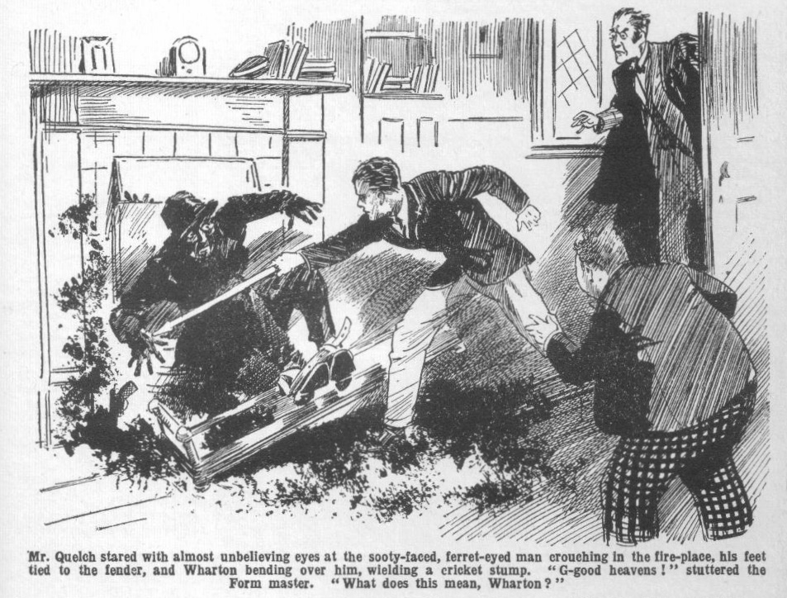 Wharton lunged instantly with the stump, and the pointed end jabbed into the rascal’s hand, almost puncturing it.
The Ferret gave a howl of agony, and the automatic dropped with a clatter into the hearth.
“ G-good heavens!” stuttered Mr. Quelch. “ Wharton—my boy—” !
Wharton did not heed. He sprang forward and kicked the automatic out of the reach of the doubled, twisting figure in the grate.
The Ferret grabbed at him with savage hands, missed him, and pitched forward across the hearth. He gave a yell as he crashed down, and instantly twisted like a cat, grabbing at his bound feet.
Crack!” Came the cricket stump across his hands! Crack! It came again, and the Ferret had to give it up.
Sprawling over the fender, he glared up at the cool junior like a wild anima1.
Wharton watched him, with the stump uplifted.
“ You’re not getting loose, old bean!” he said.
A fierce oath answered him.
Mr. Quelch tottered into the study. He picked up the automatic, holding that dangerous weapon in a rather gingerly manner. The Remove master was not so used as the Ferret to such things.
“ Bless my soul !“ gasped Mr. Quelch. “This is—is—is amazing! Who—who—what—what is this man?”
“ I haven’t the least idea, sir!” answered Harry. “ Bunter saw him coming down the chimney—”
“Some-some desperate character; a—a thief of some kind!” gasped Mr. Quelch. “Wharton, go at once and get help. I will watch the man. Go at once to the Sixth Form Room. Request the Head to send the prefects here. I will take care of this—this miscreant—!”
Harry Wharton ran out of the study. The Ferret twisted up to get at his tied feet again. Perhaps he hoped to have better luck with an elderly Form master than with the watchful school-boy. But Henry Samuel Quelch, though a scholastic gentleman, was a man of action also. He stepped towards the sprawling rascal, with a grim face, holding the automatic by the barrel.
“ Make an attempt to escape, you scoundrel, and I will strike you with the butt of this weapon!” said Mr. Quelch in his most acid tones.
“I will stun you if necessary. I warn you!”
The uplifted butt, with Mr. Quelch’s gimlet eyes glinting over it was enough for the Ferret. He sprawled and muttered oaths, realising that the game was up. There was a trampling of feet on the stairs and in the passage. Help was not long in coming. Wingate of the Sixth was the first in the study; after him came Gwynne and Loder and Carne and Walker and several more big seniors.
There was amazement in every face. But amazement did not prevent prompt action. The Ferret, in his sooty state, was not pleasant to touch, but the Greyfriars seniors touched him with a prompt and tenacious grasp. His feet were untied, and he was allowed to stand, both arms gripped by strong hands. He spat out oaths.
“Secure him!” exclaimed Mr. Quelch.
“We’ve got him, sir!” answered Wingate. “He won’t get away in a hurry.”
“He is a desperate scoundrel,” said Mr. Quelch. He produced this deadly weapon; and would certainly have used it, had not Wharton been so prompt in disarming him. You had better tie his hands.”
“Here’s a duster.” said Carne.
While Wingate and Gwynne held the Ferret by the arms, Carne of the Sixth bound his wrists together with the twisted duster.
“And now,” said Mr. Quelch sternly, fixing his eyes on the sooty, scowling face. “Who are you, and why did you enter here?”
The Ferret gave him a quick, searching look. Then he shrugged his shoulders with an assumption of indifference.
“Name of Jones, sir!” he answered. “And I fancy you can guess what I was after—looking for something to pinch, if you ain’t guessed it.”
Mr. Quelch eyed him keenly and doubtfully.
That the man was a thief did not admit of doubt; and the only explanation of his presence seemed to be that he had sneaked into the school in the hope of pilfering valuables. But it was unusual, at least, for a sneak-thief to be armed with an automatic pistol, and still more unusual for him to enter a building by way of a chimney. Mr. Quelch realised that there was something behind this which he could not understand.
“Have you nothing more to say?” he demanded.
“Wot’s the good ?” said the Ferret. “You know I’m a pincher, or I shouldn’t be ‘ere, old covey! I’m ready to take my three months’ stretch.”
“Take him downstairs,” said Mr. Quelch. “He must be locked in a room, till a constable can come and take him into custody. I will telephone to Courtfield Police Station at once. Wharton, you may go to the Form-room.”
And the Ferret was led away—taking his capture, after the first burst of rage, with philosophical coolness.
As a matter of fact, the Ferret was congratulating himself. He was booked for what he called a “three months stretch,” on a charge of unlawfully entering a building with intent to steal. But three months in the “stone jug” did not matter much to the Ferret, so long as his true object in visiting Study No. 1 in the Remove remained unknown.
And Mr. Quelch, puzzled as he was, keen as he was, certainly did not guess that a green-leather satchel containing seven thousand pounds in banknotes, belonging to the Courtfield and County Bank, was concealed in a cavity in the ancient chimney—and that the Ferret’s thievish fingers had been almost upon it when Harry Wharton collared him from below. Mr. Quelch was not likely to guess that; and the Ferret was still less likely to tell him the secret of the study.
THE SEVENTH CHAPTER.
Beastly for Bunter!
HARRY WHARTON found the Remove-room in a buzz of excitement when he arrived there. Mr. Quelch was busy with the disposal of the captured intruder, and the Remove was left to themselves for a time. They were not thinking of Roman history now! Billy Bunter had gasped out his story of the strange happenings in Study No. 1; but that story was so strange that there was a good deal of doubt on the subject, and questions were showered on Harry Wharton as he entered the Form-room.
“What’s happened?”
“Has anything happened?”
“Only Bunter’s gammon!” said Skinner.
“Was there a man in the chimney, Wharton?”
“Have they got him?”
“I say, you feIlows, I’ve told you there was a man came down the study chimney!” hooted Billy Bunter.
“Shut up, Bunter!”
“It’s true,” said Harry. “They’re locking him up in a room for a bobby to come for him. He came down the chimney in my study. He says his name is Jones, and he’s owned up to having butted in to pinch what he could lay his hands on. If Bunter hadn’t been there, he would have got on with it, I suppose. So it’s rather lucky, in a way, that that fat villain went to my study to scoff the cherries—”
“Oh, really, Wharton! I never touched the cherries—”
“They seem to have touched you, you fat fraud, judging by the smears on your frontispiece!” chuckled the Bounder.
“Ha, ha, ha!”
“The queerfulness of this absurd affair is preposterous,” remarked Hurree Jarnset Ram Singh. “I have never heard of an esteemed pilferer coming down a chimney before.”
“It’s jolly queer!” said Bob Cherry. “How on earth did he get at the chimney?”
“Must have climbed on the roof somehow.” said Harry. “I dare say he picked out the chimney of Study No. I to come down because it’s a big old-fashioned one with plenty of room in it. And it’s still got the old irons that the chimney-sweeps used to climb by.”
“It’s jolly odd!” said Vernon-Smith. “The fellow must have got himself covered with soot—”
“Black as the ace of spades.” answered Harry. “He would have looked rather conspicuous when he went—if he had got away. Might have been taken for a chimney-sweep, though.”
If he’s just a sneak-thief, he’s the most original sneak-thief I’ve ever heard of,” said the Bounder, shaking his head. “ BIessed if I understand a dodge like that.”
“He picked a good time for his stunt.” remarked Johnny Bull. “All the school in class, and the studies empty. Looks as if’ he must have been watching the place, or he wouldn’t have known all that.”
“ It’s jolly queer!” said the Bounder. “Looks to me as if there’s something more than pilfering in it. Only a few nights ago there was a burglary—and the burglars were scared off by that ass, Coker of the Fifth, coming home in the middle of the night, after his motor bike let him down umpteen miles away. And then there was that fellow who got into the school and handled Quelch, and chloroformed him. Looks to me as if some gang have got their jolly old eye on Greyfriars for some reason. May have been after the Head’s safe.”
Harry Wharton nodded.
“I shouldn’t wonder,” he agreed. “This rotter was armed—and it’s jolly unusual for a sneak-thief to carry a pistol. He may turn out to be some crook that the police know, when they get him.”
“I say, you fellows, he was jolly well after the Head’s safe, and I put the stopper on him!” declared Billy Bunter. “That’s me all over, you know; the right man in the right place.”
“I haven’t kicked you yet for scoffing the cherries—”
“Ow! Keep off, you beast!”
The return of Mr. Quelch cut short the discussion of the strange affair, and the Rernovites rushed to their places. Roman history, however, was not immediately resumed. Another matter had to be dealt with first.
“Wharton,” said Mr. Quelch in a very kindly tone, “I must commend you for the coolness and courage you displayed in dealing with the rogue who entered the House by way of your study.”
“Oh!” said Wharton, colouring. “Thank you, sir!”
“ Bunter!” Mr. Quelch’s tone was much less kindly as he rapped out Bunter’s name.
“Yes, sir!” said Bunter brightly. “Does the Head want me, sir?”
“The Head? Certainly not. What do you mean?”
“Oh! I—I thought perhaps the Head wanted to thank me, sir—”
“What?”
“Well, sir, considering what I’ve done—”
“I am about to speak of what you have done, Bunter!” said Mr. Quelch grimly. “ It appears that you were in Wharton’s study when you saw that— that person descending the chimney.”
“Yes, sir! 1 spotted him—”
“What were you doing in Wharton’s study, Bunter?”
“ I—I wasn’t eating cherries, sir—”
“Cherries!” repeated Mr. Quelch.
“Nothing of the kind, sir! I never knew there were any cherries in the study.” said Bunter, in a hurry. “ I never saw Nugent taking them in, sir.”
“Ha, ha, ha!”
“Bunter! I left you in your study, according to your own statement, unable to walk owing to an injury to your knee—”
“Yes, sir—it pained fearfully, sir. I—I couldn’t move a step, sir—”
“In that case, Bunter, you will kindly explain how you came to leave your own study and go to Wharton’s study.”
“ Oh!” gasped Bunter.
“ I directed you to come to the Form- room as soon as you could leave your study, Bunter! Instead of that, you remained out of class.”
“I—I—I—”
“I fear, Bunter, that you deceived me as to the extent of your injury.” said Mr. Quelch.
“Oh, no, sir!” gasped Bunter. “ My—my leg was nearly broken, sir—there’s a fearful bruise, sir—”
“You may show me the bruise, Bunter!”
“Oh! I—I—I mean—there isn’t exactly a fearful bruise, sir, but—but it feels as if there was, sir!”
Mr. Quelch picked up the cane from his desk.
“Bunter!”
“Oh lor’ !”
“You will bend over that form, Bunter.”
“Oh crikey!”
Whack!
“ Whoooooop!”
Whack
“ Yarooooh!”
“You are a very untruthful boy, Bunter.” said Mr. Quelch, laying down his cane. “ As you have missed an hour’s class this afternoon, owing to your untruthfulness, you will be detained for an hour after lessons.”
“Ooooogh!”
“I shall set you a task in deponent verbs—”
“Oh crumbs!” groaned Bunter.
“Silence!”
Roman history was resumed. Billy Bunter sat through it with a fat, woebegone countenance. Evidently Bunter was not going to be thanked by the Head. He was not going to be thanked by anybody. He felt dismally that it was a thankless world.
Lessons ended at last, and the Removites filed out of the class-room— with the exception of Billy Bunter, who settled down to deponent verbs.
Once again that fat Owl was paying dearly for his sins.
THE EIGHTH CHAPTER.
Mysterious!
“HALLO, hallo, hallo!”
Bob Cherry stared.
It was after tea, and Bob Cherry came down the Remove passage, and looked into Study No. 1 for Wharton and Nugent, to march them down to Little Side for half an hour at the nets.
Wharton and Nugent were not there.
But the study was not unoccupied. Bob stared in surprise at the sight of a Sixth Form man.
What Carne of the Sixth was doing in Study No. 1 was rather a mystery. A Sixth-Former had no business there, especially when the owners were absent.
Carne spun round at Bob’s surprised ejaculation, and his cheeks flushed a little under Bob’s stare.
He seemed taken aback, and at a loss.
“Want anything here, Came?” asked Bob.
“I—I came here to speak to Wharton. He seems to be out.” said Car+ne. “I—I‘ll speak to him another time.”
He left the study, and walked away to the stairs. Bob Cherry’s glance followed him.
“What the jolly dickens—” muttered Bob.
If ever a fellow looked as if he was caught, and telling the first untruth that came into his head, Arthur Carne did. Bob Cherry was in a state of considerable astonishment as he followed Carne down the stairs, and went out into the quad.
“Seen Wharton, Toddy?” he called out, as he met Peter Todd. “And Nugent?”
“They’re on Big Side.” answered Toddy.
“What the thump are they doing on Big Side?”
“Games fagging.” answered Toddy. “Loder’s bagged them.”
“Oh!” said Bob, and he walked away to the senior cricket ground.
Loder of the Sixth, for once in a way, was putting in some batting practice, and Bob found his friends fagging at fielding. He joined them.
“Looking for you men,”said Bob. “1 looked in your study for you, and found Carne of the Sixth there.”
“What the dickens did Carne want in our study?” asked Wharton.
“He said he’d looked in to speak to you.”
“What rot! He spoke to me ten minutes ago, when he told us that Loder wanted us on Big Side.”
“Did Carne know you were here, then?”
“Of course he did, as he told me to come here for Loder.”
“I thought he was telling a whopper.” said Bob. “He looked like it! But why the thump should he?”
“Blessed if I know.”
“Send in that ball, you fags!” shouted Loder.
Harry Wharton ran after the ball. Bob Cherry walked away, considerably puzzled. It was odd, to say the least, that a Sixth Form man should have been in a junior study at all; and very odd indeed that ho should have told a falsehood to account for his presence there. It was clear that he had sent the two owners of that study down to the senior cricket ground, where they would be occupied for some time, and had then gone to their study—obviously, not to speak to Wharton.
Carne of the Sixth was a good deal of a bully, and, according to rumour in the Lower School, a good deal of a blackguard also. But he had very little to do with the Remove follows, except in the way, sometimes, of wielding the prefect’s ashplant. It was impossible to suppose that a Sixth Form prefect could have dropped into a junior study for a “jape” as a junior might have done. But what was he up to?
Bob Cherry walked back to the House.
What Carrie of the Sixth had been “up to” in Study No. I was a complete puzzle; but it was pretty clear that he had been “up to” something, or he would not have gone there after sending the owners away from the House.
Whatever it was, Bob had interrupted him; and if Carne had returned to the study after Bob had left, the junior meant to interrupt him again. Whatever Carne was after, he had no business there.
Bob came up the Remove passage, and grinned as he noticed that the door of Study No. 1 was shut. It had been left open. Somebody, evidently, had gone into that study.
Nobody was in the passage; almost all the fellows were out of the House after tea. If a Sixth Form man had any desire to “nose” into one of the Remove studies, he had found the coast clear.
Bob stopped outside Study No. I
There was a sound of someone moving within the room. Someone was there; and Bob did not need telling that it was Carne.
Billy Bunter, in Bob’s place, would no doubt have applied to the keyhole, to ascertain what the senior was up to in that study. Bob Cherry did not think of the keyhole. But he turned the door-handle quietly, and opened the door without a sound.
His eyes fixed on Came.
The Sixth Form man was there, and he had his back to the door. He was bending over a box-seat under the window—which the owners of the study rather proudly described as an “ottoman.” The lid was up, and Carne was scanning the dusky interior.
Bob stared at him, almost stupefied. That “ ottoman” was used as a receptacle for all sorts and conditions of lumber in the study. There was an ancient football boot; a dismantled tennis racket; two or three cardboard boxes; a few old magazines, and other things of the same sort.
What Came’s interest in such a collection could be, was an utter mystery. But it was evident that his interest was keen, for he was holding up the lid of the “ottoman!” with one hand, and rooting among the contents with the other in an intent search.
For a full minute Bob Cherry stared at the prefect’s back, Carne being too deeply and intently occupied to look round, and remaining in ignorance of the fact that the door was open.
“Hallo, hallo, hallo!” roared Bob Cherry suddenly, with the full forceof his powerful lungs.
The voice of Stentor, of olden times, could hardly have produced a more tremendous volume of sound. It startled Carne—as Bob had intended that it should.
Crash!
The “ottoman” lid came crashing down as Carrie jumped, and let it go. He whirled round with a gasp.
Bob grinned at him cheerily.
A flash of rage came into the senior’s eyes. He made a fierce stride towards the junior in the doorway.
“You young idiot!” he gasped. “What —what the thump do you moan by yelling like that?”
“Made you jump, what?” asked Bob coolly. “And now, perhaps, you’ll explain what you’re rooting about Wharton’s study for, Carne?”
For a moment Carne had looked as if he would spring at the junior who had so startled him. But he checked himself, anid stood biting his lip.
“ I—I came here——” he stammered.
“To speak to Wharton?” asked Bob sarcastically, “ After sending him down to Big Side to fag for your pal Loder? And as he wasn’t here you filled in the time by nosing among his things, what?”
“If you’re asking for a whopping, Cherry!”
“You won’t whop me, Carne!” answered Bob coolly. “ You begin, old bean, and I’ll go straight to Quelch and ask him to inquire what you wore nosing in this study for.”
Carne caught his breath.
“ I—I—” Bob could almost have pitied him, it was so clear that he was cudgelling his brains for a plausible lie. “ I—I’ve hearing that smoking has been going on in the Remove studies, and I came to—to look—to—to see if—if—”
“ You wouldn’t take the trouble to explain that to me if it was true!” retorted Bob contemptuously, “and you know jolly well that there wouldn’t be any cigarettes in this study. You’d better go to your own study in the Sixth, if you’re after smokes—I fancy you’ll find some there.”
Carne clenched his hands convulsively. It was hard for a Sixth Form prefect to take this sort of back-chat from a Lower Fourth junior. But, in the circumstances, it was impossible for Carne to “come the prefect.” Whatever had been his mysterious motive for “nosing” about Study No. 1, he assuredly did not want his peculiar action to be shouted all over the House.
He stood for a moment or two glaring at Bob, as if he would have liked to bite him. But he was completely at a loss.
“I don’t know what your game is here,” went on Bob, as the senior did not speak. “But whatever it is, I’m giving you the tip to chuck it. Wharton doesn’t want a prying tick rooting over his things. You’d better travel, Carne —and don’t take a return ticket this time!”
“That’s enough!” hissed Carne.
He tramped out of the study and departed.
Bob Cherry whistled. Carne’s peculiar conduct was a mystery to him; but whatever his game had been, a stop had been put to it. He had been caught in the study twice ; and he was not likely to come back to be caught a third time. So, after a few minutes of perplexed thought, Bob Cherry dismissed the matter from his mind, and went down to the cricket.
THE NINTH CHAPTER.
Like a Thief in the Night!
TWELVE boomed out from the clock-tower into the calm summer night. At that hour it was rare for a light to be still burning in Greyfriars School. A master might occasionally stay up so late, or some studious senior “swotting” in his study; but generally the whole school was asleep before the “witching hour” of night.
Now, however, one light was still burning, and a faint glimmer from the window of a Sixth Form study fell into the dusky quad.
In that study Arthur Carne, of the Sixth, was not “swotting.” Books lay on the study table, but they lay unheeded. Carne was pacing up and down the room, with his hands in his pockets, and a deep line in his brow, the victim of harassing thoughts.
Again and yet again, he drew a letter from his pocket, and read and re-read it. Finally, with a gesture of weary fury, he tore it across, and applied a match to the fragments, and watched them burn in his grate. That letter had not come by post; it was signed “J. B.,” the initials of Mr. Joseph Banks, the bookmaker, and it had been slipped into Carne’s hand, out of gates, by a messenger from Mr. Banks.
It contained a curt announcement that if Mr. Banks did not soon receive what was due to him, there would be bad trouble to follow; and the hapless sportsman of the Sixth knew what that meant. It meant that he had to pay or face exposure at Greyfriars—in a word, an interview with his headmaster and expulsion from the school.
With a grim, harassed brow, Carne watched the torn letter reduced to ashes. It was not the kind of letter he wished to keep about him.
He had got rid of Mr. Banks’ letter; but he could not, unfortunately, get rid of Mr. Banks himself so easily. Mr. Banks’ red, greasy face haunted him like a grisly spectre. How was he to satisfy the man and keep him quiet?
Joseph Banks was not, according to his lights, a hard man. He had given the wretched sportsman ample time to pay. The trouble was that Carne had gone in too deep for his means. He had lost, and he had plunged deeper in the hope of winning back his losses— that will-o’-the-wisp which has led so many gamblers to their ruin.
He could not pay what he owed to his sporting friend at the Cross Keys; he could not even raise a sum to give him on account to keep him quiet. It was too late to repent of his reckless black-guardism, and to make resolves for the future. He had to meet the present difficulty—and he could not meet it. For weeks Arthur Carne had been worried and harassed, and he could see no way out of his trouble.
The incident of the bank raider had given him a shameful, guilty hope. If Jerry the Rat had left his plunder hidden in some nook or cranny of the Cloisters, and if Carne could have found it—
Yet he had been glad when his pal Loder warned him off; glad that he had not found the lost loot and added the guilt of dishonesty to the rest. He had determined to dismiss such thoughts from his mind, dimly conscious of the black gulf that they opened before his feet.
But that letter from Joe Banks had changed the current of his thoughts again.
Fear of exposure, fear of that grim interview with the Head, drove other fears from him; and he knew that if he could have found the lost loot, he would have taken all risks, to save himself from the “sack.” And it was because his miserable thoughts were concentrated on the subject that he had seen more in the mysterious affair of Study No. 1 that afternoon than anyone else had dreamed of seeing in it.
Jerry the Rat, fleeing from Courtfield after the bank holdup, had dodged into the school to escape, and had been captured there. Somewhere he had got rid of his plunder—seven thousand pounds in banknotes. Every foot of the way the bank robber had fled had been searched meticulously—combed with a small comb, as it were—and the loot had not been found.
For that reason Inspector Grimes had surmised that Jerry the Rat might have “parked “ it in the school precincts, and there had been a search which had revealed nothing. But what had hatpened that afternoon seemed to Carne’s anxious, pondering mind to let in a gleam of light.
Was it possible that Terry the Rat, now in prison on remand, had contrived to communicate somehow with his friends outside? It was, at least, possible. Why had that ferret-eyed pilferer climbed down the chimney of Study No. 1 in the Remove? Such a mode of ingress was almost unthinkable; yet it had happened. It puzzled everybody; but it seemed to Carne that he could put his finger on the answer to the riddle.
He remembered that the hunted bank raider, hunted through the House, had passed through Study No. 1. He had locked the door to check the pursuit, while he climbed out of the window on the ivy.
Was it in that study that he had hidden the loot, and was the pilferer today some confederate who had come in search of it? That would account for the man’s perplexing conduct. In that case, his business was in Study No. 1 and nowhere else—and in the daylight he could pick out the chimney of that study to effect his entrance.
Had Bob Cherry known the thoughts that were in Carne’s mind he would have been at no loss to guess why the prefect had been “nosing ” about in Wharton’s study.
Carne had been interrupted there; but he had had time to make a farly close examination of the room. It was unlikely that a bundle of banknotes could have been hidden there without being discovered, after so long a lapse of time by the occupants of the study—and Carne had satisfied himself that the loot was not there.
But as he paced hi room now he was thinking hard. He recalled that the man who had descended the chimney had not emerged into the study—Wharton had caught him standing in the grate, evidently at a halt, and that had given the junior the chance of securing him. Why?
“The chimney!” muttered Carne aloud.
It was improbable—it seemed a fantastie idea Jerry the Rat had been only a few brief moments in the study in the course of his desperate flight through the House. But it was possible—and it seemed to Carne that many circumstances pointed to it. If Jerry the Rat had thrust the bundle of banknotes out of sight in that old chimney—
Carne shivered.
If the money was there, if he found it there, it was his duty to hand it over to the owners at once. If he touched any of it he was a thief. His mind recoiled from the thought.
Yet it lingered and haunted him.
He moved towards his bed at last in the alcove in his study. But he stopped again, and after another weary pacing of the room extinguished the light.
He felt in his pocket for an electric torch he had already placed there. He removed his shoes and put on a pair of soft slippers.
His heart was beating in great jumps as he opened his door and put his head out into the passage and listened.
All was silent and still.
The Sixth were all asleep in their rooms. The whole school was buried in slumber.
It was safe enough—quite safe—to steal through the darkness to that study in the Remove to ascertain whether his theory was correct. But for long minutes Carme stood where he was, with thumping heart.
His mind scented to sway to and fro, like a leaf in the wind.
It was by means of a self-deception that he stirred hirnself at last to action. He would go to the study, he would discover whether the loot was there, and he would decide afterwards what he would do with it. That decision need not be taken now. After all, it might not be there. Carne almost hoped that it was not there!
He moved silently along the passage in his slippers. Silently he mounted the stairs to the Remove passage, starting and trembling at every faint sound of the night, staring uneasily into the dim shadows.
He reached Study No. 1 at last, entered quietly, and closed and locked the door after him.
A glimmer of summer starlight fell in at the windows. Carne glanced round him, with a pale, guilty face.
For a full minute he stood before the ancient chimney, looking at it in the dimness, without approaching it. But at last he bent his head and flashed the light of his electric torch up into the darkness.
There was ample space in the sooty interior. In olden days chimney-sweeps had ascended by the rusty old irons that he could see projecting from the brickwork. Jerry the Rat, however, certainly could not have ascended the chimney to hide his loot, if he had hidden it there. He had had no time— and he would have borne traces of such an ascent that would have betrayed hm. If the banknotes were there they were hidden within reach of a man’s arm.
Carne drew himself under the chimney, standing in the wide, old grate, and flashed the light of the torch round him.
It glimmered on something that was stuffed deep into an old cavity in the bricks.
He caught his breath.
There was a glimmer of green leather in the light. With a shaking hand, he groped for it and drew it out.
It was a green leather satchel, stuffed full—of something! Carne did not need telling what.
His heart beat almost to suffocation. With streaks of soot on his face, mingled with streams of perspiration, he stooped and emerged from the old chimney, the green leather satchel in his grimy hand.
With trembling fingers he opened it.
“Oh!” he breathed.
The little satchel was stuffed with wads of banknotes. He flashed the light on them for a second. Bank of England notes, of various denominations, most of them a high figure. He shut off the light at once. He thrust the satchel into his pocket and stole trembling to the door, unlocked it, and let himself out of Study No. 1.
He hardly knew how he got back to his own study. He went like a fellow in a dream.
But he was there at last, his door locked—safe! And seven thousand pounds in his hands! His nerves were twittering, and he dared not turn on his light. But by the gleam of the pocket torch he made a hurried examination of his prize. Banknotes in wads, most of them for one hundred pounds each! He did not count them; he knew the total. Everybody knew how much Jerry the Rat had carried off from the Courtfield and County Bank on the day of the hold-up.
Seven thousand pounds!
It was dazzling—a1most terrifying! Seven thousand pounds—and he needed only thirty to save him from ruin! And not a shilling of it was his, and he could not touch a shilling of it without doing that which would bar him off from all decent people for ever!
He tried to think, but his mind was in a whirl of confusion. After all, it could wait.
He closed the satchel again, and in the darkness, groped to a corner of his study and turned up the carpet, where there was a loose section of board in the floor. He lifted the board. In the space below there was a box of cigarettes and a racing paper. This was the recess where Carne kept certain possessions that he dared not risk being found in his study. The green leather satchel was placed beside the box of cigarettes, the board replaced, the carpet placed over it again, and, for additional security, he stood a chair over the spot.
He stood breathing hard for long moments, like a fellow who had come up from a deep dive.
He moved towards his bed at last. Then, with a spasm of terror, he realised that he must be stained with soot from the chimney in Study No. 1, traces that the daylight would reveal, when it came. He dared not turn on his light, lest some unsleeping eye should observe the light in his window, and someone should wonder why he was still up at that hour. He was not a thief—not yet—but the sense of guilt was heavy upon him.
By the glimmer of the electric torch, carefully turned away from the curtained window, he washed off the traces of soot and brushed his clothes. Then, at last, weary in mind and body, the sportsman of the Sixth turned into bed. But, weary as he was, it was long before he slept.
THE TENTH CHAPTER.
The Broken Window!
CRASH!
Clatter! Clatter! Crash! Clatter!
The fellows in the Remove Form-room jumped. The crashing of breaking glass came from a distance, but it was loud and startling. Probably it was heard in every Form-room at Greyfriars.
It was second lesson in the morning, and Mr. Quelch, though he certainly must have heard that terrific crashing, carried on regardless. Somebody, somewhere in the school, had smashed a window, and seemed to have done it with considerable energy. But an incident like that was not likely to put the Remove master off his stroke, so to speak. Heedless of the crash and the clatter, Quelch did not even start or glance round, and when Harry Wharton, who was on “con,” paused, he rapped out:
“I am waiting, Wharton!”
And Wharton resumed “con.”
It was all very well for Henry Samuel Quelch to pass that startling uproar by like the idle wind which he regarded not. The Remove fellows were not so indifferent. Neither were they so keen on Latin verse as their Form master. Willingly they would have swarmed out of the Form-room to see what had happened. But they could not venture to do so, and they exchanged glances and whispers instead.
Second school seemed very long to them that morning. They were glad when Mr. Quelch dismissed them, at last, for break, and they swarmed out into the quad.
The Fourth Form were out a few minutes before the Remove, and Temple of the Fourth shouted to Wharton as he came out of the House.
“Your window’s smashed, Wharton!”
“My study—” exclaimed Wharton.
“Yes. Smashed by a stone, or somethin’ !” said Temple.
“Great pip!”
There was a rush of fellows to a spot whence they could see the windows of the Remove studies. Quite a crowd gathered there to stare up.
It was true. The window of Study No, 1, in the Remove, showed great gaps in the glass. Harry Wharton & Co. stared up at it in amazement.
The breakage could not possibly have been accidental. Every pane in the study window was smashed, evidently by missiles hurled up from below. Some person unknown, it was plain, had deliberately smashed that window while the fellows were in class.
“Our study!” gasped Frank Nugent.
“My only hat! Who—” exclaimed Wharton.
He ran towards Gosling. The old porter was there, blinking up at the
broken window.
“Who did that, Gosling?” demanded Wharton.
“Wot I says is this ‘ere—you can ask me another, sir!” answered Gosling. “Not knowing, can’t say.”
“You must have heard the glass breaking—”
“I ‘eard it,” assented Gosling, “and I comes out of my lodge to see what was hup, and I see a feller standin’ jest about ‘ere, sir—a blooming ragged robin, he was, if you ask me—a-chuckin’ stones up at that winder! Soon as he sees me he nips off, he does, and bolts.”
“A tramp?“ asked Harry, utterly puzzled.
“That’s what he looked like.”
“But what the thump should a tramp sneak into the school for and smash a study window? ” gasped Wharton. “And why the jolly old thump should he pick out my window?”
“Dunno, sir!” answered Gosling.
Wharton stared up at the high window again. Several stones, at least, must have been hurled, to break l the panes. No other window had been damaged. The unknown window-breaker had concentrated on Study No. 1, as if he had some special grudge against the owners of that room.
It was simply amazing.
The Famous Five went into the House and ascended to the Remove passage. They stared into Study No. 1. Half a dozen large, jagged stones lay on the floor, surrounded by fragments of broken glass.
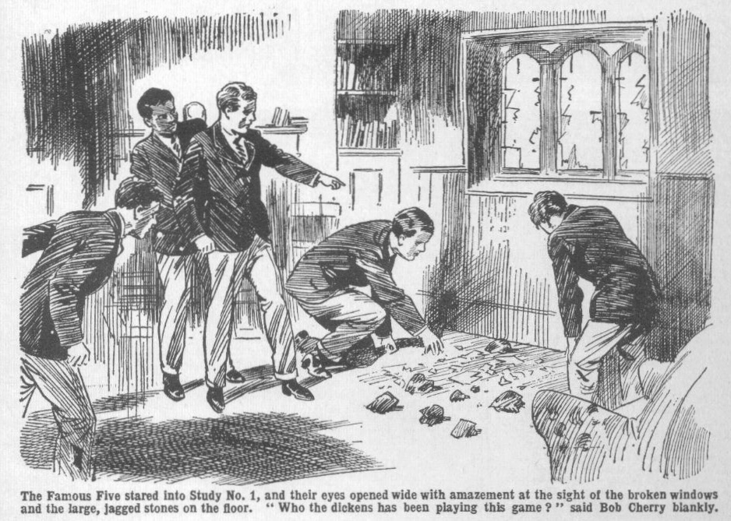
“Well, this beats the band.” said Bob Cherry blankly. “ Who the dickens has been playing this game?”
“Not a Greyfriars man.” said Johnny Bull. “ Everybody was in class—and Gosling says he saw a tramp—”
“ But why should a tramp—”
“ Goodness knows!”
“The goodness-knowfulness is terrific.” said Hurree Jamset Ram Singh. “It is a preposterous mystery.”
“I’d like to get within punching distance of that merchant, whoever he was.” said Harry Wharton. “But who—”
“Here comes Quelch!”
Mr. Quelch rustled up the passage. The juniors made way for him to enter the study. He gazed at the broken window, the scattered glass, and the stones. Then he looked at Wharton.
“Do you know anything about this, Wharton?”
“Nothing, sir.”
“Gosling states that he saw a tramp in the quadrangle, who ran away as he approached. The man appears to have selected your window—no other damage has been done. Have you no idea who the man may have been?”
“ None, sir.”
“Have you had any dispute or quarrel with any rough character outside the school?”
“No, sir.”
“Or you, Nugent?”
“No, sir.
Mr. Quelch pursed his lips.
“It is very singular,” he said. “It appears to be an act of ruffianly revenge—it is obvious that this window was specially selected by the miscreant. You have no idea who may have done this?”
“None at all, sir. ”
“Very well ; I shall communicate with the police. It is a very extraordinary occurrence.”
Mr. Quelch left the study, angry and puzzled, leaving five puzzled juniors behind him. His first step was to telephone to the police station, his second to ring up Chunkley’s, at Courtfield, requesting that firm to send a glazier to mend the broken window. Messrs. Chunkley assured him that a man should be sent that very afternoon. With that the matter had to be dismissed, disturbing and perplexing as it was.
“ Some tipsy tramp must have done it for a lark.” said Bob Cherry, when the Remove master left the study.
Harry Wharton shook his head.
“Why should he pick this window? Every one of the stones came into this study. A tipsy tramp might have busted windows, but he wouldn’t be so jolly particular about one window.”
“Must have been rather a good shot, too,” said Nugent. “ The window’s high up from the ground, and every stone came through a pane. A tipsy man couldn’t have got away with it.”
“Then it was somebody whose fur you’ve rubbed the wrong way,” said Bob.
“But how the dickens would an outsider know that this was our study?” said Wharton. “ Even if it was some fellow we’ve had trouble with, I don’t see how he could pick out our study.”
“Blessed if I do, either.” confessed Bob. “It beats me hollow—unless it was some jolly old wandering lunatic.”
The strange incident was discussed up and down the school. The general opinion was that it was a freak of some tipsy tramp—though that theory hardly seemed to explain it. A constable came from Courtfield, and received Gosling’s description of the tattered tramp he had glimpsed in the quad, and went away again. Whether the affair was a ruffianly “ lark,” or whether the man was somebody who had a grudge against the chums of Study No. 1, could not be guessed.
The affair had to remain a mystery. All that could be ascertained was that some unknown person, who looked to Gosling like a tramp, had stolen into the grounds while the fellows were in class, and smashed Wharton’s study window. It seemed an objectless outrage, and it had to be given up as a mystery. All that could be done was to get the broken window repaired—and while the fellows were in class that
afternoon the glazier arrived for the repairs. Certainly no fellow at Greyfriars was likely to give any particular thought to that glazier. But, had they known it, the man who came to mend the window was worth rather particular attention!
THE ELEVENTH CHAPTER.
Surprising for William Jenkins!
WILLIAM JENKINS, plumber and glazier, alighted from the
the motor-bus at the corner of the road, about a quarter of a mile from Greyfriars School. That was the nearest stopping-place of the motor-
bus that ran from Courtfield to Redclyffe. Mr. Jenkins had to walk the
rest of the distance, with his case of glass and his bag of tools.
On that pleasant, sunny summer’s afternoon the walk down the shady
road was agreeable enough, and Mr. Jenkins set out on it quite cheerfully.
William Jenkins’ life, hitherto, had been quiet and prosaic, and nothing of a startling or dramatic nature had ever happened to him—and he certainly had no expectation of anything of an exciting or dramatic nature happening to him. But Destiny had a dramatic episode up its sleeve for Mr. Jenkins, and it was just going to happen. It was an episode that furnished Mr. Jenkins afterwards with an almost inexhaustible topic at his favourite resort, the Peal of Bells, in Courtfield.
A man in gaiters, with an unlighted cigarette in his mouth, was loafing by the roadside, at a little distance from the school. He loafed idly, with his hands in his pockets, and seemed to have nothing to do. But his eyes were very keenly on every man that passed, and they fixed intently on Mr. Jenkins’ case of glass and bag of tools.
“ Got a light, matey? ” asked the man in gaiters, as William Jenkins came along.
“Lots!” answered Mr. Jenkins civilly.
With his free hand he felt in his pockets for a matchbox.
“ On a job, what?” asked the man in gaiters.
“Mending a winder.” answered Mr. Jenkins.
“ You got a long walk to the village from here.”
“It’s at the school.” answered Mr. Jenkins, with a nod towards the grey old tower of Greyfriars, rising over the trees. “ ‘Ere’s a match.”
The man in gaiters accepted a match and lighted his cigarette. He returned the matchbox, thanked Mr. Jenkins, and walked on by his side towards the school.
The road at this point was bordered by a wood, into which ran shady, dusky paths. The man in gaiters began to whistle, loudly and shrilly.
A little distance ahead two men stepped out of the wood, and apparently they were friends of the man in gaiters, for they waited for him to come up.
It was then that the dramatic episode happened to Mr. Jenkins.
As he reached the spot where the two men waited they stepped quickly to either side of him and grasped his arms.
“Sharp!” said the man in gaiters.
Almost before he knew what was happening the glazier from Messrs. Chunkley’s was walked off the road, up one of the shady paths into the wood.
He gasped with astonishment.
“Here, what’s this game?” exclaimed Mr. Jenkins. “ I’d like to know what you think you are up to? Leggo, will you?
“ Hold your row, my man!” said the man in gaiters. “You ain’t going to be hurt, but if you give as much as a yelp you get this where it will hurt!”
He jerked a life-preserver from his pocket.
Willian Jenkins blinked at it.
“Gum!” he said.
He made no resistance. His head was almost turning round with amazement. The grip on his arms was like iron, and the man in gaiters walked behind him, evidently ready to crack his head if he gave trouble.
“I ain’t got more’n ninepence about me.” said Mr. Jenkins at last, as he was led from the path into the dusky depths of the wood.
The man in gaiters grinned.
“Nobody’s after your ninepence.” he said. “You’re all right, you are! But shut up your mouth, and keep it shut!”
“Look here, what are you arter, then?” demanded Mr. Jenkins.
“Didn’t I say keep your mouth shut?” The man in gaiters made a threatening motion with the life-preserver. Mr. Jenkins sagely decided to keep his mouth shut, as requested.
Deeper and deeper into the wood he was led, more and more amazed at every step, till he reached a little glade secure from all eyes. There another man was waiting.
William Jenkins blinked at him.
He was a man of slim, but athletic frame, with steely eyes and a hard mouth. William Jenkins had never seen him before and he had never even heard of Dandy Sanders, crook and cracksman.
The steely eyes gleamed at him.
“Here he is, guv’nor!” said the man in gaiters.
It dawned on William Jenkins that he had been watched and waited for, and that the three rascals had kidnapped him at the order of the man with the steely eyes. That discovery only added to his amazement. What the steely eyed man’s motive could be was a puzzle to Mr. Jenkins. Certainly he was not after the ninepence in Mr. Jenkins’ trousers pocket.
“You need not be alarmed, my man,” said the man with the steely eyes quietly. “No harm is intended. Your name?”
“Bill Jenkins!”
“Where are you employed?”
“Chunkley’s, in Courtfield.”
“You were going to the school—Greyfriars School?”
“To mend a window?”
“What window?”
“Boys’ study winder, so they told me.”
“Who sent the order?”
“Dunno. It was a phone order.”
“Someone at the school telephoned for a man to be sent to mend a boys’ study window?”
“That’s it.”
“Very good! Put down your glass and tools.”
Mr. Jenkins, bemused with amazement by this time, obeyed. The next order astonished him still more. Dandy Sanders pointed to a suit of clothes folded in the grass.
“Change into those clothes—quick!”
“What?” gasped Mr. Jenkins.
“ Do as you are told!”
“But, I say—” gurgled the amazed glazier.
“Do you want your head cracked, Bill Jenkins 2” asked Dandy Sanders.
“ Oh crikey!”
“Then do as you are told!”
Mr. Jenkins did as he was told. There was no help for it. Goggling with amazement, he changed his clothes.
Then two pairs of hands grasped his arms, and he was led into a thicket, where he was tied to a tree, and a gag was placed in his mouth. The two rascals remained with him, keeping watch.
He was out of sight now of Dandy Sanders, and had no knowledge of that gentleman’s next proceedings.
With the help of the man in gaiters, Dandy Sanders put on the glazier’s discarded clothes. In a few minutes the well-dressed crook was transformed into the semblance of an honest workman,
Then the man in gaiters opened a little make-up box, and proceeded to make some changes in the Dandy’s looks. With a mottled
chin, darkened eye- brows, and reddened nose, the
crook looked very little like William Jenkins.
“You’ll do, guv nor!” grinned the man in gaiters.
“Hold up the glass, Hookey.”
The man in gaiters held up a pocket mirror, and the crook surveyed
his reflection therein.
“I fancy that will do.” he remarked.
“They wouldn’t know you at Scotland Yard now.” assured Hookey.
“Keep an eye on Jenkins!”
“You bet~”
The Dandy picked up the bag of tools and the case of glass. A quarter of an hour later the man who had come to mend the window
of Study No. I arrived at Greyfriars, and was admitted at a back door by Trotter, the page, who conducted him to Study No. 1 in the Remove, and left hm there to get on with his job.
THE TWELFTH CHAPTER.
Too Late!
DANDY SANDERS breathcd hard and deep.
He stood in Study No. 1 in the Remove—alone, unwatched
unsuspected. His latest trick had been successful.
Trotter had left the study door open, after landing the “ man from Chunkley’s” in the study. Dandy Sanders waited till the page’s footsteps had died away, and then quietly closed the door.
Now he stood looking at the old fire-place.
Luck had favoured him at last ; yet it seemed almost too good to be true.
More than once since Jerry the Rat had hidden the loot in the old chimney of Study No. 1 had the Rat’s confederates sought to obtain possession of it.
The imprisoned bank raider had got word to his confederates; they knew what to look for, and where to look for it.
This was not Dandy Sanders’ first visit to the school in search of the bundle of banknotes. But in his earlier visits luck had failed him. Once a fat schoolboy had given the alarm; another time, a senior boy, coming home late at night, had interrupted him. And the third attempt, made by tho Ferret, had failed equally, though the scheme of gaining the roof and climbing down the chimney while the school was at class had seemed quite a sure thing. But three attempts had failed; it was now the fourth, and the fourth had “ struck lucky”—or so it seemed.
The steely eyed crook was free to do as he liked—uninterrupted. He would be expected to remain at least an hour in the study repairing the broken window—and a few minutes would be enough for him! It was the most daring, and yet the simplest, of the schemes the Dandy had laid for obtaining possession of Jerry the Rat’s loot, and it looked like an easy winner.
Certainly no one at Greyfriars School guessed that that study window had been smashed by an unknown “ tramp,” in order that a man might be called in to repair it. No one dreamed that watch and ward had been kept for such a man on his way to the school. Still less was anyone likely to imagine that the man had been kidnapped, tied to a tree in the wood, and left under guard while a desperate crook came to the school in his clothes and his name. No one—except Carne of the Sixth—was aware that Study No. 1 had any interest for a gang of crooks.
The Dandy smiled.
Really, it was almost too easy. His previous attempt had been more risky than this. But simple as it was it had wanted thinking out; it was only after long cogitation that he had hit on this cunning scheme. But it was the easiest and safest of all. He had had to pass under no scrutiny; he had seen only the servants when he came. They had given him no attention; one of them had taken him up to the study without the faintest suspicion that he was anything but what he represented himself to be.
He did not intend to touch the broken window. Indeed, the Dandy, clever as he was, could not have mended a broken window; he did not know how to handle the tools in Mr. Jenkins’ bag! His plans were cut and dried. A few minutes—ten minutes at the most—and the green leather satchel hidden in the chimney would be in his hands and concealed in an inner pocket. Then he would go down, leaving his glass and his tools in the room, and explain that he had forgotten some necessary tool, and had to go back to Courtfield for it. After which he would walk out unsuspected, and vanish for ever.
When William Jenkins, after his release, told his strange tale nobody would be able to understand what it all meant, least of all William Jenkins himself. The Dandy could have laughed as he thought of it.
For two or three minutes, after shutting the door, he listened. But Trotter was gone; there was no one at hand. Theman from Chunkley’s had the whole passage to himself. All was safe; there was no danger of interruption. And at length he approached the chimney, bent his head under it, and stood in the fireplace, head and shoulders in the dusky, ample space of the ancient chimney.
It was sunny in the study, but deeply dark in the chimney. Dandy Sanders flashed on an electric torch, little dreaming that fifteen hours ago a Sixth-Former of Greyfriars had been doing that very thing in that very spot! He did not yet know that he had come too late.
The loot could not have been discovered yet. Its discovery would have been announced in all the newspapers. It could not have been destroyed; there were no fires in the studies in the summer. It was there, ready for Dandy Sanders to lift it—or should have been.
A cavity in the old brickwork, as high as Jerry the Rat could reach from below—that was the hiding-place. It should be easy enough to find.
There were several such cavities in the old brickwork. Dandy Sanders flashed the light into each of them in turn.
Accumulations of dusty old soot were there. Nothing else! His faceset grimly, and he knitted his brows over his steely eyes.
He had expected to spend a few minutes on his search. Ten minutes had passed, and he had found nothing—but soot!
By that time he had carefully examined every cavity within reach.
The steely eyes glittered.
For the first time a suspicion came into his mind that Jerry the Rat was “double-crossing” him. Jerry’s information had been precise; there was no mistaking it. Had the rascal hidden the loot elsewhere, and lied to his confederates, with the intention of keeping the seven thousand pounds as a nest-egg for himself when he came out of the “stone jug”?
Dandy sanders gritted his teeth at that thought; a natural suspicion to occur to the mind of a man who was an Ishmael. His hand against every man, and every man’s hand against him.
But he shook his head.
Jerry the Rat would not have dared to double-cross. And if he had lied, he would not have specified the place of concealment so meticulously. He would have said that he had thrown away the loot on Courtfield Common, which was the statement he had made to the police. No, the loot had been hidden there and it must be there still, unless it had been found and removed. And if it had been found, the fact would have been made known.
Dandy Sanders resumed the search.
But there was no fresh cavity in the brickwork to be discovered. Ho had found them all, and examined them all.
But his intent, searching eyes noted now a circumstance that had escaped him at first. All the cavities in the bricks were choked with old dried soot, excepting one. That one, which had plainly been choked like the others, was partially cleared, as if the soot in it had recently been disturbed.
The Dandy concentrated on that cavity.
He scanned it with watchful, savage eyes. There was still soot in it, but it had been disturbed and scraped. Something had been thrust into that space, and drawn out again. The Dandy’s eyes seemed to burn as he noted it.
He had found the place. In the light of the electric torch he stared at the spot where the satchel had lain. He knew that it had lain there, but it was not there now. His thoughts turned to the Ferret, but he knew that the Ferret had not touched the satchel. Had the plunder been found on the man who had descended the chimney the day before, the fact would have been made known. It was not that. Someone else. But who?
Dandy Sanders ground his teeth.
The lost loot was gone. He had come too late. He stood quite still for some minutes, his face pale with rage.
He had been certain, absolutely assured, that the loot of the Courtfield and County Bank was still where Jerry the Rat had hidden i., for it had been beyond doubt that its discovery would have been published. Whether found by searching, or found by chance, it came to the same thing. Yet evidently it had been found, and whoever had found it had kept the discovery a secret. Who could have found it? Who was so dishonest as to keep it? For that was what it came to. It had been found by someone who was no more scrupulous than Dandy Sanders himself. Whoever had found it had kept it. With all his cunning the crook had not foreseen that.
He left the chimney at last.
He had failed.
Someone, a thief like himself, had been before him.
Who? There seemed, to the crook, only one possible answer to that question. Who could have rooted in the study chimney and found the green leather satchel, excepting the schoolboys to whom the study belonged? Some unlooked-for chance had led to the discovery, and greed had done the rest.
The Dandy was not finished in the study yet.
He had plenty of time, and there were things that he wanted to know. It was easy enough for him to learn the names of the boys to whom that study belonged; there were books on the table and on the bookshelf, with names written in them. One name was H. Wharton ; the other was F. Nugent. He found no others. It seemed that the study was shared by two schoolboys, whose names were Wharton and Nugent. Dandy Sanders made a careful mental note of those names. In the near future he had to deal with those two schoolboys whose names were Wharton and Nugent.
There was nothing more to be done. The “man from Chunkley’s “ went down the stairs, and was let out by Trotter, to whom he explained that he had to fetch a forgotten tool. An hour later Dandy Sanders and his gang had disappeared into space, and the astonished Mr. Jenkins had walked back to Courtfield to tell his strange story to an equally astonished police-inspector at Courtfield Police Station.
THE THIRTEENTH CHAPTER.
Perplexing!
ARTHUR CARNE of the Sixth Form gave a violent start.
He was in the quad talking to Loder of the Sixth, when his eyes fell on a burly figure coming in at the gates.
Loder stared at him for a moment, and then followed Carne’s glance, wondering what had startled him.
“ Old Grimes again!” remarked Loder.
There was nothing, to Gerald Loder’s eyes, startling in the appearance of Inspector Grimes at the school. He might have called in connection with the affair of the man who had come down the chimney of Study No. 1 the day before, or in connection with the mysterious breaking of the study window that morning. But it was evident that Carne of the Sixth was startled by the sight of him.
“What’s up, old man?” asked Loder, puzzled.
“Nothing.”
“Its old Grimes from Courtfield, not his ghost!” said Loder, staring at his pal. “ What’s the matter?”
“Oh, don’t be an ass!”
Carne swung away, leaving Loder staring.
His heart was beating painfully.
Carne had often had secrets to keep from his headmaster. He had to keep secrets which, if they came out, would have terminated his career at Greyfriars School on the spot. He was used to that. That was little or nothing to the sportsman of the Sixth. But the secret he had now to keep weighed on his mind like lead.
The mere sight of a police-inspector was enough to send a thrill of icy terror to his heart.
He knew that Mr. Grimes’ visit could have nothing to do with him. How could it? Grimes probably did not know him by sight—most likely had never heard his name. If Grimes even suspected that the lost loot was to be found at Greyfriars, assuredly he could not suspect that a Sixth Form man had found it and hidden it afresh.
But at the sight of the inspector’s plump, rosy face Carne’s thoughts had raced at once to the green leather satchel hidden under the loose board in his study floor.
Ff it was found—
It could not be found, of course. But if it was found, it meant not only disgrace and expulsion for Came of the Sixth—it meant worse than that. It meant that he would share the fate that had befallen Jerry the Rat and the Ferret.
He was sick at heart as he tramped away under the elms, anxious to avoid all eyes—especially the keen eyes that twinkled from the rosy face of the Courtfield inspector.
An impulse came to him to go at once to Mr. Grimes, to lead him to his study, to hand over the lost loot; to get rid of it. To stop himself, at any risk, before he took another step on the slippery path downward.
But that was only for a moment. How was he to explain having kept the banknotes in his possession? And then the red, greasy face of Joe Banks rose before his mind’s eye.
He had not touched the plunder yet. He told himself that he had not made up his mind yet to touch it. Only if he was driven to it—only if there was no other resource, and than only exactly as much as he needed to ssee him through. There seemed less guilt in that, somehow. But he had not touched it yet ; he hoped that he never would touch it. In the meantime, it was safe. Nobody had lost anything by what he had done. It had been undiscovered in Study No. 1. It remained undiscovered in Carne’s study. Nobody was a penny the worse. So the wretched fellow told himself, as he tramped away alone, anxious to avoid all eyes, lest guilt should be read in his face.
Inspector Grimes walked on to the house, little dreaming of the terror his arrival had caused to one Greyfriars fellow, and never even thinking of glancing in Carne’s direction.
Harry Wharton & Co., near the House steps, capped Mr. Grimes civilly as he rolled up. The plump inspector stopped to speak to them.
“Is your window mended yet, Master Wharton—what, what?” he asked.
“Not yet, Mr. Grimes.” answered Wharton, rather wondering that the tolice-inspector was interested in that trivial matter. “The man’s only just come.”
“A man came this afternoon, I think?”
“So Trotter says.” answered Harry. “It was a different man, and he had to go back for a tool, or something.”
“ Did you see the first man?”
“No; I was in class.”
“Ah! Of course,” assented Mr. Grimes, “the school would be in class at that time—only the servant who let him in would see the man! Quite !”
With an amiable nod to the juniors Mr. Grimes passed on into the House, and was shown into the Head’s study.
Dr. Locke was expecting him, having been apprised by telephone that the police-inspector was calling. He greeted Mr. Grimes courteously. and listened in astonishment to the inspector’s succinct account of the peculiar adventure of Mr, William Jenkins on his way to the school that afternoon.
“Obviously, sir, the man’s clothes were borrowed by some person who desired to impersonate him.” concluded the inspector. “ This person undoubtedly visited the school, remained for a time, and left without having done the job, on some pretext. No blame attaches to the servant who admitted him, as he was, naturally, taken for the man expected from Chunkley’s. But it is essential to ascertain, sir, for what purpose this man came.”
“Quite so!” said the amazed Head. “ I am quite at a loss. Nothing, so far as I am aware, has been missed. It can scarcely have been pilfering—”
“No. But it is fairly clear that a window was broken by some unknown person, in order to provide this impostor with an opportunity of entering the school and remaining some time unsuspected—”
“Bless my soul!” said Dr. Locke. “What can possibly have been the man’s object, Mr. Grimes?”
“That is what I desire to find out, sir! With your permission, I will question the servant who admitted him.”
“Certainly!”
The Head rang for Trotter.
“Inspector Grimes desires to ask you some questions, Trotter.” said Dr. Locke.
“Yessir.” said Trotter, in surprise.
“You admitted a man from Chunkley’s this afternoon, my lad, who came to mend a broken window?” asked the inspector. “ Did you know the man— ever seen him before?”
“No, sir.”
“Describe him to me as accurately as you can.”
Mr. Grimes took out notebook and pencil.
Trotter’s description was rather vague. The man had looked like an ordinary plumber, and Trotter had noticed that he had a mottled chin and a rather red nose. He had been dressed just like the man who was now engaged on mending the window of a Remove study.
“How long did the man stay?”
“About half an hour, sir.”
“Why did he leave without doing his work—I mean, what explanation did he give?”
“He said he had forgotten a tool.”
“He was left alone in the study?”
“Yessir.”
“Do you know whether he left the study and visited other parts of the House “
“I couldn’t say, sir.” answered Trotter. “I was in the boot-room
“Did anyone else see him, to your knowledge?”
“Cook saw him when he came in, sir.”
“Um! That will do; you may go, Trotter.”
The astonished Trotter went.
Inspector Grimes closed his notebook with a snap. There was a rather grim expression on his plump face. Dr. Locke regarded him inquiringly. The strange affair completely puzzled the Head, but he could see that some idea was working in Mr. Grimes’ official mind.
“Can you explain, Mr. Grimes?” he askcd, at last.
“I can form a theory, sir!” said Mr. Grimes. “The man does not appear to have been a pilferer, as nothing was taken. He may posib1y have been a spy, picking up information as to the lie of the land, with a view to some subsequent attempt at burglary. Or—”
Mr. Grimes paused, and gnawed his lip.
“Or—” repeated the Head.
“You are aware, sir, that the loot taken from the Courtfield and County Bank by the man now in prison, has never been recovered.” said Mr. Grimes. “ The search has been very thorough, and, with your permission, I extended it to the precincts of this school, on the chance that Jerry the Rat might have parked his plunder here before he was captured in the House. That did not seem very probable then; but now—”
He paused again.
“ Bless my soul?” exclaimed Dr. Locke. “You do not think that the stolen banknotes may have been hidden in this building during the flight of the bankraider, and that this man was a confederate——”
“A confederate in search of them.” said the inspector, with a nod. “It appears to me possible, at least.”
“But surely the man in prison has not been permitted to communicate with his confederates
Mr. Grimes smiled.
“Certainly not, sir! Jerry the Rat has had no communication with the outside world, except with the solicitor engaged to defend him—a Mr. Sanders. But there are ways and means—ways and means! The possibility exists, at all events. But if such is the casa we are too late to put salt on the tail of our bird. We shall know nothing until the banknotes are put into circulation— probably in a foreign country.”
Inspector Grimes took his leave, a puzzled and rather worried gentleman. The suspicion was in his mind that the “man from Chunkley’s” had been a confederate of Jerry the Rat, in quest of the lost loot; in which case, it appeared certain that the plunder was gone beyond hope of recovery. It was only a suspicion, but he could not help feeling that, if the loot had ever been hidden inside Greyfriars, it was there no longer.
The plump inspector little dreamed that a Sixth Form man watched him go, with a throb of relief, when he disappeared. Inspector Grimes was a keen officer; but it certainly never occurred to him that a Greyfriars prefect could have told him where to lay his hands on the lost loot.
THE FOURTEENTH CHAPTER.
The Way of the Transgressor!
“NOT here?” yawned Loder.
Loder and Walker of the Sixth strolled into Carne’s study late in the evening. They expected to find Arthur Carne there; but he was not visible.
Of late, Carne’s chums had not been seeking his company. His money troubles bored them too much. There was hardly a man in the Sixth whom Carne had not of late tried to “ touch” for a loan.
Loder and Walker, as his special pals, had had the worst of it.
Probably they would not have dropped into his study now, but for the fact that both of them had run out of cigarettes. For that excellent reason the black sheep of the Sixth had strolled along to give Carne a look-in and borrow a smoke.
Walker sat down in Carne’s armchair.
“Bother the man!” he said. “He can’t be far off. Wait for him.”
Loder laughed.
“That’s all right.” he said. “ I know where Carne keeps his smokes. He won’t mind us bagging a few.”
Loder crossed to the corner of the study, where the loose board was hidden by the corner of the carpet. Carne’s desk, which usually stood by the window, was standing there now. Evidently Came was taking more than usual precautions to keep his supply of “ smokes”
out of sight.
Loder swung the desk aside. It was a rather heavy desk, and he grunted as he shifted it.
“Carne’s gettin’ nervy.” he remarked. “Does the duffer think that the beaks will come rootin’ about under his study floor, lookin’ for smokes ? He’s gettin’ as nervy as an old hen !”
“I suppose that blackguard Banks is still on his track!” yawned Walker.
“I suppose so! More fool he, to go in deeper than he can stand! I hope he’s got some cigarettes here.”
Loder turned back the corner of the carpet.
As he did so, there was a step in the passage, and the door opened and Arthur Came came into the study. “Hallo, old bean!” said Walker cheerily. “
Carne did not look at him. His eyes fixed on Loder, kneeling in the corner of the study, with the loose board already in his hand, lifting it.
Carne’s heart stood still.
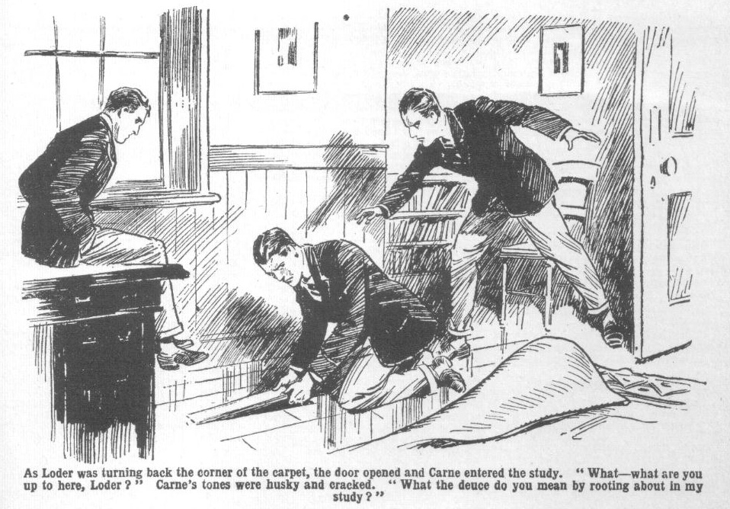
A few seconds more and the loose board would have been up. Carne had no time to think or speak. He made a sudden spring across the study, caught Loder by the shoulder, and dragged him over.
“ Oh gad?” gasped Loder.
He sprawled at full length on the floor, and the board he had been lifting dropped back into its place.
Carne put a prompt foot on it, panting.
Walker jumped up from the armchair, staring at Carne in amazement.
Gerald Loder, sprawling on his back, blinked up at him in almost idiotic bewilderment.
Carne panted for breath, his heart thumping almost to suffocation. His brain was spinning. He had been within an ace of discovery—but for his return to the study, and his prompt action, the bundle of banknotes in the green leather satchel would have been fairly under Loder’s eyes. His face was white as chalk.
Loder sat up, gasping.
“What the thump—” he exclaimed.
“What on earth’s the matter with you, old man?” asked Walker. “ Gone off your giddy rocker?”
Carne found his voice.
“What—what are you up to here?” His tones were husky and cracked. “What the deuce do you mean by rooting about in my study ?”
“Can’t a fellow help himself to a smoke?” demanded Walker.
“A—a—a smoke?” repeated Carne.
Gerald Loder picked himself up. He gave Arthur Carne a black look. He was amazed by the prefect’s violence, but more angry than amazed.
“ You cheeky cad?” said Loder, between his teeth. “You’ve borrowed my ,mokes often enough, haven’t you? You’d better keep your paws to yourself, Carne—I’ve a jolly good mind to knock you across the room.”
“ I’ve no smokes there—I don’t keep them there now?” muttered Carne. He remained standing on the loose board. Wild horses would hardly have dragged him from that spot, while his friends were in the study.
“No harm in a man lookin’, I suppose.” growled Loder, settling his ruffled coat. “What’s the matter with you?”
“Nerves?” said Walker, with a grin. “You’re gettin’ jolly nervy, Carne, old bean. If you don’t pull yourself together, the Beak will notice somethin’ before long.”
“Let’s get out of this.” grunted Loder. “I can tell you I’m jolly well fed-up with you, Carne.”
“Get out as soon as you like.” snarled Carne. “I never asked you into my study that I know of.”
“You rotter—?”
“Oh! get out I”
“I’ll get out fast enough, and I shan’t be in a hurry to come in again, either?” growled Loder. “Come on, Jimmy.”
Loder swung angrily out of the study, and Walker, after another surprised stare at Carne, followed him.
Carne kicked the door shut after them.
What his friends thought of his strange conduct, he cared little; at all events, they were not likely to guess the truth.
He stood with a white face, staring at the carpet that covered the hiding-place of the lost loot.
His escape had been so narrow that it made him giddy to think of it. He had forgotten the fact that the secret receptacle of his smokes was known to his friends.
The loot was not safe there. But where else could he hide it? He dared not leave it about his study—he dared not trust it even in a locked desk. What could he do with it?
Give it back where it belonged— before it was too late? He could not make up his miserable mind. Place it where it would be found by chance— after taking what he needed? But he could not resolve on that. Once he had abstracted a note from that bundle he would be a thief, and he shivered at the thought. He could not resolve to place it out of his power. Yet if he left the loot where it was and it was found—as it had already narrowly escaped being found—
Carne left the study at last, locking the door after him, and putting the key in his pocket.
When he returned he had a screwdriver and screws in his pocket, borrowed from some fellow’s toolchest.
He locked the door again carefully; turned back the carpet, and proceeded to screw down the loose board. He breathed more freely when that was done; the carpet replaced, and his desk standing over the spot. There could be no chance discovery now—only a search could reveal the secret, and that was out of the question.
But as he slept that night in his bed in the alcove of the study, the sportsman of the Sixth dreamed of what was hidden under the screwed board—dreamed of Loder bending over it; and in the vision of sleep, the features of Loder gradually changed to those of Inspector Grimes—and he awoke with a gasp of terror ; and it was long before he slept again.
Truly, the way of the transgressor was hard!
THE FIFTEENTH CHAPTER.
Bunter Begs for It!
“ I SAY, you fellows—”
“Bow-wow!”
“Here comes Wharton! Now for goodness’ sake, let’s begin!”
said Billy Bunter peevishly.
It was past tea-time ; and four members of the famous Co. were in Study No. 1. Billy Bunter was there, likewise. Billy Bunter had asked himself to tea; and he was anxious to get going. But as Wharton was with Mr. Quelch on some matter connected with his duties as head boy, the Co. were waiting for him to come up—regardless of the fat Owl.
Bunter saw no reason whatever for waiting for Wharton to come up. In fact, he would have preferred tea in the study without Wharton arriving at all; there would have been all the more provender for Bunter. And Bunter was hungry; having had nothing since dinner except tea in Hall.
But he had to wait ; and so the sound of footsteps coming up the passage and stopping at the door of Study No. 1, was welcome to his fat ears.
The door was pushed open; and a Remove man looked in. But it was not Harry Wharton ; it was Herbert Vernon-Smith.
“HaIlo, hallo, hallo!” said Bob Cherry. “Trot in, old bean!”
“Oh dear—it isn’t Wharton!” groaned Bunter. “When is that silly ass coming? I say, you fellows, what’s the good of waiting for Wharton? Quelch may keep him half an hour yet! You know what Quelch is.”
“Fathead!” said Frank Nugent. “Come in, Smithy.”
“I say, you fellows, for goodness’ sake don’t ask Smithy to tea! There isn’t a lot to go round as it is—”
“Shut up, Bunter!” roared Johnny Bull.
“Oh, really, Bull—”
“Isn’t Wharton here?” asked the Bounder, glancing round the study and laughing. “Don’t be alarmed, Bunter—I haven’t come to tea.”
“Where’s Wharton, you fellows?”
“Chin-wagging with Quelch in his study.” answered Nugent. We’re waiting tea for him.”
“Silly rot, I call it,” grunted Bunter. “Look here—”
“Shut up, Bunter!”
“I say, you fellows—”
“Kick him, somebody.”
“Beast!”
“I’ve got a message for Wharton, ” explained the Bounder. “I’ve just come in, and Gosling asked me to tell him. There’s a man waiting at old Gosling’s lodge to speak to him.” “What the thump does heo want?” asked Nugent.
“A tip, I expect,” answered Vernon-Smith, with a grin. “It’s a taxi-driver, from Courtfield, I suppose, and he says he’s picked up a letter addressed to Wharton here. Looks as if old Boggs, the postman, has been jolly careless, dropping letters along the Courtfield road I told them I’d bring it in, but he said he’d rather hand it to the owner.
“He ought to hand it over to Quelch.” said Nugent. “Letters for the Remove are supposed to go through Quelch’s hands.”
“So Gosling has told him,” answered the Bounder. “but I dare say the man doesn’t know our jolly old manners and customs here. He won’t hand it over to Gosling except in the presence of the chat it’s addressed to. So old Gosling asked me to tell Wharton to trot down.
“I’ll tell him when he comes up!” said Nugent.
“Right-ho!”
The Bounder nodded, and walked on to his own study.
“I say, you fellows, if Wharton isn’t coming—”
“ Shut up, Bunter!”
“Look here— ”
“Jolly queer old Boggs dropping letters addressed to the school out of his bag.” said Johnny Bull. “That’s a pretty serious thing for a postman to do.”
“Well, he must have, if this taxi chap has picked one up!” said Bob. “ Jolly good-natured of him to run along with it.”
“Might be from Wharton’s uncle with a tip in it.” remarked Nugent. “Harry has been expecting a letter from home. If Colonel Wharton has been thoughtful enough to put in a ten-bob note, it will run to sosses for tea. That would be luck.”
“The luckfulness would be terrific,’ grinned Hurree the at the Jamset Ram Singh “ But the probability is not preposterous.”
Billy Bunter’s eyes glimmered behind his big spectaclcs.
“ I say, you fellows, I shouldn’t wonder if that taximan’s made a mistake, and that letter’s for me.” he said thoughtfully. “ I’ve been expecting a postal order for some time
“Ha, ha, ha!”
“Blessed if I see anything to cackle at! Haven’t I mentioned to you fellows that I was expecting a postal order?” exclaimed Bunter warmly.
“You have!” chuckled Bob Cherry. “ Lots of times! But this can’t be your jolly old postal order, Bunter. The age of miracles is past, you know.”
“ Oh, really, Cherry! I know that something’s happened to delay my letter.” said the fat Owl “ If old Boggs has dropped it out of his bag, that accounts for it. You see, my postal order hasn’t come. It’s from one of my titled relations—”
“If any!”
“Beast! If that letter’s for me—”
“How could it be for you, fathead, if it’s addressed to Wharton?” demanded Johnny Bull.
“Well, the writing may be indistinct, you know, and the man may have misread it.” said Bunter. “Some of my relations don’t write a very good hand. Noblemen don’t, you know.”
“Oh crumbs!”
“Look here, if we’re not going to have tea—”
“Not till Wharton comes up, you fat cormorant!”
“Then I’m jolly well going to see if that letter is for me.” said Bunter. “It’s jolly odd that my postal order hasn’t come yet. I’ve been expecting it for some time.”
“Ha, ha, ha!”
Up to the Billy Bunter rolled out of tho study, leaving the chums of the Remove chuckling.
It was true that Bunter had been expecting a postal order for some time— quite a considerable time, in fact. It was equally true that there had been delay in the post, if that celebrated postal order was coming at all.
Certainly it seemed unlikely that the taximan who had picked uptheletter could have misread “ Bunter! Home backs pace ” as “ Wharton!” in the address. Still, if the letter had been addressed by one of Bunter’s relatives, and that relative wrote anything like Bunter himself, the writing might have meant almost anything.
Anyhow, Bunter wanted to get that letter into his hands, if there was a remittance in it. If there wasn’t, Wharton or anybody else was welcome to it! But if there was, Bunter was prepared to find hiso own name on it, if it was humanly possible so to do.
He rolled out of the House, and took his way down to the porter’s lodge.
Smithy had said that the taxi-driver was waiting there, but Bunterfound Gosling alone. He could hear the sound of a running engine in the road.
He blinked in at Gosling’s door.
“Where’s the taximan, Gosling?” he asked
“Gone back to his taxi!” grunted Gosling. “He’s got a passenger in it. If Master Wharton’s asked you to get thoat letter you can’t ‘ave it. Letters can’t be took in without Mr. Quelch knowing.”
“Sure it’s for Wharton?” asked Bunter.
“I ain’t seed it!” grunted Gosling. “The man won’t ‘and it over ‘cept Master Wharton’s present. Cheek!”
“Perhaps he thinks you’re not to be trusoted, if there’s money in the letter, Gosling!” suggested Bunter brightly.
Gosling looked at him.
“Wot?” he ejaculated. “Why, you impudent young rip, wot I says is
“Well, you see —”
“You take your face out of my lodge!” growled Gosling.
Billy Bunter took his face out of Gosling’s lodge. He rolled out of the gateway, blinking round him through his spectacles.
A taxicab was halted at a little distance, the engine running. A man with a thick moustache sat in the cab, with a Homburg hat shading his face, from under which gleamed a pair of keen, steely eyes. A man in chauffeur’s uniform stood beside the taxi, speaking in a low tone to the passenger.
Both of them looked at Bunter as he appeared.
The driver turned towards him, touching his peaked cap.
“Master Wharton?” he asked.
Evidently he did not know Harry Wharton by sight. As the fat junior came out to the cab, he naturally took him for Wharton; but he asked the question to make sure.
Billy Bunter nodded cheerfully.
All he wanted was to get that letter into his fat hands, and make quite sure that it was not addressed to W. G. Bunter before he let it go out of his possession. Even if he had to acknowledge that it was addressed to Wharton, the captain of the Remove could hardly refuse a small loan to the fellow who had taken the trouble to fetch the letter for him—if there was a remittance in it. The taxi-driver’s natural error made the thing quite easy for Bunter.
“You’ve picked up a letter addressed to me.” he said breezily.
It hardly occurred to the fatuous Owl that this was a deception. Truth and Bunter had always been strangers. Remove fellows declared that Bunter could not have told the truth if he had tried— not that he was ever likely to try!
“Yes, sir.” said the man civilly. “Here you are, sir!”
Bunter approached him with a fat hand outstretched to take the letter.
What happened next seemed like a wild dream to the Owl of the Remove.
The steely eyed passenger in the car threw open the door. The taximan seized Bunter, and hurled him bodily into the vehicle like a sack of coal.
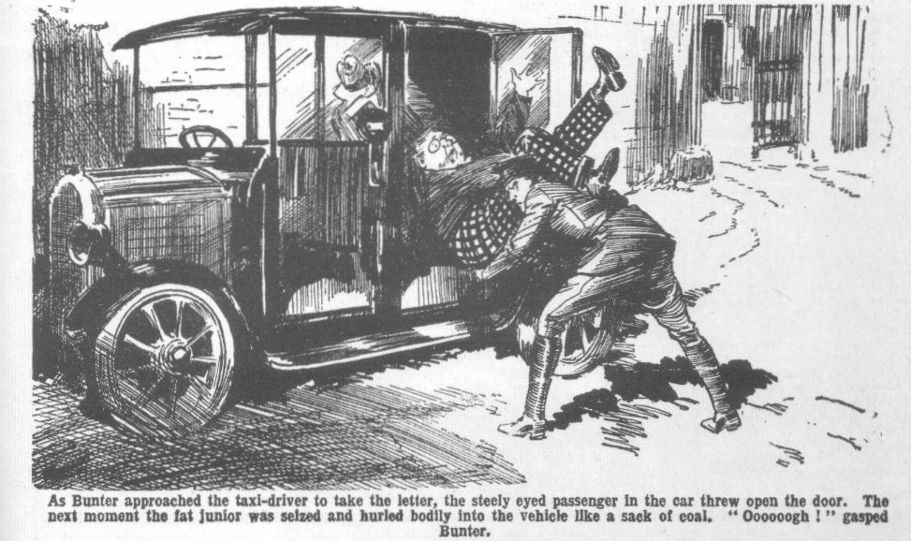
“Ooooogh!” gasped Bunter.
He sprawled on the floor of the taxi, dizzy with amazement.
The driver was instantly in his seat, and the taxi was racing along the road.
Bunter would have struggled up, but a heavy motor-rug was thrown over him, and a foot pinned him down.
“Keep quiet!” said a cold, hard voice. “You’re not going to be hurt unless you give trouble; but keep quiet!”
Bunter ahnost fainted with terror and astonishment. And he kept quiet!
The taxi raced away. Three or four Greyfriars fellows, who were coming along to the gates, had witnessed what had passed; but it had passed too swiftly for intervention to be possible.
They stood staring blankly after the car as it vanished in the distance in a cloud of dust.
“My only hat!” exclaimed Coker of the Fifth. “What’s that game?”
“What the jolly old thump does that mean?” exclaimed Temple of the Fourth.
The racing taxi vanished.
Five or six minutes later, Harry Wharton came down to the gates, having received the message from Nugent in the study. He found an excited crowd of fellows at the gates, and Goslingo staring out into the road in blank astonishment. Wharton tapped the old porter on the arm.
“Man with a letter for me—” he said. “Where?”
“Gorn!” gasped Gosling. “Gorn!” Mr. Coker says he chucked Master Bunter into the taxi and bolted! Wot I says is this ‘ere, I don’t ketch on.”
Neither did Harry Wharton “catch on,” nor any other fellow. Billy Bunter was gone, and unless it was some extraordinary practical joke, there seemed no imaginable explanation. In ten minutes all Greyfriars knew what had happened, but nobody within those ancient walls could begin to guess what it meant.
—
THE SIXTEENTH CHAPTER.
The Wrong Bird!
BILLY BUNTER gurgled.
Sprawling in the bottom of the taxi, under the heavy motor-rug, the fat junior gasped and gurgled for breath, and wondered whether this was some fearful dream.
But the foot planted on the rug, pinning him down, was very real. It was hard and heavy, and it pressed uncomfortably on Bunter’s well-filled waistcoat. It was no dream! Amazing as it was, this really was happening. Billy Bunter, breathless, bewildered, terrified, was rushing away in unknown hands as fast as the car could carry him.
And that was very fast indeed. The car, though fitted up like a taxi to look at, had an uncommonly good engine, and the driver was letting it out. It fairly whizzed.
Bunter had no idea of the route followed. Up one road and down another, by lanes and crosslanes, the car fled, throwing all possible pursuit off the track. Nobody passing the car and glancing into it could have seen Bunter sprawling under the rug. The steel-eyed man satsmoking a cigarette, with home backspace an air of casual unconcern. . Only when a louder gurgle or grunt than usual came from Bunter he increased the pressure of his foot as a warning to the kidnapped Owl to keep quiet.
Had Billy Bunter tries to think the matter out, he could not have imagined what this amazing occurrence meant. But he was not thinking, or trying to think; he was gasping and gurgling and palpitating in a state of mingled funk and bewilderment.
The car solowcd down at last.
Bunter, still half suffocated under the thick rug, realised that it was halting. The engine ceased to throb.
The rug was suddenly jerked away.
Bunter blinked in the light.
“ Get up!”
Dandy Sanders rapped out the words. Has steely eyes glittered down at the fat junior. There was a contemptuous expression on his hard face, called up by Bunter’s obvious terror, but he was not dissatisfied. The more frightened the schoolboy was, the more easily Dandy Sanders expected to deal with the fellow he supposed to be Harry Wharton, of Study No. 1 in the Remove.
Bunter sat up dizzily, and blinked and spluttered.
“I—I—I say—” he gasped.
“Get out of the car!”
“Oh lor’!”
The man with the steely eyes had thrown open the door. The driver had already alighted. He grabbed Bunter us the fat junior tottered from the car, and set him on his feet.
Bunter set his spectacles straight on his fat little nose, and blinked round him like a bewildered owl.
The car had halted in a narrow, solitary lane. Woods shadowed it on either side. But Bunter knew where he was. He had been through that lane before, and he knew that it lay between Greyfriars School and the Redclyffe road. After that burst of speed in the fleeing car; he was only five miles from Greyfriars.
There was no sign of a habitation in sight. Bunter knew that there was no building nearer than the wood-cutter’s cottage, several miles distant. He was in a leafy, shady solitude with the two kidnappers.
“I—I say——” he stuttered.
“Follow me!”
Dandy Sanders strode into the wood. Billy Bunter blinked after him, and hesitated, until a rough shove from Hookey started him. Then he lost no time in scuttling after the steely eyed man.
The car was left, with the engine shut off, in the narrow lane. The shadowy woods swallowed the Owl of the Remove and his kidnappers.
His fat knees knocked together as he went. He could only imagine that he had been brought to that solitary spot to be robbed—but on that score Bunter need not really have been greatly alarmed. His worldly wealth consisted of a French penny—unless the mysterious pair took a fancy to his rolled gold watch! Certainly, if they were motor-bandits, they had struck a poor patch in Bunter, and were not likely to find the game worth the candle!
The steely-eyed man halted under the thick, wide-spreading branches of an old oak. Trees and thickets surrounded the spot, shutting it off from all possible observation. Billy Bunter leaned on the trunk of the oak, gasping for breath, blinking at his conductors in dire apprehension. If they meant harm to him, he was utterly at their mercy. Yet, even in his terror, he could hardly believe that they meant serious harm to a schoolboy whom they did not even know by sight.
“Now,” said the steely eyed man, his keen, searching eyes fixed on Bunter’s scared face, “1 have a few questions to put to you. Answer them truthfully, and you will not be hurt. A single falsehood, and “ He made a gesture, and Hookey, for a moment, showed the bluish barrel of an automatic pistol from his pocket. “You understand?”
“Oh crikey!”
But for the support of the oak trunk the hapless Owl of the Remove would have collapsed.
“You share your study at Greyfriars with another boy.” said the steely eyed man.
“Yes!” gasped Bunter. Even in his dire terror he was amazed by such a question. What could these armed scoundrels possibly care about his study and his study-mate at Greyfriars School?
“I have been able to get hold of only one of you!” said the Dandy grimly. “But, if necessary I shall not fail to get hold of the other. But I think it will not be needed. One of you can scarcely have made such a discovery without the knowledge of the other, I should imagine, as you share the room. You understand me now?”
Billy Bunter was far from understanding. He could only blink at the crook in utter bewilderment.
What “discovery” he was supposed to have made in his study was a mystery to Bunter. He did not realise, at the moment, that the man supposed that he was speaking to Harry Wharton. But had he realised that, it would have let in no light on the matter. So far as Bunter knew, there had been no discovery of any kind in any Remove study.
“You understand?” rapped Sanders.
“N-n-no!” gasped Bunter.
The steely eyes glittered at him.
“Listen to me,” said Dandy. “ I have taken a great deal of trouble to get you into my hands, Master Wharton! You can guess by this time, that no letter addressed to you was picked up—you must have sense enough to guess that it was a trick to get into touch with you, because I did not know you by sight. I knew your name, and the name of your study-mate, that was all. Now I have you in my hands—”
“Oh crumbs!” gurgled Bunter.
He understood now that the man believed that he was Wharton, Really, Dandy Sanders could hardly have believed anything else, when the fat Owl had claimed the letter in Wharton’s name. But this discovery was a relief to Bunter. If they wanted Wharton, they did not want him, and he had only to tell them who he was.
The expression of relief that flashed into his fat face puzzled Dandy Sanders and Hookey. They stared at him.
“I—I—I say!” gasped Bunter. “I say, if you think I’m Wharton—”
“What do you mean?” snarled the Dandy. “You are Wharton!”
“I ain’t!” gasped Bunter. “I—I never was, you know! Nothing of the sort! I’m Bunter!”
The automatic showed again from Hookey’s pocket, as he scowled fiercely at the fat Owl.
“You lying young rascal!” said Dandy Sanders in concentrated tones.
“I have warned you not to lie to me! You are Wharton—Harry Wharton. You occupy Study No. 1 in the Remove at Greyfriars—”
“I ain’t!” groaned Bunter.
“Why did you claim the letter in Wharton’s name, if you are not Wharton?”
Bunter gave a groan. Never had the fat Owl so deeply repented of his fatuous trickery.
“I—I thought it might be for me.” he mumbled dismally. “I—I was expecting a postal order, and I—I thought—”
“He’s lying!” muttered Hookey savagely.
“I ain’t!” wailed Bunter. “Wharton was with Quelch, and I came to take the letter. Of course, I’d have given it to him if it had been for him. Wharton’s still in the school. He’s nothing like me. You can ask any Greyfriars man. He—he ain’t like me at all! He—he’s not good-looking.”
Dandy Sanders gnawed his lip.
He had not spoken yet of the green-leather satchel containing the lost loot which he fully believed had been found by one or both of the juniors in Study No. 1. He was glad of it now. If this fat, frightened fellow was not Wharton, the Dandy did not want to give his game away. A fellow who was neither Wharton nor Nugent was of no use to him. But he eyed the fat Owl, with almost wolfish ferocity and doubt.
“I—I say, I can prove that I’m not Wharton!” groaned Bunter. “ We have our names written in our hats at Greyfriars. Mine’s in my cap.”
Dandy Sanders snatched the cap from the fat Owl’s bullet head. He muttered an oath as he read “ W G. Bunter” therein.
“ I’ve got letters in my pocket, too, addressed to me.” said Bunter hopefully.
“Show them to me!” said Dandy harshly.
Bunter fumbled in his pockets. He produced two old letters, at which the steely eyes gleamed savagely. One was from Mr. Bunter, stating that that gentleman had no intention of zending William anything over his allowance that term; the other was from Bessie Bunter, requesting the return of a half-crown that her affectionate brother had owed for a long time. Dandy Sanders crumpled the letters in a savage hand and threw them on the ground.
He was convinced now.
“By gum!” growled Hookey “If we’ve got the wrong bird, guv’nor—”
Sanders spat out an imprecation.
“We’ve got the wrong bird!” he snarled.
Hookey’s hand gripped the automatic in his pocket. Billy Bunter gave a shriek of terror.
“Don’t be a fool!” Dandy Sanders snarled at his associate. “We’ve failed this time—but one swallow doesn’t make a summer! Get back to the car.”
Hookey, muttering oaths, tramped away through the trees towards the lane. Dandy Sanders eyed the shivering Owl wolfishly. This mistake was going to make his task more difficult. A fatuous, unthinking fool of a schoolboy had by sheer folly knocked to pieces a carefully laid scheme, and after this was told at Greyfriars it would not be so easy to get hold of the juniors he wanted. But it was not to be helped. The wary crook was not likely to share the desperate thought that had come into Hooky’s ruffianly mind.
He had no use for Bunter.
He made a stride towards the fat junior and gripped him by the collar.
Bunter gave a howl of fear..
The Dandy swung him round, and kicked.
His boot landed hard on Billy Bunter’s tight trousers, and the Owl of the Remove fairly flew.
Bump!
“Whoooop!”
Dandy Sanders turned away and stared after his confederate. He disappeared among the trees.
Billy Bunter sat up, spluttering.
“Ow! Wow! Beast! Wow!”
From the direction of the lane came the roar of an engine. The crooks were gone—the roar died away in the distance.
“Oh crikey!” gasped Bunter.
* * * * * * * * * *
“Hallo, hallo, hallo!”
“Bunter!”
“He’s come back!”
A crowd of fellows surrounded Bunter as he tramped in at the gates of Greyfriars just before lock-up.
Bunter blinked at them dismally. He had an ache in every fat limb.
“I say, you fellows, I’m tired!” groaned Bunter. “ I say, they landed me dozens of miles away, and I’ve had to walk home! Ow! Catch me fetching a letter for you again, Wharton. I’m always doing these good-natured things, and this is what I get for it! Oh dear!”.
“But what did they want?” asked Harry Wharton.
“Ow! They wanted you—”
“Me!” ejaculated the captain of the Remove.
“Ow! Yes! And I jolly well wish they’d got you! I’ve had an awful time! The silly idiots thought I was you, because I said I was—”
“Oh; my hat! But what—”
“There wasn’t any letter—it was just a trick to get hold of you, and they got hold of me. Ow! My legs are dropping off! Wow! I say, you fellows, do you think Quelch will let me off prep to-night? I’m too jolly tired to do any prep—exhausted, you know—”
Billy Bunter trailed on dismally to the House, with a buzzing, amazed crowd round him. He was called into Mr. Quelch’s study, and then taken to the Head, and later he saw Inspector Grimes —after which nearly every fellow at Greyfriars listened to his amazing story. But none of his hearers could begin to understand what it all meant. From that amazing story one fact seemed to emerge clearly—that two persons unknown had wanted to get the captain of the Remove into their hands; but why and who they were it was impossible to guess. But forewarned was forearmed, and Billy Bunter’s strange adventure had at least had the effect of putting Harry Wharton upon his guard.
THE END.

