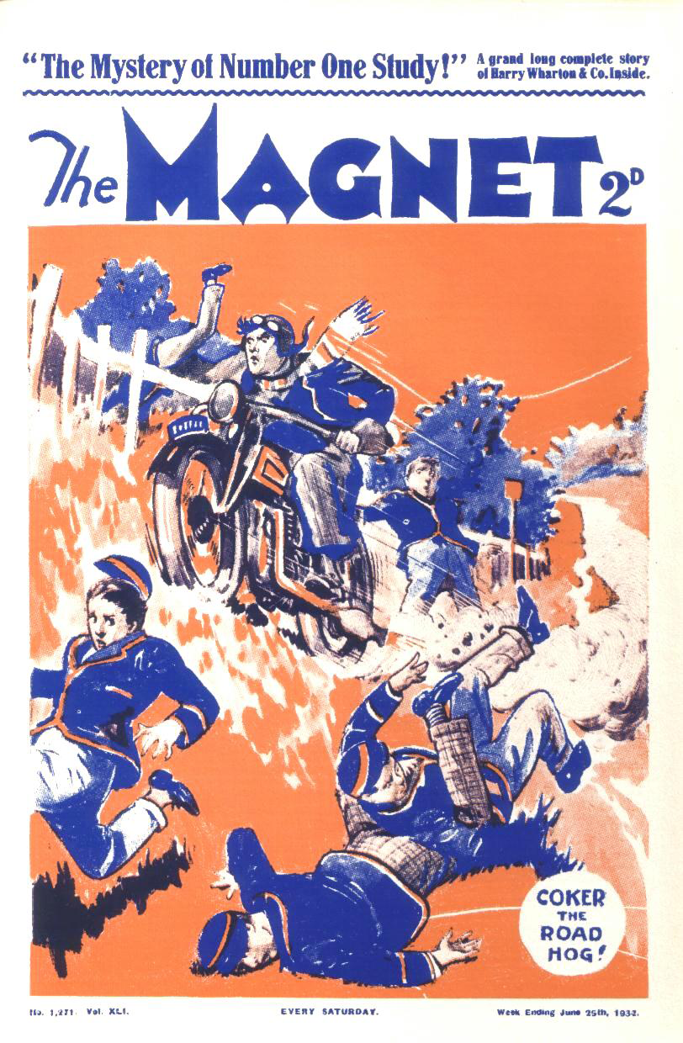
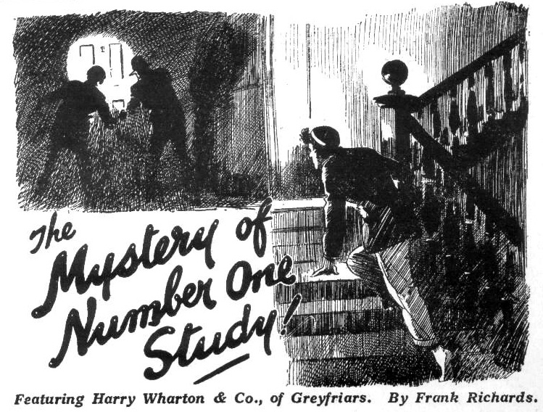
THE FIRST CHAPTER.
Coker Gets Going!
“Oh, listen to the band!” chortled Bob Cherry.
Harry Wharton & smiled.
Coker of the Fifth did not smile.
He glared.
If there was anything that Coker loathed, when his motor-bike wouldn’t start, it was a mob of fags gathering round to watch the entertainment.
Sometimes that motor-bike went like the wind; and Coker, astride of it, careered at terrific speed, to the terror of all inhabitants. Sometimes, like the donkey in the old song, it wouldn’t go!
This was one of the latter times. Why the jigger wouldn’t go Coker was not aware—but it wouldn’t! It uttered what seemed to be sounds of bitter protest. It grunted; it roared; it coughed. But it did not go.
Coker, red and ruffled, wrestled with it, persuaded it, coaxed it, and called it names, in turn; but the motor-bike was deaf to the voice of the charmer.
Coker had been at work some time, and he was getting oily and grimy and frightfully exasperated, when the Famous Five came along and stopped to enjoy the show.
For long, long minutes that motor-bike had been producing music like that of a jazz band with an extra allowance of saxophones. But it seemed disinclined to further exertion. It remained where it was, and Coker of the Fifth grew redder and redder, and more and more ruffled.
“Go it, Coker!” said Harry Wharton encouragingly. “Never say die!”
“Nil desperandum, you know!”” said Frank Nugent.
Coker breathed fury. And in
“If you fags don’t clear off,” he said, in concentrated tones, “I’ll take a
spanner to you!”
“Can’t we help?” asked Johnny Bull.
“We’ll give you a shove behind if you like, Coker.”
“I fancy Coker’s forgotten to wind it up!”” said Bob Cherry gravely. “Have you wound it up, Coker?”
“Ha, ha, ha!”
Coker glared. Horace Coker did not really know a lot about motor-bikes, but he knew they did not have to be wound up.
“If you fags want to be smashed—” hissed Coker.
He gripped a spanner convulsively, and the chums of the Remove prudently backed out of reach.
But they did not depart. That sunny June afternoon was a half-holiday at Greyfriars, and Harry Wharton & Co. were walking to Courtfield, across the common. But they were in no hurry: they had plenty of time to watch Coker and his jazz band. Coker was heading in the opposite direction, towards the village of Friardale, but at his present rate of progress he did not seem likely to see Friardale very soon, if at all.
Crash! Clang! Coker was getting busy on the bike again. What he fancied he was doing with the spanner was not clear; but at looked as if ho were bent on giving the obstinate jigger a jolly good thrashing.
“Dont beat the poor thing, Coker!” said Nugent reprovingly.
“The beatfulness is not the proper caper, my esteemed Coker!”” said Hurree Jamset Ram Singh.
Bob Cherry began to sing:
“If I had a stink-bike that wouldn’t go,
Do you think I’d wallop it? Oh, no, no!”
“Ha, ha, ha!” yelled the juniors.
“I—I—I’ll—” gasped Coker.
Coker was on the point of abandoning the bike to its own devices, end hurling himself at the Removites. But just then the coughing, grunting, and sneezing changed to a tuneful buzz, which indicated that the jigger, at long last, was going to “go.”
“Oh, good!” gasped Coker.
“Look out, you men!” shouted Bob Cherry. “Jump for your lives!”
“Ha, ha, ha!”
The juniors, laughing, backed away out of danger. If Coker was really getting going at last, he needed a wide berth. Once Coker was mounted on that bike, there was no telling what he would do. Coker on a motor-bike required plenty of sea-room.
Chug, chug, chug, chug!
“It’s going!” exclaimed Johnny Bull. “Wonders will never cease!”
Chug, chug, chug!
Coker hopped along with the bike, forgetful of the juniors. Far ahead of them, in the lane from Friardale, a car appeared in a cloud of dust, coming along at great speed.
“Look out, Coker!” shouted Harry Wharton. The
Coker did not heed.
A car bearing down on him at 50 m.p.h. was a trifle light as air to Horace Coker.
Besides, he had his hands full with that bike.
It was going, and Coker was on board; but the motor-bike still seemed to have a will of its own. It was a wilful and rebellious stink-bike. It roared away to the side of the road, and Coker barely swerved from a crash. It roared across to the other side, and by another miracle Coker just escaped a nose-dive into a hawthorn hedge. Any fellow watching Coker on a motor-bike might have supposed that he preferred zig-zags. He favoured both sides of the road impartially.
“Oh, my hat!” breathed Harry Wharton.
The Famous Five, bunched against the school wall, stared after Coker, and beyond him the car that was shooting along from Friardale.
It was a small car—one of those baby cars which cover the roads like wasps in he summertime. Only the driver was in it, and he seemed to be going all out, like a man in a hurry. He came along almost like lightning; while Coker zigzagged to and fro in the road, oblivious of him.
Coker, considering how he handled a motor-bike, had marvellous luck: his hairsbreadth were innumerable. But it really looked as if something was going to happen this time. It really was not safe to do fancy skating on a motor bike when a car was coming along at top speed.
“Oh crumbs!” murmured Bob Cherry.
The juniors gazed tensely.
It all passed in seconds. Coker, probably by chance, got on the left of the road, and no doubt the motorist supposed that he was going to stick to that side. There were few motorcyclists like Coker, and no doubt that motorist had never met one. But with the car almost on him, Coker shot across the road again.
The juniors gasped together.
It was not Coker who avoided the crash. Coker was, apparently, still unconscious of the car. The motorist, in the nick of time, spun his car away from Coker, and the next moment it was crashing into the hawthorns. By prompt action the motorist had avoided slaughtering himself and Coker; but he seemed to have slaughtered his car. The little car pitched over in the tangled hawthorns, the driver pitched out of it, rolled over, picked himself up—and the next moment, he was saying things that almost turned the atmosphere blue.
THE SECOND CHAPTER.
Exchange Is No Robbery!
“Oh, my hat!” gasped Bob Cherry.
Harry Wharton & Co. ran swiftly on the scene.
The man in the car did not seem to have been hurt. But he seemed to be in a fearful temper—which was perhaps not surprising in the circumstances .
Coker barged on towards Friardale.
But it dawned on Coker that there had been an accident, and he circled in the road—with two narrow escapes from the hedges—and came barging back.
He shut off and jumped down—to receive a volley of frenzied vituperation from the man who had driven the car.
Coker stared at him.
“Look here, chuck it!” he said. “What are you slanging me for, I’d like to know? Can’t you drive? If you can’t drive, you shouldn’t be out with a car !”
“What?”
“Barging in a fellow’s way!” exclaimed Coker indignantly. “Might have barged me over!” Might have been my motor-bike smashed , instead of your tuppenny-ha’penny car!”
“Oh crikey!” murmured Harry Wharton.
Coker evidently did not consider himself at fault. But that was Coker’s way! Coker never did!”
“Coker, you fathead—” exclaimed Bob.
“Shut up, Cherry!”
“You preposterous ass, Coker---”
“Shut up, I tell you!” snapped Coker.
“I don’t want any cheek from fags!”
“You silly chump!” roared Harry Wharton . “You’ve wrecked this man’s car—”
“Shut up, Wharton!”
The juniors eyed the motorist rather anxiously. He seemed to be almost foaming with rage. Anger and annoyance were natural and justifiable when his car lay a wreck, jammed in the hedge. But he was not merely angry and annoyed; he was infuriated.
He was not, now the juniors saw him closely, a prepossessing man to look at. He had a narrow, thin face, with close-set eyes that gave him a rather foxy look, and a hard, thin mouth that looked like a gash. The thin, foxy face was pale with fury, the narrow eyes glittered.
“Fool! Foot! Fool!” He snarled out the words, his thin lips drawn back from his teeth. “Fool! My car is wrecked—”
“Your own fault!” said Coker. “You shouldn’t drive if you can’t handle a car!”
“It’s your fault, you ass!” yelled Nugent,
“Shut up, Nugent!”
Harry Wharton & Co. more than half expected assault and battery to be the next item on the programme. The foxy-faced man seemed hardly able to keep his hands off Coker.
“Fool! Clumsy idiot—”
“Oh, chuck it!” snorted Coker. “This is how you thank a chap for coming back to see if he could help! Wish I’d left you to it!”
“Fool!”
The man turned to the juniors.
“Can I got a car anywhere here?” he asked , panting. “I am in a hurry— a great hurry! Important business!”
“You can get a taxi at Courtfield, sir.” said Harry Wharton. “There’s plenty there: but it’s nearly three miles by road.”
The man snapped out an oath.
He stared at the car. Obviously time would be required to get that car going again. Then his eyes flashed as they turned on Coker’s motor-bike.
Coker, displeased and indignant, was about to mount again; he had no use for an ungrateful motortst who only slanged him, when he had kindly come back to see what he could do.
Chug, chug, chug!
A few seconds more, and Coker would have been speeding away.
The foxy-faced man made a sudden spring.
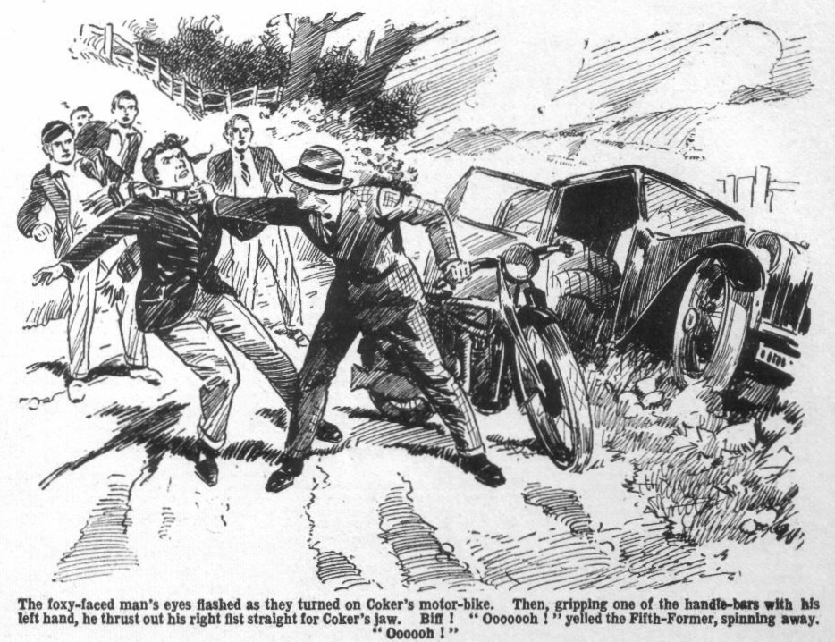
A fist that seemed like a lump of iron caught Horace Coker on the side of the jaw without warning, and the Fifth-Former, with a gasping yelp, spun away and sprawled in the dust.
The motor-bike swung round in the man’s grasp.
He had a leg over it in a flash; and before the juniors quite realised what he was at, he was roaring away towards Courtfield on Coker’s jigger.
Coker sat up, spluttering.
He had a hand on his jaw, which felt as if a mule had kicked him there.
“Oooooh!” gasped Coker. “Oooogh!”
“Great pip!” gasped Bob Cherry. “He’s snaffled Coker’s bike! Oh, my only summer bonnet!”
“Phew!”
The juniors stared after the foxy-faced mant, almost in stupefaction. His action had been so sudden and swift that it had taken them by surprise as it had taken Coker. There was no chance whatever of stopping him. Already he was vanishing in a cloud of dust far up the road.
Coker staggered to his feet, still holding his jaw.
“He—he’s got my bike!” stuttered Coker dazedly. “That—that blighter has got my bike!”
“He’s left you his car!” grinned Bob Cherry. “Exchange is no robbery!”
“I—I—I’ll smash him!” gasped Coker. “I’ll go after him and smash him into little pieces! I’ll have him ran in! I—I—I’ll--- Ow! My jaw! Hitting a man when he wasn’t looking! Wow!”
Coker limped away, clasping his damaged jaw convulsively. The man on the motor-bike had vanished.
“Well, this is a go!” exclaimed Bob. “That chap must have been in a fearful hurry. Might be a matter of life or death, and if it was I suppose he could borrow Coker’s bike, when Coker wrecked his car for him.”
“Must be jolly pressing business, I should think!” said Harry. “He’s left his car here—he doesn’t seem to care what becomes of it. I—I suppose he’s not stealing the bike! The car’s worth more than the bike—though it wants a few repairs, I fancy!”
Johnny Bull stared along the sunny road towards Friardale.
“I wonder it that sportsman was getting away from somebody?” he said. “He’s a rotter. He ought not to have given Coker that jolt on the jaw when he wasn’t looking; it was a dirty trick, whether he’s in a hurry or not. I shouldn’t wonder if his tremendous hurry means that somebody’s after him.”
“Oh, my hat!”
The juniors looked along the road, rather thrilled by the idea that the foxy-faced man might have been some lawbreaker fleeing from pursuit. But there was no sign of pursuit on the road. The only vehicle that came in sight was a cart belonging to old Joyce, the woodcutter, jogging along with a load of logs.
“Well, the jolly old entertainment’s over!” said Bob Cherry. “Let’s get off to Courtfield. Smithy and Redwing will be waiting for us at the bunshop by this time.”
Wharton glanced again at the car jammed in the hawthorn hedge.
“I suppose the man will come back for his car, sooner or later.” he remarked. “Anyhow, it’s safe there—it will want some shifting! Let’s get off!”
And the Famous Five walked away in the direction of Courtfield, across the green expanse of the common and dismissed the matter from their minds, little dreaming how soon they were to see the foxy-faced man again.
—
THE THIRD CHAPTER.
The Hold-Up at Courtfield!
HERBERT VERNON-SMITH, the Bounder of Greyfriars, set down his glass of ginger-pop and stared across Courtfield Hih Street.
He was seated at a little table outside the bunshop, where an ancient beech— much more ancient than the bunshop— cast a grateful shade from the blazing June sun.
His chum, Tom Redwing, was on the other side of the little table, also with a glass of ginger-beer before him.
There was not much traffic on the old-fashioned High Street of the country town. Two or three horse-drawn vehicles crawled slowly by; and a taxi hummed in a leisurely way towards the railway station. Almost opposite the bunshop was the Courtfield & County Bank, where one or two leisurely persons passed up or down the granite steps every now and then. A little farther on, at the corner, a plump policeman kept an eye on such traffic as there was.
From the direction of Courtfield Common, beyond which lay Greyfriars School and Friardale, a motor-bike came zipzipping into the High Street, and it stopped outside the bank. A slightly built man, with foxy eyes and a gash of a mouth, dismounted from it, secured it by the pavement, and walked across the steps of the bank.
From across the street the Bounder’s eyes fixed curiously on the motor-bike, and he grinned.
Redwing, catching his grin, glanced across the street, and then down it, in the direction of the common.
“They’re not coming yet, Smithy.” he remarked.
“Who? Oh, no—I was looking at the bike.” said Smithy.
“The bike?” repeated Tom.
Smithy and Redwing had been at the pictures, and dropped in at the bun-shop afterwards for a refreshing ginger pop. Harry Wharton & Co. were to join them there, for a ramble up the river. But the Famous Five were not yet in the offing.
“What about the bike?” asked Redwing, rather surprised by his chum’s interest in the machine.
“Ever seen it before?” asked Smithy.
“Well, motor-bikes are much alike,” said Tom. “I may have seen it before. What about it, Smithy?”
“Motor-bike numbers are not much alike. ” said Smithy. “You can see the number-plate from here, if you squint at it.”
“‘ KK66606.’” said Redwing. “What about that, Smithy? ”
“Nothin’ much—only it’s Coker’s jigger. ” answered Vernon-Smith.
“Coker of the Fifth?” exclaimed Redwing.
“That very identical fathead !“ assented the Bounder. “But the merchant who got off it wasn’t Coker, by long chalks. Looks us if somebody’s borrowed old Horace’s jigger when he wasn’t looking.”
Redwing started.
Pinched it, do you mean, Smithy?” he exclaimed.
“That’s exactly what I mean.” agreed the Bounder. “Coker’s not
likely to have lent the jigger, I suppose —especially as I know he was going out on it this afternoon? I heard him jawing with Potter and Greene about it. Dear old Horace has let somebody pinch it”
The Bounder lifted his glass of ginger-pop again.
“Dash it all, Smithy, if Coker’s jigger has been pinched, we ought to chip in!” exclaimed Redwing. “Where’s the man gone who was riding it?”
“He went into the bank.”
“Oh!” said Tom. “Can’t quite imagine a bike-thief going into a bank. Still, if you’re sure it’s Coker’s jigger—”
“Of course it is, fathead!”
Redwing rose from his chair.
“Look here, Smithy, Coker may have lent that bike—but it’s not at all likely. If it’s been pinched. Coker’s not going to lose it. I’m going to speak to that bobby over there.”
“Oh, all right!” The Bounder seemed rather amused, than anything else, by the possibility that Coker’s jigger had been “pinched.” But he rose to his feet. “Let’s! It won’t do any harm.”
The two juniors crossed the street, and walked quickly to the constable who stood at the corner.
He looked at them inquiringly.
“Man’s just ridden up on that motorbike, and gone into the bank.” explained Vernon-Smith. “I’ve recognised it as belonging to a fellow at our school. Looks as if it’s been pinched. Think you’d better ask the man how he got hold of it, when he comes out of the bank?”
The Courtfield constable looked a little dubious.
“Sure of what you say, sir?” he asked.
“Quite! I know the jigger quite well, and the number, too.”
The constable glanced along towards the halted machine.
“You say the man’s in the bank?”
“Yes—just gone in.”
“Um!” said the constable. No doubt it seemed to him, as it had seemed to Redwing, unlikely that a man who had stolen a bike would visit such an institution as a bank on it.
“No harm in speaking to him, officer.” said Redwing. “ I don’t believe Coker would lend that bike to anybody, but if he has, the man can say so, and there’s no harm done.”
“I’ll speak to him when he comes out of the bank!” said the constable, and he walked along to the spot where the motor-bike stood by the pavement opposite the bank entrance.
There he took up his stand, to wait for the foxy-featured man to emerge. The two juniors waited with him, rather curious to know how the affair would turn out. It was destined to turn out in a manner of which they had never dreamed.
Bang!
From the portals of the bank came the sudden, startling report of a firearm.
Bang!
It was instantly followed by another.
The constable jumped almost clear of the pavement.
“What—” he gasped.
He spun round towards the building, staring at it. Then he started across the pavement, at a run, for the steps.
Redwing gave a gasp.
“Smithy---what---”
“A bank raid!” yelled the Bounder, his eyes blaring with excitement. “Oh, my hat! look! Look!”
From the bank portals a figure came running.
It was that of the foxy featured man who had ridden Coker’s motor-bike into Courtfield.
He met the incoming constable in full career, and the officer of the law staggered, rolled down the steps, and crashed on the pavement.
From the bank came a wild shouting. The foxy-faced man staggered, from the shock for a moment, and then ran swiftly across the pavement towards the bike.
Redwing stared at him, spellbound.
But the Bounder was quick to act.
Crash! Clatter! Crash!
With a hefty shove Smithy sent the motor-bike rolling over on its side into the street.
It clattered and crashed as the running man reached the edge of the pavement.
He spat out an oath and, with a whirling blow from the back of his hand, sent the Bounder reeling.
Then he leaped at the fallen bike.
“Stop him!” panted the Bounder, as he fell.
Redwing sprang after the bank raider.
He clutched him as he grasped at the bike, tore him away from it, and dragged him over in the road.
“Help!” he yelled.
The next instant he was struggling frantically in desperate clutches. The Bounder scrambled up breathlessly and ran to his aid.
The constable was scrambling up.
“Stop him! Hold him!” he yelled.
A bareheaded man came hurtling out of the bank doorway.
“Help! Police!” he shouted. “Stop that man! Help!” He rushed wildly down the steps.
Redwing, clinging to the bank-raider like a cat, held him for a moment, eut a clenched fist dashed on him and struck him away, and the man leaped free.
Six or seven people were rushing up by this time.
The foxy-faced man stared round him for a split second with blazing eyes, snarling with fury, and then ran like a hare down the street. He had no chance of getting the motor-bike going now, and he realised it on the instant, and ran.
“After him!” shrieked the Bounder.
“Stop him!”
“Stop, thief!”
“After him!”
The man’s feet seemed scarcely to touch the earth as he fled, heading for the open common, the way he had come, which was visible at the lower end of the High Street. Redwing and the Bounder dashed in pursuit, with the heavy tread of the constable close behind, and from all directions others joined in the chase. Ahead of his pursuers, tearing along like one possessed, the foxy-faced man came out on the road over the common, with the chase whooping behind.
THE FOURTH CHAPTER.
A Hot Chase!
“HALLO, hallo, hallo!”
“What the thump!”
“It’s the sportsman who pinched Coker’s bike!”
“What the jolly old dickens---”
The Famous Five, sauntering along the road over the common, were quite near Courtfield, when a startling scene burst on their.
The foxy-faced man, running lake the wind, was coming directly towards them, and in the distance behind him a yelling, whooping crowd in hot pursuit.
The chums of the Remove came to a halt, staring.
They knew the man again at once as he came racing along, his foxy face streaming with perspiration in the hot June sunshine. The thought had crossed their minds that he might be some sort of a law-breaker when he had abandoned his car and seized on Coker’s motor-bike. They could have no doubt on that subject now. Distant as the pursuers were, the roar from them came clearly across the common
“Stop him!”
“Stop, thief!”
“This is where we butt in, old beans.” said Bob Cherry. “We’re going to tackle that jolly old sportsman!”
“What-ho!”
“The tacklefulness will be terrific!” chuckled Hurree Jamset Ram Singh.
The man came racing on and the five juniors barred the road in a row, ready to collar him.
The narrow slits of eyes blazed at them. They saw the man’s hand dip to a pocket, and it flashed out with something in it that gleamed in the sunshine. With a jump they realized that it was an automatic. For a moment it seemed that the desperate man would rush on at the schoolboys with the deadly weapon spitting death.
But before he reached them he turned aside, leaving the road and dashing away across the gorsy common.
“Oh crikey!” gasped Bob Cherry. “That’s a popgun he’s got in his fist! Oh, my Aunt Jemima!”
The fugitive disappeared behind a belt of hawthorns and brambles. The pursuing crowd from Courtfield, leaving the road, cut across the common after him.
“Come on!” exclaimed Harry Wharton.
The Famous Five joined in the pursuit.
The fugitive had lost ground by changing his direction. But he was still running with desperate speed, and keeping ahead of the chase. Again and again he vanished from sight among brambles and gorse ; again end again he bobbed into view, and loud shouts from behind greeted his reappearance every time. Three or four cars had come rushing out of the town and, had the man remained on the road, he would have been ran down soon enough, but the cars could not follow him on the rough common.
Once, on a hilly rise, the desperate man stopped, and turned, and the automatic in his hand swept up to a level, aimed at the breathless crowd in chase. But he seemed to change his intention, for he thrust the weapon into his pocket, and ran on again.
A fence enclosing a plantation appeared ahead, beyond it the grey, old tower of Greyfriars rose into view. The foxy-faced man had to swerve once more, running along by the fence, and again the pursuit gained ground.
We’re getting back to Greyfriars!” panted Bob Cherry. “ He will have to pass the school if he keeps on! If the fellows there knew—”
“He can’t get clear!” gasped Wharton. “He will have to take to the road again, and he will jolly soon be stopped then.”
“Here we are again, you fellows!” chuckled the Bounder’s voice, as he came up with the Famous Five. .4 Jolly old excitement for a half- holiday, what?”
“Smithy, what’s the fellow done?” asked Harry.
“Bank raid at Courtfield—”
“Oh, my hat!”
“We heard two shots fired in the bank.” panted Smithy. “ I don’t know what damage he’s done. But I heard somebody shouting that a man was wounded, and that that sportsman has got a big bundle of banknotes. He came in on Coker’s jigger—but he couldn’t get away on it—”
“We’ve got him now!”
“Looks like it. Put it on!”
The desperate man, in full view, was running along by the fence, and he came out on the open road again. The foremost pursuers were not a dozen yards behind him. Ahead of him, on the left of the road, were the gates of Greyfriars School—and a dozen or more Greyfriars fellows were bunched near the gates, staring towards him.
The running man slackened.
Loud shouts and yells apprised the crowd at the school gates of what was on, and they crowded aross the road to stop the fugitive. Even if the wretch had been desperate enough to use his automatic, he could not have got through, and he realised it, and slackened speed.
Wildly, like a hunted animal, the bank-robber glared round him, the shouting and the tramp of feet drawing closer behind every second.
He had no yet reached the school buildings. On his left, between the plantation and the school wall, ran a narrow lane. Where it led, or whether it led anywhere, the man could not have known, but with a crowd before and a crowd behind, he had no choice in the matter, and he turned and ran like a hare up the narrow lane.
He disappeared from all eyes as he turned the corner.
Panting in great gulps, the foxy-faced man tore on, with the plantation on his left, and a high stone wall on his right; a wall that bordered the ancient Cloisters of Greyfriars.
He was, for the moment, out of sight of the pursuit, though he could hear it roaring behind.
He stopped, panting, and stated back for a second, and then, with a desperate bound, reached and clutched the top of the stone wall.
In a twinkling he had dragged himself over it, and dropped on the inner side.
Ten seconds later the leading pursuers turned the corner from the road, and came racing up the narrow lane. A minute more, and the whole swarm were following.
But a few seconds had been enough for the bank-raider. He was on the safe side of the high wall, hidden from sight; and the chase went roaring on up the lane, and into the fields beyond.
“Hallo, hallo, hallo, where is he?” gasped Bob Cherry.
In the open fields at the end of the little lane there was no one to be seen. The fugitive had vanished.
“Dodged into cover!” panted the Bounder.
“Look out---”
“Try back!”
He’s taken cover——”
“Hiding somewhere—”
Evidently the bank-robber, while momentarily out of sight, had dodged into cover—either into the plantation on one side of the little lane, or into the school grounds on the other. And the chase went whooping back in search of him.
THE FIFTH CHAPTER.
A Surprise for Billy Bunter!
BILLY BUNTER was enjoying life.
The fattest junior at Greyfriars was happy and jammy and sticky.
Greyfriars fellows had various ways of enjoying a half-holiday. Harry Wharton & Co. had gone on a ramble. Skinner and his friends were smoking cigarettes in some quiet spot. Other fellows were playing cricket. Others were on the river.
Billy Bunter, like Gaulle of old, cared for none of these things.
Bunter was enjoying his half-holiday in his own way—which seemed to his podgy mind the very best way imaginable.
A pudding was missing from the pantry. Billy Bunter was missing from the House. Both were in the Cloisters.
Bunter liked puddings. Of all puddings, he preferred Christmas puddings, but these, the best of all, were naturally not available in June. Next to a Christmas pudding, Bunter liked an apple pie. And It was an apple pie which had been in the dish on Bunter’s knees—most of it now transferred to the capacious interior of Bunter, though a considerable quantity of the apple was adhering to his hands and face.
Billy Bunter did not, as a rule, love solitude, but he knew that there would be inquiry for that pie, and he sagely sought an extremely secluded spot while he disposed of the evidence against him.
It was a large pie, but not too large for Bunter. He gobbled, with great satisfaction.
Sitting on the old stone flags, leaning back against the wall that enclosed the old Cloisters, secure from all eyes in that solitary spot, Billy Bunter loaded cargo with his usual reckless disregard of the Plimsoll line.
Nobody was likely to spot him there; nobody was likely to drop on him in that hidden nook, unless, indeed, somebody dropped from the sky.
But that, unlikely as it seemed, was exactly what was destined to happen to William George Bunter.
“Prime!” murmured Bunter, with his mouth full of pieo.
Then the unexpected happened!
Something—Bunter did not know what—slithered down the wall against which he was sitting, and sprawled over him.
Crash went the pie-dish, breaking into a dozen fragments on the stone flags; irrevocably wasting what was left of the apple pie.
“Yaroooooh!” roared Bunter.
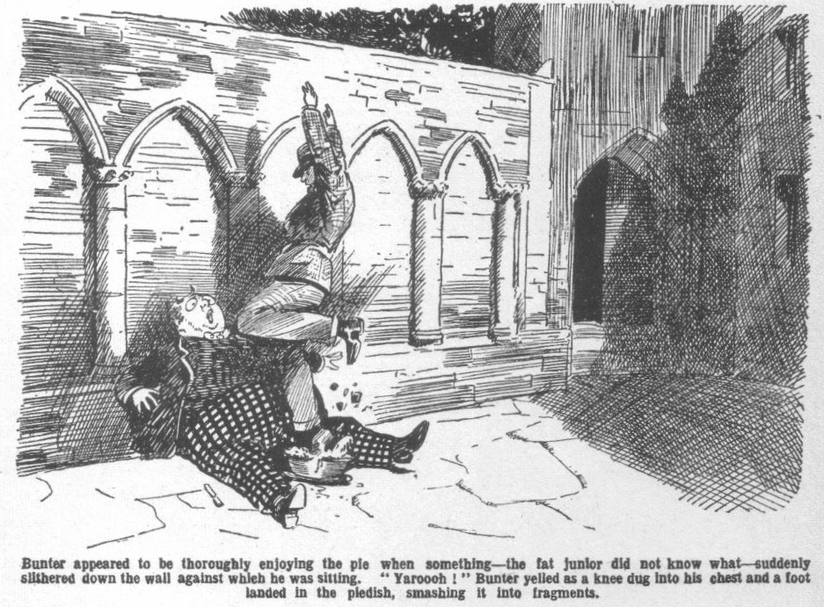
He rolled over in a state of dizzy amazement. His first impression was that the old stone wall had toppled over on him.
Then he realised that it was a human form that was sprawling across him. Somebody—he could not imagine whom—had dropped over the wall from outside, evidently without knowing that he was there.
“Grooogh!” gurgled Bunter. “Gerroff, you beast! Whoooooh!”
A lithe, nimble figure scrambled off Bunter, and leaped to its feet, panting. Two close-set, foxy eyes glared at the astounded Owl of the Remove. But only for a second did the bank-robber glare at Bunter. Two or three articles had dropped from him as he sprawled and rolled—one of them an automatic pistol, another a green leather satchel. It was at the latter that the bank-thief leaped, catching it up breathlessly, and jamming it into a pocket. The next moment he was running along the Cloisters, and the old stone pillars hid him from the eyes of Billy Bunter— goggling after him in amazement and terror.
“Oh crikey!” spluttered Bunter.
He gathered himself up, gasping for breath. He set his spectacles straight on his fat little nose, and blinked like a startled owl.
“Oh crumbs! What the thump---” gurgled Bunter.
The fat junior had been vaguely conscious of a sound of shouting from the distance, but he had not heeded it. Now he became aware that it was louder and nearer. The lane that ran beside the old stone wall outside the school grounds seemed to be swarming with excited people.
Bunter blinked up at the top of the wall.
From outside a face rose into view, and Bob Cherry stared over.
Bob had been “bunked” up by his chums to look over the wall in search of the vanished bank-raider, and his eyes unexpectedly fell on Billy Bunter, blinking up at him with bulging eyes.
“Hallo, hallo, hallo! Here’s Bunter!” exclaimed Bob. “Has anybody nipped over this wall, Bunter?”
“Oh crikey!”
“Have you seen anybody, fathead?” roared Bob.
“Ow! Yes! Oh crumbs!” gasped Bunter. “I say---”
“Did a man get over?” roared Bob in great excitement. “Quick!”
“Ow! Yes! The beast bumped right on me!” gurgled Bunter. “Knocked me right over, the beast--- Ow!”
Bob clambered to the top of the wall, sat astride, and waved his hand shouted to the crowd swarming in the lane below.
“This way!” he bawled. “He’s been seen—he got over this wall! Some of you cut round to the gates:_this way!”
“This way!” shouted the Bounder.
Vernon-Smith leaped at the wall and clambered over. He was down on the inner side before Bob.
But Bob was very quick after him, and the rest of the Famous Five swarmed over.
Billy Bunter blinked at them breathlessly.
“I say, you fellows---” he gasped.
Bob caught him by a fat arm.
“Which way did he go?”
“Ow! Leggo!”
“You fat Owl, where is he?” roared Bob.
“He ran down the Cloisters!” gasped Bunter. “I say—”
“Oh, my hat! Ho must have dropped this!” exclaimed the Bounder, leaping at an object that lay by one of the stone pillars.
He picked it up and held it in the air. It was an automatic pistol.
Bunter gave a yell.
“Ow! Don’t point that thing this way, Smithy, you idiot!”
“That’s proof that he came this way!”exclaimed Johnny Bull. “After him! he’s inside the school grounds!”
Harry Wharton, on top of the wall, shouted back to the crowd in the lane. Inspector Grimes of Courtfield was among them now; a car had brought the inspector on the scene.
“This way!” shouted Harry. “ Mr. Grimes, he’s in the school! We’ve picked up his pistol here!”
The next moment Mr. Grimes was heaved up the wall by a stout constable, and came gasping and clambering over.
Wharton dropped back and ran after his chum, who were already racing up the Cloister. After them thundered the plump Courtfield inspector, after him a constable, and then a dozen or more of the pursuers, who had climbed the cloister wall. The echoes of Greyfriars were awakened far and wide by shouts and yells.
“Oh crikey!” gasped Billy Bunter.
The fat junior was left alone. For several minutes he stood staring, in a state of spluttering amazement. Then he gave his attention to what remained of the apple pie.
But he shook his head sorrowfully over those remains! The remnant had been trampled under foot, and even Bunter, who could eat almost as many things as an ostrich, could not have eaten it. He could only congratulate himself on having packed away the greater part of the pie before the bank raider happened!”
“Beasts!” grunted Bunter.
He rolled away towards the House. As there was no more pie he
had leisure to be interested in what was going on. And the shouting and yelling all over Greyfriars showed that what was going on was extremely exciting.
—
THE SIXTH CHAPTER.
Hunted Down!
GREYFRIARS SCHOOL fairly rocked with excitement.
Masters and boys, Sixth Form prefects and fags of the Second Form, even the stately Head himself thrilled with it.
It was the sensation of the summer term.
All sorts and conditions of people swarmed in the old quad and round about the ancient buildings, shouting to one another—people who had chased the bank-raider out of Courtfield, and others who had joined in the chase en route— policemen, errand-boys, farmer’s men, butchers and bakers and candlesticknakers, so to speak. Mingled with them were Greyfriars fellows of all Forms, stalwart seniors and yelling fags and masters in cap and gown.
Greyfriars rang and echoed from end to end.
Cricket had been going on, on Big Side and Little Side; but the alarm brought the cricketers swarming away from their game. Some of them had grabbed bats and stumps at the startling news that a desperate crook had been chased into the precincts cf the school. Mr. Mimble, the gardener, worse on the scene with a spade; old Gosling had come out of his lodge with apoker; Mr. Prout, the master of the Fifth, had grabbed his ancient rifle from his study wall and was making a frantic search for cartridges—fortunately without finding any.
“Where is he?”
“Which way did he go?”
“He’s in the House!”
“After him!”
“Look out for his popgun!”
“Par ici—par ici!” the squeaky voice of Monsieur Charpentier, the French master, shrieked from the house. “ Par ici, messieurs!” Je l’ai vu—he run—he rush—he skip—he bolt—zis way!”
Inspector Grimes, panting, reached the little French gentleman with a bound.
“You’ve seen him!”
“Mais oui—mais oui!” trilled Monsieur Chartentier. ‘ Voila le scelerat qui monte l’escalier—”
“For goodness’ sake speak English!” shrieked Inspector Grimes.
“Mais oui ! Yes!” J’oublic—I forget! He go up a stair---”
“Up the stairs?”
“Mais certainement.”
Tramp, tramp! went the inspector’s tread on the stairs. After him went a swarm.
“Bless my soul!” said Dr. Locke, gazing dizzily on the exciting scene. “ Dear me! What—what------ Bless my soul!”
Tramp, tramp, tramp!
“Really—upon my word!” said Mr. Quelch. the master of the Remove.
Such a scene was unheard of at Greyfriars. Elderly members of the staff were rather scandalised.
Still, if a desperate crook had dodged into the school to escape, it was obvious that he had to be run down and secured. It was unprecedented—un-heard of—nerve-racking---but it had to be!
What had become of the desperate man was not clear. He had dodged over the Cloisters wall and got into Greyfriars—that was certain. No doubt he had hoped to dodge out at another spot, and leave his pursuers guessing—but his falling on Billy Bunter had put paid to that hope. Pursuit had been instantly on his track.
Mimble, the gardener, had sighted him and headed him off with a spade; some of the senior cricketers had seen him and nearly got him; a dozen fellows had seen him dodge round the House; and Monsieur Charpentier had beheld him, with starting eyes, bolt into the house itself by the open doorway—perhaps seeking concealment, perhaps simply running by the only way that was open to him.
According to Mossoo, he had fled up the stairs, and as the pursuit went trampling up, a yell from above announced that he had been seen again.
Hobson of the Shell was yelling on a landing.
“This way—this way!”
“Seen him?” roared Inspector Grimes.
“He dodged along that passage!”
“Tally-ho !“ roared Bob Cherry.
“After him!”
“He’s got into the Remove!” yelled Johnny Bull. “Well bag him in a Remove study.”
“More likely he’ll hop out of a window!” gasped Wharton.
“They’re watching the windows---”
“We’ve got him!” panted the Bounder. “Oh, my hat! What a lark!”
“The larkfulness is terrific!”
“Where is he?”
“Draw the box-rooms---”
“Look in the studies—!”
“It was clear that the hunted man had dodged into the Remove passage.
If he hoped to escape by a window he had little chance. An innumerable crowd swarmed round the House—every door and every window was under a sea of eyes.
By this time there were six or seven policemen on the scene, and half the local inhabitants seemed to have invaded the scholastic precincts of Greyfriars School. And every Greyfriars man who was at hand was on the scene. If the bank-raider was hunting cover, he was certain to be rooted out; and if he leaped desperately from a window, he could only leap into capturing hands. The game was up for the man who had held up the Courtfield bank.
Up and down the Remove passage went swarming crowds, shouting to one another, staring into studies, opening and shutting doors. But there was one door that did not open. It was the door of Study No. 1. which belonged to Harry Wharton and Frank Nugent.
“This door is locked!” shouted Mr. Grimes, grabbing at the handle.
“That’s my study!” exclaimed Wharton.
“Did you leave it locked?”
“No!”
“Then it’s locked on the inside! We’ve got him!”
The inspector roared down the staircase.
“Watch the windows! He’s locked in a room! Keep guard outside! We’ve got him now.”
Outside Study No 1 the Remove passage was crammed. The bank-raider was run down at last; and only a locked door stood between him and capture.
THE SEVENTH CHAPTER
The Hidden Loot!
JERRY THE RAT panted for breath.
Perspiration streamed down his thin, foxy face.
He leaned on Harry Wharton’s study table, breathing in great gulps.
The game was up for Jerry the Rat; and he knew it.
It was not the first time, by many a one, that Jerry had held up a bank at the point of the “ this is gun,” and cleared off with a bundle of banknotes. His luck had been good—till the inevitable change of fortune came. This time his luck had failed him, and let him down with a crash.
The thing had gone wrong unexpectedly; Jerry did not even know how it had gone so awfully wrong.
In the first place, a clumsy duffer on a motor-bike had got in his way and wrecked his car. That had looked, for the moment, as if Jerry the Rat would have to abandon his plans for that day.
But Jerry was a man of resource. Leaving his wrecked car in the hedge, he had seized the motorcycle, and proceeded to use it to carry out his scheduled raid on the Courtfield Bank. What became of the car mattered little to the Rat; it was a stolen car, and Jerry had not intended to keep it after the raid was brought off successfully. The motor-hike served his turn—and the raid should have been put through, and Jerry safe over the horizon, before the enraged owner of the bike—Coker, of the Fifth—could get the police after him.
Then the unexpected had happened. Why a policeman was waiting for him outside the bank, Jerry did not know and could not guess. The mere chance that a Greyfriars junior had noticed the bike, noticed the number, and recognised it, was not a detail that the most wary holdup man could have foreseen. But that was what had happened, and it had knocked Jerry’s plans sky-high.
Deprived of his mount, he was well aware that matters were desperate when he fled on foot. But he had a good turn of speed, he had twisted and dodged like a hare, and he had hoped for the best. Even at the finish he might have eluded the pursuit had not a schoolboy seen him dropping in over the wall. But his chances had been slim; and when the chase drove him into the House, Jerry the Rat realised that his number was up.
He could hear the shouting crowd in the passage outside the locked door. A glance from the window showed him a staring crowd below.
The game was up!
Ten years of strict seclusion stared Jerry in the face. He had wounded a bank cashier with his reckless shooting at the hold-up; and he knew what was coming to him.
But that was not the chief thought in his mind. His hand, in his pocket, clutched the green-leather satchel— stuffed with banknotes.
It had been a big haul—if only he could have got clear with it. He had been working on information—Jerry was a member of a gang, who had their own hidden means of acquiring information necessary for their peculiar business. He had known that there would be a big haul at the bank that day; and he had called in for it. He knew that there was not less than seven thousand pounds in banknotes stuffed in that leather satchel—the biggest haul of Jerry’s career. And the cornered crook was thinking less of what was coming to him than of that plunder—a fortune, if only possession could be kept of it.
He had hoped, during his flight, to find some hiding-place into which he could thrust the green-leather satchel, to keep it safe in the event of capture. But the chase had been too hot and close for that.
Now he had a respite.
Leaning on the table, gulping in breath, trembling with exhaustion, Jerry’s rat-like eyes searched the room he was in.
It was a schoolboy’s study—he could see that! A cricket bat lay on the table—dog-eared school books beside it—the room was just as some schoolboy had left it. The green-leather satchel, left in that room, was certain to be found. But the rat-like eyes fixed on the grate. There was a wide, old-fashioned chimney over the grate—and there was, in the summer, no fire. Jerry the Rat left the table and approached the grate, bent his head, and stared up the old chimney.
He hesitated.
Thump!
It was a loud knock on the door.
“Open this door, my man!” came the deep tones of Inspector Grimes. “We know you’re there! The game’s up!”
Jerry knew that as well as the inspector could tell him.
There might be a chance—a remote chance—of dodging away when he broke cover; but the chance was too remote for Jerry the Rat to take it with his loot in his pockets.
He groped up the old chimney.
As far as he could reach, his fingers came into a cavity in the ancient brick-work.
Once more he hesitated; but it was only for a moment! Safe or unsafe, it was the only chance. It was that or nothing!
A few moments more and the green-leather satchel was crammed into that hidden cavity in the chimney of Study No. 1.
Jerry the Rat stepped back from the grate.
He breathed more freely.
Thump, thump! came at the door.
Jerry did not heed.
He crossed to the window and stared out.
There was a roar below, as the foxy face was seen looking out of the window of Study No. 1 in the Remove.
There he is!”
“That’s the man!” roared Coker of the Fifth. “That’s the rotter Lhat pinched my jigger! That’s the blighter!”
Jerry the Rat hardly heeded the crowd below.
His keen eyes noted the thick ivy clambering over the old stone walls. He clambered out of the window, trusted himself to the ancient ivy, and climbed away like a monkey.
Escape was impossible--- or next to impossible. Jerry hardly hoped to escape. But he hoped to lead his pursuers on a false scent—as far as possible from the room where he had hidden his loot
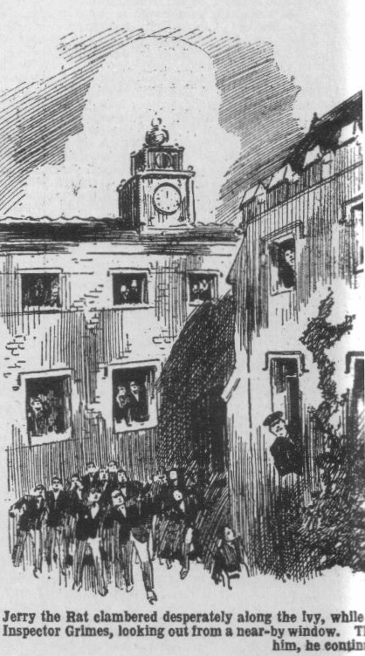 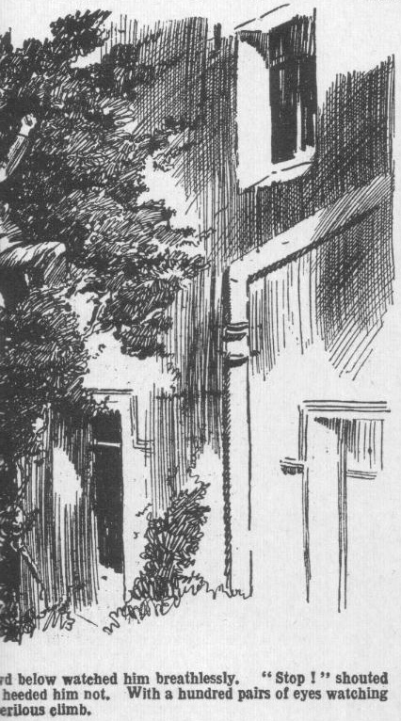
He clambered desperately along the ivy, while the crowd below watched him breathlessly and shouted and yelled.
From a window the head of Inspector Grimes was projected as he was warned of the crook’s desperate attempt by the shouts from outside.
Jerry the Rat, only a few yards from Mr. Grimes, gave him a savage glare and clambered swiftly on.
“Stop!” shouted the inspector.
Only a snarl replied.
Window after window was crammed with faces.
“There he is—on the ivy!” shouted the Bounder.
“My hat—if he falls!” gasped Bob Cherry.
Jerry the Rat was not likely to fall. The ivy was old and tough and strong, and the nimble crook climbed like a monkey. With a hundred pairs of eyes watching him, he sought for a window for ingress. At a considerable distance the clambering crook found a window at which there were no staring faces— the window, as it happened, of Mr. Quelch’s bed-room. There was a crash of breaking glass and the crook disappeared within the building again.
“That’s Quelch’s room!” shouted Bob Cherry. “This way!’
There was a scampering of rushing feet.
“There he is---”
Jerry the Rat ran out of Mr. Quelch’s room almost into the arms of the eager searchers. He leaped to the stairs, threw himself on the banisters, and shot down recklessly. A second later he was running below.
“Stop him!”
“Collar him!”
A dozen hands grasped and caught at the bank-thief, but he twisted and dodged, and escaped. An open doorway lay before him, and perhaps for a moment hope awakened in Jerry the Rat’s heart. But as he reached the door a burly figure came running in, and he fairly crashed into Coker of the Fifth.
“Here, look out!” spluttered Coker, not realising with whom he had established contact. “You clumsy ass---”
“Collar him!”
“Hold on, Coker!”
Coker of the Fifth was not quick on the uptake. Staggering from the shock, he failed to hold on. But Jerry the Rat was staggering, too, and before he could get going again hands were upon him.
For a second or two he struggled. Had his automatic been still in his possession, the desperate man might have used the weapon, though it could not have saved him from capture now. As it was, he went over in the grasp of many hands, and Inspector Grimes clicked the handcuffs on his wrists. The bank raider of Courtfield was a prisoner at last!
THE EIGHTH CHAPTER.
Lost Loot!
“SEVEN thousand pounds!”
“That’s a lot of money!”
“A lot to you fellows!” remarked Billy Bunter. “Not much to me, you
know. Still, it’s a tidy sum.”
“Ha, ha, ha!”
“I say, you fellows, what about hunting for it? Lots of people in Courtfield and Friardale and Woodend are hunting for it! Fancy seven thousand pounds lying about on the common, somewhere!”
It was the following day, after class. Greyfriars School was still bubbling with excitement over the startling happenings of Wednesday afternoon.
Fellows in the Rag were discussmg the latest news.
The whole neighbourhood, as well as the school, thrilled with the exciting episode.
Greyfriars fellows had gained some credit in the affair.
Coker of the Fifth—though quite unintentionally—had contributed to the defeat of the bank-raider by getting in his way and wrecking his car.
Had Jerry the Rat carried out the raid in that car, the probability was that it would have been a complete success.
Coker did not, perhaps, feel proud of his performance ; still, there was no doubt that it had come in useful.
The Bounder was personally complimented by Inspector Grimes for the part he had played. It was certain that Smithy was the prime cause of the hold-up man’s capture. It was his recognition of Coker’s borrowed stink-bike and Redwing’s determination to call the constable’s notice to it that had started the sequence of events that led to the raider’s capture. Even Billy Bunter had helped, though inadvertently.
It was known now that a man had been wounded at the bank by the desperate raider, though, fortunately, not seriously. It was known that the rascal had fled with seven thousand pounds in banknotes. But now that he was a prisoner, lodged in a cell at Courtfleld Police Station, the loot had not been recovered. He had been searched immediately after capture, and nothing found on him. And in answer to questioning he had confessed that he had flung away a bag containing the banknotes in his flight across Courtfield Common.
Ever since, an extensive search had been going on. But the chase had extended over miles, and there was plenty of ground to cover. And the statements of Jerry the Rat were not exactly reliable. It was quite probable that he had stated that he had thrown away the loot on the wide common for the excellent reason that he had thrown it away somewhere else. It was quite possible that among the many searchers for that bundle of banknotes wore confederates of the man who was now in a cell. In which case, Jerry the Rat was not likely to have told the truth.
All that was known for certain was that he had got rid of the plunder somewhere between the scene of the robbery and the spot where he had been captured; and search for it, therefore, rather resembled a search for a needle in a haystack.
“Might have parked it somewhere,” remarked the Bounder. “ In a hollow tree, perhaps?”
“Or a rabbit burrow on the common?” said Peter Todd.
“Or chucked it into the bushes?” said Bob Cherry. “There’s about ten thousand places between here and CourtfieId where it might lie for weeks without anybody seeing it.”
“I say, you fellows, I’m jolly well going to hunt for it!” declared Billy Bunter. “ And if I find it---”
“Finding’s keepings—what ? chuckled Skinner.
“Oh, really, Skinner—”
“If we see Bunter changing bank-notes at the tuckshop we shall know that the jolly old loot has been found.” said Skinner.
“Ha, ha, ha!”
“Beast!”
“According to what the man said, the banknotes are in a small black bag.” said Harry Wharton. “But---”
“ But if he said so, they’re jolly well not(.” grinned the Bounder. “ That sportsman doean’t want them found—except by his friends.”
“I say, you fellows, if I find it I shall claim a reward” said Billy Bunter. “There’s bound to be a reward. After all,_I’m a pretty good Scout and I think I---”
“Ha, ha, ha!”
“Still, I thhik I shall wait till the reward’s out. ” added the Owl of the Remove cautiously. “ No good taking trouble for nothing.”
“Let’s try it on, you men.” said Bob Cherry. “We were just behind the fellow all the time and we can pick up his trail and follow it foot by foot. No end of a catch, if we snaffled seven thousand pounds. The bank might tip us a fiver out of it and we’d stand a spread in the Rag.”
“Hear, hear!”
And after tea Harry Wharton & Co. and quite a crowd of other fellows wheeled out their bicycles to ride to Courtfield, and from that spot to follow on the trail of the fleeing bank-raider.
They found Courtfield Common, generally rather solitary, alive with people in the golden June sunshine.
Policemen could be seen here and there, but every sort and condition of local inhabitant had turned up for the search.
Most of them, no doubt, were keen on finding the lost loot in the cause of law and order and justice ; but, some, perhaps, had an eye to the banknotes themselves in case of a discovery, for there was a good many tramps and vagrants “mooching” about the common with questing eyes.
Starting from the town, the Famous Five wheeled their bicycles on the course the bank-raider had taken. It was a winding, twisting, zigzag course, but it was possible to keep to the right track, for the tramp of scores of feet in pursuit left plenty of “sign.”
The chums of the Remove would have been extremely pleased to discover the lost loot and to march triumphantly into the Courtfield Bank with it. But they soon realiscd that the task was a well-nigh hopeless one.
Hundreds of searchers were rooting about, and many of them had been rooting about all day. But there were innumerable places where the bundle of banknotes might have been tossed out of sight—in hollows of the ground, in the branches of trees, in the tangled hawthorns.
However, the Famous Five kept on the trail till they reached the little lane by the Cloister wall, where the fugitive had entered the school. By that time it was near lock-up, and they gave it up and wheeled the bikes in.
“Try again tomorrow!” suggested Bob Cherry.
Harry Wharton laughed.
“Nothing doing!” he answered. “I’ve got a jolly strong suspicion that the rascal never threw the loot away at all, but jammed it into some place where he thought he might find it again, or where it might be found by his friends. If that’s the case, it’s hopeless.”
“Oh, my hat! If that’s the case, some pal of his may have been along and snaffled it already!” said Bob.
“I shouldn’t wonder.”
The chums of the Remove went in to call-over. Other fellows who had been on the quest came in, equally unsuccessful. That evening Jerry the Rat and the lost loot were the chief topics in the studies, and the next day fellows who went along to Courtfield Common found a much smaller number of people keeping up the search. The excitement died sway, and after another day or two it was almost forgotten. The police, no doubt, were still searching, and a few pertinacious members of the public, but that was all.
Harry Wharton & Co, with the cricket and plenty of other matters to think of, soon dismissed the bank raid and the lost loot from their minds.
Wharton and Nugent, when they sat to prep in Study No. 1, little dreamed how near they were to the bundle of banknotes for which so many had quested in vain. Jerry the Rat said nothing, and the ancient chimney of Study No. 1 in the Remove kept its secret.
THE NINTH CHAPTER.
Nosey-Parker!
“GO it, old beans!” murmured Skinner of the Remove.
Some of the fellows chuckled.
Skinner made that remark loud enough for the Removites to hear, but not loud enough to reach the ears of Mr. Quelch or the Head.
It was morning, and the Lower Fourth were gathered by the door of their Form-room, and Mr. Quelch, their respected Form master, was coming along, when the Head stopped him to speak.
Unpunctuality was, in Mr. Quelch’s eyes, one of the seven deadly sins; but the most particularly punctual Form master had to heave to, as it were, when his chief weighed in.
So the Removites waited, not at all displeased to leave first school over for a few minutes, while Dr. Locke talked to Quelch.
Indeed, they hoped that the Head would keep it up. It was rather more agreeable to watch the chief beak talking to Quelch, than to hear Quelch talking to themselves.
The two beaks were too far away for the juniors to hear what they said, not that they cared to hear beak conversation, which was generally on subjects totally lacking in interest for the minds of youth.
Billy Bunter, however, was an exception.
Bunter always wanted to hear what did not concern him, and very often contrived to do so. Next to eating and sleeping, Billy Bunter counted “nosey-parkering” among the leading joys of existence. So Billy Bunter gave a fat ear—or, rather, two fat ears—to the talk of the headmaster and the Form-master.
Unostentatiously, the fat Owl moved up the corridor, blinking along the floor through his big spectactes, as if he had dropped something and was looking for it. By this masterly manoeuvre, the Peeping . Tom of Greyfriars drew unheeded within earshot.
Neither the Head nor Mr. Quelch observed him, or, at least heeded him, and the juniors who did observe him watched him, with grinning faces. Probably the fat eavesdropper would have been kicked, but for the presence of the beaks. But nobody wanted to draw Quelch’s gimlet eye on himself by kicking Bunter—so the fat Owl had to be allowed to go ahead.
“The name is—um—Jackson!” the Head was saying, as Bunter’s fat ears came within range. “He represents the—the—let me see— the ‘Lantham Advertiser.’ A local paper, I presume. It is somewhat disconcerting, my dear Quelch, that so much publicity—I might say notoriety—has been caused by the late regrettable occurrence here—”
“Very!” agreed Mr. Quelch.
“Already,” said the Head, “a number of reporters have been here, and I really supposed that the matter was at an end.”
“It is high time that the matter was at an end, sir.”
“ I quite agree. Nevertheless, this Mr. Johnson—I should say Jackson—expressed himself very politely and civilly on the telephone, and I did not feel that I could refuse to accede to his request.”
Mr. Quelch made no reply to that
Quelch was made of sterner stuff than his chief. Henry Samuel Quelch would have had no compunction whatever in “telling off” Mr. Jackson, of the “Lantham Advertiser” Too many newspaper reporters, in Quelch’s opinion, had already called at the school after the exciting episode of the capture of Jerry the Rat in the House. Now, after the lapse of a week or more, Quelch considered it high time that the newspaper men gave Greyfriars a rest.
“In fact,” continued the Head, “I have told Mr. Jackson that he may call this morning, Quelch.”
“Very good, sir!”
“But as I really have no time to deal with the matter, I should be very glad, my dear Quelch, if you would see this Mr. Thompson—I mean, Johnson—that is to say, Jackson.”
“Certainly, sir, if you so desire.”
“No doubt you could spare him a few minutes when you are free from your Form in the morning break, Quelch.”
“I will make it a point to do so, sir.”
“Thank you, Mr. Quelch! Counting upon your assistance, I have told him to ask for you when he calls. No doubt you will see him, and—and dispose of him as soon as possible.”
“With pleasure, sir.”
“I thank you once more, my dear Quelch.”
“Not at all, sir!”
The Head turned and sailed away for the Sixth Form Room, his majestic mind relieved of that little matter.
Mr. Quelch turned and strode towards the Remove-room—hastily, for he was several minutes late. He almost strode into Billy Bunter. The Form, gathered at the Form-room door, were at a distance. Bunter was quite close at hand. Mr. Quelch stopped just in time to avoid a collision, and glared at the fattest member of his Form.
“Bunter!”
“Oh! Yes, sir!” Bunter jumped.
“I—I was looking for my handkerchief, sir! I—I’ve dropped it somewhere, sir---”
“Your handkerchief is in your pocket, Bunter! I can see it.”
“Oh! I—I mean my Virgil, sr
“What?”
“I—I’ve dropped my Virgil along the passage somewhere, sir, and—and I was just looking for it. ” stuttered Bunter.
“I can see your Virgil under your arm, Bunter.”
“Oh lor!” C-c-can you, sir? I—I mean---”
“What do you mean, Bunter?” inquired Mr. Quelch, in a grinding voice.
“I—I mean, my pocketknife, sir——”
“Your pocket-knife?” repeated Mr. Qucich.
“Yes, sir! I’ve dropped it along the passage somewhere, and 1—I was just looking for it, sir!” gasped Bunter.
Truth and Billy Bunter were complete strangers. They had never even struck up a nodding acquaintance. Bunter was always ready with a fib. But he seldom had any luck with his fibs. Practice is said to make perfect; but it had never had that effect on Bunter’s fibbing.
He could see that Mr. Quelch did not believe him. Really, Henry Samuel Quelch would have had to be a very creduIous gentleman to believe the variety of explanations Bunter offered of his presence in the offing.
“Bunter, how dare you prevaricate?” demanded Mr. Quelch.
“I—I wasn’t, sir I—I mean, I didn’t! I—I assure you, sir, I—I dropped my fountain-pen—”
“Your what?” thundered Mr. Quelch.
“I mean my pocket-Virgil—that is, my handker-knife—I mean, my pocket-knife, sir——” Bunter was getting confused.
“You were listening, Bunter—a mean, contemptible, and foolish action!” boomed Mr. Quelch.
“Oh, no, sir! I never heard a word!” said Bunter. “ Not a syllable, sir I never heard the Head mention Mr. Jackson—I’ve never even heard the name before---”
“Follow me to the Form-room, Bunter!”
“Oh lor’!”
Evidently Mr. Quelch did not believe Bunter.
With a frowning brow the Remove master whisked on. He opened the door of the Remove Form Room, and the juniors marched in, Bunter trailing behind them with an apprehensive face.
His apprehensions were well founded. Mr. Quelch picked up a cane from his desk, and pointed to a chair with it.
“Bunter, bend over that chair!”
“Oh crikey!”
Whack, whack!
“Yarooooh!”
“ Let that be a warning to you, Bunter!” said Mr. Quelch severely. “Of all petty meannesses, Bunter, eavesdropping is the most contemptible. Bear that in mind, Bunter!”
“Wow!”
Bunter crawled away to his place. The warning Mr. Quelch had given him was an emphatic one—very emphatic! Bunter sat very uncomfortably on his form during first school, wriggling and twisting dismally, and probably wishing, for once, that he had not given ear to that which did not concern him.
THE TENTH CHAPTER.
A Shock for Mr. Quelch!
MR. QUELCH grunted.
He had retired to his study after dismissing the Remove for morning break.
Trotter, the page, arrived with a card which he presented to the Remove master. It bore the style and title:
“MR. HENRY JACKSON,
“ Lantham Advertiser.
Quelch had not forgotten that the Lantham reporter was to call on him in break that morning. Neither was he unwilling to oblige the Head by taking the newspaper man on his hands. But he was irritated. Publicity did not appeal to him: he disliked, as his chief disliked, seeing the name of Greyfriars School in the newspapers. And he did not want to give up his scanty moments of leisure. So he grunted.
“The gent’s been waiting, sir,” said Trotter. “I showed ‘im into the visitors’ room, sir. He’s a-setting there, sir.”
“You may show him in here, Trotter —or, rather, I will go to him,” said Mr. Quelch, anxious to have done with Henry Jackson as soon as possible.
Mr. Quetch whisked away to the visitors’ room. He entered that apartment, and a man rose from a seat by the window. He was a slim, rather well-dressed man, with steel-grey eyes that gleamed sharply through steel-rimmed spectacles. He had a little case in his hand, which Mr. Quelch guessed to contain a camera. Mr. Quelch did not like reporters, and he did not like their cameras. But his manner was frostily polite.
“Mr. Jackson?” he asked.
“From the Lantham Advertiser, sir.” answered the man with the steely eyes. “The head master told me on the phone that I should see a Mr. Quelch”
“I am Mr. Quelch. What can I do for you?”
“I must apologise for troubling you, sir,” said Mr. Jackson courteously. “ I’ve no doubt a good few newspaper men have been here already.”
“Quite.”
“With your permission, sir, I should like to take a snap or two---”
Mr. Quelch shook his head.
“I regret that Dr. Locke has a rooted objection to photographs of the school appearing in the public prints,” he said.
“I was thinking of an interior, sir.” explained Mr. Jackson. “I gather that the bank-raider, when he took refuge in this building, entered a room---”
“That is correct.”
“If you will permit me to take an interior, sir, in that room, it would be of great interest to our readers.”
“As the room in question is my own bed-room, sir, I fear that it is impossible.” said Mr. Quclch.
Mr. Jackson raised his eyebrows over the steely eye.
“From what 1 have been told, sir, I gathered that it was a study—a school boy’s study---”
“To which room are you referring?” asked Mr. Qucich. “The man passed through a boy’s study, locking the door after him, climbed out of the window, and re-entered the House through my bedroom window—”
“I was referring to the boy’s study, sir. No doubt you would not object to my taking an interior view of such a room
“I fear, sir, that Dr. Locke would object to any photographs—”
“I am disappointed, Mr. Quelch.”
“I am sorry, sir.” said the Remove master politely.
However, no doubt you will have no objection to my seeing the study,” suggested Mr. Jackson. “I will leave my camera here.”
“Certainly you may see the study if you wish. Be kind enough to accompany me.” said Mr. Quelch.
Mr. Jackson, leaving his camera, on the table in the visitors’ room, followed Mr. Quelch from that apartment.
They ascended the staircase—and a pair of little round eyes blinked inquisitively after them through a pair of big round spectacles.
Mr. Jackson’s call that morning was known only to the Head and Mr. Quelch—and Billy Bunter.
Billy Bunter was keeping an inquisitive eye open for the representative of the “Lantham Advertiser.”
Possibly the other fellows would have been interested had they known that a reporter was on the scene. Billy Bunter knew, and he was interested, anyhow. Bunter would have been glad to get a word with that reporter, and would have enjoyed telling him how he had nearly captured the bank-raider in the Cloisters. Bunter did not share the Head’s dislike for publicity. Bunter would have given anything that wasn’t eatable to see his name in the newspapers.
The fat Owl rolled up the staircase after Mr. Quelch and the reporter had disappeared above.
At a safe distance he stalked them to the Remove staircase, and then into the Remove passage.
Evidently Quelch was taking Mr. Jackson to Study No. 1, the room from which Jerrv the Rat had made his desperate climb from the window. Probably he would leave him there—in which case, Billy Bunter was going to butt in.
Quite unaware that he was being stalked by a fat Owl, Mr Quelch opened the door of Harry Wharton’s study and showed the reporter in.
The juniors, of course, were out of doors in break, and the study was untenanted.
“This is the room,” said Mr. Quelch. He stood just within the room, the door half-open behind him. He waited with frosty politeness for Mr. Jackson to take his survey of the apartment that interested him.
The steely eyes behind the steel-rimmed glasses shot round the room very keenly, resting for an instant on the grate and chimney.
“This is the study in which the bank-raider locked himself while he escaped from the window?” asked Mr. Jackson.
“Precisely.”
“And it was from this window---”
“Quite so.”
“I will make a few notes, sir.” said Mr. Jackson. “I need not detain you, Mr. Quelch; I am aware that your time is of value.” He took out a notebook.
“I will remain, sir,” said Mr. Quelch. Perhaps he suspected the newspaper man of intending to produce another camera from some hidden recess, like a conjurer producing a rabbit from a hat. Or perhaps he suspected a design of taking a sketch, which would have been just as bad. Or perhaps it was just politeness. Anyhow, Mr. Quelch did not intend to leave the man from the “Lantham Advertiser” to his own devices.
He remained where he was, rather like an icy statue, unaffected by the obvious fact that Mr. Jackson bit his lip with an annoyance he could not conceal.
The steely eyes fixed on him with a strange gleam in their depths for a second. Then Mr. Jackson turned to the window again.
“Perhaps, sir, you will point out the way the man went when he climbed from this window?” he suggested.
“Certainly.”
Mr. Quelch crossed to the window. He was about to lean from it. with Mr. Jackson a little behind him. What happened next seemed like a fearful, awful, unbelievable nightmare to Mr. Quelch.
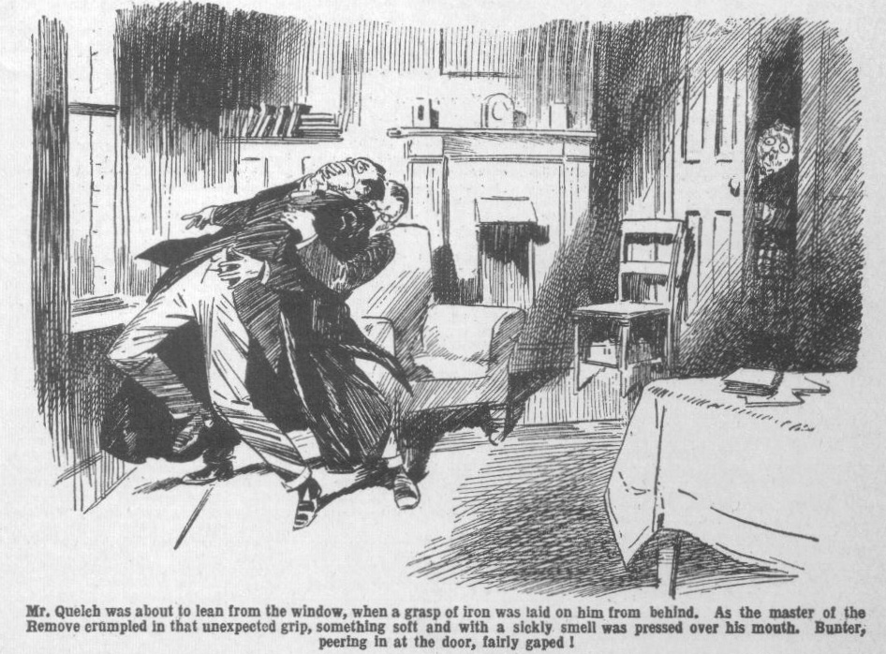
A grasp of iron was laid on him from behind, and as he crumpled in that unexpected grasp something soft and with a sickly smell was pressed over his mouth.
Utterly amazed, astounded, horrified, Mr. Quelch attempted to struggle. Over the chloroform pad that was pressed on mouth and nose his eyes dilated, gazing in unbelieving horror at the coot, hard face of Mr. Jackson, which seemed to dance before him. It was only for a few moments, and then Mr. Quelch, sinking into insensibility under the potent influence of the drug, knew no more. And the man with the steely eyes, breathing hard, lowered him silently to the floor.
THE ELEVENTH CHAPTER.
The Alarm!
BILLY BUNTER stood transfixed. He fairly gaped.
Bunter for the moment could not believe his eyes, or even his
spectacles.
What Bunter saw was really too amazing to be believed.
The fat junior was in the Remove passage. He was there to butt in, with his usual impudence, if Quelch left the reporter to himself.
But as Quetch did not leave the reporter to himself Bunter could not butt in. He remained outside the study. As the door was half-open Bunter had a view of the interior through the crack between the door and the jamb. He did not venture to put his inquisitive head round the door—he would have been spotted. But the wide crack between door and jamb gave him a view of the interior of Study No. 1—and he was prepared to bolt along to his own study if either Mr. Quelch or the reporter came out.
Then the amazing thing happened.
Bunter gaped and blinked.
If it was not a dream, it seemed like one.
The man, the reporter—the man from the “ Lantham Advertiser “—had hold of Quelch, squashing something over his face; and with distended eyes behind his spectacles Bunter saw him lower the insensible Form master to the floor.
Mr. Quelch lay on the study floor without movement. It was clear that he was quite unconscious.
For a moment or two Mr. Jackson watched the insensible man, breathing hard and deep.
Bunter, transfixed, watched Mr. Jackson.
Then the man swung round and came swiftly towards the door.
His intention, doubtless, was to close and lock it, to prevent any possibility of interruption.
But Bunter, of course, could not guess that.
As the man, with swift steps, came towards the study door, Billy Bunter woke from his trance of terror and amazement.
He let out a yell that woke every echo of the Remove passage, and started for the stairs at a run.
“Help! Help!” yelled Bunter.
His terrified voice rang far and wide. “Help! Help! Quelch has becn murdered—help!” shrieked Bunter, as he did the Remove staircase three steps at a time. “ I say, you fellows! Help! Murder! Help!”
Most of the fellows were out of the House, in break, but there were plenty of ears to hear Bunter.
Voices called from a dozen directions.
“What the thump---”
“Who’s that---”
“What---”
“Help!” raved Bunter.
He missed a step, rolled down, and bumped on the lower landing. Two or three Fifth Form men who happened to be in the games study ran out.
“Ow, wow!” Bunter sat up. “Help! Murder! Help!”
“You potty young ass!” roarcd Coker of the Fifth. “What are you up to? What do you mean?”
“Kick the young lunatic!” said Potter.
“Ow! Help! Quelch—murdered--- Wharton’s study---” spluttered Bunter. “I saw him—he’s murdered---”
“The kid’s mad---”
“Ow! Help!” Fire! Murder! He’s murdered Quelch!” shrieked the fat Owl. “ I tell you I saw him murder Quelch!”
“What the thump can have happened? ” exclaimed Potter, as he ran up the Remove staircase
Innumerable feet were trampling up the lower stairs by this time. Bunter’s frantic yells were heard all over Greyfriars. FeIlows in the quadrangle heard them, and started, and stared, and ran for the House to see what was up.
They fell on many startled ears; but the ears that were most startled were those of the steely eyed man in Study No 1
He had shut and locked the study door as Bunter started to yell, and swung back towards the fireplace. But if the steely eyed man was interested in the study chimney and what it hid, he had no time for investigation. The insensible Form master, on the floor, could see nothing, hear nothing; he was safe from Quelch. But as the echoing yells of Billy Bunter rang in his ears, he started, and turned, like a wild animal, and sprang to the door again.
He unlocked it, opened it a few inches, and listened.
His face was convulsed with fury.
Startled voices sounded from many directions; high above them rang the frantic shrieks of the terrified Bunter. Footsteps rang on the stairs,
The steely eyed man gritted his teeth. For a moment he swung back towards the fireplace. But he knew that he had no time, and he stopped again. What he had learned from Jerry the Rat, now awaiting trial in prison, could not serve him now. There was no time to grope in the study chimney for the cavity in which the bank raider had thrust the green leather satchel—no time to attempt to carry out the desperate purpose for which he had entered the school by trick. There was barely time to escape—if there was yet time!
With a savage imprecation, the man with the steely eyes tore open the study door, and ran out.
The stairs below were already crowded —there was no escape that way. Desperately he ran up the Remove passage in the opposite direction.
From Study.No. 14, at the end of the passage, a bony face stared out. Fisher T. Fish was the only Remove fellow who was in his study in break. Fishy had been counting his money—his favourite occupation in leisure moments. But he left even that entrancing occupation as he heard the fearful yells in the passage, and looked out to see what was up.
“ Waal, I swow!” ejaculated Fisher T. Fish in amazement, as he saw a man in steel-rimmed glasses bolt out of Study No. 1, and come racing up the passage.
Fisher T. Fish stepped out of his study, staring at the running man blankly.
The next moment the man reached him, and with a swing of his arm, sent the Transatlantic junior reeling.
“Aw! Wake snakes!” gasped Fisher T. Fish, as he crashed.
Without a look at him the man dashed on. At the end of the passage he glanced round him like a hunted animal. A little stair led to the Remove box-room, and the steely eyed man dashed up it, and into the box-room. A few seconds later he was clambering out of the window on to the leads below.
He had hardly disappeared up the box-room stair, when Potter of the Fifth came running up the staircase, and stopped at the door of Study No. 1.
The Fifth-Former stared into that study.
“Quelch!” he gasped.
Under his eyes, the Remove master lay stretched on the floor, insensible. Potter gazed at him in amazement and horror.
He yelled back to the fellows on the lower landing.
“This way, you men! Something’s happened to Quelch---”
There was a swarming up the stairs. In Study No. 1 an excited,
breathless, amazed crowd gathered round the insensible master of the Remove.
THE TWELFTH CHAPTER.
What Bunter Saw!
WINGATE of the Sixth took the Remove in third school that morning. But third school was little more than a buzz of excited talk. A week ago the school had been wildly excited by the episode of the bankraider. That episode had been almost forgotten; and it was completely forgotten now in the new excitement. What had happened to Quelch was stranger, more startling, more utterly amazing. Nobody could even begin to explain or guess what it all meant—unless the man in the steel-rimmed glasses was some escaped lunatic. And his actions, though unaccountable, had been too cool, too cleverly planned, to be those of a lunatic. Who he was, what he was, where he was, remained a mystery. And
He had escaped.
Only a few eyes had seen him at all—Gosling, at his lodge when he came : Trotter, when he admitted him to the House ; Mr. Quelch, Billy Bunter, and Fisher T. Fish. One or two other persons had seen him casually, that was all. His description was easy enough to establish, but not his identity. For, of course, it was clear that he was not, as he had pretended, a reporter on the staff of the “Lantham Advertiser.” That pretence had been a trick to obtain admittance to Greyfriars ; and when the Head telephoned to the newspaper office, he was informed, as he fully expected, that they had never heard of “Mr. Jackson,” and certainly had never sent him to Greyfriars.
Who was he—what was he—where was he? Greyfriars fellows asked one another those questions; and lessons were hardly more than a farce in all the Form-rooms that morning.
Fisher T. Fish told how the man had rushed past him, and knocked him over in the Remove passage, while Potter of the Fifth was coming up the stairs. Fishy guessed that his cabeza was still singing from the sockdolager the guy had handed over.
It was ascertained that he had left by the box-room window and the leads, apparently having then cut across the kitchen gardens into the fields beyond. He had had ample time to get clear while the horrified crowd gathered round Mr. Quelch in Study No. 1.
Mr. Quelch had been taken to his room, the school doctor telephoned for; and he was now under medical care. He was quite unable to take his Form again that day—a circumstance which the Remove did not regret, though, of course, they were sorry for Quelchy.
Inspector Grimes was said to be coming over from Courtfield; and, in fact, he came, while the school were in the Form-rooms after break ; and he departed again a very much puzzled inspector. Mr. Quelch, sitting up in bed, pale and worn, was as puzzled as Mr. Grimes, and everybody else. For there seemed absolutely no motive for the unknown man’s actions; downy bird as Quelch was well known to be, he could not begin to explain the riddle.
It was, as Bob Cherry remarked, a jolly old mystery. Hurree Jamset Ram Singh declared that the mysteryfulness was terrific; and the other fellows agreed that it was.
“Mr. Jackson” was an absolute stranger at Greyfriars. Nothing what-ever was known of him, except that he was not what he had pretended to be. The camera he had left behind gave no clue to his identity.
Why had he done it?
Wingate of the Sixth hardly tried to stem the tide of excited talk in third school. He could not have succeeded.
Even in the Sixth Form room, the seniors were in a buzz and even the Head’s own majestic mind wandered from school subjects.
The Greyfriars fellows were glad to be dismissed from the Form-rooms. They came out in a buzzing throng— eager for further news.
But there was no further news— except that Mr. Quelch was still keeping his room. Mr. Quelch had been through a disagreeable and alarming experience, and he had had a severe shock; and the medical man recommended rest and repose. In the quad a crowd surrounded Billy Bunter. Bunter was the “ goods” for the moment. Bunter had given the alarm ; Bunter had actually seen his Form master in the grasp of the known dastard ; Bunter knew more about it than any other fellow. Bunter was enjoying himself. He loved limelight, of which as a rule he received very little. But now he was getting and lots. Bunter, of course, could not stick to the facts. The facts themselves were startling enough; but facts were always too tame for Bunter. He had, on being questioned by the Head, told the truth—by accident, as it were, being
startled and terrified to do anything else. Since then the fat Owl had had time to think.
“I say, you fellows, you see, I was keeping an eye on the man,” Bunter explained. “I suspected him from the first---”
“Hallo, hallo, hallo!” That’s a new one!” exclaimed Bob Cherry.
“Oh, really, Cherry—”
“How did you happen to be up in studies in break?” asked Frank
Nugent.
“I didn’t happen!” replied the fat Owl. “I wasn’t keeping an eye on the reporter to get a chance to speak to him if Quelch cleared off ; nothing of the sort. I didn’t know he was making himself out to be a reporter. You see, I never heard the Head tell Quelch so in the Form-room passage this morning---”
“So that’s what you were picking up when you got licked for listening.” said Harry Wharton.
“Nothing of the sort! The actual fact is—”
“Let’s hear the facts!” grinned Peter Todd. “There’s an extra big one coming now ; I can see it in his eye.”
“Oh, really, Toddy---”
“Get on with it, Bunter!”
“Well, if you’ll leave off interrupting a chap and making out that he’s exaggerating I’ll tell you the actual facts.” said Bunter. “The actual fact is, that I suspected the man from the first. I noticed that he had a syrupstitious look about him—”
“A quarter!” yelled Squiff.
“A syrupstitious look---”
“The potty owl means surreptitious, perhaps!” suggested Toddy.
“ Ha, ha, ha!”
“You needn’t jaw, Toddy ; you never even saw the man! I noticed his syrupstitious look and kept an eye on him,” said Bunter. “ Feeling that he was up to no good, I tracked him to the Remove passage. I was ready to seize him at a moment’s notice. I watched him like an—an— an——”
“Owl?” suggested Skinner.
“Like an eagle!” He got Quelch to look out of the window, and collared him and jammed something over his face. Quelch cried out, I Help me, Bunter! My brave boy, rescue! Just like that!”
“Oh crikey!”
“It’s turned out since that it was a chloroform pad,” went on Bunter. “ Poor old Quetchy put up hardly a wriggle. He gave a deep, fearful groan and sank into— into unconscionability.”
“ My hat! That must be a jolly old mixture of insensibility and unconsciousness,” remarked Skinner. “What a mixture!”.
“Oh, really, Skinner, I can still hear that fearful groan!” said Bunter impressively. “ He turned a grim, ghastly, despairing look on the villain, uttered that one fearful groan, and sank into---”
“The mixture as before!” suggested Skinner.
“Ha, ha, ha!”
“I was about to rush into the study---”continued Bunter.
“When you rushed the other way instead!” remarked Skinner. “Second thoughts are best,”
“Beast!” Then he slammed the door.” said Bunter. “Then, with my usual presence of mind, I rushed away for help. I wasn’t scared, or anything of that sort. Cool as a cucumber, you know. But I needn’t tell you fellows that; you know what I’m like when there’s danger about.”
“We do,” grinned Bob Cherry. “Like a rabbit.”
“ Beast!”
“ Is that the lot?” asked Hobson of the Shell.
Bunter sniffed.
It was the lot, as a matter of fact. But if his hearers did not consider that they had had their money’s worth, so to speak, Bunter was prepared to hand out more of the same.
“He knew I was there.” continued Bunter “ The minute he had laid Quelch on the floor he turned on me, with his eyes glittering, grinding his teeth like—like---”
“ Like a saw?” asked Skinner.
“Like—like anything,” said Bunter.
“Like billy-ho. He said in a hissing voice, ‘Ha, I am watched! Just like that. Revolver in hand, he rushed upon me---”
“An entirely new scene, featuring a revolver!” said Skinner
“ Ha, ha, ha!”
“I jolly well saw it all, and you didn’t!” hooted Bunter. “ I suppose I know what I saw! He sprang towards me, and as he fired---”
“As he whatted?” yelled Bob.
“As he fired,” said Bunter, “the bullet barely missed my head---”
“You benighted bandersnatch, draw it mild! Think nobody would have heard it if there had been a shot?”
“Oh, I—I—I mean---”
“Well, what do you mean, you fibbing, foozling frump?”
“I mean he was just going to fire---”
“Not a lot of difference,” remarked Temple of the Fourth, with a chuckle. “ As he was only going to fire, I suppose the bullet was only going to barely miss your head, Bunter.”
“Exactly! I—I mean---”
“ Ha, ha, ha!”
“Blessed if I see anything to cackle at!” I can tell you I jolly well shaved Quelch’s wife—I mean, saved Quelch’s life!” roared Bunter. “ If I hadn’t been on the spot---”
“ It’s a jolly queer business,” said Vernon-Smith. “What the dickens could the man have been up to?”
“Goodness knows!”
“I fancy it’s some old enemy of Quelch’s who has tracked him down!”” said Billy Bunter sagely. “ Like they do on the films, you know.”
“Sub-title—Tracked Down!” said Skinner.
“In fact, now I think of it,” went on Bunter, his own suggestion starting his fertile imagination on a new tack, “ now I remember he said, “At last! Tracked down at last!” as he clutched Quelch—”
“Ha, ha, ha!”
“ Just like they do on the films, you know,” said Bunter.
Billy Bunter was a great patron of the films, and he had a touching belief that things that happened on the films also happened elsewhere.
“Rather too much like a jolly old film!” chuckled the Bounder. “Now Bunter’s finished telling lies---”
“Oh, really, Smithy—”
“It beats a man hollow,” sald the Bounder. “The blighter seems to have tricked Quelch away into a study just to chloroform him. But what his game was, beats me hollow. Might have been up to something if that fat owl hadn’t given the alarm. But what could he have been up to?”
“Daylight raid---” hazarded Bob Cherry
“What the dickens was there to raid? He wasn’t after school books and an inkpot, I suppose. Might have been something worth while if it had been the Head’s study. He had got into a part of the House where there was simply nothing to be picked up.”
“Mightn’t have known that, being a stranger here,” said Johnny Bull. “Or he might have intended to go through the upstairs rooms after getting rid of Quelch. If he hadn’t been spotted he would have had a clear field, with nearly everybody out of the House. He wouldn’t have been spotted if Bunter hadn’t been eavesdropping and prying.
“ Oh, really, Bull---”
“It’s a blessed mystery,” said Harry Wharton. “I dare say we shall find out what the fellow was up to if the police get hold of him. He must have been a thief, I suppose; but it’s all jolly queer.”
“The queerfulness is preposterous.”
“I say, you fellows, I’m pretty certain that he was an old enemy of Quelch’s, who had tracked him down—”
“Fathead !“
“I tell you I heard him say---”
“Rats!”
“Look here, you beast— ”
“Bow-wow!”
“Yah!” snorted Bunter. And he rolled away in search of other hearers.
THE THIRTEENTH CHAPTER.
Coker Going Strong!
“HALLO, hallo, hallo! What’s that row?”
Coker s jazz band!”
“Ha, ha, ha!”
After class that day Harry Wharton & Co. sauntered out of the gates of Greyfriars for a ramble before tea. Sounds of suffering and complaint reached their ears, and apprised them that Coker of the Fifth had entered into another contest with his motor-bike.
Propped up beside the road, that motor-bike was displaying more than its accustomed obstinacy. Coker was looking rather more excited than usual. He looked so excited that the chums of the Remove stopped at quite a respectful distance to watch his performance.
Coker glared at them over the motor bike.
“Seen Potter?” he called out.
“No!” answered Harry Wharton.
“Seen Greene?”
“No. ”
Snort from Coker.
“I told both those silly asses to turn up!” he snapped. “Forgotten, of course. Well, I jolly well won’t take either of them now, blow ‘em!”
Whereat Harry Wharton & Co. smiled. They did not think that Potter and Greene of the Fifth had forgotten to turn up when Coker was starting. They suspected that Potter and Greene had remembered not to turn up.
In the kindness of his heart Coker was willing, indeed eager, to take one of his pals for a spin on the pillion of his motor-bike. But the willingness and the eagerness were all on Coker’s side. Potter and Greene were not keen on it— perhaps because they thought that life was dear.
Coker was going for a long, long spin—if once his jigger started. He had told Potter and Greene that he was going to hit Brighton before he turned back. His friends certainly had no objection to giving that popular seaside resort a look-in ; but perhaps they doubted exactly how Coker was going to hit Brighton. If he hit it with a crash, neither of them wanted to be mounted behind him when he made the hit.
Probably, too, they feared that on such a long spin he might hit many other things before he hit Brighton.
Coker, as a motor-cyclist, had to rely on a constant succession of miracles to see him through ; he went through hairs-breadth escapes and nerve-racking shaves without even being conscious of them. It was, as Potter told Greene, fool’s luck—they were always surprised to see Coker come home in one piece. So when Coker told them to turn up at the start, and to toss up which sat behind him on that wild ride, Potter and Greene had pressing business in another quarter—and immediately departed to attend to it.
But the ride had not started yet.
The jigger had always had a will of its own, generally in opposition to Coker’s. Now it was more wilful than ever; possibly owing to the crash it had had in Courtfield high Street, when the Bounder pitched it over to keep it out of the hands of the bank-raider. Coker had been tinkering at the jigger ever since, but what Coker did not know about motor-bikes would have made a complete education for an engineer.
Snort! Cough! Sneeze! Grunt! came from the jigger, and occasionally a moan and a groan. Coker had been busy for some tinie, and he was still busy and very red and ruffled and cross.
“If you’ll take a tip, Coker---” said Bob Cherry.
Coker glared at him.
“What do you mean, you young ass? You don’t know anything about motor- bikes! Shut up!”
“What about trying a bunch of carrots? ” asked Bob blandly.
“A bunch of carrots!” repeated Coker. “What the thump use would that be, you young idiot?”
“You hold them before its nose,” explained Bob. “ It tries to bite them, and you get it started---see?”
“Ha, ha, ha!” yelled the Co., quite entertained by the look on Horace Coker’s face as Bob made that playful suggestion.
They had seen obstinate donkeys started in that manner: but really it was no method for motor-bikes.
Coker did not answer. He grasped a spanner, and rushed at the cheery Co. They chortled, and scattered up the road; and Coker, breathing wrath, turned back to his jigger.
“Poor old Coker!” chuckled Bob. “He will get that bike started about time for call-over. Listen to the band!”
The snorting and groaning of Coker’s jigger followed the juniors for quite a considerable distance up the road. But it died away at last, and they strolled on and forgot Coker and his motor-bike.
About a quarter of an hour later they were reminded of them.
Honk, honk, honk!”
Bob Cherry glanced round, “Hallo, hallo, hallo! Here comes Coker !”
Evidently Coker had got started. Once started, Coker put on speed. Coker was a speed-maniac on a bike—when once he got going, though it was not always clear whether Coker put on the speed or whether the jigger took the bit between its teeth and bolted.
He came up the road rather like a flash of lightning.
“Give him room!” grinned Nugent.
“Lots of room!” chuckled Johnny Bull. “If Coker’s going to kill himself, tic, need for him to kill us, too!”
There was a high green bank beside the road, and the Famous Five stepped on it, to give Coker the whole road.
Coker, in point of fact, needed the whole road, and a little more, when he was really going strong.
Honk! Honk! Chug-chug-chug!
Coker came careering on.
He frowned at the five juniors on the grassy bank. Perhaps his guidance of the bike followed his eye. To the surprise of the Famous Five---well as they knew Coker—the jigger left the road and came swooping up the sloping, grassy bank.
“Oh, my hat!” yelled Bob. “ Look out!”
“Jump for your lives!” howlod Johnny Bull.
“Oh crikey!”
The juniors scrambled hurriedly up the bank to the hawthorn hedge at the top. After them charged the motor bike, as if Coker was bent on running them down and barging them through the hedge in a bunch.
Fortunately, Coker did not hit the hedge; he swerved just in time, ploughed along the bank, and charged back into the road.
“ Oh crumbs!” gasped Bob Cherry.
“The crumbfulness is terrific!”
Coker roared away up the road.
They watched him as he went, and saw him shave old Joyce’s woodcart by a couple of inches and the Redclyffe motor-bus by one inch. Then he disappeared over the horizon, and the roar of his engine faded away. Coker was gone—at a speed that looked like breaking records—and anything else that came his way.
Once more Harry Wharton & Co. forgot Coker. Once more, however, they were reminded of him when they camc into hall at Greyfriars for calling-over later. Mr. Prout, the master of the Fifth, was taking the roll—and he paused at Coker’s name and repeated
“ Coker!”
But tlere was no answer from the ranks of the Fifth.
Coker was not there.
Prout marked Coker absent and went on. Potter and Greene of the Fifth looked at one another expressively.
They were wondering whether old Horace had “done it” this time, and feeling immensely relieved that they had not accepted his generous offer of a spin behind him on his fearsome steed. They were Coker’s chums, and they liked old Horace, and were sorry to think that by this time he might be scattered in small pieces by mount and stream and sea; but naturally they did not want to be scattered along with him.
“Coker’s cutting call-over!” remarked Harry Wharton.
“Poor old Coker!” murmured Bob Cherry. “ If he hits Brighton, after all, he may have hit it hard!”
“Smashed up at last!” sighed Skinner. “ Poor old Coker—he’s gone and done it at last!”
When the school was dismissed after call-over a good many fellows were surmising what might have become of Coker of the Fifth.
He did not come in for prep; in his study there was unaccustomed peace and restfulness while Potter and Greene did their prep. They were thankful for that; it was a pleasant change from Coker. Still, they felt a friendly concern for old Horace. They heard that it was only the jigger that had come to grief, and that the wild rider would yet return in one piece—it was really too awful to think of old Coker coming home on a gate in a semi-detached state. After all, as Potter pointed out, fool’s luck always had befriended Coker, so why should it fail him now?
But there was real concern when bedtime came, and no Coker. Harry Wharton & Co. were not specially concerned with Coker of the Fifth, except in the way of ragging him occasionally, but they hated to think of Horace charging under the wheels of a motor-bus or making a frontal attack on a lorry. Still, it was more likely that that wilful and obstinate jigger had conked out long miles from home, and stranded Coker in some far-away spot. Anyhow, there was no news of him when the Remove went to their dormitory, and as a topic Coker superseded the strange affair of Mr. Quelch in the talk that ran from bed to bed till the Removites fell asleep.
Neither had Coker returned when, later, the Fifth went to their dormitory. Potter and Greene were quite anxious about him, though their anxiety did not, fortunately, keep them awake.
Mr. Prout, as Coker’s Form master, was more annoyed than anxious. It had happened before that Coker had been stranded by that unreliable jigger, and had blown in late. Prout had no doubt that history had repeated itself; anyhow, he was not going to be anxious till he saw just cause for anxiety. When his own bed-time came Prout snorted, and decided to sit up another hour.
At midnight Prout was yawning his head off, and feeling more annoyed than ever. At half-past twelve Prout was the only man awake in all Greyfriars, and the worst-tempered man in the county of Kent. At one o’clock Prout decided that that stupid boy, that obtuse boy, that crass and troublesome boy, Coker, had been stranded so far from school that he had put up somewhere for the night and would return in the morning; and when that time came Prout was prepared to talk to Coker in a way that would make Horace’s hair curl. Prout, snorting, went to bed, and the last light in Greyfriars School was extinguished.
THE FOURTEENTH CHAPTER.
Thieves In the Night!
“IT’S jest pie, Dandy!”
“Quiet!” muttered Dandy Sanders.
The man with the steely eyes—no longer behind steel-rimmed glasses—stood in the shadow of an ancient elm, scanning the House.
The hour of two had chimed out from the clock tower. Silence followed, only faintly broken by the almost indistinguishable murmur of the sea in the distance.
Greyfriars slept.
The June night was fine and clear. A myriad stars spangled the sky. Not a single light gleamed from a window in all the buildings of Greyfriars. Long ago the school had been sleeping. Even Prout, the latest to go to bed, was deep in the land of dreams.
For long minutes the steely eyed man stood in the shadow of the tree, and watched and listened. The slinking figure by his side was silent. It was Sanders who spoke at last.
“All clear, Ferret!” he muttered at last. “It’s an hour since the last light went out; someone was sitting up late. But whoever be was, he’s gone to bed now; it’s all clear.”
“It’s jest pie, Dandy!” whispered the Ferret. “You’re sure of the room—the study, they call it?”
“Quite!”
The steely eyed man gritted his teeth silently.
“But for some fool of a schoolboy giving the alarm, I should have got away with it yesterday!” he muttered. “A few minutes—I needed no more! But I found out all that we wanted to know. We’ve had it from Jerry the Rat that he hid the stuff in the chimney of the room he locked himself in when they were after him. It was only necessary to spot the room, and I had no difficulty about that. If I had been left alone there for a few minutes---”
He broke off.
“ Anyhow, I know the room now; it’s the first study in an upstairs passage— easy enough for me to find again.”
The Ferret’s eyes glittered.
“And the stuff’s there—seven thousand of the best!” he breathed.
“Of course it’s there. It would be announced at once if it had been found!” snapped Dandy Sanders.
“It’s jest pie—we jest got to pick it up, Dandy. The Ferret chuckled softly. “They ain’t got any suspicion that Jerry parked it in the school ?”
“Not in the least. I believe the police are still combing Courtfield Common for it. Jerry was only a minute or two in the study ; they sup- posed that he had locked the door to keep them off while he climbed out of the window. They’re not likely to imagine what he was doing in that minute or two.”
Sanders knitted his brows.
“But the stuff might be found by accident any time!” he muttered. “The sooner it’s lifted the better. They’re not likely to have a fire in the study this weather. But if they did---”
“Strike me pink!” murmured the Ferret, startled by the idea of seven
thousand pounds in banknotes in a chimney with a fire underneath.
“It’s not likely. But if they did—or if the chimney was swept—we can’t get it away too soon.”
“I believe you, Dandy.”
“If we could have got word from Jerry sooner, we might have had it safe before this. But—”
“Safe as ‘ouses now, Dandy!”
“Come!” muttered the crook.
Quietly, swiftly, the two shadowy figures approached the House. There was no wakeful eye to see the dim shadows that flitted in the June starlight.
They stopped by a small window which gave on a lobby at the end of
the Sixth Form passage. “Mr. Jackson” had used his steely eyes to good purpose during his previous visit to Greyfriars as the representative of the” LanthamAdvertiser.” In ten years as leader of a
gang of crooks and cracksmen, Dandy Sanders had learned to use his eyes. He knew almost as much about Greyfriars as he could have wished to know for his present purpose.
There was a faint click, and the little window was open. Darkness lay within. Faintly pegs and hats and coats could be seen.
The Ferret climbed in quickly and silently.
Dandy Sanders was about to follow when he suddenly stopped, started, and turned his head and listeited.
Faintly from a distance came a sound of a tinkling bell.
The crook gritted his teeth.
“What—” he breathed.
He stood, with bent head, listening. The Ferret, leaning from the window, listened, too.
The sound came from the direction of the distant school gates---so faint in the distance that only a keen ear could have picked it up. It came again and again.
“ Someone at the gate, ringing for admittance!” breathed the Dandy at last. “ What can it mean—at this hour?”
“ Strike me pink!” breathed the Ferret.
It was an utterly unexpected interruption. It was almost unimaginable that anyone could be coming home at two in the morning in a place like Greyfriars School. But there was no mistaking that tinkle of the bell from the distant porter’s lodge. There was someone outside the gates, ringing to awaken the school porter.
The two crooks listened intently, almost feverishly, expecting to hear other sounds—of an opening door and an opening gate. But they heard nothing, save that faint, distant tinkle of the bell, and that sound ceased at last.
Knock Knock!
Faintly, but unmistakably came the sound of knocking at the distant gate. It could not have reached sleeping ears in the House, but it reached the intent ears of the crooks listening, with beating hearts.
Dandy Sanders eyes glittered with rage. Cunning and wary as he was he could never have foreseen such an incident as this.
The knocking continued for several minutes. Although it could not reach sleeping ears in the House, it should have reached the porter’s ears in his lodge. But perhaps Gosling was sleeping very soundly; Gosling was a very sound sleeper after he had taken his nightcap of gin-and-water---in which it was Gosling’s custom to mix more gin than water.
There was no sound of a movement from the porter’s lodge. Either the school porter was still asleep and heard nothing, or he did not choose to hear anything at two o’clock in the morning. The knocking at the gate ceased at last.
It was not renewed. Dead silence followed.
Minute followed minute.
The two crooks continued to listen. But there was no sound, save the faintest of murmurs from the sea.
“All clear!” muttered Dandy Sanders at last. “Whoever it was, he’s gone. But who—who the deuce— Some drunken tramp, perhaps, playing the fool. A runaway knock, I suppose. Anyhow, he’s gone.
“He’s gone!” agreed the Ferret.
For several more minutes Dandy Sanders listened. But the silence was unbroken, and he was satisfied at last. There was no sound from the gate, and the porter had not awakened. All was silent and still again.
“Get on with it!” muttered the crook. He drew himself lightly in at the window.
In the blackness within, two imperceptible shadows moved soundlessly. The little window was shut, but left ajar, in readiness for a hurried retreat if there should be an alarm. But Dandy Sanders and the Ferret did not expect any alarm. Round them the school was sunk in slumber and darkness, as they stole stealthily through the shadows..
THE FIFTEENTH CHAPTER.
Coker Comes Home Late!
HORACE COKER, of the Fifth Form, was not enjoying life. Coker of the Fifth was at all in one piece, though his friends had feared that he might return home in sections.
But he had been having a hectic time.
He had not, after all, hit Brighton on that long spin. He had hit a haycart several miles from Brighton.
After a series of narrow escapes, after spreading terror among dogs and poultry unnumbered, after being yelled at by motorists, shrieked at by pedestrians, raved at by policemen, Horace Coker had, at long last, rushed on his fate.
But the fool’s luck which his friends attributed to him still held good. Coker after his adventurous voyage, landed in a dry ditch. He did not linger there. There were nettles in the ditch—lots of nettles and Coker discovered them at once. He left that ditch like a Jack-in-the-box.
Coker of the Fifth was not much damaged. The hay-cart was not much damaged. But the motor-bike was in a mixed-up state. Coker’s ignorance on the subject was like Mr. Weller’s knowledge of London—extensive and peculiar. But even Coker felt helpless as he regarded that stink-bike. Even to Coker’s eyes, it did not look like a going concern.
The man in the hay-cart had been astonished and angry at Coker’s performance. He told Coker so, at considerable length, while Horace was gazing at his wrecked jigger. But he came round when Horace offered him a “quid” to give him and his bike a lift to the nearest place where wrecked jiggers could be set going again. Indeed, he told Coker that he could do it again at the same price, if he liked.
The diminution of speed from Coker’s jigger to a hay-cart was considerable. It was a safer mode of transit, but it was undoubtedly slow. But Coker and his fiery steed were deposited at a garage at last ; where Coker got an expert opinion. He learned, without satisfaction, that his only resource was to leave his jigger for extensive renovation and repairs, and seek some other means of getting back to Greyfriars.
Then Coker got on his travels.
He was several miles from everywhere when he started. He missed fast trains and caught slow trains in his own inimitable way, and he got into the wrong train, and had a narrow escape of arriving unexpectedly in London. Long after call-over at Greyfriars, long after bed-time, Coker was still on his travels. The last train at Lantham landed him at that town, ten miles from the school, at midnight. There was no conveyance to be had, but Coker, a walker, cared little for ten miles, and he set out briskly. Nature had not been kind to Coker in the matter of brains, but in compensation she had given him plenty of beef and brawn, and Coker set out quite cheerfully on a ten-mile tramp.
As the night grew older Coker grew tired and cross. Beefy and brawny as his legs were, they began to feel like dropping off.
He walked and walked and walked! Like Felix, he kept on walking!
Two o’clock chimed out as he sighted the old tower of Greyfriars against the deep blue of the June night.
He almost tottered to the gates.
It seemed to Coker that he had reached port at last. But that was only one more of Coker’s many mistakes.
He rang, and he knocked. Unless Gosling was as deaf as a post, he should have heard Coker ringing and knocking.
Perhaps Gosling was as deaf as a post ; or perhaps he preferred to be so in the small hours. At all events there was no sign from William Gosling, and Coker gave it up at last.
Probably Gosling knew that a Greyfriars senior was out of gates, and might be expected home some time before the early milkman. But, perhaps, in the shadows of sleep Gosling had forgotten. Or perhaps he thought it might do Coker good to stay where he was, as a warning for the future. Anyhow, Gosling snored on, and Coker glared at the gate—producing no effect on it.
Obviously, Coker had to get in somehow. Once within the school walls it would be easy to knock up the House. Leaving the gate, Horace Coker proceeded to prowl round the school wall, seeking an entrance.
He found a favourable spot for climbing---climbed, and bumped down with a heavy bump. Then he climbed again, and negotiated the wall and dropped on the inner side. Naturally, he lost his footing when he dropped, and sat down. Breathing hard, he picked himself up, and started for the House.
Even Coker felt a little trepidation at the idea of knocking up the House after two o’clock in the morning.
He could imagine Prout’s face, if Prout came down.
Very likely it would have to be Prout—Coker, though not a suspicious fellow, could not help suspecting that the servants in the House might be sleeping just as soundly as Gosling in his lodge.
Of course, Coker was not to blame. How could a fellow help it, if a fool in a hay-cart got in the way of his motor-bike?
But though he was obviously not to blame, Coker had a strong feeling that Prout might think he was to blame, somehow. Prout would hate turning out of bed at two o’clock a.m. As likely as not he would take it out of the blameless Cokcr.
It was a distinctly unpleasant prospect.
Prout would be frightfully shirty. Coker, as a Fifth Form man, was not likely to be caned, but Prout would scarify him with his tongue, and give him impositions and detentions, and all sorts of things.
Arguing with Prout was no good, it only made him worse, as Coker knew from experience.
Coker approached the House slowly, thinking.
If Fifth Form men had been allowed latch-keys, it would have been all right. Coker would not have approved of latch- keys for the common run of fellows, but in his own case it would have been judicious—Coker being one of those eminently sensible, reliable chaps ! Coker would have preferred to enter the House quietly, slip into his bed in the Fifth-Form dorm, and face Prout in the morning—when Prout, after breakfast., would be feeling better and in a more reasonable temper than at two a.m.
All the Fifth knew that if you had to tackle Prout, it was best to tackle him after brekker. And there would be another advantage—Prout would not know how frightfully late Coker had got bome. All he would know was that Coker had got in after he, Prout, had gone to bed.
Horace Coker’s powerful intellect worked slowly, and perhaps creaked a little as it worked, but it did work. By the time he was near the House, Coker was considering the possibility of getting in quietly, going quietly to bed, and leaving Prout till the morning.
Sometimes, he knew, that old ass Prout left his study window unfastened—and if he had done so on this particular night, all was plain sailing.
Coker, therefore, instead of steering direct for the door, bore down on Prout’s study window.
Here a disappointment awaited him. It was just like “old Pompous” to leave his study window unfastened when nobody wanted it unfastened, and to fasten it carefully on the especial night when Horace Coker wanted to burgle it. Coker reflected, with bitterness, that it was just like Prout —Prout all over, in fact!
But by this time Coker was warming to the idea. Some other beak might have left a window unfastened—or a door might have been left unlocked by a careless servant—or some sportsman who had been out of bounds might have done something of the sort.
Coker determined to leave no stone unturned before he woke Prout.
Coker had heard that Loder and Carne, the sporting men of the Sixth, were rumoured to have sneaked out of the House by the Sixth Form lobby at times. It was a chance, at least, and Coker hastened to the spot, and tried the door—which was fast—and then the window, which opened to his hand.
“Oh, good luck!” breathed Coker, greatly relieved.
Obviously, it was not secured. Coker put it down, naturally, to some sportsman of the Sixth who had broken bounds and returned that way. But that was immaterial, anyhow. Coker had found an unfastened window on the ground floor, and he lost no time in introducing his burly person into it.
It was a great relief to find himself safely inside the House.
He closed the window and fastened it carefully.
Then be groped his way in the dark to the inner door of the lobby, which he found open. Beyond lay the Sixth form passage, where the Sixth-Formers slept in their rooms, and Coker paused. He did not want to wake up the Sixth, treading past their doors at to in the morning. But Coker was full of bright ideas this particular night. He stopped and removed his boots, and trod away softly in his socks. Coker had a rather elephantine tread; but in his socks even Coker could be quiet. ,
He reached the staircase. Glancing up, before he mounted, he noticed what seemed like a dark shadow passing before the glimmering starlight at a landing window above.
He wondered for a moment whether somebody else was out of bed at that late hour.
But it was improbable, and there was no sound and no light.
Dismissing that idea from his mind. Coker trod softly up the stairs in his socks. He reached the landing and stepped on it, and as he did so the blood rushed to his heart with a sudden thrill, as a whispering voice came through the darkness:
“It’s to the left from here—quiet! Show a glim!”
A beam of bright light suddenly stabbed the blackness.
It came from an electric torch turned away from Coker. For a moment that beam of light played on floor and walls and passages, and was then shut off. The whisper came again:
“This way!”
Coker stood rooted to thc landing.
THE SIXTEENTH CHAPTER.
Three In the Dark!
HORACE COKER hardly breathed.
For a long moment he was too astounded to move.
He stood rooted.
Within a couple of yards of him there were two unseen figures, unconscious of his presence—as he had been unconscious of theirs until that low whisper reached his cars.
They had their backs to him, and the brief light had glimmered out in front of them, so it had shown Coker little—only a brief, uncertain glimpse of two shadowy, dark forms.
Cokor’ heart thumped.
The faintest shuffling sound of feet told that the two unknown lurkers of the night were moving away
Coker suppressed a gasp.
Coker was not quick on the uptake; but it was clear to Coker that these two shadowy intruders, stealing softly through the darkness, did not belong to Greyfriars School.
Anyone who came down in the night would have carried a light, and certainly would not have turned on a torch for a second and then shut it off again. Neither was any Greyfriars master likely to use such an expression as “show a glim.”
Coker was amazed and startled, but he was not scared. Coker’s pluck was unlimited. He realised that he was in the presence of thieves of the night—intruders in the House in the small hours. It dawned on him now how he had happened to find the lobby window unfastened. It had not been left carelessly unfastened by some “sportsman” coming in after breaking bounds. It was the way these thieves had entered. Coker understood that now.
The shuffling footfalls receded from him, across the great landing towards another staircase. That was not Coker’s way to his dormitory. It was, in fact, the way to the Remove studies. “Mr. Jackson,” alias Dandy Sanders, was at no loss; a moment’s glimmer of light had enabled him to pick up his bearings.
Coker stood, with beating heart, silent in his socks, his boots in his hand.
There were two burglars creeping through the darkness only a few yards from him; he knew that! Coker was not in the least scared, but he was doubtful what he had better do.
His first impulse was to rush at the enemy, hitting out right and left, Coker’s methods generally being of the bull-at-a-gate variety. But two midnight marauders were rather a handful for one fellow to tackle— even when that fellow was Horace Coker of the Fifth Form. His next thought was to shout at the top of his voice, and awaken the whole House.
His third thought was to grope his way to the nearest electric light switch and turn on the light, before he did anything else. This seemed to Coker the best idea, and he proceeded to carry it out. And in the breathless excitement of the moment he forgot the boots he was carrying in his hand, and they slipped from his grasp.
Crash, crash!
In the dead silence of the night the impact of the largest boots at Greyfriars on an oak floor, sounded almost like thunder.
Coker himself was startled by the sudden crashing, and he gave a gasp. His gasp was echoed from the darkness, as Dandy Sanders add the Ferret spun round in startled alarm at the noise.
A flash of light from the Ferret’s electric torch picked up Coker at once and dazzled him with its glare.
He heard a muttered oath.
The next instant Coker was roaring like the Bull of Bashan.
“Help! Wake up! Burglars!”
The light was shut off instantly, and there was a patter of soft footsteps.
Whether the shadowy intruders were making for him to attack him, or whether they were running past him to escape to the stairs, Coker did not know. Probably the latter was the case, for with the alarm echoing through the House, the Dandy must have realised at once that it was impossible for him to carry out his purpose, and that a prompt gct-away was the next item on the programme.
But whether they were coming for him, or making their escape, was all one to Horace Coker; he was not the man to let them do either without all the trouble he could give them.
He barged forward at once, and came into collision in the darkness with an unseen form, and grasped it.
“Help!” roared Cokcr. “ Burglars! Oh crikey!”
A crashing blow on the chest sent him staggering back. He reeled against the wall, spluttering, and as he reeled, he heard the sound of footsteps dropping swiftly down the stairs.
Doors were opening, voices calling, lights flashing on. Coker’s stentorian roar had awakened everybody in the House except Billy Bunter in the Remove dormitory.
Coker staggered and gasped, but only for a moment. The two unseen men were running down the stairs, and Coker, game to the backbone, rushed after them.
Coker was not a cat, to see in the dark. No doubt that was the reason why he missed the edge of the landing and did the staircase in one!
Bump, bump, bump!
Coker went rolling down, roaring as he rolled.
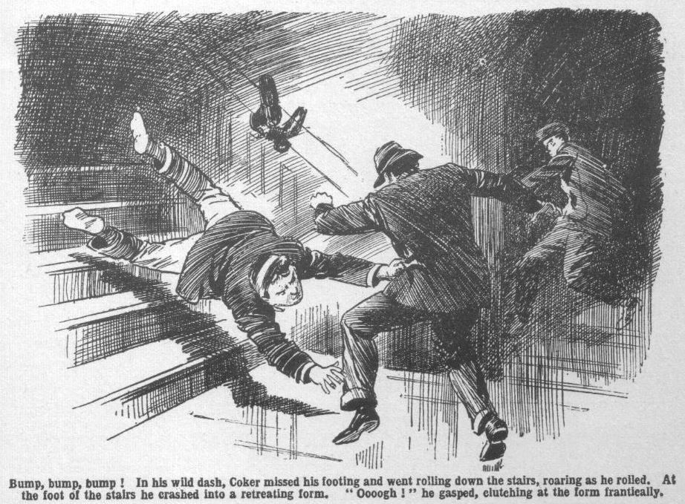
That method of descent was disturbing and painful; but it had, at least, the advantage of rapidity. At the foot of the stairs Coker crashed into a retreating form.
He clutched at the form frantically, and then hit out.
“Ooooogh!”
A spluttering gasp answered the blow, which landed, apparently, on a waistcoat. There was a horrible1 gurgling sound.
Coker hit out again, but his fist swept the empty air. A gasping, gurgling man was retreating in the dark. Coker heard a voice, in a fierce whisper:
“Quick, you fool!”
A gurgle answered. The Ferret, winded by Coker’s drive, was squirming away through the gloom after his confederate.
Coker picked himself up, and made a rush, cannoned against a wall, and roared. It was rather reckless to charge blindly in the dark, but this reflection occurred to Coker too late to be of any use to him. He hit the wall, roared, and sat down, still roaring.
Lights were flashing on all over the House now; voices called and shouted from every direction.
Above the rest sounded the boom of Mr. Prout.
Where the burglars were, Coker did not know. He sat and clasped his nose with both hands, with crimson trickling between his fingers. He had hit the wall hard, and his nose had taken most of the shock. It seemed to Coker that that nose had been driven right through his head. It hadn’t, but it felt like it.
Clasping his hapless nose with both hands, Coker sat and crooned with anguish; and in that situation he was revealed as the lights flashed on and an excited and amazed crowd surrounded him.
THE SEVENTEENTH CHAPTER.
Doubting Thomases!
“HALLO, hallo, hallo!”
“Who the dickens—”
“What the thump---”
Bob Cherry was first out of bed in the Remove dormitory. But a dozen other fellows were up a second lator. Every fellow was awake, but Bunter, whose deep snore boomed on regardless. Harry Wharton dragged open the dormitory door.
“That’s Coker bellowing!” he exclaimed. “ Coker of the Fifth—”
“Or else an escaped rhinoceros!” said Skinner.
“ Coker!” gasped Bob Cherry “ But what—”
“ Come on!” shouted the Bounder, snatching a pillow from his bed, and leading a rush from the dormitory.
A crowd of fellows followed him.
Coker had been missing when the Remove went to bed, but it was evident that he had returned; there was no mistaking the bull-like roar that woke every echo of the House. Coker was there ; and apparently burglars were there, unless Coker was giving that wild alarm for nothing. The heroes of the Remove were quite keen to get on the scene, and they thoughtfully took their pillows with them, for the benefit of the burglar.
The whole House seemed to be up.
Fellows of all Forms swarmed out of the dormitories; Sixth-Formers crowded out of their rooms, masters, in dressing gowns and slippers, popped up on every side. Lights flashed right and left. A wildly excited crowd, half-dressed or in pyjamas, swarmed on stairs and in passages. Mr. Prout’s fruity voice was heard over the din.
“What is it? Where is he? It was Coker—Coker, of my Form, who was shouting! What—what—what——”
“There he is!”
“What the thump
“How the dickens
“It’s Coker——”
“ But what the jolly old deuce is he up to? ” asked the Bounder.
A buzzing swarm circled round Coker of the Fifth. Amazed eyes stared at him. Form masters glared at him. Prout looked at him like a basilask. Coker, for the moment, heeded none of these things. The pain in Coker’s nose claimed all his attention.
Sitting on the floor, clasping his nose, Coker moaned.
“Ooooooh!”
“Coker!” boomed Prout.
“Mooooooh!” came from Coker, as if he were understudying an afflicted cow “Moooooh!”
“Coker! Boy!”
“Wooooooh!”
“Why have you alarmed the House?” boomed Prout. “How did you gain admittance? What do you mean? Speak!”
“Ooooooh!”
Prout, in towering wrath, stooped over Coker, grasped him by the collar, and jerked him to his feet.
Coker staggered up. He ceased, at last, to grasp his injured proboscis. The first agony had abated, though it was still very painful. His nose like Marian’s in the ballad, was red and raw, and it streamed claret. But Coker remembered the burglars.
“After them!” he gasped.
“Who—what—whom—”
“The burglars!” gasped Coker. “They’re getting away—two of them! I got one of them in the breadbasket and---”
“What—what?”
“I mean in the tummy! I’d have had him, only I bashed into the wall, and then---”
“Upon my word!” gasped Prout.
“Coker,” broke in Mr Quelch’s quiet, severe voice, “will you explain why you have caused all this uproar?”
Mr. Quelch’s voice seemed to have a cutting edge on it. The Remove master was still feeling the effects of his handling by “Mr. Jackson” that morning, and he was far from pleased at being called out of bed by an alarm in the small hours. He really looked as if he could have bitten Coker of the Fifth. Coker stared at him.
“B-burglars!” he stuttered. “Didn’t you hear me say burglars?”
“Nonsense!” boomed Prout. “Utter nonsense!” You have been frightened by a shadow in the dark!”
“Me!” gasped Coker. “Me frightened!I can jolly well tell you I tackled them, sir, and I’d have had at least one of them, only I missed my footing and rolled down the stairs---”
“Ha, ha, ha!”
“Silence!” boomed Prout. “This boy’s absurdities are not a laughing matter! How dare you cause this uproar, Coker? Explain at once how you entered the House at this hour of the night!”
“The Sixth Form lobby!” gasped Coker. “The window was open—it was the way they got in---”
“More likely the way Loder of the Sixth got in!” whispered the Bounder, and there was a snigger among the Removites.
“Nonsense!” boomed Prout. “The window was carelessly left open! Do you mean to say that you saw burglars in the House?”
“I jolly well did!” hooted Coker. “And I tell yon I landed one of themi a jolt in the breadbasket and he gurgled—”
“Ha, ha, ha!”
“Silence! Nonsense! If there were burglars, where are they?” boomed Prout. “I repeat, where are they?”
“Gone, by this time, I supposc, said Coker. “If I hadn’t run into a wall in the dark and bashed my nose — ”
“Ha, ha, ha!”
“Silence! Silence! Will you be silent?” roared Prout. “Wingate, Gwynne, Loder, Walker, will you kindly make a search—though I have not the faintest belief that this stupid boy saw anything but a shadow!”
“Oh, certainly!” said Wingate.
“Now, Coker, explain why you entered the house surreptitiously, instead of making your return known!” boomed Prout.
“I—I didn’t want to wake anybody up, sir.” explained Coker. “I thought I d go quietly to my dormitory, sir, and —and see you in the morning.”
Even Coker had tact enough not to mention that he considered it judicious to see Prout after Prout had breakfasted.
“Absurd! You should have done nothing of the kind. Coker, you are incorrigibly stupid! You have caused alarm and wakened the whole House by your crass folly!”
“Well, I like that —“ gasped Coker. “If I hadn’t butted in, sir, those burglars---”
“There were no burglars!” roared Prout.
“Two of ‘em, sir! I fancy, they were after the Head’s safe. They came up the stairs just in front of me and---”
“The Head’s safe s not upstairs, Coker. There is nothing to tempt a burglar on the upper floors. Your statement is absurd.”
“Oh! Perhaps they didn’t know the way, sir. Anyhow, they were after something. They must have been---”
“Nonsense! You were frightened by a shadow---”
“Rot!” howled Coker.
“What?” gasped Prout. “What did you say, Coker?”
“I—I mean, you’re mistaken, sir—”
“Got to your dormltory at once! I will deal with you in the morning, Coker.Your conduct is of a piece with your usual unexampled stupidity and obtuseness. I shall take you to your headmaster in the morning. Go to your dormitory.”
“Hadn’t I better go after the burglars sir? They may be still in the House, for all you know
“Silence!” roared Prout. “Go to your dormitory! Not another word! Go to your dormitory at once!”
Potter of the Fifth slipped his arm through Coker’s, and led him away. It was really time. Prout looked as if he could have kept his majestic hands off that member of his Form hardly a moment longer.
Coker, burning with indignation, went. Mr. Quelch’s icy glare turned on a grinning crowd of Removites.
“What are you boys doing out of your dormitoryy” he demanded.
The heroes of the Remove did not stay to answer that question. They vanished like ghosts at cockcrow.
Fellows crowded back to bed, most of them chuckling.
Sixth Form prefeots, rooting dutifully through the House, found no trace of Coker’s burglars. They fully shared Mr. Prout’s disbelief in the existence of those burglars. They found the lobby window open, but they had no doubt that Coker had left it open. Dandy Sanders and the Ferret had long been gone; and they were not likely to be seen again anywhere near Greyfriars— that night, at all events. In all the House, nobody believed in the burglars, but Horace Coker.
Prout went back to bed in a state of towering wrath, the other masters in a very irritable mood, the Sixth Form prefects sniffing with annoyance, and the juniors chortling.
In the Fifth Form dormitory the fellows glared at Coker, and told him what they thought of him. Not a man believed in his burglars. Even Potter and Greene asked him to ring off and let a fellow go to sleep.
Coker turned in, breathing wrath and indignation. Fortunately, however, he soon fell asleep, and forgot his wrongs and grievances, and dreamed that he was mounted on his motor-bike, doing 500 m.p.h.—a happy dream that brought a smile to his slumbering face.
—
THE EIGHTEENTH CHAPTER.
Lucky for Coker!
HARRY WHARTON & Co. smiled.
“Poor old Coker!” said Bob Cherry.
Perhaps it was rather heartless to smile. Coker’s sombre countenance ought not really to have evoked merriment. Coker of the Fifth looked as if he would never smile again.
It was in break the following morning, and Coker, on his lonely own, strode to and fro under the elms, frowning. Fellows who glanced at Coker, or passed him, smiled—they couldn’t help smiling. The Famous Five were only like the rest of Greyfriars in that respect.
Coker seemed to be taking a fearfully serious view of life. The rest of the school smiled.
It was in vain that Coker, almost with tears in his eyes, assured Greyfriars fellows that there really had been burglars the night before.
Nobody believed in his burglars
In vain he asseverated that he had landed one of the miscreants in what he termed his “ breadbasoket.” Nobody doubted that he had punched a banister and mistaken it for a burglar. That he had made mistakes in the dark was evident from the state of his nose. Coker’s nose was swollen and crimson, and anything but a thing of beauty. A fellow who would rush at a wall when he fancied he was rushing at a burglar was capable of punching a banister and supposing that it was a burglar’s breadbasket. Coker, in fact, was considered capable of anything.
Even his bright idea overnight, of getting into the house quietly without awakening anybody, was regarded as another sample of Coker’s usual fat-headedness. If he had done it, it would have been all right; but the result had been awakening the whole house, from the Sixth to the Second. That, of course, was to be expected of Coker.
“Poor old Coker!” repeated Bob. “Poor old Horace! I hear that the Fifth have been slanging him right and left, and everybody else is laughing— except Prout! Prout’s is mad as a hatter. Poor old fathead !”
“They say Prout’s taking him to the Head.” remarked Frank Nugent. “Might be a beak’s licking!”
“ Well, after waking up the whole House in the middle of the night---” grunted Johnny Bull.
“ Poor old Coker!” said Harry Wharton. “He’s fairly asked for it—begged for it! Coker ought to learn that there’s a limit!”
“ My esteemed and ridiculous chums.” said Hurree Jamset Ram Singh, who had a thoughtful expression on his dusky face, “ I am terrifically curious to know how he came to find the lobby window open.”
The nabob’s comrades looked at him.
“Some sportsman left it unfastened, after breaking bounds, of course,” said Bob. “Loder or Carne of the Sixth, I fancy, or Price of the Fifth. Don’t we know their jolly old ways?”
“But they would naturally fasten the esteemed window after getting in, my ridiculous Bob.”
“Forgot it, of course.” said Bob. “Things happen like that! Inky, you ass, you don’t fancy there’s anything in Coker’s burglars, do you—anything but a shadow that Coker took for a burglar?”
“There is a preposterous possibility that absurd intruders were in the House.” said the nabob. “You will rememberfully recollect, my esteemed and idiotic chums, that yesterday morning the honoured Quelch was attacked by a ridiculous intruder who pretended to be an esteemed reporter.”
The juniors started.
“There’s no connection—” began Wharton.
“It is possible, at least,” murmured the nabob. “That esteemed scoundrel was interrupted by the ridiculous Bunter giving the alarm. Nobody knows what he wanted here; but he must have been up to something. Perhapsfully he came back in the absurd small hours of the night—”
“Phew!”
It was a new idea to the chums of the Remove.
The strange attack on Mr. quelch had remained an impenetrable mystery, impossible to explain. Certainly no one but the nabob had thought of any possible connection between that mysterious episode and Horace Coker’s burglars.
“My hat!” said Harry Wharton slowly. “After all, that merchant must have been after something, though goodness knows what. Whatever it was he had to chuck it and bolt. He might have come back at night---”
“Might!” said Johnny Bull.
“The mightfulness is terrific.” said Hurree Jamset Ram Singh.” “ but the proof of the esteemed pudding is in the ridiculous eating! If some idiotic breaker of bounds left that window unfastened---”
“That’s what happened!” said Bob.
“In that case, the absurd Coker is a ridiculous ass! But if the window was opened from outside by an esteemed cracksman---”
“It wasn’t!”
The nabob smiled.
“Let me finish my ridiculous observations.” he suggested. “ If the window was forced, probably there is some trace left of the ridiculous instrument that was used---”
“Um!” said Bob doubtfully. “Like to look at it?”
“That is the absurd idea, my idiotic chum!”
“Oh, let’s!” said Nugent. “ Nothing in it, but it won’t do any harm.”
The Famous Five walked away to the window of the Sixth Form lobby. The door and window were both open now and Wingate of the Sixth happened to be there. He stared at the juniors.
“What do you fags want here?” he asked.
Bob Cherry grinned.
“Inky has an idea that burglars may have been the genuine article, Wingate; he wants to look at the window-catch.”
“Young ass!” said the Greyfriars captain. “Look, if you like, and cut off!”
“The thankfuIncs is preposterous, venerable Wingate!” said the nabob gravely.
He mounted on a chair at the window, and his keen, dark eyes scanned the fastening.
It was a common catch, securing the upper sash to the lower when the window was fastened—impossible, of course, to reach from outside.
From without it could only have been moved by an instrument inserted between the two sashes, which could have forced it back. Such a task was simplicity itself to a housebreaker ; but it could scarcely have been done without leaving some trace.
A glitter shot into the nabob’s eyes.
“My solitary hat!” he ejaculated.
“What’s the jolly old verdict, Inky?” grinned Bob.
Hurree Jamset Ram Singh glanced down at him.
“ The absurd verdict is in favour of the idiotic Coker. ” he answered. “This catch has been forced from outside.”
“Wha-a-at?” exclaimed the juniors all together.
“What’s that, you young ass?” ejaculated Wingate.
“Look!” said the nabob quietly. “The seefulness is the believefulness!”
The juniors and Wingate jumped to the window. They scanned the catch with eager eyes.
“My hat!” murmured Wingate.
The “sign” was not to be mistaken. On the wood of both sashes showed traces where a narrow blade had been forced up between them. On the metal catch was a deep, distinct mark, where the metal had been “nicked” by the pressure of the instrument that had forced it open. Only a close examination would have revealed those traces, but under a close examination they were unmistakable.
“My hat!” repeated Wingate blankly.
“Great pip!” said Bob.
The nabob stepped down from the chair.
“This esteemed window was not left unfastened by accident last night.” he said. “It was opened from outside— some esteemed person came in before Coker.”
“Then—then there really was somebody!” said Johnny Bull. “Let’s go and tell Coker!”
“Good news for jolly old Horace!” said Bob Cherry, with a chuckle. “He really might have thought of this himself—if his brain-box was a going concern. Let’s tell him!”
The Famous Five hurried away to look for Coker. They found him on his way to the House. Coker’s gloomy meditations under the elms had been interrupted by a message calling him to his Form muster’s study. His rugged face was more sombre than ever. That interview with his Form master was not going to be pleasant. Still less pleasant was the prospect of the interview with the Head to follow. Coker, naturally, was in no mood to be bothered by fags. He glared at the chums of the Remove as they came trotting up, and stalked
on.
“Hal1o, hallo, hallo! Hold on, Coker!” shouted Bob Cherry.
Coker stalked on regardless.
“Coker—stop called out Harry Wharton.
Coker stalked into the House.
“The silly ass!” exclaimed Wharton. “Come on!”
The juniors ran into the House after Coker. In Masters’ Passage, Harry Wharton grabbed him by the sleeve.
“Coker—stop a minute—”
“You cheeky young ass!” roared Coker. “Cut off !”
He jerked his arm away, gave the captain of the Remove a shove, and stalked on.
The door of Prout’s study closed behind him.
“The howling ass!” gasped Wharton, as he staggered against the wall.
“The —the silly fathead! Serve him right to leave him to it.”
Bob Cherry chuckled.
“Coker can’t help being a born idiot, old bean!”” he said. “We’d better butt in before Prout scalps him.”
“The buttfulness is the proper caper!”
“Come on, then.” said Harry.
And the juniors hurried down the passage towards the Fifth Form master’s study. The door was closed; but Prout’s booming voice could be heard from within. Prout was going strong.
“I shall take you. Coker, to your headmaster to be dealt with! I feel that you are beyond me! Such stupidity —such obtuseness—such unthinking and irresponsible absurdity---”
Harry Wharton tapped on the door and opened it.
“Please, sir---”
Prout, cut short in the full flow of eloquence, glared round at the five faces in the doorway. Coker glared, too, inimically. Coker had no desire for fans to be on the scene while he was being slanged by his Form master. Heedless of glares, Harry Wharton slipped into the study.
“Wharton! What do you want here?” boomed Prout. “How dare you interrupt me—leave this study at once!”
“But, sir—”
“Go!”
“We’ve found out---”
“Enough!”
“That Coker—”
“Silence!”
“That Coker was right, sir.” Wharton got it out, undeterred by Prout’s glaring and booming. “It’s proved, sir, that the lobby window was forced open from outside ——”
“Nonsense!”
“Wingate knows, sir---”
“What? What?” Prout paused. “Do you mean to say that Wingate of the Sixth—where is Wingate?”
“Here, sir,” said a voice in the doorway, and the Greyfriars captain stepped in. “I came to tell you, sir, that it seems that Coker was right in stating that the House was forcibly entered last night.”
“Goodness gracious!” exclaimed Mr. Prout. “if you really think, Wingate—”
“There is no doubt about it, sir, I think. I am going to report to the Head, and I am sure he will telephone to the police.”
“Bless my soul!”
Harry Wharton & Co. retired from the scene. They looked at Coker as they went, and noted that the sombre cloud had passed from the rugged face of that great man, and was replaced by a grin of satisfaction. Coker of the Fifth was vindicated at last.
Harry Wharton & Co. smiled as thcy went down the passage—leaving the happy Horace grinning almost from ear to ear.
“Wonders,” said Potter of the Fifth, “will never cease!”
“They never will!” agreed Greene.
Coker’s friends were surprised. Coker, for once, had not, after all, acted like a howling ass and a born idiot. So it was no wonder that his friends, who knew him so well, were surprised.
Everybody, in fact, was surprised; and some still doubted, till Inspector Grimes was seen examining that lobby window; after which none could doubt.
Prout’s voice was heard booming in the common room that day.
“A boy of my form!” said Prout, not once, but many times. “A boy of my Form—by a happy combination of good fortune and presence of mind, undoubtedly prevented a burglary here last night ! A boy of my Form, sir---a Fifth Form, boy—Coker, sir, of my Form——”
Prout seemed to have considerably changed his opinion of that boy of his Form!
Coker, of course, was pleased. In his happy satisfaction, he quite forgot that his vindication was due to so insignificant a person as
a junior in the Remove. Coker carried his head high that day; and indeed seemed to be imitating the classical gentleman who was like to strike the stars with his sublime head! Coker felt that he was the goods, the genuine goods, and it was not Coker’s way to leave anybody in ignorance of that fact.
Coker was vindicated; but otherwise the strange affair remained a mystery. So far, at least, not a man at Greyfriars had even a remote inkling of the secret of that study.
THE END.

