BILLY BUNTER’S VENGEANCE !

By Frank Richards

The Magnet Library 1265

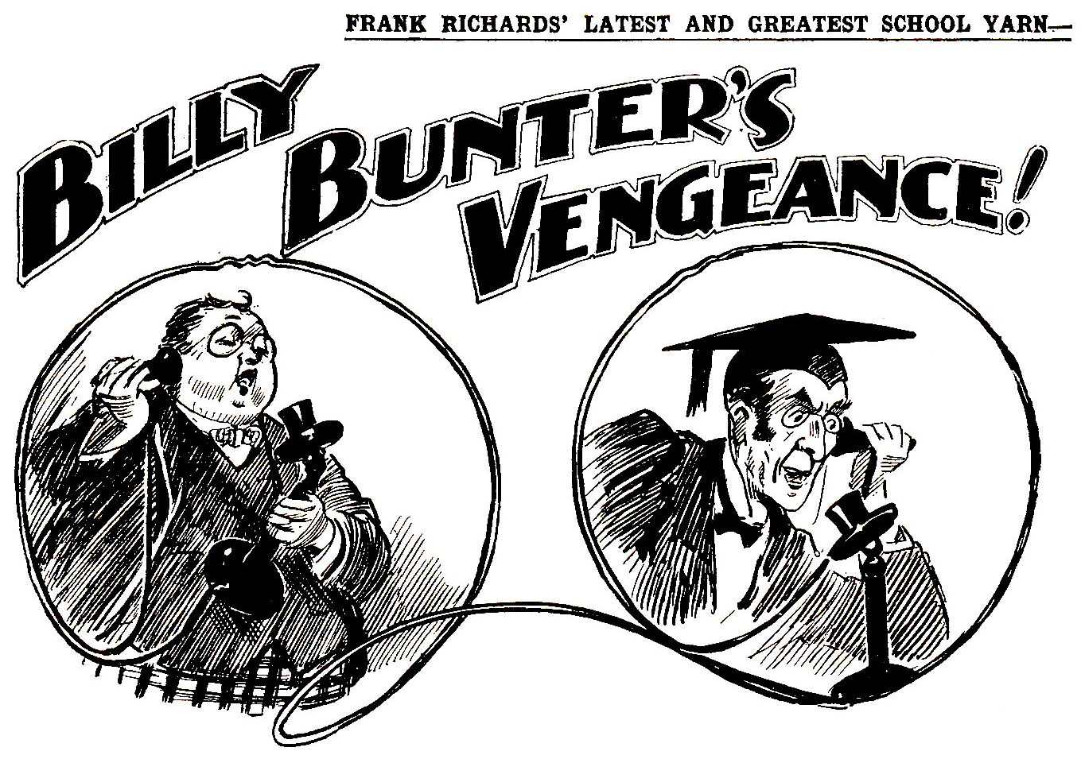

THE FIRST CHAPTER.
The Man in Possession

“LOOK out, Bunter !”
“I say, you fellows—”
“Smithy's coming !”
“I—I don't care !”
“You look as if you don't !” chuckled Bob Cherry.
“Ha, ha, ha !”
Most of the Greyfriars Remove seemed to be gathered about the doorway of Study No. 4, in the Remove passage.
Most of them were laughing.
One fellow, who was inside Study No. 4, was not laughing. It was Billy Bunter, the fat ornament of the Remove. So far from joining in the general hilarity, Billy Bunter was looking very serious—very serious indeed. He was also looking rather apprehensive. He blinked at the laughing juniors in the passage through his big spectacles with a troubled blink. “Smithy's coming, old fat bean !” grinned Johnny Bull.
“Blow Smithy !”
“Better cut !” said Frank Nugent.
“Shan’t !”
“Go while the going’s good, old fat man !” advised Harry Wharton.
“I—I—I’m not going !”
“Wait till Smithy gets in one with his foot !” chortled Skinner. “I fancy you’ll go then, quick !”
“The quickfulness will be terrific !” chuckled Hurree Jamset Ram Singh.
“Ha, ha, ha !”
“I—I say, you fellows, stand by a pal, you know !” said Billy Bunter uneasily. “Of course, I’m not afraid of Smithy—”
“Bursting with pluck, what ?” asked Bob Cherry. “You look it !”
“I say, one of you go and call Quelch.”
“Ha, ha, ha !”
“You go and fetch Quelch, Bob, old chap.”
I don’t think !”
“I—I—I’m not going to be turned out of my own study, you know. I say, Wharton, you can lick Smithy, you know. You licked him last term. You—you whop him, old chap. I’ll hold your jacket !”
Harry Wharton laughed.
“Take my tip and get out of Smithy’s study, you fat frog !” he advised. “It was a mean trick to bag Smithy’s study because he was kept away and came back late this term. We’ve all told you that. Toddy will let you go back into Study No. 7, won’t you, Toddy ?”
“I’m not going back to Study No. 7 !” roared Bunter. “This is my study, and I’m sticking to it !”
“Here comes the Bounder !” yelled Skinner.
“Let him come !” said Billy Bunter. “Let him come, and be blowed to him ! Yah !”
“Ha, ha, ha !”
Herbert Vernon-Smith, the Bounder of Greyfriars, was coming up the passage from the stairs. There was a rather grim expression on Vernon-Smith’s face.
He pushed his way through the crowd of grinning Removites and looked into Study No. 4.
His face grew grimmer as his eyes fixed on the fat, countenance and glimmering spectacles of William George Bunter.
“Still here ?” said Smithy. He stepped in.
Billy Bunter backed round the study table. The Bounder followed him round. Bunter accelerated. The Bounder put on speed. Twice they circumnavigated the table, Bunter keeping ahead. There was a roar from the passage.
“Here we go round the mulberry bush !” chanted Skinner.
“Ha, ha, ha !”
“I say, you fellows !” squeaked Bunter. “Stop him !”
“Ha, ha, ha !”
Smithy, his face growing angrier, made a rush. Billy Bunter skipped round the table again like a fat but active kangaroo.
Considering the weight he had to carry, the fat Owl of the Remove was displaying wonderful activity. But he knew what would happen if he lingered within reach of the Bounder’s foot.
The fellows in the passage crammed the doorway, watching the chase, with howls of laughter.
Round they went again, as if they were playing at going round the mulberry bush. The spectators seemed to be enjoying the entertainment. Billy Bunter did not seem to be enjoying it.
“The Bounder made another rush. Bunter made another agile skip. They changed sides again, but the table was still between them.
“Go it, Bunter !”
“After him, Smithy !”
“Ha, ha, ha !”
“I say, you fellows, one of you call Quelch !” yelled Bunter.
Nobody seemed disposed to go down and call Mr. Quelch, the master of the Remove, on the scene. It was seldom that, Billy Bunter desired to see his Form master. Now he would have been overjoyed to behold the severe features and angular form of the master of the Remove.
But Quelch was not in the offing. Quelch was far away in his study downstairs, never dreaming how anxious one of his pupils was to see him.
The Bounder came to a halt, and glared at Bunter across the table.
“Are you getting out, you fat scoundrel ?”
“Oh, really, Smithy—” gasped Bunter. “Cheek, I call it, to ask a man to get out of his own study !”
Billy Bunter was in the right so far as that went. Study No. 4 had been left vacant at the beginning of the term, and Billy Bunter had bagged it, as he or any other fellow had a right to do.
Smithy and Redwing, to whom the study belonged, had not come back with the rest of the school. Redwing was not back yet. Smithy had been back a few days, and had unexpectedly found himself with a new study-mate.
He had not, as most of the fellows anticipated, booted Bunter out at once. He had let him remain until this afternoon, when Redwing was expected back at Greyfriars. Now that Redwing was coming, Smithy had told Bunter to clear, adding that if found in the study again he would depart on the toe of a boot. Bunter was determined not to clear. He had bagged that study, and he was sticking to that study. He was the man in possession.
Although the fat Owl was, according to the rules, in the right, no fellow in the Remove had any sympathy to waste on him. The Remove men had gathered, not to sympathise, but to see Bunter drop. Right or wrong, Smithy was not the man to give in; he was the fellow to have his own way, especially as he had recently been elected captain of the Remove, and it had perhaps got into his head a little.
Kicking Bunter out when Bunter had the House rules on his side was rather a high-handed proceeding. But Smithy was the fellow to do it, and evidently intended to do it.
Bunter watched him warily across the table, gasping for breath, and prepared to dodge again. The hilarious Removites watched from the passage. There was quite a struggle for front seats for the entertainment.
“I—I’m jolly well not going, you know !” gasped Bunter. “Look here, Smithy— Ow !”
Smithy rushed again, and Bunter dodged. They circled the table once more, amid roars of laughter.
“Keep off, you beast !” howled Bunter. “Look here, Smithy—”
Crash !
The Bounder seemed tired of the chase. He grasped the study table and up-ended it out of the way. Then he rushed again.
“Yarooooh !”
“Ha, ha, ha !”
There was no more dodging for Bunter. The Bounder’s muscular grasp was on him. The fat Owl of the Remove spun doorward.
“Look out !” yelled Bob Cherry.
The swarm of juniors backed. Nobody wanted to stop Bunter when he flew. Hurriedly they gave him room to drop.
“I—I say, you fellows— Yoooop !” roared Bunter.
The fat Owl was whirled to the door. The Bounder drew back his right foot. There was a terrific thud as that foot established contact with the tightest trousers at Greyfriars.
Billy Bunter’s yell was heard far and wide. Louder still sounded the concussion as the fat Owl landed in the passage. He rolled and roared.
“Ooooooooop !”
“Ha, ha, ha !”
“I—I say, you fellows— Whoooop !”
Slam !
The Bounder’s study door closed on Bunter.
THE SECOND CHAPTER.
The New Captain !

“WHARTON !”
“Yes, sir!’
Harry Wharton stopped. It was the voice of Henry Samuel Quelch, his Form master, and there was a very sharp note in it.
“Kindly tell Vernon-Smith to come to my study at once, Wharton !” rapped Mr. Quelch.
“Yes, sir.”
Wharton was going out of the House, but he turned back to the stairs.
He mounted the stairs rather slowly. His friends were waiting for him in the quad, and he did not want to speak to the Bounder if he could help it. But when Mr. Quelch rapped out a request to any member of his Form, to hear was to obey.
It was an hour since the forcible ejection of William George Bunter from Study No. 4. Wharton wondered whether the fat Owl had carried his wrongs and grievances to his Form master, and whether that was why Smithy was wanted.
Smithy had the sympathy of the Remove in his dealings with the fat Owl, but there was no doubt that those dealings were rather high-handed. It was very probable that Quelch intended to intervene with authority if the matter had reached his cars. And all the Remove knew that Herbert Vernon-Smith was not in his Form master’s good books.
Harry Wharton tapped at the door of Study No. 4 in the Remove and opened it. The Bounder was alone there; Redwing, his chum, had not yet turned up. Vernon-Smith, stretched in the study armchair, had his feet on another chair, and a curl of smoke rose from a cigarette in his mouth. He made a rather hasty motion to remove the cigarette as the door opened, but as he saw that the caller was only a Removite he left it where it was. His eyes gleamed at Wharton through the haze of smoke.
“Oh ! You !” he said. “You can come in.”
Wharton stopped in the doorway. He had no desire to enter the Bounder’s study. He intended to see as little as he could of Vernon-Smith that term. It was no secret that Vernon-Smith had come back after the Easter holidays determined to carry on the feud of last term, and the Famous Five had agreed that they were going to steer clear of trouble with Smithy if they could. So far as cricket was concerned, they had to come into contact with him; outside the Form games they wanted to give him a wide berth.
Bob Cherry had remarked that it took two to make a quarrel; to which Wharton assented, though he could not help having a misgiving that it took two also to keep the peace. But Wharton, who was quite conscious that he had been partly to blame for the trouble of last term, was resolved that he would not be to blame for new trouble. If the Bounder wanted it, he had to look for it, and admit that he was looking for it.
“Only a message from Quelch, Smithy,” said Harry. “You’re wanted in his study.”
The Bounder gave a grunt.
“What’s the trouble now ?”
“Quelch didn’t say.”
“Well, come in all the same; Quelch can wait.”
Wharton hesitated.
“Quelch doesn’t like waiting, Smithy,” he said.
“Let him lump it, then,’ said Smithy carelessly.
“I want to speak to you about the cricket.”
“Well, you’d better cut it short, then.”
Harry Wharton stepped into the study.
“You can take a pew !’ said the Bounder sarcastically, as Wharton remained standing.
Wharton sat down on the edge of the table.
“No good offerin’ you a smoke ?” asked Smithy satirically.
“No !” said Wharton briefly.
“Same old model of righteousness, what ?”
Harry Wharton gave him a steady look.
“You said you wanted to speak about the cricket, Smithy. If it’s a row you want I’ll clear.”
“Stay where you are !”
The Bounder’s tone was dictatorial. Harry Wharton flushed, and made a movement to go. But he remained. Smithy was captain of the Remove now, and if he wanted to speak to a member of the team about cricket it was up to that member to listen. Wharton told himself over again that he would not be to blame for a new outbreak of trouble in the Form.
“We’re goin’ to win matches this term,” the Bounder went on. “I’m takin’ the Form games seriously in hand. I shall be makin’ some changes, but I shall want you. It will be rather a change for you.” The Bounder watched Wharton’s face while he was speaking. “Last term you were captain of the Form, but the men got fed-up with you, as you know—” He paused, but Wharton made no remark. “And they put me in. Now, I want you to bear in mind that you’re a man in the team like any other, and the sooner you forget that you were ever anything else the better. See ?”
“Is that the lot ?” asked Harry.
“From now on you’ll toe the line like any other man in the Remove,” said Vernon-Smith.
“Any more ?”
Vernon-Smith threw away his half-smoked cigarette and rose to his feet. His intention was to irritate Wharton, once captain of the Remove; and still, Smithy was convinced, his rival for the post. Instead of which he was growing irritated himself, while the junior sitting on the table remained quite calm and equable.
“We shall be playin’ Redclyffe next week. I’m goin’ to see that the men are in form to beat Redclyffe” rapped the Bounder.
“Oh, quite ! I should !” assented Wharton,
“There’ll be extra games practice fixed up, and every man will have to attend. Nobody will be allowed to cut,” said Vernon-Smith; “not even if he happened to be captain of the Remove once upon a time.”
Harry Wharton laughed. It was so obviously the Bounder’s object to “draw” him, that it was rather amusing to refuse to be drawn.
“I may as well say right out that if there’s any kickin’ over the traces I shall come down on it hard !” snapped the Bounder.
“This reminds me of something in Shakespeare,” said Harry Wharton thoughtfully.
“What do you mean, you silly ass ?”
Wharton proceeded to quote from the great bard:
၇
“ ‘Man, vain man,
Dressed in a little brief authority,
Plays such fantastic tricks before high heaven
As make the angels weep !’ ”

The Bounder crimsoned with vexation. There was no doubt that he intended to exercise his new authority to the full, and that he was going to use it to make his old rival “squirm” if he could. Some of the Remove were already saying that Smithy needed a larger size in hats now that he was captain of the Form. But doubtless the Bounder did not realise that now he was “dressed in a little brief authority” he was proceeding to “make the angels weep.”
He made a stride towards the junior sitting on the edge of the table. He had intended to get Wharton’s “rag” out by adopting a dictatorial tone to the former captain of the Remove. But it was his own rag that was out. He clenched his hands. “If you want me to knock you of that table—” he said, between his teeth.
Wharton laughed contemptuously.
“Do you think you can bully me like Bunter ?” he asked. “Don’t be a silly ass, Smithy ! If you’ve done throwing your weight about I’ll clear. I’ve told you that Quelch wants you in his study.”
“Hang Quelch !”
There was a footstep and a rustle of a gown in the passage.
“Vernon-Smith !”
“Oh gad !” The Bounder unclenched his hands and spun round towards the doorway, in which was framed the angular form and severe countenance of his Form master.
“Oh, my hat !” murmured Wharton.
Evidently, as the Bounder had not gone to Mr. Quelch as directed, Mr. Quelch had come to the Bounder. He had arrived at a rather unfortunate moment for the new captain of the Remove.
“Vernon-Smith”—the Remove master’s eyes glinted at the Bounder—“I heard your remark !”
Vernon-Smith breathed hard, but he did not answer.
“I sent for you to come to my study, Vernon-Smith !”
“I—I was just comin’ !” muttered Smithy.
“You should have come at once, Vernon-Smith ! For the words I heard you use you will take five hundred lines !”
The Bounder stood silent and sullen. Wharton slipped from the table, but he could not leave the study while the doorway was filled by his Form master. He had to wait.
“I desired to see you, Vernon-Smith,” went on Mr. Quelch “in reference to a complaint made by Bunter. Bunter changed into this study this term, as he was entitled to do, as the room was unoccupied. It appears that you have turned him out by force. This will not be allowed.”
“It’s my study, sir,” muttered the Bounder sullenly. “Redwing will be back to-day, too. A fellow is allowed to take his old study—”
Quite so, in the first day of term,” said Mr. Quelch. “If a boy chooses to come back late, long after the rest of the school is assembled, he must take his chance in such matters. Bunter is entitled to choose this study, and I shall uphold him. If you venture to eject him again you will deal with me, Vernon-Smith. That is all. I shall expect your lines to-night.”
With that Mr. Quelch rustled away.
The Bounder stood with a black and sulky brow. Harry Wharton left the study, without a glance at him. The door slammed after him as the Bounder savagely kicked it shut.
THE THIRD CHAPTER.
A Highcliffe Rag !

“HALLO, hallo, hallo ! There’s old Redwing !”
“Redwing !” repeated Harry Wharton.
The Famous Five were seated on the stone parapet of Friardale Bridge. They had strolled along the towpath, on the bank of the Sark, after class, and now they were taking a little rest before walking back to the school for tea.
The road from the bridge ran through a wood, where it disappeared from sight; but beyond the wood it came into view again, winding away up to the cliffs like a white ribbon on the green downs. Far in the distance a figure came into sight, and Bob’s keen eyes had recognised it as Tom Redwing, of the Remove.
“I heard that Redwing was coming back to-day,” remarked Frank Nugent. “Let’s wait for him and trot on together. He will be crossing the bridge in ten minutes.”
“Let’s !” agreed Johnny Bull.
“Um !” said Harry Wharton, rather doubtfully.
Bob glanced at him.
“You want to see old Redwing, don’t you ?” he asked. “I hear he was laid-up in the hols, too—that’s why he’s late back.”
“Well, Redwing is Smithy’s pal, and Smithy is out for trouble this term,” said Harry. “We all like the chap, but—”
“The butfulness is terrific,” agreed Hurree Jamset Ram Singh, with a nod of his dusky head. “The esteemed Smithy will be shirty if the absurd Redwing trots in with our honourable and ridiculous selves.”
Grunt from Johnny Bull.
“Let him, and be blowed to him !” said Johnny. “I’m getting fed-up with Smithy’s airs and graces.”
“The airy gracefulness of the esteemed Smithy is preposterous. But—”
“He’s seen us !” said Bob, as the distant figure waved a hand.
On the higher ground beyond the wood Redwing was in view across the treetops. But as he followed the descending road he disappeared from sight among the trees.
“May as well wait,” said Bob Cherry; and Wharton nodded assent.
The five juniors on the bridge waited for Redwing to appear in sight on the road from the wood.
They expected him to appear in a few minutes. But he did not emerge from the wood. Instead of that, there came the echo of a distant shout.
“Hallo, hallo, hallo ! What’s that ?” ejaculated Bob.
“It’s Redwing ! Listen !”
“Rescue ! Rescue ! Greyfriars !”
Faintly from the distance came the shout. Evidently it came from Tom Redwing, still out of sight on the road in the wood.
Bob Cherry jumped down from the stone parapet.
“Come on !” he exclaimed.
Evidently something had stopped Redwing in the wood, and he was in need of help. Bob Cherry started along the road at a burst of speed, and his comrades were not slow to follow him. Where the road passed through the wood it was shadowed by great branches, that shut off the bright May sunshine. Something was happening there, out of sight of the Famous Five—and they put on their best speed as they rushed to the rescue.
“Highcliffe cads !” exclaimed Bob.
The Greyfriars fellows came suddenly on the scene.
Three bicycles were leaning against the trees by the roadside, near a fallen trunk left by the wood-cutters. Round about that trunk lay a number of burnt matches and cigarette-ends. Three Highcliffe juniors—Ponsonby, Gadsby, and Monson—were surrounding Tom Redwing, who was putting up a strenuous but losing fight against the three. Evidently Ponsonby & Co. had stopped in that secluded spot to enjoy a smoke, when Redwing came along, falling fairly into their hands. Any Greyfriars man was fair game for Ponsonby & Co. so long as the odds were on their side. They had thrown away their cigarettes at once at the sight of Redwing, and he was hard pressed when the Famous Five came tearing up.
“Rescue !” yelled Redwing.
“Shout away, old bean !” grinned Ponsonby. “You’re far enough from Greyfriars here—no other cads about ! Collar him !”
“Snaffle the cad !” chuckled Gadsby. “We’re not far from the river—we’ll roll him down and duck him—what ?”
“What-ho !” chortled Monson.
“All together !” said Ponsonby. ‘Now then, rush the rotter over !”
The three Highcliffians closed in on Redwing with a rush, and he went down with the three sprawling over him. There was a fearful howl from Gadsby as they were mixed up on the ground. He had caught Redwing’s knuckles with his eye.
“Whoooooh ! Oh, my eye !” yelled Gadsby.
“Pin him !” gasped Ponsonby. “Oh gad ! The brute’s as strong as a horse ! Scrag him !”
Redwing was still resisting manfully, and the three Highcliffians were too busy to observe the five running figures that came racing down the road as if they were on the cinder-path.
“Hallo, hallo, hallo !” roared Bob Cherry. “Here we are, old bean !”
“Oh gad !” gasped Ponsonby.
He released Redwing as suddenly as if that youth was red-hot, and leaped to his feet. He was in time to stop Bob Cherry’s right with his nose, and he spun over with a roar.
“Oh crumbs ! Greyfriars cads !” gasped Monson.
“Look out !” panted Gadsby.
“Mop them up !” roared Johnny Bull.
“The mopfulness is terrific !” chuckled the Nabob of Bhanipur.
Redwing sat up, dusty and dizzy. Pon & Co. made a frantic rush for their bicycles. Monson reached his machine, threw a leg over it, and went whizzing away down the road before he could be collared. But Ponsonby and Gadsby were grasped in time and whirled back.
“No, you don’t !” grinned Bob Cherry, as he fastened a grasp of iron on Pon’s collar. “What’s the hurry ?”
“Leggo, you rotter !” panted Ponsonby.
“Not yet, old tulip ! We love you too much to lose you.”
“Ha, ha, ha !”
Harry Wharton gave Redwing a hand up.
“Oh, my hat ! I’m glad you fellows were around,” gasped Redwing. “Lucky I saw you on the bridge !”
“The luckfulness was terrific, my esteemed Redwing,” grinned Hurree Jamset Ram Singh. “But the luckfulness is a boot on the other leg for the esteemed and ridiculous Ponsonby.”
“I—I say, chuck it, you men !” gasped Gadsby. “We-we weren’t goin’ to hurt the fellow, you know—only a joke—”
Well, let’s all join in the joke,” said Bob Cherry. “We’re rather jokers ourselves.”
“The jokefulness is terrific.”
“Will you let go my collar ?” hissed Ponsonby.
“Not till I’ve jolly well banged your napper, old bean ! This is where you get the cream of the joke.”
With a swing of his sinewy arm Bob Cherry jerked the dandy of Highcliffe to the nearest tree. The hapless Pon in dire anticipation of what was coming, struggled frantically. But it booted not.

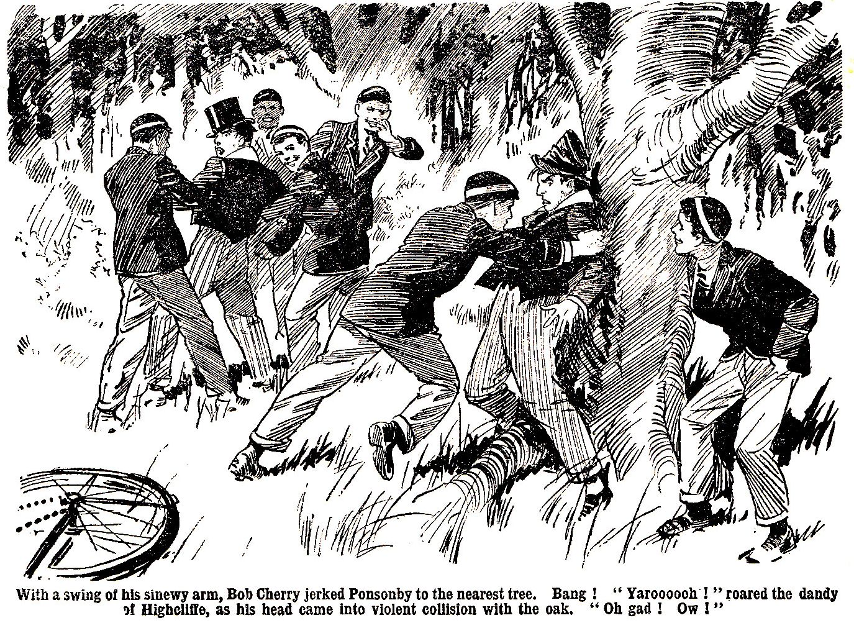

Bang !
“Yaroooooh !” roared Ponsonby, as his head came into violent collision with the oak. “Oh gad ! Ow !”
Bang !
“Whooooop !”
“Ha, ha, ha !”
“Have another ?” asked Bob affably.
“Ow ! Wow ! Yow ! Leggo ! Oh crikey ! Wow !” yelled Ponsonby. “Ooooh ! Woooooh !”
“Does that mean yes or no ?’”
“Ha, ha, ha !”
“Ow ! Wow ! No ! Don’t ! Oh my napper ! Wow !”
“Pon seems to have had enough !”remarked Bob. “He’s not greedy—he knows when he’s had enough. You can sit down, Pon.” Pon sat down, hard, and yelled again. “Your turn, Gaddy !”
“I—I say—l” Gadsby was wriggling, in a state of horrified apprehension, in the grasp of Johnny Bull and Frank Nugent. “I say, it was only a joke, really—look here—d-d-don’t—oh, my hat—oh, my head-oh !”
Bang!
“Whoooop ! roared Gadsby, as his head met the oak. “Oh gad ! Oh crikey ! I say—whooooop !”
“Whoooo-hoooooop !”
“Sit down !” grinned Johnny Bull.
Gadsby sat down beside Ponsonby. They sat and gurgled and rubbed their heads and howled. Seldom had the heroes of Highcliffe felt so sorry for themselves.
“Want any more, you two ?” asked Bob cheerily.
“Yow-ow-ow !”
“Wow ! Wow !
The answer is in the negative” chuckled Hurree Jamset Ram Singh.
“Ha, ha, ha !”
“Come on, Reddy—unless you’d like to kick Pon before you go,” said Harry Wharton, laughing.
“I think Pon’s had enough,” said Redwing with a chuckle; and he walked on with the Famous Five—leaving Ponsonby and Gadsby sitting in the road, rubbing their heads, and wishing from the bottom of their hearts that they had not thought of starting that, little rag.
THE FOURTH CHAPTER.
Bad for Bunter !

SMITHY, old chap !
Herbert Vernon-Smith did not reply, and he did not turn his head as he heard the fat voice of William George Bunter.
The Bounder was standing in the old gateway of Greyfriars, looking down the road. He was waiting there for Redwing to come in.
Billy Bunter, as he rolled up, blinked warily at the new captain of the Remove through his big spectacles.
Billy Bunter’s tone was friendly as he addressed Smithy—very friendly indeed. Bunter wanted to be friends with his new study-mate.
In fact, unless friendly relations were established with the Bounder, Bunter’s new study was not likely to be of much use to him.
It was not for the enjoyment of Herbert Vernon-Smith’s society that the Owl of the Remove had changed into Study No. 4. It was for the enjoyment of the lavish spreads that the wealthy Bounder was accustomed to stand in his study. Billy Bunter, as usual, was after the loaves and fishes. He was at his old game, as a snapper-up of unconsidered trifles !
Bunter knew—if nobody else did—what a fascinating and altogether charming fellow he was. Bunter could not help thinking that any fellow ought to have been glad to have him in his study.
Properly speaking, Smithy ought to have jumped at it. But he hadn’t—he had jumped at Bunter. The fat Owl was still feeling a twinge where the Bounder’s foot had landed.
Bunter had hoped that Smithy would take the new arrangement in a friendly way. But he had doubted.
His doubts had been justified. But he had not given up hope, which is said to spring eternal in the human breast.
Anyhow, he was established in Study No. 4. Quelch had put his foot down about that, and the Bounder could not resist the authority of his Form master. He had to let Bunter stay. That point settled, the fat Owl was anxious for Smithy to “come round.”
“I say, Smithy, old fellow.” Bunter almost cooed, though he had to coo at the back of the Bounder’s head. “I say, what’s the good of ragging, old chap ? We don’t want a cat-and dog life in the study, do we ?”
If Vernon-Smith heard, he heeded not. He continued to stare along the road, deaf to the voice of the charmer.
“As for Redwing, I shan’t mind him in the study,” continued Bunter. “The fellow’s not my class, of course; but dash it all—I’m no snob ! I can stand Redwing, Smithy !”
Smithy seemed deaf.
“The fact is, as Redwing’s coming back to-day, I was thinking of standing a rather special spread—sort of housewarming, you know,” went on Bunter.
“Make the fellow feel welcome in my study, you know, what ?”
Bunter paused, like Brutus, for a reply; but like Brutus, he did not get one.
“Look here, Smithy, I suppose you can answer a chap !” he hooted.
Apparently Smithy couldn’t ! At all events, he didn’t.
“I say, old chap, what’s the good of keeping this up ?” urged Bunter. “I’d have had the spread all ready now, only I—I’ve been disappointed about a postal order. I told you I was expecting a postal order, didn’t I, old bean ?”
No answer ! But really no answer was needed. Smithy undoubtedly knew that Billy Bunter was expecting a postal order. All Greyfriars knew that !
“There’s been some delay in the post,” continued Bunter. “It hasn’t come ! It’s rather odd, too, as it’s coming from one of my titled relations. But—it hasn’t ! I suppose you could lend me the ten bob till it comes, Smithy ?”
Although hope springs eternal in the human breast, Billy Bunter was not feeling very hopeful as he made that suggestion.
Smithy did not even seem to hear it. He stared out into the road, taking no more notice of Bunter than if the fat junior had been a buzzing insect.
A bunch of Remove fellows had come into sight, from the direction of the river. Vernon-Smith’s eyes fixed on them.
One of them was Tom Redwing; the others were Harry Wharton & Co. The Bounder’s eyes glinted as they approached the gates. Redwing was his pal—the only fellow in the wide world for whom he had ever had any real liking. But the sight of Redwing, sauntering and chatting pleasantly with Harry Wharton & Co., brought a scowl to his face. If Redwing thought that he was going to run with the hare, and hunt with the hounds—that was the thought that came into the Bounder’s mind, as he watched them.
“I say, Smithy, old fellow, what’s the good of being shirty ?” Billy Bunter’s fat voice went on at his elbow. “We shall get on all right in the study, old thing. If you like to stand the tea to-day, I’ll stand it to-morrow—can’t say fairer than that. And I’ll tell you what, Smithy—after tea, I’ll give you some of my ventriloquism—”
The Bounder turned his head at last.
“Will you shut up ?” he asked.
“Oh, really, Smithy—”
“Cut, you fat rabbit !”
“If that’s what you call civil, Smithy, to a fellow in your own study—”
The Bounder made a motion with his foot, and Billy Bunter backed promptly away. Evidently the Bounder was deaf to the voice of the charmer—not even tempted by the offer of some of Bunter’s wonderful ventriloquism in the study after tea. Bunter gave him a devastating blink as he backed out of reach.
“Yah ! Cheeky cad !” hooted Blunter. “I’m jolly well sticking to the study, anyhow—you jolly well can’t turn me out—so you can put that in you pipe and smoke it—yah !”
And having delivered that defiance, William George Bunter beat a rather hasty retreat.
“The Bounder gave him no further heed. He stood in the gateway, his hands in his pockets, an unpleasant gleam in his eyes, watching the cheery party of juniors as they came up. Redwing caught sight of him there, left his companions, and ran forward, his face brightening.
“Back again, Smithy, old chap !” he exclaimed.
The Bounder nodded coolly.
“Don’t let me take you away from your friends !” he said sarcastically.
Redwing gave him a look.
Harry Wharton & Co. went in, and walked on to the House, leaving Tom with his chum. The Bounder was not looking very chummy, however.
“It was rather lucky I fell in with those fellows, Smithy,” said Redwing. “I met Ponsonby and his gang on my way here, and they started ragging. There was a scrap—”
“You’ll have to report to Quelch now you’ve got here, won’t you ?”
“Yes.”
“Hadn’t you better go and do it ?”
Redwing gave him another look, and followed the Famous Five towards the House. There was a cloud on his face as he went. He had been looking forward to seeing his chum again; but it was evident that the Bounder was in one of his sulky tempers.
Vernon-Smith remained staring out moodily into the road. It was lock-up now, and Greyfriars fellows were coming in in twos and threes. The Bounder remained where he was, till Gosling came down to lock the gates. Then he walked away slowly to the House.
Tom Redwing was standing in the doorway of Study No. 44, when Smithy came up the Remove passage. A fat voice was audible from the study.
I say, Redwing, old chap, let’s have tea ! No good waiting for Smithy—he’s in one of his tantrums. Look here, I’ll cut down to the tuckshop, if you like—”
“For goodness’ sake, dry up, Bunter.”
“Oh, really, Redwing—” Billy Bunter blinked out of the study. Oh ! Is that you, Smithy ? Waiting tea for you, old chap !”
Bunter says that he’s in this study now, Smithy,” said Redwing, with a puzzled look. Is that fat frog really landed on us ?”
“Look here, you cheeky beast—”
“Yes; I’m tea-ing with Skinner,” said the Bounder. “We’ve left it rather late—come along.”
“Skinner ?” repeated Redwing hesitating.
He was not on “tea-ing” terms with Skinner & Co., of the Remove.
“Yes; will you come, or not ?” grunted the Bounder.
“Oh, all right !”
“’I say, you fellows !” Billy Bunter blinked at the two juniors as they went up the passage to Study No. 11. I say—”
Vernon-Smith and Redwing turned into Skinner’s study. Billy Bunter blinked into an empty passage with a dismayed blink..
“Beasts” he ejaculated.
Bunter was left in possession of his new study. But the possession of the disputed study did not seen to afford him much satisfaction. If the Bounder was “tea-ing out,” that study was absolutely useless to Billy Bunter. There were no crumbs to fall from the rich man’s table for the fat Owl.
“Oh crikey !” grunted Bunter.
He left Study No. 4 at last, and rolled along to Study No. 1. The Famous Five were there, and there were the remains of a meal on the table; but the meal was over.
“I—I say, you fellows—”’ said Billy Bunter, blinking disconsolately into Study No. 1—at five grinning faces.
“Hallo, hallo, hallo ! How are you getting on in your new study, old fat bean ?” chuckled Bob Cherry.
“I say, that beast Smithy is tea-ing out—”
“Ha, ha, ha !”
“Blessed if I see anything to cackle at ! I say, Smithy seems in a rotten temper about something.” said Bunter. His manners are simply horrid, you know. If he keeps this up, I jolly well shan’t stay in his study—he can’t expect it.”
“Ha, ha, ha !”
“You fellows had tea ?”
Yes.”
“Anything left ?”
“No !”
“Beasts !”
Billy Bunter rolled away, leaving the Famous Five roaring. Bunter had succeeded in landing himself in the study which was like unto a land flowing with milk and honey; but like Moses of old, he seemed destined only to view the Promised Land, without entering into the delights thereof. Bunter, evidently, had expected the Bounder to “come round”—which showed that he had a hopeful nature.
The fat Owl rolled into Study No. 7. Peter Todd was there, and he gave Bunter a look of surprised inquiry.
“Want anything ?” he asked.
“Oh, really, Toddy—”
“Shut, the door after you.”
“The fact is, Toddy, old man,” said Bunter blinking at him. “I don’t want you to think I’m turning you down in changing studies, you know. I’m not the fellow to turn down an old pal, I hope.”
“Not at tea-time !” agreed Toddy.
“I mean to see a lot of you still, old fellow. I shall drop into this study to tea, sometimes—”
“You jolly well won’t !” grinned Peter.
“He, he, he ! I don’t mind your little jokes, old chap. I—I—I say, Toddy, wha-a-at are you going to do with that fives bat ?”
“Wait a tick, and you’ll see,” answered Toddy, as he rose from the table. Just a tick—”
Billy Bunter did not wait, a “tick.” He did not wait half a tick. He departed hurriedly from Study No. 7, banging the door after him with a bang that echoed from one end of the Remove passage to the other.
THE FIFTH CHAPTER.
A Chance for Smithy !

“I SAY, you fellows ! When are we going ?”
“When we start ! answered Bob Cherry.
“Eh ? Well, when are you starting ?”
“When we go !” answered Bob, gravely.
The Famous Five smiled—in contrast to William George Bunter, who frowned.
It was Saturday—a half-holiday—and in the bright May weather, the chums of the Remove looked merry and bright. They were waiting to hear the bell for dinner, when the fat Owl joined them outside the House. Billy Bunter was in quest of information—which the chums of the Remove did not seem keen to impart.
“Now, look here, you fellows,” said Bunter. “I know you’re going over to Cliff House this afternoon, and if I’m coming with you, I shall want to know what time to start. See ?”
“But you’re not, old fat bean,” said Harry Wharton.
“The notfulness is terrific.”
“I don’t think you fellows ought to want to keep me away from Cliff House just because Marjorie likes to see me there,” said Bunter reproachfully. Think of her !”
“Oh, my hat !” said Bob.
They say it’s a pleasure to give pleasure, you know,” argued Bunter. “Well, then, why not make the afternoon a pleasure for Marjorie ! Think what her feelings will be like, if she thinks I’m coming, and then only you fellows turn up.”
“Oh crikey !”
“Besides, they always have a good tea in the school-room when they ask fellows to tea,” said Bunter. “Miss Primrose generally lets them have a cake ! Of course, I’m not thinking about the tea, personally—not like you chaps—”
“You fat chump—”
“Still, the fact is, I’m on rather hard tack lately, and I don’t mind telling you so, as you’re my pals,” said Bunter in a burst of confidence. You know, Toddy used to be mean, in Study No. 7—that was one reason I changed out; I never could stand selfishness. But—would you fellows believe it—the men in my new study are meaner than Toddy ! They tea out every day, and—and so—”
“And so the poor dog had none !” said Bob Cherry sympathetically.
“Ha, ha, ha !”
“Blessed if I see anything to cackle at ! That cad Smithy would like to make out, you know, that a man was after his tuck—as if I thought of that when I changed into Study No. 4. Not the sort of thing that I should think of, as you fellows know.”
“Certainly not !” ejaculated Bob.
“And Toddy’s frightfully inhospitable, in my old study !” went on Bunter. “He makes out that he’s glad I’ve changed out—only his joke, of course, but he keeps it up just as if he meant it.”
“Ha, ha, ha !”
“And, to tell you the truth, I’d really like tea at Cliff House to-day,” said Bunter. Apart from making the affair agreeable and pleasant to Marjorie and Clara and the rest, I’d really like to go. There !”
“My dear old fat porpoise,” said Harry Wharton. “We’re going on our bikes, and we’re having a spin for two or three hours, with Marjorie and Clara—and two or three minutes would fold you up, so roll away, and don’t bother.”
“That’s all right,” said Bunter. “I’ll come ! I’ll ride a bit slow to make it all right for you fellows ! If I tire you out, just remind me, see ?”
The Famous Five gazed at Bunter.
“Only there’s the question of a bike,” added the fat Owl, thoughtfully. Mine’s got three punctures. No time to mend them before dinner—but you can mend them before we start, Bob !”
“Ask next door !” suggested Bob Cherry.
I think you might mend them for me, old chap—you’re rather a clumsy ass at most things, but you can mend punctures. You mended one for Marjorie the other day. I suppose if you can mend punctures for Marjorie, you can mend them for me ?”
“Suppose again !” chuckled Bob.
Apparently, Robert Cherry saw some difference between mending punctures for Miss Marjorie Hazeldene, and mending them for William Bunter.
“Well, if you’re going to be lazy and selfish about it, I shall have to borrow a bike,” said Bunter. I’d borrow Mauly’s, but he’s such a slacker—he’s never had it repaired since he lent it to me last week. Look here ! What about one of you fellows staying in, and lending me his bike ?”
“Hear, hear !” chortled Bob Cherry. What about it, you men ? Don’t all speak at once !”
“Ha, ha, ha !”
“Well, perhaps I can have Smithy’s—after all, a fellow ought to be willing to lend his bike to a fellow in his own study, what ?” said Billy Bunter. “I’ll ask him, anyhow.”
The Famous Five chortled. They could not exactly “see” Herbert Vernon-Smith lending Bunter his handsome jigger.
“Hallo, hallo, hallo, Smithy !” roared Bob Cherry, as the Bounder came along towards the House, the bell for dinner beginning to ring. Stop a minute—you’re wanted.
Vernon-Smith glanced round and paused. He was not on speaking terms with Harry Wharton, and more or less “barred” the whole cheery Co.; but Bob Cherry had no use for sulks or sullenness, and he cheerfully ignored the Bounder’s grim looks.
“Well, what ?” snapped Smithy/
“Go it, Bunter !”grinned Bob.
“It’s me, old chap,” said Bunter, turning his big spectacles on the Bounder. “These fellows are going out for a spin this afternoon with the Cliff House girls, and starting soon after dinner. They’re awfully keen on my going with them, but I shall have to borrow a bike. Can I have yours, old chap ?”
The Bounder gave the Owl of the Remove one expressive look, swung away, and walked on to the House without answering.
Bunter blinked after him.
“I say, you fellows, has Smithy got his back up about anything ?” he asked. “He absolutely refuses to answer when I speak to him ! Like a dumb beast in the study, you know ! Hardly opens his mouth, except to call a follow names, I—I suppose he means I can have the bike.”
Think so ?” gasped Bob.
“Well, silence gives consent, you know,” argued Bunter. “I suppose that’s what he means. I’ll borrow Smithy’s jigger, and come along with you fellows. If Smithy makes out afterwards that he never meant me to have the bike, and kicks up a row, you can lick him, Bob. You can lick Smithy all right ! Wharton’s licked Smithy, you know—and you licked Wharton once, so— I say, you fellows, don’t walk away while a fellow’s talking to you !”
But the Famous Five did walk away. Somehow, they seemed to have had enough of Bunter’s bright conversation.
When the juniors went in to dinner, Vernon-Smith glanced at the Famous Five, across the Remove table, with a sarcastic expression on his hard face.
Redwing, who was next to the Bounder, eyed him once or twice rather uneasily. He could see that something was working in the Bounder’s mind—something of a disagreeable nature.
Harry Wharton & Co. gave the new captain of the Remove no attention, however. The Bounder had made it plain that he was keeping up the “feud” and that he intended to use his new position as captain of the Form to make himself as unpleasant as possible. But that did not have much effect on the cheery equanimity of the Co. They were thinking of their plans for the afternoon—a merry spin on the bikes in the bright May sunshine, winding up with tea at Cliff House with their schoolgirl friends—and they had forgotten Smithy and all his works.
After dinner the Bounder went to the Rag, Redwing following him. He sat down at the table there, dipped a pen in the ink, and wrote out a notice to pin on the door—the usual place for posting games notices concerning the Remove.
Redwing watched him in silence, and read the notice when it was pinned up—and compressed his lips. It was a brief notification that a practice match had been arranged for that afternoon, requiring the presence on Little Side of all the Remove cricketers.
“It’s rather late in the day to put that up, Smithy,” said Redwing.
“Think so ?” asked the Bounder, with a smile.
“It’s not a compulsory day, either.”
“My dear chap,” said the Bounder, “who cares about that ? Compulsory games practice was instituted to round up the slackers and keep them from frowsting in the studies. This isn’t intended to keep Skinner away from his smokes, and Bunter away from the tuckshop. It’s only meant for members of the Form eleven and the reserves. Can’t you read ?”
“Plenty of fellows have made other arrangements for the afternoon by this time, Smithy.”
“Other arrangements can be thrown over, when it’s a question of getting into form to beat Redclyffe next week.”
“Yes; but—”
“I’ve got to keep the men up to the mark, Reddy. I don’t want; the men to be sayin’ that we’re losin’ matches under a new captaincy.”
“No; but—”
“You don’t want to play cricket this afternoon ?”
“I’m keen enough; but—look here, Smithy, I heard Hazeldene mention that he’s going on a spin this afternoon, with his sister at Cliff House—”
“I’ll let Hazel off, if that’s an arrangement. Shouldn’t like to disappoint his sister at Cliff House.”
“I mean, Wharton and his friends are going, too.”
“Are they ?’ said the Bounder.
Well, if you didn’t know—” said Tom, eyeing him doubtfully.
“They don’t generally tell me their arrangements for the half-holidays,” said the Bounder gravely.
“I—I suppose not ! But, look here, Smithy, a lot of fellows will think you knew—I shan’t think so, of course. I know you wouldn’t play a mean trick—”
“Thanks !” said the Bounder.
“But it will really look as if you’re dishing those chaps because you’re on scrapping terms with them. It will look as if you’re throwing your weight about, old fellow.”
“That’s rather a failin’ of mine !” assented the Bounder. I’m afraid I can’t afford to consider the looks of things, old bean—I’ve got my jolly old duty to do. We’re goin’ to beat Redclyffe, you know.”
But those fellows can’t very well cut any arrangements they’ve made with the girls at Cliff House—”
“They can standout, if they like—it’s not a compulsory day, as you say. But any man who stands out of the practice match to-day will be left out of the team for Redclyffe on Wednesday,” said the Bounder calmly. I’m not puttin’ a crew of slackers up to be whopped when Redclyffe come over here on Wednesday. My dear man, don’t you worry—they’ll all be frightfully keen !”
The Bounder walked out of the Rag, whistling.
THE SIXTH CHAPTER.
The High Hand !

“CHEEK !” said Johnny Bull.
“The cheekfulness is terrific !”
“Side !” growled Bob Cherry.
“Swank !” snapped Nugent.
Harry Wharton did not speak. He stood looking at the notice on the door of the rag, with closely-compressed lips.
Word had soon passed through the Remove that the notice was up. Most of the fellows remarked that the captain of the Form might have thought of posting it earlier in the day; but most of the cricketers were keen enough. Indeed, some fellows had thought that the new captain of the Remove might prove rather slack, and were glad to see that he was taking the Form games so seriously and energetically.
Peter Todd had remarked that Smithy was giving his friends at the Cross Keys the go-by; and Skinner & Co., who had been expecting a little run out of bounds with Vernon-Smith, were angry and annoyed.
The Famous Five, keen cricketers as they were, were not pleased. Certainly, they did not want to figure as slackers who loafed about on a half-holiday—fellows who objected to being kept up to the scratch by an energetic skipper. But they could not help guessing that it was not the great game of cricket that Smithy had in mind on this occasion.
“Cheek !” repeated Johnny Bull. That notice should have been stuck up long ago, if it was going up at all. If Smithy thinks he’s a little tin god, the sooner he finds out his mistake, the better !”
Harry Wharton drew a deep breath.
“We’re going out on our bikes,” he said. Smithy’s put this up for our particular benefit—to dish us. I’m taking no notice of his rotten cheek !”
“Same here !” agreed Johnny Bull.
“It’s a rotten trick !” remarked Nugent.
‘Um !” said Bob Cherry doubtfully. It’s rotten enough. But—”
“Smithy can go and cat coke, so far as I’m concerned said Harry Wharton. “And that’s that !”
“Hallo, hallo, hallo ! Here’s Smithy !”
Vernon-Smith came into the Rag with Skinner. Harold Skinner was looking irritated and sulky, and the Bounder impatient. Skinner was speaking as they came in.
“Well, look here, Smithy, I think it’s pretty thick, washing out an arrangement at the last minute like this. We had it all fixed up, and now you throw us over at the last minute—”
“Shut up !” muttered the Bounder, with a gesture towards the Famous Five.
“Well, if you’re not coming—”
“How can I, ass, when I’m playing cricket ?”
“Oh, rats !” snapped Skinner, and he left the Bounder and stalked away, evidently in a very bad temper.
Johnny Bull gave an audible sniff.
It was fairly plain that the black sheep of the Remove had planned some shady excursion for that afternoon, which the Bounder had thrown over in order to fix up that special practice game.
If they had doubted before, they would not have doubted now that it was on their particular account that Smithy had changed his plans.
“Time you men got changed, isn’t it ?” drawled the Bounder, with a mocking look at the frowning five.
“My esteemed and ludicrous Smithy—”
“The practice begins at two-thirty.” Smithy pointed to the notice. “Don’t be late on the ground.”
“We shan’t be late on the ground,” said Harry Wharton.
“That’s good !” smiled Smithy.
“I mean we shan’t be there at all.”
“How’s that ?”
“I don’t think I need to explain,” said Wharton contemptuously. “Come on, you fellows, let’s get out of this.”
Some of the Co. were feeling rather dubious, but Harry Wharton moved away and they followed him. The Bounder’s face set hard, and his eyes glinted.
“Hold on a minute, Wharton !”
“Well ?”
“I’m pickin’ out the men for the Redclyffe match this afternoon. If you cut the practice to-day you cut the match next Wednesday, too.”
“Look here, Smithy—” began Bob Cherry hotly.
“I don’t want any jaw !” said the Bounder. I’ve told you how matters stand—and that’s that !”
“You fellows coming ?” asked Harry, without answering the Bounder, and he walked away, and his friends followed him.
They left the House and walked away in the direction of the bikeshed. Billy Bunter was in the quad, blinking round through his big spectacles, apparently in search of somebody. He gave a fat squeak as he sighted the Famous Five.
“I say, you fellows—”
“The chums of the Remove walked on, regardless of Bunter. The fat Owl rolled after them.
“I say, you fellows, I’ve been looking for you !” he howled. “I say, hold on, I tell you ! I say, I’ve seen Hazel—”
“Go and cat coke !”
“Oh, really, Wharton—”
The Famous Five accelerated, and the fat Owl was left to waste his sweetness on the desert air.
They went into the bikeshed and lifted their machines from the stands.
“I—I suppose—” said Bob Cherry, still dubious.
Wharton interrupted him.
“I’m going, Bob ! Smithy’s played this trick just to throw his weight about—just that and nothing else. You know that.”
“I know that, fathead ! All the same—”
“Well, I’ve no use for his swank !”
“The swankfulness of the esteemed Smithy is truly terrific,” remarked Hurree Jamset Ram Singh. “But—”
“I say, you fellows—”
The fat figure and podgy countenance of William George Bunter were framed in the doorway of the bikeshed.
“Oh, roll away, you fat chump !” exclaimed Wharton impatiently.
“But, I say—” hooted Bunter.
“Ring off !”
“Look here, I jolly well won’t tell you what Hazel said now !” hooted Bunter indignantly. “He asked me to tell you when he went out, and now I jolly well won’t ! See !”
“Fathead !”
“All right !” said Bunter loftily. “You won’t get it out of me now. I’m not saying a word. Catch mc telling you now that Hazel had a phone call from Cliff House after dinner—”
“What do you mean, you silly ass ?”
“Find out !” retorted Bunter. I’m not going to tell you anything. You can jolly well find out for yourselves that Clara’s got a cold and can’t come out this afternoon—”
“What ?”
“Hazel asked me to tell you when he went out, and I was going to,” said Bunter indignantly. But if you can’t listen civilly to a chap I jolly well won’t ! See ?”
Do you mean that Hazel said it’s off ?” demanded Bob.
“That’s telling !” sneered Bunter. I’d have told you if you’d been civil. Now I won’t. Clara may have a cold, and she may not. Marjorie may have phoned to Hazel that she thinks she ought to stay in with Clara, and she may not. Hazel may have asked me tell you fellows, and he may not. I’m not going to tell you anything ! So yah !”
“Ha, ha, ha !”
“You can cackle !” snorted Bunter. But you won’t get anything out of me. You can jolly well go over to Cliff House and find that the girls can’t come out for yourselves. I jolly well shan’t tell you ! I would have if you’d been civil. Now I jolly well shan’t !”
And Billy Bunter, snorting with indignation, turned and rolled away—having made up his fat mind not to deliver Hazel’s message !
The Famous Five looked at one another.
“Oh, my hat,” said Bob.
“Then it’s off,” said Nugent, replacing his machine on the stand. May as well get down to the cricket.”
Bob Cherry grinned.
“Rather lucky Smithy’s fixed up a practice game this afternoon. It will fill in the afternoon nicely. It’s rather rough on Skinner and his jolly friends at the Cross Keys, but all right for us.”
Harry Wharton’s frowning face broke into a grin. Obviously the new captain of the Remove had set out to “dish” the Famous Five. It looked as if he had succeeded in dishing himself !
“Come on !” said Harry, laughing.
And the Famous Five left the bikeshed and went in to change for cricket.
THE SEVENTH CHAPTER.
Not as per Programme !

HERBERT VERNON-SMITH smiled as he walked down to Little Side in flannels, with his bat under his arm. Redwing, who was with him, was not smiling; he looked worried. Smithy looked quite satisfied with himself and with things generally. But Redwing, who had no intention of entering into his feud with the former captain of the Remove, was far from satisfied.
“Rippin’ day for cricket, old bean !” said the Bounder amicably. I want you to pull up your socks to-day, Reddy. You’re playin’ on Wednesday, you know—and we don’t want the men sayin’ that I’ve put you in simply because we’re pals.”
“I hope that isn’t the reason, Smithy,” said Redwing quietly. That’s not cricket.”
“Bow-wow !”said Smithy.
“It will be your first match as cricket, captain, Smithy. You don’t want to take chances with it.”
“You’re not keen on playing for Greyfriars ?”
“Of course I’m keen, but if you leave out a better man---”
“You’re too jolly modest, old bean ! Anyhow, there will be places to be filled. Wharton won’t be in the team.”
“That’s rot !” said Tom. “You won’t be ass enough to leave out the best bat in the Remove.”
“Let him give me a chance, that’s all !” said the Bounder grimly. I can’t chuck the man without an excuse—but let him give mo one ! I fancy he’s goin’ to. With a jolly old temper like Wharton’s, I shan’t have to wait long for him to queer his own pitch.”
Redwing’s face became very grave.
“That means that you’re carrying the feud into cricket, Smithy.”
“Oh, don’t be an ass !” said the Bounder. Wharton was captain of the Remove last term. Do you fancy that he’s satisfied to leave it in my lands ? “He’s up against me all along the line, of course—and I’m down on him like a ton of bricks. Let him give me a chance to squeeze him out of the Form games, and I’m jumping at it with both feet ! He’s givin’ me a chance this afternoon; his jolly old pride won’t let him toe the line. Well, a man who doesn’t choose to turn up for games practice can’t expect to play in the matches. I fancy I shall have most of the men on my side in takin’ that line.”
“It’s hardly fair—”
“Dear me !” said the Bounder mockingly.
He laughed.
“You pulled a long face about my goin’ out with Skinner and his gang this afternoon. Ain’t you jolly glad I’ve chucked them, and fixed up cricket instead ?”
“Yes; but—”
“Well, you don’t look jolly glad !” grinned the Bounder. “It’s no good jawin’, Reddy. There’s no room for two top dogs in the Remove ! Wharton started the trouble last term, and now he’s goin’ to get what’s comin’ to him.”
“If you lose matches—”
“Oh, we shan’t lose matches !” said the Bounder carelessly. Wharton’s not the only pebble on the beach. We’re goin’ to beat Redclyffe on Wednesday, and you’re goin’ to help. And Wharton can look on, gnashin’ his jolly old teeth.”
Redwing said no more. It was useless to argue with the Bounder. Smithy was a sportsman, in his way; but it was evident he was thinking more of his feud with the late captain of the Remove than of cricket. When the Bounder’s back was up, considerations of fair play were lost on him. And his back was up now, implacably.
“Hallo, hallo, hallo !” An unexpected voice greeted the two juniors as they arrived on Little Side. “Waiting for you, skipper !”
The Bounder almost jumped. Most of the Remove cricketers were on the ground by this time, and among them were five fellows whom the new captain of the Remove had certainly not expected to see there.
He stared blankly at Harry Wharton.
Even if the other members of the famous Co. had decided to turn up, the Bounder most assuredly did not expect to see Wharton. But there he was, in flannels, waiting with the rest. Neither did he look angry, or sulky, or annoyed. There was a cheerful smile on his face.
“Oh gad !” muttered the Bounder.
Redwing smiled faintly.
As a dutiful and strenuous captain of cricket, Smithy ought to have been glad to see all his men turn up at his behest. But he could hardly hide his disappointment and irritation.
“Oh, you’re here !” he said, as he came up.
“The herefulness is terrific, my esteemed and ridiculous Smithy !” said the Nabob of Bhanipur.
“Didn’t you expect us ?” asked Bob Cherry innocently. “Didn’t you give the jolly old order. Isn’t to hear, to obey ?”
“The hearfulness is the ridiculous obeyfulness, venerable Smithy !” grinned Hurree Jamset Ram Singh.
The Bounder’s eyes gleamed at Wharton. “You changed your mind, then ?” he shot out.
“Not at all,” answered Wharton, with cool contempt. As it turned out, we had nothing to do this afternoon, and we were jolly glad to get a game of cricket !”
“Glad you fixed it up, Smithy !” smiled Nugent. “We should have been at a loose end.”
The Bounder bit his lip.
“Well, we’re ready, Smithy,” said Johnny Bull, with grim sarcasm, unless you’re going to change the programme again, and get off to the Cross Keys, after all. Which is it to be—cricket or billiards ?”
“Ha, ha, ha !”
“That’s enough !” snarled the Bounder, and he turned his back on the Famous Five.
Vernon-Smith was not in a good temper during that practice game. His bad temper had a considerable effect on his play, and he was bowled by Russell—a bowler whom, as a rule, Smithy could have knocked all over the field. What happened in a practice game was not of much account, but it was intensely irritating to the Bounder to lose his wicket for half a dozen runs to a third-rate bowler.
His chagrin was not lessened by the sight of Harry Wharton knocking the bowling about with perfect ease, and evidently enjoying the game.
Wharton was in great form, which really ought to have pleased a skipper who was to pick out good men for an important fixture, due in a few days.
So far from looking pleased, the Bounder, gave his best batsman black looks—which, however, had no perceptible effect on the batsman.
The Bounder was glad when it was over. Matters had not gone as Smithy had planned and anticipated.
The Famous Five strolled away after the game in a cheery, smiling bunch. Vernon-Smith stalked off to the house by himself.
He tramped savagely into Study No. 4, and slung his bat with a crash into a corner.
“I say, Smithy, old chap—”
The Bounder became aware that he was not alone in the study. The fat form of Billy Bunter reposed in the armchair.
Bunter blinked at him through his big spectacles.
“I say, Smithy, I never went over to Cliff House, after all ! It was all off, you know ! I—I haven’t had my tea.”
The Bounder stepped towards the corner where he had hurled his bat.
“What about tea in the study, old chap ?” went on Bunter hopefully. “I say, old fellow, what’s the good of keeping on ragging ? I was going to get tea ready for you, but I’ve been disappointed about a postal order. Look here ! If you’d like me to cut down to the tuckshop—”
The Bounder had picked in the bat. He came towards Bunter, with an expression on his face that even the short-sighted Owl of the Remove could not mistake.
Bunter jumped out of the armchair.
“I—I—I say— Yaroooooooh ! Yow-ow-ow ! Keep that bat away, you beast ! Wharrer you batting me for, you rotter ? Oh crikey ! Oh crumbs ! Yarooooh !”
The bat had not done much execution on the cricket field. But it was doing quite a lot now. Billy Bunter made a wild break for the door. The bat fairly rang on his tight trousers. It really looked as if Smithy was trying to get a boundary with Bunter.
“Ow ! Wow ! Beast ! Yaroooooh ! Whoooooop ! roared Bunter.
The fat Owl vanished along the Remove passage, still roaring.
THE EIGHTH CHAPTER.
Whose Pie ?

BOB CHERRY chuckled.
His chuckle was echoed by the other members of the Co.
It was the sight of the fat face of William George Bunter of the Remove that caused their merriment.
Bunter’s fat face, that Monday afternoon, caused a good many smiles among the Remove fellows.
Not that Bunter was smiling himself. Bunter was looking lugubrious.
There was quite a cloud on his fat brow as he rolled up to the Famous Five in the quad after class.
“I say, you fellows—” There was a sorrowful note in Bunter’s fat voice.
“Hallo, hallo, hallo, old fat bean ! Enjoying life, what ?” chuckled Bob.
“Ha, ha, ha !”
It had happened before, more than once, that the universe was not run to the satisfaction of William George Bunter. Now he was more dissatisfied than ever.
Bunter was safely landed, by his Form master’s authority, in Study No. 4 in the Remove. The Bounder, like the heathen of old, might rage; but he could not get rid of Bunter. Since Mr. Quelch had intervened authoritatively in the matter, Smithy had had to refrain from ejecting the fat Owl on his fat neck. Bunter was a sticker—and he stuck.
But Smithy had not, as Bunter hoped that he would, come round. The chief thing, it had seemed to Billy Bunter, was to get himself landed in that study, along with the wealthiest fellow in the Remove. No doubt he had relied on his fascinating manners and charming customs, to make the Bounder realise what an acquisition he was.
It had been a cruel disappointment. So far from “coming round,” the Bounder only snarled at Bunter in the study—like, as the fat Owl complained, a beastly dog at a strange dog in the kennel.
Worse than that—much worse—the study that had once been like unto the land of Egypt in the fat years, now resembled the land of Egypt in the leanest of lean years.
Not a single “spread” had been stood in that study. No crumbs fell from the rich man’s table for Bunter to pick up. Smithy did not even “tea” in the study. He’d tea’d in Skinner’s study, and insisted upon Redwing tea-ing there with him. Skinner, undoubtedly, was pleased. Tea in Skinner’s study was unusually lavish these days.
But Bunter was deeply displeased.
At this rate, he might as well have remained in his old study. Indeed, it would have been better for him, for there had generally been something in Study No. 7, and there was nothing at all in Study No. 4. As a member of the study, Peter Todd had tolerated Bunter with more or less good temper; but he made it quite plain—indeed, painfully plain—that the fat Owl was not desired as a guest.
Bunter continued to hope that Smithy would “come round,” and realise how nice it was to have him, in the study. But Smithy showed no sign whatever of it, and Bunter’s hope was growing faint.
Hence the lugubrious expression on his podgy countenance at tea-time on Monday.
Harry Wharton & Co. seemed entertained by the sorrowful sadness in Bunter’s fat face. They seemed to have no sympathy whatever to expend on the hapless Owl, whose calculations had gone so frightfully awry. Bunter blinked at them dolefully,
You fellows had tea ?” he asked.
“Not yet, old fat man.”
“Well, I’ll tell you what,” said Bunter, I’ll tea with you—and I’ll stand it to-morrow, when my postal order comes. See ? That suit you ?”
“Quite !” said Harry Wharton. “Let’s get along to Hall before it’s too late ! Come on, Bunter !”
“You silly ass, I didn’t know you were tea-ing in Hall. I say, you fellows, hold on a minute—lots of time to get in for the doorsteps and dishwater ! I say, I’m getting pretty sick of Smithy !”
“I fancy he reciprocates !” grinned Bob Cherry.
“Of course, I thought he would like to have me in the study. Wouldn’t any fellow ?” argued Bunter.
“Oh, my hat !”
“I can make allowances for his beastly temper, you know. After all, Smithy’s a bit of an outsider, and a follow of decent family has to make allowances for these outsiders,” explained Bunter. “I told him that he ought to be thankful to associate with a fellow of good family, like me.”
“Ha, ha, ha !”
“Blessed if I see anything to cackle at.” Billy Bunter rubbed his fat little nose reminiscently. The fellow’s an utter cad, you know. A perfect beast ! I thought you a beast, Wharton, when I used to be in your study—”
“Thanks !”
“But you weren’t such a beast as Smithy ! In fact, I’ve thought of changing back into your study, old chap.”
“Think again !” suggested Wharton.
“I got on better with Toddy than with that brute Smithy,” said Bunter sorrowfully. “Toddy was stingy; I was never satisfied with Toddy. There was never much for a chap, you know, and when Toddy tea’d out he would forget about me entirely. Selfish, you know. But Smithy’s the limit ! You’d almost think that he doesn’t want me in his study at all.”
“Only almost !” chuckled Nugent.
‘Mean isn’t the word for that rotter Smithy !” said Bunter. Would you fellows believe that he went for me with a cricket stump because there was a box of chocolates gone ! I never had them, you know. I’d disdain to touch the fellow’s things. I told him so. But he made out that I’d had them because he saw no eating them—”
“Oh, my hat !”
“I’d jolly well complain to Quelch about it, but a fellow doesn’t like to bring a beak into a row. Quelch might not believe me, too. He’s doubted my word more than once. I say, you fellows, don’t walk away while a fellow’s talking to you !”
“My dear old porpoise, all the doorsteps and dishwater will be gone, if we don’t get into Hall.”
“I’ve got something better than that,” said Bunter. “That’s why I was looking for you fellows. How’d you like a pie ?”
“A pie ?” repeated Wharton.
“Yes—a tip-top steak-and-kidney pie like the one that Coker of the Fifth had, that he made out I pinched from his study—”
“You fat villain ! Have you been raiding Coker of the Fifth again ?”
Oh, really, Wharton. The pie’s in my study. It’s the first time Smithy’s left any grub in the study since that box of chocolates went. I say, you fellows, it’s a ripping pie !” Bunter’s little round eyes glistened behind his big, round spectacles. “Simply ripping ! I want to whack it out with you men.”
“You want to whack out Smithy’s pie !’ exclaimed Wharton.
“Well, it’s not exactly Smithy’s pie ! I—I found it in my study ! It’s in the study cupboard now. I dare say Smithy will make out that it’s his pie—he’s unscrupulous—”
“You fat frog ! You’d better let Smithy’s pie alone,” said Bob.
“I say, you fellows, I really want you !” urged Bunter. I’m not the man to keep a good thing to myself, as you know ! I never have anything without whacking it out among my friends. Come up to the study !”
“We’re not on steak-and-kidney terms with Smithy, old bean !”chuckled Bob.
“You’ll come as my guests !” said Bunter with dignity. “I can ask men into my own study, I suppose. If Smithy kicks up a shindy, you fellows can handle him easily enough ! That isn’t why I’m asking you, of course. Don’t you run away with the idea that I’m afraid of Smithy !”
“Ha, ha, ha !
“The fact is, it’s not Smithy’s pie at all—I had it in a hamper from Bunter Court !” explained the fat Owl. “I can tell you it’s topping ! You know what Mrs. Mimble’s seven-and-six pies are like !”
“You had one of Mrs. Mimble’s seven-and-six pies in a hamper from Bunter Court !” roared Johnny Bull.
“Ha, ha, ha !”
“I—I—I mean—”
“We know what you mean, old fat man !” chortled Bob Cherry. We’re not going to scoff Smithy’s pie, and whop him if he kicks up a shindy. You’d better give that pie a wide berth.”
“I say, you fellows, Smithy and Redwing are out to tea, and there’s nobody in the study. Smithy’s got that pie in for supper, I expect. Look here, if it’s gone when he looks for it he won’t know we had it ! We can all swear that we never went near the study, see ?”
“Oh crumbs !”
“Besides, it isn’t Smithy’s pie, as I’ve told you. He can’t make out that it’s his pie when it came from Bunter Court—I mean, when I gave seven-and-six of my own money for it at the tuckshop. Besides, you can lick him, Bob—and it’s high time he was licked. Look at the airs he’s put on since he became captain of the Form. It will do Smithy good to have a jolly good whopping. In fact, I’ve been going to whop him myself, only—only a follow doesn’t want to whop a man in his own study. I say, you fellows, don’t walk away while I’m speaking—”
Harry Wharton & Co. walked away to tea in Hall. No doubt they would have preferred a steak-and-kidney pie to the school fare which Bunter described as doorsteps and dishwater. But certainly they had no intention of helping Bunter to scoff Smithy’s pie, and whopping the Bounder if he made a fuss. There was no doubt that that pie would have been scoffed already, had not Bunter felt that it was a rather risky proceeding—in view of the Bounder’s temper. Bunter would have “scoffed” the pie, all on his lonely own, with pleasure—but he disliked the idea of seeing Smithy when he inquired after it. At that stage in the proceedings the Famous Five would have come in useful.
“Beasts !” snorted Bunter.
He rolled away dismally. Bunter was hungry—tea in Hall made little difference to that. The thought of that ripping pie haunted him. Smithy had left it in the study cupboard, just as if he wanted to tempt Bunter. And there was no doubt that Bunter was tempted—sorely tempted. Twice the fat Owl turned towards the House with the intention of heading for Study No. 4and turned back again, remembering the weight of Smithy’s boot. A third time he turned—and this time he went in. Still in doubt, but with his fat mouth watering at the thought of the pie, the Owl went up to the Remove passage.
He found Peter Todd sitting on the banisters on the Remove landing. Peter grinned at him.
“Had your tea, old fat man ?”
“Not yet, Toddy.”
“Like a spread in your old study for once ?”
“Oh ! Yes, rather, Toddy !” Bunter beamed.
“So should I !” said Toddy. And if you’ll stand the spread—”
“We’ll have it together,” concluded Peter.
“Beast !”
Peter Todd chuckled.
“I—I say, Toddy, now you mention it, it’s the very thing I was thinking of,” said Bunter. Cut into my study and get Smithy’s pie—I—I mean, get my pie out of the cupboard, and bring it to No. 7—”
“I don’t think !” grinned Peter.
“It’s a topping pie, Peter. Specially made by our French chef at Bunter Court. I haven’t touched it yet, old chap—I’ve been keeping it specially to whack out with you—and—and you could handle Smithy, Peter, if he makes a fuss—”
“Ha, ha, ha !” roared Peter.
“Look here, you beast—”
“Better leave it alone, old fat man ! Smithy’s got a bad temper and a heavy boot.”
“Yah !”
Bunter rolled on up the Remove passage. He rolled into Study No. 4. There, he opened the cupboard-door, and gazed at the pie.
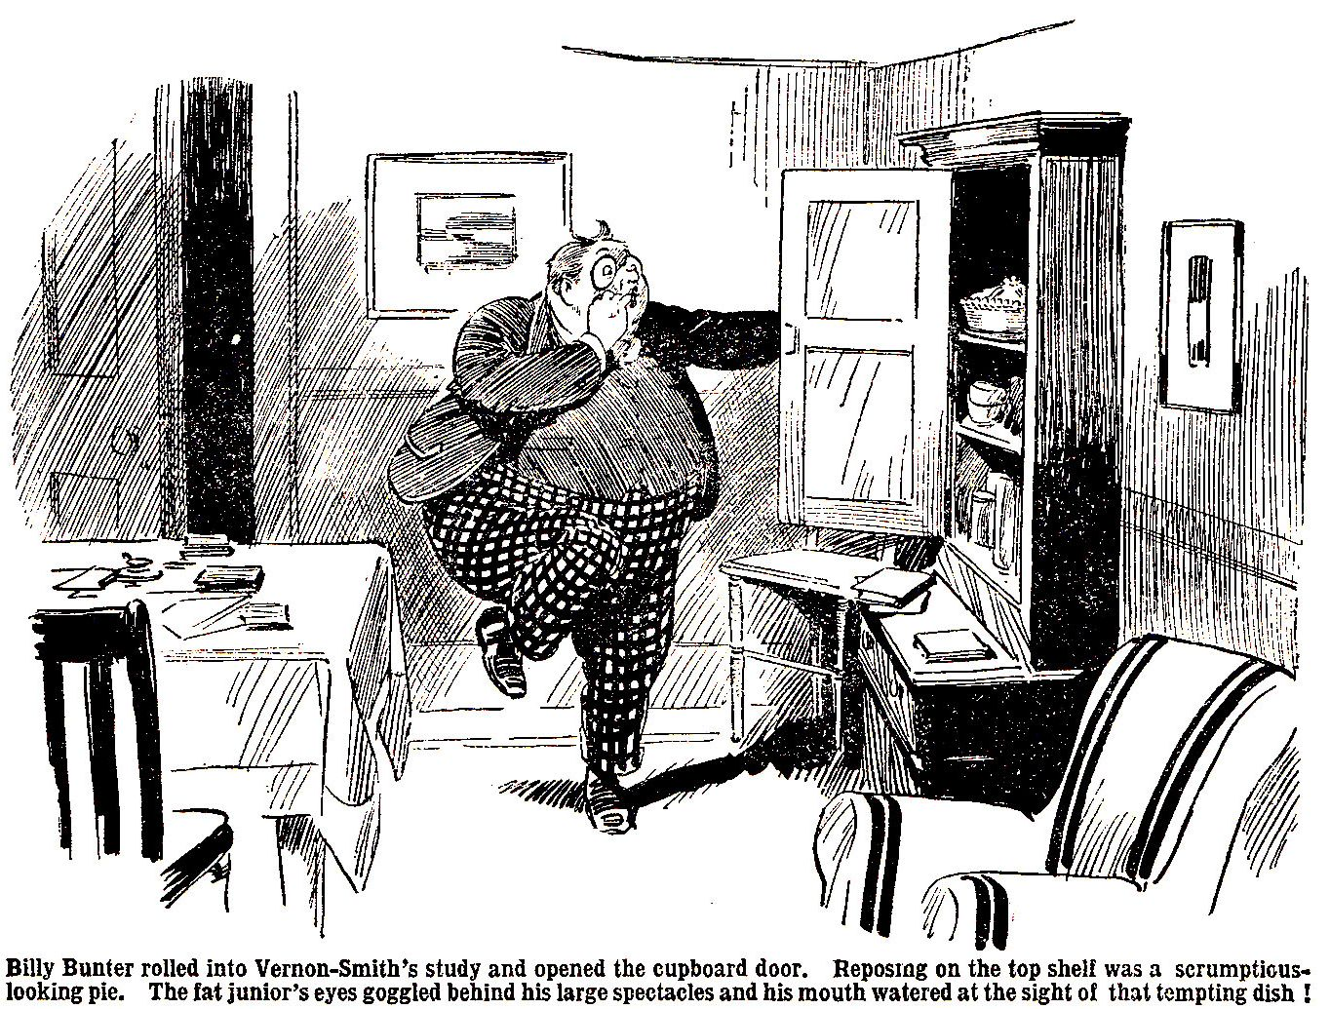

It looked a very nice pie. It looked, in fact, a scrumptious pie. It was enough to make a fellow’s mouth water, when a fellow had had only one tea.
Bunter had not yet decided to take the risk of annexing that pie. But the pie decided for him. The pie was irresistible.
Almost unconsciously, Bunter’s fat hands stretched out to the pie. After all, the beast should not have left it in the study. It was asking for it. Besides, how was he going to prove that Bunter had had the pie ? It might have been the cat—or the rats—only that day Smithy had said that there were rats in the study, and that he was going to get something from the chemist for them.
Bunter had never noticed any rats in the study—still, if Smithy fancied there were rats, ho might believe that the rats had had that pie. Anyhow, that scrumptious pie was not to be resisted—and Bunter started on it.
It really was a scrumptious pie.
Bunter would have preferred his pals to rally round him, on this occasion, with a view to dealing with Smithy if he made a fuss. But as he travelled through the pie, he was rather glad that after all they hadn’t rallied round him. There was certainly not too much for Bunter on his own. Billy Bunter travelled through the pie at express speed. It really was a corker. When Bunter had finished, the pie-dish was as clean as if it had been newly washed. The pie had vanished. X-rays would have been needed to discover what had become of it. And Bunter, in a state of fat and happy satisfaction, departed from the study—with Smithy’s pie as an inside passenger.
THE NINTH CHAPTER.
“Rough on Rats !”

HARRY WHARTON & CO. came up the Remove staircase. It was time for prep in the Remove, and most of the juniors were going to their studies. The Owl of the Remove was on the landing, and he gave the Co. a blink through his big spectacles. Billy Bunter did not seem wholly easy in his mind ! After the feast came the reckoning, and Bunter had been thinking about the reckoning ever since he had packed away the pie.
“I say, you fellows—” began Bunter.
Hallo, hallo, hallo ! Did you scoff the pie, you fat fraud ?” grinned Bob Cherry. “Look out for Smithy’s boot !”
“Oh, really, Cherry ! The fact is, I—I never touched the pie,” said Bunter. I—I thought I wouldn’t, you know. But—it’s gone.”
“The gonefulness is probably terrific,” chuckled Hurree Jamset Ram Singh, “and the guessfulness where it has gone is an easy one.”
“Smithy said to-day that there were rats in the study, you chaps—”
“Bosh ! said Harry Wharton. I’ve never heard of rats in the Remove passage. There aren’t any.”
“Present company excepted,” added Bob Cherry.
“Ha, ha, ha !”
“Oh, really, Cherry ! Well, Smithy thinks there are—he said he was going to get a bottle of ‘Rough on Rats’ from the chemist, to get rid of them,” said Bunter. I say, you fellows, do—do you think that Smithy will believe that the rats had that pie ?”
“Oh crumbs !”
“Of course, it might have been the cat !” said Bunter. Mrs. Kebble’s cat is always prowling round the House, you know. In fact, I saw the cat in the study—”
“You didn’t see a pig in the study ? asked Johnny Bull.
“Eh ? No.”
“Then you didn’t look in the looking-glass,” said Johnny.
“Ha, ha, ha !”
“Beast ! I say, you fellows, it was either the cat or the rats. I haven’t been in the study myself, you know.”
“Not when you saw the cat there ?” chuckled Nugent.
“I—I mean—yes—no—that is—”
“You fat villain,” said Harry Wharton, there are no rats in the Remove studies, and Mrs. Kebble’s cat couldn’t have scoffed a steak-and-kidney pie. You’d better think of a better one before you see Smithy.”
“Hallo, hallo, hallo ! Here comes Smithy ! Let’s hear you tell him your cat-and-rats story, Bunter. Stand clear for Bunter to drop, you men”
Vernon-Smith and Tom Redwing came up together. The Bounder gave the Famous live a black look, and Redwing looked uncomfortable. Smithy’s feud was causing his chum a great deal of discomfort. He was determined not to be drawn into it; but at the same time, he could scarcely keep on friendly terms with fellows to whom his chum was openly hostile.
Bunter blinked at the Bounder. The fat Owl was rather uneasy about telling Smithy his cat-and-rats story, as Bob called it—he could not help feeling that that story required a very simple and innocent hearer, to be believed—and Smithy was anything but simple and innocent. He was tempted to leave Smithy to make the discovery for himself.
On the other hand, Bunter had to go into No. 4 for prep, and he did not want to be shut up with the Bounder when the discovery was made. He felt that it would be safer to let Smithy know in the presence of the Famous Five. They would chip in if the Bounder kicked too hard.
“I-I say, Smithy,” gasped Bunter, hold on a minute, Smithy ! I say, that pie’s gone. The cat—”
“What ?”
“I mean the rats !” gasped Bunter.
“What the dickens do you mean, you fat ass ?”
“It—it wasn’t me, old fellow. You can take my word for that. I—I saw Mrs. Kebble’s rats—I mean, Mrs. Kebble’s cats—her cat, I mean—they—I mean it—”
“Do you mean that the rats have eaten the pie I left in the study cupboard ?” asked Vernon-Smith calmly. To Bunter’s surprise and relief, he showed no sign of wrath.
“That’s it, old chap,” gasped Bunter. As Smithy seemed disposed to believe the rat story, Bunter dropped the cat story at once. He did not care whether Smithy believed that it was rats or cats, so long as he did not believe that it was Bunter.
“All right,” said Vernon-Smith indifferently.
“I—I saw the cat—”
“The what ?”
“I mean the rat !” gasped Bunter. “I—I happened to look into the study, you know, and saw a great big rat-a—huge rat—whisking into the study cupboard. An enormous rat—”
“They’ve been nibbling at the things in the cupboard for a long time,” said Vernon-Smith, with a nod, “time they were got rid of. Well, they won’t bother us any more, if they’ve nibbled at that pie.”
“They—they’ve cleared it right out, Smithy—the whole pie—must have been a lot of them,” stuttered Bunter. “In fact, I saw three or four—that is, five or six—”
“My hat ! They haven’t wolfed all that pie, surely ?”
“They—they have, old fellow. Only the dish left.”
“Well, all the better,’ said Smithy. “It will clear them off, and it’s just as well they’ve wolfed the lot. It was worth the pie, and half-a-crown for the bottle of ‘Rough on Rats,’ to get shot of them.”
The Bounder walked on.
Bunter jumped.
The Famous Five stared.
Billy Bunter, for an instant, blinked at the Bounder’s back, with his eyes almost popping through his spectacles.
Then he rushed after Smithy, and grabbed him by the arm. The expression on Bunter’s fat face was extraordinary.
“Smithy ! You beast ! Did—did you put that pie there for the rats—d-d-did you put the rat-poison in that pie ?”
“Let go my arm, you fat owl ! What are you burbling about ?” exclaimed the Bounder impatiently. “We had to get rid of the rats, fathead. If they’ve scoffed a whole bottle of the ‘Rough-on-Rats’ they’re done for.”
“Yarooooh !”
“What’s the matter ?”
“Help !”
Billy Bunter staggered against the wall of the passage. His spectacles slid down his fat little nose, and he blinked over them with a blink of horror. Both his fat hands were pressed to his ample waistcoat.
The Bounder stared at him.
“What on earth’s the matter with that fat idiot ?” he exclaimed.
“Smithy !” Redwing caught his chum’s arm. “Smithy you surely weren’t ass enough to put poison for rats in the study cupboard—”
“Why shouldn’t I ?” demanded the Bounder. “Where should I put it for them ? In the bookcase, or up the chimney ?”
“But—” gasped Redwing.
“Where’s the harm ?” asked the Bounder.
“Yoooop !” roared Bunter.
“Is that fat duffer mad, or what ?”
“Yarooop !”
“What is he yelling about ?”
“Yow-wooop ! Send for a doctor ! Grooooogh !”
“Is anything the matter with Bunter, you men ?” asked the Bounder, glancing round. Bunter’s yells had drawn a crowd of Removites to the spot.
“Ow ! Help !”
‘Plenty the matter with him, if you really put rat poison into that pie !” said Bob Cherry. “But—”
“The butfulness is terrific !” murmured Hurree Jamset Ram Singh.
“Help !” yelled Bunter. “I say, you fellows, I’ve got a fearful pain ! I’m dying Yaroooh !’”
“What’s given you a pain ?” asked Smithy.
“Ow ! You beast ! You villain ! That pie—”
“The pie the rats ate ?” asked Smithy innocently.
“Ow ! Wow ! Help ! I’m expiring—I’ve got awful pains—fearful—help ! I say, you fellows—yarooooooooop !”
“Oh, my hat !” exclaimed Smithy, with quite a dramatic start. You don’t mean to say that you scoffed that pie, Bunter ?”
“Urrrrrgggh !”
“Well, if you scoffed a pie that was doctored for the rats, I’m sorry for you—”
“Oooooogggh !”
“Of course, a fellow couldn’t foresee that !” said Smithy, looking round at a circle of grinning faces. It never crossed my mind of course, that Bunter might scoff the pie—”
“You ass !” exclaimed Redwing, in great relief. For one terrible moment he had really feared that the Bounder had been careless enough to “doctor” a pie for the rats, and leave it in the study cupboard.
“No fellow would guess that, would he ?” asked Smithy.
“Ha, ha, ha !”
“It’s not a thing Bunter would do—”
Ha, ha, ha !”
Naturally, I never dreamed that Bunter would even think of scoffing a pie that did not belong to him—”
“Ha, ha, ha ! yelled the Removites.
Billy Bunter, yelling and howling, blinked at the Remove fellows in horror and amazement. They were laughing—actually laughing—while Bunter was in these awful throes. Bunter’s vivid imagination had already conjured up fearful pains and agonies. He pressed his fat hands to his waistcoat and roared.
“Will you send for a doctor ? Yarooh ! Get a doctor-quick !”
“No doctor can help you, Bunter, if you’ve really got outside a whole bottle of ‘Rough-on-Rats,” said Smithy, shaking his head. Better make your will !”
“Beast ! Help !”
“This means a lot of trouble for me !” said Vernon-Smith. “I suppose there will be an inquest—”
“Yarooooh !”
“When I’m up before the coroner—”
“Urrrgggh !”
“You fellows will have to bear witness that I put the stuff there for the rats, and never dreamed that Bunter would scoff the pie—”
“Ha, ha, ha !
“Help !”
“How much did you put in the pie, Smithy ?” yelled Skinner.
“Not more than half a pint—”
“’Half a pint !” shrieked Bunter. “Oh ! Ow ! I’m done for ! You’ll be hanged—that’s one comfort ! I say, you fellows, go and call Quelch—tell him to phone for a doctor—yoooop !”
“No good bothering the doctor, if you’ve got half a pint of rat poison in your tummy !” chuckled Peter Todd. “It’s too late !”
“Beast ! Help !”
“Well, look here Bunter !” said Vernon-Smith. “We’ve got our prep to do, and we can’t work while you’re kicking up that row. If you’re goin’ to die, die quietly ! Be reasonable, you know !”
The Bounder walked on to his study. He left the Remove fellows yelling—and Bunter yelling loudest of all. A fellow who had—or supposed he had—half a pint of “Rough-on-Rats” inside him was entitled to yell. And Billy Bunter’s frantic yells awoke every echo of the House.
THE TENTH CHAPTER.
Not Fatal !

MR. QUELCH came up the Remove staircase, two at a time.
The expression on Mr. Quelch’s speaking countenance might have excited the envy of the fabled Gorgon.
Wild yelling and howling from the Remove passage had been heard all over the House.
Mr. Quelch was coming to inquire. Thoughtfully, he had put a came under his arm when he started.
Several other masters stood at the foot of the staircase. They exchanged sarcastic looks.
“Quelch’s boys !” said Mr. Prout, with a sniff.
“An unruly Form !” said Mr. Capper.
“This is really—really—” said Mr. Twigg. “Really—really, you know—really—”
“Scandalous !” said Prout.
Mr. Quelch had the pleasure—or otherwise—of overhearing those remarks as he whisked up the stairs. Perhaps they were not intended for his ears. On the other hand, perhaps they were.
Anyhow, he heard them, and they gave the finishing touch to his wrath. He did the stairs in record time. His brow was set, his eye beneath, flashed like a falchion from its sheath. He swept across the Remove landing like a thundercloud.
“Boys !” roared Mr. Quelch.
Generally, Quelch’s voice was not loud, but deep ! Now it was both loud and deep ! He almost bawled.
“Oh, my hat !”
“Ware beaks !”
“Yarooh ! Help ! I’m dying ! I’ve got awful pains ! I say, you fellows, call that beast Quelch—”
“Bunter !”
“Ow ! Yaroooh ! Send for a doctor !” shrieked Bunter. He clutched at Mr. Quelch’s gown, and dragged at his Form master. “Help !”
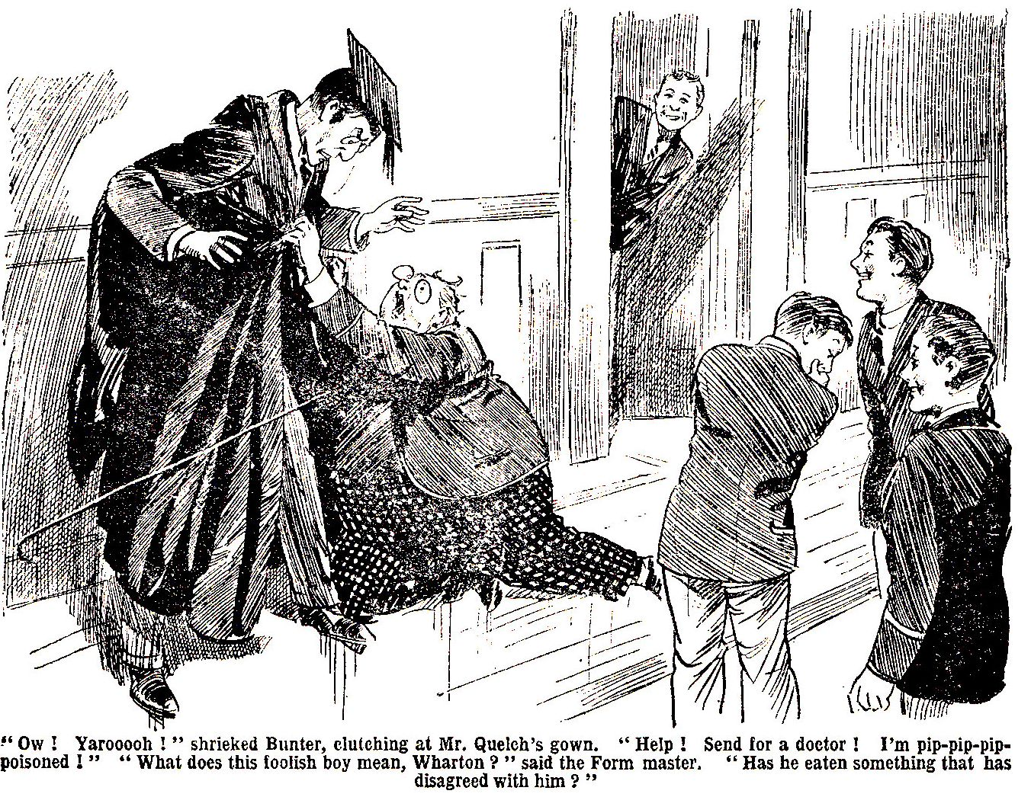

“Bless my soul ! What—”
“I’m pip—pip—pip—”
“Wharton ! What is the matter with this boy ?” gasped Mr. Quelch.
“N-nothing, I think, sir !” stuttered Wharton.
“Ow ! You beast ! You know I’m pip—pip—pip—”
“What do you mean, Bunter ?”
“Pip-pip-poisoned !” Bunter got it out. Mr. Quelch jumped almost clear of the floor.
“Bunter ! Are you out of your senses ? Cease that absurd noise at once ! You can be heard all over the House !”
“Yaroooh !”
“What can have put into this foolish boy’s head that he has been poisoned ?” exclaimed Mr. Quelch aghast. Bunter, have you eaten something that has disagreed with you ? Is that it ?”
“Ow ! That pie—yaroooh ! Will you send for a doctor, and—and a tummy-pump, or something !” yelled Bunter. “I’ve swallowed half a pint of poison.”
“Ha, ha, ha !”
“Cease this untimely merriment at once !” hooted Mr. Quelch. This is no occasion for merriment !”
“Isn’t it ?” murmured Bob Cherry, sotto voce.
The juniors did their best to cease their untimely merriment. But really they did not agrees with their Form master that it was no time for merriment. It seemed to them that it was !
Any fellow but Bunter might have guessed that, if he had really eaten a poisoned pie, the Bounder would not have taken it so calmly, and the other fellows would not have been yelling with laughter.
But Bunter was too terrified to think of that; he was too terrified to think of anything but his terrors.
He yelled and howled and roared, heedless of the portentous frown on his Form master’s face.
Will you be silent, Bunter ?” shrieked Mr. Quelch.
“Yaroooh !”
“Tell me what has happened—”
“Wow ! I’ve got fearful pains—awful agonies—yoop ! That beast Smithy has poisoned me—yarooop ! He’s done it to shift me out of the study ! Whoop !
“The boy must be insane ! Where is Vernon-Smith ? Call Vernon-Smith at once !”
The Bounder looked out of his study.
“Here, sir !” he answered.
“What do you know about this, Vernon-Smith ?”
“Nothin’, sir.”
“I’m pip-pip-pip-poisoned !” shrieked Bunter. “It—it’s coming all over me—awful pains and fearful agonies. It was in the pie.”
“What pie ?” shrieked Mr Quelch.
“Ow ! Smithy’s pie—the pie in the cupboard ! He put the rat poison in it, and I ate the pie ! Yarooooh !”
“Upon my word ! Vernon-Smith, is it possible that you have been so reckless, so criminally careless, as to—”
“Not at all, sir !”
“If you have brought rat poison, or anything else of a dangerous nature, into the school, Vernon-Smith, I shall take you to your headmaster to be flogged !”
“I haven’t, sir.”
“It’s a whopper !” shrieked Bunter. He’s telling whoppers because he doesn’t want to be hung—”
“Ha, ha, ha !”
“Silence. What can have put into the head of this incredibly stupid boy that he has been poisoned—”
“I tell you I’m pip-pip-poisoned ! I’ve got half a pint of ‘Rough on Rats !’ inside me !” raved Bunter. Smithy said that there was half a pint in the pie—”
“Did you say so, Vernon-Smith ? Have you been taking advantage of this foolish boy’s crass stupidity to frighten him ? Did you make the statement that there was half a pint of poison in the—the pie ?”
“Certainly not, sir.”
“All those fellows heard him !”yelled Bunter.
“Smithy didn’t say that, sir,” gasped Harry Wharton. “He said he hadn’t put more than half a pint in the pie. He never put any in, sir, so he couldn’t have put more—”
“A foolish jest !” thundered Mr. Quelch. “Vernon-Smith, you should not make such jests at this absurd boy’s expense. Bunter—”
“Whooop ! These awful pains—”
“Bunter, if you are not silent at once I shall cane you—”
“Yoooop ! These fearful agonies—”
Whack !
Words proving useless Mr. Quelch tried the effect of his cane ! It rang across Bunter’s fat shoulders.
“Yarooooh !” roared Bunter.
“Ha, ha, ha !”
“Vernon-Smith ! Answer me directly ! Was there, or was there not, anything of a deleterious nature in the—the pie that Bunter appears to have consumed ?”
“Nothing, sir ! Only steak and kidney,” answered the Bounder. “I don’t think there’s anythin’ deleterious about steak and kidney, sir.”
“Bunter ! You incredibly foolish boy, you can see now that you have been the victim of a thoughtless prank !”
“Oh !” gasped Bunter.
Even Bunter could see that now.
You have caused all this disturbance, for nothing !” hooted Mr. Quelch. “You have alarmed the whole House, Bunter, without cause. You have complained of pains that could only have existed in your imagination—”
“Oh !” gasped Bunter. He realised that his awful pains had ceased. “I—I say, sir, I—I thought I was pip-pip poisoned, so—so I thought I had awful pains—”
“Ha, ha, ha !”
“I have said that this is not a laughing matter !” boomed Mr. Quelch. “The next boy who laughs will be caned.”
Sudden gravity descended on the Remove.
Vernon-Smith, your conduct has been reprehensible—unfeeling—”
“I never asked Bunter to scoff my pie, sir,” said the Bounder meekly. “He should have let another fellow’s pie alone.”
“That—that is certainly true ! Am I to understand that Bunter purloined an—an article of diet belonging to you without your leave ?”
“He has told you so, sir.”
“I—I didn’t !” gasped Bunter ! “I—I never touched the pie !”
“What ?” thundered Mr. Quelch.
“I—I never touched it, sir !”’ gasped Bunter. “I—I hope I’m not the fellow to bag another fellow’s pie !”
“Bless my soul !”
“I—I never knew Smithy had a pie, sir ! I—I never offered to whack it out with some of the fellows, sir ! You can ask Wharton ! He was one of the fellows I asked—”
“Bunter !”
“I—hope you can take my word, sir—”
“Take your word !” said Mr. Quelch dazedly. “No, Bunter, I cannot take your word. You are an untruthful young rascal, Bunter.”
“Oh, really, sir—”
“I shall, punish you severely for having made this disturbance. And as you have pilfered—yes, pilfered !—from your study-mate I shall not allow you to remain in that study, Bunter. You will go back to your former study ! Now follow me.”
“If—if you please, sir, there’s prep—”
“Follow me !” thundered Mr. Quelch.
“Oh lor’”
Billy Bunter followed his Form master. He had recovered from the awful pains and fearful agonies in his fat imagination. But he could foresee that he was going to get some real pains and agonies when he arrived in Mr. Quelch’s study. He rolled after the Remove master in the lowest of spirits. He left the Remove fellows chortling.
When Bunter came back he was, apparently, trying to fold himself up like a pocket-knife. He heralded his arrival with a series of hair-raising groans. And he did not roll into Study No. 4. Billy Bunter had intended to stick to Study No. 4 like the Old-Man-of-the-Sea in “Sinbad the Sailor.” But the Bounder had got rid of his Old-Man-of-the-Sea at last !
THE ELEVENTH CHAPTER.
The Fingers of Scorn !

“GAZE, my infants !” said Bob Cherry.
The Со. Gazed—and grinned.
It was morning, and the Remove fellows were gathering at the door of their Form-room for class.
Billy Bunter gathered with the rest.
Herbert Vernon-Smith came lounging up, and upon Herbert Vernon-Smith the fat Owl fixed his eyes—and his spectacles.
He looked at the Bounder’s feet, allowed his glance to travel up to the Bounder’s face, let it drop to the feet again, and then once more raised it to Smithy’s surprised face.
Bunter was looking the fellow up and down !
This process was expressive of contempt, scorn, disdain, and other bitter feelings of that sort. It conveyed—or was meant to convey-the impression that Bunter, from lofty heights of scornful superiority, was scarifying his hapless victim with his contempt. Bunter had no doubt that the effect was withering—blighting—almost obliterating.
Instead of being withered, blighted, and obliterated, the Bounder stared at the fat Owl blankly.
“What the thump are you making faces for, you silly chump ?” he inquired. “Don’t make faces at me like a monkey.”
Bunter reddened with wrath. He was not making faces—at least, he did not mean to be making faces. He was obliterating Smithy with unbounded scorn—and the irritating fellow only supposed that he was making faces.
Harry Wharton & Co. gazed, as Bob bade them. Bunter, in this scornful mood, was worth watching. They grinned, as if the fat Owl’s scornful aspect struck them as funny.
“Yah !” said Bunter. It was not elegant, but it was not meant to be elegant; it was meant to be crushingly contemptuous. “Yah ! Rotter ! Yah !”
“You benighted owl !” said Vernon-Smith.
“Yah !”
“Do you want me to kick you ?”
“Yah !”
“Ha, ha, ha !” roared the Removites.
“Is that fat idiot off his rocker ?” asked Vernon-Smith.
“Yah !”
“Was he ever on it ?” grinned Skinner.
“Yah !” repeated Bunter, scornfully defiant. “Rotter ! I despise you ! Playing a mean trick to get a man turned out of his study ! Yah ! Making out that a fellow had your pie, to get old Quelch to butt in—”
“Bunter !”
Mr. Quelch was coming along to the Form-room, unfortunately for Bunter, from the opposite direction. He rapped out Bunter’s name like a pistol-shot.
“Oh lor’ !” gasped Bunter, spinning round like a fat humming-top. He quaked under Quelch’s gimlet-eyes.
“Bunter ! Did you allude to me, your Form master, as ‘old Quelch’?” demanded the Remove master in a voice of thunder.
“Oh ! No, sir ! Not at all, sir ! I never mentioned you—”
“I heard you, Bunter !”
“D-d-did you, sir ? I mean—”
“You will take a hundred lines, Bunter !”
“Oh crikey !”
Mr. Quelch opened the Form-room door, and the Remove went in and took their places.
Billy Bunter seemed to be in a rather unusual mood that morning. He gave more attention to the Bounder than to his lessons.
Continually he stared round at Herbert Vernon-Smith, sometimes with his fat lip curling, sometimes with his fat little nose turned up even farther than Nature had already turned it.
The Remove derived more amusement from Billy Bunter than instruction from their Form master that morning.
The Bounder scowled when he caught Bunter’s scornful glares and sneers. Any other fellow, probably, would have regarded the fat Owl’s antics as entertaining. But Smithy soon seemed to get fed-up with them, and he whispered to Skinner that immediately after class he was going to kick Bunter from one side of the quad to the other.
Considering that Vernon-Smith was now captain of the Form, the fat Owl’s antics were far from respectful. And considering that Smithy had the most uncertain temper in the Remove, Bunter really seemed to be asking for it, in fact, begging for it.
Evidently Bunter’s back was up.
Study No. 4—that land of plenty—was barred to Bunter now. Instead of “coming round,” as Bunter had so happily anticipated, the Bounder had thought only of ways and means for getting rid of the most fascinating follow in the Remove. Bunter had told all the fellows that it was a mean trick—a, rotten trick—just like Smithy ! He had been scared out of his fat wits. He had brought Mr. Quelch on the scene, and Mr. Quelch had considered the purloining of the pie a sufficient reason for relieving the Bounder of his new study-mate.
Bunter declared that Smithy had planned the whole thing just to get him turfed out of the study—as perhaps he had. Bunter declared that it was the limit, and hinted darkly that Smithy was going to be made to suffer for his sins. How Smithy was going to be made to suffer was not clear. Perhaps Bunter had not yet thought out that bit; but, in the meantime, he was making it quite clear that he regarded the tricky Bounder with ineffable contempt.
It was rather a risky business, for Bunter really might have foreseen that, after class, he would have the Bounder’s boot to reckon with. But in the Form-room, at all events, he was safe from Smithy’s boot.
In second lesson Bunter surreptitiously wrote a note on a slip of paper and passed it along the desks to Vernon-Smith. Fellows kindly passed the note along, under the desks, till it reached the Bounder.
Smithy stared at it when it reached him. It ran:

“SNEEKING TODE ! YAH !”

The Bounder crumpled that missive in his hand and glared at Bunter. The fat Owl caught his eye, and immediately turned up his fat little nose.
Smithy breathed hard. He was longing for break. Judging by Smithy’s looks, Bunter was booked for a high old time in break.
“You fat duffer, chuck it !” whispered Peter Todd. “Smithy will strew the quad with what’s left of you if you get his rag out like this.”
“Who’s afraid of Smithy ?” sneered Bunter.
“Well, you are old bean. Better chuck it.”
“Rats !”
Evidently the Owl of the Remove was determined to rush upon his fate. Peter gave it up.
Mr. Quelch gave his Form a good many severe glances. He did not know what the Remove were grinning at so much. Anyhow, the Form-room was not the proper place for grinning.
Presently Mr. Quelch turned to the blackboard and proceeded to chalk up a little problem for his Form. His back being turned to the class, Billy Bunter blinked round at the Bounder, and all eyes turned on Bunter. The fat junior was “at it” again.
Vernon-Smith gave him a deadly glare. Bunter’s contempt, perhaps, did not worry Smithy very much. But he felt that Bunter’s antics were making him look ridiculous.
Billy Bunter, blinking at him scornfully, lifted his right hand, put the thumb to his nose, and extended his fingers.
The Remove fairly gurgled.
That disrespectful gesture made the Bounder crimson with annoyance and mortification. Had he been within reach of Bunter, even Mr. Quelch’s presence would probably not have saved the fatuous Owl from a hack. Luckily for Bunter the Bounder was well out of reach.
But Bunter was not finished yet. He put his left thumb to the little finger of his extended right hand, and stretched out the fingers of his left hand.
It was too much for the Remove, and they burst into a yell of laughter.
“Ha, ha, ha !”
Mr. Quelch spun round from the blackboard. His eyes almost started from his head at the sight of William George Bunter with his extended fingers to his fat nose.
“BUNTER !”
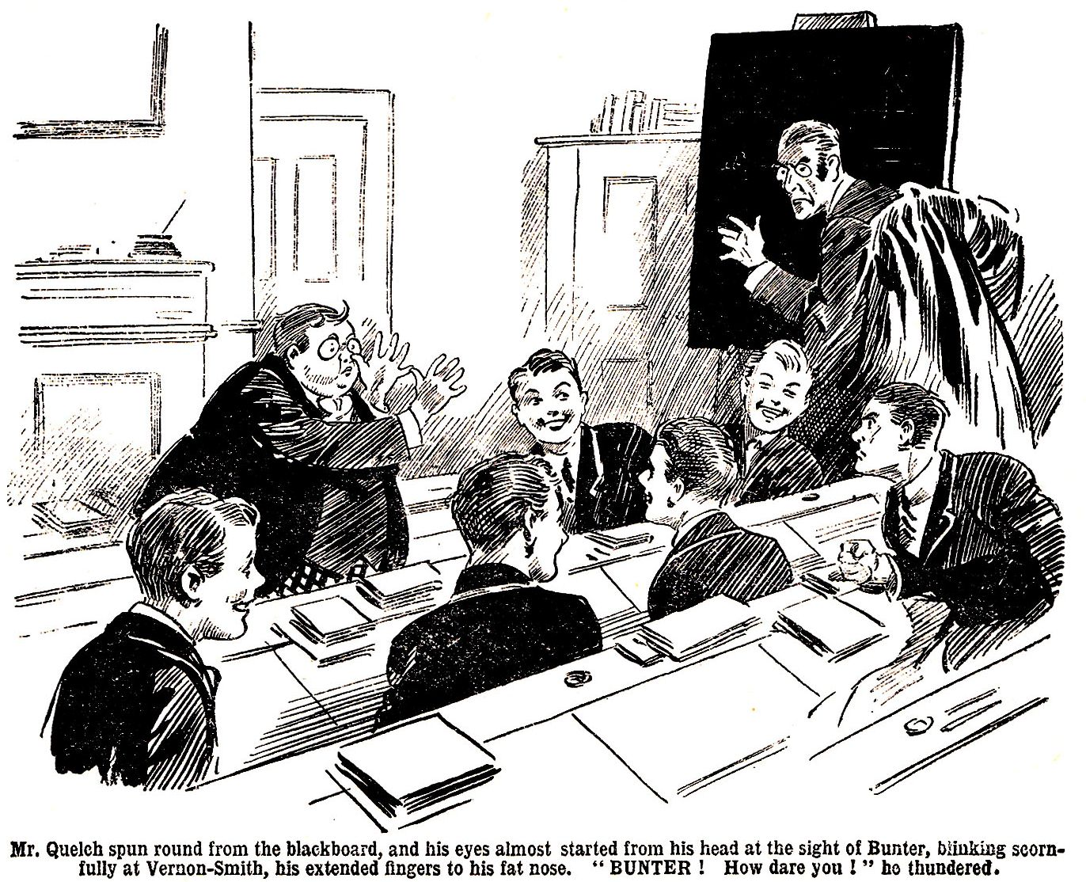

“Oh lor’!” gasped Bunter. He spun towards his Form master, too started for the moment to remove his fingers from his nose. A fellow could not think of everything at once.
For an awful moment the fat Owl faced his Form master with extended fingers to his nose, just as if he intended that disrespectful and contemptuous gesture for Mr. Quelch himself !
Mr. Quelch stood petrified.
“Bunter, what—”
He fairly jumped at Bunter. A grip of iron on his collar jerked the fat junior out before the Form.
“Ow !” gasped Bunter. I say— Wow !”
“Bunter, how dare you ?”
“I—I didn’t ! I—I wasn’t ! I—I never—”
“Ha, ha, ha !”
“Bunter, fetch the cane from my desk !”
“Oh lor’ !” I—I say, sir, I—I wasn’t making noses at you, sir. I was making noses at Smithy—”
Ha, ha, ha !”
“Fetch my cane, Bunter !”
“Oh crikey !”
Whack, whack, whack, whack !
“Oh scissors ! Ow ! Wow, wow !”
Go to your place, Bunter. If there is any repetition of this absurd, this extraordinary conduct, I shall send you to your headmaster for a flogging !”
“Ow !”
“Bunter crawled back to his place. There was no repetition of his absurd, his extraordinary conduct. Four whacks from Mr. Quelch’s cane were enough for Bunter. Second lesson terminated without Billy Bunter testifying any further his overwhelming scorn for the new captain of the Remove.
THE TWELFTH CHAPTER.
Bunter the Boxer !

“BOB, old fellow—”
“Stony !” said Bob Cherry sadly.
“I don’t want to borrow anything you silly ass !” hooted Bunter.
“What did you call me ‘old fellow’ for, then ?”
“Beast ! I—I mean. I say, old fellow—”
It was after prep, and Bob Cherry, Johnny Bull, and Hurree Jamset Ram Singh had come along from their studies to Study No. 1, where they joined Wharton and Nugent, to go down to the Rag. Billy Bunter rolled up and interposed. There was a serious expression on Bunter’s fat face, and he gave the Famous Five a very serious blink through his big glasses.
I want you to back me up, old chap,” said Bunter. “I’m going to thrash that rotter Smithy—”
“Oh, Christopher Columbus !”
“Ha, ha, ha !”
“If Billy Bunter had announced that he was going to whop Carnera, it could not have surprised the chums of the Remove more. They roared.
“Blessed if I see anything to cackle at,” said Bunter crossly. “Look at the way the fellow’s treated me ! Getting me turned out of my study by a mean trick—”
“Ha, ha, ha !”
“He kicked me in break this morning—after Quelch had whopped me, too. He kicked me again after dinner, because I told him he was a cad ! Then he kicked me again this afternoon, because I told him he was a worm—”
You shouldn’t tell fellows these painful truths, old fat bean,” chuckled Bob.
Well, I’m fed-up with the rotter,” said Bunter. “Of course, I never really wanted to be in his study. It was rather a favour to him than anything else. He was ungrateful—”
“It’s an ungrateful world !” chuckled Nugent.
The ungratefulness is terrific.”
“You know what Shakespeare says,” said Bunter, “about a thankless tooth being sharper than a child’s serpent—”
“Oh, my hat ! Did Shakespeare say that ?”
“Well, something of the sort ! But it’s not only his beastly ingratitude—I’m used to that, really ! You fellows, f’rinstance, are never really grateful, after all I’ve done for you—”
“You fat chump—”
“Oh, really, Wharton ! I despise the fellow, you know—I bar him !” said Bunter. He thinks no end of himself since the fellows elected him captain—but who is he ? I ask you ! Who is he ?”
“The who-fulness is terrific !” agreed Hurree Jamset Ram Singh.
“Who cares for him ?” continued Bunter. “I jolly well don’t ! I’d refuse to go back to Study No. 4 if he asked me on his bended knees. I’m rather particular whom associate with, and I bar that rank outsider ! He’s kicked me three times to-day—”
“Well, if you make faces at a chap you—”
“You silly ass, I wasn’t making faces—I was treating him with scorn and contempt—”
“Ha, ha, ha !”
“Well, I’m not standing any more from Smithy !” said Bunter darkly. “As I said, I’m going to thrash him. But—but I’m not sure that I should pull it off if I tackled him at once—”
“There’s a slight doubt !” agreed Bob.
“Just a shadow of a doubt !” grinned Johnny Bull.
“The thrashfulness might be a boot on the other leg !” suggested Hurree Jamset Ram Singh.
“Well, I’m going to train a bit, see ?” said Bunter. That’s where I want your help, Bob, old chap ! You can box. You whopped Wharton once—”
“You pernicious idiot—”
“So you’re the man I want ! I want you to give me some tips in boxing. Have the gloves on, you know ! You see, I’ve thought it out,” explained Bunter, as the Famous Five stared at him blankly. “You can lick Smithy all right—so as soon as I can lick you, I shall be able to handle Smithy.”
“ As—as—as soon as you can lick me !” murmured Bob Cherry, like a fellow in a dream.
“Yes, I may not be able to lick you at first go-off—”
“Nunno !” gasped Bob. I—I think you mayn’t—”
“Ha, ha, ha !”
“But as soon as I can, I shall tackle Smithy and whop him. See ? Now let’s strike the iron while it’s hot,” said Bunter briskly. Wharton’s got some boxing-gloves in the study. Let’s have ’em on. You won’t mind if I hurt you a trifle ?”
“Oh crikey !”
“That’s all right, then ! I want to have the gloves on with you every evening this week,” said Bunter. “You’re going to teach me all you know, and by Saturday, say, I dare say I shall be able to knock you out. As soon as I can knock you out, I’m after Smithy—and then let him jolly well look out.”
Bob Cherry gurgled.
“Oh, my hat ! I’m your man, Bunter, old bean. I’ll put you through it, and you can knock me about as much as you like—get your hand in for Smithy, you know ! Sort out those gloves, Wharton, will you ?”
“What-ho !”
The Famous Five went into Study No. 1, and Bunter rolled in after them. The fat junior’s eyes were gleaming behind his spectacles.
Evidently Billy Bunter was on the warpath.
It was said of old that the worm will turn. Now the worm was turning with a vengeance.
Thrashing Smithy was the programme. But Billy Bunter plainly had thought it out. He realised that he was not, at the moment, equal to the rather hefty task of thrashing Smithy. A little training would put that right. There was no doubt that, if Bunter trained till he could whop Bob Cherry, he would then be able to whop Smithy. It stood to reason. All he had to do, therefore, was to box with Bob till he was able to beat him, and then Smithy was, so to speak, a gone coon !
Bob was only too willing to oblige. Bob knew more about boxing than Bunter was likely to learn if he survived to the age of Methuselah. He was willing to teach Bunter all that Bunter could learn. He doubted whether Bunter could learn enough to whop Smithy. He doubted still more, whether Bunter could learn the first and most important lesson, of standing up to hard punches. Bunter was in a warlike and determined temper, spurred on by his wrongs and grievances. But though the spirit was willing, it was possible that the flesh would be weak. There was a difference between, so to speak, before taking and after taking !
The fat Owl removed his jacket and donned the boxing-gloves that Harry Wharton smilingly handed to him, handing Wharton his spectacles in exchange.
He blinked at Bob.
“Ready, old chap ?”
“Quite ! Don’t hit me too hard !” grinned Bob.
“Well, the fact is, I shall have to punch you a bit,” said Bunter. No good fooling about, you know. If you’re afraid of a tap or two—”
“Ye gods ! Tap away !” said Bob. “I’ll try to stand it !”
“That’s right !” said Bunter encouragingly. “Stand up to it, you know ! Like me !”
“Time !” chuckled Harry Wharton.
The table had been pulled aside, to give the boxers plenty of room. The Co. stood back by the walls. Several fellows gathered at the open doorway, staring at the unaccustomed sight of Billy Bunter with the gloves on.
“What’s this game ?” asked Peter Todd.
“Bunter’s taking up boxing,” explained Wharton. “He’s getting in form to whop Smithy !”
“Ha, ha, ha !”
It was a yell in the passage. Bunter’s intention of whopping his Form-captain seemed to take the Remove men by storm. They roared.
Bunter did not heed. He blinked resolutely at Bob Cherry, and started to attack. Bunter, as a matter of fact, fancied that he could box. As another matter of fact, he couldn’t ! His fat arms rather resembled the sails of a windmill as he started. He seemed quite surprised when he received a gentle tap on his fat little nose.
“Ow !”
“Ha, ha, ha !”
“Guard with your left, old fat bean,” advised Bob. “If you don’t guard, I shall tap you all the time, like that !”
“Yow !”
“And that—”
“Wow !”
“And that—”
“Yarooooh !”
Bob was careful to tap gently. But a gentle tap from the hefty Bob was rather like a vigorous punch from any other fellow.
Bump !
Bunter sat down.
“Tired, old chap ?” asked Bob.
“Ha, ha, ha !”
Ow ! Wow ! My nose !” gasped Bunter. Wow ! My nose ! Beast !”
“Ha, ha, ha !” yelled the Removites. The crowd at the doorway was thickening. More and more fellows arrived to see Bunter boxing.
Harry Wharton heaved the fat Owl to his feet.
“Stick it, Bunter !” yelled Todd.
Having regained his feet, Bunter warmed to his work and made a wild swipe at Bob Cherry’s curly head.
The cheery Bob ducked in the nick of time, with the result that Bunter’s flailing fist crashed into the laughing onlookers in the doorway and sent them toppling over like a row of skittles.
They sorted themselves out, however, and all but Skinner, who had received the full force of that devastating punch, laughed uproariously.
Bunter seemed rather more doubtful now. Perhaps it had dawned on his fat brain that it would take him rather longer than a week to get into form to whop Bob Cherry. Perhaps it even dawned on him that it might take him a few centuries.
There was no doubt that, if Smithy’s thrashing depended on Bunter getting into form for whopping Bob Cherry first, Smithy’s thrashing was a very remote contingency, and there was little for the Bounder to worry about.
“Go it, Bunter !”
“Go for his nose !”
“Whop him, Bunter !”
Shouts of encouragement came from the passage. But it was a very dubious Bunter that faced Bob Cherry again.
“Stop that one !” said Bob.
“Yarooooh !” Bunter stopped it—with his nose. “Whooop !”
“Now stop that one !”
“Yaroooop !”
Bump !
“Man down ! yelled Skinner.
“Ha, ha, ha !”
“Yow-ow-ow-ow !”
“You’re getting on, old man,” said Bob encouragingly. Every punch you get teaches you how to stand punishment—”
“Whoooooop !”
“Ha, ha, ha !”
Billy Bunter staggered up. Bob squared up to him again, and the fat Owl jumped away in a great hurry. The spirit, perhaps, was still willing, but the flesh was weaker than Bunter had anticipated.
“Ow ! Keep off, you beast !” roared Bunter.
“Oh, my hat !”
“Ha, ha, ha !”
Bunter peeled off the gloves. He rubbed his fat little nose and glared at his instructor.
“Not finished ?” asked Bob, in surprise.
“Ow ! Beast ! Wow !”
“It will be a jolly long time before you lick Smithy at this rate !”
“Ha, ha, ha !”
“Beast !”
Bunter was finished. Wharton helped him on with his jacket. That boxing lesson had been brief, but it had been long enough for Bunter. If this was the sort of thing that was necessary as a preliminary to whopping, Smithy, Bunter had to realise that he would have to leave Smithy unwhopped. Bunter had had enough.
“Well, my hat !” said Bob, as he threw the gloves on the table. “Sure you’ve had enough, old fat man ?”
“Beast !”
Billy Bunter rolled out of the study. He caressed his fat little nose as he rolled. A roar of laughter followed him.
“It looks to me,” said Bob, “as if Smithy will never get that whopping.”
”Ha, ha, ha !”
“The whopfulness will not be terrific !” chuckled the Nabob of Bhanipur. “The esteemed Smithy has had a preposterously narrow escape !”
“Ha, ha, ha !”
Billy Bunter’s brief career as a fighting-man was over. If the Bounder was going to be made to suffer for his sins, it was clear that Bunter had to find other ways and means. He was no longer thinking of whopping Smithy !
THE THIRTEENTH CHAPTER.
Bunter Knows How !

HARRY WHARTON & CO. looked merry and bright the next morning. It was a glorious May morning, and the weather was ideal for cricket, and cricket was the order of the day. Redclyffe were coming over early, and school for the members of the eleven ended at morning break. Less lucky fellows had to go back to the Form-room for Third School. Four members of the famous Co. were in the eleven. If there was a fly in the ointment it was the fact that they were to play under the captaincy of Herbert Vernon-Smith. There were plenty of fellows who did not doubt that Harry Wharton found his new position irksome, but his looks gave no sign of it. His face was bright and cheery when he came out of the Form-room with his friends.
The Bounder gave him a sour look.
He would have been glad of a pretext for leaving his rival out of the cricket, but at the same time he was aware that Wharton was the most useful man in the Remove at the wickets, and undoubtedly he wanted the first match under his captaincy to be a win. Solely as cricket captain he would have been glad enough that Wharton was to play. But Smithy was a not thinking wholly and solely as a cricketer. He was glad in one way and angry and irritated in another, which was rather a mixed state of feeling, and did not improve Smithy’s temper.
“I say, you fellows !” Billy Bunter rolled up to the Famous Five in the quad. I say—”
“Want some more boxing ?” asked Bob Cherry. “If you’d like to have the mittens on again—”
“Ha, ha, ha !”
“Oh, don’t be an ass !” said Bunter peevishly. “I say, you fellows, have you seen Prout ?”
“Prout ? He went out a few minutes ago,” answered Harry. “What about Prout ?”
“Oh, good !” said Bunter. “I heard him tell Quelch he was going out for a walk, you know, only I wanted to make sure.”
The Famous Five stared at Bunter. Mr. Prout, the portly master of the Fifth, had rolled majestically down to the gates and gone out—a matter of absolutely no concern to the Removites. Billy Bunter was often interested in matters that did not concern him. But why he should be interested in Mr. Prout’s walks abroad was a mystery.
“What the dickens does it matter, fathead ?” asked Bob.
“Oh, nothing ! He, he, he !”
“What are you cackling at, ass ?”
“That’s telling !” chuckled Bunter. “He, he, he !”
Bunter, apparently, was in possession of something in the nature of a jest. That jest, apparently, was connected with the circumstance that Prout had gone for a walk. It was quite mysterious.
“I say, you fellows, I’m not going to whop that cad Smithy,” went on Bunter.
“Not really?” ejaculated Bob.
No. I’m not going to soil my hands on the fellow !” answered the fat Owl, shaking his head.
“You’ve been soiling them on something,” remarked Johnny Bull.
“Oh, really, Bull ! But if that rotter thinks I’m done with him he’s jolly well mistaken said Bunter, his eyes gleaming, behind his spectacles. I’m jolly well going to make him sit up. You wait !”
“What are you going to do ?” inquired Bob Cherry. “Boil him in oil, or strew the hungry churchyard with his bones ?”
“Ha, ha, ha !”
“You wait, and you’ll jolly well see !” answered Bunter mysteriously. “I can tell you that cad Smithy is going to have it ! There are more ways of killing a cat than choking it with cream, you know. I’m not going to lay hands on the fellow. That’s beneath me ! That rotter Smithy thinks he’s going to swank on Little Side to-day, and—Yaroooooop !”
It was rather unfortunate for Bunter that Herbert Vernon-Smith came along within hearing. Bunter gave a yell as the Bounder’s grasp fastened on the back of his collar.
Ow ! Leggo !” roared Bunter.
“What did you call me ?” asked Smithy.
“Ow ! Wow ! I—I wasn’t calling you a rotter, old chap ! Yow ! I was speaking of quite another rotter—”
“Ha, ha, ha !”
“Take that !” grunted the Bounder.
“Yarooooh !” roared Bunter as he took it. It was the Bounder’s foot, and it seemed to hurt Bunter.
Vernon-Smith scowled at the Famous Five and walked on towards the cricket ground. Bunter, at a safe distance, gave him a defiant yell.
“Yah ! Rotter ! Beast ! Yah !”
The Bounder swung round savagely, and Bunter bolted for the House.
He vanished into the House like a fat rabbit into a burrow. The Famous Five grinned and strolled after Vernon-Smith towards Little Side. They were thinking of cricket, and quite forgot the dark and mysterious hints emitted by Billy Bunter. Bunter had realised that whopping ‘Smithy was not practical politics, and it seemed that his fat brain had hatched some other scheme for making the new captain of the Remove “sit up.” But the Famous Five forgot Bunter. Certainly Vernon-Smith gave him no thought. Having kicked Bunter, he supposed that he was done with him. As a matter of fact, he was not done with him. The worm will turn, and that particularly fat worm was on the point of turning.
Billy Bunter rolled away to Masters’ Studies. He stopped for a moment outside Mr. Quelch’s door and grinned as he heard a movement in the study, which revealed the fact that the Form-master was there. That, apparently, was all Bunter wanted to know. Having ascertained that Quelch was in his study, the fat junior rolled on up the passage and dodged into Prout’s study.
Mr. Prout’s study, of course, was vacant, the Fifth Form master having gone for a walk.
Bunter closed the door carefully and rolled across the study to Mr. Prout’s telephone.
Prout was not likely to be back for ten minutes, at least. Bunter had ample time.
He jerked the receiver from the hooks and rang up a Greyfriars number. He grinned as he heard the voice of Mr. Quelch, the master of the Remove, coming over the wires.
Mr. Quelch, certainly, would have been very much astonished had he known that he was rung up from Prout’s study. But Mr. Quelch was not going to know that.
It was not Billy Bunter’s well-known fat voice that spoke into the transmitter.
There were many things that Billy Bunter could not do. But there was a least one thing that he could do, and do well. His ventriloquial tricks had earned him more kicks than halfpence in the Remove; but Bunter was undoubtedly some ventriloquist. He could imitate any fellow’s voice to perfection; indeed, it was still told in the Remove how Bunter had once locked himself in the Head’s study and imitated the Head’s majestic voice from behind a locked door.
Standing at Mr. Prout’s telephone, Billy Bunter proceeded to speak, in a voice that was utterly unlike his own—but a voice that was often heard at Greyfriars when Mr. Samuel Vernon Smith, the millionaire, came down to the school to see his son, Smithy, of the Remove.
THE FOURTEENTH CHAPTER.
Hard Luck !

MR. QUELCH frowned over the telephone.
Mr. Quelch had a little pile of papers to correct, in morning break; and he was a busy man with little time to spare.
The telephone is a wonderful instrument; but like so many wonderful modern inventions, it is sometimes a rather doubtful blessing.
Certainly Mr. Quelch did not look as if it added to his enjoyment of existence as he left his papers and took up the receiver. He barked into the instrument.
“Yes—what—”
Is that Mr. Quelch ?” came a deep and rather fruity voice. “Mr. Vernon-Smith speaking.”
Mr. Quelch restrained another bark. It was necessary for a Form master to refrain from barking when he was rung up by the father of one of his pupils. Parents, of course, were the bane of a schoolmaster’s life. It would really have been more comfortable for a schoolmaster if there had been no parents at all and if schoolboys, like Topsy in the story, “growed.”
On Speech Days and other festive occasions, parents invaded Greyfriars in hordes, and had to be treated with tact and courtesy. But really a schoolmaster ought to have been safe from them at other times. They ought to have kept off the telephone. Mr. Quelch felt that. He felt that this was annoying. Had he been a Remove boy instead of Remove master, he would have described it as “too jolly thick.”
However, he did not think of telling Mr. Samuel Vernon-Smith either that it was annoying, or that it was too jolly thick !
“Oh ! Good-morning, Mr. Vernon-Smith !” That was what Mr. Quelch said, though not what he thought.
“I hope I am not interrupting you, Mr. Quelch.”
Again Mr. Quelch restrained his natural feelings ! This man was ringing up a busy Form master, and hoped he was not interrupting him ! It was like a parent—very like !
Really, it was fortunate that Mr. Quelch did not know who that “parent” was, and how near at hand he was !
“The fact is,” went on the voice over the wires, “I must see my son to-day. I apologise for wasting your time, Mr. Quelch—but it is urgent—very urgent. I understand that it is a half-holiday at the school to-day.”
“Quite !”
“In that case, there can be no objection to Herbert coming home for the afternoon.”
“None !”
“I shall, of course, see that he returns in time for call-over. Perhaps you would kindly allow him to start at once, as it is a long journey to London.”
“Certainly !”
“I am much obliged to you, Mr. Quelch. I would not have telephoned, but the matter is quite urgent. I desire very particularly to see my son this afternoon.”
“Very good.”
“Please tell him to come to Courtman Square, and to wait for me if have not returned from the City.”
“I will tell him.”
“Thank you, Mr. Quelch ! You will mention that this is a matter of the greatest importance, and that Herbert must put aside any arrangements he may have made for the half-holiday.”
“Yes !”
“Then I shall expect Herbert home early in the afternoon, sir ! I apologise once more for wasting your time—”
“Not at all !”
“I trust you find yourself well, Mr. Quelch.”
“Eh ! Oh ! Thank you, quite !”
“We are having lovely weather—”
“Oh ! Beautiful ! Good-bye, Mr. Vernon-Smith.” Mr. Quelch had no time to expend on discussing the weather.
“Good-bye, Mr. Quelch !”
Mr. Quelch dropped the receiver on the hooks. He rang for Trotter, and dispatched the page to send Vernon-Smith to his study.
Then he sat down to his papers again. Not the remotest suspicion crossed the Remove master’s mind. He knew Mr. Vernon-Smith’s voice; he had heard it often enough; and the voice on the telephone, if it was not the millionaire’s, was twin brother to it.
But even had he not known—or supposed he had known—the voice, Mr. Quelch would hardly have suspected that his majestic leg was being pulled by a member of his Form. ! Such a suspicion as that was not likely to enter the mind of Henry Samuel Quelch.
Farther up the passage, a fat figure rolled out of Mir. Prout’s study, blinked round cautiously, and departed.
Billy Bunter was grinning.
The fat, Owl was feeling good !
Loafing in the House doorway a few minutes later, he beheld Herbert Vernon-Smith coming up to the House—having received Mr. Quelch’s message from Trotter.
“The Bounder was scowling.
It was time now for Redclyffe to arrive, and they might appear any minute. The captain of the Remove was not pleased at being called away from the cricket ground to his Form master’s study. Billy Bunter could read that in his face. And he thought that the Bounder would probably be still less pleased, when he heard what Mr. Quelch had to say.
He chuckled as Smithy went into the House.
This beast had turfed him out of his study; kicked him more times than he could remember. Reluctantly, but inevitably, Bunter had had to relinquish the idea of “whopping” Smithy ! But, as he had sagely remarked, there were more ways of killing a cat than choking it with cream.
The worm had turned !
It did not occur to Billy Bunter’s fatuous mind that there was anything underhand or “rotten” in this trick. Smithy had played a trick on him—and he was playing a trick on Smithy ! And that was that !
Smithy was very keen on that match—keen on swanking on the cricket field, as Bunter expressed it, as captain of the Remove. Instead of which, he was going to spend hours in railway trains, while the other fellows played cricket ! Bunter wished him joy of it.
There was, so far as Bunter could see, only one drawback to this masterly scheme. He would not be able to tell Smithy who had spoofed him. The kickings he had received would be as moonlight unto sunlight, as water unto wine, compared with the kickings he would receive if the Bounder found him out. Bunter realised that; and he intended to be awfully, fearfully careful in keeping that little secret.
Five minutes later, the Bounder passed Bunter again, coming out of the House.
His brow had been dark when he went in. Now it was black as thunder.
“He, he, he !”
Vernon-Smith stared round at Bunter as the fat junior cackled.
Thump !
Bump !
“Whooooop !”
Vernon-Smith strode on, leaving Billy Bunter sitting in the doorway, spluttering.
“Ow ! Oh crikey ! Beast ! Wow !” gasped Bunter.
The Bounder tramped away to the cricket ground without giving Bunter another glance. His lips were compressed, and his eyes gleamed under his knitted brows. Many curious glances turned on him from the group of cricketers before the pavilion.
“Hallo, hallo, hallo !” murmured Bob Cherry. “Our jolly old skipper’s got his jolly old rag out ! Mind your eye, my infants !”
Tom Redwing gave his chum an anxious look. The other fellows stared at him, some of them grinning.
“What’s up, Smithy ?” asked Redwing.
“I’ve got to cut the match,” said the Bounder savagely. “My father’s phoned Quelch—some dashed rot or other—I’ve got to get off home this afternoon. It’s sickenin’ !”
“Oh, my hat !”
“My first cricket match as skipper,” muttered the Bounder. “Of course, the pater knows nothin’ about all that ! But he told Quelch it was something very urgent and important—goodness knows what it can be ! I’ve a jolly good mind not to go—”
He broke off.
“I’ve got to go ! Hang it ! He turned to the cricketers. “I’m called away, you men. I’m out of the game. Another man will be wanted.”
“Hard luck !” said Harry Wharton. It was so evidently a heavy blow to the Bounder that even the fellows who liked him least sympathised, and Wharton spoke sincerely enough.
The Bounder’s eyes glittered at him.
“You’re sorry, what ?” he asked, with a sneer.
“Yes, certainly !” answered Harry.
You can tell that to anybody who’s fool enough to believe it,” snarled the Bounder. No good tellin’ me !”
Wharton coloured with anger.
“Smithy—” muttered Redwing.
“Oh, can it !” said Vernon-Smith rudely, and he swung round and tramped of the field again.
“What I like about Smithy,” remarked Bob Cherry, is his polished manners. Jolly old Chesterfield was a fool to him.”
Some of the fellows laughed.
The Bounder heard the laugh as he went, and turned his head. His eyes fixed on Harry Wharton, and Wharton met them with contemptuous indifference. It looked for a moment as if the Bounder would come striding back to pick a quarrel on the spot with his old rival. But if he was thinking of that he changed his mind again, and tramped away to the House.
Wharton’s lip curled.
No doubt this was a heavy blow to the Bounder; but, all the same, a Greyfriars fellow was not supposed to make an exhibition of his feelings. There had been reason for the nickname that had been given Smithy in the Remove.
“Well, that’s that !” said Johnny Bull. “It’s up to you now, Wharton, and you’ll want another man.”
Wharton’s eyes lingered for a moment on Frank Nugent—he would have been glad to play his best chum—and Nugent grinned faintly. But the game came before other considerations with Wharton, and he glanced round.
“Where’s Ogilvy ?”
“Here, old bean !” said the Scottish junior promptly.
“Cut in and change.”
“You bet !”
Herbert Vernon-Smith was leaving Greyfriars just as the Redclyffe cricketers were arriving on the ground. The Redclyffe fellows wondered who the dickens was the Greyfriars man who scowled at them as he passed.
THE FIFTEENTH CHAPTER.
The Limit !

“WHARTON—good man !”
“Well hit !
“Oh, good man !”
There was a shouting crowd round the field. Not only Remove men, but fellows of other Forms, had gathered on Little Side. Wingate of the Sixth, captain of the school and head of the games, had walked down in the afternoon to see what was to be seen, which was a tremendous honour for the heroes of the Remove.
It had been a great game. Unexpectedly, Harry Wharton was captaining the Remove once more, and it looked as if he was leading them to victory.
Redclyffe were, in great form, and putting up a good game, and there was no doubt that the Bounder was missed from the ranks of the Remove. As a batsman Smithy had few equals in the Remove, and as a bowler he was a very useful man. Fortune had smiled on the visitors at first. Redclyffe had taken 100 in their first innings; Greyfriars had been dismissed for sixty—Wharton not out. And it was very probable that with Smithy at the other end the innings would have gone on over the Redclyffe score.
But in the Redclyffe second innings Hurree Jamset Ram Singh presented his friends with the “hat trick,” a feat that was repeated by Squiff, and the visitors were all down for seventy.
Harry Wharton opened the last innings with Bob Cherry. Bob had bad luck, being caught in the slips for four. Toddy, who took his place, was clean bowled by a Redclyffe man for two.
By that time the opinion of the Redclyffians was that it was all over bar shouting. That opinion was shared by a good many Remove men round the field. And it grew stronger when Hurree Jamset Ram Singh was bowled for six, and stronger still when Redwing put up a duck’s-egg.
“Wharton’s set !” remarked Bob Cherry to the men at the pavilion. “But, by gum, I wish we had Smithy at the other end !”
“The wishfulness is terrific ! sighed the Nabob of Bhanipur.
And Billy Bunter, who had rolled down to give the game a few minutes of his valuable time, had quite a serious expression on his fat face as he heard. For the first time it occurred to Billy Bunter’s powerful intellect that there was a serious side to the trick he had played on Smithy. But it was rather too late for the fat, and fatuous Owl to think of that, Smithy was many a long mile away. But Bunter’s face was quite grave as he rolled away from Little Side; and he remained in a thoughtful mood for several whole minutes—till he found a packet of toffee in Ogilvy’s study and forgot all about cricket and such trifling matters.
But it was not, after all, “all over bar shouting.” Johnny Bull came in to join Wharton, and then the fur began to fly. Johnny was not a brilliant bat; but he was a solid, steady stone-waller, quite content to keep the innings open while a more brilliant man did the shining, as it were. He played a game that the Bounder, good man as he was in his own way, would never have dreamed of playing in his place. Leaving the fireworks to his partner, Johnny Bull solidly and stolidly defended his sticks, only stealing a run every now and then to give Wharton all the bowling he could. And then the Remove men began to “enthuse.”
Harry Wharton was at the top of his form. The Redclyffe men were active in the field, and their bowlers were good; but Wharton looked like being not out a second time; and Johnny Bull might have been a wall of granite, for all the effect the bowling had on him.
The score was going up now by leaps and bounds. The crowd thickened round the field. There was a roar when it topped the hundred.
Ten to tie—eleven to win !” chirruped Bob Cherry. “Gentlemen, chaps, and sportsmen, we’re going to win this game with wickets in hand.”
Hear, hear !”
“Bravo, Wharton—well hit, old bean ! Bet you that’s another four !”
And it was !
“Now, Johnny, stand up to it !” breathed Bob, as the field changed over.
And Johnny stood up to it nobly, stopping ball after ball, with phlegmatic calm. And when the bowling came back to Wharton, the Remove men told one another that this was going to be the last over.
Six to tie—seven to win !” said Bob. “Old beans, cricket’s an uncertain game, but I’ll bet any man ten to one in doughnuts that this is our game !”
“Good man, Wharton !”
It was another four.
“Two to tie—three to win !” chanted Bob Cherry. “Did anybody take that bet ? Who owes me a doughnut ?”
“There it goes—”
“Bravo !”
The panting fieldsmen were after the ball; the batsmen were running. Once—twice—thrice !
There was a terrific roar. It rang far beyond the playing fields. It was heard in every corner of the House; and the Head, in his study, started a little and smiled.
Vernon-Smith, however, could not hear it. He was seated in a train on his way back to Greyfriars, feeling tired and vengeful. Perhaps it was well for the Bounder he did not hear it.
While the Remove cricketers were beating Redclyffe, Smithy had not been enjoying his day. A long railway journey had landed him at home, to learn that his father was in the City. He waited, as he had been told to do. He waited long, and, tired and irritated, he had tried to get Mr. Vernon-Smith on the phone.
But the millionaire was not at his office, and the Bounder, in a mood of growing bitterness and irritation, had to wait till Mr. Vernon-Smith came home after a busy day among the bulls and bears.
And the millionaire’s astonishment at finding his son at home was as great as the Bounder’s at learning that his father had not telephoned to the school at all. The journey back to Greyfriars was a long-drawn-out misery to the Bounder. He had been tricked—fooled—spoofed !
Somebody had used his father’s name over the telephone to Mr. Quelch—obviously, to get him away from Greyfriars and from the Redclyffe match. And the Bounder did not need telling who had played that miserable trick—or caused it to be played. Who but his rival and enemy—the fellow he had ousted as captain of the Form—the fellow he had wanted to “chuck” out of the eleven—the fellow who, with Smithy gone, was able to take his old place as cricket captain—who but Wharton ?
The Bounder had no doubt of it.
The train seemed to crawl, to his impatience; it seemed as if he would never reach his journey’s end.
It drew into the station for Greyfriars at last, however, and the Bounder thrust open the carriage door and alighted.
Sounds of merriment from the other platform reached his ears the next moment, and Vernon-Smith turned round to see the Greyfriars cricketers shouting and cheering, and apparently bidding good-bye to the Redclyffe team.
“Hallo, hallo, hallo ! Here’s Smithy ! Bob Cherry caught sight of the furious face of the Bounder, pushing through the shouting crowd. “Smithy, old bean, we’ve pulled it, off !”
“‘It’s a jolly old win, Smithy !” said Peter Todd. “But what’s the matter, Smithy—what—”
“Sorry you missed it, Smithy !” said Harry Wharton.
The Bounder did not reply; he could not. His face was dark with passion, his eyes aflame. Startled looks were turned on him, from all sides, as he shoved his way roughly towards Wharton.
Wharton, in amazement, backed a step.

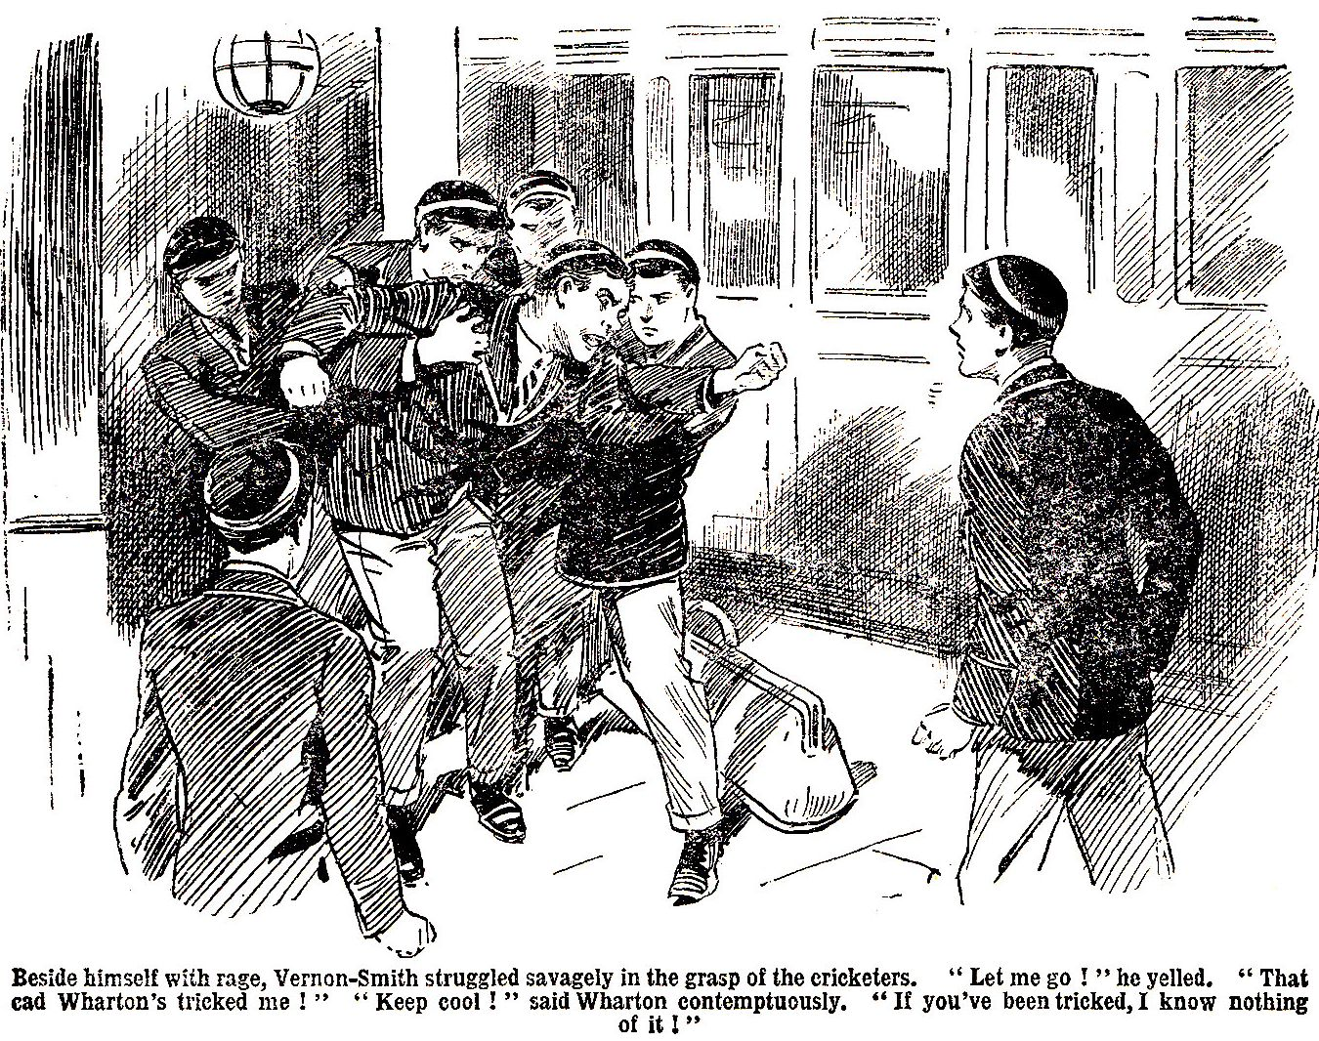

“What—” he began.
“You rotter !” The Bounder found his voice. “You cur ! You did this—”
“What the thump—”
You—you—”
The Bounder’s voice choked in his throat, and he fairly hurled himself at Harry Wharton.
Hands grasped him on all sides and dragged him back.
“Let me go !” yelled the Bounder. I tell you, he tricked me ! My father never phoned this morning—it was a trick—and Wharton—”
“Keep cool !” said Wharton contemptuously. “If you’ve been tricked, I know nothing of it—as you’d understand if you were a decent fellow yourself.”
“It’s a lie-a lie !” yelled the Bounder. “You rotters ! Let me go—”
He tore himself loose, and leaped at Wharton—heedless of everything but his own rage and vengeance.
Wingate of the Sixth, who had accompanied the eleven to the station, towered over the crowd of juniors and grasped the Bounder by the collar.
“That will do !” said the captain of Greyfriars. “Return to the school, Vernon-Smith !”
“I tell you—”
“Do as I order !”
And the Bounder, white with rage, obeyed.
It was the one topic at Greyfriars that evening—not only in the Remove, but all through the school. Who had done it was a mystery. The Bounder had his belief; but he found that he had it all to himself. And a fat and fatuous junior, who could have enlightened the Greyfriars fellows, was very careful not to do so. For the first time on record, Billy Bunter understudied that sagacious animal, Brer Fox, and “lay low and said nuffin’.”
THE END.

