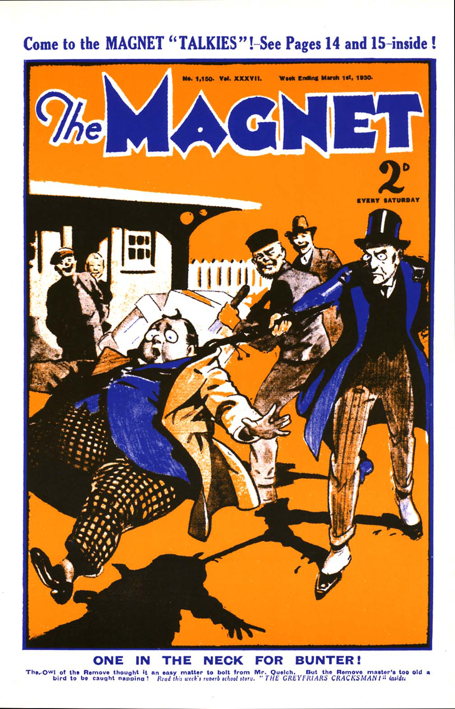

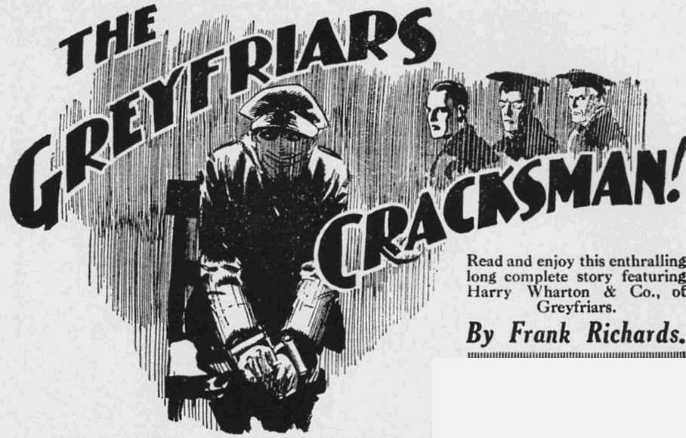

THE FIRST CHAPTER.
Only Bunter!
CLINK!
“Hallo, hallo, hallo!” ejaculated Bob Cherry.
Five fellows in Study No. 1 in the Greyfriars Remove, stared round at the window.
The Famous Five, of the Remove, were at tea. Outside, the quadrangle was dim with the early winter darkness; and Greyfriars fellows were all in the House—or, at least, were supposed to be.
So the sound of a pebble clinking on the study window was rather startling.
“What the dickens—” exclaimed Harry Wharton.
Clink!
Crack!
Another pebble smote the window pane from outside, evidently tossed up from the quad below. This time the smite was more emphatic, and the pane cracked.
The chums of the Remøve jumped to their feet.
“Some silly ass buzzing stones at the window!” ejaculated Frank Nugent. “The pane’s cracked !”
“The crackfulness is terrific!” remarked Hurree Jamset Ram Singh.
Johnny Bull, who was nearest the window, ran to it and threw it open. He stared out into the darkness below. It was unfortunate that, at the lame moment, a third pebble came whizzing up from the quad, aimed at the window.
It did not hit the window. But every bullet has its billet; and the same rule applies to pebbles. Johnny Bull’s nose was directly in the line of fire; and it was upon that feature that the pebble landed—with considerable force.
There was a roar from Johnny Bull.
“Whoooop!”
“Oh, my hat!”
Johnny Bull jumped away from the window, with his hand clasped to his nose.
“Ow! Oh! By dose!” he mumbled “By dose! Ow!’
“What thumping idiot is playing the goat like that?” exclaimed Harry Wharton, in amazement and wrath.
“Look out!”
Another pebble came whizcing, and as the window was open now it flew into the study. It landed on the milk-jug on the tea-table, and there was a loud crack. The jug immediately “went west,” and the milk spread in a flood over the table
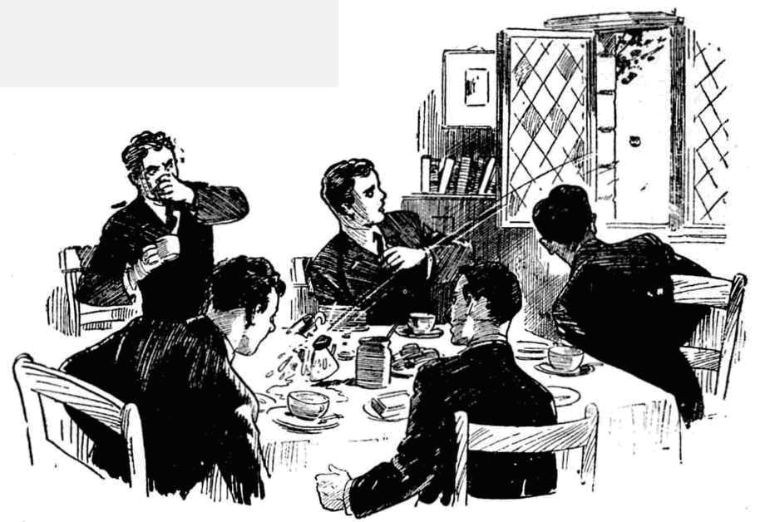 “My only hat! We’ll go down and mop up the quad with that howling ass!” exclaimed the captain of the Remove.
Johnny Bull was still caressing his injured nose, and mumbling. After Johnny’s experience, nobody felt inclined to look down from the window, to ascertain who was playing that extra- ordinary trick. The Famous Five made for the study door.
If some fellow thought it funny to buzz stones at the study window the chums of the Remove were prepared to give him their views on the subject in a prompt, drastic, and efficacious manner. They went down the Remove stair-case, two or three steps at a time. On the middle landing two Form masters were standing in conversation —Mr. Steele, the master of the Remove, and Mr. Prout, the master of the Fifth.
The juniors discovered them just in time to avoid cannoning into them.
Mr. Prout gave them a stern frown of disapprobation. Lower boys were not tO race about the passages and the stairs; in fact, there was a very strict rule against such proceedings. In the excitement of the moment Harry Wharton & Co. had forgotten that rule. Mr. Steele gave them a quiet look from his keen grey eyes.
“You seem to be somewhat in a hurry!” he remarked.
“Oh! Yes, sir!” gasped Wharton.
“The hurrifulness is terrific, honoured sahib!” said Hurree Jamset Ram Singh.
Mr Steele smiled.
“Well, please proceed in a more orderly manner!” he said.
“Yes, sir.”
“Oh, certainly!”
And the Famous Five proceeded in more orderly manner, glad to escape so cheaply.
They went down the lower staircase quito sedately.
“Prout would have given out an impot!” chuckled Bob Cherry, when they were out of hearing. “Steele’s a good sort!”
“One of the best!” said Harry. “But I fancy he would cut up rusty if he knew we were going out of the House. This way! We can get out by the Fourth Form room—Capper always forgets to lock it.
They found the door of Mr. Capper’s Form-room unlocked and groped into that apartment.
There was a door from the Fourth Form room on the quad; but that was locked. But a window served the purpose equally well.
Harry Wharton opened a window, and dropped out into the dusky quad. One after another his comrades followed him.
Then they hurried round the buildings to reach the walls under the windows of the Remove studies.
Who it was that had “buzzed” stones at the study window they could not imagine; but they hoped that, whoever he was, he was still there. They were quite anxious to catch him in the
act.
Clink! Crack!
The sound from above greeted years as they came under the study windows. Evidently the unknown practical joker was still there, and still “buzzing” stones. Another pane had cracked. As the owners of the study were liable for such damages, they were naturally excited and wrathy.
“There he is!” breathed Nugent.
In the dimness the juniors sighted a fat figure, standing a little back from the building, with face upturned to wards the study windows high above.
A hand was thrown back, evidently to hurl another stone; the fellow was it still “at it.”
“Collar him!” exclaimed Wharton.
The juniors rushed at the dim figure. The stone flew, and there was another crack from the window above. The next moment five pairs of hands grasped the dim figure, and it was up- ended and came down on the ground with a bump.
There was a startled yell.
Yaroooooh!”
“You cheeky rotter!” roared Wharton. “What the thump——”
“Yooop! Yow-ow-ow! I say, you fellows—”
“Great pip!”
“Bunter!”
“Billy Bunter!”
In sheer amazement the juniors released the dim figure that sprawled and spluttered on the ground. They stared down at him blankly as he wriggled and gasped and gurgled.
Bunter! My only hat!”
THE SECOND CHAPTER.
The Woes of W. G. Bunter!
BILLY BUNTER struggled to a sitting position.
He set his big spectacles straight on his fat little nose, and blinked up at the Famous Five.
“Ow!” he gasped. “Beasts! Ow! Groogh! Wharrer you bump a fellow over for? Ow! I say, you fellows— Oooooch!”
“Bunter 1” repeated Harry Wharton blankly.
“The esteemed and ridiculous Bunter” ejaculated Hurree Jamset Ram Singh.
“Bunter—here!” exclaimed Nugent.
“Ow !“ gasped Bunter.
It was Bunter—William George Bunter, as large as life! And it was amazing, for William George Bunter was supposed to be anywhere but at Greyfriars. William George Bunter had incurred the wrath of the powers that were, and had been sent home— not permanently, but temporarily, as a warning and a lesson to him.
If the Remove men had missed Billy Bunter during his absence, they had shown no sign of mourning. It was possible to see too much of Bunter; but impossible to see too little of him.
Fellows wondered if he would come back. Indeed, it was probable that the fat existence of William George Bunter would have been forgotten before very long, had he not turned up again.
Now he had turned up!
“You fat, flabby, frabjous ass!” said Harry Wharton, in measured tones. “What’s this idiotic game?”
“Oh, really, Wharton—”
“You’ve not got leave to come back !“ exclaimed Bob Cherry.
“Nunno!”
“Then why are you here? ” demanded Johnny Bull.
“Oh, really, Bull I—I was so anxious to see my dear old pals.”
“Oh, scat!”
“The Head doesn’t know you’re here?” asked Nugent.
“No fear!”
“Or Steele?”
“Of course not!” Billy Bunter had risen to his feet now, and was spluttering a little less emphatically, “I’ve come back syrupstitiously.”
“Wha-a-a-t?”
“You see, those beasts sent nie home.” said Bunter. “I cut class— well, fellows have cut class before. It was rank injustice! I’ve bad a lot of injustice since I’ve been at Greyfriars, as you fellows know. You fellows have generally been beasts—you can’t deny it. The Head’s rather a beast—Quelch was a beast—and Steele is worse than Quelch. I say, you fellows, do you know when Quelch is coming back 7”
“No, ass!”
“Well, Steele came here as a temporary master.” said Bunter. “It’s time he went—high time. I—I hoped he might have gone by now.”
“Well, he isn’t.”
“You see, if our old Form master was back he would see me righted.” said Bunter. “Quelch couldn’t help being a beast, being a schoolmaster, you know: but he wasn’t such a beast as Steele.” Bunter blinked anxiously at the staring juniors through the dimness. “I say, you fellows, it was rather rotten of you not to reply to my letters.”
“You’ve been writing?” asked Wharton.
“I’ve written to each of you. I wasn’t able to stamp the letters, being rather short of tin; but you could have paid double on them. It was rather mean of you if you didn’t—”
“You fat chump!” said Harry. “The letters never got to us. You were sent away, and, of course, you wouldn’t be allowed to write.”
“That’s what the beasts said—no communication with Greyfriars while I was in disgrace.” said Bunter. “Of course, I never took any notice of that.”
“I expect Steele did,” chuckled Bob. “Your letters must have been handed back to the postman, as they had no stamps on; Steele would know your fist. You’ll get them hack from the Dead Letter Office one of these days.”
“The awful rotter—interfering in a fellow’s correspondence!” said Bunter indignantly. “So that’s why you never sent me a little loan, though I explained in every letter that I needed it for a railway fare.”
“Ha, ha, ha!”
“Probably we shouldn’t have sent the little loan, anyway!” grinned Johnny Bull. “I know I shouldn’t have, for one!”
“Beast!”
“But what’s the game?” demanded Harry Wharton. “You’ll be booted out if you’re seen here, Bunter. You’d better cut before you’re seen,”
“Oh, really, Wharton—”
“Well, what are you up to?” asked the captain of the Remove. “And what were you buzzing stones at our study window for?”
“That was to attract your attention.” explained Bunter. “I knew you were there, as the window was lighted, and I checked up stones to let you know your old pal was here and wanted you.”
“You’ve cracked a couple of panes.”
“He, he, he!”
“Is that anything to cackle at?” demanded Nugent indignantly. “Somebody will have to pay for those panes.”
“That’s all right, old chap! I’ll pay for them! I’m expecting a postal-order—”
“Oh, my hat!”
“Well, now you’ve attracted our attention, fathead, and we’re here, ass, what about it, dummy?” asked the captain of the Remove.
“I say, you fellows, you’ve got to stand by me.” said Bunter. “Think of all I’ve done for you—”
“That won’t take a second!” remarked Johnny Bull.
“Ha, ha, ha!”
“After all I’ve done for you follows I expect a little return.” said Bunter. “I’ve had to come back. My father was waxy about my being sent home. I thought, of course, that he would be waxy with the Head and Steele. Instead of that, he was waxy with me.”
“Go hon!” said Bob Cherry sarcastically.
“He was really.” said Bunter, in an injured tone. “I explained to him that I was not in the least to blame; but he interrupted me rudely a lot of times; and, in fact, hardly listened to ne at all. He said it was bad enough having me home in the holidays, and that having me at home in term was too thick. ‘Intolerable’ was the word he used—meaning too thick. Fancy that!”
“I feel for him!” said Bob.
“The feelfulness is terrific!”
“Oh, really, you fellows! I never had any pocket-money, and the pater actually got a man to give me instruction in book-keeping!” said Bunter. “It was worse than being at school—work, you know, and worse! He said I was not to waste my time! As if you could waste time worse than by working !“ said Bunter sorrowfully. “I stood it for a few days! Any fellow ought to be able to stand his people for a few days, in my opinion. But there’s a limit.”
The famous Five chuckled. Apparently Billy Bunter had not enjoyed his few days of rustication.
“So I’ve come back.” concluded Bunter. “It was too thick, and I chucked it. I hoped Steele might be gone by this time, and Quelch might be back. Fancy any fellow wanting Quelch back! But that’s what it’s come to!”
“Well, he isn’t back,” said Harry, “and you’d better clear before you lose the last train home.”
“I’m not going home! I left my pater a note to say it was all arranged. I’m staying here. Do you think you fellows could square it with the Head? I mean, if you go to him and explain that Steele is a scoundrel, and a villain, and a beast, and all that, he may see that it is all Steele’s fault, and let me come back at once—in fact, apologise into the bargain. What do you fellows think?”
“Oh crumbs !“ gasped Bob Cherry, “1 can see myself going to the Beak and saying that!“
“Ha, ha, ha!”
“Well, I leave it to you fellows.” said Bunter. “Here I am, and it’s up to you to fix things somehow. What do you suggest?”
“If it’s up to us.” said Johnny Bull. “T suggest drowning him in the fountain!”
“Ha, ha, ha!”
“Beast! Look here—”
“Cave!” ejaculated Bob Chorry suddenly. “‘Ware Beaks!”
But it was too late!
There was a rapid footstep; and an athletic figure loomed up in the dusk. A deep voice came—the voice of Richard Steele.
“Boys! What—”
There was a terrified squeak from Billy Bunter.
“Ow! Oh crikey I”
The Owl of the Remove fled into the darkness. In an instant Billy Bunter had vanished like a ghost at cock-crow.
Harry Wharton & Co. were left facing the stern eyes of the master of the Remove.
THE THIRD CHAPTER.
After Bunter!
MR. STEELE fixed his eyes on the chums of the Remove. Dim as it was in the quad, he evidently recognised the five juniors.
“Wharton!” he rapped out.
“Oh! Yes, sir!” stammered Harry.
“Who was that with you here a moment ago?”
“Oh! Who—who was it, sir!” stuttered Wharton. “D-d-did you say who—who was it, sir?”
“I did! 1 think I recognised the voice I heard.” said Mr. Steele. “It was Bunter, was it not?”
It was impossible to deny it, even if that had been of any use. Mr. Steele knew that Bunter had been there.
“Yes, sir,” said Harry at last. Mr. Steele’s brow became sterner. “You boys are well aware that Bunter was sent home as a punishment for a serious infraction of the rules of the school.” he said “You are well aware that you are not allowed to communicate with him during the period of his punishment.”
“We—we—” stammered Bob Cherry.
“The communication is not terrific, esteemed sahib!” said Hurree Jamset Ram Singh.
“Bunter has returned without leave.” said the Remove master. “Have you seen him here before this evening?”
“Oh, no, sir!”
“How did you know he was here at all, then ?“
“He buzzed stones at our study window, sir.” said Harry. “He wanted to speak to us.”
“And you left the House after lock-up for that reason?”
“We didn’t know it was Bunter.” said Harry. “We came down to mop up the fellow who was buzzing stones. Thon we found it was Bunter.”
“I see! And that is all?”
“That is all, sir.”
“Where has he gone now?”
“I don’t know. He just cleared oft when he heard you coming, sir.”
“The foolish, absurd boy! I must find him! You will take fifty lines each for leaving the House after lock-up. Follow me!”
The Famous Five trailed after Mr. Steele, as he led them back to the house. lie did not leave them till they were safe indoors, and then went back into the quadrangle, obviously to search for the vanished Owl.
The Famous Five returned to the Remove passage.
Fifty lines each did not worry them very much. Lines fell, like the rain, upon the just and the unjust alike; and there were generally lines to be done from one cause or another. And they had no doubt that Mr. Quelch, their old Form master, would probably have made it a hundred each. The temporary master of the Remove was not quite so heavy-handed as Quelchy. They were thinking chiefly about Billy Bunter and his extraordinary proceeding in returning to the school without leave. And they wondered what would happen to him when Steele found him.
Tea had been interrupted in Study No. 1, and the chums of the Remove resumed their interrupted meal.
“The howling ass!” said Bob Cherry. “Steele will give him six, and pack him into the next train. He’s got to stay at home till the Beaks let him come back.”
“No wonder his pater’s waxy.” chuckled Nu ugent. “Bunter isn’t really the fellow to make home merry and bright.”
“It’s queer, though.” Said Johnny Bull thoughtfully. “It’s unusual to send a fellow home like that; and, after all, Bunter only played the fool, and he was always doing that more or less. Quelchy would have licked him, and left it at that.”
Clink!
“Great pip!” gasped Wharton.
He spun round to the window.
A pebble had clinked on the glass, thrown up from the quad below. The Famous Five jumped up from the table.
“Bunter again!” ejaculated Bob Cherry.
“The burbling idiot!”
“The frabjous ass I”
The juniors rushed to the window. Evidently !”illiam George Bunter had dodged Mr. Steele. and was trying once more to get into touch with the Famous Five.
Apparently Bunter was determined to stay at the school by hook or by crook, and depended on Harry Wharton & Co. to see him through somehow.
“You silly ass!” bawled Bob Cherry, from the window. “Hook it! Do you hear? Hook it!”
“I say, you fellows—” floated plaintively up from below.
“Clear off !” roared Johnny Bull.
“Beast!”
“Steele is after you!”
“I know that! I’ve dodged him!” howled back Bunter. “I believe the brute is still looking for me. I say, you fellows—”
“Bunk, you frabjous ass I”
“I want you fellows to let me in somehow!” yelled Bunter. “Come down and let me in, will you?”
“Fathead!”
“I can’t stay out here—alone——”
“You’ll have half the school with you soon, if you go on yelling on your top note, you frightful chump.”
“I say, you fellows, I’m relying on you, you know. I say, I’m hungry!”
“Ha, ha, ha!”
“Blessed if I see anything to cackle at! WilI you come down and let me in?” howled Bunter.
The Owl of din Remove had thrown caution to the winds now that his presence had been discovered by Mr. Steele. His emphatic squeak sounded far and wide.
No doubt Bunter was hungry after his journey. And when Bunter was hungry, all other considerations faded into mere nothingness. A meal for Bunter was the one matter of outstanding importance in the universe just then.
“Look out!” roared Bob Cherry, as he detected a darker shadow among the shadows in the quad below.
He guessed that it was Steele, and that the Remove master had heard shouting up to the study window.
“I say— Oh crikey!”
“Bunter!” came a deep voice in angry tones.
“Oh lor’ !”
There was a sound of hurrying footsteps.
“Bunter, stop! I command you to stop at once! Do you hear me, you stupid boy? Bunter, stop immediately!”
Bunter, apparently, did not stop. Fleeing footsteps died away in the distance.
“Oh crumbs!” gasped Bob Cherry. “ What a game!”
The deep voice of Richard Steele floated up:
“Wharton!”
“Here, sir!”
“Close that window at once, and do uot open it again !”
“Very well, sir.”
The study window was closed, and the chums of the Remove turned away from it, grinning. The extraordinary adventures of the Owl of the Remove struck them as comic, though undoubtedly the situation was serious enough to William George Bunter.
They resumed tea once more, uninterrupted by stones clinking at the study window.
Somewhere, out of the house, in the February gloom, Billy Bunter was dodging and doubling, with vengeance, in the shape of Richard Steele, on his track. And the chums of the Remove wondered, hilariously, how he was getting on.
THE FOURTH CHAPTER.
Barnes Is Not Taking Any!
BILLY BUNTER was not getting on at all well.
He was tired, breathless, and hungry.
Once more he had escaped pursuit, thanks to the deep gloom, and now he was hugging the trunk of an elm-tree, hidden in its black shadow, breathing in great gasps, and palpitating.
Twice he heard the footsteps of Mr. Steele, passing and repassing; many times he heard the voice of the Form master, calling.
He clung closer to cover, and gave no sign,
The footsteps and the voice ceased to be audible at last. Mr. Steele had apparently gone farther afield in his search for the elusive Owl.
Bunter breathed a little more freely.
He was safe for the moment, at least. Immediate booting out of the precincts of Greyfriars was no longer to be feared.
But his situation was precarious, Bunter realised that. Above all, he was hungry.
Returning to the school without leave was a wheeze that would probably not have occurred to any brain but Bunter’s. But to William George it had seemed the only resource, as he found things so uncomfortable at home. Somehow or other he hoped to square matters—exactly how, he did not know. But he knew that he wanted a square meal, and that he wanted it quick; he knew that, without a shadow of doubt. If those beasts had got him into the House somehow, it would have been all right, and they ought, of course, to have done it. A licking all round would have been a light price to pay for Bunter—Bunter’s comfort being the only thing that really mattered. But it was clear, now, that he was not going to get into the House, and where he was going to get a meal and pass the night, was a problem . Bunter had to solve that problem while dodging Mr. Steele, and he felt that it was hard.
Bunter’s intellect had not been designed by nature to deal with difficult problems. But under pressure, it worked. He had palpitated and cogitated for half an hour under the shadowy elm , when a glimmer of light dawned on his fat brain.
He left his cover at last, and trod cautiously away. This time he did not approach the House.
It was useless to buzz stones at a study window and yell up to the fellows; that would only bring Steele down on him again. But Bunter had thought of another resource.
He headed for the garage.
Probably Steele would not think of looking for him there. He would not suspect Bunter of taking refuge with Barnes—at least, Bunter hoped that he wouldn’t. The Head’s chauffeur, it was true, was certain to be extremely unwilling to shelter a fellow who was forbidden to be within the precincts of Greyfriars at all. But Bunter had an idea he could wangle that.
In the garage yard, the fat junior blinked in at the windows of the rooms that the Head’s chauffeur occupied over the garage.
One of the windows, that of Barnes’ sitting-room, was lighted. The man was there, which was satisfactory as far as it went
Bunter rolled to the door beside the garage which gave access to Barnes’ staircase. The door was fastened , and Bunter knocked loudly on it.
There were footsteps within. Barnes was coming down from his room. A light was switched on, and the door opened.
Barnes, the Head’s chauffeur, stood there in the light, staring at Bunter. Bartnes’ usually impassive face registered astonishment.
“I say, Barnes—” gasped Bunter.
“Mr. Bunter.” said Barnes quietly. “What do you want here, sir? The young gentlemen are not allowed here !”
“That’s all right, Barnes.” said Bunter. “I want you to let me in !”
Barnes blocked the doorway.
“I am afraid that is impossible, sir.” he answered “Please go away at once.”
“Look here, Barnes—”
“I shall be obliged, sir, if you will go away at once. ” said the chauffeur firmly. “You should be in the House at this hour. You will get me into trouble with my employer. Dr. Locke would be annoyed—”
“Let me in, I tell Jou.”
“Nonsense.” said Barnes. He peered at Bunter. “I had heard that you were sent away from the school, sir. Is not that the case?’
“I’ve come back—”
“Without leave!” ejaculated Barnes.
“That’s it! I’m going to work it somehow.” explained Bunter. “But that beast, Steele, is after me. I’ve got to keep clear of him and I’ve got to have some supper. That’s important!”
Barnes smiled faintly.
“You cannot enter my quarters, sir! You know that perfectly well. If you do not go away at once, I shall have to take you to the House and hand you over to your Form master.”
Bunter’s little round eyes gleamed behind his big spectacles.
“You’d better not!” he grunted.
“Indeed!” said Barnes quietly.
“Look here, Barnes, one good turn deserves another. See? I know a lot about you that I could tell the Head if I liked.” said Bunter desperately. “I dare say it would get you the sack. You’ve got a good job here. See?”
Barnes compressed his lips. His keen eyes narrowed almost to pin-points, as he fixed them searchingly on the fat face before him.
“Will you explain what you mean, sir?” asked Barnes, very quietly.
“You jolly well know!” growled Bunter. “The Head thinks you’re no end of a quiet chap, and a model chauffeur, and all that. I could tell him some things, if I liked.”
“What could you tell him, sir?” asked Barnes, still very quietly, though there was a glint in his eyes that might have alarmed any fellow less shortsighted and obtuse than William George Bunter.
Bunter sneered
“What about your goings on, lots of times?” he said. “You remember when I was with Wharton for the Christmas holidays at Wharton Lodge, and you drove the Head there to visit Colonel Wharton. I found that you were out at night, when you were supposed to be in bed. It was the night of the burglary at Sankey Hall. I knew you were having your master’s car out for a joyride—in fact you owned up to it and asked me to keep it dark.”
There was a strange, indefinable expression on Barnes’ calm face for a moment.
“I remember, sir.” he said evenly.
“And that night last term, when Wharton and I got back late from Folkestone, and couldn’t get in.” added Bunter. “We came round to the garage for you to let us in, and you were out—at two in the morning. I’m jolly sure the Head never knew that.”
“Indeed, sir!”
“I remember it all right, it was the night of the burglary at Hogben Grange, near Courtfield. said Bunter.
Barnes’ lips were compressed again. “I’m not going to give you away,” said Bunter. “I don’t care a rap if you take the Head’s car out for joy rides; in fact, I expect I should do the same if I were a chauffeur. But one good turn deserves another. You know jolly well that I could get you the sack.”
Barnes did not answer that.
“I’ve got to have a shelter for the night, and some supper.” went on Bunter. “I expect you to see me through, Barnes.”
“Dr. Locke would be displeased—”
“Oh, cut that out,” said Bunter. “Of course, I shall pay you, and pay you handsomely. That’s understood. Not immediately, perhaps, as I’m rather short of money at the present moment. But I’m expecting a postal order, and it will be all right”
“Really, sir—”
“One good turn deserves another.” said Bunter. “I’m not going to keep your rascally conduct dark if you don’t help a fellow out, Now—”
Bunter broke off suddenly,
There was a footstep in the garage yard.
The fat junior spun round with a gasp if alarm. The athletic the figure of Richard Steele was approaching with long strides.
“Bunter!” boomed the deep voice.
“Oh lor’ !”
Billy Bunter dodged away from Barnes’ doorway and ran.
“Stop!” shouted the Remove master. Bunter didn’t stop.
Mr. Steele was about to rush in pursuit, but he paused, and came over to Barnes, who was still standing in the lighted doorway looking out, his face calm and expressionless.
“What does this mean, Barnes?” asked the Remove master, “What was Bunter doing here?”
“He was asking me to take him in for the night, sir,” answered Barnes. “I refused, of course
“The absurd boy!” exclaimed Mr. Steele.
And he strode away in pursuit of Bunter. Barnes glanced after him as he disappeared in the gloom, and then shut and locked his door.
THE FIFTH CHAPTER.
Bunter Butts In!
“PREP!” yawned Bob Cherry.
Football jaw ceased round the fire in the Rag. It was time for prep, and the fellows in the Rag made a move for the studies.
Some of the fellows were looking from the windows, in the dusky dimness of the quad.
By this time, the unexpected and unbidden return of William George Bunter was known to all the Form, and there had been many chuckles and chortles on that subject. Now that the moon was rising, there was a silvery glimmer of light in the quad, and fellows looked out, hoping to see something of Bunter. But if the Owl of the Remove was still within the precincts of Greyfriars, he was not on view.
Steele, it was known, had come in and gone to his study. Whether he had given up the search as a failure, or whether he had found Bunter and packed him off, nobody knew. The Bounder suggested some fellow going to Steele and asking him; but he did not seem disposed to be the fellow who was to go and ask. But everyone was rather curious on the subject, and wondered whether the fat Owl would turn up again.
The Famous Five went up the Remove staircase together. They went into Study No. 1, where there was toffee. The toffee was to be disposed of before prep; It was, in fact, a more interesting matter than prep.
Harry Wharton turned on the light, and crossed to the study cupboard to get out the toffee, He did not seem to see it there at first glance, and he looked through the cupboard with a puzzled expression on his face.
“ You shifted the toffee, Franky?” he asked.
“No!” answered Nugent.
“Well, somebody has” said Harry. “It was there when we went down after tea.” answered Frank, and he joined Wharton at the cupboard.
“Hallo, hallo, hallo!” ejaculated Bb Cherry. “Somebody raided the toffee? I thought Bunter was the only grub-raider in the Remove.”
“Well, there’s somebody following in Bunter’s footsteps.” said Harry. “The toffee’s gone.”
“Rotten!” said Bob. “Well, if the toffee’s gone, we nay as well go, too. Come on, Inky; prep, old black bean,”
“But who the thump has lifted that toffee?” exclaimed the captain of the Remove indignantly, “There hasn’t been any grub-raiding in this passage since Bunter was booted out if some other outsider is taking it up, we’ll jolly well lynch him!”
“I say, you fellows l’t
“Wha-at?”
“BUNTER!”
A fat face, adorncd by a large pair of spcctacles, peered out from under the study table.
The Famous Five stared at it blankly.
“Bunter!” yelled Bob Cherry.
“Oh crumbs!”
“I say, you fellows, don’t make a row!” gasped Bunter, “I’ve come in syrupstitiously—”
“You fat chump, do you mean surreptitiously?” asked Wharton.
“I mean what I say!” snapped Bunter. “I’ve come in syrupstitiously, and nobody knows I’m here. Don’t give me away.”
“Well, my hat!“ said Bob, staring at the fat Owl. “We needn’t inquire further for the toffee!”
“The inquirefulness would be preposterously superfluous!” grinned Hurree Jamset Ram Singh.
“Oh, really, you fellows! I suppose you don’t grudge a fellow a snack when he’s practically starving to death! I think it was jolly lucky I found the toffee in the cupboard.” said Bunter warmly.
“You born chump!” said Wharton. “I suppose you’ve got outside the toffee. Now got outside the study.”
“Oh, really, Wharton—”
“How did you gut into the House?” demanded Nugent.
Bunter grinned.
“Syrupstitiously.” he answered. “I say, you fellows, I went to the garage, and that beast Barnes refused to take me in—he was quite heartless. While I was arguing with him, that rotter Steele came on me again, and I had to cut and run. I’ve been dodging about the place in the dark, and I can tell you I got fed up. Then I thought of getting in at a window.
“Oh!” said Harry. He understood.
“1 found a window in the Fourth Form room unfastened.” said Bunter. “Some silly ass had left it unfastened. Luck, wasn’t it?”
“We left it unfastened,” said Bob. “That’s the way we got out when we found you in the quad. Steele marched us in at the door, and I forgot all about the window.”
“Well, I got in that way.” said Bunter, “and here I am. It’s up to you fellows now.”
“What’s up to us, fathead?’
“To stand by me and see me through.” said Bunter. “I suppose I can’t go to dorm to-night; I should be spotted. You can hide me in this study—’
“Eh? ”
“Get some blankets for me, you know, and a pillow. Anything will do so long as I’m made comfortable.”
“Oh crumbs!”
“And grub.” said Bunter. “That’s important. I want some grub. A lot, in fact. The tuckshop’s closed; but you can manage it. Go along the studies and ask all the fellows. I’m sure all the Remove will rally round, in the circumstances”
“I wouldn’t bank on that!” grinned Johnny Bull.
“You can’t let a fellow down.” said Bunter. “Did I ever let a fellow down myself? I ask you!”
He blinked severely at the staring juniors through his big spectacles.
“You benighted chump!” said Harry. “You can’t stop here. You’d be spotted; and the maids would find you in the morning—”
“I’ll get up early and dodge them. That’s settled.” said Bunter. “To-morrow it will be all right. I want you to go to the Head, Wharton. You’re captain of the Form, you know, and it’s up to you. You’ve got to see fair play. You don’t know why I was sent home—”
“For cutting class.” said Harry.
Bunter snorted.
“That was the excuse!” he sneered. “That beast Steele sent me home so that I couldn’t tell the fellows what I’d found out.”
Harry Wharton started.
Wharton was the only fellow at Greyfriars who knew Mr. Steele’s secret; that the new master of the Remove was, in reality, Inspector Irons of Scotland Yard; and that his chief business was to track down the “Courtfield cracksman,” the notorious crook who had a dozen robberies to his credit in the neighborhood.
“What have you found out, you fathead?” asked Bob Cherry. “Nothing very important, I imagine.”
Wharton was silent.
If Bunter had found out the Form master’s secret, it was not likely to remain a secret now. He waited anxiously for what the fat Owl of the Remove had to say.
“That’s all you know, Cherry,” sneered Bunter. “The fact is, that that day I cut class I got into Barnes’ quarters over the garage, to keep away from Loder of the Sixth, You remember that Steele was supposed to be away that morning, and Loder was taking the Remove in his place. Well, Steele wasn’t away at all.”
“What rot!” said Bob.
“I tell you he wasn’t! I saw him in Barnes’ room over the garage, and he was searching the place—goodness knows why! Picking locks, opening drawers and boxes and things, and going through everything. I thought at first he was pinching things—”
“Oh, my hat!”
“But it wasn’t that,” said Bunter. “I watched him a long time through the keyhole, and he was not taking anything—only searching and examining everything in the room. The Head had sent Barnes away to Folkestone in the car that morning. I heard Steelo ask him to. He had it all cut and dried to root through Barnes’ quarters while he was away.’
The juniors stared at Bunter in amazement, almost in stupefaction. They could see that he was telling the truth, though his statements appeared incredible.
“Well, afterwards,” said Bunter, “I put it to Steele. 1 told him that one good turn deserved another, and that I’d keep it dark about spying in Barnes’ room, if he’d say nothing about my cutting class and keep Loder off, I thought that a fair offer,”
“Oh scissors!”
“And what do you think?” said Bunter indignantly. “He took me to the Head, and persuaded the old donkey, somehow, to send me home. And the Head refused to listen to me. Steele’s got him under his thumb somehow. They made out that I was sent home for cutting class, and all that. Gammon! Steele didn’t want ne to give him away! That’s why I was scooted out of the school! See?”
“Great pip!” said Bob Cherry.
“Well, if the Head really knew how it was, he wouldn’t let Steele get away with it like this.” argued Bunter. “The Head’s a beast, of course—all masters are beasts; but he’s not such a beast as all that. I want you to go to him to-morrow, Wharton, and explain that I’m the victim of a designing scoundrel. See?”
“I can see myself doing it!” remarked Wharton.
“I think it’s up to you! Otherwise, you may lose me again I” said Bunter impressively. “If I’m sent back home you may not see me again for weeks.”
Bunter apparently regarded that as a clincher. But the Famous Five did not seem frightfully dismayed at the prospect of losing Bunter again, perhaps for weeks! It was, in fact, a loss that they were prepared to bear with fortitude.
“You see, I’ve thought it all out.” said Bunter. “I’ve got to lie low till you can make the Head understand that I’m a victim, Wharton. See? Now, what about some grub?”
There was a step in the Remove passage.
Bunter gasped.
He forgot even “grub.” Eli, head popped back under the table, like that of a tortoiso disappearing into its shell.
“I say, you fellows!” he gasped. “Stand round the table—keep me dark! D-d-don’t give a fellow away I”
That appeal was not to be resisted. The Famous Five gathered round the study table, to conceal William George Bunter as well as they could, as the door opened, and Wingate of the Sixth looked in,
THE SIXTH CHAPTER.
Poor Old Bunter!
WINGATE glanced sharply at the five juniors in the study.
Perhaps there was a rather startled and flustered look about the chums of the Remove. The fatuous Owl of Greyfriars had placed them in an extremely awkward position. They felt that they could not give the Owl away; but it was undoubtedly a serious matter to conceal the presence of a fellow who was there without leave,
And they guessed, too, that the captain of Greyfriars had come to the study on Bunter’s account.
“Well” said Wingate, rather grimly.
“Yes, Wingate?” said Wharton meekly.
“Have you seen anything of Bunter?”
“Bunter?” repeated Wharton.
“Yes. I’m looking for him.”
“Oh! Looking for him, are you?” repeated Wharton.
“A Form.roozn window has been found open, and Steele thinks he may have got into the House,” said Wingate.
“Think he’d have the nerve?” asked Bob Cherry blandly.
“He would have the idiocy, at least.” answered the prefect. “If he’s got into the House, he’s pretty certain to make for this passage—he might be ass enough to think that fellows here would hide him.”
“He—he might!” said Nugent.
“The mightfulness is terrific,”
. “He’s got to be found, and sent home, before it’s too late,” said Wingate. “Steele has telephoned to his father to expect him home; and he’s got to go by the next train. I’m going to search all the Remove studies for him. You kids can help.”
“Oh !”
“There’s no time to be lost!” said Wingato. “I’ll begin with this study.”
“Leave this study to us.” suggested Nugent. “We—we’ll search it while you’re looking along the passage, if you like, Wingate.”
Wingate laughed.
“Thanks!” he answered, “I don’t need much more than that. Bunter’s here, I suppose.”
The chums of the Remove made no answer. Wingate stepped into the study.
“Where is he?” he asked.
“I—I can’t ice him!” said Bob, staring round the study.
“What are you kids backing up round the table for?” asked the Greyfriars captain sarcastically. “Nothing to hide, I suppose?”
“Hem!”
“Stand aside !”
There was no help for it. The game, evidently, was up. Harry Wharton & Co. moved away from the study table.
From under that table came a startled gasp.
“Come out!” said Wingate.
“Oh lor’ !”
“Come out, you young ass!”
“Oh crumbs! I—I’m not here!”
“Will you come out, you young idiot?”
“I—I say, Wingate!” groaned Bunter. “I say, keep it dark I”
“What?” ejaculated Wingate.
“I—I want you to go to the Head!” gasped Bunter. “Tell him I’m a victim—”
“Come out!”
“Tell him that Steele is a designing villain—”
“Great Scott! Will you come out?”
“I—I say—”
Wingate grasped the study table, and shifted it aside. Billy Bunter was revealed, squatting on the well-worn carpet.
There was a chortle from the Remove passage. Half the Remove had gathercd outside Study No. 1 by that time, and were staring in. The hunting of Bunter seemed to entertain the Form of which he had been an ornament.
“There he is!” yelled Skinner, as Bunter was revealed.
“Ha, ha, ha !”
“As large as life, and twice as natural!” chuckled the Bounder.
Bunter scrambled to his feet,
Wingate stretched out a hand to take him by the shoulder; but the Owl of the Remove dodged away.
Bunter’s movements were not, as a rule, rapid. But he was desperate now. He whipped round the table, placing that article of furniture between him and the prefect.
“I—I say, Wingate !” he gasped.
“You young ass, come hereat once!” roared Wingate.
“Lemme alone!” gasped Bunter. “I keep on telling you I’m a victim—”
“Ha, ha, ha!” cane in a roar from the crowded passage.
“I say, you fellows, collar him!” exclaimed Bunter desperately. “Collar him and hold him while I bunk!”
“Oh crumbs !“ gasped Bob Cherry, quite overcome by the idea of collaring the captain of the school and holding him while Bunter “bunked.”
“Ha, ha, ha !”
“You fat duffer!“ said Peter Todd, from the doorway. “Chuck it!”
“I say, Peter, hold that beast while I bunk!”
“Ha, ha. ha !”
Wingate started round the table after Bunter. Bunter flew for the doorway.
The doorway was crowded with grinning fellows.
But they ceased to grin the next moment! Bunter charged them like a battering-ram.
A charge with Billy Bunter’s weight behind it was no light matter. Fellows went spinning right and left under that hefty charge.
“Owl Oh! Yaroogh!”
“Oh, my hat I”
Peter Todd staggered to the right. Smithy to the left: Skinner sprawled onthe floor, and Snoop sprawled over him. Bunter charged on blindly. Hazeldene was knocked over, Squiff staggered against the opposite wall, Fisher T. Fish went down with a howl. Bunter was through, and he went up the Remove passage at a speed that was really remarkable, considering the weight he had to carry. He left a gasping and wrathful crowd behind him.
“Stop I” roared Wingate
He shoved through the Removites, and raced up the passage after Bunter.
Bunter flew.
It was unfortunate that Lord Mauleverer came out of Study No. 12 just as Bunter was passing the door at top speed.
There was a terrific crash.
Lord Mauleverer spun over and landed on his back, with a yell. Billy Bunter sprawled across him.
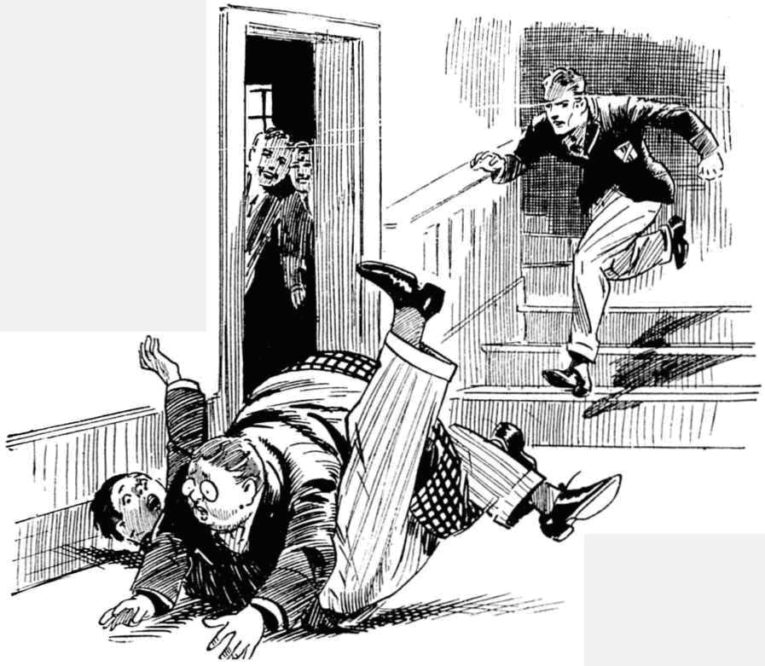
“Ow, ow, ow! Ooooch!” came from the hapless Mauly.
“Groooogh! Ooooh!” gasped Bunter.
He scrambled breathlessly to his feet. He had hardly reached them when the grasp of the pursuer fell on has fat shoulder.
“Now, you young sweep—” gasped Wingate.
“Ow! Leggo! Wow!”
“Come along.”
“Ow! Shan’t! Wow! I say, you fellows, rescue!” yelled Bunter desperately.
But there was no rescue for the Owl of the Remove.
With Wingate’s grasp like a steel vice on has shoulder he was marched down the Remove passage to the stairs.
A roar of laughter followed him.
“Exit Bunter !”said Skinner.
“Poor old Bunter!”
“Ha, ha, ha!”
A crowd of felows followed down the Remove staircase, interested to see the last of Bunter.
For it obviously was the last of that interesting youth; now that he had been captured he was not likely to get loose again.
Mr. Steele was waiting at the bottom of the stairs. Wingate handed the captured Owl over to the Remove master.
“Here he is, sir.”
“Thank you, Wingate!”
A still more steel-like grip was on Bunter’s fat shoulder now. He blinked dismally at the master of the Remove.
“Bunter!”
“Ow!”
“But for your well-known stupidity I should punish you very severely for this absurd freak.” said Mr. Steele, sternly. “If you should repeat this performance, Bunter, you will be flogged and sent home again. Do you understand me?”
“Wow !”
“Now I shall take you to the station andsee you into your train.” said Mr. Steele. He glanced up the crowded staircase, with a frown. “Go back to your studies at once, boys.”
The Removites vanished up the stairs.
Ten minutes later a taxi-cab bore Mr. Steele and the Owl of the Remove to Courtfield Station. The fat Owl was gone once more, and he left the Remove chortling.
“Poor old Bunter.” said Peter Todd.
“I wonder how long it will be before we see him again.”
“It can’t be too long,” remarked Skinner.
“Home, sweet home, for Bunter.” said Snoop. “Bunter senior will be killing the fatted calf for him—I don’t think!”
“Well, he’s gone.” said Bob Cherry. “Poor old Bunter!”
The Removites went back for Prep.
After prep the Famous Five gathered in Study No. 1 again, and Bb Cherry spoke on the subject that was in all their minds.
“That’s a queer yarn Bunter was telling us about Steele!” he said.
“The queerfulness is terrific.” assented Hurree Janset Ram Singh.
“Not like Steele to do a thing like that.” said Johnny Bull. “But—I think Bunter was telling the truth, for once. What do you think, Wharton?”
Wharton did not reply immediately. Bunter’s story had startled him more than the others. Knowing that the new master of the Remove was in reality is a Scotland Yard detective Wharton would not have been surprised to hear that he had been engaged as Bunter had seen him engaged over the garage; but he was intensely surprised to learn that “Inspector Irons” had been searching Barnes’ rooms. For it was obviously as Inspector Irons, not as Richard Steele that the man with the square jaw had been making that search.
It could mean, so far as Wharton could see, only one thing—that Arthur Barnes, the Head’s chauffeur, was under the detective’s suspicion.
That was a startling thought.
But it was not a thought that Wharton could communicate to his friends. Irksome as it was to him to keep a secret from his chums, he had no choice in the matter. The identity of Inspector Irons had to be kept from all knowledge; and that was all the more important if Mr. Irons suspected a man who was actually at Greyfriars.
Wharton had no doubt that Bunter had been sent home not so much as a punishment for cutting classes as to keep him from tattling what he had discovered in the school. Mr. Irons could not afford to take risks in such a matter, and the Head, evidently, was giving him his full support.
The captain of the Remove was silent. Johnny Bull looked at him curiously.
“What do you think?” he repeated.
“1—I think Bunter was telling the truth.” said Harry. “But—we’d better say nothing about it.”
“ Bunter ought not to have been prying,” said Nugent. “But it’s rather hard on him, all the same. Steele had no business in Barnes’ quarters”
“1 wonder what ho wanted there?” said Bob. “And what the thump would Barnes think if he knew?”
“For goodness’ sake, not a word!” exclaimed Wharton, “It’s not a matter to he talked about.”
“That’s so,” agreed Bob. “But—”
“The stillfulness of the wise tongue saved a bird in the bush from going longest to the well, as the English proverb says.” remarked Hurree Jamset Ram Singh.
“Good old English proverb!” chuckled Bob.
“Ha, ha, ha !”
“Say nothing about it, you fellows,” said Wharton. “A still tongue shows a wise head—and it’s no bizney of ours,”
“Not a word!” agreed Bob.
And not a word on the subject was said by the Famous Five outside their own select circle. And not a word was likely to come from William George Bunter—now enjoying once more the delights of home, sweet home!
THE SEVENTH CHAPTER.
Under Suspicion !
“HEARD?” asked the Bounder.
It was a few days later, and Harry Wharton & Co. were punting a footer about in break, when Vernon-Smith came up— with news.
“Which and what?” inquired Bob Cherry.
“Quelchy’s coming back.”
The Famous Five took notice at once. It was interesting news, if well founded.
Mr. Quelch, the master of the Remove, had not been seen at Greyfriars since the Christmas vacation. It was understood that he was prolonging his holiday for reasons best known to himself and the Head, Richard Steele taking his place as a temporary master.
If Quelch was now coming back, so late in the term, it meant that Steele was going.
The news was rather a shock to the juniors. They had got used to Steele as Form master, and they liked him. Still, it had been known from the first that he would not be staying permanently.
It was more startling to Harry Wharton than to his friends. He knew who Richard Steele was, and why he was really at Greyfriars. If he was leaving it indicated that his “case” was completed, or near completion—that he had succeeded in tracing out the Courtfield cracksman.
On the other hand, it might mean that he had failed, and was giving up the hunt. But that Wharton did not believe for a moment. The man with the square jaw was not the man to admit failure,
Of the Courtfield cracksman, whose robberies had caused excitement and alarm in the neighbourhood for months past, nothing had been heard of late.
Since the burglary at Topham Croft the cracksman had lain low; and many surmised that he had, at long last, left the district to seek fresh fields and pastures new. Others opined that he was simply lying low till the excitement calmed down and the search for him slackened.
It was known that his confederate had been taken into custody; but it seemed clear that the arrested man had said nothing concerning his chief, for there was no news of the arrest of the cracksman himself. But it was very probable that he had taken the alarm, and was now playing a very cautious and wary game.
“How do you know, Smithy?” asked Bob Cherry, unconscious of the thoughts that were passing through Wharton’s mind. Only Wharton knew that there was any connection between Steele and the police.
“It’s on the board,” answered the Bounder. “Quelchy will be here tomorrow.”
Then Steele will be clearing.” said Nugent.
“I suppose so.”
“Rather sorry he’s going,” said Bob. “He’s a good sort! But I suppose he will go when Quelchy butts in again.”
By the time the Remove went in to third school, all the Form had heard the news. Mr. Steele came in to take the Form, and was the object of some unusual interest.
Most of the fellows, by this time, liked Steele, and only a few, like Skinner and Snoop, professed to be glad that he was going. But their gladness was rather dimmed by the knowledge that Mr. Quelch was coming back. Skinner confessed that really there wasn’t a pin to choose between them; they both expected a fellow to work, and saw that he did.
When the Remove we’re dismissed after third school. Mr Steele beckoned to the captain of the Form to remain behind when the juniors went out.
Wharton stopped at his desk.
The Remove master began to speak on matters connected with the Form until the others were out of hearing. But Wharton guessed that it was not upon Form matters that he desired to speak.
“I am leaving to-morrow, Wharton.” said Steele, as soon as the Remove were gone.
“I am sorry, air,” answered Harry.
Steele smiled.
“My appointment here was, of course, of a temporary nature.” he said. “It comes to an end now that your Form master is returning to the school.”
He paused a moment.
“I need not ask you, Wharton, whether you have spoken on the subject I desired you to keep secret. I am sure that you can be trusted nor to betray what came to your knowledge by’ accident,”
“I have said nothing, of course, sir,” answered the captain of the Remove But—”
“But what?” asked Steele, rather sharply,
“It’s rather awkward for me, sir.” said Harry. “I don’t like keeping secrets from my friends. I’m sorry you’re going, sir, but I shall be glad when there’s no necessity for me to keep secrets any longer.”
“I quite understand. “That is why I am speaking to you on the subject now, Wharton. After I am gone, it will be more necessary than over for you to keep silent concerning what you know,’
“I shall say nothing until you give me permission, sir.”
“Not a word—not a whisper—even to your closest friends,” said Steele quietly. “It may do incalculable harm. Indeed, it is not too much to say that a single incautious word may spoil the whole case on which I have been at work for months, and cause the ends of justice to be defeated,”
“I understand, sir,”
Wharton understood better than the schoolmaster detective guessed. Now that it had come to him that Steele suspected Barnes, the Head’s chauffeur, it was very clear that an incautious word might ruin the plans of the man front Scotland Yard. Any talk among the schoolboys on the subject would have been certain, sooner or later, to reach the ears of the suspected man.
“In the case of a boy of a less firm and honourable character than yourself, I should take drastic measure, to ensure silence.” said Steele, “But I have observed you, Wharton, and know that you arc to be relied on. I am simply giving you a word of warning that my departure from the school makes no difference to the strict necessity for silence.”
“I shall not say a word, sir.”
“Probably in the near future, it will be no longer necessary for you to keep the secret, or any other secret concerning me.” said Steele. “But until that time comes, the silence of the grave:
You understand?”
“Quite, sir.”
Harry Wharton left the Form-room In a thoughtful mood.
Knowing what he did of the schoolmaster detective and his business at Greyfriars, he naturally took a deep interest in the matter. But the secret was irksome, all the same
His chums were punting about a footer at a distance, and Wharton did not join them. He walked away, and unconsciously his footsteps took him in the direction of the garage,
What could Steele’s secret search of Barnes’ quarters mean, excepting that he suspected the chauffeur?
But Wharton could hardly get used to the ides that the Head’s chauffeur was an object of suspicion.
He had never given much heed to Barnes, naturally, but he had come into contact with him a good many times, especially at the time the Head was staying as a guest at Wharton Lodge. and his car and chauffeur remained there during the stay.
Many unheeded incidents had crowded into Wharton’s mind since his attention had been turned to Barnes by Bunter’s strange story of what he had seen at the garage.
It was during the Head’s visit to Wharton Lodge that the burglary had occurred at Sankey Hall, near the Lodge. And later, when the Head had driven to Cherry Place during the Christmas vacation, it was while he was dining there with Major Cherry that an attempted burglary had occurred. The Head’s chauffeur had, of course, been on the spot, on both occasions.
Other incidents came to Wharton’s recollection, all pointing the same war. He remembered that the Bounder had seen Barnes making a secret search one night in Steele’s room during the master’s absence. That looked like the fear inspired by an uneasy conscience. He remembered how he had seen Barnes leaving the school secretly by way of the Cloisters one night, instead of going out by the garage gate as naturally he would have done. He remembered, with a start, that Barnes’ cheek had been bruised, the day after the burglar at Hogben Grange had received a blow in the face when making his escape. Many other little incidents, unheeded at the time, crowded back into his mind.
And yet, somehow, the thing seemed impossible. Barnes, who was said in the school to be an ex-officer, had seemed such a quiet, well conducted young man - a model chauffeur; reserved, well mannered, respectful; to all appearance above suspicion.
Wharton found himself at the gate in the garage yard, and he saw Barnes there, cleaning the Head’s car.
He looked at the chauffeur with an interest he had never felt before.
Barnes was quietly and sedulously at work. He was smoking as he worked: if he had a vice, it was cigarette smoking, and a cigarette was seldom out of his mouth when he was off duty. A fragrant whiff of the cigarette came to Wharton, and he remembered that some fellows had remarked that Barnes smoked press “Turkish Glory,” one of the most expensive cigarettes on the market, a very expensive luxury for a chauffeur who smoked so many. Too expensive for a man on a chauffeur’s wages, perhaps, but cheap enough to the Courtfield cracksman.
The Courtfield cracksman!
Looking at the quiet, industrious chauffeur, it seemed more impossible than ever.
Barnes’ face was turned away from Wharton, but he seemed to become aware, somehow, that he was being observed. He glanced round, and touched his cap respectfully to the junior.
“Good morning, sir.” said Barnes, in his quiet, well cultivated voice.
Wharton coloured.
“Good morning, Barnes!”
“The young gentlemen are not allowed here, you know, sir!” hinted Barnes.
And Wharton, with a nod. turned and walked away, his mind more puzzled than ever.
Surely it was impossible! Yet what could Inspector Iron’s secret search of Barnes’ quarters mean, if it did not mean that? If Barnes was suspected, did he guess? Had he observed the Remove master’s habit of leaving the school quietly at night, and had it awakened some uneasiness in his mind, leading him to penetrate into the master’s room that night is when the Bounder had seen him there?
More and more puzzled, Wharton thought the matter over, till Bob Cherry’s voice hailed him, and he was glad to dismiss the puzzle from his mind, and join his chums in a punt-about.
THE EIGHTH CHAPTER,
An Unexpected Meeting!
MR. HENRY SAMUEL QUELCH stepped from the train at Courtfield Junction.
It was the following morning, and the express landed Mr. Quelch at the Courtfield station while the Remove were at third school at Greyfriars; the last class they were taking with Richard Steele.
Mr. Quetch’s somewhat crusty face had a very bright expression.
He had enjoyed an unusually long holiday; but the Remove master had reached a period of life when prolonged holidays did not appeal to him very much.
His life was wrapped up in his work at the school; and, like many schoolmasters he had rather a lost feeling outside the school walls.
Undoubtedly Mr. Quelch was glad to be getting back into harness again.
He had entered quite amicably into the arrangement the headmaster had made with the authorities, to allow Richard Steele to take his place temporarily at Greyfriars. Mr. Quelch was very keen to hear of the arrest of the cracksman who had attempted, last term, to carry off the famous school silver; and the schoolmaster-detective had had his very best wishes. Nevertheless, Henry Samuel Quelch was very glad that that arrangement had now come to an end, and that he was going back to his old study, his old Form, and his old work.
Mr. QucIch was not always in a good humour; but he was in a remarkably good humour this frosty morning.
So he looked surprised, but not displeased, when, glancing along the train with an eye for his luggage, he observed a faniiliar fat figure alight from a carriage a little distance away.
“Bunter!” murmured Mr. Quelch.
He was surprised for he was not a way or that Bunter had been sent home; still less aware that the fat and fatuous Owl would have the unexampled nerve to return to school without leave after being sent home. Bunter, he supposed, would now be in the Remove room with his Form; and it was a surprise to see him alight from the same train that had brought Mr. Quelch himself to Courtfield.
He stared at Bunter, who stood blinking about the platform after getting out of the train.
Bunter had no luggage to trouble about ; but perhaps he was troubled by the possibility that a Greyfriars master or prefect might by some chance be in the offing.
After a few days at home Bunter was coming back again.
In “home, sweet home,” so far as Billy Bunter was concerned, the ‘sweet’ had most decidedly been left out.
Bunter’s presence was enough to make any home a happy one; in the opinion of the Owl of the Remove. Unfortunately, Mr. Bunter’s opinion did not coincide with that of his hopeful
son.
Mr. Bunter was, as W.G.B. described it, waxy. His waxiness, instead of waning, waxed!
Bunter, sent away from school in disgrace, was prepared to stand his people with as much fortitude as he could muster. It was utterly rotten to find that his people had no such fortitude, and could not stand him.
But so it was!
Remote, unfriended, solitary, slow: like Goldsmith’s traveller, Billy Bunter found that his lines were not cast in pleasant places. Hence his appearance at Courtfield Junction that frosty morning. Bunter was going to try his luck again.
“BUNTER!”
The fat junior jumped.
That old, familiar voice, which the Remove fellows likened to a cross between a foghorn and a file, was enough to make any fellow jump.
Bunter spun round.
“Oh!” he gasped.
His little round eyes and his big round spectacles were glued on Henry Samuel Quelch.
His spectacles almost fell off in his antonishmejit,
Bunter haul changed trains at Lantham, getting into Mr. Quelch’s train without the remotest suspicion that his old Form master was on board, Now he saw him for the first time since Greyfriars had broken up for the Christmas holidays.
“Oh!” he repeated.
“Bunter !”
The Owl of the Remove cast a wild blink round, as Mr. Quelch walked towards him. He was thinking of escape; but there was no escape. Mr. Quelch’s long legs would have registered at least a yard to every foot of Bunter’s short, fat ones.
“Oh, sir!” gasped Bunter.
He raised his cap mechanically. It was putrid luck to be bagged hike this the minute he got out of the train.
“What are you doing here, Bunter?”
To the fat junior’s surprise, Mr. Quelch’s tone was kindly,
The fact was that Mr. Quelch was glad to see Bunter. Bunter, in himself, was hardly worth seeing, perhaps. But Bunter belonged to Mr. Quelch’s Form ; he was part of Greyfriars; he stood for the scholastic life from which Mr. Quelch had been so long excluded, and to which he was so anxious to return. Mr. Quelch, seeing a Greyfriars fellow, felt like the war-horse sniffing the battle from afar. It was like the smell of the barracks to an old soldier.
For the first time in history, probably, somebody was glad to see Bunter.
“You should be in class, Bunter.” said Mr. Quelch, still kindly; and there was actually something like a frosty smile on his face. “Are you out of school on leave, my boy?”
“Oh! Yes, sir !” gasped Bunter.
“I am glad to see you, Bunter!” said Mr. Quelch.
“Oh crikey!”
“Eh?”
“I—I mean, I—I’m glad to see you, sir!” gasped Bunter.
He felt like a fellow in a dream when Mr Quelch shook hands with him.
Hope returned to Bunter’s podgy breast. He no longer felt a desire to escape. He realized that this was, perhaps not bad luck, but good luck. Possibly his good angel had directed him, into the train by which Henry Samuel Quelch was returning to Greyfriars.
Obviously, Quelch did not know that he was in disgrace. Quelch would see justice done! Bunter longed for justice, not realising that he had had it! His fat face brightened.
“It—it’s a pleasure to see you again, sir !” he stuttered. “I—I say, sir, are you going back to Greyfriars, sir?”
“Yes, Bunter.”
“I’m so glad, sir!”
Mr. Quelch peered at him a little suspiciously.
He had always been respected by his Form, and popular with them, in a way. But affectionate regard had been a little lacking. Mr. Quelch was deeply pleased to be returning to his Form; but it had not occurred to him that his Form would be overjoyed. Had he thought about that, he would have doubted.
But there was no doubting the heartfelt satisfaction with which Billy Bunter spoke. His whole face expressed it.
Mr. Quelch became more and more genial.
This was pleasant!
Bunter had been his very worst pupil; obtuse, lazy, obstinate. And Mr. Quelch had had occasion to punish him more times than he could remember. Yet, in spite of all this, Bunter was glad to see him back; openly and obviously glad.
A warm feeling came into Mr. Quelch’s heart. His Form had missed him, then! If Bunter was glad to see him, the others, surely, would be still gladder. Never for a moment had he dreamed that Billy Bunter was capable of affectionate attachment to his Form master—or, indeed, to anybody at all excepting W. G. Bunter. This really was a pleasant surprise.
“You are glad, Bunter?” said Mr. Quelch, smiling.
“Yes, rather, sir!” said Bunter emphatically. “I can’t say how pleased I am, sir! It seems too good to be true!”
Mr. Quelch’s smile expanded. At first he had suspected an attempt to pull his majestic leg. But it was impossible to doubt the sincerity of Bunter’s satisfaction.
“Well, well,” said Mr. Quelch, smiling quite brightly, “I am very pleased, Bunter, to see that my return is agreeable to my boys. I presume that you are returning to the school now?”
“Yes, sir. I—I’ve been home.”
“On leave from the Headmaster, I trust?” said Mr. Quelch, with a sudden return of frost.
“Oh, yes, sir! The Head himself told me to go home for—”
“Very good! As you are now returning, Bunter, I will give you a lift in my taxi, if you wish.”
“Oh, thank you, sir! That will be prime!” ejaculated Bunter.
“You must not use that expression, Bunter.”
“I—I mean ripping, sir.”
“Neither is that a word of which I can approve, Bunter, in speaking of your Form master.”
“I—I meant to say corking, sir!” gasped Bunter.
“Well, well, let us go!” said Mr. Quelch, giving it up.
Bunter rolled after the Remove master, grinning. He was going back to Greyfriars in Mr. Quelch’s taxi, in Mr. Quelch’s company; under Mr. Quelch’s wing, as it were. All he had to do was to explain to Quelch, on the way to the school, what an injured fellow he was—a victim, in fact—and it would be all right! Quelch had come back just in the nick of time to see Bunter righted!
A fat smile adorned Billy Bunter’s fat visage as he sat in the taxi with his Form master and glided away down Courtfield High Street. And Mr. Quelch, seeing that smile of happy satisfaction, smiled, too. For the first time since Billy Bunter had honoured Mr. Quelch’s Form by belonging to it, Mr. Quelch felt that he really liked Bunter.
THE NINTH CHAPTER.
Just LIke Quelchy!
BILLY BUNTER sat silent as the taxi whizced along the road over Courtfield common. He was thinking how to tackle Quelch. He had to get the matter settled before the taxi reached Greyfriara, but he realised that it was a delicate matter. Quelch knew nothing of what had happened, and he would hear Bunter’s version first. That would be an advantage. Quelch, Bunter considered, would be bound to shy a little at the temporary master who had taken his place; no schoolmaster could possibly believe that his place could be satisfactorily filled. It was in the nature of things that Quelch would he rather up against Steele. That was another advantage. Altogether, things looked rosy for Bunter. But he realised that tact was required.
It was Mr. Quelch who broke the silence before the Owl of the Remove had quite thought out an opening.
“I presume that my Form know that I am returning today, Bunter.” he remarked genially. “But perhaps you had not heard when you went home?”
“Oh! No! Yes!” said Bunter. “I mean, yes, sir! They—they’re wild with joy, sir.”
“You must not exaggerate, Bunter!” said Mr. Quelch, but he delivered that injunction very gently.
“Not at all, sir! You see, sir, that beast—”
“Eli?”
“That beast Steele, sir—”
“Are you speaking of Mr. Steele, who has taken the Remove during my absence, Bunter?” asked Mr. Quelch coldly.
“Yea, sir! You see—”
“Kindly refrain from using such expressions,” said Mr. Quelch sternly.
“Oh! Yes, sir!” said Bunter, considerably damped.
Mr. Quelch sat silent for a few minutes. Certainly he could not allow a Remove boy to speak in such a manner of a member of the staff, even a temporary member. But perhaps he was not wholly dissatisfied. He had fallen in with the Head’s views, but he had the natural feeling that no man but himself was able to deal really efficiently with his Form. Probably Steele had failed to handle the Remove satisfactorily. Very probably indeed!
“I trust that the Remove have preserved their reputation for order, obedience and general good conduct during ny absence, Bunter.” said Mr. Quelch, beginning again.
“Oh!” gasped Bunter. He was unaware until Mr. Quelch mentioned it that the Remove had ever enjoyed any such reputation. “Oh! Yes, sir! I—I think so, sir!”
“I am glad of that.” said Mr. Quelch.
“Only, sir—”
“Only what, Bunter?”
“The fact is, sir—” mumbled Bunter, Greyfriars was drawing near, and there was no time to waste. “Only, sir, a man like Steele—”
“You must not discuss Mr. Steele with me, Bunter.”
“Oh, no, sir! But he’s got a down in me, sir.” gasped Bunter. “It was through Steele that I was sent home, sir.”
Mr. Quelch started.
“You did not tell me that you were sent home, Bunter. I understood you to say that you had gone home on leave.”
“I was chucked out, sir!” gasped Bunter. “I had done nothing, sir; only I know something that Steele wanted to keep dark. It was a frightful injustice, sir. I—I thought you’d see me righted, sir.”
Mr. Quelch gazed at him. He was no longer smiling. The real meaning of Bunter’s gladness to see him was dawning now upon Mr. Henry Samuel Quelch,
“You were sent home by the Head, Bunter?”
“Yes, sir,”
“For what reason?”
“That beast—I mean that rotter—that is, Steele—”
“For what reason?” repeated Mr. Quelch in an awful voice, just as if Bunter had not spoken.
“For cutting classes, sir!” gasped Bunter. “I mean that was the excuse! The real reason—”
“Have you leave from the Head to return?”
“Nunno, sir! You see—”
“Is it possible, Bunter, that you are returning to the school, after being sent home by yOur headmaster, without permission?”
“You—you see, sir—”
Bunter’s voice died away under Mr. Quelch’s awful look.
Quelch was the old Quelch now—only rather more so. Geniality had dropped from him like a cloak. Never had Quelcb been so Quelchy, as it were. Never had his eyes looked so much like gimlets. They seemed to be boring holes in Bunter.
“Bunter!” All the kindliness had gone out of the voice, winch was once more a cross between a foghorn and a file. “Bunter! How dare you act in this manner! How dare you, I repeat !”
“Oh lor’ !” groaned Bunter.
His hopes in Mr. Quelch sank to zero. It did not look now as if Quelch was going to see him righted. The beast was, after all, as beastly a beast as the other beast. Bunter felt that be might have known it, knowing Quetch as he did of old.
“You have the audacity,” said Mr. Quelch—“you have the impudence to contravene your headmaster’s commands —and to utilise the vehicle in which I am returning to the school for that purpose! Bunter! This passes all bounds!”
“Oh dear! You see, sir, I thought if I explained to you—’ stammered Bunter. “Steele being a beast, sir.
“Silence!”
“And the Head being taken in by that beast, sir—”
“Silence, I say !”
Mr. Quelch’s voice was so formidable that Bunter quaked and relapsed into silence.
The taxi ran on across Courtfield common. Mr. Quelch sat staring before him with a frowning brow.
Obviously, he was angry.
Why he was angry Bunter’s powerful intellect could not comprehend. But there was no doubt about the fact. Bunter could see that.
The fat Owl regretted now that he had accepted that lift in Mr. Quelch’s taxi. Instead of taking him to Greyfriars and seeing him righted, Quelchy was plainly going to be a beast. Bunter had, in fact, handed himself over to the Phihistines.
The grey old tower of Greyfriars was in sight now, against a steely sky, across the trees. Bunter waited dismally for Quelch to speak.
When Quelch spoke, it was not to Bunter; it was to the taxi driver. He rapped out a request to the man to drive hack to Courtfield station.
“I—I say, sir—” gasped Bunter.
“Silence!”
“Wha-a-at are we going back to Courtfield for, sir?” asked the dismayed Ow of the Remove.
“I am going to put you in a train for your home, Bunter.”
“B-b-but, sir——”
“ Enough !”
“I—I’d rather walk back, sir!” gasped Bunter. “I—I’m afraid I—I’m delaying you, sir! If—if you’ll stop the cab, sir, I—I’ll get out.”
“No doubt!” said Mr. Quelch grimly. And he did not stop the cab.
Billy Bunter could have groaned aloud as the taxi rushed back to Courtfield. With Quelch in this beastly mood, he would be as badly off at Greyfriars as with the other beast, Steele. Still, he would have got there if he could, and chanced his luck. But it was clear that he was not going to get there. Mr. Quelch was going to see to that, now that he knew how matters stood.
The taxi stopped at the station. Mr. Quelch stepped out.
“Bunter!”
Bunter alighted after him.
“Look here, sir—” gasped Bunter.
“If we were at the school, Bunter, I should cane you with the greatest severity!” said Mr. Quelch sternly.
Bunter felt rather consoled for not having arrived at the school, after all, with Quelch.
“But, sir! he stuttered.
“Silence !”
I’m not going home, sir!” gasped Bunter desperately. “I—I thought you’d see fair play sir, and—and justice, and—and———”
“Silence !”
But Bunter was not silent. Silence was not really in his line. And he was desperate now.
“I can’t go home, sir! The pater is—”
Mr. Quelch took a grip on his umbrella, as if it were a cane. Perhaps he remembered in time that it was not a cane, or that the chastisement of a junior could not properly take place in the High Street of Courtfield, under the eyes of porter, passengers, station loafers, and a taxi rank. He unloosed the grip.
“Follow me, Bunter!”
“Oh dear!”
Mr. Quelch strode towards the station entrance.
Bunter followed a few paces. Then he stopped. He was not going home! Quelch had failed him! Greyfriars was still close to him, and there was nobody to see him righted! But he was not going home. There was no sweetness at home for Bunter—only sourness, that grew sourer and sourer every day There was nothing for it but bolting— and relying on Greyfriars fellows to help him in his extreme need. Alter all, they were bound to play up, after all he had done for them. Ceasmg to follow Mr. Quelch towards the station, Billy Bunter turned in another direction, and started at a run.
Mr. Quelch spun round.
“Bunter! Stop!”
Bunter accelerated!
With an exclamation of annoyance, Mr. Quelch strode after him. He took long strides, and reached after Bunter with the crooked handle of his umbrella.
“Groooooogh!” gurgled Bunter suddenly, as the crook of the umbrella-handle caught in the back of his coat-collar, and jerked him back.
“Bunter!”
“Ow! Leggo, you beast!” yelled Bunter.
“What! Bunter—”
Mr. Quelch hooked Bunter back to him, and grasped him with his left hand. Bunter struggled to escape! He was quite reckless now!
“Bunter!” gasped Mr. Quelch. “How dare you! Bunter!”
“Ow! Leggol”
“Bunter!”
Mr. Quelch was acutely conscious of a widening interest in his proceedings on the part of a number of the inhabitants of Courtfield. Taximen, porters, errand-boys, passing citizens, gathered round, gazing at the Greyfriars master and the Greyfriars boy. So far from understanding that the matter was a serious one, these spectators were all grinning, as if they saw the affair only in a comic light.
‘Ook it, sonny!” called out a merchant with a barrow, encouragingly. “You old covey, you ‘it one your own size!
Mr. Quelch was crimson.
He gripped Bunter’s collar in a grip of iron, and jerked him, wriggling, into the station. Laughter, and some hoots and jeers, followed them in.
“Now, Bunter—” gasped Mr. Quelch.
Smack, smack!”
Yaroooop I”
Mr. Quelch boxed Bunter’s fat ears, right and left. Boxing the ears was a practice never permitted at Greyfriars. But the case was extreme. Quelch had to deal with Bunter somehow. Besides, it produced the desired effect. Bunter’s wriggles ceased immediately, and he roared instead of wriggling.
“Now come with me, Bunter!” gasped Mr. Quelch.
“Ow! Wow! Ow!”
“Silence!”
“Yow-ow-ow!”
Still holding Bunter by the collar, Mr. Quelch took a ticket for him, and walked him back to the platform.
There was twenty minutes to wait for the train, and during that period Mr. Quelch’s grip on Bunter never relaxed.
The train came in at last.
Bunter was assisted—not gently—into a carriage. He collapsed into a corner sea+t, blinking dolefully and dismally at the Remove master.
“Now, Bunter,” said Mr. Quelch, in a grinding voice, you are going home, to remain there till Dr. Locke gives you leave to return. The cost of your ticket will be charged to your father. Should you return to school before leave to do so is given, I shall immediately administer so severe a caning that it will, I think, be a salutary lesson to you.”
“I say, sir——”
“Silence!”
Mr. Quelch closed the carriage door and stepped back. The train moved out of the station.
Billy Bunter was homeward bound once more. And with Mr. Quelch’s grim threat ringing in his ears, it was probable that the Owl of the Remove would remain there—for a time, at least.
Mr. Quelch returned to his taxicab and drove to Greyfriars—alone!” The next day Mr. Quelch was taking the Remove in the old Form-room—but Bunter was not in his place in the Form.

THE FIFTH CHAPTER.
The Cracksman Again!
RICHARD STEELE was gone.
The temporary master of the Remove had left Greyfriars on the day of Mr. Quelch’s return,
and was seen no more at the old school. Many of the fellows had said good-bye to him with real regret. They had greeted their old Forn master with rather mixed feelings.
Under Steele’s rule, some of them had wished Quelchy back, Under Quelch’s rule, they rather changed their opinion, and wished Steele back. But the die was cast, and Henry Samuel Quelch reigned in his old domain, and the Remove settled down under his gimlet eye, as of old.
Steele, with his baggage packed in his little Austin car, had driven away from the school, and nobody expected to see him at Greyfriars again, unless it was Harry Wharton.
Wharton wondered about him a good deal.
He had taken it for granted at first that “Inspector Irons” must have completed his case, or he would not have gone. Now he began to wonder whether, after all, the keen eyed man from Scotland Yard had failed, where the local police had failed.
Certainly there was no news ref the discovery or arrest of the Courtfield cracksman.
And if, as Wharton had surmised, Barnes was an object of suspicion, nothing appeared to have come of that suspicion.
Barnes was still in his old place, going about his duties as usual—quiet, reserved, respectful; the model chauffeur he had always been, and obviously as trusted and highly valued by the Head, as of old.
If Steele suspected him, clearly he had said nothing to Dr. Locke on the subject. If he was watching the man, it seemed strange that he should have left Greyfriars, where it was easiest of all to keep watch on him unnoticed.
But as the days passed, the master passed a good deal out of Harry Wharton’s mind - which there were plenty of other matters, of nearer personal interest, to occupy.
In a few days Steele was hardly mentioned in the Remove. The Form settled down again with Mr. Quelch, and almost forgot that there had been a temporary master in his place for half
a term.
Billy Bunter, still revelling in the pleasures—such as they were—of home, sweet home, was also in danger of being forgotten.
Indeed, he would probably have been quite forgotten, but for the possibility that he might butt in unexpectedly some time—when the Remove wondered how Quelch would deal with him. Not as gently as Steele, was the general opinion. They also wondered when the fat Owl would be allowed by the Head to return. Nothing was known on that subject, so far.
It was a few days after the departure of Richard Steele that the Bounder came into the Rag one evening, with a paper in his hand, and some excitement in his face.
“At it again!” Vernon-Smith announced, holding up the evening paper.
“Who’s at what?” inquired Bob Cherry.
The jolly old Courtfield cracksman.”
“Another burglary?” exclaimed Harry Wharton.
“Just that!”
There was a rush to look at the paper.
It was two or three weeks since the last exploit of the Courtfield cracksman, and the general opinion was that the mysterious marauder had left the vicinity
It was obvious now that he was still in his old haunts and still at his old game,
The report in the paper was brief, but it announced a robbery at Redclyffe Manor House, a few miles from Greyfriars School. And there was no doubt that it was the work of the secret cracksman who had more than a dozen other daring robberies to his credit.
“So he’s still around!“ said Bob Cherry.
“Looks likes it.” said the Bounder. “We may see him here again. He had a try at Greyfriars last term.”
“Not much good his trying again.” said Peter Todd. “Everybody knows that the school silver has been taken to the bank at Courtfield.
“Well, it’s bound to come back sooner or later—may have come back already, for anythin’ we know. Greyfriars is a crib worth crackin’ when the stuff is at home.” said the Bounder.
Harry Wharton was silent, with strange thoughts passing in his mind.
Evidently the cracksman was not gone, and Barnes was still in his old place.
Yet what could it mean? If Inspector Irons suspected Barnes, why had he gone and left the field clear for the secret thief?
That was inexplicable.
That secret search of Barnes’ quarters, which Bunter had witnessed could have led to nothing tangible. The arrest of the cracksman’s confederate had evidently led to no discovery concerning a cracksman himself.
It looked to Wharton as if the man from Scotland Yard had failed were so many others had failed, and that he had left Greyfriars defeated. And yet he could not imagine Richard Steele as a man to admit defeat,
At all events, it was clear that the man of mystery, after lying low for a considerable time, was now at his old game again—and a patently with impunity. Whatever Inspector Irons suspected or knew, the Courtfield cracksman seemed to be able to bid defiance to him.
“They’ll get him sooner or later.” said Bob Cherry. “He will put his foot in it one of these times.”
“They haven’t had much luck so far.” said the Bounder, “‘There’s a Scotland Yard man on the case, but he doesn’t seem to have had any more luck than old Grimes at Courtfield, You saw him that day at Topham Croft, Wharton?”
Wharton started.
“Yes, I---I saw him,” he admitted.
“You thought he looked like a man who was up to his job?” said Vernon-Smith.
“I thought so.” said Wharton, with a smile: he wondered what the Bounder would have thought had he known that it was Richard Steele whom he was discussing.
“Well, you were offside—he’s no more good then Grimes. They’ll never get the man.” said the Bounder. “I’ll give any man three to one that they don’t get him.”
“No takers!” said Skinner.
Wharton said nothing. As a matter of fact, he was beginning to incline to the Bounder’s opinion. And yet, as he remembered the steady grey eyes and firm square jaw of the man from Scotland Yard, he had a feeling that the end was not yet, and that when the end came it would witness the triumph of the man who had been known at Greyfriars as Richard Steele.
THE ELEVENTH CHAPTER.
Surprising!
“ABSURD!” said Mr. Prout.
The master of the Fifth Form expressed that opinion in Masters’ Common-room.
He expressed it at the tea-table, were most of the staff were gathered, in a booming voice that drowned the remarks of lesser mortals.
Mr. Prout was emphatic.
“Absurd!” he repeated, looking round as if in search of contradiction, But nobody contradicted Mr. Prout.
Contradicted, Mr. Prout would go on to prove his point; uncontradicted, there was a hope, at least, that he would leave off talking.
In the present case the hope proved delusive.
Mr. Prout went on talking. Prout had a deep affection for the sound of his own voice—it was music to his ears if to no others.
“I am surprised.” said Prout—”very much surprised. It is asking for trouble—what?”
“I daresay the Head knows best.” Murmured mild Mr. Capper, the master of the Fourth.
Snort from Prout.
In the privacy of Masters’ Common room the staff sometimes ventured to criticise even that majestic being, the headmaster! Prout, indeed, sometimes criticised him freely. Prout knew best, and knew that he did, so why should he not criticise?
“After all—” remarked Mr. Wiggins.
Another snort from Prout.
“Last term,” said Prout, “the notorious law breaker who has haunted this vicinity for months made an attempt on Greyfriars. He was put to the rout by mere chance—a boy happening to go down from his dormitory—a boy in your Form, I think, Quelch.”
Mr. Quelch nodded.
“A boy named Bunter.” he said.
“A boy named Bunter,” resumed Prout. “A mere chance! But for that mere chance the burglar might—in fact would—have cleared out all the valuables—a considerable sum, I believe. The alarm was given, and the burglar put to flight. But the head, very sensibly, transferred all articles of value to the vaults of the bank at Courtfield. I say very sensibly.”
“Quite.” said Mr. Hacker, of the Shell.
“But now,” said Prout, “although that extraordinary and successful criminal is still at large, defying the police of the locality—and even, as I have heard, a special detective sent down from Scotland Yard—now, sir, the Head has decided that the valuables shall be brought back to the school! I say it is absurd! I say it is asking for trouble! I repeat it!”
“Really!” said Mr. Quelch,
“Absurd!” insisted Prout firmly. “The famous school plate, at least, should remain in the safety of the bank’s vaults, until the lurking marauder has been taken into custody—or at least until there is reason to suppose that he has left the neighbourhood. I cannot imagine why the Head should run such unnecessary risks with valuables that can never be replaced—plate of historic value—far above its intrinsic value, which is, however, very great.”
“It does appear risky.” remarked Capper.
“Really!” said Quelch.
“There is no doubt about it?” asked Wiggins.
“None,” said Prout. “It is not even kept a secret—all the school and all the neighbourhood, apparently, is allowed to know that after today there will be a rich prize available for the Courtfield cracksman in this building. And I say it is absurd. Do you not agree with me, Quelch?”
“I rely entirely upon the Head’s judgment.” said Quelch.
Prout could only snort.
As a matter of fact, Prout’s opinion was shared, not only in Common-room but outside Common-room.
The Head’s decision was known to everyone, though exactly how it had become public property was not clear.
Dr. Locke had told Quelch in the first place, and Quelch had referred to the matter in Common-room. That was not much like Quelch, who was a man of few words and little given to idle talk. However, there it was, and it was doubtless due to Mr. Quelch having mentioned the matter in Common-room that it had spread over the school.
Prout, portly and ponderous and self-satisfied, was generally regarded in Greyfriars as an old donkey. But for once Prout’s opinion was the opinion of most of the school.
The prefects discussed the matter and took Prout’s view The Fifth discussed it in the games study, and for once the Fifth Form men found themselves in accord with their Form master, The juniors discussed it, and Found it a very interesting topic. There was hardly a fellow in the school who did not express an opinion on this matter, generally in criticism of the headmaster’s action.
The exploits of the mysterious Courtfield cracksman had gone on so long and so successfully that he and his doings were a standing topic for many miles round Greyfriars.
Such matters seldom had any interest for Greyfriars men; but the Courtfseld cracksman had become so notorious that they could not help taking an interest in him—especially as he had the previous term, made an attempt on the school itself.
Who the rascal was, and where he hid himself, and how long he would succeed in evading the police, were questions keenly discussed and debated in the school, as in every other place within the wide circle of the mysterious crook’s activities.
The man was still at large—still continuing his deprecations. In the circumstances the Head’s decision that the school valuables should be brought back from their safe resting-place in the bank’s vaults, caused surprise—and still more surprise was caused by the fact that the decision was not kept a secret.
“Chance for the jolly old cracksman now!” said Vernon-Smith, in the Rag. “The Head’s asking for it !”
“He may never hear.” said Bob Cherry. “The blighter can’t be in touch with the school, Smithy—how’s he to hear?”
“Rot!” answered the Bounder. “He gets to hear anything he wants to know in the way of business. The Beak ought to have kept it dark at least.”
“That’s so.” remarked Nugent. “The man’s supposed to worm what he wants to know out of the servants in the places where he cracks cribs—at least, he always seems to know when a place is worth his while. Look at that robbery at Highcliffe a few weeks ago, for instance.”
“He will hear of this.” said the Bounder positively. “The Head will wake up some mornin’ and find that the stuff’s gone.”
“Queer that it should have been let out all over the school like this.” said Harry Wharton.
“The queerfulness is terrific !“
“It’s asking for it!” said the Bounder. “Nobody knows who the cracksman is; but it’s jolly plain that he’s a fellow who can walk around and ask questions without being suspected.”
“He won’t get anything from a Greyfriars man.” said Bob.
“He may be talking to Gosling, or old Mimble, or Barnes at this very minute.” answered Smithy.
Wharton started a little at the mention of Barnes. He wondered once more whether Barnes really was the object—and justly the object—of Inspector Irons suspicion. If so, there was no doubt that the Courtfield cracksman would know immediately that Greyfriars School was once more a crib worth cracking.
Certainly there was no secretiveness or reticence about the matter at all. The Head went in person in his car to bring back the box from the Courtfield bank. It was during break, in the morning. that he went: and a crowd of fellows saw Barnes and the car waiting outside the Head’s house till Dr. Locke came out, entered the car, and drove away.
Harry Wharton was among them, and he could not help glancing curiously at the chauffeur.
But the quiet, impassive face of Barnes expressed nothing.
It was after third school that the Head returned from the bank, and again a crowd of fellows saw the car stop, and saw Barnes and Gosling carrying the box into the House.
“That does it!” said the Bounder, with a grin. “No deception, gentlemen! There’s anything from five to ten thousand pounds waitin’ here for the cracksman to pick up when he’s got an evenin’ to spare.”
And the matter was an interesting topic for the rest of that day.
Late that evening, when Henry Samuel Quelch dropped into the Head’s study for his usual chat, it was also a topic there.
Dr. Locke was standing before the safe in his study when the Remove master came in.
He turned, with a thoughtful frown on his brow.
“1 am quite in the dark, Quelch,” he remarked. “I felt bound to carry out the instructions of Mr. Irons; but—”
“But—” said Quelch.
“I do not profess to understand what purpose Mr. Irons hopes to serve by this measure.”
“Neither do I, sir.” said Quelch.
“It is very perplexing!” said the Head.
“Very!” agreed Quelch.
“Doubtless there will be further oommunication from Mr. Irons.” said the Head. “Perhaps that will make it clear”
“Doubtless,” said the Remove master. And it was left at that.
THE TWELFTH CHAPTER.
SmIthy’s Big Idea!
“YOU fellows game?”
Herbert Vernon-Smith asked that question in Study No. 1 in the Remove.
Prep was over, and the Famous Five had gathered there before going down to the Rag, when the Bounder came in.
“Game?” repeated Wharton.
“The gametulness is terrific, my esteemed Smithy!” remarked Hurree Janset Ram Singh. “But what—”
“Breaking bounds again?” grunted Johnny Bull.
The Bounder laughed.
“Only dorm bounds this time,” he answered.
“What’s up, then?” asked Wharton.
“Us—to-night, if you fellows are game,” answered Smithy. “We’ve had a hand already in dealing with the Courtfield cracksman. It was through us that they got hold of his confederate. Well, I’m goin’ to take a hand again.
“What rot!” said Wharton uneasily.
“Get on with it, Smithy,” said Bob Cherry. “Have you got a wheeze for putting salt on his tail? ”
“You know what the Head’s done.” said Vernon-Smith. “You know that the cracksman tried his luck here last term, and would have got away with it, but for that ass Bunter going down after Coker’s cake, and butting into him. Now the stuff’s here again he will try his luck again; that’s an absolute dead cert!”
“I dare say the Head knows best!” remarked Nugent.
“What the head knows outside school bizney could be put into a thimble, leaving plenty of room for a finger I” retorted the Bounder.
“Well, what’s the big idea, anyhow?”
“The man will come.” said the Bounder. “There isn’t the shadow of a doubt that he will hear what’s happened—in fact, that he’s got on to it already. He may come tonight, or any
night; but that he will come is a dead cert. Isn’t that so?”
“Likely enough “ agreed Johnny Bull “Well, that’s where we come in,” said the Bounder. “It would be rather a lark to bag him when he comes.”
“Oh, my hat!”
“You don’t mean to go down from the dorm at night, and watch for him?” exclaimed the captain of the Remove,
“I mean exactly that!” said the Bounder coolly.
“Give it a miss, then. It’s not a matter for us to butt into.”
The Bounder shrugged his shoulders.
“That means that you’re not game, I suppose? he sneered,
“Oh, rot! We’re game enough, but it’s none of our business.”
“It would mean a flogging,” grinned Bob Cherry. “The Head wouldn’t be at all grateful to a Lower Fourth man for taking care of him. You know these headmasters! They think they
know better than the Lower Fourth.”
“Ha, ha, ha!”
“That’s where they’re off-side; they don’t,” said tho Bounder coolly. “Look here, if you fellows join up, we can take it in turns. The man may come any night: and he mayn’t come for weeks. Sooner or later he’s bound to come. We want to spot him when he does.”
“And to lose our beauty sleep every night till he happens in!’ grinned Bob Cherry.
“We can take it turn and turn about if you join up. It would be no end of kudos fr the Remove if we bagged the man.”
The Co. looked at Wharton. Wharton shook his head decidedly.
“Rot, old man!” he said
“The rotfulness is terrific.” agreed Hurree Jamset Ram Singh. “The esteemed and ridiculous Head would be infuriated.”
“Blow the Head!” retorted Vernon-Smith.
“Well, you can’t blow your headmaster, you see.” remarked Nugent. Give it a miss, Smithy.”
The flounder looked angry and disappointed.
“Then you’re not taking a hand?” he demanded.
“No fear! Better keep clear of what doesn’t concern us.” said the captain of the Remove. “You may do a lot of harm butting in.”
“How do you mean?”
“I mean—”
Wharton paused.
He could not explain. Indeed, the idea that he had at the back of his mind was vague even to himself. He was, perhaps, losing his faith in Inspector Irons of Scotland Yard and yet the belief lingered that “Richard Steele,” though absent, was still to be reckoned with. And if the “case” was still in Steele’s hands—if Inspector Irons was still at work on it, it was obvious that interference from outside might have the effect of marring the detective’s plans, whatever they might be.
But it was impossible to explain that to the Bounder; Wharton had still his secret to keep.
“What do you mean?” repeated the Bounder.
“Well, I mean that you’d better leave the matter alone,” said Harry. “If the Head chooses to take risks, it’s his own bizney; it’s not up to us to meddle.”
“That’s your opinion? ”
“That’s it.”
“Go and boil it, then!” snapped the Bounder.
And he swung angrily out of the study.
“Now Smithy’s got his back up!” grinned Bob Cherry. “As a matter of fact, it’s rather a wheeze, you know. It would be a tremendous lark to bag that jolly old cracksman !“
A fellow can’t do better than mind his own business,’’ remarked Johnny Bull sapiently.
“True, O King!” said Bob. “Anyhow, I can’t quite see myself missing my balmy slumbers at nights and watching for enterprising burglars. Too much of a good thing—unless the dear man sends us the tip the night he’s coming; and I don’t suppose he would be polite enough to do that. These burglars have no manners.”
“Ha, ha, ha!”
So far as the Famous Five were concerned, the Bounder had no support to expect. But anything in the nature of a reckless adventure appealed to the Bounder; and opposition only made him more obstinate.
It was not likely that he would give up his idea; in fact, it was fairly certain that he would stick to it all the more because the other fellows turned it down.
That night, when the Renove went to their dormitory, Wharton had his eyes on the Bounder, and noticed that he slipped a pair of rubber shoes out of sight under his pillow.
That was a clear indication of the Bounder’s intentions.
But it was useless to argue with him,. and Wharton did nothing. If the Bounder went down, it was probable that he would have nothing but a weary and lonely vigil to reward him, which might make him tired of his stunt. In any case, opposition was all the Bounder needed to spur him on.
The Remove were fast asleep when the hour of midnight chimed out from the clock-tower.
But there was one who was wakeful. As the last chime died away, the Bounder slipped quietly from his bed and dressed in the darkness.
Harry Wharton was deep in the land of dreams when a hand on his shoulder awakened him. He opened his eyes, blinking.
“Coming? ” whispered a voice.
“Smithy!”
“Yes. Coming?”
“No, ass
“Funky ?“ jeered the Bounder.
“Go and cat coke I”
The shadow beside Harry’s bed disappeared. But he heard a whispering of voices, and recognised Redwing’s tones.
“It’s rot, Smithy! The Head would be in a frightful wax if he knew! Go back to bed !”
“You funky, too, Reddy “ sneered the Bounder.
“Oh, don’t be an ass!”
“Look here, are you coming? ”
“No. It’s all rot! Go back to bed, and don’t play the giddy ox! We can’t break the rules like that.”
“Blow the rules !”
“It’s all rot, Smithy—”
“Oh rats!”
The whispering ceased. In the silence, the sound of a door was heard softly closiny.
The Bounder was gone.
THE THIRTEENTH CHAPTER.
Something Like a Surprise!
HERBERT VERNON-SMITH shut his teeth hard. —
His heart beat fast.
For half an hour the Bounder had been out of his dormitory, in the darkness and silence of a sleeping House.
Without a sound, without a quiver of the nerves, the Bounder had crept down in the silence and darkness, and reached the corridor on which the Head’s study opened.
In that study was the safe, and in the safe was a plunder sufficient to make the fortune of the Courtfield cracksman—if he could get at it. The combination lock on the head’s safe was not likely to defy his thievish fingers for long, if he came. And the bounder was convinced that he would come, if not sooner, then later.
But as he stood in the darkness of the corridor, close to the door of the Head’s study, leaning on the wall, silent, listening, watchful, the Bounder began to have his doubts. He was as certain as ever that the secret cracksman would make an attempt on the school. But when he would make it was another matter. With one or two other fellows keeping him company, that vigil in the darkness would not have been so bad, but alone, the Bounder was finding it a bore.
It was, in fact, more obstinacy than anything else that had led him to carry on with the scheme. And obstinacy was a poor companion in the dismal darkness and silence of a winter night.
But the Bounder resolved to stick it out. And then, suddenly, from the deep silence there came a faint footfall.
It sent the blood rushing to the Bounder’s heart.
He had listened so long and so intently that he doubted whether his ears might not have deceived him. But there was no mistake—the soft and stealthy footfall came again. It was coming along the corridor—so soft, so stealthy, that it made if the Bounder think of some beast of prey stealing along stealthily in the darkness.
His heart beat almost to suffocation.
The stealthy footfalls were approaching the study door. They would be passing the Bounder as he crouched against the wall in a few moments.
Ho crouched closer, stilling his breathing. But he could not still the wild throbbing of his heart.
That the cracksman would come sooner or later, he had felt absolutely certain. But he had hardly expected that the man would come as soon as this—the very first night after the box had been brought home from the bank.
But it could scarcely be anyone else. Who else was likely to be creeping so stealthily along in the darkness at half-past midnight?
The faint footfalls drew closer and closer.
The windows of the corridor were curtained; there was no gleam of light. The Bounder was thankful for the profound darkness. Whoever it was would pass within a few feet of him, and the blackness was the Bounder’s only defence.
Closer and closer—till Vernon-Smith could hear a soft sound of breathing and he tried to still his own breath.
The footfalls ceased.
Smithy’s heart gave a great leap.
The unseen man was close to him now —just abreast of the spot where he stood crouching against the wall; and he had stopped. Vernon-Smith knew what that meant. He was discovered. His breathing, perhaps, had been audible; or some second sense had warned the unseen man of his presence.
The man knew he was there!
Even as that knowledge came to the Bounder, there was a sudden flash of blinding light.
It came from a tiny electric torch, turned on so suddenly that it dazzled and blinded the Bounder.
The light glared into his face.
Behind it, the man who held the torch was utterly invisible. Only the Bounder’s startled face showed in the beam of light.
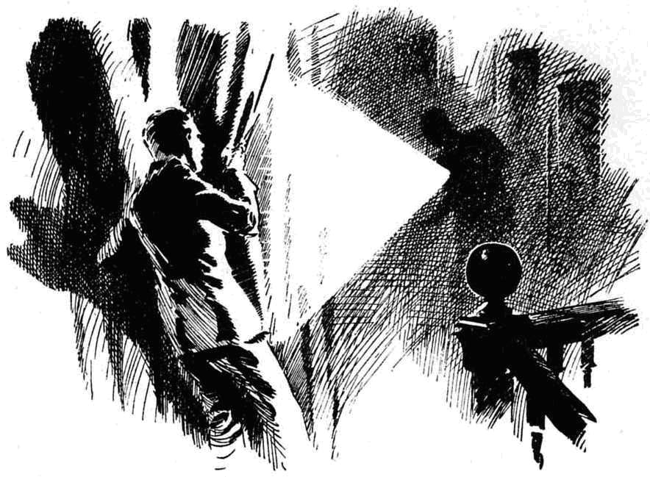
But the sight of that face seemed to startle the unseen man as much as Vernon-Smith himself was startled.
“A boy!” He heard the sharp ejaculation. “You! Vernon-Smith!”
That voice almost stunned the Bounder with amazement.
For he knew it!
It was the voice of Richard Steele, the temporary master of the Remove, last heard on the day Mr. Quelch had returned, and which the Bounder had never expected to hear again.
He gasped.
“Steele!”
The Bounder heard a sharp breath in the darkness.
“Silence!”
Steele almost hissed the word. The light was instantly shut off.
Vernon-Smith was silent from sheer, stupified astonishment. Steele! What was Steele doing at Greyfriars, creeping about the House in the darkness like a thief in the night?
“Silence!” repeated the well-known voice in a hissing whisper. “Boy! Come with me!”
A hand grasped the Bounder’s arm. He was led away, and he went like a fellow in a dream. What did it mean? What could it mean?
Steele—at Greyfriars! Who was he, what was he? The Bounder remembered the strange story that had once been a topic in the Remove, concerning the new master. Was the man, after all, a cracksman himself? But he knew it was not that, though what it all meant was a mystery to him.
In silence, the unseen hand led him away, and the Bounder went unresistingly. It was to Masters’ passage that he was led, the door of Mr. Quelch’s study was opened, and the Bounder was led in.
“Stand there!”
“Yes, sir!” breathed the Bounder.
“I—I don’t understand—”
“Silence!”
The Bounder stood silent. He heard Steele cross to the window and draw the thick blinds carefully. When it was certain that not a gleam of light would escape from the window, Steele turned the switch. The study was suddenly flooded with light, and the Bounder blinked in it. With startled eyes he stared at Richard Steele. -
The man was dressed differently now, dressed entirely in black, with rubber shoes. But it was Steele. The light gleamed on the keen grey eyes, the well-known square jaw. The expression on the strongly-marked face was stern, almost menacing.
The grey eyes fixed on the Bounder.
What are you doing out of your dormitory?” asked Steele.
“I might as well ask what you are doing here, Mr. Steele?” retorted the Bounder. He was recovering his nerves now. “Everybody believes that you’ve left Greyfrlars.”
“Answer my question,” snapped Steele.
“I came down—”
“For what?”
The Bounder explained coolly enough. Steele listened to him in silence.
“You would have done better to mind your own affairs, my boy.” he said, when Smithy had concluded. “Remain here till I return.”
“I don’t see—”
“Be silent!”
Steele left the study.
“My only hat!” murmured the Bounder, as Steele turned the key in the outside of the lock. He was taking no chance of the Bounder being gone before he returned. “Great pip! Has he gone to fetch Quelchy—or what? What on earth does it all mean?”
That was a question to which the Bounder could find no answer.
He waited.
He had not to wait long. The study door was unlocked again, and Mr. Quelch entered in slippers and a flowing dressing-gown, followed by Steele. The expression on Mr. Quelch’s face was not reassuring. His gimlet-eyes glinted at Herbert Vernon-Smith.
“Vernon-Smith! You have left your dormitory, at this hour of the night—”
“I’ve told Mr. Steele, sir—”
“Mr. Steele has told me. You have acted in a thoughtless, reckless, foolish way, Vernon-Smith, and might have done harm of which you never dreamed.”
“I know I’m goin’ to be licked, sir,” said the Bounder recklessly. “I’m ready.”
Mr. Quelch’s face set more grimly.
“You will not be caned, Vernon-Smith! You will be confined to the punishment-room. You will follow me there at once, and you will take care to be silent and wake no one.”
The Bounder stared. Fellows at Greyfriars were hardly ever confined to the punishment-room, which was more a survival of ancient times than anything else. Quelchy was coming down unexpectedly heavy.
“But, sir—” stammered the Bounder.
“You have brought this on yourself, Vernon-Smith! You need say nothing. Follow me !”
In silence, the Bounder followed the Remove master from the study. Steele shut off the light, and followed behind the Bounder.
THE FOURTEENTH CHAPTER.
Hard on Smithy!
“WHERE’S Smithy ?“
“Goodness knows!”
“The wherefulness is terrific.”
The rising-bell clanged out over Greyfriars, and the Remove turned out in the frosty morning. And the fact that the Bounder was no longer in the dormitory was at once apparent to the rest of the Remove.
“My hat!” said Skinner. “He’s making a night of it! Smithy never told me he was goin’ out of bounds.”
Harry Wharton stared blankly at the Bounder’, empty bed.
He had fallen asleep after the Bounder had gone in the night, and had not awakened again till the rising-bell sounded in the February morning. Evidently, Vernon-Smith had not come back.
“What on earth can have happened to him?” exclaimed Redwing.
“Grabbed by the Beaks for being out of dorm!” said Bob Cherry. “But I’m blessed it I can guess why he hasn’t come back! Quelchy would round him up and walk him home.”
The Remove men lost no time in getting downstairs that morning. Every man in the Form was early for prayers.
Vernon-Smith was not present at that function. Where he was, what had become of him, was a mystery.
Had he gone on one of his excursions out of school bounds, it might have been supposed that some accident had occurred. But it was known that he had not gone out, he had gone down to watch for the cracksman. Had anything happened to him in the House, it would have been heard of before this. Yet he had vanished.
The Remove fellows were intensely curious. At breakfast, which Mr. Quelch took with his Form, the Remove master’s face was seen to be very grim. But grim as he looked, Harry Wharton ventured to speak. That the Form master knew what had become of the Bounder, was plain, for he had made no remark on his absence from prayers, or his absence from the breakfast table. The Remove also wanted to know, and they considered that it was up to Wharton, as captain of the Form, to speak. So he spoke.
“Vernon-Smith is not here, sir.” said Harry.
The gimlet-eyes turned on him.
“I am aware of it, Wharton,”
“May I ask where he is, sir?” said the captain of the Remove diffidently.
“Certainly! Vernon-Smith is confined to the punishment-room!” said Mr. Quelch. “He was found out of dormitory bounds at a late hour last night, and taken to the punishment-room by me. He will remain there for some days.”
“Some days, sir?” repeated Wharton.
“Precisely.” -
“Smithy meant no harm, sir,” said Tom Redwing, speaking up for his friend. “He only had an idea of looking for burglars, sir.”
Mr, Quelch smiled faintly.
“I am aware of that, Redwing; Vernon-Smith explained his foolish conduct. But I have reason to be severe in this instance; and for the present, Vernon-Smith will remain locked in the punishment-room. He will take his meals there, and will not be allowed to communicate with the Form. Any boy attempting to communicate with him will be reported to the headmaster for a flogging.”
“Oh!” murmured the Remove.
“I may add,” continued Mr. Quelch grimly, “that any boy following Vernon Smith’s example, and leaving his dormitory after lights out at night, will be punished in the same way as Vernon-Smith. The period of Vernon- Smith’s detention is not yet decided, but it will probably be a lengthy one. I advise the boys of my Form not to follow his example.”
After which there was no more to be said—in the presence of the Form master, at least.
In break that morning, many follows trailed round the House, to stare up at the high window of the punishment room; a window crossed by iron bars, high up in an ivied wall.
Bob Cherry, whose eyes were very keen, declared that he could make out the face of the Bounder against the glass behind the bars.
“Poor old Smithy!” said Bob. “I wonder what sort of temper he’s in?”
“Ratty, I expect,” said Nugent.
“The rattifulness is probably terrific.” remarked Hurree Jamset Ram Singh. “It is preposterously hard on the esteemed Smithy.”
“Let’s chuck somethin’ up to the window to show him we’re here.” said Skinner. “Show him we sympathise, what?”
“Hallo, hallo, hallo!” ejaculated Bob Cherry. “‘Ware prefects!”
But it was too late to “ware” prefects. Round the building, from one direction, came Wingate of the Sixth, and Gwynne from the other, Loder, Carne and Walker. Skinner hastily dropped the pebble he had picked up.
“You’re out of bounds here, you kids!” said Wingate gruffly. “Every man here will take a hundred lines.”
“Oh, any hat! Just for looking up at a window!” ejaculated Johnny Bull.
“Just for that! Quelchy’s orders! And any of you found here again will get six of the best! Cut off!”
The juniors departed. Evidently unusual precautions were being taken to prevent communication with the incarcerated Bounder
There was no more gathering under the window of the punishment room.
After third school that day, Mr. Quelch was seen to turn his footsteps into the passages that led to the remote punishment-room. Apparently he was going to visit the prisoner. No doubt he had some nice little exercise in Latin verbs for the Bounder, to keep him from wasting his time during his imprisonment. And some of the fellows surmised that Smithy would cheek him when he got there; they could not imagine the Bounder taking this sort of punishment patiently.
As a matter of fact, however, Herbert Vernon-Smith was in a very subdued mood when the Remove master entered the punishment-room and closed the door behind him.
“I trust you have not wasted your morning, Vernon-Smith said Mr. Quelch, not unkindly
“I’ve done some of the exercises, sir!” answered the Bounder.
“Very good.”
“I’m tired of this, sir!” added Smithy.
Mr. Quelch smiled faintly.
“No doubt! But you have brought it on yourself, Vernon-Smith, and you have no right to complain.”
“I’m aware of that, sir.” answered the Bounder. “What I mean is, that I can be trusted to hold my tongue.”
Mr. Quelch looked at him.
“I’m shut up here, because I saw Mr. Steele in the House last night, and nobody knows he’s here, and I’m not wanted to spread it all over the school.” said Vernon-Smith coolly. “I’m no fool, sir; and I know perfectly well that that is the reason.’
“Indeed!” said Mr. Quelch.
“ Isn’t it so, sir?’
“You are punished for a serious infraction of the rules of the House, Vernon-Smith. You have no just cause of complaint.”
“I’m not complaining, sir! But I’m willing to give my word to say nothing of what I found out last night, and think you might trust me, sir. I’m not a babbling ass, like Bunter.”
Mr. Quelch stared slightly. The Bounder grinned.
“Since I’ve been shut up here, sir, for seeing Mr. Steele last night, I’ve done some thinking.” he said. “I suppose Bunter found something out, and that’s why he was sent one.”
The Remove master frowned.
“The less you think about matters that do not concern you, Vernon-Smith, the better.” he said dryly.
“I think you might trust me to keep my word, sir, if I promise to keep my mouth shut.”
The Remove master looked at him steadily.
“The matter is not wholly in my hands, Vernon-Smith,” he said. “neither do I feel satisfied that I could trust your discretion. You must remain here—and you have, as you must admit, only yourself to thank.”
And the Bounder remained. That day, and the next day, his place was vacant in the Remove; and the fellows wondered how long it was going to last.
The Bounder—with plenty of time for thinking on his hands now—wondered, too; and wondered still more what Richard Steele’s secret presence in the House might mean, and why the powers considered it so important to keep that presence a secret. A word from Harry Wharton might have enlightened him; but no word came to the Bounder—and in all his surmises he came nowhere near the truth,
THE FIFTEENTH CHAPTER.
Caught in the Act!
MIST from the sea rolled heavily over the quadrangle of Greyfriars, deepening the darkness of the February night
One had boomed out from the clock- tower, echoing dully through the shrouding mist.
The House was silent, buried in darkness and slumber. Not a light gleamed from a single window. If anyone in the great building was awake, he was as silent as those who slept.
In the dim mist of the quadrangle a silent figure flitted. It moved like a spectre — swift, flitting, noiseless. Hardly a sound mingled with the moaning of the wind, as a window opened under a skilled hand.
Within the house, the window closed but unfastened behind him, the dark figure stood motionless for many minutes, listening, intently, with bent ear.
Then it flitted on.
In the darkness, it was invisible, had there been any eye to watch; but had it been visible, only a dark-clothed, active figure, a face hidden by a pulled down cap add a thick muffler drawn across, would have been seen.
Eyeholes were cut in the dark muffler bound across the hidden face, from which two searching eyes glinted but, watchful as a cat’s.
The man with the hidden face must have been well acquainted with the interior of the House, for his swift movements never paused till he reached the door of the headmaster’s study.
His hand groped over that door, and it opened under his touch. Within the study, he closed the door softly.
Again he stood still listening. But now it was only for moments. There was no hint of alarm in the sleeping House. And, like a man who knew the way well even in the clinging gloom, the dark figure crossed to the safe in the corner of the study,
A brilliant beam of light shot out of the blackness. It was concentrated on the door of the safe from an electric torch in the hand of the midnight prowler.
Round him the blackness was all the more intense from the brilliancy of that single narrow beam of light.
A black-gloved hand wandered over the lock of the safe. There was a soft, almost inaudible chuckle from the man with the hidden face. The combination lock presented little difficulty to the Courtfield cracksman.
Quietly the man drew a little table towards the safe and set the flash-lamp on it, its bright beam concentrated on the lock.
The black-gloved hand felt over the hock again. No fingerprints would be left to betray the midnight thief.
The dark figure, partly revealed where it intercepted the light, hardly stirred. Only the hand on the knob of the safe was active. There was a whirring sound.
The hidden face was bent as the cracksman listened intently to the click and whir of the tumblers, as it by listening he could divine the secret of the combination—as, no doubt, he could.
Once or twice he paused, as if in mental calculation; then the whirring went on again.
Soundlessly the heavy iron door rolled open.
The Head’s safe was at the mercy of the thief in the night
He picked the flash-amp from the table and turned its light into the interior of the safe.
From the interior he lifted out a heavy, iron-bound box, so heavy that it cost him an effort to lift it from its resting-place.
It was the box that Dr. Locke had brought from the bank at Courtfield a few days before; and from its weight, it had plainly not been unpacked, whatever had been brought away from the bank was still within it.
Setting the box on the floor and placing the lamp to gleam on it, the cracksman bent over it. The box was locked; but that was not likely to delay long the man to whom the combination lock of the safe had given little trouble.
In a minute, or less, the lid was raised. Thievish fingers groped in the box.
Then there was a muffled, startled exclamation. The glinting eyes through the eye4ioles in the muffler stared into the box amazedly, unbelievingly.
“Lead!”
Not the famous Greyfriars plate, gold and silver; not the bundles of bonds that he had expected to see. Blocks of lead were packed in the iron-bound box —packed within it to give it weight.
For a long second the cracksman stared at the worthless mass of metal in the box.
His lips were drawn back from his teeth in a snarl; his eyes burned. It was not only surprise, disappointment, that stirred him. He knew that he had been tricked. The valuables were still at the bank; there was nothing in the safe that was worth his while. But the trick that had been played told that his visit had been looked for; that it was watched for; that he had fallen into a trap.
And even as that bitter knowledge flashed into the mind of the thief in the night a grip of iron was laid on him from behind and he was borne to the floor; and a sharp click followed as his hands were dragged together and the handcuffs snapped on his wrists.
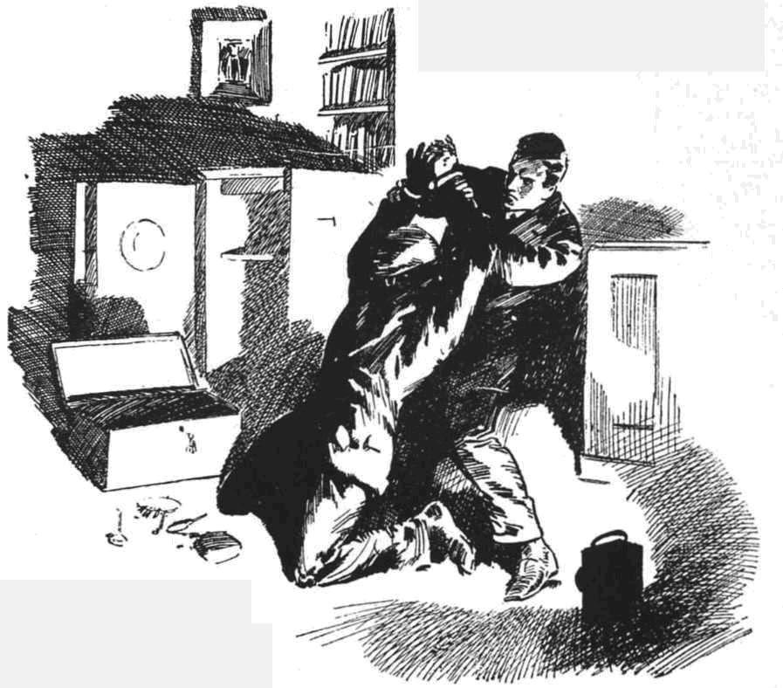
The next instant the man was struggling wildly, savagely, intensely, with the ferocity of a caged tiger. But his struggles were futile with the strong steel fastening his wrists together; neither was he a match physically for the tall, athletic man whose grasp was upon him.
For a full minute it lasted, the silence broken only by panting breaths and shuffling feet. Then it ceased, and the man with the hidden face lay gasping on the floor.
The other man stepped to the electric light switch and turned it on.
The room was flooded with light.
It shone on the gasping, panting, manacled man sprawling on the floor, his eyes burning like fire through the holes in the muffler. It shone on the grey eyes and square jaw of Richard Steele, standing over the captured cracksman, gazing down at him.
“You!” breathed the man with the hidden face.
Steele nodded.
“You! Who are you?”
Inspector Irons, of Scotland Yard— at your service!”
THE SIXTEENTH CHAPTER.
At Last !
“BLESS my soul!”
Dr. Locke uttered that ejaculation as he stepped unto the study, followed by Mr. Quelch.
The man with the hidden face was seated in a chair now. his less were tied to the legs of the chair; his handcuffed hands lay helpless on his knees; the schoolmaster detective had made sure of that, before leaving the study to call the two masters.
They gazed at the captured cracksman.
He was quiet and calm. On the well-cut lips below the mask in muffler that still hid his face a cynical smile could be seen. The game was up; the Courtfield cracksman had come to the end of his long run at last; but he was game at the finish.
“You—you have taken him!” said Mr. Quelch.
“As you see, sir!” answered Mr. Steele
“Bless my soul!” repeated the Head.
His glance wandered to the open door of the safe; to the iron-bound box that lay on the floor with its lid forced open.
Steele smiled.
That precaution, after all, was not needed, sir.” he said, with a nod towards the lead packed in the box. “But with so cute a customer it was as well not to take risks. Had I failed I should have been sorry to see the famous Greyfriars plate go to the melting pot.”
“But you have not failed.” said Mr. Quelch. His eyes were fixed on the bound man in the chair. The face was hidden, but there seemed something familiar to them in the chin and the mouth. “This, then, is the Courtfield cracksman.”
“It is the Courtfield cracksman.”
“You were right, Mr. Irons,” said the Head. “I suppose 1 may use your name freely now that your work is done. Evidently this man learned that the box had been brought from the bank, as you believed he would. Yet how he learned—”
“It was this talk of the school, sir.” said this Scotland Yard man, with a smile. “You were good enough to carry out my instructions implicitly.”
“True! But—”
“The man was not far away, sir.”
“You mean that his hiding-place was close to this school!”
“Very close indeed, sir! No farther off, I think, than your own garage.”
The head started.
“Mr. Irons, impossible !”
“You must prepare yourself, sir, for a shock.” said the man from Scotland Yard quietly. “I have said nothing hitherto—it was more advisable not— but now you must know the truth. This is a man you know and have trusted.”
He drew muffler from the hidden face.
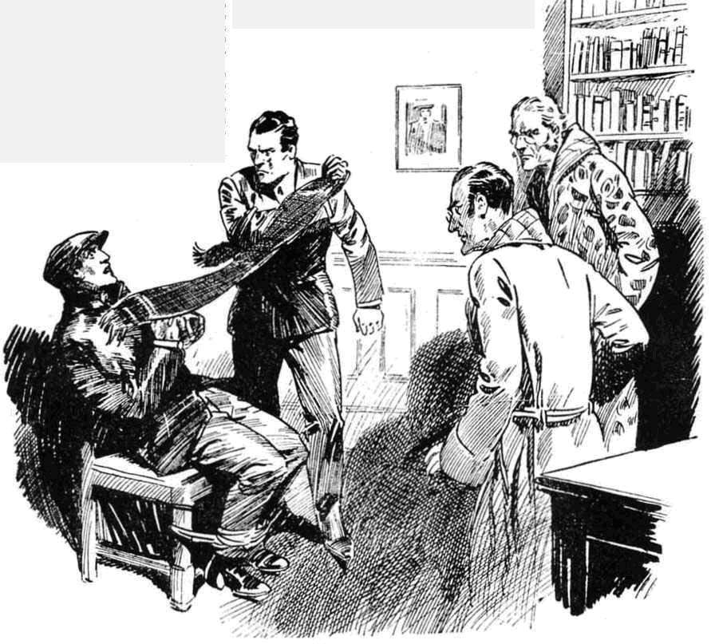
The Head uttered a cry.
“Barnes!”
It was upon the face of Barnes, the Head’s chauffeur, that the light shone now that the disguising muffler was drawn from the face of the Courtfield cracksman.
The Head gazed at him in horror. Mr. Quelch in almost stupefied amazement.
“Barnes!” repeated the Head.
More correctly. Poynings.” said Inspector Irons. “His past career has been traced out, during last few weeks. Arthur Poynings, ex-officer— known to you as Arthur Barnes, chauffeur. There is no doubt that he had been following his lawless career for years, before he came intO your service, sir—every employment he has held previously has been traced, and in every place there is a history of mysterious robberies.”
Dr. Locke could only gaze at the rascal in silence.
“And I never guessed!” said Barnes, his eyes turning to the man from Scotland Yard. “You played your game well, Irons! I soon found out that the new schoolmaster was a night prowler, and I wondered what his game was—even for a moment suspected what it really was! But I searched your rooms, at night when you were prowling, and found nothing—and you have played the schoolmaster well—oh, well indeed !”
“I was once a Form master!” said the man with the square jaw.
“If I had guessed—” The cool face worked for a moment, the eyes burned. But in an instant Barnes was calm again. “How did you know?”
“I did not know—and I came here never dreaming that my man was within the walls of the school,” said Inspector Irons. “It was partly through some of the schoolboys, partly by chance, that my attention first turned to you. And even after that, you were so wary that I almost despaired. You have given me the hardest task of my career, Poynings.”
“That is not what I would have given you had I guessed!” said Barnes. ‘You took your life in your hands, sir.” He shrugged his shoulders. “You played your game well! When you left, any uneasiness I had was gone—and all the time—all tho time you were watching—watching—” He broke off.
Bah! I’ve had a long run, and a good run, and I’m ready to take my gruel! You’ve done me, and I’m not whining! And I fancy that the prison is not yet built that will hold me.”
“We shall see!” said the inspector. And he stepped to the telephone.
* * * * * *
Greyfriairs heard the news next day.
It was more than a nine days’ wonder.
Barnes was gone before the fellows came down; gone to the cell that awaited him, there to remain till he stood his trial. The Courtfield cracksman was in custody at last, and the news flashed far and wide by telegraph and telephone.
But greater than the sensation of the cracksman’s arrest, greater than the sensation that the cracksman’s was Barnes, the Head’s chauffeur, was this sensation of the revelation that Richard Steele, pro-tem. master of the Greyfriars Remove, was a Scotland Yard detective. The secret that had once been known only to Harry Wharton, was a secret no longer, and was known to all.
“So that was why!” said the Bounder, understanding at last, and glad enough that the final success of the schoolmaster detective had released him from the punishment-room. “That was why! Well, good luck to him—I’m glad he’s got his man!”
“The gladfulness is terrific!” said Hurree Jamset Ram Singh. “But the surprisefulness is preposterous .”
“All’s well that ends well.” said Bob Cherry. “There’s only one fly in the ointment, my beloved ‘earers.”
“And what’s that?” asked Harry Wharton.
“Bunter will be coming back!”
“Bunter?”
“Yes, Bunter! It’s jolly clear now that lhe was scooted out to keep his silly tongue from wagging—and it doesn’t matter now if it wags from morning to night. So they’ll let him come back.”
“If you have tears prepared to shed them now!” grinned Nugent .
“Ha, ha, ha!”
But on the whole, the Famous Five were not sorry that Bunter would be coming back. They had had, at least, a long rest from Bunter, and when he came back, they were prepared to bear him with fortitude .
But Bunter was not back yet! Billy Bunter’s return to the school he adorned was destined to be made in remarkable circumstances.
THE END.

