The to the to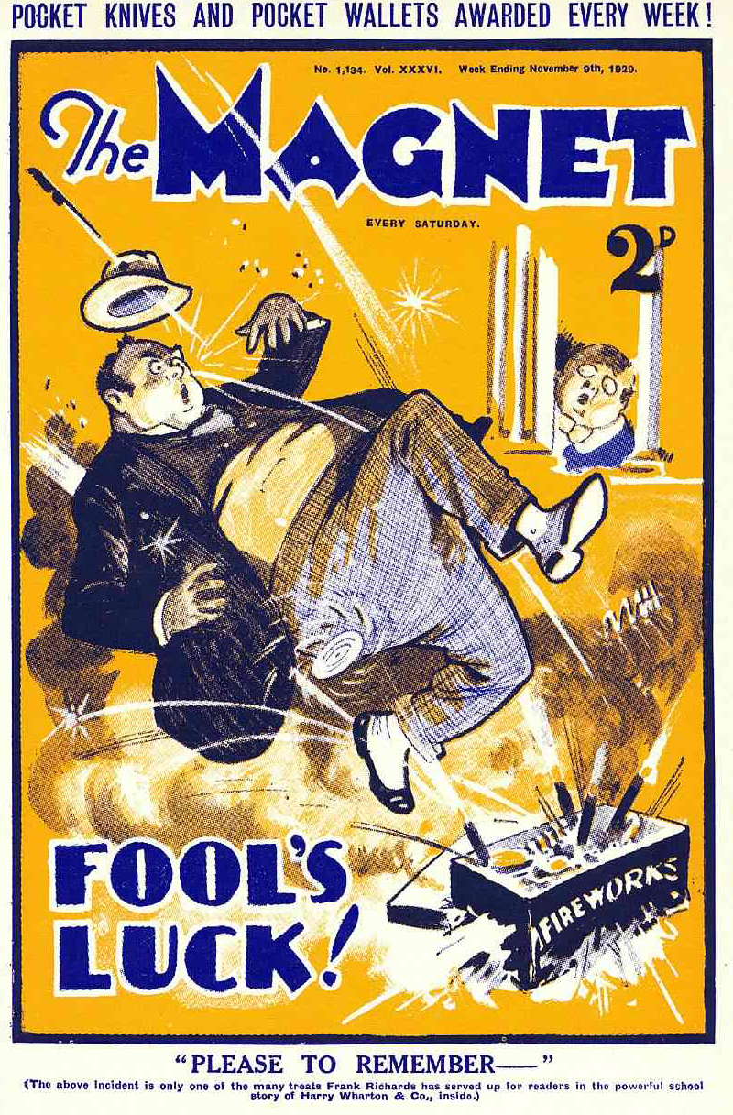
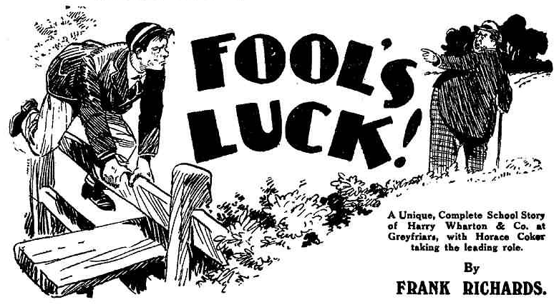

THE FIRST CHAPTER.
A Matter of Principle!
“NEVER”
Coker of the Fifth uttered that word in loud and emphatic tones. So loud and so emphatic were Coker’s tones that they reached many more ears than those for which they were intended.
“But, old chap—” urged Potter of the Fifth.
“You see—” said Greene.
‘Never!”
Coker repeated the word, with even more loudness and emphasis. That a dozen other fellows, as well as Potter and Greene, heard him, did not matter a straw to Coker. He would not have cared if all Greyfriars had heard him. He did not care if the whole world listened in
Horace Coker was standing under one of the old elms in the
quad, leafless now in the November winds. He stood erect, his shoulders squared, his hands thrust deep into trousers pockets, his whole attitude and expression indicating dogged determination. Ajax, in his celebrated lightning defying act, must have looked a good deal as Coker looked at that moment.
Harry Wharton & Co., coming along to the House, naturally paused to look on. So did other fellows. Coker did not mind. In fact, Coker liked an audience.
“Never!” said Coker, for the third time.
“The neverfulness is terrific!” murmured Hurree Jamset Ram Singh; and the other members of the Famous Five chuckled.
“But what’s up?” asked Bob Cherry
“I suppose Coker’s playing the giddy ox again.” remarked Harry Wharton. “After all, it would be rather unusual if he wasn’t.”
“Coker old man—” urged Potter.
“Cheese it, Potter!”
“Old chap—” murmured Greene.
“Shut up, Greene!”
Potter and Greene exchanged helpless looks. Coker having reduced them to silence, proceeded, with the emphasis as before:
“Never! I’ve said never, and I mean never! See? I’ve stood enough from Prout. There’s a limit to what a man can stand from an old donkey of a Form master! Prout’s reached the limit. He stops there! See?”
“Oh, its Prout!” said Frank Nugent.
Many faces registered hilarity.
Coker’s troubles with his Form master were perpetual. Coker being the densest and most backward fellow in the Fifth, and being convinced that he was the brightest and cleverest fellow in that Form, trouble was bound to accrue. Prout would lose patience with Coker—and Coker would lose patience with Prout.
Now, it seemed, matters were coming to a head.
“There’s such a thing,” said Coker, “as justice! If a fellow wasn’t in the right, a fellow could give in. But when a fellow’s clearly in the right, what’s a fellow to do?”
“You have to give a Form-master his head!” urged Potter.
“Like a horse!” said Greene.
“There’s a limit!” said Coker firmly.
“Look at it! Prout jumped on me for nothing. I was thrashing some fags— those young sweeps who are standing grinning there—”
Harry Wharton & Co. grinned more expansively.
Coker, according to his own description and belief, had been thrashing them. Their own impression was that Coker had been getting the thrashing.
“Prout butted in,” continued Coker indignantly, “gave me five hundred lines. Like his cheek! He’s always butting in! Prout’s a man who never can realise that another man knows best!”
“Form master, you know!” muttered Potter. “We always give in to Prout, old chap!”
“That’s all right for you,” said Coker. “But I’ve got my personal dignity to consider, add my position in the school.”
How Coker’s position in the school differed from that of any other Fifth-Former at Greyfriars was a secret known only to Coker. But Horace was satisfied that it did. In Coker’s own eyes Horace James Coker was a person of tremendous importance.
“He butted in,” resumed Coker. “He gave me a hefty impot. I said I wouldn’t do the lines, and have I done them? Never!”
“But you’ve got detention for not doing them!” said Potter.
“I’m not doing the detention, either” said Coker. “Prout’s detained me this afternoon! I’m not standing it! I said never! You heard me?”
“Nearly all Greyfriars heard you, old bean. ” said Bob Cherry. “In fact, you could be heard nearly as far as Friardale.”
“Ha, ha, ha!”
“Shut up, Cherry!” Coker frowned at the grinning Removites. “If you want another licking, I’m the man to give it to you! Look here, Potter, it’s no good talking. I’ve got detention unjustly. I can’t give in, as a matter of principle. I refuse to be detained.”
“But—” said Potter distressfully.
“Never!”
“But—” sighed Greene of the Fifth.
“Never!”
“I say, you fellows, ” squeaked Billy Bunter, “ here comes Prout!”
“Oh, my hat!”
All eyes turned in the direction of the House.
From the House came Mr. Prout, the master of the Fifth Form, and he came directly towards the group under the elms.
Prout was not looking genial. The
Generally, the portly and ponderous master of the Fifth Form was a genial and cheerful gentleman. He fancied himself in the character of the schoolmaster who has not forgotten his own youth, and who cultivates frank and friendly terms with his boys. Often he was in a chatty mood, and would keep a Fifth Form man standing for ten minutes or more, shifting wearily from one leg to the other, while he chatted. Prout’s genial chats were dreaded in the Fifth. Fifth Form men would dodge round corners to escape them.
But the overflowing good-humour of the Fifth Form master had been conspicuous by its absence for some time past. Neither genial nor chatty, Mr. Prout had become testy, irritable, impatient.
What was the matter with Prout was a mystery in the Fifth. They agreed that Coker was enough to turn any Form master’s hair grey; that a man who had to teach Coker things might well be heading for a nervous break down. Still, it couldn’t be all Coker. There was something else—some worry on Prout’s mind. Nobody in the Filth knew what it was; but they got the benefit of it. Prout had been so ratty and unpleasant the past few days that the Fifth would almost have preferred him in his old chatty mood.
Prout came ponderously down the path, and the watching eyes of a score of fellows saw his frown deepen as be glanced at Coker.
Coker faced him resolutely.
Under so many eyes Coker felt that he had to stand up to Prout. He had announced, loudly, his intention of not giving in to Prout. Coker was not the man to eat his words.
There was silence as Prout arrived.
“Coker!”he said.
“Yes, sir!” answered Coker, with a, judicious mingling of the firmness due to himself and the respect due to a Form master.
“I have told you that you are under detention this afternoon.”
“Quite, sir. But— ”
Prout raised a plump hand.
“You need say nothing, Coker. I have prepared a detention task for you. Go to my study now, and wait there.”
“But, sir—” began Coker.
Prout, heedless, passed on. He proceeded on his ponderous way. leaving Coker and his audience behind.
All eyes turned on Coker. Every fellow was interested to know what Coker would do. It was not uncommon for a fellow to declare that he couldn’t stand the Beak, that he wouldn’t stand the Beak; and that he was going to tell the Beak exactly what he thought of him. But when it came to the pinch such a fellow always discovered that he could and would, after all, stand the Beak; and he never did tell the Beak what he thought of him.
There was a long pause.
“Better go in, old chap. ” whispered Potter, anxious to save Coker from himself, as it were.
“I’ve said I’m not going to be detained, Potter” answered Coker.
“Yes; but——”
“What I say I mean!” said Coker.
“Yes,” said Greene; “certainly. “But—”
“But,” said Coker, “I can go to the man’s study. He has a right to tell me to go to his study. I will do that.”
“Oh!” said Potter and Greene.
And Coker walked away to the House and went in. Potter and Greene stared after him, looked at one another and grinned. The other fellows chuckled.
The threatened rebellion in the Fifth Form at Greyfriars had not—for the moment—come off. It was, at least, postponed. And the general impression of Coker’s audience was that it would be indefinitely postponed.
THE SECOND CHAPTER.
Startling!
“SCANDALOUS!”
Billy Bunter jumped.
“Iniquitous!”
Bunter stared.
The Owl of the Remove had had the impression, until that moment, that he was alone in the old Cloisters.
It was because it was such a secluded spot that Bunter had selected it.
Bunter as a rule, was a gregarious fellow. He liked company. But circumstances alter cases.
When Bunter was in possession of a cakehe found that solitude had its charms.
It was all very well for the poet to ask “O Solitude, where are the charms that sages have seen in thy face?” When a fellow had a cake there was a lot to be said for solitude.
Besides, the parcel under Bunter’s arm did not belong to him. It was only his by right of possession. Possession is said to be nine points of the Law. By nine points of the law, therefore, that parcel belonged to Bunter. By the tenth point it belonged to Bob Cherry, from whose study cupboard Bunter had surreptitiously extracted it.
So the idea of solitude appealed to Bunter more than ever. Solitude spelled safety. Bob Cherry took a large size in boots and Bunter had no desire to ascertain their exact weight.
With the parcel under .his arm, therefore, the Owl of the Remove had rolled away to that sequestered spot. He stopped in a shady spot among the old stone pillar, and unfastened the string of the parcel. That the parcel contained a cake Bunter did not yet know, but hp had no doubt of it. He had seen Bob carry that parcel into Study No. 15, half-concealing it under his jacket, as if he wished to keep it from general observation, Rooting in the study afterwards, Bunter had found it at the very back of the cupboard, hidden by three or four other articles placed over it, screening it from sight. Obviously, to Bunter’s mind, the parcel contained tuck. For what else but tuck could a fellow be so extremely careful about, and take so much trouble to conceal?
Inside the wrapping paper Bunter felt a cardboard box. Obviously, to Bunter, that box contained a cake.
It was not long since dinner1 and even Billy Bunter was not hungry again yet. But hungry or not, Bunter could always deal with a cake.
He proceeded to unwrap the parcel, exposing the cardboard box to view. He was about to open the box itself, when those startling ejaculations, in the rich, fruity voice of Mr. Prout, reached his fat ears.
“The rascal!”
“Oh crikey!” murmured Bunter.
He blinked round the stone pillar in alarm.
Prout, evidently, was walking in the Cloisters. It was half an hour since that little scene with Coker in the quadrangle, and Bunter had noticed, at the time, that Prout’s ponderous tread had carried him in the direction of the Cloisters. Since then he had forgotten all about Prout. Apparently the master of the Fifth was still there; and he also must have been rather forgetful, as Coker, no doubt, was waiting for him in his study all that time.
“Scoundrel!”
Bunter quaked.
His impression was that Prout had spotted him in surreptitious and felonious possession of another fellow’s cake and was addressing those unpleasant remarks to him.
“Villain!”
Prout’s ponderous tread passed the stone pillar behind which Bunter quaked, with the parcel in his fat hands.
To Bunter’s relief, it passed, and did not stop.
He realised that Prout had not seen him, and did not know that he was there.
Prout was talking to himself!
Certainly, he was not calling himself all those unpleasant names. He must have been alluding to some other person whom he regarded with wrath and scorn.
Bunter blinked at Prout’s broad back as he passed. a whiff of strong cigar-smoke came back to him, and Bunter almost sneezed.
Prout smoked big black cigars, with a hefty scent. Prout really had reached an age when a gentleman cannot smoke big black cigars with impunity. As a rule, Prout allowanced himself rather carefully with those cigars. But of late, wth a somewhat mysterious trouble on his mind, Prout had sought solace in tobacco, and instead of one cigar in the evening, he would light up five or six in a day. Probably that helped to account for Prout’s irritable temper in these days.
Bunter suppressed his sneeze. He did not want to attract Prout’s attention. He waited for the footsteps to die away.
They died away, and Prout was gone leaving a trait of blue smoke behind him. Then Bunter proceeded to open the cardboard box.
His little round eyes glistened behind his big round spectacles as he did so. He was sure it was a cake. It might, perhaps, be tarts, or candied fruit, or something like that. Whatever it was, Bunter was going to enjoy a feast.
But as he removed the lid of the cardboard box a change came o’er the spirit of his dream, as a poet has expressed it.
“Oh!” gasped Bunter.
He blinked into the cardboard box.
It did not contain a cake; it did not contain tarts; it did not contain anything that even Bunter could regard as edible.
It contained fireworks!
Bunter was aware that the Fifth of November was near at hand. Like other schoolboys, he was pleased to remember the Fifth of November, and to celebrate the anniversary of Mr. Fawkes’ desperate attempt to stem the tide of eloquence in the House of Commons. He was aware that some fellows were laying in fireworks, strictly against the rules of the House, which very properly forbade such dangerous things to be kept in the studies. The surreptitious manner in which Bob Cherry had convoyed that parcel to Study No. 13 was explained now. Bunter’s thoughts, naturally, had run on tuck. Bunter lived and moved and had his being in tuck. Bob’s thoughts, evidently, had run on fireworks.
“Oh crumbs! Beast!” gasped Bunter. He stared at the box of fireworks, and glared at it! His very spectacles gleamed with indignation.
“Beast! Giving a fellow all that trouble for nothing!” gasped Bunter. “Of all the rotters—”
There was quite a stack of fireworks in the box—squibs, Catherine-wbeels, crackers, and jumping crackers! On the glorious Fifth, with the bonfire going, they would have been delightful. But they were of no use to Bunter now. He had not wended his solitary way to the Cloisters to let off fireworks all by himself; neither could be have let them off without giving himself away to all Greyfriars.
“Beast!”
Bunter was landed with plunder that he did not want. It had been risky getting that parcel away from Bob’s study and the risk had to be taken over again to return it. Bunter did not think of taking that risk. If the beast wanted his beastly fireworks, he could find them and fetch them. Bunter discontentedly dropped the box at his feet, with the intention of leaving it there.
“Scandalous!” It was Prout’s voice again. “Iniquitous!” Prout was still communing with himself.
“Oh crumbs!” murmured Bunter.
He crouched behind the stone pillar.
Prout had not gone when Bunter supposed he had. He was paving the Cloisters, and, having paced to the end, he was now pacing back. Prout, plainly, was in a troubled and angry frame of mind, reflecting on the mysterious trouble that had fallen on him of late, and which made life so trying in the Fifth Form room. With a cigar near its end, glowing in his mouth, the portly master of the Fifth came ponderously along, and Bunter quaked in cover, alarmed at the posibility of being caught in possession of that box of forbidden fireworks. Until the great day came a junior was not supposed to have fireworks in his possession, and Bunter realized that, though the fireworks were not his own, he could not explain to a Beak that he had pinched them in mistake for tuck.
Prout’s heavy tread came nearer and nearer, and Bunter, blinking from behind the pillar, saw him, and popped his head back quickly. Prout’s eyes were on the ground, his brow deeply corrugated. He had not seen Bunter. He was buried in troubled thought—thought so deep that he had not noticed that his cigar was burning perilously close to his lips, and would give him a shock soon if it was not ejected.
On the November breeze that whistled through the Cloisters there came again a powerful whiff from the cigar. This time it caught Bunter fair and square, and before he knew what was happening he was sneezing.
“Oooooh! Atchoo! Atchooo! At- chooooooh!”
Prout stoppcd suddenly. He had supposed himself alone in the Cloisters. That Gargantuan sneeze warned him that he was not.
“Who is there?” snapped Prout, making a stride round the stono pillar behind which Bunter stood and sneezed. “Ow! Ow!” he continued, as the cigar, at the last lap now, began to burn his majestic mouth.
Mr. Prout promptly hooked the remnant of the cigar from his mouth and flung it down.
It fell into the box that lay at the foot of the pillar, and which Mr. Prout had not noticed.
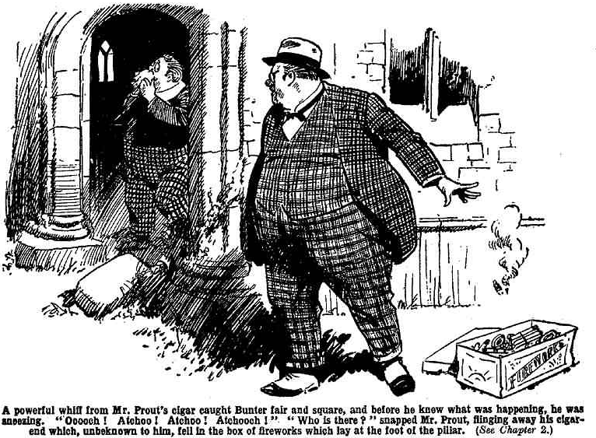
“Bunter!” he snapped.
“Atchoo! Chooo! Chooo!” sneezed Bunter.
“What are you doing here ?“ rapped out Prout.
Probably the Fifth Form master was aware that, in his supposed solitude, he had been muttering his reflections aloud, and it was intensely irritating to discover that a Lower boy had overheard him.
“I—I— Atchooh!” gasped Bunter. “I—I wasn’t doing anything, sir! I—I—I—”
“You were listening!” hooted Prout
“Nunno! Oh, no, sir! I—I never heard a word of what you were saying about Coker, sir !” gasped Bunter.
“Coker?” repeated Mr. Prout, blankly.
“Yes, sir I never heard you calling Coker a villain, and a rascal, and a scoundrel, sir!” stuttered Bunter.
“Pooh! You are a ridiculous boy!” snapped Mr. Prout, who certainly —had not been thinking of Coker when he made those cryptic remarks. “You—”
Mr. Prout was interrupted.
Bang! Fizz! Whizz!
“Good gad!” gasped Mr. Prout.
The inevitable had happened. A burning cigar-end could not be dropped into a box of fireworks without something happening. Now it started to happen.
Bang! Bang! Bang! Fizzzz! Whooooch! Fizzzz!
“Oh crikey!”gasped Bunter.
He backed away hurriedly as the sparks flew. Mr. Prout, who was standing close beside that box of fireworks, stared round him in wonder and alarm. It seemed to him that an earthquake was breaking out at his feet through the old stone flags of the Cloisters.
Bang! Bang! Bang! Bang! Bang!
“Oh, goodness gracious! Bless my soul! Oh!” spluttered Mr. Prout, leaping away with an activity that was amazing, considering the weight he had to lift.
The stack of fireworks in the box were all going strong now. They scattered as they exploded. Catherine-wheels whirled merrily in all directions. Squibs squibbed in showers of sparks. Crackers cracked. Mr. Prout, in a state of utter bewilderment, jumped away, and staggered against the pillar.
Bang! Bang! Bang! Fizzzzz!
“Bless my soul! Goodness gracious! What—what—what—”
Bang! Bang! One of the fearsome contrivances called jumping crackers, which explode a nunber of times in succession, landed between Mr Prout’s, leaped after him. Bang! Prout made another jump, and the cracker made another jump. Bang!
“Goodness gracious! Upon my word! What—what——”
Bang!”
“Ow! Yaroooh!”
Prout, in his hurry, stumbled over the cardboard box and fell. The cracker, with its last jump, landed on his back. There it proceeded to give fourth its last bang.
Bang!
Whooop !
Prout rolled over among the exploded fireworks. A squib, just at the end of its tether, exuded its last sparks into Prout’s neck. The roar that burst from Prout awoke every echo of the ancient Cloisters.
He scrambled to his feet. His face was purple, his eyes ablaze. The mildest tempered master might have been exasperated by what had happened; and Prout had already been irritable and testy. Now he was in a state of towering rage, compired with which the wrath of Achilles, so eloquently sung by Homer, was a mere trifle, light as air. With purple face and gleaming eyes Prout rushed towards a fat figure that
was bolting out of the Cloisters.
In the quad there were startled exclamations and irrepressible chortles at a strange and unaccustomed sight, unprecedented in the history of the school—that of a fat junior, streaking towards the House at frantic speed, with a portly, purple Form master streaking on his track.
“Go it, Bunter!” shrieked a dozen voices.
“Ha, ha, ha!”
Terror is said to lend wings. Certainly Billy Bunter appeared to be doing something like sixty as he streaked across the quad. He won that wild race and plunged into the House and vanished. The next moment, Prout plunged in after him; and a roar of laughter followed Prout in.
THE THIRD CHAPTER.
A Phone Call!
BUZZZZZ!
Horace Coker grunted.
Coker was still in Prout’s study when the telephone bell rang stridentiy.
Prout had told him to go to that study and wait. Coker had decided to do as he was told. He was still determined that be would not be detained that afternoon. On a matter of principle, Coker felt that he could not give in. But a fellow who was standing up for his rights was bound to be careful to observe the rights of others, especially those in authority. Coker felt that. So Coker was going to obey all reasonable orders. That was how Coker put it to himself, though to other fellows it simply seemed that Coker had backed down under his Form-master’s eye.
Coker had been in the study more than half an hour now. He would have supposed that Prout had forgotten him, had it seemed possible for anyone to forget so important a person as Horace James Coker. That not being, in Coker’s opinion, possible, he concluded that Prout had been delayed somehow,
Coker was standing at the study window, gloomily staring out into the quad, when Prout’s telephone bell rang. He grunted, but gave it no other heed.
Buzzzz!
The bell rang again. Coker, at last, turned impatiently from the window and took the receiver off the hook.
Naturally, he couldn’t stand the incessant buzzing of the raucous bell. Besides, it was only good-natured to tell the caller that Prout wasn’t there and take a message for the absent Form master—if any.
“Hallo!” growled Coker into the transmitter.
“Mr. Prout?” came a squeaky voice.
“This is Mr. Prout’s study— ”
There was am indistinct mumbling on the telephone. As so often happens on long-distance calls, the instrument was buzzing, and the voice of the caller was only one item on the programme.
Through the blurred buzz on the wires, Coker heard the name of Prout repeated, and a word he took as “tie!”
“Blow the beastly thing!” said Coker. “I suppose this is Prout’s haberdasher, and he’s been ordering some new ties or something. Look here, I can’t hear you!”
The squeaky voice came more clearly for a moment.
“I have not heard from you, Prout. You stated that you would telephone or write. You have done neither.”
Coker did not reply for the moment. He stared at the instrument. That squeaky voice had a familiar ring to his ears.
Somewhere, he had heard that unpleasant, acid-toned, squeaky voice before. He was sure of that
“Can you hear me? The instrument is buzzing! Can you hear me?”
“Who’s speaking?” demanded Coker.
“Tighe.”
“Yes, I know you’re speaking about a tie. Are you the outfitter at Courtfield?”
“I cannot hear you distinctly,” came the squeaking voice. “Kindly tell me your intentions at once, Mr. Prout. I have the document ready for your inspection, and I am prepared to meet you in the same place as before, this afternoon, at the same time, and show it to you.”
“Look here—”
“Am I to see you or shall I let the law take its course?” came clearly and angrily. “Yes or no?”
“My hat!” murmured Coker, in amazement. “Do they think Prout has pinched a tie out of their shop, or what? You must be potty, I think. Sure you’ve got the right number”
“What? Is that not Mr. Prout’s study at Greyfriars school?”
“Yes. Prout’s out.”
“What? ”
“Prout’s out, and as I happened to be in the study, I’m taking the call. Can I give Prout a message?”
“Oh!”
The buzzing on the phone had cleared somewhat, and the owner of the squeaky voice apparently heard all that Coker said. He seemed to be startled at hearing his interlocutor was not Mr. Prout.
“I’ll give him a message, if you like,” said Coker. “But I tell you that if you’ve missed a tie, it’s no good asking Prout about it. He can’t know anything about your ties.”
“That is not Mr. Prout speaking?”
“Of course it isn’t! I keep on telling you that Prout’s out,” grunted Coker. “I’ll give him a message, if you like, when he rolls in”
Who is speaking? Your voice seems familiar,” squeaked the man at the other end. “Now that I hear it clearly, it seems familiar to me.”
“So does yours to me,” said Coker. “I suppose you’ve served me in the shop, or something. Who are you, the Courtfield outfitter?”
“No, no! Tighe—Mr. Tighe
“For goodnes sake, ring off about that tie!” hooted Coker. “I don’t care two straws if you’ve missed a tie and Prout doesn’t either. Do you think a Greyfriars Form master is a shoplifter?”
“What? What? I don’t understand you.”
“And I jolly well don’t understand you. I ask you who you are, and you keep on blithering about a tie you’ve missed. Talk sense! If you tell me you’ve missed a tie again, I’ll put the receiver back.”
“Who is speaking? I am sure I know your voice.”
“My name’s Coker—”
“WHAT?”
It was a startled bowl instead of a squeak.
“Coker—Horace Coker, of the Fifth Form here. Prout’s my Form master. What the thump’s the matter? Nothing in a fellow’s name to make you jump, is there? Look here, if you’ve got any message for Prout, cough it up! I’m getting tired of standing here, see! Now, then?”
Coker paused, like Brutus, for a reply. Like Brutus, he paused in vain. There was no reply.
“Hallo!” hooted Coker. “Are you there? Hallo! Cough it up, I tell you!”
Silence!
“My hat! The fellow’s rung off!” ejaculated Coker in amazement. “Without giving me a message for Prout, too! Must be a born idiot! Hallo! Hal1o!
Coker bawled into the telephone. But there was no reply save a faint buzz, and it was clear that the unknown caller had rung off
Coker put up the receiver in great astonishment. It really seemed as if the mention of his name had frightened the man off the telephone. It really was surprising. Coker’s name was not, perhaps, a musical name; not one of those melodious names that impinge gratefully upon the ear. Still, there was nothing in it to make a fellow jump, and drop a receiver. Coker’s face, in the opinion of many Greyfriars fellows, might have produced iuch an effect. But there was no reason why his name should do so.
“Must be potty!” concluded Coker. “First he burbles about missing a tie, as if Prout could possibly know anything about his silly neckties, and then he rings off without leaving a message, as soon as I mention my name. Some giddy lunatic.”
And Coker returned to the window, and his survey of the quad, while he waited to hear the approaching footsteps of Mr. Prout.
THE FOURTH CHAPTER.
Hiding Bunter!
“I SAY, you fellows!”
“Hallo, hallo, hallo!”
“Hide me gasped Bunter.
“What?”
“Oh crikey! Hide me!” spluttered the Owl of the Remove.
Billy Bunter had down the Remove staircase at record speed. He whizzed into Study No. 1 in the Remove.
Five juniors were gathered there, discussing what they were going to do with the half-holiday. It was, so far, a fine afternoon, but the November sky threatened rain. The programme was not yet decided, when William George Bunter burst in on the Famous Five like a stone from a catapult.
He leaned on the study table and spluttered for breath. It was not a warm day, but perspiration streamed down Bunter’s visage.
“Ow! Oh! Help! Hide me!” he gasped
“What on carth’s the matter?” demanded Harry Wharton, staring at the fat Owl in atonishment.
“Hide me!” spluttered Bunter.
“Loder of the Sixth after you?” asked Frank Nugent.
“Ow! No! Worse than that— Prout!” spluttered Bunter.
“Prout!” exclaimed Bob Cherry. “Fathead! The Fifth Form Beak won’t come up here.”
“He’s after me!” gasped Bunter.
“Rot!” said Johnny Bull.
There was a sound from the direction of the Remove staircase, as if an elephant or a hippopotamus was negotiating the ascent. There was only one person at Greyfrars to whom those footsteps could be attributed—the portly and ponderous master of the Fifth.
“He’s coming!” groaned Bunter.
“My esteemed chums, that is either the absurd Prout or a ludicrous earthquake.” said Hurree Jamset Ram Singh.
“I say, you fellows, you might help a chap!” moaned Bunter. “I never let off the fireworks in the cloisters. Prout dropped a cigar into the box. But he’s after me! Oh dear!”
“BUNTER!”
It was a deep, booming voice in the Remove passage. Evidently Mr. Prout was after Bunter.
EquaIly evidently, he was wrathy. In his wrath he had quite forgotten the etiquette whicñ forbade a Form master to take into his own hands the punishment of a fellow belonging to a Form other than his own. Prouts proper course was to lay a complaint before Mr. Quelch, the master of the Remove. But in his present mood that was not a satisfying procedure for Mr. Prout to adopt. He wanted to lay his own hands on the impudent junior who had fireworked him. Prout was on the trail of vengeance.
“Bunter!”
“Cheek!” said Harry Wharton. “No Beak, excepting Quelchy, has a right to come up here. Go and tell him so, Bunter.”
“Oh dear, he’s wild!” gasped Bunter. “Frantic, in fact. You fellows hide me in this study before the beast gets hold of me.”
Harry Wharton pulled out a screen that stood in a corner of the study. Bunter rolled behind it
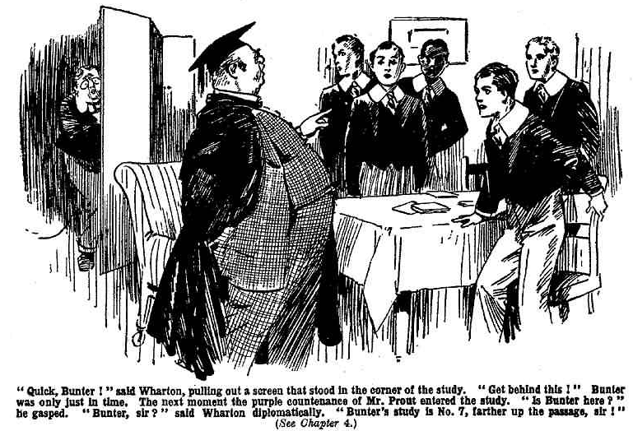
He was only just in time.
Less than a minute later the purple countenance of Mr. Prout was glaring in at the doorway of the study.
“Is Bunter here?” he gasped. But
“Bunter, sir!” said Harry Wharton diplomatically. “Bunter’s study is No. 7, sir, farther up the passage.”
Prout gave a stare round the room, and, as Bunter was not visible there, he rolled on up the passage.
There was a gasp behind the screen.
“I say, you fellows—”
“Keep mum, fathead!” said Bob. “He will be coming back soon.”
“Oh dear!”
Only Bunter’s stertorous breathing was heard after that. The chums of the Remove resumed their discussion of the programme for the afternoon. In the distance they could hear Prout’s ponderous progress up the Remove passage, and his deep, fruity voice inquiring for Bunter. Most of the Remove were out of doors but there were a few felIows about, and Mr. Prout inquired of everyone he saw. But nobody seemed to have seen Bunter, and Study No. 7 was empty.
Prout came rolling back along the passage, at last, puffing and blowing. Bunter had vanished. And all that remained to Prout was to take his complaint to the master of the Remove
His heavy footsteps died away on the Remnove staircase. Harry Wharton pulled the screen aside.
“You can come out, fatty. ” he said. “All clear!”
The clearfulness is terrific!”
Bunter rolled out of the corner, gasping. The Famous Five eyed him curiously. They had hidden Bunter, as in duty bound when a Remove man was in trouble. But they wondered what he had done to excite the wrath of the Fifth Form master.
“I say, you fellows, is the beast gone?” gasped Bunter.
“The gonefulness is terrific!”
“Like his beastly cheek, you know, coming up here after a Removc man!” said Bunter. “ I’ll jolly well tell him if he comes back, too!”
“Ha, ha, ha!”
“Blessed if I see anything to cackle at! I’m not afraid of Prout, if you fellows are!” said Bunter. I say, you fellows, you should have seen the old ass dancing when the fireworks went off. He, he, he!”
“You’ve been fireworking a Form master?” demanded Bob Cherry.
Bunter grinned. Now that the danger was over, the fat junior was full of courage, and disposed to take full credit for his remarkable and unintentional performance with the fireworks in the Cloisters.
“You fellows wouldn’t have the nerve.” he remarked complacently.
“Well, I don’t think we should have the nerve to firework a Form-master,” said Harry, staring at the fat junior. “Mean to say—”
“He, he, he! Well, I did it,” grinned Bunter. “Crackers and squibs and things banging and fizzing all round him. You should have seen him jump. Like a kangaroo. He, he, he!”
“You fat ass—”
“Oh, really, Cherry!”
“You’ll get into a frightful row with Quelch—”
“Oh, I—I mean, it was an accident!”
“Ha, ha, ha!”
“In fact, Prout did it himself!” gasped Bunter.
“Chucked a cigar-end into a box of fireworks. What did he expect, the old ass?”
“Quelchy will want to know what you were doing with a box of fireworks.” grinned Johnny Bull.
“They weren’t mine. I can prove they weren’t mine. I—I don’t know how they got into the Cloisters at all. ” stammered Bunter. “I never took the box tbere, you know. I say, you fellows, you can take my word, of course—but do you think Quelchy will? ”
“About as much as we do.” chuckled Bob,
“Look here, you beast, if there’s a row, you’ll have to own up that they were your fireworks!” gasped Bunter,
Bob Cherry jumped.
“Mine?” he ejaculated.
“Yes, and you’ll have to own up.”
“You bagged my box of fireworks!” roared Bob Cherry.
“Oh!” gasped Bunter. “No, certainly not! I—I never knew you had a box of fireworks, old chap. I—I thought it was a cake.”
“You thought it was a cake!” stuttered Bob.
“Yes, or else I shouldn’t have taken it, of course. Not that I did take it, you know,” added Bunter cautiously. I never saw you take the bøx into your study and hide it in the cupboard.”
“Oh crumbs!”
“As for thinking that it a cake, I never thought abøut it at all, not knowing that it was there.” explained Bunter. “I haven’t been near your study to-day. How those fireworks got into the Cloisters is a mystery. But if theres a row, you’ll have to own up that they wcrc yours. I expect that of you.”
Bob Cherry stared fixedly at the Owl of the Remove.
“You bagged that box from my study, thinking there was a cake in it.” he articulated. “You let Prout drop a cigar into it and blow up all my fire-works. You fat villain—”
“Oh, really, Cherry—”
“Seven-and-sixpence worth!” roared Bob Cherry. “All 1 had for the ‘Fifth. I’ll jolly well—”
“I’ll pay for the fireworks, of course.” said Bunter hastily.
“Shell out, then!”
“1’m expecting a postal-order—”
“What?” howlcd Bob Cherry.
“As soon as my postal order comes, I’ll settle up at once.” said Bunter, blinking at him through his big spectacles. “I’ll tell you what, Cherry, the postal order will be for ten bob. You hand me half-a-crown now, and I’ll let you have the whole postal order when it comes—see?”
“Ha, ha, ha!”
Bob Cherry did not join in the laugh. He was thinking of his seven-and-sixpence worth of fireworks—gone from his gaze like a beautiful dream.
“You—you—you—” he gasped.
“No need to get waxy about it. ” said Bunter. “All your own fault. What was a fellow to think, when you hid that box away so carefully? Of course, 1 thought there was tuck in it. Not that 1 touched it, you know. I hope I’m not the fellow to bag a fellow’a tck.”
Bob Cherry breathed hard and deep.
“Bunter came here and asked us to hide him, you men. ” he said.
“That’s all right. ” said Bunter. “Prout’s gone. No need to hide me now. I’ll be going. But what about that half-crown?”
“You’re going to get what you’ve asked for!” answered Bob.
He picked up a fives bat.
Bunter jumped away towards the door. Bob Cherry promptly headed him off.
“I—I—I say, what are you gorng to do with that bat, old chap?” gasped Bunter.
“Hide you. ” answered Bob.
“Oh, really, you know—”
“And I’m going to hide you till you burst, you fat villain!” roared Bob Cherry. “And you can think of the hiding next time you bag a fellow’s things.”
“I say, you fellows— Yarooogh! Leggo! Whooop !” roared Bunter, as a hefty hand was laid on his collar, and he was jerked over on the table.
Whack! Whack! Whack!
“Yow-ow—ow!”
Whack! Whack!
“Ow! Help! Murder! Fire!” roared Bunter.
Whack!
“Whooop!
“There, you fat villain!”
“Yow-ow-ow-ow-ow!”
Bunter travelled into the Remove passage at express speed, a large size in boots helping him on his way. He travelled, roaring.
“Ow! Beast! Yaroogh! Oooch!”
The door slammed on Bunter, and the Owl of the Remove limped away, repenting him that he had fled into Study No. 1 to ask the fellows thereto hide him. The hiding had not been at all to his taste.
— —
THE FIFTH CHAPTER.
Under Detention!
HORACE COKER was fuming with impatience by the time he heard the heavy tread of Prout in Masters passage.
Considerably more than half an hour had Horace Coker waited in the study, and he could not help feeling that it was cheeky of Prout to keep him waiting like this. Several times was Coker tempted to leave the study in defiance of his Form master’s order, but he stayed on. After all, Prout might have been delayed, and he might not be to blame.
So Coker waited, and was rewarded at Iast by hearing the heavy tread of his Form master approaching. He turned from the window as Mr. Prout rolled majestically in at the door.
Prout had not looked good-tempered when Coker last saw him. Now he looked less so than ever.
The incident of Bunter and the fireworks had not had a mollifying effect on Prout. Neither had his interview with the Remove master, to whom he had laid his complaint. Mr. Queleb, of course, agreed that Bunter had been seriously to blame, and should be called on the carpet. But his gimlet eyes had grown very steely when he heard that Prour had pursued Bunter to the Remove studics and lost him there. He had pointed out that he never intervenecI in matters affecting the Fifth, and that he expected other Form masters to observe the same reticence with regard to the Lower Fourth. Prout had snorted, and Quelch had sniffed, and they had parted very coldly indeed.
Prout’s eyes gleamed under knitted brows at the sight of Coker in his study. He had totally forgotten Coker’s existence. Reminded of it by the sight of Horace James. he seemed more than ever annoyed. Prout was troubled by a private affair, he did not want to be troubled also by a dense,, obstreperous fellow like Coker. In his normal genial mood Prout could tolerate Coker; but when he was worried be found Coker hard to bear.
“Oh! You are here?” snapped Prout.
“You told me to wait for you here, sir!” answered Coker resentfully. “I’ve been waiting a jolly long time.”
“Quite so!” said Prout, just as if it didn’t matter.
“A jolly long time,” repeated Coker, who was persuaded that it did matter.
“That will do Coker!”
Prout turned to his table and began turning over some papers. No doubt he was looking for the detention task that he had thoughtfully prepared for this ornament of his Form.
“By, the way, sir—” said Coker, remenbering his talk on the telephone.
“You need not speak, Coker.”
“Really, sir—”
“Be silent.”
“But, sir—” persisted Coker.
“If you do not obey my injunctions, Coker, I shall have no resource but to cane you!” said Prout. “You cannot help being stupid, Coker. You cannot help being unusually obtuse. But you can help being dsrespectfirl and disobedient. Silence.”
“Very well, sir. ” said Cohor. “I thought I ought to tell you that a man had telephoned. But never mind, of course.”
Mr Prout spun round from the table. “Someone telephoncd while i was absent from the study?” he ejaculated.
To Coker’s surpriso he observed that the Form master’s ruddy face had lost most of its colour all of a sudden.
“Yes, sir,’ said Coker; “as the bell was ringing I thought I ought to take the message for you.”
“Oh!” gasped Mr. Prout. “Who— who—who was it?”
“He did not give his name, sir, but I think it must have been the outfitter’s at Courtfield.” answered Coker. “He refused to give his name or to leave a message. He said he had missed a tie—”
“Wha-a-t!”
“Missed a tie, sir.”
“Upon my word!”
“I think he was rather barmy, sir,” went on Coker. “He said the law would have to take its course, and the matter would be placed in the hands of the police, and that he would meet you in the same place and show you a document—”
“Goodness gracious!” gasped Mr. Prout.
“And all about a tie, so far as I could make out sir,” said Coker. “He repeated several times over that he had missed a tie.”
The Fifth Form master gazed at Coker. Many times in the Fifth Form room he found Coker’s obtuseness intensely exasperating. For once he was glad of it. He did not want Coker, or anyone else at Greyfrfars, to know anything about Mr. Tighe. Coker, evidently, had misinterpreted what had bcon said on the telephone.
“Is—is that all?” asked Prout, at last.
“That’s all, sir. The man rang off very suddenly when I told him my name. I think he thought he was speaking to you at first.”
“You should not have taken the call, Coker.”
“Really, sir —”
“On another such occasion do nothing of the kind!” rapped Mr. Prout.
“I tbought—”
“I fear that you Are incapable of thinking, Coker. Say no more.”
Coker relapsed into indignant silence. This really was too thick. Any fellow would have taken a call for a man who was absent, there might have been an important message. Prout, instead of being grateful, was nastier than ever.
Coker had long ago given up expecting justice from Prout. But he felt that this was the limit.
He remained silent while Prout sorted through his papers and finally turned from the table with one in his plump hand.
“Here is your task, Coker. You are extremely—I may say disgracefully— backward in irregular verbs. I have set you an exercise in Latin irregular verbs. I shall expect this paper to be completed by six o’clock.”
He held the paper out to Coker.
Coker did not take it. He had no use for it.
“If you please, sir,” said Coker firmly, “I’d like to point out that I have some rather important business on this afternoon—”
“Nonsense!”
“Not at all, sir! It’s very important—in fact, I think I may be able to give assistance to the Law, sir,” aaid Coker.
Prout started and stared at him.
“What do you mean, CokerV’
“Some months ago, sir, my Aunt Judith had a secretary, a man named Buzzard, a dishonest rogue who robbed her,” explained Coker. “He cleared off and has never been seen since by the police. He was a very unpleasant little beast and I put him down as a rogue when I saw him at Aunt Judy’s house, He robbed my aunt of a good deal of money and valuables—and bolted.”
“I am sorry for Miss Coker’s loss, but this does not concern me, Coker, or your deLention this afternoon,” said Mr. Prcaut.
“It does, sir,”
“In what way ?” snapped Mr. Prout impatiently.
“Because I’ve seen the man since,” explained .Coker. “Last Wednesday I went to Lantham with my friends to see the League match there. I went by train, owing to some cheeky fags bagging my car. At Lantham Station I saw the man.”
“The man who robbed your aunt?”
“Yes, sir, that rascal Buzzard. 1 knew him at once, and he knew me and bolted. He got away.”
“Well?” said Mr. Prout. “1 suppose you informed the police.”
“No, sir—I didn’t think about that,” said Coker. “Besides, I don’t think much of the police. Not very intelligent, if you ask me, sir.”
“Bless my soul I”
“I’m going to look for myeIf, sir,” said Coker. “I’ve got a lot of reliance on my own judgment and common sense. ”
“Your— your what? ” asked Mr. Prout, as if dazed.
“Judgement and common sense, sir! I’m going to find that man Buzzard and hand him over to the police. I don’t suppose for a moment that thcy rould catch a slippery rogue like that. I fancy I can.”
“You—you—you fancy you can!” gasped Mr. Prout.
“Yes, sir.” answered Coker cheerfully. “What is wanted as brains, and that’s where I come out strong.”
“Upon my word! Coker, I’ll not waste time talking to you. You are a very dense and obtuse boy. You are detained— ”
“You see, sir, I made up my mind to hunt for that villain Buzzard the very next half-hohday,” said Coker. “I know he’s about somewhere—”
“Do you mean you have reason to suppose him to be in this neighborhood?”
“That’s it, sir. When I saw him that day at Lantham he was on the station platform waiting for the local train that comes to Friardale. That showed that he was coming in this direction. He lost the train owing to my going for him. He was scared, and I fancy he cleared right off. Still, he must have had some business in this direction, what? May have another job like the one he had with my Aunt Judy, playing the same game over again. You see, sir. I’m bound to get after him in the interests of justice.”
“I see nothing of the kind, Coker. I do not suppose for one a moment that you would succeed in finding the man yon speak of. Nethor is it an activity to be undertaken by a Greyfriars boy.”
“Really, sir—”
“You are, in fact, talking nonsense,
“I, sir?” exclaimed Coker, in astonishment.
“Yes. You are detained for the afternoon, and I shall leave you in the Fifth Form room with your task. Follow me!”
“But sir—”
“Follow me!” boomed Prout, and he rolled out of the study.
Coker hesitated.
His mind was made up that he was not going to be detained that afternoon. Apart from his keen desire to huut down that bad man Buzzard, it was a matter of principle with Coker. He wasn’t going to undergo detention in the Form-room—that was as fixed and immutable as the laws of the Medes and Persians.
But he followed Prout. A Form-master, Coker admitted, had a right to order a fellow to follow him. So he followed on.
Coker did not admit to himself that he jibbed at rebellion in the actual presence of his Forn master, and that he was postponing that rebellion till Prout was out of sight. He decided that he was carefully obeying all of the reasonablo orders, as a fellow was bound to do— reserving to himself the right to disobey unreasonable ones.
He followed Prout into the Fifth Form room Prout laid the detention task on Coker’s desk.
“Sit down, Coker!”
Coker admitted that that was a reasonable order, and he sat down.
“You will now proceed with your task, Coker. I fhall probably be absent from the school for the greater part of the afternoon. On my return I shall expect to find your task finished. That is all! In the the event of your breaking detention during my absence, Coker, I shall report you to your headmaster for a flogging. ” added Prout in a deep voice .
Coker almost smiled. He could not see Dr. Locke flogging a Fifth Form man—especially so important a man as Horace Coker
“You see, sir—” he began.
“That will do, Coker.’’
Prout rolled from the Form-room.
The door closed behind him, and Coker was left alone with his detention task.
He did not begin work on it; he hardly glanced at it. Verbs, regular or irregular, never had appealed to Coker.
Cokcr was thinking, not of his detention task. He was thinking of the easiest and quickest way out of detention. Now that Prout was gone, and he was no longer under his Form master’s baleful eye, Coker was more determined than ever. As a matter of principle, he wasn’t going to be detained. Moreover, he felt it his duty to put in the afternoon hunting for that bad man Buzzard. And Latin irregular verbs were pretty sickening, anyhow.
Coker rose to his feet about a minute after Prout had left the Form-room. He gave Prout just time to get clear. Then he prepared to bolt.
THE SIXTH CHAPTER.
Hard Cheese!
“RASCAL!.
Harry Wharton & Co. stared round, almost jumping. The Famous Five—still a little undecided as to what was to be done with the half-holiday—had come out of the House, and were strolling along in the quad by the masters‘ windows.
Some of the windows were open, and from one of them came that deep and booming voice
“My hat! That’s Prout!” murmured Bob Cherry.
The juniora glanced at the open study window.
Within Mr. Prout’s portly form could be seen. He was standing at the telephone, receiver in hand.
First Prout evidently was quite unconscious of the fact that his booming voice sounded out in the quad.
“Rogue!” he said into the instrument. “Yes. I will come. I will see the documeut. But I warn you——
What—what?”
“Move on!” said Harry Wharton quickly.
The chums of the Remove acccleratcd And passed out of hearing.
Their cheery faces were rather grave. Any other fellows at Greyfriars who had chanced to hear Prout’s peculiar remarks into the telephone would only have supposed that Prout was in an unusually bad temper. But the Famous Five, as it happened, know more than that.
The chums had almost forgotten what had happened last Wednesday, when, quite by chance, they had overheard the talk between Mr. Prout and the little green-eyed man in black—Tighe, as he called himself.
It was no business of theirs, and they had dismissed it from their minds. But Prout at the telephone recalled it
They had little or no doubt that “the rascal” and “rogue” whom he was addressing was the man Tighe, whom he had met last Wednesday on the old stone bridge over the Sark, and who, from what the juniors had heard, was seeking to extort money from him.
Prouts bad temper and nerves of late days had puzzled as well as exasperated the Fifth Form, and had attracted some notice outside the Fifth. Harry Wharton & Co. had a pretty accurate idea of the cause.
“I say, that’s rotten, you men!” said Bob Cherry uncomfortably. “I suppose Prout’s phoning to that little bcast in black.”
“That’s it, 1 suppose.” said Harry.
“I’m jolly glad we ducked the little beast in the pond !” said Johnny Bull.
“The gladfulness is terrific.”
“Poor old Prout!” saId Nugent. “It’s rather hard on a man to be bothered like this, owing to his nephew landing himself in trouble.”
“Hard cheese!” agreed Harry Wharton. “What that man Tighe is doing is what they call blackmail. He could be sent to choky for it: but I suppose Prout is thinking of his name in the papers.”
“Poor old Prout!”
The chums of the Remove felt genuinely sympathetic towards Prout. With great discretion, they had not only kept what they knew to themselves, but had refrained from speaking about it to one another. The secret, therefore, was not likely to leak out. It would have surprised Prout had he been able to guess how deeply he was obliged to these discreet members of the Lower Fourth.
“Poor old Prout!” repeated Bob Cherry; and with that the matter was dismissed. It was obviously not a matter in which juniors should concern themselves.
“Now, about this afternoon—” went on Bob, coming back to a matter which did concern the chums of the Remove
“Here, you kids!”
A gruff vofce hailed the juniors.
“Hallo, hallo, hallo! That’s jolly old Coker!”
Coker of the Fifth was standing at a window of the Fifth Form-room. The window was open, and Coker was beckoning to the juniors.
Harry Wharton & Co. were on terms of warfare with Coker of the Fifth. But they were obliging youths, and they were sorry for a fellow under detention.. So they walked along to the Form-room window.
“You young asses!” was Coker’s greeting.
“Eh?”
“I had to call you!” growled Coker. “I don’t want to get a crowd here. If you’d kept your eyes open you’d have seen me making signs to you”
The Famous Five smiled up at him
“Forgot your existence, you see!” explained Bob Cherry cheerily.
“What?”
“We quite forgot that there was such a howling ass in the wide world!” further explained Johnny Bull.
“You cheeky young sweeps—”
Is that what you called us for, Coker!” askcd Harry Wharton. “If that’s all, we’ll clear. Your conversation palls after a time.”
“After a very short time!” said Frank Nugent.
“‘The shortfulness of the time is terrific. ”
“ Don’t jaw!” said Coker, frowning. “I didn’t call you here to listen to your gabble, I want you to do something for me.”
“And that’s your polito way of asking?” inquired Johnny Bull.
“The politefulness is—”
“Preposterous!” chuckled Bob Cherry.
“Ha ha, ha!”
“Will you shut up?” growled Coker. “You’re wasting time with your silly gabble and babble. Have you seen Prout about?”
“He was in his study a few minutes ago.”
“He’s not gone out yet, then?”
“No; we should have seen him.”
“Bother him!” said Coker. “Still, I can’t waste time waiting here till the old donkey goes out. My time’s of value.”
It did not occur to Coker that anybody else’s time might be of value, too. But it occurrod to the Famous Five, and they moved on.
“Here you young chumps!” rapped out Coker. “Stop! I haven’t told you what I want yet!”
“Well, cut it short, Coker.” s aid Harry Wharton, turning back again. “We haven’t a lot of time to wastc.
“You young—”
“Cut it short, I tell you!” interiupted the captain of the Remove.
Coker glared at him, but he cut it short. It occurred even to Coker’s mighty brain that in the present circumstances he was not master of the situation, and that these cheeky juniors, if they liked could walk away regardless of his high behests. Coker suppressed his feelings.
“Look here, I’m getting out of this?” he said. “Prout thinks I’m going to stay in detention. I’m not. See? l’m clearing off. I’ve got important business on this afternoon, which can’t be neglected to please an old ass like Prout. Go and find Potter and Greene, and tell them to wait for me in the lane. I’ll join them outside the school. Safer, you know. See?”
The juniors regarded him curiously.
Coker was going to break detention. That was a serious matter, though Coker’d powerful intellect did not seem to realise the seriousness of it. It was liko his cheek to make them parties, in this way, to his act of rebellion. They were willing to oblige him, so far as that went, though Coker certainly lacked tact when asking favours. But— there was a but!
“You understand?” exclaimed Cokpr impatiently.
“Yes” said Harry. “But—”
“Don’t waste time. Get off and find Potter and Greene.”
“But—” repeated Wharton.
“Shut up, you young ass!”
“But—you’d better not bolt,” said the captain of the Remove calmly. “You’ll land into trouble, Coker.”
“Mind your own business!” roared Coker.
“Besides, it’s naughty,” said Bob Cherry, shaking an admonitory forefinger at the rugged, wrathy face of Horace Coker.
“What?” gasped Coker.
“Naughty!”
“The naughtiness is terrific, my esteemed and fatheaded Coker.”
Coker’s face became purple
“You cheeky young rotters!” he roared. “I’ve a jolly good mind to jump down from this window and thrash the lot of you!”
“Go it!” chuckled Bob.
“You—you—you—” gasped Coker. “Look here, you cheeky little beasts, will you do as I’ve asked? I can’t go round looking for those fellows when I’m supposed to be detained. I shalt have to cut off quick, once I’m out of this. Look here—”
“Oh we’ll do it,” said Harry resignedly. “We—”
“Wharton!”
“Oh! Yes, sir!”
It was the sharp voice of Mr. Quelch, and the Removites turned to at once. Henry Samuel Quelch came along tho path under the Form-room windows, with a frowning brow.
He gave Coker of the Fifth a glance of disfavour, and then fixed his gimlet eyes on the the juniors.
“What are you doing here?“ he rapped.
“H’m! We—we—”
“Well?” snapped Mr. Quelch.
“We—we—we were just speaking to Coker, sir.” stammered Wharton.
“I presume that a that Fifth Form boy is under detention. ” said Mr. Quelch.
“Ye-e-es, sir.”
“You are aware that no one is allowed to speak to a boy under detention, more especially a member of a different Form?”
“Ye-e-es, sir.”
“You are deliberately breaking a strict rule of the school.”
“H’m!”
“You will go into your Form-room, and remain in for an hour,” said Mr. Quelch. “You will occupy the time in writing out Latin conjugations.”
“Oh!”
“Go!” said Mr. Quelch.
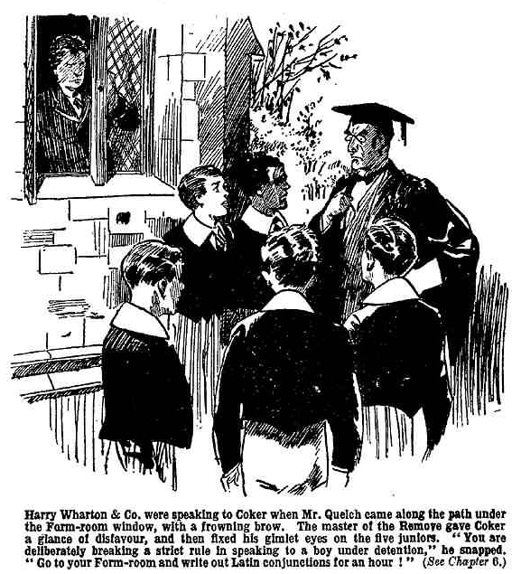
The Famous Five, with dismayed looks, went. Mr. Quelch, with frowning brow, watched them into the House.
The chums of the Remove had not yet settled what was to be done with the half-holiday. But that was not a pressing matter now. For the next hour, at least, it was settled for them, and Latin coujugations in a deserted Form-room were the order of the day.
THE SEVENTH CHAPTER.
Coker Boils!
HORACE COKER breathed hard and deep.
His luck seemed to be out that afternoon. Coker wanted to be out himself, but only his luck was out.
His determnination as more fixed than ever. He was not going to submit to detention.
But there were difficulties in the way. Difficulties, it is said, only to be overcome. Coker was determined to overcome them. Still, the question remained, how it was to be done.
Mr. Quelch, after seeing his happy pupils into the House, walked slowly and thoughtfully up and down the path under the Form-room windows.
Coker, looking at him from the Filfh Form winclow, wondered when he was going. But it was futile to wonder. Quelch was not going. He was staying,
The fact was, that Quelch was on literary work that afternoon. His famous “History of Greyfriars” occupied his mind. Unlike most modern authors, Mr. Quelch followed the old-fashioned method of thinking before he wrote. He was thinking now, shaping in his mind what he was going to click off on his typewriter. With his hands behind him, a thoughtful wrinkle in his brow, Quelch paced up and down that quiet path, deep in reflection— forgetful of Coker and everything ls but the well-turned phrases that were growing in his mind. Qucich was going to pace there, heedless of the passage of time, until the spirit moved him to return to his study and write.
Which was very discomforting for Coker. Quelch, it was true, was not his Form master, and Quelch was very particular not to intervene in another Form master’s affairs. Still, it was manifestly impossible for a detained fellow to drop from a Form-room window under the very eyes of a master.
So long as Quelch was there, Cokcr couldn’t bolt by the window. That was a cert. And Quelch showed no sign of departing.
Coker turned wearily away from the window.
He crossed to the Form-room door and looked out If he went that way he ran the risk of being stopped at any moment. He might run into anybody—into Prout himself!
If Prout stopped him on his way out, what was Coker to do? Nothing short of hitting Prout would solve the difficulty.
Coker did not contemplate hitting Prout.
Hitting a Form master was jolly bad form. There were other considerations, too—such as the absolute certainty of the “sack” for a fellow who raised his hand to a master.
Prout was not to be seen. But at the end of the Form-room passage two masters stood in conversation—Hacker, the master of the Shell, and Capper, master of the Fourth.
Coker popped his head back into the Form-room. With a master pacing under the windows, and two masters cackling in the passage—for that was how Coker regarded the serious conversation that was going on between Hacker and Capper—he wes fairly cornered, unless he escaped by tho chimney, which realty was not to be thought of.
The stars in teheir courses fought against Sisera; and really they seemed to be up to the same game in regard to Coker of the Fifth!
“Blow ‘em!” growled Coker.
He paced the Form-room like a lion in a cage.
His detention task lay unheeded on his desk. Coker did not give it a glance. He was less inclined than ever for irregular verbs.
The minutes passed.
Coker’s time, as he had said, was of value. That afternoon was to be devoted to trailing that bad man Buzzard, who had swindled his Aunt Judy. The police being incapable of capturing that unpleasant gentleman, the task fell to Coker’s more capable hands. Coker was prepared to take it on and make a success of it. But while he was retained in the Fifth Form room there was nothing doing. Wherever that bad man Buzzard might be, certainly he was not in the Fifth Form room at Greyfriars. Coker’s time, which was of such value, was being wasted.
No wonder Coker fumed.
He went to the window again at last. On the path below, Quelch was still pacing in meditation. Coker glared at the top of his head. Why the old ass was walking there, why he couldn’t walk somewhere else, why be wanted to walk at all were mysteries to Coker. But there he was!
Coker’s glance passed him, and dwelt on a group of Fifth Form men chatting at a distance. T,here were BIundell, the captain of the Fifth, Hilton, Fitzgerald, Potter, and Greene, in the group. Coker’s glance dwelt on them sourly. Potter and Greene were not even looking towards the Form-room—they seemed quite forgetful of their detained chum. Talking football, most likely— fiddling while Rome was burning!
Gazing morosely from the window, Coker presently beheld a portly, pondurous form rolling away from the House.
It was Prout!
Plump, portly, and majestic, Prout, in coat and hat, rolled down to the gates. He was going out at last.
it was a relief to see him go, at all events. With Prout off the scene, breaking detention was easier. Coker watched him disappear, with satisfaction.
Still Quelch showed no sign of departing. Coker scowled at the top of his head again and left the window. Once more he crossed to the door and looked out.
Hacker and Capper were no longer talking there. But Wiggins the master of the Third, was standing in the open doorway of a Form-room, apparently talking to someone inside.
Coker snorted.
It seemed to be raining Form masters that afternoon.
Coker had never realised before how numerous and hew objectionable were the staff of Greyfriars School.
How long was that ass Wiggins going to stand there, cackling? That was what Coker wanted to know.
Coker gave him five minutes. If he was not gone by then, Coker was going to chance it. After all, Wiggin might not be aware that he was under detention—might not take any heed of him as he passed. Anyhow, Wiggins wasn’t his Form master—only the master of a fag Form! Coker determined to chance it.
Five minutes elapsed; but Mr. Wiggins did not elapse—he was still there, still talking to someone in the Third Form room. Coker drew a deep breath, and walked out.
Wiggins glanced round at his rather heavy footsteps.
From the surprised expression on his face, Coker could see that Wiggins, after all, knew that he was under detention. Knew, obviously, that ho ought to have been in the Fifth Form room, sitting at his detention task, instead of walking down the passage.
Coker marched on grimly.
“Ah, Coker!” said Mr. Wiggins mildly. “Coker ! Do you hear me, Coker?”
Coker heard him, but he did not heed him.
He marched on, leaving Mr. Wiggins staring after him.
“Upon my word!” said Wiggins. Then he turned back to resume his interrupted conversation with the inmate of the Third Form room.
Coker’s heart was beating a little faster than usual. So far he had got away with it. But he was not out of the wood yet.
“Hallo! What’s this game, Coker?” asked Wingate of the Sixth, meeting him face to face.
“Eh? What game?” asked Coker.
“You’re under detention,” said the captain of Greyfriars. “What are you doing out of your Form-room?”
“What put that into your head, Wingate?” asked Coker pleasantly.
“Prout!” answered Wingate.
“He told you ?”
“Prout talks a lot too much!” remarked Coker.
“Well you’d better get back, and I won’t mention that I’ve seen you,” said the Greyfriars captain good-naturedly
“My detention’s over,” explained Coker.
“Not till six.”
“Yes; I’m let off.”
Wingate eyed him dubiously.
“Prout’s gone out,” he said. “Who let you off, then?”
“I did!” answered Coker coolly. “1 let myself off Wingate. And I’m jolly well going out, and you can go and eat coke, and tell Prout to do the same, if you like.”
With which defiant speech, Coker ran round Wingate, bolted for tlio door, and sprinted into the quad.
“My hat!” ejaculated Wingate.
Coker rushed down the steps into the quad. It was unfortunate for Loder of the Sixth that he happened to be coming up at the same moment.
There was a sudden collision, and Coker staggered, and Gerald Loder sat down with a bump at the bottom of the steps.
“Ow!” gasped Loder. “What—”
Coker recovered himself, and rushed on and sprinted across the quad. He did not stop to ask Loder whether he was hurt. No doubt he knew he was. He lost no time in getting to the gate.
“‘Ere, Mr. Coker!” It was Gosling, the porter, who had evidently been apprised by Prout that Coker was gated till six. “Ere! You stop! Mr. Prout’s horders—”
If Coker had not heeded a Form master, and the captain
of the school, he was not likely to heed William Gosling.
He sprinted on.
“You ‘ear me!” shouted Gosling.
“Wot I says is this ‘ere— “ But Coker heard no more. He dodged out of gates, Gosling staring after him, as well as a score or more of Greyfriars fellows,
The news flew round that Coker of the Ffth, detained by his Form master, had broken detention. Coker had bolted!
“The ass!” said Potter of the Fifth. when he heard.
“The chump!” said Greene.
“The silly owl!” continuied Potter.
“The burbling bandersnatch!” said Greene.
“It will mean a flogging!” said Blundell of the Fifth. “Pretty disgraceful for a Fifth Form man to be flogged like a fag !“
“Well, let’s hope it will do Coker good!” said Potter: and with that charitable wish he dismissed Coker from his mind.
THE EIGHTH CHAPTER.
The Man with the Green Eyes!
“BLOW him!”
“Bless him!”
“The ass!”
“The chump!’
“The preposterous fathead!”
Harry Wharton & Co. in the Remove room were speaking of Coker of the Fifth, relieving their feelings a little by telling one another what they thought of him.
An hour’s detention was only an hour; but sixty minutes seemed very long to the chums of the Remove.
Neither did Latin conjugations make the minutes fly. Rather, they made therm drag.
Having conjugated a sufficient number of Latin verbs to satisfy Quelch—or so they hoped, at least—the Famous Five gave up the classics, and found comfort in talking about Coker of the Fifth.
“The howling ass!” said Harry Wharton. “The burbllng chump! Landing us in detention on a half- holiday—”
“The born idiot!” growled Bob Cherry.
“The terrific and preposterous dummy!” grunted Hurree Jamset Ram Singh
“That blessed clock must be slow!” said Frank
Nugent. “I believe we’ve been here two hours at least.”
“Twenty - five minutes,” said Harry. “Five minutes
more! Just our luck for Quelch to land on us while
that ass Coker was wagging his chin!”
The last five minutes dragged by like snails. “Hallo, hallo, hallo! Here comes Quelchy!”murmured Bob Cherry, as there was a footstep in the passage.
Five juniors jumped to their desks and assumed a
studious aspect. Mr. Quelch, looking into the Form-room a few seconds later, looked at them—and might have supposed that thof five fellows asked nothing better of life than to sit in a Form-room
conjugating Latin verbs, had he not, from experience,known better! The Remove master smiled faintly.
“You may go!” he said.
“Up jumped five Removites, as if movcd by the same spring.
They lost no time in getting out of the House. Wharton glanced towards the windows of the Fifth Form room; but Coker was not visible there, and he wondered whether Coker had bolted. As a matter of fact, he had—a quarter of an hour ago.
Having decided on a walk down to the village and a visit to Uncle Clegg’s tuckshop there, the Famous Five strolled out of gates. Coker they dismissed from their minds. But Coker, like a bad penny, was bound to turn up.
The school had bcn left behind hardly five minutes when Coker appeared in the offing, in Friardale Lane, and hailed the chums of the Remove.
“Hallo, hallo, hallo! Here he is!” exclaimed Bob Cherry. “Now, let’s give him a jolly good bumping for getting us detention with his jaw!”
“Hear, hear!”
Coker came striding towards the juniors.
“Stop!” he rapped out.
He did not ak them to stop. He ordered them to do so. That was Coker’s way. As he often said, he had a short way with fags.
But as the Famous Five intended to stop, anyhow, and deal with Coker, they obeyed the order smilingly.
“I want one of you to run into the school with a message,” said Coker. “Any one of you will do. Find Potter and Greene—”
“We’re not interested in Potter and Greene, thanks!” said Bob.
“Eh? You young ass, I didn’t suppose you were! Don’t be cheeky! I want them to come out here,” said Coker. “Tell them I’m waiting in the lane, and I want them to come out and join me at once. I’ve been waiting for a fag to turn up to take that message in.
I’m glad you’ve come along.”
“We’re rather glad you’ve come along, too,” remarked Harry Wharton. “So the pleasure is mutual.”
“The gladfulness is terrific.” grinned Hurree Jamset Ram Singh.
“You see, you got us detention, wagging your silly chin from the Form- room window.” explained Johnny Bull.
“Look here—”
“Collar him!”
“You cheeky young sweeps!” roared Coker. “Go and take that mesage at once, or I’ll jolly well thrash the lot of you! And, I mean it. I give you one minute.”
“Go ahead!” chuckled Bob. “You’re going to thrash the lot of us, and the lot of us are going to bump you, Coker! Get on with it and let’s see how it works out.”
“Ha, ha, ha!”
Coker got on with it, and the Famous Five got on with it. For a few minutes one senior and five juniors were mixed up in the lane, with a considerable quantity of dust. But it was not the thrashing that happened next; it was the bumping.
Bump, bump!
“Oh!” roared Coker. “Ow! Leggo, you young villains! Oooooooop!”
The Famous Five let go, leaving Coker sprawling in the lane.
A little breathles, cheery and satisfied, they walked on towards the village, while Coker sat and struggled for his second wind.
Coker did not follow. Perhaps his time was of too much value; or perhaps he was too winded. Anyhow, the chums of the Remove arrived in the village without seeing any more of Coker of the Fifth.
Under the hospitable roof of Uncle Clegg they disposed of light refreshments, the minutes passing much more pleasantly than they had done in the Form-room. The threatened rain was still holding off, and there was a glimmer of winter sunshine in the November sky. Ginger pop and buns were grateful and comforting.
“Hallo, hallo, hallo!” ejaculated Bob Cherry suddenly.
“What—”
“Seen that sportsman before?” asked Bob, with a nod towards a man who was passing along the street outside, coming from the direction of the railway station
The juniors glanced out of the tuckshop. The man on the pavement outside was a little man, dressed in black, with a long nose and greenish-coloured eyes. He had a meagre, mean, unpleasant face, that once seen was not soon forgotten. The juniors knew him at once.
“That’s Tighe!” said Frank Nugent.
“The Tighefulness is terrific!”
Harry Wharton’s brow darkened as he looked at the man in black. It was the man who had met Mr. Prout on the Sark Bridge a few days before—the
blackmailer. He passed on out of the sight of the schoolboys in the shop.
“That rotter is here again” said Harry.
“He’s come down to see Prout, I suppose.” remarked Johnny Bull. “Poor old Prout! What a scrape for a man to be in!”
“The scrapefulness is preposterous” said Hurree Jamset Ram Singh. “Let us give that unpleasant and esteemed beast another ducking.”
“It would serve him right.” said Harry. “But—but—he shook his head— “better not butt in. If he’s going to see Prout, we can’t stop him; and from what we heard the little beast saying to poor old Prout it would be all the worse for Prout if we did”
“He ought to be in choky!” growled Johnny Bull.
He stepped to the door and looked out after the man in black. Tighe was turning into a side-street, from the High Street, that led towards the river. He disappeared from sight the next moment.
“Jolly good idea to follow him and give him a ragging!” said Johnny, as he turned back into the shop.
“Might run into Prout at the same time.” said Harry. “It’s pretty certain that his business here is in connection with poor old Prout.”
‘Prout’a meeting him somewhere,” said Bob, with a nod. “We heard the little beast say, the other day, that he wouldn’t go to the school to see Prout; he’s got some rcason for keeping away from the school. He makes poor old Prou come and keep an uppoiratment st a distance from Greyfriars. That’s why he picks a half-holiday, when Prout can get off.”
“Poor old Prout!”
The chums of the Remove finished their ginger-pop in a thoughtful mood. They were sorry for “poor old Prout” and would have given a week’s pocket-money to deal with Mr. Tighe as he desorved. But it was evidently wiser not to butt into a delicate matter that did not concorn them. And the long-nosed, green-eyed Mr. Tighe went on his way, never dreaming how narrowly he had escaped a ragging.
—
THE NINTH CHAPTER.
Prout’s Predicament!
“UNPARALLELED iniquity!” said Mr. Prout.
Prout, in times of trouble, found solace in rolling out
impressive words of that kind.
The portly master of the Fifth sat on one of the old stone seats of the bridge over the Sark. He was early tor the appointment he had made by telephone, to meet Mr. Tighe in the same place as before.
His eyes were on 33 Bridge Lane, that led towards Friardale, and there was deep wrath in them.
Prout had consented to see the blackmailer again, but he had not in the least made up his mind how to deal with him.
He felt, in fact, helpless, like a bird in a snare—a fat old bird, who had never been in a snare before and did not know how to meet such an emergency.
To yield to Tighe’s demands seemed impossible as well as an act of wcakness of which he should be ashamed. But the thought of disgrace, though not of his own making, was unnerving to him.
He had held his head so high at Greyfriars. He was the most impressive figure in Masters’ Common-room; or, at all events, he was persuaded that such was the cse. Other members of the staff hung on his words as if pearls of wisdom were falling from his lips, and it never occurred to Prout that they were merely waiting for him to leave off talking.
His Form respected and admired him—anyhow, Prout had no doubt that they did. Respectful silence fell on the Fifth Form games study when Prout rolled in for one of his friendly chats. How was Prout to guess that it was the silence of dismay? He never did guess.
Occupying this enviable position in the school, it was awful to think of disgrace falling on his name—of fellows telling one another that Prout’s nephew had been sent to “quod.”
Prout was not responsible for his nephew’s actions. There were fellows in the Fifth who averred—in private— that he was hardly responsible for his own! But there it was. Eustace Prout was his near relative bearing the same name, and the thought of that name in all the newspapers, in connection with a sordid trial, made Prout writhe.
Justice is a great thing. Courts of law must exist in a civilised community—less happy in that respect than a savage one. But there is no doubt that, as a rule, punishment falls more heavily on a criminal’s relatives than on the criminal himself. A reckless rascal goes to prison, and suffers less than his connections, who have to pursue their daily avocations with the shadow of disgrace on their name. Prout had never realised this before, or, indeed, thought about it at all. Now he thought about it quite a lot. He reflected bitterly that if names were suppressed in newspaper reports, this sort of trouble would not fall on the innocent, punishing them along with the guilty.
He thought some very hard things about newspapers.
Prout was no nearer to making up his mind when the slight figure and unpleasant face of Mr. Tighe appeared in Bridge Lane.
He rose from the stone seat, and walked off the bridge to meet the newcomer. He preferred to meet Mr. Tighe in a less conspicuous spot.
Tighe stopped, under the trees by the wayside, and waited for him to come up. Prout came up, breathing heavily.
“Good-afternoon, Mr. Prout!” said Tighe, in his squeaky voice, with a kind of mocking civility.
Prout did not return the greeting. He stared at Tighe with all the contempt and biting scorn that he could compress into his glance. It had no more effect on Tighe than water on a duck’s back.
Probably Mr. Tighe was accustomed to angry and contemptuous looks and hardened to them. In his peculiar line of business he must have met with an extraordinary aniount of contempt.
“I am here.” said Prout in his deep, booming voice.
“So I see.” assented Tighe.
“I have consented to see you.”
“Quite so.”
“But I have no intention of yielding to your demands, or making any concession to your unparalleled iniquity!” said Prout.
“Indeed!”
“Yes, indecd, sir!” boomed Prout.
“Then may I ask why you are here at all?”
There was a pause. Prout found it difficult to answer that question. His purple face registered scorn—again with no perceptible effect on Mr. Tighe.
“Let us come to business.” suggested Tighe coldly. “I have come from London to see you, Mr. Prout. It is a long and expensive journey; neither do I like the country—and this part of the countiy I specially dislike. I had better warn you that this, my second visit, is also the last.”
“I am glad to hear it, sir!” boomcd Prout. “ I certainly have no desire to see your rascally face again.”
“Unless we come to terms now you will hear nothing further from my principals, Sharp & Co.”
“I have no doubt, sir, that you are Sharp & Co. yourself.” snapped Mr. Prout. “I have no doubt that that is the name under which you carry on your rascally business as a moneylender. !”
Tighe shrugged his shoulders.
“That is neither here nor there.” he remarked. “To come to the point, I have the document with me. Your nephew, Captain Eustace Prout, gave us this cheque, post-dated, in return for a loan of fifty pounds.”
“I offer you that sum to redeem the cheque.”
“Let us talk sense.” suggested Mr. Tighe. “The cheque is forged. It has never been seen by the man whose name is signed to it. It is endorsed on the back by Captain Prout. It is absolutely valueless in itself, but it may possess a value to any gentleman bearing the name of Prout, who has his position in life to consider.”
“Sixty pounds is a large sum for me to part with.” said Mr. Prout. “But I will pay it to save that foolish, reckless young man, and to avert digrace from my name. That is my offer.”
“It is refused” said Tighe. “The price of that document, as I have told you, is five hundred pounds.”
“Rascal!”
“You are wasting time, Mr. Prout.”
“Scoundrel!”
“Really, sir
“I may tell you,” said Mr. P rout, “that I have Iearned that my nephew is no longer in the kingdom. Apparently he raised that loan from a rascally moneylender in order to get abroad. That he intended to redeem the cheque I am certain, though his act s only to be explained by his peculiar state of mind, due to shellshock in the War. The cheque, you say as post-dated— and I am assured that Eustace will meet it before the date when it falls due for payment.”
“No doubt that is his intention.” assented Mr. Tighe.
“Then on what grounds, sir, dare you trouble me in the matter? You need not present that cheque. You have only to retain it until Eutace Prout redeems it at your hands.”
Tighe smiled, almost pityingly.
“That is not our object at all, Mr. Prout.” he replied.
“No.” boomed Prout. “I understand, sir. I understand that you would not have taken that paper from my nephew at all had you not known that it was forged, and that he had a relative in a high position, who could be blackmailed.”
“Clearly, you have reflected on thc matter to some purpose, sir.” said Tighe coolly. “Nevertheless, we are wasting time. Do you desire to see the cheque, to ascertain beyond doubt that matters are as I state? I believe you mentioned that you would not accept my word.”
“Your word!” said Mr. Prout contemptuously.
“I have the document here. You will kindly keep your distance while I show it to you.”
Tighe stepped back a pace or two, drew out a folded paper from an inner pocket, and held it up—safe out of the Form master’s reach, had Mr. Prout so far forgotten his dignity as to snatch.
Prout gazed at it with perspiration gathering on his brow. If he had had any doubt before he could have none now. The wretched young man, in desperate straits for money, had obtained a cheque form from an acquaintance in some surreptitious manner, filled it in as payable to himself, and signed the owner’s name to it. It bore the date of December 1, and was not, therefore, due for payment for nearly a month to come. Ten pounds interest for a month’s loan of fifty pounds was exorbitant enough, and no doubt Eustace Prout had supposed that Sharp & Co. would be satisfied with that, and would keep the cheque until he redeemed it before the date of payment. But that, evidently, was not the way in which Messrs. Sharp & Co. did business.
Prout gazed at the cheque till Tighe folded it again and slipped it into his pocket
The portly Form master made a movement, and Tighe skipped back like an active cat. He was quite prepared for an attempt on the part of the Greyfriars master to obtain the cheque by violence.
“Are you satisfied now?” he sneered.
“I am satisfied that your statements are correct. I will pay you the fifty pounds advanced to my nephew, and the ten pounds agreed on as interest—a total of sixty pounds!” said Mr. Prout huskily. “You will hand me that wretched paper, and the transaction will be closed.”
Tighe laughed softly.
“If that was our intention, sir, we could afford to wait till December 1, when I have no doubt that Captain Prout will be prepared to settle.”
“Rascal!”
“The price of that scrap of paper is five hundred pounds.” said Tighe. “You may take it or leave it.”
“Villain!”
Tighe’s greenish eyes glittered.
“I warn you, Mr. Prout, that this is your last opportunity. Refuse, and I return to London, and shall not see you again. The law will be set in motion.”
“And what will that benefit you?” demanded Mr. Prout. “In law you cannot recover a single sixpence on that worthless paper.”
“Quite so. But the man who forged that worthless paper will be sent to prison, and his nane, and the name of his relative, will be an every newspaper in the country.” sneered Tighe. “I think a Form master at a school like Greyfriars can scarcely afford that, sir.”
Prout’s portly form trembled with anger.
“This is blackmail!” he said. “This is extortion!”
“You may call it what you please.”
“You are making a criminal use of that document. You are committing a crime baser than forgery.”
Tighe looked at his watch.
“I am in no hurry to catch my train,” he remarked. “But 1 dislike wasting time. May I request your answer?”
“I do not believe,” hooted Prout, “that you would carry out your threat. I do not believe that you would lose sixty pounds merely to gratify your malice.”
“You will find that a somewhat frail reed to hang upon, Mr. Prout. “You are not the only man with whom we are doing business. If we have to make an example of you it will be beneficial to our other clients.”
Prout gasped, and gazed at the little man in black in horror. For some moments he could not speak.
“Wretch!” he gasped at last.
Tighe looked at his watch again.
“You have ample time to walk back to the school and catch the collection with a letter.” he said. “If we receive the cheque by the first post in the morning—”
“You will receive nothing of the kind.”
Tighe’s mean, narrow face set in a very ugly expression.
“You definitely refuse, then?”
“I do.”
Tighe stepped back to the lane. “Nothing remains to be added.” he remarked. “Good-afternoon, Mr. Prout. You will receive your next news of your nephew from the newspapers.”
Mr. Prout gasped.
“Stop!”
“I have no further time to waste, Mr. Prout. If we receive your cheque by the first post in the morning, we hold our hand. Otherwise, the law will be set in motion.”
“I—I must have time to—to think what—”
“You have had ample time to think.” answered Tighe, coldly. “And you may think further, if you choose, while you walk back to the school.”
“That—that paper—”
“Remains in my hands. It will be sent to you by registered post as soon as your cheque for five hundred pounds has been cleared.”
“You imagine that I will trust you to—”
“I imagine that you have no choice in the matter. However, I will concede a point. If you like I will go with you to your bank. We can get a cab in the village, and you may make the payment in notes in exchange for this document.”
Tighe waited for an answer.
Mr. Prout stood irresolute. On the one side was a heavy loss and the shame of submitting to blackmail: on the other was the shadow of deep disgrace, under which he felt that he could never hold up hisa head at Greyfriars again. The hapless gentleman’s confused mind swayed like a leaf in the wind. He had had, as Tighe said, ample time to think, yet, even now, at the last moment, he could not decide.
“Your answer?” snapped Tighe, at last.
A gust of passion swept over the persecuted gentleman. Anger took the place of decision.
“No!” he boomed. “No, never! I will not submit to a scoundrel” I withdraw my offer of sixty pounds. I will pay fifty—the sum you lent to my nephew. Not a penny more! Not a halfpenny more! Scoundrel! Do your worst!”
“Very well.” Tighe’s voice came like the hiss of a snake between his thin, tight lips. “Very well, you will hear further soon. There is nothing more to say, Mr. Prout.”
He jumped back as the portly Form master, grasping his stick, strode at him.
Swish!
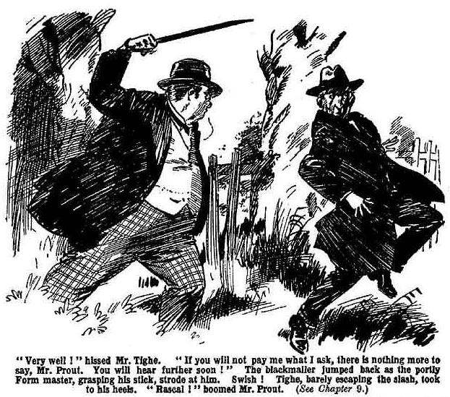
Tighe barely escaped the slash of the walking-stick. Prout strode at him for another slash, and Tighe took to his heels, running down the lane like a rabit.
“Rascal!” boomed Mr. Prout, after him.
Tighe disappeared from sight in a few moments. And Mr. Prout, angry, alarmed, dismayed, turned slowly away, in the direction of Greyfriars. He had defied the blackmailer, and that was satisfactory, so far as it went. But the consequence had to follow. And the unhappy Mr. Prout, as he trod ponderously back to the school, thought of the consequences, and his plump heart almost died within him.
THE TENTH CHAPTER.
Bunter’s Reward!
HORACE COKER fumed with impatience.
Time was passing—Coker’s time—which was of such value.
Coker, hanging about Friardale Lane, was wasting time, and could not help feeling that he might as well have stayed in the Form-room.
Having bolted out of detention, Coker was free for the afternoon. He was at liberty to undertake the task he had set himself. But Coker did not want to “go it” alone. Naturally, he wanted his friends with him. He had no idea of mooching about all through the half-holiday on his lonesome. He liked company, and he liked an audienceo. Potter and Greene were his chums, and loyal chums should have been on the look-out to make themselves useful to Coker. Instead of which, they seemed to have forgotten his existence.
It was scarcely possibIe, of course, for any sane person to forget so important a person as Coker of the Fifth. No doubt Potter and Greene supposed that he was still under detention in the Form-room. Still, they ought to have been on the look-out. They ought to have joined up with Coker before this.
But they hadn’t, and it was necessary to get word to them. Having bolted, Coker could not very well walk into Greyfriars again tooktng for them. He had to find some fag to take a message. He had found Harry Wharton & Co., and, instead of obeying his order they had bumped him, and gone on their way regardless. Coker fumed impatiently as he waited in the lane looking for some fags more amenable to persuasion.
At last he sighted a fat figure rolling down the lane from the school. It was William George Bunter of the Remove. Coker stepped out of the hedge, and beckoned to Bunter.
“Here, you fat freak!” he called out. Coker had his own particular way of asking favours of a fellow.
Billy Bunter stopped and blinked at him through his big spectacles, and grinned.
“He, he, he! So you’ve bolted, Coker. I say, Prout will be waxy.”
“Don’t be cheeky!” snapped Coker.
“You’ll get a flogging.” grinned Buner. “Fancy a Fifth Form man getting flogged! I say, the Fifth won’t like it.”
Coker glared at him.
“Do you want a jolly good hiding, Bunter?” he bawled.
Bunter backed away. Apparently he didn’t.
“Now, shut up!” said Coker. “I want you to go and find Potter and Greene, and tell them to come out here to me—see!”
“Think I’m a fag?” demanded Bunter, backing farther off, and preparing to take to his heels.
Coker clenched a heavy hand.
But perhaps his experience with the Famous Five had taught Coker something. Perhaps he realised that punching Bunter, though a satisfactory proceeding in itself, would not help in getting a message to Potter and Greene.
He unclenched his hand, unknitted hi5 brows, arid spoke as civilly as it was possiblo for Coker to speak to a Lower Fourth fellow.
“Look here, Bunter, take that message in for me. There’s a cake in my study cupboard. You can have it, if you like.”
Bunter’s eyes glcatned behind his spectacles.
This sort of appeal touched him. The mere mention of a cake was enough to interest Bunter.
“Well, I don’t mind obliging a chap.” he said, “What sort of a cake?”
“Plum.” growled Coker. “Look here, tell Potter and Greene—”
“What size?”
“You fat little beast—”
“Oh really, Coker—”
“Tell Potter and Greene I’m waiting for them.”
“Yes, but how much cake—”
“Two pounds!” shrieked Coker. “Now, go and tell Potter and Greene I’m waiting for them here, and they’re to come out at once.”
“Right-ho!” answered Bunter cheerfully. And he turned round and started for the school again, leaving Coker to fume.
Bunter retraced his steps at a good speed. Coker was glad at least, to see that he was hurrying off with that message. It was more probable that Bunter was hurrying off for the cake.
The fat junior went in at the gates and hurried towards the House. He gave a perfunctory blink round him; but Potter and Greene were not in sight. Bunter rolled into the House, and headed for the Fifth Form quarters.
He intended, of course, to find Potter and Greene and deliver the message. That was only cricket, as he was to have the cake as a reward. But first things came first; secondary things second. The cake was important; the message to Potter and Greene less important. Bunter decided to deal with the cake first, and the message afterwards. There would be ample time to look for the two Fifth-Formers when he had disposed of the cake.
So Bunter headed direct for Coker’s study. He opened the door and rolled in.
“Oh!” he ejaculated.
The study was not untenanted. Potter and Greene were there.
Bunter blinked at them.
Potter and Greene, evidently, had remembered that there was a cake in the study cupboard. The cake was no longer in the cupboard. It was on the table, and Potter and Greene were eating it.
Perhaps they were missing Coker that afternoon, and consoling themselves for the loss of his company with the cake. Possibly, indeed, they liked his cake better than his company.
Anyhow, they were disposing of the cake with considerable satisfaction to themselves when Bunter rolled in.
The two Fifth-Farmers glared at him. “You cheeky young ass, what do you want here?” demanded Potter. “Think you can butt into a Fifth Form study when you like, you sweep?”
“I say, you fellows—” gasped Bunter.
“Get out!”
“That cake— Is—is—is that the cake that was in the cupboard?” gasped Bunter. More than half the cake was already gone, and Potter and Greene were still eating. Bunter’s reward was performing a vanishing trick under his very eyes.
“What the thump do you mean?” snapped Potter. “Mean to say you came here after Coker’s cake, you grub-raiding young sweep?”
“Oh, really, Potter—”
“Get out!” snapped Greene.
“I say, you fellows, that’s my cake!” gasped Bunter. “I say, I came here for that cake—”
“You’ve got the cheek to tell us so?” exclaimed Potter, in amazement. “Well, of all the nerve!”
“I mean—”
“Give me that fives bat, Greeney!”
“I—I say!” gasped Bunter. “Ow! Leggo, Potter you beast Yarooooh!”
Instead of letting go, Potter twisted the Owl of the Remove over, with a grip of iron on his collar, and applied the fives bat to Bunter’s tight trouser. There was a fiendish yell from Billy Bunter.
Whack, whack!
“Whooooop!”
“There!” said Potter. ‘That’s a tip about raiding tuck in a senior study. Now get out!”
“Yaroooh! Beast! Wow!”
“Kick him out!” said Greene, cutting another slice of cake. “For goodness sake don’t let him make that row in here!”
“I say!” howled Bunter. “Coker sent me with a message to
you fellows! Wow! I came here to find the cake—I mean, to
find you fellows—ow! Leggo! Coker says— Yarooooh!”
“Coker sent you in with a message?” grunted Potter,
glaring at him.
Potter did not, somehow, seem pleased at getting a message from Coker.
“Ow! Yes! Wow!”
Boast!”
“Well, what’s in the message?” snapped Potter.
“He’s waiting for you in Friardale Lane, and you’re to go to
him at once!” gasped Bunter. “He said I could have the cake.”
Potter and Greene exchanged a dismayed look. They had supposed, and hoped, that they were clear of Coker for the afternoon. A little of Horace Coker’s company went a long way, with hs friends.
Moreover, they were not keen on getting mixed up with a
fellow who was rebelliously out of bounds. They were feeling inclined to slaughter Bunter for bringing them that message. Now that they had received it, they couldn’t very well make out that they hadn’t; and they did not want to quarrel with Coker. They had recently quarrelled with Coker to the extent of locking him out of’ the study, and there had been a severe dearth at tea-time till they had buttered him up again and brought him round.
“Bother you, Bunter!” growled Greene.
“You fat little meddling ass!” grunted Potter.
“I suppose we shall have to go!” mumbled Greene.
“I suppose so!” growled Potter.
“I say, you fellows, that’s my cake!” wailed Bunter.
“Get out!”
“But Coker said—”
“Do you want some more of the fives bat?” roared Potter.
“But that’s my cake—”
Potter made a jump for Bunter. Bunter, in alarm, made a jump for the door. Potter’s boot caught him in transit, and Bunter went into the Fifth Form passage like a bullet from a rifle.
“Yowp!”
Bunter disappeared into space. Obviously there was no cake for Bunter; nothing but a hard, unsympathetic boot.
Potter and Green finished the cake. They seemed in no hurry to join Coker, urgent as his messag was. And the cake was good. They finished it to the last crumb, and then left the study and the House. They felt bound to go out to Coker, but they went without enthusiasm.
In the quad a fat junior gave them a baleful glare through his spectacles. Potter paused to give Bunter a kick in passing—the reward he deserved, in Potter’s opinion, for bringing in that message from Coker. Then the two Fifth Form men went out of gates, leaving William George Bunter in a state of mind that was positively homicidal.
—
THE ELEVENTH CHAPTER.
Up to Coker!
“OH; here you are?” growled Coker.
“Here we are, old chap!” said Potter.
“Yes, here we are 1” said Greene.
“I’ve been waiting a jolly long time,” said Coker. “If you fellows had had the sense of bunny rabbits you’d have guessed that I was waiting for you out of gates.”
“Hem! You see—” murmured Potter.
It was not likely to please Coker to tell him that they had guessed it, and that that was why they hadn’t come out before. So Potter and Greene tactfully did not mention that.
“You got my message, I suppose?” grunted Coker.
“Yes, old fellow.”
“Wel1, now you’re here, don’t waste time jawing.” said Coker. “Come along!”
Potter and Greene followed him down the lane.
“Prout’s gone out.” remarked Potter casually. “Some time ago. Chance for you to get back to the Form-room, Coker—”
“What?”
“Save a row, you know.” said Greene.”If Prout finds you there when he comes in, it will be all right.”
“Don’t be a silly ass, Greene !”
“Well, it means a frightful row.” said Potter uneasily. “Your friends would hate to see you flogged, Coker.”
“Don’t be an idiot, Potter!”
“Prout will be frightfully wild.” urged Potter. “He’s been like a bear with a sore head lately. He’s sure to report you to the Beak for a flogging if he finds out you’ve cut.”
“The Head is hardly likely to flog me.” said Coker contemptuously. “The Fifth are never flogged.”
“Well, he might sack you, instead!”
“Don’t be a fathead! The Head would think twice before he sacked me.” said Coker disdainfully. “There are some fellows in every school who can’t be spared—fellows whose character gives a tone to the school. That’s my position at Greyfriars. The Head may be waxy, but he won’t cut off his nose to spite his face. He knows that Greyfriars can’t afford to lose a man like me.”
“Oh crikey!” said Greene.
“But—but—but,” babbled Potter, “do you think you’re going to defy Prout like this, and get away with it?”
“Certainly!”
“Oh crumbs!”
“Prout will take me to the Head, of course.” said Coker. “I expect that. I shan’t be sorry, either.”
“You’ll be sorry by the time the Head’s through with you.” said Potter, with conviction.
“Don’t be a footling ass! I shall explain the whole matter to the Head, and show up Prout. Mind, I don’t want to. I’d rather say nothing about the old duffer. But if Prout takes me to the Head, I shall have no alternative but to point out that Prout was wholly to blame in the matter—”
“Oh, my hat!”
“And let him see that Prout is a footling old donkey.” said Coker. “I’m rather sorry for Prout; but if he asks for it, he gets it. That’s all.”
Potter and Greene wero reduced to silence. Obviously, an intellect like Coker’s was out of the reach of argument.
“Never mind all that.” said Coker, dismissing the trivial subject with a wave of the hand. “I’ve no time to bother about gout now. We’ve wasted a lot of time, owing to his fatheadedness, already. We’ve got some work to
do this afternoon. That man Buzzard is—”
“That man Buzzard!” groaned Potter.
“Oh, dear!” said Greene.
If there was one topic on which Horace Coker was more fearfully and awfully a bore than any other, it was the topic of that bad man Buzzard, who had swindled his Aunt Judy.
When Coker got on that subject, Potter and Greene felt that they really couldn’t stand any more of it. It was the Thing-too-Much!
They had already had it over and over again. They were fed-up with at to the very teeth. If Coker got going on that subject again, his friends felt that they would scream
Coker, regardless, got on the subject.
“I’m after that rascal.” he explained. “I think I mentioned to you fellows that he got a job with my Aunt Judy a few months ago as secretary—I saw him in the holidays—and robbed her and bunked. If I’d been on the spot at the time—”
“Oh dear!”
“What’s the matter, Potter?”
“Oh, nothing!” groaned Potter.
“We saw him at Lantham Station a few days ago.” resumed Coker. “He was waiting to take the Friardale train. He got away—you fellows let him slip through your fingers. It was like you!”
It did not seem to occur to Horace Coker that Buzzard had slipped through his fingers also.
“Well, we’re after him again.” said Coker. “He was coming down to Friardale—that’s clear. We got after him at Lantham, and he bunked. Well, he must have had some business in this neighbourhood, or he wouldn’t have been coming here. See that?”
Coker stated this masterly deduction quite in the manner of Sherlock Holmes.
“Did you work that out in your head?” inquired Potter sarcastically.
Sarcasm was wasted on Coker.
“Yes.” he answered. “I’ve worked it out—I’ve a head for such things, you know. As I’ve mentioned to you fellows more than on I’ve practically all the brains of our study. Well, we chased the little beast off—but if he was up to some rascality in this quarter, he would stick to it, of course. My idea is that he’s very likely playing the same game over again—getting a job with somebody to rob them. See! I’ve worked it out that he’s planted somewhere about here, and all we’ve got to do is to nose him out and bag him.”
“Is that all?” asked Potter, still sarcastic.
“That’s all! Having got him, we shall hand him over to the police.” said Coker. “The police are capable of dealing with a man who is handed over to them, though a fellow with brains is required to catch the man. See? Well, I’m going to catch him, and you fellows are going to help me.”
“But how?” demanded Greene. “Do you expect to run into the man walking about the lanes?”
“Quite possible!” said Coker. “If he’s living in this neighbourhood, as I suspect, he won’t stay indoors all his life, I suppose. Might butt into the man any minute, walking about.”
Potter and Greene looked at him. If Coker was building his hopes of a capture on such a foundation as this they could not help feeling that the bad man, Buzzard, was not in very great danger from Cokcr.
But it was useless to argue with Coker. Like an obstinate horse, Horace had to be given his head.
“Well, we’re after him.” went on Coker. “I told Prout I was going after him, and what do you think Prout had the cheek to say? He said it was nonsense! Prout all over!”
“But—” said Pottor helplessly.
“Don t jaw, old chap! You’re too fond of jawing—like Greene. I keep on telling you fellows that you talk too much. This way!” said Coker, swinging himself over the stile into Friardale Wood.
“Look out!” gasped Potter.
“Prout!”
“Oh crumbs!”
Coker stared along the footpath, up which he had been about to stride. A portly, ponderous figure was coming along it. Mr. Prout, returning from his meeting with Tighe, had arrtived at the stile on Friardale Lane from one direction, as Coker & Co. reached it from the other.
Potter gave one glance at the portly lgure, and vanished up the lane towards the village. They had no desire for their Form master to spot them in company with a fellow who had broken detention. They stood not upon the order of their going, but went at once.
Coker, having got over the stile on Prout’s side of it, could not retreat so rapidly.
“Upon my word!” boomed Prout.
He sighted Coker at the stile. He could scarcely believe his own majestic eyes, at the sight of the senior he supposed to be undergoing detention in the Fifth Form room at Greyfriars.
“Coker!” he stuttered.
“Oh, jiminy!” ejaculated Coker.
He swung himself hurriedly back over the stile into the lane. Mr. Prout accelerated.
“Stop!” he shouted. “Coker! I command you to stop! I shall take you back to the school with me! Stop, I command you !”
Coker did not stop.
He jumped back into the lane, and started at a run in the direction taken by his friends.
Prout reached the stile, gasping for breath.
“Coker! Stop! Rebellious boy! Rascal! Stop!” boomed Prout.
Coker vanished in the distance.
Prout slowly negotiated the stile, and stood in the lane, gazing after the vanished ornament of his Form.
“Upon my word!” he gasped. “This passes all bearing! He shaIl be flogged—expelled—bless my soul!”
And Prout resumed his way to Greyfriars, thinking less now of the unparalleled iniquity of Tighe than of the unprecedented rebelliousness of Horace Coker.
THE TWELFTH CHAPTER.
Fool’s Luck!
POTTER and Greene halted, breathless, on the outskirts of Friardale. They looked back along the winding lane, but there was no one in sight.
“Oh dear!” gasped Potter. “Prout never spotted us, I think.”
“He must have spotted Coker.” said Greene.
“Luckily, that don’t matter.”
“Quite!” agreed Greene.
“We should have got into a fearful row, going round with a fellow out of detention.” said Potter. “Prout’s frightfully bad-tempered lately, and I don’t want him on my track.”
“Same here.”
“Coker’s welcomc to him.” said Potter. “He seems to like getting Prouty’s rag out. I suppose Prout’s got him and is marching him back to the school.”
“Unless Coker’s knocked him down!” said Greene.
“Oh my hat! Even Coker isn’t fool enough for that.”
Greene shook his head.
“Cokers fool enough for anything.” he answered.
“Well, if Coker’s sacked, it will be a quiet life in the study.” said Potter, drawing comfort from that reflection. “After all, no follow could stand Coker permanently,”
“Great pip! Here he comes.”
There was a thudding of heavy footsteps in the lane, and Coker came sprinting up, dusty and breathless.
“Oh, here you are, you fellows!” he gasped.
“Prout didn’t get you?” asked Potter.
A suspicious fellow might have detected a note of disappointment in Potter’s voice. Fortunately, Coker was not a suspicious fellow.
“I shouldn’t be likely to let him.” answered Coker disdainfully. “He ordered me to stop. Of course, I took no notice.”
“Oh!” said Potter and Gteene.
“I simply left him.” said Coker. “Prout ought to understand that I’ve wasted enough time on him for one day. But he’s dense.”
“You ran for it?” asked Greene.
Coker frowned. “Running for it” was rather an undignified proceeding, more suitable to a fag than to a great man of the Filth Form.
“I Left him,” said Coker. “I wasted no time, of -iourae. I did not ‘run for it, Greene—but I cleared off. It was that or hitting the man—and it’s bad form to hit a Form master. I hope I shall nvor be driven to hitting Prout.”
Coker shook his head seriously. He seemed to be troubled, for the moment, by the painful possibility that he might have to hit Prout some day.
“Anyway, we’re done with him now.” he continued, more brightly. “We’ll keep on this way—no good going back
—we’ll go by Bridge Lane.”
“Might walk as far as Pegg, and get tea there!” suggested Potter.
“Not a bad idea!” agreed Greene. “They stand you a good tea at the Anchor!”
“I’m afraid we’ve no time to think of tea this afternoon.” said Coker coldly. “We’ve got work on hand. We shall need every minute to scour the neighbourhood for that man Buzzard.”
“Rather like looking for a needle in a haystack, what?” asked Potter flippantly.
“Don’t be an ass, Potter.”
“But we really haven’t an earthly of finding the man, even if he’s in the neighbourhood at all, which isn’t likely.” urged Greene.
“Don’t be a fathead, Greene.”
“But look here, Coker—”
“Dry up!”
Coker walked on, and his faithful chums dried up, and followed him. They walked through the village and turned into Bridge Lane. In that lane five juniors of the Remove were strolling and chatting, after a satisfactory spread at the village tuckshop.
“Hallo, hallo, hallo! Here’s jolly old Coker again!” said Bob Cherry, glancing round at the Fifth-Formers.
“Turned up like a bad penny!” grinned Johnny Bull.
“The badfulness of the penny is terrific.”
Coker frowned at the Famous Five. The sight of the quintette of cheery Removites was, to Coker, like a red rag to a bull.
“Look here, you men,” he said to Potter and Greene, “we’ve no time to waste, but we can spare a few minutes to thrash those cheeky young scoundrels!”
“You’d want more than a few minutes old bean!” chuckled Frank Nugent.
“And more than a few of the Fifth!” said Harry Wharton, laughing.
“Come on, you men!” said Coker.
Potter and Grcene did not come on. They were willing—or unwilling—for Coker to drag them round highways and byways looking for a needle in a haystack. But they objected very strongly to being mixed up in an uproarious shindy with a mob of Lower Fourth fags.
“Look here—“ exclaimed Potter.
“For goodness’ sake, chuck it!” said Greene.
And they walked on very quickly, passing the Famous Five, and heading for the river at a good rate.
“Come back!” roared Coker.
Potter and Greene did not come back. They did not even turn their heads. They walked on more quickly than before.
Coker stared after them. Then he stared at the grinning Removites.
“Waitng for you to begin, old bean” said Bob Cherry genially.
“The waitfulness is terrific.”
“Wade in, old tulip!” said Johnny Bull invitingly.
Coker breathed hard. Lessons were wasted on Horace Coker, but his last experience with the Famous Five was so recent that, perhaps, it had impressed upon him that single-handed he could not deal with those five cheeky juniors. And Potter and Greene, so far from backing up the great man, were already disappearing in the distance.
“I’ve no time to waste on you now.” said Coker at last. “I’ll thrash you later on, you young sweeps!”
“Better late than never.” said Bob. “Gentlemen, chaps, and fellows, Coker isn’t going to thrash us now. So the question before the meeting is—are we going to thrash Coker?”
“Ha, ha, ha!”
“The thrashfulness is the proper caper,” said Hurree Jamset Ram Singh. “Let us give the esteemed and preposterous Coker a terrific ragging.”
“Hear, hear!”
“Collar him! Coker wants more!” said Harry Wharton.
Potter and Greene were almost out of sight. If Coker was not to lose his friends, he had to hurry after them.
He hurried.
Coker would have disdained the bare idea of running away from a mob of juniors, howsoever numerous. But he had to run to overtake Potter and Greene, and he ran.
A roar of laughter followed him.
“Go it, Coker!”
“Put it on!”
“We’re after you!”
“Ha, ha, ha!”
Coker heard, and his ears burned, but he did not turn back. The fags could wait; Coker had no time to waste on them that afternoon. Coker disappeared round a bend of the winding lane; and the Famous Five, chuckling, sauntered in a more leisurety manner in the same direction.
Coker had to run hard, as a matter of fact, to overtake Potter and Greene. They were losing no time—no doubt hoping that they were losing Coker. Tramping about the lanes all the afternoon and missing their tea was not a prospect that appealed to Potter and Greene. Still, they did not care to run and thus reveal to Coker their powerfil disinclination for his fascinating society. So Horace overtook them at last.
“You silly owls!” he gasped, as he came up panting. “I might have lost you—marching off like that!”
Potter and Greene glanced at one another. Their brief hope had failed them.
Marching off, instead of backing a fellow up!” exclaimed Coker wrathfully. “Do you call that pally? I’ve a jolly good mind to knock your silly heads together!”
“What about looking for that—that man Buzzard?” murmured Potter. “No good wasting time on a lot of fags when we’ve got something really important on hand, Coker.”
Coker’s brow cleared.
“Well, that’s so.” he agreed. “I’m glad to see you’re so keen. Still, you should leave it to my judgment. It’s always best to leave things to my judgment—you fellows being a pair of fools, as I’ve often told you!”
“Oh!” said Potter.
“Ah!” said Greene.
They walked on towards the distant bridge.
On a fallen log by the wayside a man was sitting to rest smoking cigarette after cigarette as he sat there. The grass round him was littered with cigarette-ends and burnt matches. He had his back to the three felIows coming up the lane, and Coker’s glance fell carelessly on him as he approached the resting wayfarer. But suddenly Coker gave a start, and his eyes were riveted on the back of the little man in black who sat on the 1og.
“My hat!” breathed Coker.
He gripped Potter’s arm.
“Ow!” ejaculated Potter.
“See that man?” breathed Coker.
“Eh—what man?”
“That fellow sitting on the log smoking.”
“Yes. What about him?”
“He looks like Buzzard—”
“Oh, rot!”
“What?” hooted Coker.
“I—I mean, you can’t see his face; you can’t recognise a man by his back, you know.” said Potter.
“Well, he seems familiar. I’m jolly well going to see his face!” said Coker. “Come on!”
Horace Coker strode onward. Potter and Greene looked at one another and grinned. Coker’s idea that he might run into that bad man Buzzard and bag him seemed to his chums the very limit in fatheadedness even for Coker. But they did not allow for the chapter of chances, not to mention fool’s luck.
“The born idiot.” murmured Green. “I suppose he’s going to take every man we see for that blighter Buzzard.”
“I suppose so.” assented Potter. “Coker can’t help being an idiot. But it must be a funny thing to have a brain like Coker’s. Handicaps a fellow.”
They walked on after Cokcr, without the slightest expectation that the man sitting on the log would turn out to be the man they had seen at Lantham Station.
Coker, hurrying ahead, had almost reached the man when he noticed the Fifth-Former’s heavy footsteps and turned his head.
His face was revealed. It was a thin meagre face with a long nose and greenish eyes.
Potter and Greene stared at it almost in stupefaction. It was the man!
Coker gave a roar.
“Buzzard!”
With a cry of alarm, the green-eyed man leaped up from the log and bounded out into the road. Coker jumped at him.
“Buzzard, you rascal! I’ve got you now!” he roared.
But Coker had not quite got him. The little man in black dodged round Coker with desperate agility and started to run. He headed for the distant village at a frantic speed.
“Stop him!” yelled Coker, pounding on his track.
But the green-eyed man was past Potter and Greene before that astonished pair could lift a hand to stop him.
Leaving them behind, he raced on towards Friardale.
“After him!” shrieked Coker.
He rushed frantically in pursuit, and Potter and Greene joined up. But the man in black was running like a hare.
After him pounded the three Fifth-Formers, and Coker’s voice woke the echoes of the countryside as he roared:
“Stop, thief! Stop, thief!”
THE THIRTEENTH CHAPTER.
Mr. Tighe-Buzzard-Sharp-Brown!
HARRY WHARTON & CO. came to a sudden halt.
“What the thump?” ejaculated Bob Cherry.
“That’s Coker yelling—” said Frank.
“Either Coker or a steamer’s siren got loose somehow.” said Johnny Bull. “But what the merry dickens—”
“Stop, thief!” came a roar along the winding lane. “Stop, thief!”
Harry Wharton & Co. had been sauntering along in a leisurely way when that sudden uproar startled them. Just ahead of them was a bend in the Lane, and a clump of trees hid from their sight what was passing. But they could hear the rapid beat of footsteps approaching, and Coker’s roar in the distance.
“Stop, thief! Stop, thief!”
“Well, we’ll stop him!” said Bob Cherry. “Line up, my infants, and bag him as he comes by. If some jolly old thief has been pinching something from Coker it’s up to us.”
“Yes, rather.”
“The ratherfulness is terrific.”
The Famous Five spread out across the lane, from hedgerow to hedgerow. Whoever it was that was racing towards them was not likely to get by.
Their eyes were fixed on the corner by the trees, round which the racing man would appear in a few seconds.
He came suddenly into sight, running towards them with almost the fleetness of a hunted hare.
“Great pip! Its Prout’s man!” ejaculated Bob.
“The sportsman with the green eyes!” exclaimed Johnny Bull.
“My only hat!”
“Stop him!”
The man with the greenish eyes was almost upon the juniors in his desperate flight from Coker, before he saw them. But as he sighted them he drew to a panting halt, casting wild glances round him for a way of escape. Their attitude showed that they meant to stop him, and there was no chance for the man in black to get through the five of them.
“Collar him!” roared Bob Cherry.
Even without Coker’s cry of “Stop, thief!” to incite them, the chums of the Remove were quite prepared to handle the rascal who was blackmailing a Greyfriars Form master.
As he ceased to run they started towards him swiftly. Tighe alias Buzzard, made a desperate spring for the hedge beside the road,
He crashed into it and strove to struggle through; but the juniors were too quick for him. Bob Cherry leaped after him and grasped one of the plunging legs, and the next moment Harry Wharton grasped the other. Tighe, alias Buzzard, was hooked out of the hedge by main force, and he came down in the Lane with a heavy bump.
“Got him!” chuckled Bob.
“Bag him!”
“What-ho!”
The man in black struggled desperately. But all the juniors had hold of him now, and he had not an earthly.
“Let me go!” he shrieked. “Release me at oncc! Help!”
Coker came pounding round the bend breathlessly. After him came Potter and Greene.
“Great Scott! Those kids have got him!” roared Coker, in great delight.
A moment more, and Coker’s powerful grasp was on the man in black.
“Got you, Buzzard!” chirruped Coker.
The juniors released the man with the green eyes. Coker’s hefty grasp was quite enough to secure him, But they stood round ready to collar him again if he dodged.
The long-nosed man seemed to crumple up in Coker’s bands. He panted and gasped spasmodically.
Coker grinned at Potter and Greene as they came breathlessly up.
“What did I tell you?” he demanded.
“It’s the man!” said Potter in amazement. “That’s the merchant we saw at Lantham the other day, right enough.”
“Didn’t I tell you I’d get him?” chuckled Coker.
“You did,” gasped Greene—”you did! And you’ve done it! Wonders will never cease!”
“Coker was right.” said Potter “and some ass said that the age of miracles was past!”
“Let me go!” whined the man in black. “You are making a mistake— I’ve never seen you before. I—”
“You’ve jolly well seen me, and I’ve jolly well seen you!” grinned Coker. ‘You saw me at Coker Lodge, when you were secretary to my Aunt Judy, you rogue! You know me all right, Buzzard,”
“My name is not Buzzard !” gasped the green-eyed man. “1 assure you— it is a mistake. My name is Brown— John Brown!”
“Oh, my hat!” ejaculated Bob Cherry. “You’ve got a lot of names, old bean. It was Tighe the other day.”
Tighe stared, and stared, at him.
“Have you kids seen this rascal before?” asked Coker.
“We’ve seen him.” said Harry Wharton.
“It is a mistake!” panted Tighe. “My name is Brown—”
“Chuck it!” said Coker. “Your name’s Buzzard—at least, that was the name you used when you swindled my Aunt Judy. I know you, Buzzard!”
“But what has he done?” asked Frank Nugent.
For the moment the juniors had had the impression when they recognised Tighe, that Coker was butting into the affair of Prout. But it was clear that Coker knew nothing about Tighe’s connection with the Fifth Form master of Greyfriars. It appeared that Tighe, under the name of Buzzard, was an old acquaintance of Coker’s.
“He swindled my Aunt Judy,” said Coker. “She took him on as a secretary, and he robbed her and cleared out, after a lot of swindling that came out afterwards. The police have wanted him ever since, but, of course, they couldn’t bag him. That was left for me to handle.”
“Now I’ve got him,” said Coker gleefully. “You needn’t wriggle, Buzzard, and you needn’t tell lies! I’ve got you, and I ain’t letting go till you’re handed over to the police.”
“Oh crumbs!” murmured Bob Cherry. “That’s why the rotter told Prout he wouldn’t go to the school to see him. He was afraid he might run into Coker.”
“That’s it!” said Harry.
“What do you kids know about this scoundrel?” asked Coker.
“Oh, we happened on him once.” said Wharton. He had no intention of telling Coker anything about Mr. Prout’s affairs. “We saw him on our way back from Lantham the day we went to the League match there.”
“That was the day I nearly got him at Lantham Station,” said Coker. “Well, we got hirn all right this time. I said I would—and I have.”
The juniors grinned. Coker had got him, that was certain; but without Harry Wharton & Co. on the spot it was exceedingly doubtful whether Coker would have got him. The fleeing rascal was leaving him hopelessly behind, when the juniors took a hand in the game. But Coker was not the man to give credit to anyone but himself. Coker had said that he would get Buzzard, and he had got him; and that was all there was about it.
“We helped a little, didn’t we?” grinned Bob Cherry.
“Don’t be cheeky, Cherry!”
“The helpfulness was terrific, my esteemed and fat-headcd Coker.” remarked Hurree Jamset Ram Singh.
“Shut up!”
“That’s Coker’s delicate way of expressing thanks for services rendered,” observod Bob Cherry. “Chesterfield isn’t in it, with Coker.”
“Ha, ha, ha!”
“Don’t cackle, you fags! And don’t jaw!” said Coker. Tighe alias Buzzard, wriggled, and Coker’s grasp tightened on him. “Keep quiet, you rotter! I’ve got you, and you’re not getting away!
“I tell you it is a mistake! I am not—”
“Shut up! Now,” said Coker, “this rotter has been up to some rascality here, as I told you fellows. What have you been up to, Buzzard?”
“Nothing!” panted Tighe. “I—I was simply having a day in the country—I was doing no harm—”
“Gammon !“ said Bob. “You measly worm, you jolly well know that you ought to be in chokey, whether your name’s Tighe or Buzzard or Brown.”
“I tell you—”
“You deny that you’re Buzzard, do you?” demanded Coker.
“Yes, yes: I have never heard the name before.” panted Tighe.
“Well, I dare say you’ve got some proof on you.” said Coker. “Hold the little beast, Potter, while I search him.”
“I—I say, hadn’t you better leave that for the bobbies?” asked Potter.
“Don’t be an ass, Potter.”
“But—but—”
“This matter is in my hands. Simply do as I tell you, and you won’t go far wrong.” said Coker, in his most autocratic manner. “Hold the little beast by the collar, while I go through his pockets.”
Potter took the green-eyed man by the collar. Tighe struggled convulsively as Coker calmly proceeded to search his pockets.
“Shouldn’t wonder if he’s got some loot about him now.” remarked Coker. “You can see he’s afraid of being searched.”
“I protest!” shrieked Tighe. “I— I—”
“Shut up!”
Coker turned out the rascal’s pockets remorselessly. A pocket-book came to light, and Coker jerked it open. There were a number of letters and papers in it.
“This will fix him, I fancy.” remarked Coker complacently. “The bobbies may want some proof that he is Buzzard, when I give him into custody. My hat! His name seems to be Sharp, as well as Buzzard and Tighe and Brown!”
There were letters in the pocket-book, addressed to Messrs. Sharp, at Biter’s Buildings, E.C. 2. And there was a folded paper, evidently a cheque, which Coker unfolded and lookcd at.
“Great pip!” he ejaculated. “This cheque has got Prout’s name on it.”
Harry Wharton & Co. looked at one another.
From what they knew already of Mr. Prout’s trouble, they could guess what cheque that was.
“It’s payable to Eustare Prout, signed by somebody named Stacey, and endorsed on the back by Eustace Prout!” said Coker. “That rascal must have stolen it.”
“I—I did not!” gasped Tighe. “It was handed to me in security for a loan!—”
“Shut up! Think I’m going to believe a word you say?” snapped Coker. “You men, old Prout’s got a nephew named Eustace—an old Greyfriars man. You’ve seen his name on the roll at Grcyfriars—he was wounded on the Somme and got shell-shock and things. This cheque belongs to him.’
“I tell you—” shrieked Tighe.
Coker shook him till his teeth rattled.
“Now shut up!” he said. “I don’t want any more from you, Buzzard. I’ll bang your napper on a tree if you don’t dry up. You robbed my Aunt Judy, and it’s plain that you’ve robbed Prout’s nephew—”
“Looks like it,” said Potter. “Anyhow, that cheque can’t belong to Mister Buzzard-Tighe-Sharp-Drown!”
“There’s nothing here with the name of Buzzard on it,” said Coker, after further examination of the papers. “I suppose he chucked that name for good, after he bunked from Coker Lodgc. But that cheque’s proof that he’s a thief, anyhow; and I’m prepared to swear that he’s Buzzard. I’ll keep these papers to hand over to the police.” Coker slipped the papers into his pocket, Tighe eyeing him wistfully as he did so. “As for the cheque, I’ll hand that to Prout, to send back to its owner—”
“Good egg!” said Harry Wharton. “I—I’m sure Prout would be jolly glad to get hold of that cheque, Coker.
“I don’t want any advice from fags, or any help either. You kids can clear off.” said Coker. “Now about getting this rogue to the station— My hat! What’s the matter with him ?”
Tighe had suddenly crumpled up, and hung, a heavy weight, on Potter’s arm. Potter let him slip to the ground.
“Fainted!” he said.
“Sheer funk!” said Coker contemptuously. “Man ought to have a little more beef in him, when he starts as a rogue. Get some water from the pond, and mop it over his chivvy. You can use his hat.”
Potter picked up Tighe’s hat, and stepped away towards the pond. Coker stood staring contemptuously down at the man in the faint.
But a moment later Coker had a surprise. Mr. Tighe’s faint might have been more properly described as a “feint.”
The apparently unooncious man made a sudden jump to his feet, and fled along the lane at top speed, before a hand could be raised to touch him.
“Oh, my hat!” gasped Greene, clutching at him—too late! “The rotter.” roared Coker. “Spoofing! He never fainted at all! You silly asses, to be taken in like that! After him!”
Coker rushed in furious pursuit. Potter and Greene trailed after him, Potter still with Tighe’s bowler hat in his hand.
Hatless, desperate, Tighe covered the rornd like a hare.
He bolted into a footpath acioss the fields towards the river, and fled on, with Coker & Co. whooping after him. Harry Wharton & Co. looked after the chase—and smiled. Coker had stated that he did not want any help from fags; so they left him to it.
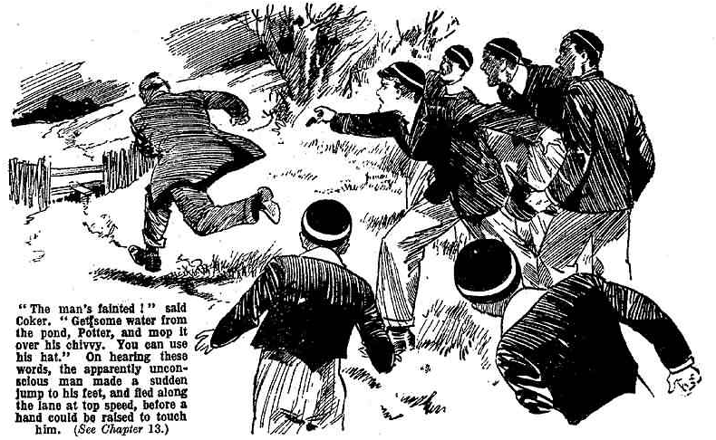
Help from the fags, however, might have been useful to Coker, though he did not want it. For, an hour later, Coker & Co. were trailing home in the November dusk—without the green-eyed man. He had vanished somewhere among fields and hedges, and Coker & Co. had sought in vain. And all the way back to Greyfriars Coker explained to Potter and Greene what a pair of benighted asses they were, to let the man get away
THE FOURTEENTH CHAPTER.
All Right for Coker!
WRATH, deep wrath, dwelt on the brow of Prout.
Standing at his study window, Prout looked out in the dusk and beheld Greyfriars fellows coming in, in twos and threes and fours.
Harry Wharton & Co., as they came up to the House, discerned Prout standing there, and noted the thunderous wrath in his brow.
“Something waiting for Coker when he gets in!” remarked Bob Cherry.
“Something hot!” said Nugent.
“The hotfutness will be terrific!”
And the juniors passed into the House, leaving Prout still staring thunderously from the study window.
Dusk deepened to darkness.
Prout shut his window, and turned from it. He paced his study, his brow more thunderous than ever, his eyes glinting.
He was waiting for Coker to come in.
Often and often had Prout been exasperated, indeed enraged, with that remarkable member of his Form. But never had he been so deeply incensed as now.
Prout was worried and troubled; and on top of his worries and troubles came the worry of the ineffable Coker. It was really too much.
His interview with Tighe had left the Fifth Form master in a frame of mind far from enviable. Anger and alarm, rage and apprehension, alternated. He could not and would not yield to the demands of the blackmailer.
Yet he shrank from the inevitable concquences. That cheque in Tighe’s hands, once made known, would cover the name of Prout with shame as with a garment.
His nephew’s name was in the Roll of Honour at Greyfriars; Prout had often gazed at it there with pride, seen with pride others gazing at it. But what comments would it evoke, when the truth was known? For the unhappy young man there were many excuses; the War had left him with a mind unhinged. But that did not alter the fact that he had stained himself with crime—that he had brought shame on his name, on Mr. Prout’s name. Pondering miserably over it, Prout was tempted to yield alter all, to pay the dastardly blackmailer the sum he demanded, and gain possession of the tell-tale document.
Time was passing; and he had not—he could not decide. Prout’s fat and rather flabby mind was not equal to dealing with emergencies.
And on top of this tormenting worry there was Coker! Coker, at least, should be made to feel the weight of his wrath.
The fellow who defied his authority, who had disobeyed his direct commands, who had flouted him, should suffer for his sins.
A Head’s flogging was the very least that would satisfy Prout. Indeed, he was considering whether he should demand Coker’s expulsion from the school. No punishment, he felt, was too severe for the obtuse, obstreperous fellow who had so unthinkingly added to his troubles when he was deeply troubled already.
Every minute, as it passed, added to Prout’s deep wrath.
Tap!
The portly Form master spun round to the door as he heard the tap. The door opened.
Coker of the Fifth presented himself.
Prout’s eyes gleamed at him.
Coker stepped into the study; not in the least alarmed, ashamed, or uneasy. Horace Coker was perfectly satified with himself and his proceedings; and his looks showed as much. Coker could see clearly that he was in the right, all along the line; and if Prout could not see it, too, so much the worse for Prout!
“Coker!” said Prout, in a deep voice. “You have returned!”
“Yes, sir!” said Coker cheerfully.
“You have dared,” said Prout, his deep voice breaking in anger—“you have ventured to break detention—to disregard your Form-master’s authority, and—”
“Quite unavoidable, sir, in the circumstances.” said Coker, with the same cheery satisfaction. “As I explained to you, sir, I was going after that man Buzzard—”
“You—you—” gasped Prout.
“I got him, sir, but some silly duffers who were with me let him get away again!” said Coker. “Still, I’ve got his London address, and even the police may be able to get him now, with my assistance.”
Prout gazed at him.
“Coker! You—you will come with me to the Head—”
“Certainly, sir.” said the cheery Horace. “But I’ve something to hand you, sir, before we go into that.”
“What do you mean?”
“Something that belongs to you, sir— or, rather, to your nephew.” said Coker
“My—my nephew?”
“Yes sir—Captain Eustace Prout—a cheque—”
“A cheque?” said Mr. Prout faintly.
“You see, sir, I got that man Buzzard.” said Coker. “He seems to have had a lot of names. He had letters in his pockets addressed to Sharp & Co.—”
“Sharp & Co.?“
“ And Tighe—”
“Tighe?”
“Seerns to leave used the name of Tighe, among others.”, said Coker. He was caIled Buzzard when he spoofed my Aunt Judy —a nasty little beast ‘with a long nose and green eyes.”
Mr. Prout laid one hand on the corner of his study table for support. He gazed at Coker, as if Horace’s cheery face mesmerised him.
“You—you—you have seen—seen the man Tighe?” said Mr. Prout, in an almost inarticulate voice.
“You know anything about him, sir?” asked Coker.
“I—I—”
“Well, among the papers in his pocket was this,” said Coker, laying a cheque on the table. “I knew he must have stolen it, as he’s a thief, anyhow, and it’s made payable to Eustace Prout, and endorsed Eustace Prout on the back. 1 don’t know where your nephew is, sir, so but I thought I’d better bring it to you. I suppose you can send it to Captain Prout.”
Like a man in a dream, Prout gazed at Coker.
With trembling, fat fingers, he picked up the cheque.
It was the incriminating document that Tighe had shown him. There it was—the forged cheque with his nephew’s name on the back!
Prout looked at it. He devoured it with his eyes. It was the paper for which the backmailer had demanded five hundred pounds! And now it was in Prout’s hand—placed there by Coker!
Prout hardly breathed.
It seemed to him that this must be a dream—a delusion! The frightful worry that had tormented his mind, the shadow of disgrace that had darkened his days— where were they now? Gone——vanished! His nephew was saved, and he was saved—by the biggest fool at Greyfriars, or anywhere else!
“1 suppose you’ll know what to do with that cheque, sir’” said Coker.
Prout’s glance wandered to the fire.
“Eh? Yes! I—I know what to do with it, Coker!” he articulated. “Upon my word! I—I am surprised! In fact, astounded! I—I feel quite dazed!”
Prout was silent for some moments. His fat fingers clutched the cheque, and he strove to pull himself together.
He spoke at last.
“Coker! In the—the circumstances— you are excused. I—I overlook your rebellious conduct. It must not occur again; but—but I excuse you. You may go, Coker.”
“Thank you, sir.” said Coker heartily. “I was sure that, on reflection, sir, you would realise that I was not to blame in any way; that I was bound to act as I did. I am really glad that you see it now, sir.”
Prout waved him to the door. Coker departed.
The moment the door closed behind Coker, Prout jumped to the grate, and the cheque dropped into the glowing coals. It disappeared from existence in a moment. And Prout breathed freely, feeling as if a mountain had been rolled from his mind and his heart.
* * * * * * *
“Flogging?” asked Potter.
“Or the sack?” asked Greene.
Coker stared at them as he greeted him with those queries.
“What are you burbling about?” he asked. “Prout’s done the sensible thing—he’s let the whole thing drop.”
“He’s let it drop?” gasped Potter.
“Certainly.”
“You’re not going to be flogged?” gasped Greene.
“No, ass!”
“Oh crumbs!”
Coker saw nothing surprising in this state of affairs. He had been in the right, and Prout had seen it on reflection. What was there surprising in that? Potter and Greene were surprised, however; and they never could understand how Coker had got off without receiving what he had asked for so earnestly.
Other fellows were astonished, too. It was agreed that Coker of the Fifth had more than his fair but allowance of fool’s luck. Only Harry Wharton & Co. had a shrewd idea why Coker had been let off. But what the Famous Five knew they kept strictly to themselves.
THE END.

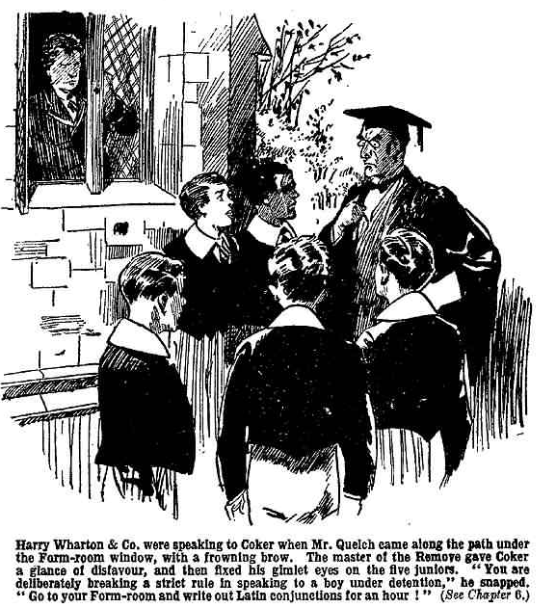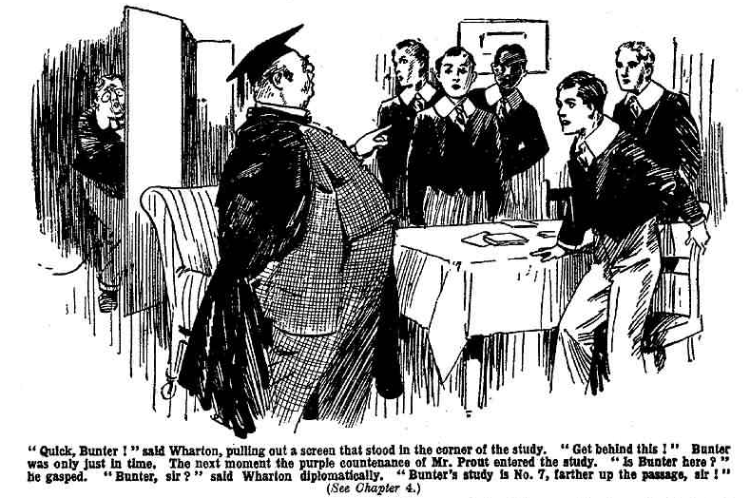

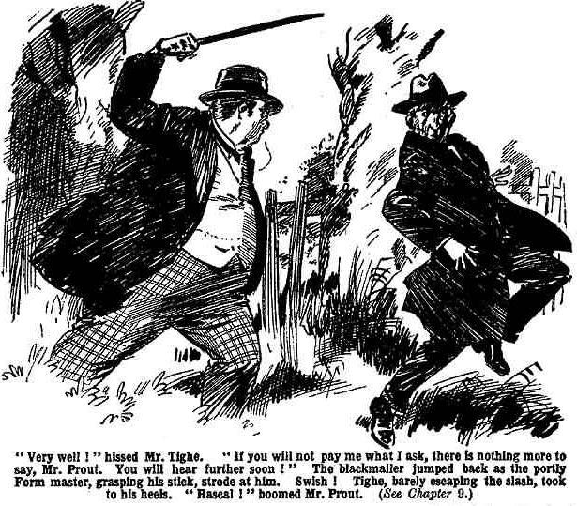

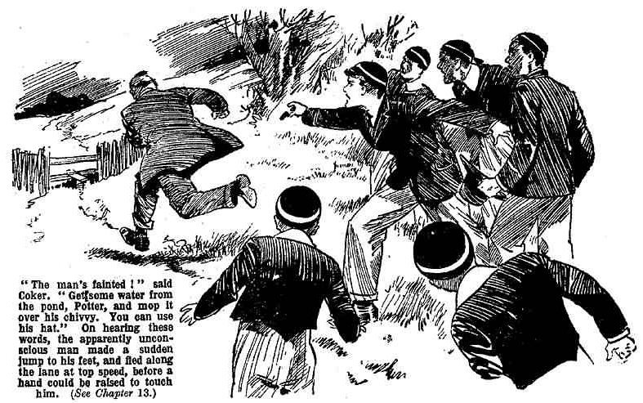2

