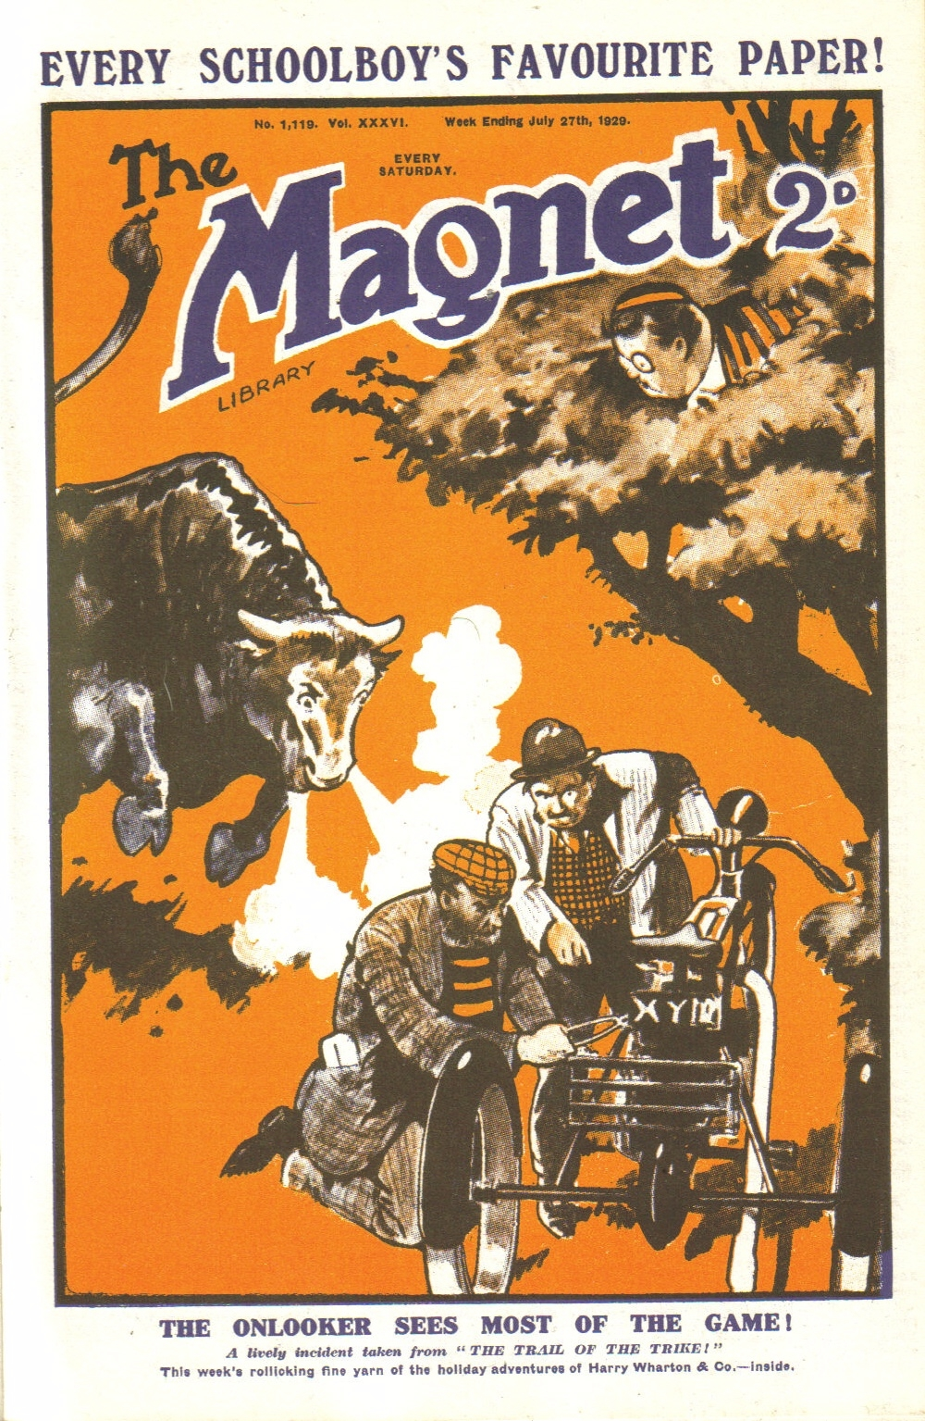
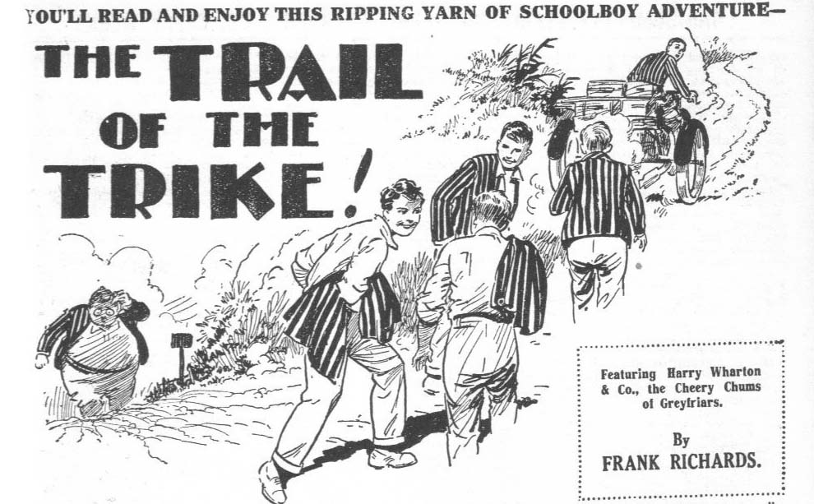

THE FIRST CHAPTER.
Ups and Downs!
JOHNNY BULL paused, mopped his forehead with his handkerchief, slew a gnat that had settled on his nose, and breathed hard.
“They call these the downs ?“ he said.
“ The Sussex downs !“ agreed Harry Wharton.
“More ups than downs, if you ask me.”
“ The upfulness is terrific,” remarked Hurree Jamset Ram Singh. “It is one of the esteemed mysteries of the beautiful and ludicrous English language. They are called downs, but they are really ups.”
“ What’s the odds so long as you’re happy?’ asked Bob Cherry cheerfully. Bob, as matter of fact, was rather better circumstanced than the other members of the Greyfriars walking-party.
He was sitting in the saddle of the Dionysius tricycle, attached to which was a carrier that bore the luggage.
The Famous Five of Greyfriars were negotiating a lane that ascended a long, low hill.
It was glorious, summer weather
The sun was hot.
There was no doubt that the summer weather was glorious. All the juniors agreed that it was glorious. But as they laboured up that hill, they could have wished that it was a little less glorious. They were warm— they were perspiring—the sun blazed down on them, reminding Hurree Jamset Ram Singh of the tropical blaze in his native country, and reminding the other fellows of a particularly hot furnace with the door open. Glorious as the summer weather was, the walkers would have given a great deal for a sudden snowfall. But in summer—even an English summer—snow was not to be expected. All through a dismal spring they had longed for a glorious summer. Now they had got it.
“Put it on !” said Bob.
“That’s all very well !” grunted Nugent.
“ Well, you don’t want to slack about, you know.”
“Fathead !” was the reply from four members of the Co.
It was indeed all very well for Bob to tell his comrades to put it on. Certainly, that long hill had to be negotiated. But such advice came very easily from a fellow sitting at ease on a roomy old saddle, with a motor- tricycle snorting under him. Bob could have “ put it on” easily enough, he had only to let out his engine. It was quite painful to Bob, who liked a high speed, to linger on the road accommodating the pace of the tricycle to that of the four pairs of legs belonging to the rest of the Co. It seemed to Bob that his comrades were giving more attention to fanning themselves, than to getting over the ground. It was true that the walking-party were not in a hurry, they had all the vacation and all Great Britain before them. Still, a fellow wanted to arrive somewhere.
“ Ass !” added Nugent, and he made a ferocious drive at a wasp that sought a resting-place in his eyebrows.
“Dummy !” remarked Johnny Bull.
“My dear chaps!” said Bob, with the kind and patient reasonableness of a fellow who was not tired. “ We didn’t come to settle on these downs—we’re not going to live here, you know.”
“Chump !”
“We’ve got a lot of miles to cover.”
“The milefulness is terrific,” murmured Hurree Jamset Ram Singh.
“And we’re a walking-party, aren’t we? ” inquired Bob. “ Not a crawling- party, old beans ! Get on with it!
Instead of getting on with it, the four juniors slowed down and halted:
A big oak tree by the wayside gave a welcome shade. In the shade of the oak, the four juniors took a little rest.
Bob sighed and shut off the engine of the tricycle. Neither Bob nor the tricycle needed a rest.
“Taking it easy?” he asked.
“ Look here -- “ said th8 four, together.
Then they paused.
One thought as in all their minds, the thought that it was high time that somebody else took a turn in the saddle, while Bob stretched his legs. It was a case of four with but a single thought, four hearts that beat as one. But it was rather a delicate matter.
That tricycle of ancient design and uncommon appearance was Bob Cherry’s big bargain. His chums had scouted the bare idea of their trundling it along on the vacation. They had laughed at the suggestion—they had laughed still more when they saw the trike. That was quite excusable for undoubtedly that trike was a remarkable one and it had evoked many smiles on the country roads since the walking-party had started walking. Its arrangements were some what peculiar; if there had ever been any other trike like it, all the others had dropped out of existence long ago. Its proper place was in a museum, and the proper place for a fellow who wanted it was in a home for idiots. The four had agreed on that. But they had given in, on the express condition that Bob had the handling of the trike. It was his bargain, his idea, and his responsibility. He had to steer the strange thing, he had to do the running repairs, he had to attend the inquests of any unhappy pedestrians who wore slaughtered by it. That was settled before the party started.
Bob had agreed willingly.
He had faith in that trike. He had explored its mysterious interior, like Stanley or Livingston exploring the mysterious interior of Darkest Africa. He knew, or thought he knew, how it worked. He declared that it would cease to give trouble, and settle down to steady business, under a skilful hand. And it seemed that he was right. Remarkable if as the trike was to look at, it obeyed Bob like a well-trained horse, it almost came at his call and fed out of his hand.
For two or three days, the juniors had nourished a secret expectation, if not a hope, that it would suddenly burst, or blow up, or fall to pieces. But it hadn’t. Just as if it had adopted the system of Coue, every day and in every way it grew better and better.
On account of its age, which was venerable, the juniors had named it Methuselah. It was not, of course, so old as the original Methuselah, but they agreed that it looked as if it was. It was undoubtedly as old as any motor-vehicle possibly could be. It dated from the early, dark age of motoring. Yet it worked ! It ran! It carried considerable baggage, and it carried Bob. It did not burst, it did not blow up, it did not suddenly disintegrate. More and more smoothly it ran, with each passing day. Bob Cherry cheerfully bore the jests and laughter of his comrades, on the principle that he laughs best who laughs last. Now the laugh certainly had come to Bob. Fresh as a daisy, he sat in the roomy old saddle, and grinned at four tired and perspiring walkers under the shade of the spreading oak.
“Look here−” said the four juniors again.
Then there was another pause.
“Go it !” said Bob.
“Hem !”
Really it was a difficult and delicate matter.
All four had vowed solemnly that they would not be found dead on that trike. All four had vowed solemnly that rather than handle the thing, they would leave it by the wayside. All four had stated, categorically, that it was up to Bob, and to Bob alone. So really it was rather awkward to claim a turn at riding Methuselah.
“Cough it up,” said Bob, staring at them. “You’ve got something to say?”
“Well, you see−” began Wharton.
“Yes?”
“Oh! Nothing.”
“ You see—” said Frank Nugent.
“I don’t, quite,” said Bob. “What are you driving at?”
“Oh, nothing.”
“If you mean that you want to take a rest, I don’t mind,” said Bob, good-humouredly. “ It’s rather a pity that you’ve got such a prejudice against the trike—you might ride it in turns, you know, if you weren’t so jolly set against it.”
“Oh!”
The Co. looked at one another quite sheepishly.
After that they simply couldn’t utter what was in their minds.
“Let’s get on!” said Johnny Bull, with a sigh.
“ Let’s !” groaned Nugent.
“Put it on!” said Bob encouragingly.
“Oh dear!”
The tricycle snorted again, and rumbled on up the hill, taking the hill with ease if not with grace.
After it tramped the four, leaving the shade of the branching oak for the blinding sunshine of the dusty road.
A white road, seemingly endless, and with decidedly more ups than downs, stretched before them. Bob Cherry hummed a cheery tune as Methuselah bore him onward. Four dusty fellows behind did not hum tunes. They needed all their breath for the hill. They tramped on doggedly, their only solace a lingering hope that the trike might yet blow up.

THE SECOND CHAPTER.

A Happy Meeting “
“I SAY, you fellows !”
“Great pip !”
“Bunter !”
“Oh, my hat!”
Billy Bunter smiled.
The Famous Five did not smile.
Not by the widest and wildest stretch of the imagination could William George Bunter have supposed that they were glad to see him. Obviously they were not pleased. But Bunter was pleased, and that, after atll, was all that mattered.
He blinked at them through his big spectacles, and smiled genially.
“Bunter !” repeated Wharton blankly.
“The Bunterfulness is terrific.”
A minute before, and the Famous Five had been feeling quite bucked. On that long hill in the Sussex downs, where the sun-scorched lane seemed endless, and human habitations unknown, they had suddenly come upon a wayside inn.
It was a little old-fashioned inn, almost hidden by creepers, with red chimneys and diamond-paned windows, coyly tucked away from the roadside amid spreading beeches. It was a most attractive-looking inn, and never had it seemed so attractive as it did to the eyes of the dusty and thirsty walkers of Greyfriars. It was yet early in the afternoon, and the chums of the Remove had intended to keep on a long way yet.
Their route had been marked out before leaving Greyfriars, in fact, and in Wharton’s pocket was a map on which likely spots were marked for camping. With the optimism of youth, they had marked out rather long stretches, which were not so easy to cover when it came to the actual walking.
At the sight of that coy little inn four members of the party decided instantly that this was going to be the halting place. Camping out was all very well, but it was, after all, a thing that could be overdone. Bob, sailing merrily along on the trike, saw no special reason for halting. His four comrades saw excellent reasons for doing so, and they halted. Bob good-humouredly gave in.
So they halted. The trike was wheeled into the inn yard, where an old plump ostler gazed at it in astonishment and admiration, never having seen a vision before. Then they walked to the honeysuckle-clad porch of the inn, and then —
Then Bunter happened.
Harry Wharton & Co. had not seen the Owl of the Remove since Greyfriars had broken up for the summer holidays. Bunter had intended to join the walking-party. The walking-party had had quite other intentions. They had started the tour in the happy belief that they would not see Bunter again till next term at Greyfriars. And now, here he was.
“You !” said Nugent faintly.
That “ bucked “ feeling of the Greyfriars chums quite evaporated. The sight of Bunter seemed to deflate them.
“Yes, old chap,” said Bunter affectionately
“You !” stuttered Johnny Bull.
“I say, you fellows, you seem surprised –“
“ The surprisefulness is terrific.”
“Well, I suppose we oughtn’t to be surprised,” said Harry Wharton. “ You were bound to turn up, like a bad penny—“
“ Oh, really, Wharton –“
“What on earth are you doing here? demanded Johnny Bull.
“Waiting for you chaps.”
“Waiting? “
“Certainly. Didn’t I tell you I’d come with you on this walking-tour ?“ asked Bunter reproachfully. “ I’m not the man to let old pals down.
“Oh dear !”
“ How the thump did you know we were coming this way !” exclaimed the captain of the Remove.
Billy Bunter grinned.
“ You had it all mapped out at Greyfriars,” he explained. “ Having looked over that map in your study —‘
“You prying villain !”
“Oh, really, Wharton! Of course, I studied the map, as a member of the party. If I hadn’t, I might have missed you.”
“What a catastrophe!” said Bob Cherry sarcastically.
“Yes, it would have been rotten, wouldn’t it ?” agreed Bunter. “Knowing that you would be on this road, I thought of meeting you here. I’ve been at the Red Lion three days waiting for you and keeping an eye on the road.”
“Oh, my hat ! If we’d only passed after dark !” murmured Nugent.
“ Well, I don’t think I should have missed you,” said Bunter. “ You see, I’ve asked several people to keep an eye open for a tricycle that looks as if it’s come out of the Ark.”
“What ?” growled Bob Cherry.
Bunter chuckled.
“You’d be known by that trike anywhere,” he explained. “ I saw you miles off. A car stopped here an hour or so ago, and the man said to the landlord that he’d passed a weird-looking machine on the hill—fearful and wonderful, that was how he described it. So 1 knew you were coming!”
“You fat idiot !”
“Oh, really, Cherry !” Bunter blinked at the juniors. “ You haven’t said yet that you’re glad to see me, old chap.”
“ The gladfulness is not preposterous, my esteemed Bunter.”
“Oh, really, Inky! After I’ve waited three days for you !” said Bunter. “ I’ve run up a bill at this inn waiting for you. It’s rather lucky you never changed your route.”
“Is it ?” said Wharton doubtfully.
“Yes, old fellow. You see, leaving home in rather a hurry, 1 came away without any money. If you fellows hadn’t come, goodness knows how my bill here would have been paid.”
“Oh crumbs!”
“Now it’s all right,” said Bunter comfortably. “I can rely on my old pals to see me through.”
“You can rely on your old pals to see you blowed first !” said Johnny Bull forcibly.
“He, he, he !” Bunter decided to take that remark as a joke. “The bill doesn’t come to much—only a few pounds—“
“Only a few pounds, in three days!” ejaculated Nugent.
“Yes, old chap. I’ve been careful not to run up a lot,” said Bunter. “ Of course, a fellow has to eat. The grub here is good—old-fashioned English grub, you know. The ham—well, the ham is a dream. I could sit and eat it for hours. Melts in your mouth, you know. And the cream !“ Bunter gave an ecstatic sigh. “You wait till you sample the cream ! I’ve gone rather heavy on that, perhaps ! The ginger-beer is the same as usual; but a chap can do with a lot of ginger-beer in this weather! Don’t you think so?”
“ I think I could do with one now,” said Nugent.
“Come in and have as many as you like,” said Bunter generously. “ My treat, you know. Don’t spare it.”
“ Your treat ?” ejaculated Johnny BuIl.
“Certainly. Anything you like, and put it all down to me,” said Bunter. “ Dash it all, a fellow likes to be hospitable when he sees his best friends after an absence.”
“ Your treat—to go down on the bill that you want us to settle ?” hooted Johnny Bull.
Bunter looked pained.
“ Oh, really, Bull ! That’s rather sordid, you know. I don’t like that way you have of always bringing up money matters into a pleasant friendly conversation. Don’t you think it’s—well, a little mercenary ?”
“You—you —“
“ Oh, let’s get in !“ said Wharton. “Come on.”
The juniors entered the inn. Billy Bunter rolled in after them, his fat face full of satisfaction.
From Bunter’s point of view, at least, it was happy meeting. Certainly, had the walking-party changed the route they had mapped out at Greyfriars, Bunter would have been in some difficulty about his bill at the Red Lion. He had counted on the walking-party coming along, and he had been right; but certainly he had taken chances. But Bunter was accustomed to taking such chances.
Whether somebody else paid his bill at the Red Lion, or whether it remained unpaid, was, after all, immaterial. Bunter assuredly was not going to pay it, as he was not supplied with the necessary cash. Had not the walking- party turned up, no doubt Bunter would have been reduced to the painful expedient of departing from his quarters by a window in the middle of the night. But now all was serene, and the fat junior beamed with satisfaction.
In a shady room, looking out on a garden bright with flowers, the dusty quintet sat down to tea—a most attractive meal, with beautiful ham, which deserved Bunter’s description of it, and new-laid eggs of huge size, and ecstatic cream. Bunter, it appeared, had already had his tea once, but was quite prepared to join his old friends in another. But the juniors made it clear that it was not Bunter’s treat. They did not want Bunter’s treat added to the bill that was already long, and which—in spite of Bunter’s happy certainty on the subject—they did not intend to settle. It was all very well for Bunter to state airily that it was only a few pounds. A few pounds were rather a considerable item to the walking- party; and as they paid their way, they had to be more careful with money than Bunter needed to be.
“Isn’t this jolly?” said Bunter, beaming over the festive board. “ Didn’t I tell you the grub was ripping?”
“The ripfulness is terrific.”
“ And the jam,” said Bunter dreamily. “They make the jam them- selves from fruit they grow an the garden— raspberry, strawberry, black currant, and apple—best jam I’ve ever tasted. You fellows mayn’t believe it, but I’ve eaten pots and pots of it.”
“ I can quite believe it,” said Harry.
“The believefulness is terrific.”
“And the innkeeper’s let you run on ?“ asked Johnny Bull.
“Well, I suppose he knows a gentleman when he sees one,” said Bunter, with dignity. “I’ve mentioned that I’m a public school man. lie would hardly be likely to doubt the honour of a public school man, I suppose.”
The juniors gazed at Bunter.
“But you’re going to bilk him !“ gasped Nugent.
“Oh, really, Nugent —
“What do you call it, then?” demanded Bob Cherry.
“ Oh, really, Cherry
“You fat villain!”
“I rely on my old pall to see me through this,” said Bunter. “I shall settle with you later. If you let me down –“
“The let-downfulness will be preposterous !”
“In that case, I shall telephone home for a remittance,” said Bunter. “But that means waiting here some time. Of course, if you fellows are not in a hurry to get on, that’s all right. I don’t mind putting in a few more days here. The grub is splendid—”
“We’re going on at daybreak.”
“Thanks for the tip. I’ll be up early,” said Bunter. “ After all, the innkeeper can wait. I can send him a cheque later. You fellows can tell him it’s all right—that you know me well.”
“ A fellow who knows you well could hardly tell the innkeeper that it’s all right.”
“Oh, really, Wharton
“Better give the landlord a tip to send for a policeman !“ remarked Johnny Bull.
“ Beast !“
“Look here, Bunter
“ What about the jam ?” asked Bunter. “Tell the waiter to bring the jam. I can tell you it’s scrumptious !”
“But look here –“
“ You fellows talk such a lot,” said Bunter peevishly. “ You’re like a sheep’s head—all jaw ! Let’s have the jam now, and talk afterwards, if you must keep on wagging your chins.”
So they had the jam ; and when the Famous Five were finished, and strolled away, Bunter remained at the table, still busy with the jam. Undoubtedly it was very nice jam ; and they fully believed Bunter’s statement that he had disposed of pots and pots of it. In fact, while they strolled round the inn, Bunter was proceeding to dispose of more pots and pots.

THE THIRD CHAPTER.

The Sticker!
“WONDERFUL, sir !“ said the ostler of the Red Lion. “ The latest thing, I s’pose, sir?”
Bob Cherry glanced at the plump, red-faced ostler suspiciously.
He suspected sarcasm.
The juniors had looked into the inn yard, after leaving Bunter busy with the jam, see that the jigger was “all right”, as Bob expressed it. His comrades had no doubt that it was “all right.” They could not imagine anyone in his senses stealing that jigger.
It was true that attempts had been made to steal it, before it came into their possession, from the cycle dealer’s in Lantham, near Greyfriars. Bob reminded them of Alfred Snooks, who had made really desperate efforts to get posession of that antiquated Dionysius tricycle.
To which the juniors rejoined that the said Alfred Snooks was obviously not in his senses. How could he be, if he wanted that trike?
Anyhow, Alfred Snooks was not likely to be anywhere near that wayside inn on the Sussex downs ; and nobody else in the wide world was likely to share his taste for prehistoric trikes. Still, they followed Bob into the inn yard to see that the jigger was all right. Bob, at least, bad a happy fancy that there was some value in that jigger.
The ostler was standing by the ancient machine, regarding it with interested and, indeed, with awed eyes. Plainly, it was a new thing in his experience, although far from a new thing in itself.
He was not indulging in sarcasm. His ruddy face was quite innocent, as Bob looked at it.
The trike was, in fact, so old that the Sussex man thought it was new ! The design had passed out of existence so long ago that it came as a novelty to his eyes.
“The things they make nowadays, sir !“ said the Red Lion ostler admiringly. “I seed a lot of machines on the road, sir—every make you can call to mind—but I never seed the like of that!”
Four of the juniors smiled.
Bob coughed.
“It’s a jolly good machine,” he said. “The Dionysius factory turned out ripping machines when that jigger was made.”
“I seen a lot of Dionysitis machines on the road, sir, but never the like of that,” said the ostler. “ Everything new. There’s ‘ardly a thing about that machine that I’ve seen about other machines.” The juniors sauntered away, leaving the ostler still regarding the trike with interest and admiration.
“ I suppose if a mastodon came along it, would be a novelty,” remarked Frank Nugent; “ and if a pterodactyl flew over Red Lion they’d think it was some thing new in birds.”
The juniors chuckled.
“Old or new, it’s a good machine,” said Bob. “Look at the way that man Snooks tried to bag it before we left Greyfriars.”
“Poor chap!” said Johnny Bull.
“You mean because he couldn’t have that jigger?”
“No; I mean because he must be potty to want it.”
“Look here, you ass – ”
“ My esteemed chums, never mind the excellent and execrable jigger,” said Hurree Jamset Ram Singh. “The esteemed question is, what about the ridiculous Bunter?”
“Blow Bunter !”
“I’ve been thinking about that,” said Johnny Bull. “ Bunter is a sticker, but he’s got to come unstuck.”
“Hear, hear!”
“We were thinking of putting up at this inn to-night,” went on Johnny Bull. “Bunter thinks we’re safe till morning. What about pushing on?”
“Good egg!” said Bob Cherry heartily. “It was rather fatheaded to stop, you know, only you fellows seemed tired. I wasn’t tired.”
“Sitting down isn’t so tiring as walk- ing,” remarked Nugent.
“Well, I like that !“ said Bob warmly. : You fellows make me stick to that jigger. I haven’t had a chance to stretch my legs since we started. I’m not the chap to go back on an agreement, but I can tell you I got pretty fed up with it; while you fellows had all the fun.”
“Oh, my hat!”
“Well, what about starting soon after dark?” asked Johnny Bull. “We can fill up with a good supper and bunk. Bunter can wake up in the morning and find us gone. As he knows the route we’ve mapped out, we’ll vary it a bit
“Ha, ha, ha!”
“You’ve forgotten one thing,” said Nugent.
“What’s that?”
“ Bob won’t agree to leave the trike behind
“No fear !“ snorted Bob Cherry.
“ And if the trike starts up all Sussex will know we’re starting,” said Frank. “Even if Bunter were stone deaf he would hear it.”
“Look here –“
“That’s all right,” said Wharton hastily, “ There are pedals on the thing.”
“ On the what ?“ snapped Bob.
“On that magnificent jigger –”
“Ha, ha, ha!”
“Bob can pedal it away to a safe distance. About a mile off Bunter won’t hear it snort.”
“Better make it ten miles,” said Nugent.
“You silly ass !“ roared Bob Cherry. “Anyhow, if Bunter heard the trike he would only think it was a motor-bike passing.”
“That trike has a snort of its own— unmistakable,” said Nugent, shaking his head. “ Bunter might think it was a grampus, perhaps—only he would know there wasn’t a grampus so far inland as this. He might think it was a steamer’s siren out of order—but he knows there are no steamers here. But if there’s one thing he couldn’t take it for, it would be a motor.”
“ Look here --”
“We’ll pedal it or trundle it away,” said Wharton, laughing. “One thing’s certain—we’re not going to be landed with Bunter on this trip. Only a fellow doesn’t like to kick him. Let’s just get off quietly and leave him to it.”
“Jolly good idea,” said Bob. “There’ll remove tonight, and it will be cool ! Couldn’t do better.”
“I say, you fellows.”
Billy Bunter rolled after the juniors. He had finished the jam. Traces of it were thick about him as leaves in Vallambrosia.
He was jammy and happy and sticky. He was also a little suspicious. It was clear that he did not intend to let the Greyfriars waking-party get out of his sight for long. Bunter cheerfully assumed that the addition of his fascinating self would have made any walking tour a success. At the same time he was wary. Bunter was a sticker, and he intended to stick. What the other fellows intended did not matter—to Bunter.
“I say, you fellows, some motorists have just stopped,” he remarked, with a fat chuckle. “They’re looking at that jigger in the yard.”
“Well, let ‘em look !” said Bob.
“Killing themselves with laughing !” chuckled Bunter.
“What ?”
‘I really thought some of them were going into fits,” said Bunter. “ He, he, he ! I say, you fellows, you must have a nerve to trundle that horrid thing about the country with you.”
“You silly owl!”
“Oh, really, Cherry ! Look here, I’ve got an idea,” said Bunter.
“What about selling it as scrap iron? Might get ten bob for it.”
“We gave four pounds for that jigger,” said Bob, breathing hard.
“ You were done, old chap,” said Bunter. “ Done to the wide ! That cycle-dealer at Lantham must have been glad to see you coming ! I dare say he’d been waiting for dog’s ages for some silly idiot to come along and take that relic off his hands. He, he, he !”
“Cheese it, you fat ass !“
“ Fools and their money are soon parted, ‘ said Bunter agreeably. “ Well, what about trying to sell it for scrap in the next village? As a matter of fact, I hardly care to be seen with that trike.”
“That’s all right—you won’t be seen with it !” growled Bob Cherry.
Bunter blinked at him.
“Shush!” murmured Nugent.
“They’re pretty simple in the country, you know,” said Bunter. “Man might give ten bob for it.”
“Oh, go and eat coke !”
Bob Cherry stalked away, and his comrades followed him. The charms of Bunter’s conversation had already been exhausted.
“I say, you fellows --”
“Bow-wow !”
Bunter accelerated. He had a deep-rooted suspicion that, in spite of his many well-known fascinations, the walking-party would have been glad to get on and leave him at the inn. That prospect did not suit Bunter at all. His fat little legs twinkled as he pursued the Famous Five, and he came up with them breathlessly.
“I say, you fellows, don’t hurry !“ gasped Bunter. “What’s the good of hurrying? Take it easy, you know.”
“Buzz off, you fat bluebottle !“ hooted Bob Cherry.
“Oh, really, Cherry--!”
“Look here, Bunter —”
“If you fellows don’t want my company on this trip you’d better say so !” snapped Bunter.
“So !“ said five voices together.
“He, he, he! You chaps will have your little joke,” said the fat junior pleasantly. “Don’t mind me! He, he, he! I say, you fellows, what about having some ginger-beer? That jam’s made me thirsty.”
“You go and have some ginger-beer while we stroll round.” said Nugent.
“Oh, that’s all right! I’d rather stroll round with you,” said Bunter affably. “The ginger-beer can wait.”
Bunter strolled round with the Famous Five. They did not escape his eyes and his spectacles till they got back to the inn. Obviously, Bunter was prepared for a sudden break on the part of his victims, and did not intend to he caught napping. However, the night was the time for naps. and the Greyfriars walking party had no doubt that he would be caught napping then.

THE FOURTH CHAPTER.

Unstuck!
“WHAT about bed?”
Bunter yawned deeply.
Supper was over; a substantial supper, especially so far as Bunter was concerned. There was no doubt that the grub at that little Sussex inn was good. But it seemed doubtful whether the supply would last much longer if Bunter continued as a guest at the Red Lion.
If aving supped, as if hc were laying in supplies for a sicgc, Billy 1tiritcr is sleepy. lie was ready for bed; but he did not intend to go to bed till the walking-party went. Bunter knew a trick worth two of that. Not till the Greyfriars walkers were safe in their rooms did William George Bunter intend to close his little round eyes. He had waited three days for the walkers to pass, and now he had made his capture he was not running any risks.
He yawned, and blinked at the Famous Five.
“Bed, you chaps! Early to bed and early to rise, you know! That’s the way to be healthy, wealthy, and wise.”
Harry Wharton rose.
“Come on, you men.”
The Famous Five went to their rooms. The rooms had already been booked before the change had been made in the programme. They had no objection to spending an hour or so there, while the Owl of the Remove settled down to sleep. It seemed the easiest way of causing the fat junior to come unstuck, as Bob expressed it.
Bunter puffed and blew his stentorous way up the narrow stairs of the Red Lion. He had a heavy cargo to carry up with him; he was loaded far beyond the Plimsoll line. He was quite breathless when he arrived at the top.
“ I say, you fellows,” he gasped.
“ Good-night, Bunter.”
“Sleep well !” added Bob Cherry ironically.
“But hold on a minute, old chaps. I say, the landlord knows I’m going on with you fellows to-morrow,” said Bunter.
“Does he?” said Johnny Bull grimly. “ Yes ; I mentioned it to him. I’ve told him to make out one bill for the lot.”
“That’s all right—I’ve told him not to.’
“Oh, really, Bull –”
“Good-night, Bunter !“
“ Hold on minute. Ny bill doesn’t come to much—just over four pounds,” said Bunter. “ Which of you fellows is lending me the money ?”
“ The whichfulness is terrific.”
“Well, settle it among yourselves,” said Bunter. “ I don’t mind which, as you’re all my pals. Good-night !”
Bunter rolled into his room. He was sleepy, but he was still cautious. He kept his door open till the other fellows had gone into their rooms and shut their doors. Then, relieved in his fat mind at last, Billy Bunter went to bed, and his melodious snore awoke the echoes of the Red Lion.
A little later doors opened on the passage, and five fellows looked out, grinned at one another, and listened.
Snore!
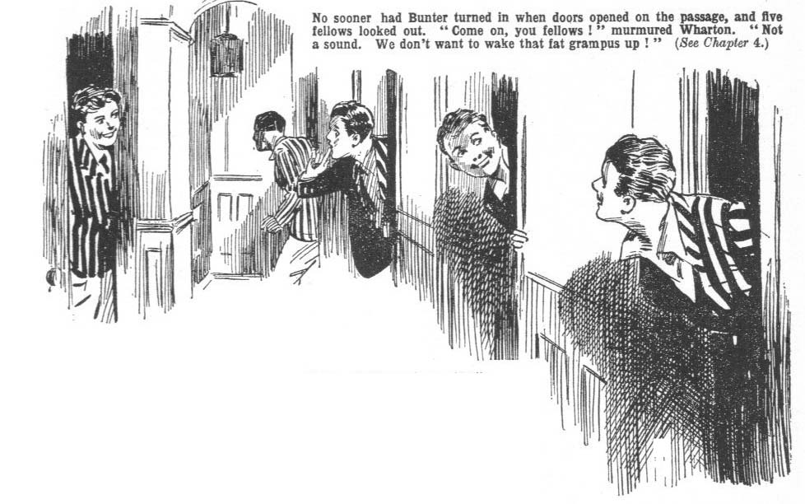Bunter was going strong.
“night !” murmured Bob Cherry, glancing from a window into the garden, where the silvery moonlight lay in pools on grass and trees. “Just the night for the open road.”
“Just !” grinned Nugent.
“The justfulness is terrific!”
“Come on !” murmured Wharton. “ Not a sound ! Not that that fat grampus is likely to wake up.”
“Not unless there’s an earthquake, or unless Bob starts up the trike!” said Nugent.
“Oh rats! Come on!”
The old stairs creaked under the tread of the Famous Five. But creaking was not likely to awaken William George Bunter when he was once safe in the land of dreams. There was a roar from a passing motor, drowning Bunter’s snore ; but when it had passed the snore was going as strong as ever. It really seemed that Bunter was safe till morning.
Downstairs, the Red Lion was not yet closed. The juniors stated that they were going on, after all ; paid their bill, took out their bags to the yard, and packed them on the carrier behind the trike.
Taking hold of the Dionysius, they wheeled it out of the yard into the highway.
There Bob Cherry mounted it ; but the ancient engine was suffered to sleep. The maker, evidently a man of foresight, had provided that trike with pedals, and Bob Cherry drove at them heftily. It was not light work ; but Bob’s limbs were stout and strong, and his friends helped him with a friendly shove now and then.
Methuselah trundled away along the road.
The lights gleaming from the diamond panes of the Red Lion, through the trees, died out of sight behind at last.
The way still lay uphill ; and without the power turned on the trike disliked hills. Bob Cherry laboured hard, and his comrades helped ; but it was, in every sense of the word, uphill work.
“ Better turn on the juice now, I think !“ gasped Bob, at last.
But his comrades demurred. They were not running risks of Bunter hearing the unmistakable note of the Dionysius. Although, it had been reduced to order, to a great extent, since Bob had had the handling of it, it still reminded hearers of a jazz band when it was in rapid motion.
“This blessed hill is miles long !” grunted Bob.
“That’s all right : let’s take the next turning. ” said Wharton. “ Bunter knows where we’re going, if we keep on as we mapped it out. We don’t want to meet him again to-morrow. Take the next turning, and trust to luck.”
“Good !”
A leafy, shadowy lane was the next turning. Where it led the juniors did not know ; but it did not matter much to a walking-party with the summer vacation before them. It led downhill, and it led away from Billy Bunter— and other things did not matter.
Downhill, the trike behaved handsomely. Bob had to brake it occasionally, to keep from leaving his comrades far behind.
At the bottom of the slope the trike halted. They were now about a mile from the Red Lion, in a level lane bathed in silvery moonlight, shadowed by great trees on either hand, growing over an expanse of grass. It was a beautiful spot, and seemed as solitary as the Sahara.
“Look here, I’m going to start up now,” said Bob. “These blinking pedals are only meant for an emergency! My blinking legs aren’t made of blinking iron or blinking steel—see?”
Bob seemed a little tired of footwork.
“All serene !” said Wharton, laughing. “ Bunter can’t hear even Methuselah from this distance. Go ahead!”
Bob went ahead.
His comrades waited while he started up. There was no danger of Bunter, at the distance, hearing Methuselah snort. There was, as a matter of fact, no danger of anybody hearing the the trike snort. The juniors waited, but no snort came from Methuselah.
“Waiting, old chap,” said Nugent.
“Wait, then !” grunted Bob. His tone was acid.
“ Shut; up while you waiL!”
“Oh!”
Pvidently Methuselah was going to give trouble again.
“ Oh crumbs !” said Johnny Bull. “Can’t you start her up !”
“ Don’t be an idiot ! Of course I can start her up ! Haven’t you seen me start her up a lot of times?”
“Then, why don’t you ?”
“For goodness’ sakc shut up!”
Bob was getting cross. His comrades exchanged a grin. They had been thinking that a turn on the motor-trike would be rather agreeable. Now they unanimously left. it to Bob.
“Something wrong?” asked Nugent, at last.
“I’ve told you plenty of times that there’s nothing wrong with this tricycle, Nugent !”
“Then, why won’t it start?”
“Because I’m answering silly-fool questions, instead of getting it going !”
“Oh!”
The juniors waited. They sat down on the grassy bank beside the lane to wait. Bob, his face growing redder and redder, wrestled with Methuselah.
“They’re been meddling with this machine!” he said savagely. “That idiotic ostler, I suppose. You see that he was interested in it. I suppose he’s been messing about with it. It was all right when we arrived at the inn, you know that! Now it’s out of order somehow.”
“Whats the matter with it !” asked Harry.
“If I were a cat, and could see in the dark, I’d tell you, like a shot. I’m not a cat !” stated Bob Cherry.
“Oh dear! Look here! is it going again, or isn’t it?” asked Johnny Bull.
It’s going again.”
“When?”
“When it’s ready.”
“Oh, my hat !”
For half an hour Bob Cherry explored the mysteries of the old tricycle. He did not succeed in elucidating them. He had told his chums that he knew every piece of that trike inside out. But there was evidently some piece that passed understanding.
His comrades waited patiently; though Johnny Bull remarked that if they were going to stop there for the night they might as well have been in the cosy beds at the Red Lion. Johnny was not always tactful.
After half an hour Bob turned an oily and greasy face, full of suppressed emotion, towards his comrades.
“Better leave it till daylight;” he remarked, with a sort of laborious carelessness. “Of course, I could start it up all right, taking a little time; but it’s hardly worth it at this time of night. We had to camp somewhere, and we may as well camp here. Beautiful spot !”
“Oh, beautiful !” said Johnny Bull.
“It was worth while leaving the inn to walk a mile and camp out—I don’t think!”
“I don’t see that we’re in a hurry to get anywhere. Hurry’s rather a fat-headed thing on a walking tour. Sensible fellows take it easy. I don’t mean that you chaps are sensible fellows, of course.”
“My esteemed Bob —”
“If you don’t want to halt here, get on !” said Bob stiffly. “ I’ll stay and look after the trike. I’ll catch you up easily enough to-morrow.”
“ But now we’ve altered the route you wouldn’t know where to look for us,” said Wharton.
“I don’t mind! Bit of a rest to get away from a lot of cackling idiots who can’t shut up while a fellow’s doing running repairs.”
Evidently Bob’s sunny temper had suffered in that wrestle with Methuselah.
The juniors grinned.
“We’ll camp here,” said Wharton amicably. “As good as anywhere else, and we’re in no hurry. If Bunter follows on, he will follow the route he got from our map, and miss us. We’re all right. Let’s camp.”
The carrier was unpacked, and the tent spt up on the grass by the lane, under a spreading beech. By the time the juniors were ready to turn in, Bob had recovered his good-humour.
“That trike’s all right, you know,” he said.
“Of course it is,” said Wharton soothingly ; “ as right as rain !”
“The rightfulness is preposterously terriffic !”
“Only some ass meddled with it at the inn, you see. No machine could stand a silly idiot poking into the works,” said Bob. “After all, this is a jolly spot for camping !”
“ Topping !” said Nugent.
“And we’ve chucked Bunter,” said Bob. “He’s come unstuck, after all.”
“Hear, hear !”
And the Greyfriars walking party, happy in the certainty that Bunter had come unstuck, turned into their blankets, and were soon in dreamland.
Outside the tent the ancient trike stood, as if keeping watch and ward; and even Bob was not uneasy lest it should be stolen in the hours of darkness.
Any cycle thief attempting to make off with Methuselah was, in fact, likely to feel sorry for himself before he had got it very far in its present to rebellious mood.
So the Greyfriars walking-party settled down to blissful slumber unconscious of the exciting happenings that that summer’s night still held in store for them.
THE FIFTH CHAPTER.
Bunter’s Bolt!
“BEASTS!”
Billy Bunter made that remark in a thrilling whisper.
Bunter, who had been left safe asleep, was now wide awake—very much awake.
It was midnight.
The Red Lion slumbered, but the Owl of the Remove was wakeful. Probably it was the first time on record that Bunter had been wakeful at midnight. In ordinary circumstances, Bunter could have been depended on to snore till late in the morning. Indeed, it was said at Greyfriars that only the rising-bell prevented him from sleeping the clock round. But the circumstances were not ordinary.
Bunter’s dreams had been chiefly of the lovely supper he had packed away inside him. That supper was substantial—in fact, a little too substantial for even Bunter to negotiate with impunity. It troubled him a little. Amid happy dreams of scrumptious grub, there were occasional twinges, and there was a haunting remembrance of the danger of being left behind by the walking-party in the morning. Bunter had a strong suspicion that if he overslept himself, they would not take the trouble to call him before they started. This suspicion mingled with his dreams. What with that lurking uneasiness, and the disagreement that had set in among the various comestibles Bunter had stacked away, he awoke at a late hour, and his deep snore ceased to reverberate through the stilly night.
He sat up in bed.
All was silent, save for the creak of the sign-board outside the Red Lion, and the sigh of the wind in the trees. From the silence suddenly came the hoot and buzz of a motor-car speeding through the night. It died away into silence again.
It was not the sound of Methuselah in motion, but it gave point to the vague suspicions in Bunter’s fat mind. He had suspected an early departure of the walkers, to leave him snoring. Now it
came into his mind that the walking-party might depart at a very early hour—before the inn was up. On that glorious summer’s night, travel was pleasant and agreeable —not so pleasant and agreeable
as Bunter’s society, of course, but with such beasts, you never
could tell.
Bunter did not know the time, and he could not ascertain what it was, for two reasons; he had no matches, and his watch did not go. He sat and blinked into darkness, and considered. Dragging himself from bed required a great effort. On the other hand, if these beasts cleared off before daylight and left him stranded—
The thought of his unpaid bill gave Bunter quite a cold feeling down the back. Unsuspicious as the landlord of the Red Lion was, Bunter had an impression that he was already growing a little restless.
Bunter hopped out of bed.
If those unspeakable beasts had any idea of leaving him in the lurch, those unspeakable beasts were going to be disappointed.
In his pyjamas, Bunter crept from his room, and by the moonlight that glimmered in at a window, paddled along to the next room, into which Wharton had gone at bed-tune.
He opcned the door and blinked in.
Front the window, bright moonlight streamed on an unoccupied bed.
Bunter glared.
Not only was the bed unoccupied, but obviously it had not been occupied at all. The captain of the Remove had not risen uncommonly early. He had not gone to bed.
“ Beasts !”
Bunter’s voice thrilled with deep feeling.
He understood now.
He had suspected—but he had not suspected enough ! The unspeakable beasts had not intended to depart early and leave him asleep ! They had only waited for him to go to bed, to clear off that night.
To make all sure, Bunter blinked into another room, and another. All were unccupied. No fellows—no baggage! And no trike in the inn-yard, Bunter was certain of that ! They were gone!
“Beasts !”
Obviously, they had changed their minds about stopping at the inn, and had gone on the road instead.
Bunter breathed hard and deep, his indignation was intense. His scorn overpowering. He was tempted to throw over that walking-party that had treated him in so cavalier a manner.
But there were difficulties about that. The walking-party might not yearn for his fascinating society, but neither did anybody else yearn for it. And Bunter was a gregarious fellow. He did not want to pass the summer holidays on his lonely own. Moreover, there was the unpaid bill to be considered. He knew the route the walkers had mapped out. He could follow on. And he simply could not stay at the Red Lion. He knew, he felt, that in the morning there would be a strong hint about the account he had run up. His baggage was light —very light. Bunter, as usual, was relying on other fellows for anything he might need on his trip. A guest without baggage, who ran up a long bill, was bound to have a painful interview with his landlord sooner or later— unless he paid! Paying was out of the question. Now that these beasts were gone, bilking was the only resource. Bunter had had some experience in the way of bilking, so the prospect did not worry him so much as it might havc worried some fellows.
Not that Bunter was dishonest, or intended to leave that bill permanently unpaid. It was merely a temporary matter. Later on, when he received some postal-orders he was expecting, he could send the landlord of the Red Lion a remittance. So that was all right, and it satisfied Bunter’s conscience— though whether it would have satisfied the innkeeper was quite another matter.
“Beasts !” repeated Bunter.
Bunter could foresee that, if he stayed on, there would be a sordid argument about money with the innkeeper.
He had been through such things before, and he knew that such people, in money matters, were liable to doubt the personal honour even of a gentleman anti a public school man. His somewhat painful experiences had taught him that.
it was useless for the innkeeper to argue with Bunter about money, as Bunter hadn’t any.
It would be a mere waste of breath, and it would be only kind to save the innkeeper that useless expenditure of breath.
So Bunter did not need to reflect long on his course of action. He had to rejoin the walking-party, and he had to dodge the innkeeper. Everything pointed to a midnight flit as the only resource.
That was already Bunter’s scheme in reserve, if the walking-party had not turned up as per schedule. Now it had to be put into practice.
Bunter trod softly back to his room, and packed his few effects. They packed easily into a very small bag.
Then he opened his window.
He had already surveyed the ground, with a view to eventualities. It was rather rotten for a gentleman, and a public-school man, to have to leave his inn in this uncomfortable manner, but if a thing couldn’t be helped, it couldn’t be helped. The branches of a tree brushed Bunter’s window-sill, and he
was capable of the necessary exertion to clamber downit.
He dropped his bag to the ground, and clambered down the tree, picked up the bag, and melted away into the night.
The Red Lion slumbered on, unconscious of the loss of that
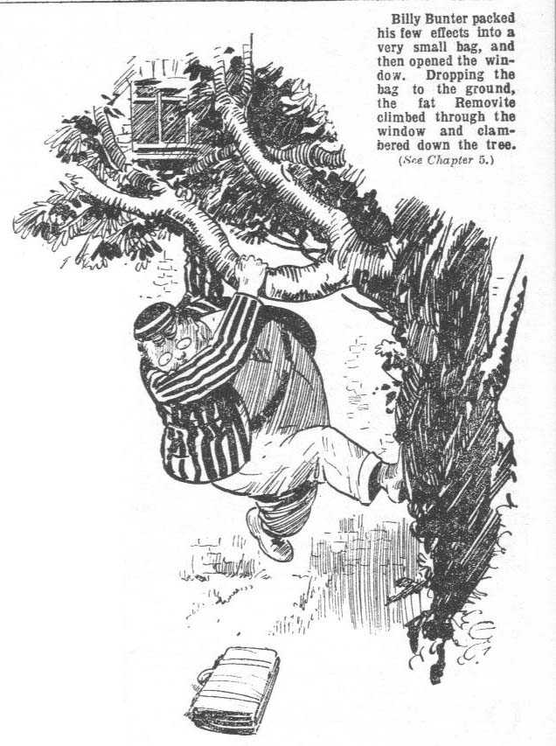
valuable guest. Had he known of Bunter’s midnight envasion,
the innkeeper might have been annoyed. Still, it was certain that Bunter’s departure was a paying proposition to the innkeeper.
Had Bunter remained, he certainly could nt have paid his
bill, and all he could have done would have been to add to it. It would have paid any inn or hotel to speed the parting guest, when Bunter was the guest.
There was regret in Bunter’s heart, as he sneaked quietly out by a garden gate, and bolted. It was not the unpaid bill he was thinking of, however, or any sorrow the innkeeper might have felt at losing so charming a guest. He was thinking of the scrumptious grub. Though now lost to sight, it was to memory dear. Still, life is made up of painful partings, and Bunter had to bear it.
He rolled away down the road, rather relieved to get to a safe distance without any sound of pursuit. It would have been very discomforting had the landlord awakened, and stepped out after him.
Bunter rolled on in the bright moonlight.
Fortunately he had the walking-party’s route by heart and he knew exactly the direction they had planned to take.
It did not occur to his fat mind that, as they knew he was aware of the route, they had changed it.
A fellow could not think of everything.
He plugged on cheerfully.
Losing his sleep was annoying. But it was a lovely summer’s night; the moonlight made the road almost as light as by day, and there was keen satisfaction in the thought of overtaking the walking-party and joining up with them. Their faces would be worth watching, Bunter considered. Of course, so long as they kept on the road Bunter was not likely to join up. But they had to camp sooner or later—and he was bound to come up with their camp.
So he was in a fairly cheerful mood as be plugged on, by a lonely road, and arrived at the point where the downhill lane turned off—which, though Bunter did not suspect it, was the way the walking-party had also turned off.
Bunter was about to pass on and leave that turning behind him when ho suddenly became aware that the lonely road was not so lonely as he had supposed.
Two dim figures were halted at the turning, and there was a murmur of voices. The two men seemed to be debating which way they should take.
“It was this ‘ere way !” Bunter heard a voice. “I keep on telling you, Bill ‘Arris, that it was this ‘ere way.”
“‘Ow do you know, Alf?” grunted the other. “I keep on asking you ‘ow do you know?”
“Cause we know they turned off, and there ain’t any other blinking turning they could ‘ave took, blow me tight.”
“That’s all very well, but a bloke’s legs ain’t made of iron, and I tell you at straight, Alf, mine are fair dropping off.”
“Look ‘ere—“
At that moment the two speakers became aware of Bunter. They ceased to speak, and turned towards him, and he caught the glint of their eyes in the moonlight as they watched him suspiciously.
Bunter felt a deep tremor.
In his keenness to get after the walking-party he had rather forgotten that the King’s highway has its perils late at night in lonely places, for a fellow on his lonesome.
These two men looked like tramps. One of them was a short, squat man, with red hair, and a cast in his eye.
The other was also short, but rather fat, with a walrus moustache and a flat nose, evidently damaged at some time or other, in a fistical encounter. Both of them were shabby, dusty, unclean, and unpleasant-looking, and neither was the kind a fellow wanted to meet on a lonely road at midnight.
“‘Ere’s a cove, Bill,” said the little man with the defective eye. “P’r’aps he’s seen that lot.”
“Pr’aps he’s got the price of a drink about ‘im, anyway,” said Bill in a hoarse voice. “Wot about that, Alf”
“P’r’aps he has,” said Alf, “and if he has I’m sure he’ll ‘and it over.”
‘Oh, crikey!” gasped Bunter. From the bottom of his fat heart Billy Bunter wished that he had remained in bed at the Red Lion, in spite of unpaid hills and innkeepers. But it was too late, and all that remained was flight.
Flight was a desperate resource for Bunter. He had too much weight to carry.
Before he had taken six steps the two tramps had reached him, and they grasped him by either arm and jerked him to a halt.
THE SIXTH CHAPTER.
Pinching Methuselah!
“Ow!” gasped Bunter.
“You ‘old on !” growled Bill Harris.
“Oh, dear !”
“ No ‘arm intended, sir,” said Alf. “We wouldn’t ‘urt a fly. Would we, Bill !”
“Not half !“ said Mr. Harris.
“We’re looking for some friends of ourn, sir,” exclaimed Alf. “ Party with a motor-tricycle. Seen ‘em”
Bunter jumped.
“A—a—a motor-tricycle?” he stuttered.
“Well, p’r’aps you wouldn’t know it was a motor-tricycle, looking at it,” said Alf. “It’s a bit out of date, far as that goes. Old Dionysius machine. ”
“Oh, crumbs! You’re Snooks !” gasped Bunter.
He knew now who the little red- haired man was. He had heard the juniors describe Honest Alfred Snooks, the man who had once worked in the Dionysius cycle factory, and who had made several attempts to steal that ancient trike before it came into the possession of the Famous Five. This Alf was obviously Alfred Snooks.
Equally obviously he was still on the track of the trike. Apparently Mr. Snooks and Mr. Harris were trailing town the walking party on account of their extraordinary and inexplicable desire to get hold of that antiquated tricycle.
Bunter was so astonished that he almost forgot to be scared.
“Snooks is my name, sir,” said the little man cheerily, “ Alfred Snooks − Honest Alfred they called me when I worked at the Dionysius works afore the war. You ‘8ard of me?” He stared at Bunter. “ You’re a schoolboy !”
“Yes !” gasped Bunter.
“Pal of them gents what is travelling with that tricycle?” asked Mr. Snook, guessing how the matter stood.
“ Yes. ”
“Blow me tight !” said Mr. Snooks. “ Now ain’t this ‘ere a stroke of luck. Jest luck, coming across you like this, sir.”
Bunter did not see where the luck came in.
“We want to find them young gents,” said honest Alfred.
“ P’r’aps you can tell us where they are.”
“ No !” gasped Bunter.
Mr Snooks compressed his grip on the fat junior’s arm, like a vice, and Bunter gave a squeak.
“Ow !”
“Wot about giving him a wipe across the kisser, Alf ?” inquired Mr. Harris, who seemed prone to rougher measures than his friend.
“ ‘Old on,” answered Mr. Snooks, “ this here young gent is going to tell us all he knows about that tricycle party. Now look ‘ere, fatty,” Mr. Snooks compressed Bunter’s arm again, eliciting another squeak. “ We’ve been follering of them young gents. We got it right that they was at the Red Lion, ‘arf a mile back along the road. That trike was in the yard and we saw it with our own eyes. See?”
“Oh, dear!”
“But they bunked,” said Mr. Snooks, in an aggrieved tone. “ We reckoned it was just pie to get that trike away, but when we come round about eleven o’clock it wasn’t there. They’d gone on.”
“Knowed we was arter them,” said Mr. Harris.
“We’ve been looking for them,” said Mr. Snooks, “Up and down this ‘ere road. I fancy they’ve turned off. Bill, here, thinks they ain’t ! What you think ? ”
“ I—I think they’ve gone on !“ gasped Bunter. “ I—I was going after them. They—they left me behind.”
“If you’re a pal of them you know jest where to look for them,” said Mr. Snooks suspiciously.
“Give ‘im a wipe !”
“ Shut up, Bill, and let the covey speak. I’ll wring his fat neck fast enough if he don’t give us the office.”
“1—I—I --” stuttered Bunter. “They- - they let me down, you know, and—and went on without me. But I knew which way they went, so I was going after them. They’re somewhere ahead on this road.”
“I knowed they was on the road,” said Mr. Harris.
“And I knowed they ain’t,” said Mr. Snooks obstinately. “There’s the mark of a tricycle in that mud round the corner.”
“More’n one tricycle in Sussex, you fat’ead, you.”
“There ain’t a lot of tricycle’s about these days. And that old Dionysius is wider than most. I tell you they turned off.”
“This here covey says they went on.”
“I dessay he does, and I dessay if they’re friends of his’n he don’t want us to find ‘em. I dessay he’ll say something different when I’ve twisted his arm a bit.”
“Yaroooh !”
“Blow me tight! What you ‘owlin about?” demanded Mr. Snooks. “I ain’t twisted your blooming fin yet.”
“Ow! Leggo!”
There was a sudden flashing of brilliant acetylene lights, and the whirr of a car. Down the road a motor came buzzing, rushing down on the group of three, from the night.
Mr. Harris and Mr. Snooks leaped out of the way, releasing Bunter. Bunter also leaped.
The motorcar roared by.
When it had passed the two tramps looked for Bunter. But they found him not.
Bunter did not often act with promptness and despatch. His motions were generally slow, if not stately. But Bunter could move at times, and this was one of the times.
The fat junior had plunged through a hedge, taking advantage of the interruption caused by the passing motor. He plunged headlong into a field, and plunged on desperately. He was only thinking of putting a safe distance between himself and the ruffianly tramps, and did not think or care where he was going. He did not want either a twisting of his arm, or what Mr. Harris elegantly described as a wipe on the kisser. Neither appealed to Bunter in the least.
He fled for his fat life.
Mr. Snooks and Mr. Harris hunted up and down the road for him, and glared into gaps in the hedges. But Bunter negotiated that field in record time, and plunged through another hedge into another field. He was gone from their gaze like a beautiful dream.
“S’elp me !” said Bill Harris. “ He’s ‘ooked it, Alf.”
“He has that,” said Mr. Snooks.
“You fat’ead, you –“
“Oh, bottle, it up !“ growled Mr. Snooks. “ Look ‘ere, them coveys went down that lane, I keep on telling you !”
Snort from Mr. Harris.
“Well, I’m going down that blinking lane, and chance it !” said Mr. Snooks sullenly. You can go and fry your blinking face !”
And Honest Alfred started down the lane, evidently having made up his mind. Mr. Harris, having hurled after him some remarks of a trenchant and withering character, finally followed him.
As it happened Mr. Snooks was right. The two frowsy rascals, as they tramped along the downhill lane, were drawing nearer and nearer to the camp of the Greyfriars walking-party.
And, suddenly, Mr. Snooks halted, grasped his companion by the arm, and hissed ;
“Look !”
“Wot the ‘oly smoke --”
“The trike !”
“My eye!” said Mr. Harris.
Under a spreading tree, by the moonlit lane, a tent was visible on the broad belt of grass. And outside the tent, stood the ancient Dionysius tricycle.
“Wot did I tell you ?“ grinned Honest Alfred.
“My eye !” repeated his friend.
“You was right, Alf. I say, stow the gab ! There’s five coveys in that there tent.”
“Quiet “ agreed Mr. Snooks. “ Wo got it now, Bill ! We can’t get the blinking ignition tube off it without waking them! And we don’t want a shindy !”
“We don’t !“ said Mr. Harris emphatically. “Not with five blokes.”
“We can get the jigger away.”
“You’ll wake all Sussex if you start it up.”
“I ain’t going to start it up, fat’ead ! Don’t I know what a clatter that blinking jigger kicks up! We’re going to wheel it away on the Q.T.” Mr. Snooks chuckled softly. “Let the lads sleep. I wouldn’t disturb their blinking slumbers for anything! Quiet—and lend a ‘and !”
In the tent five Greyfriars fellows slept the sleep of the just. Outside the tent Mr. Harris and Mr. Snooks did the work of the unjust. Quietly and cautiously they seized the ancient tricycle, and softly they wheeled it away over the grass. Carefully they edged it out on the road at a distance from the camp. Gleefully they trundled it away downhill, leaving the Greyfriars walking-party farther and farther behind, sleeping soundly, and perhaps dreaming, but never dreaming that Methuselah had left them in the lurch.

THE SEVENTH CHAPTER.

Bunter’s Luck!
BILLY BUNTER gasped.
Bunter was having a hectic time.
Field after field the fat junior crossed, with terror at his heels.
in every whisper of the summer breeze he heard the ferocious tones of Alfred Snooks and William Harris. In every rustle round him he heard their footsteps.
There was only one fortunate thing— the ground sloped down. The fields he was negotiating seemed to be on the side of a hill, at the top of which the road ran. They sloped gently downward, so the going was easy. But if it was easy, it was not pleasant. Bunter stumbled into ditches wher8 he found mud and stinging-nettles. He hooked himself on to thorns, and thorns hooked themselves on to Bunter. He was scratched, he was bumped with many stumbles and falls. He was breathless
—especially breathless.
Bunter had not yet fully recovered from his supper at the Red Lion. Exertion never came easily to him, and it came less easily than ever now. But to Bunter the moonlit night was peopled with ferocious tramps, and he ran and ran till he felt as if he would burst if he ran any longer. He rolled through a gap in the large hedge and found himself in a leafy lane, where the moonlight lay in pools among the shadows of great branches. There he stopped; flesh and blood could do no more.
He sank down in thick grass, and gasped for breath. For long minutes Billy Bunter did nothing but pump in wind.
Had an army of tramps appeared before him Bunter could not have lifted himself and the Red Lion supper from the earth. He was spent.
But nobody appeared. The little leafy lane was quite deserted, not even a “moo” came from the adjoining fields.
The Owl of the Remove recovered himself a little at last. He ceased to gasp and splutter. He wiped his perspiring forehead; and his fat heart ceased to thump like a piston.
“Oh dear !“ murmured Bunter.
H8 set his spectacles straight on his fat little nose, and blinked round him in silvery moonlight and black shadow.
Where was he?
Safe from the tramps, at all events. That was the chief thing. He was sure that he had crossed at least half a mile of fields and hedges, and they had been left behind on the highway.
That was all right.
But now that he was safe from the tramps the object with which he had started on his journey recurred to him. That object seemed to be quite defeated by his flight from Messrs. Snooks and Harris. The walking-party, to the best of his belief, had followed the main road as per schedule. And Bunter was far from the main road ; he did not know his way back to it, and would never have dared to return to it, in any case, with Messrs. Snooks and Harris in the offing.
“ Beasts !” groaned Bunter.
All this would not have happened had not those beasts left him behind. Bunter felt that be was a much-injured youth.
Still, though Bunter found solace in grousing, he realised that grousing would not, so to speak, catch him any fish. He was lost till daylight. Taking up the trail of the Greyfriars walking- party was impossible until day dawned. It was useless to stir; and Bunter was extremely unwilling to stir. The grass was thick and soft ; the night was warm. But Bunter decided that the best thing he could do would be to go to sleep. That was often Bunter’s recourse, anyhow. In his category of earthly pleasure, sleeping came next to eating, talking being a good third. Eating and talking being out of the question how, sleeping was evidently the thing for Bunter.
He groped for a comfortable place in the rich grass, and stretched his weary, fat limbs. He was comforted by the reflection that it would be an easy thing, on the morrow, to pick up the trail of the trike. He knew the route laid down by the walking-party, and even if they wandered from it, it would be easy to get news of the trike. Nobody who saw Methuselah pass would be likely to forget the sight. A wondering population, in fact, was left behind, wherever the ancient tricycle travelled. On the morrow he would land himself on the Greyfriars walkers, and take care that they did not got out of his sight again. Comforted by such reflections, William George Bunter closed his eyes and sought repose.
Then he opened them again.
Sounds reached his ears—sounds of something or somebody, or both, advancing along that little leafy lane. There was a whirring, a clattering, a grinding. Bunter thought first that it was a gipsy caravan, strung with goods and chattels under and behind. Then he thought of an American jazz band. But he realised that it was neither of these. He sat up in blank amazement. It was the sound of Methuselah on the march.
“My only hat !” murmured Bunter.
He grinned.
Faintly in the moonlit lane, barred by black shadows of foliage, the ancient trike came into view, with two dim figures, one walking, the other seated in the saddle pedalling.
Methuselah moved easily, though no power was on; for the lane ran down hill, and Methuselah, though old and respectable, certainly had a preference for the downwatd path.
Bunter sat in the grass and grinned. Those beasts were on the march, and he had fallen in with them. That was his first thought. Then all of a sudden he ceased to grin. Only two figures were with the trake, and as they came nearer Bunter could see that they were not schoolboys. It was not those beasts, but the other beasts—Harris and Snooks.
“Oh, crikey !” breathed Bunter.
It was the tricycle, but it was not the walking-party. The camp of the latter could not be far away, for evidently Harris and Snooks had found it and walked off with the trike. Still it must have been left behind some little distance, for the tramps were no longer careful about avoiding noise. They let Methuselah make as much noise as he liked, and unless Methuselah was sternly suppressed he made a great deal.
“ Look ‘ere, Alf, this ‘ere will do” said the husky voice of Mr. Harris. “We’re a good step from them coveys now. They won’t ‘ear you ‘andle the blinking wrench.”
“ It’s down’ill,” said Mr. Snooks. “May as well keep on a trifle.”
“ Let a covey ‘ave a turn in that there saddle and you ‘oof it, and we’ll keep on a ‘underd miles, if you like,’ rejoined Mr. Harris sarcastically.
“ You’re the bloke for grousing, Bill, you are, blow me tight!”
“‘Op out of the saddle, and I’ll do the ridin’, and you can do the grousin’” said Mr. Harris, still sarcastic.
“Well, I dessay we’re fur enough,” said Mr. Snooks. “ ‘Old on to the blinking jigger. I don’t trust them brakes. They was good brakes twenty years ago, but twenty years ago ain’t to-day. ‘Old to it, Bill!”
The tricycle was brought to a stop.
Bunter sat in the grass and quaked.
He was not ten feet from the halted tricycle at the side of the lane ; but, fortunately, the shadow of overhanging branches completely concealed him. The two tramps certainly had no suspicion that anyone was at hand. They had not seen the direction in which Bunter had fled from the highway, so they were quite unaware that he had crossed the fields that lay near the lane they had followed to the Greyfriars camp. No doubt they had forgotten all about the fat junior long ago. And at two in the morning they did not expect anyone to be about.
Bunter quaked, and was silent.
But, alarmed as he was by the reappearance of Messrs. Harris and Snooks, he was interested, too, in their proceedings.
Why Mr. Snooks wanted to steal Methuselah was a deep mystery, which puzzled Harry Wharton & Co. as much as it puzzled Bunter. Now it appeared, from what Bunter observed that it was not the ancient tricyde itself that Honest Alfred wanted. It was, apparently, some part of it—some portion of the ancient framework. Bunter heard him sorting out tools, and then Mr. Harris’ voice:
“‘Ow long getting it off, Alf ?”
“Ow should I know?” said Mr. Snooks. “ They built machines in them days, Bill—built ‘em, I’m telling you. Stuck ‘em together tight ! This here Dionysius may be queer to look at, but I tell you she’s put together all right. Still, I’m going to get that blinking tube off, if it takes till morning. Arter that, them coveys can ‘ave her back and welcome.”
Mr. Harris chuckled.
“ She won’t be much good without the tube, Alf.”
“ She won’t,” agreed Mr. Snooks. “Not as a goer, anyhow. They can stick ‘er in a museum, and charge coveys tuppence a time to look at ‘er. She’s worth it.”
And Mr. Harris gave another husky chuckle.
Apparently, the two thieves had pinched the old trike in order to get a “tube” off it. What they could possibly want with an old tube off a second-hand tricycle was more mysterious than a desire to steal the trike itself. Bunter wondered dazedly
whether that trike might once upon a time have belonged to a burglar, who had hidden his loot, perhaps diamonds, in some recess of the ancient frame. It seemed inprobable, even to Bunter; but it was still more improbable that Messrs. Harris and
Snooks should be doing what they actually were doing —stealing a tricycle in order to jerk off a worthless bit of tubing. Undoubtedly the mystery of Methuselah was a very deep mystery.
Mr. Snooks was scrummaging between the back wheels, and Mr. Harris held the trike by the handle-bars. Just at that place the slope of the lane grew steep, and, left to itself, Methuselah might have walked away. Bunter’s fll.luck ordained just then that Mr. Harris, idly watching his comrade, should think of solacing himself with a pipe. Keeping the trike blocked with his knee, Mr. Harris took out pipe and tobacco, jabbed the latter into the former, with a stubby thumb, and struck a match.
The light of the match gleamed on a pair of spectacles, and a pair of startled eyes, so near that Mr. Harris jumped and dropped the match.
“My eye !“ he stuttered.
“Shut up, and ‘old that jigger !” grunted Alfred Snooks.
“There’s a covey watching of us!”
“Wot?”
“That fat covey we saw on the ‘igh road, he’s follered us.’
“Blow me tight!”ejaculated Mr. Snooks.
He jumped up.
“Let me get a wipe at ‘im with this spanner, and he won’t get nosing arter a covey agin in a ‘urry !” he exclaimed.
Bunter jumped up.
Mr. Harris was already making for him across the grass, and Mr. Snooks followed his comrade fast.
Bunter stood paralysed for a moment. Behind him was a thick hedge, and he had quite forgotten where was the gap he had come through. Before him were the two tramps, one with a spanner in his hand, with which he was anxious to give Bunter a “wipe.”
The extremity of terror will lend courage, or at least desperation. A frightened sheep will sometimes charge straight at the enemy; a moth will dart at the flame of the candle. Bunter charged! To retreat was impossible; to remain where he was, was to be “wiped” with a spanner; and, in sheer desperation, Bunter charged at the foe.
That was unexpected.
A charge with Bunter’s weight behind it was not a light matter. He crashed into Mr. Harris, and sent him staggering against Mr. Snooks. Mr. Harris was not light-weight, and the slim and weedy Mr. Snooks crumpled up. There were loud howls as the two tramps stumbled over in the grass. Bunter flew on!
To get into the open lane and run for it, was his thought. But— There was Methuselah!
Bunter almost ran into Methuselah. He did not stop to think; it was one of those moments when a fellow had brilliant inspirations and acted on them. He leaped into the saddle and grasped the handle-bare, and jerked the steering-wheel out from the roadside.
Methuselah went!
Downhill, Methuselah could always be relied upon to go. Bunter did not think of starting the engine. He did not know how, even had the engine been startable, as it wpre, which it was not at that moment. But on a slope Methuselah would travel rapidly by its own weight, and there was a steep slope before Bunter. And he pedalled. His feet did not reach the pedals, but he jammed a foot at either in turn as it bobbed up. And Methuselah flew.
Messrs. Harris and Snooks scrambled up, uttering lurid words. They rushed into the lane.
“Stop !” howled Alfred Snooks.
“My eye! He’s got the tricycle? Stop!” yelled Mr. Harris.
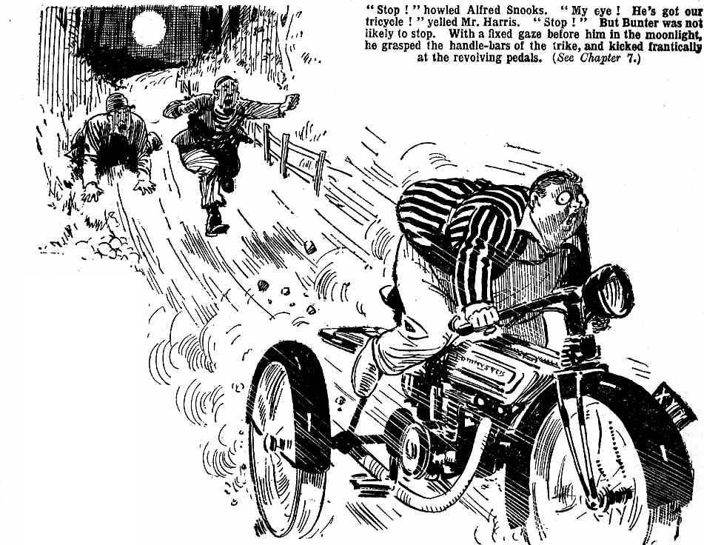
Bunter was not likely to stop.
With a fixed gaze before him in the moonlight, grasping the handle-bars with a deadly grasp, kicking frantically at the revolving, pedals, Bunter drove wildly on.
The lane was narrow and rugged. It was broken up in ruts and ridges that made Methuselah almost dance. But for a good two miles it ran downhill, and Methusolah gathered more and more speed. All Bunter’s attention, all his nerve, were required, to steer straight and keep from going on his beam-ends. He concentrated on the task. Methuselah flew, and Bunter flew with it; and, far behind, two breathless tramps gasped and spluttered, and finally halted, winded to the wide. Far from the ken of Messrs. Snooks and Harris, Billy Bunter continued his wild ride—fairly for it now for he could no more have stopped Methuselah than he could have stopped the regular revolutions of the globe. Had that hill sloped on to infinity, Bunter would have sloped on to infinity. Far, far behind, two winded tramps sprawled in the grass and said things, with what breath they had left. Bunter sailed on through the moonlit night, the wind rushing by him, trees and hedge-rows flashing by. Like the Wild Huntsman in the ballad
“How fled what moonlight faintly showed—
How fled what darkness hid!
How fled the earth beneath his feet,
The heavens above his head !”
It is said that there is such a thing as fool’s luck. Bunter’s experience seemed to demonstrate that it was so. That narrow, rutty lane had many windings, some of them of a corkscrew pattern. Bunter took them all at top speed, and took them successfully. On sun-baked, muddy ridges, where the heavy wh8els of farm carts had piled up mud in w8t weather, Methuselah hopped and almost jazzed. Once or twice, Bunter thought that the old tricycle had leaped clear of the earth, all three wheels at once. He knew that he was seldom on more than two. Still, Methuselah nobly refused to turn turtle. Still the prehistoric trike fled on and on and on, wildly whirling through the night, till at last, to Bunter’s immense relief, the downhill path came to an end, and the ancient trike slowed down on a level.

THE EIGHTH CHAPTER.

Methuselah Missing!
“HALLO, hallo, hallo!”
Bob Cherry uttered that ejaculation in startled tones.
There had been no alarm. Bob Cherry had awakened for a simple reason, which might have occurred in any camping-party, with five fellows in a tent. Johnny Bull, turning over in blissful slumber, had jabbed an elbow into Bob’s eye. Bob opened that eye, and the other. Johnny Bull slept on blissfully, and Bob rubbed his eye. Being awake, Bob thought of glancing outside the tent at Methuselah before going in to sleep again. He was not really uneasy about the trike. But a fellow couldn’t be too careful. He glanced out, fully expecting to see the gaunt frame of Methuselah standing there in the moonlight, as it had been left. He stared blankly at the vacant space no longer occupied by Methuselah. He uttered a startled ejaculation. He plunged out of the tent so swiftly that he trod on Wharton’s legs, on Johnny Bull’s chest, and on Frank Nugent’s nose.
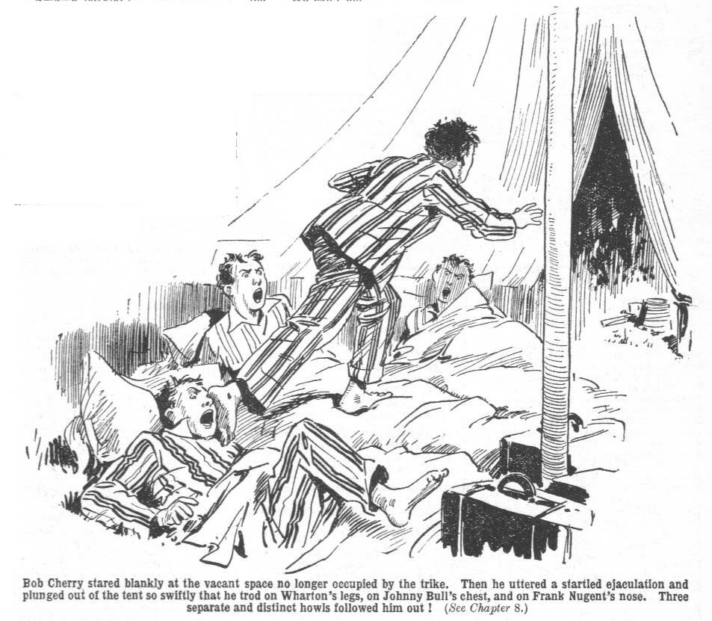
”Hallo, hallo, hallo!” Gone !” roared Bob.
“Yow-ow! What --”
“ Wow ! Ow !”
“Gone !” bawled Bob Cherry. “Trike gone !”
Harry Wharton sat up, still half asleep. Nugent sat up and rubbed his agonized nose. Johnny Bull was indulging in deep, ferocious growls, like a hungry tiger. Hurree Jamset Ram Singh awakened in his usual good humour, perhaps because he had not been trodden on. Outside the tent, the excited voice of Bob Cherry was waking the echoes of the Sussex downs.
“Gone! Pinched! The triko! Turn out, you fellows! The trike’s gone !”
“Hang the trike !”
“Oh,my nose !” moaned Nugent. “Somebody’s stamped on my nose! Wow !”
“The trike!” raved Bob.
“ Bless the trike—and bless you ! What the thump —”
“Pinched yelled Bob.
The juniors turned out. Five figures in pyjamas gathered where the tricycle once had been. Nugent still clasped his nose.
“It’s gone !” said Wharton, blinking.
“ The gonefulness is terrific !”
“Beats me :“ said Johnny Bull. “I thought it wouldn’t go.”
“Gone !” repeated Bob. “Pinched while we were asleep. We ought to leave kept watch. Silly lot of asses to go to sleep and leave a jigger to be pinched!”
“ I say, look out, you men !“ said Johnny Bull, glancing round. “It would be no joke to run up against a wandering lunatic in a place like this.”
“A lunatic?” repeated Bob.
“ Yes. Must have been a lunatic who pinched the trike.”
“ Is this a time for your rotten, fat-headed jokes about that trike?” roared Bob Cherry. “ It’s gone ! Lucky we had the baggage off it, or that would be gone, too. We’ve got to get after it. They can’t have started it up, so it can’t be a jolly long way off.”
“They can’t have started it up, that’s a cert,” said Johnny Bull. “I suppose they’re not miracle workers, whoever they are. Look here, what about leaving it till morning?”
Bob Cherry did not answer that question in words. He simply glared.
As a matter of fact, four members of the Co. were prepared to bear the loss of Methuselah with equanimity. It was true that Methuselah had faithfully carried the baggage. As a beast of burden he had been worth his allowanc8 of juice. On the other hand, he had his drawbacks---many of them. Four juniors, at least, would have parted with him for ever and ever, dry-eyed.
Not so Bob Cherry. A tigress robbed of her young, a patriotic politician deprived of his salary, were quite tame, in comparison with Bob Cherry at this moment. Bob was boiling.
“You—you—you silly chumps, go to sleep, if you like !” he gasped. “I’m going after that trike ! I’m going after the pinclher. I’m going to slaughter him ! I’m going to pulverise him ! I’m going to spiflicate him !” Bob plunged into the tent for his clothes, and plunged into them anyhow. He plunged out of the tent again. “Go and eat coke, you pifflling duffers ! I’m going after the trike.”
6 Sink or swim together!” said Harry Wharton, with a sigh. “ Let’s all go after it.”
“ After all, we may not find it,” said Johnny Bull hopefully.
The juniors hurriedly dressed.
Bob was examining the ground for traces of the trike. The lane was considerably rutty and muddy, the mud dried hard by hot summer suns. Methuselah was a heavy machine, and likely to leave some sort of a trail, even on hard ground. Bob soon nosed out the traces, where the jigger had been wheeled along the grass and where it had been trundled out into the lane. But in the hard-baked mud of the lane, “sign” was not easy to pick up, even by the most skilful Boy Scouts of Greyfriars.
“It was wheeled away,” said Bob. “They never dared to start up the engine. They’d have awakened us --”
“And everybody else in the South of England,” remarked Johnny Bull.
“Cheese it! Besides, the engine is out of order—luckily, as it happens,” said Bob. “They wheeled it away, and then, of course, pedalled it --”
“But where?” said Nugent.
His nose had calmed down by this time, and he was prepared to take some interest in the trike.
“ We can pick up the way they went in this mud,” said Bob. “Luckily, it’s a bright moon. I suppose they’d try to get it back to the highroad. It runs better on a high-road— ”
“ When it runs at all !”
“Shut up ! There’s some tracks leading up the l’aiie wc came down, from the high-road—
“ My esteemed chum——”
“ No time to waste in jaw !“ said Bob.
“ Let’s get after it. We may meet somebody on the high-road who’s seen it. Plenty of motors about, even at this time of night.”
“ My excellent and absurd chum −”
“Oh, come on!”
“ But I have a suggestive remark to make,” urged Hurree Jamset Ram Singh. “ A stitch in time saves a bird in hand from going longest to the well, as the English proverb says.”
“ Follow on, fathead, and don’t jaw.”
Harry Wharton laughed.
“Better let Inky get it off his chest. I think he’s going to point out that those tracks lead down, not up. You haven’t noticed that”
“ Ha, ha, ha !”
“ That is the ridiculous remark I was about to make,” as+sented the nabob. “The tracks you have spotfully discovered, my esteemed Bob, were left by the absurd jigger coming down from the high road. Besides, another wheezy idea has occurred to my esteemed arid idiotic brain−”
“ For goodness’ sake, cut it short !”
“ The esteemed thieves who have pinched the absurd jigger would surely go downhill with it,’ said the nabob. “It is uphill to get back to the high road, and the other way goes downhill. If I were an esteemed cycle thief, and landed with that terrific jigger, I should certainly prefer to proceed downhillfully.”
“ Oh !” said Bob.
The juniors chuckled. Undoubtedly there was wisdom in Hurree Singh’s remark. Any man landed with Methuselah was absolutely certain to prefer the downward path, if there was one handy.
“ Well, come on !” said Bob..
And he turned downhill.
The five juniors followed the moonlit lane, scanning the ground for trails. They soon picked up sign of Methuselah. Muddy ridges had been gashed by the heavy old wheels, and the marks were unmistakable. The Greyfriars fellows were undoubtedly on the right track.
They hurried on.
Four of them, perhaps, were not in pressing haste. But Bob Cherry proceeded at a run, and his comrades kept up with him.
It was, as Bob said, lucky that Methuselah’s internal arrangements had been out of order. The cycle-thief, whoever he was, was not likely to have been able to turn the power on in a hurry. And unless he was a man of remarkable muscular powers he was not likely to pedal that heavy trike faster than active fellow could follow on foot. The trouble was that he had a start, and that the way was downhill. Still, downhill ways could not last for ever, and as soon as he came to a rise, pedalling Methuselah was a task to break the heart of the stoutest cycle-thief. So Bob ran on hopefully, and his comrades followed him, and the tent was left behind, and it could only be hoped that the only thief abroad that night was the cycle-thief, and that there were no tent thieves or baggage thieves prowling around in the immediate neighborhood.
Suddenly, from the dimness ahead, sound came to the ears of the running juniors. Sounds of voices—raised in discord.
“I tell you, Alf, I ain’t taking another step ! No another blinking step ! ‘Ang the old trike!”
“I tell you, Bill ‘Arris, we got to get arter it ! Are we going to ‘ave all our trouble for nothing, 1 ask you.”
“I’m fair winded ! I says, and I says agin, ‘ang the trike, I says.”
“Blow me tight ! If I get my ‘ands on that fat covey agin —“
The five juniors came breathlessly up. On the grass beside the lane sprawled two unkempt figures, gasping, swearing, and recriminating. One of them, a red-haired gentleman with a cast in his eye, was well known to the Greyfriars fellows.
“ Snooks !” roared Bob Cherry.
A moment more, and Messrs. Harris and Snooks were in the grasp of many hands. One more moment, and their frowsy heads were banged together with a bang that caused them to see more stars than any astronomer ever picked out with the most powerful telescope.
“ Yarooooh !”
“Whoooooop !”
“Now, where’s that trike !” roared Bob Cherry.
THE NINTH CHAPTER.
Tracking the Trike!
“BLOW me tight !‘ gasped Mr. Snooks faintly.
Honest Alfred was on his back in the grass, with Bob Cherry’s sinewy knee planted on his chest. His head was spinning from its violent contact with Mr. Harris’. Mr. Harris was wriggling spasmodically in the grasp of two or three pairs of hands. The tramps had lost the tricycle, but they had found its owners— not a lucky find for them.
“ Where’s that trike ?” roared Bob.
“ Ow ! Gerroff a bloke !”
“Where’s that trike ?”
“Git off !” wailed Mr. Snooks. “ You’re a-grinding a bloke to blooming powder. For goodness’ sake git orf !”
Instead of getting off, Bob ground his sinewy knee still harder into Mr. Snooks’ far from muscular chest. There really seemed danger of Mr. Snooks cracking under the strain. He had a horrid feeling that that grinding knee was going right through him.
“Ow !” moaned Alfred Snooks. “ Wow ! Git orf!” Go easy with a covey ! Git orf !”
“ You frowsy thief !” roared Bob. “ You’ re the same scoundrel that tried to pinch that trike before. I know your face. You’re Snooks. You’ve got that trike. Where’s that trike?”
“I dunno,” gasped Mr. Snooks. “ I’d tell you and willing if I knowed ! Take your blinking knee off my weskit.”
Bob Cherry grasped Mr. Snooks by his frowsy hair. He raked Mr. Snooks’ head and banged it forcibly on the ground. There was a yell of anguish from Honest Alfred.
“Now where’s that trike?”
“ Yaroooop!”
“My hat ! I’ll smash the rotter into small pieces!” roared Bob. “Where’s that trike, you thief !”
“I dunno!” wailed Mr. Snooks. “A covey got it off us, and bunked with it. We was arter him, but we got winded! Blow me! tight ! S’elp me, it’s the truth I We was robbed of that jigger !”
“Set a thief to catch a thief !“ chuckled Nugent.
“It’s the ‘oly truth,” gasped Mr. Harris. “We was robbed of that machine, and the covey’s bunked with it.”
“We jest wheeled it away from your camp, sir, to—to —I mean, jest for a joke, sir,” moaned Mr. Snooks. “We wasn’t going to steal that machine! Was we, Bill ?”
“Not half !“ said Mr. harris.
“When I was at the Dionysius works afore the War, I was called Honest Alfred !“ moaned Mr. Snooks. “Honest as the day, sir—that’s me. I ain’t the man to pinch a jigger, sir! I’ll ‘elp you to look for it ! I tell you straight I’m fair anxious to get ‘old of that covey what pinched it from us.”
“Which way did he go ?” demanded Bob. He was constrained to believe that Mr. Snooks was telling the truth, for there was no sign of the tricycle to be seen.
“Down the ‘ill,” said Mr. Snooks. “ Bolted, he did, and being down ’ill, the jigger went! Up ‘ill would ‘ave been a different matter !”
“Better go after it,” said Bob, withdrawing the grinding knees at last, much to Alfred Snooks’ relief. “Some other thief has got it away from these rotters! Come on !”
“Hold on !“ said Harry Wharton.
“No time to waste !”
“More haste less speed,” said the captain of the Remove. “ We’re not leaving those rotters loosc to go and pinch the things from our tent.”
“Never mind the tent!”
“All our things are in it, fathead !”
“Never mind the things !”
“The mindfulness is terrific, my esteemed Bob. Let us leave these esteemed and disgusting rotters safe. !”
“ We’re wasting time !“
“ Fathead !”
Bob was impatient to get after the new pincher of the trike. But four of the juniors, at least, valued the tent and its contents more highly than they valued Methuselah. Messrs. Harris and Snooks had lost the trike, and they were not to bc allowed to indemnify themselves by robbing the tent while the chase went on.
“We can fix them up safe” said Johnny Bull. “ Find something to tie their paws with.”
“Look ‘ere——” said Mr. Snooks and Mr. Harris simultaneously.
“ Shut up, you !“
Something was found to tie up the “paws” of Messrs. Harris and Snooks. Mr. Harris wore a belt, which was annexed for the purpose, and two dirty neckcloths came in useful. Two spotted handkerchiefs of large size were also of utility. Two pairs of grubby hands, drawn behind two frowsy hacks, were bound tightly. Then the left arm of Mr. Snooks was tied to the right arm of Mr. Harris; and his left leg was tied to Mr. Harris’ right leg. In that state, rather resembling the Siamese twins, the two tramps were left. They were securely fastened together, their hands bound behind their backs; they grew in beauty side by side, as it were.
The juniors grinned at them cheerfully. In such closc company the two tramps were not likely to travel far or fast. They were not likely to do any mischief before morning, at least.
“You ain’t leaving us like this ‘ere!” ejaculated Mr. Snooks, in great dismay.
“We are !” grinned Johnny Bull.
“Look ‘ere——” roared Mr. Harris.
“Come on, you men.”
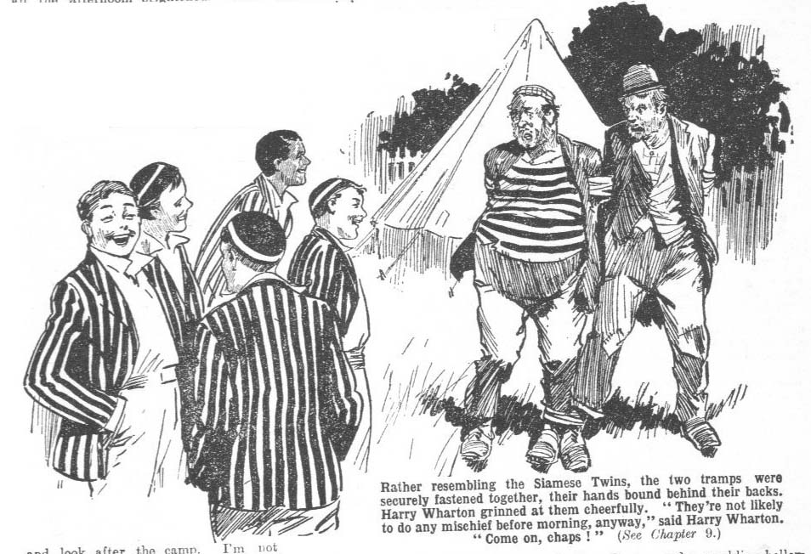
“This ‘ere is agin the law !“ howled Mr. Snooks. “You ain’t got no right to tie up a covey like this ‘ere.”
“Good bye.”
The Famous live, grinning, went on their way downhill, after the vanished trike. Messrs. Harris and Snooks were left in the moonlight, struggling. They lurched and hopped and stumbled, and the remarks they made to one another almost turned the atmosphere blue. Where the two tramps would get in that twin-like state, and how long it would take them to get there constituted problems that the Greyfriars party did not trouble to solve. They hurried on their way, and left Messrs. Harris and Snooks to it. Infuriated voices followed them for some distance, and died away into silence at last.
Still downhill ran the winding lane, and the Famous Five proceeded at a rapid trot. Downhill was easy going; but it was evident that so long as the slope lasted, they would never overtake Methuselah. Still, the longest hill had to reach the level at last.
Traces of the passage of Methuselah were easily found. Where there was grass it was deeply scored by the heavy old wheels. Where there was dried mud the ridges were broken by the careering tricycle. The long, long bill was negotiated at last, and the breathless juniors came out on the level. Then there was a yell from Bob.
“The trike !”
“My hat !”
The juniors panted on, the trike in full view. It stood there in the light of the soaring moon, in the middle of the lane. The Greyfriars party could not help being amazed. It was amazing, perhaps, that anybody should take the trouble to steal Methuselah. But it was still more amazing that the thief should abandon his prey like this. Evidently he had abandoned it. The trike stood there, deserted; and there was no sign of any living creature in the vicinity.
“Well, we’ve got it !” gasped Bob.
“The gotfulness is terrific!”
“But who—what ?” said Wharton, puzzled. He stared round at the shadowy hedges that shut in the moonlit lane. “Who on earth could have brought it as far as this and then left it?”
“Found out it wasn’t worth pinching, perhaps,” suggested Nugent.
“Idiot!” commented Bob.
“Well, we’ve got it,” said Johnny Bull. “Getting it back to the camp won’t be so jolly easy. It’s about two miles uphill.”
“This trike will go uphill,” said Bob. “One fellow pedalling, and the rest shoving behind −”
“I can see us doing it!” remarked Nugent pleasantly.
“I don’t think !” chuckled Johnny Bull.
“Look here— !”
“Chuck it, old man! We’re not trundling that bag of tricks two miles uphill,” said Harry Wharton. The fact is, we could leave it here quite safely— ”
“ Fathead !”
“Well, the thief doesn’t seem to want it−”
“Idliot !”
“Hallo, there’s somebody in the hedge !“ exclaimed Frank Nugent, as a rustling caught his ears. “Why, who— what —“
“I say you fellows !“
“Great Scott!”
“Bunter !”

THE TENTH CHAPTER.

Bunter Hooks On
BILLY BUNTER emerged from the hedge, with a fat grin on his face.
The Famous Five stared at him blankly.
So far as they had been aware, William George Bunter was still fast asleep in bed at the Red Lion Inn. Yet here he was! They stared at him as if he had been a fat ghost.
“Bunter! My hat !”
Bunter grinned cheerfully. After getting off the trike. the fat junior had deserted it without a pang. Bunter did not care two straws, or one, if the pursuing tramps recaptured the trike, so long as they did not recapture him. Leaving it in the lane, Bunter had scuttled through a hedge. and taken cover. Their he had settled down to a much needed rest, till the arrival of the juniors startled him. Supposing the new arrivals to be Messrs Harris and Snooks, Bunter had remained lying low, till the voices of the Grey friars fellows reached him and reassured him. Thpn he emerged from his hiding-place.
“I say, you fellows, fancy meeting you !” he remarked.
“How on earth did you get here?” asked the captain of the Remove blankly.
“He, he, he! I got the trike back for you,” explained Bunter.
“Whaa-at ?”
“Was it you got it. away from those tramps?” gasped Bob Cherry. “Who did you think it was?” demanded Bunter.
“Well, my hat !”
“But how ? ” gasped Nugent.
“ It’s perfectly simple,” explained Bunter. “ Finding you had gone on and forgotten to call me, I followed. ”
“Oh !”
“Then I met those tramps. Knowing they were after the trike, I kept an eye oh them, and caught them fairly in the act—with the trike! They were two to one, but you fellows know that I don’t count odds when it comes to a scrap.”
‘Ye gods!”
“ Some fellows might have been scared of tackling a couple of desperate ruffians,” said Bunter. “You fellows would have been, f’r instance. Not me !”
“Great pip!”
“I just waded in, knocked them right and left, and took the trike away,” explained Bunter airily. “ I ran it downhill as far as this, and—and got off for a rest. I wasn’t hiding behind that hedge, you know.”
“ We know !“ grinned Nugent
“ Nothing of the sort, of course. I was just taking a rest. If those tramps had had the nerve to come after me, I should have pitched into them again, and given them another thrashing. As for keeping out of sight, and leaving them to bag the trike if they liked, I never even thought of it.”
“Ha, ha, ha !”
“Blessed if I can see anything to cackle at,” said Bunter warmly. Some fellows would thank a fellow for tackling two hefty tramps and getting the trike back.”
“Blessed if 1 can make it out !“ said Bob Cherry in perplexity. “ I suppose Bunter must have sneaked the trike from them when they weren’t looking and— ”
“Oh, really, Cherry— ”
“Anyhow, I’m jolly glad you got it, Bunter. If they’d had time to get the engine going, we should never have seen it again!”
“He, he, he !”
“What are you cackling at, you fat duffer !”
“They didn’t want the trike,” explained Bunter. “ I knew nobody could be potty enough to want to steal that trike They wanted something off it. They were going to break off a tube from—!”
“A tube?”
“Yes ; that was what they wanted !”
“Which tube?”
“ Blessed if I know. That’s what they were saying. They wanted to get some tube off it; and then they were going to leave it. Then they saw me --”
“Saw you?”
“I mean,” said Bunter hastily, “ then I rushed on them and knocked them right and left, collared the trike, and bunked on it. See!”
Bob Cherry stared at the trike. His comrades stared at it. That passionate desire on the part of Alfred Snooks to get hold of the ancient Dionysius was a puzzle. But if all he wanted was to wrench off some piece of the tubing, it was more puzzling still. All Methuselah was not worth very much, and a small piece of him could not be worth anything.
In the bright moonlight, as Bob examined the machine, he discerned marks of a tool on the ignition tube. It was not damaged but it was plain that tools had started work on it, and it; looked as if that was the “ tube ” the tramps wanted. It was old and very, very discoloured, but a bright gleam showed here and there where a tool had gripped. Bob gazed at it.
“They must be mad!” he said. “What could they want to get the ignition tube off th’ trike for?”
“What about diamonds?” asked Bunter.
“Diamonds !” stuttered Bob
“Yes. Suppose that trike belonged to a burglar once --”
“A—a—a burglar!”
“Yes; and suppose he hid the loot in the ignition tube --”
“Ha, ha, ha!”
“Blessed if I see anything to cackle at. It seems to me jolly likely !” said Bunter warmly. “Suppose he was some cracksman, a pal of those rotters— they’re that sort. They know where he put the stuff, and perhaps he’s gone to chokey, and can’t get after it himself. See? So they’re after it. ”
“You frabjous ass!” shrieked Bob Cherry. “Do you think the trike would work if the ignition tube were choked up with burglar’s loot?”
“Ha, ha, ha!”
“Well, let’s break it up and see !“ suggested Bunter “They wanted it for something, and what else could they have wanted it for !”
“Fathead !”
Well, I think it’s a jolly good idea to break that trike to pieces, and see if there’s anything valuable hidden about it.”
“Ha, ha, ha !”
The juniors roared at the expression on Bob Cherry’s face. It was clear that the suggestion of breaking Methuselah into pieces did not appeal to Bob.
“I say, you fellows, it mayn’t be diamonds—it may be a missing will !” said Bunter. “Perhaps a missing will with a lot of titles and estates depending on it. Or a clue to a murder! Perhaps those tramps have murdered somebody, and hidden something in that tube—”
“The body ?“ asked Nugent.
“Ha, ha, ha !”
“Oh, don’t be an ass, you know! They couldn’t hide the body in it, of course! But something—some mysterious clue to a fearful murder! ‘The Mystery of the Twisted Tube!’ doesn’t that sound just like Edgar Wallace “
“Ha, ha, ha !“
“Well, what abut getting this trike back to the camp ?‘ asked Bob Cherry.
“Nothing about that, old bean,” answered Nugent affably
“The nothingfulness is terrific!”
“Look here——”
“If the mountain can’t go to Mahomet, Mahomet must go to the mountain,” said Harry Wharton, laughing. “We can’t get the trike to the camp, but we can get the camp to the trike.”
“Ha, ha, ha !”
“Good!” said Johnny Bull. “I’d rather shove the baggage down the hill than shove the trike up the hill!”
Bob Cherry grunted.
“If it was going ” he said.
“If !” murmured Nugent.
“I say, you fellows--”
“Shut up, Bunter !”
“But, I say, did you bring any grub with you?” asked Bunter. “Keeping awake at night like this makes me hungry. Got any grub?”
“No. you cormorant.”
“You’ve got some at your camp, I suppose ?“ asked Bunter anxiously.
“Yes, you fat cannibal !“
“I say, you fellows, let’s get to the camp! Some tramp might come along and steal the grub!”
“Ha, ha, ha !”
“You fellows can go back to camp,” said Bob Cherry. “I’ll stay here with the trike. It’s not far to morning now; and in the morning I’ll get the jigger going and come back for you.”
“Oh, we’ll stay, if you like!” said Harry.
“You can get back and have brekker ready for me when I turn up with the trike. The tent ought to be looked after. I shall handle the repairs better without a lot of silly geese cackling and making idiotic jokes.”
“Oh, all right! Let’s get back, you fellows!” said Wharton. “What are you going to do. Bunter?”
“Oh, really, Wharton--”
“Well, good-bye !”
“He, he, he! I know you want me to come back to camp with you, old fellow, and I don’t mind your little jokes. Plenty of grub, I hope?”
“I suppose we’d better put the fat snail up till morning,” said the captain of the Remove. “Come on !”
The juniors started back up the hill, Billy Bunter rolling after them. Bob Cherry remained with Methuselah. There were signs of the coming of the early summer dawn; and at the first gleam Bob got busy with the trike. He was sure that Methuselah could be got to go. It only needed time and patience. There was plenty of time; and Bob had plenty of patience.
With grim determination he kept to his task; while the sun rose higher over the glorious Sussex downs, and the birds twittered in trees and hedges, and the early ploughman plodded his way in the fresh green fields, and the clang of a pump from an adjacent farm told that the milkman was getting ready for his early round.
Oily and greasy, but relentless as Fate, Bob worked away, and at last the welcome, if unmusical, sound of Methuselah’s snort startled the wild birds to silence, and caused satisfaction to glow through the oil and grease that obscured the countenance of Robert Cherry.

THE ELEVENTH CHAPTER.

One Pound for Bunter!
SNORT ! Grunt ! Clatter!
“Here she comes !”
“Bravo!”
Harry Wharton & Co. had breakfasted. They had packed the baggage for the road. They had sat about under the trees, admiring the scenery. They had listened, not with gratification, to the deep snore of Billy Bunter, who was taking a nap after breakfast, to make up for loss of sleep during is that hectic night.
And they had waited for Bob. Bob was to come back on the trike for breakfast. It looked like being a late breakfast; then it looked like lunch instead of brekker. Nugent proposed walking down the hill, to see whether they could lend Bob a hand. That proposal was promptly negatived.
Bob, whose temper was sunny and serene, was never at his best when he was mending Methuselah. At such times his temper was likely to be neither serene nor sunny. It was agreed that it was best to leave him to it.
The bright morning hours glided by, and still the juniors waited. Really, it did not look as if Methuselah would save them a lot of time on that trip. But at last the varied sounds of the old motor tricycle were heard; and the four juniors greeted it with cheers as it came up the hill.
Billy Bunter awoke, and sat up in the grass. Even Bunter had to wake when Methuselah was in the offing.
“Brekker ready ?“ asked Bob, as he sailed up, shut off Methuselah, and jumped down.
“I fancy it’s cold by this time,” said Johnny Bull, with a grin. “Won’t you have lunch, instead?”
“Got at the trouble, whatever it was ? ” asked Wharton.
“Oh, yes! It was quite simple. I’m learning a lot about that trike!” “It’s an education in itself, isn’t it?”
“Where’s that brekker? I’m hungry !”
Bob’s breakfast was undoubtedly cold; but he did not mind. He sat down and dealt with it cheerfully. Methuselah was once more a going concern, and that was all Bob cared about.
While he ate his belated breakfast the juniors discussed their future proceedings; and the name of Billy Bunter did not occur in the discussion. So far as Bunter could see, these beasts did not realise that he was now a member of the walking-party. Bunter proceeded to set that error right.
“I say, you fellows— ”
“Hallo, hallo, hallo! Bunter still here?”
“Oh, really, Cherry −”
Bunter blinked at the Famous Five through his big spectacles.
“I say, you fellows! I’m ready to start. The fact is, I don’t want to hang on about here all day. We’re not very far from the Red Lion, “ And you didn’t pay your bill before you left?”
“ If a fellow’s friends let a fellow down what is a fellow to do?” asked Bunter. “ I can only leave it over, and send the innkeeper a cheque—later.”
“Much later, I expect,” remarked Nugent.
“The latefulness will be terrific!”
“Look here, you fat villain,” said Harry Wharton, frowning. “ You ought to be jolly well scragged for bilking the innkeeper !”
“Oh, really, Wharton —“
“ Let’s take him back to the Red Lion, and hand him over to the land lord,” suggested Johnny Bull.
“Oh, really, Bull −”
“ Let’s ! !” said Nugent.
1 Oh, really, you fellows, you’re wasting time with these rotten jokes— in jolly bad taste, too, if you ask me. The innkeeper can wait for his money. I suppose. Talk about bilking ! You fellows owe me four pounds, if you come to that.”
“What “
Bunter pointed to Methuselah.
“You gave four pounds for that jigger,” he said. “You’d have lost it if I hadn’t tackled that gang ot tramps and driven them off. I’m accustomed to ingratitude, but this really is the limit! You might thank a chap !”
Bob Cherry stared at him, and then laughed.
“After all, Bunter seems to have butted in, and prevented those rascals getting away with the trike,” he said. “If they’d smashed the ignition-tube we should never have got it going again.”
“That so ?“ asked Nugent. “Then we should have had to leave it behind !”
“No doubt about that.”
“Then let’s kick Bunter for butting in !”
“Ha, ha, ha!”
“Look here !“ snorted Bob Cherry. “Don’t be an ass! I dare say it was an accident, Bunter getting the trike away from those tramps; still, he did get it away, and saved it for us.”
“I had a desperate struggle.” said Bunter. “The whole gang piled on me --”
“The whole gang of two?” asked Nugent.
“I mean they both piled on me. I knocked them right and left. Some fellows would have bpen scared—you fellows, for instance. As for me, I rushed on them —”
“ Draw it mild !” said Bob. “ But Bunter did save the trike, which cost us four pounds,and is worth forty, at least. It must have cost over a hundred when it was new !”
“ And money was money in those days!” remarked Nugent. “Hundreds of years ago— “
“Oh, cheese it, ass! My idea is that a Bunter has saved us four pounds, we might have a whip round
“ Rot !”
“ And raise four pounds —“
“Now you’re talking!” said Bunter. “The fact is, I’m actually short of money at the present time. Owing to leaving my banknotes at home when 1 started —”
“ Four pounds isn’t such an awful lot, whacked out among five fellows, and we’re all rather in funds,” said Bob.
“ A mere trifle !” said Bunter. “ But, in fact, ‘I’ll take it simply as a loan. As soon as we step in town I’ll phone home for a remittance. ”
“Shut up!” roared Johnny Bull.
“ Oh, really, Bull --”
“Besides, I don’t like the idea of an innkeeper being done by a Greyfriars man,” went on Bob.
His comrades stared at him.
“Oh, ncver mind the innkeeper,” said Bunter. “ He can wait ! I’ll ask my pater to send him a cheque. That’s all right!”
“Kill him, somebody!”
“ Oh, really, Nugcnt —”
“ Oh !” ejaculated Wharton, catching on to Bob’s idea. “ You mean, we’re to reward Bunter by paying his bill at the Red Lion?”
“ Of course !”
Bunter jumped.
“You silly idiots!” he bawled. “Never mind !fl bill at the Red Lion ! You hand me four pounds! That’s all right ! The innkeeper can wait till I settle !”
“ He would have to live to be as old as Methuselah !“ grinned Nugent.
“Well, what about it ?” asked Bob. “That innkeeper was a decent old chap, and it’s rotten to see him bilked. We’ll pay Bunter’s bill and kick Bunter.
“ Hear, hear !”
“And then get off. Is it a go?”
“ It’s a go !” agreed the juniors.
“ I say, you fellows--”
“Shut up, Bunter.”
“ Sha’n’t !” roared Bunter. “ You’re not going to give my money away, you beasts ! You hand me my four pounds.”
“The handfulness will not be terrific, my csteewed bilking Bunter.”
“Beast ! I tell you— !”
“Dry up, Bunter.”
“I say, you fellows -- Groogh !” gasped Bunter, as Johnny Bull reached out and tapped him on his well filled waistcoat. Bunter sat down suddenly in the grass ! And for some minutes after- wards he was fully occupied in gasping and spluttering.
Meanwhile, the required sum was made up, and Bob under’ook to run back to the inn on the trike and settle with the innkeeper on Bunter’s account. To the surprise of four members of the party Methuselah rolled off merrily with Bob, and snorted away into the distance in great style. Billy Bunter blinked after the trike and the tricyclist with breathless indignation.
“Spending my money !” he gasped. “You cheeky beasts –-” Johnny Bull reached out again, and Bunter dodged just in time.
“If this is what you call honest --” he hooted.
“Oh, my hat!”
“Spending my money on a beastly innkeeper !” hooted Bunter. “Practically robbery! I must say I think you’re a shady lot! Greyfriars men are expected to be a bit more particular than this in money matters, I can tell you.”
“My esteemed and ridiculous Bunter –”
“ Gimme my four pounds !” hooted Bunter.
“ My esteemed, fat Bunter, I will bestowfully give you four pounds, with terrific pleasure --”
“Oh,” said Bunter, “ that’s all right, then ! You’re a bit more honourable than these chaps, Inky. Hand it out.”
Hurree Jamset Ram Singh handed it out. His dusky fist clenched, and landed on Bunter’s podgy chest, and Bunter sat down again, with a roar.
“Yarooogh !”
“That is the first pound !” said the nabob of Bhanipur, gravely. “Get upfully, my esteemed Bunter, and take the other three.”
“Ha, ha, ha !”
“Yaroogh! Beast! Wow !”
“My esteemed and idiotic Bunter, I am waiting --”
“Yow-ow! Keep off !” yelled Bunter. “Wharrer you pounding me for, you silly idiot! Keep off!”
Bunter wriggled out of reach. He had only received one pound, but he did not want the other three. There are pounds, and pounds; and pounds of this variety did not appeal to Bunter.
“Ha, ha, ha !” roared Johnny Bull. “Let’s all give Bunter a pound --”
“Beast !”
“Don’t you want the other three?” chortled Nugent.
“Yah!”
Billy Bunter kept at a safe distance till the snort of the old tricycle was heard again. Bob Cherry came sailing merrily home.
“All serene,” he said, “I’ve settled Bunter’s bill and here’s the giddy receipt. Better keep it, Bunter—it’s most likely the first receipt you’ve ever had in your life.”
“Ha, ha, ha !”
That matter having been settled, the baggage was packed on the carrier, and the walking-party prepared for the road. They took it. As they started a fat figure rolled after them.
“I say, you fellows —”
“Good-bye, Bunter.”
“What I’m rather worried about,” said Bunter, “is this ! You fellows are going to camp out, and do your own, and all that—and you know what rotten cooks you are! Now, I’m a splendid cook ! I can do a lot of things, as you know, and do them thoroughly——”
“Especially innkeepers !” remarked Nugent.
“Ha, ha, ha !”
“Oh, really, Franky, old chap! I can do a lot of things, as I said, but cooking is my long suit. I’m rather worried about you fellows getting bad cooking. It causes indigestion and all sort of fearful complaints. Now, if you ask me civilly, I’m prepared to come along with you and do the cooking. What do you say?”
“Rats!”
“Oh, really, you fellows! Besides, you may run into another gang of tramps and need me to protect you --”
“Oh, crumbs!”
“If you’re going to ask me——”
“We’re not.”
“Well, what’s the good of standing on ceremony among old pals ? ” said Bunter, I’ll come all the same.”
And he came.
THE TWELFTH CHAPTER.
On the Road!
“I SAY, you fellows!”
“Shut up, Bunter !”
“But I say— ”
“Rats !”
It was the following day. Breaking camp early, the Greyfriars walking party started on a long stretch. Methuselah was behaving well. Bob Cherry certainly succeeded in getting out of that ancient trike the best that was in it. The attention it drew on the party from motorists and pedestrians was not wholly gratifying; even Bob Cherry could not believe that the glances it received were all glances of admiration.
But there was no doubt that it was useful. A camping outfit for five fellows, with a stock of provisions, weighed a considerable weight— and Methusolah carried it all with ease. And Methusolah had at least one advantage—he did not require feeding like a horse or donkey. With his due allowance of juice Methuselah was satisfied. Petrol was easy enough to buy along the road, and except for occasional fits of obstinacy Methuselah obeyed his master’s voice. Bob was more and more pleased with him, and the other fellows grew accustomed to his ways, and to his uncommon looks.
They were, in fact, more satisfied with Methuselah than with Bunter, as a member of the walking-party. Methuselah did not require feeding—Bunter did, on a large scale. Methuselah did not talk—Bunter did, enormously. Methuselah gave trouble sometimes, but Bunter gave it all the time, and Methuselah, at least, did not grouse, and Bunter regarded grousing as a special privilege. Still, it was true that Bunter was a good cook; and it was equally true that Bunter would not become unhooked unless he was left for dead on the road. So the walking-party made the best of him.
And it worked both ways, for if the walking-party were not satisfied with Bunter, neither was Bunter satisfied with the walking-party.
He had gained his point, he had hooked on. But walking really was not much in Bunter’s line.
His idea of a walking-tour was a gentle stroll for about half a mile, and then a long rest and camp and grub. After that he was prepared to do another half-mile and camp for the night.
That was not the programme of Harry Wharton & Co. They were taking matters quite easy on their ramble, but it was not the idea of the Greyfriars walking-party to spend the whole vacation covering a few miles. This morning they had covered about a mile when Bunter suggested halting for noon—at ten o’clock. He repeated the suggestion at half-past ten. He repeated it with emphasis at eleven. But he was severely discouraged.
The fat junior plugged on, with a morose countenance. His fat, little legs were tired, and he was getting hungry. He had eaten hardly enough for three fellows at breakfast, so by this time lunch filled his fat mind.
“I say, you fellows!” he began again.
“Save your breath, old fat bean,” said Nugent. “We’re coming to a hill— we—we’ve got to get there before we stop.”
“Look here, I’m going to take a turn on the trike !” said Bunter. “Don’t you be so jolly selfish, Bob. Sitting down all day while other fellows are hoofing it.”
“Fathead! You can’t drive a motor-tricycle without a driver’s licence,” said Bob Cherry, “and you can’t drive one, anyhow, you haven’t sense enough.”
“Oh, really, Cherry —“
“I’ll shut off the gas, and you can pedal it if you like !” offered Bob.
“Ha, ha, ha !”
Billy Bunter was not likely to accept that offer. Pedalling Methuselah was rather worse than walking.
“Well, look here,” said Bunter, “I could sit on the carrier behind. You fellows can carry the baggage.”
“ I can sort of see us doing it—I don’t think !” remarked Nugent.
“It isn’t such a lot, if you all put your shoulders to the wheel,” said Bunter. “ Don’t be slackers!”
“ Roll on, fatty !” said Johnny Bull, encouragingly. “ Only another four miles to camp.”
“Oh, dear!”
Bunter plugged on.
All of a sudden he gave a deep groan.
“Hallo, hallo, hallo! What’s the trouble now?” asked Bob Cherry, looking round from steering Methuselah.
“Ow ! My foot !” groaned Bunter. “Wow ! There’s a nail in my boot! Wow !”
“ Hurt?” asked Johnny Bull.
“ Ow ! Yes ! Fearfully.”
“ Why not sit down and take a rest ?”
“Are you fellows going to halt?” asked Bunter hopefully.
“ Oh, no !”
“Beast!”
Billy Bunter began to limp. Occasionally he emitted a deep groan, varied by an occasional deep sigh.
“Don’t you fellows worry about me !” he said. “There’s a nail in my boot— I’m suffering fearfully! But I can bear it! Don’t you fellows bother.”
“That’s all right—we’re not bothering.”
“Beast !”
Billy Bunter limped on. His limp grew more and more pronounced. The walking-party slowed down for him.
“Look here, if Bunter’s really got a nail in his boot, we might stretch a point,” said the good-humoured Bob. “The fat ass could squat on the carrier, if we shift some of the things.”
“More likely he’s gammoning !” grunted Johnny Bull.
Groan, from Bunter.
“Oh, give him a chance,” said Bob, and he got off the trike.
“Rats !” said Johnny Bull.
Groan!
Buntor sat down by the roadside, with an expression of anguish on his fat face.
“I—I can’t take another step,” he moaned. “Go on, if you like, and leave me to suffer! It would be like you fellows! Ow! Ow !”
“Oh, we’ll manage to give you a lift, old fat man,” said Bob.
Nobody was enthusiastic. Bunter could not be trusted to steer Methuselah with the power on, and certainly he was not capable of pedalling the heavy old machine very far. So if he was given a lift, he had to be carried as baggage, which meant that some of the other baggage had to be distributed among the walkers. However, if Bunter was suffering from a nail in his boot, it was time to stretch a point, so room for Bunter was made on the roomy carrier, and each of the walkers shouldered a pack.
Then the party proceeded.
“I say, you fellows, this beastly thing jolts a lot!” said Bunter peevishly, “and I really think you might have brought some cushions. There’s something sticking into me all the time. I say, Cherry, can’t you make the beastly thing go a bit steadier?”
“Get off when you like !” answered Bob.
“Beast !”
Bunter did not get off. His seat was not, perhaps, very comfortable, but it was better than walking. Anything was better than exertion.
The long white road glided under the feet of the Greyfriars walkers, and under the wheels of Methuselah. Harry Wharton consulted his map several times, and a halt was called at last. On the edge of a shady wood, the walking-party pitched their camp for rest and lunch.
Bunter revived at lunch. He seemed to have forgotten the pain in his foot, if any. Over the meal, he grew quite bright.
“ I say, you fellows, I may as well stick on the trike all the way,” he remarked. “ It’s not comfortable—not what a fellow would expect, among pals. But you fellows always were selfish. Besides, you can buy some cushions when we come to a shop. That will fix it up better. If you carry all the baggage, it will make room for half-a-dozen cushions. I prefer down cushions.”
“ Better make a note of that, you men,” said Nugent gravely. “Bunter prefers down cushions.”
“Ha, ha, ha!”
“ You’re going to walk this afternoon, old fat man,” said Bob Cherry. “Take off your boot, and I’ll see if I can get that nail out for you.”
“ Look here, you fellows, if you think I’m going to tramp miles and miles and miles, you’re jolly well mistaken,” hooted Bunter’. “If you’re not going to treat a fellow decently, you can’t expect a fellow to stay with you. This is not what I expected when I consented to join you.”
“Oh, my hat !”
“Take your boot off, fathead,” said Bob. “ We’re starting again in a quarter of an hour. Here, I’ll take it off, if you’re too lazy to move.”
Bob jerked off the boot. He examined it carefully, but there was no trace of a nail in it. He glared at Bunter.
“There’s no nail in this boot, you fat spooling villain.”
“He, he, he !”
“ I knew he was spoofing !“ growled Johnny Bull.
“ There was a nail in that boot when I had it on,” said Bunter.
“ It’s not in it now.”
“ Of course not—it’s on my foot.”
“On your foot?” ejaculated Bob.
“Yes. It was a toenail, you know. He, he, he !”
“Mum-mum-my only hat “ gasped Bob Cherry. “It was a t-t-toenail, was it? Is that a joke, you fat chump? ”
“He, he, he!”
Bunter seemed to think it quite a good joke. The humour, however, was lost on the fellows who had carried the baggage, to give Bunter a lift because he had a nail in his boot. Certainly, they had not supposed that the nail in Bunter’s boot was merely a toenail.
“Squash him !” growled Johnny Bull. “I say, you fellows—he, he, he—can’t you take a joke? He, he, he! Here, I say stop kicking me, you beasts!” yelled Bunter. “Yoop! Help! Fire! Murder! Whoop !”
When the party started again, Billy Bunter was not given a lift, he rolled on behind the walking-party, grunting and moaning. Hopes began to rise in the breasts of the Greyfriars walkers, that he would get fed up, and desert them. Undoubtedly he got fed up. But he did not desert them. Bunter was a sticker—and he stuck.
THE THIRTEENTH CHAPTER.
Bunter and the Bull!
“THAT’S a nice little field!”
“The nicefulness is terrific.”
“Water, and all --”
“And shady trees !”
The Greyfriars walkers stopped outside the wide wooden gate that gave on the road, and looked into that nice little field.
It was a pleasant spot.
High hedges surrounded it, except on one side where a little stream flowed, glistening in the sunshine. In the distance the chimneys and red tiles of a farm-house could be seen. Close by the stream, great trees grew, with spreading shady branches. A more delectable spot for a camp could hardly have been found in all the beautiful county of Sussex.
“ I say, you fellows, let’s camp here “ gasped Bunter.
Bunter was ready to camp anywhere. He would rather have camped on a heap of flint stones, than not have canped.
“Well, it looks all right, said Harry. “But it’s private property, and most likely belongs to that farm over there. We can’t camp in it without permission.”
“ Oh, let’s !” gasped Bunter.
Bunter had a great regard for the rights of property, so far as his own possessions were concerned. In regard to the property of others, he was prepared to adopt the principles of extreme Bolshevism.
“ Might get kicked out, fathead,” said Johnny Bull.
“ Well, we can ask the farmer,” said Bunter. “One of you fellows can go and ask the farmer, while I take a rest.”
“ Here’s a chap we can ask.”
A young man in gaiters came swinging across the field, whistling cheerily. He looked like a farmer’s son, as no doubt he was. He arrived at the gate where the Greyfriars walkers were clustered, opened it and came out, and saluted the juniors in passing, in the cheery manner of country folk.
Then his glance rested on Methuselah, and he started a little. Methuselah produced his usual effect of astonishing the natives.
“This field belong to you?” asked Harry Wharton, as he polit8ly returned the young man’s salute.
“ It belongs to my father,” answered the young man, with a smile.
“ We’re looking for a camp.”
“ Oh !” said the young man, surveying the party. “ You’d like to camp in the field ?”
“If there’s no objection” said Harry. “ Of course, we should be careful to do no damage.”
“The carefulness would be terrific,” remarked Hurree Jamset Ram Singh. “We should not leave a single preposterous trace of our ridiculous presence when we departfully took our absurd leave.
The young man started again. Hurree Jamset Ram Singh’s easy flow of English seemed to surprise him more than the trike.
“Well, I don’t know that there’s any objection,” he said. “They won’t be turning the bull into the field to day; hc’s in another field till to-morrow. Look here, I’m going to the village now, but I’ll mention it to my father when I get back, and it will be all right. Camp if you like, and welcome”
“Many thanks!”
“Not at all.”
The farmer’s son went down the road, and the Greyfriars walkers gladly opened the gate and marched into that nice little field. Billy Bunter looked round him rather anxiously through his big spectacles. The farmer’s son had mentioned a bull, and Bunter hated a bull at close quarters. Even cows made him rather uneasy.
“I say, you fellows, if that beastly bull gets into the field --”
“The chap said he’s in another field, fathead! I suppose he knows” “Wcll, yes; but you fellows would be scared of a bull,” said Bunter. “I might not be able to protect you
“Ha, ha, ha!”
“Still, I suppose the chap knows,” said Bunter. “Anyhow, I’m jolly well not going on any farther to-day. My legs are dropping off!”
The party moved across the field to the stream, and camped under the spreading trees there. Three or four oaks stood stately, and thick willows fringed the stream. It was an ideal spot. Methuselah was unpacked; the cooking-stove put up and lighted. Billy Bunter’s face, which had been morose all the afternoon, brightened. Food was at hand. A kettle and a saucepan were placed on the stove, and Bunter sat down to watch them. Bunter could do with a great deal of sitting down.
“I say, you fellows, you can walk into the village and get some grub,” he said. “I’ll look after the things.”
“Sure you wouldn’t like the walk?” grinned Bob Cherry.
“Well, yes; but I’m willing to stay in and look after the camp. I’m not selfish like some fellows.”
Bob winked at his chums.
“Don’t let’s take advantage of Banter’s unselfishness, you men,” he said. “Let Bunter have the walk into the village.”
“Hear, hear!”
Look here, you beast, if you think I’m going to walk into the village when my legs are nearly dropping off --” roared Bunter.
“Ha, ha, ha!”
Harry Wharton & Co. walked down to the village. It was not much more than a hundred yards from the gate of the field. Billy Bunter was left alone in the camp by the stream. Provisions were low, but there was no doubt that the supply could be renewed at the village shops. Meanwhile, Bunter looked out what remained in the pack, and devoured it, en passant, as it were. He needed a snack to go on with.
Having completely cleared up all that remained in the baggage of an edible nature, Bunter sat down again, leaned back against the gnarled trunk of an oak, and closed his eyes happily. He was going to enjoy a little nap till the Famous Five came back.
His fat chin dropped on his fat chest, and his deep and reverberating snore rumbled across the field.
Crash!
Bunter awakened suddenly.
It was not easy to awaken Billy Bunter when he was once asleep. But that crash would have awakened Rip Van Winkle.
He started, and opened his little, round eyes behind his big, round spcctacles, and blinked in alarm.
The crash had come from the cooking-stove. It had gone over, and the kettle had travelled in one direction, the saucepan in another.
Bunter blinked at the wreckage blankly. That stove stood firmly on four legs, and a very strong wind would have been needed to blow it over. And there was no wind.
What had knocked over the stove was a mystery to Bunter, but not one that he was disposed to get up and investigate . He was about to close his eyes again when a rumbling, throaty sound startled him. The next moment Bunter sat bolt upright, his blood freezing in his veins, and each particular hair standing up on his head like quills upon the fretful porcupine.
“Oh, crikey !” murmured Bunter faintly.
His terrified eyes were fixed on a fearful vision. A huge black bull was within six yards of him.
The bull had not noticed Bunter yet. He had noticed the stove, with disastrous results to it. Now he was nosing round Methuselah, apparently as much surprised by the ancient trike as every one else who beheld it. He was rumbling ominously as he examined the tricycle, and his tail whisked in a way that showed that he was angry. He butted his head several times at Methuselah, and shook it, as if displeased by the contact. Bunter watched ham, frozen with horror.
Evidently the bull had been turned into that field, after all. The farmer’s son had been in error on that point.
The bull was in the field and so was Bunter. It was a magnificent bull; but his magnificence was quite lost on Bunter, who did not even think of admiring the huge, towering animal. Bunter quaked with dread.
Horror froze him to the spot. He dared not move; he scarcely breathed. His eyes almost bulged through his spectacles as he watched that fearful vision.
The bull seemed to tire of Methuselah at last. He turned to a heap of baggage and poked his horns into it. There was a rumbling roar from him as be became entangled with the tent canvas. For some minutes the bull was active, cavorting about with canvas trailing from his horns. He got rid of it at last and bellowed angrily. Then his red eyes fell on Bunter.
He stood pawing the ground, his eyes fixed on Bunter, and a rumbling bellow awoke echoes far and near.
It electrified Bunter. A moment before he had been unable to move from sheer terror. Now he moved with remarkable swiftness.
He knew that the bull was about to charge. That was quite plain. That black bull was not a good-tempered animal, and he was already irritated by his experiences with the baggage. Bunter acted promptly. He leaped up like a jack-in-the-box, clutched at the trunk of the tree, and scrambled up it with amazing celerity, considering the weight he had to lift.
There was a roar, a heavy trampling, and the tree shook under the impact of a huge and heavy head on the trunk.
Bunter, fortunately, was in the lower branches by that time. The bull’s head smote the tree a yard below him.
“Ow!” gasped Bunter.
He scrambled higher into the tree. He wedged himself into a fork of the branches, held on for his life, and blinked below. The bull, standing under the tree, looked up at him and roared.
“Oh crumbs! Ow !”
Bellow after bellow came from the bull. The bang of his head on the trunk had probably hurt him a little. He was evidently annoyed by Bunter’s escape.
For ten minutes, at least, he stood under the tree and bellowed. Bunter clung to his hold, shaking like a fat jelly. Then the bull seemed to give up all hope that Bunter would drop like a ripe fruit, and moved away. He gave a little more attention to the baggage, goring the tent canvas savagely, and trampling over loose articles, and butting at the overturned stove. Obviously, he would have prcferred Bunter; but he had to make the best of what he could get at. Finally, tiring of that entertainment, he lumbered away towards the stream. He stood knee-deep in shallow water and drank, and then disappeared among the thick growth of willows. Bunter heard him snorting as he settled down to rest, and then h8 was silent.
“Oh crikey!” groaned Bunter.
The bull was out of sight now, but he was not ten yards away. Bunter had no idea of descending from the tree. He wedged himself in more securely, and waited for the Greyfriars party to return.
THE FOURTEENTH CHAPTER.
Trouble for Two !
“LUCK !“ said Honest Alfred Snooks.
“1 believe you!” said Mr. Harris.
It was not only luck, but it seemed almost incredibly good luck to time two frowsy gentlemen who leaned on the gate ant stared across the field at the camp and Methuselah.
Indeed, it seemed such a stroke of luck that Alfred Snooks was a little suspicious, and he watched the camp and the field for some time without venturing to open the gate.
Like Moses of old, he looked this way and that; but there was no man.
“Blow me tight !” said Mr. Snooks.
“Who’d have thought it?”
“Not half !” said Mr. Harris.
“There’s the blooming trike!” said Mr. Snooks. “And not a soul in sight! Nothing nearer than that farm’ouse ‘arf a mile away.”
“This ‘ere,” grinned Mr. Harris, “is where we come in, Alf !”
“It are !“ said Mr. Snooks.
“Let’s get to it,” said Mr. Harris.
“Come on, then!”
“l’m arter you !”
Alfred Snooks opened the field gate, and his friend followed him in. The gate swung shut, and the two tramps crossed the field at a run towards the camp, by the stream on the farther side.
Nobody was to be seen—and, naturally they did not know that the foliage of a big oak near at hand hid William George Bunter, who was blinking at them through the oak-leaves with distended eyes.
“Blow me tight !” Mr. Snooks’ voice came to Bunter’s ears. “They’ve left the tools all ‘andy for us, Bill! Kind of them young gents—what!”
“Not half !” grinned Mr. Harris.
“I reckon I’ll ‘ave that blooming tube off in ten minutes, Bill! I know where to sell it, too. And if it ain’t worth twent-five quid to us, Bill, it ain’t worth a blinking ‘apenny !”
Mr. Snooks, tool in hand, knelt behind the trike. His friend stood behind him, watching. Farther behind, a large black form rose from the drooping willows and stood for some moments pawing the ground behind the tramps. They were too intent on their own business to think of looking round. Bunter, in the branches of the oak, caught his breath. Something was going to happen; and he watched with a fascinated gaze, hardly breathing.
“Go it, Alf !“ said Mr. Harris encouragingly. “Thresp blokes may be back any minute.”
“You leave it to me,” answered Mr. Snooks.
At that moment Mr. Harris became aware that something was stirring behind him in a field that he supposed empty. But he had no time to look round and ascertain what it was. When the black bull happened, he happened suddenly.
All of a sudden what seemed like the shattering of the universe in the crack of doom happened to Mr. Harris. Something like a battering ram struck him behind, and he was detached from th8 earth and hurled bodily forward, crashing down in a heap on Mr. Snooks, and hurling that gentleman face foremost into Methuselah.
A fiendish yell came from Mr. Snooks. His features had crashed on the works of Methuselah, and the contact was horribly unpleasant.
Mr. Harris rolled off him, dazed and dizzy. Mr. Snooks squirmed round, with a flow of language that might have daunted even the black bull, had he understood it. Squirming round, Mr. Snooks found himself staring at a huge head and a pair of horns, two fiery ey8s, and a wide mouth that was just opened to emit a terrific bellow.
The flow of language froze on Mr. Snooks’ tongue.
He gazed at the bull, stupefied.
The bull roared.
“ Ow ! ‘Elp !” moaned Mr. Harris. ‘Elp ! ‘Elp ! ‘Elp !”
“ Blow me tight !“ stuttered Mr. Snooks.
Alfred Snooks moved suddenly. He whipped round Methuselah, placing the old trike between himself and the bull, with remarkable activity. Mr. Harris whipped after him.
Across Methuselah they gazed at the bull, and the bull gazed at them and bellowed.
“ Ow !” spluttered Mr. Harris. “ ‘Ook it ! For ‘evings’ sake, ‘ook it !”
The trike was between them and the bull, but it was a very flimsy protection. The bull came round it.
Round it also flew Mr. Harris and Mr. Snooks.
They wanted to keep it between them and the bull. Round it they flew ; and round it after them roared the bull. For several minutes, the two tramps and the black bull kept up that game, as if they were playing “here we go round the mulberry bush.” Then the bull got mixed up with the trike, and Methuselah went over with a crash. Mr. Harris and Mr. Snooks flew for the distant gate. After them thundered the bull.
It was a breathless race. Mr. Harris and Mr. Snooks were not unaccustomed to foot-racing, on occasion, but never, even with a policeman behind, had they put it on as they now put it on. Their feet seemed scarcely to touch the ground .
But the bull was also putting it on. The earth seemed to shake under the thundering hoofs behind the fleeing tramps. They panted and flew. The gate drew near at last, and still the hull had not reached them. It was only a couple of yards distant, when Mr. Snooks suddenly felt himself lifted into the air, and hurled over the gate. He landed in the road without even knowing how he had got there. Then the bull turned his attention to Mr. Harris. That gentleman made a frantic leap at the gate just in time; he caught his feet in the top bar, and nose-dived after Mr. Snooks, and joined him in the road.
Within the gate the black bull raged and roared. Outside the gate Messrs. Harris and Snooks sprawled in the dust and raised their voices in a chorus of anguish.
THE FiFTEENTH CHAPTER.
All Clear!
“HALLO, hallo, hallo !”
“Those blessed tramps again!”
“Look out — there’s a bull --”
Harry Wharton & Co. had arrived from the village laden with parcels. With them came the farmer’s son, whom they had encountered in the village store, and who had walked back to the field with them. They stared in amazement at two dusty, disheveled, breathless figures that sprawled in the dust and howled. Over the gate the black bull was looking with fiery eyes. No doubt he was eager, like Alexander, for fresh worlds to conquer ; but fortunately the gate was strong, and the bull had to take it out in bellowing.
Messrs. Harris and Snooks sat up dismally, and blinked at the juniors.
“After the trike again, you frowsy villain !” exclaimed Bob Cherry.
“Ow ! Wow ! Ow ! Yow !” groaned Mr. Snooks. “ I’m gored ! I’ve got a ‘ole in my back ! Ow ! Wow ! Yow !”
“Them bulls ought to be kep’ safe !” moaned Mr. Harris. “ Ow ! Wow ! Wow! I’ve busted my blinking nose ! Ow !”
The juniors grinned. They could guess with what object the two tramps had entered the field; but plainly Messrs. Harris and Snooks had suffered for their sins.
“ But what about Bunter ?“ exclaimed Nugent. “ The bull’s in the field—and Bunter --”
“Oh, my hat! Bunter --”
“ They seemed to have turned the bull into the field after all,” remarked the farmer’s son. “ All right—I’ll see to it. He knows me.”
He vaulted over the gate, and rather to the astonishment of the juniors, the black bull allowed himself to be led away. The juniors lined the gate, staring across it towards the camp. What had happened to Bunter?
“Come on !“ said Bob Cherry. He jumped over the gate, and his comrades followed him. The bull was going quietly with the young farmer towards another gate in a distant hedge. Harry Wharton & Co. started for the camp at a run.
Messrs. Harris and Snooks picked themselves up.
“ ‘Ook it !” said Mr. Snooks briefly.
And the two frowsy gentlemen hooked it unregarded.
The Famous Five arrived breathlessly at the camp. They found Methuselah lying on its beam-ends ; and the cooking-stove overturned, and the baggage in a scattered and rumpled condition. But there was no sign of Bunter.
“Bunter !” shouted Bob.
“ Bunter ! Bunty! Bunt !” roared Johnny Bull.
“I say, you fellows --”
A fat figure came slithering down the oak,
“Oh, here you are !” exclaimed Harry Wharton, greatly relieved. “All right now, Bunter—the bull’s taken away—”
“I know that, or you fellows wouldn’t be here,” grinned Bunter. “I wasn’t afraid of the bull.
“You bunked into the tree because you weren’t afraid of him ?” asked Bob.
“I got into the tree to see if you fellows were coming,” explained Bunter. “I’m not the fellow to be frightened by a bull, I suppose. Bulls don’t hurt you if you’re not afraid of them. It only needs nerve. You quell them with your eye, you know. Of course, you fellows wouldn’t have the nerve. I just looked at that bull, and he let me alone,”
“Oh, my hat !”
“Nerve does it,” said Bunter. “If the bull was still in the field, I’d show you how I did it—”
“He is still in the field,” said Bob.
“Wha-at?”
“The man’s leading him out, but he’s not out yet—”
“Ow!”
Bunter made one jump for the oak. He scrambled wildly up the trunk, and sprawled into the branches.
“Ha, ha, ha!” roared Bob Cherry. “Come down and quell him with your eye, Bunter! ,Show us how it’s done !”
“Ha, ha, ha!”
“Ow! I say, you fellows, tell me when that bull’s gone! I’m not coming down till that bull’s gone Oh, dear! Owl”
“Ha, ha, ha !”
The clang of a distant gate; closing behind the bull, told that all was clear. But Bunter allowed ten minutes to elapse before he descended from the oak again He was not taking chances.
“We’d better keep watch to-night,” said Bob Cherry, after supper.
“What on earth for?”
“Those tramps are still after the trike.”
Johnny Bell yawned.
“More power to their elbow!” — he remarked.
“I’m going to sleep.”
“What about taking watch in turns ? ” asked Bob.
“Nothing about that, old bean. ”
“Then I shall jolly well sit up all night and watch !” said Bob, firmly.
And when the rest of the walking-party turned into their blankets, Bob sat up to keep watch. His comrades slept peacefully round him, and for about ten minutes Bob kept his eyes manfully open. Then his chin dropped on his chest, and his eyes closed. Lulled by the musical snore of Billy Bunter the Greyfriars walking-party slept the sleep of the just.
THE END.

