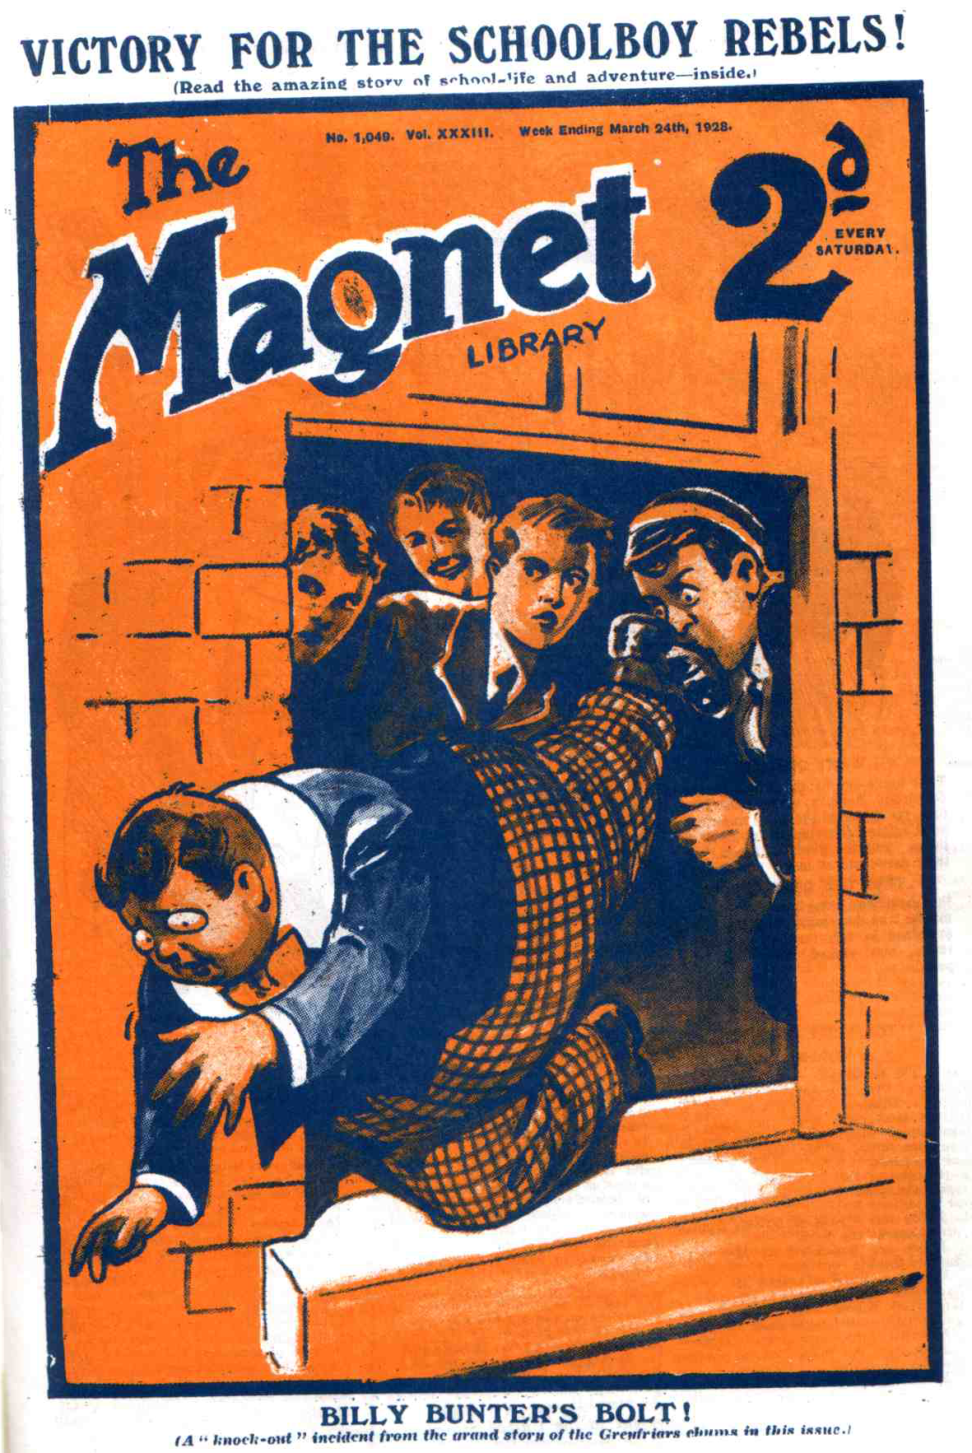
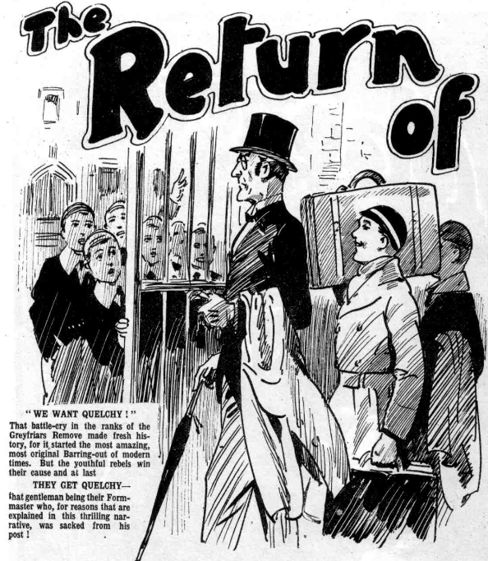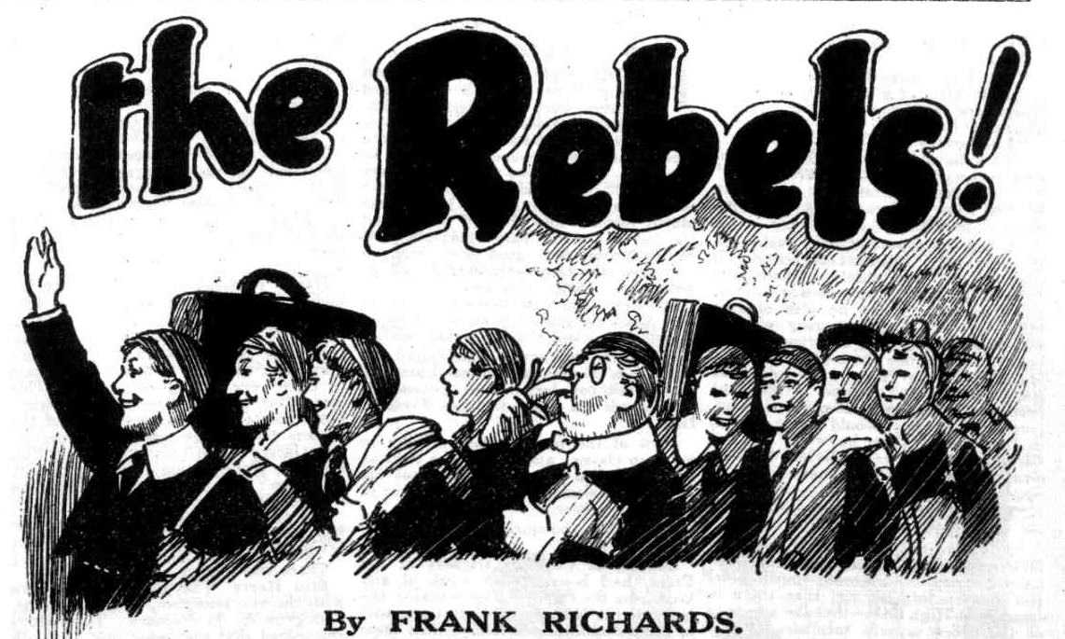

THE FIRST CHAPTER.
Unexpected!
“IT’S Quelchy !”
“Oh, my hat!”
Classes were just over at Greyfriars, and the quad was swarming with fellows, when the tall, angular figure of Mr Quelch appeared at the gates.
Hobson of the Shell was the first to spot him, and Hobby passed the word
at once.
There was a rush of fellows from all directions at the news.
Every eye was fixed on Mr. Henry Samuel Quelch.
Only a week or so before Mr. Quelch had been master of the Remove at Greyfriars School, and his coming and going had excited no remark.
Now his sudden appearance at Greyfriars sent a thrill of excitement through the school.
Much had happened since the last time that Mr. Quelch had taken his Form in the Remove room. No Greyfriars man had expected ever to see him at the school again. Mr. Quelch had not resigned; he had been dismissed from his post by the headmaster for reasons known only to the Head himself. And the Remove had marched out of the school as a protest against the dismissal of their Form master. In the circumstances it was a surprise to see Henry Samuel Quelch walk in at the gate, and the crowd of fellows who watched him come in wondered what it might portend.
Mr. Quelch, icily calm as usual, walked in as if quite unaware of the sensation caused by his arrival.
He hardly glanced at the crowd of astonished faces that surrounded him as he walked towards the House. But he could not help hearing the excited comments of the Greyfriars fellows as he passed them.
“It’s Quelchy—”
“He’s come back!”
“There’s going to be a row,” said Tubb of the Third. “There’s going to be a shindy, you fellows. You’ll see.”
Mr. Quelch coloured slightly as he heard that remark.
Whatever might be Mr. Quelch’s object in revisiting the school from which he had been ignominiously dismissed, certainly his object could not have been a “shindy” A shindy was miles, if not leagues, below the dignity of a Form master, even a dismissed one.
He strode on towards the House.
An army of fellows followed him.
To the fags, at least, it appeared probable that Mr. Quelch had come back to Greyfriars to tell the Head what he thought of him ; and if there gong to be a row they did not want to miss it.
Mr. Quelch arrived at the door of the House with quite a numerous escort.
in the doorway Wingate of the Sixth met him, and he fairly jumped with surprise at the sight of the dismissed master.
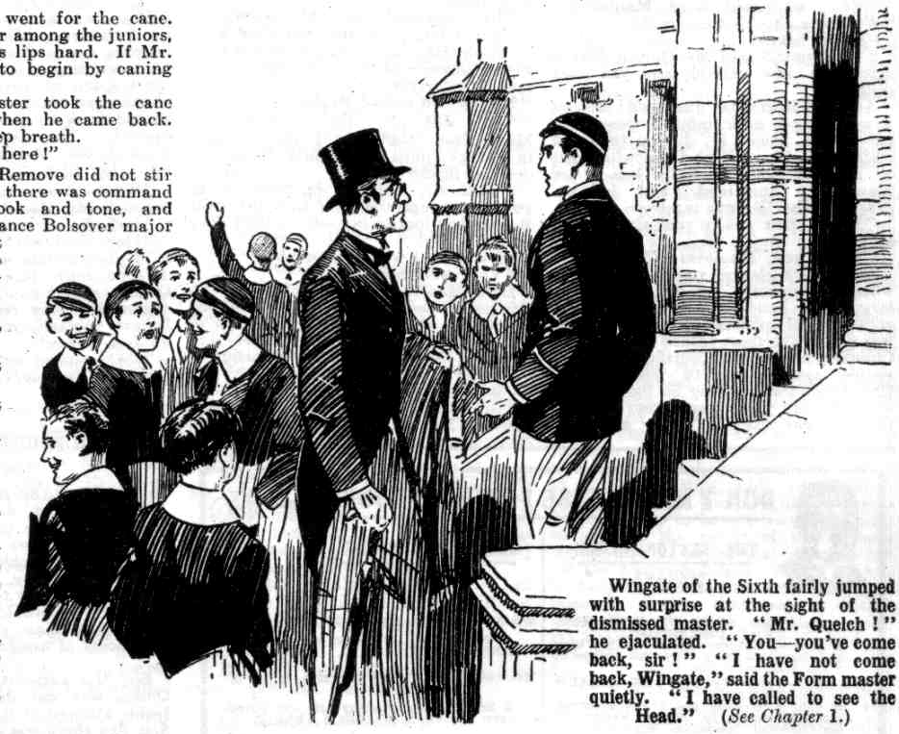 “Mr. Quelch!” he ejaculated.
“Yes, Wingate.” said the Form master quietly.
“You—you’ve come back, sir?” exclaimed Wingate.
“I have not come back, Wingate. I have called to see the Head.”
“Oh, sorry, sir!” said the captain of Greyfriars. “We were all sorry when
you left, sir.”
“Thank you, Wingate. The Head is within?”
“In his study, I think, sir. I’ll call Trotter.”
Trotter, the House page, gaped at the sight of Mr. Quelch. He almost tottered away to take in the name of this unexpected caller to the Head.
Mr. Quelch waited.
More and more fellows gathered a more or less respectful distance to eye the amazing visitor. Apparently unconscious of the sensation, Mr. Quelch chattcd calmly with Wingate of the Sixth until Trotter came back.
Trotter’s face was red, and he stuttered as he delivered the headmaster’s message to the frowning Remove master.
“If—if you please, sir——”
“Well?” said Mr. Quelch incisively.
“Thc ‘Ead says, sir—he says—”
“Well?”
“ The ‘Ead says, sir, that he does not desire to see you. sir!“ gaspcd Trotter.
“ Begging your pardon, sir, that’s what Dr. Locke says, sir.”
A pink spot glowed in either of Mr. Quelch’s cheeks. The gleam that came into his eyes made Trotter back away.
“That’s what the ‘Ead says!” stuttered Trotter.
The Greyfriars fellows exchanged glances. Tubb of the Third nudged Paget of that Form.
“There’s going to be a shindy—you’l1 see!” he breathed ecstatically.
And then Tubb, catching Wingate’s eye, faded out of view.
Mr. Quelch stood quite still and silent for a moment or two. Apparently he had not expected this rebuff. He did not even know why the headmaster of Greyfriars had so summarily dismissed him, and he was quite at a loss to account for the bitterness of the mild old gentleman’s feelings towards him. Bitterness begets bitterness, and Mr. Quelch’s own feelings were far from cordial or friendly now; still, he was surprised, and evidently taken aback. He spoke at last.
“Trotter!”
“Yessir?” gasped Trotter.
“You will go to Dr. Locke again and tell him that I have called with refer- ence to the Remove boys now absent from the school.”
“ Yessir!”
Trotter hurried away again along Head’s corridor. Mr. Quelch, with a heightened colour, awaited his return.
The pagc came back at last.
“Dr. Locke will see you, sir, if you will kindly foller me.”
“Very well.”
Mr. Quelch followed Trotter, and was shown to the Head’s study. A crowd of fellows pressed on to the corner of Head’s corridor and saw him pass into the head’s study. The door closed behind him, cutting him off from their eager eyes.
Tubb of the Third and his friends waited with eager anticipation for the sound of a shindy. But no such sounds came to their ears.
In the Head’s study at that moment there were feelings that in the Third Form-room would undoubtedly have led to a shindy. But in the Head’s study a shindy was unthinkable. All was calm and circumspect.
Dr. Locke rose from his seat as the former Remove master was shown in.
He fixed his eyes upon Mr. Quelch.
He did not ask him to be seated. There was no welcome in his looks. Mr. Quelch had not only been the most valued member of his staff, but his friend, in his days at Greyfriars. But the Head’s grim face showed that friendship was a thing of the past.
“I have called, sir—” began Mr. Quelch icily.
“This is not a call, sir. it is an intrusion!” broke in the Head. “I regard it as most improper for you to visit Greyfriars in the circumstances.”
“If you will kindly allow me to speak, sir—”
“I am waiting, sir, to hear your explanation of this intrusion. You can scarcely nourish any hope of reinstatement in your former position here.”
Mr. Quelch’s eyes gleamed.
“I should refuse reinstatement here, sir, if you offered it!” he snapped. “I have no desire whatever to become a member of your staff again. I should certainly decline to serve under a headstrong, unreasonable, tyrannical head- master!”
“ Sir !” ejaculated Dr. Locke.
“ Sir!” retorted Mr. Quelch.
The glances of the two scholastic gentlemen crossed like rapiers. Had Tubb of the Third seen them at that moment he would have had to doubt that the shindy was close at hand. Possibly both the gentlemen regretted that the dignity of their position prevented them from expressing their feelings in the untrammelled manner of the Third Form. Still, they did not think of expressing them in that manner.
“You have not called, sir. simply to utter these insulting remarks, I presume!” said the Head at last.
“No, sir. I have called with reference to my Form
“Your late Form” interposed the Head.
“ My late Form,” Mr. Quelch conccded bitterly. “ The Remove boys have left Greyfriars as a protest, they tell me, against my dismissal. I need not say that I disapprove strongly of their action.”
“Indeed!“ said the Head.
“lndeed!” said Mr. Quelch.
“Well?”
“The boys have installed themselves in High Oaks, sir at a short distance from Gteyfriars as you are, of course, aware.”
“I am aware of it, sir.”
“They have been there, left to their own devices, for more than a week, sir.”
“That does not concern you, Mr. Quelch, since you no longer have anything to do with that Form.”
“I beg your pardon, sir,” said Mr. Quelch grimly. It concerns me very nearly. These boys were in my charge when I was a Greyfriars master. I had no idea of anything of this kind occurring when I left, and I was greatly surprised when I heard of it. When these boys requested me to come to High Oaks and take charge of them, I refused in the most peremptory manner. I naturally supposed that the boys would be taken back to Greyfriars. This, however, has not happened. They are still left to their own devices by the headmaster who is responsible for them.
“I repeat, sir, that the matter need not concern you.”
“And I repeat, sir, that it does, and must, concern me. I have studiously refrained from interference—until now. But I have learned, sir, that there is disorder at High Oaks—that the attempts of the more orderly members of the Remove to maintain order have failed—that the juniors are wasting their time, and that, in short, it is quite impossible for the present state of affairs to continue. I have, therefore, decided to install myself at High Oaks, and take charge of these boys who were formerly under my charge at Greyfriars.”
“Mr. Quelch!”
“Dr. Locke !”
“ You will be allowed to do nothing of the kind, sir!” exclaimed the Head, his voice trembling with anger. “You will never be allowed to intervene in the affairs of Greyfriars, sir.”
“I have no such desire,” said Mr. Quelch, “But I refuse, sir—I refuse absolutely—to see the boys who were once in my charge left to their own devices, without a master. If you, sir, lack a sense of duty towards these boys and their parents, I, sir, feel it my duty to step into the breach. I have called to tell you so, sir, in order that there may appear nothing surreptitious about my action. If the Remove, sir, are taken back to Greyfriars, I am prepared to wash my hands of the whole matter. It is for you to manage that. But so long, sir, as these boys are out of Greyfriars I shall assume control of them,
sir, and I tell you so plainly.
“This reprehensible conduct, Mr. Quelch—
“ Enough, sir! I have not called here to bandy words, but to state my intention. I have no more to say.”
“You will listen to me, sir—”
“I shall not listen to you, sir.”
And Mr. Quelch opened the door of the study and stalked out. The Head’s voice followed him.
“Mr. Quelch, legal proceedings will be taken——”
Slam!
The study door closed after Mr. Quelch, cutting short the Head’s wrathful speech. Mr. Quelch came striding down the corridor, and the crowd at the corner parted for him to pass. Without a glance to the right or the left, Mr. Quelch strode out of the House and down to the gates. And Tubb & Co., in utter disgust, realised that there was not to be a shindy, after all.
THE SECOND CHAPTER.
Mr. Quelch Takes Control!
HARRY WHARTON &. CO. lined the drive at High Oaks, and there were loud cheers. Mr. Quelch raised his hat slightly in response to the cheers of his old Form. Nearly all the Remove were there to meet Mr. Qucich, and they shouted uproariously. The arrival of the Remove master to the control at High Oaks meant 1essons, and the old grind, and the end of a rather easy time; but most of the juniors were glad to see him all the same. For they realised that a school without a master was not a practical proposition, and that the alternative to Mr. Quelch’s control was a return to Greyfriars. And that was surrender.
For a time the new “school” had run without a master, and a good deal of class-work had been done; but it had not lasted. It really was not likely to last.
Most of the Remove were willing to keep up classes, and thus make it clear
they had gone on strike, not for the sake of slacking, but in the cause of
right and justice.
But though the spirit was willing, the flesh was weak.
Skinner & Co., the slackers of the Form, had been against work of any kind from the start; Bolsover major, the bully of the Remove, jibbed at any sort
of control, and better fellows than these thought at times that a stroll round the grounds, or a pick-up game of football was rather more agreeable than class.
So long as the dissentient were few they had been kept in order by Harry Wharton & Co. But when the dissentients outnumbered the rest of the Form,
the Famous Five realised that the game was up.
So the school without a master ceased to bear much resemblance to a school at all, and, as in the days when there was no king in Israel, every man did what was right in his own eyes.
That was a state of affairs that could not continue; yet the juniors were extremely unwilling to return to Greyfriars.
Mr. Quelch had not been reinstated.
To return was surrender, which was very unpalatable to Lord Mauleverer and the Famous Five and other leaders of the Form.
Moreover, there was the Head’s attitude to be considered.
Dr. Locke had menaced the leaders of the revolt with expulsion, and their followers with a general flogging.
That prospect was extremely unattractive.
The advent of Mr. Quelch saved the situation. Even fellows who were far from keen on classes and had no desire whatever to increase their store of knowledge, were glad to see him arrive.
They crowded round Mr. Quelch, cheering, as he walked up the drive towards the big door of High Oaks.
Mr. Quelch entered the great hall of the house.
The juniors followed him in—almost all the Remove. Some members of the Form were not there. Skinner was lying low in some quiet spot, and Billy Bunter had locked himself in a room with a supply of provisions as the surest method of keeping out of classes. But the rest of the Form turned up, even Bolsover major realising that the time had come for an end of truculence. Mr. Quelch’s position at High Oaks was a rather peculiar one, and the foundation of his authority there was rather vague. But it was well known that he was not a man to be trifled with. He had come to take control, and it was quite certain that his control would be as complete as it had ever been at Greyfriars.
“Wharton!”
“Yes, sir,” said Harry Wharton promptly.
“You will kindly call the roll.”
“Certainly, sir.’
The captain of the Remove called the roll, and all the fellows answered to their names with two exceptions. Skinner and Bunter were absent.
“Wharton, you will find Skinner and Bunter, and tell them to come here at once.”
“Yes, sir.”
Harry Wharton left the hall on his mission. Quelch stood by the fireplace, immovable as a bronze image.
As he had not given the word to dismiss, the Removites remained where they were, standing in order. But some of them very soon grew restless. This was rather a change from a school without a master, and to very many of the juniors the change was not agreeable. Bob Cherry shuffled his feet, Johnny Bull grunted, Bolsover major began to talk to Snoop. In a minute more there was a hum of voices.
Mr. Quelch’s gimlet eyes turned on the Form.
“Silence, please !” he rapped out.
There was silence.
Still Harry Wharton did not return with the two absentees, and the restlessness grew in the Remove. The fellows considered that they were not, after all, at Greyfriars, and Mr. Quelch was only in authority at High Oaks by request of the Remove. Some of the fellows were not keen on implicit obedience to a master whom they had themselves appointed. Bolsover major spoke at last.
“May we go now, sir?”
Mr. Quelch’s eyes gleamed at him.
“No, Bolsover! You may not go!”
Bolsover major shifted uneasily.
“The fact is, sir—” he began.
“ You need not speak, Bolsover.”
“But, sir—”
“Silence!” —
Bolsover major scowled, and gritted his teeth, but he was silent, though he was looking and feeling extremely rebellious. But then Harry Wharton re-entered, leading in Skinner, with a grip on Skinner’s arm. Harold Skinner, obviously, did not want to come, but a grip of iron on his arm had persuaded him to do so.
His eyes fell before Mr. Quelch’s glance. Skinner—in his belief that he would never come again under the authority of Mr. Quelch—had told his late Form master, on the telephone, what he thought of him. What Skinner thought of Mr. Quelch was not complementary. Now that the Remove master had unexpectedly resumed authority over the Form, Harold Skinner expected trouble.
But Mr. Quelch had apparently forgotten that talk on the telephone. Or perhaps he did not feel entitled to punish Skinner for misdeeds that had been done before he assumed control.
“ Take your place with the Form, Skinner.” he said quietly. “On this occasion I shall not punish you for being late; but you will remember in future that I require punctuality.”
“ Oh!” gasped Skinner, in great relief. “Yes, sir! Certainly, sir!” And Skinner retreated into the ranks of the Removc.
Wharton left the hall again, to fetch Bunter. Again there was a long delay, and restlessness grew. Two or three fellows whispered to Bolsover major, and the burly Removite spoke to Mr. Quelch at last.
“I’m tired of standing here, sir.”
“What?”
nn”Tired of it, sir.” Grunted Bolsover.
At Greyfriars, assuredly, Bolsover major would never have ventured to address Mr. Quelch in that strain. Evidently he supposed that matters were on a different footing, so far as discipline was concerned.
“You are impertinent, Bolsover!” he said icily. “That is not the way to address your Form master!”
“We’re not at Greyfriars now, sir.” Mumbled Bolsover major sulkily.
“Quite so. Mauleverer!”
“Yaas, sir?” said Lord Mauleverer, with prompt respect. Mauly, at least, wanted to make it clear that he respected the Remove master as much at High Oaks as at Greyfriars.
“No doubt there is a cane in the class-room?”
“Yaas, sir.”
“Kindly fetch it for me.”
“Oh! Yes, sir.”
Lord Mauleverer went for the cane. There was a murmur among the juniors, and Bolsover set his lips hard. If Mr. Quelch was going to begin by caning fellows——”
The Remove master took the cane from Mauleverer when he came back. Bolsover drew a deep breath.
“Bolsover ! Step here!”
The bully of the Remove did not stir for a moment. But there was command in Mr. Quelch’s look and tone, and before his steady glance Bolsover major quailed. He left the ranks of the Remove, and advanced sullenly. Mr. Quelch pointed to a chair with the cane.
“You’re not going to cane me, sir?” muttered Bolsover major.
“I certainly am, Bolsover.”
“You’re not our Form master now!” muttered Bolsover sulkily. “You’ve no right to cane us!”
“Shut up, Bolsover!/” said Bob Cherry. “Play the game!”
“You need not speak, Cherry!” snapped Mr. Quelch.
“Oh, No, sir!” stammered Bob.
“I am waiting, Bolsover, for you to bend over that chair!” said Mr. Quelch sternly.
Bolsover major paused, breathing hard. He looked at the Remove, hoping to find support there. But there was no support for a rebel. Skinner & Co. sympathised, but they were not likely to offer active support; and almost all the other fellows were strong in support of Mr. Quelch’s authority’ Only grim looks met Bolsover major; and at last, reluctantly and sullenly, he bent over the chair.
Swish! Swish! Swish! Swish! Swish! Swish!
It was six, and severe a six as Mr. Quelch had ever administered in the Remove Form-room at Greyfriars. Bolsover major fairly wriggled and squirmed under it.
“You may go back to your place, Bolsover.
Bolsover major limped back. He wriggled in his place painfully, but he did not speak again, and the other fellows did not speak. The Remove were waiting the pleasure of Henry Samuel Quelch, and it was borne in upon every mind that the school without a master had a master now, and a master who would stand no nonsense.
THE THIRD CHAPTER.
Bunter Thinks Twice!
“YAH!”
It was the fat voice of William George Bunter.
Bunter was speaking through a keyhole.
The door of the room in which the Owl of the Remove had taken refuge was locked, and barricaded with furniture; and Billy Bunter, safe behind his defences, hurled defiance at the captain of the Remove through the keyhole.
“You fat ass!” breathed Wharton.
“Yah!”
“You’ve got to come out.”
“Rats!”
“Quelchy is here.”
“Blow Quelchy!”
“I tell you he has come to High Oaks, and he is master now!: exclaimed Wharton.
“He may be your master, old bean, but he ain’t mine!” jeered Bunter. “I tell you I ain’t coming out! I don’t care for Quelchy! Quelchy can go and eat coke!”
”You fat chump!”
“Rats! Quelch ain’t my Form master.” said Bunter. “He was sacked from Greyfriars by the Head, and a jolly good thing too! Best thing the old Beak ever did! Like his cheek to come here, I consider! He’s jolly well not going to come the Form master over me!”
“Will you come out?” roared Wharton.
“No, I won’t!”
“Mr. Quelch has told me to take you.”
“Tell hin to go and eat coke!” retorted Bunter. “Tell him he’s an old donkey, and I don’t care a snap for him, or for a dozen of him! Tell him that, and—“
“You fat idiot!”
Harry Wharton turned away and went down the stairs. It was for the Remove master to deal with the fat rebel. Billy Bunter was full of defiance now, but Wharton had a strong suspicion that the first snap of Mr. Quelch’s sharp voice would reduce him to order. A fat chuckle from the locked room followed him.
“Mind you tell him to go and eat coke, Wharton!” yelled the Owl of the Remove.
“Fathead!”
Wharton did not deliver Bunter’s message. When he returned to the hall alone, Mr. Quelch gave him an enquiring look.
“Where is Bunter, Wharton?”
“He’s in a room upstairs, sir.” “He—’hem— doesn’t seem to understand, sir. Perhaps if you spoke to him, sir—”
“Very well.” said Mr. Quelch. “I will deal with Bunter presently. I have a few words to say to you juniors.”
Evidently it was those few words for which the Remove had been kept waiting. Mr. Quelch looked at his Form, and the Remove waited quietly and respectfully for him to speak.
“My boys,” said Mr. Quelch, “you are here under somewhat peculiar circumstances. Lord Mauleverer, with his guardian’s permission, has purchased this building, as you know, and whatever I think of that proceeding, I will offer no comment. You boys have left Greyfriars
as a protest against the Head’s dismissal of your Form master. I disapprove strongly of your action.
“Oh !” murmured the Remove.
“ Nevertheless “ resumed Mr. Quelch, “ I thank you for your attachment to me, though I think you have displayed it in very mistaken manner. I have advised you to return to Greyfriars. This advice you have not taken. I fully expected the Head to compel you to return. He has not done so. In the circumstances, I felt it my duty to come here and take control. I shall remain in control until you return to Greyfriars or until your parents otherwise decide. Classes will proceed on precisely the same lines as at Greyfriers— the same work will be done and the same discipline will be maintained. I desire this to be understood very clearly. You are schoolboys, and, now that I am in charge, you are at school, and there must be nothing in the nature of disrespect, disobedience, or rioting. I trust I make myself clear?’
“Yaas, sir “ said Lord Mauleverer. “ We ask nothin’ better, sir.”
“Hear, hear!”
“Very good,” said Mr. Quelch. “That matter is now settled, and you may dismiss.
And the Removites dismissed ; and, as it was not yet dark, most of them went out of the house, to discuss the new state of affairs at High Oaks with more or less approval, generalIy less. Lord Mauleverer remained, and he approached the Remove master.
“ May I show you to your study, sir ?” he asked.
”Thank you, Mauleverer!”
Mr. Quelch glanced round the room to which Mauleverer led him. It was a large and handsome room, furnished regardless of expense. Lord Mauleverer was one of the most valued customers at Chunkley’s Stores in Courtfield . and his simple system was to telephone to Chunkley’s for anything he thought was wanted, or that any other fellows thought was wanted. The schoolboy millionaire did not count the cost, that was left to Chunkley’s.
“I am afraid you have been expended a great deal of money, Mauleverer.” said Mr. Quelch, perhaps by way of thanks for being provided with such very comfortable quarters.
“ Yaas, sir,” said Lord Mauleverer innocently. .
“ It is extraordinary, Mauleverer, that your guardian should give you permission to do so.”
“Oh, not at all, sir!” said Maulcvcrcr. “ Nunky—I mean, my uncle, sir—has no end of faith in my judgment, sir. He knows I spotted a good property in High Oaks sir—no end of a bargain.”
Mr. Quelch looked at him.
“ Indeed !” he said dryly.
“Oh yaas, sir!” said Mauly. “If we don’t keep the place on as a school, sir, it will be sold for buildin’, and it will bring in about twice as much as I paid for it in bulk sir. I’m rather a business man in this line, sir. I know my way about.”
“ Bless my soul!” said Mr. Quelch.
“But I hope, sir, that we shall keep on High Oaks, and that you will remain as headmaster of the new school, sir.” said Maulevcrcr.
Mr. Quelch smiled slightly,
“ We will not discuss that now, Mauleverer. Certainly I shall remain in charge until something definite is decided in the matter.”
“ Yaas, sir. I’d like to show you to your room upstairs, sir; but that ass Bunter has locked himself in that very room.”
“ I will deal with Bunter now.”
“ Very well, sir.”
Lord Mauleverer led Mr. Quelch up the stairs and along to the handsome apartment which had been furnished as a bed-room for the Form master, and of which Bunter had taken possession.
His lordship tapped at the door.
“ Bunter, dear man!”
“ Go and cat coke!” came Bunter’s voice. “ I’m barring out the lot of you, and that includes old Quelch too. I’ve got lots of grub here, and I can jolly well tell you I’m not coming out—see?”
“Mr. Quelch—”
‘ Blow Mr. Quelch!” interrupted Bunter.
“He’s here, you fat ass!” gasped Mauleverer.
‘I don’t care where he is——”
“Bunter!”
Mr. Quelch’s voice was not loud but deep. There was a gasp from within the locked room.
“ Who—who—who’s that ?”
“It is I, your Form master, Bunter.” said Mr. Quelch in a deep voice.
“Oh, lor!”
Lord Mauleverer grinned. William George Bunter’s defiance had burst like a pricked bladder. His courage, such as it was, had oozed out at his fat finger tips. The well-known, authoritative voice of the Remove master was enough for the fat rebel: .
“Open this door at once, Bunter!”
“ Ow ! Oh! Yes, sir!” gasped Bunter.
There was a hurried sound of removing furniture, and a crashing as several articles, removed rather too hurriedly, went whirling over. In a wonderfully short space of time Billy Bunter had demolished his barricade, and the key turned back in the lock and the door opened. The Owl of the Remove blinked out at the Remove master, quivering like a fat jelly with terror.
“What does this mean, Bunter?” snapped Mr. Quelch.
“I—I—I——” stuttered Bunter.
“How dare you?” .
“I—I—the fact is, sir, I—I—I——”
“You may go, Bunter,” said Mr. Quelch. “But you will remember that discipline is now restored, and you will behave yourself, you absurd boy.”
“I—I—I”
” Go !“ rapped out Mr. Quelch.
“ Ow ! Yes, sir !“ gasped Bunter.
And he fled.
THE FOURTH CHAPTER.
Fed-up!
HIGH OAKS SCHOOL, the following day, was as orderly as any school in the kingdom, if not a little more so.
Had Mr. Quelch’s authority been disputed, there were plenty of fellows in the Remove ready to back him up. The Famous Five would have handled any rebel as one man, and they would have had plenty of assistance had they needed it.
But the authority of Henry Samuel Quelch was not disputed. After the feeble attempt of Bolsover major on the first day there was no more opposition.
Mr. Quelch had a forceful character.
He had a voice of authority, and an eye like Mars to threaten and command. Skinner & Co. argued—among themselves—that Quelchy had no right to
give them orders, but they obeyed Quelchy’s orders with commendable promptness. Resstance might be debated in the study or the dormitory. but under the gleaming eye of Henry Samuel Quelch it became unthinkable.
During the two or three following days the slackers of the Remove were brought to book sharply ; and even the fellows who had been most enthusiastic in the cause of Mr. Quelch, and who had been keenest to get him to High Oaks, wondered a little if they were wholly satisfied with their success.
A school without a master might not amount to much in the way of a school, but it had its agreeable side. Now the High Oaks fellows might as well have been back in the Form-room at Greyfriars.
No doubt many of the fellows had expected an easier rule. Mr. Quelch owed his present authority to them. He was, so to speak, an elected monarch, not king by right divine. Older and more experienced fellows would have been aware that an elective monarch ís a good deal more jealous of authority than the genuine article, and that the president of a republic is likely to be much more imperious than royalty. So it was with Mr. Quelch in his present anomalous position. Instead of ruling with a lighter hand than at Greyfriars, he was undoubtedly more severe and exacting. A man holding authority that might be questioned at any moment by anyone was bound to be much more particular in maintaining that authority.
Upon the whole, however, the Remove were satisfied, and the dissentients grumbled without being much regarded.
Meanwhile no move came from the headmaster of Greyfriars. That gentleman was still puzzled, and at a loss how to deal with the recalcitrant Remove. So far, it was clear that he had not communicated with the parents of the Remove fellows, since the juniors had heard nothing from home on the subject.
Perhaps the Head was waiting for the whole affair to “ fizzle” out of its own accord ; but, if so, he was likely to have to wait a very long time. The greater part of the Remove, at least, were determined to stand by their dismissed Form-master, and to keep out of Greyfriars till he was reinstated in his old position. They were, perhaps, a little discouraged by the fact that Mr. Quelch did not seem at all obliged to them for taking up his cause; and. indeed, seemed rather to regard it an impertinence on their part. But they were determined all the same.
“ I say, you fellows, I’m fed up with Quelchy!” Billy Bunter announced to the Famous Five, after a few days of the new rule.
“ Go hon!” remarked Nugent.
“ I mean it,” said Bunter firmly; “ and, look here, I’ve got an idea! Now there’s no Remove at Greyfriars, there’s no Remove master—the Head won’t appoint a new Form master till the Form go back.”
“What about it, Fatty?” asked Johnny Bull.
“Don’t you see? There won’t be any classes there for us—until there’s a new master. I mean, if a few fellows went back——”
“ A few fellows won’t go back.”
“You chaps can stick here if you like.” said Bunter. “ In fact, the longer you stick the better ; but I’ve decided to go back.”
Bunter blinked very seriously at the Famous Five. He had thought it out, and he considered that he was on to a good thing.
“ You fellows keep it up.” he said. “Keep it up as long as you like; I’m going back on my own, see? I shall have a jolly easy time. The Head won’t get a new Form master just for me—and he won’t appoint a prefect to take a class of one. Looks to me as if I shall have nothing to do, see?”
“Which, of course, would be simply glorious!” remarked Bob Cherry sarcastically.
“Exactly !”
“ Chuck it!” said Wharton. “You’re not going back!”
“Oh, really, Wharton —-“
“ The whole Form have got to stick together, ass!”
“The stickfulness is the proper caper, my esteemed fat Bunter.” said Hurree Jamset Ram Singh.
“ Rats!” retorted Bunter scornfully. “Besides, there’s another thing—a very important thing. The Head’s not sending on our letters. I was expecting a postal-order —
“ Oh, my hat!”
“ From one of my titled relations !” explained Bunter.
“Give it a rest !”
“Well, I can’t afford to leave my money lying about.” said the Owl of the Remove. “I am actually short of ready cash now. I shan’t get that postal order unless I go back to Greyfriars.”
“ And perhaps not even then !” suggested Johnny Bull.
“Ha, ha, ha!”
“ The perhapsfulness is terrific !” chuckled Hurree Singh.
“Well, I’ll tell you what,” said Bunter. “ It you fellows want me to stay here, lend me the pound—”
“What pound?”
“The postal order is for a pound. Lend me the pound, and you can have the postal-order when I get it, see?”
“ When!” grinned Bob Cherry.
“If you refuse——”
“ Take that as read !” suggested Bob.
“Then I’m going.”
“Fathead!”
“I mean it,” roared Bunter ; “ and I’m jolly well going now.”
And Bunter, with a defiant blink, rolled away towards the door. He did not roll very far, however.
Five hands grasped him all at once.
“Bump him !” said Wharton..
“Here, I say—leggo—I say, you fellows—Yarooooh!”
Bump!
Whoooop!” roared Bunter.
Bump!
“ Yow-ow-ow-ow-ow-wooooop!”
“That’s a tip!” said the captain of the Remove. “Cut it out, old fat man. You’re sticking to the form.”
“Yow-ow-ow! Help! Fire! Murder! Yooop!” roared the fat junior.
“What is this disturbance ?” It was Mr. Quelch’s sharp voice, as he came into the hall of High Oaks. “ What does this uproar mean?”
“Yaroooogh!” yelled Bunter. “Leggo!”
“Release Bunter at once!” exclaimed Mr. Quelch, frowning.
The Famous Five released Bunter at once—so suddenly, in fact, that he bumped on the floor with a heavy bump, and an ear splitting yell.
“Wharton! This horse-play in hall cannot be allowed! You are head boy of the Remove, and should know better.”
“Hem!”
“Each of you will take two hundred lines,” said Mr. Quelch severely.
“Oh !”
“Let there be no more of this.”
“Hem!”
Mr. Quelch rustled away, frowning, and the Famous Five blinked at one another, rather uncertainly.
“I suppose that’s Quelch’s way of expressing his thanks for backing him up!” murmured Bob Cherry.
“The thankfulness does not seem to be terrific.”
Johnny Bull grunted.
“Are we going to do those lines?” he demanded.
“Must play the game.” said Harry.
“ We’ll do the lines. But—”
“ But what?” grinned Nugent.
“Oh, nothing.”
“ He, he, he !” Billy Bunter contributed a fat cachinnation. I say, you fellows, serve you jolly well right. I’m going.” .
Bunter rolled away again. The Famous Five glared after him—but this time no hand was raised to stop him. Backing up Mr. Quelch, and receiving impositions from that gentleman by way of reward, was rather too much of a good thing. The Owl of the Remove departed unhindered, and when the roll was next called at High Oaks, W. G. Bunter failed to answer “ adsum!” to his name.
THE FIFTH CHAPTER.
The Deserter!
SAMMY BUNTER, of the Second Form at Greyfriars, blinked through his spectacles at a fat figure that rolled in at the gates, and grinned. He recognised his major, whom he had not seen since the day the Lower Fourth marched out of Greyfriars. Sammy had not missed his major. In the Bunter clan, brotherly love could not very well continue, as it had never started. But Sammy rolled down to the gates to greet his returning relative, with a fat grin on his podgy face.
“So you’ve come back, Billy!”
William George blinked at his minor.
“Yes, Sammy. Glad to see me?”
“Eh! Not specially!” answered Sammy. “I say, you’re for it, you know.”
“What do you mean, you little beast?”
“ Head’s licking!” grinned Sammy. “The Beak is in a fearful rage. I hear that he’s been giving the Sixth a high old time.”
“Blow the Sixth !” said Bunter uneasily. “I shall tell the Head that I never wanted to go. I was practically kidnapped by those beasts, you know.”
“He, he, he!”
“What are you cackling at, you fat little rotter?”
“You can tell the Head that.” chuckled Sammy. “Perhaps he will believe it! I fancy he will make you sit up all the same.”
Bunter paled. He was fed up with Mr. Quelch at High Oaks ; and he anticipated a much easier time at Greyfriars—where there was at present no Remove master, and where the Head was scarcely likely to constitute a class of one, consisting only of William George Bunter. Bunter’s idea was that he was going to have a very easy time. So long as the revolt of the Remove lasted—and he hoped that it would last till the Easter holidays. But if he was to bear the first brunt of the headmaster’s wrath, that put a rather different complexion on the matter. He began to doubt whether he had not escaped from the frying-pan into the fire.
But it was too late for retreat now. He had cut classes at High Oaks, and for that there would be severe punishment—if he returned there. He had spent a happy afternoon loafing about and arrived at Greyfriars just before lock-up. He relied upon his wonderful powers as an Ananias to make his peace with the Head; though now that he was on the point of facing that gentleman, he began to doubt. Sammy Bunter chuckled, apparently deriving entertainment from the dubiety in his major’s fat countenance.
“You’re for it, old man,” he said comfortingly “ Better put some exercise-books in your bags before you see the Beak.”
“Rot!” grunted Bunter. “The Head’s bound to be glad to see me back. I’m setting a good example to the Form, you know, by coming back to duty, and all that. Besides, I never had anything to do with it. I disapproved of the whole thing.”
“Tell the Head that!” chuckled Sammy.
Billy Bunter hesitated for some moments. But there was ccrtain punishment behind him, whatever there might be before him. So he solaced himself by kicking Sammy, changing that fat youth’s chuckle into a wild yell, and then rolled on towards the School House.
“Hallo, here’s Bunter!” yelled Hobson, of the Shell. And there was a rush of fellows towards the returning Owl of the Remove.
“ I say, you fellows, I’ve come back!” said Bunter. “I say, is the Head in a wax?”
“ Ha, ha, ha!”
“Wax?” grinned Hobson. “ Wax isn’t the word. He’s in a towering rage.”
“ Fearful!” said Hobson.
“Gnashing his teeth,” said Stewart, of the Shell.
“Oh!” gasped Bunter.
“If you have tears, prepare to shed them now!” chuckled Temple, of the Fourth.
“Ha, ha, ha!”
“I—I—I say, you fellows, I—I think I’ll go back to High Oaks, after all.” stammered Bunter. “ Only, that beast, Quelchy, will wallop me for cutting class this afternoon. Oh, dear!”
“Hallo! Here’s a Remove kid!” roared Coker of the Fifth. “ They’re coming back! Where are the other cheeky young rotters, Bunter?”
“ They—they haven’t come,” stuttered Bunter. “ I’m setting them a good example, you know. I say, Coker, is the Head really in a wax?”
“ Frightful!” chuckled Coker. “ Raging like a Hun!”
“ Oh, dear!”
Billy Bunter blinked towards the gates. Wingate, of the Sixth, came out of the House. He had seen Bunter from his study window.
“Here, Bunter—”
“I—I say, I’m not staying!” gasped Bunter. “ I’m going back—”
The prefect’s hand dropped on his shoulder.
“You’re not!” he said grimly. “You’re coming in.”
“I—I say, Wingate
“ That will do. Come on!”
“Is—is—is the Head in a wax, Wingate?” mumbled the Owl of the Remove.
“ You’ll find that out soon enough.”
“Oh, dear!”
Wingate marched the fat junior towards the House steps. A shout of laughter from the Greyfriars crowd followed him. Evidently all the fellows expected the Head to make an example of Bunter, as the only Remove rebel within his reach. And they did not seem to sympathise at all with the deserter from High Oaks. Bunter had arrived at Greyfriars in quite a hopeful mood; but now his spirits were down to zero. His footsteps were slow and reluctant as he went towards the House, and the Sixth-Former jerked him along impatiently.
“Get a move on!” he snapped.
“ I—I say, Wingate—”
“Shut up!”
“ I’m jolly well not going to be licked!” howled Bunter indignantly.
“I fancy you are! Come on!”
Billy Bunter’s little round eyes gleamed behind his spectacles. As they reached the House he suddenly wrenched himself away from Wingate’s grasp and bolted for the gates. Wingate stared after him.
“ Stop!” he roared.
Bunter flew.
“Stop him, you fags!” shouted the Greyfriars captain.
“ Ha, ha, ha!”
Five or six Lower School fellows closed up in Bunter’s path. Cecil Reginald Temple, of the Fourth, stretched out a hand to seize him.
“Chuck it, Bunter!” he grinned. “ You—— Oh, gad! Yooop!”
Bunter, in desperation, lowered his head and butted Cecil Reginald fairly upon his waistcoat. Cecil Reginald went spinning, as if a battering-ram had smitten him. He sprawled in the quad with a gasping howl.
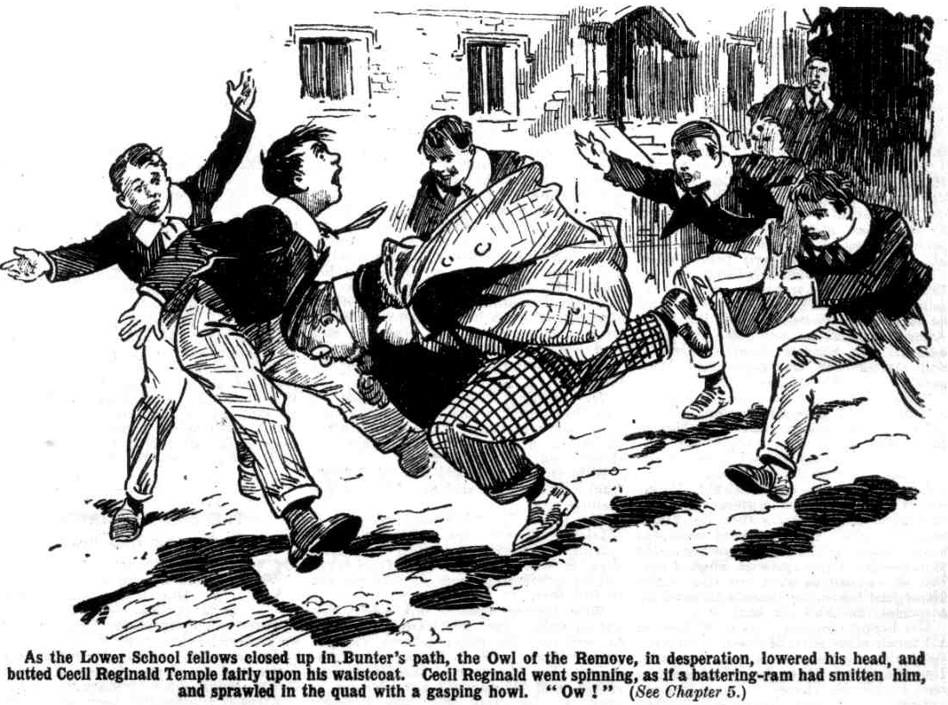 “ Ow!” gasped Bunter.
He rushed on wildly. But Hobson of the Shell grasped his collar and spun him round.
“ You’re wanted, Fatty!” he chuckled.
“Yaroooh! Leggo!”
“This way—”
“ Leggo!” roared Bunter. “I’ll hack your shins! I’ll— Yaroooh! Leggo, you beast!”
“ Here he is, Wingate!”
Wingate’s grasp closed on the Owl of the Remove again. This time it closed like a vice.
Billy Bunter was led into the House. By that time the Owl of the Remove wished, from the bottom of his fat heart, that he had stayed at High Oaks. But it was too late now. Wingate led him to the door of the Head’s study and tapped.
“Come in!”
“ Bunter, sir!” said Wingate, opening the door.
“ Bunter, of the Remove! Bless my soul !”
“ I—I say—”
Wingate pushed the fat junior into the study, drew the door shut, and walked away, and William George Bunter was left quaking in the presence of the Head of Greyfriars.
THE SIXTH CHAPTER.
The Deserter’s Reward!
DR. LOCKE stared grimly at the fat junior. If he was glad to see Billy Bunter at Greyfriars once more, his looks did not betray his gladness. There was a thunderous frown on his face. Probably the Head was thinking more of Bunter’s sins than of his virtues, and more of his having taken part in the Removc rebellion than of his tardy return to obedience. Certainly the look he gave William George Bunter was almost terrifying.
“ Bunter!” said the Head, in a deep voice. “ So you have returned!”
“ Yes, sir.” gasped Bunter. “ I—I’m awfully glad to see you again, sir. I— I’ve missed you, sir.”
“Where are the others?”
. “ The—the others ? They haven’t come,
“ What ? Do you mean to say that the rest of the Lower Fourth Form are persisting in rebellion and disobedience?” demanded the Head.
Really, the Head seemed to think it was Bunter’s fault that the Remove persisted in rebellion and disobedience. And really, it wasn’t!
“ They—they wouldn’t come, sir.” stammered Bunter. “ I—I urged them, sir, with—with tears in my eyes, sir——”
“ You have come alone ?”
“Yes, sir ; I—I thought I’d set the fellows a good example, sir. I—I’m rather shocked at them, sir. I haven’t cleared out of High Oaks because Quelchy’s come there and made us work, sir.”
“What?”
“ Nothing of the sort, sir. I—I thought you—you’d like me to come bank to Greyfriars, sir.”
“I am glad to see, Bunter, that you have returned to obedience, whatever your motives may have been. I shall, of course, cane you severely for having left the school without permission.”
“Oh, really, sir—”
“You may be thankful, Bunter, that I do not expel you from Greyfriars.” snapped the Head. “I shall cane you for —“
“I—I say, I—I wasn’t to blame, you know.” gasped Bunter. “ I never wanted to leave Greyfriars at all. I was against it all along. I wasn’t waxy at you sacking old Quelchy, sir. I thought it a jolly good thing. I think he’s a beast, sir, same as you do.”
“What?” gasped the Head, scarcely believing his ears.
“An awful beast, sir.” said Bunter. “I was jolly glad you bunked him, sir, and— “
“How dare you use such an expression, Bunter?”
“I—I mean, sacked him, sir. “That is booted him!” stuttered Bunter. “The other fellows thought you a high-handed old donkey, sir, but I didn’t——-”
“ What?”
“ I didn’t really, sir. And if I did I wouldn’t tell you so, sir. I’m too respectful to tell my headmaster what I think of him, sir.” gasped Bunter.
Dr. Locke rose to his feet and picked up a cane from the table. Bunter’s explanation had not cleared the thunder from his brow. Rather, it had intensified it.
“ Bunter, bend over that chair!”
“I—I say, sir, I—I wasn’t to blame. I—I was practically kidnapped by the other fellows, sir. I never wanted to go—”
“Bend over that chair!”
“ Oh dear! I wish I’d stayed at High Oaks!” gasped Bunter. “ I say, sir, l’ve come back to set a good example to the other fellows, sir!”
“I am waiting, Bunter,” said the Head grimly. “ As you have returned to school of your own accord, I shall make your punishment lighter than it would otherwise have been.”
Bunter’s fat face brightened a little. But it became overcast again as the headmaster went on:
“I shall give you only one dozen strokes, Bunter.”
“ Ow !” gasped Bunter.
If the Head regarded a dozen strokes as a light punishment, his ideas on that subject differed very considerably from William George Bunter’s.
“ Now, bend over that chair immediately, Bunter!” rapped out the Head.
“ Oh lor’ !”
There was no help for it. Billy Bunter bent over the chair in fear and trembling, and waited in anguish for the fall of the cane.
The hapless Owl of the Remove had supposed that his return to Greyfriars of his own accord would have the effect of making his peace with the Head— that he would be welcomed with open arms as it were, as the only dutiful and obedient fellow in a rebellious Form.
Instead of which, he had let himself in for a punishment, which the fellows who persisted in rebellion were escaping—so far, at least.
Bunter might really have expected it. The Head wanted to cane all the Remove ; but the Remove were out of his reach. Only one member of the rebel Form was within reach of the headmaster, so naturally the Head caned him—and quite probably was giving him a little extra on account of the rebels still out of reach
Whack! Whack! Whack!
“ Yaroooogh!” roared Bunter.
“Cease that absurd noise, Bunter!” rapped out the Head angrily.
“Wow-ow-ow!”
The cane whacked on forcibly; and Bunter did not cease that absurd noise; he increased it. The yells of the Owl of the Remove rang far beyond the Head’s study. They floated out into the quadrangle, where a crowd of Greyfriars fellows heard them, with unsympathetic grins.
“ Bunter’s getting it!” remarked Hobson of the Shell.
“What did the fat idiot expect?” grinned Hoskins.
“Serve him jolly well right!” growled Temple of the Fourth, caressing his waistcoat, under which there was a lingering pain. “ I hope the Head makes him squirm!”
“ Oh, rather!” said Dabney.
“ He, he, he!” cackled Sammy Bunter. “He’s making a row, ain’t he? Poor old Billy! He, he, he!”
Louder and louder rang the roaring of William George Bunter.
If Bunter hoped to touch the Head’s heart by those sounds of suffering, and to cause him to lay on the cane more lightly, he was disappointed. The Head appeared to be more exasperated than touched, and he laid on the strokes harder, instead of softer—perhaps with the intention of giving Bunter something substantial to yell for. He even seemed reluctant to stop when he had laid on a dozen. However, he stopped.
“Bunter—”
“Yow-ow-ow-ow-ow!”
“You may go, Bunter! I shall arrange for your studies tomorrow. As you will be doing no preparation this evening you will write out three hundred lines of Virgil, in order not to waste your time.”
“Ow!”
“You will be gated, Bunter, and if you should venture beyond the school gates on any pretext whatever you will be flogged!”
“Yow!”
“Now leave my study!”
Billy Bunter crawled away from the Head’s study. He moaned and groaned as he limped down the corridor. His happy anticipation had not been realised; and apparently even his studies were to be arranged. He was not to spend his time in slacking, as he had expected. Deeply did he wish that he had remained at High Oaks. Even Quelchy was better than this!
He crawled away to Study No. 7 in the Remove—his old study. There he put in a considerable time moaning and groaning. The Remove passage was silent and deserted; Bunter was the only fellow there. They would be having tea now at High Oaks; and at High Oaks tea was ample and plentiful.
In the lowest of spirits, Bunter reflected on what he had left behind— and on what lay before him. The recolletion that he would be late for tea in hall stirred him at last, and he rolled dismally downstairs, greeted by grinning faces on all sides. There was no fatted calf for the returned prodigal; the Head had treated him with what Bunter could only regard as base ingratitude; and the Greyfriars fellows evidently thought that he was rather a rotter to have deserted his Form, and rather an ass to have placed himself in the hands of his incensed headmaster.
Bunter, as he sat at tea in Hall, wriggled very uncomfortably on his seat ; and later, as he sat in his lonely study grinding out lines, he still wriggled, and before long he had made up his fat mind to get back to High Oaks at the very earliest possible moment. Having escaped from the frying-pan into the fire, as it were, the Owl of the Remove was eager to get back into the frying-pan. But that, as he was to discover, was not likely to prove easy.
THE SEVENTH CHAPTER.
Bunter’s Bolt!
BILLY BUNTER came down the following morning with a glum face.
The Remove dormitory was deserted now, in the absence of the Form, and Bunter had been given a bed in the Third Form dorm. There the fags of the Third had chipped him and jeered at him, and even pelted him with pillows, after lights-out, not in the least appreciating the honour of having a Remove man in their dormitory.
They had stayed awake unusually late in order to make things warm for Bunter. And when the rising-bell clanged out in the morning, and Bunter had sought to snatch a few extra minutes before turning out. Tubb and Paget and Bolsover minor had turned him out in a yelling heap on the floor.
Only too clearly Billy Bunter realised that he would have done better to share the fortunes of the other rebels at High Oaks ; the unpleasantness of Quelchy was, compared with this, as moonlight unto sunlight, as water unto wine. And William George Bunter rolled out into the quad before breakfast, determined to clear off without even waiting for that meal.
But, like the lion’s den in the fable, Greyfriars was easier to get into than to get out of.
One member of the rebel Remove was back in the school ; and that member was not to be allowed to rejoin the rebels—the Head had seen to that. When Billy Bunter rolled away to the cloisters, to climb over the wall out of sight there, Loder of the Sixth called out:
“ Bunter !”
The fat junior blinked round.
“Go into the House!” rapped Loder.
“I—I say, I—I am taking a walk before brekker!” faltered the hapless Owl of the Remove.
Loder grinned.
“Quite!” he agreed. “Now, take a walk in to the House—and stay there. And take that for answering me back!”
“That” was a ringing cuff, and Bunter took it with a wild howl.
Then he rolled dismally into the House. He realised that the prefects had been instructed to see that he did not get out of bounds. He was gated by the Head, and with the Sixth Form prefects keeping an eye open for him, his escape was exceedingly problematical.
Bunter breakfasted in dismal spirits. Fortunately the troubles on his fat mind did not affect his appetite, and he took in provisions in bulk as usual. After breakfast he went into the quad again. He blinked around cautiously, and started for the gates—and Wingate’s voice followed him:
“Bunter!”
“Oh, dear!” groaned Bunter.
“Keep in sight of the House, Bunter!”
“I—I say, Wingate—”
“That’s enough!”
Bunter kept in sight of the House till it was time for classes. He still nourished a faint hope that he would escape classes. But that faint hope was soon shattered. There was no Form for Bunter—his Form was at High Oaks. But he was not to waste his time. The Head had taken the trouble to arrange a special timetable for him’
His happy morning was spent first in a French class with Monsieur Charpentier, then in a maths set with Mr. Lascelles, and then in a geography lesson with the Third.
That filled up Bunter’s morning nicely.
It was quite as bad as classes at High Oaks; worse, in fact, for Bunter hated mathematics with a deadly hatred, and Mr. Lascelles was a man who made a fellow work.
After class, Bunter wandered into the quadrangle, and cautiously went down to the gates, which were now open. No prefect’s voice hailed him, but as he reached the gates the portly figure of Gosling interposed, and Gosling waved him back with a gnarled grin.
“You ain’t allowed out of gates, Master Bunter.”
“Oh, really, Gosling—”
“Wot I says is this ‘ere, you go back to the ‘Ouse, Master Bunter, and it’s my dooty to report you.”
“Beast!” howled Bunter.
“I’ll report that, too.” grinned Gosling. “Calling a man names for carrying out the horders of the ‘Ead.”
“Look here, you rotter——”
“Go it.” said Gosling. “I’ll report it all to the ‘Ead.”
“Yah!”
Bunter rolled away dismally. About ten minutes later Gwynne of the Sixth tapped him on the shoulder.
“Head’s study!” he said briefly.
“Oh dear!”
Bunter limped to the Head’s study. Dr. Locke picked up a cane as he presented himself.
“Gosling reports that you have attempted to break bounds, Bunter.”
“Oh, no, sir!” gasped Bunter. “I—I was just going to —to—to look out of gates to—to see if any of the fellows were coming, sir.”
“Gosling reports that you called him names for stopping you.” said the Head, unheeding.
“Oh, dear!”
“Hold out your hand, Bunter!”
Swish!
“Yooop!”
“The other hand!”
“Swish!
“Yow-ow-ow!”
“Take warning, Bunter,” said the Head, as he laid down the cane. “Your next offence will be visited by a much more severe punishment.”
Bunter rolled away from the Head’s study feeling thatlife was hardly worth living. He did not make another attempt before classes were resumed, and that afternoon he had French again, and mathematics again, and then the remainder of his time was filled up by an exercise in Latin irregular verbs, which the Head set him specially, and which he had to write out in his study. He had finished the exercise by the time the other fellows had finished classes, and when he took it to the Head he was told that it was slovenly, and was directed to write it out again. Writing it out again occupied Bunter till tea-time.
The evening, at least, he hoped to have to himself, while the rest of Greyfriars were at prep. Instead of which, as he had no prep to do, he was given three hundred lines to write out.
Billy Bunter had been fed-up at High Oaks. But fed-up did not describe his feelings now.
The Lower Fourth Form, now that it consisted of only one fellow, was receiving more attention from the Head than it had ever received from that august gentleman when it was present in full force.
Billy Bunter went to his study, but not to write lines. He waited there till he was sure the other fellows were at prep. Then he crept cautiously downstairs. The big door of the House was closed, and Bunter did not venture to open it. He crept into the Remove Form-room and closed the door after him silently. Then he opened a window.
He blinked out into the quadrangle. All was dark there beyond the radius of light from the House windows.
The fat junior climbed on to the window. As he did so the door of the Form-room opened, and he heard a voice— the voice of Gerald Loder of the Sixth Form.
“I tell you I saw him, Walker. The little beast came into this room.”
Bunter quaked.
“Why, there he is!” shouted Loder, as he glimpsed the fat form wriggling out of the window.
Loder rushed across the Form-room. Bunter clambered hurriedly out, but the prefect was too quick for him. Loder’s grasp closed on a fat ankle.
“Got him!” said Loder grimly. “I thought he was up to this! I’ve got you, you young rascal, and you may as well— Yaroooooh!”
Bunter was desperate. Loder had captured one foot; but the other was free, and Bunter drove it at Loder, careless of where it landed.
It landed on Loder’s chin with a terrific impact.
Crash!
Loder staggered backwards, yelling frantically. His chin felt as if it had been driven half way down his neck. He clasped it with both hands in great anguish, and Bunter, finding himself released, slipped out of the window and dropped to the ground.
“Got him?” asked Walker, groping across the shadowy Form-room.
“Yooooooogh!” was Loder’s reply.
“Anything the matter?” Walker inquired in astonishment. He could not understand Loder’s remark.
“Gurrrrrrrrrrrrrrgh!” moaned Loder, still clasping his chin. Murrrrrrgh!”
“Didn’t you get Bunter?”
“Goooooooooooooooogh!”
“You’ve let him go?” asked Walker. “I don’t see him! What are you making that row about, Loder?”
“Yooooooooooooooch!”
Loder did not explain what he was making that row about. He could do nothing but clasp his chin and moan. Walker stared at him in the gloom, and then stared into the shadowy quad. He could see nothing of Bunter.
Bunter was not lingering.
He had damaged Loder—he knew that. He was rather glad of it—if he got clear. If he did not get clear he would be sorry for it, there was no doubt about that. Bunter streaked for the Cloisters as fast as he could carry his weight.
There was a negotiable wall at the end of the Cloisters, and Billy Bunter negotiated it breathlessly. He scrambled wildly over, and dropped on the other side bumping, and picked himself up and fled. High Oaks, with which Bunter had been so fed-up the previous day, was his only refuge now, and William George Bunter fled for High Oaks—puffing and blowing wildly, but not daring to halt. But there was no pursuit, and William George Bunter puffed and blew at last in at ther gates of High Oaks.
THE EIGHTH CHAPTER.
The Bounder Does Not Go!
“SKINNER! Snoop! Stott!”
There was no answer.
Mr. Quelch was calling the roll at High Oaks.
Three members of the Remove failed to answer to their names.
The Remove master glanced over the Form and noted the absence of Skinner & Co., but made no remark.
Already Bunter had been absent for a whole day; now there were three more absentees. Whether Mr. Quelch was pleased or displeased the Removites could not tell from his looks.
He finished calling the roll, and dismissed the Form.
“Three more gone!” remarked Bob Cherry. “Not much loss anyhow. We can do without Skinner.”
“Yes, rather!” assented Nugent.
“Quelchy doesn’t seem to mind.” remarked Squiff.
“I fancy he would rather like to see the lot of us hike back to Greyfriars.”
“Yaas, but we’re not goin’,” said Lord Mauleverer.
“No fear!”
“The Head’s bound to come round if we stick out long enough.” Said his lordship confidently. “He will have to take back Quelchy along with us. Anyhow, we’re not goin’ back without Quelchy.”
“He’s so nice, isn’t he?” suggested Vernon-Smith, with a grin. The Bounder had been caned that day, and he was already turning it over in his mind whether he should follow the example set by Billy Bunter—and example which Skinner & Co. had evidently followed.
“It’s the principle of the thing, dear man.” Said Mauleverer. “We’re standin’ up for Quelchy.”
“He doesn’t seem to appreciate it much.”
“That makes no difference; we’re standin’ or him, all the same. It will all come right in the end.” said Lord Mauleverer comfortably. “Besides, I dare say Bunter got a lickin’ when he went back. I’m not keen on a lickin ‘ from the Head.”
“The lickfulness was probably terrific.” Remarked Hurree Jamset Ram Singh.
“Bunter would have come back in that case.” said the Bounder
“They mightn’t let him,” said Harry Wharton.
“ Well, I’m thinkin’ of chancin’ it,” said the Bounder. “I’m gettin’ fed-up here. What’s the good of backin’ up a master who thinks we’re only playin’ the goat in backin’ him up.”
Bob Cherry grinned.
“Quelchy isn’t exactly grateful.” he agreed. “ But Form masters have their own queer ideas, you know; you never know how to take them. Stick to the Form, Smithy; play the game, you know.”
“You can’t sneak off like Bunter and Skinner, old chap,” said Tom Redwing. “It’s not good enough for you.”
Vernon-Smith grunted.
“Quelchy’s here at our invitation,” he said. “We’ve made him what he is. We give him his authority here. But he seems to fancy that he can rule the roost just as he used to at Greyfriars.”
“ Well, that’s right.” said Wharton. “It would not be much use having a master who had no authority.”
Another grunt from the Bounder.
“I don’t like it.” he said.
“Smithy, old chap—” urged Redwing.
“ I think we ought to have an easy time here, as we’re on strike, and we chose to take Quelchy in as master’” said the Bounder. “ He had the cheek to cane me to-day; and I’ve got two hundred lines for answering him back in class. I’m not going to do those lines.”
“Oh, rot!” said Bob.
“Better do them, Smithy,” said Redwing. “ Look here, I’ll help you. You’ve got to take them in before prep.”
“I’m not goin’ to do a single line of them,” said the Bounder deliberately. “Quelchy can go and eat coke, and I shan’t mind tellin’ him so.”
“That’s not playin’ the game, Smithy.” said Lord Mauleverer.
“ Thanks for your opinion.” saeorcd the Bounder. “ But it won’t make any difference to me.”
“ You’ll get licked,” remarked Hazeldene. “ Quelchy’s shown that he isn’t standing any cheek.”
“We’ll see.”
The Bounder did see. When the hour of prep came round, and the juniors went to their studies, Mr. Quelch came along to see the Bounder.
“Vernon-Smith !”
“Yes, sir,” said the Bounder coolly and negligently.
“Have you written your lines?”
“No, sir.
“Very well, I shall cane you. Vernon. Smith. Follow me to my study.”
The Bounder did not move.
“I don’t think you ought to cane me, sir.” he said.
“I do not desire to hear your opinion on that subject, Vernon-Smith. I have told you to follow me to my study.”
And as the Bounder did not stir, Mr. Quelch dropped a heavy hand on his shoulder and marched him away.
Smithy went with a black brow. A few minutes later the sound of a swishing cane was heard from Mr. Quelch’s study.
When the Bounder, came out he did not join the Remove at prep. He took his coat and cap and walked out of the house. That caning had decided the Bounder, and he was going back to Greyfriars.
There was a footstep behind him on the shadowy drive as he reached the gates. Redwing came hurrying after him.
“ Smithy!” panted Redwing.
The Bounder looked back.
“Well?” he snapped.
“Come back, old fellow.” urged Redwing, catching hold of the Bounder’s arm.
“ Rats! I’m goin’.”
“You can’t desert the Form, Smithy, like a fat duffer like Bunter, or a sneak like Skinner. It’s not good enough.”
“Hang the Form,” grunted the Bounder. “You come with me, Reddy, and we’ll go back together to Greyfriars.”
“ Can’t be done.” said Redwing, shaking his head. “ I’m sticking to the Form. You ought to do the same, Smithy.”
“ Then I’ll go alone.” growled Vernon-Smith.
“Grooogh! Oh dear! Ow! Grooogh!”
Both the juniors started as that breathless gasp came to their ears from the darkness.
“What on earth—” exclaimed Redwing..
“Grooogh! Oh dear !”
“ Bunter !” breathed the Bounder.
“ Then he’s come back!” grinned Redwing.
“Looks like it!”
A fat figure and a pair of glimmering spectacles loomed up in the shadow. Billy Bunter gave a start at the sight of the two juniors.
“I say, you fellows
“ What have you come back for, you fat idiot?” asked Vernon-Smith.
“Oh, really, Smithy! Grooogh! I’m out of breath!” gasped Bunter. “ I say, you fellows, I’ve had an awful time. Grooogh! I’ve run all the way—oooch! I believe that beast Loder is after me! Oh dear! I say, you fellows, I’ve had an awful licking. The Head walloped me—groogh !”
“Wasn’t he glad to see you back?” chuckled Redwing.
“Nunno! At least, he didn’t seem pleased.” groaned Bunter. “ I explained that it wasn’t my fault—groogh—and it didn’t make any difference—ow! He gave me a frightful licking, and—and he set special class for me—oh dear! I’ve had French and maths, and no end of lickings—and gated, too! Prefects jumping on a chap all the time! I—I wish I hadn’t gone back ! Oh dear!”
The Bounder chuckled.
“Skinner will wish the same, at that rate.” he remarked.
“Eh? Has Skinner gone back?” exclaimed Bunter.
“Yes; with Snoop and Stott.”
“He, he, he!” Billy Bunter seemed to forget his own woes for a moment. “ He, he, he! They’ll have a high time! He, he, he!”
Bunter rolled on up the drive. Redwing looked rather curiously at his chum. The Bounder remained silent for a few moments; and then he started back to the house with Redwing. Evidently he had changed his mind about returning to Greyfriars.
THE NINTH CHAPTER.
Asking For It!
“It’s risky!” muttered Snoop.
“Rot!” said Skinner.
“The Head may take it out of us!” said Stott dubiously.
“Rubbish!”
Skinner, at least, was confident.
The three deserters were in sight of Greylriars. The school gates were closed for the night; and Snoop and Stott hesitated to apply for admittance. They were following Skinner’s lead, as they usually did but they could not help feeling doubtful.
“I tell you, it’s all right,” exclaimed Skinner impatiently. “The Remove has been away more than a week—and the Head’s done nothing to bring them back. He can’t do anything. Doesn’t it stand to reason that he’ll be glad
“ Well, yes,” admitted Snoop. “ But has—”
“He looks a fool, as matters stand,” said Skinner. “The Lower Fourth have defied him and he can’t do anything
and sooner or later the fellows’ parents, or the governors of the school, will butt in, and then he will look a bigger fool than ever. He must be simply longing to see the chaps comin’ back to Greyfriars, and if he’s got any sense, he will welcome them with open arms when they begin to come back, to encourage the rest to follow.”
“Yes—but has he got any sense?” asked Stott doubtfully. Headmasters haven’t got much, you know.”
“ Well, Bunter’s tried it, and found it all right,” said Skinner. “1 don’t say I’d be the first to try it on. Bunter went yesterday, and I’ve waited a day to see whether he came back. He’d have come back fast enough if they’d made it hot for him.
“Well, yes, but—”
“Oh, rats.” said Skinner. “I keep on telling you it’s all right. We shall tell the Head, of course, that we had nothing to do with the rebellion—we were forced away by the other fellows. I’ve no doubt Bunter’s told him that, and it must have worked, or Bunter would have cleared back to High Oaks again. Safe as houses, old beans.”
Skinner was not aware that, in those very moments, William George Bunter was dropping from the Cloister wall, and scudding off to High Oaks as fast as his fat little legs would carry him. Had Skinner been aware of that, no doubt it would have dashed his confidence in his own perspicacity. But Skinner was not aware of it.
“Come on,” he added. “ You follow my lead and I’ll see you through. You can rely on it that the Head will be jolly glad to see us back, and will treat us well to encourage the other fellows to follow our example when they hear of it.”
And Skinner settled the matter by ringing a loud peal on the bell.
There was a delay of some minutes before Gosling came grunting down to the gate. Gosling peered through the bars at the three juniors.
“Ho!” he grunted.
“Let us in, old bean!” said Skinner. “We’ve come back!”
“Ho!” repeated Gosling.
And he admitted the three. Skinner & Co. went in, and the gate clanged shut behind them. Gosling locked it again, and grinned a gnarled grin.
“You go up to the ’Ouse,” he said. “Nice goings hon—I don’t think! Wot I says is this ‘ere, you young rips go and report yourselves to the ‘Ead.”
Goslng’s crusty grin had a rather depressing effect on Snoop and Stott, and even Skinner, with all his airy confidence, felt a little uneasy.
Gosling certainly looked as if he supposed that the three returned prodigals were booked for an unpleasant time when they reported themselves to their headmaster.
But it was too late to retreat now, with the gates locked behind them. Skinner started for the House, and Snoop and Stott followed him.
Skinner had worked the matter out, in his own mind, to his satisfaction. The Head had been unable to deal with the Remove rebellion— the rebels were still at High Oaks, flouting his authority. If they came back of their own accord the Head was saved from an awkward and humiliating position. It was obviously his cue to encourage their return, and, by a kind reception of the first deserters, undoubtedly the remainder would be encouraged to return.
When Skinner & Co. let the other fellows know that the Head had received them kindly and benignantly, more desertions from High Oaks were very likely to follow, and, in the long run, the return of all the Remove.
What the Head would do, if he had any sense, as Skinner expressed it, was clear. Skinner was still feeling confident, as he arrived at the House, and he rang the bell with a cheery smile on his face.
The Greyfriars fellows were at prep; but Wingate of the Sixth came along to see the returned Removites. He eyed them with a mixture of grimness and astonishment.
“So you’ve come back?” he asked.
“Yes, Wingate.” said Skinner meekly.
“ Any more of you?”
“ Only us three, so far. We tried to persuade the other fellows to follow our example.” said Skinner virtuously; “ but at present they won’t listen to us. We were practically forced to go when the others went—” -
“ You can tell the Head that,” said Wingate dryly. “I’ll take you to him now. Have you seen anything of Bunter?”
“ Bunter!” repeated Skinner, with a start. “ Isn’t Bunter here?”
“He was here, but he cleared off. He seems to have got out of a window, or something.”
“Oh, my hat!”
“ I—I—I say, why did he clear off ?” exclaimed Snoop in alarm. “ Was-was —was the Head rough on him, Wingate?”
“Not rough enough, in my opinion.” answered Wingate. ‘ But I dare say Bunter thought it rough. Come on!”
“ Oh crumbs !” muttered Stott. “You ass, Skinner! I jolly well knew we were fools to come back! But you always fancy you know everything!”
“We’re for it now!” mumbled Snoop.
“Follow me!” snapped Wingate.
The three deserters followed the Greyfriars captain. Even Skinner was apprehensive now, but there was no help for it ; retreat was impossible. If Bunter had bolted by way of a window it did not look as if the reception of deserters from High Oaks was very kind or benignant; apparently the head had not so much sense as Harold Skinner had given him credit for possessing. In great trepidation the three Removites trailed after Wingate of the Sixth to the Head’s study.
“ These juniors have returned to Greyfriars, sir!” announced Wingate.
Dr. Locke turned a glinting eye on the three.
“ Very good, Wingate! Has Bunter been found?”
“ No, sir ; I’m afraid he succeeded in getting out of the school. Loder very nearly caught him.”
“ Loder appears to have been very careless!” snapped the Head. “ He should not have allowed Bunter to leave. You will take care, Wingate, and warn the other prefects to take care that these three boys do not succeed in leaving Greyfriars again !”
“Certainly, sir !“ said Wingate.
“Kindly send Gosling here.”
“ Very well, sir!”
Wingate left the Head’s study, leaving Skinner & Co. quaking. The Head had sent for Gosling, and they knew what that meant. It was to be an official flogging—not a mere bending over, but a flogging! Snoop and Stott looked at Skinner as if they would have eaten him. This was what Skinner’s airy confidence and perspicacity had landed them in.
Dr. Locke, taking no notice whatever of the quaking trio, resumed writing at his table. Skinner cleared his throat.
“ If you please, sir——” he stammered.
“ You need not speak. Skinner.” said the Head, without looking up.
“But, sir, I want to explain——”
“There is nothing to explain. Be silent!”
“We—we’ve come back, sir——”
“I am aware of that, Skinner, as I see you standing before me.” said the Head. “ Say no more!”
“We—we never wanted to leave Greyfriars, sir—”
“ Nonsense!”
“The—the other fellows forced us to go with them—”
“If that is correct, Skinner, you should not have allowed them to do so. It does not excuse your conduct in the least.”
“ We—we came back of our own accord, sir.” moancd Snoop.
“I am taking that into consideration.” said the Head grimly. “ I shall not expel you from the school, as you deserve. I shall flog you for your rebellion and disobedience!”
“Oh dear!”
“ I—I—I say—” stammered Stott.
“Silence!”
The wretched three were silent. In a few minutes Gosling came into the study, with a crusty grin on his gnarled features.
Then the head rose to his feet, and selected a birch. Skinner & Co. felt their hearts sinking into their boots.
“ You sent for me, sir,” said Gosling.
“Yes, Gosling; these juniors are to be flogged. Kindly take up Skinner first.” said the Head.
“ Yessir.”
Skinner gave a hunted look at the door. But there was no escape for Skinner. He had walked into the lion’s den of his own accord, and there was no way out.
Gosling, whose expression really seemed to hint that he was enjoying this unhappy episode, hoisted Skinner on his broad back, in a position for flogging. Then the Head started in with his birch..
Loud and sharp rang the whacking of the birch, and louder still ran Harold Skinner’s wild yells. The Head at other times had never seemed to be a believer in the savage old maxim that to spare the rod is to spoil the child. But he seemed to have become a believer in it all of a sudden. Certainly he ran no risk of spoiling Skinner by sparing the rod. Skinner had been flogged before ; but he had never been through it like this.
He was gasping and groaning when the Head had finished with him.
Then came Snoop’s turn.
Sidney James Snoop’s yells rang louder than Skinner’s.
Then came the turn of Stott. Stott went through it more hardily, scowling savagely instead of yelling.
The Head laid down the birch at last and dismissed Gosling.
“You may now go to your study.” he said. “ Each of you will write out three hundred lines. Not a word! Go!”
The three went without a word. They limped into Study No. 11 in the Remove passage, and for some time nothing was heard in that study but gasping and groaning. Stott was the first to speak, his eyes gleaming vengefully at Skinner.
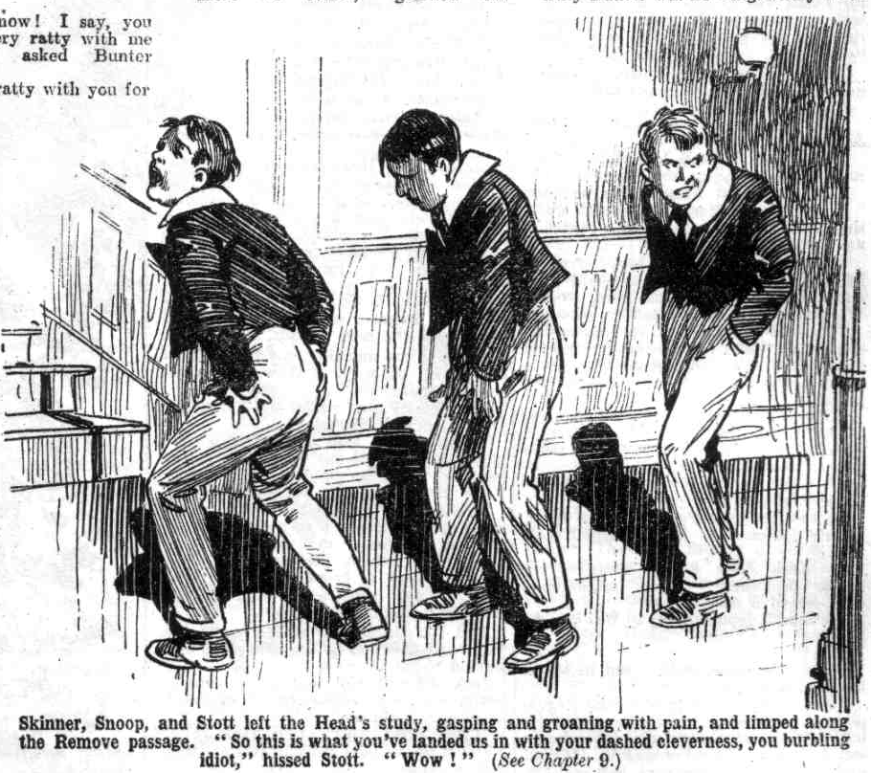 “ So this is what you’ve landed us in, with your dashed cleverness, you burbling idiot!” he hissed.
Groan from Skinner.
“ You told us to follow your lead and it would be all right!” hissed Snoop. “You always know better than other fellows, Skinner. Well, we’ve followed your lead. Is that all right?”
“Oh, shut up!” moaned Skinner.
“ I’m aching all over!” yelled Snoop.
“Glad of it!” snarled Skinner. “ I wish you’d had it worse ! Oh dear!”
“ You dummy!”
! You frabjous ass!”
And Snoop and Stott, with one accord, fell on Harold Skinner and smote him hip and thigh.
For the next ten minutes Study No. 11 in the Remove was the scene of wild and whirling scrapping.
Not till they were tired out did Stott and Snoop relax their efforts, and by that time Harold Skinner was more than tired.
“There!” gasped Stott at last. “ Perhaps you won’t be so jolly clever another time!”
Groan!
Skinner lay on the floor in a collapsed state, feeling as if he had been under a traction engine.
The way of the transgressor was hard. By this time Skinner was repenting, not only that he had deserted the Remove, but that he had played the scurvy trick which had caused the trouble in the first place between the Head and Mr. Quelch, with the Remove rebellion as a result. It was Skinner who had caused the trouble—and it was Skinner, undoubtedly, who was getting the chief benefit of it. Which was no more than he deserved, though that knowledge afforded no comfort whatever to Harold. Skinner. -
THE TENTH CHAPTER.
Bad for Bunter!
“I SAY, you fellows !”
“Grcat Scott!”
“Bunter!”
“I’ve—I’ve come back, old chaps!” said Billy Bunter, blinking feebly into the room which Wharton and Nugent used as a study at High Oaks, and which they tried to think was as jolly as their old study at Greyfriars.
The two juniors stared at Bunter’
“Turned up again, like a bad penny!” Didn’t the Head jump with joy to see you, Bunter?”
“Oh! yes! But I—I thought I’d come back. You see, I missed you fellows a lot.”
“Oh, my hat!”
“What sort of a time have you had?” asked the captain of the Remove, eyeing Bunter curiously.
“Oh, topping!” said Bunter. “Ripping, in fact! I’ve really had the time of my life; but I was sorry to leave you chaps in the lurch. How have you been getting along without me?”
“Fine!”
“Splendid!”
“Oh, really, you know! I say, you fellows, is Q!uelchy very ratty with me for clearing off?” asked Bunter anxiously.
“More likely to be ratty with you for coming back, I should think.” answered Harry Wharton. “Most likely you’ll get licked. Did you get licked at Greyfriars?”
“I—I’ve had a splendid time—”
“Liar!” said a voice behind Bunter; and he blinked round at Herbert Vernon-Smith.
“Oh, really, Smithy—”
“Why, you fat rotter, you told me you’d been licked, and had a rotten time!” said the Bounder. “Redwing heard you.”
“Only pulling your leg, old chap.” said Bunter. “I never meant to tell you—I mean, there wasn’t anything to tell you. I had a fine time at Greyfriars. The Head was very glad to see me. He asked me into his study as soon as he knew I’d come. He said, “My dear Bunter, how pleased I am to see you here again! His very words!”
Bunter had evidently repented him of having stated the facts on his return to Redwing and Smithy. He had had time to think it over since, and had improved his story considerably.
“He patted me on the shoulder.” went on Bunter. “He was quite touched.”
“Must have been touched if he was glad to see you!” remarked Nugent. “Awfully touched—fit for Colney Hatch.”
“Ha, ha, ha!”
“He was so pleased,” roared Bunter. “that I thought he was going to hug me. He said, “My dear, dear boy, how I have missed you! Just like that! I said, ‘All serene, old man—’ ”
“You said that to the Head?” shrieked Wharton.
“Those very words! ‘All serene, old bean! I said to him. ‘I’ve come back, but I’m not standing any nonsense!” You see, I though I’d put it plain to him.” explained Bunter.
“Ha, ha, ha!”
“Blessed if I see anything to cackle at!” grunted Bunter. “If you don’t believe me—”
“Believe you!” gasped Wharton. “Oh deart!”
“Well, I can’t do more than tell you the facts.” Said Bunter. “I’m almost sorry I came back here now. It will be a blow to old Locke. He told me that Greyfriars didn’t seem the same without me there. It made me feel quite sorry I’d left the poor old chap.”
“Pile it on!” said Nugent.
“Still, here I am.” said Bunter. “I felt that I couldn’t desert you fellows, so I came back. I—I suppose Quelchy will be pleased.”
“Blessed if I know why he should be!”
“Oh, really, Wharton—”
“here he comes.” grinned the Bounder. “He doesn’t seem to me to look very pleased. But perhaps he’s hiding his emotions.”
“Ha, ha, ha!”
Billy Bunter blinked round in alarm, as Mr. Quelch bore down on him. The Remove master was frowning.
“Bunter! What are you doing here?” he snapped.
“I—I’ve come back, sir!” gasped Bunter.
“Why have you come back?”
“I—I—I thought you’d like me to, sir.” mumbled Bunter.
“Nonsense!”
“I—I couldn’t keep away, sir!” gasped the Owl of the Remove. “You see, sir, I—I—I’m so fond of you, sir.”
“Kindly do not make such ridiculous statements, Bunter. You have been at Greyfriars, I presume, during the past day?”
“Yes, sir.”
“You should have remained there.” Said Mr. Quelch. The Remove master had a cane under his arm. He slid it down into his hand, and took a businesslike grip on it. “You will bend over, Bunter!”
“Oh, dear! I—I thought you’d be glad to see me here again, sir!” gasped the Owl of the Remove.
“I see no reason why you should have supposed anything of the kind, Bunter.”
“Oh!” gasped Bunter.
“Bend over at once!”
“Oh, lor’!”
Whether Mr. Quelch was caning Bunter for having left High Oaks without leave, or for having returned to High Oaks unrequested, was really not clear. Bunter was left in doubt on that point; but on one point he was not left in doubt—the caning was a vigorous one—on that point no room at all was left for doubt.
Billy Bunter was howling wildly when Mr. Quelch tucked his cane under his arm again and walked away.
“Ow, ow, ow,ow! I say, you fellows, I’m not going to stand this!” howled Bunter. “Old Quelch’s got no right to lick a chap! Ow, ow! I’ve a jolly good mind to tell him so! Ow!”
“Only a jolly better mind not to tell him.” suggested Nugent.
“Ha, ha, ha!”
“Ow, wow, wow~”
“Try Greyfriars again!” suggested Harry Wharton, laughing. “If the Head’s so jolly glad to see you there, you—”
“Ow! Beast!”
Billy Bunter did not try Greyfriars again. He limped away to his study, groaning. Peter Todd was at prep there, and he glanced upas Bunter came in, and grinned and glanced down again. Apparently he was not overjoyed by his fat study-mate’s return.
Bunter sat down and groaned. It was Peter’s cue to be sympathetic, in Bunter’s opinion; but Peter did not seem to see it; he went on with his prep regardless. Bunter groaned and groaned again, more and more deeply, in order to impress Peter with a proper sense of his suffering.
Peter looked up again at last.
“What are you making that frightful row for?” he demanded.
”I say, old chap, that beast Quelchy licked me!”
“Hard!” asked Peter.
“Yes, old chap!”
“WeIl, if you kick up that row in this study I’ll lick you harder!” said Peter. That’s a tip!”
“Why, you awful beast!” howled Bunter. “ Is that what you call sympathy?”
“Shut up!”
“Shan’t!” howled Bunter, and he gave a deep groan.
Peter picked up a ruler.
“Where will you have it?” he inquired.
“ Beast!”
Bunter did not seem to want it anywhere. He retired hastily from the study; and Peter grinned and went on with his prep, while Bunter, in great indignation, groaned in the passage till he was tired of groaning.

THE ELEVENTH CHAPTER.
An Unexpected Visitor!
“HALLO, hallo, hallo!”
“ What—”
“Your jolly old uncle, Wharton.
“ Oh, my hat!”
It was the following day, and morning class was over at High Oaks. Harry Wharton & Co. were punting a footer about, when Bob spotted the tall, soldierly figure that was coming up the drive from the gates.
Colonel Wharton sighted the juniors at the same time, and fixed his eyes upon them rather severely.
“Phew!” murmured Nugent. “ Something’s going to happen now. What’s your uncle doing here, Harry?”
“Goodness knows !“ said Wharton.
“You haven’t heard from him that he was coming?”
“Nunno! I haven’t had any letters, of course—letters could go to Greyfriars, as usual, and I suppose we can’t expect the Head to send them on to High Oaks.”
“ Ha, ha! Hardly!”
The colonel had halted on the drive and beckoned to his nephew. Harry Wharton left his comrades, and hurried to meet his uncle.
He was feeling rather dismayed.
What view Colonel Wharton would take of the revolt of the Remove Harry did not know; but he had a strong suspicion that that the old military gentleman would not approve of rebellion of any kind.
“Certainly his look now was not approving. His brows were contracted as he waited for his nephew to come up.
“Well?” he rapped out as Harry joined him.
“ Well, uncle.” said Wharton.
“What does this mean, Harry?”
“What, exactly?” asked Wharton.
The colonel frowned portentously.
“This!” he rapped out. “ Why are you not at Greyfriars?
“I—I——I’m here, you know!“ stammered the junior.
“I do not need telling that.” said the colonel. “As I had no answer to a letter I wrote you at Greyfriars, Harry, I telephoned to the Head this morning, and he informed me—to my great amazement—that you were the ringleader in the rebellion.”
“ Well, not exactly that, uncle,” said Harry. “ We elected Mauleverer leader—and a jolly good leader he was, too. I was his first lieutenant.”
The colonel stared at him.
“ You do not appear to be ashamed of yourself, at all events!” he exclaimed.
“ Well, no. You see——”
“ You have rebelled against the authority of your headmaster?”
“Yes; but—”
“You have left your school without leave?”
“ Yes. You see——”
“ You have led the rest of your Form into the same rebellious conduct?” exclaimed the colonel sternly.
“They didn’r need much leading, uncle. We’re all together in this. If you’ll let me explain ——--“
“I was simply astounded when Dr. Locke told me what had happened.” said the colonel. “ I could scarcely believe my ears. You’re aware, Harry, that I am a member of the governing board of Greyfriars. You should have thought of that, before placing me in this position. The Head can scarcely do anything but expel you from the school.”
“ You see, uncle——”
“A nephew of mine, expelled from school!” snorted the colonel.
“I’m not going back to be expelled.” said Harry.
“Neither are the other fellows. We’re all standing together. The Head can’t expel a whole Form. We shan’t go back till he comes to terms.”
“Are you presuming to dictate to your headmaster?” demanded Colonel Wharton.
“ Yes.”
“ Oh, good gad!” ejaculated the colonel. quite taken aback by this reply.
“You see, we’re in the right.” said Harry. “If you’ll let me explain— “
The rest of the Co. had come up now, taking off their caps very respectfully to Colonel Wharton. Other fellows looked on from a distance. with great interest. All of them realised that matters had taken a serious turn, now that a governor of the school was on the spot.
“You see, sir, we couldn’t do anything else” said Bob Cherry. “ I’m sure you’ll think so when you know the facts.”
“I think that’s very unlikely!” grunted the colonel. “But I’m waiting for you to explain.”
“We’re backing up our Form master.” explained Harry. “You know Mr. Quelch, uncle—“
“I know Mr. Quelch, and respect him very highly.” said the colonel. “ Do not tell me that Mr. Quelch approves of your conduct. I am sure that he does nothing of the kind.”
“Well, not exactly.” said Harry. “But we’re backing him up all the same. You see, he was sacked by the Head--”
“What?”
“ I mean, dismissed—”
“Do you mean that he resigned”
“No; he was dismissed, without any reason that anybody knows.” said the captain of the Remove. “Just turned off.”
“ Impossible “ exclaimed the colonel. “Dr,. Locke could never have acted in such an arbitrary manner.
“But he did, uncle.”
“The didfulness was terrific, honoured sahib,” assured Hurree, Jamset Ram Singh, “and we were all terrifically infuriated.”
“We backed up Quelchy, sir.” said Johnny Bull. “It was an insult to the Remove, for our Form master to be sacked for nothing.”
“We weren’t going to stand it, sir,” said Nugent. “It was Mauleverer’s idea to march out of Greyfriars as a protest; but we were all keen on it except a few sneaks.”
Colonel Wharton stared at the juniors in puzzled perplexity. Evident1y Dr. Locke had not told him, on the telephone, of the dismissal of Mr. Quelch.
“I cannot understand this.” said the colonel at last. “ I have learned from Dr. Locke that you boys left Greyfriars and took possession of this place, and that he has not yet decided by what means to compel you to return to the school. It is incredible to me that the Head can have treated Mr. Quelch in the way you describe. Do you seriously tell me that Mr. Quelch was dismissed front his post ?“
“ Yes, uncle.”
“Without a reason?”
“ No reason was given.” said Harry.
. “Nobody at Greyfriars knew of any reason, and 1 am sure that Mr. Quelch does not.”
“This is extraordinary. Mr. Quelch was the Head’s personal friend, as well as colleague,” said Colonel Wharton. “There must have been some sort of misunderstanding. That, however, does not excuse the rebellion of junior boys against their headmaster’s authority.”
“We stood by our Form master, sir” said Bob.
“We felt bound to back him up, uncle.” said Harry. “The Head had no right to treat him as he did.”
“That is not for Lower Fourth boys to decide,” said the colonel. “I am sure that Mr. Quelch did not approve of your backing him up, as you call it.”
“ Well, no; he didn’t.” admitted Wharton. “ But it was the principle of the thing, you know.”
“ Yaas,” chimed in Lord Mauleverer, joining the group on the drive. “Very glad to see you here, sir. As a governor of the school, you may be able to persuade the Beak— I mean, the Head—to see reason, sir. We’re not goin’ back to Greyfriars without our Form master.”
“ Hear, hear !“
“I must see Mr. Quelch.” said thc colonel. “ Can you tell me where he is at present?”
The juniors grinned.
“Here, sir.” answered Nugent.
“Here!” ejaculated the colonel.
“He came here to take control, a few days ago,” explained Harry. ‘ I’ll take you in to him, uncle.”
“Do so,” grunted the colonel, and his dutiful nephew led him away to the house.
“Well, something’s going to happen now.” remarked Bob Cherry. ‘ Now a governor of the school is taking the matter up, something’s bound to happen. All the same, we’re not going back to Greyfriars without Quelchy, governor or no governor !”
“No fear!”
“ Perhapsfully the esteemed colonel will be able to set the matter right,” suggested Hurree Jamset Ram Singh.
“ Perhaps!” said Bob doubtfully. “ “I suppose there really was some sort of misunderstanding between the two old donkeys—”
“Ha, ha, ha!”
“ And a third old donkey butting may clear it up!” suggested the Bounder, with a grin.
“ Shurrup !” murmured Bob Cherry, as Harry Wharton came back from the House.
“Well, the fat’s in the fire now, you fellows,” said Harry, as he rejoined his comrades. “ I suppose it was bound to happen sooner or later. But we’re still standing by Quelchy.”
“Yes, rather!”
“Whether he likes it or not.” grinned the Bounder.
“It’s the principle of the thing, dear man.” said Lord Mauleverer.
“I thinkfully opine that there is a terrific probability that the esteemed colonel may set the matter right,” said Hurree Jamset Ram Singh. “ He is an esteemed codger of terrific understandfulness, and a friend of both the ridiculous parties. Perhaps he may roll away the cloud of misundertandfulness between the two esteemed old jossers.”
“Ha, ha, ha!”
And the juniors hoped—though with doubt—that Hurree Jamset Ram Singh would prove to be right.
THE TWELFTH CHAPTER.
The Colonel Takes a Hand!
MR. QUELCH greeted his unexpected visitor with stiff politeness.
Certainly the Remove master was not pleased to see a governor of Greyfriars at High Oaks.
His own position there was too anomalous for that. It was, in fact, very awkward for him to be found in charge of a junior Form, who were in a state of rebellion against their head-master, and that position was exceedingly difficult to explain.
Mr. Quelch was stiffly prepared for misunderstanding and condemnation; to which he would have retorted with icy dignity and reserve. Fortunately, Colonel Wharton was a gentleman of tact.
He began by shaking hands most genially with Mr. Quelch, just as if he had called to see the Remove master at Greyfriars.
“I am afraid I have taken you somewhat by surprise, Mr. Quelch.” he said.
“A little, sir,” said the Form master. “No doubt you are surprised to see me here, in charge of boys who have left their school without leave.”
There was a challenge in the Remove master’s tone; but the colonel tactfully did not observe it.
“I am bound to say, first of all, Mr. Quelch, that I have no doubt that you are acting from the best possible motives, and from a strict sense of duty,” said the colonel. “ From my knowledge of you, sir, I can entertain no doubt on that point.”
Mr. Quelch simply had to melt.
“ You do me no more than justice, Colonel Wharton.” he said, much more cordially. “ I am aware how very extraordinary the present position must seem to a governor of Greyfriars. I trust that I need not tell you how deeply I regret—”
“I am sure of it, sir.”
“ When I was dismissed, sir”—Mr. Quelch boggled a little at that word, but he got it out—”when 1 was dismissed, my boys followed from a feeling of attachment to me, and from a sense of the injustice that had been done me. I disapproved most strongly of their action, and advised them most earnestly to return to the school. Yet you find me here in charge of them, which I am aware needs explaining.”
“I think I can guess the explanation, sir.” said the colonel. “If the boys were here without a master, they certainly needed to be taken into control by someone.”
“ That is precisely how the matter stood, sir,” said Mr. Quelch. “ You apprehend my meaning exactly. I fully anticipated that the Head would, in some way, persuade or compel the boys to return to Greyfriars. This did not happen—and I could not leave them to disorder. I came here, therefore, to take control till some arrangement was made—first calling upon Dr. Locke to explain my intention!”
“I quite understand.”
“You, sir, as a governor of Greyfriars, have authority to take the boys in hand.” said Mr. Quelch. “I relinquish the charge of them into your hands with pleasure.”
The colonel shook his head.
“Not at all, Mr. Quelch. They could not be in better hands than they are in at the present time”
“It is very kind of you to say so, sir; but Dr. Locke is unfortunately not of the same opinion,” said the Remove master, with some bitterness.
“That is a matter I should like to discuss with you, Mr. Quelch” said the Colonel. “ I was quite unaware that you had left Greyfriars—”
“Dismissed, sir—dismissed!” said Mr. Quelch. “I must admit that the Head offered me the alternative of resigning. I refused to resign. Resignation would have been tantamount to an admission of fault; and I was conscious of no fault.”
“But Dr. Locke gave a reason— ”
“None, sir.”
“No reason for requesting your resignation!”
“ None whatever.”
“ But this is amazing, sir.” said the colonel, in astonishment. “ I cannot believe that my old headmaster has acted thoughtlessly, tyrannically, arbitrarily. There must be some misunderstanding.”
“I know of none, sir.
“ But doubtless there was some disagreement—some dispute—”
“ Nothing.”
“Upon my word!” said the colonel, quite nonplussed.
“ Indeed, sir, I had some thought of appealing to the Governing Board against the Head’s dismissal,” said Mr. Quelch. ‘I considered, however, that it would be beneath my dignity to do so. For years, sir, I have been a Form master at Greyfriars, and Dr. Locke had had no fault to find with me. I will be frank, sir—I was guilty of one act of carelessness—which no headmaster would have commented upon—upon which it was beneath the dignity of a headmaster to comment. This was apparently made an excuse by Dr. Locke for dismissing me.”
“My dear sir, you—”
“I can use no other words,” said Mr. Quelch. “I will tell you the facts, sir. For the first and only time in my remembrance I forgot class. I was busy at the time on some literary work—I believe you are aware that I was compiling a History of Greyfriars — and for once, sir, immersed in my task, I forgot class; and the boys unfortunately took advantage of my absence to indulge in horseplay in the Form-room.
“Boys will be boys !“ said the Colonel, with a light smile.
“Quite so, sir—the matter was not in the least serious. The noise in the
Remove room brought the headmaster there—he sent one of the juniors to fetch me, and handed the class over to me. I punished the rioters; and supposed that the matter was at an end. Judge of my amazement, sir, when 1 found that the Head avoided me—that he declined to speak to me—and that he finally sent me a note by a servant requesting my resignation.”
Mr. Quelch’s voice trembled with indignation.
“Is it possible?” exclaimed the colonel.
“That is what happened, sir. I admit the fault—such as it was. I was guilty of a slight act of carelessness—such an incident as occurs not at all infrequently with some masters at Greyfriars, sir—but very infrequently indeed with me. Obviously, it was used by the Head simply as a pretext to dismiss me.”
“He must have had some reason—“
“If so, he did not confide it to me, sir,” said Mr. Quelch. “ I was treated with the grossest injustice and tyranny—all Greylriars was aware of it—indeed, the rebellious conduct of the Remove demonstrates what was thought of it in the school.”
“You amaze me, sir ! There must surely have been some misunderstanding
—perhaps mischief made by some ill-disposed person—”
“I know of nothing, sir,” said Mr. Quelch. “ I have acquainted you with the circumstances, Colonel Wharton, bccause, as a governor of Greyfriars you have a right to know how the matter stands. Now I desire nothing better than to hand over my charge here and to retire from the scene.”
The colonel shook his head.
“ I request you to carry on, Mr. Quelch. The juniors, of course, must return to Greyfriars. Until they do so, they cannot be in better hands than yours. I shall see Dr. Locke on that subject at once.”
“As you please, sir.”
He was a very perplexed old gentleman as he walked back to his car, which was waiting at the gate.
That his old headmaster had acted in the tyrannical way described by Mr. Quelch was incredible to him ; yet it was impossible, of course, to doubt the Remove master’s statement.
There was some extraordinary misunderstanding or deception in the matter; the colonel felt assured of that: and he hoped to be able to set the matter right.
Harry Wharton met his uncle at the gates.
“You’ve seen Mr. Quelch, uncle?” he asked.
“Yes, my boy.”
“Now you know how the matter stands, you don’t blame us for backing him up?” asked Harry.
“Hem!” Thc colonel coughed. I will not express an opinion, at present, on that point, Harry. I am going to Greyfriars now.”
“And we?” asked the captain of the Remove.
“You will remain here for the present.”
“Good!”
The car rolled away with the colonel.
THE THIRTEENTH CHAPTER.
In Black and White!
A JOLLY old governor ?” remarked Coker of the Fifth.
“Eh?” said Potter.
“ That old codger is Colonel Wharton, a governor,” said Coker, with a nod towards the soldierly gentleman who was alighting from the car at Greyfriars. “Relation of that kid Wharton in the Remove, I think.”
Potter and Greene looked round with a little interest.
“Well, the governors were bound to butt in sooner or later.” remarked Greene. “Those fags have got to be brought to order.”
“ I’d have brought them to order fast enough if the Head had placed the matter in my hands.” said Coker.
Whereat Potter and Greene chuckled.
A good many other fellows, as well as Coker & Co., looked at the tall figure of the colonel with interest. The Greyfriars fellows had no doubt that it was the revolt of the Remove that had brought a governor of the school down to Greyfriars, and they wondered how the Head was going to explain the present extraordinary state of affairs.
“That’s Wharton’s uncle,” Skinner remarked to Snoop and Stott. “ He’s a governor. This means the finish for the Remove. They’ll have to come bsack now. We’ve got our flogging over: they’ve got theirs still to come. Some of them will be sacked. Mauleverer’s sure to be bunked. and most likely Wharton and Bob Cherry. Can’t say I’m sorry.”
Skinner certainly did not look sorry; he looked quite bucked at the prospect.
Apparently unconscious of the widespread interest his arrival had caused, the colonel entered the House and was shown to the Head’s study.
Dr. Locke greeted him with some embarrassment.
It was not pleasant for a headmaster to face a governor of the school in the present circumstances.
The Head was well aware that it was his business to have gathered in the Remove, somehow, and brought them back to the school. He had not been able to do so. But it was difficult to explain that to a governor of the school.
Colonel Wharton, however, did not immediately refer to the secession of the Lower Fourth. The question of the dismissal of Mr. Quelch was uppermost in his mind.
After a few words, therefore, he came to that subject, and immediately a deep frown darkened the face of the headmaster.
“That is a matter which, I fear, it would be unprofitable to discuss.” said the Head stiffly.
“I hope not,” said the colonel blandly.
“The matter is entirely in your hands, sir, and no governor would dream of interfering between the headmaster and a Form master. But—”
“I had reasons for my action, Colonel Wharton.”
“No doubt. But ” —the colonel coughed—“these reasons have not been made public, I think.”
“ No, sir. I should not be likely to publish to the school a Form master’s derogatory criticisms of his chief.”
“Surely Mr. Quelcb did not——”
“He did, sir.”
“I have seen Mr. Quelch, Dr. Locke and he appears to be quite unaware of the cause of his sudden dismissal.
“He cannot fail to be aware of the cause, sir. I did not go into details with him; it would have been beneath my dignity to do so. I have no objection to explaining to you, as a governor of the school, if you insist, though the subject is very painful to me.”
“ Certainly I do not insist, Dr. Locke; but I think some misunderstanding may have arisen” said the colonel.
“ No misunderstanding can have arisen, sir, when Mr. Quelch expressed his contemptuous opinion of me in writ- ing, sir, in his own hand.”
“Is it possible?”
“It is not only possible, but true, sir. It was a great shock to me—a very great shock” said the Head’ with a tremble in his voice. “ Mr. Quelch was my most valued colleague, but more than that—he has been my personal friend for a quarter of a century. I was accustomed to rely upon his judgment, his assistance, his friendship. I learned that, while I trusted him, he regarded me with contempt and dislike, and actually said as much in letters written from this school. I could scarcely retain him in his position here after making such a discovery.”
“Most decidedly not,” said the colonel. “But— ”
“A letter—or, rather, a portion of a letter—came into my hands by accident.” said the Head. “I will explain. There was a slight incident—Mr. Quelch forgot his class, and there was a riot in the Remove Form room, and I had to go to them. Afterwards, thinking that Mr. Quelch might be feeling a certain awkwardness over this incident, I went to his study to see him, in order to assure him that my confidence in him was unimpaired. On my way to his study, I was stopped by a Remove boy, who had picked up a paper in the passage, and this paper the junior handed to me. It proved to be a portion of a letter written by Mr. Quelch, in which he referred to me, sir, in the most bitter and scathing terms.”
“ Good gad !” ejaculated the colonel.
“I should not, of course, have looked at the letter had I known it was part of a private letter, but I was unaware of this until I had seen it. Fortunately, it was folded, and the boy Skinner had not seen its content. Having seen that paper, sir, I did not carry out my intention of calling on Mr. Quelch. I was pained, greived, disgusted, as you may imagine.”
“ No doubt, sir. But you are sure that there was no mistake—no trickery in the matter?”
“I have the paper here, sir, and you shall see it.” said the Head. “It is a sheet from an ordinary writing-pad, and evidently part of a letter. I did not return it to Mr. Quelch, because I disdained to enter into a discussion with him on so sordid and unpleasant a topic.”
The Head unlocked a drawer of his desk.
He took out a sheet of paper, and handed it to Colonel Wharton.
“You are acquainted with Mr. Quelch’s hand ?” he said.
“ Quite.”
“ Then you will see that this is written by him.”
“ Undoubtedly.” said the colonel.
The old military gentleman stared blankly at the sheet. He could scarcely believe his eyes as he read in the well-known handwriting of his nephew’s Form master, the following:
“The Head was arbitrary and tyrannical. It is painful to write such words of the headmaster of Greyfriars, but it is the undoubted fact. The tactless interference in the Form-rooms, between masters and boys earned him both dislike and contempt.”
“Good gad!” said Colonel Wharton blankly
Dr. Locke compressed his lips.
“Are you satisfied now, sir, that 1 had no alternative but to dismiss Mr. Quelch?”
“ Quite, sir !”
Colonel Wharton rose to his feet, his brow very dark.
“I had no idea of this, sir—no idea whatever.” he said. “ Certainly I have always had a great respect for Mr. Quelch—a respect which appears to have been misplaced. The man who could write in this strain of a headmaster who trusted him and confided in him, is a—a—” Colonel Wharton paused. “I will not say what. Obviously, you were deceived in him, and he is quite unsuitable to hold a responsible position at Greyfriars or any other school.”
“I had no doubt you would think so, sir, when you knew the facts.” said the Head. “ A disloyal colleague and a false friend——”
“It is shocking!” said the colonel, his eyes glinting. “ “Such hypocrisy is appalling. I quite understand why you did not desire to make this public, sir, preferring rather to allow Greyfriars to receive a mistaken impression of your action. Unfortunately, the Remove boys, knowing nothing of the facts, looked upon their Form master as a wronged man, and their chivalry led them to act lawlessly in his support. If my nephew, for instance, had been aware of this—”
“It must not be made public, sir.” said the Head hastily.
“Quite so—I fully agree! But in the circumstances, sir, you may very well pardon this outbreak on the part of the boys, if they return to their duty. They have acted in error.”
“But they have not returned yet, sir, with the exception of three boys.” said the Head.
“I shall see that they return, Dr. Locke.” said the colonel grimly. “ I fully agree that this disagreeable matter should be kept strictly secret but there is no reason why I should not tell my nephew and his friends that I have investigated the matter, as a governor of the school, and found that Mr. Quelch’s dismissal was just and necessary ; that I should have advised you, had you consulted me, to dismiss him instantly. I have no doubt that this assurance from me will have the desired result.”
“I agree with you, sir,” said the Head relieved. “That would certainly be a very satisfactory ending to a very unpleasant episode.”
“Allow me to retain this paper, sir,” said the colonel. “ I must see Mr. Quelch again—and I desire very much to show him this paper and request him to reconcile it with his explanations to me, and his assertions that he is unaware of the cause of his dismissal. I have no doubt that he will be overwhelmed with confusion.”
Dr. Locke hesitated.
“As you please, Colonel Wharton,” he said, at last. “The paper is, after all, the property of Mr. Quelch ; and you may return it to him if you so desire.
“Very well, sir. I shall return to High Oaks at once, and I have no doubt whatever that those young rebels will have returned to their duty in a few hours from now.”
And a few minutes later, the car was whirling back on the Courtfield road towards High Oaks, the old military gentleman sitting bolt upright in it, with a grim frown on his face that boded a very unpleasant interview for Mr. Quelch at; the end of his journey.
THE FOURTEENTH CHAPTER.
Light at Last!
“I SAY, you fellows—”
“ Bow-wow!”
“ The old codger’s come back.”
“ The what?”
“The old codger!” explained Bunter.
“ What old codger, fathead ?“ asked Harry Wharton.
“Your uncle!”
“ What?” roared Wharton.
“Ha, ha, ha!”
The captain of the Remove reached for William George Bunter, and grasped him by the back of the neck.
There was a roar from Bunter.
“ Yarooogh! Leggo, you beast!”
“ Now, what did you call my uncle?” inquired Wharton, tapping Billy Bunter’s bullet head on the trunk of a tree beside the drive at High Oaks.
“ Yarooogh!”
“ That wasn’t the word,” said Bob Cherry.
“ Ha, ha, ha!”
Tap!
“Yoooop!”
“That wasn’t the word either,” chuckled Bob.
“Yow-ow-ow ! I didn’t mean codger, you beast!” howled Bunter. “I meant the old josser—”
“ Ha, ha, ha !”
Tap!
“ Yow-ow-ow-ow-ow-ow-ow!” yelled Bunter.
“Harry!”
It was the colonel’s voice; he came striding up the drive, and landed rather unexpectedly on the group of laughing Removites. Wharton released William George Bunter as suddenly as if that fat and fatuous youth had become red- hot.
“ Oh! Yes, uncle !” he gasped.
“ Yaroooogh !” roared Bunter. “Ow! Wow! You beast, Wharton! I’ll jolly well lick you! Blow you, and blow the old codger, too! Your blinking uncle is a blinking old codger—a fossilised old josser, and I’d jolly well tell him so if he were here —“
“Bunter!”
“ Oh!” stuttered Bunter.
He spun round and blinked at the colonel through his big spectacles in alarm.
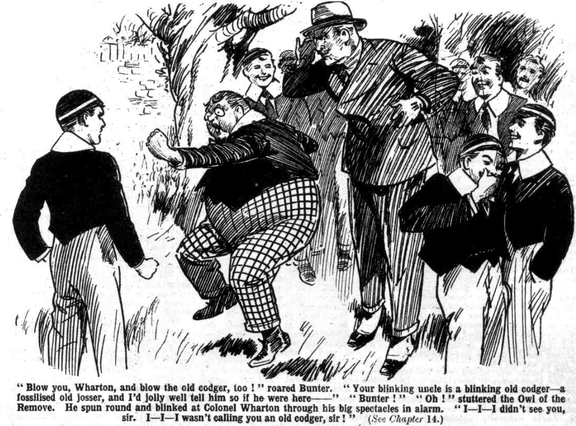
“ Oh! I—I didn’t see you, sir!” he gasped. “I—I wasn’t calling you an old codger, sir!”
“ What?”
“I—I wasn’t speaking of you at all, sir” gasped Bunter. “ I—I was speaking of another old codger, sir—”
“ Ha, ha, ha !”
The colonel gave William George Bunter a grim stare.
“You are a disrespectful young rascal, Bunter.” he said. “I am sorry I interrupted you, Harry.”
And the colonel strode on towards the house. Billy Bunter blinked after him.
“ I—I say, you fellows, fancy that old codger—yarooogh! Leave off kicking me, you beast.”
And Billy Bunter fled.
Mr. Quelch was in his study at High Oaks, when Juggins announced Colonel Wharton. The Remove master rose to greet him, with an amiable smile on his severe face. After his interview with the colonel that morning, Mr. Quelch was naturally feeling very amicable towards the old military gentleman. But as the colonel entered, he could see at a glance that his visitor was not feeling at all amicable. The friendly smile froze on Mr. Quelch’s face.
“ I have returned, sir,” said the colonel formally. “ I am here to direct the Remove boys to return to Greyfriars immediately.”
“Indeed, sir !” said Mr. Quelch.
“I shall explain the circumstances to them sufficiently, sir, to ensure their immediate obedience.” said Colonel Wharton. “ They are quite unaware of the cause of Dr. Locke’s action, Mr. Quelch, and I do not intend to acquaint them with it, but I shall enlighten them to a certain extent. They will take my word for it that their head master’s action was fully justified.”
“Indeed?” repeated Mr. Quelch.
His look was hard and bitter.
“ You informed me this morning. sir, that you were unaware yourself of the cause of your dismissal from Greyfriars.”
“I stated the facts, sir !“ said Mr. Quelch icily.
“ Then I shall be glad to hear, sir, how you reconcile
your statement, with this description of Dr. Locke in your own handwriting,” snorted the colonel.
And he tossed the sheet from Mr. Quelch’s writing-pad on the table before the Remove master.
Mr. Quelch glanced at it carelessly. Then he picked it up and scrutiniscd it. To the colonel’s surprise. He did not seem overwhelmed with confusion in the least.
“That is your property sir!” said the colonel.
“Quite so; and I am quite at a loss to understand how it came into your possession.” said Mr. Quelch. “I had not missed it. but certainly it is my property.”
“ You do not deny that it is written in your hand?”
Mr. Quelch raised his eyebrows.
“Certainly it is written in my hand.” he said. “ Why should I deny it, CoIonel Wharton?’
“This is effrontery, sir !” said the Colonel sternly. “ You are at a loss, you say, to understand how that paper came into my hands. It was handed to me by Dr. Locke.”
“Indeed!” said Mr. Queloh dryly. “ Then I am equally at a loss to know how it came into Dr. Locke’s hands.”
“It was handed him, as he explained to me, by a junior boy, named Skinner, who picked it up in Masters’ passage at Greyfriars on the day following the episode in the Remove Form-room, which you have described to me.”
“ I quite fail to understand why Skinner should hand a paper belonging to me to anyone else.”
“The letter was folded, and the boy did not know what it contained, as Dr. Locke tells me. He handed it to the Head, thinking that it was a paper belonging to some Form-master; and Dr. Locke naturally unfolded it and looked at it, to ascertain to whom it belonged.”
“ Quite so. A very natural explanation.” said Mr. Quelch. “ But I am still at a loss to know why Dr. Locke did not return it to me, as he must have known that it was my property.”
“Dr. Locke did not care to enter into a discussion of such a matter, sir.” said the colonel. “ Very properly, too, in my opinion. He declined to speak one word to you on such a subject. But you, sir, were perfectly well aware of what you had written though you did not know that it had fallen into Dr. Locke’s hands. You cannot, therefore, have been ignorant of the cause of your dismissal. You must have known that Dr. Locke had somehow discovered your true opinion of him, sir.”
Mr. Quelch stared blankly at the colonel.
“I fail to understand you in the least, sir!” he snapped. “ You are not telling me seriously that Dr. Locke was annoyed by what is written on this sheet of paper?”
. “ I am telling you so very seriously, sir. Upon my word!” exclaimed the colonel, in amazement. “ He was not merely annoyed, but shocked, sir, disgusted, grieved—indignant as any headmaster would have been. Cannot you see this for yourself, sir ?”
“ Most certainly not!” said Mr. Quelch, in bewilderment. “ I am utterly at a loss to know why this paper should have offended the Head in any way whatever.”
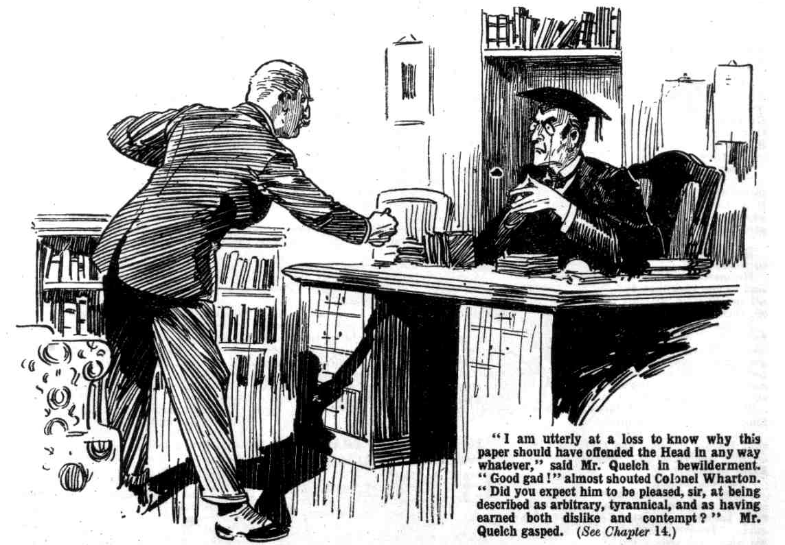
“ Good gad!” almost shouted the colonel. “ Did you expect him to be pleased, sir, at being described as arbitrary, tyrannical, and as having earned both dislike and contempt?”
Mr. Quelch gasped.
“ Bless my soul!”
“And now, sir—”
“One moment,” stuttered Mr. Quelch. “ Is it possible—is it remotely possible— that Dr. Locke supposed these words written here to refer to him?”
“They refer to the headmaster of Greyfriars!” rapped the colonel. “ Dr. Locke is headmaster of Greyfriars.”
“ Good heavens !“ said Mr. Quelch. “ This is—is terrible ! No wonder my old friend was incensed if he believed that I had referred to him in such terms! I had no suspicion of this—not the faintest idea! If only he had shown me this paper, I could have explained instantly.”
The colonel eyed him in wonder.
“I begin to believe, sir, that you are wandering in your mind!” he snapped. “ In that letter, or portion of a letter, you describe your chief in the most bitter and disloyal terms—”
“This paper is not a letter; it was never intended as a letter ; it is a written note—”
“That does not alter the case, sir.”
“It does not refer to Dr. Locke!” shrieked Mr. Quelch.
“What? It refers to the headmaster of Greyfriars! There is no other Greyfriars School in the kingdom !”
“ But there were other headmasters of Greyfriars!” gasped Mr. Quelch. “This reference is to a headmaster of Greyfriars who died before Dr. Locke was born.”
“ What?” ejaculated the colonel. “Good gad! To whom then, does that paper refer, Mr. Quelch?”
“ To Dr. Trumpington, who was headmaster of Greyfriars in the year 1828, the year of the great barring-out.”
“ Wha-a-at ? A headmaster of a hundred years ago !” exclaimed Colonel Wharton.
“Certainly. This sheet is one of hundreds, the written notes I have made for my ‘ History of Greyfriars.’”
“Your—your—your ‘History of Greyfriars!’” stuttered the colonel.
“Certainly,” said Mr. Quelch. “On the afternoon when the episode in the Remove Form-room occurred I was busy with my history, and for that reason forgot, for once, the hour of class. I remember writing out this very note that afternoon—it was left on my table with a large number of others, when I was suddenly called away to the Remove-room. It is my custom, sir, to write out my work on sheets from a writing-pad, and afterwards to correct them and type them out on a machine. This is one of the sheets. How it came to be lying about the passage I do not understand. It was possibly blown out of my study by a draught from the window. I have my other notes here, sir—a large pile of them, and you may compare them with this if you choose. This fragment, sir, is a description of Dr. Trumpington, headmaster of Greyfriars in the year 1828. And Dr. Locke fancied—”
“Good gad!” exclaimed the colonel.
There was silence in the room for some moments.
Mr. Quelch’s face was very distressed. He understood at last the reason of the Head’s sudden and unaccountable resentment and anger towards him; but he was not now feeling angry himself. He was only feeling deeply distressed at the pain he knew must have been given to his kind old friend by the discovery of his supposed disloyalty.
“I understand, sir.” said Colonel Wharton at last. “ “Please excuse any— ‘hem !—expressions I may have said. I certainly took the same view of this paper that was taken by Dr. Locke. No name is mentioned in it, and a reference to the headmaster of Greyfriars could only be supposed to refer to the present headmaster by anyone unacquainted with the circumstances. I beg your pardon, Mr. Quelch.”
“ Not at all, sir.” said Mr. Quelch cordially. “I am only too thankful that your intervention allows this unfortunate misunderstanding to be explained. It is very unfortunate that this one paper, among so many others, should be the one to fall into Dr. Locke’s hands—a most lamentable chance.” Mr. Quelch paused suddenly. “ Indeed, I scarcely believe that it was a chance. The paper may have been placed in Dr. Locke’s hands with the intention of causing mischief. You have mentioned that it was Skinner who handed it to Dr. Locke, and I recall now that it was Skinner who was sent to call me to the Form-room that day, and that I left him in my study, with my papers, after caning him for impertinence. I shall question Skinner very closely. In the meantime, sir—”
“ In the meantime, Mr. Quelch, I shall convey your explanation to Dr. Locke, who, I am sure, will be very glad to be enlightened,” said the colonel. “I will lose no time.”
There was a whir of a car on the road when the Remove fellows went in to dinner. The colonel was gone.
“ I say, you fellows the old codger’s gone again!” said Billy Bunter. “ Let’s hope he’s gone for good this time.”
“I wonder what the game is ?“ remarked Bob Cherry.
“ The to-and-fro-fulness of the esteemed colonel is terrific,” said Hurree Jamset Ram Singh. “ Perhaps the excellent and ludicrous old gent is pouring oil on the troublesome waters. Let us hope, my esteemed chums, that the smile of friendship is about to replace the scowl of infuriated hostility.”
“Something’s on, anyhow,” said Squiff.
It was clear that something was on. and the Remove rebels could only wonder what it might portend. They were soon to know.
THE FIFTEENTH CHAPTER.
Friends Once More!
BUZZZZZZZZZ!
Billy Bunter blinked round as the telephone-bell rang at High Oaks.
Dinner was over, and all the fellows excepting Bunter were out of doors. Mr. Quelch was strolling up and down on the terrace, with his hands clasped behind him, and a deeply thoughtful expression on his face. William George Bunter was frowsting in an armchair near the fire in the old hall when the telephone-bell rang. And William George Bunter immediately left that armchair and rolled away to the instrument.
Willliam George was perfectly well aware that the telephone-call could not be for him. Had it been for him, indeed, he would not have been so keen on taking it. But Bunter had no doubt that the call came from Greyfriars, and Bunter wanted to know. Something was going on—something of which Bunter knew nothing. Bunter wanted to know what it was, and intercepting a telephone-call seemed quite an easy way.
So the Owl of the Remove rolled hurriedly to the phone, hoping that that ring had not reached Mr. Quelch’s ears, and grabbing off the receiver before the bell could ring a second time.
He put the receiver to a fat ear, and grinned. -
“Hallo.” he remarked in the transmiitter.
“ My old friend !” came an agitated voice over the wires.
Bunter jumped.
“My old friend, Colonel Wharton has. explained the matter—explained the unhappy misunderstanding. How can I express my regret?”
. Bunter blinked.
It was Dr. Locke’s voice—the Head of Greyfriars was speaking. He seemed j to be in a changed and chastened mood.
Bunter’s curiosity was intense.
It was obvious that Dr. Locke had rung up High Oaks to speak to Mr. Quelch, and that he supposed that he was addressing that gentleman. The Owl of the Remove cheerfully left him in error.
“I was deceived,” went on the Head’s agitated voice “ I was deluded—but your own hand-writing, my dear Quelch—”
“ My hat !” murmured Bunter.
“What did you say, Mr. Queleh ?”
“Oh! Ah! Please go on!” gasped Bunter, making his fat voice as deep as he could, in the hope that the Head would take it for Mr. Quelch’s.
Dr. Locke was in too disturbed a frame of niind, just then, to distinguish carefully the tones of a voice of the telephone wires.
“Your own hand-writing, Quelch! No name was mentioned on the paper! I was naturally deluded! True, I should have known you better—I should have trusted you more implicitly! I realise that now.”
“ Oh! Yes!” gasped Bunter, as the Head paused, apparently like Brutus for a reply.
“ It was most unfortunate that the paper fell into my hands, my dear fellow, most unfortunate.”
“ What paper ?” gasped Bunter, devoured by curiosity.
“What ! The paper—that section of your History of Greyfriars which was picked up by Skinner of the Remove and given to me—”
“ Oh !“ stuttered Bunter.
“How was I to guess, my dear Quelch, that the reference thereon was to a headmaster of Greyfriars of a hundred years ago?”
“ Phew!”
“ I was quite unaware that the paper was merely a written note belonging to your compilation of the History of Greyfriars. I am aware now, of course, that such was the case: now that the matter is explained. I could not guess at the time. Could I?”
“ Nunno!” gasped Bunter.
“ It was very unfortunate that Skinner found that particular paper and handed it to me I am sure that the boy was unaware of its consents—and was unconscious of the harm he was doing.”
“He, he, he!” ‘
Bunter simply could not restrain that cachinnation.
He understood the whole matter now; and at the idea that Skinner had caused all the trouble without intending to do so, Bunter could not help chortling.
He remembered some remark Skinner had made, before the trouble occurred, about the probability of Mr. Quelch getting the “sack” : remarks which had puzzled the Remove fellows : and which had been very strangely borne out by subsequent happenings.
Those remarks of Skinner’s were no longer puzzling—to Bunter.
The Head might believe, if he liked, that Harold Skinner had caused all this trouble inadvertently. Bunter was not likely to believe it.
“He, he, he!”
“Bless my soul!” came the Head’s startled voice, as the transmitter faithfully transmitted that fat cackle to his ears. ‘ Is—is—is not that Mr. Quelch! To whom am I speaking?”
“Oh!” gasped Bunter.
He realised that he had given himself away, and that his fat cachinnation had cut off the supply of the information from Dr. Locke.
“ Who is speaking ?” rapped out the head. “Whoever you are, call Mr. Quelch to the telephone at once. Do you hear ?”
Bunter heard, but he did not answer. He did not intend to let it become known who had intercepted the Head’s call. He was quite well aware that he deserved a thrashing for his inquisitiveness, but Bunter always had a strong objection to getting what he deserved.
He replaced the receiver quietly, and strolled away.
Buzzzzzz!
“The telephone, sir,” said Juggins to Mr. Quelch, a few minutes later on the terrace.
“Thank you,” said Mr. Quelch, and he went in to take the call.
Mr. Quelch sat at the telephone a good ten minutes, in conversation with Dr. Locke at Greyfriars.
His face was very bright and cheerful as he sat and talked with his old chief.
All was explained now—the clouds had rolled by.
The Head was full of regrets and apologies—he asked his old friend to forgive him, and his old friend was only too willing to do so. Colonel Wharton had been the means of clearing up a painful misunderstanding: and the two old gentlemen agreed that the Colonel’s visit had been a blessing.
That Mr. Quelch was to resume his old position at Greyfriars, in all honour, was a foregone conclusion.
The Head begged him to return : and Mr. Quelch was only too glad, in his present state of enlightenment, to accede.
“I should have come over to High Oaks, my dear Quelch” said the Head, “but I could not delay—I desired to speak to you at the very earliest possible moment—to assure you of my regret, my remorse, my unshaken confidence and friendship.”
“My dear sir,” said Mr. Quelch, deeply moved, “ need I say how deeply I appreciate your kindness, your benevolence? How deeply I regret that unfortunate misapprehension
“ My fault entirely, my dear Quelch, and—“”
“Not at all, sir! My carelessness was the prime cause
“I will not allow you to say so, my dear Quelch! I blame myself absolutely. You will return—”
“ I shall return with pleasure, sir—”
“I shall await you with eagerness, my dear Quelch.”
“ I shall lose not a moment, sir.”
Ten minutes at least—and at the end of that talk, Mr. Quelch’s face looked ten years younger! He was going back to the old school that he loved, where his best years had been spent: he was going to resume his old duties, and resume his labours on that celebrated “ History of Greyfriars” which was the cause of all the trouble—plus Skinner. Mr. Quelch’s steps were quite light and springy when he walked out of the house, to call together the Remove.
THE SIXTEENTH CHAPTER.
All’s Well That Ends Well!
“HE, he, he!”
Thus William George Bunter.
Bunter was almost suffocating with mirth.
“Hallo, hallo, hallo, what’s the jolly old joke ?” demanded Bob Cherry.
“He, he, he!”
“What the thump—” exclaimed Harry Wharton.
‘ “Oh, dear! He, ha, he!” gurgled Bunter.
Never had Billy Bunter been in possession of so huge a joke. He chuckled and cackled and gurgled with tears in his eyes.
“ What’s the cackle about ?” demanded Peter Todd.
“He, he, he!” gasped Bunter.
“You fat dummy—”
“ Oh, dear ! I say, you fellows, I’ve found it all out !” gasped Bunter. “It was Skinner all the time!”
“What was Skinner, ass.
“:He, he, he! He pulled the Head’s leg, and pulled Quelch’s leg—he, he, he! He started them rowing like donkeys! He, he, he! You remember Skinner saying that Quelchy would be sacked?”
“ I remember,” said Harry. “What about—”
“Well, and he was sacked, wasn’t he?”
“ Yes but———”
“ And Skinner did it ! He, ne, he !”
“You fat idiot, how could Skinner have done it?” demanded Bob Cherry, “What are you burbling about?”
“He, he, he!”
“ Explain, you fat chump!” roared Bob.
Billy Bunter got it out a last.
All the Remove gathered round to hear his tale of what he had learned on the telephone.
“My only hat!” said Bob Cherry.
“Something about a former headmaster, in Qulelchy’s ‘ History of Greyfriars.’ And Skinner got it to the Head, and the Head thought Quelchy was writing rotten things about him,” gurgled Bunter. “ Skinner did the whole thing. That’s how he knew Quelchy was going to be sacked. He, he, he! He did it bccause Quelchy licked him, you know. He, he, he !”
“The dirty trickster!” exclaimed Wharton.
“ And you think it’s funny, do you, you fat villain?” roared Bob Cherry.
“Rather! He, he, he! No end of a joke! He, he, he!” chortled Bunter. “ Fancy those two old donkeys. He, he, he ! Yaroooogh!”
Bump!
“ Yow-ow-ow-ow! Leggo!” roared Bunter.
“That’s because you think it funny for Skinner to make mischief.” said Bob Cherry. “ Now give him another for listening to a private conversation on the telephone !”
Bump!
“Yow-ow-ow-woop!”
“Do you still think it funny?” demanded Bob. “If you do we’ll give you some more. “
“Ow! No,” yelled Bunter. “It’s not funny at all! Nothing of the kind. Leggo! Yaroooh!”
“Ha, ha, ha!”
“Boys!”
It was Mr. Quelch’s voice.
“Oh! Yes, sir!”
The Removites eyed their Form master rather curiously as he came hurriedly up from the House. After what Bunter had told them they could guess what was coming. They did not fail to note the bright cheerfulness in the Remove master’s face.
“ My boys,” said Mr. Quelch, in a moved voice, “ it has transpired that there was a—a misunderstanding between Dr. Locke and myself. The Head was—’hem !—deluded by—by certain peculiar circumstances. All is now explained, and Dr. Locke has requested me to resume my old position at Greyfriars.
“Oh, sir!”
“I shall return to Greyfriars immediately,” said Mr. Quelch. “ I have asked the Head, in the circumstances, to pardon my Form for rebellion and disobedience, and Dr. Locke has very kindly consented to do so, on condition that you return to Greyfriars at once.”
“ With you, sir?” said Lord Mauleverer.
“Certainly!”
“That’s all we wanted, sir.” said Lord Mauleverer. “ If you’re goin’ back, sir, we’ll all be jolly glad to go back.”
“Yes, rather.”
“ The ratherfulness is terrific.”
“Hurrah!”
“There will be no punishment if you boys return to your duty at once.” said Mr. Quelch. “ Please lose no time.”
No time was lost.
The Remove had marched out of Greyfriars in support of their dismissed Form master. Now that he was reinstated in all honour, the cause of the rebellion no longer existed. Certainly, it was only indirectly that the Remove rebellion had brought about the reinstatement of Mr. Quelch. Still, he was reinstated, and that was the important point.
Mr. Quelch walked back to Greyfriars with his Form, and it was quite a triumphal march.
A crowd of Greyfriars fellows gathered to see them march in at the gates.
“ Now for the lickings!” said Coker of the Fifth.
But Coker was mistaken. There were no lickings. Only Skinner & Co.—who had gone back a little too early—had been licked. But nobody had any sympathy to waste on Skinner & Co. on that account.
Mr. Quelch went in immediately to see the Head.
A little later the two gentlemen were seen walking in the quadrangle together, evidently on the best of terms; and all Greyfriars could see that the trouble, whatever it had been, was over. Both of them shook hands very fervently with Colonel Wharton, when that gentleman took his leave.
Later; Mr. Quelch had an interview with Skinner. He suspected very strongly that Skinner had not acted inadvertently or innocently in placing that paper in the hands of his headmaster. But Skinner affected complete ignorance, and Mr. Quelch dismissed him at last, unpunished, giving him the benefit of the doubt.
But Skinner did not long remain unpunished. The Remove did not give him the benefit of the doubt, for there was no doubt in their minds.
The Remove gave him the ragging of his life.
For two or three days after the return to Greyfriars, Skinner had more aches and pains than he could have counted, and it was borne in upon his mind once more that the way of the transgressor is hard.
At the temporary home of the Remove, where once a gilt-lettered board had displayed the legend : “ High Oaks School,” there was now an estate agent’s board, announcing : “ This Valuable Building Land for Sale.”
And so ended the rebellion of the Greyfriars Remove.
THE END.

