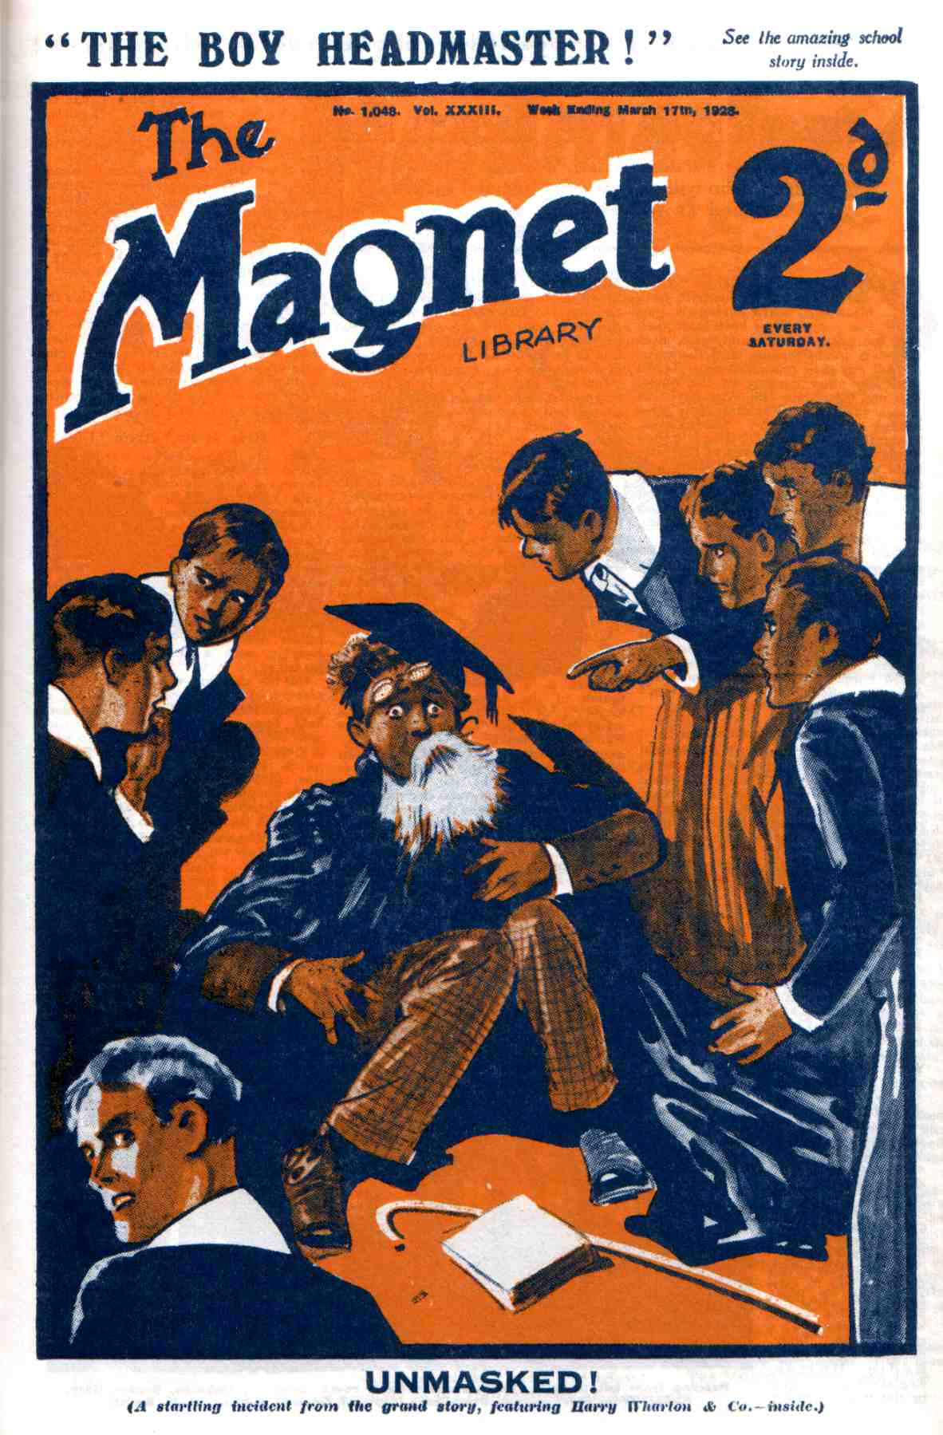 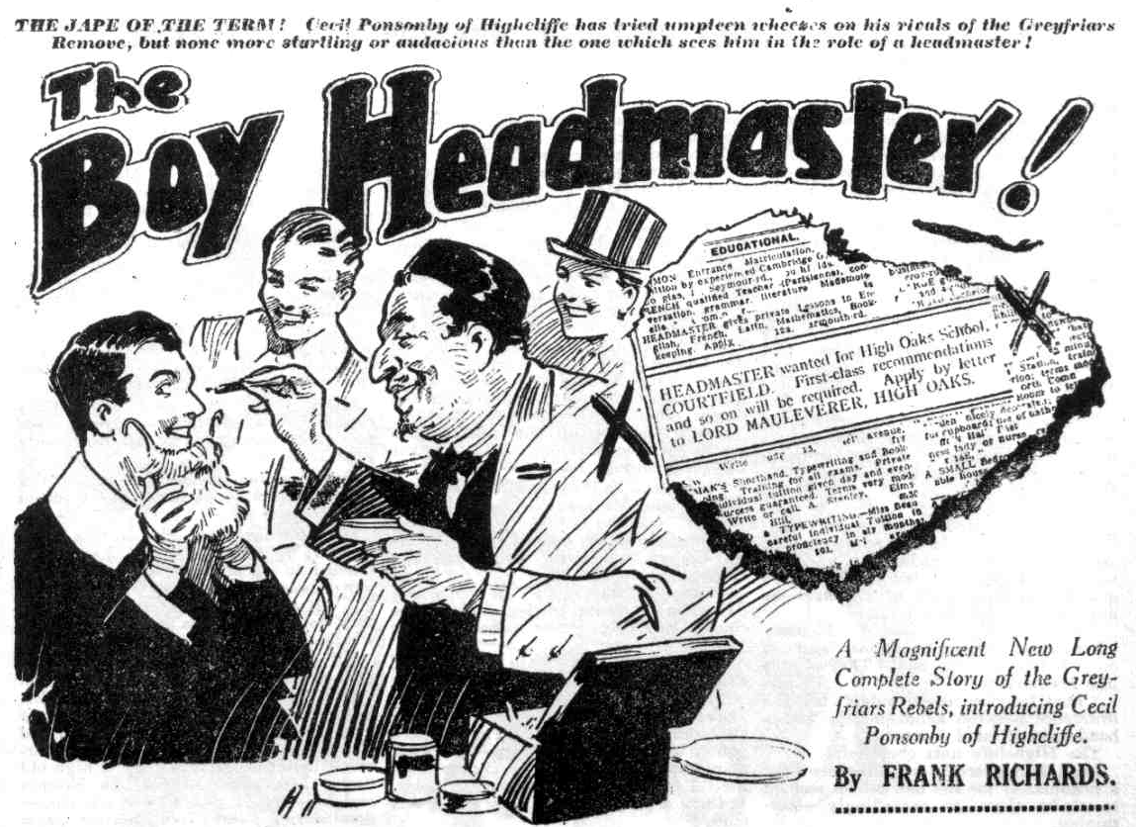
THE FIRST CHAPTER.
Ponsonby’s Wonderful Wheeze!
“THOSE Greyfriars cads——”
“ Eh?”
“Are askin’ for it.”
Cecil Ponsonby, of the Fourth-Form at Highcliffe, made that declaration.
Pon of the Fourth was sitting on the edge of the table in his study, with his feet reclining on a chair.
He had a newspaper in his hands.
Gadsby, and Monson, and Vavasour loafed in their chairs, smoking cigarettes. They had been regarding Ponsonby with attention. As Pon had a newspaper in his hands, they naturally expected him to read out some news concerning the “gee-gees,” in which they were deeply interested, Pon’s study at Highcliffe being a sporting study, not to say a disreputable one.
They looked surprised when he mentioned Greyfriars. For once, Pon was not thinking of horses, and the sums that might be made—or lost in backing those elusive animals.
Oh, bother Greyfriars!” said Monson. “I’m fed-up with Greyfriars, and Greyfriars cads.”
“Fed up to the chin!” agreed Gadsby.
“ Absolutely!” yawned Vavasour.
Ponsonby did not heed those remarks. Pon was monarch of all he surveyed in that study, and when Pon said turn the study had to turn.
“They’re askin’ for it.” he said. “Beggin’ for it, in fact. Those Remove cads, you know—Wharton and his mob.”
“ Now, look here, Pon” said Gadsby. “I’m as much against that mob as you are. But I’m fed-up. What’s the good or denyin’ that we always get the worst of it when we row with them? Look at what Bob Cherry did to your eye last term.”
Ponsonby scowled.
“I’m goin’ to make Bob Cherry sorry for what he did to my eye, Gaddy.”
“Look at the way Wharton handled Monson last time—”
“Oh, cheese it, Gaddy!” grunted Monson.
The reminder seemed rather painful to Monson. He passed his hand tenderly over his rather prominent nose as he spoke.
“I know you’re funky of them, Gaddy. You needn’t take the trouble to explain that.” snapped Ponsonby.
“Well, I don’t want an eye to match yours, or a nose to match Monson’s.” argued Gadsby. “Why not let them rip?”
“Absolutely!” concurred Vavasour.
“If you’Il give a man a chance to speak I’ll explain.” said Ponsonby, un- heeding. “ There’s been a lot of jolly queer goings-on in the Greyfriars Remove lately. From what I hear, Dr. Locke dismissed their Form master, and the Remove got their backs up about it. Goodness knows why, but they did. Anybody would have expected them to be glad to get shut of a bitin’ old blighter like Mr. Quelch. But they weren’t.”
“No accountin’ for tastes.” said Monson. “I know I shouldn’t kick up a shine if our head sacked Mr. Mobbs. I should chirp.”
“Well, the Greyfriars chaps didn’t chirp. They seem to have broken out into a sort of rebellion,” explained Ponsonby. “That slackin’, foozlin’ ass, Mauleverer, appears to have taken the lead. I’ve had it from Skinner. They just walked out of Greyfriars—”
“Cheek!” said Gadsbv.
“They always were a cheeky crew.” said Monson. “ I hope they’ll all get flogged, or sacked, or somethin’ worse. But what the dooce does it matter to us, Pon, what those cads do?”
“Lots!” answered Pon. “ They walked out of their school, and refused to return unless the Head took their Form master back. That foozlin’ dummy
Mauleverer, bought a place called High Oaks—you know that old manor house near Courtfield, that’s been empty for dog’s ages. His guardian seems to have let him do it—he’s a millionaire, you know. They’ve turned it into a school —of sorts, and they’re just stickin’ there an’ defyin’ till he comes down off his perch an’ takes their Form master back. Of course, he won’t do it—so there you are! Goodness knows how it will end. Not that I care. Only —”
“ My hat ! They must be havin’ a high old time!” said Monson enviously. “ No masters—no lessons —easy thing all round—”
“Off-side !” said Pon. “From what I hear, Mauleverer is makin’ them toe the line, and most of the men back him up. They’re tryin’ to run the place as a school, with classes, an’ so on. But, of course, a lot of the fellows don’t see it, and there’s no end of shindies, accordin’ to what Skinner tells me.”
Gadsby, and Monson, and Vavasour yawned in unison.
They were not particularly interested in the remarkable proceedings of the Greyfriars Remove. and they wondered what Ponsonby was driving at—without specially wanting to hear.
But if they did not want to hear, Ponsonby wanted to tell them. And Pon’s word was law in Pon’s study. So he went on:
“I’ve been thinkin’ it over, and wonderin’ whether there was a chance of gettin’ at the rotters.” said Ponsonby. “Now they’re askin’ for it, and fairly puttin’ it in our hands. I’ve got a wheeze.”
Gadsby raised a hand in protest.
“We know your wheezes !” he remonstrated. “I’ve had some. I’ve been
there before. There’s always somethin’ goes a little bit wrong somehow, and we bag the beatin’. Wash it out, Pon !”
“List to this,” said Ponsonby, unheeding. “ It’s an advertisement that that foozlin’ chump, Mauleverer, has put in the paper. Skinner says they’ve been tryin’ to get Mr. Quelch to go to High Oaks as their headmaster and Quelchy’s not takin any. Now Mauleverer’s advertisin’ for a headmaster.
“What?” yelled the three.
They sat up and took notice at that.
“Here’s the advertisment,” said Ponsonby. And he proceeded to read it out of the newspaper, Gadsby, and Vavasour, and Monson listening with amazed attention now.
“ Headmaster wantcd for High Oaks School, Courtfield. First-class recommendations, and so on, will be required.—Apply by letter to Lord Mauleverer, High Oaks.”
“My only sainted aunt !“ said Gadsby, in amazement. “ Is the fellow potty? Advertisin’ for a headmaster, as if he wanted a page, or a boots! He won’t get any answers from headmasters—or any masters, for that matter.”
“ Not likely!” chuckled Monson. First-class recommendations, and so on! I like the ‘ so on !’ That sounds like Mauleverer!”
“That fumblin’ idiot couldn’t tell the difference between a headmaster and a head-waiter,” said Vavasour.
The Highcliffe nuts chuckled.
Lord Mauleverer’s advertisement for a headmaster for the new school seemed to strike them as exceedingly entertaining.
“ Didn’t I say they were askin’ for it?” asked Ponsonby, with a grin. “Of course, any genuine master, seein’ this, would want to know what High Oaks was, in the first place, and when he found that it wasn’t a school at all, but a mob of juniors in rebellion against their headmaster, you can guess that he wouldn’t touch it, if he was ever so hard up for a job.”
“I fancy not. Ha, ha, ha!”
“All the same’, they’re goin’ to get an answer.” said Ponsonby.
“From whom ?”
“What price me?” asked Pon.
His comrades stared at him.
“ You?” ejaculated Gadsby.
“ Little me!” said Pon complacently. “They’re askin’ to have their silly leg pulled, and I’ve been lookin’ for a chance of pullin’ it. They’re offerin’ me the chance now—askin’ for it. I can get a man to write the letter, and then—’
“ You can’t walk into High Oaks and ask for a job as headmaster, I suppose?” muttered Gads by.
“Just that. Just that, an’ nothing more or less.” answered Ponsonby coolly. “ And if I pull it off I’ll give them such a high old time that they’ll wish they’d never left Greyfriars.”
“ But — but — but you’re potty!” babbled Gadsby. “ Won’t they know you, you ass? And do you think even a foozlin’, frabjous ass like Mauleverer is lookin’ for a headmaster no older than himself? Are you wanderin’ in your mind, Pon?”
“Don’t be an ass!” said Ponsonby curtly. “I’m not thinkin’ of walkin’ into High Oaks in Etons. You saw me got up as a man of fifty when we did the theatricals in the Christmas term— I borrowed Mobby’s cap and gown, and got old Lazarus to make me up—and fellows would have sworn I was a middle-aged Form master. I can do it again, I suppose.”
“Oh crumbs!”
“Ha, ha, ha!”
“But—but they’d lynch you, if they caught you pullin’ their leg like that!” gasped Vavasour.
“ They won’t catch me.”
“ Mean to say you’ve got the nerve to go to High Oaks got up as a school. master?” said Gadsby dazedly.
“Yes, ass! I tell you I can pull it off!” said Ponsonby confidently. “ Mind, not a word outside this study— specially to Courtenay or the Caterpillar ! It’s got to be kept deadly dark. I can get leave from Dr. Voysey to go home for a few days. I can get all the things I need at old Lazarus’ shop ; and old Larazus will help me make-up—he’s a dab at it! 1 could do it on my head, now they’re askin’ to be taken in and done for!” Ponsonby chuckled. “I fancy those Greyfriars rotters with me as their headmaster! I shall rather put them through it !”
“Ha, ha, ha!” yelled Gadsby and Monson and Vavasour.
Tap!
The study door opened, and Rupert de Courcy, otherwise known as the Caterpillar, looked in.
“Sorry to interrupt!” he remarked. “ Courtenay wants to know if you’re comin’ down to footer practice, dear youths.”
“Tell him to ask again next year!” answered Pon.
“ From which I gather that the answer is in the negative.” said the Caterpillar, with a nod. “ That’s where you’ve got the pull over me—the dear man won’t take a negative answer from me. I’ve got to go an’ slave at Soccer. Is there a jolly old joke goin’ on in this study ?”
“Oh, no! Nothin’ of the kind!” said Ponsonby hastily.
“ Won’t you tell me the funny story ?” urged the Caterpillar. “ I dare say I’ve heard it before, but anythin’ that will keep me away from footer for a few minutes will be a boon and a blessin’ !”
“Fathead ! Shut the door after you!”
“You won’t tell me the giddy jest ?“
“There isn’t any jest, you ass!”
The Caterpillar laughed and closed the door, as Frank Courtenay’s voice called from the end of the passage.
Ponsonby & Co.—much too busy now to think of Soccer—put their heads together, and Pon’s wonderful scheme was discussed, and discussed again, and decided upon ; and all that remained was to carry it out.
And though Pon’s chums had considerable confidence in Pon, and Pon had unbounded confidence in himself, Gadsby & Co. were glad that it was their chief and not their noble selves, who was to enter High Oaks School as a bogus headmaster—feeling that the venture was remarkably like the ancient exploit of Daniel in entering the lions’ den.
They were all keen enough to score over Harry Wharton & Co., but of all the nutty company certainly Cecil Ponsonby was the only one that dared to be a Daniel.
—
THE SECOND CHAPTER.
Surprising News at High Oaks!
“I SAY, you fellows——”
“Shut up, Bunter!”
“But, I say,” howled Billy Bunter, “ there’s a notice on the board!”
“ Blow it!” sniffed Bolsover major.
“ Bother it!” said Skinner.
“But I tell you —“
“Rats! Think anybody wants to read Mauly’s silly notices on his silly board?” snapped Hazeldene.
“But I say, you fellows, there’s a headmaster coming——“
“What?”
“ A new headmaster!” said Bunter.
“Gammon!” .
“It’s on the board, in Mauly’s fist!” said the Owl of the Remove. “ I say, you fellows, I’m not going to stand it, you know!”
Bolsover major snorted.
“We’ll give him headmaster! Lot’s go and see it, you fellows! If Mauly springs a headmaster on us, we’ll give him socks!”
“ Yes, rather !”
And there was a rush of the Removites into Hall at High Oaks, to see that new notice on the board.
High Oaks was now High Oaks School, as a gilt-lettered board over the gates announced to all who could read.
But if it was a school in name, it did not, at present, look much like a school in fact.
It might have been likened to a bear-garden ; at times it might have been likened to a pandemonium. More and more the rebel juniors of Greyfriars had got out of hand; more and more had they fallen from the high ideals with which the rebellion had been started.
All the best fellows in the Remove agreed that the Form had rebelled and marched out of Greyfriars because Dr. Locke had unjustly dismissed their Form master But many members of the Form scouted that idea, and per- sisted that they were out for a high old time. Incurable slackers like Skinner and his friends wanted a slack time— domineering fellows like Bolsover major refused to be dictated to—and the majority of the Form swayed sometimes one way. and sometimes another.
Even Harry Wharton & Co., though they heartily backed up Lord Maule- verer, had occasionally yielded to the temptation to play football instead of going in to class ; and other fellows had sometimes felt that a fine day called them up the river rather than to Latin irregular verbs.
But, generally, Harry Wharton & Co. and their friends backed up Mauly for all they were worth, and set an example of law and order to the rest of the Form—which was sometimes followed, and sometimes not.
The fact was, as they all realised, that a school without a master was not a practical proposition.
Fellows who had to decide the matter for themselves often found wonderfully convincing reasons why they should take an extra holiday.
Most of the fellows played up fairly well ; but Bolsover major was against law and order on principle, and Skinner & Co. were against work in any shape or form; and Billy Bunter was resolutely opposed to any occupations except eating and sleeping.
These fellows gave all the trouble they could all the time, and sometimes they were supported by a majority of the Form : sometimes they were in a minority; but always they were a thorn in the side of Lord Mauleverer. But it must be confessed that even Mauly himself, determined as he was that High Oaks should not be a home for slackers and work-shys, sometimes was found reclining in an armchair after the bell had rung for class, and sometimes permitted himself the relaxation of a nap in the class-room.
All this; however, was going to be changed—According to his lordship. Mr. Quelch had steadfastly refused the pressing invitation of the rebels to come to High Oaks and take control. The only alternative was to appoint a headmaster, or to return to Greyfriars.
Nobody wanted to return to Greyfriars. The Remove was backing up their dismissed Form master, little as he appeared to appreciate their devotion. They were resolved not to surrender. And fellows who did not care a rap about Mr. Quelch, cared a good many raps about getting out of classes. So all the Remove, good, bad, and indifferent, were united on one point—to stick to High Oaks as long as they could, which most of the fellows expected to be until the Head appealed to their parents to intervene. That, however, Dr. Locke was obviously unwilling to do; and so, for the present, the Re- move remained out of Greyfriars, and every fellow did what was right in his own eyes.
The malcontents of the Form, of whom Bolsover major was the acknowledged chief, though his following varied from day to day, received the news of the now headmaster with astonishment and indignation. They crowded to the notice-board in Hall to read the paper that was pinned up there, in the well-known hand of Lord Mauleverer.
That notice bore out Bunter’s statement:
“NOTICE TO THE SCHOOL!
A headmaster of High Oaks las now been appointed, and will arrive to-day. The school will assemble in Hall at five o’clock to meet the Head.
“ MAULEVERER.”
“Well, my only hat” ejaculated Bolsover major. “Of all the cheek! Of all the neck! Does that chump think we’re going to stand it ?”
But where on earth has he dug up a headmaster?” asked Skinner, in perplexity. “You can’t hire schoolmasters by the hour like window-cleaners.”
“ Ha, ha, ha!”
“Must be some jolly queer sort of a johnny, to take on a job as headmaster here!” said Snoop.
A genuine headmaster wouldn’t do it.” said Stott. “Mauly’s been spoofed by some man out of work”
“ Might be some man who’s been sacked from some school, and can’t get another job.” remarked Hazel. “P’r’aps he can’t afford to be particular.”
“ Lots of tutor chaps can’t get jobs,” observed Russell sagely. “ It’s an over-crowded profession, you know. I dare say this johnny, whoever he is has been looking for a job for donkey’s ages, and he may have jumped at this chance.”
“We’ll make him jump again, if he comes here!” growled Bolsover major. “If we want to knuckle under to a head-master, there’s our own Beak at Greyfriars. But we don’t.”
“No fear !”
“Why, we wouldn’t stand Quelchy, if Quelchy came here, as those silly chumps asked him to,” exclaimed Bolsover major. in great wrath. “ We’re not kow-towing to any dashed schoolmaster, not if we know it”
“Hear, hear!”
“Where’s that idiot Mauly? I’ll jolly well talk to him about this.” said the bully of the Remove. “ Anybody seen him?”
“I guess he’s in class.” said Fisher T. Fish.
“Class!” Bolsover major snorted. “Class! We’ll jolly soon have him out of class—and we’ll rag the class-room, too. Let’s go and have Mauly out, and rag all those swots who are playing at classes.”
“Hurrah!”
Bolsover major jerked the notice down from the board.
“I’ll make Mauly eat this!” he said.
“Ha, ha, ha !”
And Bolsover major, with the paper crumpled in his hand, and his rugged face red with wrath, led the way to the class-room, where the more orderly members of High Oak School were at lessons. A crowd of fellows followed him, keen for a “ rag ” to relieve the monotony of existence. Shouting and trampling’ they poured along the passage to the classroom. The door was closed, and Bolsover major opened it by the simple expedient of planting a heavy boot against it with a terrific kick.
“Have ‘em out!” he roared.
“Go it!”
“Ha, ha, ha!”
It really looked as if the new headmaster of High Oaks, when he arrived,
would discover that he had taken on a full-sized man’s job!
- -
THE THIRD CHAPTER.
In Class!
“CHERRY!”
There was a chuckle in the class-room.
While Bolsover major and his crowd were reading the notice in Hall, Harry Wharton & Co. were in class.
Lord Mauleverer was manfully suppressing a portentous yawn. It was a fine spring day—and on a fine spring day, Lord Mauleverer felt a strong disinclination for work. He felt the same disinclination, as a matter of fact, on summer days, autumn days. and winter days.
The Famous Five were playing up, though Bob Cherry could not wholly suppress his sense of humour.
Mark Linley, the most studious fellow in the Remove, was taking the place of Form master. Mark was popularly supposed in the Remove, to have acquired stacks and stacks of knowledge, such as would have made a Shell fellow’s head ache, or even a Fifth-Former’s. Certainly Mark seemed far enough ahead of his Form fellows to be able to play the part of Form master with credit. His quiet, serious character invited him for the role, also, and he took his duties sedately. Bob Cherry was prepared to punch anybody’s head if he bothered Marky in class. Yet Bob himself could not refrain from enlivening the proceedings with a little humour. The whole class grinned as he addressed Linley as he would have addressed Mr. Quelch in the Form-room at Greyfriars.
“Chuck that, Bob,” said Harry Wharton, shaking his head. “Remember Linley’s our Form master—pro tem.”
“The pro-temfulness is terrific!” murmured Hurree Jamset Ram Singh. But the respectfulness to the ludicrous Marky is the proper caper.”
“Well, a man calls his Form master sir, you know.” said Bob.
“No larks in class!” said Nugent.
“Stick to the rules.” said Johnny Bull. “ Remember we’re setting a giddy example to the slackers and moochers.”
Bob Cherry chuckled
“One of the rules is that there’s no talking in class,” he said. “What are you fellows doing?”
“Hem!”
“Shut up, the lot of you,” said Vernon-Smith. “There’s Linley wanting to talk all the time; and Form masters are allowed to talk as much as they like in real schools.”
“Yes, silence in class,” said Tom Redwing. “ Go ahead, Linley.”
“ Silence for the chair!” said Peter Todd.
“Ha, ha, ha!”
“ Order!” bawled Squiff. “ Silence !”
“ Yaw-aw-waw!” came from Lord Mauleverer. The class-room being full of voices now, his lordship saw no reason for suppressing further the yawn that had been troubling him for some time. So he yawned, deeply, and with great relief; and finding solace in it, yawned again.
“Look here, you chaps, this isn’t the thing,” said Mark quietly. “ If this is going on, you fellows may as well be outside the class-room with the others.”
“ Mea culpa!” sighed Bob Cherry. “My fault, old bean! I withdraw the ‘Yes, sir,’ with apologies.”
“Shall I punch his head, Linley?” asked the Bounder.
Vernon-Smith was one of the orderly members of High Oaks now—he had backed up Mauly since his fight with that noble youth, in which Mauly had had the better of it. Smithy seemed to respect Mauly now as he had never done before, which was a rather unexpected outcome of the fight, and a disappointment to Skinner & Co.
But though the Bounder was now one of MauIy’s backers, he was rather keen on anything that would disturb the studious solemnity of the class-room. He was ready to keep order; but he would have preferred to keep it by means of a rough-and-tumble with any other fellow, instead of by sticking to lessons.
Bob gave him a warlike look.
“Better not, Smithy,” he said emphatically. “I don’t think my head would get the hardest punch, if you did.”
“Rats!” said the Bounder
“Shut up, Smithy,” whispered Redwing.
“Rot! I’m keepin’ order—backin’ up Mauly and Linley. You were grousin’ at me for not backin’ them up a little while ago.”
Bob jumped to his feet.
“Look here!” he shouted.
“Order!”
“Sit down!”
Wharton dragged Bob back to the form.
“Well, that cheeky ass—” said Bob warmly.
“Cheese it! Order!” said the captain of the Remove. “ Marky has been trying to speak all this time. Do shut up.”
“Sorry, Marky,” said Bob. “Go ahead, old chap ! I won’t say another word. Not a giddy syllable.”
Mark Linley suppressed a sigh. He had taken on the task of temporary Form master, at the urgent request of Lord Mauleverer, backcd up by the other fellows. But the task was no sinecure.
“You were speaking to me, Marky,” went on Bob, the next moment. “Sorry I interrupted you. Cut in.”
“You’re interrupting him again,” remarked the Bounder.
“You dry up, Smithy. You talk too much.”
“Well, I like that! If ever there was a fellow like sheep’s head—all jaw— you’re the chap.“
“Look here—”
“Silence!”
“ Cut in, Marky.”
“I was going to say.” began Linley, “that drawing Red Indians on your blotting paper is not what you’re in class for, Cherry.”
“Oh, crumbs!” ejaculated Bob.
He gazed at the figures delineated on his blotting-paper, and then at the boy
Form master.
“ Are they Red Indians?” asked Nugent, looking over Bob’s shoulder.
“Well, Marky says they are, and he’s our Form master.” said Bob, rather gruffly. “ But I was drawing a football match —at least, I thought so.”
“ Ha, ha, ha!”
“ Some artist!” chuckled the Bounder.
Mark Linley joined in the laugh—he could not help it. Bob’s hands were remarkably active and very reliable with the boxing-gloves, or with a cricket bat ; but they certainly lacked skill in any form of pictorial art. His footballers might have been Red Indians, or Chinese pirates for that matter.
“ Anyhow, chuck it!” said Mark, at last.
“ Certainly, old fellow!”
Bob screwed up the blotting-paper and hurled it across the room towards the wastepaper basket. The waste-paper basket was behind Mark Linley, a little to one side ; there was room for the missile to pass—had not Mark moved just then. But he did move; with the result that the crumpled-up blotting-paper landed on his neck.
“Oh !” he gasped.
“ Oh, my hat! Sorry!” exclaimed Bob. “ You told me to chuck it, you know. So I—I chucked it !”
“Ha, ha, ha !”
Bob was evidently in a humorous mood—a mood which would have been carefully repressed, had Henry Samuel Quelch been in charge of the class. But Bob, with the best intentions in the world, could not help allowing himself a little licence, in charge of a Form-master no older than himself.
Mark quietly picked up the blotting-paper and tossed it into the wastepaper basket.
“This won’t do!” he said
“Nunno! Awfully sorry, old tulip!”
“Give him six, Marky,” said Lord Mauleverer. “ There’s a cane on the desk.”
“Shut up, Mauly,” said Bob. “ You’re talking in class! I’m surprised at you. If the House of Lords sets us a bad example, what will become of us common mortals?”
“Ha, ha, ha!”
“ Oh, begad! Look here—”
“Order!” grinned Nugent. “You talk too much, Mauly.”
Tramp! Tramp! Tramp!
“Hallo, hallo, hallo! Here come the fellows!” exclaimed Bob. “You’re to have a full class after all for this lesson, Marky.”
Footsteps and loud voices came surging along the passage. A tremendous kick caused the class-room door to fly open. Bolsover major and his merry men had arrived. They crowded into the doorway. Bolsover was careful to get the door wide open and plant himself inside, before it could be closed. On a previous occasion when the rowdy element had attempted to rag the class-room, Linley had locked them out. This time there was no chance of locking them out. They were already in.
“Class going on, what?” roared Bolsover major. “Playing at lessons, what, you set of saps?”
The class jumped to their feet at once.
“ Get out of this, Bolsover!” exclaimed Harry Wharton. “ If you’ve come in for lessons, you can sit down quietly—if not——”
“Ha, ha, ha! Not !” roared Bolsover.
“Then get out!”
“ Outside, and sharp!” shouted Bob Cherry.
“Yaas, get out, you know!” yawned Lord Mauleverer. “You’re interruptin’ the work, you know.”
“That’s what we’ve come for!” said Bolsover major. “ Mauly, you crass ass, you’ve stuck this notice on the board?” Bolsover major held up the crumpled paper.
“Yaas!”
“ What does it mean?” demanded Bolsover major.
“What it says, dear man!”
“Mean to say you’re engaged a head-master to take control of High Oaks?” thundered Bolsover major.
“Yaas!”
“Think we’ll take any notice of him?” shouted Skinner.
“Yaas!”
“You silIy ass!” hooted Snoop. “ Do you think you can bring along some down-at-heel tutor-wallah and put him over us?”
“Yaas!”
“You’re going to eat this!” roared Bolsover major. “See? I’m going to make you eat your words—paper and all.”
“ Outside, you rotter!” shouted Bob Cherry.
“And we’re going to rag the clasroom, and stop all this rot, and when your precious headmaster comes, we’re going to rag him !” roared Bolsover,
“Oh, gad ! Will you get outside?” asked Lord Mauleverer. “I keep on tellin’ you you’re interruptin’ the work. You men, lend me a hand to shove them out.”
“You bet!”
“Pile in!” shouted the Bounder.
“ Kick ‘em out !”
“Hurrah!”
The whole class fairly rose to the task. They were the orderly members
of High Oaks—they were playing the game, sticking to work. and setting an example. But there was no doubt—no doubt at all—not the shadow of a doubt—that they preferred a shindy to lessons. In the present circumstances, a shindy was required in the case of law and order—and the orderly section jumped at the chance. And any stranger, looking in at High Oaks just then, would have been extremely puzzled to distinguish the orderly fellows from the disorderly ones—they certainly all looked much of a much ness as they scrambled and scrapped and struggled and yelled, in the midst of overturned forms, and inkpots, and scattered books and papers.
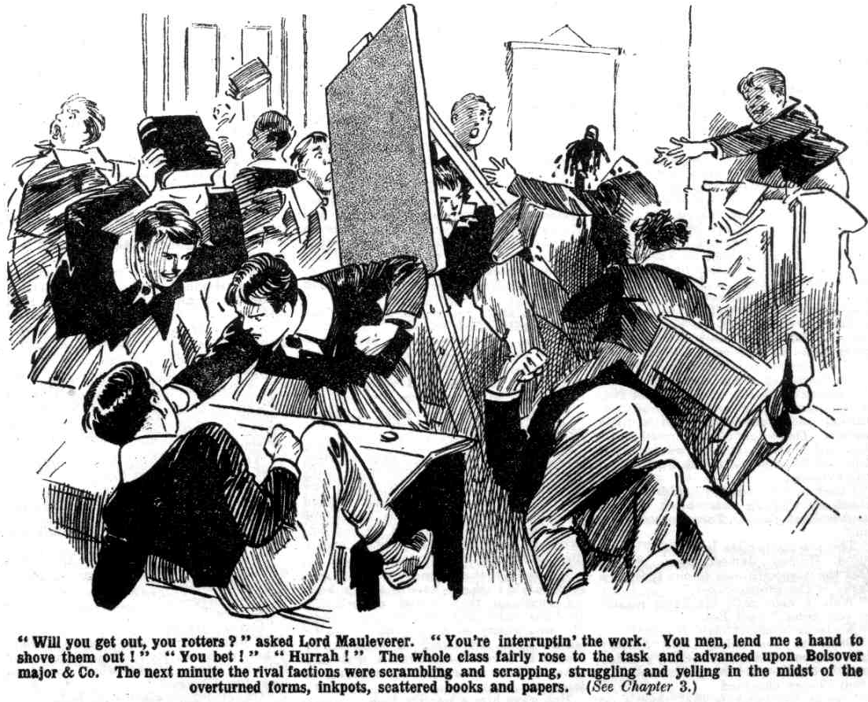
THE FOURTH CHAPTER.
Something Like a Shindy!
“SOCK it to them!”
“Give ‘em beans!”
“Yarooogh!”
“ Kick them out !”
“Mop ‘em up!”
“Owl Wow, yow!”
It was a wild and whirling scene.
The odds were on the side of the raggers, but on the other side were the best fighting-men in the Greyfriara Remove—the Famous Five and Smithy, and Peter Todd, and Squiff, and Mark Linley. It was, so to speak, quantity against quality; and quality held its own very well indeed.
Other fellows, taking neither side in the shindy, crowded along the passage and stared in at the doorway, shouting encouragement to the side they sympathised with, or to both sides impartially.
“ Go it, ye cripples! Pile in!”
“ I say. You fellows, mop up these rotters!’
“ Bravo !”
Crash! crash! bump! stamp! tramp! tramp!
Both sides in the classs-room were going strong.
Lord Mauleverer, a few minutes before, had looked a picture of lazy slackness. Now he was fighting like a Trojan ; and he had Skinner’s head in chancery ; and Skinner’s voice was heard all over High Oaks as his lord- ship punched and pummelled. Bob Cherry and Bolsover major were fighting hard, with plenty of punishment given and taken. All the other fellows were engaged hotly.
Quality told over quantity at last. The raggers were driven back to the doorway, and Snoop was the first to flee. The battle was to the strong, but the race was to the swift. Sidney James Snoop vanished ; and Skinner, getting away from Mauly at last, followed him fast.
“Shove ‘em out!” roared Bob Cherry. “Out you go, Bolsover, you rotter !”
Bolsover was driven to the door before Bob’s vigorous attack but he rallied there and came charging back.
But man after man of the raggers was hurled forth, sprawling, into the passage, and there they picked themselves up and bolted.
Bolsover major was the last, and he resisted manfully as three or four fellows drove him out. But he was sent spinning through the doorway and rolled in the passage.
He sat up there gasping, and clasping his nose which was streaming crimson.
“He, he, he!
Billy Bunter, undoubtedly, sympathised with the raggers, though he did not carry his sympathy to the length of lending them a hand. Still, he seemed to find entertainment in Bolsover’s battered visage, as his fat cackle testified.
“Ow!” gasped Bolsover major. “ Wow !”
“He, he, he!”
Bolsover major staggered up.
He had had enough of Bob Cherry—a little too much, in fact. He did not think of entering the class-room again. But even in his present state he was not to be sniggered at by William George Bunter. His heavy hand smote, and Bunter’s cackle was changed into a roar of anguish.
“ Yow—oooop!”
Bunter rolled on the passage floor, and Bolsover, staying only a moment to kick him as he rolled, stalked away. The yells of William George Bunter awoke all the echoes of High Oaks.
Harry Wharton slammed the door of the class-room after the ejected raggers. Then he looked round the scene of havoc —what time he caressed a damaged nose and an injured ear.
“Oh, my hat!” he ejaculated.
Bolsover major had not succeeded in making Lord Mauleverer eat his words, as he had set out to do. But he had very effectually interrupted class. Fellows who had been studying—more or less— under Mark Linley’s guidance, were now attending to manifold injuries—there was not a man present who did not bear signs of the combat. Breathless fellows gasped and panted, and dabbed their noses.
The classroom was a wreck. Forms were overthrown, books and papers trampled underfoot: ink scattered in all directions. The room looked as if a cyclone had struck it.
“My hat !” repeated the captain of the Remove.
“ My nose!” mumbled Johnny Bull.
“Ow! My eye!“ moaned Frank Nugent.
“We’ve beaten the rotters!” exclaimed Bob Cherry. “ They’re licked to the wide, anyhow !”
“The lickfulness is terrific!” gasped Hurree Jamset Ram Singh. “The pain fullness in my esteemed boko is also great.”
“ Look at my nose!” said Johnny Bull.
“What about class?” asked Mark Linley.
A chorus of groans answered him.
“Oh, blow class!” said Peter Todd. “I’m jolly well going to bathe my eye! Look at it!”
“Bless class!” said Squiff. “Look at my nose!”
“Yaas, begad!” said Lord Mauleverer. “I shall have to go out and get a clean collar! Look at my collar, after Skinner’s paws have clawed it! Class is dismissed for the day.”
“ Right-ho!” said Mark. “ I can do with a rest. Blessed if I know what the new headmaster will think when he sees us. I never saw such a collection of prize noses and thick ears.”
“ The new Head will keep order.” said Lord Mauleverer.
“I hope so.” said Mark, rather dubiously.
“The hopefulness is terrific; but the likeliness is a boot on the other leg.” remarked Hurree Jamset Ram Singh.
“Oh, he will be all right!” said Lord Mauleverer confidently. “ I’ve gone into that with him in my letters, you know. He knows he’s got rather a handful here, and he’s prepared for it. I’m goin’ to change my collar.”
The juniors streamed out of the class-room. Class was over for the day; the casualties had to be attended to now. The troubles at High Oaks had come to
a head now ; something like civil war was reigning at that remarkable scholastic establishment. If the new headmaster engaged by Lord Mauleverer succeeded in establishing order and maintaining it, it would certainly be a considerable feat on his part; and all the felllows had very strong doubts on the subject.
That afternoon, Lord Mauleverer, having removed all the signs of combat that he could, dressed with care, and telephoned to Courtfield garage for a car. He was going to meet the new headmaster at Courtfield Junction, he explained to the Famous Five, and bring him to High Oaks.
“ And for goodness’ sake have the fellows in order, if you can,” said his lordship, rather plaintively. “ We don’t want Mr. Buncombe to think we’re a lot of giddy hooligans, you know.”
“The orderfulnes of our esteemed selves will be terrific,” said Hurree Jamset Ram Singh. “ But the other esteemed fellows—” He shook his dusky head.
“Let’s go for ‘em and mop them up again,” suggested Bob Cherry. “ That will teach them manners.”
Harry Wharton laughed.
“ Don’t you think there are enough black eyes and swollen noses at High Oaks already?” he asked.
“Well, a few more would do ‘em good.”
“ Mr. Buncombe, if that’s his name, will find all his work cut out here.” said Johnny Bull. “ Can’t understand the man taking on the job. Does he know we belong to Greyfriars, Mauly?”
“ Yaas.”
“He knows we’ve cleared out of school, and started on our own, and told our headmaster to go and eat coke.”
“ Yaas.”
“ And still he’s taken on the job?”
“Yaas.”
“Blessed if I catch on. How many answers did you have to your advertisement?”
“ Only Mr. Buncombe’s.”
“Where does he come from?”
“Lantham.”
“ Any recommendations?”
“Lots!”
“Well, what are they ?”
“He’s goin’ to tell me when he comes.”
“Oh, my hat!”
“Sure he’s a schoolmaster at all and not some moocher looking for a job ?” asked Nugent.
“Yaas.”
“Well, how do you know?”
“He’s told me so.”
“Ha, ha, ha!”
“Well I must be off,” said Lord Mauleverer, glancing at his watch.
“You must be off,” agreed Peter Todd. “Right off, I should say, if you take on a man on his own recommendations without seeing him.”
“ You see, it’s a case of Hobson’s choice.” explained Lord Mauleverer. “ I’d rather have had Mr. Quelch here; and if Quelchy wouldn’t come, Marky could have run the school if the fellows played up. But they haven’t. Must have a headmaster, and if only one offers, must havo that one. See?”
“ Well, it may turn out all right,” said Harry Wharton, laughing. “ He will be a good man if he can keep order here, at any rate.”
“Yaas! You fellows will promise to obcy orders, and back him up all along the line, of course?” said Lord Mauleverer. “With half the Form backin’ him up, he will soon got the rest to toe the Line”
“ Rely on us, old bean.”
“The backupfulness will be terrific.”
And Lord Mauleverer, the car having arrived from Courtfield, stepped into it, and departed to meet the new head-master at the station. Bolsover major & Co. saw him start, and exchanged grins.
“ He’s coming back with the new Head,” said Bolsover. “ We’ll all turn up in Hall to meet him—and give him the ragging of his life. We’ll make him glad to take the next train home.”
“ Hear, hear!” said the rebels in chorus.
The new headmaster was evidently going to have a very mixed reception at High Oaks School.
THE FIFTH CHAPTER.
A Change of identity!
“ PON! Oh, my hat!”
“Ha, ha, ha!”
Gadsby and Monson and Vavasour chuckled in chorus. Mr. Lazarus rubbed his fat hands and grinned.
In the little parlour behind Mr. Lazarus’ shop in Courtfield High Street, the Highcliffe nuts had gathered that Wednesday afternoon. There Ponsonby had undergone a remarkable transformation.
Pon, undoubtedly, was clever at amateur theatricals. He was, in fact, clever at many things had he chosen to use his cleverness for good ends—which he seldom or never did. Mr. Lazarus, who kept a stock of goods for private theatricals, did a good deal of business in that line with fellows belonging to Highcliffe and Greyfriars, and sometimes he gave his skilled assistance in making-up. He had been very successful with Ponsonby on this occasion. Certainly Pon’s nearest and dearest relation would not have recognised him now.
Mr. Lazarus was given to believe that he was helping Pon make up for theatricals at Highcliffe. Not that he cared much about the matter, so long as his fee was paid. On that point Mr. Lazarus was rather particular.
The Highcliflians eyed Pon, when the transformation was complete, with many chuckles and great admiration. They had had a good many doubts at first; but now that they saw Pon in his new character, they considered it very likely that he would succeed in “getting away” with it.
Ponsonby looked about fifty, with greyish hair and a greyish beard, and scholastic wrinkles in his brow.
Elevators in his boots added considerably to his height, and he was naturally rather tall and slender, and his slenderness was now disguised by
skilful padding.
A large pair of horn-rimmed glasses added to his age and his scholastic look, and helped to disguise him beyond the remotest possibility of recognition.
His boots had elastic sides, and squeaked as he walked, like Mr. Mobbs’ boots at Highcliffe.
“ Oh, Pon!” gasped Gadsby. “ Oh, my sainted aunt! Blessed if 1 really believe it’s you!”
“ Silence in the class!” rapped out Ponsonby suddenly, in a squeaky voice very like Mr. Mobbs’, and nothing at all like Ponsonby’s own. “ How dare you talk in class! Take fifty lines!”
“Ha, ha, ha!”
“Ripping!”
“Absolutely!”
“I rather think I shall pass!” grinned Pon, his grin contrasting oddly with his wrinkles, his spectacles, and his grey hair. “ If the car’s there, we may as well go!”
“Ha, ha, ha!”
The Highcliffians left Mr. Lazarus’ establishment together. A car was drawn up to the kerb.
“Well, goodbye, old chap, and good luck !” said Gadsby.
Ponsonby stepped into the taxi.
“Redclyffe Railway Station!” he said to the driver in his squeaky voice—the voice he had practised carefully for his character of Mr. Buncombe.
“ Yessir!” said the taxi-man.
The driver evidently had no suspicion that this elderly gentleman was no older than the schoolboys who were saying good-bye to him.
The taxi rolled away, and Gadsby, Monson, and Vavasour walked back, chuckling, to Highcliffe. In all the alarums and excursions of the Highdiffo nuts against the Greyfriars Remove, Pon & Co. had generally come off worst. But this time, they agreed, it looked as if Pon would score. The Greyfriars fellows had, as he said, fairly asked for it, and Pon was going to give them what they had asked for.
Ponsonby grinned under his disguise as the taxi bore him away to Redclyffe Station. In his correspondence with Lord Mauleverer, in answer to the advertisement. Pon had used a Lantham address, having acquaintances in the town, and Lord Mauleverer understood that the new Head was coming from Lantham by railway. Pon had no intention of travelling ten miles, how- ever ; he intended to pick up the train at a near station. Quite easily Pon had obtained leave to go “home” for a few days — Mr. Mobbs had obligjngly arranged that for him—and at Highcliffe it was supposed that Pon had gone home that afternoon. Only Pon’s immediate friends and cronies knew where Pon had planned to pass those few days
The taxi arrived at Redclyffe, and Pon stepped out at the station and dismissed the car.
He walked into the railway station, with a suitcase in his hand. He was in
good time for the train, and had ten minutes to wait before it came along for Lantham.
“ Oh, gad!” murmured Ponsonby, below his breath, as he caught sight of several Greyfriars fellows on the platform, evidently waiting for the same train.
Wednesday was a half-holiday at Greyfriars as well as at Highcliffe. The Greyfriars men were Coker, Potter, and Greene, of the Fifth Form. Pon’s first impulse was to avoid their sight; his second to court it, as a test of his disguise. Coker & Co. knew him well by sight in his natural person—indeed, Coker had once taken it upon himself to cuff the dandy of Highcliffe, whom he had found smoking a cigarette in the lane—Coker being a fellow who was always as ready to mind anybody else’s business as his own, if not readier.
Ponsonby walked past the three Fifth-Formers of Greyfriars with the slow and leisurely tread of a middle-aged gentleman.
They glanced at him carelessly as he passed, but took no further heed of him, evidently supposing that he was what he looked—a middle-aged man who was a stranger to them.
He passed them again and again, and on the third occasion bumped into Coker. Coker gave a grunt.
“Mind where you’re going!” he snapped. “Are you blind?”
Ponsonby blinked at him through the horn-rimmed spectacles.
“Eh—did you address me, little boy?” he asked in a squeaky voice.
Horace Coker turned crimson, and Potter and Greene exchanged a grin.
Coker was a Fifth Form man, and a Fifth Form man was a great man; and Coker, in his own estimation, was one of the greatest. To be addressed as a “little boy” naturally aroused Coker’s ire.
“Look here, don’t you be cheeky, and don’t tread on a fellow’s toes!” he snapped angrily.
“Did I tread on your feet, little boy ?”
“Yes; you jolly well did !”
“You should not have such large feet!” said Ponsonby. “Do you call them feet?”
“What !” gulped Coker.
“I should call them yards !”
“Wha-a-at!”
“Ha, ha, ha !” roared Potter and Greene.
Coker glared at this middle-aged gentleman who ventured to jest on the subject of his feet—an extensive subject. It was not to be denied that Coker of the Fifth had been treated liberally by Nature in the matter of feet. He had, of course, only two, but there was enough of them to provide an ordinary fellow with three or four. Coker was rather sensitive about them ; his friends were aware of that, and they agreed that Coker had a lot to be sensitive about.
“Why, you—you cheeky old chump,” exclaimed Coker, in great wrath, “joking about a fellow’s feet! If you weren’t old enough to be my father, I’d jolly well dot you on the nose! What sort of an old ass do you call yourself?”
The old gentleman blinked at him. Ponsonby realised that his little joke was scarcely in accord with his elderly appearance. But it entertained him to pull Coker’s leg. He had not forgotten the cuff that the Greyfriars Fifth-Former had once bestowed upon him.
“Be civil, please!” he said. “I shall complain to the stationmaster if you are not civil!”
“Complain to your grandmother!” snorted Coker.
“You are a rude little boy,” said Ponsonby reprovingly, “ but carry my bag!”
“ Carry your bag!” stuttered Coker.
“ Yes. Put it into a first-class carriage when the train comes in, and be careful with it! I will give you sixpence!”
“Sus-sus-sixpence!” stuttered Coker.
“I never give more than sixpence!” said Ponsonby.
“You—you—you footling old ass, what do you take me for?”
“Why, you—you—you cheeky old chump !”
“Eh—aren’t you the porter’s boy ?”
“The—the porter’s boy?” gasped Cokcr.
“ Aren’t you looking for a job?”
“Looking for a j-j-job!”
“ Take my bag! And, mind, I shall not give you more than sixpence!
I do not believe in pampering the lower classes!”
“Oh, my hat!” gasped Potter, while Greene turned his face away to hide his emotion.
Coker stood in a dazed state.
“Why, you—you—you cheeky old chump!” raved Coker. “I’ll give you porter’s boy! I’ll give you lower classes! I’ll give you sixpence! I——”
“Hold on, Coker!” gasped Potter, clutching at Horace Coker’s arm. “You can’t hit an old man, you ass! Chuck it!”
“ I’ll punch his cheeky head!” roared the incensed Coker.
“Cheese it, old chap, for goodness’ sake!”
Ponsonby walked away rather quickly. His disguise—not to mention his features and his feelings—would have suffered considerably from Coker’ s heavy fist at close quarters.
He walked quietly along the platform with his bag, leaving Potter and Greene arguing with Coker and gently restraining him.
The train came in from Lantham, and Ponsonby entered it. Coker & Co. were still arguing; and doors slammed along the train before Coker made a rush for it, realising that he was near losing it. He charged at the carriage Ponsonby had entered; and Pon jerked the door shut just before he reached it. Coker grabbed at the handle, and Pon held it on the insidc. Coker glared at him furiously.
“ You!” he howled “You old duffer, let me in! I shall lose the train !”
“ Stand back, there !” yelled a porter.
“Next carriage, old chap!” exclaimed Potter.
“I’m going into this carriage!” roared Coker. “What right has that old donkey to keep me out, I’d like to know?”
“We shall lose the train !” exclaimed Greene.
“I’m going in here!”
Coker, righteously indignant and wild with wrath, dragged at the door. Ponsonby, holding the handle with one hand, let down the window with the other, reached out, and gave Coker a terrific thump on the nose.
“Yaroooh!”
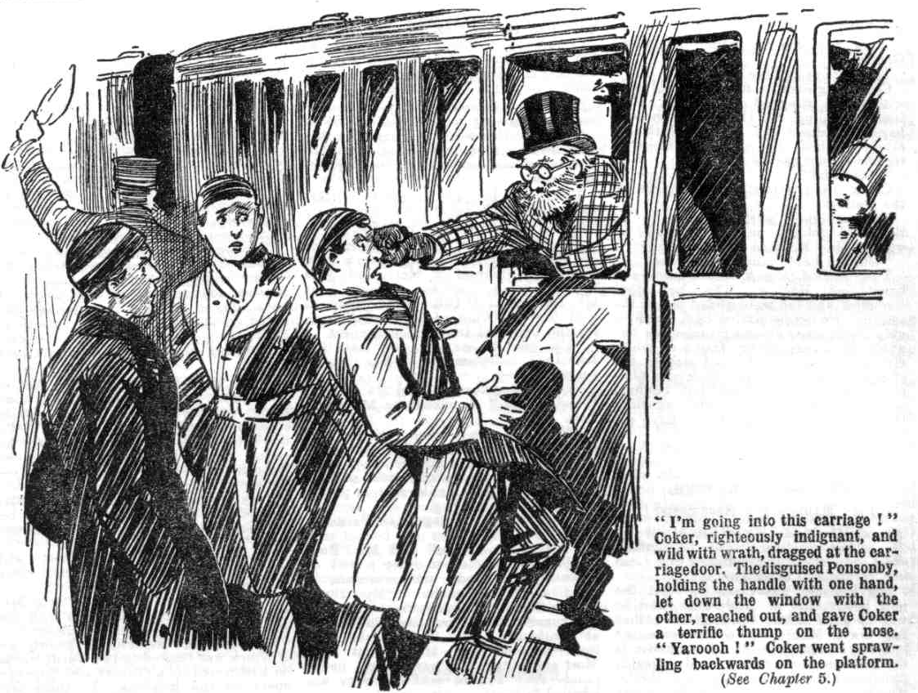

Coker went sprawling backwards on the platform.
“Oh crumbs!” gasped Potter. “ Is that old johnny mad, or drunk, or what? He's knocked Coker down!”
“ Oh, my hat!” stuttered Greene.
They rushed to pick up the dazed and bewildered Horace. The last door slammed, and the train glided out of the station. Ponsonby settled back comfortably in his seat, grinning under his disguise, in a very cheery frame of mind. He considered that he had started the afternoon well. On the Redclyffe platform Coker & Co. were left behind; and Coker glared after the vanishing train with a glare that might have excited the envy of a basilisk.
THE SIXTH CHAPTER.
Lord Mauleverer’s Headmaster!
LORD MAULEVERER stood on the platform at Courtfield Junction and watched the train come in from Lantham.
His lordship was there to meet the new headmaster of High Oaks, and he was in good time. With all his rather lazy ways, Mauly was seldom or never late for an appointment. Punctuality is the politeness of princes as Mr. Quelch sometimes told the Remove; and Mauly, who forgot nearly everything else, never forgot to be polite. So there he was, ready and waiting dressed very nicely as usual, with a shining topper on his well-brushed head, and only a slight swelling on his noble nose marring his good looks—a trace of the scrap in the classroom at High Oaks.
The train stopped, and nine or ten passengers alighted from it. Lord Mauleverer glanced over them and picked out at once a rather little old gentleman in horn-rimmed spectacles.
This was the only passenger who could possibly have been taken—or mistaken— for a schoolmaster; the others being obviously nothing of the kind. So Mauleverer approached the horn- rimmed gentleman and raised his hat with great politeness.
“ Excuse me, sir.” said Mauleverer respectfully, “am I speakin’ to Mr. Buncombe?”
The middle-aged gentleman blinked at him through his huge spectacles. It did not occur to Mauleverer that the man knew him by sight. Certainly it was not likely to occur to him that a man with horn glasses and grey hair and beard was no older than himself.
“Yes, my boy,” said the gentleman, blinking at him. “My card, sir—my card.”
The horn-rimmed gentleman, with the deliberation of middle age, took out a card-case and extracted therefrom a card, which he handed to Lord Mauleverer. Mauly looked at it and read:
“ Joseph Buncombe,
M.A. Oxon, O.B.E.”
Lord Mauleverer looked at the little gentleman again. He was rather impressed by learning that the man was an O.B.E. A man who had obtained the Order of the British Empire was bound to be more or less distinguished in some way or other. A man who was not only a Master of Arts of Oxford, but an O.B.E., was surely a suitable headmaster for High Oaks school.
There are certain legal penalties attached to giving a false description of oneself, as Ponsonby of Highcliffe was well aware. But he had had his cards printed in Lantham without the slightest hesitation.
Howsoever his jape on the Greyfriars Remove turned out, it was not likely to bring him in contact with the law.
Lord Mauleverer, in the innocence of his heart, did not reflect that a man might call himself a Master of Arts without being ‘artium magistar” at all. And that O.B.E. might stand as well for the Order of the Bad Egg as for the Order of the British Empire.
“ I’m glad to see you, sir,” said the schoolboy millionaire. “I’m Mauleverer, sir—”
“Quite so, quite so—Lord Mauleverer, I understand.” squeaked the Master of Arts.
“ Yaas. If you’ll come with me, sir, I’ve got a car waitin’—”
“Very good, very good!
Mr. Buncombe walked out of the station with Lord Mauleverer, a porter following with his bag.
“Any more baggage, sir?” asked Mauleverer.
“Yes, quite, quite,” said Mr. Buncombe, who seemed to have a way of repeating his words, not uncommon in middle-aged gentlemen. “ My trunks
—hem—two large trunks, will come on; the guard failed to put them in his van at Lantham. I saw them on the platform—hem—as the train went out. Most annoying! But never mind, never mind; they will be sent on; they are labelled.”
“I’ll phone along the line, sir, if you like—”
“ Not at all, not at all! The railway is quite reliable; the trunks will arrive in due course.
“Very well, sir.”
Lord Mauleverer conducted the O.B.E. to the car, and followed him in. The chauffeur started for High Oaks at once.
Mr. Buncombe blinked at Mauleverer through the big horn glasses, which gave him an oddly owlish look, and certainly a rather learned aspect as well.
Lord Mauleverer returned his inspection with some interest.
As a matter of fact, Mauleverer was quite well aware that advertising for a headmaster was, to say the least, an unusual proceeding, and that a school- master who applied for the post was not likely to be in the ordinary run of schoolmasters.
But so far as he could see, Mr. Buncombe was satisfactory.
He looked owlish and learned, he looked middle-aged and respectable; and he was a Master of Arts of Oxford University, and an O.B.E. over and above.
High Oaks School was rather fortunate to bag such a headmaster, in the somewhat extraordinary circumstances, Mauly considered. Few Masters of Arts or O.B.E.’s would have cared to take on the mastership of a school composed of fellows who had marched out of their own school in defiance of their own headmaster. Mauleverer could not help wondering a little that Mr. Buncombe had done so. But that, after all, was Joseph Buncombe’s own business.
“ Perhaps I’d better warn you, sir, that you may find the fellows at High Oaks a little out of hand.” said Mauleverer.
“ No doubt, no doubt.”
“You’ll know how to handle them,
“Oh, quite, quite! I have been used to unruly boys.” said Mr. Buncombe. “I have had great experience as a Form master, and headmaster also—very great experience. I assure you that I maintained very careful discipline when I was—hem—a Housemaster at Eton.”
“ You’ve been a Housemaster at Eton, sir?” asked Mauleverer, feeling that this was an additional recommendation.
“Quite, quite! I gave up my House-mastership in the War,” explainecd Mr. Buncombe, answering the question Mauleverer was too courteous to ask. “War work kept me very busy—hem. It was then I was—hem—awarded the
—hem--trifling distinction I bear—hem. having considerable private means, I have allowed myself a long holiday, devoted chiefly to study. No doubt at High Oaks I shall find time for continuing my work on the Earlier Greek Poets.”
“Yaas, sir,” said Mauleverer, feeling his respect greatly increase for a man whose constitution and intellect would stand the Earlier Greek Poets. “ We don’t take Greek in the Remove,” he added rather hastily. “ Only two or three fellows had Greek with Quelchy— I mean Mr. Quelch.’
“My favourite subject,” said Mr. Buncombe. “Possibly it may be practicable to institute a special Greek class.”
“I—I don’t fancy the fellows will exactly rise to it, sir.” said Mauleverer in dismay.
“Well, well, we shall see!” said Mr. Buncombe, winking into space with the eye that was away from Mauleverer.
Ponsonby of Highcliffe’s knowledge of Greek was limited to two words which he had heard in a Gilbert and Sullivan opera in the holidays. In these circumstances, certainly Mr. Buncombe would have found some difficulty in dealing with a Greek class at High Oaks.
The car glided out of Courtfield now, and was following the road across the common, which led to High Oaks, and beyond that scholastic establishment to Greyfriars and Friardale.
By the roadside a tall, angular gentleman was walking, and he glanced at the approaching car.
Mr. Buncombe looked at him, and so did Mauleverer—the latter recognising Mr. Quelch, late Remove master at Greyfriars.
Mr. Quelch, though dismissed from Greyfriars School, and steadily refusing to have anything to do with High Oaks, was still staying on in Courtfield.
Perhaps he was at a loose end now that his duties as a Form master had closed, and considered that Courtfield was as good as any other place in which to spend his leisure. Perhaps anxiety for what was happening to his late Form kept him there. Or perhaps he was simply haunting the scene of his former activities because he could not tear himself away, like a ghost revisiting the glimpses of the moon. Certainly his dismissal had been a heavy blow to Mr. Quelch. and he could not reconcile himself either to idleness or to seeking another post in another school.
He was now in possession of leisure; but he had had so little leisure for so many years that he hardly knew what to do with it. He was, in fact, a school- master bred in the bone, and out of a school he was at a loss. Once he had been, so to speak a real turtle, and now he was only a mock turtle.
There was a cloud on his face as he walked along the road over the common in the sunny spring afternoon. But his expression changed at the sight of Lord Mauleverer in the car.
“ Bless my soul!” said Mr. Buncombe, in his squeaky voice. “ That odd old gentleman seems to know you, my boy.”
“That what, sir?” asked Mauleverer, rather sharpIy.
“I refer to that bony person with a face like a crawfish.” explained Mr. Buncombe.
Mauleverer frowned.
“That is Mr. Quelch, my Form master at Greyfriars, sir.” he said, very stiffly. “ A gentleman whom I respect very highly, sir.”
“ Oh, yes, yes; the person who was dismissed, I think you mentioned in your letter to me.” said Mr. Buncombe. “ Why was he dismissed? Drink?”
Lord Mauleverer jumped.
“Certainly not!” he gasped.
Mauleverer signalled to the chauffeur to stop the car. Mr. Quelch had stepped into the road. and evidently desired to speak. The car drew up, and Lord Mauleverer saluted his old Form master very respectfully.
Mr. Buncombe looked away from him out of the window on the other side. No doubt he had his own reasons for not desiring to meet the gimlet eyes of Henry Samuel Quelch, if he could help it:
“Good-afternoon, sir.” said Lord Mauleverer. “Takin’ a little walk this nice afternoon, sir?”
“Yes,” said Mr. Quelch, glancing past Mauleverer at the horn-rimmed gentleman, and obviously curious, or at least interested. “ I am sorry to see, Mauleverer, that you and your friends have not yet returned to school.”
“We’re at our own school, sir.”
“Nonsense!”
“ Hem!”
“ Although I am no longer your Form master, Mauleverer, I have not lost my interest in my late Form.” said Mr. Qucich.
“You’re very kind, air.”
“I trust that something like order is being preserved in the Remove, in spite of their rebellious conduct.
“Well, sir, the fellows have been a bit out of hand.” said Lord Mauleverer. “ I engaged a prizefightin’ chap to keep order—”
“Wha-a-at?”
“But there was a bit of misunderstandin’, and a row, and he went. But it will be all right now, sir.” said Mauleverer. “We’ve got a headmaster now.”
“Impossible.”
“This gentleman, sir,” said Mauleverer, indicating his companion in the car.
“I repeat, impossible.” said Mr. Quelch “ No headmaster would assume control at High Oaks in the circumstances.”
“ Mr. Buncombe has done so, sir.”said Lord Mauleverer “Perhaps I’d better introduce you, sir—”
“Nothing of the kind.” interrupted Mr. Buncombe. still with the back of his head towards Mr. Quelch. “ In the circumstances, it is bettter not, my boy. It would be most awkward for me to come into any contact with your former master.”
“I stand corrected, sir.” said Mauleverer. “As you like, sir.”
Mr. Quelch was fixing a penetrating look on the back of Mr. Buncombe’s head, as if he really desired to pierce through it to his features beyond.
“I cannot understand this, Mauleverer” said the late Remove master. “I can understand no man taking on such a responsibility. I trust, Mauleverer, that you have not been deceived.”
“Oh, sir!”
“By some charlatan !“ said Mr. Qucich grimly.
Lord Mauleverer flushed.
“That is scarcely civil, sir, to Mr. Buncombe.” he said. “Perhaps we had better drive on.”
And at a sign the car passed on, Mr. Qucich standing in the road staring after it with a blank expression on his face.
That any headmaster of a proper standing would accept the headmaster- ship of High Oaks, as matters stood, Mr. Quelch felt to be impossible. That the simple and unsuspicious Mauly had been taken in by some charlatan was the only explanation of which Mr. Quelch could think.
He was feeling deeply uneasy as he stared after the car. Perhaps at last he was beginning to reconsider his resolve not to have anything to do with High Oaks School. If some charlatan— some man of dubious character—was imposing himself upon the juniors as a headmaster, it was assuredly time for somebody to intervene.
Mr. Quelch’s face was deeply thoughtful and perturbed as he resumed his walk towards Courtfield.
“I apologise, sir.” said Lord Mauleverer. “I’m sorry we stopped to speak to Mr. Quelch, sir. I hope you’re not offended, Mr. Buncombc.”
“No—no; the man is doubtless annoyed by his dismissal, and speaks bitterly in consequence.” said Mr. Buncombe. “ But I, of course, cannot have any contact with a dismissed Form master. It would be—hem—infra dig. Is that High Oaks?” he added, as the car turned into the drive.
“Yaas, sir. We’re there now.”
There was a yell from a fat junior loafing near the gates.
“I say, you fellows, he’s come!”
And there was a rush of the Removites to behold their new headmaster.
THE SEVENTH CHAPTER.
The Heavy Hand!
MR. BUNCOMBE stepped from the car.
He stood on the steps of High Oaks, surveying the mob of juniors who gathered round. Lord Mauleverer stood by his side as the car glided away down the drive to the gates.
“ So that’s the man!” snorted Bolsover major.
“I say you fellows, he’s rather a guy! Look at his specs!”
And Billy Bunter blinked through his own big glasses at the horn-rimmed spectacles of Mr. Buncombe with great entertainment.
“What a specimen!” grinned Skinner. “Not much of him, but what there is isn’t much to look at!” remarked Sidney James Snoop.
“Order!” shouted Bob Cherry.
“Rats!”
“Shut up, Bolsover.”
“Go and eat coke!”
“Rag him!” yelled Stott.
“Order!”
There was a roar of contradictory voices.
A trace of uneasiness might have been observed in Mr. Buncombe’s wrinkled, owlish, spectacled visage.
Ponsonby of Highcliffe had planned to jape the Remove; but certainly not to be ragged by those cheery young gentlemen.
He had not taken into account the possible state of feeling at High Oaks, where something like civil war was now the order of the day.
A ragging from the unruly spirits, to begin with, would have been an absolute disaster to Mr. Buncombe.
So long as he was only looked at, and not touched, he could see that he would pass muster. But a rough handling would have played havoc with his grey hair, and beard, and spectacles, and make-up; and would, in fact, have revealed the imposture. In which ease, the venturesome japer had the time of his life to expect.
He backed a little behind Lord Mauleverer.
“ This—this reception” he stammered.
“ I’m afraid some of the fellows are a bit unruly, sir,” said Lord Mauleverer apologetically. “ But we’ll jolly soon bring them to order. Shut up, you ruffians”
“Yah!”
“Go and eat coke, Mauly!”
“ Duck that old image in the pond!” yelled Bolsover major.
“Good egg!”
“Rally round, you men!” exclaimed Lord Mauleverer.
“ Yes, rather !”
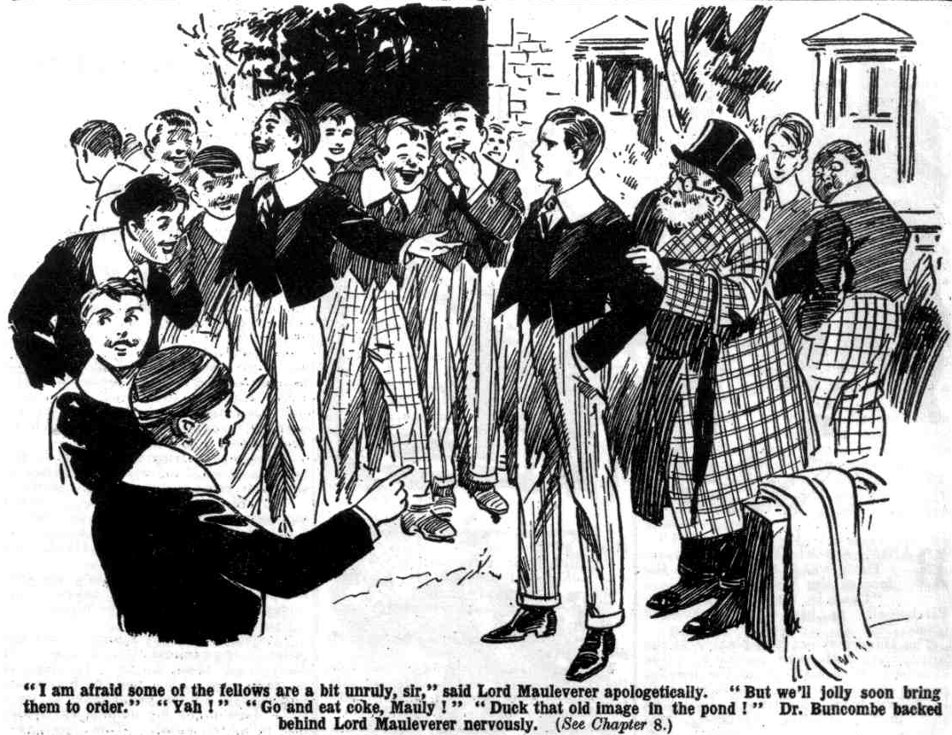H
Harry Wharton & Co. formed a body- guard. round the new headmaster at once. Whatever they thought of Mr. Buncombe, and of his accepting the extraordinary appointment Lord Mauleverer had offered him, they were
to stand by him and uphold his authority.
“ Line up, you fellows!” said Harry Wharton.
“The line-upfulness is terrific.”
“ Back up!” shouted Peter Todd.
Toddy joined the bodyguard, and Squiff, and Tom Brown, and the Bounder, and Redwing, followed suit. Nearly half the Form were on the side of law and order; and of the others several stood aside as neutral. Bolsover major & Co. found themselves in a considerable minority.
But the bully of the Remove was in a truculent temper.
“ Rag the old donkey!” he roared.
“ Shut up, Bolsover!”
“Rag him!” yelled Bolsover; and he led a rush at Mr. Buncombe.
That gentleman was quite reassured now. He knew the Removites better than they supposed; and he was aware that all the hefty fighting-men of the Form had rallied for his protection.
“This is most disorderly!” he repeated in his squeaky voice. “I was—hem—far from expecting this! Order! I repeat—order!”
“Rats to you!” roared Bolsover. He came on with a rush; but in face of the determined attitude of Lord Mauleverer’s supporters, Bolsover’s followers melted away. Bolsover arrived alone within punching distance.
And the punching, when it started, was all received by Bolsover major, the whole bodyguard falling upon him and smiting him hip and thigh.
It is said to be more blessed to give than to receive; and that is undoubtedly true in the matter of punches straight from the shoulder.
Bolsover major went spinning off the steps, and he crashed down on the drive with a heavy concussion and a loud roar.
“Next man in!” chortled Bob Cherry. .
“ Ha, ha, ha!”
There was no next man.
Now that a rallying point had been found, in the person of the new head- master, all the orderly elements in the Remove had rallied; and they had the upper hand without question. Doubtful neutrals promptly went over to the winning side. Fisher T. Fish, with his keen Transatlantic cuteness, saw at once upon which side victory was going to smile, and he ranged himself along with the bodyguard; and others followed. Skinner & Co. backed away; Bolsover major sat up, dizzy and furious, and breathless, and found that he had no supporters at all. Only a short time before he had been a rebel leader; now he lay there, like JuIius Caesar, with none so poor to do him reverence.
“Ow!” he gasped. “Wow! I’ll smash you! Ow!”
“Come and have some more!”. grinned Nugent.
“The morefulness is ready and terrific, my esteemed, beastly Bolsover!” chuckled Hurree Jamset Ram Singh.
Bolsover major staggered up.
It was clear, even to the bully of the Remove, that he was not going to rag the new headmaster of High Oaks. There was no support to be had—for the present, at least—from his late followers; indeed, they were grinning at him now, apparently entertained by his dusty and battered looks.
“You rotters!” gasped Bolsover major. “If you think I’m going to knuckle under to that old image you’re mistaken! See?”
“You’ll toe the line with the rest.” said Harry Wharton. .
“Rats to you!”
“Go into Hall now, all of you,” said Lord Mauleverer.
“Shan’t!” yelled Bolsover.
Mr. Buncombe stepped forward. He was feeling sure of himself now.
“ What is your name, boy?” he asked. The bully of the Remove glared at him.
“Find out!” he snapped.
“That is not the way to address your headmaster!”
“ Rats!”
“ Discipline must be restored in this school.” said Mr. Buncombe.
“School!”, yelled Bolsover derisively. “It ain’t a school, and you ain’t a schoolmaster, or you wouldn’t be here. We belong to Greyfriars, and we’ve chucked our headmaster, and we’re not taking on another—see?”
“Shut up, Bolsover!”
“Rats to you!”
“Your name is Bolsover, I understand.” said Mr Buncombe. “Bolsover, you will obey my orders!”
“Catch me” sneered Bolsover.
“Mauleverer!”
“Yaas, sir!”
“I presume there is a cane in this school?”
“Oh, yaas!”
“Kindly fetch it for me!”
“Certainly, sir.”
Lord Mauleverer went in for the cane. Bolsover major gave the horn- rimmed gentleman a glare of concentrated wrath.
“I am going to flog you, as an example,” said Mr. Buncombe.
“Why, you—you—you blinking old owl, I’ll smash you if you lay a finger on me! I could knock you into pieces with one punch!”
“Take hold of that boy!” said Mr. Buncombe, pointing at the bully of the Remove, and addressing the Famous Five. “Bend him over, and hold him!”
There was a moment’s hesitation. If any fellow ever had asked for it, Bolsover major had; but nobody wanted to see the new headmaster begin by flogging one of the Remove. But Harry Wharton & Co. had given Mauleverer their word to back up his new headmaster; and their word was their bond. They had no choice in the matter.
“If Bolsover apologises, and obeys orders, sir—” hinted Harry.
“Catch me!” roared Bolsover. “I’ll knock the old fool’s blinkers through the back of his head!”
“That does it!” exclaimed the captain of the Remove angrily. “If you will have it, you bullying chump, here goes! Collar him!”
The next moment Bolsover major was struggling furiously in the grasp of five pairs of hands.
Bolsover was a powerful fellow; but his hefty struggles availed him nothing. He was unceremoniously dragged over, bent in a favourable position for a flogging, and held there in a grasp of iron. Lord Mauleverer came back with the cane, and handed it to Mr. Buncombe. That gentleman’s eyes gleamed over his horn-rimmed glasses. There had been an occasion when Bolsover of the Remove had kicked Ponsonby of Highcliffe. He was going to pay for that kick now, though he was quite unaware of it.
Mr. Buncombe flourished the cane, and amid a breathless silence on the part of the Remove brought it down on Bolsover major with a terrific cut.
Bolsover’s yell rang far beyond the confines of High Oaks.
Whack, whack, whack!
Mr. Buncombe laid on the cane with all the strength of his arm, which was considerable.
Six terrific swipes brought a succession of fearful yells from the bully of the Remove.
The juniors looked on breathlessly.
They had seen floggings at Greyfriars, some of them severe; but they had never witnessed such a thrashing as this.
Bolsover major fairly crumpled up under it.
“Leggo!” he yelled. ”I give in. Let a fellow go! Oh, my hat! Keep that brute off! Yaroooogh! I give in! Ow!”
“That’s six, sir.” hinted Harry Wharton, as Mr. Buncombe raised the cane for another lash.
“Silence, Wharton!”
“But, sir—”
“Hold your tongue, boy!”
Wharton coloured and was silent. The cane came down again, with another terrific swipe, and Bolsover major fairly howled.
“Isn’t that enough, sir?” asked Lord Mauleverer.
“Silence!”
“Oh, begad!”
Harry Wharton & Co. exchanged a glance, and released Bolsover major. He had asked for the thrashing, but there had been enough of it, in the opinion of the Famous Five. Bolsover major squirmed away just as the cane descended for the eighth time, and escaped the slash.
“Yow-ow-ow-ow!” he roared.
Mr. Buncombe tucked the cane under his arm.
“That will do,” he said. “Take that as a warning, Bolsover. You will be flogged again if you are disobedient.
“Yow-ow-ow!”
“Now go into Hall!” said Mr. Buncombe.
In deep silence the Removites marched into Hall, Bolsover major limping in with the rest, his rugged face white and furious, but all the truculence taken out of him for the time being. And when the roll was called Bolsover major answered to his name as obediently and promptly as if he had been in the old hall at Greyfriars, with Dr. Locke calling the roll. Skinner & Co. were even more prompt. The look on Bolsover’s face was enough for the malcontents of the form. And, for the present, at least, there was no resistance to the authority of the new head of High Oaks.
THE EIGHTH CHAPTER.
The New Head of High Oaks!
“JUGGINS!”
“Yes, my lord?”
“Show Mr. Buncombe to his room, Juggins.”
“Yes, my lord!”
Juggins fairly gaped at Mr. Buncombe.
The happenings at High Oaks, ever since it had been turned into a school, had caused Alfred Juggins more and more astonishment, but the arrival of a new headmaster was, to Juggins, the most astonishing circumstance of all. That any headmaster could be found to take charge of a school such as High Oaks was, to Juggins’ mind, amazing.
“This way, sir!” he gasped.
Mr. Buncombe followed him. A very handsome room had been prepared for the reception of Mr. Quelch at High Oaks, and had never been occupied, except by Billy Bunter for a short time— Bunter having had a little “barring out” on his own there. Mr. Buncombe now took possession of that apartment. His bag was carried into it by the amazed Juggins. His larger baggage had not yet arrived—and, indeed, was not likely to arrive, as it had no actual existence.
“You are the school porter, Juggins?” asked Mr. Buncombe.
“Yes, sir.” gasped Juggins, and confidential servant to his lordship, sir. P’r’haps you’ll ring this bell if you want anything, sir.”
“There are servants here, then?” asked the new Head.
Juggins suppressed a grin.
Almost every relation that Alfred Juggins possessed in the wide world had secured a job at High Oaks by this time. And as all the jobs were exceedingly well-paid ones, the Juggins clan were happy.
“Very good. You may go.” said Mr. Buncombe, rather sharply, noticing that Juggins’ eyes lingered on him very curiously.
“Yes, sir. Thank you, sir!”
“Juggins went, ruminating as he departed. There seemed, to Juggins’ to be something queer about Mr. Buncombe having taken up his appointment, and something queer about Mr. Buncombe himself. What it was he could not tell exactly, but there it was— Juggins was sure of it. His ancient eyes certainly did not penetrate the new master’s disguise, but something struck him as not being as it should be. He was very dubious indeed, and after leaving Mr. Buncombe in his room he proceeded to seek Lord Mauleverer, whom he found in hall.
“My lord,” said Juggins, with a cough.
“ Yaas?”
“Mr.—hem !—Buncombe, sir. I—I suppose your lordship knows all about him, sir?” hinted Juggins
“Yaas.”
“Oh ! Very good, sir !” said Juggins. “In the present somewhat—hem!— unusual circumstances, sir, it struck me as a little odd that a schoolmaster should, if your lordship will excuse me—”
“ Oh, quite,” said Lord Mauleverer affably. “But he is all right, Juggins. Master of Arts of Oxford, and all that.”
“Indeed, sir !”
“And an O.B.E., Juggins.”
“Really, sir ? “ said Juggins. “Your lordship has seen his credentials, of course, my lord?”
“I’m goin’ to.” said Lord Mauleverer. “As it happens, his papers are in his trunks, which have been rather delayed on the railway, it seems. Not that it makes any difference.”
“Oh!” said Juggins, eyeing his lord ship. “Very good, sir, if your lordship is satisfied, my lord.”
“Oh, yaas, quite.”
Juggins gave it up at that. He was quite convinced in his own mind that Mr. Buncombe was some sort of a charlatan. The same idea had occurred to Mr. Quelch. It really seemed incredible that a bona fide headmaster would take control at High Oaks. Still, it was no concern of Juggins, if his lordship was satisfied. The man could hardly be a burglar—there was nothing much at High Oaks to burgle, if it came to that. And he looked like keeping the schoolboys in order—which, from Mr. Juggins’ point of view, was a consummation devoutly to be wished.
Mr. Juggins had been ragged more than once by Bolsover major and his
crowd, and is own opinion was that the more they were thrashed the better it was for them, and High Oaks generally. So Mr. Juggins let the matter drop, though he could not help wondering what sort of a spoofer Mr. Buncombe was.
Lord Mauleverer was not worrying. over the bona-fides of Mr. Buncombe. But he was a little troubled by the severity of the punishment inflicted on Bolsover major. He strolled along to Wharton’s study after a time, and found
all the Famous Five there.
“Hallo, hallo, hallo, here’s Mauly!” said Bob Cherry. “Well, how do you like your new Beak, Mauly?”
“He looks like keepin’ order.” said Mauleverer.
“Hem! Yes.”
“You fellows think him rather a brute ?” asked Mauleverer.
“Well I couldn’t help thinking so.” said Wharton candidly. “He seemed . fairly to enjoy thrashing Bolsover, and he laid it on frightfully hard. Almost as he knew the chap, and had a grudge against him.”
“ Yaas. But, after all, Bolsover asked for it. You can’t call a headmaster names to his face, you know.”
“Oh, yes ; that’s all right. But——”
The captain of the Remove did not finish.
“You’re not quite satisfied yourself, Mauly.” remarked Johnny Bull, with a grin.
“ Well, perhaps not quite, “ assented Mauleverer. “ But my idea is, give the man a chance: We want a man to keep order; and he can do that. I’d rather chuck up the tussle an’ go back to Greyfriars than run this place as a bear- garden, with a hooligan like Bolsover doin’ as he chooses.”
“Same here!” agreed Wharton.
“The samefulness is terrific.”
“Yes; give him a chance, by all means.” said Harry Wharton “I don’t quite understand the man. There seems to be something about him—“
Wharton paused, looking puzzled, as he felt.
“Something a bit queer.” said Bob Cherry,
“Out of the common, anyhow,” said Wharton. “ I can’t exactly give it a name, but—well, he may be all right. We’ll give him a chance. Rely on us to back him up, Mauleverer.”
“That’s what I want,” said his lordship, relieved. “ If you men set the example the others will follow, an’ things will soon be goin’ on swimmingly at High Oaks. We wanted a headmaster, an’ we’ve got one, and it’s no good grousin’ first shot.”
“ Right as rain, old bean.”
“ I say you fellows “
William George Bunter blinked into the study.
“Hallo, hallo, hallo! How do you like the new Beak, Bunter?” grinned Bob.
Snort from Bunter.
“I can jolly well tell you that I don’t like him at all. If he thinks he’s going to lick me, he’s making a mistake. I shall have a barring-out again if there’s anything of that kind.”
“ Fathead !”
“ Oh, really, Cherry——”
“You’re going to toe the line with the rest of us, old fat bean.” said Frank Nugent. “ You’d better do your prep this evening, too. Mr. Buncombe will be taking the class in the morning.”
“1 say, you fellows, he can’t be much of a schoolmaster, or he wouldn’t come here.” said Bunter. “Mauly’s idiot enough to be taken in by any. spoofer, you know. Ain’t you, Mauly?”
“Oh, begad!”
“Skinner says that if he’s an O.B.E., O.B.E. stands for Old Bad Egg!” went on the Owl of the Remove.
“Ha, ha, ha!”
“Skinner says he wears a wig—“
“ How does Skinner know ?“
“Well, he says so.” answered Bunter.
“Most schoolmasters are a bit bald on the crumpet.” said Bob Cherry. “ Perhaps Buncombe feels the cold there this weather. No harm in a man wearing a wig if he’s lost his mane. He may have lost his mat wearing a tin hat in the War. Lots of men did.”
“ Skinner says he’s going to fish for it out of window with a fishing-rod and line and hook it off.”
“Ha, ha, ha!” roared Bob involuntarily, and the other fellows grinned.
Lord Mauleverer chuckled, but he became grave again at once.
“Skinner will get skinned if he does anythin’ of the sort !” exclaimed his lordship. “As a matter of fact, you men. I noticed that Mr. Buncombe was sportin’ a wig in the car comin’ here— at least, I thought so. No reason why he shouldn’t, if he wants to. Look at the polished tops in Master’s Common room at Greyfriars—not a beautiful sight, is it? If the masters didn’t wear mortar-boards in the class-rooms most of them would reflect the sun like burnin’glasses.”
“Ha, ha, ha!”
“I say, you fellows—”
“ Shut up, Bunter! Prep.”
“Yah!”
Billy Bunter rolled away to prep. He was angry and indignant at having prep to do: but after what had happened to Bolsover major he considered it judicious to get his preparation done, and he did. And the rest of the Remove did the same. Nobody in the Form wanted a licking from the new headmaster in the morning. But—if they had only known it—there were lickings to come, whether asked for or not. It was a case of the wolf and the lamb over again; as the Removites would have understood had they been aware of the real identity of Mr. Buncombe. But that, so far, was a deep secret.
THE NINTH CHAPTER.
The Prefects of High Oaks!
CLANG, clang, clang!
The rising-bell rang out loudly at High Oaks in the clear spring morning.
Every fellow in the dormitory turned out at once. Even Billy Bunter did not linger for a few moments more of balmy slumber.
Harry Wharton & Co. were setting an example. But an example was hardly needed. The thrashing of Bolsover major was example enough.
The slackers, indeed, were more eager to get on the right side of the new headmaster than the others were.
Harold Skinner fairly shuddered at the thought of going through what Bolsover major had gone through. And if it came to him there would be no help for it, so long as the greater part of the Form supported Lord Mauleverer and his new headmaster. The only alternative was to cut High Oaks and go back to Greyfriars and that was an experiment Skinner hesitated to try. Matters would have to be very bad at High Oaks before Skinner would take the risk of facing the wrath of Dr. Locke at Greyfriars on his lonely own. Skinner told his chums that he meant to try it on, if Quelchy came to take control at High Oaks. But Quelchy did not come, and it was not so bad as that.
The Remove were down in good time, rather curious to see their new Head again, though not much liking him. Little had been seen of him the previous evening. He had stated that he was tired from his journey. and had supped in his room and gone to bed. Nobody minded that, and certainly nobody guessed that he was anxious to avoid observation aa much as possible on his first day at High Oaks.
Mr. Buncombe did not appear at the breakfast-table, as the juniors had rather expected. Lord Mauleverer assuredly expected to find him at the head of the table, but he was not there.
“Juggins,” called out Mauleverer.
“Yes, my lord.”
“Mr. Buncombe has been called?”
“ Yes, my lord. He is breakfasting in his room, my lord.”
“ Oh! Very good Juggins.”
“ Mr. Buncombe has instructed me, my lord, to telephone to Chunkley’s Stores, my lord, for a supply of cigarettes, my lord.”
“ Oh, begad!”
“ I thought I would speak to your lordship first, my lord.”
“ You will obey all Mr. Buncombe’s instructions, Juggins, without referrin’ to me.” said Lord Mauleverer.
“ Yes. my lord.”
“ So the Beak smokes fags, does he ?” said Skinner.
“Why shouldn’t he?” said Lord Mauleverer. “It’s his own bizney. It won’t stunt his growth as it does yours, Skinner.”
“Oh, rats!”
“I’m sure he’s done growin’,” said Lord Mauleverer. “ He can’t be less than fifty. I believe fellows finish growin’ before fifty.”
“ Ha, ha, ha!” roared Bob Cherry. “ Some time before fifty, I believe. Buncombe finished quite early, I fancy; he’s not so tall as Bolsover now.”
“And he’s got elevators in his boots.” jeered Skinner. “ I’ve seen them. Must be a little shrimp in his socks!”
“ Little but good, perhaps.”
“I don’t see what you want to spy into a man’s boots for, Skinner.” remarked Lord Mauleverer. “ Why shouldn’t a little man make himself a bit taller if he likes? Live and let live. You shove on double hose on your spindle shanks, you know, when you sport Norfolks.”
“I don’t!” yelled Skinner.
“He, he, he! You jolly well do!” chuckled Billy Bunter. “Lots of skinny follows do—bony blighters like you, Skinner. StilI, where’s the harm? Every fellow can’t have a good figure.”
And William George Bunter glanced down at his own ample proportions in genuine admiration and there was a roar of laughter along the breakfast table. Certainly William George Bunter was never likely to be in need of padding. Nature had been very generous with Bunter in the matter of width.
Bolsover major sat through breakfast in sullen silence, with a scowling brow. He was still feeling a little the effect of his tremendous licking of the day before, and he was full of bitterness and rancour. But he realised that for the present it was futile to think of making a move against the new Head. Bolsover major toed the line, but he toed it reluctantly and savagely, waiting for a chance to stir up rebellion again.
When the juniors repaired to the classroom—which they did at the first clang of the school bell, rung by Juggins—they did not find Mr. Buncombe there. The new headmaster did not seem to be in a hurry to assume his official functions.
“Taking it easy.” sneered Skinner.
“ Well, he can’t take it too easy for us!” remarked Hazeldene. “ I’m not in a hurry to begin.”
“ Does he know the time of class, Mauly?” asked Mark Linley.
“Yaas, I told him.”
“Well, shall I give him a call, then?”
Lord Mauleverer shook his head.
“Let him take his own time.” he answered. “He’s headmaster, on a full ticket, and we don’t want to look like dictatin’ to him. I think probably he’s the first headmaster engaged by the pupils themselves to take charge of a school—”
“ The probability is terrific.”
“Ha, ha, ha!”
“So the position’s rather delicate.” said Lord Mauleverer. “ We must be very careful to avoid doin’ anythin’ that would look like an infringement of his authority, what ?”
“Spoken like a giddy oracle.” said Bob Cherry. “ Besides, what’s the matter with a game of leap-frog on a cold morning!”
“Hear, hear!”
“Well, there’s no harm in a game while we’re waitin’” conceded Lord Mauleverer. “ I’ll sit down and watch you men.”
Lord Mauleverer sat down, and yawned, while the other fellows played leapfrog, or loafed about the class room. It was more than half an hour later that a step was heard in the passage.
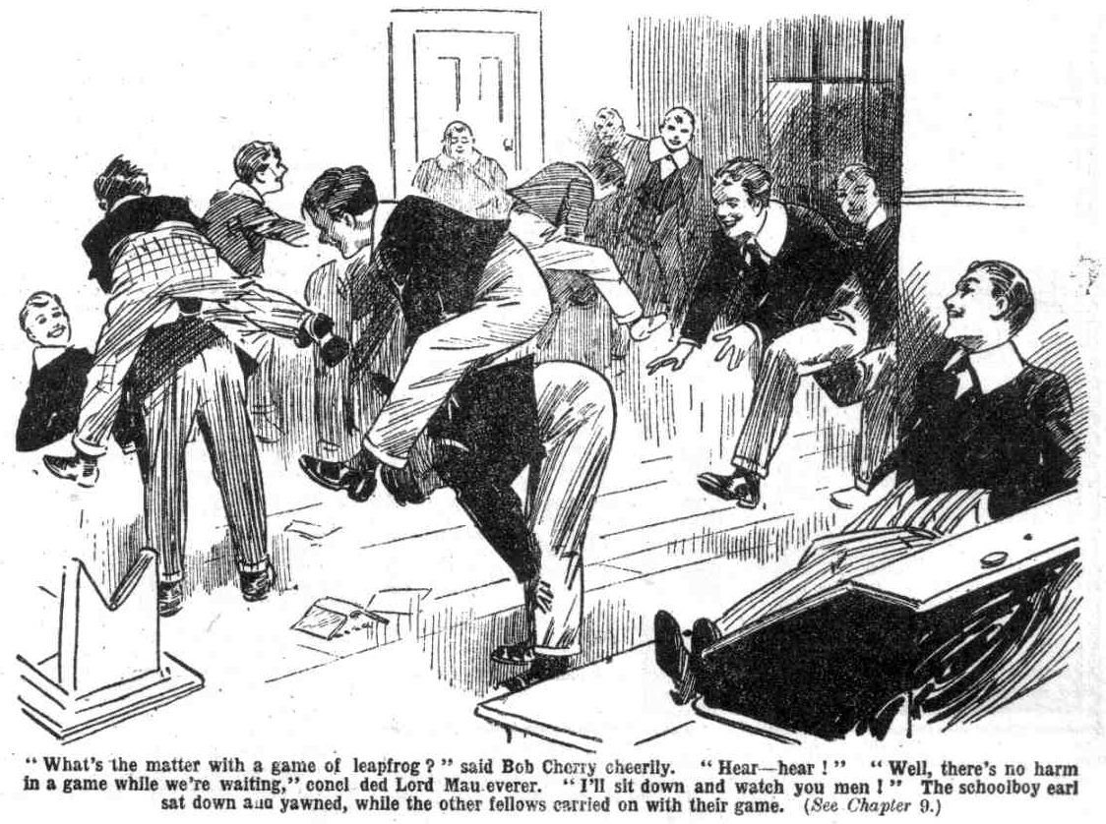 “I say, you fellows, he’s coming!” piped Billy Bunter and he made a dive tor his place.
“Sit down, you chaps,” called out Harry Wharton. “ Order when the Head comes in.”
“The orderfulness will be terrific.”
“ Rats!” said Skinner ; but he sat down all the same. Until a large majority of the Form should turn against Lord Mauleverer’s headmaster, it was Skinner’s intention to be very good indeed.
Mr. Buncombe appeared in the doorway.
He wore a mortar-board and a Master of Arts gown now, and certainly looked very scholastic; though for a middle-aged gentleman there was no doubt that he was remarkably short of stature. Not only Bolsover major, but other fellows in the Remove, were as tall as Mr. Buncombe, or taller. In a Sixth Form-room it was not uncommon for a fellow to be taller than his master; but it was extremely unusual in a junior room. Lord Mauleverer certainly would have preferred a more imposing head-master to take control at High Oaks: but, after all, headmasters did not get appointed for their inches, like guards-men. It was to be hoped that Mr. Buncombe’s intellect had developed on more extensive lines than the rest of him.
He blinked at the class through his big horn-rimmed glasses, and there was silence. Why Mr. Buncombe was so late to take the class the juniors did not know ; and certainly they did not guess that he had hesitated to face them in the class-room, for reasons that were good to himself. But he had made up his mind to it at last, and here he was.
The juniors eyed him intently. Now that they had been “ put wise,” as Fisher T. Fish expressed it, they could see that he had elevators in his boots, and were sure that his grey hair was a wig. They little dreamed, however, how much more of him was an imposture.
“Good-mornin’, sir!” ventured Lord Mauleverer.
“Good morning, sir,” said several other fellows at once, with great polite- ness.
Mr. Buncombe breathed hard for a moment. Perhaps he had doubted whether his get-up would stand the full glare of day in the class-room. If so. he was reassured now.
“Good-morning, good-morning,” he said, in his squeaky voice. “ I have-’hem—a few words to say before we—er —commence. As there are no other masters in this school, I shall select members of this Form to act as
prefects”
This struck the Removites as quite a good idea.
“Very good, sir,’ said Lord Mauleverer. “ Wharton’s captain of the Form. sir—”
“ I am not in need of advice, boy.”
“Oh, begad!”
“ Bolsover!” rapped out Mr. Buncombe.
Bolsover major jumped.
“Oh, yes, sir!” he ejaculated.
“ I appoint you head prefect of High Oaks.”
Bolsover major stared at him blankly. This was about the last thing he would have expected to hear, after his experience with Mr. Buncombe. There was a murmur in the class. In the general opinion of the Remove, the Head had made the worst selection possible.
“ You will be head prefect, Bolsover with power to cane the other boys, as is usual with prefects.” said Mr. Buncombe.
“Oh! Yes, sir!”’ gasped Bolsover major.
“ Skinner!”
“Yes, sir!”
“You are appointed a prefect also.”
“ Oh, my hat! I—I mean, thank you, sir!” stuttered Skinner in utter amazement, hardly believing his ears.
“ Stott! Snoop!”
“Yes, sir!” almost gurgled Snoop and Stott. Was the amazing Head going to make them prefects also?
He was!
“I appoint you prefects of High Oaks!” said Mr. Buncombe.’ “Four, I think, will be sufficient—Bolsover, Skinner, Snoop, and Stott. I trust that I shall be able to rely upon you.”
“ Oh, yes, sir !” gasped the astounded four.
The rest of the Remove simply stared. The new headmaster had picked out the bully of the Form, and the three worst slackers, to appoint as prefects! True, as a stranger to the Remove, he could not be expected to know the characters of the fellows yet. But surely a man with any sense at all would have waited till he knew the fellows a little before appointing prefects! It did not occur to the Removites that their new Head knew—only too well—what he was doing!
Bolsover major was grinning now. His savage sullenness had vanished. At one swoop he was turned from Mr. Buncombe’s bitterest enemy into his most enthusiastic supporter. Bolsover could be relied upon—if not exactly to be a dutiful prefect, at least to bully and rag and hector any fellows who were in his power. Undoubtedly Mr. Buncombe knew what he was doing
—if his intention was to give the Remove an exceedingly unpleasant time during his headmastership!
“Well, my only hat!” muttered Bob Cherry, in utter disgust.
Mr. Buncombe blinked round through his horn glasses.
“Someone is talking in the class! It was you, I think, Cherry.”
“I—I—I—”
“Tell me the truth, boy.”
Bob flushed angrily.
“I shouldn’t tell you anything else, sir,” he snapped.
“No impertinence,” said Mr. Buncombe. “Answer me at once, and answer me truthfully. Did you speak?”
“ I did!” grunted Bob.
“Take a hundred lines.”
Grunt from Bob Cherry.
“Do you hear me, Cherry?”
“Oh! Yes!” Bob Cherry’s manner rather lacked the respect due to a headmaster, there was no doubt about that.
“You will write out the lines after class Cherry, and hand them to the head prefect before dinner.”
“Very well, sir.” said Bob, breathing hard and deep.
“It is my intention,” said Mr. Buncombe, “to keep order in this school. Indiscipline and disrespect are things of the past at High Oaks. I shall keep the strictest order, supported by my prefects.”
His prefects grinned.
The four bitterest opponents of the new Head had been turned into his firmest supporters. There was no doubt that they would back up Mr. Buncombe for all they were worth. Mr. Buncombe might look rather an owl, and rather a guy ; but he knew what he was about! He was following the ancient Roman maxim of “divide and govern”: a maxim which, it is to be feared, most rulers keep in mind, especially in troubled times.
Lord Mauleverer felt called upon to raise a remonstrance. After all, the head was a headmaster of his own appointing.
“ If you please, sir——” said Mauleverer.
“I do not please, Mauleverer. Take a hundred lines for talking in class.”
“ Oh gad! But really, sir—“
“Two hundred lines.”
“The fellows you have selected as prefects, sir, aren’ t of much account in the Form.” explained Mauleverer. “ You see—”
“ Silence! Another word and I shall cane you.”
“Oh, my hat!”
Lord Mauleverer was silent, feeling rather like the man in the fable who warmed a viper to his bosom, and was stung in return for his kindness. This really was not what he had expected of his new headmaster. He sat silent, dismayed and perplexed.
“We shall now commence.” said Mr. Buncombe. “ I desire you all to under stand that slacking, and disorder, and carelessness in lessons, are at an end. Work is now the order of the, day. While I hold my appointment here, I shall keep High Oaks up to the mark. You have your Latin grammars, I presume? Each of you will take six Latin irregular verbs, and write them out with their complete conjugations.”
“Oh!”
“ The prefects will keep order here, as I have some other matters to attend to—matters of some importance. The prefects will not take part in the lesson; they will take charge of the class and keep order. You understand me Bolsover?”
“Oh, quite, sir.” grinned Bolsover major.
“ During my absence, do not let me hear a sound from this class-room!” said Mr. Buncombe. “Any indiscipline will be severely punished. Proceed with your lesson.”
And Mr. Buncombe walked out of the classroom.
THE TENTH CHAPTER.
Bend Over!
HARRY WHARTON & CO. looked at one another.
Lord Maueverer sat blinking. To say that the Remove were
amazed would be to put it very mildly. They were astounded.
Some of the fellows had doubted whether the new Head would be able to restore discipline at High Oaks.
Their doubts on this point were now set at rest. It was obvious that he was a strict disciplinarian. But the fellows who had been keenest to see order restored, were the fellows who were now most deeply incensed against the new Head. The malcontents were the fellows who were backing him up most enthusiastically now.
Bolsover major was still feeling the effects of his thrashing. But he had forgiven Mr. Buncombe for that now. He fully approved of stern discipline, when it gave him the power to bully and hector.
Skinner & Co. were equally satisfied. They had escaped work—which was their chief object. They were invested with official powers. They were amazed, but they were decidedly pleased.
For some moments, nothing was said. The juniors were too astonished to speak. They did not proceed with the task Mr. Buncombe had assigned them.
That task astonished them as much as anything else. Writing out Latin con- jugations from their grammars was not a lesson. They could have done that “On their own” if so inclined; a head-master was not required to give lessons of that sort. If this was Mr. Buncombe’s method of instruction, Mark Linley was a better master than the new Head.
“ Well!” said Bob Cherry, at last. “This beats it! What sort of a potty freak have you dug up, Mauly?”
“The freakfulness is terrific!”
“Those rotten slackers appointed prefects!” growled Johnny Bull, “and let off lessons, too! What does the man mean?”
“I say, you fellows, I’m not going to write out six irregular verbs.” wailed Bunter. “I hate irregular verbs, you know.”
“The man must be mad!” said Wharton.
“ Mad as a hatter!” said Nugent.
“Look here. Mauly. I’m fed up with your dashed headmaster !” exclaimed Peter Todd. “Call him a headmaster?”
“ Sack him, Mauly!” suggested Squiff. “ Say the word, Mauly, and we’ll kick him out.” said the Bounder.
“Hear, hear!”
The four “ prefects” had left their places in the class, and stood in a grinning group; the only fellows in the Remove who were pleased with the amazing turn that events had taken.
From all the rest of the class came a growl of deep discontent.
Lord Mauleverer looked worried and distressed. Hitherto, Mauleverer had proved a remarkably efficient leader for the Greyfriars rebels. But in this appointment of a new headmaster, it looked as if Mauly had made a rather bad break at last. But Mauleverer was not the fellow to turn back at the first discouragement. He had appointed the Head of High Oaks, and to cancel that appointment on the first morning in class was not to be thought of. Mauleverer was distressed and disappointed, but he was loyal.
“Take it calmly, you men.” said Mauleverer, at last. “ We wanted a headmaster, and—and we’ve got one.”
“We have—no mistake about that!” growled Johnny Bull.
“Some headmaster!” jeered Hazeldene.
“ What’s the good of grousin’?” argued Mauleverer. “ We’ve got to play up. We’re bound to give the man a free hand; and if his methods don’t exactly please us, we’ve got to stand it. After all, he’s restored order in this school, and that was what we wanted.”
“ Ye-e-es—but——” said Wharton restively.
“ You men promised to back him up.” said Lord Mauleverer quietly. “ I hold you to it.”
“ That’s all right. But—”
“The butfulness is terrific.”
“He’s got a sinecure as headmaster, if he’s going to teach us by setting us to write out verbs, while he goes out for a walk!” jeered Wibley.
“I dare say that’s his method—”
“ Rot!”
“ Rubbish!” howled Bunter. “ I’m not going to write out verbs, I know that. I shall jolly well have another barring-out, I can tell you.”
“Shut up, Bunter!”
“Oh, really, Mauly—”
“It’s all rot!” said Peter Todd.
“ Utter rot,” said Russell. “ I’m jolly well thinking that Bolsover was right, and we don’t want a headmaster here at all. I’m going to back up Bolsover, Mauly.”
“ Same here.” said Newland.
“ Yes, rather!”
“Hear, hear!”
“Play the game you know,” urged Lord Mauleverer. “We’re bound to play up; it’s up to us.”
“Rats!”
“Rot!”
Lord Mauleverer opened his Latin grammar, and took up his pen. He liked Latin irregular verbs no more than the other fellows; indeed, the mere thought of the task before him made him feel tired. But he felt that it was up to him, and he was loyal. The Famous Five though with deep feelings, followed his example. Mark Linley and Penfold were already at work. Squiff and Tom Brown and Toddy joined in more slowly. One or two other fellows—Redwing and Ogilvy, followed on. But the others talked, in rising tones of indignation. Most of them were prepared to obey a headmaster who was a headmaster: but this sort of headmastership “got their goat,” as Fisher T. Fish expressed it.
Bolsover major could have counted upon a big majority now, had he been planning an outbreak against the Head. But Bolsover major was now thinking of nothing of the kind.
Bolsover major was tasting the sweetness of power, and he was more than satisfied with the new regime. No work and official permission to bully and overbear, suited Bolsover major down to the ground. Undoubtedly the new headmaster knew very well what he was about. The loyal member of High Oaks were put on their honour, and the disloyal members were influenced by having it made worth their while to support the new Head. There was a surprise in store for the fellows who looked to Bolsover major as a rebel leader.
“ I say, Bolsover!” called out Bunter.
“ Bolsover, old man!” exclaimed Russell.
“We’re on your side, old chap !” said Hazeldene.
Bolsover major approached the class. The expression on his rugged face was unpleasant and domineering.
“Too much talking in class!” he rapped out. “ Silence!”
“Eh?”
“What?”
“Oh, really, Bolsover—”
“Silence !“ shouted the bully of the Remove, alias the head-prefect of High Oaks School.
“Look here, you beast—” howled Bunter, in breathless indignation. “You cheeky beast, do you think you’re going to come the prefect over us? Go and eat coke!”
Bolsover major eyed him grimly. Hand me the cane, Skinner, will you?”
“You bet !” grinned Skinner.
“Do you think you’re going to cane me?” shrieked Bunter. “You heard what the headmaster said !” chuckled Bolsover major.”Prefects can cane fellows for cheek and disobedience, same as at Greyfriars!”
“You’re jolly well not going to cane me!” yelled Bunter.
“You’ll see!”
Skinner handed Bolsover major the cane. The prefects of High Oaks were enjoying their morning, at all events.
“You beast, Skinner!” howled Bunter. “Why, only yesterday you were saying you’d fish off Old Bad Egg’s wig with a fish-hook!”
“Yesterday isn’t today!” grinned Skinner. “I wasn’t a prefect yesterday!”
“You’re not a prefect now, you cheeky beast!” shrieked Bunter. “And Bolsover isn’t either! Yah!”
“I’ll show you whether I’m a prefect or not!” said Bolsover major. “Stand out before the class, Bunter!”
“Shan’t!” yelled Bunter.
“Hook him out, you men!”
“What-ho!”
The other prefects proceeded at once to hook out William George Bunter. This exercise of their new and unexpected powers greatly delighted Skinner & Co. had no fault to find with their new headmaster. They approved of him and his methods with all their hearts.
Bunter, roaring protest, was hooked out before the class. Bolsover major brandished the cane.
“Bend over, Bunter!”
“Shan’t!” shrieked Bunter. “I say, you fellows, rescue! I say, lend a hand! Yaroooogh!”
Peter Todd half-rose, and sat down again. Bolsover major was only exercising the powers conferred upon him by a headmaster—and there was no doubt that a real prefect at a real school would have made Bunter bend over, in the circumstances.
“Toddy!” yelled Bunter.
“Bend over!” roared Bolsover major. “Bend him over, you chaps!”
“Skinner & Co. bent Bunter over a chair. The Owl of the Remove roared in fearful anticipation.
Whack!
“Yaroooogh!”
Whack!
“Whooooop! Help! Fire! Murder! Whooop!”
Bolsover major tucked the cane under his arm in the manner of a Greyfriars prefect with his ashplant. Undoubtedly Bolsover fancied himself in the role of prefect.
“That will do! Go back to your place, Bunter!”
“Yow-ow-ow-ow!”
“Stop that row!” snapped Bolsover.
“Cease those ridiculous noises, Bunter!” said Skinner solemnly, in imitation of Mr. Quelch’s style.
“Ha, ha, ha!”
“Oh dear! Ow, ow, ow!”
“Billy Bunter crawled back to his place. It was borne in upon his fat mind that Bolsover major really was a prefect—to all intents and purchases, at least.
The head prefect of High Oaks cast a vaunting look over the class.
“Anyone else kicking over the traces?” he asked. “I warn you that I am going to keep order here—jolly good order.
“You’d better draw it mild all the same, Bolsover!” said Harry Wharton.
“Draw what mild?” sneered Bolsover major. “You’ve been ragging me for not obeying the new Head—ragging me for kicking over the traces! Now I’m obeying orders, and doing exactly as I’m told! What have you got to grouse about, I’d like to know?”
The captain of the Remove was silent. Bolsover major, for once, was in the right—at least, it was difficult to make it appear that he was in the wrong.
“Get on with your verbs!” said Bolsover major, in his most bullying tones.
“No slackers allowed in this class! You’re so jolly keen against slackers that you ought to be jolly pleased!”
The other prefects chortled.
“Any more cheek from you, Wharton, and you’ll get the same as Bunter!”
“Yes, rather!” chuckled Skinner, in great glee.
Wharton shrugged his shoulders contemptuously.
“Mind, I mean it!” said Bolsover. “I’ll have you out before the class and
”Better not!” said Harry.
There was a gleam in the junior captain’s eyes that warned the newly appointed head-prefect not to exceed his authority. His nose had come in contact with Wharton’s fist on more than one occasion.
And Bolsover major, on second thoughts, seemed to decide that he had better not. Class that morning at High Oaks finished without any more lickings.
THE ELEVENTH CHAPTER.
Going Strong!
THE Remove poured out of the Form-room after class, most of
them with angry , discontented faces. Four of them were smiling cheerily—the four prefects. Some of the more quiet fellows, like Linley and Penfold, took the new order of things philosophically, and made no complaint. But the greater part of the Remove were infuriated.
Having fellows like Bolsover and Skinner & Co. set in authority over them was exasperating, especially to the Famous Five. But the Famous Five, undoubtedly, were in a difficult position. They had been keenest of all on keeping order at High Oaks—keenest of all on running the place as a school, and not as a refuge for slackers and frowsters. They had given Mauleverer
their word to support the authority of the new headmaster. To appoint a headmaster, and then to criticise and interfere with him, and call him to order, was obviously not the thing.
A headmaster had to be Head on a “full ticket,” as Mauleverer had said. Resistance, too, meant that the Famous Five would be placed in the position of rebels and malcontents—the position formerly occupied by Bolsover and his friends, and which they had severely condemned. There seemed nothing for it but toeing the line, exceedingly unpleasant as that was; but the chums of the Remove were indignant and sore and savage, and most of the fellows shared their feelings.
Most of the Remove told Lord Mauleverer what they thought of him and of his precious headmaster. His lordship listened patiently. He had a hopeful nature, and he still hoped that the experiment would turn out well. After all, as he pointed out, a head-master had been engaged to restore order, and order had been restored. Class was now regularly attended; not a fellow had cut the class-room that morning. That was so much to the good.
“Rot!” was Bob Cherry’s reply. “We could write out Latin verbs without a master at all ! It’s not a lesson! Isn’t the man going to do any work now you’ve got him here?”
“I dare say he has his own methods, dear man.”
“Blow his methods, then!”
“The worst slackers in the Form are still slacking, and more than before!” said Nugent.
“Yaas. I dare say he knows best.”
“ Bolsover a prefect!” Bob Cherry clenched his hands. “ Why, he may be ordering me to bend over next!”
“Yaas.”
“Well, do you think I’ll do it?” bawled Bob.
“Yaas.”
“You silly chump You’ll see!“
“Yaas.”
“Don’t you think you’re the biggest idiot ever, Mauly?” asked Nugent.
“Yaas—I mean, no!”
“Blessed if I know what going to happen now!” said the captain of the Removc. “ I suppose it’s up to us to stand it if we can !”
“I’m fed-up with the Old Bad Egg, anyhow!” growled Johnny Bull.
“You ought not to speak of our Headmaster like that, Bull! That was Skinner’s name for him! I suppose you’re not going to pick up Skinner’s ways now you’re dissatisfied?”
“Oh, rats !” grunted Johnny Bull. “I’m going to stand it—as long as I
can, anyhow! But if those precious prefects think they can cane me—”
Johnny clenched his fists at the idea.
When the juniors came in to dinner they did not see Mr. Buncombe. He was not taking the head of the table. From Juggins it was learned that the new headmaster was lunching in his study. Apparently Mr. Buncombe was bent upon keeping himself in lofty seclusion from the school, like a god on cloudy Olympus. The juniors certainly did not miss his company; they were glad he was not there.
Bolsover major took the head of the table. Bolsover was blossoming more and more under the influence of his new position. The greatest of poets has told us that man, vain man, dressed in a little brief authority, plays such fantastic tricks before high heaven, as make the angels weep. Bolsover major was dressed in a little brief authority now, and the usual result accrued. Like most rebels, Bolsover became a tyrant the moment power was placed in his hands. He hated obeying orders, but he delighted in giving them.
“There’s too much talking at this table!” snapped Bolsover. It was a remark Mr. Quelch had sometimes had to make at Greytrias, often because Bolsover’s own tongue was too busy. But circumstances had changed since then. Bolsover was top dog now.
“Oh, can it!” said Bob Cherry.
“Silence, Cherry!”
“Rats!”
“Take a hundred lines.” said Bolsover.
“ Both!”
“I shall expect those lines before class this afternoon!“ said the head prefect of High Oaks.
“ You can expect!” assented Bob.
“If they’re not done, you’ll get a licking!”
“Somebody will get hurt, I fancy.”
“Bob, old chap!” murmured Lord Mauleverer.
“Oh, rats!” growled Bob. “ Do you think I’m going to be bullyragged by a swanking cad like Bolsover?”
“ Silence, Cherry!” shouted Bolsover major.
“Rats!”
“ I shalt report this to Buncombe.”
“Report, and be blowed!”
“I shall not cane you myself, Cherry.” said Bolsover major, no doubt realising that the task would prove a little more troublesome than caning Bunter. “I shall report you to Mr. Buncombe for a caning.”
“ Oh, shut up!”
“Who’s kicking over the traces now?” sneered Hazeldene. “That’s the sort of thing you fellows were ragging us for.”
Bob Cherry coloured uncomfortably.
Dinner was not a cheery meal. The chums of the Remove were glad when it was over, and they got away from the obnoxious company of Bolsover major.
Mr. Buncombe was not seen again till afternoon class. The juniors little dreamed what motive he had for keeping himself out of sight as much as possible. Cool and confident as he was, and successful as his imposture had been, Ponsonby of Highcliffe could never feel so many eyes upon him without a lurking uneasiness.
He appeared, however, for afternoon class. All the Remove were in the class-room on time when the horn-rimmed gentleman came squeaking in in his elastic-sided boots.
“I have to report Cherry, sir.” said Bolsover major. “He says he refuses to do the lines I gave him.”
“Is that the case, Cherry?” snapped Mr. Buncombe.
“Yes, sir!” grunted Bob.
“Stand out before the class!”
Bob hesitated a moment. Then, with deep reluctance, he obeyed the order. Mr. Buncombe signed to Bolsover to hand him a cane, and the bully of the Remove grinned and handed it over.
“Bend over that chair, Cherry !”
Bob Cherry did not move.
“ Do you hear me, Cherry ?” exclaimcd Mr. Buncombe. “ Is this how you obey your headmaster?”
“ Play up, old man!” whispered Lord Mauleverer.
All eyes were fixed on Bob Cherry. There was a struggle in his breast. But he realised that it was up to him, and, with deep, suppressed feelings, he bent over the chair.
Whack, whack, whack, whack, whack, whack!
It was the first time that Ponsonby of Highcliffe had had the opportunity of thrashing Bob Cherry with impunity. He made the most of it.
The “prefects” looked on, grinning. The rest of the Remove watched in silence.
“Now go to your place, Cherry! You are a disobedient and unruly boy!” he squeaked. “ I will keep order in this school! Wharton, what do you mean by scowling in that manner?”
Wharton breathed hard.
“ Hold out your hand, Wharton!”
There was a pause, and then the captain of the Remove held out his hand.
Whack!
“Nugent!”
“Oh ! Yes, sir!”
“I will not allow you to look at me in that impertinent way. Hold out your hand !”
Whack!
Mr. Buncombe handed the cane back to Bolsover major.
“I shall be busy this afternoon, preparing some—some exercises for the school.” he said. “ You will take charge as before, Bolsover.”
“Certainly, sir.”
“Cane any boy who is disobedient or disorderly.”
“You bet, sir—I mean, certainly, sir !”
“I rely upon you to keep order. You may use severe measures.”
“Oh, yes, sir ; rely on me.”
“The class will write out six more Latin irregular verbs,” said Mr. Buncombe, who evidently had his own methods of instruction. “ The prefects will keep order as before, without taking part in the lesson. To-morrow we shall begin work in earnest. I am very disappointed in this class—a set of lazy, ignorant, stupid boys, in my opinion.”
With that, Mr. Buncombe departed.
“Get going, you fellows,” grinned Bolsover major. And there was a chortle from Skinner & Co. Mr. Buncombe was an amazing headmaster, but Skinner & Co. were beginning quite to like him.
The Remove got going, with feelings too deep for words. Bolsover major eyed the class, looking for a chance to exercise authority. But for, a time, at least, he had no chance. The juniors settled down to work, and the prefects yawned and chattered and loafed, and rapped out commands for silence whenever there was a whisper in the class. Bolsover & Co. were still enjoying themselves; but the rest of the Remove were getting very near to breaking-point.
THE TWELFTH CHAPTER.
Bunter has had Enough!
BILLY BUNTER blinked round him cautiously.
Bunter had made a pretence of being busy at work, to satisfy the searching eye of Bolsover major. But William George Bunter found it impossible—really impossible—to concentrate his fat brain on Latin irregular verbs. Bunter hated all the nine parts of speech—verbs more than any other. Latin verbs more than English, and irregular Latin verbs most of all. Bunter couldn’t, and wouldn’t, write out six Latin irregu1ar verbs in all their conjugations
Bunter was persuaded that he knew a trick worth two of that, if not three or four. And he was only waiting for a chance. Once before in the history of High Oaks School, Bunter had had what he was pleased to call a “ barring-out” on his own, and on that occasion he had barred himself out for much less reason. What he had to put up with then was as moonlight unto sunlight, as water unto wine, compared with what he had to put up with now.
Bunter, instead of cogitating over Latin irregular verbs was thinking of another barring-out all by himself, to last as long as Mr. Buncombe lasted at High Oaks, and longer, if another master came in his place.
For a long time the Owl of the Remove had no chance. But the four prefects, bored at last with watching and fault-finding, gathered in a half- circle on chairs round the fire, and entertained themselves eating toffee from a packet produced by Bolsover major.
Then William George Bunter, blinking round with the utmost caution, rose in his place.
From the class, many glances turned on him ; but the prefects had their backs to him just then, and did not see him—and Bunter took care that they should not hear him.
On tiptoe, Bunter left his place, and on tiptoe he reached the door of the class-room.
Softly, cautiously—with almost agonizing caution— Bunter turned the handle, and opened the door wide enough for his fat form to glide through.
The whole class were grinning as they watched him. Nobody made a sound to betray him. It was for the prefects to look after truants. No one was inclined to do their work for them.
Bunter wriggled silently through the doorway, and with infinite caution closed the door behind him.
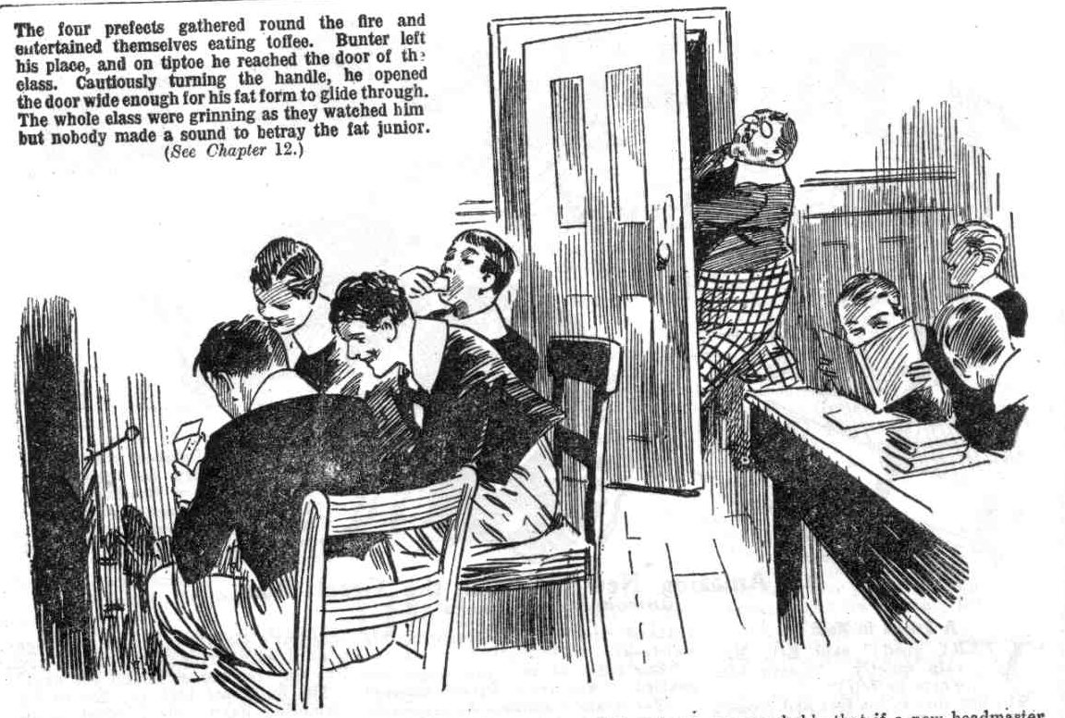
The Owl of the Remove was gone.
Just as if the Owl of the Remove had been a fat Boojum, he had suddenly, silently vanished away.
The class resumed Latin verbs, with grinning faces. It was a quarter of an hour later that Bolsover major, having finished the toffee and tired of loafing by the fire, turned his attention to the class again.
He was rather puzzled to see a large number of smiling faces; he did not expect Latin verbs, especially irregular ones, to make the juniors smile. Then he noticed that a place was vacant.
“Where’s Bunter?’” he rapped out.
“ Puzzle—find Bunter! “ murmured Bob Cherry.
“Ha, ha, ha!”
“ Stop that row in class, or I’ll jolly well lick the lot of you!” shouted Bolsover major truculently. “Wharton, where’s Bunter?”
“Find out!”
“ Do you want a thrashing ?”
“Oh, shut up!”
“The shutupfulness is the proper caper, my esteemed bullying Bolsover!” said Hurree Jamset Ram Singh. “The thrashfulness would be a boot on the other leg!”
“ Will you tell me where that fat rascal’s gone ?” roared Bolsover.
The juniors grinned, but made no answer.
“The fat slug must have crawled out while our backs were turned.” said Skinner. “May have locked himself in a room again, like he did before. We’ll make an example of him!”
“ You fellows keep order here, while I look for Bunter.” said Bolsover major, and he strode angrily out of the Form-room.
He tramped savagely up the stairs. His little brief authority had been defied—and by so negligible a nobody as W. G. Bunter. The bully of the Re- move tramped upstairs in a towering rage.
On the occasion of Billy Bunter’s previous barring out, he had selected the room prepared for Mr. Quelch—now the room of Mr. Buncombe. Bolsover major headed for that room first ; and when he found that the door was
locked, he knew that he had trailed down William George Bunter.
Bang, bang!
Bolsover major’s fist smote the door wrathfully.
“ Bunter!” he roared.
“ Yah!”
“ You fat scoundrel, unlock the door!”
“Rats!”
“What ?“ gasped Bolsover major.
“Rats!” jeered Bunter, through the keyhole. “Think I care anything for you, you long-legged, fat-headed frump! Go and eat coke! I’ve locked that door, and I’ve got all the furniture against it, and I’ve got some grub here, too—lots. I can tell you! It’s a barring-out—and I ain’t coming out again, see? Go and chop chips!”
“You fat villain!” bawled Bolsover major. “ I’ll smash you!”
“Yah! You couldn’t smash a white rabbit!”
“Wha-at?”
“I’ve a jolly good mind to come out and thrash you! But you ain’t worth the trouble. Yah!”
Bunter, behind a locked door, was evidently a new Bunter—a bold and defiant Bunter, remarkably different from the Bunter who had been caned in the class-room. Bolsover major banged on the door, kicked at it, yelled threats through keyhole, and fairly stamped with rage. While he was thus occupied, William George Bunter told him—through the keyhole—what he thought of him, of his looks, and of his manners; and all that Bunter thought— and stated—was uncomplimentary.
Bolsover major tramped away at last, and went down to the new Head’s study. This was a matter for Mr. Buncombe to take in hand.
He tapped at the study door and opened it.
“Oh, my hat!” he ejaculated involuntarily.
Mr. Buncombe had said that he would be busy that afternoon preparing exercises. The exercises were not in evidence. Mr. Buncombe was seated in a chair by the fire, tilted back, with his feet on another chair, reading a novel and smoking cigarettes. Cigarette-ends littered the floor round him, and the room was blue with smoke.
Oddly enough, he had laid aside his horn-rimmed glasses for reading; and without them his face had quite a different aspect; and there was something strangely familiar in it to Bolsover’s eyes.
He started as he saw the junior in the doorway, and scowled. In a moment he had dropped the novel, caught up the horn-rimmed spectacles, and jammed them on. He stared angrily at Bolsover major.
“What do you want?” he snapped. “Why are you not in the class-room, confound you!”
Bolsover fairly gasped. Mr. Buncombe’s voice had lost the squeaky tones he knew; it sounded different—younger, boyish, in fact, and strangely familiar to Bolsover’s ears.
But Mr. Buncombe recollected himself the next moment.
“What does this mean?” He was squeaking now. “I left you in charge of the class—”
Bolsover major stuttered out the explanation.
“Nonsense!” snapped Mr. Buncombe. “I will deal with Bunter later! Go back to the class! Cane anyone who has misbehaved in your absence. You may go!”
“Yes, sir!” gasped Bolsover.
And he went—his brain almost in a whirl. There was something about Mr. Buncombe that perplexed him strangely. He realized that there was more in the new headmaster than met the eye; but for the life of him he could not puzzle out what it was.
But he was soon to know—as well as the rest of High Oaks School. The new Head was nearer than he dreamed to the end of his tether.
THE THIRTEENTH CHAPTER.
An Astounding Discovery!
HARRY WHARTON & CO. eyed Bolsover major with smiling faces as he came back into the class-room. The fact that he came alone showed that William George Bunter had found a safe retreat. For once the Famous Five felt that their sympathies were with the Owl of the Remove. It required little more, in fact, to make them go and do likewise.
Only their promise to Lord Mauleverer to uphold the authority of his amazing headmaster kept the Famous Five from drastic measures. And that promise certainly did not bind them to submit to bullying from Bolsover major. They smiled cheerfully as the bully of the Remove came scowling in.
“Letting Bunter off—what?” grinned Bob Cherry.
Bolsover major gave him a scowl. Billy Bunter’s defiance of his prefectorial authority had exasperated him; and Bunter was safe out of his
”Cherry!” he rapped out. “I’ve warned you before about cheeking a prefect.”
“Oh, my hat!” said Bob.
“Stand out before the class!”
“Bow-wow!”
“Skinner, hand me the cane!”
“Here you are, old bean!” grinned Skinner.
The head prefect of High Oaks swished the cane.
“Stand out, Cherry, and bend over!”
“I don’t think!” said Bob.
“What?” roared Bolsover major.
“Fool!”
“Ha, ha, ha!”
“I’ve ordered you to bend over, Cherry!” said Bolsover major’
“Fool!”
“Ha, ha, ha!”
“I’ve ordered you to bend over, Cherry!” said Bolsover major. “I’ll deal with you next, Wharton. Will you stand out before the class, Cherry?”
“I rather think not!” said Bob. “I’ve got a sort of idea, not.”
“Then, take that!”
Bolsover major strode along the Form, and the cane whacked down over Bob Cherry’s shoulders. There was a roar from Bob.
“Whoop!”
The next moment there was another roar, from Bolsover major, as Bob’s fist caught him on the point of the chin.
Crash!
Bolsover major went spinning along the class -room, and landed with a terrific concussion on his back.”
Hurrah!” roared Johnny Bull. “That’s the stuff to give ‘em! Hurrah!”
“Look here, you men—“ gasped Lord Mauleverer.
The Bounder leaped to his feet.
“Mop them up!” he shouted.
”Give them socks!”
“My dear fellows—” murmured Lord Mauleverer.
Mauly was unheeded. The Bounder led the rush, and a dozen fellows followed him. Bolsover major, staggering to his feet, was swept over again; and Skinner and Stott went spinning right and left. Sidney James Snoop dodged out of the Form-room, and fled for his life.
“Bump them!” roared Vernon-Smith.
“Ha, ha, ha!”
“Bump those jolly old prefects!” yelled Bob Cherry. “We’ll give ‘em prefects!”
Bump, bump, bump!
“Yow-ow-ow!” howled Skinner. “ Leggo! Oh, my hat! Help! Yooooop!”
“I’ll smash you!” raved Bolsover major. Leggo! Help! Mr. Buncombe! Whoop! Yaroogh! Oh crikey!”
Bump, bump, bump!
“Yah! Oh! Yow!”
“Ha, ha, ha!”
The hapless prefects tore themselves loose at last, and rushed for the door.
“After them!” yelled the Bounder.
“Oh, gad!” gasped Lord Mauleverer, in dismay. “This is the giddy finish! Look here, you men—“
“After them!”
“Rag the rotters!”
The wildest excitement reigned in the Remove now. The upholders of law and order were more out of hand than the rest. There was a fierce rush in pursuit of Bolsover major, Skinner and Stott. Down the corridor the crowd of excited juniors went whooping, and the wretched prefects ran for their lives. With one accord they headed for Mr. Buncombe’s study, and the protection of the new Head.
“Collar them!” shrieked Peter Todd.
“Mop ‘em up!”
Skinner was collared, and dragged over, shrieking. Stott was captured next, and yelled wildly as he was bumped and rolled. Two or three hands clutched Bolsover major; but he tore himself away, and reached Mr. Buncombe’s study door, and hurled it open and rushed in. Mr. Buncombe leaped to his feet in alarm, just in time to meet Bolsover major, as the bully of the Remove rushed in with an excited mob at his heels.
Crash!
“Oh!” gasped Bolsover major.
“Oooch!” spluttered Mr. Buncombe.
The new headmaster went spinning from the shock, and rolled on the floor. His mortar-board tilted at an angle of forty-five degrees, and his wig became dislodged. His horn-rimmed glasses slipped from their moorings, so to speak. He sat up dazedly, with his grey beard hanging on one side of his face, bewildered and dizzy.
There was a startled yell from the Bounder.
“Look! Look at him! Great Christopher Columbus!”
“My only hat!” spluttered Peter Todd, his eyes fixed on the face of Mr. Buncombe—eyes that he could scarcely believe.
The mob of juniors had halted at the doorway, two or three of them inside the study. The Bounder, and a good many of the others, was prepared to handle Mr. Buncombe himself—they were quite fed-up with the new Head.
Whether the Famous Five would have defended him, at this stage of the proceedings, was rather doubtful. But the disarrangement of Mr. Buncombe’s disguise settled the matter beyond a doubt.
The fellows had suspected that Mr. Buncombe’s hair was a wig—but that had not made them suspect the imposture; middle-aged gentlemen sometimes sported wigs when Nature unkindly gathered in their natural crop at too early a period to please them. They had supposed, of course, that a bald pate was under the wig. But now that the wig was gone, they saw a close crop of dark hair—quite thick hair. And the disarrangement of the grey beard revealed a chin that was innocent of the slightest hirsute growth—not even a clean shaven chin, but obviously a chin upon which hair had never grown—a boy’s chin. The Removites fairly stuttered in amazement as they realized that Joseph Buncombe, M.A., O.B.E., instead of the testy old gentleman they had supposed, was a fellow no older than themselves, in a clever disguise.
Lord Mauleverer came panting up.
“You fellows! Remember you promised to back up the Head—play the game, you know—”
“Look at him!” yelled Toddy.
“It’s some swindler!” yelled Hazeldene. “Why, he’s a boy—not a man at all! He’s got up—”
“Disguised!” howled Johnny Bull. “Oh, crumbs!”
“He’s some spoofer—”
“Some swindler—a thief, very likely—a burglar—”
“You fathead, Mauly—”
“You blithering ass! Look at him!”
“Got up like a chap in private theatricals!” gasped Wibley. “I knew he had a wig—I spotted that! But—”
Lord Mauleverer gazed at his new headmaster. The fellow, whoever he was, was not yet recognizable, owing to the make-up on his face. But it was easily to be seen that he was a boy and not a man at all; and obvious that Lord Mauleverer had been taken in by some extraordinary spoof. The Bounder burst into a yell of laughter.
“You frabjous ass, Mauly! It’s some spoofer pullin’ your silly leg! No wonder his baggage hasn’t arrived—and his credentials—”
“Ha, ha, ha!”
“Master of Arts!” gasped Nugent. “Some Master of Arts!”
“O.B.E.!” shrieked Bob Cherry. “Some O.B.E. He’s not an Old Bad Egg—he’s a young bad egg!”
”Ha, ha, ha!”
“Oh! Begad! No! I—I—I’ve been taken in!” stuttered Lord Mauleverer. I—I—I suppose I ought to have made him show his credentials!”
”If any!” chortled Squiff.
“The anyfulness is terrific.”
“Who are you, you spoofin’ outsider?” demanded Lord Mauleverer indignantly.
“I seem to know your face—what I saw of it. Who are you?”
Ponsonby of Highcliffe scrambled to his feet. He cast a longing glance at the window; the doorway was crammed, and the room was half full of juniors. There was no avenue of escape for the spoofer of Highcliffe ; and the game was up now, with a vengeance. The best-laid schemes of mice and men gang aft agley, as the poet has told us; and Pon’s wonderful scheme had “ ganged agley” in the full tide of success.
“Look here !“ he gasped.
“I know that voice!” exclaimed Wharton. “ Who—”
“ Not a Greyfriars man,” said Bob Cherry. “Who are you, you rotter?”
“Collar him!” shouted the Bounder. “We’ll bump it out of him!”
“Mr. Buncombe” jumped back.
“Hands off!” he gasped. “I—I—I own up! It was only a jape! You fellows asked for it, with that silly advertisement for a headmaster. Hands off!”
“I know him now!” yelled the Bounder. “ Ponsonby!”
“Ponsonby!”
“That Highcliffe cad!”
“ Great pip!”
“Ponsonby!” gasped Harry Wharton, almost dazedly. “ We’ve been spoofed by a Highcliffe cad! Your new headmaster is Highcliffe Fourth-Former, Mauly! You frabjous, foozling ass!”
“Oh, gad!” stuttered Mauleverer.
“Hands off!” shrieked Ponsonby. “ It was only a jape—”
“Japing is all very well,” said Bob Cherry. “We’d let you off for the jape, as that footling fathead Mauleverer asked for it. But caning fellows isn’t a jape—and what’s sauce for the goose is sauce for the gander! It’s your turn now to bend over—before you’re kicked out!”
“ Fetch a cane!” yelled Squiff.
“Ha, ha, ha!”
Ogilvy rushed to the class-room for a cane. Ponsonby made a wild rush to escape, and was collared on all sides. Still in the garb of Mr. Buncombe, M.A., O.B.E., but minus his hair and horn-rimmed glasses, Ponsonby, of Highcliffe, was forcibly bent over a chair. Bob Cherry wielded the cane.
High Oaks had seen many extraordinary sights since it had had a local habitation and a name. But certainly it had seen none so extraordinary as this— its new headmaster yelling and squirming in the grasp of the juniors, under the whacking cane!
Really, it was the climax!
THE FOURTEENTH CHAPTER.
At Last!
Buzzzzz!
Lord Mauleverer went wearily to the telephone.
High Oaks School was still in a state of wild excitement.
The new Head was gone!
He had been glad to go!
In a state of dizzy and dusty dishevelment Ponsonby of Highcliffe had been kicked down the drive and kicked out of the gates of High Oaks. Such was the outcome of Pon’s great scheme of giving the Greyfriars Remove what they had asked for. But it was not to be denied that the Highcliffe spoofer had scored a success—and that it was largely by accident that he had been shown up. Ponsonby crawled away from High Oaks feeling tired of life; but the Remove fellows had to admit that the episode was “one up” for Highcliffe.
“Mr. Buncombe” being gone, his “prefects” came in for a very hectic time. They had used their little brief authority not wisely but too well, and after the feast came the reckoning. Bolsover major and Skinner, Snoop and Stott had the time of their lives, and they had an exceedingly tired feeling when they were finished with. It was very probable that if a new headmaster came to High Oaks and offered the four the position of prefects, they would decline with thanks. They had had enough.
Fellows asked Lord Mauleverer, with many chuckles, whether he was going to engage another headmaster. Lord Mauleverer shook his head sadly. One experience of that kind was enough for Mauly; he was not going to engage any more headmasters.
Once more High Oaks was a school without a master, and this time it looked as if that masterless state would be permanent. And then came the ring at the telephone, and Mauleverer took up the receiver. He gave a jump as Mr. Quelch’s voice came through.
“Mr. Quelch!” he ejaculated.
“Is that Mauleverer?”
“Yaas, sir.”
“I have been feeling very anxious, Mauleverer, concerning you and the other foolish boys at High Oaks. I was absolutely alarmed to learn that you had engaged a—a—a person as headmaster. I have not the slightest doubt that the man is some charlatan.”
Lord Mauleverer grinned faintly. At the present stage he had no doubt about it himself.
“I am very much perturbed,” went on Mr. Quelch. “I am extremely anxious. Very anxious indeed, Mauleverer, and as Dr. Locke is apparently taking no measures to control the Remove, I feel that I cannot allow matters to go on as they are at present any longer. The— the person you have so foolishly engaged is—”
“He’s gone, sir.”
“Gone!” repeated Mr. Quelch.
“Yaas, sir! He—he turned out to be a spoofing rotter, sir, and we’ve kicked him out.”
“Bless my soul!”
“You see, sir—”
“I see, Mauleverer, that the Remove require control, and that some serious disaster may occur if the present state of affairs should continue. I shall come to High Oaks, Mauleverer.”
“Oh, good, sir!” gasped Mauleverer. “I shall take control of High Oaks, and remain as your master until you return to Greyfriars. 1 shall call upon Dr. Locke and acquaint him with my intention, in order that there may be no misunderstanding.”
“We’ll all be jolly glad to see you, sir. It’s what we wanted all the time. We’re backing you up, sir, and stickin’ to you like—like glue, sir.”
“ Nonsense!”
And with that characteristic reply Henry Samuel Quelch rang off. Lord Mauleverer put up the receiver and strolled back into Hall, smiling.
“Hallo, hallo, hallo! What’s the glad tidings?” asked Bob Cherry.
“Quelchy’s coming.”
“Quelchy!”
“He’s agreed to take control here!” said Lord Mauleverer. “He seems to have got the wind up over that blinkin’ new headmaster, and he thinks it’s up to him.”
The news spread through High Oaks that Mr. Quelch was coming over to take control. It was received with rather mixed feelings; but most of the fellows agreed that it was good news. Billy Bunter was informed—through the keyhole—that Mr. Quelch was coming, and told to come out. But Billy Bunter refused to come out. His answer was that Quelchy was a worse beast than the other beast, and he added that he would see Quelchy blowed before he would come out.
THE END.

