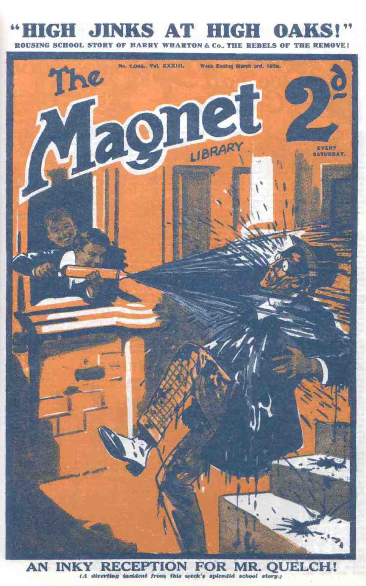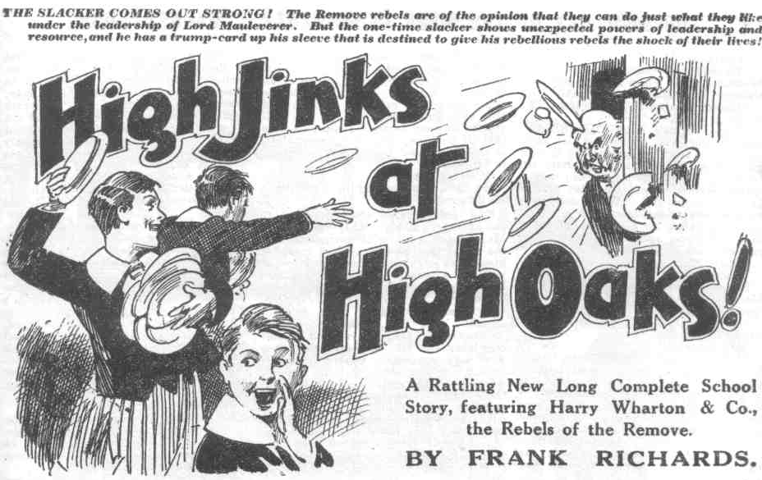
THE FIRST CHAPTER
Just Like Quelchy!
“HURRAH!”
“ Bravo!”
“Good old Quelchy!”
Most of the members of the Greyfriars Remove were fairly letting themselves go.
Hats and caps were waved in the air. Voices shouted, yelled, and roared. It was a tremendous ovation.
Any Form master might have been expected to look gratified, if not extremely bucked, at such a reception.
The Removites naturally expected it. Harry Wharton & Co., as they waved hats and caps, and shouted and cheered, looked at Mr. Quelch’s face for the expected smile of pleased and happy gratification.
They did not behold it
Instead of it, they beheld a frown.
Mr. Quelh did not look pleased: he looked irritated. He did not smile; he frowned portentously.
He could not have doubted that the boys were glad to see him. They made that quite clear. Nobody within a very considerable radius of High Oaks, who had ears to hear, could have doubted it.
Still, Mr. Quelch undoubtedly did not look pleased.
He held up a hand for silence.
But the Removites were not prepared to ring off yet. They had only just started.
Heedless of the Remove master’s gesture —-: they roared and roared again.
“Hurrah!”
“He’s come!”
“Goodd old Quelchy!”
“Silence!” thundered Mr. Quelch.
The Form master had alighted from a taxi at the gates of high Oaks. The taxi was gone now; which looked as if Quelch had come to stay. The juniors did not doubt that he had come to stay, and his arrival meant, to them, that their old Form master was joining up, as it were—backing up the Remove in their rebellion against the headmaster of Greyfriars. Hence their enthusiastic greeting.
“Speech! shouted Bob Cherry.
“Hear, hear!”
“The speechfulness is the proper caper!” said Hurree Jamset Ram Singh. “We are all earfulness, esteemed sahib!”
“Go it, Quelchy !” shouted Bolsover major.
Mr. Quelch crimsoned.
At Greyftriars he had been quite well aware that his boys referred to him as “Quelchy”——but not in his presence. He had considered it rank impertinence. Now that he was dismissed from Greyfriars—a Form master without a Form—Mr. Quelch was more punctilious on points of dignity than ever, though his enthusiastic supporters were not aware of the fact.
“How dare you, Bolsover?” he exclaimed.
“Eh?” ejaculated Bolsover major.
“Shut up, Bolsover!” said Bob Cherry “You’re always putting your hoof in it. Speech!”
“We’re jolly glad to see you here, sir!” said Wharton, speaking for the Remove as captain of the Form. “We’re all prepared to obey your orders, sir, just the same as at Greyfriars.”
“More or less!” remarked Bolsovr major.
“Shut up, Bolsover “ shouted a dozen voices
“We welcome you to High Oaks, sir!” went on the captain of the Remove. “We’re backing you up through thick and thin, sir!”
“Nonsence “ rapped out Mr. Quelch.
“Eh?”
“What!”
“Hem! Yaas!”
Something like dismay fell upon the enthusiastic crowd that had swarmed to greet Mr. Quelch when he came in at the gates of High Oaks.
Some of the more enthusiastic fellows had been prepared to hoist Mr. Quelch and carry him to the house shoulder high.
They gave up that idea now completely.
“You—you see, sir——” stammered Lord Mauleverer. “We—”
“Silence!”
“Hem! Yaas.”
Mr. Quelch looked at the crowd of juniors, now fallen silent—some of them rather resentful. The Remove had marched out af Greyfriars in protest against their Form master’s dismissal by the Head. They had taken a great risk in doing so, and the risk was by no means over yet. Nobody could say how the revolt of the Remove would turn out in the long run.
Really, Mr. Quelch might have shown a little appreciation of this devoted attachment of his Form.
He showed none whatever. Possibly his view was that it was impertinent of juniors to criticise the actions of their headmaster whatsoever that headmaster might do. Possibly he was down on rebellion in any shape or form, even when it was a rebellion in support ol himself. The juniors had to admit that there never was any telling what view Form masters might take of anything. They were. as the juniors know, queer codgers. Still, Quelchy might have shown some appreciation.
“I have come here—” began Mr. Quelch.
“Hurrah!”
“Silence!”
“Oh! Hem! Yes, sir!”
“Feeling it my duty to put an end to the state of disorderly riot that apparently obtains at this place,” said Mr. Quelch. “ You boys have left school without your headmaster’s permission!”
“Because he sacked you, sir.” stammered Bob Cherry.
“What?”
“I-—I—I mean dismissed, sir— ”
“Bunked!” said Bolsover major
“Shut up, Bolsover.”
“Matters between your headmaster and myself do not concern you boys at all!” said Mr. Quelch. “I am shocked and scandalised at your conduct!”
“Oh, my hat !“
“ Wow!”
“I regard it with the greatest disapproval. 1 have come here,” went on Mr. Quelch, “to take you back to Greyfriars.”
“What?”
“Great pip!”
“Haven t you come here to be our headmaster and Form-master, sir?” exclaimed Lord Mauleverer blankly.
“Do not be absurd, Mauleverer. This is not a school
“Yaas, sir, it’s High Oaks School,” said Mauleverer. “I’ve had the name painted up over the gates, sir, in nice gilt letters. Everything complete, sir, from the inkpots to the porter; only a master wanted. And we want you to be our master, sir. We’re not goin’ back to Greyfriars unless you go back, sir! We refuse to allow the Head to sack our Form master! We stand by you, sir—sink or swim together!”
“Bravo, Mauly!”
Hurrah!”
In the opinion of the Removites Lord Mauleverer had put it very neatly. Mr. Quelch did not seem to agree.
“You are talking nonsense, Mauleverer!” he rapped.
“Oh, begad !”
“I shall assume authority here simply for the purpose of taking you back to Greyfriars.” said Mr. Quelch. “I refuse to allow you to rebel on my account. I decline to permit my name to be used in such riotous proceedings. I will not allow this rebellion to continue!”
“Indeed, sir!” said Lord Mauleverer calmly. “But if you’re not going to be our master, sir, have you any authority to put an end to it?”
“Mauleverer!”
“Only askin’ a question, sir. We’ve marched out of Greyfriars, and were not goin’ back. We wat you to become headmaster of the new school, sir. I can tell you that we’re goin’ to run High Oaks as a school until Dr. Locke sees reason! We’re not givin’ in! If you’ll take on the job of Head of Oaks, sir, we’ll be glad. If not, we’ll carry on somehow but we’re not goin’ to Greyfriars until the Head asks you to come back, too! We’re backin’ you up, whether you like it or not, sir. You see, it’s the principle of the thing!”
“Hear, hear!”
Mr. Quelch blinked at Lord Mauleverer. His face was a study. Had he had a cane in his hand at that moment it is probable that he would have disregarded the fact that he was no longer in authority over Mauleverer, and would have used the cane—with vigour. Fortunately he hadn’t a cane.
“Mauleverer, how dare you? Silence!” rapped Mr. Quelch, as several of the Greyfriars rebels began to speak at once. “Silence! I shall go into the house now and call the roll. All of you will follow me. All of you will answer to your names. I must be sure that all are here. Then we shall proceed to Greyfriars and I shall hand you over to Dr. Locke.”
“Oh, my hat!”
Mr. Quelch stalked on up the drive to the house.
The juniors stared after him, and at one another, blankly. They had greeted Mr. Quelcb with wild enthusiasm, in the belief that he had arrived to instal himself at High Oaks, hitherto a school without a master. Their enthusiasm had very perceptibly diminished now. No cheering crowd followed Mr. Quelch. The Removites stared after him in silence. For the moment they were quite at a loss. Having rebelled against the Head for Mr. Quelch’s sake, they were now apparently hooked for a rebellion against Mr. Quelch himself, which made the state of affairs at High Oaks rather complicated. How this peculiar state of affairs was going to turn out the Greyfriars rebels did not know; but they knew one thing which obviously Mr. Quelch did not know, and that was, that they were not going back to Greyfriars.
THE SECOND CHAPTER.
Inky!
“SAFE as houses!” whispered Skinner.
“ But— “ murmured Snoop. “Leave it to me!”
“ But—” said Stott.
“It’s the only way, as the johnny says in the play,” said Skinner coolly. “ Do we want Quelchy here?”
“No fear!”
“Do we want thumpin’ lickings all round?”
“Nunno !
“Well, then, leave it to me “ said Skinner. “ Safe as houses, I tell you; only keep quiet.”
Snoop and Stott kept quiet—extremely quiet. They did not want anyone to spot them just then; either Mr. Quelch or the Remove fellows.
Skinner was standing at the hall window of High Oaks that flanked the big door. The window was partly open. The February dusk was deepening, and the window was in deep shadow.
Juggins had turned on the electric light in the hall and left it burning, Skinner had turned it out again. Skinner did not want any light on the subject.
At the half-open window Skinner stared out into the dusk and held in his hand; a large garden squirt. That squirt held two quarts of liquid. It was quite full now, with a mixture of several sorts of ink. Skinner was waitmg for Mr. Quelch.
“When he gets this,” breathed Skinner, “he will be tired of High Oaks. He won’t want to stay. He will think we are all in it.—Wharton and the lot of them. Stands to reasons ho will buzz off again. That’s what we want, isn’t it?”
“Yes,” murmured Snoop. “But—”
“Oh, rats!”
Harold Skinner peered from the window into the dusky porch. He had closed and bolted the big door.
Skinner of the Remove was, in point of fact, in a rather desperate mood. Mr. Quelch had steadfastly refused, hitherto, to come to High Oaks or to have anything to do with the rebel Removites. Skinner, in the belief that he was done with his Form master for good, had told Mr. Quelch, on the telephone, what he thought of him. That, quite unexpectedly, had decided Mr. Quelch to come. Whether he had come to stay, whether he had merely come to thrash Skinner as he deserved, Skinner did not know : but he knew that he did not want Mr. Quelch there. Mr. Quelch was only too likely to be dangerous at close quarters. Skinner was not at all anxious to have a master at High Oaks. A school without a master suited Skinner. Work had never appealed to Harold Skinner.
If Mr. Quelch was greeted by the contents of that big squirt Skinner sagely pined that he would be fed-up with High Oaks. Anyhow, it would keep him busy for a time, and he would not bother about Skinner. The moment he had delivered his fire it was Skinner’s intention to vanish, leaving no clue to the perpetrator. If Mr. Quelch stayed, he would dodge out of High Oaks and go back to Greyfriars, and take his chance with the Head. But he considered it very probable that, after being inked, Mr. Quelch would not stay. At all events, it was worth trying on.
Skinner watched cautiously.
He expected the whole crowd of Removites to arrivc at the house with Mr. Queltch, but to his great satisfaction he saw the tall figure of the Form master coming up the drive alone.
The Removites hung back and did not follow him. Mr. Quelch arrived in the old stone porch in solitary state.
Nothing could have suited Skinner better.
Mr. Quelch came up the steps and advanced towards the great oak door coming fairly into range of the hall window.
It was the psychological moment!
Whooosh! Swish! Splash!
Skinner let fty with the squirt.
His aim was good.
What happened Mr. Quelch hardly knew for some moments. A flood of ink smote him fairly on the chin, scattering and splashing there. Ink drenched the Remove master. It splashed over his face, it dyed his hair, it invaded his mouth and nose, it soaked his collar, it ran down his coat. For the moment Mr. Quelch lived and moved and had his being in an atmosphere of drenching ink.
“Oh! Ah! Oooooh!”
Mr. Quelch staggered back in his surprise, and unfortunately staggered over the edge of the step he had just mounted.
Over the edge of that step Mr. Quelch had, of course, no visible means of support.
The well-known law of gravitation did the rest.
Mr. Quelch remained for the millionth part of a second suspended in space, like Mahomet’s coffin.
Then, under the irresistible pull of gravitation. he shot towards the centre of the earth.
He did not, of course, reach the centre of the earth. The surface of the earth stopped him.
It stopped him suddenly and painfully. Mr. Quelch sat on the earth, with a feeling as if his backbone had been pushed up through the back of his neck.
“Oh!”
Skinner vanished from the window. Mr. Quelch had not seen him—he could not see anything but ink.
“Hook it!” breathed Skinner.
“Oh crumbs! You’ve done it now!” gasped Snoop.
“Hook it, you ass!”
And the three promptly hooked it.
“Ow! Oh! Grooogh! Oooooch! Mooooooh!” came in lamentable accents from Henry Samuel Quelch.
He sat breathless and gasping, with a vague impression that the house had fallen on him.
“Ooooch! Gug-gug-gug! Moooooh!”
Mr. Quelch clawed at ink on his face, gouged at ink in his eyes, and coughed and gurgled and gasped.
“What on earth——” exclaimed Bob Cherry.
“Something’s happened! Come on!” exclaimed Wharton, and he ran up the drive to the house, with a crowd at his heels.
The juniors had been too far off to see precisely what had happened; but they had seen Mr. Quelch step backwards and sit down violently. They came up with a rush, wondering what was the matter. Mr Quelch staggered to his feet and turned an inky and furious face on the astounded Removites. Many inks had been mixed in the squirt, but black predominated. Mr. Quelch had been suddenly turned into a black man, with a touch of Redskin. His aspect was alarming and extraordinary.
“Great Scott!” gasped Nugent. “What—”
“What’s happened, sir!” gasped Johnny Bull.
“Grooogh! Oooooh! Oooooch!”
Mr. Quelch’s reply was expressive, but not enlightening.
“It—it—it’s ink!” gasped Squiff.
“The inkfulness is terrific!” ejaculated Hurree Jamset Ram Singh. “The esteemed Quelchy is drenchfully soaked with it.”
“Oh, sir! What—who—” gasped Wharton helplessly.
“Grooogh! Gug! Gug! You young rascals—”
“ Wha-a-at?”
“You young scoundrels! Oooooch! Gug-gug-gug!”
“We—we—we didn’t We—we— never—”
“Young villains! Oooooch!” “So this is why you—oooch!—desired me to come here—grooogh—to play this disgusting— mooooh—ink me to come here—grooogh—to play this disgusting— mooooh—trick on me—to drench me with—ooooch---ink. I can only say— grooooogh—”
“We—we didn’t, sir!” gasped Wharton. “We never knew—”
“Some cheeky cad—” exclaimed Mark Linley.
“Some terrific rotter—”
“We’re awfully sorry, sir—“
“We had no idea—”
“Groogh! Young rascals!” spluttered the Remove master. “I have no doubt—moooch!—that you were all concerned in this—grooogh—outrage! Gug-gug gug! If I were still your Form-master—ooooch!—I should flog the whole Form! Grooogh! Oh, dear, Mooooj !”
There was ink in Mr. Quelch’s mouth, and nose, and eyes; he blinked furiously and inkily at the dismayed juniors. He was in a towering rage. That was really not surprising, in the circumstances. A middle-aged gentleman could not sit down violently on the earth without being hurt and Mr. Quelch felt hurt. And nobody could have received that cargo of ink without being annoyed. Job himself would have found his patience fail him in such circumstances.
“We— we — never—” stammered Wharton. “I assure you, sir, we know nothing about this!”
“Silence! Grooogh! Young rascals! Oooooch!”
“Good gad!” said Lord Mauleverer. “This puts the tin hat on it, and no mistake! C-c-can I help you, sir?”
Mauly came forward anxiously. In his anxiety to help Mr. Quelch, he forgot the man’s inky state.
Smack!
“Yarooooh!” roared his lordship.
In ordinary circumstances Mr. Quelch would never have boxed a fellow’s ear. It was an undignified proceeding. But the circumstances were not ordinary.
Lord Mauleverer jumped back, clasping a burning ear in anguish.
“Oh, gad! Ow! Wow!”
“My hat!”
“Look out, you chaps!”
“Here, let’s get away from him!”
The rest of the Remove crowded back in alarm. They did not want any of the same. And they did not want to handle Mr. Quelch, especially in his present state. He really was not fit to handle.
Mr. Quelch bestowed an inky glare on his dismayed Form. Then he strode away down the drive. The juniors parted to right and left to let him pass.
“Well,” said Bob Cherry, with a deep breath. “That’s torn it!”
Undoubtedly it had. High Oaks School was still a school without a master.
THE THIRD CHAPTER.
The Head Sees It All!
“WINGATE!”
“Yes, sir!” said the captain of Greyfriars.
Wingate of the Sixth had entered Dr. Locke’s study at Greyfriars, having been summoned there after class. He wondered what was wanted; but he had little doubt that he was wanted in connection with the present extraordinary state of the Lower Fourth Form.
The Remove were away from Greyfriars—still away, after the lapse of days and days. Greyfriars generally had expected the Head to come down on the rebels more or less like a ton of bricks. The Head had not come down on them like a ton, or even a hundred-weight, of bricks; and Greyfriars wondered at first, and then grinned. A headmaster who could not bring a junior Form to order was rather small beer, Coker of the Fifth told his friends; and for once the fellows agreed with Coker. Really, it was up to the Head to put that rebellion down, the school considered.
Certainly the Head had despatched the Sixth Form prefects to fetch the juniors back. The Sixth had returned in a shocking state—without the juniors. After that, the Fifth had taken the job on without instructions, just to show how they could do it. They certainly showed how they could do it—all Greyfriars was still chuckling over that. The Fifth had come back in a more shocking state than the Sixth. High Oaks seemed to be a sort of schoolboy Gibraltar, not to be taken by assault.
Wingate of the Sixth, as head prefect, and a dutiful senior, was prepared to support the Head. and to carry out any orders. But he hoped, from the bottom of his heart, that he was not to be sent a second time to fetch the Remove back from High Oaks.
It was all very well for Greyfriars generally to declare that the Lower Fourth rebels ought to be marched back, but there were serious difficulties in the way when it came to marching them back. It was one of those numerous things which are more easily said than done.
Dr. Locke eyed Wingate very thoughtfully as the prefect waited for him to speak. The Head was not looking his accustomed kind and benevolent self. The strain of the present state of affairs in the school had told on his nerves and his temper. In these days the Sixth found him very tart in their Form-room, and when he expounded Sophocles and Euripides to them they felt that they disliked him alrnost as much as Sophocles and Euripides.
“Wingate! You are—er—aware that certain juniors are absent from Greyfriars without leave?” said the Head, at last.
Wingate maintained his gravity with an effort. Certainly he was aware of it, as Greyfriars had talked of nothing else for days.
“Yes, sir,” he gasped.
“From certain statements these rebellious boys have made I gather that they left the school on account of the dismissal of their Form master.” said the Head.
“I understand so, sir.” said Wingate, wondering why the Head was telling him what all Greyfriars knew, from the Sixth to the Second.
“It appears, further,” said Dr. Locke, ‘that Mr. Quelch, whom I had occasion to dismiss from his post here, is still in the neighbourhood.”
He was fully aware that the dismissed master was staying at the hotel in Courtfield. Why, nobody knew. But the fact was certain. A dozen fellows or more had seen him since the day of his dismissal.
Apparently the fact had now come to the Head’s knowledge.
Dr. Locke looked very sharply at the prefect, as he did not answer.
I am asking you for information, Wingate.” he snapped. “Are you, or are you not, aware whether Mr. Quelch is remaining in the vicinity of Greyfriars?”
“‘I think so, sir,” stammered Wingate.
“Do you merely think so or do you know?”
“Well, I know, sir,” admitted the Greyfriars captain.
“In that case, you should have said so directly, Wingate.”
“Oh! Yes, sir, “ mumbled Wingate, reddening.
He realised that he was getting a little of the acerbity which the Head would naturally have desired to hand out to the Lower Fourth, had those cheery young gentleman not been out of range.
“ Are you aware whether Mr. Quelch is at the building which is called, I believe, High Oaks!” asked the Head.
Wingate started.
“I think not, sir. I am sure not. Mr. Quelch could not possibly be concerned in what the Remove have done.”
“It is very improbable, Wingate, that the Remove are acting in this lawless manner without encouragement,” snapped the Head. “ Mr. Quelch’s remaining in the neighbourhood requires explanation.”
Wingate stood silent. It seemed to him natural enough for the Remove master, whose time was now his own, to remain at Courtfield for a week or two. It was natural that he should be concerned about his Form, now in a state of rebellion, though he was no longer their Form master. But if Mr. Quelch’s presence in Courtfield required explaining, Wingate did not feel called upon to explain it, so he held his peace.
“Do you know where Mr. Quelch is staying, Wingate?”
“A fellow said he’d seen him at the window of the Courtfield Hotel, sir.” answered the prefect.
“You feel sure that he is not at High Oaks?”
“Quite, sir,” said Wingate, with conviction.
“You did not see him there on the occasion of your visit?”
“No, sir; the juniors would hardly have acted as they did had a master been on the spot.”
“I am not so sure of that,” said the Head dryly. “In short, you can give me no information regarding Mr. Quelch’s possible connection with this lawless outbreak of his late Form?”
“None, sir.”
“Very well, Wingate!”
It was a dismissal, and the captain of Greyfriars left the study. He was glad to go. In the Head’s present dry and touchy frame of mind an interview with him was neither grateful nor comforting.
Dr. Locke remained in deep thought for some time after the prefect had left the study. He was frowning darkly, and there was a bitter expression on his face, once so benevolent.
All Greyfriars had wondered at the dismissal of Mr. Quelch, who had been a friend, as well as a colleague, of the headmaster. The head’s change of feeling towards that valued member of his staff had taken the whole school by surprise; and certainly all Greyfriars looked upon the Head as having acted in a most arbitrary and unjust manner.
Whatever might be the reason—which Dr. Locke confided to nobody—there was no doubt that friendship had changed to a bitter aversion. At one time Dr. Locke had trusted Mr. Quelch with an absolute confidence. Now, since their estrangement, he was ready to suspect him of almost anything, on the slightest grounds, or no grounds at all. Anyone could have told the Head that Mr. Quelch was the last man in the world to approve of, or mix in, a schoolboy rebellion. But the Head was deeply prejudiced now.
He turned to the telephone at last, and rang up the Courtfield Hotel. He had a bitter suspicion that Henry Samuel Quelch was at the bottom of the Remove rebellion, and he was determined to ascertain.
“Courtfield Hote!” came a voice over the wires.
“Dr. Locke speaking from Greyfriars.” said the Head. “I desire to speak to Mr. Quelch, who, I understand, is a guest at the hotel.”
“Please hold on, sir!”
There was a pause.
“ Mr. Quelch is not in the hotel at present, sir,” came the voice, a minute later. “Any message when he returns?”
Dr. Locke compressed his lips. He was not at all surprised to hear that Mr. Quelch was not in the hotel. At the bottom of his heart he was convinced that Mr. Quelch was at High Oaks, aiding and abetting the rebellion of the Remove.
“Can you tell me where Mr. Quelch is at present?” he asked. “The matter is rather important, and I may be able to communicate with him on the telephone.”
“Certainly, sir! Mr. Quelch called a taxi a short time ago to take him to High Oaks.”
The Head almost gasped at this confirmation of his suspicions.
“Thank you!” he said.
He rang off without waiting for more. “ Iniquitous !” muttered the Head. “Infamous! It is as I supposed—it is scandalous! A Form master—a middle-aged gentleman, a Master of Arts, taking part in a schoolboy rebellion against authority! It is almost beyond belief !”
It would have been quite beyond belief had not the Head been angry, and suspicious, and prejudiced.
Dr. Locke did not ring up High Oaks. He ordered his car, and ten minutes later was gliding away from Greyfriars in the February dusk. A number of fellows watched him depart, with whispered comments.
In the car, the Head sat with a dark and frowning brow. He saw it all now—quite clearly. That unexpected outbreak on the part of the Remove—it was explained, now that he saw it all! Henry Samuel Quelch, who had—as he firmly believed, proved unworthy of the confidence placed in him—had engineered it! Planned the whole thing, stirred up the Lower Fourth to revolt, and was now keeping an otherwise loyal Form away from the school to which they owed their allegiance. Deep and bitter was the Head’s anger, now that he saw it all!
THE FOURTH CHAPTER.
Looking Black!
“BLESS my soul! What—”
Dr. Locke gasped.
The Greyfriars headmaster stepped from his car in the Courtfield road, opposite the gates of High Oaks. Over those gates was a large board, which bore, in large gilt letters: “High Oaks School “—an inscription that made the headmaster frown. The big bronze gates stood wide open, and the head entered the gateway. Then he halted, in great astonishment, and a little alarm, as a shadowy figure came down the drive in the dusk unsteadily, uttering strange and weird sounds.
“Groooogh! Uooogh! Mooooooh! Gug-gug!”
“Bless my soul!” said the Head faintly.
“Ooooooooo!”
Dr. Locke stood stock-still staring at the strange figure. Even while it was at a distance, and dim in the dusk, he was conscious of something strange and very unusual about it. As it came near enough for him to see it more clearly, the Head felt a tremor. A hideous black face glared at him out of the deep shadows of the oak drive—a face that was black, with a reddish tinge here and there and with two glaring eyes; and a voice that sounded choked uttered strange, unintelligible sounds:
“Grrrrrrh! Ooooch! Gug – gug! Oooooh!”
“Oh, goodness gracious !”
Dr. Locke jumped back, with an activity unusual in a gentleman of his years.
He had come to High Oaks to call his dismissed Form master to accoun:; to overwhelm that gentleman with scorn and contempt; to withdraw the misled Removites from his malign influence. But he had not come there to encounter a horrible-looking negro of a wild and ferocious aspect. The Head jumped back, his heart thumping wildly.
“What—what——” he ejaculated.
“Groooogh!”
Naturally the Head did not guess that this fearful-looking apparition was a Form master who had been drenched with a mixture of inks, of which a good deal had gone into his mouth. Nothing of the kind crossed Dr. Locke’s mind. He backed away rapidly, and, to his horror, found that the hideous black man was following him out of the gates.
“Good heavens!” panted the Head.
Dr. Locke was not wanting in courage, by any means, but this unexpected and unnerving encounter had quite shaken him. As the horrible looking figure followed him out of the gateway the Head turned and fairly ran for his car.
The chauffeur stared at him.
He was so surprised at seeing a dignified gentleman like the headmaster of Greyfriars bolting back to the car at top speed that he did not move to open the door of the car. He stared blankly,
“Quick!” panted the Head, in groat agitation.
He fumbled at the door.
“Oh, sir! What—” gasped the startled chauffeur.
“A—a—a horrible negro—some fearful madman, I fear!” gasped the head incoherently
“Oh my eye!” ejaculated the chauffeur. He opened the car door, and the Head fairly dived into it.
“Quick—quick!” piped the head.
But before the chauffeur could start up, the horrible-looking negro was close at hand. He stared at the car.
“Keep off!” gasped the Head. “Keep away! Do not approach! Bless my soul! Keep away!”
“Here, you keep off, you blooming nigger!” exclaimed the chauffeur, and he clutched up a spanner in sell-defence. “None of your larks here, you blinking blacky! You sheer off!”
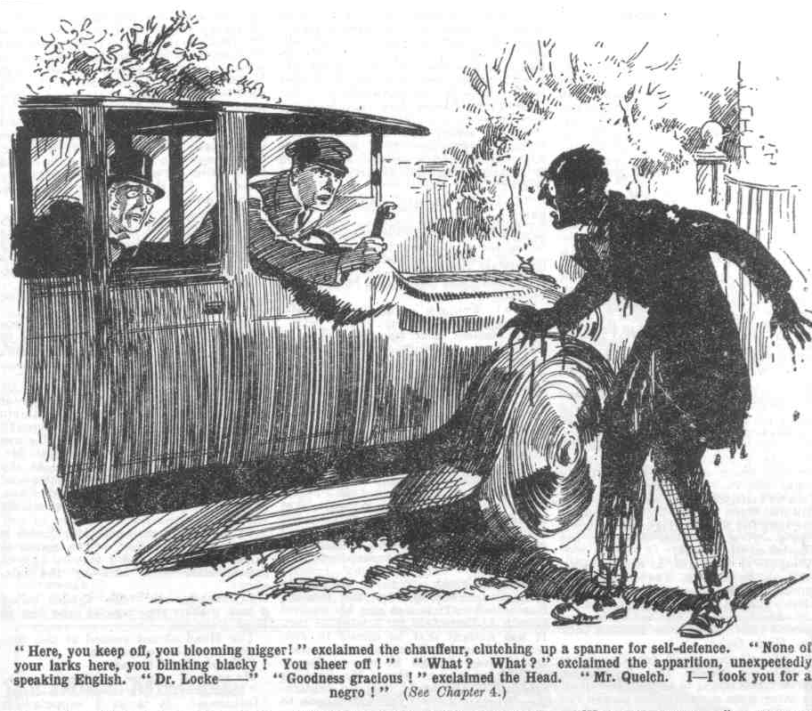 “What! What?” exclaimed the apparition, unexpectedly speaking English. ‘What do you mean? Dr. Locke—”
“You know my name!” ejaculated the Head.
“What—what! Have you lost your senses, sir?’ hooted the black man. “I am not likely to be unaware of your name, I presume, after an acquaintance of a quarter of a century!”
“What!” gasped the Head, peering from the car uneasily. “Your voice seems familiar. Have I seen you before?”
“This is childish buffoonery, sir!” exclaimed the Head, realising at last that this was the late Remove master of Greyfriars. “Goodness gracious! I—I took you for a negro—”
“What?” roared Mr. Quelch.
Alarm had now changed to indignation and scorn in the Head’s speaking countenance
“Scandalous!” he exclaimed “After your conduct, Mr. Quelch, perhaps I should not be surprised at anything you may do. But this really is almost beyond credence. For a man of your years, sir, to blacken his face and appear on the public roads in the character of a blackamoor—”
“What?” yelled the Remove master. “How dare you, sir! I repeat, how dare you!”
“And I repeat, sir, that this is scandalous!” shouted the Head. “If you are so frivolous, sir, as to attend fancy-dress balls in a childish disguise— as I judge from your appearance—at least, sir, you might conceal your folly from the public view. Is it your intention, sir, to walk the streets in the guise of a blackamoor? Could you not take a cab, at least? I trust, sir, that the police will take you in charge, sir.”
“Oh, my eye!” murmured the chauffeur. He put down the spanner.
Mr. Quelch gave the Head of Greyfriars an inky stare, fairly trembling with passion. The Hcad’s mistake really was excusable; but the Remove master did not excuse it.
“Dr. Locke! How dare you! Do you think I am a man to attend fancy dress balls in a ridiculous disguise?” he shrieked.
“I judge by what I see, sir!” retorted the Head coldly. “If that is not the case, why are you disguised, sir, as a negro!”
“You are a fool, sir!” roared Mr. Quelch.
“What?” gasped the Head.
“I repeat it, sir—a fool! Cannot you io that I have been drenched with ink—that I am the victim of a dastardly outrage!” shrieked the Rcmove master. “Do you imagine, sir that I have drenched myself with ink intentionally, sir? Have you no common sense, sir?”
“Bless my soul!”
“I came here, sir, to this place, sir, to bring the Remove boys back to Greyfriars, sir, and hand them over to you, sir!” roared Mr. Quelch. “I took this duty upon myself, sir, because you had neglected it—neglected it, sir! This is my reward, sir! And now, air, I wash my hands of the whole business—I decline to interfere further—and if you do not deal with these rascally young rebels, sir, as it is your duty to do, they may remain hero till their parents intervene, sir—I will have nothing more whatever to do with the matter, sir! I will only add, sir, that I regard you, and your opinions, sir, with the utmost contempt, sir!”
“Bless my soul!” said the Head feebly.
And Mr. Quelch, with a final inky glare at the Head, stalked away and vanished into the gIoom.
Dr. Locke sank back on his seat. He was feeling quite overcome. Obviously his suspicion had been unfounded: Mr. Quelch was not in command at High Oaks; even the prejudiced headmaster could see that now.
“‘Ome, sir ?” asked the chauffeur, after waiting several minutes.
“Yes!” gasped the Head.
The car glided away from High Oaks. At a little distance down the road, where a roadside lamp cast a glimmer on a stone fountain, an inky gentleman was sighted, washing ink from his face with the help of a handkerchief. The Head gazed at him in passing. Mr. Quelch was too busy to heed the car. ln righteous wrath and indignation, Mr. Quelch had stalked away from High Oaks, shaking the dust of that establishment from his feet; but it had occurred to him—rather late—that he was in no state to present himself in the lighted streets of Courtfield. So he was doing the best he could with a wet handkerchief and a roadside fountain.
Dr. Locke stared at him, and a faint smile came over his face. The car passed on, leaving the hapless Remove master at his ablutions; and the Head was still smiling as he glided on to Greyfriars. Apparently there was something in the episode that struck the Head as comic—though, if there was, it was quite lost on Mr. Quelch. He, at last, did not smile—indeed, judging from his expression, he was understudying that ancient king who never smiled again.
THE FIFTH CHAPTER.
What’s to be Done?
“SOMETHTN’ will have to be done.”
Lord Mauleverer made that statement.
His lordship was reclining at ease in an ample armchair in the old hall at High Oaks. He looked the picture of lazy comfort. But the expression of his noble countenance was very serious and thoughtful. Lord Mauleverer had been doing a great deal of thinking of late. Some of the Removites had wondered whether his aristocratic intellect would stand it. Now be was thinking again.
Harry Wharton & Co. nodded assent to his lordship’s remark. All (ho Famous Five agreed that something had to be done. The question was—what? No answer to that question was immediately forthcoming.
The state of affairs at High Oaks was not satisfactory from the point. of view of the more thoughtful members of the Remove. It had been Lord Mauleverer’s great scheme to march out of Greyfriars and persuade Mr. Quelch to take on the position of master of the new school, until such time as the Head of Greyfriars should see reason, and reinstate the Remove master in his old position. The Famous Five had backed him up heartily ; and the leading spirits of the Remove, such as Peter Todd, Squiff, Tom Brown, Penfold, Mark Linley, had backed up with equal keenness.
Vernon-Smith had joined up eagerly, and the Bounder had a good deal of influence in the Form—though Smithy was probably actuated rather by love of a row than love of justice. Many of the Remove, such as Skinner & Co., had joined up unwillingly. But in the present state of affairs, Skinner & Co. and their friends were the keenest on keeping up the rebellion; not on account of Mr. Quelch, and not on account of justice and fair play ; but simply because they were having the time of their lives at High Oaks—escaping lessons, prefects, masters, and all unpleasant things.
All the Remove therefore—good, bad, and indifferent—wcre united in keeping up the rebellion. That was so much to the good, as far as it went. But the idea of the leaders had not been to slack about like this—they had planned to keep on classes with Mr. Quelch or without, and for some days that idea had been a success. Now it had collapsed. Not only the slackers of the Form, but better fellows were taking a different line. Even Harry Wharton, & Co., though their intentions were still excellent, felt to a certain extent the attractions of freedom and irresponsibility.
Bob Cherry had remarked that Soccer was better than classes, and his chums could not help agreeing with him. The spirit was willing, but it appeared that the flesh was weak. More and more of the rebels had fallen away from the high ideals with which the rebellion had been started—as is rather customary in rebellions. Classes were a thing of the past. Every fellow did what he liked; and found at very agreeable. Still, the more thoughtful fellows agreed that it would not do. If parents came on the scene, or governors of the school intervened, it would not do to be found slacking and idling. That, certainly. would never look as if the Remove had gone on strike for the sake merely of justice.
“Somethin’ will have to be done!” repeated his lordship. “This sort of slackin’ can’t go on !“
The Famous Five agreed; but they grinned. Lord Mauleverer at the present moment, did not look very energetic.
“The fellows are doin’ nothin’,” went on Mauly. “Only Linley is keepin’ up study, and young Penfold. There’s a pick-up game of footer every day, while the fellows at Greyfriars are in class.”
“Hem!” murmured Bob Cherry, looking rather guilty.
“Skinner and those shad wasters play cards and smoke.” said Mauleverer. “That really isn’t what we came here for.”
“ No fear”” said Johnny Bull.
“ That fat idiot, Bunter, has locked himself in a room with a stack of grub, and is havin’ a barrin’.out on his own !”
The Famous Five chuckled.
“That’s not a. bad thing,” remarked Nugent. “It’s rather a relief to be shut of Bunter for a bit.”
“Yaas. But it won’t do.”
“It won’t,” said Harry Wharton. “You’re leader, Mauly, and we’re backing you up. Give your orders, old bean!”
“ Yaas, but that’s just the difficulty,” said his lordship. “It’s perfectly clear to me that somethin’s got to be done, but I don’t know what.”
“That ass Quelchy ought to have taken control,”” said Nugent. “ Blessed if I know why he doesn’t!”
“Well, he’s refused.”
“The refusefulness was emphatic and terrific,” remarked Hurree Jamset Ram Singh. “ We have thrashfully ragged the esteemed Skinner for inking him, but the worthy and ludicrous Quelchy is gone from our gaze like a beautiful dream”
Bob Cherry glanced from the windows. It was the day following Mr. QueIch’s rather disastrous visit to High Oaks; and a sunny, bright morning, with a breath of spring in the air. There was no doubt that out-of-doors had stronger attractions than a class-room.
“ I’ll tell you what,” said Bob, as if struck by a bright idea. “ Let’s get out and—and think it over.”
“It’s lovely weather!” remarked Johnny Bull. “Real spring! Ripping along the river this morning !”
“ The ripfulness is terrific.”
“Good!” assented Nugent. “Mauly being leader, we’ll leave Mauly to it, and perhaps he will have struck a jolly good wheeze when we get back.”
Harry Wharton laughed.
“No orders at present, Mauly?” he asked.
“Nunno! But—”
“ Then we’ll see you at dinner.”
“Yaas ; but—”
“ Ta-ta, old bean!” said Bob Cherry cheerily. And the Famous Five strolled out, leaving Lord Mauleverer to his iiieditations.
As they left the house a fat voice hailed them from an upper window.
“I say, you fellows!”
“Hallo, hallo, hallo!”
Harry Wharton & Co. looked up, as Billy Bunter looked down. The Owl of the Remove blinked at them through his big spectacles.
“ I say, you fellows, Skinner says that classes are chucked up,” said Bunter.
“Pro. tem.,” said Harry Wharton.
“ Well, if you’re going to act sensibly, I’ll come out.” said Bunter. “ Mind, I’m not having any classes, and I’m setting up when I choose in the morning. On those conditions I’ll come out.”
“Don’t trouble,” answered Wharton, laughing. “ The longer you keep yourself locked up the better, old fat bean You can’t imagine how nice it is to miss you!”
“The missfulness is an esteemed boon and blessing !“
“Beast!”
“Besides, lessons are going to begin again, as soon as we can arrange it, said the captain of the Remove.
“Mauly’s thinking it out now.”
“But there’s none to-day ?” asked Bunter cautiously.
“Ha, ha! No”
“Then I’ll come out. The fact is.” explained Bunter, “I got in enough tuck in this room, as I thought, for a week. But it’s all gone!”
“Ha, ha, ha!”
The Famous Five roared. Bunter had provisioned himself for a barring-out; but evidently he had been very active with the provisions. The largest imaginable supply of tuck was not likely to last long, when William George Bunter was at liberty to give it his undivided attention
“Well, it’s a go,” said Bunter, “I’ll come out; but mind, if you begin any rot about classes again, there will be another barring-out!”
“Fathead!”
“You fellows going out?” asked Bunter.
“Yes.”
“Hold on a few minutes, and I’ll come.”
Billy Bunter disappeared from the window.
“Put it on,” grinned Bob Cherry.
And the Famous Five accelerated. By the time William George Bunter rolled out of the house they had vanished.
Meanwhile, Lord Mauleverer was thinking over the situation in the easy chair before the log fire in the Hall. Mauly was convinced that something had to be done; and he was determined to think out what was to be done. But the easy chair was very easy and the log fire was drowsy, and the house was very quiet; and perhaps Mauly’s unaccustomed mental exertions tired him. Five minutes after the Famous Five had left him, Lord Mauleverer was sleeping peacefully; and the solving of the problem was unavoidably postponed.
THE SIXTH CHAPTER.
The Tribulations of a Ventriloqulst!
“HERE’S the car!” said the Bounder.
“Oh!” said Redwing.
Tom Redwing looked dubious.
A handsome car had stopped at the gates of High Oaks in the sunny morning. Herbert Vernon-Smith had made his arrangements for that day—not including anything in the nature of study. The Bounder, who had plenty of money, had telephoned to Courtfield Garage for a car—and here it was. He proposed to spend the day in a long run with his chum; and undoubtedly the idea appealed to Redwing. But—there was a but!
Redwing had a sense of duty—which the Bounder rather lacked. At that hour Greyfriars School was at classes; and certainly High Oaks School ought to have been similarly occupied. Smithy read his chum’s thoughts in his face, and grinned.
“You’d like to come?” he asked.
“Yes. But—”
“We’ll get a ripping run.” said the Bounder. “We’ll go by way of your old place, Hawkscliff, and have a look at your jolly old cottage, what? Then on to Folkestone, and round by Canterbury, see?”
“Ripping,” said Redwing. “But the fact is, Smithy, old man, we really ought not to go. You see—”
“I see.” assented Smithy. “It’s your jolly old conscience. You feel that you ought to be at work in school time.”
“Well, yes.” admitted Redwing. “Linley and Penfold have gone into the class-room with their books.”
“Let ‘em!” said the Bounder, shrugging his shoulders. “What are the other fellows! doing? Skinner and Snoop and Stott are in the summer-house yonder, playing banker; and I think Hazel’s with them.”
“They’re not exactly an example for us, Smithy,” said the sailorman’s son, with a curl of the lip.
The Bounder laughed.
“Well, no! But Wharton and his pals have gone up the river.”
“Oh!” said Redwing.
“Squiff and Tom Brown and Ogilvy and Russell have gone for a ramble in the woods.”
“Oh “ repeated Redwing.
“All the other fellows are loafing about, doing as they like. Why shouldn’t we do the same?”
“Well, we’re backing up Mauleverer, you know, and—”
“And Mauleverer’s fast asleep in an armchair.” grinned the Bounder.
Redwing laughed.
“All serene—let’s get off, Smithy. I’d like the run as well as you would. I’ll be glad to see Hawkscliff again - and if my father’s home from sea, I can see him.”
“If he’s home, we’ll make him hop in the car, and take him on a giddy joy-ride all over Kent.
“Oh, good!” said Tom, his eyes sparkling.
“Come on, then.”
“I say, you fellows—”
“Buzz off, Bunter!”
“I say, I don’t mind coming with you, Smithy.” said the Owl of the Remove. “In fact, I refused to go out with Wharton, specially on your account.”
“Aren’t you having a barring-out, all on your lonely own?” grinned the Bounder.
“I’ve changed my mind, old chap!”
“Good,” said the Bounder. “the one you had was a rather potty one, and you can’t have changed it for a worse one.”
“You silly ass!” howled Bunter. “I didn’t mean that! I mean—”
“Tell somebody else what you mean, old fat man. Come on, Redwing!”
Evidently the Bounder did not desire the fascinating company of William George Bunter on the motoring trip. He walked down the drive with Redwing, and Bunter glared after him, with a wrathful glare, his very spectacles gleaming with wrath. Bolsover major was standing at a little distance, and suddenly Bolsover’s voice was heard.
“Smithy! Stop! You’re not going out—I’ll lick you if you do.”
The Bounder swung round, his eyes blazing with anger.
“You cheeky cad, Bolsover!” he roared. “Lick me, by gad! Come and do it!”
Bolsover stared at him.
“Eh! What’s biting you?” he ejaculated.
The Bounder was striding towards him, his eyes ablaze and his fists clenched, when Redwing caught him by the arm.
“Smithy—”
“Let go!” shouted the Bounder savagely. “You heard what he said.”
“You ass, it was Bunter—”
“Bunter?” exclaimed the Bounder.
“It was his rotten ventriloquism, you ass!”
The Bounder stared for a moment, and then he understood. The ventriloquist of the Remove had imitated Bolsover’s voice—an old trick of Bunter’s. Ventriloquism was a gift of the Owl of the Remove—a weird gift, which had often led him into trouble. The fat junior was grinning, in the cheery anticipation of a row between Bolsover major and Vernon-Smith— both hot-headed fellows who were more prompt to hit out than to inquire. But as Redwing spoke, the Owl of the Remove ceased to grin, and turned and bolted for the house.
“Why, the fat rotter!” gasped Vernon-Smith. “I—I—I’ll—” he rushed furiously after Bunter.
“Yarooh!” roared Bunter, as he heard the pursuing footsteps behind him, “Yoop! Keep off! I didn’t—I wasn’t—I never did— Yarooooop!”
Vernon-Smith closed up behind and took a flying kick,
William George Bunter fairly flew and landed on his hands and knees, roaring.
“There, you fat villain!” gasped the Bounder.
“Help!” yelled Bunter,
“Now give me some more ventriloquism, and I’ll give you another!” shouted the Bounder.
“Yow-ow-.ow! Keep off! Wow !”
No more ventriloquism was forthcoming from Billy Bunter. He was using his own natural voice now and using it with vigour. Indeed, he seemed to be seeking to rival the celebrated Bull of Bashan.
“Come on, Smithy!” called out Tom Redwing, laughing.
And the Bounder, panting, rejoined his chum, and walked down to the gates with him. Billy Bunter sat. up, still roaring. Bolsover major grinned at him.
“I say, Bolsover———” gasped Bunter. “ I say, that beast Smithy called you names, you know.”
“Because you made him think I was cheeking him, with your rotten ventriloquism.” said Bolsover major.
“But you’re not the fellow to stand it.” urged Bunter. “Smithy’s a cheeky cad, and he called you names, you know. Look here, you go after him and lick him, old chap! I’ll hold your jacket.”
Bolsover major chuckled.
“I won’t lick Smithy.” he remarked. “I’ll lick you, you fat ventriloquising rotter! Like that—”
“Yaroooogh !”
“And that—”
“ Yooooop!”
Billy Bunter scrambled up and fled. Bolsover major did not take the trouble to follow him but it was said of old that the guilty flee when no man pursueth; and Billy Bunter rushed on at top speed, in momentary terror of the impact of a heavy boot upon his tight trousers. It really was not safe for a short-sighted fellow like Bunter to charge at full speed anywhere. He did not discern Peter Todd sauntering ahead of him till it was too late.
What seemed to Peter like a battering-ram smote him suddenly in the back, and the next moment Peter’s nose was grinding into the earth, and Peter was spluttering wildly. Bunter sat down from the shock, gasping.
“ Wha-a-at—what———” gasped Peter.
He blinked round dizzily and beheld Bunter.
“ You—you—you fat idiot!” gasped Peter. “Is that your idea of a joke, you blithering chump, to butt a fellow over from behind? Why, you dangerous dummy, I’ll pulverise you!”
“I—I say, Peter, 1 didn’t—I mean, I wasn’t— Yarooooogh!”
Once more Billy Bunter gathered himself up and fled, with Peter Todd in hot pursuit, dribbling him.
By the time William George Bunter escaped from the enraged Peter, he was wishing fervently that he had remained barred out, or alternatively, as the lawyers say, that he had not indulged in any ventriloquial stunts that morning. He had never found the life of a ventriloquist worth living at Greyfriars, and really, matters seemed to be worse rather than better at High Oaks.
THE SEVENTH CHAPTER.
Juggins to the Rescue!
“JUGGINS!”
“Yes, my lord !”
Alfred Juggins’ manner was deeply respectful, if not actually adoring.
True, Lord Mauleverer was the only millionaire with whom Mr. Juggins had come into persona! contact. But judging millionaires by Mauleverer, Mr. Juggins was prepared to approve of them heartily as a class.
Mr. Juggins, as caretaker of High Oaks, while that mansion was still a desirable residence offered for sale, had not been in a flourishing state financially. But as porter of High Oaks School, matters had looked up very much for Mr. Juggins in the financial line. As Jupiter was fabled to descend upon the dazzled eyes of Danae in the form of a shower of gold, so Lord Mauleverer had descended upon Juggins shedding currency notes. Mr. Juggins had a particular partiality for currency notes. He liked them numerous, and he liked them regular. Mr. Juggins had many relations—and the glad tidings had been spread through the whole tribe of Jugginses.
All over High Oaks, by this time, there were Jugginses of all sort and conditions, all faithfully nerving his lordship in one capacity or another, and hoping that High Oaks School would flourish long in the land. As a school, they regarded it rather with their tongues in their cheeks, but as an institution for the benefit of the tribe of Juggins they considered that it could not have been improved upon.
What the whole affair meant, what it was all about, and what the end of it wou1d be, the Juggins’ clan neither knew nor cared; they only hoped that the end was far off. In the meantime, they thrived. Juggins cooks and maids, Juggins gardeners and chauffeurs and pages and boot-boys and odd-job men, filled High Oaks like an army of occupation. There were Jugginses from the age of twelve to the age of seventy; and, with so much faithful and enthusiastic service, affairs certainly went very smoothly at High Oaks. The servant problem there was not too few servants but too many. And they were all so cheery and contented that it was quite a pleasure to Lord Mauleverer to see their faces. His lordship liked happy faces about him, and there was no doubt that he had made the Juggins’ clan happy.
Lord Mauleverer had woke up after an enjoyable nap, and rung for Juggins. Juggins was school porter, but his duties as porter were not onerous, and he was also general factotum to his lordship. He was always at hand when Mauleverer wanted him, and often when he did not.
Lord Mauleverer sat up, and yawned and blinked at Juggins. Juggins stood respectfully awaiting his lordship’s commands.
“You rang the school bell this mornin’, Juggins?” inquired Lord Mauleverer.
Juggins concealed a smile.
“Yes, my lord.”
“How many fellows went into class?“
“Two, my lord.”
“Any gone in since?”
“I think not, my lord.”
“What are the fellows doin’?”
Mr. Juggins considered.
“Master Wharton and his friends have gone up the river, my lord. Master Vernon-Smith and Redwing have gone out in a car. Master Skinner and his friends are playing banker in the arbour. Masters Field. Brown, Ogilvy, and Russell have gone for a walk in Friardale Wood. Master Wibley trying on some theatrical costumes in his study. Master Bolsover was quarrelling with Desmond and Newland. Mister Todd was kicking Master Bunter when I saw him last. I am not quite aware what the other young gentlemen are doing for the moment, my lord.”
Lord Mauleverer gave him an admiring look.
“By Jove, you’re a frightfully observant fellow, Juggins! And what a memory you’ve got! It was awf’ly lucky I found you here, wasn’t it? I hardly know what I should have done without you, Juggins.”
“Your lordship is very kind, murmured the gratified Juggins.
“From what you tell me, the fellows are havin’ rather a good time.” said Lord Mauleverer. “But this is a school, you know. Fellows don’t go to school to have a good time—at least, not in this style. Fellows go to school to learn things, Juggins. Work, you know. Carlyle—I dare say you’ve heard of Carlyle, Juggins—--”
“There is a tobacconist in Courtfield of that name, my lord.”
Lord Mauleverer coughed.
“Nunno; the chap I’m speakin’ of was a writin’ johnny—a very celebrated writin’ johnny. Well, Carlyle said there was an endless dignity in labour.”
“Did he, my lord ?”
“ Yaas; and he ought to have known, you know, because a looker-on sees most of the game, and he never did any himself. But the fellows don’t seem to see any catch in labour, Juggins. They won’t work. And we really came here to work like—like Trojans. This won’t do, Juggins. Somethin’ will have to be done.”
“Yes, my lord.”
“I asked you the other day whether you had any relation who was a school-master, Juggins. What we want is a schoolmaster here. You’re quite sure you haven’t?”
“Quite, my lord,” said Mr. Juggins regretfully.
“ It’s a pity,” said Lord Mauleverer. “Yours is an awf’ly clever family, Juggins. That nephew of yours puts a follow’s trousers in the press like a real artist. I wish you had an uncle or somethin’ who was a schoolmaster. You see, Juggins, I’m in command here, but, somehow, fellows don’t do as I tell them. I keep on tellin’ them to stick to work, but they don’t.”
Mr. Juggins concealed another smile. Possibly he thought that his lordship would do well to teach by example as well as precept. Mauleverer, leaning back in the armchair, with his hands clasped behind his head, did not really constitute a fellow who had a deep and keen appreciation of the dignity of labour.
“Can’t you suggest somethin’, Juggins?” asked his lordship. “You’re an awf’ly intelligent fellow, and all your relations seem a very clever lot. Can’t you suggest some way of pullin’ the school together, and makin’ the fellows toe the line? Haven’t you another relation somewhere who could do it?”
“If I may make a suggestion, my lord—”
“That’s what I want. Trickle on.”
“I have a cousin, sir—”
“Good !”
“Doorkeeper at the Courtfield Picture Palace, sir.” said Mr. Juggins. “I have just heard that he has left his situation owing to a misunderstanding.”
“Do we want a doorkeeper here, Juggins?” asked his lordship innocently. “If we do, bring him along.”.
“My Cousin James is officially styled a doorkeeper, my lord, but he is frequently alluded to as a chucker-out.”
“Oh I know! One of those hefty, beefy, chaps—”
“Precisely, my lord. A very powerful man physically.” said Mr. Juggins. “He contemplated, at one time, a career in the ring, and has actually had some boxing engagements. I have no doubt, my lord, that my cousin James could restore order here, and make all the young gentlemen willing—indeed, eager—to obey your lordship’s lightest commands.”
Lord Mauleverer sat bolt upright, his eyes sparkIing.
“Juggins,” he said. “you’re a genius!”
“Oh, my lord!” said Mr. Juggins deprecatingly.
“A giddy genius!” said Lord Mauleverer, with enthusiasm. “I knew it would be safe to ask you for advice. What I’m surprised at, Juggins, is that you haven’t become a banker, or a captain of industry, or a prime minister, or som’thin’, with your intellect. If you’ve no objections, Juggins, I should like to double your salary.”
“Oh, my lord!”
“I forget what it is, but double it, ” said Lord Mauleverer. “You won’t forget, Juggins?”
“Nunno, my lord!” gasped Juggins.
“Good! Now you hike along and gather in that cousin of yours, and the thing’s done. You’re sure he’s hefty?”
“He knocked out the Game Chicken, my lord.”
“ Bravo! Is he a University man ?”
“Eh?”
“If he’s a Master of Arts, or anythin’ of that sort, I can make him Headmaster here and the trick’s done.” explained Lord Mauleverer.
“Oh dear! I—I mean, no, my lord. I fear that Cousin James’ education has been somewhat neglected.” gasped Mr. Juggins. “He has learned to use his hands uncommonly well, my lord, but on other matters I fear—”
“It’s a pity. Still, Marky can play at Form master, so long as the fellows roll up for class. Bring him along. I’m goin’ to restore order here or burst somethin’. When can he come?”
“I will get word to him at once, my lord, and tomorrow—”
“Good! Lose no time, Juggins.”
“Not a minute, my lord.”
“I’m very much obliged to you, Juggins.”
“Not at all, my lord.”
And Mr. Juggins retired in a slate of great satisfaction. Cousin James was the only Juggins that had not been hitherto provided for at High Oaks, and now Cousin James was to be brought into the fold. Mr. Juggins was satisfied, and Lord Mauleverer was more than satisfied. He smiled cheerily as he rose from his chair and strolled out of the house in the spring sunshine. Bolsover major gave him a grin.
“ You ought to be in class, Bolsover.” said Mauleverer.
“Do you prefer your teeth where they are, or knocked through the back of your head?” inquired Bolsover major.
“Where they are, thanks.”
“Then don’t give me any orders, you footling ass!”
“I shall expect to see you in class to-morrow, Bolsover.”
“You can expect!” grinned Bolsover. “ Now sheer off before I dot you in the eye!”
Lord Mauleverer sheered off. He looked in at the summerhouse, where Skinner, Snoop. Stott, and Hazeldene were playing banker. They glanced at him and grinned.
“I say, this is frightfully blackguardly, you know. “ remarked Mauleverer.
“ Clear off!”
“You ought to be in class.”
“Can it!”
“You’ll be rounded up for class to-morrow.”
“ Shut up and clear!”
Lord Mauleverer shut up and cleared. He came on Peter Todd, Newland, and several other fellows punting about a footer.
“ What about class, you men?” called out his lordship.
“Go and eat coke!”
“But look here—“
“Get out of the way fathead!”
Lord Mauleverer got out of the way. He sauntered on, looking thoughtful, but with a twinkle in his eye. Obviously, his authority was at a discount. He was leader of the rebel Removites, but his leadership did not seem much of an asset. A strong hand was needed to pull High Oaks together and establish authority. Mr. Quelch had declined, without thanks, and any other schoolmaster did not seem to be immediately available. But on the morrow James Juggins would be there, and Lord Mauleverer opined that James would be able to work the oracle. There was one more day of lawlessness for the rebels of Greyfriars, after which discipline was to be restored—if James could restore it. And Lord Mauleverer had no doubt that he could.
THE EIGHTH CHAPTER.
Captured by the Enemy!
“SMITHY——”
“ Well?”
“We shall be passing Greyfriars on this road—”
“I know.”
“It will be morning break—”
“1 know that too.”
“Let’s turn off, then.”
The Bounder laughed.
The car was gliding swiftly along the road, and the old tower of Greytriars School was already in sight over the trees.
Tom Redwing looked perturbed and uneasy. The Bounder’s eyes were sparkling. He had deliberately arranged to pass the gates of the old school during morning break, when plenty of fellows would be about to see him. It was a reckless defiance of his old headmaster, and the Bounder did not pause to reflect that such a defiance was in the worst of taste.
Instead of turning off the road, as Redwing suggested, the Bounder signalled to the chauffeur to slow down. He did not intend to pass Greyfriars in haste. He wanted to be seen.
“It’s cheeking the Head, Smithy,” urged Redwing.
“Isn’t marching out of the school and refusing to return at his order cheekin’ him?” grinned the Bounder.
“Yes; but that’s for a reason—backing up Quelchy. “There’s no reason for cheeking him at his own gates.”
“Rats!” said the Bounder. “I want to show the lot of them that we don’t care two pins for the Head. It will make the fellows green with envy to see us in a car when they’ve got to stick to lessons.”
“I don’t want to make anybody green with envy, Smithy.”
“Well, I do,” said the Bounder coolly. In fact, it’s just what I want. Hallo! There’s old Prout.” The Bounder was looking from the car and he spotted the ponderous, portly figure of Mr. Prout, the master of the Greyfriars Fifth, at the school gates. “He’s looking at us. We’ll give him a yell as we pass.”
“For goodness’ sake, Smithy—“
“Bow-wow!”
The Bounder was in a reckless mood, looking for trouble. Redwing could do nothing but submit, but his face was troubled. The car glided on towards the gates of Greyfriars.
Mr. Prout glanced at the car carelessly at first, and then with a fixed gaze. He recognised the two Removites in it. A deep and dark frown came over Mr. Prout’s plump countenance. Mr. Prout was greatly shocked by the rebellion of the Remove, and amazed that the Head did not take immediate and severe measures to bring the revolt to an end. He had confided to his colleagues in Masters’ Common-room that had the matter been placed in his hands he would very quickly have put down the rebellion. Probably had Dr. Locke placed the matter in Mr. Prout’s portly hands Mr Prout would have found himself up against serious difficulties in dealing with the Remove. But the Head evidently did not think of doing so. He had not even asked Mr. Prout’s advice, though Mr. Prout was prepared to offer it at great length.
Mr. Prout frowned portentuously at the two juniors in the car. Herbert Vernon-Smith caught his eye and nodded cheerily and winked at the Fifth Form master. Mr. Prout’s plump face turned purple with indignation. To be winked at by a cheeky junior was really too much for a gentleman of Mr. Prout’s ponderous dignity.
He made a sudden stride into the road and held up his hand to the chauffeur.
“ Stop!” he thundered.
As the chaffeur could not have proceeded without running over Mr. Prout he jammed on his brakes. Who the plump gentleman was and what he wanted the Courtfield chauffeur did not know, but he did not want to kill Mr. Prout. He was a busy man, and had no time for inquests.
“Want to be run over, old codger?” he demanded. “ What the thump do you mean by jumping in front of a car, hay? Ain’t you old enough to have done with larking in the road?”
Mr. Prout fairly burbled with indignation.
“Why, you—you— I—I—” he stuttered.
“ Out of the way, old codger!”
“Drive on!” shouted the Bounder.
“Don’t want to slaughter the old gent, sir, even if he is mad—as I s’pose he is, jumping in front of a car!” said the driver
“ Do not dare to proceed!” gasped Mr. Prout. “These boys belong to this school ; they have run away from school!”
“Drive on, I tell you!” yelled the Bounder, rather alarmed now. He had not foreseen this outcome of his reckless defiance of Greyfriars generally.
“Get aside, old covey!” urged the chaffeur.
“I refuse to stir!” boomed Mr. Prout. “ I refuse to take one step aside ! Drive on at your peril !“
Mr. Prout was close up to the front of the car, almost touching the bonnet. The chaffeur simply could not proceed without massacring Mr. Prout—and he was not out for a massacre that morning. So he stopped where he was, in spite of the Bounder’s angry urgings; and, meanwhile, a crowd of Greyfriars fellows appeared on the scene.
“Remove kids !” shouted Coker of the Fifth.
“Swankin’ in a car while we’re at lessons !” exclaimed Temple of the Fourth indignantly.
“Cheek!” said Hobson of the Shell.
“Drive on, man !“ shouted the Bounder.
“At your peril!” boomed Mr. Prout. “Coker, Potter, Greene, Fitzgerald, remove those juniors from the car at once! They are to be taken into the school and delivered to their headmaster! Take them at once !”
“What-ho!” grinned Coker.
“Keep off, you Fifth Form cads!” shouted the Bounder.
“Have ‘em out!” roared Coker.
The car was surrounded now. Both doors were dragged open, and many hands stretched into the car to seize the rebels. The Bounder clenched his fists, wild with rage. Resistance was hopeless, but the Bounder did not think for a moment of submitting tamely.
“Hands off, you rotters!” he panted.
“Out with you!” grinned Coker, grabbing at him. “Out you come, you young sweep! I — Yarooooh!” Horace Coker staggered back as the Bounder landed a set of knuckles in his eye. “Whooop !”
Coker sat down quite suddenly.
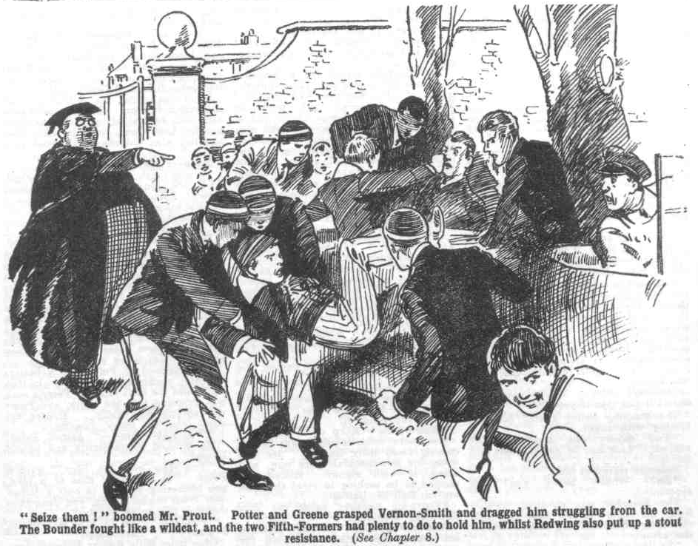
“Seize them!” boomed Mr Prout.
Potter and Greene had hold of Vernon-Smith the next moment and dragged him, struggling, from the car. The Bounder fought like a wildcat, and the two Fifth-Formers had plenty to do to hold him. Tom Redwing sprang at once to his aid, and was collared by Fitzgerald and Blundell of the Fifth.
Struggling desperately, the two juniors were dragged into the old gateway of Greyfriars.
“Well, my ‘at!” observed the driver. “This ‘ere is a game! I’d like to know the meaning of this ‘ere, old covey!”
“Those boys belong to this school!” boomed Mr. Prout. “ They have run away, and will be taken back to their headmaster. You may go !”
“ That’s all very well, old covey!” said the chauffeur. “ But who’s paying for this car if them kids ain’t ?”
“That does not concern me,” answered Mr. Prout, with dignity.
“It do concern me, old covey. This ‘ere car was booked for a drive for the day. What about it?”
“ Kindly go!” said Prout, with a wave of the hand. “Doubtless the headmaster will see that you are paid. You may go now.”
“Go back to High Oaks, and tell them what’s happened!” yelled the Bounder.
“Ask for Mauleverer—he will pay you.”
“Good enough, sir!” said the driver cheerily.
And as Mr. Prout withdrew his portly person out of the way, the chauffeur turned his car and departed for High Oaks. Vernon-Smith and Redwing, still resisting, were bundled in at the school gates, Mr. Prout following with a triumphant air, and Coker following Mr. Prout with his hand to his eye. ln the quad nearly all Greyfriars gathered round the two prisoners as they were marched in by the grinning Fourth-Formers. There were shouts of merriment on all sides. Between lines of laughing faces, Vernon-Smith and Redwing were taken up to the House. Mr. Prout followed them in.
“ Blundell! Potter! Bring them to the Head’s study!”
“Yes, sir.”
“You cheeky rotters!” yelled the Bounder.
“ Silence, Vernon-Smith!”
“Silence yourself, you old idiot!”
“What?” gasped Mr. Prout. “ What?”
“Can’t you mind your own business, you old fathead?” yelled the Bounder. “What do you want to butt in for, you fat ass?”
“Ha, ha, ha!” shrieked the Greyfriars fellows.
The expression on Mr. Prout’s purple countenance was worth a guinea a box, as Temple of the Fourth remarked to Dabney of that Form.
“Bless my soul! You—you insolent young knave!” gasped Mr. Prout. “ Take them to the Head—use force— any amount of force —”
“Ha, ha, ha!”
“Silence!” boomed Mr. Prout ferociously.
The Bounder and Redwing were marched into the Head’s corridor. Mr. Prout tapped at the Head’s door.
“Two Remove boys, sir !” he announced, with almost a smirk of satisfaction. “I hand them over to you, sir.”
“They have returned?” exclaimed the Head.
“They were passing the gates in a car, sir, and I took it upon myself to compel them to come into the school, sir,” said Mr. Prout.
“Very good, Mr. Prout!”
Dr. Locke fixed his eyes upon Redwing and Vernon-Smith. Redwing stood with his eyes to the floor; but the Bounder faced his headmaster with his usual cool hardihood.
“You have not returned here willingly, it appears.” said Dr. Locke.
“No fear!” said the Bounder.
“That is not the way to answer your headmaster, Vernon-Smith.”
The Bounder shrugged his shoulders. “Had you returned willingly, I might have taken that fact into consideration.” said the Head quietly. “As the matter stands, I shall punish you with the utmost severity.”
“Go ahead!” said the Bounder recklessly.
“How dare you answer me thus, Vernon-Smith? I am not surprised at finding you rebellious and insolent; but I am surprised, Redwing, at such conduct on your part!” said the Head sternly.
Redwing coloured uncomfortably.
“I am sorry to seem rebellious to you, sir! But we are all standing by Mr. Quelch.”
“That is impertinence, Redwing! Mr. Prout, will you send two prefects here?”
“Certainly, sir.”
Mr. Prout departed, leaving Blundell and Potter holding the two captured juniors by their collars. There was a grim silence in the study until Wingate and Gwynne of the Sixth arrived. They glanced curiously at the two Removites, and looked to the Head for orders.
“You will take these two juniors to the punishment-room, and lock them in, and bring me the key.” said the Head.
“Very good, sir!”
“Vernon-Smith! Redwing! Yoi will remain in the punishment-room today, and will pass the night there. To-morrow morning you will be flogged in public before all Greyfriars. Go!”
The two Removites were led away.
Five minutes later the key of the punishment room turned in the lock behind them.
THE NINTH CHAPTER.
Mauly Means Business!
MR. JUGGINS was standing in the gateway at High Oaks, gazing gently and placidly across the road and the common on the other side, with a pleased and contented expression on his ancient face. Tliings were going well with Mr. Juggins and all the Jugginses; and that sunny spring morning Alfred Juggins found the general arrangement of the universe quite to his satisfaction. Mr. Juggins had feared that, if High Oaks ever was sold his job there would come to an end; instead of which it had blossomed into a much better job, an enormously better job—a job such as Mr. Juggins had never dreamed of in his rosiest dreams. So no wonder Mr. Juggins looked pleased and contented.
The buzz of a car on the road caused him to look round, and he nodded to the chauffeur, who drew up opposite the gates. It was the man from Courtfield Garagc who had driven the Bounder and Redwing that morning. Mr. Juggins was acquainted with him, and he gave an affable nod.
“Back already?” he asked.
“Looks a bit like it, don’t it ?” asked the driver.
“Where’s your passengers?”
“Took!”
“Took!” repeated the driver. “Took by a stout old gent and a crowd of confounded schoolboys! Took out of my car by force, Alf! Shoved into another blinkin’ school! Now what’s this game?”
Mr. Juggins shook his head.
“Don’t ask me, Bill,” he replied. “I’ve been thinkin’ it hover and hover ever since his lordship bought this mansion, and I can’t make ‘ead or tail of it: Don’t ask me.”
“Is this ‘ere a school?” demanded Bill, staring up at the gilt-lettered board that announced that this was “High Oaks School.”
“The young gentlemen says it is,” answered Mr. Juggins. “One of their larks, I dessay. But they says so.”
Bill rubbed his nose hard.
“What are you doing here, Alf ?” he asked.
“Drawing the best pay of my life-time,’ answered Mr. Juggins, with a wink. His lordship is that open ‘anded, it’s a pleasure to watch ‘im. ‘Far as I can make out, these young rips have had a a row with their headmaster at Greyfriars, and have cleared off—cheeky young rascals, if you ask me. They make out they’re starting a school of their hown. His lordship asked me if I had a relation who was a ‘eadmaster—“
“Ha, ha, ha!”
Mr Juggins chuckled.
“I s‘pose this won’t go on for ever,” he said. “But the longer it goes on, the better I shall like it. I’m doing well ere, Bill. I’ve got jobs ‘ere for all my relations, from my Aunt Matilda, who’s sixty-nine, down to young Algernon Cecil Juggins, who’s twelve-and-a-‘arf. His lordship is a gent. He never counts his money.”
“My eye!” said Bill. “ Is his blinking lordship lookin’ for a shover?”
Mr. Juggins smiled.
“My young brothers, Percival and Albert, have been taken on as chauffeurs.” he replied. “As there ain’t any car here, two chaffeurs are enough to go on with. His lordship might think I was overdoing it if I took on another; though I’ll say this for him, he ain’t a suspicious young gentleman. It’s very pleasant, Bill, to come across such a trustful nature in this wicked world. But wot’s that you say about your passengers being took?”
“They’re took, for a cert,” said Bill. grinning. “Their own schoolmaster, I s’pose that, fat old josser was; anyhow, he took ‘em, and bunged them into Greyfriars, and young Vernon-Smith told me to come ‘ere and report, and ask Mauleverer for my money.
“That’s his lordship,” said Mr. Juggins. “Your money’s all right, Bill, don’t you worry. That young Smith is a bit of a young blighter, but he’s the son of a City millionaire—not the same class as his lordship, of course. But he’s got piles of dibs. Don’t you worry.”
“Well, if it’s all right —” said Bill.
“Right as rain!” said Mr. Juggins reassuringly.
“Right-ho!” said Bill, and he gave Mr. Juggins a nod and a grin and tooled his car on to Courtfield.
Mr. Juggins walked up the drive to the house to report to his lordship. The capture of Redwing and the Bounder did not surprise Mr. Juggins; what surprised him was the fact that all the rest of the rebel schoolboys had not been captured and taken back to the school where they belonged. Mr. Juggins would have been glad could High Oaks School have become a permanent institution; he would have liked it to last for years and years; but every day it lasted was a fresh surprise to
him.
“Good gad!” ejaculated Lord Mauleverer, when Juggins reported what had happened to Vernon-Smith and Redwing.
He blinked at Mr. Juggins in dismay.
“This is what comes of playin’ the goat, Juggins.” he said. “If those fellows had been in class as they ought to have been, this couldn’t have happened.
“ Quite so, my lord!” agreed Mr. Juggins.
“It’s their own fault, Juggins!”
“Quite, my lord!”
“But they’ve got to be got back somehow.”
“Oh, my lord !”
“Only most of the fellows are out out,” said his lordship. “Everything at sixes and sevens. Do you know when Wharton and his pals are comin’ in, Juggins?”
“They did not mention it to me, my lord.”
“Somethin’ will have to be done.” declared his lordship. “ We can’t have High Oaks chaps kidnapped in this way. I wonder if Dr. Locke has flogged them.”
“I think it very probable, my lord.” murmured Mr. Juggins. Mr. Juggins based his opinion upon the knowledge of what he would have done in Dr. Locke’s place. Certainly he would not have spared the rod.
“Well, serve ‘em right for playin’ the goat,” said Mauleverer. “1 dare say a f1oggin’ will do them good.”
“I think it very likely, my lord.”
“It may teach them to behave themselves.” remarked Mauleverer.
“ Nothing like it, my lord.” agreed Mr. Juggins.
And Lord Mauleverer dismissed the matter from his noble mind for the present. But at dinner at High Oaks, it was an exciting topic among the fellows who were indoors. Nine or ten fellows were still out, making a day of it ; and among them, the Famous Five.
It was not till the dusk was falling that the absentees returned to Higg Oaks. Harry Wharton & Co. came in a little tired, but very cheery. The day had been a very pleasant one and they had enjoyed themselves up the river. On these lines High Oaks School was rather an improvement on Greyfriars.
“Smithy back yet?” asked Wharton, as the Famous Five came into the hall, where the juniors were at tea.
“He, he, he! No fear!” chuckled Billy Bunter.
“They ought to be back by dark.” said the captain of the Remove, frowning a little. “There’s a limit.”
“The Head’s got them!” roared Bolsover major.
“What?”
“I say, you fellows, they were bagged at Greyfriars, and they won’t be coming back at all” chortled Bunter. “Serve them jolly well right, I think. I’d have protected them if I’d gone in the car,”
“They’re bagged?” exclaimed Bob Cherry.
“Yaas.” said Lord Mauleverer, “Serve them right for playin’ the goat. It would have served you fellows right, too, if you’d been collared.”
“Oh, draw it mild, Mauly!” said Nugent.
“There’s goin’ to be a change here to-morrow,” said Lord Mauleverer severely. “I’m goin’ to restore discipline !”
“Ha, ha, ha!”
“MauIy the Martinet!” chuckled Skinner.
“Ha, ha, ha!”
“You can cackle,” said his lordship. “But 1 mean it ; you’ll see! But what are we goin’ to do about Smithy and Redwing, you men?”
“Blessed if I know.” said Johnny Bull. “ If the Head’s got them, he’s not likely to let them go again.”
“The likeliness is terrific,” remarked Hurree Jamset Ram Singh.
“We’re goin’ to get them back, of course.” said Lord Mauleverer calmly. “We’re standin’ together in this row, and it’s up to us to rescue them.”
“Rescue’ them!” ejaculated Nugent. “Oh, my hat !”
“Yaas.”
“What utter rot !” yawned Skinner.
“My dear man, I—”
“ You can leave me out of such a stunt.” sneered Skinner.
“That’s just what I was goin’ to say, if you’d let me finish,” said his lordship innocently. “ Funks would be no good.”
“Why, you silly chump—”
“Ha, ha, ha !” roared the Remove.
“I shall want half a dozen fellows to come with me.” said Lord Mauleverer. “No funks need apply; so you’re safe out of it, Skinner. Same to you, Snoop.”
“You cheeky ass—”
“ And Bunter—“
“Oh, really, Mauly—”
“Let’s see.” Lord Mauleverer ran over the grinning Removites with his eye. “ Wharton, Bob Cherry, Squiff, Toddy, and Linley. That will make six, with me, if I’ve counted correctly. I believe I’m right.”
“Ha, ha, ha! About right!” chuckled Bob.
“ But who’s to be left in command here?” asked Harry Wharton.
“Nobody !” said Lord Mauleverer.
“No need for anybody to be in command when nobody obeys my orders.”
“Ha, ha, ha!”
“The commandfulness would be terrifically superfluous.” remarked Hurree Jamset Ram Singh.
“That will be all changed tomorrow,” said Mauly cheerfully. “ l’m goin’ to make a change all round to-morrow, and every fellow will be expected to toe the line.
“ Catch me !” grunted Bolsover major.
“Shall we bump Bolsover major for insubordination, Mauly?” asked Bob.
“Well, I like that, when you’ve been out all day yourself, breaking all the rules and regulations of High Oaks!” jeered Bolsover major.
“Hem! That’s different—”
“Not a bit of it, Cherry,” said Lord Mauleverer. “You’re as bad as Bolsover!”
“ Oh!” ejaculated Bob, taken aback.
“The question is, are the fellows I’ve named backin’ me up in rescuin’ those chaps at Greyfriars?” asked Lord MauIeverer. “I shall go alone if nobody backs me up.”
“Of course we’re backing you up, Mauly!” exclaimed Wharton, colouring. “We’ve made you leader, and we’re backing you up all along the line.”
“I’m not backing up anybody !” retorted Bolsover major.
“ You shut up, Bolsover.”
“Yaas, shut up. old bean; you talk too much.” said Lord Mauleverer. “I’m startin’ for Greyfriars at eight. Take a rest till then.”
“But what are we goin’ to do?” asked Bob.
“Obey orders, old bean” answered Mauleverer affably,
“Ha, ha, ha !”
And it was left at that.
THE TENTH CHAPTER.
Removites to the Rescue!
PREP was going on at Greyfriars, but certainly not at High Oaks, when Lord Mauleverer buttoned his coat against the wind, and stepped out of the big doorway. In the great lighted hall, a crowd of fellows with grinning faces watched him. The five followers he had selected were all ready; and they were the more dutiful portion of the rebel Form, and prepared to follow the leader they had elected. They were feeling very doubtful of the result of the expedition, however, and the rest of the Remove openly regarded it as a jest.
Lord Mauleverer did not, as a matter of fact, inspire deep confidence as a warlike leader. Yet the fellows had to admit that, as a leader of the Remove revolt, he had so far done amazingly well. It was Mauly who had picked on High Oaks as the new headquarters of the Remove; Mauly who had led the march out of Greyfriars; Mauly who was the fellow most determined not to surrender until the object of the revolt was attained. Certainly Mauly’s authority was now very much disregarded; but, that was not his fault; and, moreover, it was that disregard of their leader that had landed the Bounder and Redwing in their present scrape.
Still, though the schoolboy earl had proved his quality as a leader over and over again, his followers had many doubts. Mauly had been too long known us the champion slacker of the Remove. Nobody would have been surprised to find him fast asleep at a critical moment. His selected followers followed him out of the big doorway of High Oaks, but they followed him in a very dubious frame of mind.
“I say you fellows, good-bye for good!” chuckled Billy Bunter. “We shan’t see you any more.”
“Put some execrcise-books in your bags before you go into Greyfriars!” yelled Skinner. “Remember the Head’s birch!”
“Ha, ha, ha!”
Lord Mauleverer walked down the drive unheeding, and his followers followed. Skinner’s remark had made them feel a little uncomfortable. They had little doubt of getting into Greyfriars. But they had some doubt of getting out again.
If Lord Mauleverer had made any plans he had not confided them to his party. That was not because Mauly was secretive, but because he hated the trouble of talking. But the five juniors suspected that Mauly hadn’t made any plans at all; and they could not help thinking that he was leading them, not to the rescue of Smithy and Redwing, but to a similar fate.
“Well, we’re for it now!” murmured Bob Cherry. “We’ve got to see it through! Hallo, hallo, hallo! What’s that car doin’ here?”
“Waiting for us,” answered Mauly.
A car was standing at the gate;. The chauffeur alighted and opened the door for his passengers.
“Trickle in!” said Mauleverer.
“Is this a joy-ride!” demanded Peter Todd.
“Yaas; as far as Greyfriars,”
“Why on earth couldn’t we walk it?” asked Squiff.
“Tired.”
“Oh, my hat !”
The juniors piled into the car, and the car glided away in the darkness. The juniors blinked at one another in the gloom. If arriving at Greyfriars in a car was part of Mauleverer’s plan, it did not promise much in the way of success—to their minds, at least.
“Hallo, hallo, hallo! What’s this?” asked Bob Cherry, fumbling at something on the seat beside him.
“Probably a coil of rope.” answered Mauleverer.
“What on earth is it here for?”
“Very likely because I told the man to bring it when I phoned for the car.” explained his lordship.
“What’s it for, then?” asked Bob.
“Use, dear man.”
“ Are we going to take the Head prisoner and tie him up?” asked Squiff.
“Oh, give Mauly a chance!” said Mark Linley. “ I shouldn’t wonder if Mauly’s got it all cut and dried.”
“ Have you, Mauly?” demanded Squiff.
“Yaas.”
“Why can’t you explain, then?”
“ Tired.”
“Well, we shall be able to buzz off in the car when the prefects get after us.” said Bob resignedly. “That’s something!”
The car glided on swiftly through the gloom. It did not proceed as far as the school gate, however; it stopped fifty yards from Greyfriars. Lord Mauleverer alighted.
“Follow on!” he said.
The juniors followed on. His lordship led them through the darkness in the Cloister wall, a well-known spot to all Greyfriars fellows. It was a spot that had often been used for getting quietly out of bounds
“Bunk a man up!” said Mauleverer cheerily.
Bob Cherry bunked him up, and Mauleverer reached the top of the wall. He sat astride there and peered down.
“Pass up the rope!”
Wharton passed up the rope, and the juniors climbed after Mauly.
“Follow on!” said Lord Mauleverer. “You stay there, Toddy !”
“Eh! What for?” demanded Toddy.
“Keep guard.”
“Look here, if there’s going to be a shindy, I don’t want to be left out of it!” objected Toddy.
“Quite; but you’re here to obey orders, old bean.” said Lord Mauleverer placidly. “Stay where you are, old chap, and sit
on the wall. We may want a helping hand when we come back, if we come back in a hurry, and we may.”
“Very likely!” chuckled Bob.
Peter Todd grunted discontentedly.
He was not pleased with the prospect of mounting guard on the wall, and waiting there for the return of the other fellows.
The night was chilly. and there was a cold wind from the sea. But there was no help for it, and Peter grunted and remained.
Lord Mauleverer led his men through the dim, deserted
Cloisters. The quadrangle was dark and silent; but many lights gleamed from the windows in the great facade of the House. Lord Mauleverer cut across a corner of the quad; but he halted near the old fountain, and stood with his eyes fixed on the many lighted windows.
“What are we stopping for?” inquired Bob Cherry.
“Quiet, old man; voices may be heard,” murmured Lord Mauleverer. “Somebody may be takin’ a stroll in the quad.”
“ Not in this wind.”
“ Shut up, all the same!”
Bob grunted, and relapsed into silence. Lord Mauleverer led the way onward at last, skirting the school buildings. Apparently, his object was to reach the rear of the school ; why, the juniors did not know. But they felt it was up to them to follow, and they followed
Mauleverer halted again, at last, and stood looking up at the irregular pile of buildings, black against the dark. His his gaze fixed upon a little barred window high up—fifty or sixty feet from the ground. From that window a faint light glimmered.
“Good!” ejaculated Lord Mauleverer.
“Well, what’s good?” asked Bob Cherry, in a tone of exaggerated impatience.
“You know that window, dear men? It’s the punishment-room.”
“Oh!” ejaculated Wharton. They’re there! There wouldn’t be a light in the room if nobody was there.”
“My only hat!” breathed Bob Cherry. “Of course, it was likely enough that the Head would lock them up in the punishment-room. But how did you know, Mauly?”
“I didn’t know.”
“ Eh?”
“But I thought it likely. I fancied we’d draw the punishment-room first as the likeliest place.” yawned Mauly.
“Easy enough to try somewhere else, if the fellows weren’t there. Catch on?”
“They might have been in their study in the Remove passage.”
“Not in the dark.
“ Eh?”
“I looked up at the Remove window from the quad—they were all dark.”
“Oh!”
“They’re in the punishment-room,” said Mauleverer. “Saves us a lot of trouble to get right to the spot at once ——what?”
The juniors peered at Mauleverer rather curiously in the gloom. Once more his lordship was surprising them by his qualities of leadership. ObviousIy, Mauly had thought out the whole thing, and the juniors understood now what the coil of rope was for.
“Good old Mauly!” said Mark Linley.
“Hem!” said Bob. “And are we going to climb up a blank wall of fifty feet or so, Mauly, and hand them the rope?”
“Couldn’t be done.” said Mauleverer calmly. “But there are more ways of killin’ a cat than choking it with cream. I fancy Smithy will know how to get hold of the rope when we attract his attention.”
“We’re going to shout to him?” grinned Squiff. “We shall have half Greyfriars on the scene by the time Smithy hears us!”
“What about a pebble at the window, dear man?”
“Oh, good—if you can chuck a pebble up fifty feet in the dark and hit that window!”
“A catapult would do it easily, old beast I”
“Very likely. And where are you going to get a catapult from?”
“My coat pocket?”
And Lord Mauleverer drew the article required from the pocket of his overcoat.
“Oh, my hat!” murmured Bob, almost overcome. “Some leader!”
“I found the youngest Juggins peltin’ sparrows with this,” explained his lordship. “I kicked him for tryin’ to hurt the sparrows, and gave him half-a-crown for his catapult.”
“Are you a good shot with it?” asked Wharton.
“I don’t know.”
“You don’t know?” ejaculated the captain of the Remove.
“ How should I know, when I’ve never tried?”
“Oh my hat! If you’ve never tried the chances are that you’re a jolly bad shot.” chuckled Bob.
“Yaas, But the worst shot can hit a target, if he tries long enough. We’ve lots of time—it’s not nine yet, and it will be all right if we get home with the milk in the mornin’ .” said his lordship placidly. “But I don’t really think it will take me till mornin’ to hit that window
“Ye gods, I hope not—in this wind.”
“Better stand well back, you men. I should be sorry to catch one of you in the eye—”
“Not so sorry as we should be,” chuckled Bob. “Come on, kids, give him a wide berth. He’s dangerous!”
And the juniors crowded well back behind Mauleverer as he commenced catapulting pebbles at the high window of the Greyfriars punishment-room.
THE ELEVENTH CHAPTER.
French Leave!
“HANG it!”
“ Not much good grousing, Smithy.”
“Oh, rats!” snarled the Bounder.
Herbert Vernon-Smith tramped impatiently, savagely, to and fro across the narrow limits of the punishment-room. His face was pale swith anger, his expression almost desperate.
Tom Redwing sat at the little table, with a pen in his hand and a sheaf of impot paper before him. Redwing was taking it calmly. As there was nothing to be done, the sailorman’s son did not see any use in expending energy in grousing and growling.
The Head had set the two imprisoned juniors tasks, with a thoughtful desire that they should not waste their time. Redwing had sat down to his task after tea in the punishment-room ; there was nothing else to do, and he did not want to sit in idleness. But the Bounder had hurled his exercise into a corner of the room. He was not in a mood for Latin irregular verbs.
One burner shed a light in the room. The door was locked, the window was barred. Each time that Toby, the page, had come to the room, to bring in meals, to make the beds, or to take away trays, two Sixth Form prefects had stood in the passage outside all the time, cutting off the remotest chance of escape.
Now that prisoners of the punishment room had received their last visit for the night, the door was locked again and they had heard a bar placed in position outside. The mere thought of escape was hopeless, and Redwing was taking it philosophically. But the Bounder could not follow his example. He roamed and raged about the room like a caged tiger.
“Hang it! All our own fault!” he said between his teeth.
Redwing smiled faintly, and the Bounder gave him a glare. He was in a mood to quarrel even with his best chum.
“You think it was all my fault?” he snarled.
“Well, you know it was, Smithy.” said Redwing quietly. “You played the fool, and we’ve got to pay for it. Can’t be helped now”
“We’re getting a flogging in the morning.” said the Bounder savagely.
“I know.”
“Perhaps you like the prospect, blow you?”
“No more than you do, Smithy. But what can’t be cured must be endured, I suppose. Anyhow, what’s the good of grousing?”
“Oh, cheese it !”
Redwing resumed his task, and the Bounder resumedl tramping round the room, gritting his teeth savagely. He went to the window and examined it for about the twentieth time.
“I could get these rotten bars out if I had a screwdriver.” he growled. “They’re screwed in.”
“But you haven’t,. old man. And you couldn’t climb down a sheer wall, fifty feet or more, if you got the bar out.”
“Think I don’t know that?” snarled Vernon-Smith. “Talk sense, if you want to talk.”
Redwing resumed Latin verbs. The Bounder tramped, and tramped, and tramped, growling all the time, and at last threw himself on one of the beds, tired with his incessant tramping. He lay there scowling, and there was silence in the room at last, broken only by the scratching of Redwing’s pen.
But Tom Redwing ceased to write and looked up suddenly.
“What was that ?” he exclaimed.
“What was what?” growled Vernon-Smith.
“It sounded like a tap at the window.”
The Bounder gave a scoffing laugh.
“Yes, a tap at a window fifty feet from the ground is likely, isn’t it? Don’t be an ass!”
Redwing did not answer, but he laid down his pen and sat listening, staring at the little square of the window. The Bounder followed his gaze with an angry sneer.
Tap! Crack!
“ Oh, my hat!” gasped Vernon-Smith.
It was more than a tap this time— something had struck the window and cracked a pane of glass. Obviously it was a stone. Vernon-Smith bounded from the bed.
It’s some fellow signalling to us— somebody who may help us!” he breathed. “Oh, good luck! One of the fellows—”
Redwing rose and turned off the light.
“What on earth have you done that for?” snapped the Bounder.
“To show we’ve heard, so that they needn’t chuck any more stones.” answered Redwing. “Also to keep us from being seen in the window, if anybody should happen to look this tray.’
“Oh, all right!”
The Bounder was at the window with a jump. He opened it and put his head through the bars and peered down. But the darkness baffled him
From below came a faint whistle.
Obviously it was a signal to the juniors in the punishment-room, and the Bounder whistled softly in return. His eyes were gleaming now. It did not yet occur to him that rescuers had arrived from High Oaks ; he fancied that the fellow below was some friend of his in the Fourth or the Shell. But whoever it was, it meant help and a chance of escape. The Bounder was fairly trembling with eagerness.
“Got any string, Redwing?”
“No, but we’ll jolly soon make a substitute,” said Tom, jerking off his necktie. He was as eager as his chum, but much cooler. “ I wonder who it is down there ? The fellows would help us it they could ; may be some chaps from High Oaks—Mauly, perhaps.”
“That fool Mauleverer? Likely!” sneered the Bounder. “Look here, we’ve got to make a cord somehow. We’ve got to get in touch with him, whoever he is. He can send up a pole on a cord, or a rope, if he’s got one.”
“Leave it to me.” said Redwing.
The sailorman’s son was not long in making a string of strips from his hand kerchief and a sheet from his bed. The nimble fingers of the sailorman’s son worked swiftly, and the improvised cord was ready in a very short time. Vernon-Smith tied a silver pencil-case to the end to weight it, and lowered it from the window.
There was a slight jerk below, telling him that the pencil-case had reached the fellow who stood in the deep darkness beneath the window.
A pause followed, then another jerk, which the Bounder guessed to be a signal to haul in. He drew up the cord, and a strong rope followed it in at the window.
“Oh, good!” breathed the Bounder.
Redwing coiled up the rope as it was pulled in.
“But—the bars?” muttered Vernon-Smith. “We can’t get through the bars, and we can’t shift them!”
“Wait till we get the rope in, Smithy.”
The end of the rope came in at the window at last, and tied to the end was a small bag. Redwing opened it and revealcd a chiseI, a hammer, and a screwdriver. The Bounder’s eyes danced.
“Oh, good! That chap, whoever he is, has got some sense!” he
exclaimed. “ Now we jolly well shan’t be long”
The Bounder grasped the screwdriver and started on the screws. They were well driven in, but the Bounder worked feverishly and tirelessly, and one by one the screws were withdrawn and tossed back into the room. With a chuckle at last Smithy jerked a bar away.
“We can squeeze through now, Reddy.”
“What-ho! Fasten the rope to the other bar.”
“ Right-ho!”
The rope slithered down again one end knotted securely to the bar that remained screwed in position.
“ Let me go first, Smithy.”
“ Rats!” .
“I’m more used to climbing ropes than you are, old chap.” said Redwing uneasily. “It’s risky !”
“Bosh ! Fat lot I care for the risk !“
The Bounder was on the deep sill of the window, his legs already out. He gripped the rope and lowered himself, Redwing watching ham anxiously. It was a descent that many fellows might well have hesitated to make; but it was the only way of escape, and the Bounder’s nerve was of iron. He gripped the rope, and set his teeth, and lowered himself hand-below-hand, swaying in the wind against the high wall.
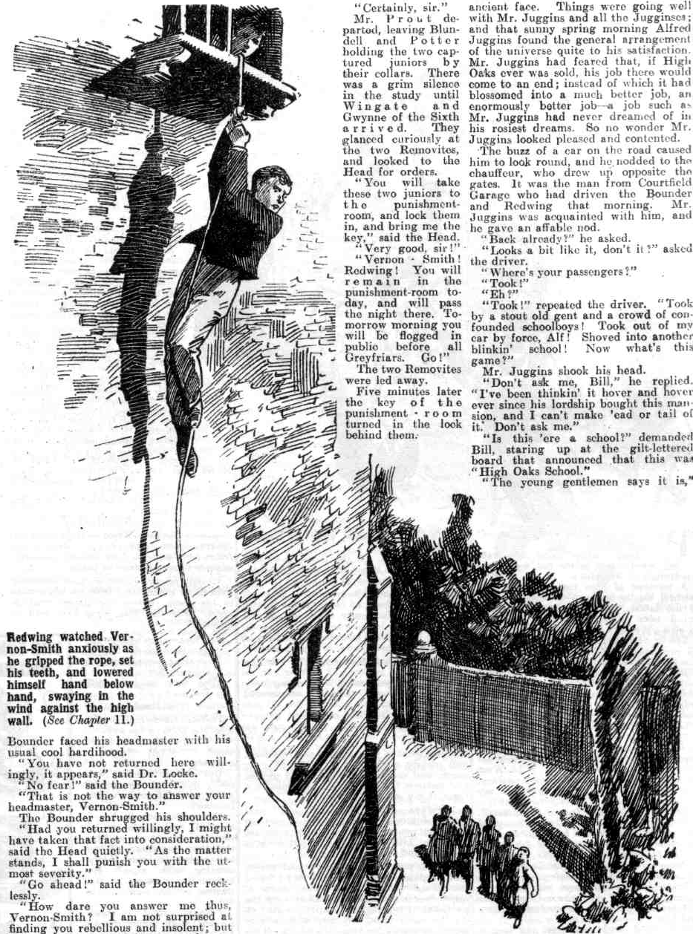 His arms were aching under the strain when at last he felt his feet touch the earth. He gasped with relief as he landed.
“All serene, old bean?” murmured a voice.
The Bounder started.
“Mauly!”
“Yaas.”
“ You!” ejaculated the Bounder.
“ Little me! Is Redwing comin’?”
“He’s comin’”
The Bounder jerked the rope as a signal to Redwing, and the sailorman’s son came actively down, making the descent in less than half the time taken by Vernon-Smith.
“It’s Mauleverer.” whispered the Bounder as Tom landed. “What a giddy surprise!”
“Hallo, hallo, hallo! All O.K., you chaps?” chuckled Bob Cherry.
“How many here?” asked the Bounder, staring round in the gloom.
“Five here, and one keeping guard on the Cloister wall,” answered Harry Wharton. “But Mauly’s done the whole bizney. He had a bag of tools in his pocket. Lucky he didn’t forget to put on his coat.
“Ha, ha, ha!”
“If you fellows are ready, we’ll mizzle.” said Lord Mauleverer quietly. “We’re not quite out of the woods yet. We’ll leave the rope as a present for the Head. The sooner we get out of this the better. Follow on!”
“Yes, rather.”
And the juniors scudded away
Mauleverer’s plan had worked like a charm. The prisoners were rescued, and an empty punishment-room remained to greet the astonishcd eyes of the head-master of Greyfriars in the morning.
All that remained for the Removites to do was to get clear of Greyfriars. They scudded into the black shadows of the Cloisters, and as they plunged into the darkness of the old stone arches there was a sudden crash.
“Oh!” gasped Vernon Smith, reeling back from a collision with an invisible object. “What the thump——”
“Bless my soul!” It was the voice of Mr. Prout, the master of the Fifth, “Goodness gracious! Who—what—that is Vernon-Smith’s voice. Bless my soul !”
And the Bounder struggled wildly in the grasp of the Fifth Form master.
THE TWELFTH CHAPTER.
A Narrow Escape!
MR. PROUT had dined not wisely but too well.
That was the cause of the collision in the Cloisters.
Mr. Prout’s old enemy, indigestion, had attacked him after a too-ample dinner, and Mr. Prout was fairly knocked out by this insidious enemy who hit below the belt. Mr. Prout had gone out tO walk it off. By old experience, he knew that indigestion could be walked off, and for a long time Mr. Prout had walked and walked. He had walked up and down and round about the quad; he had walked round the Head’s garden; he had walked to and fro across the Sixth Form green, and now he was walking in the Cloisters. It was just ill-luck that he was walking back towards the quad just as the fugitives rushed into the shadows.
Now Mr. Prout’s grasp had closed on Vernon-Smith like that of a vice and his voice boomed through the silence. Once more Mr. Prout was the right man in the right place, from his own point of view; the wrong man in the wrong place from the point of view of the Remove rebels. Nothing could have been unluckier for them than this unexpected encounter.
“Bless my soul! You have had the impudence to escape from the punishment-room !” gasped Mr. Prout.
“Let go, you old fool!” yelled the Bounder.
Really, that was not the way to make Mr. Prout let go. Instead of letting go he tightened his grip, and the Bounder strugg1ed and kicked in vain. A hack on plump shins did not induce Mr. Prout to let go, it only enraged him. With a powerful grasp, he dragged Vernon-Smith back into the dim starlight of the quadrangle.
“Rescue!” yelled the Bounder.
The sudden occurrence had taken all the party by surprise. Six juniors had rushed past Mr. Prout, and they were a good way on when they realised that Vernon-Smith had fallen foul of some invisible person in the dark.
“Stop!” panted Redwing. “Somebody’s got Smithy.”
“Oh, begad !”
“Rescue!” the Bounder was yelling. “It’s that old fool Prout; he’s got me! Lend a hand!”
The juniors came rushing back.
“ Bless my soul!” ejaculated Mr. Prout, realising that he had more than one to deal with. “Help! Help!”
Mr. Prout’s voice boomed over all Greyfriars.
He was dragging the Bounder forcibly towards the House, in spite of’his struggles. In the distance, two or three lighted windows opened, and voices were heard calling. Then there was a burst of light in the gloom as the great door of the House was flung wide open. Figures appeared in the light, running out into the quad.
By that time, however, Harry Wharton & Co. had reached the Bounder and the Fifth Form master.
“Let Smithy go, please!” said Lord Mauleverer politely. “We don’t want to handle you, sir.”
“Thump the old fool, you idiot!” yelled the Bounder.
“Shut up, Smithy! Let him go, please, sir.”
“Bless my soul! 1s that Mauleverer You young rascal!”
“Really, sir—”
“Let go!” shouted Redwing.
He grasped at Mr. Prout’s clutching hands to release them from the Bounder. Mr. Prout released one hand and gripped Redwing by the collar. Instead of losing one prisoner, he gained two.
“What’s the row?” came a calling voice across the quad---the voice of Wingate of the Sixth.
“Help, Wingate!” shouted Mr. Prout.
“Coming, sir!”
Harry Wharton & Co., rebels as they were, felt a natural hesitation to handle a majestic gentleman like Mr. Prout. But it was clear that the only alternative to the handling of Mr. Prout was the recapture of the escaped prisoners of the punishment-room.
“Collar him!“ said Lord Mauleverer. “Can’t be helped. Bump him over!”
“What-ho!”
Many hands closed on the portly figure of the Fifth Form master, and he was bumped over.
A terrific roar escaped Mr. Prout as he made closer aquaintanee, all of a sudden, with the hard unsympathetic earth.
But Paul Pontifex Prout was a sticker. He went down, but he retained his grip on the collars of Smithy and Redwing, and they sprawled over with him. Wingate and Gwynne and Loder of the Sixth were speeding towards the spot, and after them came a crowd of Greyfriars men. The whole school had been alarmed by this time.
There was not a moment to lose.
Instead of the rescue of the prisoners, it looked like capture for the rescuers now.
Mr. Prout was firmly grasped and rolled over without ceremony. His plump face was pushed into a puddle, and he gas ped and spluttered frantically, and let go his hold on the two juniors. Redwing and Smithy dragged them- selves away and scrambled up.
“Hook it!” panted the Bounder.
“Come on!”
Leaving Mr. Prout sprawling and spluttering, the juniors dashed off towards the Cloisters at top speed. They were only in time, for Wingate and Gwynne were scarcely three yards behind them. The two prefects rushed on in hot pursuit, and Loder, following on, stumbled over Mr. Prout. He gave a howl as he came down, and Mr. Prout gave a louder howl as Gerald Loder landed on him.
“Yoooooooop! You young rascal!” roared Mr. Prout, clutching Loder, evidently taking him in the darkness for one of the juniors.
“Yaroooh!” howled Loder. “Leggo!”
“Smack! Smack! Smack!
Mr. Prout, breathless and furious, was smacking Loder’s head frantically, under the impression that it was a Removite’s head that he was smacking.
“ Yow-ow-ow! Stoppit!” shreiked Loder wildly.
Smack ! Smack ! Smack !
Loder realised that Mr. Prout took him for one of the Removites, in the dark; but that did not soften those terrific smacks. Loder saw no reason why he, too, should not make a mistake in the darkness. So he landed out with a clenched fist, and caught Mr. Prout on the point of his plump jaw. There was a gasp from Mr. Prout as he collapsed.
“Wooooooooooh !”
Loder tore himself away and jumped up.
“Come on!” Wingate was shouting, “It’s those juniors—they’ve got out of the punishment-room—”
“Groogh! Seize them!” spluttered Mr. Prout, sitting up and clasping his
jaw with both hands. “Seize them! One of them has struck me! Ow! Wow! Seize them! Oh—moooooooh!”
“Put it on, you men!” gasped Lord Mauleverer.
“You bet!”
The juniors raced wildly through the shadowy Cloisters with heavy footstep thudding behind them. They reached the wall where Peter Todd sat astride, peering towards them anxiously through the gloom. It proved fortunate that Lord Mauleverer had left a man on guard there, for the escaping juniors would scarcely have had time to climb up. But with a helping hand from the top of the wall, things moved swiftly.
“Toddy!”
“Here!”
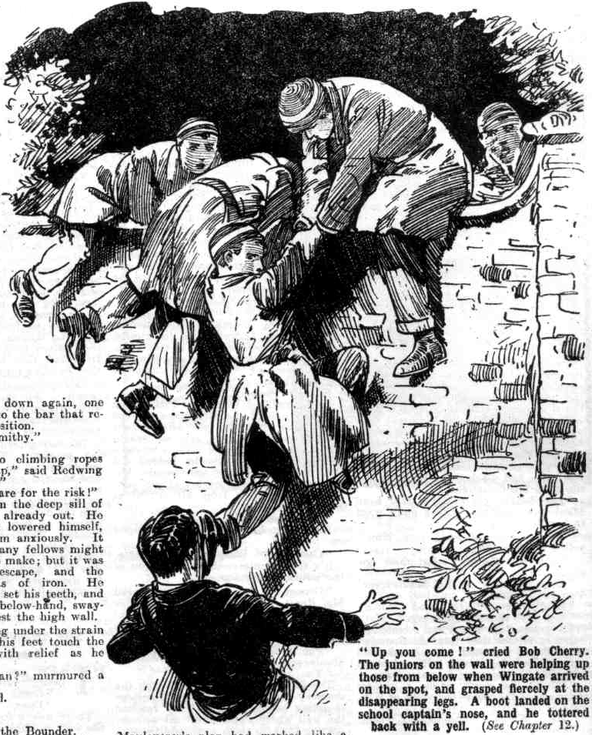
Toddy lay on the wall, reaching down. He grasped a hand, and helped the climber up. It was Bob Cherry: and the moment he as on the wall he reached down to help another; and two more juniors were dragged up, scrambling. Four on the wall were helping up four from below, when Wingate arrived on the spot, and grasped fiercely at the disappearing legs. A boot landed on Wingate’s nose, and he tottered back with a yell—and the next moment the shadowy leg had disappeared over the wall.
The juniors dropped on the farther side, breathlessly.
“All here, you men?” asked lord Mauleverer breathlessly.
The voices of all the party answered.
“Come on, then, dear men!”
“Stop, you young scoundrels!” Wingate of the Sixth was half over the wall. “Stop—do you hear?”
“Go and eat coke!”
The juniors rushed away.
Wingate dropped from the wall, and after him dropped Gwynne and Loder and five or six of the Sixth and Fifth Form, all hot in pursuit. They could hear the fleeing footsteps of the juniors, and they dashed in chase.
“Better scatter!” panted the Bounder. “We can’t race the Sixth!”
“Come on!” answered Lord Mauleverer.
“But I tell you—”
“And I tell you come on, you ass!”
“Look here—”
“There’s a car waitin’, you duffer!”
“ Oh!” gasped the Bounder.
“Mauly thought of everything!” chuckled Bob Cherry. “ Put it on— we’ll beat them yet!”
The juniors were in the road now and they could hear the throb of the engine; the chauffeur had had his instructions and he was ready to start at an instant’s notice. Had the race been run on foot, there was no doubt that the seniors would have run down the juniors very soon. But the fugitives had time to reach the car, and they bundled into it breathlessly.
“Home!” said Lord Mauleverer calmly. All through the wild excitement his lordship had been as calm as a marble statue. His lordship regarded excitement as an unnecessary exertion.
The car glided off, packed by gasping juniors. Wingate and his companions came up the road with a rush, and the red rear-light winked at them as the car dashed away. They rushed on furiously; but the red light faded into the darkness of the night, and they stopped at last, breathless and disappointed. The rescuers were gone, and the prisoners of the punishment-room were gone with them: and Greyfriars was left with a wildly-exciting topic for discussion, while the rebels of the Remove glided on swiftly to High Oaks.
THE THIRTEENTH CHAPTER.
Rebellious Rebels!
“I SAY, you fellows, they’ve come back!” yelled Billy Bunter.
“Great Scott!”
“ Phew!”
There was a roar of astonishment in the hall at High Oaks as Lord Mauleverer and his merry men came in, and with them the two rescued prisoners. The Removites could hardly believe their eyes.
“My only hat!” exclaimed Bolsover major.
“The get-awayfulness is terrific,” said Hurrec Jamset Ram Singh. “ The esteemed congratulation is great, my ludicrous friends!
“Jolly glad to see you back!” said Nugent. “ Blessed if I quite expected to!”
“You men don’t mean to say that Mauly managed it?” asked Skinner.
“Looks like it!” remarked Johnny Bull.
“ Mauly worked the whole giddy oracle.” said Bob Cherry. “Mauly’s some chief, I can tell you!”
“ Bravo, Mauly !”
“ Mauly’s the real goods!” said Mark Linley. “I’d like to see all you fellows backing him in as he deserves.”
“Rats!” said Bolsover major. “This is Liberty Hall, and we’re jolly well going to do as we like!”
“Yes, rather!” said Skinner and Snoop together.
“You swots can stick to classes, if you like, all on your own.” went on Bolsover major. “None for us, thanks!”
“I say, you fellows I don’t think classes ought to be allowed here’” said Billy Bunter. “Those swots ought to be jolly well ragged!”
Lord Mauleverer looked at his watch.
“Bed-time!” he said. “We’re back in time for dorm.”
“Think again!” jeered Bolsover major.
“I am !“ answered Lord Mauleverer mildly. “Classes begin again tomorrow, you know.”
“Rats!”
“I say, you fellows, if classes begin again, I shall jolly well have another barring-out !” said Bunter.
“I mean it,” said Lord Mauleverer. “I’ve been elected leader, and it’s too late for you men to back out now. Classes begin again to-morrow, and every man will be expected to play up.”
“Blessed are those who don’t expect!” grinned Skinner. “They never get disappointed, you know.”
“Yes, chuck it, Mauleverer,” said the Bounder. “I’m going out to-morrow for my joy-ride, as it was mucked up to-day.”
Lord Mauleverer looked at him.
“You’re goin’ to be caned tomorrow, Vernon-Smith, for goin’ on a joyride to-day without leave.” he answered.
“What?” ejaculated the Bounder.
“Caned.”
“And who’s goin’ to cane me?” demanded the Bounder, with a grim look.
“I am!” answered Lord Mauleverer calmly.
The Bounder stared at him, and burst into a scoffing laugh.
“Make your will first!” he said derisively.
“I mean it. Skinner and Snoop and Stott and Hazeldene will be caned, also for playing cards to-day.”
“I don’t think!” grinned Hazel. “Go to sleep and dream again!” suggested Stott.
“Look here!” exclaimed Harry Wharton. “Mauly’s right. We’ve elected him leader, and what’s the good of a leader if he’s not obeyed?”
“No good at all,” said Skinner. “We don’t want any leader. Mauly can go and eat coke and you can go and do the same!”
“Say the word, Mauly, and we’ll jolly soon bring Skinner to order,” said Bob Cherry.
“Will you?” roared Bolsover major. “I’m backing up Skinner in this. So are most of the fellows, I fancy.”
“Hear, hear!”
“Count me in!” said the Bounder, with a grin. “I fancy you haven’t enough supporters to carry things here with a high hand, Manly.”
“Say the word, Mauly.” repeated Bob, with a belligerent look at the Bounder. “We’re backing you up!”
“Sorry, old man, but you’re goin’ to be caned, too,” said Mauleverer.
Bob Cherry started.
“Me?” he ejaculated.
“Yaas,”
“Oh, my hat!” said Bob, quite taken aback.
“ Ha, ha, ha!”
“Is Mauly going to cane the whole giddy Remove?” chortled Snoop.
“Yaas—if they don’t toe the line,” answered Mauleverer placidly. “I mean business, you men.”
“I guess it won’t wash, Mauly!” chuckled Fisher T. Fish. “There’ll be a dead duffer lying around, I reckon, if you start in caning me.”
“But what am I going to be caned for, Mauly?” exclaimed Bob Cherry, staring at his lordship blankly.
“Takin’ a day off from classes and goin’ up the river. Wharton and Nugent and Bull and Inky, too.”
“Ha, ha, ha!”
“ Me!” exclaimed the captain of the Remove.
“Yaas”.
Harry Wharton’s face was a study.
“Ha, ha, ha!” yelled Skinner. “This is too rich! Even his Magnificence is a
naughty boy and is going to be whacked!”
Wharton drew a deep breath.
“Right!” he said. “Mauly’s right. I’ll take it quietly, Mauly, old man. The game’s the game!”
“Sorry all round,” said Lord Mauleverer politely. “But I’m goin’ to maintain discipline. High Oaks is a school, not a bear-garden.”
“Somethin’ like a school!” grinned the Bounder. “All right so long as we do just as we like.”
“Yea, rather!” said Ruell. “Call it off, Maulyl Wc’ro not going to stand it, you know.”
“I’ve said it’s bed-time,” said Lord Mauleverer calmly. “All you fellows get off to the dormitory.”
“Rats!”
“Go and eat coke!”
“Oh, play the game!” exclaimed Mark Linley. “I’m going.”
Mark set the example. Penfold followed him, and then the Famous Five. After a little hesitation Peter Todd and Tom Brown followed, and then two or three other fellows. Lord Mauleverer glanced over the numerous crowd that remained, and took out a little notebook and began writing in it.
“What’s that game?” inquired Skinner.
“Takin’ down your names,” explained Mauleverer.
“What on earth for?”
“For lickin’s tomorrow.”
“ Oh, my hat! You really think you are going to lick us?”
“Yaas.”
“You’ll find us there when you start!” grinned the Bounder.
“Come on, Smithy—dorm!” said Redwing.
“Rubbish!”
Tom Redwing went to the dormitory alone. Lord Mauleverer proceeded to take down names, amid loud laughter. When he had finished he put the book away and rang the bell for Juggins. That valuable factotum appeared at once, as if by magic.
“Your lordship rang?” inquired Juggins.
“Yaas. You’ve fixed it up with that cousin of yours?”
“Yes, my lord.”
“What time will he be here tomorrow!”
“I have told him to get here at ten o’clock in the morning, my lord.”
“Very good, Juggins.”
Juggins retired.
“Taking on some more Jugginses, Mauly?” asked Skinner, with a chuckle.
“Yaas—one more.” said his lordship. “I’m givin’ all you fellows one more chance. Goin’ to bed?”
“Rats!”
“I say, you fellows, bump him for his cheek!” squeaked Billy Bunter. “ Who’s that ass to give us orders, I’d like to know?”
“Good egg!” exclaimed Skinner.
“Bump him!”
Lord Mauleverer hastily retired from the scene. A roar of laughter followed him.
Lights gleamed from the windows of High Oaks till a very late hour that night. Bunter snored in an armchair; Bolsover major and a crowd of fellows played leapfrog; Skinner and a select circle played banker. Anyone who had looked in at High Oaks up to midnight that night would have been strongly of opinion that it was high time that the school without a master came to an end.
In the opinion of the majority of the Remove, High Oaks was “something like a school,” run on its present lines. But certainly an unprejudiced observer would have said that it was nothing like a school.
Undoubtedly it was time—high time— that a change was made and order restored. And a change was coming on the morrow—with the help of the newly enrolled member of the tribe of Juggins.
THE FOURTEENTH CHAPTER.
Ructions In the Remove!
HARRY WHARTON & CO. turned out at the clang of the rising- belt in the morning. Juggins rang the bell; and in the first days at High Oaks School the bell had been heeded. Perhaps on the ground that familiarity breeds contempt, it was generally unheeded now. Billy Bunter’s deep and sonorous snore did not cease. Bolsover major opened his eyes and shut them again. Skinner turned over: Stott yawned. The Famous Five hopped out of bed; and Mark Linley, Penfold, and Redwing followed suit. Lord Mauleverer turned out at last with a manful effort. Mauly hated turning out of bed, and he sighed deeply when he did so. But he felt that it was up to him to observe his own rules and regulations.
“Hallo, hallo, hallo, Toddy! You slacking?” bawled Bob Cherry.
Peter Todd yawned and turned his head on the pillow.
“Et tu, Brute!” grinned Nugent.
“Oh, give us a rest!” said Toddy sleepily, and he closed.his eyes again.
“What about you, Squiff?”
Sampson Quincy Iffley Field sat up, found that it was cold, and lay down again.
“What’s the matter with another half-hour?” he yawned.
“Slacker!”
“It’s catching; everybody’s slacking.”
“I shall have to take your name, Squiff.” said Lord Mauleverer gently.
Squiff chuckled.
“Take it, old chap! I don’t mind your adding my name to your collection if it amuses you.”
“You’ll be licked.”
“Spare me!” said Squiff humorously.
“What about you, Browney?” called out Bob. “Turn out! They don’t slack in New Zealand.”
That appeal was enough for Tom Brown, and he grinned and turned out. The junior from Taranaki was anything but a slacker, but example is infectious. But it was only a handful of the Remove that turned out; the greater part of the Form allowed the clang of the rising bell to pass them by like the idle wind which they regarded not.
“Precious lot of slackers!” growled Bob Cherry. “What price bumping the lot of them out of bed?”
“Too many for us to bump out, I think.” said Mark Linley. with a smile.
“I say you fellows—”
“Hallo, hallo, hallo! You turning out, Bunter?”
“No, you ass! I want you to shut up.” said Bunter peevishly. “How’s a fellow to sleep when you’re jabbering away like a lot of parrots?”
“It’s rising-bell, fathead!”
“Oh, rats! Don’t be an ass!”
And William George Bunter snored again.
Clang, clang, clang!
Alfred Juggins was doing his duty with the bell. It clanged loudly and insistently.
“ Mauly!” yelled Skinner.
“Yaas?”
“Tell Juggins to stop that row with that bell.”
“ Oh, begad!”
“ Yes, rather!” said Bolsover major. “Tell him to stop it, Mauly ; and tell him there’s not to be any more rising-bell. That frightful row in the morning spoils my sleep!”
“ It’s risin’-bell, dear man,” remonstrated Lord Mauleverer. “ There can’t be a school without a risin’ bell.”
“Oh, don’t be an ass! If you don’t. make that old donkey stop that row I’ll lick you when I get up !”
“And I’ll do the same,” said Vernon-Smith. “ I want another hour before I turn out ; I was up late last night.”
“You’re goin’ to be caned today for bein’ up late, Smithy!”
“Silly ass! Stop that bell, I tell you, or I’ll jolly well punch you when 1 do turn out.” growled the Bounder.
Clang, clang, clang!
“Do you hear, Mauly” roared Bolsover major. “Call out to that idiot, Juggins, to stop it.”
“ Nothin’ doin’,” said his lordship placidly, “ I’m advisin’ all you slackers to turn out. It will be better for you in the long run.”
Bolsover major sat up, groped for a boot, and hurled it with deadly aim. There was a wild yell from Mauleverer as he caught the boot with the side of his noble head.
”Yaroooh!”
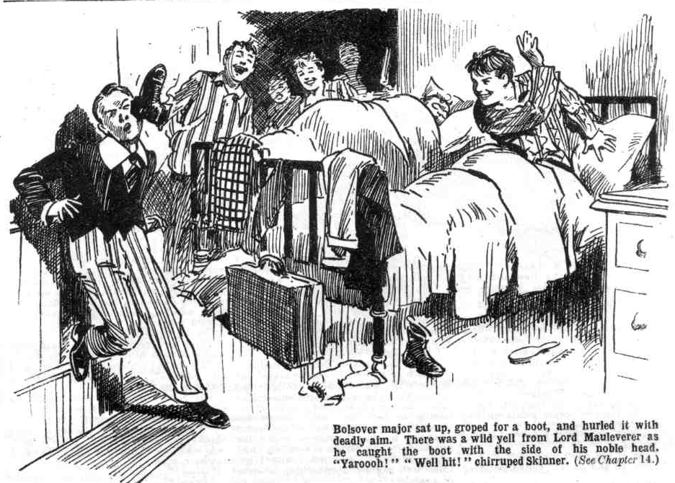
“Well hit!” chirruped Skinner.
“ Goal!” chuckled Hazeldene.
“Ha, ha, ha !”
Lord Maulevercr rubbed his head, and then picked up the boot. Bolsover sat up in bed and gave him a threatening glare.
“You chuck that boot at me, you tailor’s dummy, and I’ll get out and smash you !” he snarled.
Whiz!
The boot flew before Bolsover major finished speaking, and it landed on his chin with a terrific crash. Bolsover major gave a roar of mingled pain and wrath, and rolled furiously out of bed to take vengeance. He was rushing at Mauleverer, when Bob Cherry put out a timely foot, and the bully of the Remove sprawled over at and bumped on the floor.
“Hands off Mauly!” said Bob cheerfully.
“I—I—I’ll smash him, and you, too!” yelled Bolsover major.
“Me first, then!” grinned Bob.
Bolsover major scrambled up, dodged round Bob, and rushed at Mauleverer. His lordship had picked up a jug of water; and he met Bolsover major with the contents, in a whizzing flood.
Splash!
“Ha, ha, ha !” roared Bob, as Bolsover staggered back, gasping and spluttering. “Good old Mauly!”
“Grooogh! Gug-gug! Ooooch!t”
“Have the jug next, dear man?” asked Lord Mauleverer affably.
“Groooogh!” Bolsover major snatched a towel, and began to towel himself furiously. “I’ll thrash you within an inch of your life for that, Mauly.”
“Dear me!” said his lordship, unmoved.
Bolsover major towelled himself, and then advanced upon Lord Mauleverer, with clenched fists and blazing eyes.
“Pile in, you men!” said Bob Cherry. And the Famous Five grasped the bully of the Remove as one man, and Bolsover major came with a crash to the floor.
Bang! bang!
Wild roars came from Bolsover, as Bob, grasping his ears, knocked his head on the floor in a series of post-men’s knocks. Bolsover’s head was hard ; but the floor was harder.
“ Say when “ said Bob cheerily. “We’re backing up old Mauly, you know—we haven’t backed him up quite so well as we intended ; but nobody’s going to lift a finger on him, at any rate. Say when!”
“I’ll smash you!” shrieked Bolsover.
Bang, bang, bang!
“Yow-ow! Stoppit !” shrieked the bully of the Remove, struggling wildly. “Smithy—Skinner—back up, you rotters!”
The Bounder put a leg out of bed; Skinner remained where he was. Mark Linley quickly interposed.
“ Stay where you are, Smithy!”
“You going to stop me? sneered the Bounder.
“ Yes. if you chip in!”
“I’ll give you a chance, then!”
The next moment the Lancashire lad and the Bounder was fighting. Nobody else showed any desire to come to Bolsover’s aid ; most of the juniors were sitting up in bed now laughing. Little discipline remained in the rebel Form ; and few had any intention of regarding Mauleverer’s leadership ; but all the fellows liked Mauly personally, and nobody desired to see him punched by the bully of the Rcmovec.
Bang, bang, bang!
“Stoppit!” raved Bolsover major. “ I’ll chuck it—I won’t touch Mauly— leave off — Yarooooogh!”
“Might as well have said that at the start, and saved me a lot of trouble.” said Bob, panting for breath.
“Ha, ha, ha!”
Bolsover major was allowed to rise. He tottered away, rubbing his damaged head in anguish. The Bounder went sprawling across his bed, under a right. hand drive from Mark Linley. He was coming on again, furiously, when Bob Cherry interposed.
“ Chuck it Smithy—”
A savage punch was the only reply; and the next moment, the Famous Five collared the Bounder.
Bump, bump, bump!
Thrice the Bounder smote the floor, hard, and then he was tossed, breathless and gasping, upon his bed.
Lord Mauleverer smiled.
“I fancy that will be enough for the Bounder, by gad!”
“The enoughfulness will be terrific, my esteemed friend!” said Hurree Jamset Ram Singh, with a dusky smile.
Apparently it was enough for Vernon-Smith, for beyond glaring savagely at the Famous Five, he made no further show of resistance.
Most of the other slackers did not seem inclined to linger in bed after that ; Lord Mauleverer, obviously, had the support of the Famous Five, and the fistical prowess of Harry Wharton & Co. was well known to Skinner and his cronies.
“They all seem to be getting up.” said Bob Cherry, glancing round the dormitory. And then he started, as his gaze alighted on the fat form, huddled in blankets, of William George Bunter. That fatuous youth was snoring loudly and unmusically, apparently oblivious of what had been going on around him.
“Heave that fat idiot out!” said Bob Cherry.
“Yaasi, begad!” drawled Mauly. “I shall have to put his name down for a
canin’ !”
The Famous Five surrounded William George Bunter’s bed, and seized it at all four corners. At a signal from Harry Wharton they lifted the bed.
Bump!
“Whoop! Yah! Yoopl”
Billy Bunter came to earth, so to speak, with a bump and a roar.
“Yah! You rotters!” he gasped. “Ow! My back’s broken! My spine’s fractured in three places! Yowp! I’m dying!”
“Well, don’t make so much noise about it.” said Bob Cherry heartlessly.
He lifted his foot suggestively, and with remarkable cclerity for a person who was dying, Billy Bunter scrambled to his feet, and backed away.
“Yah! Beast!”
“I’ll give you two seconds to decide whether you’re going to get washed or not!” said Bob Cherry meaningly.
But one second was enough for the fat Removite. He rolled towards the washstand and commenced his ablutions.
“That’s that!” said Lord Mauleverer. “Now, let’s get down to brekker!”
And the Famous Five trooped downstairs, conscious of the fact that they had begun their day well.
—
THE FIFTEENTH CHAPTER.
The Limit!
BREAKFAST was a late and irregular meal at High Oaks that morning. Lord Mauleverer and the other early risers had finished before the rest of the Form came down. They came down in batches of two’s and three’s, every fellow pleasing himself in the matter. Aunt Juggins, the High Oaks cook, was kept busy for a very long time; and the scene in hall was uproarious.
Bolsover major, especially, was out of all control now; and he finished his breakfast by shying cup and saucer and plates across the room, to smash into fragments on the opposite wall. Two or three other wild spirits followed his example—nothing is so catching as a bad example, where there is no authority to restrain. The rebels of High Oaks bad been disorderly for some time, and now they were simply riotous. Skinner & Co. started smoking cigarettes after breakfast, and the Bounder began a game of nap with Hazeldene.
Harry Wharton & Co. looked at he scene and wondered whether it was not time that the Remove rebellion was thrown up. and a return made to Grey- friars. The Remove had gone on strike in support of Mr. Quelch—but the leaders of the Form had anticipated nothing like this—matters had gone from bad to worse, and evidently were going to be worse still.
“It’s not good enough, you fellows!” said Bob Cherry soberly. “This sort of thing isn’t backing up Quelchy—this is just blackguardism!”
“I suppose we might have expected it.” said Harry Wharton ruefully. “I don’t see what’s to be done. There aren’t more than eight or nine fellows backing up Mauly now—and they can’t lick the rest of the Form into order.”
“The lickfulness does not appear possible.” agreed Hurree Jamset Ram Singh. All we can do, my esteemed chums, is to set an excellent and ridiculous example.”
Harry Wharton laughed.
“We haven’t even done that, I’m afraid,” he said.
“The spirit is willing, but the esteemed flesh is weak. But we can turn over a new page,” said the nabob. “It is never too late to mend the cracked pitcher that goes longest to the well, as the English proverb says.”
“Ha, ha ha!”
“Something in that.” said Bob Cherry. “Let’s go into class when the bell rings—it’s up to us to back up Mauly.“
“Right-ho!”
And when Juggins rang the school bell, the Famous Five went into the class-room with Mark Linley and Penfold. Lord Mauleverer followed them in with a cheery smile on his face.
“You men toein’ the line?” he asked.
“ Yes, old chap—with apologies for previous shortcomings.” said the captain of the Remove.
“All serene, old bean! You’re let off your lickins, then.” said Lord Mauleverer amiably.
The chums of the Remove grinned. They had forgotten that Manly had sentenced them to be licked.
“Right-ho!” said Harry, laughing.
“Marky, old bean, you’ll take the class same as at first.“ said Lord Mauleverer. “I’ll go and round up the others!”
“Hadn’t we better come with you, Mauly?” asked Bob Cherry anxiously. “They may handle you, you know.”
Mauleverer shook ins head.
“No; you stick to class, old bean. I’ll have the rest in shortly. Leave it to me.”
“But look here—” said Wharton dubiously. He was rather alarmed at the idea of what might happen to Mauly if the schoolboy earl attempted to enforce authority over the wilder spirits of the Remove.
“Leave it to me, old bean!”
“Oh, all right!”
Lord Mautoverer strolled out of the class-room, and the dutiful members of the Form looked at one another doubtfully.
“Mauly’s in for a high old time, I fancy.” said Johnny Bull.
“Has he got anything up his sleeve?” asked Bob Cherry. “Mauly’s rather a dark horse, you know. Look how he managed the recue last night. He turns up trumps every time.”
“Silence in class, please!” said Mark Linley mildly.
And the juniors grinned and were silent.
Lord Mauleverer went back into the hall of High Oaks, where some very late risers were still breakfasting. Billy Bunter was the last down to breakfast; but he was making up for lost time. Bolsover major was enjoying himself with a new game of his own invention; shying plates at the big clock in the hall. The glass of the clock had gone very soon: and Bolsover was industriously striving to knock off the hands.
“I’ve come here to tell you fellows that you’re late for class.”
“Chuck it, you ass!”
“I say, you fellows, bump him for his cheek!” squeaked Billy Bunter. “I’m
fed-up with Mauly, for one!”
“Give a fellow a hearin’ !” said Mauleverer. “Toe the line and play the game and we’ll let bygones bygones; all lickin’s called off.”
“Ha, ha, ha!”
But, some of the fellows walked away to the class-room—Squiff, and Tom Brown, and Peter Todd, and Monty Newland. Tom Redwing, after a vain effort to persuade the Bounder to accompany him, followed them.
“Now you other fellows get a move on.” suggested Lord Mauleverer. “This sort of thing has got to stop, you know. Don’t drive me to severe measures, you men. Play the game!”
“Are you goin’ to lick us?” chuckled the Bounder.
“Yaas, if you don’t play up.”
“Come on and do it!” yelled Bolsover major.
Lord Mauleverer glanced at the clock, but the clock was out of action now; and he looked at his watch. It wanted ten minutes to ten. At ten, James, of the tribe of Juggins, was booked to arrive.
“I’m givin’ you a last chance!” urged Mauleverer.
“Shut up!”
“Go and eat coke!”
Crash! Crash! Crauls’
Bolsover major & Co. resumed shying crockery at the big clock. Juggins put his startled face in at a door,
“ Young gentlemen!” he protested. “Young gentlemen— Yarooooh!” Juggins roared, and vanished, as a plate cracked on his head.
“Ha, ha, ha!”
“I say, you fellows, shy some at Mauly!” called Billy Bunter. “That’ll teach him not to talk to us about class!”
“Good egg!”
“Go it!” roared Bolsover major.
“Oh, gad!” gasped Lord Mauleverer, as a teacup whizzed past his ear, and
a plate cracked on his watch-chain. “Oh crumbs!” And his lordship beat a
prompt retreat from the Hall, followed by yells from the rebels.
“Ha, ha, ha!”
“That much for Mauly!” chuckled the Bounder. “Now, let’s have out those swots in the class-room! This isn’t a place for sappin’. Let’s have ‘em out and make a bonfire of their books!”
“Hear, hear!”
“Come on!” roared Bolsover major.
A mob of excited fellows swarmed out of the hall, and headed for the classroom. Only Billy Bunter remained at table; he had not finished breakfast yet, having so far eaten only enough for three fellows. All the rest of the crowd swarmed to the classroom, ready for mischief. The Remove rebellion had degenerated into riot now; and High Oaks was rapidly approaching a state of anarchy.
“Have ‘em out!” roared Bolsover major, glaring in at the doorway of the class-room. “No swots allowed here! Have ‘em out!”
“Oh, my hat!” ejaculated Bob Cherry.
Mark Linley ran to the door.
“Come in to class, or keep out!” he rapped.
“Rats to you!” roared Bolsover major, coming in to wreck the room. and to rag all you swots! We — Yarooooh !”
Bolsover major broke off with a roar, as the door slammed on his nose. Mark Linley quickly turned the key. The next moment the door was shaking and creaking under a rain of blows.
“ Lets us in, you saps!”
“Open this door, you sneaks!”
“Smash it in!”
“Some school!” murmured Bob Cherry. “ This looks to me like the limit, you chaps! Unless Mauly’s got something up his sleeve, we shall have to chuck up and get back to Greyfriars.”
Crash! Crash! Bang!
The door, fortunately, stood fast. The rioters streamed out of the house, and a few moments later, Bolsover major’s excited face was looking in at a window. A Latin dictionary landed on Bolsover’s nose, and he disappeared suddenly, with a wild yell.
Crack! Crash! Crack!
Three or four panes of glass went under missiles hurled from without.
“My hat! It’s the giddy limit, and no mistake!” said Harry Wharton. “This is the finish!”
The rioters streamed away from the class-room windows. Bolsover major’s voice was heard roaring.
“Where’s Mauly? Where’s that cheeky cad Mauleverer? We’ll jolly well make an example of him! Tar and feathers, what?”
“Good!”
“Bravo!”
“After him!”
“I say, you fellows, let’s duck him in the pond!” yelled Bunter. Bunter had finished breakfast at last.
“Hurrah!”
And the rioters spread about the grounds in search of Lord Mauleverer, with direful intentions towards that noble youth when found. It was, as Bob Cherry had said, the limit: the school without a master was wholly ou. of hand, and verging into anarchy.
Lord Mauleverer, at that moment, was standing at the gates, in conversation with a brawny, thickset, muscular man in a spotted neckerchief, whose face, somewhat resembling that of a bulldog in expression, was adorned by a number of ancient scars, and was not rendered any the more beautiful by the loss of three front teeth, and a sideway twist to a pug nose.
“Mr. James Juggins, what ?” asked his lordship.
“Yes, me lord—likewise called Jimmy the Pug!” said the gentleman with the damaged nose. “I ‘ear you’ve got a job for me ‘ere, me lord?”
From the distance came a roar.
“Where’s Mauly?”
“Duck him!”
“Yaas,” said Lord Mauleverer placidly, “I’ve got a job for you, James; and the job’s quite close at hand, from what I hear. ‘Follow me, old bean!”
“I’m arter you, me lord!”
And James Juggins followed Lord Mauleverer up the drive. His job was quite near at hand—and, judging by his looks, Lord Mauleverer was of opinion that Jimmy the Pug was quite equal to his job.
THE END.

