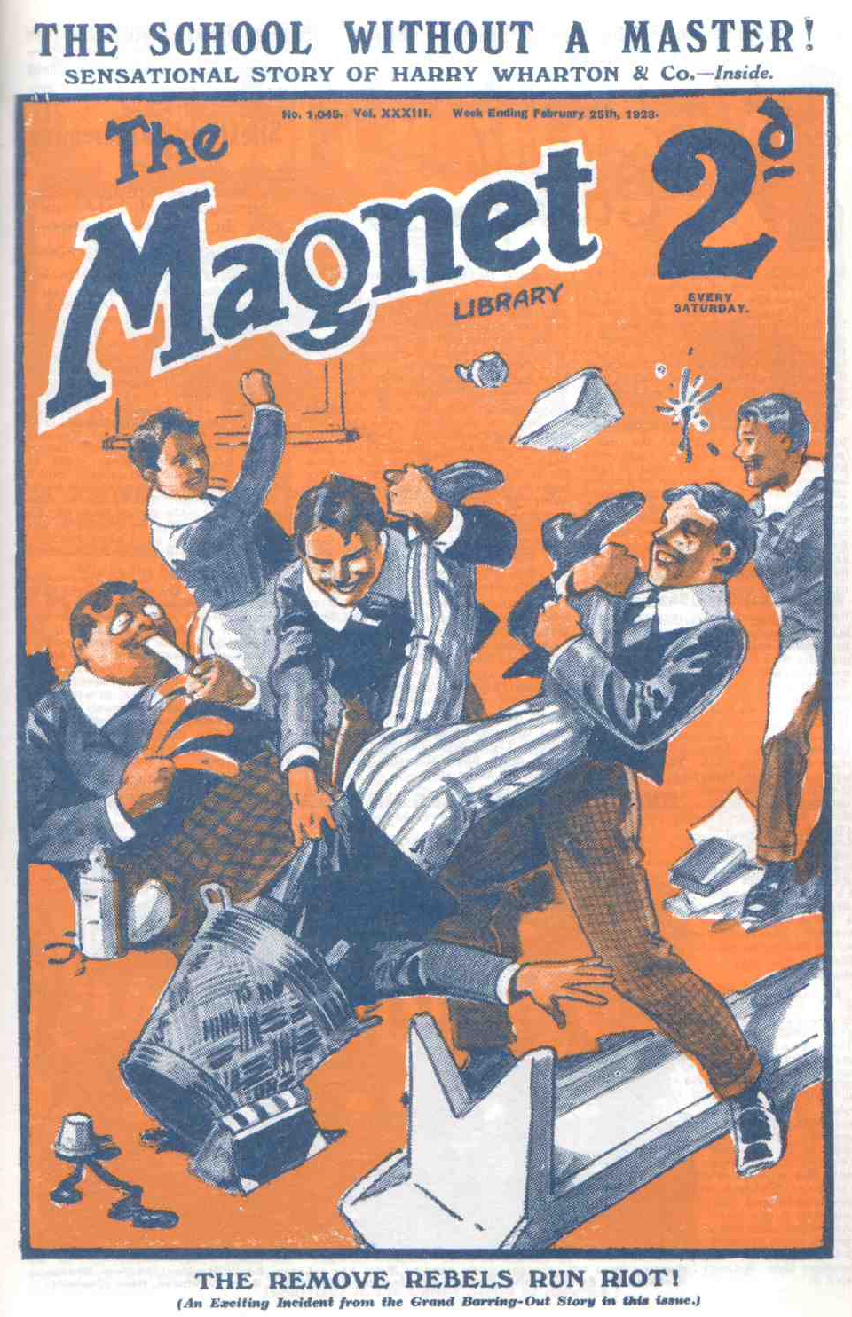
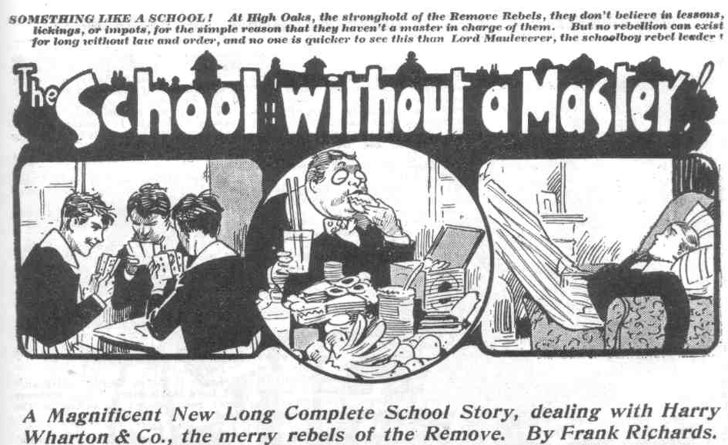
THE FIRST CHAPTER.
Woe to the Vanquished!
“BLESS my soul!”
Dr. Locke, the headmaster of Greyfriars school, uttered that ejaculation.
He uttered it in tones of amazement. The Head was standing at his study window, looking out into the quad. where the winter dusk was falling.
There was a buzz of voices and a sound of laughter in the quad. It was that outbreak of merriment that had drawn the headmaster to his study window.
“Here they come!”
“Ha, ha, ha!”
Almost all Greyfriars seemed to have gathered in the quad from the Sixth Form to the Second, with the exception of the Remove. Not a single Remove man was to be seen there in the buzzing crowd. The Remove—the Lower Fourth Form of Greyfriars—were no longer within the school. But the other Forms had turned up almost to a man, to stare at the party of fellows, who had just come in, and who were trailing wearily and drearily towards the House.
Twelve men of the Sixth Form were in the party, headed by Wingate, the captain of the school.
Seldom or never had a party of Sixth-Formers of Greyfriars been seen in such a state.
They were wet and muddy and dishevelled; they looked as if they had been drenched to the skin, and some of them looked as if they had been collecting hefty punches. Walker had a swollen nose; Gwynne had a discoloured eye; Loder was sticky with jam and treacle, and his collar and tie were gone; Carne was hatless, and his coat was spilt. Water dripped from the whole party, and squelched out of their boots.
That they had been in the wars was obvious at a glance.
Dr. Locke gazed at them from his study window in amazement and horror. He did not join in the roar of merriment that greeted Wingate & Co. as they trailed wearily across the quad. From the heads point of view, this was not a laughing matter—far from it.
To the rest of Greyfriars it evidently was a laughing matter, and they laughed loud and long.
“What price the Sixth now?” chuckled Horace Coker of the Fifth. “They’ve let a mob of Lower Fourth fag. handle them like that!”
“Ha, ha, ha!”
“Haven’t you brought the Remove back, Wingate?” chortled Hobson of the Shell.
Smack!
Wingate of the Sixth was the best tempered senior at Greyfriars, but his temper had suffered now. Hobson was incautiously within reach when he asked his question. Wingate did not reply in words: he smote Hobson of the Shell, and Hobson sat down with a roar.
“Yoooop!”
“Ha, ha, ha!”
The party of Sixth-Formers marched on. They marched between two lines of laughing fellows, who were careful to keep out of hitting distance after the collapse of Hobson. It was quite an ovation, but not the kind of ovation that the seniors seemed to like.
“You’ve got wet, Wingate!” chortled Coker of the Fifth. “It hasn’t been raining! Did the fags duck you?”
“Where did you get that eye, Gwynne?”
“I say, Walker, where did you collect that nose?”
“Ha, ha, ha!”
“Look at Loder! They’ve treacled him!”
Loder glared round savagely, but his savage glare only evoked louder roars of laughter.
“Oh, come on!” muttered Wingate, red with wrath. “Let’s get out of this!”
“Ha, ha, ha!”’
“Bless my soul!” murmured the Head.
He threw open the window and leaned out.
“Wingate!”
“Oh gad!” breathed Wingate. But he stopped. He was anxious to get out of the sight of the laughing crowd, but the Head’s voice had to be obeyed. Unwillingly, with a crimson face, Wingate of the Sixth approached the window of the Head’s study, with his drenched and dreary followers. Round them the chuckling crowd thickened.
Dr. Locke gazed from the window at the draggled party.
His eyes glinted with anger.
If the draggled dozen had looked for sympathy from their headmaster, they looked for it in vain.
There was no sympathy in the Head’s looks—only astonishment and wrath.
“Wingate, what does this mean?” he thundered.
Evidently the Head was wrathy. He was speaking to Wingate of the Sixth as a Form master might have spoken to a fag of the Third or Second.
Wingate’s colour deepened till his complexion rivalled that of a freshly-boiled beetroot.
“We—we’ve come back, sir!” he gasped.
“Have you brought the Remove boys back with you?”
The question really was superfluous. The Head could see that Wingate hadn’t.
“No, sir!”
“Why are you in this state?”
“We—we—we——” mumbled Wingate.
“This disgraceful state?” thundered the head.
“We—we—“
“ I sent you to fetch back the Remove boys who have absented themselves from school without leave! Why have you not done so?”
“They—they wouldn’t come!”‘ gasped Wingate.
“What !”
“We—we tried——”
“Do you seriously mean to tell me, Wingate, that you and all the other prefects of Greyfriars have failed to fetch the juniors back? Is it possible that you have allowed the juniors of the Lower Fourth Form to treat you in this manner?”
“We couldn’t help it, sir!” stuttered Wingate.
“Nonsense!”
“We did our best!” grunted Gwynne.
“Absurd!”
“We didn’t get into this state for fun, sir!” howled Loder.
“Silence! You are impertinent, Loder!”
Lodcr of tbe Sixth snorted. A fellow who had been bumped and thumped, and had had jam and treacle plastered over him, did not want a ragging to follow from the Head. Loder came very near telling his headmaster what he thought of him just then.
“This is disgraceful!” exclaimed the Head. “I am astonished—disgusted! You have failed in your duty!”
“The fags resisted, sir!” stammered Carne.
“Nonsense!”
“We couldn’t get at them—”
“Rubbish !”
“They turned a hose on us—”
“You should not have allowed them to do so!”
“We—we—we—”
“Enough!” exclaimed the Head. “I shall deal with this matter personally! I see that I cannot rely on) my prefects! Go!”
The Sixth-Formers went willingly, but with feelings too deep for words. The Headmaster’s window slammed. While that window had been open and Dr. Locke looking out, the Greyfriars crowd had controlled their emotions. But as soon as the Head disappeared from sight a yell of merriment broke out again.
“Ha, ha, ha!”
“What price the prefects?”
“Dear at twopence each!”
“Ha, ha, ha!”
And Wingate & Co. trailed wearily into the House, to hide their diminished heads, leaving the rest of Greyfriars to chortle.
THE SECOND CHAPTER.
Nothing Doing!
“I SAY, you fellows!”
“Shut up, Bunter!”
“I say, the Head’s coming !”
“Oh!”
Harry Whartton & Co. sat up and took notice, as it were.
Lord Mauleverer, who was dozing in a big armchair before the blazing log fire, opened his eyes wide.
“The Head!” he repeated.
“Just coming up the drive.” grinned Bunter. “I fancy he’s left his car at the gates. He, he, he !”
“Oh gad!” said Lord Mauleverer. “The jolly old Beak!” remarked Bob Cherry. “I suppose the prefects have got home, and he s listencd to their tale of woe.”
“Ha, ha, ha!”
“Well, the Head can’t do any damage.” said Vernon Smith. “We can turn the hose on him as easily as 01) Wingate and his crowd.”
“Chuck tbat Smithy 1” said Harry Wharton abruptly. Nobody’s going to turn the hose on the Head.”
“No fear !” said Bob Cherry emphatically.
The Bounder shrugged his shoulders.
“Isn’t this a rebellion?” he inquired. “Are we going to walk back to Greyfriars just because the Beak’s come over to tell us so?”
“Nothing of the kind. But there’s a limit.” said the captain of the Remove. “Cheeking the Head is barred.”
“The cheekfulness to the esteemed head is not the proper caper, my esteemed Smithy. “ murmured Hurree Jaimset Ram Singh.
“Yaas, begad !” remarked Lord Maulevcrer. “We’re not takin’ any nonsense from the Beak, but we’re goin’ to treat him respectfully. Frightful bad form to cheek one’s headmaster.”
“Isn’t it cheeky to refuse to obey his orders?” asked the Bounder sarcastically.
Lord Mauleverer rubbed his nose in a thoughtful way.
“Well, perhaps it is.” he admitted. “But that can’t be helped. We’re bound to stand up for our rights.”
“Hear, hear!”
“Lock up all the doors and keep the windows shut,” said Mauly. “The head’s too jolly dignified to try to bust a way in like Wingate and his lot. We can keep him out quite poli.ely.”
“Ha, ha, ha!”
“The poIitefulness shall be terrific.” said Hurree Singh.
The wintry dusk was falling thick, and outside the building darkness deepened ; but from almost every window of High Oaks lights were gleaming. The mansion in which the rebellious Remove had camped looked very bright and cheery, with fires crackling, and the electric lights blazing in every room.
Tea was just over and tea had been a tremendous spread. Supplies at High Oaks were unlimited. Whenever any fellow stated that anything was wanted, the obliging Mauleverer telephoned to Chunkley’s stores in Courtfield, and at Chunkley’s Stores Mauly’s credit was without bounds. There was no doubt that the schoolboy millionaire was a very valuable asset just now. For once, Mauly, generally a slacker, had taken the lead in the Form; and as a leader he was, quite unexpectedly, shining. The news that the Head was coming brought him actively out of his armchair, and he posted himself at the hall window, while a crowd of Removites scattered about the house to make sure that all doors were fastened.
Even the Bounder would have hesitated to “handle” the Head. There was a limit, even when the Remove were in a state of rebellion. But all the Form were agreed on keeping him out of High Oaks.
Up the drive from the gate came the stately figure of Dr. Locke, and many eyes were fixed on him as he came.
The Head of Greyfriars had left his car in the road outside, perhaps not wishing his chauffeur to see and hear his interview with the rebel juniors.
He arrived at the broad steps and mounted them, seemingly unconscious of the crowd of curious faces at the windows.
Knock!
Lord Mauleverer opened the window and looked out.
“Good-evening, sir!” he said politely.
The Head glanced at him.
“Open the door, Mauleverer.”
“Sorry, sir can’t be done.”
“I have told you to open the door, Mauleverer!” said the Head of Greyfriars, in a deep voice.
“And I’ve told you I’m sorry it can’t be done, sir!” answered Lord Mauleverer politely.
Dr. Locke breathed hard and deep.
“I have come here to take you juniors back to Greyfriars.” he said.
“Sorry, sir, we’re not goin’!”
“Do you venture to disobey me, Mauleverer?”
“Sorry, sir—yaas.”
“What?”
“Yaas!”
“Wharton is there, I presume?” said the Head. “I desire to speak to Wharton, the head boy of the Form.”
“Here, sir!” said Harry, appearing at the window by the side of the dandy of the Remove.
“You are the ringleader in this outrageous outbreak, I presume, Wharton?” asked Dr. Locke, his eyes glinting at the junior.
“We’re all in it together, sir,” said Harry.
“ Matter of fact, sir, I’m leader.” said Lord Mauleverer: “ The fellows have kindly put it in my hands.”
“You are the leader of this rebellion against authority, Mauleverer?”
“ Yaas, sir.”
“The matter is more serious than you seem to realise.” said the Head.” I shall be sorry to be compelled to expel anybody from Greyfriars, but I fear that I shall be forced to expel the leaders in this rebellion. The whole Form will be seve1y flogged.”
“First catch your hare!’ grinned the Bounder.
“ Shut up Smithy! Don’t cheek the Head!” said Johnny Bull:
“Oh, rats!”
“Leave it. to me, Smithy, old bean,” said Lord Mauleveer. “ Your manners aren’t good enough for talkin’ to the Head.”
“ You silly ass!”
“ Dry up, old scout! Is there anythin’ more you have to say to us, sir ?“ asked Lord Mauleverer, addressing his head master with great politeness.
“I command you to return to Greyfriars at once.”
“Can’t be done, sir. Our Form master, Mr. Quelch has been dismissed—”
“That is not your business, boy.”
“We’re makin’ it our business, Sir,” said Mauleverer calmly. “ Unless Mr. Quelch is reinstated, sir, we are not coming back to Greyfriars.”
“I decline to discuss the dismissal of Mr. Quelch with junior boys!” snapped the Head. “ Mr Quelch has left Greyfriars and will not return. That matter is closed. A new Form master will be appointed—”
“We shan’t have anythin’ to do with him, sir.” said Mauleverer. “ We’re standin’ up for right an’ justice an’ fair play and things. We want Mr. Quelch—”
“Hear, hear!”
“ And we shan’t be happy till we get him.” grinned Squiff.
“Ha, ha, ha!”
Dr. Locke stared at the juniors crowding the broad window. Possibly he had not realised that the Remove were in this determined mood. He was still calm, though his eyes were glinting with anger.
“ You must be well aware that you cannot remain here in this mansion.” he said. “ You are trespassing here.”
“Not at all, sir.” said Mauleverer cheerfully. “High Oaks is my property, sir.”
“Your property!” exclaimed the Head.
“Yaas. I bought it, sir.”
“You bought this house and land!” the Head exclaimed blankly.
“Yaas, sir, with my guardian’s approval. I’ve got rather an eye for landed property, sir.” said Mauleverer modestly. “ I rather think it was a bargain at seven thousand pounds”
“Seven thousand pounds !” gasped the Head, like a man m a dream.
“Yaas, sir.” said Lord Mauleverer placidly.
“Is it possible, Mauleverer, that your guardian has allowed you to become the purchaser of this property?”
“Yaas, sir. He’s got a lot of faith in my judgment in such matters,” said Lord Mauleverer. “I may be an ass in some things, sir, but I know my way about in matters of this kind. Nobody could call me a pup when it comes to buyin’ land, or buildin’s, or a horse.”
“Bless my soul!” ejaculated the Head.
The juniors grinned. Evidently it was an astonishing discovery to the Head of Greyfriars that High Oaks was now the property of the millionaire schoolboy.
“Mauleverer! Do you tell me that your guardian, Sir Reginald Brooke, has given you his support in this rebellion against your headmaster!”
“I haven’t mentioned it to him, sir. Just told him I was keen on buyin’ the place, and he put it through the bankers. I assure you, sir, that I’m not throwin’ the money away if that’s worryin’ you. I know a lot about land and buildin’ and nunky knows I do. When we’re done with High Oaks I shall ask my guardian to cut it into buildin’ lots, and it will sell in sections for nearly twice as much as I gave for it in bulk. I assure you, sir, I’ m frightfully well up in these things.” said Lord Maulevercr innocently.
“Bless my soul!” said the Head, blinking at Lord Mauleverer.
There was a long pause.
“This cannot go on.” said the Head at last. “If you boys refuse to return to the school, drastic rneasures will ho taken. You will not be allowed to idle about here in term time.”
“We’re not goin’ to idle, sir. We ask nothin’ better than to return to Greyfriars with Mr. Quelch—”
“Mr. Quelch will not return!” snapped the Head angrily.
“Then we shall not return, sir.” said Lord Mauleverer coolly. “But we’re not goin’ to slack about an’ waste our time. High Oaks was advertised for sale as a place suitable for turnin’ into a school, and that’s what we’re goin’ to do with it”
“Wha-a.at?”
“We’re tryin’ to get Mr. Quelch to become our headmaster
“What!” gasped the Head.
“If he won’t, we shall get another.” said Lord Mauleverer. “And until we get a headmaster we shall keep on classes and things without a master.”
“I don’t think !“ murmured Bolsover major !”
“Shut up, Bolsover!”
“I say, you fellows, we’re not going to have any classes, you know!” exclaimed Billy Bunter excitedly. “What’s the good of a rebellion if we have to work all the same?”
“Ha, ha, ha!”
“ Shut up, Bunt4’r t”
“We mean that, sir,” went on Lord Mauleverer. “High Oaks School is goin’ to be distinguished for—for hard work and scholarships, and things; no slackin’ or idlin’ allowed. Everythin’ in order.”
“You are talking nonense, Mauleverer!”
“Dear me” said Mauly.
“You cannot possibly carry out this ridiculous project!”
“We’re goin’ to try, sir.”
“Yes, rather!” grinned Bob Cherry.
“The ratherfulness is terriffic, honoured sahib.” said Hurree Jamset Ram Singh.
“I command you,” said the Head, in a deep voice, “to return to Greyfriars immediately! Otherwise, force will be used!”
“We’re prepared to deal with force, sir,” said Lord Maulnverer. “The prefects didn’t make much of a hand of it, did they, sir?”
“Ha, ha, ha!”
Dr Locke compressed his lips hard. He had driven over to High Oaks in the full belief that his commanding voice and his majestic presence would quell the rebellion, and that the Remove would march back to school at his order. But if his majestic presence, failed of its effect, he had no means of enforcing his command.
“Very well,” he said at last; “I shall communicate with your parents, and warn them that any boy who does not immediately return to Greyfriars will be expelled from the school!”
And with that Dr. Locke turned away, with as much dignity as he could, and walked down the drive to the gates.
A minute later the buzz of a car was heard, bearing the headmaster back to Greyfriars.
“All serene!” drawled Lord Mauleverer, and he returned to his armchair to rest after his exertions.
“I say, though, what will happen if the Beak writes to our people?’’ said Hazeldene. “Paters and maters won’t see this as we do.”
“Hardly!” grinned Ogilvy.
Lord Mauleverer smiled placidly.
“That’s all right,” he said. “The Head won’t be in a hurry to tell our people that he can’t manage the Lower Fourth Form. What will paters and maters think of him, if he writes and tells them that he can’t enforce obedience among the juniors? He won’t do it.”
“Why, he can’t!” grinned Bob Cherry. “Not if he can help it, anyhow.
“We’re all right till the Easter hols.” said Mauleverer. “The Head won’t bring all our people on the back of his neck in a hurry. He’s rather fed on fellows’ relations at the best of times. Parents are the nightmare of a school-master’s life, you know—an’ it stands to reason that no headmaster would bring thirty or forty parents down on himself in a lump—what?”
“Not likely!” said Tom Redwing, laughing.
“No fear!”
“The nofearfulness is terrific.”
“Just bluff!” said the Bounder, with a chuckle. “He won’t tell our people— he will be only too jolly glad if they don’t hear of it anyhow. The fact is, he can’t do anything but sack the lot of us—and if a headmaster sacked a whole Form, the governors of the school would jolly soon sack him, I imagine. The Head’s in a cleft stick.”
“He’s got to give in.” said Bob. “As soon as he asks Quelchy to go back, we’ll go back and be good,”
“He can’t give in.” said the Bounder. “His jolly old dignity is at stake. He’s fairly bunkered all round.”
“Then how is it going to end?” asked Mark Linley.
The Bounder laughed.
“What does that matter? It will be fun while it lasts—and the end can take care of itself!”
“Hear, hear!”
And that view was satisfactory to most of the juniors, who were not much given to looking ahead. At all events, the Remove were determined upon one thing—they were standing by their Form master, who had been unjustly dismissed from his post at Greyfriars and they were not going to give in until Mr. Quelch was reinstated as master of the Remove. And in the meantime, they had no objection—none at all—to a school without a master.
THE THIRD CHAPTER.
The New School!
“J UGGINS!
“Yes, my lord!”
“You will ring the rising-bell in the morning.
“The which, my lord?”
“Is there some sort of a bell to ring?” asked Mauleverer. “Any old bell will do—muffin-bell, or bicycle bell—”
“There’s the alarm bell, my lord, which used to be rung in case of fire, my lord.”
“First rate!I Ring that at seven-thirty in the morning, Juggins.”
“Yes, my lord.”
And Juggins retired, having received his instructions. Mr. Juggins, the newly-appointed porter of High Oaks School, hardly knew what to make of that school and its schoolboys. But he was more than satisfied with his position in the new scholastic establishment. He had been caretaker in the mansion during its period of vacancy. No doubt he had been paid for caretaking. But his remuneration as caretaker, compared with his remuneration in the service of Lord Maulererer, was as moonlight unto sunlight, as water unto wine.
Mr. Juggins was making a very good thing out of it. Moreover, he had introduced a whole tribe of his relatives into the place. There were Juggins gardener, Juggins cook, Juggins page and Jugginses up and down and round about. The tribe of Juggins seemed a numerous tribe, to judge by the number of Jugginses who came along to take the exceedingly well paid posts at High Oaks.
Lord Mauleverer was one of those rare and fortunate individuals who never had to count their money. At High Oaks, in these days, money was flowing like water. This exactly suited Mr. Juggins and his relations. There was no doubt that they liked it. The servant problem was no problem to Lord Mauleverer. He solved it by letting servants do what they liked and paying them what they asked.
As a matter of fact, this method was not so unbusinesslike as might have been supposed. There was no doubt that the Jugginses made a good thing out of it; but, as his lordship remarked, why shouldn’t they? The labourer was worthy of his hire; and it was long ago forbidden to muzzle the ox that treadeth out the corn. The tribe of Juggins basked in unaccustomed prosperity; but they liked his open-handed lordship; they were willing and eager to serve him, and they did their duty well.
The Jugginses were astounded at the state of affairs at High Oaks. They did not think that it was likely to continue very long. But they hoped that it would continue.
Meanwhile, they were satisfied, and they satisfied Lord Mauleverer. So nobody had any cause of complaint.
“It’s all right, you men,” announced Lord Mauleverer, after his interview with Juggins, ‘Risin’ bell at seven-thirty tomorrow.”
“Oh!” said Bob Cherry.
“I say, you fellows, I’m not turning out at rising bell,” exclaimed Billy Bunter indignantly. “ Make it eleven, Mauly.”
“ Shut up, Bunter.” said Wharton.
“Shan’t!” roared Bunter. “Might as well be back at Greyfriars if we’re going to turn out early in the morning.”
“ You fat slacker!” said Nugent. “ We haven’t kicked over the traces just for the sake of slacking.”
“Eh? I have.” said Bunter.
“ Fathead!”
“ Risin’ bell at seven-thirty.” said Lord Mauleverer calmly, “ and bed to-night at half-past nine, same as at Greyfriars.”
“ Rats !” roared Bolsover major.
“My dear man—”
“I’m going to bed when I choose,” said Bolsover major, “ and that won’t be before half-past ten.”
“ Eleven for me,” yawned Skinner.
“Same here,” said Snoop.
“I’m jolly well not going to bed early, I know that,” remarked Hazeldene. “Don’t you put on airs, Mauly. They don’t suit you.”
“I guess this school is a republic,” said Fisher T. Fish, “and I kinder reckon that this infant is going to do jest as he chooses, some.”
“Yes, rather.” said Billy Bunter.
Lord Mauleverer waited for the dissentients to finish. When they had stated their objections, his lordship spoke again.
The fellows have appointed me leader,” he said. “I’m willin’ to resist in favour of Wharton, captain of the Form, if Wharton is willin’ to take it on.”
“Stick to it, Mauly” answered Wharton at once. “I’m backing you up all along the line.”
“Very good,” said his lordship. “Now, I want all you men to understand that High Oaks is a school, not a happy huntin’ ground for slackers. CIasses shall begin to-morrow.”
“Rats!” roared Bolsover major.
“Rubbish!” hooted Micky Desmond.
“Bosh!” yeIled Billy Bunter.
“You’re interruptin’ me, you know.” said Lord Mauleverer. “I wiah you wouldn’t interrupt me—you make me forget what I was goin’ to say next.”
“Ha, ha, ha!”
“Order’s goin’ to be kept in this achool,” went on Mauleverer. “At present we’re without masters. But we’re not goin to slack and frowse. We’re goin’ to work. I hate the idea as much as you men do—”
“Ha, ha, ha!”
“But it’s a case of noblesse oblige, you know ; we’re bound to play up. We’re goin’ to work.”
“ Rats!”
“ Hear, hear 1”
“Bosh!”
“ Bravo!”
“ Until we get a master, I appoint Mark Linley to take charge of the Form, so far as classes are concerned,” said Mauleverer, “ He knows more than any oilier fellow in the Remove.”
“ Oh, draw it mild,” said Mark, laughing.
“Fact, dear man. You’re goin’ to take charge of classes. Class will be held at the usual times, and every fellow will turn up.”
“ Catch me !” snorted Bolsover major.
“And me—I don’t think!” chuckled Skinner.
“ Every fellow who kicks will be licked, same as at Greyfriars.” said Lord Mauleverer.
“ Who’s going to lick me!” roared Bolsover major. “ I’ll fight any man in the Remove.”
Lord Mauleverer shook his head.
“You won’t fight anybody, Bolsover. You’ll do as you’re told, or you’ll be thrashed. “
“Wha-a.at?” gasped the bully of the Remove. “ And who’s going to thrash me, you blithering nincompoop?”
“I shall appoint a committee of six to keep order,” said his lordship calmly. “I can’t have the trouble of thrashin’ you, Bolsover— I’m doin’ the brain work In this business, and that’s enough for me. Thrashin’s will be administered by the Thrashin’ Committee.”
“Ha, ha, ha!”
“ And who’s goin’ to be on the Committee?” inquired Herbert Vernon-Smith, with a sarcastic grin.
“ You for one, Smithy,”
“Oh!” ejaculated the Bounder, taken aback.
“ And Wharton, Bob Cherry, Peter Todd, Johnny Bull, and Squiff,” announced Lord Mauleverer.
There was no doubt that Lord Mauleverer, now that he was giving his noble intellect a run. was developing judgment. The Bounder had been quite prepared to give trouble and resist any attempt at control; but the wind was quite taken out of his sails by his appointment to the committee of authority. And Peter Todd, though quite in agreement with Mauly’s view., might not have cared to knuckle under to the rule of the Famous Five, had they been appointed to take control, as most of the fellows had expected. Mauly had appointed three members of the Famous Five, and Peter Todd and the Bounder and Squiff, thus representing on the committee of authority all parties of the Remove—excepting the slackers. The committee, too, represented all the heftiest fighting men in the Form— which was a rather valuable consideration.
“The committee will keep order.” said his lordship. “They will thrash any man who doesn’t toe the line. I’ve ordered canes from Chunkley’s.”
“Ha, ha, ha!”
“I say, you fellows, Mauly’s the biggest slacker in the Form.” exclaimed Bunter. “ They’ll have to thrash Mauly first.”
“Oh, gad? I’m goin’ to build up,” said Lord Mauleverer. “ I assure you men that I’m goin’ to play the game,”
“The committee will see that you do!” grinned the Bounder.
“You won’t make me toe the line,” roared Bolsover major.
“ Wait and see!” grinned Bob Cherry.
Lord Mauleverer looked at his watch. “Half-past nine.” he said. “Bedtime! Turn in!”
“Rats !“ hooted Bolsover.
Lord Mauleverer yawned deeply.
“I’m goin’ to bed. Follow on. you men. The committee willt look after the stragglers.”
And his lordship lounged lazily upstairs. Most of the fellows followed him; and Skinner & Co., observing that the committee of six were sorting out canes, decided to follow on. Bolsover major was left alone—but after a few moments’ reflection he decided to go to bed also—he did not want to deal with a committee of six single-handed. And the Remove turned in, just as if they bad been still at Greyfriars.
THE FOURTH CHAPTER.
Playing the Game!
CLANG, clang, clang!
It was the rising-bell in the wintry morning.
Clang, Clang!
Juggins was carrying out his instructions. Loud and sharp the bell rang, awakening all the members of the new school’
Lord Mauleverer opened his eyes—and closed them again. Mauly’s intentions were good; but he was sleepy. The spirit was willing, but the flesh was weak.
Bunter’s eyes did not even open. He tried to close his fat ears to the rising-bell. In Bunter’s case, not only was the flesh weak, but the spirit was unwilling
Harry Wharton sat and rubbed his eyes.
The captain of the Remove was not keen on turning out. But duty was duty. It had been agreed by all the leaders of the Form that slacking was to have no part in the curriculum at High Oaks School. And it was necessary to resist the beginnings. Late rising meant late breakfast and late classes, and general disorganisation. Loafing and laziness might easily become the order of the day. Wharton did not want to turn out; but he did turn out, and called to his friends.
“Rising bell, you fellows! Out you get!”
“Righ-tho!” yawned Bob Cherry.
“Yaw-aw-aw!” said Nugent. “W hat about another ten minutes?”
“Not another ten seconds, you slacker !”
Frank Nugent grinned and turned out. Peter Todd was up as soon as the Famous Five. Redwing and Squiff, Tom Brown and Dutton, Newland and Ogilvy and Russell. Vivian and Wibley, and Penfold and Mark Linley were out almost a soon. Bolsover major followed more slowly. Bolsover was quite determined not to admit any authority over him on the part of anyone; but he was not a slacker, and he turned out, reserving his resistance for more important matters. Skinner and Snoop and Stott crawled out of bed unwillingly, but they crawled out, and Fisher T. Fish hopped out when he noted Bob Cherry dipping a sponge into a basin of water.
All the Remove, in fact, turned out, excepting Billy Bunter and Lord Mauleverer. Both of them had gone off to sleep again.
“Hallo, hallo, hallo!” bawled Bob Cherry. “Mauly !”
“Eh!”
“Turn out!”
“Oh gad!” groaned his lordship. “I say, I’m sleepy.”
“What about setting an example to the Form?” asked Wharton.
“Yaw-aw-aw! You set an example, old bean, while I have a little nap.” suggested Lord Mauleverer.
“Ha, be, ha!”
Herbert Vernon-Smith strolled over to his lordship’s bed. The Bounder had very likely been thinking of giving trouble, but his appointment to the committee of control had disarmed him. As a member of the committee to enforce discipline, however, he was likely to display vigour, especially where Lord Mauleverer was concerned.
His lordship eyed the Boundcr rather apprehensively.
“I—I say, Smithy— “
“Tired ?” asked the Bounder.
“Yaas!”
“Like another half-hour?”
“Feel you can’t turn out this cold morning?”
“Exactly, old fellow.”
“Right-ho! I’ll give you something to cure all that.”
“Yarooogh!” roared Lord Mauleverer, as the Bounder jammed a dripping sponge down his neck. “Grooogh! Ooooch! Ow! You frightful ruffian! Mooch! I’m gettin’ up! Yoop!”
‘‘Ha, ha, ha!”
And Lord Mauleverer got up, in haste.
“Bunter!” roared Bob Cherry.
Snore!
“Dear me! Bunter’s still asleep!” grinnod Bob. “I wonder whether this jug of water would wake him up?”
“Keep off, you beast !” yelled Bunter.
“Hallo, hallo, hallo! He’s awake! Time to turn out, Bunter.”
Bunter sat up in bed, with the blanket snuggled round him, and blinked wrathfully and indignantly.
“I say, you fellows, I’m not getting tip yet. I tell you plainly that I’m not going to stand any rot. I refuse to get up. Got that?”
“Certainly, old bean,” said Bob. “And here’a a jug of water to help you change your mind. Got that?”
Swoooosh!
Bunter got it.
“Gurrrrggggh!”
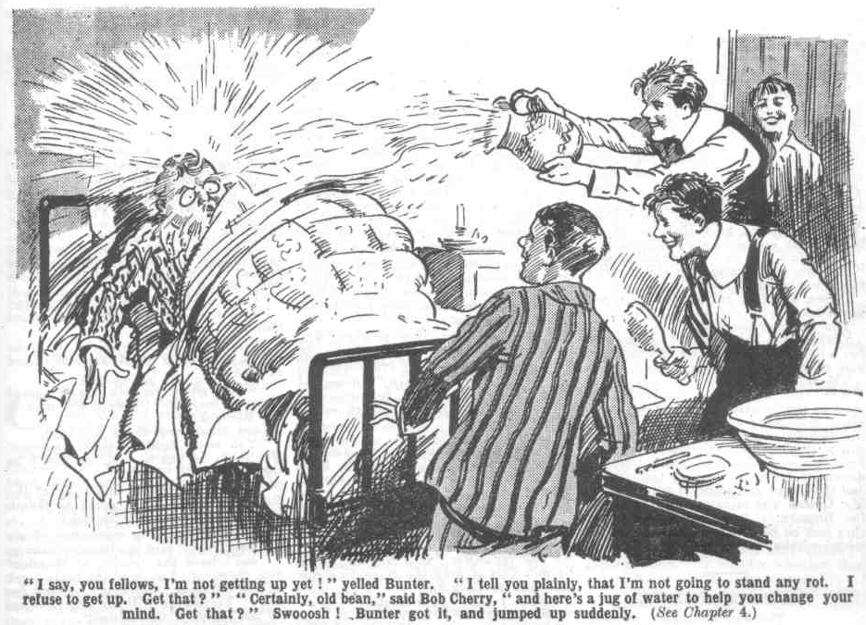 Bunter rolled out of bed and bumped on the floor.
“Have another lot?” asked Bob.
“Yarooooh! Beast!”
“Are you getting up now?”
“Grooogh! Beast! Rotter! Ow!”
‘That isn’t an answer. Here’s another jug—”
“YOW-OW! I’m getting up!” yelled Bunter. Yah! Keep off, you beast! Can’t you see I’m getting up?”
“Ha, ha, ha!”
The Remove were all up now.
Breakfast was served on time that morning, and all the Remove were ready for it. After breakfast Lord Mauleverer called the committee together, with a very serious expression on his face.
“I’ve been thinkin’, old chap.” he said.
“Again?” asked the Bounder, with a grin. “You were thinkin’ yesterday, Mauly, you know. Don’t overdo it.”
The committee chuckled.
“Serious, you know.” said Mauleverer. “Of course, we’ve bucked up against the Head on principle, and we have’nt come here to slack. We’re bound to play the game, and keep on classes and all that. But—but I’ve been thinkin’ that we might as well begin to-morrow, instead of today—what?”
“Ha, ha, ha!”
“You fellows think it a good idea?” asked Mauleverer hopefully.
“Not the least little bit in the world.” answered Harry Wharton. “We begin classes to-day, old scout.”
“A holiday does a fellow a lot of good you know” argued Mauleverer.
“We had a holiday yesterday.” Bob Cherry pointed out.
“Well, you can’t have too much of a good thing. It’s agreed, then—we put off classes till to-morrow—what?”
“No fear!”
“Play up, Mauly !” said Harry Wharton, laughing. “We’re looking to you to set us an example, you know.”
“Yaas, but—”
“Classes at the usual time,” said Vernon-Smith. “Don’t give us the trouble of lickin’ you. Mauly. I can see that we’ve got to lick Bolsover.”
“Oh dear!”
Lord Mauleverer sighed, but he made up his noble mind. At the bell for classes, rung by Juggins, his lordship made his way to the apartment that had been fitted up as a Form-room. Between his desire to play the game and his almost irresistible inclination to slack, Lord Mauleverer was in a dubious frame of mind; but his better qualities won, and he went into the Form-room. Many fellows went in with him, but when Harry Wharton called the roll six fellows failed to answer to their names.
“Job for the committee.” said the Bounder.
“Six missing — Bolsover major, Skinner, Snoop, Stott, Bunter, and Hazeldene,” said Harry Wharton. Linley, you get along with first lesson, while we round up the slackers.”
“Right-ho!” said Mark, with a smile.
“We’ll come and help round them up, I guess,” said Fisher T. Fish.
“ You won’t, old bean ; you’ll sit in class.”
“I guess—”
“Silence in the class, please.” said Mark Lintey.
“Oh, I guess you can go and chop chips,” said Fisher T. Fish, independently. “You can’t put that over me, Linley.”
“No fear,” said Micky Desmond. “I can tell you I’ll talk as much as I like, Linley. Shut up yourself, old bean.”
“What about the lesson?” asked Mark.
“Teach your grandmother!” said Micky. “You can’t teach us anything. You’re only a Remove chap yourself.”
“That’s so.” agreed Mark. “But I’ve been appointed to take charge.”
“Take charge as much as you like, but shut up.”
“The committee exchanged glances. If class was to proceed on these lines it was fairly obvious that class might as well be dismissed. Harry Wharton rappcd out:
“Desmond! Fish!”
“Oh, can it!” yawned Fisher T. Fish.
“Go and eat coke!” suggested Micky. “Both of you stand out before the class!” said the captain of the Remove.
“What for?” dermanded Micky.
“ Licking!”
“Faith, and I’ll punch the nose of any fellow that thinks of licking me!” said Micky Desmond belligerently.
“Hook him out!” said Peter Todd.
Micky Desmond was promptly hooked out. In the grasp of the committee, he was bent over a desk, struggling and roaring. The Bounder wielded a cane, and he delivered six of the best.
“Yow-ow-ow-ow !“ roared Micky. “Chuck it! Yow-ow-ow!”
“Take your place, Desmond!” said the captain of the Remove.
“Yow-ow-ow!”
“Now, Fish —“
“I guess I don’t want any, you galoots! I’m goin to keep as mum as an oyster in class!” said Fisher T. Fish, in a great hurry.
“Keep to that, then!”
“Sure!” said Fisher T. Fish.
And Mark Linley was left with quite an orderly class to deal with, while the committee sallied forth to round up the slackers.
THE FIFTH CHAPTER.
Brought to Order!
“YOUR deal, Hazel!”
“Oh!” murmured Bob Cherry.
It was Skinner s voice.
The grounds of High Oaks were very extensive. The committee had expected rather a long search for the slackers. But some of them, at all events, were at hand. Skinner’s voice proceeded from little summer-house, and Harry Wharton & Co. stopped and looked in.
Skinner and Snoop, Stott and Hazeldene, were there, playing banker. Six grim faces stared in at them.
Hazel had the grace to look a little ashamed of himself. Snoop looked uneasy, Stott sullen, and Skinner vicious. All of them realised that the game had come to a sudden end.
“Look here, you fellows are not wanted in here.” exclaimed Skinner, with an attempt at bluster.
“Hand over the cards!” said Wharton.
“Rats!”
Wharton gathered up the cards. He tore each of them into two pieces and threw the fragments away. During this process the black sheep of the Remove glared at him, but offered no active opposition.
The cards disposed of, the captain of the Remove rapped out:
“Two each! Bend over!”
“ What? “ roared Hazel.
“Bend over!”
“Do you think you’re going to cane us?” yelled Hazel.
“Yes.”
“Hard, too!” said Bob Cherry cheerfully.
“Hazel jumped up and clenched his fists.
“You’ll have a fight on your hands first!” he snarled.
“Right-ho!” said Bob. “I’ll look after Hazel, you fellows, while you cane the others.”
“Bend over, Skinner!” said Wharton.
“Shan’t!”
“Bend him over, you fellows !”
Peter Todd and Squiff grasped Skinner, and, in spite of his resistance, he was bent over.
Wharton wielded the cane.
Whack! Whack!
“Ow !“ grasped Skinner. “ Wow! I’ll make you sorry for this! Oh!”
“Now go into class!”
“ I won’t !” said Skinner.
“Whack!”
“Yaroooh!”
“Better go,” advised the captain of the Remove. “ I can keep this up as long as you do, Skinner.”
“You cheeky rotter!” panted Skinner.
Whack!
“Yow—wooooop!”
“Are you going?”
“Ow! Yes, I—I’ll go!” gasped Skinner. And he went.
“ Bend over, Snoop!”
“Look here—“
“Bend him over!”
Whack ! Whack!
“Now get into class!”
Sidney James Snoop, with a scowling face, followed Skinner to the house, Wharton turned cheerfully to Frederick Stott.
“Your turn, Stott!”
“Not without a scrap!” said Stott sullenly.
“This isn’t a scrapping match” explained the captain of the Remove. “ We’re the Thrashing Committee. You’re staying out of class—”
“Blow class !”
“ You’re playing the goat, too, which is forbidden at High Oaks, the same as at Greyfriars. We haven’t come here to play the goat. Bend over!”
“Shan’t!”
“ Bend him over!”
Frederick Stott was made of rather tougher stuff than Snoop or Skinner. There was a struggle before he was placed in a favourable position for caning. But he was bent over at last, in the grips of Toddy and Johnny Bull.
Whack! Whack!
Stott struggled and roared.
“Now cut off to class, Stott!”
“Whack! Whack! Whack! Whack!
“Ow! Wow! Ow! Wow!” yelled Stott.
“Must toe the line, dear boy!” said the Bounder. “What’s the use of kickin’ over the traces? Get goin’ !”
And Stott, wriggling with anguish, got going at last. He disappeared in the direction of the house, wriggling as he went.
Meanwhile, Hazeldene had not been putting up much of a scrap. Bob Cherry was rather too much for him. Alter a brief resistance, Hazel crumpled up and Bob sat on him till the rest of the committee were ready to take him in hand.
“Turn him over, Bob!”
“Right-ho!”
“You worm!” yelled Hazel.
Whack! Whack!
“Cut off to class, Hazel!”
“I won’t!” shrieked Hazeldene. Whack! Whack! Whack!
“Oh my hat! Leave oft!” yelled Hazel. “Oh crumbs! I’ll punch you for this. Ow! Wow! Wow !”
“Are you going into class?”
“Ow! Yes, you rotter! Ow!” And Hazeldene went.
“‘That’s four!” remarked Bob Cherry.
“Only Bunter and Bolsover left. Hallo, hallo, hallo! There’s Bolsover !”
“Come on!”
Bolsover major was stalking within view, with a defiant scowl on his face. He scowled more blackly as the committee bore down on him.
“You’re cutting class. Bolsover!” said the captain of the Removc.
“Oh, don’t be an ass!” said Bolsover major. “We haven’t come here to play at classes.”
“Bend over!”
“Catch me!“ sneered Bolsover major. “I’ll mop up the ground with the lot of you if you bring that cane near me.”
“You’ll have a chance to try. Bend him over!” said the captain of the Remove, tersely.
Bolsover major jumped back and put up his hands. Evidently the bully of the Remove meant business. But so did the Thrashing Committee.
They rushed on Bolsover.
There was a roar from Peter Todd as he caught Bolsover’s hefty right with his nose, and the Bounder yelled and spun over under a drive from the Remove bully’s left. The next moment Bolsover major was on his back, his chin feeling as if it had been driven through the back of his head—and Bob Cherry’s knuckles feeling as if they had been dashed against a wall.
“Ow, Ow, Yow!” gasped Bolsover.
“Oh, my hat! Oh, my chin! Wow!”
He was in the grasp of the committee the next moment. Two or three pairs of hands rolled him over, and the cane started. It fairly rang on Percy Bolsover
“I’ll smash you !” roared Bolsover major. “I’ll pulverise you. Ow! Leave off! Lcggo! Yarooooh !“
“Whack! Whack! Whack! Whack!
Bolsover major roared and struggled. So long as he struggled the cane rang and rang. It was something like a head’s flogging at Greyfriars, only a little more so. Bolsover major gave in at last.
“Ow! ow! Stoppit!” he panted.
“Are you going into class?”
“No!” shrieked Bolsover major.
Whack! Whack! Whack!
“Ow! I’ll smash you! I’ll go!” howled the hulk of the Remove. “Yow-Ow? I’m going! Ow! Stoppit!”
Bolsover major was released, and he staggered to his feet. He glared at the grinning committee as if he would have liked to eat them.
“You cheeky rotters!” he gasped.
“Cut into classes! You’re late!”
“I’ll jolly well—“
“Do you want some more?” demanded the captain of the Remove impatiently.
Bolsover major evidently did not want any more. He turned, scowling, and tramped away towards the house.
“Only Bunter left!” chuckled Bob Cherry. “We’re getting on!”
The search for William George Bunter took more time. The Owl of the Remove did not seem to be in the grounds anywhere; and the committee proceeded toward the house to look for him there.
“Hallo, hallo, hallo! There he is!”
Billy Bunter was emerging from a side door, with a grin on his fat face, and a bundle in his fat hands. The Committee could guess what the bundle contained. William George Bunter had been raiding the provisions, and he was sneaking off to some quiet spot to devour his prey The committee came towards him with a rush.
Bunter gave them one startled blink and fled.
“Stop!” shouted Johnny Bull.
“Ow!” gasped Hunter.
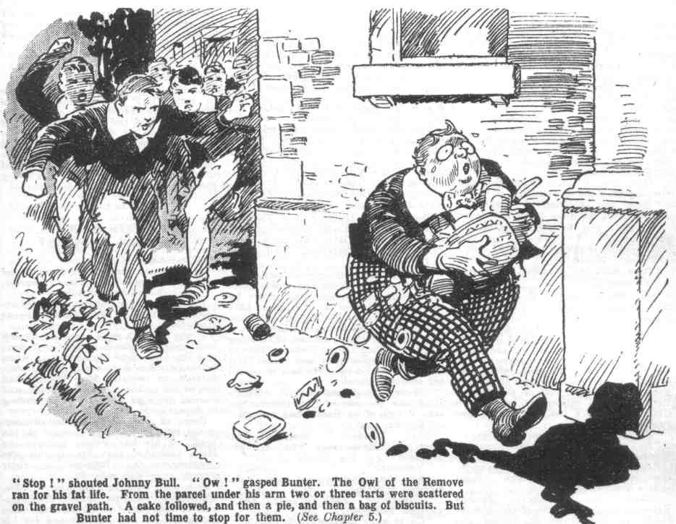 He ran for his fat life. From the parcel under his arm two or three tarts were scattered on the gravel path. Bunter had no time to stop for them. A cake followed, and then pie, and then a bag of biscuits. Evidently the Owl of the Remove had planned to have a rather extensive little spread in a secluded spot. By the time the committee ran hint down, he had left a long trail of plunder on the path.
Peter Todd’s hand dropped on his fat shoulder at last.
“You fat villain!” gasped
“Ow! Beast! Leggo !” shrieked Bunter.
He spun round in Peter’s grasp and hit out blindly. The blow landed on Peter’s nose; and a drive with Bunter’s weight behind it was not a light matter. Peter gave a gasp of anguish and collapsed.
“You fat idiot!” exclaimed Johnny Bull. “You— Oh, my hat! Yarooooogh!”
“I—I say, you fellows—” gasped Bunter.
“Collar him!” panted Bob.
“Yaroogh! Leggo! I—I say, you fellows—”
“Bend him over!” gasped Wharton.
Whack, whack, whack!
“Beast! Stoppit! Chuckit! Yaroogh! Oh crumbs! Help! Murder! Fire!”
“Murder! Fire!”
“Ha, ha, ha!”
“Give him a dozen!” yelled Peter, clasping his nose in anguish.
“Give him a hundred!” shrieked Johnny Bull, clasping his chin.
“I say, you fellows, help—help— yarooogh— I—I want to go into class--you’re stopping me——”
Whack! Whack!
“Now hook it!” gasped Wharton.
“Yarooooogh !”
Billy Bunter hooked it in a hurry. The committee followed him into the house, and into the classroom. There was a sound of disturbance in that room. Mark Linley, who had been left in charge of quite an orderly class, was struggling wildly in the grasp of Bolsover major and Skinner, who were striving to jam his head into the waste-paper basket. The rest of the fellows were laughing, apparently taking this little matter as a jest. The committee rushed to intervene.
“Six each!” rapped out Wharton.
“I—I say, it was only a joke!” gasped Skinner.
“Jokes are barred in the classroom, dear man.” said Bob Cherry. “Bend over a desk, Skinner.
“Buck up, Skinner!” shouted Bolsover major, and he charged recklessly at the committee, hitting out right and left.
“Look out!”
“Ha, ha, ha!”
There was a terrific crash, as Bolsover major went down, with Peter Todd and Bob Cherry clinging to him. The three rolled wildly on the floor in a whirling struggle. Meanwhile, Skinner had his six, and he let out a wild yell at every stroke. He did not need telling to go back to his place—he was only too glad to get there.
Then the whole committee proceeded to deal with Bolsover major. It was obvious that the bully of the Remove had to be reduced to a state of discipline, if law and order were to privail at High Oaks School. The committee proceeded to reduce him to a state of discipline.
The juniors laughed and cheered, watching the scene with intense interest. Form at High Oaks was much more exciting and entertaining than Form at Grcyfriars.
Bolsover major struggled frantically, and for some minutes the whole committee were busy with him. Then he was stretched over a desk and held there, arid Peter Todd put in some active work with a cane. There was a sound in the class-room of beating carpet. Dust rose from Bolsover major—and wild yells and roars. But Peter did not cease. He laid it on till his arm was tired.
“There!” he gasped at last. “That’s all I can do—one of you fellows can take a turn if he hasn’t had enough.”
“Ha, ha, ha!”
“Ask Bolsover “ chuckled Bob Cherry. “Have you had enough, Bolsover?“
“Yarooop I”
“Are you going to keep order?” demanded Wharton.
“Yow-ow-ow! Yes! Oh dear! Yes!“ groaned Bolsover.
“Go to your place, then.”
Bolsover major limped to his place.
That terrific thrashing had taken all the belligerence out of him—for the present at least. Bob Cherry looked round inquiringly
“Anybody else want a licking?”
“Ha, ha, ha!”
“No takers!” said Squiff.
And the committee took their places in Form, and class commenced once more. It was rather late; but it commenced. And the discontented spirits toed the line like the rest; the thrashing Committee had done its work and done it well. Law and order were established at High Oaks School, and it was only to be hoped that that happy state of affairs would be permanent.
THE SIXTH CHAPTER.
Mr. Quelch Is Surprised!
“DEAR me!”
Mr. Quelch, one-time master of the Greyfriars Remove, made that remark.
He had walked down from Courtfield, and stood in the road looking at High Oaks.
It was almost a week since Mr. Quelch had been dismissed from Greyfriars; and Dr. Locke had supposed that when he was dismissed, he would go his way. Instead of which, Mr. Quelch had stayed on at the Courtfield Hotel, and showed no sign whatever of intending to depart.
Some of the Greyfriars fellow surmised that he had had a hand in the revolt of his late Form ; perhaps the Head suspected that Mr. Quelch was encouraging the Remove in their present rebellious attitude.
But that was an injustice to Mr. Quelch. He was too keen a disciplinarian to approve of rebellion, even when it was on his own account and for his sake
Mr. Quelch looked at the tall bronze gates of the mansion which had recently been turned into a scholastic establishment. Near the gates was a board with gold letters on a black ground, bearing the legend:
“HIGH OAKS SCHOOL.”
Mr. Quelch gazed at it, and finally approached the gates, and opened one leaf of them open. He walked on, on a tidy gravel drive, and walked towards the mansion.
“Ere you, sir!”
It was Mr. Juggins, now the porter of High Oaks school. Mr. Juggins bore down on the intrusive stranger.
Mr. Quelch eyed him calmly. Mr. Quelch had an eye like Mars, to threaten and command, and it daunted Juggins a little. Still, the High Oaks porter had his duty to do.
“Nobody allowed in ‘ere, sir,” said J uggins.
“I am Mr. Quelch.” said the late Remove master icily.
“Don’t know the name, sir, but Squelch or no Squelch, you ain’t allowed in ‘ere,” said Juggins. This ‘ere is the property of Lord Mauleverer, and his lordship has hordered me to keep out trespassers.”
“1 desire to see Lord Mauleverer,” said Mr. Quelch. “I am his former Form master at Greyfriars.”
“Oh!” said Juggins. “The young gents are in school now, sir. “
Mr. Quelch almost jumped.
“In what?” he ejaculated.
“School, sir—class!” said Juggins, with a faint grin. “This ‘ere is a school, sir, though you mightn’t think it. I don’t know whether his lordship would care to be interrupted at lessons. sir.”
“Unless he has changed very much since leaving Greyfriars, 1 have no doubt whatever that he would be glad to be interrupted at lessons,” said Mr. Quelch dryly.
And he passed the porter, who looked dubious, and walked on to the house. Mr. Juggins blinked after him.
“My eye!” he murmured. “If that old covey has come to take the kids away, the game’s up ‘ere, and I’m losing a good thing! I’ve a blinking good mind to take ‘im by the back of the neck and run him out!”
But if Juggins had a good mind to act in that drastic manner, he had a better mind not to do so, for he left Mr. Quelch to his own devices.
The big door of High Oaks stood open, and Mr. Quelch entered the hall. The great hall of the mansion looked very cheerful, with a log fire blazing, and the winter sunshine glimmering in through stained glass windows. It was deserted now, save for a member of the Juggins tribe engaged in dusting.
Mr. Quelch danced round him, and walked on. The quiet of the place astonished him. The Form master had walked over to High Oaks to advise the rebels of Greyfriars, once more, to return to school. He had expected to find the place in an uproar. A junior Form that had been without masters for nearly a week was likely, in the Form master’s opinion, to be in a state of perpetual riot. But there were no sounds or signs of riot,
Mr Quelch passed through the hall and came out on a broad passage. There a youth in buttons stared at him. It was one of Mr. Juggins’ innumerable relatives, who was now page at High Oaks. and looked as if he thrived on it.
“Where are the boys, my lad?” asked Mr. Qucleb.
The youthful Juggins blinked at him.
“In class, sir.”
“Dear me! Are classes held here?”
“Yessir.”
“Bless my soul! Take me to the class room, please.”
The youthful Juggins eyed him, wondering who was this tall, angular gentlemati who presumed to give him orders.. But there was something about Mr. Quelch that enforced obedience. Young Juggins led the way as commanded.
“‘Ere’s the room, sir.”
“Thank you!”
Mr. Quelch pushed open a large door.
He looked in.
For the moment he was not observed by the numerous occupants of the room. He gazed upon the scene with great interest.
The room had been, in the palmy days of High Oaks, a reception-room. It was now turned into a class-room, with forms and desks complete, snaps on the walls, blackboard and waste- paper basket, and a high desk for a master—the Remove-room at Greyfriars over again.
The desks were occupied by the Removites. Mark Linley sat at the high desk. He had a pointer in his hand. The class was as orderly as ever it had been at Grevfriars—for the moment, at least. Mr. Quelch’s astonishment grew and grew as he watched.
“Bunter!” called out Mark Linley.
“Oh, really, Linley!_
“I forget the place, old chap!”
“Show Bunter the place, Wharton, please!”
“Certainly!”
“The—the fact is, I’d rather not construe, Linley,” said Bunter. “I say, you fellows, ain’t you fed-up with this? I am!”
“Shut up, Bunter!”
“ Oh, really, Cherry—”
“ Order, you know!” yawned Lord Mauleverer. “You’ve got to construe, Bunter, you lazy ass! Get on with it!”
“ Oh, really, Mauly—”
“I am waiting for you, Bunter!” said Mark.
“Wait and be blowed!” retorted Bunter. “I keep on telling you I’m fed-up! We might as well be back at Greyfriars, at this rate!”
“Give Bunter two, Toddy!” said Mark.
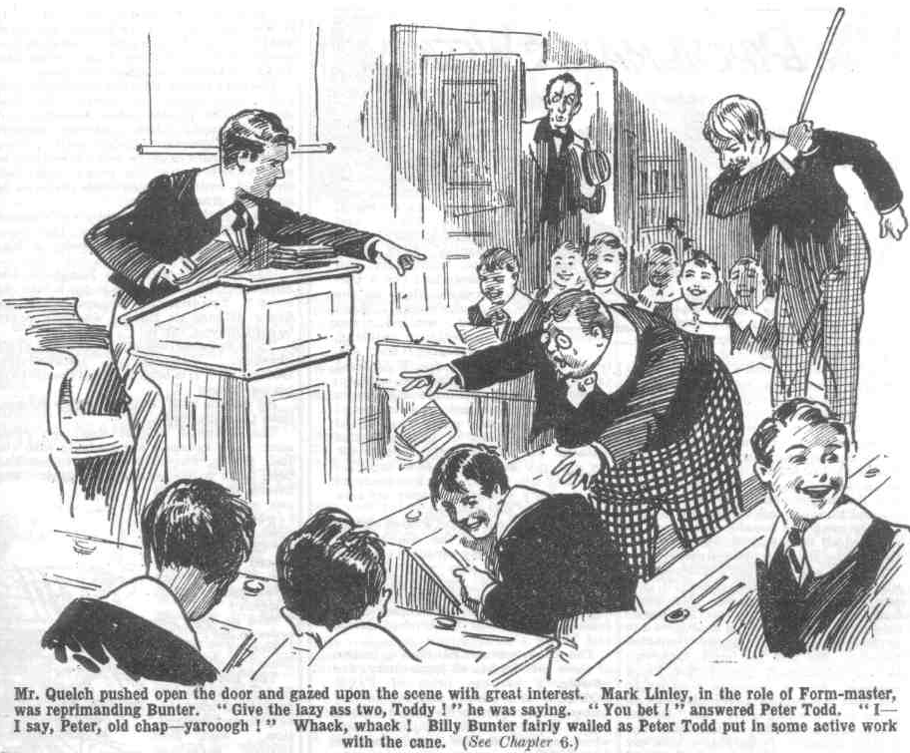
“You bet!” said Peter Todd.
“I—I say, Peter, old chap—Yaroooogh!” roared Bunter.
“Whack, whack!
“Beast! Ow!”
“I am waiting for you to construe, Bunter.” said Mark quietly.
“Oh dear! All right! Ow!”
And Billy Bunter proceeded to construe—as badly as ever he had done in the Remove-room at Greyfriars.
Mark interrupted him at last:
“ You have not prepared this lesson, Bunter!”
“ Oh really, Linley!”
“Take a hundred lines!”
“ Look here—-”
“Silence! You will go on, Skinner.”
Skinner went on to construe quietly. Skinner evidently had been brought to good order by the Thrashing Committee, for he handed out his “ con” as obediently as he had ever done in the Remove-room at Greyfriars.
“That will do, Skinner! Now you, Mauleverer.”
“ Oh gad!” groaned Mauly.
“ Go it, Mauly, old bean!” said Bob Cherry.
“Silence in class, please!” said Mark Linley. ‘”You must not, talk to Mauleverer, Cherry!”
“ Oh ! My mistake—I forgot!” grinned Bob. “Sorry, sir!”
“Ha, ha, ha!”
“ Silence, please! I am waiting for you, Mauleverer!”
“ I—I say, suppose you let me off, old bean?” asked his lordship. “The fact is, I went to sleep instead of doin’ my prep.”
“Take a hundred lines!”
“Oh gad! Is that the way you thank a fellow for appointin’ you Form master?” ejaculated Lord Mauleverer.
“Take two hundred lines!”
“Look here, you ass—I mean—yaas! All right! Must play the game!” groaned Mauly. “ All serene, old bean !“
“You will go on, Todd.”
“Yes, sir” said Peter.
“Hallo, hallo, hallo!” roared Bob Cherry suddenly.
“Silence! You —“
“It’s Quelchy!” yelled Bob
He had suddenly caught sight of the astonished face looking in at the door.
“Oh!” gasped Mark.
The Remove was all on their feet at once. Mr. Quelch stepped into the room, eyeing his boys with a curious expression on his face.
“Welcome to High Oaks, sir “ said Lord Mauleverer. “May we hope, sir, that you have come to take charge?”
“The hopefulness is terrific, honoured sahib!” said Hurree Jamset Ram Singh.
Mr. Quelch coughed.
“No!” he said hastily. “Nothing of the kind! It is quite impossible for me to do so! I came here to advise you boys to return to school!
“Can’t be done, sir.” said Lord Mauléverer. “Not unless you’re goin’ back, sir. But now you’re here. sir, let us get you to stay; we’re really badly in want of a schoolmaster, sir! Marky does his best but——”
“I shall be very glad to resign in your favour, sir. said Mark Linley, with a smile.
“ Won’t you stay and take control, sir?” asked Harry Wharton. At present it’s a school without a master.”
“1 congratulate you!” said Mr. Quelch. “I cannot approve of your rebelliousness but I am certainly surprised and pleased to see you pursuing your studies, instead of wasting your time, as I feared would be the case. Nevertheless, I advise you to return to Grcyfriars immediately.”
“ No jolly fear!” said Bob Cherry emphatically.
The no-fearfulnss is terrific!”
“I say, you fellows, we don’t want Quelchy—”
“Shut up, Bunter!”
“Shan’t!” hooted Bunter. “ Linley’s bad enough, playing at Form master; but he’s not so bad as the real thing!”
“Ha, ha, ha!”
“Kick Bunter, somebody”
“Yaroooogh!”
“My boys, “ said Mr. Quelch. “I strongly advise you to return to Greyfriars. and abandon this attitude of rebelliousness.”
“Not without you, sir!” said Lord Mauleverer.
“My return to Greyfriars is impossible, Mauleverer.”
“Then we stay out, too, sir! We’re gettin’ on all right.” said Mauly. “ Only we want you to come here as headmaster, sir.”
“That is impossible, too, Mauleverer.”
“Then we’ll carry on as we are, sir.” said Mauleverer cheerfully. “ We’re not learnin’ quite so much as at Greyfriars, but the work’s easier, so we’re really not dissatisfied.”
“Ha, ha, ha!”
“If you will not follow my advice, I can do no more.” said Mr. Qucich. “ I have now no authority over you. But I am glad, at least, to see you making some attempt to pursue your studies. I regret very much—”
The Form master paused.
Severe gentleman as Mr. Quelch was, there was no doubt that he was touched by the attachment his Form had shown and their devotion to his cause. He disapproved of all the proceedings of the Remove with his head, as it were, but not with his heart.
Undoubtedly he was tempted to take his old Form in hand. and to remain at High Oaks — headmaster instead of Form master.
But such a proceeding was not in accordance with the fitness of things, and the Remove master dismissed the thought.
“I will interrupt you no further,” he said rather abruptly, and retired from the class-room.
But Mr. Quelch’s brow was very thoughtful as he went. The Head of Greyfriars seemed to have left the Lower Fourth Form to their own devices, yet the present state of affairs could not possibly continue. That was unthinkable. Mr. Quelch realised that the rebels of the Remove must be taken in hand.
He began to wonder whether it was, after all, his duty to stand by the Form who had stood by him, since it appeared that their own headmaster was taking no further trouble about them. In a very thoughtful mood indeed Henry Samuel Quelch walked away from High Oaks—leaving the rebel juniors discussing his visit, as a pleasant change from class work.
THE SEVENTH CHAPTER.
Coker Takes a Hand!
“ABSOLUTE rot!”
That was Coker’s opinion.
Horace Coker of the Fifth Form at Greyfriars, had been thinking.
This was quite a new departure for Coker of the Fifth. But the present extraordinary state of Greyfriars affairs had, as it were, set Coker’s powerful intellect going
He was walking in the quad with Potter and Greene, when the Head passed at a little distance.
Dr. Locke did not observe the Fifth-Formers.
He was walking with his hands behind him, his head bowed a little, and a deep frown upon his face. Obviously, he was buried in thought—not very pleasant thought.
The Head of Greyfriars, in fact, had plenty of food for thought these days. He was nonplussed. A rebellion in the school, the marching out of a whole Form, and their refusal to return to his order, placed the headmaster in a difficult, a painful, and a rather ridiculous position. Such a state of affairs was unprecedented; and the Head had to admit himself that he did not quite know how to deal with it.
His personal authority had failed. The Sixth Form prefects had failed in the use of force. How were the Remove to be rounded up and gathered into the fold again? They could not be punished into submission — floggings could not be administered; and expulsion—the severest punishment of all— was impracticable. A whole Form could not be expelled.
Dr. Locke could have invoked the authority of their parents, but he shrank from doing so. How could be tell a whole army of fathers and guardians that his authority had failed, and that he wanted them to do his work for him—for that was practically what it would amount to.
He thought of calling in the aid of the Courtfield police to round up a set of juniors who had run away from school. But from that he shrank also. The affair was bad enough as it was, and he did not want to make it the sensation of the neighbourhood and the whole county. He did not want every other headmaster in the kingdom to learn that he—Dr. Locke—could not maintain discipline in the school of which he was Head without calling in the aid of policemen. It was not to be thought of.
Yet the present state of affairs could not continue. Day was following day, and the Lower Fourth were still absent The governors of the school must hear of it sooner or later, and what would they think—what would they say—what would they do? Was it not probable that they would consider that it was time for the Head to retire?
The Head was angry, worried, incensed, and growing bitter. And there was no doubt., too, that he missed his old friend, Mr. Quelch.
Mr. Quelch was no longer his friend— mutual animosity had taken the place of friendship, owing to the unfortunate misunderstanding that had arisen between the two scholastic gentlemen.
Nevertheless, the Head missed him, above all, missed his clear head and practical advice in the present emergency.
He had been accustomed to rely on Mr. Quelch in many matters. Bitter as his feelings now were towards his former friend and colleague, he could not help feeling that Mr. Quelch would have found some way of dealing with the present situation had he been there to help as of old.
Every day that passed added to the worry on the mind of the headmaster; yet, day by day he thought over the matter, and had to confess that he did not know how to deal with it.
No wonder his brow was dark and troubled as he passed within the view of the three Fifth-Formers without observing them. Potter and Greene glanced after him curiously and grinned a little. They were rather losing their respect for a headmaster who was defied by a junior Form.
“ Asolute rot, you men,” said Horace Coker. “This sort of thing isn’t good for a school. It will be getting into the papers if it goes on. Fancy Greyfriars in the newspapers! The Head seems to be rather a dud; but this kind of thing can’t go on. The prefects ought to have brought those young rascals back!”
“They wouldn’t come.” said Potter.
“ I’d have made them come, if I’d been a prefect!” snorted Coker. “ They ought to be jolly well ashamed of themselves. I never thought much of the Sixth. 1 think less than ever now.”
“ Poor old Sixth!” said Potter, with a private wink at Greene.
“The Head can’t do anything,” resumed Coker. “ The Sixth Form prefects are as helpless as babies. I’ve been thinking that the Fifth had better take the matter in hand.”
“Eh?”
“What?”
“The Fifth!” said Coker firmly. “ It’s up to us, in my opinion. Its absolute rot, as I’ve said, to let a mob of fags kick over the traces in this way. It would be rather a score for the Fifth to succeed where the Sixth have failed, what?”
“ Ye-e-es,” said Potter dubiously. “But—”
“Butting won’t do any good,” interrupted Coker, “My idea is for the Fifth to chip in, and round up those cheeky fags. I suppose you don t fancy that the Fifth couldn’t handle the Lower Fourth ?”
“That’s all right. But—”
The Head would be grateful—most likely thank us very nicely, if we brought the young scoundrels in” said Coker. “The Sixth would be wild—absolutely wild! Fancy their feelings when we did what they’ve failed to do— making them look a set of silly asses, as they are, you know.”
Potter and Greene grjnned. For once, they admitted that Horace Coker was capable of producing a good idea. There was no doubt—no doubt whatever—that the Sixth would be wild if the Fifth succeeded where the Sixth had failed. Making the Sixth wild was, of course, a consummation devoutly to be wished by any patriotic Fifth Form man.
“The Sixth put on a lot of side,” went on Coker. “If a Fifth Form man just walks on the Sixth Form green they cut up rusty, making out that the Fifth are nobodies. We’re seniors, and as good as the Sixth any day. Better, in fact, if we can keep the fags in order and the Sixth can’t.”
“Hear, hear!” said Potter and Greene.
“I’ve always thought,” continued Coker, “that prefects ought to be appointed from the Fifth as well as the Sixth. Well, if you do the job they’ve failed to do, the Head may see it, too. in fact, I hardly see how he can refuse to appoint Fifth Form prefects, when it’s proved that the Sixth are no good for the job.”
“But,” said Potter, “the Sixth will be sore if we take the matter in hand. We’ve no right—”
“ I want to make ‘em sore,” explained Coker. “I want to put ‘em in their place. They’re not really the big guns they think they are, and my idea is to bring it home to ‘em. Look here! 1 want the Fifth to back me up in this and we’ll jolly well make Wingate and his crew sing small!”
“Hem!”
Potter and Greene certainly liked the idea. Anything that would exalt the Fifth and make the Sixth sing small, naturally appealed to them. But they were dubious.
Dubiety, however, was not a weakness of Horace Coker’s. He had thought the matter out, and he had made up his mind.
“We’ll call a meeting of the Form in the games study, and put it to the fellows.” he said.
“No harm in that.” agreed Potter.
And as Horace Coker said, so was it done. A notice on the board, in Coker’s sprawling fist, called the Fifth to the meeting, and most of them came, some wondering, some amused, and some considering that it was a cheek of Coker to call a meeting at all. Blundell, the captain of the Form, came into the games study with a thunderous brow. Coker, in Blundell’s opinion. was nobody, nobody at all; a howling ass who couldn’t even play football; and for Coker to have the unexampled nerve to call a Form meeting, naturally roused Blundell’s ire.
“What the thump does this mean, Coker?” the captain of the Fifth demanded. “ What the deuce do you mean by calling a meeting?”
Coker regarded him calmly.
“I’m just going to tell the fellows,” he answered. “ Just listen, and you’ll hear”
“ You cheeky ass!”
“ Look here—” roared Coker.
“Oh, let’s hear what it’s all about, said Price of the Fifth.
“Only some of Coker’s cheeky rot !” grunted Blundell.
But even Blundell was a little impressed when Coker proceeded to explain. Blundell was a great man, captain of his Form, a member of the First Eleven, and a “blood” of the first water. But he was not, of course, a prefect, and he therefore regarded prefects with a somewhat inimical eye. He had not, of course, Sixth Form privileges, and for that reason he regarded “ Sixth Form privs” rather balefully. Coker of the Fifth was every known kind of an ass, but, for once, Blundell was inclined to think that Coker had touched the spot, so to speak. The Head had eutrusted the Sixth Form prefects with the task of rounding up the rebel Removites, and they had ingloriously failed to pull it off. The kudos that would be gathered in by succeeding where the Sixth had failed appealed very strongly to Blundell.
“ By gad,” said the captain of the Fifth, “there’s something in this. It’s a disgraceful state of affairs, a junior Form defying the headmaster. It ought to be put a stop to.”
“ Yes, rather,” agreed Bland of the Fifth.
“It’s the prefects’ duty,” went on Blundell. “They’ve failed The Head is in a fix—anybody can see that.”
“That’s so.” Hilton. “I can’t understand why the prefects didn’t round up those cheeky fags. Easy enough, I should have thought.”
“Easy as falling off a form,” said Fitzgerald.
“They’re no good, you see,” said Coker, in explanation. “A lot of duds, if you ask me.”
“We ought to back up the Head’s authority as a senior Form,” said the captain of the Fifth. “I think it’s a good idea. The Remove ought to be brought back. They’re getting to be a lot of talk about this affair in the neighbourhood, and it’s doing the school no good. The governors will be butting in, sooner or 1ater, too. Look here, if you men are willing to back we up, we’ll take it in hand.”
“Hear, hear!” agreed the Fifth.
“Back you up!” exclaimed Coker in amazement and wrath. “Back me up, you mean!”
“Oh, don’t be a silly ass, Coker!” said Blundell unceremoniously. “Who’s captain of the Form?”
“Yes, shut up, Coker,” said Price. “It’s a good idea, and you can come along if you like. That’s your limit.”
“Coker glared.
“I’m leader in this!” he bawled.
“Oh, cheese it!” said Tomlinson.
“Coker leader!“ grinned Fitzgerald. “Ha, ha, ha!”
There was a general chortle in the games study. All the Fifth seemed to be entertained by Coker’s claims to leadership.
“Look here—” roared Coker, in great indignation.
“Cheese it, old chap!” murmured Potter. “Blundell’s captain, you know.”
“Blow Blundell!” roared Coker. “Bless Blundell! I can jolly well tell you men that it’s my idea, and I’m taking the lead. I called this meeting to back me up.”
“Ha, ha, ha!”
“Shut up, Coker!”
“ Ring off, old man!”
“Yes, be quiet for a bit, Coker, while we talk at over and make arrangements.” said Blundell. “You talk a thumping lot you know.”
“You cheeky ass!” shrieked Coker.
“Shut up, Coker!” roared the Fifth.
“Look here—”
“Order !”
“Dry up!”
Horace Coker fairly snorted with indignation. Really, it was too bad. For the first time in history the Fifth Form had listened to Coker, and acknowledged that he had a good idea. And that being acknowledged, the matter was taken entirely out of his hands; and Coker, the brainy originator of the whole thing, was relegated to the humble position of a follower! It was not to be stood, and Coker did not mean to stand it.
“Look here,” he roared, “if that’s how you fellows take it, I wash my hands of the whole business. I decline to have anything at all to do with it— see?”
Apparently Coker expected this announcement to have a crushing effect on the Fifth; but it hadn’t.
“Good!” said Fitzgerald. “After all, you’d only be in the way.”
“That’s so.”
“Buzz off, Coker!”
“Don’t bother now.”
Coker strode to the door, crimson with indignant wrath. Perhaps he expected to be calk’tl back. But he was not called back. The Fifth Form men really seemed pleased to see him go. Coker strode out of the games study, and slammed the door behind him with a terrific slam that woke most of the echoes of Greyfriars.
“Now that burbling ass has gone, 1et’s get down to business.” said Blundell.
And the meeting got down to business, what time Horace Coker tramped indignantly in the quad, boiling with wrath.
THE EIGHTH CHAPTER.
The Alarm!
FRANKY!”
“Where’s Nugent?”
“Hallo, hallo, hallo! Franky!” bawled Bob Cherry.
The telephone bell was ringing at High Oaks. Harry Wharton had taken the call, and found that it was the voice of Nugent minor, of the Second Form at Greyfriars, speaking. Dicky Nugent wanted to speak to his major, and evidently had borrowed some Form master’s telephone for the purpose at Greyfriars.
Frank Nugent came scudding up as his name was shouted.
“Your fag minor on the phone,” said Bob Cherry. “May be some news from Greyfriars. Buck up!”
Frank Nugent took the receiver.
“Hallo! That you, Dicky? he asked, while a dozen Remove fellows stood round the telephone, waiting to hear whether it was news. If the fag was to give a warning of some move on the part of the Head, the matter was one of great interest to all High Oaks School.
“Yes, kid.” answered Dicky Nugent. “You still playing the goat with the other Reinovc duffers at High Oaks, Frank?”
“Don’t be a cheeky little ass!” said Nugent severely. What did you ring me up for?”
“Nothing,” said Nugent minor dutifully. “It a Prouty’s telephone, and he will have to pay for the call.”
“You young ass!”
“I’ve got some news for you, Frank.” chuckled the fag. “How are you getting on over there?”
“First-rate.”
“Do you want any visitors today?“
“Not specially. You can come over if you like, as it’s a half holiday,” answered Frank.
“Ass” said Dicky cheerfully. “The Head’s put your show out of bounds for all Greyfriars. Any fellow coming to High Oaks will be flogged. The Beak’s in a terrific wax. But you’re going to get some visitors, all the same. What price the Fifth?”
“The Fifth?” repeated Nugent, with a start.
“Just the Fifth!” chuckled Nugent minor. “They’re jawing about it, at any rate. A lot of fellows are saying that the Fifth are going to take you chaps in hand, as the prefects couldn’t do it. They want to take a rise out of the Sixth—see?”
“Oh, my hat!”
“I thought I’d let you know, old bean,” said Dicky. “I heard old Wingate tell Blundell of the Fifth he’d better mind his own business, and Blundell just grinned at him. I fancy it’s genuine, because all the Fifth got together after dinner, and they’ve gone out in a mob. They never go out all together, of course; it shows something’s on. Far as 1 can make out, all the Fifth have gone, excepting Coker, my idea is that they’re coming over to wallop you Remove kids.”
Frank Nugent whistled.
“I thought I’d tip you the wink.” said Nugent minor. “I don’t want the Fifth-Form chumps to butt in and bring the Remove back. It’s much better here without the Remove.”
“You cheeky young sweep !”
“Is that a new way of saying, Thank you?” inquired Nugent minor.
“No.” said Frank, laughing. “Thank you, Dicky! Much obliged for the tip.”
“That’s better! Looks to me as you’re in a bad box, Franky; nearly all the Fifth are coming, and, of course, you kids wouldn’t be able to handle them. But now you know you can hide in the cellars or something—what?” Dicky Nugent chuckled. “Ta-ta—I’ve to get out of this before old Prout butts in.”
And Nugent minor of the Second Form rang off.
Frank put up the receiver and turned to his chums with a rather serious face.
“The Fifth are coming !” he said.
“The Fifth?”
“They’ve taken the job on, because the Sixth can’t handle it, according to my minor.” said Nugent. “He says they’ve started.”
“The cheeky fatheads!” exclaimed Bob Cherry indignantly. “What the thump has it got to do with the Fifth!”
“Gammon!” said Bolsover major. “ Your minor’s pulling your leg, Nugent.”
“Shouldn’t wonder.” said Squiff doubtfully.
“Anyhow, we’ll be ready for them, if they come.” said Harry Wharton. “The Fifth will be rather hefty for us to tackle.”
“The heftiness will be terrific,” said Hurree Jamset Ram Singh. “ But forearmed is fore-legged, as the English proverb says.”
“ Ha, he, ha !”
“Where’s our giddy leader?” demanded Bob Cherry. Mauly! Mauleverer! Mauly! Where’s Mauly?”
“Wake up, Mauly!” roared Johnny Bull.
“Where’s that ass Mauly?”
“Mauly!” roared a dozen voices.
“Yaw-aw-aw-aw!” itwas a deep yawn from his lordship. Lord Mauleverer was taking a little nap on a sofa after dinner.
“Here he is! Wake up, Mauly, old bean.” said Bob. “The giddy enemy are coming!”
“ Yaw-aw-aw!”
“ You’re leader, Mauly.” said Harry Wharton, laughing. “Got up and lead. The Fifth are coming over to round us up!”
“Oh, gad!” said Mauleverer. He detached himself unwillingly from the sofa before the fire. “Have they got here?”
“Not yet, ass; they’ve only just started!”
“Oh! Then I’ll have my little nap.” said Mauleverer. settling down on the sofa again. “Wake me up when they get here.”
“I’ll wake you up now, old bean,” said Bob Cherry, tilting the sofa, and shooting Lord Mauleverer off in a yelling heap.
“ Ha, ha, ha!”
“Oh dear! Oh crumbs! Ow!” gasped Mauleverer. “You silly ass! You footlin’ chump! Ow!”
“Waiting for orders, Mauly.” said Nugent.
Lord Mauleverer rubbed his eyes. It was Wednesday, a half-holiday at Greyfriars, and likewise at High Oaks. Harry Wharton and Co. had planned a game of football for the afternoon: but football was dismissed now. If the Fifth were really coming, the matter was serious; for in a combat, of course the Remove were no match for a senior Form. The rebels had beaten off the prefects by barring them out of the House; in the open field they would have had no chance. And had the Fifth arrived at High Oaks and found the doors unguarded. as they would have done but for Nugent minor’s warning, there was no doubt that the juniors would have been smitten hip and thigh, and perhaps even rounded up and marched back ignominiously to Greyfriars.
Mauleverer had intended to nap while the more strenuous fellows were playing Soccer; but naps as well as Soccer were off now. His lordship had been elected leader, and a leader’s business was to lead.
“Cheeky cads, you know,” said Mauleverer. “They’ve got no bizney to butt in. But is it certain?”
“Nugent’s minor rung us up to tell us,” said Harry.
“May be pulling your leg.” said Lord Mauleverer thoughtfully. “ Still, we’re not taking chances. Smithy!”
“ Adsum!” grinned the Bounder.
“ You cut off and scout, old bean. You’ve got a bike here. Go out and see if they’re really comin’, and get back as soon as you can if you spot them’”
“ What-ho!” said the Bounder.
And he hurried out.
Lord Mauleverer wrinkled his noble brows in thought. The juniors watched him with grinning faces. In the revolt of the Remove, Mauly had developed amazing qualities of leadership, and Harry Wharton, the captain of the Form, had been content to play second fiddle. Mauly was a great leader so long, as Bob Cherry said, he could keep awake. Fortunately, he was wide awake now.
“Council of war, old man?” asked Squiiff.
Lord Mauleverer nodded.
“Yaas. You fellows give your opinions.”
“Let’s go out and meet them if they’re coming,” exclaimed Bolsover major. “ We’ll jolly well mop up the road with them.
“Jolly good idea if we could do it.” remarked Nugent. “ But the Fifth are a hefty crowd for juniors to handle.”
“ Bar the doors and windows, same as we did when the prefects came.” said Johnny Bull.
“That’s the idea.” assented Nugent.
“We can keep them off easily enough now we’re warned.” said Harry Wharton. “If they’d taken us by surprise, it would have been a different matter.”
“I say, you fellows—”
“Bunter.”
“I’m going to make a suggestion,” howled Bunter. “ Look here, let’s all clear off to Courtfield—”
“ What?”
“We can go to the bunshop and have a jolly good spread—”
“Ha, ha, ha!”
“See? Isn’t that a ripping idea?” demanded Bunter.
“Fathead!”
“Cheese it!”
“Oh, really, you fellows—”
“ Not a bad idea to clear off for a few hours,” said Skinner uneasily. “ We don’t want a scrap with a mob of big seniors. The Fifth will have to go back for lock-up at Greyfriars.”
“Rats!” roared Bob Cherry. “ No retreat!”
“No fear!”
“ The retreatfulness is not the proper caper. “
Lord Mauleverer made no remark while various opinions were being offered. His lordship was thinking. The council of war was still going strong, most of the fellows talking at once, when there was a whizzing of a bike on the drive outside, and the Bounder rushed in.
“They’re coming!” panted Vernon-Smith. “Nearly all the Fifth, with Blundell at their head: they’ll be here in a quarter of an hour.”
“No time to waste,” said Wharton..
“Begad, no!” said Lord Mauleverer. “You fellows go round the house and fasten all the doors and windows, excepting the hall door.”
“Eh! We’re not letting them in!” exclaimed Bob.
“Yaas.”
“Why, you ass—”
“Don’t jaw, old chap—just obey orders.” suggested Lord Mauleverer. “I’ve thought it out.”
“What with?” jeered Skinner.
“Shut up, Skinner.”
“But, Mauly, old man—” said Wharton uneasily.
“Leave the front door unfastened and barricade the staircase. I know what I’m talkin’ about, you men. You see, we’ve not only got to keep the Fifth off—we’ve got to teach them a lesson; we can’t have them buttin’ in here. Next time they might take us off our guard. They’ve got to be fed up with buttin’ in.”
“That’s so,” agreed Wharton. But—”
“Well, that’s the idea,” said Mauleverer. “All the doors on the Hall are to be locked and bolted on the other side. The stairs barricaded. We shalt have them like mice in a trap. Smithy, I want you for special service. You others get to work.”
“Look here—” began Bolsover major.
“Mauly’s leader.” said Wharton. “Get to it, you fellows. There’s no time to waste.”
And the Removites—though many of them in a doubtful frame of mind—proceeded to carry out Lord Mauleverer’s instructions, while his lordship consulted apart with Herbert Vernon Smith, whom he had selected for special service. And the grinning face of the Bounder revealed that the special service, whatever it was, was quite to his taste.
THE NINTH CHAPTER.
An Advance In Force!
BLUNDELL of the Fifth stopped at the gates of High Oaks, and looked up at the gold-lettered board there and grinned.
“Cheeky young rascals!” he commented.
“High Oaks School!” grinned Potter. “A school without a master! It’s high time these young rotters were brought to book!”
“Yes, rather!” said Greene.
“I suppose they’re here.” said Fitzgerald, staring up the drive. “I don’t see any of them about.”
“Oh, they’re here all right! Come on!” said the captain of the Fifth.
The bronze gates were closed, but not locked. Blundell and his merry men marched in, and walked up the drive towards the house.
On the drive they were met by Juggins. Juggins interposed his portly person and raised a hand
“You can’t come in ‘ere!” he explained.
“Can’t we?” grinned Blundell. “I rather think we can! Who may you happen to be, you old donkey?”
“His lordship’s porter!” answered Juggins, with dignity.
“Oh, my hat! Well, sit down and take a rest “ said the captain of the Fifth.
And he seized Mr. Juggins by the collar and sat him down forcibly in the drive.
“Ow!” gasped Juggins.
“Ha, ha, ha!”
The Fifth-Formers marched on, leaving Mr. Juggins in a sitting posture, gasping for breath and blinking after them.
“Here we are!” said Blundell, as the Fifth Form army arrived at the great door of the mansion
The seniors marched up the broad steps to the big oak door. The door was closed, and they fully expected to find that it was locked. But it was not locked or fastened In any way. It opened to Blundell’s hand.
“Good luck!” said Hilton. “The kids can’t have known we were comin’.”
“Oh, we’d have got in, anyhow!” said Blundell carelessly. “ A mob of fags can’t handle the Fifth, I suppose.”
“They handled the prefects!” remarked Hilton.
‘ They won’t handle us!” grunted Blundell. ‘ Follow on
He strode into the spacious hall of High Oaks. His followers marched in after him, a little puzzled at gaining so easy an admission to the house. Either the rebel juniors were taken entirely off their guard, or else they did not dare to resist the high-and-mighty Fifth—so it appeared to Blundell & Co., at least.
Neither, however, proved to be the case. The Remove were soon seen to be very much on their guard, and obviously they intended to resist.
The Fifth-Formers halted in the middle of the great hall, staring about them.
There were two staircases, one on either side, which ran to a gallery that surrounded the ancient hall at a height of about fifteen feet.
Both staircases were strongly barricaded with chairs, tables, desks, and all sort; and conditions of furniture.
The gallery above, which surrounded the hall on three sides, was swarming with Removites, looking down on the enemy.
“Hallo, hallo, hallo!” bawled Bob Cherry from above. “You Fifth Form duflers want anything here?”
“We want to take you young sweeps back to Greyfriars!” said Blundell, looking up.
“You can want!“ chuckled Bob.
“The wantfulness will be terrific!”
“If you think that barricade’s going to stop us, you’re mistaken!” said the captain of the Fifth. “We’ll jolly soon deal with that! I advise you to come down quietly and surrender!”
“Fathead!”
“Go and eat coke!”
“Rats!”
The yell of defiance from the Remove did not seem to indicate that they were in a surrendering mood.
Lord Mauleverer looked down over the thick oaken balustrade of the gallery.
“ You Fifth Form men had better clear!” he said. “We don’t want you buttin’ in here ! If you go quietly— ”
“What!” roared Blundell.
“If you go quietly, and at once, we’ll let you off!” said his lordship. “We don’t want to hurt you, but you’ve got to clear at once!”
“You wait a few minutes till I get hold of you!” said Blundell. “I think you’ll sing to a different tune then. You fellows, we’ll get through the house, and get up by some back staircase—that will save a lot of trouble.”
“Good !” said Greene, rather relieved at that suggestion.
Some of the Fifth were eyeing the barricaded stairs very dubiously. If the Removites defended the barricade as they certainly looked like doing, it was no easy task that lay before the Fifth.
Six doors opened on the hall—rather, were made to open on to it. At the present moment they did not open when the seniors tried them one after another. Every door was locked and barricaded on the inner side, and presented an impregnable front.
“I say, we can’t get through to a back staircase,” remarked Price—“not without smashing in a door, at any rate.”
“Hum!” said Blundell.
Smashing in a thick door was not a feasible proposition. There was a chortle from the Removites above.
“We’re waiting for you, Blundell!” called out Wharton.
“Yaas, waitin’, old bean!”
“Come on, you rotters!” shouted Squiff.
“Funk!” roared Bolsover major.
Blundell coloured. As a matter of fact, the more he looked at the barricaded stairs, the less he liked the prospect. He could see that the juniors had all aorta of missiles at hand in the upper gallery, and the Fifth were quite exposed to fire from above. And the stairs were blocked with furniture, some of the heavier articles being corded to the massive banisters, and others, as Blundell now discerned. nailed down to the stairs. Shifting that barricade was a herculean task, and clambering over it, in the face of a vigorous defence from above, was a task at which Hercules himself might have jibbed.
The captain of the Fifth was beginning to realise that he had taken on a contract rather more extensive than he had supposed.
Discussing the matter in the games study at Greyfriars, it had seemed simple enough for the seniors to knock a junior Form like the Remove into a cocked hat and reduce them to order. Success had seemed a foregone conclusion—in the games study at Greyfriars. On the spot it looked doubtful—or rather more than doubtful.
But it had to be done somehow. To retreat unsuccessful was too ridiculous. Blundell of the Fifth had no desire to initiate that ancient Duke of York who, with ten thousand men, marched up a hill, and then marched down again. He was there to handle the Remove and take them back to Greyfriars, thus demonstrating that the Fifth could do what the Sixth Form prefects had failed to do.
“Well?” said Potter, rather dubiously, eyeing Blundell.
“Funks!” yelled Skinner.
“Cold feet!” howled Billy Bunter.’ “I say, you fellows, if they’re afraid to come up, let’s go down and wallop them !“
“ Ha, ha, ha!”
Blundell net his teeth.
“Come on!” he said. “Take both staircases at once—and get a move on! We can’t waste all the afternoon on these fags!”
And Blundell divided his forces, to attack on both sides. And the Fifth got on with it.
Slam !
Just as the seniors were beginning to clamber up, the great oaken door of the hall slammed, drawn shut from outside.
They stopped and stared round. There was the grating of a large and heavy key in the outside of the door.
“My hat!” ejaculated Potter.
“Locked in!” murmured Fitzgerald. Blundell stared at the big door. He realised that some member of the Remove must have been concealed outside the house with the big door key, waiting for the chance of locking in the Fifth. The enemy were trapped now, their retreat cut off!
Blundell drew a deep breath.
So far from surrendering, or taking to flight, the Removites had evidently planned to entrap the enemy in the big hall, which did not look as if they expected defeat.
One of the upper windows on the oaken gallery was open, as Blundell now observed. Three or four juniors held a rope, which they dangled from the window. They all pulled together, and the Bounder’s grinning face appeared at the window and be climbed In. Herbert Vernon-Smith had performed satisfactorily the special service assigned him by Lord Mauleverer.
“All serene. Mauly!” said the Bounder cheerily. “They’re locked in now. We’ve got ‘em where we want em’.
“Yaas, begad!”
“Fire!”, chuckled Bob Cherry.
And he started with a hassock, which whizzed down from the gallery, and smote Blundell of the Fifth full upon the nose. Blundell of the Fifth went over, with a roar and a bump.
“Man down!”
“Ha, ha, ha!”
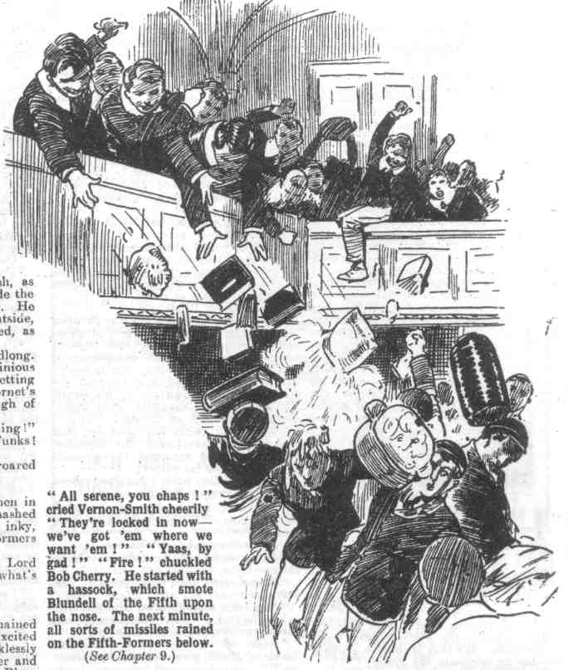 Missiles followed in a shower—all sorts and conditions of missiles—and they fairly rained on the Fifth, below. Blundell scrambled to his feet, with a crimson face.
“Come on !“ he shouted.
And the Fifth-Formers rushed to the attack.
THE TENTH CHAPTER.
The Defeat of the Fifth!
“Go it, Remove!”
“Pile in!”
“ Give ‘em jip !”
“Ha, ha, ha”
Blundell clambered desperately over the barricade. More and more it was borne in upon Blundell’s mind that he had bitten off more than he could possibly masticate. But retreat was impossible—unthinkable. All Greyfriars knew that the Fifth had set out to round up the Remove—to accomplish the task at which the Sixth had failed. If they returned unsuccessful they would be laughed to death at Greyfriars. From the Sixth to the Second, the whole school would chortle at them. Failure was not to be thought of. Blundell clambered desperately on, and his followers backed him up valorously.
Clambering over and among stacked furniture, the upturned legs of tables and chairs, was not easy. It, was, in fact, hard. And at the top of each staircase a crowd of juniors waited, some of them with rulers and pointers, some with brooms and mops, some with pails of water, some with squirts full of ink. The Remove were armed for the fray, and their weapons were many and various.
Blundell was the first to come within reach of the defenders.
Bob Cherry drove a mop at his chest and Blundell went sprawling over the barricade,
his legs slipped down among the furniture, and he could neither advance nor retreat, and he struggled and scrambled wildly.
Splash!
A pail of water swished over him from above, drenching him to the skin.
“Ha, ha, ha!”
“Come on!” shrieked Blundell.
“Yes, come on !” yelled Bob Cherry. “You men don’t seem to be in a hurry.”
“Down with the Fifth!” roared Bolsover major.
The seniors struggled and scrambled on desperately. But more and more of them found themselves tangled among the furniture like Blundell, and as they struggled wildly to free themselves missiles fairly rained on them from above.
Potter of the Fifth was fairly swept away by a Latin dictionary, that caught him under the chin; and as he flew he clutched at Greene and Tomlinson to save himself, and dragged them sprawling after him.
“Ow!” gasped Potter. “Wow!”
“Yarooooogh!” roared Greene, “Leggo!”
“Oh crumbs!”
“You young demons! Ow! Wow !”
Gamely the Fifth struggled on. But the foremost, as they came within reach of the defenders, were met by lunging mops and rapping pointers, and they scrambled back faster than they had scrambled forward. Knotted handkerchiefs and dusters were the lightest weapons that smote them. And every smite was a hard one. The Removites were putting their beef into it.
“Hallo, hallo, hallo! There goes Fitz!” yelled Bob Cherry. “Fitz has had enough! Take this dic. with you, Fitz!”
And Fitzgerald, who was scrambling back in frenzied flight, took the dictionary on the back of his neck and landed in the hall in a sprawling, yelling heap.
“Ha, ha, ha!”
“I say, you fellows, give a fellow a chance.” squeaked Billy Bunter. “ Let a fellow get at them.”
It was so clear that the attack never could succeed that even Billy Bunter was bursting with courage.
He reached over and smote at Hilton of the Fifth with a pointer. Hilton yelled as he caught the pointer on his neck. He plunged forward recklessly and grabbed at Bunter, and caught him by the collar,
“Yarooogh! Leggo! Rescue!” shrieked Bunter, all his valour petering out all of a sudden.
Harry Wharton and Frank Nugent rushed to the rescue, and Hilton was grasped and shoved back. Johnny Bull shoved with a mop that had been dipped in ink, and Hilton gurgled wildly with the mop in his face. Hilton was a handsome fellow; but he did not look very handsome as he backed wildly away from the inky mop. He went sprawling down, and joined Fitzgerald in the hall, spluttering and gasping
And after him went more Fifth-Formers, realizing very clearly that the defence was too strong for them, and that they had not an earthly.
Blundell was the last to admit the undoubted fact; but he had to admit it. When he succeded in getting loose from his jam in the barricade, his way lay downward, not upward. With a feeling as if he had been under a motor lorry, Blundell scrambled down into the hall, gasping wildly.
“ Going—going—gone!” yelled Bob Cherry.
“Ha, ha, ha!”
“Come on, you funks!” bawled Bolsover major.
“Licked to the wide! Yah!”
“I say, you fellows, give ‘em beans!” yelled Billy Bunter. “Gimme something to chuck at the beast.!”
“Give ‘em jip!”
The Fifth-Formers, dishevelled, drenched, tousled, breathless, gathered in a group in the middle of the hall. They knew that they could not carry the defences, but they were loth to retreat. But from the high gallery round the hall missiles rained on them.
“Oh, crumbs!” gasped Fitzgerald. “I’m fed up with this. We were fools to come here! Ow!”
“That ass Coker!” groaned Potter. “Just like one of his potty ideas! Wow!” he added, as an orange whizzed and landed in his eye.
“Let’s get out of this!” gasped Blundell.
He rushed to the door, forgetting, for the moment, that retreat was cut off. The door was immovable.
Whiz! Whiz! Whiz! Bump!
Crash!
Every man in the Remove was lining the balustrade of the gallery now, and hurling missiles. The Fifth-Formers were kept very busy dodging them ; but if one was dodged another smote, and another. The whole crowd of seniors backed up to the big door, the point farthest from the fusillade, gasping for breath, and dodging wildly.
“Chuck it !” yelled Fitzgerald at last. “We give in! We’ll go—” “Yah! Funk!”
“Ha, ha, ha!”
“You’re not goin’ yet, dear men,” chuckled Lord Mauleverer. “You asked for this, you
know, and you wouldn’t be happy till you got. it. Give them more, you men.”
“What-ho!”
“Stoppit!” shrieked Greene.
“Let us out, you little beasts.!”
Whiz! Whiz! Whiz! Crash! Swish! Swoosh!
Bob Cherry had a largc garden squirt., which he constantly refilled from a bucket of
water, into which bottles of red and black ink had been poured. That. inky squirt was doing great execution. All the wretched Fifth were within easy range of it. Other fellows hurled cushions and books and lumps of coal.
There was a sudden terrific crash, as Potter smashed out a window beside the door and went scrambling through. He landed in a heap on the stone outside, but he did not care how he landed, as long as it was outside.
After Potter went Greene, headlong. The Fifth were in full and ignominious flight now, and thinking only of getting away. They had awakened a hornet’s nest and evidently had had enough of the torments.
“I say you fellows, they’re running!” yelled Billy Bunter. “Yah! Funks! Come back and be licked !”
“You men in a hurry to go?” roared Bob Cherry.
“Ha, ha, hat”
The Fifth-Formers looked like men in a hurry. Another window was smashed open, and another. Drenched, inky, battered and bruised, the Fifth-Formers went sprawling wildly out.
“After them, dear men “ said Lord Mauleverer. “We can handle what’s left of them now!”
“Yes rather!”
“Come on!” shouted Wharton
Half a dozen of the Fifth remained within the building, when the excited juniors came scrambling down recklessly over the barricaded stairs. Another and another of them bolted out; but Blundell, Bland and Tomlinson remained within reach when the Remove got to close quarteras. And those three hapless members of the Fifth went down under a crowd of Removites, pinned to the floor by innumerable feet.
“Prisoners of war!” chuckled Bob. ?
“Yaas, begad! Sit on ‘em!” said Mauleverer.
“Standing room only!” said Bob.
“Ha, ha, ha!”
“Ow! Ow! Wow! Gerroff!” moaned Blundell. “Oh dear! Gerroff my neck! I’ll smash you! Ow! Oh crumbs!”
Outside, some of the Fifth were gathered in a panting crowd: but some of them were already streaking down the drive for the gates.
“I say, those young demons have got Blundell in there!” gaped Greene, as he heard the yelling of the prisoner.
“Let ‘em keep him!” gasped Hilton. “They’re welcome to him!”
“Serve him right, for bringing us here!” howled Price.
And Hilton and Price ran for the gates.
Five or six of the Fifth lingered, and looked back at the hall windows—but those windows were crammed with Removites now.
“Come on” invited Bob Cherry. The Fifth-Formers did not come on. They had had enough—or a little too much.
From the prisoners within came wild yelling and spluttering. Held in the grasp of many hands, they were being adorned with ink, jam, and soot from the big hall çhimney. Blundell, a sooty, sticky mess, was ejected by a window, and his friends hardly knew him when he appeared. Bland came next, reeking with soot, streaming with ink, and sticky with jam. Tomlinson was ejected last, in the same sticky and unsavoury state. Then all the Fifth were out, and the windows were crammed with yelling juniors.
“Come back and have some more!” shrieked Johnny Bull. “Lots more!”
“The lotfulness is terrific!”
“Ha, ha, ha!”
Blundell gave a sooty, inky, sticky glare at the Removites; but he did not want any more. He tramped away, and his friends tramped off with him, and derisive yells from the Remove followed.
It was a ghastly crowd that gathered in the road to tramp back to Greyfriars. Blundell was hardly recognisable and he was stuttering with rage. Angry recriminations broke out on all sides. That idea of putting the Sixth in the shade, by handling the rebel Form which the Sixth had failed to handle, had seemed an excellent idea—in the games study. It seemed far from excellent now. In fact, it seemed an absolutely rotten idea to all the Fifth.
With one accord, they told the wretched Blundell what they thought of him for leading them into such a scrape. It was really impossible for the Fifth to return to Greyfriars in the present state, and they washed as well as they could in a pond ; but when they had done all they could they still looked like a gang of particularly disreputable tramps. When they started for the school the Fifth were still telling Blundell what they thought of him; and their language, like that of Truthful James’ patient, was frequent and painful and free.
“It was Coker’s idea,” said Blundell a last, “ That idiot Coker—”
“Just like Coker, too!” groaned Potter.
“ Coker all over!” moaned Greene.
“ Wait till I get near him, that’s all!” said Blundell ferociously. And the wrath of the defeated Fifth found a fresh object when Coker was mentioned—they remembered that it was Coker’s idea, and they all agreed with Blundell that they wanted to get near Coker.
They came on Horace Coker before they reached Greyfriars. Curiosity had drawn Coker some distance along the road to High Oaks to see how the Fifth were progressing with the great scheme they had taken out of his hands. So it was that Coker met the ghastly array on the road, and he stared at them, when he saw them, blankly, and then burst into a roar of laughter. Coker could see at a glance that the Fifth had not prospercd.
“Ha, ha, ha!” roared Coker, aImost weeping with mirth. “You’ve bungled it, have you? What did you expect, with Blundell taking the lead! Ha, ha, ha!
Wish you’d left it in my hands, now, Blundell? Ha, ha, ha! Oh, my only hat! What a crew!”
Then the Fifth Formers dealt faithfully with Coker.
Really, it was not quite fair play, for certainly they had taken the thing out of Coker’s hands, and managed it—or mismanaged it—on their own. But the Fifth were not worrying about justice. They wanted a victim—and they wanted a victim badly; and Horace Coker had butted in at the right time, perhaps on the principle that fools rush in where angels fear to tread. What happened next Coker hardly knew ; it was like a railway accident, an air raid, and an earthquake all rolled into one.
A little solaced, the Fifth marched on, leaving Coker for dead, as it were. Loud laughter greeted the wretched Fifth when they trailed into the school : but Coker, who trailed in after them, was in a more dilapidated state than any other man in the Fifth. And not a man in the Fifth Form entertained for one moment the idea of having any more dealings with the rebel Remove—not even Coker. Lord Mauleverer had laid his plans to make the Fifth fed-up with the Remove; and there was no doubt that they were fed-up—right to the back teeth. Whatever happened to the rebel Removites, they had no more trouble to expect from the Fifth.
THE ELEVENTH CHAPTER.
Bunter the Rebel!
“I SAY, you fellows—”
“Give us a rest, old fat man!”
“But, I say—”
“Bow-wow!”
“I’ve got an idea” roared Bunter
“Whose?” asked Bob Cherry.
“Mine, you silly ass!”
“Then it can’t be any good. Take it away and bury it!”
“It’s a ripping idea!” said Bunter. “We’ve beaten the Fifth —beaten them to the wide. My idea is to have a whole holiday to celebrate the victory!”
“Good!” exclaimed Skinner, at once.
“Not bad!” admitted Bob Cherry.
For once William George Bunter had propounded a suggestion that met with a good deal of approval. Whole holidays appealed to the Removc. At High Oaks whole holidays could be arranged much more easily than at Greyfriars. In the school without a master the fellows had only to decide that matter for themselves.
It was the morning after the affray with the Fifth. High Oaks still showed a good many signs of the affray. On the Remove side, nobody had been hurt, though the Fifth had collected an enormous amount of damage. That morning the rebels were in great spirits; and it was, moreover, a fine, sunny day. Bunter’s suggestion, made at the breakfast table, seemed to catch on.
“We could get up a game of footer.” said Bob Cherry.
“JolIy good idea.” agreed Johnny Bull heartily.
“After all, it is rot having lessons, just as if we were at Greyfriars.” remarked Hazeldene.
“Utter rot!” said Skinner.
“What about it, Mauly?” asked Bob.
Lord Mauleverer shook his head.
“Must play the game, dear men,” he said. “I’m in favour of a whole holiday every day, either here or at Greyfriars. But the game’s the game. We’re standin’ up for justice, not for slackin’. Give it a miss.”
Which was really heroic on his lordship’s part, for there was no doubt that of all the Remove he was the most strongly disposed to slack through that sunny day.
“ Oh, really, Mauly———”
“Don’t be an ass, Mauly! I’m for a holiday!” said Skinner.
“Business as usual!” said Lord Mauleverer. The thrashin’ Conmmittee will deal with every fellow who doesn’t turn up for class.”
“You silly ass!” hooted Bunter.
“Don’t, dear boy!” said Lord Mauleverer plaintively. “ I don’t mind you callin’ me names, but don’t yell at a chap. Your voice ain’t musical, old bean!”
“I’m having a holiday!” howled Bunter.
“You’re not!“ said the captain of the Remove. “Mauly’s right: we’re bound to play the game, same as if Mr. Quelch had taken charge, as we wanted hiim to do. Class as usual.”
“ Yah!” from Bunter.
And Bunter’s suggestion was dropped —by all but Bunter. When Juggins rang the bell for class, the Remove turned up with the exception of William George Bunter. Mark Linley called the roll, and the Owl of the Remove failed to answer to his name. The Thrashing Committee went immediately in search of Bunter.
“Where on earth has that fat slug crawled to?” exclaimed the Bounder when they had searched the grounds in vain for the fat junior.
“ Hallo, hallo, hallo, Juggins! seen Bunter?” shouted Bob Cherry.
“Yes, sir; he’s gone upstairs, sir,” said Juggins. “ He has taken a pie with him, sir.”
“ A pie !“ ejaculated Wharton.
“Yes, sir—and a cake—a large cake— ”
“Anything else?” grinned the Bounder.
“ Yes, sir, several other things, sir.” said Juggins “All of them of an eatable or drinkable nature, sir”
“Gone off for a feed.” said Peter Todd. “We’ll give him feed! Come on.”
The committee re-entered the house, and went upstairs in search of the Owl of the Remove. He was not found in the apartment that was used as a dormitory; and they searched among the other rooms for him. and finally came on a locked door. This was the door of a bed-room that had been specially furnished from Chunkley’s, and prepared for Mr. Quelch—in the hope the Remove master would take up his quarters with his old Form at High Oaks. So far, the room had no tenant. Now it had a tenant—in the shape of WilIiam George Bunter.
“Locked!” said Squiff, as he tried the door. “The fat bounder’s here. Let us in, Bunter.”
“Shan’t !” came Bunter’s voice from within’
“We’ve come to thrash you.”
“Yah!”
“Look here, you fat villain!” roared Bob Cherry, “You’ve got to come into class—see?’
“Rats!”
“Bunter, you fat chump!” exclaimed Harry Wharton. “Open the door at once.”
“Go and eat coke!”
“You’ll get it worse when you come out “ shouted Peter.
There was a fat chuckle from within. “You see, I ain’t coming out,” said Bunter.
“You’ll have to come out for dinner, ass.”
“I’ve got my dinner here.”
“Well, for tea, then, idiot.”
“I’ve got my tea here!” chuckled Bunter. “I’ve got lots of grub. I’m not coming out at all. I’m fed up with class! It’s a barring out.”
“What?” roared the committee, with one voice.
“ A barring out !” chuckled Bunter. “If you can cheek the head, I can cheek you, I suppose, Who are you? Nobody. I despise you, the lot of you. Yah!”
Bang, bang, bang!
“You can bang on the door as much as you like,” said the Owl of the Remove cheerfully. “ I’ve got the tool chest here, and I’ve nailed it and screwed it, and screwed down the wash-stand and the sofa beside. You won’t get that door to open in a hurry. He, he, he !”
“Why, you—you fat villain!” gasped Wharton.
“Oh, really, Wharton—”
“Do you call this playing the game?” demanded Peter Todd. “ Can’t you see you’re a nasty little, fat, frowsting rotter?”
“That’s cheek, Peter.
“What?” roared Toddy.
“Cheek! If the door wasn’t fastened, I’d come out and thrash you.”
“ Thrash me?” gasped Peter dazedly.
“Yes; the lot of you. You’d scud off pretty quick if I opened that door.” said Bunter, through the keyhole. “Funks, the lot of you! Yah!”
“My only hat!” gasped Bob Cherry. “When I get near enough, you fat snail, I’ll burst you.”
“Shut up, Cherry.”
“What?” roared Bob.
“You talk too much. Shut up.”
“Why, I—I—I — Words failed Bob Cherry.
Behind the locked door, there was no doubt that William George Bunter was as brave as a lion. He hurled reekless defiance at the Thrashing Committee — through the keyhole.
“Let’s get round to the window.” said the Bounder impatiently. “We’ve got to round up the fat rotter.”
Bunter chortled a fat chortle.
The window’s forty feet tap.” he said. “ Better sign the “Daily Mail”‘ insurance coupon before you begin monkeying at the window. Your relations will benefit. He, he, he!”
“Look here, Bunter—” exclaimed Wharton.
“Shut up, Wharton!”
“Why, you—you—you—I— I—I’ll—” Give your chin a rest.” advised Bunter. “ I’m not coming out of here till it suits me. It doesn’t suit me yet. I’ve got lots of grub. I’ve fastened the window, and you1 can’t get at it, anyhow. You’d want a battering-ram to burst in the door. Even Bob Cherry’s feet wouldn’t do it.”
Five members of the committee smiled at that remark involuntarily. One member frowned.
“I’m taking a holiday.” went on Bunter. “You can go and eat coke. I’m not having any more classes at all, in fact. I think it’s rot.”
“You’ll get a flogging for this!” roared Peter Todd.
“ Go and yell somewhere else, Toddy, will you? In fact, all of you clear off, before I come out to you.’
“ My hat ! I wish you would come out to us!” breathed Peter Todd. “I’d make an example of you, you fat rascal.”
“Gas!” said Bunter cheerfully. “You couldn’t lick me, Toddy! I’d lick you to a frazzle with one hand tied behind me. I’ve often thought of thrashing you but I’ve let you off because you’re no good in a scrap. You’d break in two if I hit you, you skinny specimen.”
“Well, my only hat!” murmured Bob Cherry. “Bunter’s a plucky fellow when he’s behind a locked door. What are we going to do with him, Harry?”
“Nothing, I suppose, till we can get at him.” answered Wharton. “For the last time, Bunter—”
“Shut up, Wharton.”
“You’ll get scragged for this!”
“You couldn’t scrag me. You couldn’t scrag a kid of ten,” said Bunter. “You’re no good, you know.”
The committee bestowed a few vigorous kicks on the door, by way of expressing their feelings, and retired from the spot. For the present there was nothing else to be done in the locked room. Billy Bunter chuckled gleefully. There were no classes for the Owl of the Remove that morning; and it really looked as if Bunter’s barring- out might last as long as his provisions lasted.
One of the drawbacks of rebellion is that some rebels never know when to stop. When the leaders of the rebellion are satisfied that matters have gone far enough—that is to say, when they have overturned authority and taken rule into their own hands—their followers are only too likely to think a little more rebellion a good wheeze, and to rebel against their leaders.
A school without a master had seemed quite a feasible proposition to Harry Wharton & Co. It had started quite well. But rebellion is like a disease that has to run its course. Now Bunter had started a rebellion on his own; and when the committee returned to the class-room, they found that Bunter’s example had borne fruit.
THE TWELFTH CHAPTER.
More Rebels!
BUMP!
Just as Harry Wharton & Co. reached the door of the class-room, that door opened, and
Mark Linley came out into the passage. He came out flying, and landed in a heap at the feet of the committee, with a roar.
“Hallo, hallo, hallo!”
“What—”
“Ow!” gasped Mark. “Oh! Oh, my hat!”
Evidently class was not going on in the class-room. William George Bunter was not the only rebel who was fed up with law and order.
Crash, crash, crash!
School books followed Mark from the open doorway, raining on him and round him..
“Now, come back and we’ll give you some more!” roared Bolsover major.
“Chuck Mauly out after him!” yelled Skinner.
“Oh gad! I say Yaroooogh!”
Harry Wharton & Co. rushed in. They were just in time to meet Lord Mauleverer coming out.
Crash!
“Oh! Begad! Yooooop!”
“Ow! Ow! Oh crumbs!”
“Ha, ha, ha!” came in a roar from the class-room, as Lord Mauleverer and the committee were mixed up in the doorway.
Lord Mauleverer sat up dizzily. Harry Wharton sprang into the class-room. A Latin dictionary caught him on the chest, and he sat down. There was a wild yell from Mauleverer; the captain of the Remove had involuntarily sat on his lordship.
“Oh!” gasped Wharton.
“Yow-ow-ow! Gerroff! Oh, begad!”
Wharton jumped up.
The class-room was in an uproar. Some of the fellows were at their desk, but quite half the Remove were out of their places, roaring with laughter. Bolsover major was the leader of the outbreak, and he seemed to have gained many supporters.
“What does this mean?” shouted Wharton angrily.
“It means that we’re fed-up playing school!” snorted Bolsover major “You can stick in class, if you like! I’m not going to!”
“Same here!” shouted Hazeldene.
“We’re having a holiday to-day, Wharton!” explained Wibley.
“You’re not!” roared the captain of the Remove.
“We jolly well are!”
“Yes, rather!” shouted Russell. “And another one to-morrow!”
“Hear, hear!” chortled Ogilvy,
“Go back to your places!” yelled the captain of the Remove,
“Rats!”
“Go and eat coke!”
“Cheese it!”
“Turn them out!” roared Bolsover major.
“Back me up, you fellows!” exclaimed Wharton.
And he rushed at Bolsover major and grasped him.
The committee backed him up valiantly. Frank Nugent and Tom Redwing and Hurree Jamset Ram Singh came to their assistance. Tom Brown and Penfold joined up. Other fellows sat where they were and watched, with laughing faces Even the most orderly members of the Remove found this more entertaining than classes.
Quite a number of fellows were backing up Bolsover major. There was a terrific scrap in the Form-room.
The rebels had the worst of it. But while the scrapping was going on Skinner and Snoop disappeared from the scene, and half a dozen other fellows followed them. Bolsover major, fighting valorously, was borne to the floor, and Bob Cherry started operations with a cane, to an accompaniment of terrific yells from Bolsover. But his supporters rallied to the rescue, and the scrapping was wild and whirling. Bolsover major tore himself loose and struggled to his feet.
“Come out of this!” he shouted.
And the rebels swarmed out of the class-room. They had been defeated in the scrap, but reducing them to order was quite another matter. They streamed out of the classroom—nearly half the Remove. Obviously the spirit of rebellion was spreading far and wide.
Bob Cherry dabbed the crimson from his nose with his handkerchief.
“ Oh, my hat!” he gasped.
“Oh dear!” murmured Nugent, caressing his eye.
Somebody’s knuckles had landed in that eye, with painful results.
The Bounder burst into a laugh.
The game’s up!” he remarked. “I never thought it was a good idea myself to play at school—much better have a good time! Come on, Reddy! Let’s get out of this!”
Tom Redwing shook his head.
“I’m staying in, Smithy!” he answered.
“More ass you!” said the Bounder. “I’m going out!”
And he went.
“Come back, you rotter!” roared Bob Cherry.
“Rats to you!”
And the Bounder strolled away. whistling.
“What’s the orders, Mauly?” grinned Johnny Bull. “Are we going after them, old scout ?”
“Ow!” gasped Mauleverer. “I’m winded! Ow!”
“The windfulness of my esteemed self is also terrific,” said Hurree Jamset Ram Singh, “ and the gamefulness is up, my ridiculous friend! We shall have to let them rip!”
Harry Wharton looked round the class-room. Half the Remove were gone, and some of the fellows who remained looked rather disposed to follow. For a week the school without a master had run more or less successfully, but it seemed to have collapsed now. Obviously, it was impossible for one half the school to drive the other half into class and keep them there. The captain of the Remove grinned ruefully.
“You’re leader, Mauly!” he said.
“Yaas!” gasped Lord MauIeverer.
“Of course, we’re not goin’ to put up with this! Only I’m beginning to think that school can’t be run without a master, you fellows!”
“Go hon!” murmured Nugent.
“We’ll go after them and mop them up if you give the word, Mauly” said Johnny Bull.
“Well, they wouldn’t come into class if we did,” said his lordship. “The fact is, you can’t run a school without a master unless all the fellows agree to it. And they don’t seem to agree.” “They don’t!” grinned Squiff.
The disagreefulness is terrific!”
“Let’s stick to class,” said Mark Linley. “The fellows may change their minds and come back. Anyhow, we can play the game ourselves.”
“Yaas, that’s the idea!”
“I suppose we can’t do anything else.” said Wharton dubiously.
Bob Cherry glanced at the sunny windows.
“What about making it a holiday, after all?” he murmured.
There was a murmur of approval. Even Wharton was tempted. Football seemed really much more attractive than class when there was no headmaster or Form master to enforce class. But the captain of the Remove resisted the temptation manfully.
“Oh, let’s stick to it!” he said. “It’s up to us!”
“The stickfulness is the proper caper,” agreed Hurree Jamset Ram Singh “Let us stick to it gluefully.”
“Oh, all right!”
And the law-abiding members of High Oaks School took their places at the desks. But they did so rather half-heartedly. If their example had the effect of recalling the rebels to a sense of duty, it was all very well; but it was extremely unlikely that their example would have that effect. Outside in the grounds they could hear the shouting of Bolsover major and his party, who were punting about a footer and apparently enjoying themselves. About ten minutes later Tom Brown rose from his place.
“I’m going to speak to a chap.” he remarked.
And he disappeared.
A few minutes later Penfold went out to speak to a chap, and did not return. At intervals there were more desertions.
By the time class was dismissed, the class consisted of the Famous Five, Squiff, Peter Todd,, and Lord Mauleverer. All the other fellows had gone. Mark Linley grinned n little when he gave the signal to dismiss.
“You fellows turning up this afternoon?” he asked.
“Certainly!” said Wharton.
“Oh—’hem—certainly!” said Bob.
“The turnupfulness will be terrific !”
“Oh, yaas!” said Lord Mauleverer. “Let’s turn up, you men! Must play the game!”
And class was dismissed.
At dinner that day most of the Removites were in a hilarious mood. Harry Wharton had a very thoughtful look. Discipline had been thrown to the winds now, and he was aware that if there was a class this afternoon it would not consist of more than half a dozen fellows,. He realised that a school without a master was not, after all, a feasible scheme. It had been weighed in the balance and found wanting.
Mr. Juggins rang the school bell as usual that afternoon. Harry Wharton went to the class-room. A little later Mark Linley joined him there, and, still later, Hurree Jamset Ram Singh. The voice of Bob Cherry could be heard shouting among some fellows who had picked up sides for a game of Soccer. Apparently, Bob had forgotten class. And Nugent seemed to be occupied somewhere; he did not arrive in the classroom.
Lord Mauleverer trailed up at last.
“Oh gad ! How many of us?“ he asked.
“Four!” said Wharton, with a grimace.
“ The total is not terrific!” remarked Hurree Jamset Ram Singh. “In the esteemed circumstances; a fellow may as well join in the excellent and ridiculous footer!“
And the Nabob of Bhanipur glided away.
Mark Linley smiled.
“Looks like a fizzle!” he said. “It’s a regular stampede. I’m afraid that a school without a master is N.G. !”
And Linley went to join the footballers.
Wharton and Lord Mauleverer remained alone, looking at one another ruefully.
“Well, what are we going to do, Mauly?” asked Harry.
“I think I’ll have a nap!” said his lordship, after some thought.
“Ass! I mean about keeping up school.”
“Blessed if I know!” said Mauleverer candidly. “Looks as ii it’s played out. The fact is, old bean, we can’t run a school without a master. I rather thought Quelch would back us up. But he hasn’t.”
“He hasn’t.” agreed Wharton.
“We’re standin’ up for Quelchy, and he’s not standin’ up for us!” said Lord Mauleverer. ”It leaves us rather in a hole. We can’t run a school without a master, and if Quetchy don’t take us up, I think—”
He paused.
“You think?” asked Harry, guessing his lordship’s thoughts, which were the same as his own.
“I think we shall have to chuck it and go back to Greyfriars,” said Lord Mauleverer. “I fancy I’ll get Quelchy on the telephone, and make a last appeal to him to come here and take on High Oaks School as a business proposition. If he refuses, the game’s up, and we’d better make what terms we can with the Head. So long as we kept up classes we had a leg to stand on: but as matters stand now, we’re just playin’ truant. It won’t do. I’ll put it to Quelchy.”
“Right” said Harry.
And the captain of the Remove--not feeling disposed to constitute a class all by himself —went out out and joined the footballers. The school without a master had fizzled out. as the Greyfriars rebels might really have expected from the start.
THE THIRTEENTH CHAPTER.
Skinner Does It!
“HUSH!” breathed Skinner.
Snoop and Stott “shushed!”
Outside, Soccer was going on, and the greater part of the rebel Form were enjoying themselves in the keen air. The three black sheep were looking for a quiet place to smoke cigarettes, when they heard Lord Mauleverer’s voice at the telephone.
“Is that Mr. Quelch?” Mauly was asking, when Skinner & Co. came within hearing.
“ Mr. Quelch is speaking.” came back the voice of the Remove master over the wires. “ Is that Mauleverer?”
“Yaas, sir.”
“ What do you want, Mauleverer. I am not sure that in the eircunistanees, I can with propriety communicate with you at all,” said M. Quelch. “However, I will hear what you have to say.”
“ Yaas, sir. We want you to come to High Oaks—”
“I have already told you that that is impossible, Maulererer.
“Yaas; but listen to a man, sir.” said Maulteverer. “ We’ve had a terrific shindy here—”
“ Bless my soul!”
“ No end of a rumpus, sir!” went on Mauleverer. “ We’ve been keepin’ up classes, but they’re knocked into a cocked hat now. There’s not goin’ to be any more classes till we get another master.”
Skinner & Co. grinned at one another. Lord Mauleverer did not observe the, three juniors approaching behind him as he sat at the telephone.
“ You see, sir, we’re all at sixes and sevens.” went on Mauleverer. “ I really think, sir, that you ought to come over and take charge.”
“Impossible! I cannot countenance a revolt against the authority of your headmaster, as I have already told you.”
“But we cleared out of Greyfriars on your account, sir!” remonstrated Mauleverer.
“You should have done nothing of the kind!”
“Yaas; but— “
“My advice to you is to return to your school at once.” said Mr. Quelch. “ I have already given you that advice. and 1 repeat it.”
“ We’ve told the Head we won’t be back without you, sir.”
“ Nonsense!”
“ Hem! If you’d back us up, sir. I’m sure the Beak—I—I mean the Head— would see reason —”
“ Nonsense, Mauleverer ! You must not think of dictating to your headmaster!’ snapped Mr. Quelch. “ I disapprove of it entirely!”
“But, sir, just listen a minute— Ow!”
“ What?” exclaimed Mr. Quelch, at the other end of the wire.
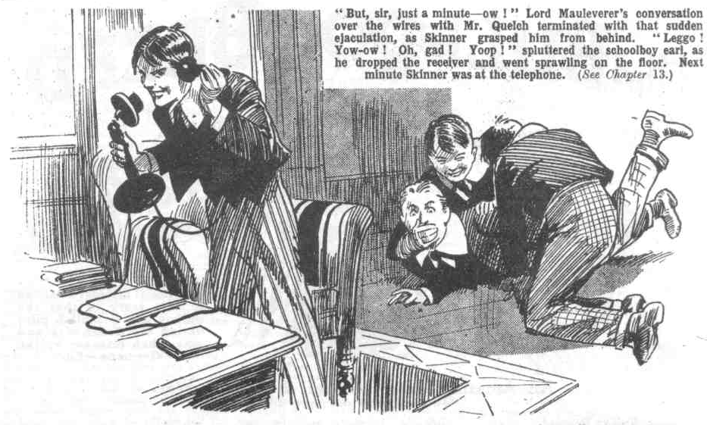 “Yow-ow-ow-o !”
What Mr. Queleb thought of that remark cannot be stated. It was caused by Skinner grasping Lord Mauleverer from behind and dragging him bodily away front the telephone.
“Leggo! Yowow! Oh gad! Yooop!” spluttered Mauleverer, as he dropped the receiver and went sprawling back on the floor.
“Sit on him, you fellows!” grinned Skinner.
“Ha, ha! Yes, rather !“
“Ow! Gerroff! Oh. my hat!” gasped Mauleverer, as Snoop and Stott planted themselves on him, and pinned him down to the floor by sheer weight. Harold Skinner caught the receiver. “Leggo!” yelled Mauleverer. “Gerroff! I haven’t finished talkin’ to Quelchy! You rotters! Ow!“
“I’ll finish talking to him for you!” chuckled Skinner. “I’ll make jolly sure that Quelchy don’t come over here to take charge, Mauly. Keep that silly idiot quiet, you chaps! Bang his head on the floor if he kicks up a row!”
“What-ho!” chortled Snoop.
“You rotters! Ow! I tell you—yaroooogh!” roared Mauleverer, as his noble head banged on the floor. “Ow-ow-ow-ow-ow !”
“Ha, ha, ha!”
“Keep quiet!” grinned Stott.
“Hallo!” said Skinner into the transmitter. “Are you there?”
“I am here!” snapped Mr. Quelch, from the Courtfield Hotel. “I was speaking to Mauleverer. What—“
“Shut up a minute!” said Skinner.
“What?” ejaculated Mr. Quelch. “Shut up a minute, Quelchy. You talk too much.”
“Bless my soul!” gasped Mr. Quelch. “That is not Mauleverer speaking. Who is speaking?”
Skinner winked at his chums.
“Little me, sir.” he answered cheerily. “Mauly’s been telling you we want you to come over here. Well, we don’t! The less we see of you, sir, the better we like you. We had enough of you at Greyfriars—too much, in fact. We’re fed-up with you!”
“I know your voice!” gasped Mr. Quelch. “That is Skinner speaking. How dare you, Skinner!”
“My dear old bean—”
“What! What!”
“My dear old bean,” said Skinner calmly, “why shouldn’t I talk to you as I like? You’re not our Form master now. You’re sacked from Greyfriars— and a jolly good thing, too, in my opinion. Blessed if I know why the Head didn’t sack you before!”
“Goodness gracious!” stuttered Mr. Quelch.
“Ha, ha, ha!” roared Snoop and Stott.
Skinner was quite enjoying this little talk with Mr. Quelch. He would have liked to tell Mr. Quelch what he thought of him, many a time, at Greyfriars, though he certainly had not ventured to do so. Now Skinner considered that it was quite safe. The school without a master was not likely to last much longer, in Harold Skinner’s opinion, and when it came to an end, the return to Greyfriars was inevitable—but there would be no Mr. Quelch there. So Skinner could not see any reason why he should not talk to the late Remove master exactly as he pleased.
“We don’t want you here, Quelchy.” went on Skinner.
“What? What did you call me, Skinner?”
“Quelchy! Old Quelchy!” said Skinner cheerfully.
“Upon my word! if 1 were still your Form master, Skinner, I should cane you with the utmost severity.” said Mr. Quelch, his voice trembling with wrath.
“I dare say you would, Quelchy,” chuckled Skinner. “But, you see, you ain’t my Form master now, and never will be again, since you’ve got the boot. Best thing the Beak ever did, in my opinion.”
“Oh, you rotter!” gasped Lord Mauleverer,
“Ha, ha, ha!”
“Oh, my hat!” gasped Snoop. ‘He’s not likely to come after that, Skinner. Sorry for you if he did, old chap.”
“I fancy I’ve put the stopper on him,” grinned Skinner,
“Skinner “—Mr. Quelch’s deep voice, trembling with anger, came over the wires—” 1 shall come to High Oaks immediately!”
“Eh?”
“I shall, for the present, resume control of my Form! You may tell the other boys so”
“Oh crumbs!” gasped Skinner, in utter dismay“
“Oh. my hat!” he gasped..
“You may expect me very shortly!” said Mr. Quelch grimly, and he rang off.
Skinner stood blinking at the telephone blankly.
Stott.
“Oh, my hat!” he gasped. “I say, he—he—he says he’s coming!”
“Coming?” yelled Stott and Snoop.
“He says so.”
“You silly ass, Skinner!” gasped Snoop.
“You footling chump!” howled Stott. “You might have known Quelch wouldn’t stand your cheek! That was the way to make him come!”
“Ha, ha, ha!” shrieked Mauleverer. He scrambled to his feet as Snoop and Stott released him. “Ha, ha, ha! You’ve done it, Skinner! Much obliged to you, old chap.”
Skinner did not reply. He was utterly dismayed. He had enjoyed that talk with Quelch on the phone; but if Mr. Quelch was coming over to High Oaks to take control, there was likely to be a severe reckoning after the feast. Skinner had done it—there was no mistake about that! He sat dismayed, while Snoop and Stott shook their fists at him, and told him what they thought of him, in emphatic language. Lord Mauleverer, still chuckling, went out to tell the news to the Removites.
“Quelch’s comin’!” he announced.
“What?”
“Did he say so?” exclaimed Wharton. “How did you manage it, Mauly?”
“I didn’t!” chuckled Mauleverer. “Skinner managed it—without meanin’ to. He’s comin’, dear men, and the jolly old school’s goin’ to have a master. Come down to the gate sand give him a cheer when he comes.”
“Yes, rather!”
“The cheerfulness will be terrific!”
“Bravo!”
There was a big crowd at the gates of High Oaks when a taxicab was seen approaching from the direction of Courtfield. Loud cheers greeted Mr. Quelch when he stepped out. Quite unintentionally, Skinner had saved the situation, Nd High Oaks was no lomnger a School without a Master.
THE END.

