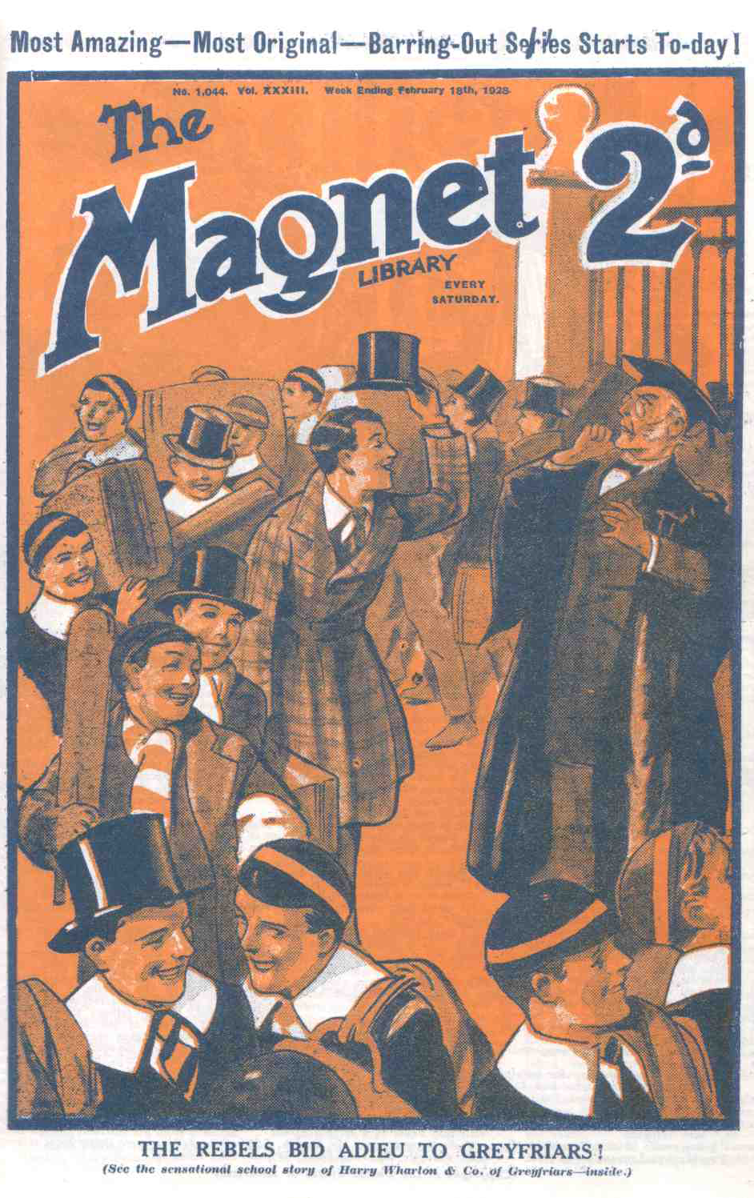

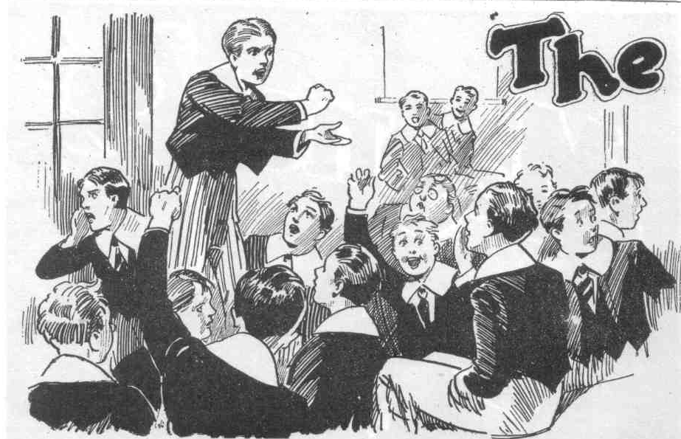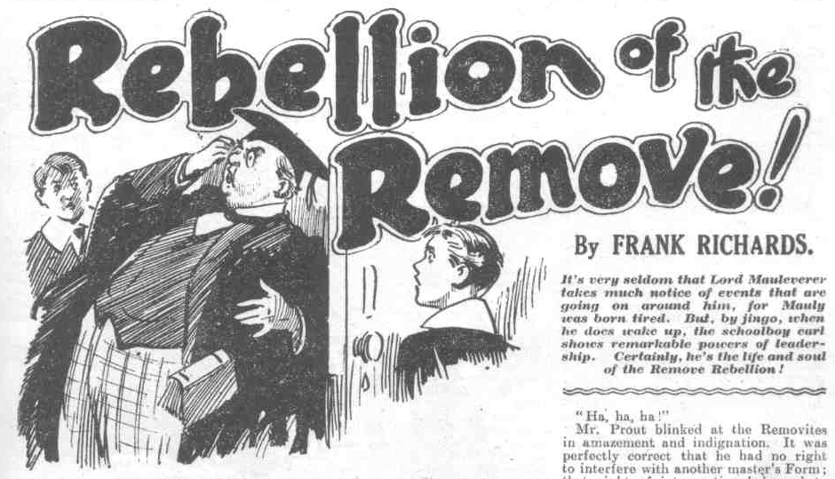
THE FIRST CHAPTER.
The Rebels!
“SHOCKING!”
Mr. Prout, the master of the Greyfriars Fifth, was fully justified in expressing that opinion’
Standing in the doorway of his own Form-room, Mr. Prout was staring along the corridor to the Remove room.
The door of that room was open.
Shouting and the scuffling of feet sounded and resounded from the Remove Form-room; and in the midst of the uproar, a sprawling figure suddenly shot through the doorway and sprawled along the passage.
No wonder Mr. Prout declared that it was shocking.
For the sprawling figure in the Form-room passage was that of Wingate of the Sixth, head prefect of Greyfriars, and captain of the school.
The captain of Greyfriars had been “chucked” out of the Remove room ---ejected on his neck!
The door slammed after him; and Wingate slowly picked himself up, and blinked, and gasped, and gurgled.
Then he came limping up the passage
He looked dusty and untidy and breathless; not at all as the captain of the school should have looked.
He was passing Mr. Prout, on his way to the Sixth Form room, to seek the Head, when the Fifth Form master stopped him.
“Wingate! What has happened?”
Wingate paused, gasping for breath. His looks showed that he had been through a rather wild time in the Lower Fourth Form-room.
“There’s some trouble in the Remove, sir.” said Wingate.
“I am aware of that!” snorted Mr. Prout. “They can be heard all over the House. But what has happened to you?”
The prefect made a grimace.
“I’ve been chucked out, sir!”
“You have surely not allowed the juniors to turn you, the head prefect of Greyfriars, out of a Form-room!”
Wingate blinked at Mr. Prout.
“They’re out of hand, sir! They seem to be wild because the Head has dismissed their Form-master, Mr. Quelch. They refuse to be taken by a prefect. If you’ll tell me how to handle forty fellows at once, sir, I’m sure I shall be much obliged.”
Wingate’s tone was sarcastic. Mr. Prout seemed to suppose that he had been willing to leave the Remove-room on his neck. Really, Wingate had no preference whatever for that mode of departure.
Mr. Prout snorted Mr. Prout snorted.
“It is your duty, Wingate, as a prefect placed in charge of the Lower Fourth, to quell this disturbance.” he said.
“Would you mind telling me how, sir?” asked Wingate politely.
Another snort from Mr. Prout.
“I shall take the matter in hand myself!” he said.
“You’re welcome, sir!” said Wingate dryly. “I’m going to report the matter to the Head; but if you can restore order, sir, I won’t trouble Dr, Locke. I’d rather not, of course.”
“Leave it to me!” said Mr. Prout majestically.
Wingate was quite willing to leave it to Mr. Prout; he was, indeed, willing to leave the Remove to anybody. In the present excited state of that Form, “taking” them in the absence of a Form-master was no sinecure.
And although Wingate was exasperated by his treatment at the hands of the Removites, his sympathies were still with that Form to a certain extent.
Their Form master, Mr. Quelch, had been abruptly dismissed from his post by Dr. Locke---in the most arbitrary and unjust manner, as it appeared to all Greyfriars.
The whole school blamed the Head and sympathized with Mr. Quelch; and the Remove were taking it personally. Their sympathy with their dismissed Form-master took a rather obstreperous form.
If Dr. Locke had any weighty reason for dismissing Mr. Quelch, he had not stated it, even to the Remove master himself. Such a high-handed, and indeed tyrannous action was quite unlike the Head: but there it was---it had happened. The Remove did not like it; and they were making that fact unmistakably clear.
Mr. Prout strode along majestically to the Remove-room.
Mr. Prout, like all the rest of the staff, was indignant at the Head’s treatment of the Remove master. But order was order, and discipline was discipline. A junior form could not be allowed to get out of hand like this. Dr. Locke had placed a prefect in charge of the Remove. The Remove had thrown that prefect out of their Form room. Evidently it was high time for the hand of authority to descent upon them.
The Fifth-Form master threw open the door of the Remove room.
All the Remove were there---but hardly a fellow was at his desk. Most of the Lower Fourth were gathered in a crowd in the middle of the room. Most of them were talking; all were excited. Two fellows were actually seated on top of the Form-master’s high desk, swinging their legs. Lord Mauleverer was standing on the Form master’s high chair, which had been dragged out into the middle of the room. Mauly, the slacker of the Remove, the laziest fellow at Greyfriars or anywhere else, was unusually bright and active. He was addressing the Remove from his rostrum, though most of the fellows were doing more talking than listening.
“Gentlemen of the Remove.” Mauly was saying, as Mr. Prout opened the door, “we’ve kicked out that dashed prefect---”
“Hear, hear!’’
“He’s gone to report to the Beak---”
“Let him!” roared Bolsover major.
“The Beak will come along here” said Mauleverer. “We’ve all got to stand together, and talk to him plain. We’re goin’ to tell him that we won’t be taken by a prefect---”
“Never!” roared Bob Cherry.
“The neverfulness is terrific” said Hurree Jamset Ram Singh.
“And we won’t be taken by a new Form master if he sends for one---”
“Hear, hear!”
“We want Quelchy---“
“ Bravo!”
“And we won’t be happy till we get him!” said Frank Nugent.
“Ha, ha, ha!”
“Our Form-master has been sacked— for nothin’, so far as any man knows.”
said Mauleverer. “Were not standin’ it!”
“Never!”
“Hardly ever!” grinned Vernon-Smith.
“If Quelchy goes, we all go—”
“Oh, my hat!”
“I know you’re captain of the Form, Wharton, and I don’t what to look like buttin’ in. You take the lead, and I’ll follow. But, anyhow, I’m goin’ if Quelchy goes.”
Harry Wharton laughed.
“Stick to it, Mauly,” he answered. “Now you’ve woke up, you’re going it, and no mistake. I leave it to you, partner.”
“Well then, we mean business,” said Mauleverer. “If Quelchy goes, we all go—we march out of Greyfriars.”
“Phew!”
“Gas!” said Skinner. “You’ll jolly well sing to a different tune when the Head 1ooks in.”
“Shut up, Skinner
“I say, you fellows---” squeaked Billy Bunter.
“Shut up, Bunter.”
“I say, there’s old Prouty——”
“What?”
“Hallo, hallo, hallo!” roared Bob Cherry. “ It’s Prouty!”
All eyes turned on the plump, majestic figure of Mr. Prout, framed in the doorway.
THE SECOND CHAPTER.
Not Taking Any!
MR PROUT stared into the Remove-room. For some moments his majestic breath seemed to have been taken away by what was going on there. But he found his fruity voice at last.
“Boys!” he boomed,
“Man!” replied Johnny Bull cheerfully.
“What?”
“Ha, ha, ha!”
“How dare you, Bull!” roared Mr. Prout.
“How dare you, Prout!” retorted Johnny Bull independently.
“Goodness gracious!” gasped Mr. Prout.
“Hold on, you men !“ exclaimed Lord Mauleverer. “Don’t cheek Mr. Prout. Bad form to cheek a Form master.”
“Let him buzz out of our Form-room, then!” growled Johnny Bull.
“Boys!” boomed Mr. Prout. “Cease this disturbance at once! Take your place at your desks this instant!”
“Rats!”
“Go and eat coke!”
“Bless my soul!” gasped Mr. Prout.
“Leave it to me, you men,” said Lord Mauleverer. Remember your manners, old bean. Mr. Prout, will you have the kindness to step out of our Form-room, and keep out?”
“Certainly not!” gasped Mr. Prout. “I have come here to restore order, Mauleverer.”
“Allow me to point out, sir, that you have no right to interfere in this Form-room.” said Mauleverer. “Keep to the Fifth, sir.”
“Silence, you impudent boy!
“Only the Head has a right to step in here, sir.” said Mauleverer firmly. “ We shan’t, stand interference from any Form-master but our own.”
“Hear, hear!”
“Get out, Prout !”
“Roll away, old fat man!” chuckled the Bounder.
“Ha, ha, ha!”
Mr. Prout blinked at the Removites in amazement and indignation. It was perfectly correct that he had no right to interfere with another master’s Form; that right of intervention belonged to the Head alone. In the unusua1 circumstances, Mr. Prout was assuming that right. But the Removites were obviously not in a mood to allow any such assumption.
“Take your places at once!” exclaimed Mr. Prout. “ I refuse to allow this outragous disturbance to continue!”
“ Goodbye, sir!” said Mauleverer. “Have the kindness to shut the door after you.”
“I shall cane you for your insolence, Mauleverer!”
“I think not; sir,” said his lordship cheerfully. “I’m warnin’ you for your own good, sir! Go out, and keep out. We shall not allow you in this Form-room. We want Quelchy
“Hear, hear!”
“No other Form masters allowed. Please travel, sir.”
Instead of travelling, Mr. Prout strode into the Remove-room, almost purple with wrath. He strode directly towards Mauleverer.
There was a roar at once.
“Outside!”
Chuck him out!”
Whiz!
An inkpot, full of ink, sailed through the air and dropped on Mr. Prout’s mortar-board. There it shed its contents in a shower.
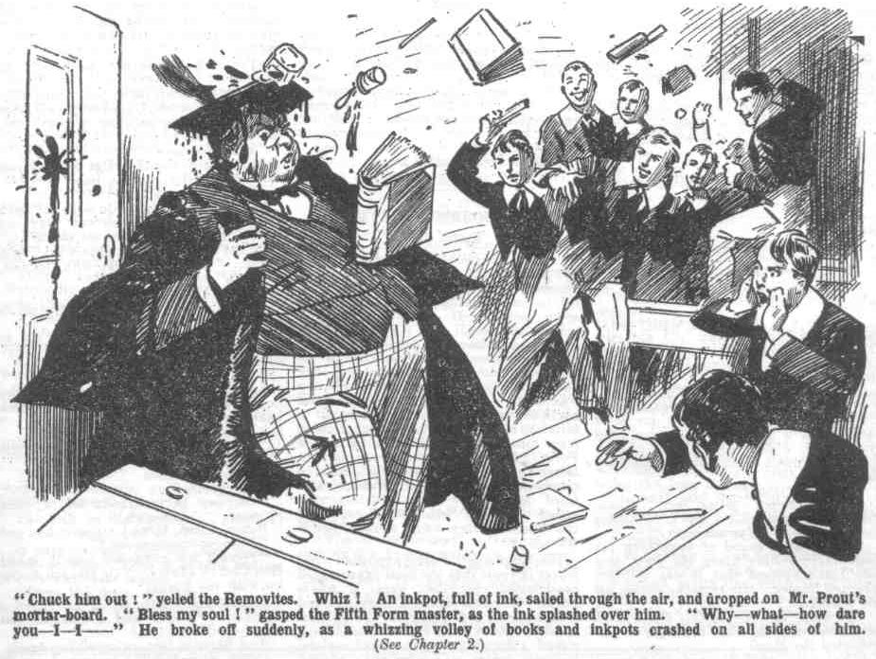 “Bless my soul!” gasped Mr. Prout, as the ink splashed over him. “Why— what—how dare you—I—I---”
Whiz! Whiz! Whiz! Books and inkpots flew in a volley, and they crashed on Mr. Prout on all sides. The juniors were out of hand now, with a vengeance. Before that whizzing volley, Mr. Prout retreated to the door. He had told Wingate that it was his duty to quell the disturbance in the Lower Fourth: but he had not told him how to do it. How to do it was a problem past Mr. Prout’s own solving. No doubt he had relied upon his personal majesty to overawe the juniors; but his majesty was evidently at a discount.
Smitten right and left by whizzing missiles, Mr. Prout backed to the door in a state of bewildered astonishment and wrath.
“Bless my soul!” You young rascals—oh! Ow! You young wretches— whoop! Oh dear! Bless my soul!”
“Travel along, old bean!” roared Bob Cherry.
“Outside, Prout!”
“Give him jip!”
“Ha, ha, ha!”
A whirling hassock caught Mr. Prout under his double chin. With a tremendous concussion, the Fifth Form master sat down in the passage outside the Remove doorway. There was a roar of laughter as he sat.
“Man down!” yelled Squiff.
“Ha, ha, ha!”
“Wait a minute, Prouty!” roared Balsover major. “I’m getting a bottle of ink for you. Hang on a tick!”
“Ha, ha, ha!”
“Bless my soul!” murmured Mr. Prout faintly.
He did not hang on for Bolsover major and the bottle of ink which Bolsover was rooting out of the Form-room cupboard. He jumped up, with unusual activity, and retreated along the Form-room passage with a celerity quite unlike his usual slow and stately progress.
He reached his own Form-room inky and dusty and spluttering. Wingate of the Sixth was waiting for him there; and he smiled as the Fifth Form master came up.
“Have you put down the disturbance, sir?” inquired Wingate politely.
“Grooogh !”
“If the Remove are reduced to order now, sir---“
“Oooch! I—I refuse to have anything whatever to do with Mr. Quelch’s Form!” gasped the Fifth Form master. “I decline to interfere, Wingate. Dr. Locke has chosen to dismiss Mr Quelch, and he may deal with Mr. Quelch’s Form! I wash my hands of the matter utterly!”
And Mr. Prout whisked away to wash off the ink he had collected in the Remove-room.
Wingate grinned, and went on towards the Sixth Form room.
Most of the other masters were looking out of their rooms, but no one of them made any suggestion of intervening and taking the rebellious Remove in hand. Had any one of them felt disposed to do so, Mr. Prout’s fate would have been a warning to them. It was up to the Head to deal with the rebellious juniors, and the staff were only too willing to leave the task to him. Indeed, they wondered whether even the headmaster would succeed in restoring order.
The Remove door had slammed again. “So much for Prouty!” chuckled the Bounder.
“Ha, ha, ha!”
“Awful cheek to butt in here.” said Lord Mauleverer. “We’re not standin’ anythin’ of the kind, of course.”
“No jolly fear!”
“Wait till the Head comes!” grinned Skinner. “What’s the good of plain’ the goat? You’ll have to toe the line when the Head comes.”
“I’m not backing up against the Head, I know that.” remarked Snoop. “I don’t want to be sacked from Greyfriars.”
“Oh, shut up!” growled Peter Todd. “We’re all standing together in this. They can’t sack the whole Form.”
Billy Bunter blinked into the passage through his big spectacles, and gave an excited squeak.
I say, you fellows! Here comes the Head!”
“Phew!”
Sudden silence fell on the excited juniors. Skinner and Snoop made a rush for their desks and sat down. Bunter followed their example, and two or three other fellows.
“I—I say, we can’t buzz inkpots at the Head!” said Peter Todd. “We can’t treat him like old Prout.”
“Nunno “ murmured Bob Cherry. “Not quita.”
“The barfulnes of the esteemed door is the proper caper!” suggested Hurree Jamset Ram Singh.
“Yaas, begad!” assented Lord Mauleverer. “The Head’s playin’ the giddy ox, sackin’ our Form master for nothin’; and we’re not standin’ it. But the Head’s the Head, and a fellow’s bound to respect his headmaster. Lock the door, and we’ll talk to him through the oak.”
“Yes, rather!”
And the key was turned in the lock of the Remove door: and the click of the key, locking him out of the Form-room, greeted the Head of Greyfriars as he arrived at the Remove-room.
THE THIRD CHAPTER.
No Admittance!
DR. LOCKE, the head of Greyfriars, had been taking the Sixth Form in Greek when Wingate arrived to report.
The Sixth had not found their headmaster in his usually equable temper that morning.
For once, the Head was irritable, and gave way to his irritation.
That day. Mr. Quelch was to leave Greyfriars dismissed by the Head, with no reason given.
The Head’s reason was known to himself, no doubt; but he kept it to himself in that case. All the school knew was that there had been a shindy; the Remove room one day because the Remove master had, for once, forgotten cIass, and left his Form to themselves —being at the time deeply engrossed in his celebrated “History of Greyfriars.”
That was not a fault calling for dismissal, or anything of so drastic a nature.
The Head’s feelings towards his Remove master, which had always been extremely cordial, seemed to have turned to bitterness itself.
No doubt his conscience was at rest:
Dr. Locke wat not the man to do anything unjustified by his conscience. But he could not fail to be aware that his action was condemned by his whole staff, and that he had excited surprise and indignation throughout the school and most of all in Henry Samuel Quelch’s own Form, the Remove.
That state of affairs naturally had an exacerbating effect on Dr. Locke’s nerves and temper; and the Sixth were very careful that morning—as careful as a fag Form dealing with a cross Form master.
Then Wingate came with his report.
Dr. Locke looked at him, as if scarcely able to comprehend for the moment. Such news was more startling to his ears than a thunderbolt. The school might criticise, under their breath; he could not prevent that. But that the school, or any section of the school, should dream of resisting his decree, was amazing, almost unnerving.
“ Wingate! You—you have been ejected from the Remove Form-room?” repeated Dr. Locke, almost dazedly.
“ Yes, sir.”
“ By force?” gasped the Head.
“Yes, sir,” answered Wingate.
“Bless my soul! But I have ordered the Remove to submit to our authority till a new Form master is appointed.” the Head exclaimed blankly.
“They refuse sir.”
“Refuse to obey my command?”
“Yes, sir.”
“I can scarcely credit this, Wingate. Have any of the boys given you any explanation of this extraordinary conduct?”
“Hem! Yes. sir.”
“Tell me at once, then.”
“They—they say—” Wingate hesitated.
“Kindly speak out, Wingate.” said the Head sharply.
“Well, sir, they say that they refuse to be taken by anyone but their own Form master.” said the prefect.
“They have no Form-master at present : I have told them so.”
“They mean Mr. Quelch, sir.”
“I have informed them that Mr. Quelch is no longer master of the Lower Fourth Form.”
“Yes, sir. But—”
“But what!” rapped the Head.
“They want him back, sir.”
Dr. Locke compressed his lips into a tight line.
“ Do you mean that they venture to criticise my action, Wingate?”
“Hem! Yes, sir.”
“These junior boys of the Lower Fourth Form1” ejaculated the head, in wrathful astonishment. “Is it possible that they imagine that I may change my intentions, under pressure from junior boys?”
“ I think they hope so, sir. They seemed to be more attached to their Form master than one would have thought.” said Wingate.
“Nonsense!”
“Hem!”
“This is simply a pretext for disorderly conduct,” said the Head tartly. “I regret that you, Wingate, my head prefect, have proved unable to maintain order in a junior Form-room. I am bound to say that I expected better things of you, Wingate.”
The Greyfriars captain flushed hotly. In the ranks of the Sixth, Loder winked at Walker and Carne, who grinned. Loder & Co. were not sorry to see Wingate getting the rough edge of the Head’s tongue; generally, in their opinion, the Head made too much of Wignate.
Wingate’s lips opened for a rather warm reply, but he checked it, and stood silent, with flushed cheeks.
“You had better go to your place, Wingate.” said the Head sharply, “I will deal with this matter personally.”
“Very well, sir,”
George Wingate went quietly to his place in the Sixth. Dr. Locke walked out of the room. leaving a good many of the Sixth grinning.
With a thunderous brow the Head of Greyfriars rustled along the passage to the Remove room. This sort of rebelliousness in a junior Form could not be put down too quickly or too drastically. The Head was prepared to use the sternest measures: and that he would or could be unable to put down this insolent rebelliousness, did not even cross his mind.
The click of the key in the Remove door startled him as he arrived there. He could not believe that the lower Fourth dared to lock out their headmaster. Doubtless they supposed that it was Wingate returning.
Rap, rap, rap!
The Head knocked sharply on the door.
There was no reply from within.
Knock. knock!
“Hallo, hallo. Hallo!” called out Bob Cherry’s voice at last.
“Is that Cherry speaking?”
“Yes, sir.”
“Open this door at once, Cherry!”
“Um!”
“It is I, your headmaster.” said Dr. Locke.
There was a murmur of voices in the locked Form-room. and the Head caught the voice of Lord Mauleverer.
“Dry up, you men; mustn’t cheek the Head! Bad form.”
Knock, knock, knock!
The head was growing impatient. “Wharton! You are there, Wharton?”
“Yes, sir,” answered the captain of the Remove.
“Admit me to the Form-room immediately, Wharton.”
“Hem!”
“1)0 you hear me1 ‘harton ?“
“Yes, sir.”
“Obey mc at Once, then.”
“Hem !”
The headmaster of Greyfriars drew a deep, deep breath. The expression on his face might have scared the Remove had they been able to see it just then. Fortunately, perhaps, they could not see through thick oak.
In the silence that followed, Billy Bunter’s squeak could be heard.
“I say, you fellows, he’s frightfully waxy.”
“Shut up, Bunter.”
“Oh, really Toddy---”
Knock, knock, knock!
“Wharton!” said the Head, in a deep voice.
“Yes, sir.”
“Will you unlock this door?”
“Hem!”
“You are head boy of the Remove, Wharton and I hold you responsible. If you not immediately obey my order, I shall expel you from Greyfriars.”
There was a deep silence in the Remove room. All eyes were fixed on Harry Wharton—breathlessly: Skinner’s mockingly. Wharton’s face was set and serious; but he did not approach the door.
“I am waiting, Wharton!”
No answer.
“Excuse my buttin’ in, sir.” came the cool, drawling tones of Lord Mauleverer.
“May I explain, sir”
“If you have anything to say, Mauleverer, I will hear you when I have entered the Form-room.”
“We can’t let you in, sir.”
“What?”
“It’s quite a mistake to suppose that Wharton is the ringleader, sir. We’re all ringleaders.”
“Ha, ha, ha!”
The Head caught his breath The juniors in the locked Form-room were actually laughing.
“The whole Form is standin’ together in this matter, sir,” went on the schoolboy millionaire. “We regard it as a matter of justice and fair play. Our Form master has been sacked---”
“That does not concern you, Mauleverer.”
“Excuse me, sir—it concerns us all a lot. We want Mr. Quelch to stay.”
“Silence!” thundered the Head. “How dare you attempt to dictate to your headmaster!”
“We wouldn’t dream of doin’ that, of course, sir. We only want you to let us have our Form master back.” explained Lord Mauleverer “You order us, sir, to let in Mr. Quelch and obey his orders, and we’ll obey you at once, sir.”
“Mr. Quelch leaves the school today, Mauleverer. He has been dismissed from his post for good reasons.”
“May we inquire the reasons, sir?”
“Certainly not!” thundered the Head.
“Then we’re not satisfied, sir.”
“You—you—you are not satisfied?” gasped the Head.
“No, sir.”
“How dare you address such words to me, Mauleverer !”
“I’m explainin’ how the matter stands, sir.” said Lord Mauleverer. “We look on the dismissal of our Form master as unjust—”
“Wha-a-at!”
“ And high-handed---”
“Mauleverer!”
“Not at all in your usual style, sir. We beg you to think it over, sir, and let us have Quelchy—I mean, Mr. Quelch—back.”
“I will not listen to this insolence!” said the Head, “in a trembling voice. It appears that you, Mauleverer, are the ringleader in this.”
“Yaas, sir.”
“We’re all in it!” exclaimed Bob Cherry.
“ Yes, rather.”
“We’re sticking together, sir.” said Wharton.
“ The stickiness is terrific.”
“He, he, he!”
“Silence!” thundered the Head.
“ Every boy in this Form shall be flogged.”
“Yaroooh !” It was an apprehensive howl from Billy Bunter. “I say, sir, I’m not keeping you out, sir. I don’t think you’re a hotheaded old ass, sir, like the other fellows---”
“What!” stuttered the Head.
“I don’t, really, sir!” gasped Bunter. “I dare say Quelchv asked for it—I know he’s a beast---he gave me lines yesterday. I don’t care if he’s sacked, sir, and I don’t think you’re a bullying old josser_—”
“A—a—a what?”
“Bullying old josser, sir. The fellows think so, but 1 don’t. I assure you, sir, I--- Yaroooooooh!”
There was a sound of something fat and heavy rolling along the floor, and the Head guessed that it was William George Bunter. His remarks ceased all of a sudden.
“ Is there any boy in the Form-room not concerned in this rebellion?” demanded the Head.
“Yes, sir,” said Skinner, in a great hurry. “ I’m Skinner, sir—I’ve got nothing to do with it, sir—I disapprove of---”
“Then open this door at once, Skinner.”
“Oh!” gasped Skinner.
“I am waiting. Skinner. If you do not unlock the door immediately I shall regard you as a rebel like your Form fellows, and punish you accordingly.”
“They—they won’t let me, sir !” gasped Skinner, in dismay.
“I command you, Skinner.”
“I—I——” stammered Skinner.
“ At once!” thundered the Head.
The wretched Skinner made a movement towards the door. The next moment the Head could hear the sound of heavy pumping and crashing, and the voice of Skinner raised in wild anguish.
“Cease to molest Skinner at once!” shouted Dr. Locke.
“Rats!” called back a voice,
“What! What! Who spoke?” gasped the Head.
“Little me, sir—Vernon-Smith,” answered the Bounder coolly.
“You will be expelled, Vernon Smith.”
“Bless my soul!” exclaimed the Bounder, in so odd an imitation of the Head’s own voice that there was a roar of laughter in the Form-room, and the Head flushed scarlet with vexation.
Knock, knock, knock!
“Skinner!” called out the Head.
“Yaroooooh!”
“Answer me, Skinner—”
“Yooooooop!”
“Skinner’s goin’ through it, sir,” said Lord Mauleverer. “Any weak- kneed blighter who doesn’t back up the Form is goin’ to be given jip, sir.”
“You’re expelled, Mauleverer”
“Thank you, sir!”
“I—I—I —Will you open the door?” shrieked the Head, almost beside himself with wrath and chagrin.
“Hem! No.”
“ Very well.” The Head suppressed his wrath with difficulty “I shall send for Gosling to force the door, and then every boy in the Form-room will be soundly flogged.’
And the Head rustled away.
— —
THE FOURTH CHAPTER.
BARRED OUT !
WHARTON drew a deep breath.
He looked round over the crowd of juniors in the Form-room.
Practically all the Remove were united and the few dissentients were silent. Skinner and Bunter had no breath left for making remarks, if they had thought of making any: and Snoop was silent from a prudent regard for his own safety. Stott, generally a follower of Harold Skinner, was divided from him now; he was backing up the Form. So long as there was an unfaltering leader in the rebellion, the rebels were not likely to weaken, and Lord Mauleverer was evidently prepared to go the “ whole unicorn,” and the Famous Five were equally determined.
The ringleaders risked expulsion ; but it was obvious that the most exasperatsd headmaster could not expel a whole Form. The rest risked a flogging, and it was worth a flogging, in the general opinion. Even Billy Bunter would have risked a flogging to get out of classes. Bolsover major was more than willing to risk it for the excitement of a shindy ; the Bounder would have risked that, or anything else, from the sheer love of mutiny. Other fellows had better motives; from whatever the motives might be, there was no doubt that the Remove stood together almost as one man.
The most serious danger felt upon the leaders ; so long as they faced it, they were not likely to lack followers. And the Famous Five showed no sign of faltering, and Lord Mauleverer least of all. It was quite unlike his lazy lordship to take the lead in anything; but in this outbreak Mauly was undoubtedly taking the lead. For once Mauly had been stirred to vigour, to the surprise and rather to the amusement of the rest of the Form.
“The hunt’s up and no giddy mistake,” grinned the Bounder. “Gentlemen, chaps and fellows, we’re for it.”
“We are—we is!” agreed Bob Cherry.
“Who’s afraid?” roared Bolsover major,
“Skinner for one!” chuckled Peter Todd.
“Blow Skinner!”
“And Bunter for another—_“
“1—I say. you fellows, I’m not afraid,” gasped Bunter. “I—I’m backing you fellows up no end.”
“Ha, ha, ha!”
“We’re up against the Head now,” said Harry Wharton soberly. “I think we’re in the right
—”
“Hear, hear!”
“The rightfulness is terrific.”
“If we get sacked we get sacked,” said the captain of the Remove. “We’re not giving in.”
“No fear!”
“The whole Form has got to stand together!” exclaimed Squiff. “Not a man is going to let the Form down, Stott---”
“ I’m with the Form,” said Stott, at once.
“Good! What about you, Snoopy?”
“Same with me’ said Sidney James Snoop. “I’m backing up the Form, of---of course.”
“You, Bunter—”
“ Oh, really, Squiff ! I’m backing you fellows up all along the line.”
“ You, Skinner ?”
“I’ve got nothing to do with it.” said Skinner sullenly. “You can play the goat if you like. Leave me out of it.”
“That’s just what we shan’t do,” said Squiff. “You’re lining up with the rest, Skinner.”
“Well, I won’t!”
“You will!” said the Australian junior.
“Every man in the Form has got to back up, you men.” said Lord Mauleverer. “There’s safety in numbers.”
“ Yes, rather!”
“Now, stack the desks against the door, ready for Gosling when he comes back with the Head,”
“What-ho!”
“Lend a hand, Skinner!” called out Harry Wharton.
“Shan’t!”
“Bump him!”
“Oh, my hat! Hands off !” yelled Skinner. “ Yaroooooh!”
Bump, bump, bump!
“Yow-ow-ow-woooooop!”
“Have a few more, old bean?” asked Cherry affably. “Or are you lining up with the Form?”
“Yaroooogh! Ow! Yes!” gasped Skinner. “I—I’ll lend a hand if you like! Ow!”
And Skinner lent an unwilling hand.
Desks were forcibly wrenched out of their place, dragged across the Form-room with a terrific din, and stacked against the door.
The barricade inside the door of the Remove-room grew rapidly. By the time Gosling’s footsteps were heard in the passage the work was nearly completed.
“I guess we can keep the Beak out,” remarked Fisher T. Fish. “But what about afterwards?”
“Never mind afterwards now!” said Bob Cherry. “We can’t handle the Head like we did Wingate and old Prout, so we’ve just got to bar him off.”
“But I guess---”
“This isn’t a guessing competition, fathead!”
“But I calculate---”
A heavy thump on the door interrupted Fisher T. Fish’s calculation. William Gosling, the ancient porter of Greyfriars, had arrived with his tools.
“You hopen this ‘ere door!” called out Gosling. “‘Ead’s horders! Wot I says is this ‘ere, you let a man in!”
“Rats!”
“Go and eat coke!”
“One moment, Gosling!” The Head interposed. “Boys! For the last time, 1 command you to open this door before it is forced.
“Skinner’s to answer.” said Lord Mauleverer.
“Oh, good!”
“Speak up, Skinner!”
“Ha, ha, ha!”
Harold Skinner turned quite white. His sympathies were not with the Remove rebels, or with the Remove master—indeed, had the Removites only known it, it was the trickery of Harold Skinner that had caused the breach between the Head and the Remove master, Skinner would have given a great deal to be on the other side of the door, under the protection of the Head. But he was on the unsafe side of the door and the rebels were all round him, and evidently meant business. Bolsover major had already lifted his heavy boot to apply to Skinner. Bob Cherry had picked up a ruler, and Tom Brown a pointer. What Skinner would have done had he been made of the stuff that heroes are made of cannot be said; but Skinner was made of quite different stuff.
“I—I—I don’t mind---” he stammered
“Go it, you funk!” snapped Bolsover major.
“I---I---I---”
“Speak up and answer the head! Mind how you answer him, or you’ll get jolly well smashed !”
There was no help for Skinner. Willy-nilly, he had to cast in his lot with the Remove rebels.
“Answer me!” exclaimed the Head.
“We---we---we---” stammered the wretched Skinner.
“Speak up, you worm!” hissed Bolsover major.
“We—we can’t open the door---” panted Skinner.
“Say we won’t, you worm!”
“We won’t open the door!” gasped Skinner.
“Ha, ha, ha! Bravo, Skinner !”
“What—what?” came the Head’s voice. “Skinner, you young rascal! Gosling, force the door at once!”
The lock on the Form-room door was big and strong.
It gave at last, and the door opened about an inch. Then it caught fast on the stacked desks inside.
“Open the door, Gosling!”
“It seems to be stuck, sir.” mumbled Coaling
“Nonsense! Push it!”
Gosling pushed, and pushed again, but he pushed in vain. A dozen Goslings could hardly have shifted the barricade stacked up inside the Remove door.
“It’s stuck somehow, sir! Them young rips—”
“Kindly do not use such expressions, Gosling.”
Gosling snorted.
“Wot 1 says is this ‘ere, sir—they’ve shoved somcthin’ agin the door, and it won’t open, sir.”
“Absurd! Open it at once!”
Gosling shoved at the door again, and shoved harder.
At the same moment Mr. Prout came rustling along the corridor from the Fifth Form-room. He had been drawn to the scene by the sound of Gosling’s vigorous assault upon the door of the Remove class-room. He arrived just as Gosling forced his gnarled fingers through the narrow opening to feel, if he could, for the obstruction. Tom Brown stepped forward with the pointer in his hand and rapped sharply on Gosling’s gnarled knuckles,
There was a fiendish yell from William Gosling, and his hand was withdrawn with startling suddenness.
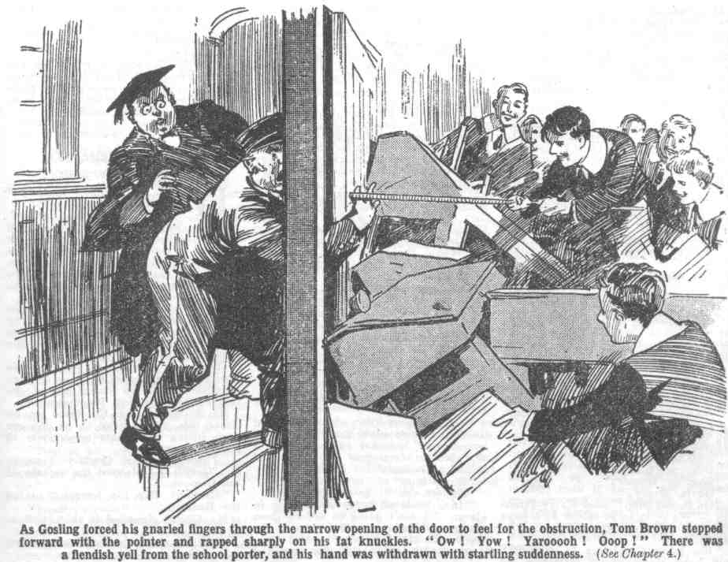
“Ow, ow! Yarooooh! Oooop!”
“Bless my soul!” gasped Mr. Prout. And he hastily retired to his Form-room again.
“Try again, old bean!” yelled Hazeldene.
“Yow-ow-ow-ow-ow!” Gosling was sucking his fingers wildly in the corridor. “Wow, wow, wow! Ow! My ‘and! Ow! My blinking knuckles!”
“Open the door, Gosling!”
“Yow-ow-ow-ow!”
“You are wasting time, Gosling!” rapped out the Head. “Cease those ridiculous noises at once and open the door!”
Gosling ceased the ridiculous nois es and glared speechlessly at the Head.
“You hear me?” snapped Dr. Locke.
“My eye!” gasped Gosling, finding his voice at last. “My blooming eye! ‘Ere I’ve got my blinking fingers fair smashed, and you tells me to hopen a blinking door that a man can’t hopen! Wot I says is this ‘ere, sir—this ‘ere ain”t a porter’s dooty, this ‘crc ain’t, and I’m done with it, sir!”
And William Gosling, still sucking his damaged knuckles in a frantic manner, tramped away down the corridor, under the astonished eyes of the headmaster of Greyfriars.
“Gosling!” boomed the Head.
William Gosling vanished round the corner.
Dr. Locke pushed at the door himself with has own majestic hand. He failed to move it.
“Is this door barricaded?”
“Yes, sir.” said Lord Mauleverer.
“Remove the barricade immediately!”
“ Nothin’ doin’, sir!”
The Removites waited breathlessly. There was a full minute of silence. Then the footsteps of the headmaster were heard receding. They died away down the long corridor,
“Gone!” said Bob Cherry.
“First round to us!” said the Bounder.
“Hurrah!”
Undoubtedly it was first round to time Remove rebels. They wondered what the second round was going to be like. Whatever it was like, the rebels of Greyfriars were ready to face it.
THE FIFTH CHAPTER.
From Friends to Foes!
MR. QUELCH, the dismissed Remove master of Greyfriars, was in his study—the study no
longer his.
He was sorting out books and manuscripts.
Most precious of all was the bulky manuscript of Mr. Quelch’s “History of Greyfriars”—a valuable historical work which now, in all probability, never would be completed.
With a tender touch Mr. Quelch put together the pinned sections of typed sheets, and the still more numerous scribbled sheets that had not yet been corrected and typed out.
His face was set and sombre.
Never had the Remove master envisaged the possibility of leaving Greyfriars— at least, until advancing age should make it necessary for him to retire from that venue of scholastic labour.
The blow had fallen with terrible suddenness.
Why the Read had turned against him the Remove master did not know, and was too proud to inquire.
It could scarcely have been merely that one instance of unpunctuality when the Remove had kicked up a “shindy” on their Form rnaster’s absence. It could hardly have been a slight disagreement of opinion on the proper rendering of a certain obscure passage in Sophocles. Mr. Quelch had been not only a valued member of the head masters staff, but a personal friend. Now he was turned down and dismissed.
But it did not seem possible.
The Head was no man to listen to mischievous tattle—or, if he was, Mr. Quelch had been mistaken in him.
All his colleagues were sympathetic, and almost openly condemned the head’s action; mischief, at least, could not have come from them.
So there was no explanation in that theory. His friend had failed him, his chief had dismissed him—unjustly, without cause.
Mr. Quelch would have been more, or less, than human, had he not felt bitterly angry and resentful.
But sorrow at leaving all that was dear to him, all that was familiar, was his principal feeling.
His face was deeply clouded, his fingers almost trembled as he put his manuscripts together, preparatory to packing them.
In the painful circumstances Mr. Quelch was anxious to leave the school as quickly as he possibly could. The commiseration of the other masters was well meant; but it stung him. The curious glances of the Greyfriars fellows made him writhe. If he was going, he could not go too quickly.
But he had a great deal of packing to do; innumerable things to sort out and put together. While the Forms were in class that morning he was very busy in that dismal occupation.
His thoughts were as busy as his fingers.
Dismissal was a serious matter for any gentleman in Mr. Quelch’s position. It militated against his securing a similar post elsewhere. He could not refer other headmasters to the Head of Greyfriars—or, rather, he would not!
He had, too, a repugnance to the idea of acting as Form-master in any other school. His attachment to Greyfriars, his friendship with the Head had made him more than satisfied with the position of Remove master. It was not merely a post to him—it was a congenial task, in which he took deep interest and pride. His feelings would not be the same in any other school.
He would never have resigned his position at Greyfriars to accept a head mastership elsewhere. But now that he was going he was thinking of a head-mastership, for which he was well fitted. Had he chosen, undoubtedly he might have secured one—before his dismissal. But after--it was doubtful. Nevertheless, he was thinking of it, and found some solace in the thought of it.
A headmastership was not likely to be offered to a dismissed man. But Mr. Quelch was a saving man; he had resources of his own. The thought of a school of his own was lurking in his mind.
High Oaks, for instance—that old country house near Friardale, which had been for sale for years, and was described by the estate-agents as “ideal” for a school! Even while he had had no remote idea of leaving Greyfriars, Mr. Quelch had walked over that old place, and walked round it, thinking what he could make of it, if by any chance he left his present position. Now he was leaving
No doubt the Head, dismissing him, supposed that he would vanish into outer darkness, as it were. There was some grim satisfaction in the thought of founding a new school almost in sight of Greyfriars—assuming a position equal, or nearly equal, to Dr. Locke’s own.
Mr. Que1ch was a single gentleman, and he had no home to which to retire. Greyfriars had been his home; his vacations had been spent in seaside resorts, or Switzerland, or at the houses of scholastic confreres, and he had always returned to Greyfriars with a sense of relief.
Now, therefore, he could go only to an hotel or a boarding-house, or to the house of an acquaintance. For the first time in his life it was borne in upon Mr. Quelch’s mind that It was a mistake to remain single. He had been free to devote his whole life to his scholastic work, and now his work had slipped from him, leaving him a good deal like a drifting ship without a port or an anchorage.
Mr. Quelch had already decided that when he went he would go only as far as Courtfield, and put up at the hotel there. Then he would make a survey of High Oaks, and consider its possibilities. There was some solace in that plan. Without a plan of some kind— some definite object—he would have felt hopelessly adrift.
There was a sharp knock at the study door, and it opened.
Mr. Quelch spun round.
The Head stood in the doorway.
Possibly for a second Mr. Quelch thought, or hoped, that his former friend had reflected, repented, and had come to beg him to overlook what had occurred, and to remain.
But the Head’s face indicated nothing of the kind.
It was set and hard; and there was a glint in his eyes.
Mr. Quelch’s face hardened.
He did not speak but looked the headmaster in the face, with a glance like cold steel.
“Mr. Quelch!”
“Well?”
The Head paused a moment.
“I leave this morning, sir,” said Mr. Quelch, with bitter sarcasm. “I have already telephoned for a car. I presume that you did not expect me to be gone already.” His voice was bitterness itself.
“The Remove are in a state of rebellion, sir!” rapped the Head.
“Indeed!”
“Yes, indeed!”
That does not concern me, sir, as I am no longer master of that Form!” said Mr. Quelch icily.
“It does concern you, sir,” said the Head. “I do not suggest that you have intentionally disseminated trouble in your late Form---”
Mr Quelch’s eye flamed.
“Sir!” he gasped.
“I repeat, I make no such suggestion.” said the Head. “ Nevertheless, it is a fact that the Remove are utterly out of hand on the morning of your departure, sir.”
“ And I repeat that that does not concern me, Dr. Locke!”
“No doubt you are unaware of the cause aligned by your boys—your late boys, I should say—for their outrageous conduct this morning.”
“I am quite unaware of anything that may have happened in the Remove, or any other Form at Greyfriars.”
“Then I will tell you, sir!” rapped out the Head.
“I am not interested, sir.” retorted Mr. Quelch.
The Remove.” pursued the Head, unheeding, “ have ejected a prefect from their Form-room, and locked the door against me!”
Mr. Quelch smiled satirically.
Certainly he did not approve of indiscipline. It was against all his principles.
At the same time it was not wholly displeasing to him to learn that his dismissal had been followed by trouble.
“They have stated to me, sir,” said the Head, “that they refuse to be taken by a prefect, and that they demand your reinstatement, sir!”
“Indeed!”
“Once more 1 say that I do not suggest that you are a party to this, Mr. Quelch. But such is the state of affairs. If the Remove refuse to submit to proper authority, I shall have no resource but to punish the whole Form severely and to expel the ringleaders in this revolt! 1 trust that that is not what you desire, Mr Quelch?”
“Certainly not!” snapped the Remove master.
“I suggest, therefore, that you speak to these boys before you leave, and induce them to abandon their present rebellious attitude.” said the Head. ‘I have no doubt that your influence will be quite sufficient for the purpose.”
“I decline, sir, to speak one word to a Form that is no longer under my authority!”
“ Mr. Quelch!”
“Dr. Locke!”
Flashing glances were exchanged between the two gentlemen.
“ Very well, sir!” said Dr. Locke, his voice trembling with anger. “Very well indeed, sir. I begin to believe, sir, that you have intentionally promoted this outbreak in the Lower Fourth Form, sir.”
“ You may believe what you please, sir.” said Mr. Quelch bitterly. “As I no longer respect you personally, sir, I am naturally quite indifferent to your opinion.”
“What?” gasped the Head. “What?”
“I trust I make my meaning plain, sir?”
Dr. Locke did not speak again for some moments. He was endeavouring to control the deep anger which very nearly led him to express himself in undignified language. Mr. Quelch stood like a stone statue, his eyes fixed on the headmaster’s face with icy hostility.
“Very well, sir,” gasped the Head at last, “I know what to think now, sir, at all events.”
“You will think what you please, sir.”
“I will only add, Mr. Quelch, that I desire you to accelerate your departure as much as possible.”
“For my own reasons, air, I shall leave at the very earliest possible moment.” snapped Mr. Quelch.
“I have no doubt, sir, that the Remove will return to a proper state of subordination when you are far away from them, sir.”
Mr. Quelch’s lip curled.
“I shall not be so far away as you appear to imagine, Dr. Locke. It is in your power to dismiss me from Greyfriars, but you do not, I presume, take it upon yourself to order me to leave the neighbourhood. I should regard such an order, sir, with scorn.
The Head gasped.
“Am I to understand Mr. Quelch, that it is your intention to remain in the neighbourhood of this school?”
“You are to understand, sir, precisely what you please. I decline to acquaint you with my intentions.”
“Your intentions, apparently, are to stir up further trouble in the Form, of which you were never suited to take charge.”
“If that statement is correct, sir, the fault is yours for having appointed me.”
“Your interference with your late Form, sir, may, and probably will, lead to the expulsion of certain boys in that Form”
“Indeed! Then they will be welcome to return to their old Form master, sir, when they leave Greyfriars.”
“You—to you, sir?”
“To me!” said Mr. Quelch, with icy grimness. His mind had not been made up before, but he made it up now, at a bound. “My intention. sir, is to open a school myself, of which I shall be headmaster, and any boy who is a victim of your tyranny, sir, will be welcome there.”
Dr. Locke seemed to be choking.
He did not trust himself to speak again. Had he spoken he would have uttered words most unbecoming in a headmaster. He turned and swept away. Mr. Quelch smiled sarcastically, and resumed packing his papers.
A sudden uproar from the quad— which should have been deserted at that hour in the morning—caused him to glance from his window.
The Remove were there!
Evidently the Lower Fourth had marched out of their Form-room—an indubitable proof that they were completely out of hand.
M.r Quelch smiled grimly.
— —
THE SIXTH CHAPTER.
Goodbye to Greyfriars!
HARRY WHARTON & CO. had waited, in the Remove-room, for some further movement on the part of the Head.
But the Head had not returned.
No doubt he was puzzled as to how exactly he was to deal with the present extraordinary state of affairs in the Remove. Probably he was postponing dealing with them until their former master was safely off the scene.
At all events, he had returned to the Sixth Form-room, leaving the Remove, for the present, to their own devices. They were, as the Bounder inelegantly expressed it, left to stew in their own juice.
Had the rebels of the Remove lacked firm leadership, undoubtedly that was the best move the Head cold possibly have made.
The rebels had time for reflection and no excitement to keep them going. Locking the Head out of the Form-room was wildly exciting. But remaining in a locked room was nothing of the sort. Morning break would be due soon, and the rest of Greyfriars would be turning out; and the Lower Fourth did not want to remain in when the rest were out. Moreover, later on there would be dinner-time, and if they remained in their Form-room there would be no dinner. That was serious—to Billy Bunter it was a tragic prospect, but it was serious enough to all.
“The old bird is going to starve us out!” said Peter Todd.
“Oh dear!” gasped Bunter,
Skinner sneered. He foresaw that the rebellion would peter out now, and that the fellows who had led it would be sorry for themselves.
Such might have been the game, easily enough, if the leaders of the revolt had weakened. Harry Wharton & Co. did not weaken, but they certainly were perplexed as to their next proceedings.
Remaining in the Form-room and missing dinner, and after that, tea, and after that, supper, was hardly to be thought of. Leaving the Form-room meant placing themselves in the hands of their incensed headmaster.
The Bounder suggested “handling” the Head if he butted in, but nobody was likely to act on that suggestion. Moreover, it was impossible, as well as unthinkable, for the Head would be supported by the Sixth Form prefects, and even the Bounder did not suggest that the Lower Fourth could beat the prefects in a battle royal.
Many of the fellows were looking dubious now. Bolsover major, who had been loudest in demanding a shindy, was silent now, reflecting that they had put their foot in it, and were in a bad box.
It was now Lord Mauleverer who came out strong.
The Head’s leavin’ us alone,” said Mauly. “We can’t stay here. Outside the prefects will nobble us as soon as the Sixth come out. I’m goin’ !”
“Where?” asked Bob Cherry, rather blankly.
“The wherefulness is a terrific question. “
“Out of Greyfriars.” answered Mauly.
“Oh, my hat!”
“We’re backin’ up Quelchy all along the line.” said Lord Mauleverer. “We refuse to knuckle under till he’s reinstated. That’s our programme.”
“Certainly,” said Wharton slowly. But———”
“It’s a programme we can’t carry out inside Greyfriars.” said Mauleverer.
“No doubt about that,” said Skinner.
“I guess we’ve bitten off more’n we can chew and we’d better cough it up.” suggested Fisher T. Fish.
“Shut up, Fishy!”
“I say, you fellows---”
“Shut up, Bunter!”
“Go it, Mauly!”
“Go it, old chap!” said Harry Wharton. “We seem to be rather at a loose end, but we’re not giving in. Cut in, Mauly.”
“We leave Greyfriars in a body,” said Lord Mauleverer. “Outside the school we butt in somewhere—we’ll find somewhere—and invite Mr. Quelch to take charge of us.”
“Great pip!”
“We’ll agree to return to Greyfriars with Mr. Quelch—not without. The Head will have to come round.”
“Catch him!” jeered Skinner.
“He must!” said Lord Mauleverer calmly. “Such a shindy will bring the governors down to Greyfriars, and they will want to know why the Head has sacked Quelchy and caused all the trouble. The Beak won’t want that, as he’s actin’ unjustly. He must come round!”
“The come-roundfulness will be terrific.” agreed Hurree Jamset Ram Singh. “Let us follow the ridiculous Mauly, my esteemed friends.”
“Hear, hear !”
“I’m not going!” growled Skinner.
“You are!” said Bob Cherry. “We’re all sticking together in this. No need to give us the trouble of bumping you again, Skinner. No time to waste.”
“Ha, ha, ha!”
The desks were lifted away from the door, and Harry Wharton looked out into the Form- room passage.
It was deserted.
“Coast’s clear!” announced the captain of the Remove. “Come on, and don’t kick up a row till we’re ready to clear off.”
“What-ho!”
All the other Forms were in class; it wanted yet a quarter of an hour to morning break. That fifteen minutes was more than enough for the Remove. There was no one to interfere; and they acted swiftly. There was a hurried visit to the Remove passage, to gather up what they wanted to take with them. Another to the Remove dormitory; and then the Removites walked out of the House, in coats and hats, many of them carrying bags. In the middle of the quadrangle they halted, to announce to all Gre friars that they were going.
“Hurrah!”
That roar rang through Greyfriars from end to end. Then they marched down to the gates.
The gates, of course, were locked. Gosling stared blankly at the array of juniors.
“Unlock the gates, old bean,” said Bob Cherry,
“Huh!” grunted Gosling.
“And look sharp!” added Harry Wharton.
“You young raskils go back,” advised Gosling. “You ain’t being let out of bounds now, not if I know it. Wot I says is this ‘ere—you go back and be’ave yourselves!”
“Bump him!”
“Ha, ha, ha!”
‘‘Ere, ‘ands off!” roared Gosling in alarm. “I ain’t going to unlock them gates, I tell you. But there’s the key---”
Harry Wharton took the key and unlocked the gates.
“I say, you fellows—”
“Shut up. Bunter.”
“But, I say, you fellows, what about dinner---”
“Cheese it!”
“I’m getting hungry already---”
“Kick him, somebody!”
“Yarooooh!”
The Remove marched out. of gates. Masters’ faces could be seen at the windows of the Form-rooms; in the doorway of the House the Head stood, staring after the departing Removites like an old gentleman in a dream.
“Bless my soul!” said the Head faintly.
He hurried down to the gates.
“Boys!”
Lord Mauleverer turned back and lifted his hat politely to his head-master.
“Did you speak, sir?” asked Mauly.
“Return to the House at once!” commanded the Head.
“Is Mr. Quelch to be reinstated, sir?”
“No!” thundered the Head.
“Then you must excuse us, sir,’ said Lord Mauleverer politely. “ We’re not
coming back without our Form-master.”
“I command you——”
“Good-bye, sir!”
And the Remove marched up the road, leaving the Head of Greyfriars standing transfixed ; staring after them as if he could scarcely believe his eyes, as indeed he scarcely could.
THE SEVENTH CHAPTER.
A Surprise for Mr. Quelch!
“ HALLO, hallo, hallo! Quelchy!”
“ Give him a cheer!”
‘The Removites, proceeding at a leisurely pace, had almost reached Courtfield, when a car hummed on the road behind them. The car was stacked with baggage, and from the window looked a grim, severe face that the heroes of the Lower Fourth knew well.
Mr. Quelch had left Greyfriars; not with any expectation of ever seeing his Form again. He saw them quite unexpectedly, streaming along the Courtfield road.
The grim severity in the Remove master’s face changed to a look of utter astonishment as he stared out of the taxi at the marching Removites.
Harry Wharton & Co. lined up on either side of the road to let the car pass, lifting their hats respectfully to their Form master.
“Three cheers for Quelchy—I mean Mr. Quelch!” exclaimed the captain of the Remove.
“Hurrah! Hip, hip, hurrah!” roared the Remove.
Mr. Quelch signalled to the chauffeur to stop.
He stared at the juniors, letting down the window.
“Wharton!”
“Yes, sir,” said Harry
“What are you doing here?”
“Walking to Courtfield, sir.”
“You should be in class at this hour.”
“Hem!”
“I recommend you to return to the school at once!” exclaimed Mr. Quelch.
“You see, sir---”
“Is this an act of rebellion against your headmaster, Wharton?”
“Not exactly, sir. But---”
“Then what does it mean?”
“We’re standing up for you, sir.” ‘said Bob Cherry.
“What? What?”
“Backing you up, sir.” said Squiff.
“The backupfulness is terrific, honoured sahib.”
“Hear, hear!”
“Hurrah!”
Mr Quelch’s eyes seemed to bulge from his head. This devotion on the part of his Form ought really to have gratified him immensely. But it did not seem to produce that effect. Personal considerations did not weigh much with Mr. Quelch in the balance, against discipline and his rigid sense of the fitness of things.
Instead of looking pleased, as the juniors rather expected, he frowned portentuously.
“Upon my word? Do you mean to say, Wharton, that it is upon my account that you boys are guilty of this act of rebellion?”
“That’s it, sir.”
“We—we thought you’d be pleased, sir!” stammered Nugent.
“Pleased!” ejaculated Mr. Qucich.
“Yaas, sir!” said Lord Mau1everer.
“This is—is unheard of!” exclaimed the Remove master. “You must cease this at once. You must return immediately to Greyfriars.”
“Oh!”
The Removites exchanged rather dismayed looks. Skinner grinned.
“I say, you fellows, let’s go back.” said Billy Bunter. “It’s getting jolly near dinner-time, anyhow.”
“Shut up, Bunter!”
“Go back immediately!” exclaimed Mr. Quelch. “How dare you use my name as a pretext for insubordination!’
“Oh dear!” murmured Wharton.
The captain of the Remove was quite taken aback.
“Excuse me, sir,” said Lord Mauleverer. “We’re standin’ out till you are reinstated as our Form-master, sir.”
“Nonsense!”
“Not at all, sir.” said his lordship calmly. “We’re standin’ up for justice and fair play. We think it’s up to us, sir.”
“Absurd!”
“Really, sir —“
“Go back immediately!” snapped Mr Quelch. “I forbid you to use my name in such a manner. I forbid you to act rebelliously. I am extremely displeased with you all!”
“Oh, my hat!” ejaculated Bob Cherry.
“How sharper than a serpent’s tooth it is, to have a thankless Form-master.” said Wibtey; and some of the juniors chuckled.
“Silence!” exclaimed Mr. Quelch. “Go back to school immediately! You hear mc? At once!”
“We—we didn’t think you’d take it like this, sir!” stammered the captain of the Remove
“You might have known it, Wharton, had you possessed a little common sense!” snapped the Remove master acidly.
“Hem !”
There was a long pause. Lord Mauleverer was the first to break the silence.
“May I ask, sir, whether you are our Form-master now?” he inquired.
“I am not, Mauleverer.”
“You have left Greyfriars, sir?”
“Yes, yes!”
Then may I ask further, sir, by what authority you order us to return to the school?”
“What—what?”
“If you are our Form master, sir, we shall obey your orders at once,” explained Lord Mauleverer. “We’re askin’ nothin’ better. But if you are not our Form master, sir, we shall act accordin’ to our own judgment—with all respect to you, sir.”
Mr. Quelch stared at Mauleverer, at a loss for words. He was so accustomed to giving orders to the Remove that he had rather overlooked the circumstance that he was no longer entitled to give them orders. The expression on his face made the juniors smile.
“You are quite correct, Mauteverer.” said Mr. Qucich, after a very long pause. “I have no authority to give orders now to any Greyfriars boy.”
“Then we’ll keep on, sir,” said Mauly.
“I say, you fellows——”
“Shut up, Bunter!”
“I’m getting hungry !”
“Kick him!”
“Yow-ow-ow-ow!”
“We’re not goin’ back to Greyfriars, sir, until you are reinstated,” said Lord Mauleverer. “Fair play’s a jewel. We’re fixed on that “
“I command you, Mauleverer—I—T mean I advise you to return to the school at once.”
“Thank you very much for your advice, sir,” said Mauleverer respectfully. “but we’re not takin’ it.”
“I beg you to listen to reason,” said Mr. Quelch, subduing his feelings. “You place me in a most painful position by acting in this manner”
“We don’t mean that, sir.”
“Oh, no, sir!”
“That is what. you are doing, whether you mean it or not.” said Mr. Quetch. “For your own sakes, return to the school.”
“We’re not worrying about our own sakes, sir.”
“No fear!”
“Cannot you see that you cannot keep up this rebellious attitude!” exclaimed Mr. Quelch, with angry impatience. “The prefects will be sent to take you back.”
“We shan’t let them do anything of the kind, sir.”
“Not likely!” grinned Bob Cherry
“Blow the prefects!” roared Bolsover major.
“Shut up, Bolsover!”
“This—this is—is extraordinary!” gasped Mr. Quelch. “This is utterly unheard of! I—I am obliged to you, if you think you are acting in my interests. But I assure you that you are doing nothing of the kind. Go back at once—I advise you most earnestly. You must be aware that you cannot remain out of school.”
“We’re goin’ to try, sir.”
“Hear, hear!”
“But—but what are your intentions?” exclaimed Mr. Quelch.
“ We want you to take charge of us, sir.” exclaimed Lord Mauleverer. “ If not at Greyfriars, then somewhere else.”
“Impossible!”
“Not at all, sir. If you can’t be our Form-master, we want you to be our headmaster.”
“Hear, hear!”
“1mpossible! You are talking no sense, Mauleverer! 1 beg you to give up this foolish escapade and return at once to your duty.”
“Our duty is to stand by our Form-master, sir, who’s been dismissed for nothin’,” said Lord Mauleverer firmly. “ Of course, if you tell us yourself that you were dismissed for good reason and that you ain’t fit to take charge of a Form, sir, that will be different.”
“Bless my soul!”
“ Otherwise, sir, we take it that the Head has acted like a tyrant, and we’re bound to resist.”
“Hear, hear!” chorused the Removites.
“Good old Mauly!”
“Wharton, you are head boy of the Form!” exclaimed Mr. Quelch. “ I appeal to you!”
“Mauleverer’s leader now, sir.” said Harry “I’m backing up Mauleverer. I think he’s right.”
“The rightfulness is terrific.”
“If you will not listen to me, or heed my wishes, I can say no more!” gasped Mr. Quelch.
“Proceed, driver!”
The driver proceeded and the taxi passed the Removites and whirled away towards Courtfield. The Remove sent a thunderous cheer after it. They were backing up their dismayed Form master, even if he did not appreciate or approve of their backing.
“Look here, this is rot! ”said Skinner. “Even Quelchy’s against it, and we’re getting ourselves into trouble for nothing!”
“Shut up, Skinner !“
“Look here---” began Snoop.
“Shut up, Snoop!”
“It’s a lark, anyhow !” said Bolsover major. “Come on!”
“I say, you fellows, I’m hungry!” wailed Billy Bunter.
“Keep on, old beans !” said Lord Mauleverer. “We stop first at the bunshop in Courtfield. We dine there—my treat. March!”
Billy Bunter brightened up at once. A spread in the bunshop was ever so much better than the school dinner.
“I say, Mauly old man I’m backing you up!” gasped the Owl of the Remove. “I’m with you all along the line, old chap !”
“Ha, ha, hat’
“March !“ said Harry Wharton.
And the rebels of Greyfriars marched. They marched on cheerily to Courtfield: and that midday the bunshop had a very unaccustomed rush of custom.
Mr. Quelch, at a window of the Courtfield Hotel opposite, saw his boys crowding into the bunshop. He was spotted at the window, and some of the juniors gave him a ringing cheer. Mr. Quelch disappeared from the window quite precipitately.
THE EIGHTH CHAPTER.
Mauly’s Brain-Wave!
“COMIN’ ?”
Lord Mauleverer addressed that question to Harry Wharton after on ample lunch at
the bunshop in Courtfield High Street.
“Where?” asked Harry.
“Stummer’s.”
“Who on earth is Stummer?” asked Nugent.
“Estate agent.”
“My only hat! What the merry thump are we going to see an estate agent for?” demanded Johnny Bull.
“Business.”
“What business, ass?”
Lord Maulevcrer sighed. His lazy lordship had taken the lead in the Remove rebellion. Wharton, in a state of mingled surprise and amusement, willingly making way for him to assume the leadership. Mauly, as a rule, didn’t shine in leadership, or anything else that required exertion, mental or physical. But he was in deadly earnest now; and in the peculiar circumstances, he was more fitted for the post than even Harry Wharton.
Most of the juniors would have followed the lead of the captain of the Remove; but there was always a party in the Form against him. Skinner & Co. were his enemies, and the Bounder was always liable to jib. But nobody was Mauly’s enemy; even Skinner rather liked him. He was always kind and inoffensive, and he never sought the limelight. He had surprised all the Remove by coming out strong like this but it was obvious to all that he had no axe to grind; he was, as he had told Mr. Quelch, standing up for justice and fair play. Mauly was, in fact, the only man in the Remove who could have pulled the whole Form together in such a matter as this.
But Mauly was feeling the exertion. He was a fellow of few words; and he had talked more that day than in a week previously. Now he sighed deeply when he was called upon to explain his plans.
“You’ve got some scheme, I suppose?” demanded Johnny Bull.
“ Yaas.”
“Well, what is it?”
“Hold on.” said Harry Wharton quietly. “We’re letting Mauly take the lead. He’s a good man for the job. I’m willing to follow his lead without asking questions.”
“Oh, all right!” said Johnny Bull. “Go it, Mauly!”
“Same here,” assented Bob.
“The samefulness is terrific!”
“That’s right,” said Mauleverer. “Save a lot of jaw, you know. Leave it to me. You fellows come along.”
“Done !“ said Wharton, with smile.
And the Famons Five left the bunshop with Lord Mauleverer, considerably perplexed, but quite prepared to leave it to Mauly.
They arrived at the office of Mr. Stummer, the estate agent of Courtfield, now reopened for the afternoon. Lord Mauleverer led the way into the office, where a young man was in charge.
“Mr. Stummer?” inquired Lord Mauleverer.
“Busy!” said the young man. “What’s wanted?” He did not seem to be impressed by half a dozen schoolboys as possible customers for real estate.
“You’re the agent sellin’ High Oaks?”
“That’s so.”
“What’s the price?”
The young man blinked at Mauleverer.
“You’re not buying High Oaks, I suppose?” he inquired, with derisive sarcasm.
“ Yaas.”
“Wha-a-t?”
“ Oh, my eye!” said Mr. Stummer’s young man. “ Is this a lark? What?”
“Not at all.”
“Shut the front door after you.” said Mr. Stummer s young man, evidently in the belief that it was a “ lark,” in spite of Lord Mauleverer’s denial.
“I’ve come here to buy High Oaks,” said Lord Mauleverer. “I suppose the place isn’t sold yet?”
“ No, it ain’t.’
“What’s the price?”‘
“Seven thousand pounds!” snapped Mr. Stummer’s young mnan. “Now chuck up larking and quit.”
“I’ll buy it.”
“ Got the money in your trouser pocket?” inquired Stummer’s young man, with withering sarcasm.
“Begad, no! I never carry seven thousand pounds about with me.” said the schoolboy millionaire innocently. Headmaster wouldn’t allow it.”
The Famous Five grinned.
“”I’ll have to telephone to my guardian,’ wesit on Lord Mauleverer calmly. “ The money will be paid either this evenin’ or to-morrow mornin’. If you want me to sign anythin’, lend me a pen. What!”
Mr. Skimmer’s young man stared blankly at Lord Maulevercr. It was borne in upon his mind that the school boy was in earnest.
“ Mauly, old man---” murmured Wharton.
“Yaas, dear boy.”
“You’re not really buying High Oaks.”
“Yaas.”
“ It’s the place they’ve been advertising for donkeys’ ages, to be sold to be used as a scbool.” said Nugent.
“That’s what I want it for.” said Mauly.
“Wha a-at?”
“For a school.”
“Ha, ha, ha!” roared Mr. Stummer’s young man. “You’re starting a school, are you? Ha, ha, ha!1”
“Yaas. What are you laughing at?”
“Can it,” said the young man.
“I think I’d better see Mr. Stummer himself.” said Lord Mauleverer. “That door looks like the private office. Come on, you men!”
“Here, you just stop!” exclaimed the young man. I tell you—”
“Sorry—in a hurry!”
Lord Mauleverer opencd the door of Mr. Stummer’s private office and walked in, foIlowed by the amazed five.
The young man in the outer office had said that Mr. Stummer was busy. He did not look very busy, as he sat with his feet on his desk, smoking a cigar and reading the “Daily Mail”
He started up in surprise as his visitors entercd.
“Why—what---” he ejaculated.
“Sorry to interrupt you, Mr. Stummer, when you’re so awfully busy,” said Lord Mauleverer politely. “I’m here to buy High Oaks.”
Mr. Stummer stared at him.
“If this is a joke—” he began.
“Oh, begad!” said Lord Mauleverer plaintively. “They must be a humorous crowd in the real estate business if they think every caller who wants to buy their houses is a giddy joker. Do I look as if I were joking, Mr. Stummer?”
“It’s all serene, Mr. Stummer.” said Harry Wharton, laughing. “This chap is Lord Mauleverer, a giddy millionaire. His guardian lets him buy anything he likes—though he’s never bought a school before.”
“Begad! Of course, the chap didn’t know who I was,” said Mauly. “ I forgot that, you men. Not that it matters, if you come to that. Do I sign somethin’, Mr. Stummer?”
“Eh!” gasped Mr. Stummer.
“I’ll sign anythin’ you like—documents and things,” offered Lord Mauleverer. “The point is, I want the property today.”
“You---you---you want a seven-thousand-pound property today!” stuttered the Courtfield Estate agent.
“ Yaas.”
“Upon my word! Do you think that country houses are sold like butter and bacon over a grocer’s counter?” demanded Mr. Stummer.
“Yaas.”
“Look here, young gentlemen---”
“ Banker will identify me,” said Lord Mauleverer. “ Courtfield branch of the Midland Southern Bank. I often call there for cash when I run out of bank notes. I dare say he will pay over the seven thousand pounds this afternoon, if I ask him. He always struck me as a very obligin’ man.”
Mr. Stummer gasped for breath.
“I think a bank manager would be very unlikely to do anything of the kind,” he articulated. “ But if you are serious---”
“Sober as a judge.”
“You are really Lord Mauleverer---”
“ Yaas”
“1 am aware that Lord Mauleverer is a millionaire, and a schoolboy at Greyfriars,” said Mr. Stummer, with a marked increase of respect in manner. “ But, of course, you cannot purchase property without the consent and approval of your guardian.”
“That’s all right; he will consent and approve.”
“You are sure of that?”
“Yaas.”
“Then I will place myself in communication with him---”
“In a hurry, Mr. Stummer. Phone!”
“Hem! But— “
“ Sir Reginald Brooke, at Mauleverer Towers. You can get him on the phone, what?”
“Yes, but---”
“Well, go it,” said Lord Mauleverer encouragingly.
Mr. Stummer blinked at him. They were not accustomed, in Courtfield, to doing business on these rapid lines. Neither did Mr. Stummer think it likely that Sir Reginald Brook would concur in the purchase of a seven-thousand pound estate by his schoolboy ward.
Still, he wanted to oblige Lord Mauleverer; Mr. Stummer had a great respect for the nobility and a still greater respect for millionaires, and Mauly was both a millionaire and a belted earl. And Mr. Stummer was very anxious, if he could, to get rid of High Oaks, which had been on his books for years without finding a purchaser; being one of those handsome county seats of a county family, which county families are too poor to keep up in these days of reckless and unreflecting taxation. Nobody was ever likely to run high Oaks as a private residence again; and nobody, so far, seemed to want it to turn into a schoo1, a sanatorium, an official residence for Prime Ministers, or a home for idiots.
If Lord Mauleverer’s offer could be made good, it was a chance for Mr. Stummer to do a handsome stroke of business.
He went to the telephone.
“Mauly, old man.” murmured Wharton, “just think---“
“I’ve thunk—I mean thought, old chap. Thought for a whole minute:” said Mauleverer. “I never believe an actin’ hastily.”
“It’s a heap of money---”
“What is?”
“Seven thousand pounds.”
“Is it?” asked Mauly innocently.
“Yes, ass; your guardian will think so! I know he lets you do anything you like, but buying a property, without his having seen it, costing a cool seven thousand quidlets, is a hefty order.”
“That’s all right. I’ve got a business head.”
“You have?” ejaculated Wharton. “I’ve never noticed it, old scout. You really mean to say you know the ropes in buying landed property?”
“Yaas! High Oaks is a bargain at seven thousand pounds. I’ve seen the place—walked round it!” explained Mauleverer. “It’s going cheap because nobody can afford to keep up a big house these days. If it were half the size, it would fetch twice as much.”
“Quite so!” said Mr. Stummer glancing round from the telephone, “I see you know something about property, my lord!”
“Yaas!”
“Twenty years ago it would have fetched twenty thousand pounds!” said Mr. Stummer. “Now it goes for a mere song. Ah! I am through! Will you speak to Sir Reginald Brooke, my lord?”
“Thanks, yaas!”
Lord Mauleverer took the receiver, and Mr. Stummer and the Famous Five stood round and watched.
THE NINTH CHAPTER.
Money Talks!
“THAT you, nunky?”
“Is that you, Herbert?”
“Yaas! How are you, nunky?” asked Lord Mauleverer. “I hope the old leg isn’t givin’ any trouble this cold weather?”
“Good gad! Have you rung me up from school to ask me about my gout, Herbert?”
Lord Mauleverer grinned over the transmitter.
“No fear, nunky! I’m buying some property.”
“Wha-a-at?”
“Place called High Oaks, between Courtfeld and Greyfriars. Price, seven thousand pounds, an’ dirt cheap at the figure.”
“Herbert!”
“Yaas?”
“Are you serious?” ejaculated Sir Reginald Brooke, in the library at Mauleverer Towers.
“Yaas!”
“My dear boy---”
“I’m in rather a hurry, nunky. I want the thing put through to-day.”
“Upon my word!”
“Of course. I suppose the giddy documents will take time. But Mr. Stummer—that’s the agent—will let me have the key as soon as the money is paid over.”
“Certainly, my lord!” said Mr. Stummer.
“Wire to the bank manager here to pay over seven thousand pounds to Mr. Stummer this afternoon, will you, nunky?”
“Good gad!”
“All serene?” asked Lord Mauleverer.
“ My dear boy, consider---“
“That’s all right; I’ve considered.”
“Under the terms of your father’s will, Herbert, you have the power to dispose of a large sum of money. But---but-—“
“Not without your consent, sir” said Mauleverer. “But 1 want you to consent to oblige me! I assure you, sir, that the property is worth twice as much—you know I have an eye for landed property, nunky ?”
“I know you have, Herbert; in such matters I have absolute reliance on your judgment: But---”
“Then take my word for it, sir.” said Mauly. “You see, there’s rather a hurry; I’ve got to get the place furnished today. I’ll explain it all later, sir. Just put it through.”
“Let me speak to Mr. Stummer---”
“Yaas; I’ll put him on!”
The estate agent took the receiver. Lord Mauleverer lounged into the outer office, and his friends went with him.
The estate agent’s talk on the telephone was much longer than Mauly’s. But when he came into the outer office he was smiling and rubbing his hands.
“All O.K., what?” asked Lord Maulveverer.
“:Quite, my lord!” said Mr. Stummer blandly. “Your guardian has—ahem!— very unusual faith in the judgment of— ahem!—a schoolboy. In this instance it is certainly thoroughly justified. You are securing a very valuable property, sir, at a tithe its value. Cut into building lots, and placed gradually on the market, it would show a profit, my lord, of a hundred per cent!
“That’s a tip for the present owner!” grinned Bob Cherry.
Mr. Stummer smiled.
“The present owner, sir, has no capital to expend, and is barely able to meet the interest on the mortgages,” he answered. “I have half a dozen large properties on my books in the same predicament. The present owner will be very glad to get rid of such an encumbrance.”
“Well, I’m takin’ it off his hands.” said Lord Mauleverer. “When can I have the key?”
“Sir Reginald is telegraphing instructions to the bank.” said Mr. Stummer. “Properly speaking, I should not hand over the key until your lordship’s solicitors have seen and approved the documents; but quite informally, I shall hand you the key now; on the under-
of course, that it is returned to me if the transaction is not completed.”
“You’re a sportsman, Mr. Stammer.” said Lord Mauleverer.
“Only too happy to oblige your lordship.” said Mr. Stummer, while his young man stared on blankly.
“Thanks no end!“
Lord Mauleverer left the estate agent’s office with the key in his pocket. Harry Wharton & Co. walked out with him grinning. Now that the slacker oft the Remove had woke up, as it were, he was developing rapid and efficient business methods that rather took their breath away. It was rather a new Mauly to them. They had known him hitherto as a good-natured, kindhearted fellow, a slacker of the first water, a fellow whose construe was the worst in the Remove excepting Billy Bunter’s. It was rather a surprise to them that Mauly knew anything at all; and his guardian’s faith in his judgment of landed property astonished them. Lord Mauleverer guessed their thoughts, and chuckled.
“It’s all serene, dear men,” he remarked. “Nunky knows I can buy an estate, or a motor-car or a horse, with any man in the kingdom. I don’t claim to be able to buy anythin’ else, exeeptin’ clothes. I can buy clothes.”
“But what are you going to do with High Oaks, now you’ve bought the place?” demanded Johnny Bull.
“Oh, dear!” sighed his lordship.
“What’s the matter now?”
“Talkin’ makes me tired.”
“Let Mauly rip,” said Harry Wharton, laughing. “Mauly’s leader, though goodness knows where he’s leading us.”
“Courtfield Emporium!” answered Mauleverer.
And the juniors walked into the emporium, where Mauly asked to see the manager. He was shut up in the manager’s private office for ten minutes, while his friends, waited for him; when he came out, the manager came with him, bowing and smiling as if worked by machinery.
“Well?” said Bob, as the juniors left the furniture emporium.
“All serene; I’ve arranged for fitting up High Oaks—one Form-room to begin with—the rest to follow!”
“Great pip!”
“Hold on, though,” exclaimed Mauly, “I’d forgotten! We shall want grub!”’
“Grub?”
“But what—”
“I ought to have brought Bunter— he’d have seen that I didn’t overlook that.” chuckled Mauleverer. “We’ll walk to Chunkley’s.”
The juniors walked to Chunkley’s Stores. The Famous Five had given up being surprised now.
They waited while Mauleverer inter-viewed the manager of Chunkley’s Stores. Then they walked back to the bun-shop, passing Mr. Stummer’s office on the way. Rather to their surprise, they saw Mr. Quelch entering that office. They raised their hats very politely to Mr. Quelch, who returned the salute icily, and disappeared into the estate agent’s office.
“Quelchy seems to be staying in Courtfileld.” Bob Cherry remarked. “ I wonder what he wants with Stummer?”
The juniors would have been rather surprised had they heard Mr. Quelch’s interview with the estate agent. Mr. Stummer came out of his private office to see the Form-master.
“I understand that you are the agent for High Oaks?” Mr. Quelch said.
Mr. Stummer raised his eyebrows
“ Quite so!” he assented. “ But—”
“I am considering making an offer for the Property.” said Mr. Quelch.
“Indeed, sir! But—”
“I undersatand that the building may easily be turned into a school.” said the Remove master.
“ Perfectly. But---”
“I should like to examine the place this afternoon, if I may have the key.” said Mr. Quelch.
“I regret to say that the properly is sold, sir.” said Mr. Stummer.
“Sold!” ejaculated Mr. Quelch.
“Precisely.”
“I understand that it has been in the market for years. May I ask when it was disposed of!”
“This afternoon, sir.”
“Oh!”
“To a Greyfriars boy, sir.” said Mr. Stummer, who knew Mr. Quelch very well. “A boy belonging to your school, sir.”
“What?”
“Lord Mauleverer, sir.”
“Are you jesting, sir?” exclaimed the Remove maister. “Lord Mauleverer is a minor, and certainly could not make such a purchase without the consent and approval of his guardian.”
“He has both, sir.” said Mr. Stummer blandly. “I have just heard from the bank manager that Sir Reginald Brooke has directed him to pay over the sum of seven thousand pounds to this firm. Sir Reginald seems to place a very singular faith in the judgment of his ward, sir—in this case more than justified—the property is undoubtedly a very great bargain.
“Bless my soul!”
Mr Quelch almost gasped.
“Am I to understand, then, that High Oaks is now the property of Lord Mauleverer—a schoolboy?” he stuttered.
“Exactly, sir. No documents are yet signed; but the payment of the purchase money justified me in giving Lord Mauleverer immediate possession.”
“Bless my soul!”
Mr. Quelch almost tottered from the estate agent’s office. He walked back to his hotel like a man in a dream, anid when he arrived there he found Lord Mauleverer, the millionaire of the Remove, waiting for him.
— — —
THE TENTH CHAPTER.
No Luck for Loder!
LORD MAULEVERER rose respectfully to greet Mr. Quelch as he came into the hotel lounge.
“Waitin’ for you, sir” he said.
Mr. Quelch stared at him.
“Mauleverer! I---”
“Won’t you sit down, sir?” asked Mauleverer. “I want to talk business, sir. I’ve left the other fellows at the pictures.”
“The—the pictures?”
“Fellows must do somethin’, sir, so I packed them into the pictures to keep them out of mischief.” Lord Mauievercr explained. “ They’re safe there till I want them. They seem to like it better than class, somehow.”
“Bless my soul!”
Mr. Quelch collapsed, rather than sat, on a seat. Lord Mauleverer was having the same effect upon him as upon Harry Wharton & Co.; he had taken the Remove master’s breath away.
“I---I have just heard from Mr. Stummer, Mauleverer, that you have purchased High Oaks, with your guardian’s consent!” said Mr. Quelch.
“Yes, sir.”
“ A most extraordinary proceeding. Mauleverer. I am astonished that your guardian should allow anything of the kind.”
“You see, sir, under my pater’s will, I can spend a good deal of my money, if I like.” said Mauleverer. “Only, of course, I should not act without my uncle’s consent—rotten bad form if I did, you see, sir. But nunky has a lot of faith in my judgment in some matters.”
“ Apparently he has,” stuttered Mr. Quelch. “ May I ask, Mauleverer, what is your object in making this extraordinary purchase?”
“That’s what I’m here to tell you, sir,” answered Mauleverer. “I’ve bought High Oaks to turn the place into a school.”
“ A—a—a school?”
“Yaas. I’ve told them at Courtfield emporium to fit the place up—one Form-room is to be ready tomorrow, others to follow.”
“ Goodness gracious!” said Mr. Quelch faintly.
“Chunkley’s Stores are supplying the grub
“The—the what?”
“I mean the food, sir. Lots of it. 1 ordered everythin’ I could think of.”
Mr. Quelch gazed at him.
“We’re goin’ there, sir,” went on Mauleverer. “ You see, we must go somewhere, and we’re not goin’ back to Greyfriars”
“You must go back to Greyfriars, Mauleverer.”
“Not without our Form master, air.”
“Mauleverer!”
“We want you to come to High Oaks, sir, and take charge.”
“I!” exclaimed Mr. Quelch.
“Yaas.”
“Bless my soul!”
“ We’re standin’ by you, sir, through thick and thin, and whether you like it or not.” said Lord Mauleverer cheerfully. “ We want you to be headmaster and Form master combined, at High Oaks School.”
“ High Oaks School!” repeated Mr. Quelch faintly. It was his own dream, which the millionaire of the Remove had realised.
“Exactly, sir!”
“ It is quite impossible, Mauleverer,”
Mr. Quelch hardly knew what to say.
“I can do nothing of the kind. You and your Form-fellows belong to Greyfriars. You are bound to return there.”
“ Nothin’ of the kind, air. Now, I put it to you,” said Mauleverer earnestly. “here we are, out of school on our own. If you take control, sir, we’re ready to obey your orders, same as we used to at Greyfriars. If you refuse, we shall camp at High Oaks, and hold the fort against anybody who tries to interfere with us. it; will be a barring-out—outside the school. But if you take charge, sir---”
“Impossible!”
“Really, sir——”
Mr. Quelch rose to his feet.
“I cannot do as you ask, Mauleverer. I thank you for your attachment to me— you and the others. But you belong to Greyfriars. Dr. Locke has treated me with the great injustice, as 1 ncd not hesitate to say—all Greyfriars is aware of the fact. But 1 cannot, for my part, act badly towards him. And he would have a very serious cause of complaint if I lent my countenance to this revolt of a whole Greyfriars Form. I advise you, too, Mauleverer, to return to school at once with your Form-fellows.”
Lord Mauleverer shook his head.
“Can’t be done, sir!”
“I urge you, my boy—”
“Nothin’ doin’, sir.” Lord Mauleverer rose. “Sorry you won’t play up, sir—but we’re goin’ to High Oaks!”
“But—but—stuttered Mr. Quelch. “if you change your mind, sir, come along there.”
“That is impossible.”
“A lot of the fellows may be runnin’ wild, sir, with no master’s eye on them. Think of that.”
“I urge you to return---”
“Courtfield one-two-three is the number, sir—the telephone’s on—if you were to ring us up and tell us you’re comin’.”
“Impossible. You had better leave me, Mauleverer. I do not wish to give any colour to a possible suspicion that I am a party to these extraordinary proceedings,” said Mr. Quelch.
“Very well, sir.”
Lord Maulverer left the hotel, leaving Mr. Quelch with his brain almost in a whirl. His lordship walked to the Courtfield Picture Palace, where the Remove rebels were having a rather better time than they would have had in the Form-room at Greyfriars. Even Skinner and Snoop were beginning to be rather keen on the rebellion now. They were quite willing to enjoy an unaccustomed liberty with someone else to take the responsibility.
The early winter dusk had set in, and the lights of the picture palace flared and glared across the street. Lord Mauleverer paced up and down sedately while he waited for the army of juniors to come out. His lordship did not care for pictures himself.
“There’s one of the young rascals!”
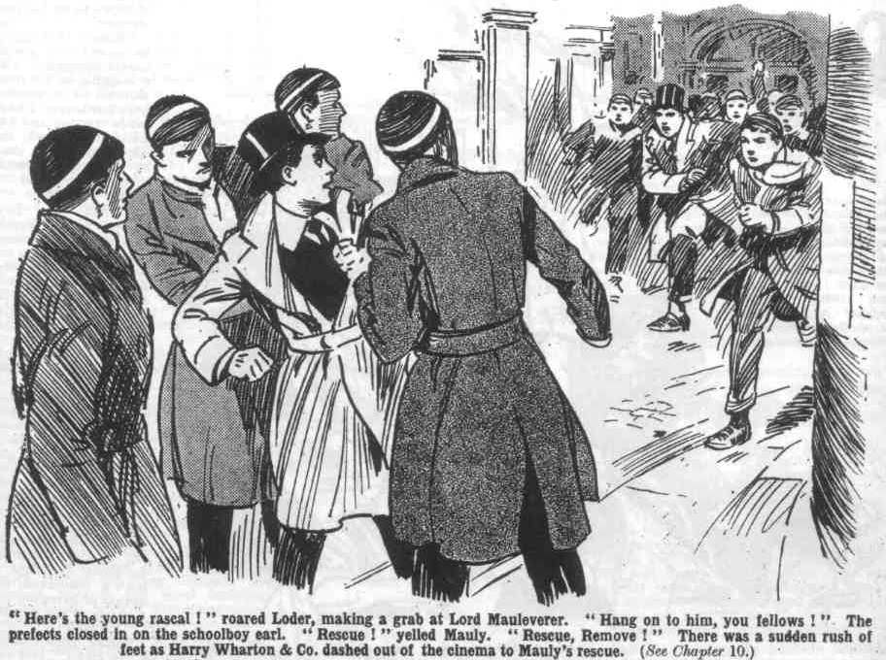 Lord Mauleverer started, and glanced round, at the voice of Gerald Loder of the Sixth. Loder and Carne and Walker were coming up the street together. They surrounded Lord Mauleverer with a rush, and Loder grasped him by the shoulder.
Where are the others?” demanded Loder.
“Let go my shoulder, please.” said Lord Mauleverer mildly.
“Tell me where the other young scoundrels are!” snapped Loder. “Dr. Locke has sent us to take you back to Greyfriars.”
Lord Mauleverer jerked his shoulder free from the prefect’s grasp.
“Hands off, dear man,” he said placidly. “For the present, 1 don’t belong to Greyfriars, and I don’t recognise your authority. As a matter of fact, you’re not the sort of fellow I want to be seen speakin’ to, Loder
“What?” roared Loder.
“Not the sort of fellow I want to be seen speakin’ to.”
Loder gritted his teeth.
“Bring that young scoundrel along.” he said. “That’s one, anyhow. We’ll find the rest.”
“Hands off!” yelled his lordship. “Rescue, Remove!”
“Hallo, hallo, hallo!” The Removites were coming out now. “ Here, buck up, you men!” “
“Coming, MauIy.”
There was a rush.
“Oh, here they are!” exclaimed Walker. “ You cheeky young sweeps, we’ve been sent to take you back---” “Rats!”
“Go and eat coke.”
“I say, you fellows, roll ‘em over!” yelled Billy Bunter from the rear.
“ Rush them!” roared Bolsover major.
“ Hurrah!”
Loder & Co. went spinning before the rush of the Removites. The three Sixth Formers were hefty fellows; but they were not much use against twenty sturdy juniors. They hit out right and left but in a minute or less they went rolling off the pavement into the road.
“Come and have some more!” roared Bob Cherry, as the three dazed and dizzy prefects picked themselves up out of the slush.
“Ha, ha, ha!”
Better clear, you Sixth-Form men.” advised Lord Mauleverer. “We’re not coming back, and we shouldn’t care for your company, anyhow, thanks all the same.”
“Roll them over!” roared Bolsover.
Loder & Co. promptly backed away. They had collected all the mud they wanted, and a little more.
“Good gad! Let’s get out of this!” gasped Walker.
And they got—promptly
A derisive yell from the Remove crowd followed them as they scuttled away.
“So much for Loder!” chuckled Bob Cherry.
“We’re fairly for it now.” said Squiff.
“I say, you fellow---”
“Shut up, Bunter.”
“I say, what about tea---”
“Tea at the bun-shop, if you men are ready,” said Lord Mauleverer. “Then we’ll get all the
taxicabs from the station and start for High Oaks.”
“Bravo!
It was a very hilarious crowd that tea’d at the bun-shop. Billy Bunter’s fat face was shining,
Rebellion—so far, at least—agreed with the Owl of the Remove amazingly. After tea, the
Remove army walked along to the railway station, where there was a cab rank. Every taxi on the stand was engaged by Lord Mauleverer, and they started in a procession through the High Street— and the Courtlfield folk stared and grinned at the procession, as the juniors waved their hats and cheered. Then they buzzed on out of the town into the winter dusk and headed for High Oaks.
THE ELEVENTH CHAPTER.
Moving In!
“HIGH OAKS!” said Harry Wharton.
“ Hurrah!”
“ Some place!” grinned Bob Cherry.
“The somefulness is terrific!
The gates of the old manor house stood wide open. A long drive led up to the house. and rather to the surprise of the juniors, they saw that many of the windows were lighted. A broad flight of steps led to the front door, and the door stood open, a lighted hall beyond: and in the doorway was an ancient gentleman whom the juniors guessed to be the caretaker—and from that ancient gentleman’s manner, it was clear that he had heard that High Oaks had been purchased by a nobleman, and that the nobleman was coming to take possession that day. A crowd of the juniors came up the steps, while Lord Mauleverer was paying off the cabs
“My lord—” began the caretaker, addressing Harry Wharton with deep respect.
Wharton smiled.
“I’m not Lord Mauleverer.” he said.
“Sorry, sir! My lord---” said the caretaker, addressing Frank Nugent.
Nugent chuckled.
“Not guilty,” he answered.
“Ha, ha, ha!”
“Is his lordship here?” asked the caretaker. “Mr. Stummer telephoned that he would be coming---”
“Hallo, hallo, hallo! Roll up, Mauly!” roared Bob.
“Yaas. Comin’ , dear man.”
Lord Mauleverer came up the step. The caretaker’s deep respect was transferred to him at once.
“Welcome, my lord! Glad to see your lordship ‘ere, my lord. Name of Juggins, my lord! Caretaker, sir—I mean, my lord. Mr. Stummer telephoned, my lord, that your lordship would he here this afternoon, my lord, and I’ve got everything ready for your lordship, my lord. The furniture vans have been here, my lord, and your lordship’s furniture has been delivered, my lord. If your lordship—”
“Oh gad!” ejaculated Lord Mauleverer.
It was clear that Mr. Juggins dearly loved a lord. No doubt he had been surprised to hear from the estate agent that a schoolboy had bought High Oaks: and no doubt he considered that such a schoolboy was worth buttering a little. A schoolboy who could command such a sum as seven thousand pounds was likely to be good for very handsome tips.
“Is your lordship staying here to-night?’ asked Juggins.
“Yaas.”
“And your lordship’s friends?”
”Mr. Juggins could not help being astonished. Being a local resident, he knew that the juniors belonged to Greyfriars, and how they came to be seeking new quarters, unaccompanied by masters, was a deep mystery to him.
“Very good, my lord!” he gasped.
“Begad, it’s rather lucky there’s a caretaker here.” Lord Mauleverer remarked. “Place might have been damp—”
“It might,” grinned Johnny Bull.
“In fact, I fancy it is,” said Harry Wharton. “It; hasn’t been lived in for a long time.”
“I say. you fellows, if we catch cold---”
“Shut up, Bunter.”
“Oh, really, Cherry—”
“We can camp out somewhere.” said Lord Mauleverer cheerily. “1 believe I ordered a lot of blankets and things at Chunkley’s—and bedsteads, too, I believe, and a lot of things. We can camp all right.”
“Right as rain.” said Bob.
“I’ve got some fires lighted, my lord.” said Mr. Juggins. “But if your lordship would like fires in the other rooms—“
“Yaas.”
“I will order more coal, my lord---”
“Yaas.”
“How much, my lord?”
“Eh? Blessed if 1 know,” said Mauleverer. “Don’t you know, Mr. Juggins?”
“Oh!” gasped Mr. Juggins. “Yes, my lord. Has your lordship brought your lordship’s servants?”
“Begad! I never thought of that!” ejaculated Lord Mauleverer, in dismay. “We shall want a housedame, and housemaids and things, and a porter and gardeners, and all sorts of things.”
“Ha, ha, ha!”
“Look here, Buggins—did you may your name was Buggins?”
“Juggins, my lord.”
“Yaas. Juggins—look here, Juggins, you look an intelligent sort of a bloke.” said Mauleverer.
“Thank you, my lord.”
“I suppose you can send for what’s wanted.” said Mauleverer. “Get in any sort of help you can, see, and set ‘em going--- what ?“
“Yes. my lord 1” gasped Juggins.
The juniors were spreading over the house, exploring it with great interest.
High Oaks was an extensive place, and it had been kept pretty well aired, which was fortunate in the circumstances.
In the hall and several of the rooms, big fires already blazed, diffusing a welcome warmth, and the house blazed with electric light. Furniture from the Courtfield Emporium, stacks of provisions from Chunkley’s Stores, were piled in the great hall.
What sort of a staff Mr Juggins was likely to get in to help, the juniors did not know ; but they were quite able to help themselves.
Harry Wharton gave directions, and the juniors turned to with a will, to prepare the big house for habitation.
Bunter and Skinner and Snoop and one or two other slackers were promptly rounded up and set to work with the rest.
Many hands made light work. Firewood and coals were carried into the various rooms, fires started in every grate in the house, bedsteads set up, bedding sorted out.
Many things that were needed had been overlooked by Lord Mauleverer, but to make up for this he had ordered great quantities of articles that were not likely to be wanted at all.
Deficiencies were easily made up, however, for the shops were not yet closed in Courtfield, and Lord Mauleverer was posted at the telephone.
Every shopkeeper in Courtfield was only too glad to promise prompt delivery of goods ordered by his lordship from High Oaks.
Up the drive came a constant stream of deliveries.
Fellows who found out what things were wanted would put their heads into the telephone cabinet and shout;
“Mauly!”
“Yaas?”
“ No towels.”
“Oh, gad! Lucky you found that out, old bean. Where do you order towels? Grocer?”
“No, you ass! Try Chunkley’s—they sell everything.”
“Yaas.”
And Lord Mauleverer rang up Chunkley’s to order towels, and ordered a dozen; and on second thoughts, realising that a dozen would not go round, he made it twelve dozcn.
“Mauly!”
“Yaas?”
“No soap!”
“Oh gad! Did I forget soap! Might be Bunter runnin’ the show at this rate.”
“Oh, really, Mauly——”
“No crockery!” roared Squiff.
“Oh gad!”
And Lord Mauleverer rang up Chunkley’s once more, and ordered soap and crockery-ware in wild and reckless quantities.
The exchange was kept busy with the High Oaks telephone for quite a long time. Delivery vans trod on one another’s heels, so to speak, for hours, grinding up the drive. The Courtfield shops were doing an unaccustomed trade that day, and had the Courtfield tradesmen known anything about the Remove rebellion no doubt they would have approved of it highly.
What was going on at Greyfriars, what the school was thinking, what the Head might be thinking, the Removites neither knew nor cared---they were too busy to think about that aspect of the matter,
It was a busy evening at High Oaks. Bed-time was rather later than at Greyfriars. At present the Remove was rather in the state of the Israelites of ancient time, when there was no king in Israel, and every man did what was right in his own eyes. Before going to bed, Lord Mauleverer rang up the Courtfield Hotel, and asked for Mr. Quelch. The Remove master came to the telephone.
“Mauleverer speakin’, sir,” said his lordship.
“Well?”
“We’re here, sir.”
“Where?”
“High Oaks—I mean, High Oaks School, sir.” said Mauly, “Everythin’ is O.K., and we’re gettin’ on fine. All we want is a schoolmaster.”
“Bless my soul!”
“I’ve had a room fitted up for you, sir, and a study, and all that, ready if you care to come over and take control.”
“Impossible, Mauleverer.”
“I’m afraid the fellows will get into rather slackin’ ways, sir, if you don’t come and take us in hand.”
“I advise you to return to Greyfriars.”
“Not unless you do, sir.”
“Nonsense, Mauleverer.”
“Thank you, sir,” said his lordship imperturbably. Good-night, sir !“
“Bless my soul! Good night!”
And Mauleverer rang off.
THE TWELFTH CHAPTER.
Wingate Is Called In!
“ AMAZING!” said Mr. Capper.
“Shocking!” said Mr. Hacker.
“Scandalous!” boomed Mr. Prout.
Masters’ Common-room at Greyfriars had plenty to say.
So had all the school, for that matter. Greyfriars had turned out in the morning at the clang of the rising-bell, with a whole Form missing.
Not a man of the Lower Fourth was to be found within the length and breadth of Greyfriars
The school simply gasped over it.
It was undoubtedly a most unprecedented state of affairs. From Wingate, the captain of the school, down to the smallest and inkiest fag an the Second Form, all discussed it breathlessly, and wondered what would come of it.
The staff were inexpressibly shocked.
They sympathised with Mr. Quelch in his dismissal ; they regarded the head as having acted, for once, in a high-handed and tyrannical manner. But the rebellion of the lower Fourth was utterly inexcusable, in the eyes of those in authority.
Other eyes saw the matter differently. Other fellows rather envied the Removites their freedom. All the fags, at least, agreed that it was no end of a lark.
Everybody wondered what the Head would do, when he would do it, and why he hadn’t done it already.
Obviously, as Coker of the Fifths pointed out, the Head couldn’t take this lying down. He couldn’t allow a whole Form to be missing from the muster-roll of Greyfriars. He had to do something.
He couldn’t let juniors dictate to him was agreed on all hands. He was not at all likely to reinstate Mr. Quelch. It was not at all certain that the proud and offended Remove master would come back, even if Dr. Locke wanted him to do so. And the Remove had declared that they would not come back without their Form master,
“Nice goings hon!” Gosling said to Mr. Mimble, the gardener “ Wot I says is this ere, nice goings hon!”
And Mr. Mimble could only agree that the goings on were extraordinary’
“The Head’s bound to fetch the young asses back!” Hobson of the Shell told Hoskins of the same form. “They’ll be brought in and flogged! Young duffers, you know---just cheeky fags.
“Just that !” agreed Hoskins.
“ Only why don’t the Head make a move?” asked Stewart of the Shell.
“Goodness knows.”
“The prefects were sent after them yesterday.” remarked Hoskins. “Loder looked awfully muddy and bad-tempered when he came in.
“Must have handled him.” said Stewart.
Sniff from James Hobson.
“They wouldn’t handle me, if I were a prefect!” he said “I’d jolly well bring ‘em up with a round turn.
So perhaps it was fortunate for the rebel Removites that Hobson of the Shell was not a prefect.
After class that morning a good many fellows got out of gates to look for the missing Removites. They returned without having seen anything of them.
The Remove were not in Friardale, and they were not in Courtfield, and nobody knew where they were. Only a good many fellows had learned that Mr. Quelch, instead of shaking the dust of the vicinity from his feet, was staying on in the neighbourhood. Potter of the Fifth had seen him walking in the High Street; Gwynne of the Sixth had met him on the Courtfield road, apparently taking a walk; two or three fellows had glimpsed him at the windows of the hotel. The news spread fast that Quelchy had a hand in the extraordinary proceedings of the Form.
“Is Quelchy at the bottom of it?” asked Coker of the Fifth, addressing Potter and Greene.
“Bosh!” said Potter.
“Looks like it to me.” said Coker. “What’s he hanging on in Courtfield for if he hasn’t a hand in this game?”
“Ring him up and ask him,” suggested Greene.
“Don’t be a silly ass, Greene! This state of affairs ought to be brought to an end.” said Coker, frowning. “We shall have all the other fags kicking over the traces if the Remove are allowed to act the goat in this way. The Head ought to put his foot down.”
“Tell him so,” suggested Greene, with a wink at Potter.
“I’ve thought of that---”
“Oh, my hat!”
“But you never know how these headmasters will take a tip,” said Coker disparagingly. “Old fossils, you know— might cut up rusty!”
Potter and Greene thought it highly probable that the Head might cut up rusty if Coker offered him advice. Fortunately, Coker didn’t.
In the Sixth Form-room that day the seniors eyed the Head very curiously. But his face was impenetrable.
What he was going to do was still unknown, though all Greyfriars was burning to know it. Obviously the present amazing state of affairs could not be allowed to continue. If the Head thought that the Remove would repent of their folly and return to the school he was certain to be disappointed. No fellow who got out of classes was likely to return to them if he could help it, as Temple of the Fourth pointed out in the Rag. If the Remove weren’t licked for their cheek they would not get less cheekier, they would go on getting cheekier and cheekier. That was Ceci1 Reginald Temple’s opinion—and the Fourth agreed that the words of Cecil Reginald were words of wisdom.
“Scandalous!” Mr. Prout said at tea time in Master’s Common-room, making that remark for at least the twentieth time. “What would the governors think?”
“ What, indeed!” said Mr. Capper.
“This cannot go on
“It cannot!” agreed Mr. Hacker.
“Sooner or later,” said Mr. Prout, “it will reach the ears of the governors of the school, and they will intervene.”
“A very painful position for Dr. Locke,” said Mr. Hacker, rubbing his hands—” very painful, indeed!”
The boys’ parents should be communicated with,” said Mr. Prout. “That would solve the difficulty”
There was a general smile in Master’s Common-room.
“Dr. Locke will be slow to take such a step,” remarked Mr. Wiggin. “It would be tantamount
to a confession to the boy’s parents that he is unable to maintain his authority.”
“Which is the absolute truth as the matter stands!” boomed Mr Prout.
“ Undoubtedly.”
“But the Head will not advertise the fact.” said Mr. Hacker.
The Common-room wondered what the headmaster would do but they did not wonder sympathetically. They resented the high handed dismissal of one of their number, which they regarded as a humiliation of the whole staff. They were rather disposed to draw a grim
enjoyment from the difficulties which had accrued from that highhanded action.
Where the Remove might possibly be was a deeply interesting mystery at Greyfriars. They could not have scattered to their various hones, that was quite certain. Parents and guardians would hardly have sympathised with a school rebellion; the rebels would have been sent back, in most cases at least. But if they hadn’t gone home, where were they?
It was impossible for a numerous Form to vanish into thin air, but it really looked as if the Greyfriars Remove had done so.
Some fellows, however, noted that the headmaster’s telephone was ringing a good deal that day. No doubt the Head was making inquiries after the missing Removites in his own way, without allowing the matter to interfere with his usual duties. And there was a thrill through the school when it became known after class that the Head had sent far Wingate of the Sixth. He was getting down to business at last, in the opinion of all the fellows--- and Coker of the Fifth remarked that it was about time he did. The whole school would have been glad to hear that interview between the captain of Greyfriars and the Headmaster. But they could guess, anyhow, that the head had learned the whereabouts of the missing Remove, and was calling on the Sixth Form prefects to round them up.
Wingate was in a rather curious and expectant mood when he stepped into the Head’s study. He found Dr. Locke as calm and grave a usual, showing no sign whatever of disturbance. There was no doubt at all that the Head must have felt the matter very deeply, but he had sufficient self-command to keep up an unmoved and dignified calm, in looks at least.
“Ah, Wingate, come in!” said the Head quietly. “You are probably aware, Wingate, that the Lower Fourth Form has absented themselves from the school without leave.”
“Yes, sir.” gasped Wingate. He could scarcely have failed to be aware of it, as all Greyfriars had discussed nothing else all day long. But it was the head’s cue to treat the amazing affair as a mere incident.
“I learn that they have lodged themselves in a mansion between Greyfriars and Courtfield, Wingate,” said the Head.
“Indeed, sir?”
“A mansion called High Oaks. Doubtless you have heard of it?”
“Yes, sir; I’ve passed it a few times.” said Wingate. I thought it was an empty housee, and up for sale.”
“The juniors seem to have obtained possession of it somehow,” .said Dr. Locke. “Possibly by permission, possibly by impudent trespass. At all events, they are there now. I desire the boys to be brought back to school, Wingate.”
“Yes, sir.”
“You will take as many of the other prefects as you deem necessary, and proceed to High Oaks, and fetch the boys back.” said the Head
“Very well, sir.”
Wingate hesitated, though the Head’s manner was a dismissal.
Dr. Locke glanced at him.
“That is all, Wingate.”
“But, sir—” stammered Wingate.
“Well?”
“It—it’s possible, sir, that they may refuse to return---”
Dr. Locke’s brows contracted.
“If the juniors should be so ill-advised as to resist the authority of the prefects, Wingate, you will use force— any force that may be needed.”
“Oh! Very well, sir!”
And George Wingate left the study and went to gather his forces, not feeling nearly so assured as the Head that he would be able to bring the rebel Removites back to Greyfriars with him.
THE THIRTEENTH CHAPTER.
The Enemy In Sight!
“ I SAY, you fellows this is prime!
“Hear, hear!”
“The primefulness, is terrific!”
“Anybody want to go into class?” sang out Skinner. Even Skinner was growing rather keen on the rebellion now.
“Ha, ha, ha!”
“No prep last night, no construe this morning!” chuckled Haze1dene, “We’re doing all right !”
“Right as rain!”
“It would have been maths to-day with Lascelles,” went on Hazel. “Anybody keen on maths?”
“Ha, ha, ha!”
A gigantic fire blazed in the wide old hearth in the oak-panelled hall of High Oaks, The hall was long and wide and high, and there was almost room for a Form to lose themselves in it. The fire was piled with coal and logs. The weather was cold— very cold. But motor-vans had landed stores of fuel, and it was going up in smoke at a great rate. Large as the mansion was, it was well warmed from end to end and side to side; and in the vast dining-room a perpetual spread was in progress.
Every imaginable sort of provisions had been ordered in huge quantities. Fellows helped themselves. The amount of washing-up that was required was already enormous, and all the more enormous because little or none had been done so far. Bolsover major had proposed to make Bunter general washer-up, and, in spite of the Owl’s breathless indignation, would certainly have done so had he been in authority. But bullying was barred, and the Owl of the Remove had a narrow escape of getting a hefty job that no one would have envied him.
In the wintry afternoon a crowd of fellows had gathered round the large fireplace in the old hall—Bunter with a cake under his arm, from which he helped himself in large chunks.
It was no wonder that Bunter considered the situation “prime.” No lessons made the affair a success, anyhow, in Bunter’s estimation. Unlimited tuck made it a glorious success. Lord Mauleverer was ready to telephone for anything that anybody suggested; the Courtfield tradespeople were more than ready to deliver the goods promptly. And so the supply of everything was unlimited. William George Bunter was having the time of his life. So were many other fellows.
Harry Wharton was a little thoughtful. It was not his idea at all to establish a sort of lazy lubberland at Higb Oaks, though that was rather how it had worked out so far. He was not keen on classes, but he knew that classes were a necessity; that slacking could not be a permanent institution, even if he wanted it, and though a day or two of idleness mattered little too much of it would not do at all. Dodging work was not a reason for the rebellion, it was a good reason why the rebellion should be put down, as the more thoughtful fellows knew. Wharton had hoped, indeed expected, that Mr. Quelch would take control. Mr. Quelch had most definitely refused to take control. and that left the rebels rather at a loose end.
To keep up a rebellion on lines of laziness and slacking would not do at all; it might do for Bunter and Skinner and such fellows, but it was not in the Famous Five’s programme. But how to institute classes without a master was a bit of a problem.
Lord Mauleverer, sprawling gracefully in a deep armchair, with his hands behind his head, was thinking, too. Thinking was not much in his lazy lordship’s line; but Mauly had been coming out in the most unexpected ways of late. Now he was thinking.
“Prime!” repeated Bunter. “I say, you fellows, what about keeping this up for the rest of the term?”
“Hear, hear!”
“Right on to the Easter hols,” said Bunter eagerly. “Fancy cutting classes all the time!’
“Good egg, if we can do it I” grinned Skinner.
“The Head will be after us soon,” remarked Snoop, “Still, we can bar him out of this house. It’s Mauly’s property.”
“Yes, rather”
“The ratherfulness is terrific.”
Lord Mauleverer sat up.
“You men——” he began.
“Hear, hear! Go it, Mauly!” chorused the juniors. Mauleverer’s leadership was admitted on all sides now; the Famous Five were proud to be his lieutenants. Certainly no other fellow in the Remove could have done what Mauleverer had done. There was only one millionaire in the Lower Fourth.
“I’ve been thinkin’,” said Mauleverer modestly.
“Ha, ha, ha!”
“Hurt your brain-box?” inquired Skinner sympathetically.
“You shouldn’t do these things too suddenIy, Mauly,” grinned Peter Todd. “Begin it by degrees.”
“Yaas, old bean, “ said Lord Mauleverer. “ You see, you men, I’ve been thinkin’ it out. We haven’t come up here to slack.”
“Eh ?“
“What?”
“ We’re backin’ up old Quelchy. We want him to take charge, but if he won’t, we’ll advertise in the ‘ Daily Mail ‘ for a schoolmaster, or somethin’,”
“Oh, my hat!”
“Ha, ha, ha!”
The juniors shrieked.
“One of those small advertisements, you know,” gurgled Skinner. “School master wanted for a Form who have sacked their headmaster. Pound a week and all found.”
“Ha, ha, ha!”
“Or there’s a registry office in Courtfield,” said Mauleverer, “Perhaps they get you schoolmasters and things.”
“Order one from Chunkley’s Stores!” suggested Squiff,
“Ha, ha, ha!”
“Well, somethin’ will have to be done, you know.” said Mauleverer. “If we keep on slackin’ we’re puttin’ ourselves in the wrong.”
“Rot!” said Bunter.
“You don’t agree with me, Bunter, dear man?”
“ No fea!”
“Then I’m sure I’m right. We’ll give Quelchy time to think it over, and if he doesn’t play up, we’ve got to get a schoolmaster from somewhere, or else give ourselves lessons.” aaid Lord Mauleverer. “Can’t spend the time slackin’ about like a lot of frowsy work-shys.”
Grinning glances were turned on his lordship. Mauly, sprawling in the arm-chair, and looking as if he felt too lazy to live, did not seem exactly the fellow to give lectures on slacking. But his lordship was in earnest.
“I loathe classes as much as you men.” he said. “More, in fact. But right’s right. We’re standin’ up for a principle, and we’re goin’ to play the game. Besides, we shall have to explain to our people later. We can’t tell them we cleared out of school and wasted our time. Of course,” added his lordship cautiously, “there’s no hurry. We won’t begin to-day---”
“Rather not!” grinned Skinner.
“Or to-morrow—”
“Hear, hear!”
“Or the day after,” said Mauleverer. “But after that—sometime after that, you know —”
“Ha. ha, ha!”
“Hallo, hallo, hallo! Here’s Juggins,” said Bob Cherry.
Mr. Juggins insinuated himself in. Mr. Juggins, like the Remove follows, was having the time of his life. Lord Mauleverer gave him carte blanche, and Mr. Juggins had never seen so many currency notes before as he handled now. Mr. Juggins was staying on as porter and several other things, and he had provided a brother who was a gardener, and a cousin who was in undergardener, and an aunt who was a cook and a nephew who was a page, and all these relatives of Juggins’ were now on their way to High Oaks, and Mr. Juggins was in communication with other relatives and friends, either keen on providing Lord Mauleverer with ample service, or else generously desirous of letting the whole clan of Juggins into a share of the plunder. Wages had been arranged on a very generous scale—a scale that was likely to attract all the Juggenses to High Oaks that Mr. Juggins could get in touch with.
“My lord---”
“Just the man I want to see.” said Lord Mauteverer genially. “You’re an awf’ly useful man, Juggins.”
“Thank you, my lord. I was going to mention that I had another nephew who would be proud and glad to serve your lordship.’
“Bring him along, Juggins”
“Yes, my lord, thank you, my lord!”
“Do you happen to have a relation who is a schoolmaster, Juggins?” inquired lord Mauleverer.
“Eh?“
“I’m in want of a schoolmaster,” explained Lord Mauleverer. “You’ve such a lot of relations, Juggins, and they’re all so jolly useful, I thought you might have a schoolmaster among them.”
“Oh, my eye!” gasped Mr. Juggins.
“Well, have you ?“ asked Lord Mauleverer.
“Nunno, my lord. There ain’t any scboolmaster in my family,” stuttered Mr. Juggins.
“Begad! That’s rather a pity,” said his lordship. “If you happen to remember an uncle or somethin’ that’s a schoolmaster, bring him along.”
“Yes, my lord!” gasped Mr. Juggins.
“I say, you fellows, there’s Wingate!” yelled Billy Bunter, who was blinking out of one of
“Oh, my hat!”
“Lock the door!”
“All hands on deck to repel boarders!” roared Bob Cherry.
“Ha, ha, ha!”
“Buck up, Mauly!” exclaimed Harry Wharton. “You’re leader, you know.”
“Yaas!”
Lord Mauleverer reluctantly detached himself from the armchair.
“Juggins!”
“Yes, my lord.”
“Do you know how to handle a garden-hose?”
“Certainly my lord.”
“Go and fix it up, then, Juggins, if you’ll be so good, as near to the front door as you can.”
“Yes, my lord.”
Juggins hurried away, and Mauleverer stepped to a window. Up the drive from the gates came Wingate of the Sixth, with a dozen stalwart men of the Sixth Form of Greyfriars, and every one of them had an ashplant under his arm.
“Looks as if they mean business.” remarked Bob Cherry.
“Yaas. So do we.”
“What-ho!”
“All you men get hold of somethin’.” said Lord Mauleverer. “if they use their ashplants, we can use pokers and things.”
Knock!
The enemy were at the door.
THE FOURTEENTH CHAPTER.
Holding the Fort!
WINGATE of the Sixth knocked loudly on the door.
Behind him, the Sixth- Formera were arrayed on the broad steps.
There were a dozen of the hefty seniors, and most of them were fully convinced that there would be little difficulty in handling the rebels of the Lower School. In fact, they rather expected their mere appearance to terrify the Remove into submission. Some of the Removites, undoubtedly, were not keen on trouble with the Sixth. Bunter and Skinner and Snoop had already vanished into remote corners of the house.
Knock! Knock!
“Hallo, old bean!”
Lord Mauleverer leaned from an open window that flanked the great door, and hailed Wingate cheerily.
The captain of Greyfriars ceased to knock at the door, and turned, to fix his eyes on Mauleverer.
“Oh! You’re here!” he said grimly.
“Yaas.”
“You’re to come back to Greyfriars at once”
“Can’t be done.”
“We’re here to fetch you,” said Wingate.
“We don’t want to be fetched.” explained Lord Mauleverer
“ Open the door.’
Lord Mauleverer shook his head.
“We’re standin’ up for Mr, Quelch.” he explained.
“Don’t be a young ass!”
“Well, don’t be an old ass!” siuggested Lord Mauleverer placidly. “The fact is, we’re not comin’.”
“No fear!” bawled Bolsover major.
Wingate set his lips.
“The Head has sent us to fetch you kids back to school.” he said. “If you don’t let us in we shall force an entrance, and some of you may get hurt. I advise you to come back quietly.”
“Many thanks, old bean, but we’re not askin’ advice of the Sixth at present. Take a message back to the Head instead. Tell him that we’ll return to Greyfriars when our Form master returns. Not before.”
“That doesn’t concern you juniors.”
“Your mistake, old bean. It does.”
“Oh, don’t jaw to the cheeky young scoundrels!” exclaimed Loder. “Let’s get at them! A thundering good hiding all round is what they want!”
“That’s cheek, Loder!” said Lord Mauleverer.
“What?” roared Loder.
“Cheek!”
“Open that door, you young rascal !”
“Rats!”
“Look here, you kids---” exclaimed Wingate.
“Allow me to point out that you’re trepassin’,” said Lord Mauleverer politely. “If you care to come in to tea peaceably you’re welcome. But if you’re here to kick up a shindy, Wingate, I order you off my premises.”
“Your premises!” ejaculated Wingate, staring at him.
“Yaas.”
“What do you mean, you young idiot?” demanded Gwynne of the Sixth.
“Exactly what I say, you old idiot!”
“Ha, ha, ha!”
“This house belongs to Mauleverer.” Harry Wharton explained, from the window. “He bought it yesterday.”
“Bub-bub-bought it!” stuttered Wingate.
“Yes; and you’re trespassing on his property!” chuckled Bob Cherry. “You could be run in if Mauly telephoned for the police.”
“Ha, ha, ha!” roared the Removites. “I don’t want to be inhospitable.” said Lord Mauleverer calmly. “I’ll ask you all in to tea if you’ll promise to be good boys.”
“Ha, ha ha!”
“But we’re not takin’ any Sixth Form swank at present. Go back and give the Head my message an’ save trouble.”
Wingate drew a deep breath.
“Will you let us in ?“ he demanded.
“No fear!”
“Bung in a window, then!” exclaimed Loder impatiently. “We’ve got to get hold of the young scoundrels !”
“Come on!” roared Bolsover major.
Wingate and his men moved along to the window where the juniors stood. It was a large window, and it was open, and there was ample room for the seniors to enter if they were not stopped. Judging by the looks of the crowd of Removites within, however, they were likely to be stopped.
“You kids will be to blame if you get hurt.” said Wingate grimly.
“The hurfulness is likely to be a boot on the other leg, my esteemed idiotic Wingate.” chuckled Hurree Jamset Ram Singh.
“Come on, you fellows!” said the Greyfriars captain.
And he strode at the window and put a knee on the low sill to clamber in. Bolsover major gripped a large bath broom.
“Stand clear, you men!”
“Go it!”
Bolsover major charged with the broom. The rough head of it smote Wingate on the chest and fairly hurled him away from the window. There was a roar of laughter from the Removites, as the Greyfriars captain went sprawling. Loder gripped the broom before Bolsover major could jerk it back, and tore it away. He shoved it viciously at the juniors lining the window, and they backed, and Loder flung himself in headlong.
But it was only for a second that the juniors backed. Loder was only halfway in when they closed on him.
Many hands grasped Loder, and he was dragged bodily in, and half a dozen juniors sat on him. Bolsover major sat on his chest, and Ogilvy on his head and Loder roared and struggled, and struggled and roared, but he did both in vain. His struggles were futile, and his roars were unheeded. Peter Todd rushed up with a jar of jam, fresh from Chunkley’s Stores, and Loder’s roaring changed to suffocated gurgling as the jam was splashed over his face and into his mouth and nose and ears.
The rest of the seniors were coming on, however, and the Famous Five, at the window, had plenty to do. There was excitement and hot blood on both sides, now, and it looked as if some damage was likely to be done. Two or three of the seniors sprawled under the window, gasping, but the rest were forcing a way in, hitting out recklessly. Then Lord Mauleverer, who had hurried back to the fireplace, returned to the scene with a poker in his hand, of which the end glowed red-hot.
“ Sorry, dear men,” he said placidly. “I warned you—and there’s still time to bunk.”
“Keep that poker away!” shrieked Walker. I---I---I’ll----Yarooooh!”
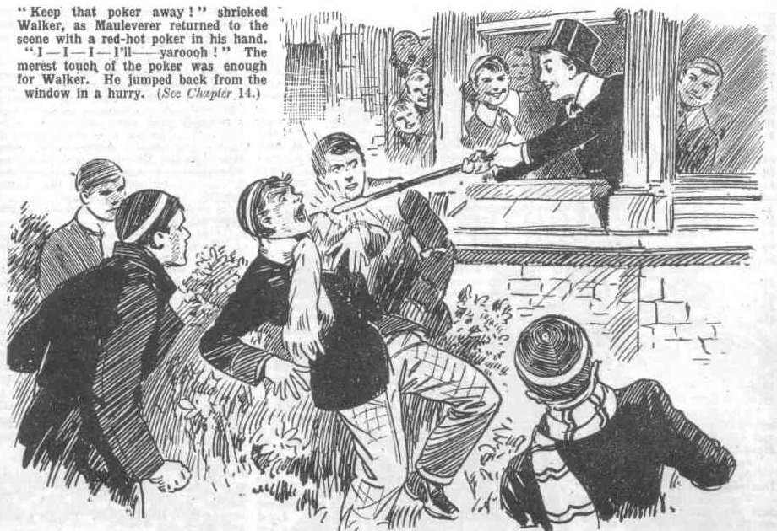 The merest touch of the poker was enough for Walker. He rolled back out of the window in a frantic hurry.
“Mind if I tap your nose with this, Carne?” asked Lord Mauleverer politely.
Judging by the haste with which Carne of the Sixth bounded away, he did mind.
“You, Gwynne
Gwynne of the Sixth jumped back.
The attack had ceased quite suddenly. A roar of defiance from the Removites followed the discomforted seniors as they retreated.
“Yah! Go home!”
“Down with the Sixth !“
“Ha, ha, ha!”
Lord Mauleverer leaned from the window over the low sill, poker in hand. The seniors within reach of a lunge backed hastily off, glaring at the schoolboy earl as if they would have liked to eat him. There was no doubt that Mauly was developing great qualities of leadership.
“Now, you Sixth Form men are warned off !” he said. “ I order you to clear off my premises at once !”
“You young villain “ gasped Wingate.
“I take that as an answer in the negative,” said Lord Mauleverer, “Sorry, but 1 can’t allow you Sixth Form men to trespass on my premises and kick up a shindy at my front door. Juggins!”
Juggins had the garden hose fixed, and was standing with it, staring at the amazing scene with eyes that nearly bulged from his head in his astonishment. What it meant, and what it was all about, Juggins did not know; indeed, Juggins almost wondered whether he was dreaming. He was so astounded by what he was beholding that he did not evenl heed Lord Maueverer.
“Juggins!” rapped out Mauly.
“Oh! Yes, my lord!” gulped Juggins, coming out of a trance.
“These fellows are trespassin’ here, Juggins. Turn the hose on them!”
“ Yes, my lord!”
“ Don’t you dare——” shrieked Walker.
“Throw Loder out, you men!” said Mauleverer.
“Yaroooh—leggo! I’ll go!” gurgled Loder. Peter Todd, having plastered him with jam, was now adding golden syrup from a tin which he had up-ended over Loder’s face.
Loder made one jump for the window when he was released, and bolted out head-foremost. He had had enough of the Remove at close quarters, and stood not upon the order of his going, but went at once; so hurriedly that Bolsover major had time to deliver only one kick as he went. Still, that one kick helped Gerald Loder out all the faster.
Whiz! Swoooh! Splash! ?
Mr. Juggins did not know what it was all about; but he knew that it was up to him to obey his master’s orders. The big hose was promptly turned on the group of gasping and enraged Sixth Formers. The icy stream of water struck them fair and square.
Splash! Swooooooosh! Swissssssh!
“Oh crumbs! Ow! Woooooooh!
It was a powerful jet of water, and Mr. Juggins played it freely on the Sixth-Formers of Greyfriars. In a second, or little more, every man of the Sixth was in full retreat. Icy water drenched them, and they had had enough---more than enough. Loder, in the lead, had already reached the gates and dashed out into the road, with Walker a close second and Carne a close third. The rest of the seniors were after them at a run. Wingate, staggering to his feet, in a towering rage, found himself alone. And the icy stream from the hose was still playing on him, Mr. Juggins grinning over the nozzle. For a moment Wingate hesitated; but the game was definitely up---the door was open now, and a crowd of Removites pouring out. Wingate scudded away down the drive after his comrades. Yells of triumph followed him.
“Going.” gasped Bob Cherry--- “going---going---gone!”
Wingate was the last out of the gates. A draggled, enraged crowd of Sixth-Formers took their weary way back to Greyfriars. Mr. Juggins chuckled and shut off the water.
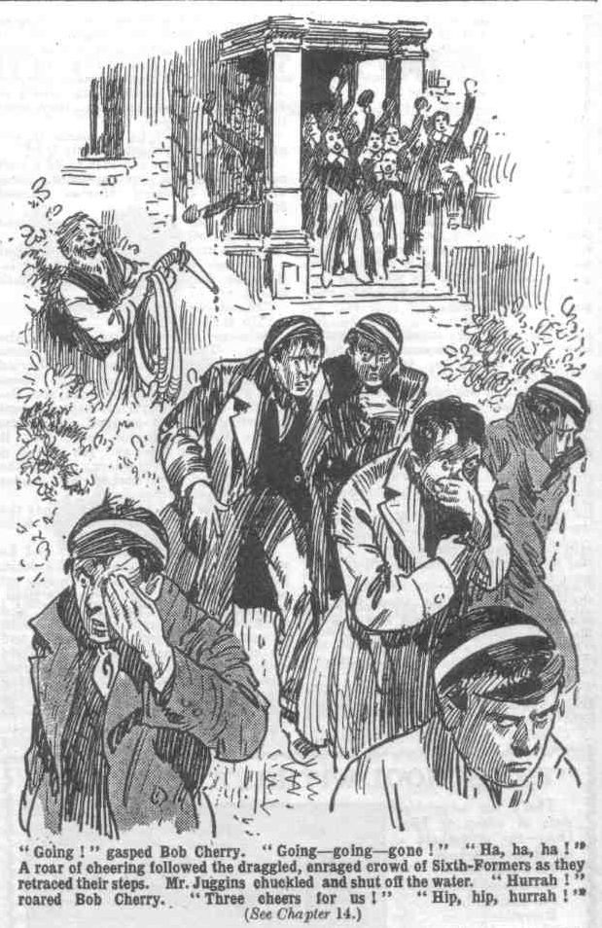 “Hurrah!” roared Bob Cherry. “Three cheers for us!”
“Hip, hip, hurrah!”
The roar reached the ears of the Sixth-Formers as they went. It added to their wrath; but they did not think of turning back. They were fed up with the rebels of the Remove. Draggled and dreary, they tramped back to Greyfriars, to report their failure to the Head---while the Remove rebels, victorious and elated, rejoiced over their victory.
THE END.

