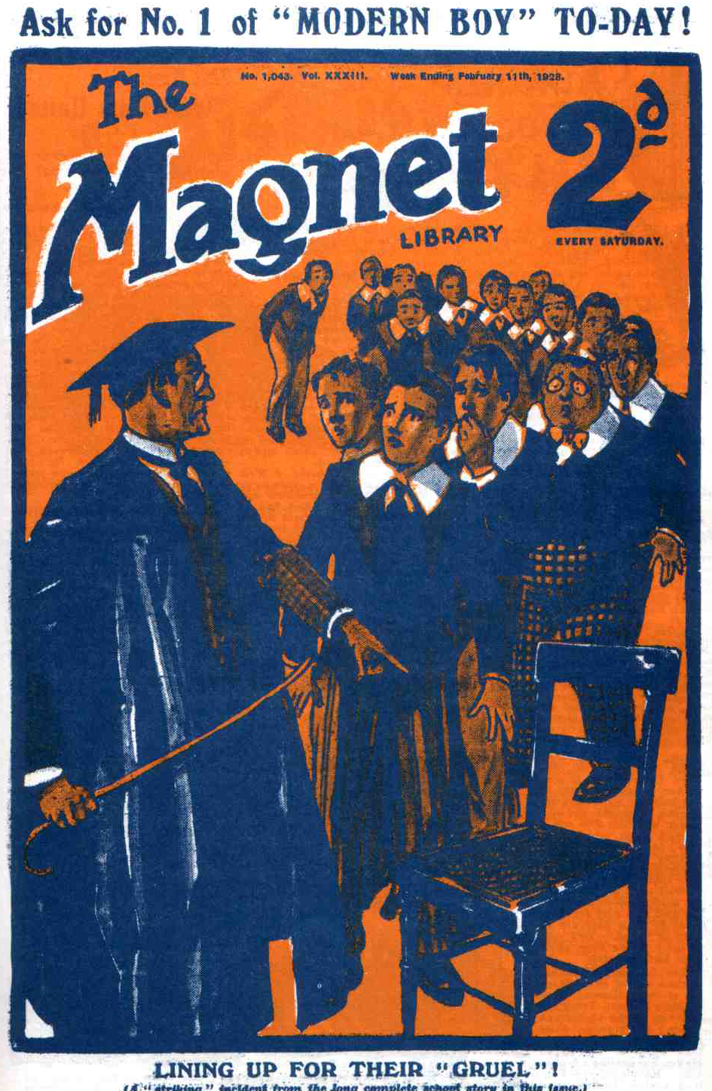
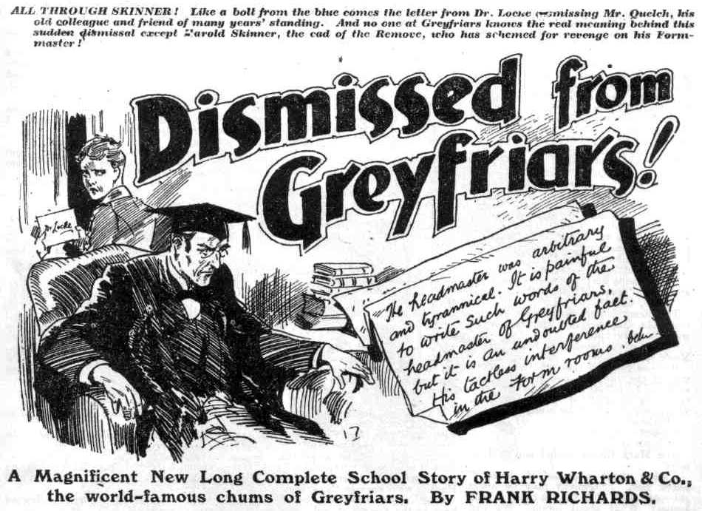
THE FIRST CHAPTER.
While the Cat’s Away!
“QUELCHY’S late!”
“Better late than never!” remarked Skinner.
“Ha, ha, ha!”
Mr Quelch—disrespectfully alluded to by his Form as Quelchy— was undoubtedly late.
The Remove had gone into their Form-room for afternoon class, quite punctually. Mr Quelch was a punctual man himself, and insisted upon punctuality in the Remove. The Remove did not agree with him; but they were accustomed to giving Mr. Quelch his head.
Now he was late.
For ten minutes the Lower Fourth had been in their Form-room, and Mr. Quelch had not appeared.
It was almost unprecedented. The Removites were surprised, and they could not help wondering.
Not that they minded. The later Mr. Quelch was, the better his Form liked it. Latin prose was the order of the day, and hardly a man in the Remove was keen on Latin prose. They did not love the dead languages; indeed, there was a strong opinion in the Remove that those languages, being dead, ought to be buried.
But it was surprising, as well as gratifying, for Mr. Quelch to be late. Often Mr. Quelch had told his Form that punctuality is the politeness of princes, and that procrastination is the thief of time. It was really remarkable for Mr. Quelch to give up the politeness of princes in favour of the thief of time.
Surprised as they were, the Removites hoped that Mr. Quelch, late in life, was forming new habits, and that they would be permanent.
The juniors, deprived of the delights of Latin prose by the unpunctuality of their Form master, were not wasting their time. Had they been perfect characters they would, of course, have sat down quietly at their desks, opened their books, and studied sedulously, while they waited for their Form master to arrive. But the perfect characters in the Greyfriars Remove could have been counted on the fingers of one hand, leaving out several digits. They improved the shining hour in quite different ways.
Lord Mauleverer, on a back form, leaned on the wall and dozed comfortably. Mauly was always prepared to put in a doze when he had a spare moment. Billy Bunter, greatly daring, put a cigarette into his mouth, though he did not venture to light it. Half a dozen fellows played leap-frog. Others stood around and chatted. Bolsover major, who had a squirt, filled it with ink, and took surreptitious potshots at fellows who were not looking. At that time in the afternoon the Remove-room should have been very quiet and orderly. Instead of which, there was noise in the Remove-room, which gradually grew into a din.
And still Mr. Quelch did not come.
“Quechy’s awfully late.” said Harry Wharton. “Don’t make too much row, you men; they’ll hear it in the other Form-rooms.”
“Let ‘em’” said Bolsover major.
“We don’t want Capper or Hacker to come along.”
“Rats!” retorted Bolsover.
And, to display his independence, Bolsover major gave up the squirt, and started tramping noisily.
“Chuck it, you ass!” said Bob Cherry.
Bolsover major tramped more loudly than ever. Skinner, and Snoop, and Stott promptly joined him. It was sufficient for Wharton to express an opinion for Skinner & Co. to take the opposite tack.
There had been noise in the Remove room before. Now there was an uproar.
Frank Nugent opened the door, and glanced along the passage. In the Form-room passage there was no sign of Mr. Quelich.
In the other Form-rooms the various Forms were assembled—the Second with Mr. Twigg, the Third with Mr. Wiggins, the Fourth with Mr. Capper, the Shell with Mr. Hacker, the Fifth with Mr. Prout. At a greater distance, fortunately, was the august apartment where the Sixth sat with the Head. All Greyfriars was on the grind—excepting the Remove, Unaccountably, Mr. Quelch had not turned up to take his Form.
“Shut that door, Nugent, you ass!” said Hazeldene. “We shall have the Head here at this rate.”
Nugent shut the door.
“Quelchy’s not coming,” he said.
“It’s jolly odd,” remarked Johnny Bull.
“The oddfulness is terrific.” observed Hurree Jamset Ram Singh. “But as the esteemed Skinner has remarked, the latefulness is better than the neverfulness.”
“I say, you fellows—”
“Hallo, Hallo, hallo! Bunter know!” exclaimed Bob Cherry. “Bunter knows everything except his lessons. Why hasn’t Quelchy come, Bunter?”
Bunter grinned.
“He’s at it.” he said.
“At what, fathead?”
“Scribbling.”
“Oh!”
“Ha, ha, ha!”
“I saw him,” explained Bunter. “Saw him from the quad, before we came in! Scribbling away like billy-o!”‘
“Ha, ha, ha!”
The Remove understood now.
They were well aware that Mr. Quelch, in his hsours of scanty leisure, had literary occupations. A History of Greyfriars had been growing under Mr. Quelch’s pen for years and years. When he had completed a section of that great and extensive work, Mr. Quelch would type it out on his typewriter, the click of that machine from Mr. Quelch’s study was a well-known sound at Greyfriars. Mr. Quelch was not at the typer now; he was in the throes of composition. In those throes he had forgotten class—forgotten the Remove—forgotten all things but his literary work!
“Oh, that’s it, is it?” exclaimed Bob Cherry. “Good egg! More power to his giddy elbow!”
“What-ho!”
“Let’s hope he’ll keep it up all the afternoon.” said Johnny Bull heartily.
“Hear, hear!”
The Remove were only too willing to leave Mr. Quelch at his literary labours without interruption.
“What about reminding him?” asked Mark Linley.
But the voice of that scholastic youth was as the voice of one crying in the wilderness. Not a single voice was raised in support of the suggcstion. There was a roar of derision.
“Fathead!”
“Ass!”
“Chuck it!”
And Mark Linley smiled and said no more.
“What about a same of footer?” asked Bob. “Quelchy may be hours yet—may stick at it till tea-time. Who knows? What about footer? We can use a dic. for a ball.”
“Hear, hear!”
“Bravo!”
The suggestion caught on at once; it was evidently much more popular than Linley’s.
Football, with a dictionary for a ball, was not likely to be Soccer at its very best; but any kind of football was obviously ever so much better than lessons; and football in the Form-room was undoubtedly a lark.
Sides were picked up at once.
“I say, you fellows, suppose Quelchy butts in!” squeaked Billy Bunter.
“Shut up, Bunter!”
“On the ball!” roared Bolsover major.
“Play up!”
It was an exciting game. There was more kick and rush than anything else, but it was exciting, and it was jolly. It beat Latin prose to a frazzle.
For some minutes the Removites moderated their transports, so to speak; but as the excitement of the game grew they forgot all about Mr. Quelch, as Mr. Quelch had pparentIy forgotten all about them. They kicked, they rushed, they trampled, they shouted, they roared, they cheered. Masters’ studies were a good distance from the Form-rooms, and Mr. Quelch was not likely, after all, to hear. But the juniors were not thinking of him now, anyhow. They were enjoying their afternoon—quite unexpectedly; and the din and uproar in the Remove-room grew, and grow, till anyone passing by that room might have fancied that pandemonium had broken loose there.
THE SECOND CHAPTER.
A Remove Rag!
“SCANDALOUS!
Mr. Prout, the master of the Fifth, put his head out of his Form-room doorway, like a
tortoise popping its head out of a shell, and ejaculated “ Scandalous!” and popped his head in again.
Mr. Capper came out of the Fourth Form-room, and Mr. Hacker out of the Shell-room. They stared along towards the Remove quarters, and exchanged astonished glances.
“Extraordinary!” said Mr. Capper.
“Amazing!” said Mr. Hacker.
Crash! Bump! Roar!
The Remove were going strong.
Bump! Bump! Crash!
“On the ball”
“ Pass, you fathead! Pass!”
“This way!”
“Hurrah “
Bump! Crash! Bump!
“Yaroooh!”
“Ha, ha, ha!”
These sounds were undoubtedly amazing and extraordinary, proceeding from a Greyfriars Form-room in class-time.
“One ought to intervene,” hazarded Mr. Capper. “Mr. Quelch must be— hem!—absent.”
“He can scarcely be present, with that uproar going on.” said Mr. Hacker.
“It is outrageous! Mr. Quelch may, of course, act as he pleases with regard to his own Form, but this outrageous noise interferes with the work of other Forms.”
“A word to Mr. Qucich
Mr. Hacker shook his head.
“ Mr. Quelch does not like interference with his Form, Mr. Capper. He has very nearly come to words with Mr. Prout on the subject more than once. This is absolutely outrageous, but I, for one, decline to interfere.” And Mr. Hacker went back to the grinning Shell.
Mr. Capper hesitated, but he went back to the Fourth at last. It was true—only too true—that Mr. Quelch resented anything like interference in his management of the Remove. The present was an exceptional case, certainly; still, there was no telling how a tart gentleman like Henry Samuel Quelch might take the most kindly and well-meant intervention. Mr. Capper decided not to risk it.
From the Remove-room the din continued and intensified. Football in a Form-room could not be conducted without noise. While the cat was away the mice were at play, and they had quite forgotten the cat by this time.
From the Third Form-room Mr. Wiggins put a worried face. From the Second the kind and benevolent face of
Mr. Twigg peered.
The two masters exchanged glances.
“This is really—really—really—” said Mr. Twigg.
“It is really—really—agreed Mr. Wiggins.
But they felt a disinclination to intervene. Mr. Quelch’s business was, after all, Mr. Quelch’s business.
They shut their Form-room doors again.
Ill-fortune drew Monsieur Charpentier, the French master, to the spot. There was no French set going on just then, and Mossoo was at liberty, and he was taking a walk round. The uproar from the Remove-room smote forcibly on his ears as he entered the Form-room passage, and he stared in great astonishment.
“Mon Dieu!” he ejaculated. “Qu-est- que-c’est, que cela!”
Monsieur Charpentier did not reflect, like the Form masters, that Mr. Quelch was very touchy about intervention in his Form-room. Something was wrong, that was clear, and Mossoo rushed in where angels feared to tread.
He threw open the Remove door—unfortunately, just as a sort of scram was taking place within. In a Form-room, with a “dic.” for a ball, and desks in the way, the rules of Soccer were not closely observed. That game was enjoyable and exciting, but it resembled Rugger as much as Soccer, and a dogfight as much as either.
Five or six juniors were bunched just inside the door when Mossoo opened it so hurriedly.
Crack!
There was a fiendish yell from Bolsover major as the door came into violent contact with his head.
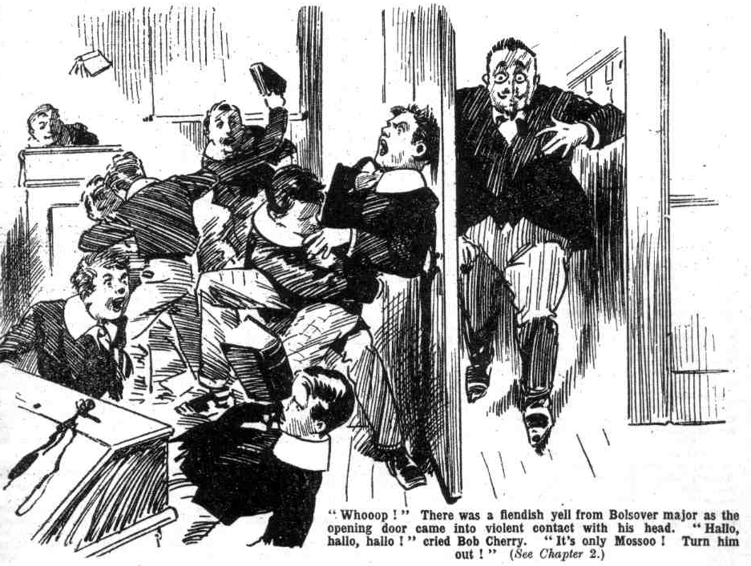 “ Whooooop!”
“Hallo, hallo, hallo! Who—”
“ Only Mossoo!”
“Turn him out!”
“Mes enfants!” exclaimed Monsieur Charpentier, staring blankly into the wildly disordered Form-room. “ Mes enfants! Vat is all ala ? Vat is zis zat you doo viz yourselves, isn’t it !”
“Shut that door!”
Mossoo never was much regarded. Even in the French class he was mercilessly ragged. Now that he had butted in where he had no business, the Removites, with their blood up, were not likely to take any heed of him. Three or four books and a hassock flew through the air, and all of them crashed on Mossoo at once.
“Ciel! Mon Dieu! Ooooch!”
Mossoo sat down in the passage.
Hazeldene slammed the door after him.
“Go it!” roared Bolsover major. “ On the ball!”
“Hurrah!”
“Hold on!” exclaimed Harry Wharton breathlessly. “Mossoo may go to Quelchy—”
“Blow Quelchy! Funk!” hooted Bolsover major.
Wharton plunged into the game again at once. He was not to be considered a funk by a fellow like Bolsover.
The mixture of Soccer, Rugger, and a dog-fight was resumed in the Remove- room with more vim than ever.
“On the ball!” roared Bob Cherry.
“Play up!”
“Pass! Pass!”
“Ow! Gerroff my neck!”
Crash! Bump! Bump! Yell!
Outside the Remove-room Monsieur Charpentier sat in a dazed state. He was breathless, he was astonished, he was pained. Round him lay several volumes that had smitten him in various places.
“Mon Dieu!” he gasped. “Zis is terrible! He is one riot! He must be stopped! But I cannot stop him! Vere is Monsieur Quelch! Mon Dieu!”
There was a stately tread in the passage.
It was the Head!
The Remove were a good distance from the Sixth Form-room, and they really had to exert themselves to be heard as far as that. But they were exerting themselves now. In the august apartment where the Head and the Sixth had been revelling in the joys of Sophocles, the uproar had been heard— with amazement. The Sixth-Formers looked at one another, the Head looked more and more surprised and perturbed, till at last he had left the Sixth and Sophocles to themselves, and sallied forth to investigate the cause of this unwonted disturbance.
It was easy enough to trace the din to the Remove-room. The Head arrived there, and blinked over his glasses at the slim French gentleman who was sitting on the floor.
“Monsieur Charpentier!” he ejaculated.
“Oh! Ah! Je vous demande pardon, monsieur!” gasped the French master, scrambling to his feet breathlessly.
“What—what—
“I have been smite viz book, sir! I have been trownt over by trowing of two-three books!” gasped Monsieur Charpentier. “Jo crois—I tink zat Monsieur Quelch he is absent, and so boys zey are out of ze hand.”
The Head frowned.
“It would seem so!” he said.
There was thunder on the brow of the headmaster as he stepped towards the Remove door.
“Mais—but—I complain not!” exclaimed Mossoo hurriedly. He was a kind-hearted little gentleman. “I zink
it is fun zat make zem garcons trow book: zey forgett zemse1ves some little, monsieur. It is nozzing—rien de rien— nozzings at all.”
And the little French gentleman drifted away, htoping that the Remove were not going to get it too severely. Judging by the Head’s expression, that hope was ill-founded.
Dr. Locke turned the handle of the door and opened iIt. There was a roar within.
“That outsider again!”
“Bung an inkpot at him!”
“Biff him with a dic.”
The next moment the roars died away in a quivering gasp.
“The Head!”
And silence fell on the Remove-room—a silence that could be felt.
THE THIRD CHAPTER.
The Head Takes a Hand!
“The Head!”
The Removites seemed frozen.
In the excitement of that happy and uproarious afternoon they had forgotten Mr. Quelch, and they had not thought of the Head at all.
The sudden apparition of their headmaster standing in the doorway, with Jove-like wrath and majesty in his brow, smote them with dismay.
Sudden stillness fell upon the juniors. Peter Todd, who was taking a kick, actually stopped with his foot in the air, suspended in space like the coffin of Mahomet. Billy Bunter who was lying on his back roaring, suddenly ceased to roar. Lord Mauleverer, who had dozed comfortably all through the riot, woke up.
For some moments the gaze of the head held the startled eyes of the Removites like a magnet.
He spoke at last, and his voice, though not loud, was deep, and It seemed to reverberate through the Form-room.
“What does this mean?”
Silence.
“What does this riot mean?”
Still silence.
“What do this outrageous riot mean?”
Still there was no answer as the Head went on crescendo.
“Wharton!”
“Oh! Yes, sir?”
“You are head boy in this Form, I think.”
“Ye-e-e-s, sir!” stammered Wharton. The captain of the Remove could not help feeling conscious that he had not been acting in precisely the manner expected of the head boy of a Form.
“Did Mr. Quelch leave you in charge here?”
“Oh! No, sir!”
“Nevertheless. in the absence of your Form master it is your duty to attempt to maintain some semblance of order.”
Wharton was silent, his cheeks crimson.
“Where is Mr. Quelch?”
“I—I don’t know, sir.”
“Has he not yet taken his Form?”
“N-no, sir.”
Dr. Locke compressed his lips.
“You are very much to blame, Wharton, in not seeking to stop this riot in the absence of your Form master. If I am not mistaken, you were taking part in it.”
“It—it wasn’t exactly a riot, sir.,” stammered Harry. “it was only a—a sort of game, sir.”
“Just to pass the time, sir.” ventured Bob Cherry.
The Head made a gesture for silence.
“Shall I call Mr. Quelch, sir?” asked Skinner officiously. “I know where to find him, sir.”
“You may call him, Skinner.”
Harold Skinner scudded out of the Form-room. He was rather glad to get out of the headmaster’s sight—as the other fellows would have been had it been possible. But the whole Form could not offer to go and call Mr. Quelch. Skinner had spoken first, and it was a case of first come first served.
“Take your places!” said the Head in a deep voice.
The Remove took their placcs.
Dr. Locke went to the Form master’s high desk and sat down there on Mr. Quelch’s high chair.
The Remove faced him, sitting in tense silence. They fully expected some exemplary punishment. Even Bolsover major admitted that they had been rather going it. All the fellows knew that they had gone far over the limit, though they had not exactly intended doing so; they had not intended anything in particular except to have a good time while their Form master was away. That the Head was deeply wrathy they could see, and some of them surmised that he regarded it as a serious matter to be called away from the Sixth.
But the Head said nothing of punishment. He sat and waited, evidently for the arrival of Mr. Quelch. Some fellows hoped that Quelchy was going to catch it, instead of their culpable selves. Not that that, on reflection, would have done much good ; for Quelchy would be certain to “take it out” of them afterwards, twice or three-fold.
In the midst of the deadly silence the stage whisper of Billy Bunter was heard. Bunter, of course, was bound to speak.
“I say, you fellows, he’s frightfully waxy!”
“Shurrup, you born idiot!” breathed Peter Todd.
“Oh, really, Toddy—”
“Shut up, Bunter!” hissed several Removites, with horrified glances at the Head.
But the Head gave no sign.
Certainly he must have heard Bunter’s whisper, but he disdained to heed it. And the almost homicidal looks of the fellows round him prevailed upon the Owl of the Remove not to offer any more remarks. The whole Form waited in silence for the arrival of Mr. Quelch —the Head sitting as still and silent as a bronze image at the Form master’s desk.
Meanwhile, Skinner had reached Masters’ Passage and Mr. Quelch’s study. He tapped at the study door and opened it and stared in curiously.
Mr. Quelch was seated at his table, and had not even heard Skinner’s tap, so deeply immersed was he in his literary work. It was but seldom, if ever, that Mr. Quelch forgot time and place in this manner—but even Form masters, after all, are only human, and for once Mr. Quelch was in fault.
The fact was that he had reached a particularly interesting period in that great work the “History of Greyfriars School,” by Henry Samuel Quelch. He was now dealing with the barring-out that had occurred a century before—in those rough-and-ready old days when barrings-out were barrings-out. In those old days a certain Dr. Trumpington had been headmaster of Greyfriars, and he had flogged not wisely but too well. And the barring-out had been a tremendous affair, led by Lovelace of the Sixth, the captain of the school.
Mr. Qucich of course, could never have approved of a barring-out, under any provocation whatsoever.
But he was a gentleman with a judicious mind, and he was dealing with his subject fairly, judging both sides impartially.
That old headmaster, Trumpington, had been a hard-handed tyrant, and his tyrranny had caused the trouble that shook Greyfriars to its foundations in the far-off days of William IV.
In that tremendous affair, which was now only a dim tradition at Greyfriars, soldiers had come over from Wapshot camp to deal with the rebels—soldiers with fixed bayonets had guarded the headmaster’s study. They were the days for such deeds.
It was really not surprising that Mr. Quelch, dealing with that heroic period in the history of Greyfriars, had become for once so deeply engrossed in his subject that he had forgotten the Greyfriars of the present day.
Skinner grinned as he looked at him.
Sheets and sheets of paper covered the Remove master’s table, some fully written up, some containing only sections and sentences that were to be worked later into the main narrative.
In Skinner’s opinion the whole thing was rot ; but to the Remove master it was a life’s labour and a darling task.
Mr. Quelch paused to gnaw the handle of his pen.
Then he sighted Skinner.
Skinner’s mocking grin vanished instantly as the gimlet eye of the Remove master turned on him. He looked awfully serious.
Mr. Quelch jumped.
The sight of Skinner in his doorway jerked him back from the past tense to the present tense. At a bound he covered a hundred years.
“Bless my soul!” ejaculated Mr. Queleh.
He rose hurriedly to his feet.
“I am late for class!” he exclaimed.
“Yes, sir!” said Skinner.
“Upon my word, I—I am very late!” exclaimed Mr. Quelch, in some agitation. “It is most—most unfortunate! You came to call me, Skinner?”
“Yes, sir.”
“Thank you, my boy! I am much obliged to you !“ said Mr. Quelch.
Skinner had hard work not to grin. Mr. Quelch supposed that he had come of his own accord to call him—which really was not a probable proceeding on Skinner’s part.
The Form master glanced at his watch. He really was shocked at his own thoughtlessness. He was an hour late for class!
“I—I trust the boys have been keeping order in the Form-room, Skinner?”
“‘Hem! I think some fellows were kicking up rather a row, sir!” said Skinner blandly. “ The Head—”
“ What!”
“The head’s there, sir!”
Skinner was not a good-natured youth. He fairly revelled in the dismay and discomfiture of Henry Samuel Quelch at that moment,
“The Head is there?” repeated the Remove master faintly.
“ Yes, sir!”
Mr. Quelch gasped.
“Do you mean to say, Skinner, that the Head was drawn to my Form-room by any disturbance there?”
“I—I think so, sir.”
“ Bless my soul!”
Mr. Quelch turned away to gather up the precious sheets on his table. As soon as his back was turned Skinner permitted himself a broad grin.
But it occurred to Mr. Quelch at once that he had not an instant to spare even for his literary works if the Head had been forced to leave the Sixth Form to deal with a disturbance in the Remove.
He turned round again at once, and so it was that he caught the sneering, malicious grin on Harold Skinner’s face before Skinner had time to compose his features.
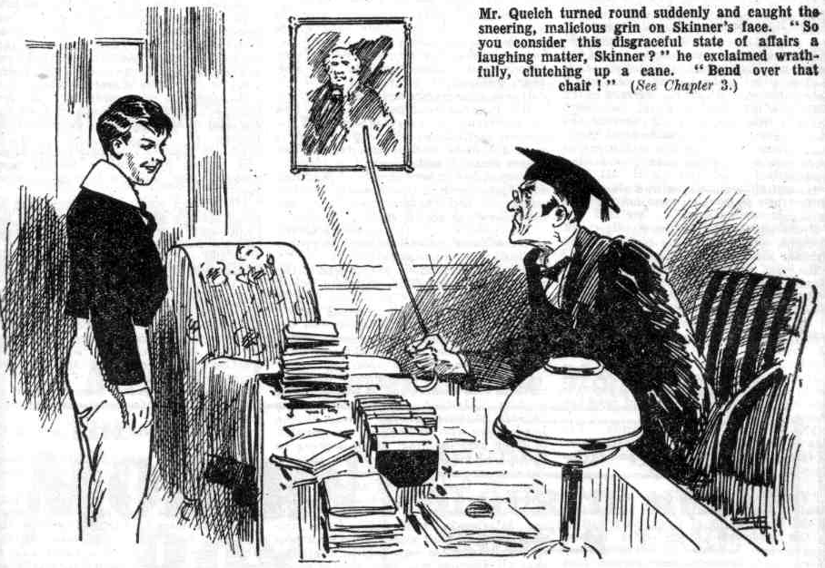 Mr. Quelch glared.
It was no grinning matter for him. He proceeded to make it no grinning matter for Skinner.
“Oh, you consider this disgraceful state of affairs a laughing matter, Skinner!” exclaimed Mr. Quelch, his eyes fairly darting flame at the hapless Skinner. He clutched up a cane. “ Bend over that chair!”
“I—I—I—”
“Bend over!”
Skinner—no longer grinning—bent over the chair.
Whack! Whack! Whack!
Skinner fairly yelled. The whacks were severe—awfully severe. They expressed Mr. Quelch’s feelings at the moment, and expressed them emphatically.
“Yow - ow – ow! Yoooop!” yelled Skinner. doubling up with anguish.
Mr. Quelch threw down the cane, and, without another glance at Skinner, he hurried from the study, and whisked along the passages to his Form-room. Skinner did not follow him. He really couldn’t for the moment. He leaned on Mr. Quelch’s table—regardless of the priceless manuscripts he was sprawling on—and roared.
THE FOURTH CHAPTER.
After the Feast—the Reckoning!
“DR. LOCKE!”
“Mr. Quelchl”
Breathless, with a total absence of his usual sedate dignity, Mr. Quelch hurried into his Form-room.
Dr. Locke rose to greet him.
Mr. Quelch’s face was crimson.
He had been caught out in a fault— a very serious fault. That was bad enough in itself. But he was caught out in the presence of his Form—that made it ten times worse. The Head was the most courteous of old gentlemen; for no consideration would he have humiliated a member of his staff, especially in the presence of schoolboys. But facts were facts! Mr. Quelch stood like a delinquent in his presence ; that was the actual fact, and the most courtly courtesy could not alter it.
And the state of the Form-room showed plainly enough that the head’s intervention had not been uncalled for.
Books and papers were strewn far and wide. A desk was overturned. The wastepaper-basket had yielded up its contents, which were scattered all over the room. Many of the juniors were extremely untidy and dusty, many of them still breathless. Obviously, there had been something like a riot in the Remove room.
It was a moment of bitter discomfort and humiliation to Mr. Quelch.
He was the member of the Greyfriars staff who was on the most amiable terms with the headmaster; he was, indeed, Dr. Locke’s right-hand man. Between the two masters was a mutual regard and esteem.
But the Head’s face was cold and impassive now; Mr. Quelch’s crimson with mortification.
“I found it necessary to step into your Form-room, Mr. Quelch,” said the Head gently.
“I—I—I must have forgotten—” stammered Mr. Quelch.
The Head made a gesture.
He was not the man to add to the Form master’s confusion by a word or a look. What had happened was in itself a sufficient punishment for the Remove master; there was no need for his chief to rub it in.
“I now leave your Form in your hands, Mr. Quelch!” said Dr. Locke, with polished urbanity.
That was all.
Fellows who had expected to hear the Head “slang” Quelchy were disappointed.
With a polite bow, Dr. Locke passed from the Form-room, leaving Mr. Quelch in command.
The Form master stood quite still for some moments.
Had the Head “slanged” him in the presence of his boys, as some headmasters would have done, the humiliation would have been too bitter for endurance. Mr. Quelch would have resigned his post on the spot.
But the Head’s mode of treatment was almost more bitterly galling to the Remove master than slanging.
Obviously the Head intended to say nothing more whatever about the matter, but that could not undo what had happened. Had he been rated by his chief, Mr. Quelch would have been supported by feelings of anger and resentment. But he could not resent polished courtesy; he could not be angry at gentle urbanity. He had, in fact, not a leg to stand upon. His confusion and humiliation was overwhelming.
Harry Wharton & Co. wished from the bottom of their hearts that they had not indulged in that good time that afternoon. They could feel for the position in which their Form master was placed.
Mr, Quelch stirred at last.
“There has been a riot here!” he said, in a trembling voice. “For once I am late, and my boys could not behave themselves in my absence! The headmaster was forced to intervene!”
“We’re sorry, sir!” said Harry Wharton, sincerely enough.
“The sorrowfulness is terrific, honoured sahib!” said Hurree Jamset Ram Singh.
“We—we never thought, sir—” stammered Bob Cherry.
Mr. Quelch breathed hard and deep.
“I shall cane the whole Form!” he said.
“Oh !”
Many of the Removites had been feeling sorry for Mr. Quelch. All of them now felt sorry for themselves.
They had reason.
Mr. Quelch took a cane from his desk—a stout cane. A chair was placed midway between the Form master’s desk and the Form. In a quiet but intense voice, Mr. Quelch directed his hapless pupils to march past that chair, each bending over in turn as he passed it.
Harry Wharton, as head boy of the Form, led the march. He received six severe cuts. One by one the Removites bent over the chair, receiving four cuts each.
The Remove was a numerous Form, and Mr. Quelch had set himelf a hefty task. But he proved equal to it. No one, looking at Mr. Quelch, would have suspected that he was such an athlete.
His right arm rose and fell tirelessly. Removite after Removite bent over the chair, received his punishment, and limped back to his place. It was a wholesale execution, such as had very seldom taken place in any Form-room at Greyfriars.
There was weeping and wailing and gnashing of teeth in the Remove-room. Billy Bunter tried to explain that he was as innocent as a babe in arms in the matter, and received an extra cut as a reward; Mr. Quelch was not in a mood to be reasoned with. Lord Mauleverer, who really had taken no part in the riot —the only Remove man who hadn’t— manfully followed along with the rest. There were sounds of woe, and set, grim faces, all through the Form.
An angry Form faced an angry master when the execution was over. Mr. Quelch, breathing hard, laid down his cane.
It was then that he observed that Skinner had not yet returned to the Form-room.
“Wharton!” he said harshly.
The captain of the Remove looked at him grimly.
“Go and tell Skinner to come here immediately. You will doubtless find him in my study,” said Mr. Quelch. “I shall not leave the Form-room myself— I cannot trust my Form in my absence.”
Wharton left the Form-room without a word: Latin prose began at last— very late. Nobody was in a humour for it: never had Latin prose seemed so prosy. But every fellow gave it his best attention. Mr. Quelch was not to be trifled with; his manner reminded his pupils of a tiger about to spring. Wriggling uncomfortably on their seats, mumbling and gasping, breathing wrath, nevertheless, the Remove devoted themselves to Latin prose as if they loved it.
—
THE FIFTH CHAPTER.
A Chance for Skinner!
SKINNER, in Mr. Quelch’s study, had ceased to gasp and groan.
He was in no hurry to return to the Form-room, however.
He had a shrewd idea that caning would be the order of the day there, and he had a faint hope of slipping in quietly after it was over.
But that was not his only reason for lingering in Mr. Quelch’s study. Skinner was hurt, and Skinner was revengeful.
His malicious eyes roved over the numerous papers scattered on Mr. Quelch’s table, all more or less covered with writing in the Remove master’s hand.
How dear those manuscripts were to the Form master, Skinner well knew. And he was thinking whether he dared damage any of them, in return for the three terrific cuts he had received.
The temptation was strong. Injury to his precious manuscript would have touched Mr. Quelch on the tenderest spot. Skinner would have had no compunction whatever in damaging or even destroying them. But he shook his head. He dared not. Mr. Quelch knew that he was there—would recall later that he had lingered there—and would not fail to guess who had done the damage. There was no limit to Skinner’s malice, but there was a very decided limit to his courage. Reluctantly he refrained from jamming any of the priceless papers into the study fire.
But as he glanced over them, Skinner gave a sudden start, and picked up a partly-written sheet.
He stared at it blankly, his eyes opening wide.
Mr. Quelch wrote out his literary works on an ordinary writing pad, and detached leaf after leaf as soon as written. It was the same writing-pad that he sometimes used for ordinary correspondence, when he did not use the school paper. Some of these loose leaves were covered —others contained only a few sentences—all this being merely the rough draft of the great work.
Only a few sentences were on the page Skinner was staring at with amazed eyes.
For the moment Skinner did not realise that what he was reading formed part of the ancient history of Greyfriars, at a period very remote from the recent ; and he was astounded to see such words written in Mr. Quelch’s hand. For the fragment ran:
“The head was arbitrary and tyrannical. It is painful to write suchh words of the headmaster of Greyfriars, but it is the undoubted fact. His tactless interference in the Form-rooms, between masters and boys, earned him both dislike and contempt.”
Skinner stared, and stared; and then it dawned upon him that what he was reading referred to a dead-and-gone Headmaster of Greyfriars, and was, in fact, a part of the history that Mr. Quelch was compiling.
“ Oh, my hat!” murmured Skinner. “ Some jolly old headmaster we’ve never heard of, I suppose; blessed if I didn’t think for a minute that he was writing this about old Locke.”
Skinner grinned.
The thought flashed into his keen, cunning mind, that if Dr. Locke had seen that sheet detached from the rest, he would certainly have fallen into the same error.
Skinner breathed hard.
Suppose Dr. Locke saw it—suppose Skinner took measures to make it impossible for him to avoid seeing it!
Skinner hastily folded that sheet into the ordinary shape for an envelope, picked up a blank envelope out of Mr. Quelch’s stationery cabinet, and put the paper in it.
He slipped it into his pocket.
Skinner had not yet fully thought out the matter, or decided what he was going to do with those startling words written in the Remove master’s well known hand. He knew that the possession of that sheet placed it in his power to play a deadly trick on his Form master; and that was enough for him.
He had little fear that a single sheet would be missed from the dozens on Mr. Quelch’s table.
The Remove master could scarcely remember the whole of what he had written that busy afternoon; and even if he missed the sheet he would only suppose that he had mislaid it or inadvertently destroyed it.
There was little danger in purloining a single partly-written sheet from among so many.
Skinner turned to the door.
With that stolen sheet in his pocket, he realised that the sooner he was out of Mr. Quelch’s quarters, the better.
He trod away softly down the passage.
“Oh! Here you are, Skinner.”
Harry Wharton met him at the corner of the passage. Skinner gave him a rather furtive look.
Quelchy send you for me!” he asked.
Wharton nodded.
“You’ve been through it?” asked Skinner as he walked back to the Form-room with the captain of the Remove.
“Yes, rather—the whole Form, caned all round. Yours is to come, I suppose.”
“I’ve had some” grunted Skinner. “Quelchy gave me three because hr thought I was laughing at him.”
“And you weren’t, of course grinned Wharton.
“Well, perhaps I was: but I suppose a fellow can smile without getting three awful cuts.” growled Skinner.
“Not this afternoon.” said Harry Wharton, laughing. “Quelchy’s on the giddy war-path.”
“Blow him!” grunted Skinner. “He’d better leave me alone—I’ll jolly well make him sit up if he gives me any more, I know that.”
“Rot!” said Harry.
“You’ll see.”
They entered the Remove room, and Wharton went to his place. Skinner hoped to sneak quietly to his place; but the sharp voice of his Form master called a halt.
“Skinner!” rapped out Mr. Quelch.
Skinner turned back, scowling apprehensively.
“You shared in the riot in this Form-room, Skinner.”
“I’ve been caned once, sir.” said Skinner sullenly.
“That was for impertinence in my study.” said Mr. Quelch sternly. “You will be punished for your share in the disgraceful riot here, Skinner, the same as the others. Bend over that chair.”
With a face that resembled that of a demon in a pantomtime, Skinner bent over the chair which had already been used in the wholesale execution of the Lower Fourth.
Whack! Whack! Whack! Whack!
Mr. Quelch had tasted blood, so to speak. At any other time he would probably have let Skinner off more lightly, in view of his previous caning only a short time before. Now he did not even think of letting him off lightly. Four times the cane rang on Skinner, as it had rung on every other fellow in the Remove, and Skinner squirmed and wriggled and yelled.
“You may go to your place, Skinner,” said Mr. Quelch harshly.
Skinner crawled away.
Latin prose was resumed.
The rest of that afternoon was a nightmare to the Remove. It had started happily—exuberantly—but after the feast had come the reckoning, and the reckoning was severe. As if to make up for lost time Mr. Quelch worked his Form hard, and the slightest fault, the most excusable mistake, was punished with lines or a caning on the spot. Never had the Remove known their Form master to be so implacable; but never, it was true, had his Form given Mr. Quelch such deep offence.
The fellows fairly gasped with relief when the hour of dismissal came and they escaped from the Form-room. ‘I
“What a life!” groaned Bob Cherry, as they went down the passage.
“Awful!” grunted Toddy.
“The awfulness is terrific.”
“I dare say Quelchy will be all right tomorrow.” said Harry Wharton. “ After all, we did rather get his rag out, you know.”
“The beast!” said Skinner, between his teeth. “ I’ve had seven cuts altogether, and every one a swipe! I’ll make the brute sorry for swiping me.”
“Oh, rats!” said the Famous Five, with one voice.
“I say, you fellows, I’m suffering fearfully!” groaned Billy Bunter.
“Suffer quietly instead.” suggested Bob.
“Beast!”
“ I’ll make him sit up!” said Skinner savagely. “I know how to do it, too! You’ll see! You may see Quelchy booted out of this school one of these days.”
“What on earth do you mean?” demanded Wharton. “Talking out of the back of your neck!”
“You’ll see!” growled Skinner.
And he swung away and said no more. Skinner was full of his scheme of vengeance, and brooding over it; but it was not a scheme that it was safe to talk about. Skinner said nothing, even to his own chums, Snoop and Stott; but he thought the more.
THE SIXTH CHAPTER.
The Scheming of Skinner!
HARRY WHARTON & CO., and all the Remove felt sore in a double sense. But those feelings wore away. After class the Famous Five punted a footer in the keen air in the quad, and felt much better. After that they went in to tea; and hot tea and sosses and cake made them feel better still. By that time they were in a mood to realise that, though Quelchy had come down heavy, the weight of his coming down was only in proportion to the offence given by his Form, and they generously forgave Quelchy. Most of the other fellows in the Remove felt the same. Those cheery youths were too healthy and wholesome to brood over grievances and nurse grudges. A fellow who keeps himself physically fit seldom or never bears malice. So, for most of the Remove, the affair blew over, after tea, and they had little further thought to waste on it. But it was not so with Skinner.
Skinner’s slacking, slouchng ways, his habit of surreptitious smoking, did not make him fit or healthy. Had he joined in punting the footer about before tea, the keen north wind might have blown away his grievances. But Skinner hated football, hated punting a footer, hated a north wind, hated anything that called for energy or hardihood. He frowsted over his study fire instead of facing the wind in the quad, and the more he slacked, and the more he frowsted, the more bitter and malicious he felt. He had, as a matter of fact, been treated rather severely; he had some cause for complaint. And instead of taking that as a bit of ill-luck, to be dismissed from his mind when the pain had worn off, Skinner brooded on it, hugged it, almost gloated over it, as if his injury was a sort of precious jewel he could not bear to part with.
There were few fellows like Skinner in the Remove, or any other Form at Greyfriars; but one was enough to cause plenty of mischief at times. And Skinner’s brooding over his wrongs and thoughts of vengeance was destined to cause, on this occasion, more mischief than even Skinner ventured to dream of.
In the privacy of his study he read over and over again the scribbled sheet he had purloined from his Form master’s study.
He gloated over it and grinned over it.
Those few lines, written on a sheet from an ordinary writing-pad, looked like a part of an ordinary letter.
What would the head think if he saw it?
What could he think, excepting that the words written by Mr. Quelch referred to the happenings of that afternoon in the Remove Form-room?
More and more closely Skinner’s little scheme was forming in his sharp, malicious mind.
No name was mentioned in the written sheet—only the Head. And was Dr. Locke likely to guess that the Head referred to was not himself, but a headmaster of generations ago?
Interference in the Form-room was mentioned, and that afternoon Dr. Locke had intervened in the Remove room.
What could the Head think if he saw that paper, except that the Remove master, embittered by the occurrence, had written a letter on the subject to some friend or relative outside the school, referring to the Head in terms which that gentleman could never either forget or forgive?
Skinner chuckled.
If the Head, seeing that paper fled into a temper, he might very likely never tell Mr. Quelch what his offence was—might dismiss him from his post, in his anger and resentment, and let it go at that.
That was a happy thought to Skinner.
He had long scores against Mr. Quelch, a master who was indeed rather hard, as a rule, on slackers and frowsters.
If the Head did not fly into a temper—if he was only grieved and hurt—at least he could not fail to turn the “marble eye” on Mr. Quelch; the confidence and friendship between the two masters would he shaken, perhaps destroyed for ever.
Another possibility was that the Head might show that paper, if it came into his possession, to Mr. Quelch, and demand an explanation. Mr. QueIch, of course, could explain, but would the Head believe him?
Skinner, who judged others by himself, and doubted everybody’s word on principle, thought it unlikely that the Head would credit the Remove master’s explanation.
Whichever way Skinner looked at it, it seemed that he was certain to score, if only that tell-tale paper could be conveyed to the Head, in some manner which would not betray the hand of a malicious meddler.
As for the risk there was none, so far as Skinner could see; he had only to take care that he was not detected in possession of the paper.
A scheme of revengeful mischief-making, with no risk attached, was exactly what appealed to Skinner.
He thought and thought.
If the Head was to suppose that that sheet was part of a letter written by Mr. Quelch, referring to the events of the afternoon, somehow the fact must be accounted for thati t had not been sent off by post, or at least had not remained in thc Remove master’s study.
If Dr. Locke, for instance, found it lying in his own study, he would wonder how it had got there, and might suspect something.
This was rather a problem for Skinner, and required the exercise of his keen wits.
Skinner was still thinking it over, with many half-formed schemes floating in his mind when Snoop and Stott came into the study to tea. He hastily thrust the paper out of sight in his pocket.
“Hallo, what have you got there?” asked Snoop at once.
“Nothing.” answered Skinner.
“You’re in a jolly hurry to get nothing out of sight,” grinned Snoop. “What is it—a letter from a bookie?”
“Just that!” assented Skinner.
“Liar!” chuckled Snoop. “You wouldn’t say so, if it was. Got over your licking yet, old bean? You seem to have bagged more than any other man in the Form this time.”
Skinner scowled.
“I dare say Quelchy will be sorry for it, some time.” he said.
“You’re going to punch his nose?” asked Stott humorously.
“Or whack him with his own cane!” grinned Snoop.
“More ways than one of killing a cat.” said Skinner sourly.
“It you’ve got anything up against Quelchy, you can tell us,” said Snoop. “We’re with you all along the line’”
“Yes, rather!” assented Stott.
Skinner shook his head.
“Oh, nothing!” he said hastily. “I’d like to make him sit up, of course; but a fellow has no chance against a Form master. He’s safer left alone.’
Sidney James Snoop looked at him keenly.
“That means that it’s something awfully deep if you won’t tell your pals,” he remarked. “Mind your eye, Skinner, old man. Quelchy is about as safe to play with as a wild tiger, just at present.”
“Oh, I’m letting him alone, of course.” said Skinner. “What about tea?”
After tea, Skinner left the study and went to the Rag, Fellows who noticed him were rather surprised to see him smiling. Skinner had had more punishment than the rest of the Remove, and he was not a fellow to bear any punishment at all without flinching. Yet he seemed quite cheerful now, as if comforted by some inward solace.
“Hallo, hallo, hallo!” roared Bob Cherry. “Who’s had an accident, Skinner?”
Skinner stared at him.
“Nobody, that I know of,” he answered.
“Anybody ill?”
“I haven’t heard of it.”
“Somebody up for a flogging?”
“Not that I know of.”
“Then what the thump are you looking so jolly pleased about?” asked Bob.
“Ha, ha, ha!”
“That jolly old grin means that somebody’s up against something, doesn’t it?” inquired Bob Cherry.
“Go and eat coke!” snarled Skinner. And he lounged away, leaving the Famous Five laughing.
THE SEVENTH CHAPTER.
A Bitter Blow!
“PLEASE, sir—”
Dr. Locke paused in his majestic walk.
He was proceeding along Masters’ Passage towards Mr. Quelch’s study.
It was a custom of Mr. Quelch to drop into the Head’s study some time after class, and before the hour when the Head dined in his house, for a chat, sometimes on the affairs of the school, sometimes on the topics of the classics. which both the old gentlemen loved with a deep devotion,
The latest enthralling topic was a certain obscure passage in Sophocles, which the Head elucidated in one way, Mr. Quelch in another-—Sophocles being one of those ancient authors who have left puzzles for subsequent generations to perplex their minds about—puzzles of the deepest interest to old scholastic gentlemen.
That evening Mr. Quelch had not dropped in.
That the Remove master was keen on that obscure passage in Sophocles, keen to resume the discussion when his duties allowed, the Head, of course, knew. But Mr. QueIch had not dropped in.
Dr. Locke, of course, was not at loss to divine the cause.
It was the unfortunate incident in the Remove room that afternoon.
Mr. Quelch had been in fault; the Head had had to intervene. A certain awkwardness resulted.
It was not the Head’s intention to make the remotest reference to that unfortunate episode, now or ever. Mr. Quelch was so extremely dutiful and painstaking a master that one fault could very easily be forgiven, and the head’s only desire was that the Remove master should forget the incident, dismiss it entirely, obliterate it out of existence.
That was why he was now on his way to the Form-master’s study.
As the mountain had not come to Mahomet, so to speak, Mahomet was going to the mountain.
Dr. Locke intended to drop into Mr. Quelch’s study instead of Mr. Quelch dropping into his; and in Mr. Quelch’s study the enthralling topic of Sophocles could be resumed, and every vestige of awkwardness banished between the two old friends.
On his majestic way to the Remove master’s quarters the Head was addressed timidly by a Remove junior.
“Please, sir—” said Skinner.
The Head paused, looking down at Skinner, who held a folded paper in his hand.
“Excuse me, sir; I think you dropped this.” said Skinner, with an air of respectful timidity becoming in a junior addressing his headmaster.
“Dear me!” said the Head.
He took the folded paper from Skinner.
It was obviously written upon written upon, but it was folded with the writing inside, and could not be read without unfolding.
“I do not think I dropped this paper, Skinner” said the Head kindly. “Where did you find it?”
“I picked it up this minute, sir.” explained Skinnner. “It was just where you passed, sir, so I thought you must have dropped it. Of course it may have blown out of one of the studies. I never thought of that, sir.”
“Quite so,” said the Head. “Thank you for picking it up, Skinner; it may be of some importance.”
And Skinner respectfully retired. Dr. Locke was left with the paper in his hand.
He was sure that he had not dropped that paper, as the junior had—perhaps—supposed. No doubt some master had left a window and a door open, and the draught through his study had done the rest. Dr. Locke unfolded the paper, to ascertain to which of the masters it belonged from what was written on it. Valuable as his time was, he could spare a few moments to restore the paper to its owner. He had no doubt that it was some exercise which might have cost some Form master time and trouble.
He unfolded the paper and glanced at it by the light that burned in the passage.
From the corner of the passage, out of sight, with palpitating heart, Harold Skinner was watching him.
He saw a strange alteration in the Head’s face.
Dr. Locke gazed at the paper, recognising at once the familiar handwriting of the Remove master.
But at the same moment, of course, he took in the sense of what was written.
It seemed as if for some moments he could not believe his eyes, for Skinner saw him adjust his glasses and read the paper a second time.
The kind old face set sternly. For this is what Dr. Locke, the headmaster of Greyfriars, read, in the hand of his Remove master:
“The Head was arbitrary and tyrannical. It is painful to write such words of the headmaster of Greyfriars, but it is the undoubted fact. His tactless interference in the Form-rooms, between masters and boys, earned him both dislike and contempt.”
The hand that held the paper trembled.
There was something like horror1 as well as amazement and anger, in the face of the headmaster.
Skinner, peering round a distant corner, was almost frightened by what he saw, and he backed away, and tiptoed off the scene, his heart thumping.
Dr. Locke stood motionless.
He read the paper for a third time, and the blood flushed into his cheeks.
He made one step towards the Remove master’s study. This paper, which had apparently blown out of the Remove master’s study, belonged to Mr. Quelch. To restore it to him, without a word, with rebuking dignity, was the Head’s first thought.
But he stopped.
Mr. Quelch was not only his Remove master, but his colleague and friend. At least, the Head had fancied that he was his friend. He knew differently now. No friendly hand could have written such bitter, scathing words, No friendly heart could have nourished such resentment for the incident of the afternoon— a trifling incident, after all. Posing as his friend, this man was holding him up to ridicule and contempt to some unknown correspondent. So it appeared to the head. Seeing Mr. Quelch, speaking to him, was too inexpressibly painful in the circumstances.
Dr. Locke returned to his own study.
Dislike!
Contempt!
Those words fairly burned into Dr. Locke’s mind.
According to Mr. Quelch he was disliked and despised by his staff. It was false! Whatever might be Mr. Quelch’s own feelings—and they were plain enough from this letter, or portion of a letter—such feelings were not shared by the rest of the staff. The Head was certain of that. Other masters at Greyfriars did not nourish bitter, treacherous hostility under a show of amiable confidence. The miserable, false words recoiled on the head of the writer, proving only that his own mind was perfidious and malicious, that his own heart was bad.
It was a severe shock to the Head.
His duty as headmaster caused him to intervene in every Form-room on certain occasions. Did the masters regard this as tactless interference between masters and boys?
They did not; he was sure of it. Only Mr. Quelch—only the Remove master, whom he had trusted more than any other member of his staff.
“It is shocking!” the Head whispered to himself. Such callous want of proper feeling, such—such perfidy——”
His hand trembled as he placed the paper in a drawer of his desk and locked the drawer.
No eye but his must see that paper; he was thankful to remember that the junior who had picked it up had handed it to him folded, and could not have seen what was written upon it.
He would not overwhelm the Remove master with confusion by returning it to him. Indeed, the man who was capable of writing such words of the headmaster who trusted him was capable of lying and shuffling, of attempting to make false explanations, of any deceit. No explanation was possible: the Head knew Mr. Quelch’s hand as well as he knew his own. He shrank with loathing from the thought of listening to halting falsehoods, still more from the thought of a bitter scene, if the man who had written these base words, realising that all disguise was over, should speak out at last, in plain language, all the rancour he doubtless nourished in his breast, and had doubtless nourished through long years of seeming friendship.
The paper was safely locked up; the Head could not decide what he should do with it, except that he would never allow Mr. Quelch to learn that he had seen it. But—after this exposure of the man’s secret thoughts it was impossible for him to remain at Greyfriars.
THE EIGHTH CHAPTER.
Trouble Coming!
HARRY WHARTON & CO., the following day, had almost forgotten the shindy in the Remove room, and the execution that had followed. They observed that day that their Form Master was very quiet and thoughtful; and he was remarkably punctual. It was not likely that Mr. Quelch would forget classes again—a thing that had probably not happened twice or thrice in all his scholastic career. He was rather sharp with the Remove that day, which looked as if he did not forget the shindy so easily as the juniors did. But as a matter of fact, Mr. Quelch was not thinking of the failings of his pupils, or of his own fault; he was thinking of the Head.
He was rather troubled in mind.
As a matter in fault, in whose Form-room the Head had been compelled to intervene, he had felt a certain delicacy in dropping into Dr. Locke’s study for the usual chat. He had hoped that the Head would come to his study; but the Head had not come, and Mr. Quelch did not know how very nearly he had come.
Mr. Quelch was unwilling to allow the slightest breach to open between himself and his respected chief. He knew that the head would never dream of humiliating him, and he could not bear that the head should think that he was resenting the visit to the Form-room. For that reason the Remove master had, that morning, intentionally placed himself in the Head’s way when Dr. Locke went to the Sixth Form-room.
A cheery good-morning, a few minutes’ chat, would have cleared the air and placed matters on their old footing.
To Mr. Quelch’s surprise, the Head had passed him with a formal bow, without even bidding him good-morning.
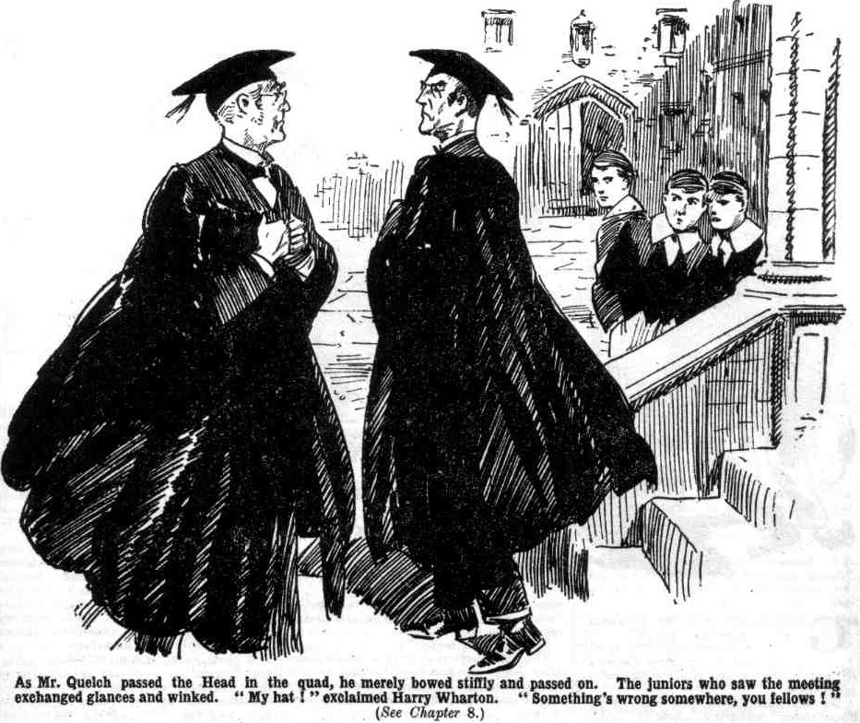
Mr. Quelch was so astonished that he stood staring after Dr. Locke until the headmaster’s stately form disappeared into the Sixth Form-room.
It was no wonder that the Remove found their Form master very thoughtful that morning.
Mr. Quetch could only conclude that the Head took a serious view of yesterday’s happening, that he was angry, and desired the Remove master to see that he was angry—that he, was, in fact, treating a gentleman of Mr. Quelch’s stantding as a culprit.
The bare thought of being treated as a culprit made Henry Samuel Quelch’s cheeks burn.
Certainly he was not the man to be so treated.
Mr. Quelch was not, like so many Form masters, wholly dependent upon his appointment in the school.
He was a careful gentleman with money. and he had private resources. More than once he had dallied with the idea of a headmastership elsewhere, for which he was well fitted in every way. It was his love of Greyfriars, his keen interest in the school that he had served well for so many years, and his personal regard for the Head, that combined to keep him where he was. He had never seriously contemplated leaving Greyfriars at all—at least, so long as Dr. Locke was headmaster.
Now he was tempted to resign.
It would be a wrench to him-—a severe wrench. But Henry Samuel Quelch was not a man to be taken into favour, and turned out of favour, at the whim of another man, even if that man was his chief.
The thought of resignation, however, was followed by a feeling of resentment amid obstinacy.
Why should he resign over a slight mistake of which the headmaster chose to take an absurdly serious view?
Other masters had been late for class many times, Mr. Quelch hardly ever. Mr. Wiggins, the absent-minded master of the Third, had been known to start on a walk when classes were due; the Head and Mr. Quelch had often smiled together over Mr. Wiggins’ absent-mindedness. Mr. Prout, the portly master of the Fifth, was late for class at least once a week, sometimes oftener. Mr. Twigg, of the Second, was nearly always late. From the Second Form-room it was not at all uncommon to hear uproarious noises at a time when classes should have been on.
Yet one disturbance in the Remove was to lead to all this fuss!
Mr. Quelch, utterly ignorant of what was really in the Head’s mind, could only conclude that Dr. Locke was either taking a childishly serious view of a small episode, or that the Head actually desired to humiliate him and to pick an occasion for a break. He even began to wonder whether it was their difference of opinion over that obscure passage in Sophocles that had caused it. They had differed—rather emphatically, it was true. Many masters, diplomatically, would have come round to the Head’s opinion, or at least affected to do so. Mr. Quelch was not that kind of a master. Sycophancy of any sort was not in his line. And hitherto, most decidedly, the Head had seemed to value him for his sincerity and candour. But—you never could tell!
If the Head wanted sycophancy he would not get it from Henry Samuel Quelch. But if he wanted to establish absolutely formal relations, Mr. Quelch was bitterly prepared to meet him halfway.
He would avoid the Head as much as he could; when he had to see him he would be coldly respectful, icily deferential. But he would not yield to his first indignant impulse and leave Greyfriars. He would not leave his life’s work because of another man’s foolish vagaries.
And so, when Mr. Quelch, taking a walk in the quad after morning class, passed the Head, he bowed as formally as the Head had done that morning near the Sixth Form room—and passed on.
And half a dozen follows, who saw the meeting, exchanged glances, and some of them winked at one another.
“I say, you fellows, Quelohy and the Head are rowing!” Billy Bunter breathlessly announced to the Famous Five, a little later.
“What?” roared the five together.
“Rowing!” gasped Bunter. “I saw them pass in the quad, and they fairly glared at one another.”
“Fathead!”
“It’s true!” yelled Bunter. “Lots of fellows saw them. Skinner thinks that Quelchy is going to get the sack.”
“Skinner had better let Quelchy hear that!” grinned Bob Cherry. “More likely the sack for Skinner then!”
“Cheeky ass!” said Harry Wharton. “I can tell you the beak gave him the marble eye.” said Bunter, “and Quelchy gnashed his teeth!”
“Ha, ha, ha!” yelled the Co., greatly tickled at the idea of Mr. Quelch gnashing his teeth.
“Well, he gritted them hard, anyhow!” said Bunter. “At least, he set his lips! He really did, you know!”
“Ha, ha, ha!”
“I say, you fellows, if Quelchy gets sacked, we may be a week or more without a Form master!” said Bunter brightly. “That means an easy time for the Remove. I hope he’ll be sacked! We might get an easygoing merchant like old Twigg of the Second. Fancy that!”
Bunter beamed at the thought.
“Or an absent-minded ass like old Wiggin. of the Third, you fellows! Fancy having a Form master who forgets to ask for a fellow’s lines.”
“Gorgeous!” chuckled Johnny Bull.
“The gorgeousness is terrific!”
Skinner strolled up, with a happy smile on his face. Skinner had witnessed the meeting of the two masters with great enjoyment.
“Looks like trouble among the beaks, you men.” he remarked. “The Head practically cut Quelchy in quad.”
“What utter rot!” said Harry Wharton sharply.
“Well, he did; ask Toddy!” grinned Skinner. “Toddy saw them. Here, Toddy, you saw the Beak and Quelchy?’
“It’s jolly queer, you chaps!” said Peter Todd. “The Head and Quelchv gave each other the marble eye. That row in our Form-room yesterday can’t have caused trouble, surely?”
“Well, the Head chipped in,” said Frank Nugent, “and Quelchy is rather touchy!”
“Believe me, Quelchy will have to go!” smiled Skinner.
Harry Wharton gave the cad of the Remove a keen look.
“You were saying something like that yesterday, Skinner.” he said. “You can’t have been playing any of your knavish tricks, I suppose?”
Skinner laughed, and strolled away. His intervention in the matter was not likely to be discovered, and certainly he had no intention of revealing it.
That afternoon all the Remove knew that the Head and Mr. Quelch were giving each other the marble eye. All the masters knew it, and it was a topic in Masters’ Common-room—a room where the smallest topic was discussed with avidity, as in most masters’ Common-rooms at most schools. Silence fell suddenly on tjhe room when Mr. Quelch came in.
The Remove master knew why perfectly well, but his impassive face gave no sign. Mr. Prout, who never could keep his attention fixed solely upon his own atfairs, ventured a condolence.
“I hear that there was some disturbance in your Form-room yesterday, my dear Quelch.” “In fact, I was considerably disturbed by the uproar.” remarked Mr. Prout.
“I regret that, sir.” said Mr. Quelch. “Such things will happen occasionally, however, as when all the Forms were disturbed by the trouble in the Fifth Form room recently, with one of your boys, named, I think, Coker.”
Mr. Prout frowned.
He did not Like receiving a Roland for his Oliver.
“I understand that the Head takes a somewhat. serious view of this matter, Mr. Quelch.” he remarked, rather tartly.
“Indeed.”
“Yes, indeed!” said Mr. Prout, more tartly than before.
“No doubt the Head has informed you o( his view.” suggested Mr. Quelch, with sarcasm.
“The Head has not spoken to me on the subject.”
“Then I fail to see how you can be acquainted with the matter at all, Mr. Prout.”
Mr. Prout breathed heavily.
“I believe it is the talk of the Form rooms and the passages, Mr. Quelch.” he answered.
“Ah,” said Mr. Quelch, “I have always considered it a mistake to take any notice of the tattle of the passages!
And the Remove master rustled out of the Common-room before Mr. Prout could thinik of a rejoinder, leaving the Fifth Form master with a purple face.
“Mr. Quelch takes it to heart!” remarked Mr. Hacker.
“His position is somewhat painful!” observed Mr. Capper.
“In his place, I should resign!” boomed Mr. Prout.
“If the Head actually reprimanded him—“
“I have no doubt he did.”
“An actual reprimand—’
“I am assured of it”
“Very painful for Mr, Quelch!”
“Very painful indeed!”
“Most unfortunate!”
All the staff had remarks to contribute; really, it might have been supposed that they were gloating over this item of news; the endless cackle of Common-room had started, and was not likely to cease until a fresh topic turned up. And Mr. Quelch, who had not been a schoolmaster for so many years without learning what a Masters’ Common-room was like, was perfectly aware of it, and he almost writhed to think of it.
THE NINTH CHAPTER.
Bunter’s Problem!
“PETER, old chap—“”
Peter Todd waved his hand, as if waving Bunter away.
“I say, old fellow—”
“Stony!” rapped out Peter Todd.
“Oh, really, Peter
“Shut up!”
“It isnt that!” howled Bunter. “It’s my lines!”
“Oh! Not a little loan, to be repaid at the Greek Kalends, or when the cows come home?” asked Peter Todd.
“No, you beast! Quelchy gave me fifty lines to-day, and I haven’t done them.” said Bunter.
Peter Todd grinned.
“Then my advice to you, my fat pippin, is to do them, and hand them in before prep. You want to be tactful with Quelchy these days!”
“I was thinking that you might do them for me, old chap.”
“ Think again!”
“You can make your fist like mine,” urged Bunter.
“I could put on enough blots and smudges and bad spelling to make Quelchy think the impot was yours.” agreed Peter. “ But you can do your blotting and smudging and bad spelling yourself, old fat man!”
“I tell you what, Peter. You do my lines, and I’ll have you home for the Easter hols. at Bunter Court!”
“Ha, ha, ha!” roared Peter.
“I mean it!” said Bunter, blinking at Peter through his big glasses. “Honest Injun, Peter! I’m no snob!”
“Eh?”
“It will rather let me down, having a chap like you home for the hols. But I don’t care! I’ll do it!”
Peter Todd ceased to laugh. and picked up an inkpot. It was so obvious what he intended to do with that Bunter vanished through the doorway of Study No. 7 at a marvellous speed. considering the weight he had to carry.
“ Beast!” he roared, from the safe side of the door.
“Come in, old fat men. The inkpot’s ready!”
“Look here, I’ve got to come in and do my lines1” howled Bunter.
“I’m not stopping you!” chuckled Peter. “In fact, I’m going to supply you with ink free of charge.”
“I say, old chap, chuck it!” pleaded Bunter.
“I’m going to chuck it when you come in!”
“I don’t mean that, you ass!”
“1 do!” said Peter cheerfully.
“Bealt 1”
William George Bunter decided not to come in. He rolled away down the Remove passage, and looked in at Study No. 4, where Herbert Vernon- Smith and Tom Redwing were already at prep. The Bounder looked up.
“Outside!” he said briefly.
“I’ve come here to speak to Redwing, not to you, Smithy!” said Bunter, with dignity. -“ I say, Redwing, old fellow.”
“Prep!” said Redwing.
“I say, do listen to a chap!” said Bunter peevishly. “I’ve got fifty lines to do for Quelchy, and they’ve got to be shown up before prep.”
“Better buck up, then,”
“The fact is, I’ve hardly enough time left. You’re a good chap, Redwing— I’ve always liked you.”
“Thanks!” said Redwing, laughing.
“Well, look here, I’ll do my lines here, and you can help me.” said Bunter. “You can make your fist a bit like mine.”
Tom Redwing hesitated; he was, as Bunter had said, a good-natured chap. But the Bounder settled the matter by picking up a hassock and taking aim at Bunter. The Owl of the Remove had just time to dodge out before the cushion flew.
“Beast!” he yelled.
“I’ll take the poker if you come in again.” called out Vernon-Smith.
“Yah! Rotter! Come out here, and I’ll lick you!”
There was a sound of a chair moving; and William George Bunter departed in haste, without waiting for the Bounder to come out. He rolled into Study No. 1, where Harry Wharton and Frank Nugent were sorting out their books for prep.
“You fellows like to do some lines for a chap?” asked Bunter.
“Thanks.” said Wharton, laughing.
“Not the least little bit in the world.” grinned Nugent.
“I say, you fellows, you might lend me a hand, after all I’ve done for you.” urged Bunter. “ Don’t be ungrateful. Remember what Shakespeare says— how sharper than a serpent’s tail it is to have a thankless tooth.”
“Ha, ha, ha!”
“Lend me a hand, Wharton, old chap—”
“I’ll lend you a foot!” said the captain of the Remove. And he did, and Bunter departed once more.
It really began to look as if William George Bunter would have to do the lines himself, if they were done at all.
But Bunter had a deeply-rooted objection to doing lines, if he could help it. Lines were work; and work had never appealed to Billy Bunter.
He rolled along to Study No. 14, which belonged to Johnny Bull. and Squiff and Fisher T. Fish. Johnny
Bull and Squiff were there, but the American junior seemed to be absent.
Bunter blinked into the study.
Fisher T. Fish, a business-like youth, was always prepared to do lines for a fellow, for a consideration. Bunter, it is true, had no consideration to offer; but he had a faint hope that Fishy might do the lines on “tick.” But Fishy was not there.
“I say, you felIlows, where’s Fishy?” asked Bunter.
“Gone to see a man in the Shell, I think.” answered Johnny Bull. “Don’t jaw—prep.”
“I wanted him to do some lines for me?” groaned Bunter. “If you fellows would like to whack them out—”
“ Fathead!”
“Fishy’s been grunting and groaning over his own lines.” said Squiff, laughing “He’s had fifty.”
“ Oh!” said Bunter.
He rolled into the study, and looked at Fisher T. Fish’s impot, which lay finished on the table. When Fishy did lines for another fellow, that fellow generally would write a few, and Fishy would keep as near the hand as he
could in doing the rest. But Fishy’s own natural scrawl was not unlike Bunter’s—-a sagged round-hand, written as fast as the pen could travel the paper. Bunter blinked at it.
“Fishy must have forgotten to take this in.” he said. “I’d better take it to him.”
“ Better leave it alone.” said Johnny Bull.
“Oh, really, Bull! I suppose I can do a kind action if I like. Fishy might be caned for being late with his lines.”
“ Rats!”
“Yah!I”
Bunter picked up the impot and rolled out of the study. He took it down to the Rag. where there were pens and ink; he did not want to go back to his own study while Peter Todd was in his present unreasonable mood. Seated at the table in the rag, Bunter made a few alterations in the imposition, which made it a little more illegible than before, and dropped a few blots, and added a smudge or two. With these improvement and additions. it needed a keen eye to detect that this impot was not William George Bunter’s own work.
It was true that Mr. Quelch had a keen eye—compared by his pupils to a gimlet for its keenness. But in a matter of this sort a certain amount of risk had to be taken. Bunter was not fond of taking risks; but an uncertain risk was better than a certain task, in his opinion. Hoping for the best, the Owl of the Remove rolled away to Mr. Quelch’s study with the impot for delivery.
What Fisher T. Fish would say, and do, when he found that his impot had been appropriated in this unblushing way, Bunter did not know. He did not think about that. At present he was thinking about satisfying Mr. Quelch. Fishy would come later. Besides Fishy could be squared by the usual payment for the lines, when Bunter’s postal- order came. Anyhow, Fishy did not matter very much.
Bunter arrived at Mr. Quelch’s study and tapped at the door. The sharp voice of the Remove master—a little sharper than usual—bade him enter.
Bunter rolled in.
Mr. Quelch was seated at his table, with a little pile of exercises before him, which he was marking. He was not at his literary work now After that unhappy occurrence in the Remove Form-room, Mr. Quelch had locked up his manuscripts — without, as was natural, missing a single unfinished sheet from among so many. He was doing Form work now—carefully, almost viciously. There should be no further occasion for fault-finding, the Remove master was bitterly determined.
He glanced up at Bunter.
“Well?”
“My lines, sir!”
Mr. Quelch held out a hand.
Bunter had hoped that he would be told to lay them on the table, to be looked at later, at the Form master’s leisure. He would have preferred not to be present when Mr. Quelch examined those lines. But the Remove master took them from him, and proceeded to examine them in his presence—just as if he was suspicious of trickery, as Bunter scornfully reflected. Billy Bunter did not approve of a suspicious Form master. Certainly, his methods would have been safer with an unsuspicious one.
The expression that came over Mr. Quelch’s face made it clear that he was, indeed, suspicious of trickery.
Bunter quaked inwardly.
Mr. Quelch looked up with a glittering eye.
“Did you write these lines, Bunter?”
“Oh! Yes, sir.”
“Oh!”
“M-m-may I go now, sir?” murmured Bunter, as the Form master began to examine the imposition still more carefully. Schoolboy scrawls were often much alike, and Mr. Quelch, though not in a happy mood or a cordial temper, did not want to be unjust.
“Wait!” rapped out Mr. Quelch.
“Oh, yes, sir!” mumbled Bunter.
He waited.
Tap!
The Remove master looked up irritably as the tap came at his door.
Billy Bunter involuntarily backed away.
“Come in!” snapped Mr. Quelch.
It was Trotter, the House page, who entered. He laid an envelope on the table before Mr. Quelch.
“From the ‘Ead, sir, and, if you please, I’m to take back an answer, sir.” said Trotter.
“Very good!” said Mr. Quelch quietly.
He took up a paper-knife and slit the envelope, and drew out the enclosed note, Trotter waiting with a stolid face. Billy Bunter’s little round eyes and big round glasses were fastened on the Form master’s face. And he fairly thrilled with inquisitiveness as he saw the change that came over the countenance of Henry Samuel Quelch.
THE TENTH CHAPTER.
Dismissed!
MR. QUELCH had forgotten Trotter. He sat with the headmaster’s note in his hand staring at it, as if he could scarcely believe what his eyes told him was written there. Astonishment was at first his feeling; it was succeeded by deep anger, which his look betrayed only too plainly. Bunter noted it, with breathless excitement, as an item of news to retail in the Rag. Even the stolid Trotter had a sense that something was wrong. Mr. Quelch’s eyes glittered, and his jaw set square and hard. Bunter would have given a great deal to have been able to read what the Form master was reading.
The Head’s note, which so astonished and angered the master of the Remove, was brief, but very much to the point. It began with “Sir.” Always, when the Head had occasion to send a note to the Remove master, it began with “Dear Mr. Quelch,” or “My dear Quelch.” There was a change now, with a vengeance.
“Sir,—I am somewhat surprised that I have not received from you an offer of your resignation. I have no doubt
that you will be as willing to offer it as I to accept it. Please send reply by bearer.
H. LOCKE (Headmaster).”
Mr. Quelch was surprised himself by the anger that welled up in his breast. This—for so trifling an occurrence—this, for practically the first fault his chief had ever had occasion to find with him. The injustice of it stung the Form master to the very quick.
For long minutes he sat staring at the note, the colour deepening in his face, his hand trembling with anger and resentment.
There had been a disturbance in his Form-room, and his resignation was demanded.. Trouble in Mr. Prout’s Form. room, only a week before, had been the talk of the school; but there had been no hint of resignation from Mr. Prout—tho Head, indeed, had appeared unconscious of the whole matter. But Mr. Quelch, it seemed, could not make the smallest slip without what amounted to dismissal descending upon him at one fell swoop. And this was the man who had been, as he supposed, his friend as well as his chief!
Mr. Quelch laid down the note at last and drew ink and paper to him. With black bitterness in his face and in his heart, he indited his reply to the Head of Greyfriars:
“Sir—I have received your note with the greatest surprise. 1 have no intention whatever of resigning my position
here. If you desire to dismiss me, that is in your power.
“ H. S. Quelch.”
Mr. Quelch sealed that note carefully in an envelope and handed it to Trotter.
“Take that to Dr. Locke, Trotter.”
“Yessir.”
Trotter shuffled out of the study and closed the door.
Mr. Quelch sat motionless, his eyes fixed on the headmaster’s note, reading and rereading it.
Billy Bunter could see that his presence in the study was utterly forgotten. He wondered whether he had better draw the Form master’s attention to himself by coughing or shuffling his feet. But the expression on Mr. Quelch’s face was so black, so bitter, that Bunter was extremely unwilling to draw his attention just then. He remained as silent as a mouse, and Mr. Quelch did not once glance in his direction.
The hapless master of the Remove was sunk in a deep and gloomy reverie.
Tap!
Mr. Quelch started out of his dark thoughts.
“Come in.”
Trotter re-entered the atidy.
“From the ‘Ead, sir,” he said, “and if you please I’m to take an answer.”
Mr. Qijeicli nodded, and took the note from him. It was shorter and sharper than the first:
“ Dr. Locke regrets that Mr. Quelch does not see his way to resign, and has no alternative but to dismiss Mr. Quelch from his present post at Greyfriars.”
The Remove master drew a deep, deep breath. He had asked for it, and he had received it. To resign was to admit, in some measure, dereliction of duty, which he had no intention of admitting in the very least. But it was in the headmaster’s power to dismiss him and the head had done so.
Dismissed!
It was a heavy blow—a crushing blow. But indignation helped Mr. Quelch to bear the blow. He wrote a brief reply, which he handed to Trotter.
“Sir,—I shall not demand, as is my right, your reason for acting with tyranny and injustice. I have no desire to serve a headmaster whom I can no longer respect. I shall leave Greyfriars at the earliest possible moment.
“H. S. Quelch.”
Trotter departed with that final message. Mr. Quelch sat like a stone image. The angry flush died out of his face, leaving it quite pale.
“Dismissed!”
That word dropped from his lips.
“After all these years! Dismissed!”
Billy Bunter trembled.
Burning with curiosity as he was, he dared no longer leave Mr. Quelch in ignorance of the fact that he was there, within hearing. He gave a fat, frightened cough.
Mr. Quelch started, and spun round towards him.
“Bunter! You - What are you doing here?”
“You—you told me to wait, sir!” gasped Bunter, in terror.
For a moment the Remove master’s eyes blazed at him. But he controlled his temper.
“Quite so,” he said calmly. “You may go now, Bunter.”
Bunter was only too glad to go.
The study door closed behind him, and the Owl of the Remove scudded away. Breathless with excitement, he tore up the staircase, and burst into the Remove passage—with news more startling and exciting than any he had ever had to tell before in the whole course of his fat career.
THE ELEVENTH CHAPTER.
Doubting Thomases!
“I $AY, you fellows!”
Billy Bunter burst into Study No. 1 in the Remove almost like a bombshell.
“I—I say—” he gasped.
Wharton and Nugent glared at him. They were at prep, and they felt that, in view of the recent happenings in the Remove, it behoved them to be very careful with prep,
Apparently it did not behove Bunter; he seemed to have forgotten prep.
“Shut up, you fat ass!” exclaimed Nugent. “ Buzz off! Shut the door after you!”
“I—1—I say—” stuttered Bunter.
“ Hook it!” rapped out Wharton.
“I—I say—grooogh!” gurgled Bunter. He had made such hot haste to the Remove passage with his startling news that he was quite winded, and could not get the news out.
“If you’re going to have a fit, hop out and have it in the passage.” said the captain of the Remove.
Groogh! Gug-gug!”
“Shy that dic. at him, Franky !”
“What-ho!”
Frank Nugent picked up the Latin dictionary.
“I—I—I say!” gurgled Bunter. “ I say, you fellows, listen to a chap! Quelchy’s sacked! Ow! Groogh!
Sacked!”
“Who’s sacked?”
“Quelchy!” stuttered Bunter. “The Head’s sacked hint. What do you fellows think of that”
“You fat idiot I”
“Oh, really, Wharton
“You burbling chump!” exclaimed Frank.
“Oh, really, Nugent “
“Go and tell your funny stories up the passage.” said Wharton. “No use for them here.”
“It’s true—”
“Fathead!”
“I’ve heard—”
“Buzz off!”
“Quelchy said so!” shrieked Bunter, greatly exasperated by this reception of his amazing news. “ Quelchy himself !”
“Quelchy said so to you?” exclaimed Wharton, staring at the Owl of the Remove.
“Yes.” gasped Bunter.
“Sort of confided it to you, what?” grinned Nugent.
“ Exactly.”
“ Oh, my hat!”
“He told me in his study.” explained Bunter. “Told me by word of mouth, you know, that he was sacked by the Head.”
“I think I can hear Quelchy telling a Lower Fourth man that he was sacked!” chuckled Frank.
“He didn’t say sacked exactly.”
“Oh, most exactly!”
“Nunno. He said dismissed.”
“Quelchy told you that he was dismissed?” demanded Wharton.
“Yes. Spoke to me like a friend.” said Bunter. “I could see that he was rather cut up, so I sympathised with him.”
“Great pip!”
William George Bunter had intended at first to relate only the facts, which were startling enough in themselves. But facts were never safe in Billy Bunter’s keeping. His fertile imagination was already at work. Already the story was growing, like Jack’s bean-stalk in the fable.
“Awfully cut up!” said Bunter, “ It quite touched me to see tears in his eyes—”
“Teara in Quelchy’s eyes!” shrieked Wharton.
“Tut-tut-tears!” stuttered Nugent.
If Bunter had stated that he had seen tears in the eyes of the bust of Socrates over Mr. Quelch’s bookcase, his statement could not have been more startling.
“Absolutely weeping!” said Bunter.
“Woo-woo-weeping!” gasped Nugent.
“Yes. poor chap! I put my hand on his shoulder, and said, “Bear up, old fellow! I was quite touched!” said Bunter.
“I think you’re quite touched!” ejaculated Wharton. “No mistake about your being touched, you potty duffer! But you’re not touched enough to call Quelchy ‘old fellow’!”
“I don’t mean that sort of touched, you silly owl! I mean, it touched my heart! I said ‘ Never mind, Quelchy’ !”
“Ha, ha, ha!” shrieked Study No. I.
“Oh, really, you fellows, if you don’t believe me—”
“Believe you!” sobbed Nugent. “Oh, my hat! Believe you !”
“He’s going!” said Bunter. “Poor old Quelch! Of course, he’s a beast, but I’m really sorry for the poor blighter, you know! He’s going! We’re going—“
“We’re going?” exclaimed Wharton.
“Yes, we’re sacked, too?”
“1 mean, we’re going——”
“Sure you mean anything?”
“We’re going.” howled Bunter— “we’re going to have a new master in the Remove. Can’t you let a man speak? I say, you fellows, fancy Quelchy being sacked—turned off after all these years, you know!”
“I can’t quite fancy it!” grinned the captain of the Remove. “I haven’t your lively fancy, old fat bean!”
“He told me——”
“Fathead! Travel along and tell some other study—only don’t let it get to Quelchy He would skin you !”
“I tell you it’s true—”
“Ass !”
And Wharton closed the door of Study No. 1, Bunter having just time to jump back into the passage. Wharton and Nugent laughed, and went on with their prep, not placing the slightest faith in Bunter’s remarkable tale.
The Owl of the Remove gasped with indignation. He had imparted the thrilling tale to Study No. 1 first, and instead of thanking him, the study had not even believed him. He rolled to the next study. in Study No. 2 Tom Brown and Hazeldene were at prep.
“I say, you fellows, Quelchy’s sacked !” announced Bunter.
“Idiot!”.
“Ass!”
There seemed to be plenty of doubting Thomases in the Remove.
In Study No. 3 Bunter found Ogilvy and Russell. They were not even interested in the news, which they regarded as an unusually wide stretch of Bunter’s well-known imagination. Ogilvy rewarded him with a whizzing dictionary, and Bunter roared and ran.
He looked into Study No. 4, and Tom Redwing laughed when he made his announcement, but the Bounder looked interested.
“How do you know?” demanded Smithy.
Redwing looked at the Bounder.
“You don’t think there’s anything in it, surety, Smithy?” he exclaimed.
“Might be. I know there’s some trouble between the two old jossers.” answered the Bounder coolly. “How do you know, Bunter?”
“Quelchy told me.” explained Bunter.
“Told you!” yellcd Vernon-Smith.
“Yes; spoke like an old friend. “I’m dismissed, after all these years, Bunter!” was what he said. His very words.”
“Ha, ha ha!” yelled Redwing.
Vernon-Smith jumped up. He had no doubt now that the Owl of the Remove was pulling his leg.
“Quite funny!” he remarked. “But when a fellow’s at prep, you shouldn’t butt in with your funny stories! Travel!”
Bunter travelled so fast, with the Bounder’s boot to help him, that he fairly flew into the Remove passage.
Bunter’s yell and Bunter faded away along the passage.
In a state of seething indignation William George Bunter rolled into his own study—No. 7. He had expected to thrill the Remove from end to end with his news; instead of which he had not found a single believer so far, and he began to doubt whether he would find any at all. But his own studymates, he considered, wLro bound to believe him— fellows who knew him so well.
But even in his own study Bunter found only disbelief—perhaps because the fellows knew him so well.
“I say, Toddy! Quelchy’s sacked!”
“Can it!” said Peter, without even looking up.
“He told me so!”
“Cheese it !”
The Head’s dismissed him! “Shut up, ass!”
“Dutton, old man!” Bunter turned, almost in despair, to his other study-mate, Tom Dutton, the deaf junior. “I
say, Dutton— “”
“Quelchy’s sacked!”
Dutton stared at him.
“Smacked! Smacked whom?”
“Not smacked — sacked!” howled Bunter. “The Head’s sacked him!”
“Yes, I think I can see the Head smacking a Form master!” said Tom. “Give us a rest, you fat duffer!”
“Sacked !“ shrieked Bunter. “Dismisssed!”
“Who’s missed ?”
“Dismissed— Quelch!” shrieked Bunter.
“I can’t make you out! Who’s missed Quelchy?” asked Dutton. “I know I shouldn’t miss him !”
“He’s turned out of the school!” yelled Bunter.
“Rubbish! If he was going to turn out a fool, he would have done it before now! What do you mean?”
“Oh dear!” gasped Bunter. “I say, you tell him, Peter!”
“Tell your own wlioppers, old fat man!” answeerd Peter Todd.
“ It isn’t whoppers!” wailed Bunter. “It’s true ! Every word the truth! Quelchy told me—”
“Ha, ha, ha!”
“ At least, I heard him say so !”
Bunter came down to the facts at last.
“Cheese it!”
The door of Study No. 7 opened, and a keen hatchet face looked in.
“Is that fat clam here now?” asked Fisher T. Fish. “Oh, hyer you are, Bunter! What have you done with my
lines?”
“ Eh—what ?”
Bunter had forgotten all about the impot he had borrowed from Fisher Tarleton Fish.
“Bull says you took my lines to give them to me. You haven’t given them to me! Where are they?”
“Oh, that’s all right!” said Bunter. “Quelchy won’t ask you for those lines, Fishy! He’s sacked!”
“What!” yelled Fisher T. Fish.
“Sacked, old chap! We’re done with Quelchy !”
Fisher T. Fish looked at Bunter as if he would bite him.
“You’ve bagged that impot !”
“I tell you it’s all right—you won’t have to do it again! Quelchy won’t ask you for any lines, now he’s sacked !”
“You—you—you—” gasped Fisher T. Fish. “You’ve bagged my impot, and now you spin me a yarn like this! Why, I—I—I’ll—”
“Here, yon keep off!” yelled Bunter.
Fisher T. Fish didn’t keep off. He rushed at Bunter and clasped him round the neck, and a bony fist jammed hard on Bunter’s little fat nose.
“Yaroooogh! Help!” yelled Bunter. “You fat clam! You pesky mugwump! Take that—and that—and that!” gasped Fisher T. Fish.
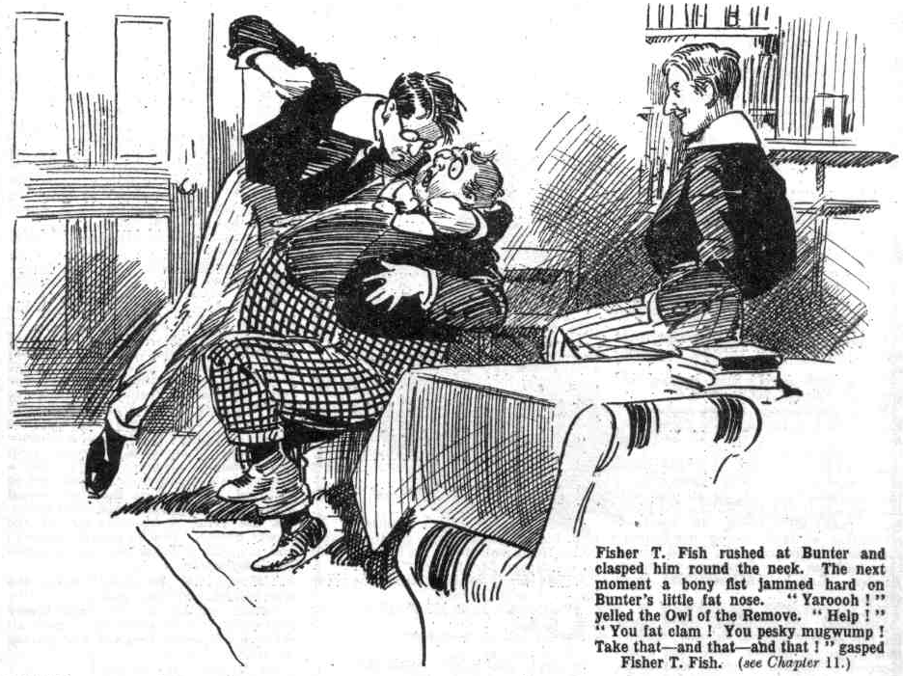 “Yow-ow-ow! Peter, old chap—
“Yarooooh! I tell you Quelchy’s sacked! Yooop! It’s all — yarooogh!— right! Oh crumbs! Whooooop!”
“Ha, ha, ha!” yelled Peter Todd.
“Grooogh! Help!”
Fisher T. Fish was punching at the Owl‘of the Remove, as if he took Billy Bunter’s fat countenance for a punch ball. WiIliam George Bunter roared and wriggled and squirmed, till Peter kindly intervened and grasped the incensed Fisher, and with a swing of his powerful arm tossed him into the passage.
“Ow! Ow! Wow!” gasped Bunter.
“Oh dear! Ow! Oh! Ow! I say, Peter, old man, Quelchy’s sacked !”
“Chuck it! And Billy Bunter, in deep indignation, “chucked it” at last. He sat and caressed his fat little nose, which had been considerably damaged by Fishy’s bony knuckles, and gave attention to prep.
When his own work was done, Peter gave the fat junior a word of advice.
“You’d better do some prep, you fat ass! You’ll get it hot and strong from Quelcby tomorrow.”
“ I’m not going to do any prep ! Quelchy’s sacked!”
“You fat chump—”
“I tell you he’s sacked—”
Peter took the Owl of the Remove by the collar, and gently but firmly knocked his head on the study table.
“Yooooop!”
Then Peter, still unbelieving, left the study, leaving Bunter rubbing his head instead of his nose.
THE TWELFTH CHAPTER.
A Shock for the Remove!
B ILLY BUNTER rolled into the Rag a little later; and in spite of of the reception which his news had met in the Remove passage, he expected to find the Rag buzzing with it.
But the Rag was not buzzing.
The juniors who had heard Bunter’s tale did not believe a single word of it ; and so far from being excited by it, they had dismissed it from their minds. Nobody was discussing the matter; and nobody heeded Bunter when he rolled in, important as the Owl of the Remove was at this moment as the only fellow who really knew!
The matter was important enough to the Lower Fourth—had the fellows believed it. A change of Form master was a very unusual happening. The Second Form sometimes had a change, Mr. Twigg often being laid up with one complaint or another, and going away for a time when a temporary master would take his place. Yet though Mr. Twigg must have caused the Head a great deal of extra trouble, it obviously never crossed the Head’s mind to dismiss him or require him to resign. For the head to dismiss a master—for any master to transgress to the extent of earning dismissal—was not only unknown at Greyfriars School, but unthinkable. Certainly the Remove would have been very interested had they believed that they were to have a change of Form-master. But the bare idea of the dismissal of Mr. Quelch was absurd.
Billy Bunter grunted discontentedly as he blinked round the Rag. The thrilling news was true—unlike so much of Bunter’s news; and really it was hard for a fellow not to be believed when he was telling the actual truth for once, by accident, as it were.
But the Owl’s fat face brightened as he saw Skinner & Co. in a group by the fire. He remembered that Harold Skinner, for some reason unknown, had surmised that the Remove master might be sacked. In Skinner, therefore, he was likely to find a believer. So he rolled up hopefully to the black sheep of the Remove.
“I say, you fellows—”
“Hallo! Where did you get that nose?” asked Skinner genially. “Is it a nose?”
“Oh, really, Skinner—”
“I gave Bunter that nose,” growled Fisher T. Fish, “and I guess I’ll him another if Quelch comes down on me about my lines!”
“My hat! Then he’ll have two!.
“Ha, ha, ha!”
“Quelchy won’t come down on you, silly, skinny ass!” snapped Bunter. “He won’t come down on any of us
any more.”
“ Eh? How’s that, umpire?” asked Skinner.
“He’s sacked.”
“ Quelchy sacked?”
“Just that !“
“What utter rot!” said Snoop.
“ Piffle!” said Stott.
But Skinner’s eyes were gleaming. Bunter had been right in expecting to find a believer in Harold Skinner. Skinner had his own reasons for expecting to hear news of that kind sooner or later.
“Tell us how you know. old fat man.” said Skinner.
“I was in his study with my lines—
“My lines, you mean, you fat clam!” hooted Fisher T. Fish.
“Oh, shut up, Fishy! I was in his study, when Trotter came in with a note for the Beak. Quelch sent an answer, and then Trotter came back with another note—notice of dismissal.”
“ You saw it?”
“ Quelchy told me.”
“Quelchy told you he was sacked?”
“That’s it!
“He was quite—quite overcome,” said Bunter. “ Leaning on my shoulder, he said—”
“ Quelchy leaned on your shoulder?” gasped Snoop.
“Yes—leaning on my shoulder, he said in a faint voice, ‘I am dismissed, after all these years!” I said. ‘ Buck up, Quelchy!”
“ You—you—you said ‘ Buck up, Quelchy’ ?” babbled Snoop.
“My very words! He cried—”
“Cried?” shrieked Skinner.
“Cried on my shoulder, like a child,” said Bunter, “ I said, ‘ Never mind, old chap! Bear up!”
“Ha, ha, ha !“
“Blessed if I see anything to cackle at!” said Bunter crossly. “I can tell you, it’s jolly serious for Quelchy. All right for us, of course—I’ve done no prep. He won’t ask you for any lines, Fishy. There won’t be any classes to-morrow! Something like—what?”
“Now tell us what really happened.” suggested Skinner.
“Ha, ha, ha!”
“You might have told us this before prep, you fat idiot! If I’d known Quelch was going I wouldn’t have done
any. I haven’t done much.”
“You don’t believe it, Skinner?” exclaimed Stott, staring at him.
“1 believe that Quelchy is sacked. The rest is lies, of course.”
“Oh, really, Skinner—”
“Tell us what really happened, you fat fool!” went on Skinner. “How do you know that Quelchy has got the push?”
“I’ve told you !” howled Bunter.
“Tell us again—and keep to the facts.”
Skinner proceeded to question the Owl of the Rrmove and gradually elucidated what really had occurred. Remove fellows gathered round and listened. The fact that Skinner believed the news had a good deal of effect on the other fellows, Skinner’s sharpness being well known. And when Billy Bunter’s story was bolied down, so to speak, to the actual facts, it sounded a good deal more probable. Skinner’s eyes glistened.
“It’s the boot for him right enough.” he said. “ Well, there’ll be a whole lot of dry eyes in the Remove when he clears.”
“ I don’t know about that,” said Harry Wharton sharply. “If it’s true. I’m sorry enough to hear it.”
“The sorrowfulness is terrific.” said Hurree Jamset Ram Singh. “ The esteemed Quelchy has not had justice or fair play.”
“ It can’t be true!” exclaimed Bob Cherry. “The Head would never dismiss a master like that! What has Queleby done?”
“ Only that shindy in the Form-room.”
“WeIl, that was our fault, not Quelchy’s. All he did was to forget class for once; and the other masters forget sometimes—especially old Wiggins; he’s always forgetting something.”
“Jolly queer that the Head should come down heavy like this on Quelchy, if it’s true,” remarked Hazeldene. “He was more friendly with Quelchy than with any of the other masters.”
“It can’t be true !”
“Oh, really, you fellows —”
“It’s true enough,” said Skinner. “ I’m glad to hear it, for one. Old Quelch is a good deal too free with the cane in the Form-room, for my taste.”
“ Look here, Skinner, what do you know about it?” exclaimed the captain of the Remove.
“Only what Bunter’s told me, of course.”
“ You were saying something of the kind yourself yesterday—”
“ Merely expressing a hope, which turns out to have been a winner.” said Skinner blandly. “ How could I know anything about it personally!”
It’s jolly odd if Mr. Quelch is dismissed after what you said.” answered Wharton. “ If it were possible for you to have played any rotten trick, I should think you’d done so.”
“Thanks!” sneered Skinner.
“But you couldn’t make mischief among the masters as you do among the follows.” said Harry, knitting his brows. “All the same. I believe you know something about it.”
“ Believe what you like, old bean.” said Skinner, with a yawn. “I fancy Bunter’s yarn is true. I’m going to see Quelch7c”
“Going to ask him?” gasped Snoop.
Skinner chuckled.
“Not quite; I don’t want to be bitten in two! But a fellow can go to his Form master to ask a question about translation—in fact, Quelchy likes it. And a fellow can watch his face while he’s asking.”
“Better leave him alone,” said Squiff. “If this is true, Quelchy will be feeling pretty rotten now.”
“Very likely.” agreed Skinner. “Looking rotten, too, I fancy—and that’s what I’m going to see.”
And Skinner left the Rag.
He came back again in about ten minutes, grinning serenely. A dozen fellows looked at him with mute inquiry.
“It’s true enough.” said Skinner. “Quelchy looked a white as chalk. He’s frightfully cut up. He was sorting books out of his bookcase and making a stack of them on his table: Getting ready to pack.”
“1 don’t believe it!” growled Bob Cherry.
“Go and see for yourself, old bean.”
“Oh, rats!”
“I guess I’ll mosey along.” said Fisher T. Fish. I can make an excuse about my lines for butting in. I guess I want to know,”
And Fisher T. Fish made his way to Mr. Quelch’s study and tapped at the door.
“Come in!”
Fishy entered.
Mr. Quelch was standing before his bookcase, sorting out books. His face was not white as chalk, as Skinner had said; but certainly it was pale, and looked worn. Fisher T. Fish was a little startled; he had never seen his Form master look like that before.
“What is it, Fish?” asked Mr. Quelch very quietly.
“My—my lines, sir.” stammered Fish. “I—T haven’t done them, sir—”
“You are excused the lines, Fish. You may tell all other boys in my Form that all impositions are cancelled.” said Mr. Quelch.
“Oh, thank you, sir!” gasped Fish.
“He retired from the study and went back to the Rag. There he announced Mr Quelch’s message.
“It’s true, then!” said Harry Wharton.
“Cancelling the impots must mean that he’s going,” said Hazel. “Good luck; I had a hundred to do!”
“I had a hundred.” grinned Bolsover major. “I say, this is jolly good news!”
“I guess I’m sorry for him.” said Fisher T. Fish soberly. “He looked cut-up, I guess. It isn’t playing the game for the beak to come down on him like this!”
“I can’t understand it,” said Harry Wharton. “Dr. Locke couldn’t be so harsh and unjust as to dismiss a master for what happened in our Form-room yesterday. There must be something else,”
“What else could there be?” asked Nugent.
“Blessed if I know!”
“Up to that time they were on good terms,” said Hazeldcne. “I saw them jawing yesterday morning, cheery as anything. It’s the shindy in our Form-room that’s done it.”
Wharton frowned.
“Looks like it.” he said. “But if that’s so, it’s rotten unjust; and I can’t understand the head acting like that”
“The injustice is terrific, and the esteemed sympathy with Quelchy is very great.” said the Nabob of Bhanipur.
“Look here, you men!” It was Lord Mauleverer who spokc. His lordship had been listening so far without a word. But his noble brain had been at work. “Look here, you men, this is too thick. It’s simply sickenin’ for a man who’s been here so long to be turned off like this. The Head can’t have a right knowledge of what happened yesterday. He may think that Quelchy has grown careless, or undutiful, or somethin’, and that he’s often forgettin’ classes, or Ieavin’ the Remove to run wild. He must be actin’ under some mistake, or he wouldn’t be actin’ like this; the Head’s a gentleman.”
“Right on the wicket, Mauly.” agreed Bob Cherry.
“If the Head’s makin’ a mistake, what about settin’ him right?” asked the schoolboy earl.
“Oh; my hat!”
“We’re to blame for havin’ played the goat in the Form-room yesterday,” said his lordship. “If Quelchy’s sacked, it’s our fault. It’s up to us to chip in and put the head right.”
“Is this your funny turn, Mauly?” grinned Skinner.
“You shut up, Skinner!” growled Johnny Bull. “Mauly’s right, you fellows. If this really turns out to be true, it’s up to us to go to the Head and put him right. He must be making some mistake.”
“Hear, hear!”
Harry Wharton nodded.
“Mauly’s right,” he said. “Old Mauly generally is right when he takes the trouble to talk at all. We shall know for certain to-morrow. And if Mr. Quelch really is dismissed we’ll go in a body to the Head
“Leave me out!” sneered Skinner.
“I mean all the decent chaps will go in a body to the Head.” said the captain of the Remove. “That’ll leave you out, Skinner.”
“Ha, ha, ha!”
“It’s a go!” said Bob Cherry. “Quelchy is a bit of a Tartar at times, but he’s a good man; and even when he licks us, I dare say he fancies it’s for our own good. Masters do, you know. We might go a jolly long way without finding a better Form master. Why, I’ve always looked on him as a fixture— like old Gosling, or the Head himself, or the gargoyle on the waterspout
“Ha, ha, ha!”
Billy Bunter’s news had had its effect at last—now that it was more or less verified. the Remove were undoubtedly in a state of excitement when they went to their dormitory that night.
Long after lights-out the Removites were discussing the dismissal of their Form master, and almost all the Form agreed that that dismissal was an act of high-handed injustice, only to be excused on the ground that the Head as under some misapprehension. That, indeed. was the truth of the matter, if the juniors had only known it. But there was only one fellow in the Form who knew—and Harold Skinner was very careful to keep his own counsel.
THE THIRTEENTH CHAPTER.
Harry Wharton & Co. Mean Business!
GREYFRIARS knew it the following morning; from end to end of the school it was known that Mr. Quelch was going.
The news was almost incredible.
Masters’ Common-room fairly buzzed with it.
It was ouch a topic as that apartment had rarely had. It thrilled Common-room.
Every man on the staff sympathised with Mr. Quelch.
While the Remove master had simply been under the frown of the great man, as it were, many of the staff had been rather inclined to rub it in.
Mr. Prout especially had never seen any reason why the Head should select the Remove master from all the staff for personal friendship and for his right-hand man—Mr. Prout, in his own estimation at least, being much more suitable for selection. Mr. Prout, therefore, had not been displeased when the Remove master fell from his high estate.
But matters were different now.
Dismissal was quite another affair. So far as the staff knew, Mr. Quelch had given no offence, save that single instance of neglect of duty that single instance of forgetfulness, which had led to a riot in the Remove Form-room.
A kind and considerate chief like Dr. Locke was not expected to issue even a reprimand for such an occurrence; he was expected to leave it to the good sense of the master concerned not to allow such an incident to recur.
Apparently the Head was not so kind and considerate as his staff had always believed.
Instead of a reprimand, which would have been considered too severe, the Head had decided on dismissal which was an act of severity out of all reason.
Petty jealousies and resentments in Masters’ Common-room were banished in the presence of catastrophe.
For it was a catastrophe; all the staff knew that. Greyfriars had been so long Mr. Quelch’s home that his work there was practically his life’s work; cut adrift from the old school he had served so long and so well, he was like a rudderless ship, drifting.
Sympathy for Mr. Quelch, indignation at the Head’s action, filled Common-room with eloquence.
Mr. Capper even suggested a remonstrance to the Head; though that suggestion was not taken up.
The Head was, after all, the Head, and he was not a man to be remonstrated with, when he had decided. All the Common-room agreed that his act was an act of flagrant injustice; that it destroyed the confidence that had hitherto obtained between staff and chief. But they had no power to intervene, and they knew it. Indeed, if the Head was developing unreasonable tyranny, it behoved the staff to walk very warily in dealing with him, and they knew that, too. A post at Greyfriars was a good and well-paid post; and no other member of the staff desired to follow the Remove master into the wilderness.
All the Forms discussed the startling news, and in every Form there was surprise, and some indignation. Wingate of the Sixth had been requested by the Head to take charge of the Remove for a few days until a new master was appointed. Wingate almost fell down in his amazement when Dr. Locke made that request. It was his first intimation of the present state of affairs.
“Is Mr. Quelch leaving, sir?” he stuttered.
“Yes, Wingate.”
“But, sir—” gasped Wingate.
The Head’s face was cold and severe.
“That is not what I desire to discuss with you, Wingate” he said, in an icy voice.
“Oh! No! No, sir! Of—of course not !” stammered the Greyfriars captain.
“I desire you to take charge of the Remove for a few days. I shall rearrange the time-table, and the French master and the mathematics master will take the Lower Fourth for additional sets. For the rest. I think I can trust you with the Form, Wingate.”
“Oh, certainly, sir!” said Wingate.
“That is all, Wingate. Thank you!” said the Head, in his most stately manner.
And the prefect withdrew, utterly astonished.
“Something or other’s happened.” he told his friend Gwynne of the Sixth. “ The Head looked like an iceberg when he mentioned Mr. Quelch.”
“That shindy in the Remove the other day—” said Gwynne.
“If it’s only that, the Head is acting very badly.”
“What else could it be?”
“Goodness knows.”
Wingate was quite perplexed.
“I say, you fellows, Wingate’s taking us this morning.” Billy Bunter announced to the Remove follows after breakfast. “He’s put up on the board.”
“That settles it, then.” said Bob Cherry. “Quelchy’s really going.”
“It’s a rotten shame!” said Johnny Bull.
“The shamefulnes is terrific!”
“What about goin’ to the Head?” asked the Bounder. “I agree with Mauly. After all. Quelchy’s our Form-master. I’ve ragged him enough, and he’s taken it out of me often enough: but this is too thick. I never thought the Head would do a rotten thing. But this is rotten.”
“Sheer tyranny!” said Frank Nugent hotly.
“I’m going to speak to Mr. Quelch.” said Wharton. “We must have it officially before we butt in.”
“He wasn’t at brekker.” said Squiff. “He breakfasted in his own study, I think. That proves it.”
“He doesn’t want to face us, under sentence of the jolly old sack.” grinned Skinner.
“Shut up, Skinner!” howled a dozen fellows.
Skinner shrugged his shoulders and shut up. Most of the Romovites, now that they were to lose their Form-master, realised that they were rather attached to Mr. Quelch. They had always respected him; the fact that he would stand no nonsense from them made them respect him. But a good many fellows were surprised to realise now that they liked him, too.
Severe master as he was, there were few fellows in the Form who had not received acts of kindness from him, in one time or another; scanty as his leisure was, he was always willing to help a fellow who needed help.
And he was being treated with injustice. He was down now, and there are few fellows who do not sympathise with a man when he is down.
Harry Wharton went to the Remove master’s study. As head-boy of the Form, he had a right to speak. Mr. Quelch had not been seen that morning by his boys ; and the notice on the board showed that they were not to see him in the Form-room. Almost all the Remove had joined in the idea of going to the Head in a deputation ;
obviously it was necessary to place the matter beyond a shadow of a doubt before that step was taken.
Wharton tapped at Mr. Quelch’s door.
“Come in!”
Mr. Quelch’s voice was firm as usual, but pitched unusually low. Harry Wharton entered the study.
He was shocked at the change in the Remove master’s looks.
Mr. Quelch was not a man to wear his heart on his sleeve ; he was quiet and self-contained, and he had not intended to show a sign of the trouble and distress that he was feeling. His manner was calmness itself. But he could not disguise, perhaps he was even unaware of, the pallor in his face, the deepening wrinkle in his brow, the worn droop of his mouth. Harry Wharton felt a throb of compassion. It had never occurred to him that the time would ever come, when he would compassion- at the grim, severe master of the Lower Fourth. But he pitied him now; and mingled with his pity was a growing indignation.
“What is it, Wharton?” asked the Remove master, very gently.
“Please excuse me, sir.” said Harry respectfully. “It is being talked all through the school that you are leaving us, sir.”
Mr. Quelch’s lips twitched.
“That is correct, Wharton!”
“I’m sorry, sir! Every fellow in the Remove will be sorry you’re leaving, sir.”
“Thank you, my boy!” Mr. Quelch’s voice trembled for a moment, but it was firm again as he went on : “ I am leaving somewhat suddenly, Wharton—I have a few preparations to make, but later in the day I shall be gone. I am glad you have come in—I desire to say good-bye to you, and through you, to all my Form—my late Form. I have always tried to do my duty by my Form—I have tried to be a friend and helper to my boys, as well as their Form-master. Whether I have succeeded I cannot say—but I hope that my boys will try to remember me with kindness.”
“Oh, sir,” said Harry. He felt a lump in his throat, as he realised, dimly. that he was in the presence of a tragedy.
“That is all, my boy.” said Mr. Quelch. “ I am sorry to be leaving you—very sorry, indeed!”
“It’s our fault, sir.” said Wharton miserably. “ If we’d behaved ourselves the other day. this wouldn’t have happened. I—I hope you’ll forgive us, sir —we never meant any harm.”
The next moment he could have bitten off his tongue for having uttered the words; which had revealed to Mr. Quelch the fact that his boys knew that he had been dismissed. The Form-master himself had spoken only of leaving. For an instant, a flush showed in Mr. Quelch’s cheeks. But he answered the junior kindly.
“I am sure of that, Wharton. My Form acted thoughtlessly—boys will be boys, and the fault was mine. But I gather from what you say that it is reported in the school that I am under dismissal.” In spite of his self-control, Mr. Quelch’s voice shook. “It is perfectly true, Wharton—I had not desired it to be discussed, but it is certainly
correct. But you must not think that the fault was yours, or that of your Form. Now good-bye, my boy!”
“It’s a shame, sir!” broke out Wharton passionately.
“You must not say that, Wharton! Good-bye!”
The Remove master shook hands with Wharton, and signed to him to leave the study.
Wharton went out with a flushed face.
He went to the Rag, where all the Remove had gathered. Hs look, as he came in, was enough for them.
“Officia ?” asked Bob Cherry.
“Yes.”
“He’s going?”
“It’s a rotten shame!”
“And if he goes, the Head’s going to know that we think it a rotten shame!” said Wharton, with a flash in his eyes. “I’m going to the Head now. All you fellows follow on.”
“Yes, rather!”
“Hear, hear!”
“What rot!” jeered Skinner. “Oh! Ow! Leggo! Yaroooh! Whoop !”
Skinner went spinning across the Rag and sprawled on the floor. He sprawled
there dizzy and spluttering.
“Want any more, you rotter ?“ bawled Bob Cherry.
“Ow! Grooh! Ow!”
“Shut up, you cad!”
“Come on, all of you!” said the captain of the Remove, and almost the whole Form followed him. Outside the Rag they came on Wingate of the Sixth.
“You kids forgotten Form?” asked the captain of Greyfriars. “Get off to the Form-room. Can’t you tell the time?”
“We’re going to the Head,” said Harry.
“What? You’re going to your Form-room!”
“We’re going to the Head, to speak to him about Mr. Quelch,” said the captain of the Remove determinedly.
Wingate stared at him.
“You’re doing nothing of the kind!” he rapped out.
“We are!”
“And you jolly well shan’t stop us!” roared Bob Cherry.
“What?”
“We don’t want any trouble with you, Wingate, but we’re going to the Head.”
said Harry Wharton. “Let us pass, please.”
“You don’t want any trouble?” repeated Wingate, almost dazedly. “Do you understand that you’re talking to a Sixth Form prefect?”
“I don’t care!”
“You don’t care?” stuttered Wingate.
“No, I don’t—not a rap!” retorted Wharton. “Will you let us pass?”
“Get into your Form-room at once!”
“Rats! Come on, you men!”
And the Remove, led by Wharton, rushed on. and Wingate of the Sixth
went spinning out of the way under that rush, powerful fellow as he was.
“Good gad!”
Wingate sat up, gasping.
The Remove were gone.
THE FOURTEENTH CHAPTER.
Nothing Doing!
DR. LOCKE was on his way to the Sixth Form-room.
His face was clouded.
The blow which had fallen so heavily on Mr. Quelch had been a blow to the Head also.
He had not chosen to see the Remove master; it had been less painful to him to settle the matter by an exchange of notes. He did not wish to see Mr. Quelch again—now or ever.
But he was feeling it, all the same. He was losing the man whom he had always regarded as the most valuable member of his staff; and he was losing an old friend. True, what he had seen written in Mr. Quelch’s hand seemed to prove that that friendship, on Henry Quelch’s part, had been a pretence—a delusion and a snare. But real or unreal, it was a loss, and the Head missed
it. He was angry with himself for missing it angry with Mr. Quelch for having proved unfaithful and untrustworthy, and altogether, that morning, the usually kind-hearted old gentleman was in a very disagreeable mood. Not in the very least in a mood to take calmly any recalcitrance on the part of the Lower School. It had not even occurred to him that Mr. Quelch’s Form might resent his high-handed treatment of Mr. Quelch. He was now to learn that.
He halted, in sheer amazement, at the sight of a mob of juniors in the Form-room passage near the Sixth Form door. What they were there for he did not yet know; but his temper was already irritated, and it was still more irritated at the unexpected sight. Really, it seemed us if Mr Quelch’s Form had no sense of propriety at all. No doubt it was time Mr. Quelch gave place to a new man with new methods.
Before any of the juniors could speak the Head rapped out at them sharply:
“What are you doing here?”
“If you please, sir,” began Harry Wharton, in his most respectful manner.
The Head interrupted him.
“It is time for your first class. Go to your Form-room immediately.
“May we speak to you first, sir?”
“You may do as I tell you.” said the Head harshly. “ I have appointed a prefect, to take charge of you until a new Form master arrives here. Mr. Quelch’s departure makes no difference. You may go.”
Wharton drew a deep breath.
It was no light matter to face the Head, and oppose his lofty will, when he was angry. Already two or three fellows in the rear were treading quietly away.
But the captain of the Remove stuck to his guns. He had come there with something to say, and he was determined to say it.
“We want to speak to you about Mr. Quelch, sir.”
“What, what?”
The Head stared in great astonishment.
“Mr. Quelch is our Form master, sir and we shall all be sorry to lose him,” sald Harry,
“Indeed! No doubt you anticipate that a stricter discipline will be kept by a new Form master?” snapped the Head.
“Sarc!” murmured Bob Cherry.
“Oh, no, sir!” said Harry. “But we think you don’t know, sir, what really happened the other day.”
“What?”
“You seem to blame Mr. Quelch, sir, but every fellow in the Remove will own up that what happened was all our fault.”
“Bless my soul !” exclaimed the Head.
“It’s the first time this term, sir, that our Form master has ever been late for class,” said Wharton. “We thought you did not know that, sir. It’s happened only once, and—”
“That will do, Wharton.”
“But, sir, what happened was all our fault. Mr. Quelch caned the whole Form for it !”
“We kicked up a row, sir,” said Bob Cherry. “We never meant any harm. But you can’t blame our Form-master for it.”
“The harmfulness is ours, my esteemed sir!” said Hurree Jamset Ram Singh.
Dr. Locke knitted his brows.
“This is not a matter that 1 can discuss with juniors, as you know very well.” he said. “I have listened to you patiently. Now go to your Form-room.”
“But, sir—”
“Silence, Wharton! Do you dare to bandy words with your headmaster?” exclaimed Dr. Locke angrily.
Wharton lit his lip hard.
“Excuse me, sir,” drawled Lord Mauleverer. “We all thought, sir, that you did not know the rights of the matter, sir, and we came here to explain, sir, before Mr. Quelch left.”
“I understand, Mauleverer. Now go to your Form-room.”
“Is Mr. Quelch stayin’, sir?”
“What? Certainly not!”
“But now we’ve explained that Mr. Quelch was not in fault, sir, and owned up that we were to blame—”
“I am well aware that you boys were to blame for the riot in the Remove-room. That is enough. Go !”
“We’re entitled to an explanation, sir,” said Lord Mauleverer coolly. “if it’s admitted that we were to blame for the row, sir, may I ask why our Form-master is sent away?”
“You may not !“
“We’ve a right to know, sir.”
Dr. Locke fairly blinked at Mauly. So did the Removites. It was utterly unlike his lazy lordship to take a forward place in any proceedings. Generally he gave the impression of being too tired to live. On very few occasions did Lord Mauleverer display anything like energy. Those occasions were only when somebody else’s welfare was concerned. Now he was coming out in a way that astonished the Lower Fourth. Wharton. the captain of the Form, had been silenced, for the moment at least. and Lord Mauleverer rushed into the breach, as it were..
“What did you say, Mauleverer?” exclaimed the Head at last.
The coolness of the schoolboy earl seemed to have taken his breath away.
“We’ve a right to know, sir,” said MauIeverer.
“Upon my word!”
“We respect Mr. Quelch, sir, and rather liked him, in a way.” said lord Mauleverer, “He makes us work jolly hard, but we don’t blame him for that; he thinks it’s his duty. I dare say Form masters are like that, and a fellow ought not to blame them. So far as we can see, sir, Mr. Quelch is bein’ treated with injustice—”
“What?”
“Injustice, sir.”
“How dare you say such a thing to me, Mauleverer?”
“If it’s not the truth, sir, I’m sorry. If it’s the truth, I don t see any harm in sayin’ it.”
The Head breathed hard and deep.
“You boys are seeking to interfere in a matter that does not concern you.” he said. “I warn you that my patience is exhausted. Go back to your Form-room.”
“Is Mr. Quelch staying, sir?” persisted Mauleverer.
“ No.”
“Then we think it’s a shame, sir!”
“A-a-a-a what?”
“A shame!” said his lordship deliberateIy. “A rotten shame, sir! All the Form thinks the same!”
Dr. Locke’s face was quite pale with anger.
“Loder!” he called out.
Half a dozen of the Sixth were looking out of their Form-room, Loder among them.
“Yes, sir,” said Loder.
“Kindly bring me a cane.”
“Certainly, sir.”
Loder brought a cane in record time. Dr. Locke swished it.
“You will bend over, Mauleverer.”
“I’m bound to obey your orders, sir.” said Mauly cheerfully, and he bent over, and received three severe cuts, under the grim stare of the Remove.
Lord Mauleverer was not supposed by the Form to be a hardy fellow. But he did not flinch under the castigation. and he uttered no sound.
The Head handed the cane back to Loder.
“Now go to your Form room!” he snapped his eyes glinting at the Remove.
“Very well, sir,” said Lord Mauleverer. “I’m bound to say, though, that if my Form master leaves Greyfriars I leave, too!”
“Silence!” thundered the Head.
And he stalked into the Sixth Form room with a frowning face.
Slowly the Remove trailed away to their Form-room. The appeal had been made to the Head, and it had failed, and it was a very angry and excited Form that gathered in the Remove-room
THE FIFTEENTH CHAPTER.
In Revolt!
“GOOD old Mauly!”
“Ow!” said Mauly, with a wriggle.
“Good man!” said Harry Wharton. There’s nothing doing, but Mauly put it to the Head in plain English, at least.”
“Yes, rather!”
“The plainfulness was terrific’” grinned Hurree Jamset Ram Singh. But the esteemed Quelchy is going, all the same.”
“It’s a rotten shame!” said Wharton, his eyes gleaming. “I’ve a jolly good mind—”
He paused.
“Say on, O king!” chuckled Bob Cherry.
“I just don’t see having our Form master chucked for nothing, and letting a prefect take us.” said Harry. “If the Head chooses to leave us without a master, and a good master, he must expect some trouble. What price shifting Wingate out when he comes to handle us?”
“What?”
“Wingate’s a good chap, and we all like him; but it’s the principle of the thing.” said the captain of the Remove.
“If we show the Head that we mean to stand by Quelchy, he may see reason.”
“Hem? He may.”
“Anyhow, it will be a lark.” said Bolsover major. “I’m for a shindy!”
Bolsover major, as a matter of fact, always was for a shindy, if there was any chance of one. But on this occasion he found most of the Form in agreement with him.
“May a fellow speak a word, you men?” inquired Lord Mauleverer.
“Go it, Mauly!”
“Quelchy’s getting injustice and rotten treatment,” said Maulevcrcr. “I’m standin’ by him to the last shot in the locker. If he goes I go, as I told the Head.”
“You can’t, you ass!” said Squiff.
“I can and I will,” said his lordship calmly. ‘Fair play’s a jewel, and Quelchy isn’t getting fair play. Tho Head’s got to see reason. If Mr. Quelch leaves Greyfriars, I leave, and chance it. I suggest that the whole Remove walk out of the school after Mr. Quelch.”
“Oh, my hat!”
“That will mean floggings,” said Nugent.
“Let it!”
“It may mean bunkings.”
“The jolly old Beak can’t bunk a whole Form. If he does, we’ll go in a body.” said Lord Mauleverer. “My idea is that it’s up to us to stand by a man who’s always treated us decently, and who’s bein’ treated rottenly and unjustly. We’ll begin by makin’ it clear that we’re not goin’ to be taken by a prefect.”
“Hear, hear!”
“Let the Head send Mr. Quelch here, and we’ll be as good as gold and as meek as lambs. Until we get Quelchy back we let things rip. The motto of this form is goin’ to be W.W.Q.”
“What on earth does that mean?”
“We want Quelchy!” explained Lord Mauleverer.
“Oh, my hat! Bravo!”
Harry Wharton’s eyes sparkled.
“Mauly’s right!” he said. “Mauly’s given us a lead, and we’re going to follow it. We back up Mauly.
“Mauly’s woke up just at the right time.” chuckled Bob Cherry.
“Ha, ha, ha!”
“Hallo, hallo, hallo! Here comes old Wingate!” said Bob Cherry.
And the Remove faced the door as the captain of Greyfriars came in, with his official ashplant prominent under his arm. Wingate evidently foresaw that the ashplant might be required, in the present excited state of the Lower Fourth.
The Remove eyed him grimly. Hardly a man was in his place; the juniors stood in a crowd in the middle of the Form-room.
“Take your places!” rapped out Wingate.
“Sorry, old man” said Bob Cherry. “Nothing against you personally, you know; but we’ve decided to cut class till Mr. Quelch comes to take us.”
“Mr. Quelch leaves Greyfriars to. day,” said Wingate, “and it’s no business of yours, anyhow. Sit down, the lot of you!”
“No fear!”
“Rats!”
“The ratfulness is terrific!”
“Go and eat coke!”
Wingate slid his ashplant down into his hand, and to a buinesslike grip
on it.
“Wharton!” he rapped out.
“Yes, Wingate?”
“You’re the ringleader in this!”
“I’m captain of the Form, at any rate, and ready to lead.” answered Harry Wharton coolly. “But the Form don’t need much leading. We’re all of the same opinion.”
“I shall make an example of you. Bend over that desk!”
Harry Wharton laughed.
“I’m not deaf !”
“Bend over, then!”
“Rats!”
“You refuse?” roared Wingate.
“ Yes, rather!”
“You refuse to obey a prefect?” exclaimed the Greyfriars captain.
“I refuse to obey anybody except Mr. Quelch,” said Wharton steadily. “I will obey my Form master.”
“Mr. Quelch is no longer your Form master.”
“I don’t admit that.” answered Wharton coolly.
“You young ass—”
“We want Quelchy!” roared Bob Cherry.
“Hear, hear!”
“I order you to bend over, Wharton!” shouted Wingate.
“You can order till you’re black in the face, but no man here will obey your orders!” retorted Wharton. “We want Quelchy.”
“Bravo!”
“Hop out, old man,” advised Lord Mauleverer. “We don’t want to hurt you, Wingate, old bean—”
“Hurt me!” gasped Wingate, hardly able to believe his ears.
“Yass. But get out while you’re safe!”
Wingate breathed hard. He was a good-tempered fellow, but his temper was at boiling-point now.
“I’m going to cane every fellow here who’s cheeked me.” he said. “I’m beginning with you, Wharton. For the last time, bend over!”
“Bow-wow!”
“Rats!”
“Get out!”
“Go and eat coke!”
Twenty voices shouted defiance in chorus. The Remove were wildly excited now, and the prefect’s ashplant had lost its terrors.
Wingate, however, Wingate did not quite realise that. He made a stride at Harry Wharton, and grasped him by the shoulder, with the evident intention of bending him over by force, and applying the ashplant.
“Hands off, Wingate!” said the captain of the Remove, between his teeth.
“Hands off, you ass!” shouted Bob Cherry.
“Rescue, Remove!”
There was a rush. Wingate of the Sixth had to release Wharton, to face that torrent of excited fellows. Almost before he knew what was happening, his ashplant was wrenched away, and a dozen pairs of hands were laid on him on all sides.
“Chuck him out!” roared Bob Cherry.
“Hurray!”
“You young scoundrels!” panted Wingate, struggling frantically in innumerable hands. “You’ll be flogged for this!”
“Rats!”
“You’ll be sacked!” roared Wingate.
“Shut up, old bean—you talk too much!” said Peter Todd. “Now, then, all together—heave!”
“Ha, ha, ha!”
Wingate, in a towering rage, struggling wildly, but powerless in the grasp of so many hands, was dragged to the door. He went in a breathless, struggling heap, resisting vainly. Hazel opened the door; and the crowd of juniors hurled Wingate into the Form-room corridor.
Crash! Bump!
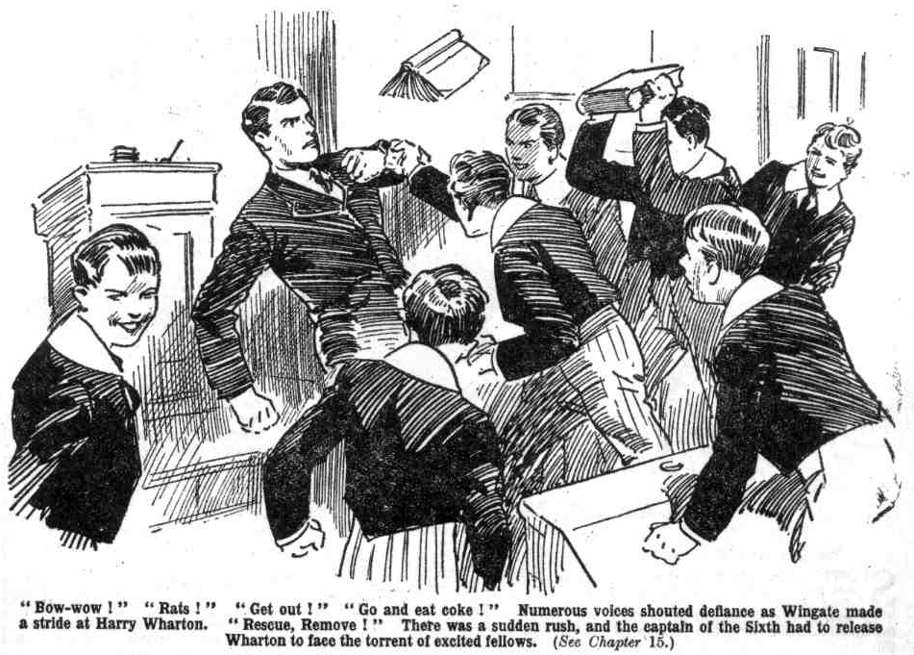
Wingate sprawled in the passage, disheveled, breathless, dizzy. He sat up there and blinked dazedly at the doorway, crammed with yelling juniors.
“Ow!” he gasped. “Oh!”
“Get out of it!” roared Bolsover major. “If you hang about here, we’ll come out to you!”
“You—you—you—“ gasped Wingate. “I shall have to report this to the Head—”
“Report, and be blowed!”
“Tell the Head, and tell him we want Quelchy!”
“Down with the prefects!” roared Bolsover major.
“Hurray!”
Wingate picked himself up dizzily and limped away, gasping for breath. The door of the Remove room slammed after him. In that apartment, the wildest excitement reigned: while Wingate limped breathlessly away to the Sixth Form -room, to report to the Head that the Remove were still in revolt.
THE END.

