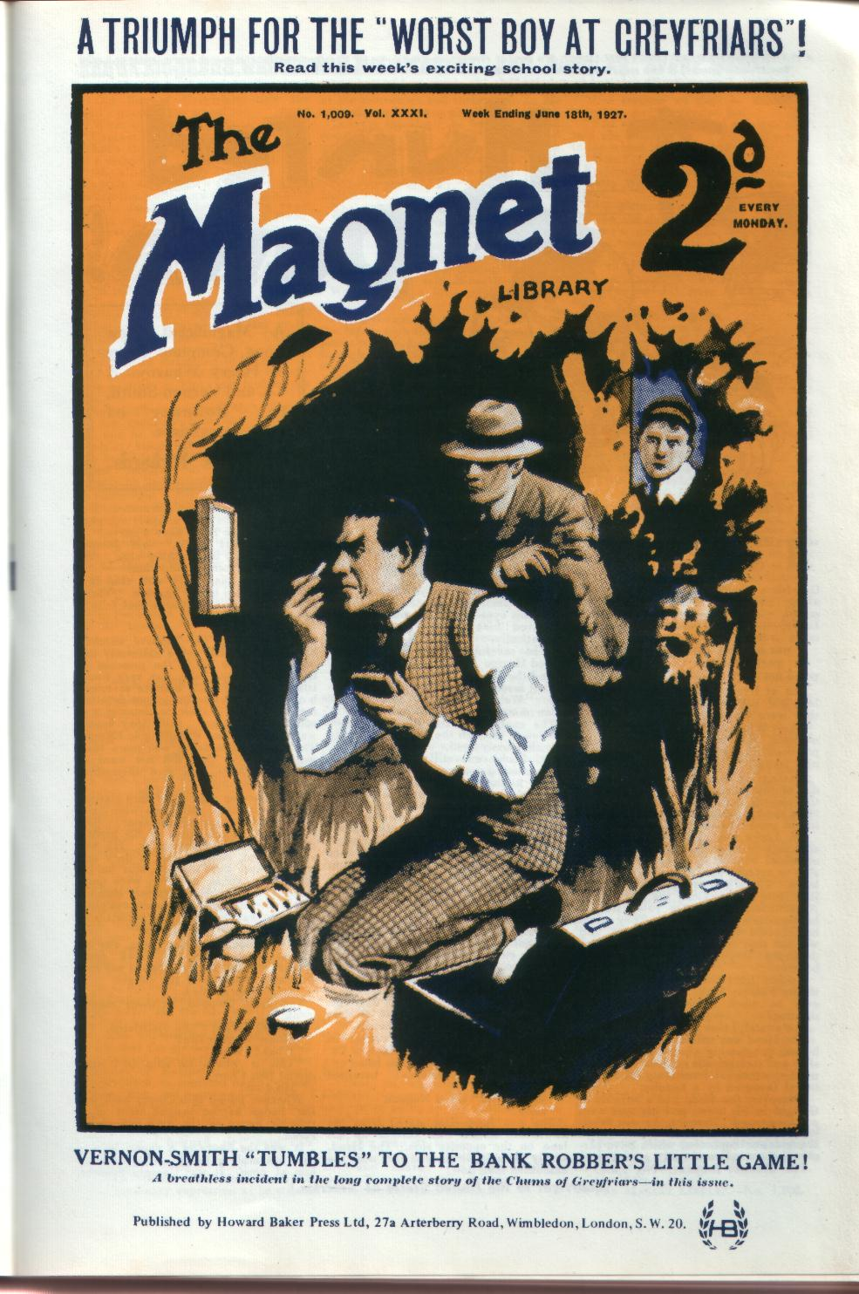
A BANK ROBBER AT GREYFRIARS ! No one at Greyfriars believes in Vernon-Smith’s story that Captain Spencer, the Head’s guest is the mystery man who raided the Lantham Bank. But with his usual calm indifference to public opinion, Smithy sets out to substantiate his story, and he succeeds where police brains have failed!
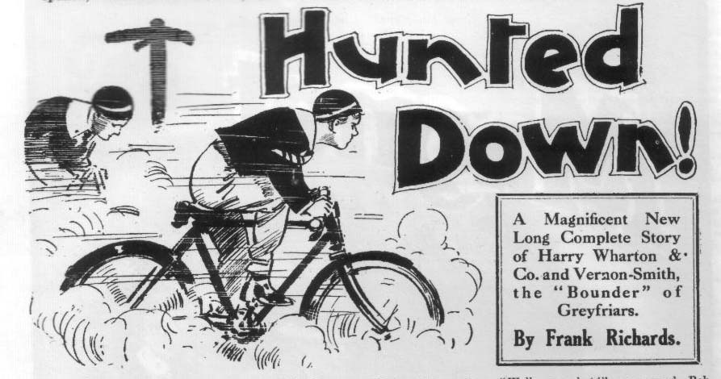
THE FIRST CHAPTER.
“Doggo!”
“THE Head !”
“Cover!” grinned Bob Cherry.
Five Remove fellows of Greyfriars were sauntering cheerily along Friardale Lane, towards, the school, when the majestic figure of Dr. Locke, the headmaster of Greyfriars, came in sight.
It was morning break at Greyfriars.
In morning break fellows were supposed not to go outside the school gates.
But at Greyfriars, as elsewhere, fellows did not always do precisely what they were supposed to do.
Harry Wharton & Co., on this especial morning, had allowed themselves the privilege of relaxing the rule in their own favour.
Having let themselves surreptitiously out of the school precincts, by way of the cloister wall, they had enjoyed a little ramble, and now they were returning in good time for third lesson.
Dr. Locke was certain to stop them, and inquire what they were doing, out of school bounds in break. They were able to explain that they were doing no harm. There was no imaginable harm in a little ramble along the leafy lanes. Nevertheless, rules were rules, from a Headmaster’s point of view. They would be reported to their Form master, and whether they received lines or a licking, depended largely upon Mr. Quelch’s humour.
Neither lines nor a licking appealed to the Famous Five. Obviously, it was ever so much better to dodge the meeting.
Fortunately, that was not difficult.
The Head was still at a distance, and he was progressing along the road at a slow and stately pace suitable to a Headmaster, somewhat resembling the rate of travel favoured by a tortoise.
Moreover, the Head had a wrinkle of thought in his brow, and his eyes were on the ground. Probably he was thinkmg out one of those obscure passages in Euripides, or Sophocles, which have perplexed the scholars of many generations, and doubtless never will be satisfactorily elucidated, even if they are worth elucidating.
By the time Bob Cherry had uttered Bob the word “Cover!” the chums of the Remove were in cover. They fairly flew through a gap in the high hawthorne hedge, and vanished from the sight of their headmaster if he had raised his eyes—which he did not.
“Saved !” ejaculated Bob Cherry dramatically.
The savefulness is terrific !” murmured Hurree Jamset Ram Singh.
And the juniors chuckled.
“All serene,” murmured Harry Wharton. “We’vc only got to lie doggo for a few minutes, and he will be past.”
The captain of the Remove peered cautiously through the gap in the hedge into the sunny road.
Dr. Locke was still a dozen yards away, coming majestically onward. He looked neither to the right nor to the left, and obviously had not the slightest suspicion that five Lower Fourth fellows were lying doggo so near at hand.
Harry Wharton gave a sudden start. From a gap in the hedge on the opposite side of the road, only a few feet ahead of Dr. Locke, a face was looking.
It was turned away from Wharton’s direction, the eyes being fixed on the advancing Headmaster.
Wharton had a full view of the man, who was crouching in the hedge, and could not help noticing that he gripped a heavy cudgel in his hand.
Wharton stared at him blankly. It seemed incredible that a footpad could be lying in wait for the headmaster of Greyfriars, in broad daylight, on a road where pedestrians or cars might have passed at any moment.
Yet the crouching man, cudgel in hand, was watching the approach of Dr. Locke, and waiting for him to come up.
“Look here, you fellows !” breathed Wharton.
“What is it?” asked Nugent.
“Look!”
The five Removites stared from the hawthorne at the man farther up the lane on the opposite side. The Head, slowly as he came on, was very near the ambushed man now.
“My hat !” murmured Bob Cherry. “Looks like a giddy footpad. But if he is, he must have a nerve.”
“That’s what he is,” said Johnny Bull. “Can’t be anything else. We shall see in a, minute, and then—”
“Then we shall jolly well chip in,” said the captain of the Remove. “There are enough of us to handle that fellow, cudgel and all.”
“Yes, rather!”
The chums of the Remove watched breathlessly. They were extremely unwilling to show up in the presence of their headmaster who was very punctilious on such little matters as school bounds. But that consideration mattered little if their headmaster was actually in danger. Still, they sagely waited to see what was going to happen. The man’s appearance was more than suspicious; but they did not want to make a mistake, and give themselves away for nothing.
The crouching man never once glanced in their direction. His eyes were fixed on the approaching schoolmaster. The juniors had a full view of his profile, and it was not prepossessing. He had a large, red, bulbous nose, a. dark and stubbly face, and an ugly scar on his chin. His clothes, however, were quite respectable. It seemed scarcely credible that so decently dressed a man was planning highway robbery; yet his attitude told of that and nothing else.
A few moments later there was no further doubt. As the Head came abreast of him, the man leaped out into the road, brandishing the cudgel.
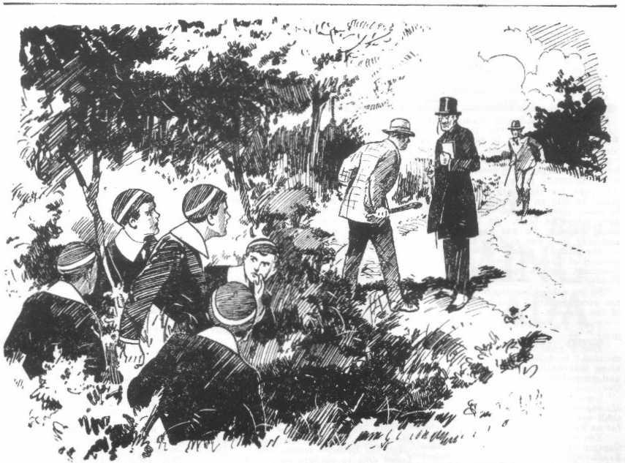
“Stop !” he shouted.
The Head stopped in sheer amazement.
“What? What?” he ejaculated.
“Money or your life !“
“What? What?”
“This is where we chip in,” murmured Bob Cherry.
“ Hold on !”
Wharton pulled Bob Cherry back into the hedge as he caught sight of a running figure on the road behind the Head.
It was the figure of a young man of slim but athletic build. Wharton knew him at once. It was Captain Spencer, an Old Boy of Greyfriars, now the Head’s guest at the school.
“What —“ began Bob.
“Captain Spencer’s there—”
“Let’s chip in, all the same. He’s got a cudgel.”
“Oh, all right!”
Captain Spencer, however, had reached the spot before the Famous Five emerged from the hedge. He came panting up, passed the amazed Head, who was standing like a man in a dream, and hurled himself upon the footpad, heedless of a swing of the cudgel.
The next moment the man was sprawling in the road.
“Just in time!” gasped Eric Spencer.
“ Bless my soul !” stuttered the Head. “What—what—what——— I am quite bewildered! Thank you, Captain Spencer! Bless my soul !”
The footpad scrambled to his feet.
He backed away as Captain Spencer made a stride at him, and took to his heels.
The captain rushed in pursuit; but his left leg suddenly crumpled up under him, and he dropped on one knee. All Greyfriars knew that Eric Spencer had a limp in his left leg, the result of an old wound received in Flanders. Apparently he had forgotten it himself, in the excitement of the moment. He gave a sharp cry as he collapsed, and Dr. Locke hurried to his assistance at once.
The footpad, racing away down the lane, would have been clear in a minute more; but he was running in the direction of Harry Wharton & Co., whom he had not yet seen.
He saw them now!
The Famous Five, pouring from the gap in the hedge, fairly jumped on him, and the footpad, taken utterly by surprise, went with a crash into the road, with the Removites sprawling over him.
THE SECOND CHAPTER.
The Famous Five’s Capture!
“GOT him !”
“Sit on him !”
“Hurrah !”
“The gotfulness is terrific.”
The footpad was down on his back, with Bob Cherry kneeling on his chest, Wharton and Nugent grasping his arms, and Johnny Bull and Hurree Singh trampling recklessly on his legs.
Under the five juniors, he was helpless; never was a man more thoroughly and effectually captured.
The chums of the Remove were feeling in high feather. They had made the neatest possible capture, and they felt that that would be a considerable set-off against the fact that they were out of bounds. The Beak could not fail to be pleased by that handsome capture of a dangerous footpad.
“ Got him, sir !” shouted Bob Cherry. “Got him safe !”
“Bless my soul !”
Dr. Locke had helped Captain Spencer to his feet. He stared blankly at the bunch of juniors pinning down the footpad. The whole thing had happened so quickly that the good old Head was still in a state of bewilderment. From the intricacies of Euripides, he had been brought back to common earth with a startling jerk, and he was quite dazed.
“Bless my soul !” he repeated. “ ‘These —these are Remove boys What are you boys doing out of gates in break”
“Catching a footpad, sir !” said Bob Cherry.
“Dear me! Upon my word!”
Captain Spencer’s handsome face had an extraordinary expression as he stared at the schoolboys and their captive. He seemed utterly taken aback.
Leaving the Head, he hurried on and reached the spot, where the footpad wriggled painfully and breathlessly in the grasp of the Famous Five. Dr. Locke followed him more slowly.
“We’ve got him, sir,” grinned Johnny Bull.
The captain breathed quickly.
“Yes, I see you’ve got him,” he said. “You—you acted very promptly. But —but what were you doing here at all?”
“You boys should not be out of gates.” said the Head, coming up.
“Sorry, sir,” said Wharton meekly “We—we took a little stroll in break, sir—ahem !”
“You should not have done so,” said the Head, frowning. “However, I shall pass over the matter, as you have been the means of securing this dangerous scoundrel. I should have been seriously injured had not Captain Spencer come up in time. Hold him fast !”
“The fastfulness is terrific, honoured sir,” said Hurree Jamset Ram Singh. He will not get away from our esteemed selves.”
“No fear !”
“Shall we walk him to the police station, sir?” asked Bob Cherry. “ There are enough of us to hold him safe till We get him there.”
The Famous Five looked hopefully at their headmaster. Taking the captured footpad to the police station meant not only a service in the cause of law and order, but also misaiming third school, in the Renove room at Greyfriars. And that morning there were “ maths.”
Captain Spencer spoke before tho Head could reply.
“Leave him to me,” he said.
“ Hc might get away from you. sir,” said Bob. “You wouldu’t be able to run after him, sir.”
The captain smiled.
“He will not get away when I get a grip on him,” he said. “ I think your form master will be missing you by this time,’’
“ Hem!”
The Famous Five were quite willing to be missed by their form master, and the longer Mr Quelch missed them the better they would have liked it, when mathematics were the order of the day. And really it was no concern of an Old Boy at Greyfriars.
But the Head evidently shared Captain Spencer’s opinion. He had been about to assent when the captain spoke. Now he shook hi shead.
“You boys had better return to the school at once,” he said. “I will excuse yu for breaking bounds, in the circumstances; but you must not miss your class.”
“We—we shouldn’t mind, sir, for—for once!” murmured Bob.
“Come, come,” said the captain.
He stooped and grasped the footpad by the arm.
“ Let him get up !” he said.
Rather reluctantly the juniors released their prisoner. The man, covered with dust from the road, staggered to his feet, the captain gripping his arm. He gave the schoolboys a black, savage look.
“Now, no nonsense, my man’’ said Captain Spencer. “ I’ve got you safe, and you’re going to t he Station. If you try to get loose, you’ll get hurt. Get a move on!”
“ Let a man off, sir —”
“That’s enough. WiIl you come, too, sir, and charge the man at the station?” asked Captain Spencer.
“Certainly. ” said the Head.
“I—I suppose we shall be wanted as witnesses, sir?” suggested Bob.
“You will not be wanted as witnesses,” said the head dryly. “You will return to the school immediately.”
“Hem!”
Evidently there was nothing doing.
Harry Wharton & Co. started for the school.
They glanced back at a little distance and saw the dusty footpad, with Captain Spencer’s grip on his arm, tramping away towards Friardale, the Head following.
“Well, I suppose he’s safe,” said Bob, with a laugh. “We’re not really wanted; but I’d have liked to cut maths.”
“Same here.”
“The samefulness is terrific.”
“Rather mean of Captain Spencer to let us down,” grunted Johnny Bull. He might have remembered what it was like when he was a Greyfriars chap. I dare say lie liked to cut a class now and then.”
“Might have let us walk along,” said Nugent. “But as we’ve got to get in, we’d better hurry. We’re late for third lesson, already.”
The Famous Five hurried on to the school, and arrived at the gates. The big gates of Greyfriars were closed and locked, and Bob Cherry rang a terrific peal on the bell. As their breaking of bounds was known, and excused, the chums of the Remove did not see any reason for getting in the way they had got out, over the Cloister wall. So they presented themselves cheerily at the school gates, and rang William Gosling, the porter, out of his lodge.
Gosling came down grunting, and stared at them.
“You’re hout of bounds !” he said.
“ Hout’s the word !” assented Bob Cherry. “Hemphatically Hout !”
“ Ha, ha, ha !”
“Wot I says is this ‘ere —”
“”Ha, ha, ha !”
“Life’s too short, old man; ring off and open the gate,” said Bob. “We shall miss third lesson at this rate, and even mathematics are more entertaining than you are, William. Let us in.”
“It’s my dooty to report yer.”
“ We’ve reported ourselves, old bean !” said Bob, as Gosling swung back one leaf of the big gates and allowed the juniors to enter. “ we’ve just met the Head, and he was so pleased to see us that he’s let us off.”
Snort from Gosling. Evidently the Greyfriars porter did not credit that statement.
Leaving Gosling snorting, the Famous Five, crossed to the School house, where the rest of the Remove were already in their Form-roomii, They found Mr. Lascelles, the maths matser, in charge of the Remove for third lesson, and to him they explained why they were late, and that the Head had excused them. The Renove fellows heard their explanation and stared; and Billy Bunter gave a fat snigger,
“I say, you fellows,” whispered Bunter, as the Famous Five went to their places. “Lucky for you it was Lascelles! That yarn wouldn’t have done for Quelchy. ‘He, he, he !”
“It’s true, fathead !“ growled Bob Cherry.
“He, he, he! Wow-ow-ow !” added Bunter involuntarily, as Bob pinched his fat ear in passing. “ Yaroooooop !”
Mr Lascelles looked round.
“Bunter, how dare you howl out in class in that ridiculous manner? Take fifty lines.”
“Ow, wow!—”
“Silence!”
“But I—”
“Take a hundred lines !”
“Oh, lor’ !”
And William George Bunter, feeling sorry that he had spoken, subsided into indignant silence, and Harry Wharton & Co. sat down, smiling, in their places.
THE THIRD CHAPTER.
The Bounder Climbs Down!
“I‘M fed-up with this:’
Herbert Vernon Smith, the Bounder of Greyfriars, growled out the words savagely.
Vernon-Smith was tramping restively about the punishment-room, the small apartment in which he had been confined for several days.
The Bounder was “fed-up “—more than fed-up. The punishment-room was a pleasant place, and solitude did not agree with the Bounder. For days he had seen nothing of his Form fellows, save an occasional glimpse of a fellow in the distance, when he had been allowed out of the room for exercise on the adjacent leads. In dismal loneliness, even the tasks set him by his Form master had been a welcome relief to the monotony. No one came near the punishment-room. Even his pals, Skinner and Snoop and Stott, did not venture to risk a caning by doing so. Not a fellow had even whispered a word through the keyhole.
It was no wonder that the Bounder was fed-up.
The bright sunshine glimmered in at the little, barred window. He knew, by his watch, that it was morning break— that the Remove fellows would be out in the fresh air and the sunshine. If they thought of him at all, it was only as an ass who had asked for trouble and got it.
He heard a footstep in the corridor outside, and scowled. No doubt it was his Form master, with a new task for him for the day. He stood facing the door, with a black brow, as the key turned and it opened.
Mr. Quelch, with a severe, unsmiling countenance, entered the punishment-room. But he did not bring a paper or a book in his hand. It was not a new task this time.
Mr. Quelch closed the door, and turned to the sullen Bounder and fixed his eyes upon hin.
“This will be your last day here, Vernon-Smith,” he said coldly.
Smithy’s face brightened.
“I’m glad of that, sir,” he said.
“The Head has decided—rightly, in my opinion—that you cannot be kept longer under detention here,” said the Remove master. “It is for you to decide whether you rejoin your Form, or whether you leave Greyfriars.”
“Oh!” said the Bounder.
“Your absurd and unworthy suspicion regarding Captain Spencer, the guest of your headmaster—’
“It is not a suspicion, sir,” said Vernon-Smith steadily. “Captain Spencer has deceived the Head. He is the man who held up the Lantham and County Bank last week, and whom I saw removing his disguise in Lantham Chase. He is the man who struck down Inspector Craven, when I was showing him the hollow oak in Lantham Chase where the loot was hidden. He—”
Mr. Quelch held up his hand.
“I have heard enough—more than enough—of your wild accusation,” he said harshly. “It is only because you appear to believe this yourself that the Head has dealt leniently with you. But for that you would have been expelled from the school for insulting his guest. Dr. Locke has made allowances; but you have tired out his patience. This cannot be permitted to continue. If this foolish belief is fixed in your mind—“
“I can believe my own eyes, sir.”
“It is probable that the man you saw bore some kind of resemblance to Captain Spencer,” said Mr. Quelch. “I cannot think that even so reckless and unscrupulous a boy as you are, Vernon-Smith, would wholly invent such a story. But this resemblance, if it exists, does not justify you in bringing a wild accusation against the Head’s guest, still less in disseminating such a story through the school as you have done”
“I admit that much, sir,” said the Bounder. “I’ni sorry now that I told all the fellows. But I was wild at the Head treating what I told him as a falsehood.”
“There is no excuse for you,” said the Remove master coldly. “If you really believe this absurdity, it cannot be helped; but your headmaster forbade you to speak of it outside his study, and you disobeyed him. So long as you persist in this attitude you cannot be allowed to associate with other Greyfriars boys. But, as I have said, you cannot remain longer in confinement in the punishment-room. I require you to promise to say nothing more in the school on this subject, to refrain from repeating, in a single instance, your accusation against an honourable man. Give me this promise, and keep it, and you go back to your Form. Refuse—”
He paused.
“Well, sir?”
“Refuse, and you will be sent away from Greyfriars to-day.” said the Remove master curtly. “The Head is quite decided upon that point; and I am to take you home by the afternoon train.”
“Oh !”
“Think, and decide!” snapped Mr. Quelch.
The Bounder’s face set hard.
He had little difficulty in perceiving that his refusal would not have been unwelcome to his Form master. All through that term the Bounder had been a thorn in the Remove master’s side, rebellious himself, and setting an example of insubordination to the Lower Fourth. Undoubtedly, the master of the Renove would have been glad to see the gates of Greyfriars close behind the Bounder.
But Herbert Vernon-Smith as not disposed to gratify Mr. Quetch upon that point.
He had followed his own course recklessly, at the risk of being “sacked” by the incensed headmaster. But in the punishment-room he had had plenty of time to reflect.
Certainly, he believed that Inspector Craven, of Lantham, believed his story, and was working up the case against Eric Spencer. But he could not he sure of that. And, even so, the rascal might be too cautious to commit himself again, and the task of connecting him with the Lantham hold-up might prove insuperable. If the man were found out and exposed, the Bounder, even if expelled, must be allowed to return to Greyfriars. But what if he were not found out? The Bounder realised that he had been leaning upon a very unreliable reed.
And so Vernon-Smith had made up his mind that if it came to the “sack,” hp would have to give in, bitter as the pill was to swallow.
It was hard for him to yield, even to his Form master and his headmaster.
The Bounder was a rebel by nature. But he did not intend to gratify Mr. Quelch by going. and he did not intend to leave Captain Spencer without a single eye to observe him in the school. Already the Bounder had realised that the time had come to climb down.
Mr. Quelch waited for his reply. Deeply incensed as he was with the rebellious junior who had set his authority at naught, he was a just man, and willing to give the rebel of the Remove every chance. But he broke the silence at last.
“I am waiting for your answer, Vernon-Smith.”
The Bounder breathed hard. He had no choice, and he knew it.
“I must do as you say, sir,” he answered. “I can’t change my belief. But I promise to say nothing further about Captain Spencer in the school. So far as I am able, 1 will not say a word again on the subject, unless—”
“Unless what “ rapped out Mr. Qucich.
“Unless it should be proved that I was right, and that Captain Spencer is the man who held up the bank at Lanthem.”
“That proviso is of no moment, as nothing of the kind can ever be proved or believed by any person with a less distorted mind than yours, Vernon Smith. I shall accept your promise, and release you from detention here. I must warn you, however, that if you break your pledge you will be sent away from Greyfriars the same day.”
“Very well, sir !”
“The matter, then, closes, on the understanding that you keep your word ” said the Remove master coldly. “You may leave the punishment-room, Vernon Smith, and take your books back to your study.”
“Thank you, sir !”
Mr. Quelch quitted the room, leavng the door open.
Glad enough was Herbert Vernon-Smith to get out of his unpleasant quarters. Trotter, the page, came up the passage to remove his belongings, and the Bounder, with a cheery grin, tipped him a couple of half crowns.
Then he strolled away.
Third lesson was not yet over in the Remove-room; but Mr. Quelch had not told the Bounder to repair thither, and he did not approach the Form-room. He knew it would be maths with Mr. Lascelles, and he liked neither Mr. Lascelles nor maths.
The Bounder sauntered out into the sunny quad, breathing deep of the fresh air, rejoicing in his freedom. He whistled cheerily as he strolled about the green quad with his hands in his pockets. It was good to be free again; although it was only a few days since he had been taken to the punishment room, it seemed like weeks to him, if not months. The Bounder detested solitude, and seldom enjoyed his own company. He was quite eager for the fellows to come out of the Form-rooms, eager to mingle once more in a crowd.
Suddenly he stopped, and a glint came into his eyes.
He was strolling near the gates when the Head came in with Captain Spencer.
They were speaking as they came up the path, and the Bounder caught Eric Spencer’s words:
“My fault — entirely ! I blame myself—”
“Not at all, my dear fellow !” said the Head. “ You could not help it. It is of little consequence, too. The police have the man’s description.”
“But for my wretched limp, he would not have got clear!”
“Do not distress yourself. It really is of no moment.” said the head.
Dr. Locke’s eyes fell on the Bounder the next moment.
Vernon Smith capped him respectfully.
He gave no heed to Captain Spencer; he could not bring himself to salute the man he regarded as an impostor and a secret thief.
But the head stopped, and signed to the junior to come up.
The Bounder approached, with his most respectful air, but still keeping his eye on Dr. Locke, and apparently unaware of Captain Spencer’s presence. Spencer eyes were fixed on him, however, with a glint in them.
“1 see you are at liberty, Vernon-Smith?” said the headmaster.
“Yes, sir.”
“1 authorized Mr. Quelch to release you on certain conditions. You are now upon your honour to refrain from mentioning Captain Spencer’s name except with the respect that is his due “ said the head sternly.
“ Yes, sir.”
“Very good. If you attach any value to my good opinion, Vernon Smith, which you have justly forfeited, you will express your regret to Captain Spencer, here and now, for the absurd and insulting mistake you made.”
The Bounder looked at Eric Spencer for the first tnne.
“If I have done Captain Spencer any wrong, sir, I beg his pardon most humbly!” said Vernon-Smith.
Dr. Locke’s severe brow cleared.
“Very well,” he said. “As you have apologized, I have no doubt that Captain Spencer will pardon you.”
“Certainly !” said the captain, with a smile. “ I trust that master Vernon-Smith will come to understand me betterbefore I leave Greyfriars. But I can pardon an honest, though foolish, mistake.”
And the captain walked on with Dr. Locke. leaving the Bounder smiling sarcastically. There had been an ‘if” in his apology, and it was a big “if.” Certainly, he was sorry if he had done Captain Spencer wrong. But he did not believe that he had done him wrong, and he felt sure that the captain understood what he meant to convey, though the Head did not.
Five minutes later the fellows were out of the Form-room, and the Bounder was surrounded by a crowd of the Remove.
THE FOURTH CHAPTER.
The Same Old Smithy!
“HALLO, hallo, hallo !”
Smithy!”
“The esteemed Bounder !”
“You’re out again, Smithy!”
“Out of quod “ grinned Skinner.
“Ha, ha, ha!”
“Jolly glad to see you loose again, Smithy !”
“The gladfulness is terrific!”
Harry Wharton & Co. greeted the Bounder cordially enough. Most of the Remove fellows were glad to see him free again. The Bounder nodded and smiled at the Famous Five.
“Yes, here I am again,” he said. “Jolly glad to be out! I can tell you, I was getting fed up with it !”
“You asked for it !” remarked Bolsover major.
“Oh, quite!”
“And what price Captain Spencer now ?“ asked Skinner, with a grin. “Are you keeping up your yarn about him ?”
The Bounder shook his head.
“No !”
“Well, I’m glad of that !” said Harry Wharton. It really was a little too thick, Smithy “
“But what’s changed your opinion, Smithy ?“ asked Bob Cherry.
“I haven’t changed it.”
“But you said-—”
“I’m let loose again, on condition that I say nothing about Captain Spencer. As it’s a promise, I shall keep it. It makes no difference to my belief, of course.”
“Oh!” said Harry Wharton slowly.
“Well, so long as you chuck it, all right” said Bob. “Since you’ve been in chokey, Smithy, another silly ass has started a yarn of the same kind! You see, it was catching!”
“Ha, ha, ha !”
“Oh, really, Cherry,” squeaked Billy Bunter, “I’ve told you a hundred times at least that I described just what happened—”
“You could tell me a thousand times, old fat man, and it wouldn’t make any difference !” said Bob.
“I can jolly well tell you—”
“Chuck it, Bunter !” said Harry Wharton. “It was bad enough from Smithy, but nobody wants Srnithy’s yarns at second-hand from you!”
“Oh, really. Wharton—”
“Dry up !”
“Look here!” roared Bunter.
“Kick him, somebody !”
“Yaroooh !”
Herbert Vernon-Smith glanced curiously at the Owl of the Remove as Bunter rolled away. It was news to him that another Remove fellow had taken up the strange story he had told about Captain Spencer. Bunter, with his fertile imagination and utter disregard for the truth, was just the fellow to spin an unfounded yarn, and. in other circumstances Smithy would have taken no heed. At the present time, however, he was eager to hear anything that was said on the subject of the Head’s guest, whom he had accused of being the “hold-up” man of Lamtham, and he resolved to question Bunter later.
“So the subject’s going to be dropped for good, Smithy?” asked the captain of the Remove.
“Yes; I’m bound to say nothing more.”
“That’s good! Least said, soonest mended.” said Harry. The police are after that hold-up merchant, anyhow, and they don’t want any help from Greyfriars men. Let it drop.”
“I’m bound to, after my promise to Mr. Quelch,” said Vernon-Smith. “I shall not mention the matter again, so far as I can help it.”
‘You see, we’ve seen a good deal of Captain Spencer the last few days,” said Frank Nugent. He seems a decent fellow all round. He’s come down to Little Side for the cricket more than once.”
“Has he?” said the Bounder, with a sardonic grin.
He was not surprised to hear that Enc Spencer was seeking to make himself popular in the school. Friends were less likely to be suspicious and observant than enemies.
“And if you’d seeii him this morning—” said Johnny Bull.
“I have seen him,” said Vernon-Smith. “I saw him come in with the Head ten minutes ago.”
“I mean, before that. He tackled a footpad in Friardale Lane who was going to rob Dr. Locke —“
“Eh! Pulling my leg?” asked Smithy.
“Not at all !” And the Famous Five proceeded to explain together what had happened in morning break.
The Bounder listened with a deep attention that was quite flattering to the narrators.
The footpad was a hefty chap, and had a cudgel,” said Bob Cherry. “It was plucky of the captain to tackle him. Of course, he couldn’t do anything else as the man was attacking the Head. Still, it was plucky.”
“I’ve no doubt he’s plucky.” said the Bounder. “Whatever he’s short of it’s not courage. He’s got pluck enough. The man who held up the bank at Lantham in broad daylight was no funk, at least.
‘There you go again!” grinned Nugent.
“My mistake—I shouldn’t have said that! !” But, I say, this is a queer yarn you’ve spun me,” said Vernon-Smith. ‘I wish I’d been there. I can see now that I made a mistake in getting shut up in punny. You say he knocked the man down and the fellow bunked—”
“Captain Spencer would have collared him, only his leg gave way,” explained Bob. "His limp, you know”
“I know. And then you fellows—”
“We got him!” grinned Bob.
“The gotfulness was terrific.”
“And you didn’t see him safe to the station? That was rather a mistake.”
“The Head wouldn’t let us!” chuckled Bob. “We were quite keen to cut maths; but the head was too wide.”
“Was Captain Spencer willing for you to go to the station with the foot- pad, if the Head had been willing?”
The chums of the Remove exchanged uncomfortable glances. They could not help remembering that it was owing to Eric Spencer that they had had to return to the school, leaving the captured footpad in Spencer’s charge.
“Look here ! What are you getting at, Smithy ?” asked Wharton.
“I fancy you’ve been taken in, that’s all, and the Head, too,” said the Bounder coolly. “It’s a bit too much like a film story for me. A footpad waylays the Head in broad daylight— Captain Spencer happens on the spot in the nick of time—and the man gets away—or would have got away if you fellows hadn’t been there by sheer chance. Looks to me like a put-up job.”
“Oh, what utter rot!”
“You say the footpad was crouching in the hedge when you spotted him, waiting for the Head to come up?”
“Yes—“
“How did he know the Head was going for a walk in morning break” asked the Bounder sarcastically. “Dr. Locke does so perhaps once in a week. Somebody who knew him tipped him the wink.’”
“Rubbish! He was waiting for any prosperous-looking johnny to come along, of course and it happened to be the Head.”
“And Captain Spencer happened to be taking a walk in the same direction, at the same time? And his game leg came in handy to let the man escape.”
“Oh, chuck it !” said Bob, in some disgust. “Blest if you wouldn’t turn any dashed thing the wrong way out, Smithy. You’ve got a jolly suspicions mind—that’s your trouble.”
“Anyhow, Captain Spencer has taken him to the police-station,” said Wharton gruffly. “Would he do that if it was a put-up job, as you call it?”
“He would not.”
“Well, then, doesn’t that make it all clear?” snapped the captain of the Remove.
“Yes, if the footpad got to the station.” said Smithy.
“We watched them go.”
“You didn’t watch then as far as the police-station. I rather think you’ll find that the man got away somehow.”
“Rubbish !”
“Rot !”
“How could he get away, with Captain Spencer holding his arm all the way ?” demanded Bob Cherry.
The Bounder laughed.
“I mustn’t say anything about Captain Spencer—it’s a promise. So I’ll put it like this. Owing to something or other, the footpad unfortunately got away before they reached the police-station.”
“Bosh!”
“The boshfulness is terrific.”
The Bounder shrugged his shoulders.
“You seem to be taking your promise to Mr. Quelch rather easily, Smithy,” said the captain of the Remove, with a frowning brow. “But just to prove to you that you’re talking out of the back of your neck, I’ll go and ask Captain Spencer this minute whether the man was safely jugged at the station.”
“Do !” said the Bounder. “I’m interested to know,”
Harry Wharton went into the House at once.
The other fellows waited for him to return and they improved the shining hour, while they waited, by telling the Bounder what they thought of him and his endless suspicions. Vernon-Smith listened in silence, with a sardonic grin. He remembered the snatch of conversation he had caught between the head and Captain Spencer when they came in, and he was quite sure that his surmise was well-founded.
Harry Wharton came back in five minutes or so. There was quite a peculiar expression on his face.
“Well! ” demanded the Co., in chorus.
“It—it’s rather odd,” said Wharton haltingly. “As it happens, Smithy has guessed right.”
“Oh !”
“Not that I believe a single word of Smithy’s rot, of course,” said the captain of the Remove emphatically. “But it certainly is the case that the footpad got away before they got him into Friardale. He struck Captain Spencer a sudden blow and got loose, and the captain’s game leg prevented him from collaring the man again, once he jumped out of reach. The fellow scudded off across the fields and got clear,”
There was an uncomfortable silence. It was broken by the Bounder’s sneering laugh.
“That couldn’t have happened if you fellows had gone to the station with them!” grinned the Bounder.
Harry Wharton & Co. looked at the Bounder, and turned away from him without another word.
Vernon Smith shrugged his shoulders and walked away by himself, with his hands in his pockets. Ho was looked upon as a traducer; as a suspicious fellow eager to find evil in the most trifling circumstances. But the Bounder cared little. He was certain, in his own mind, that the whole scene of the footpad had been a “put-up job,” for some purpose as yet unknown. The escape of the captured ruffian was a conclusive proof, to his mind. To ensure no query as to his motives, Eric Spencer had placed the Head under a personal obligation to him, by a theatrical trick of rescuing him from a dangerous character. That helped on his game at Greyfriars. But that was not all—Smithy was assured that that was not all. There was something more behind it. And what that “something more” was, Herbert Vernon-Smith was determined to find out, now that he was free from detention, free to observe and to act.
THE FIFTH CHAPTER.
Tea in Smithy’s Study!
HERBERT VERNON SMITH took his place with the Remove that afternoon.
Somewhat to the surprise of the other fellows, he was extremely respectful and attentive to the Form master, and seemed to bp making an effort to get into Mr. Quelch’s good graces. For nearly a term he had been a reckless rebel, and the Remove fellows had not expected him to be improved by several days of detention in the punishment-room. Neither had Mr. Quelch; and he was prepared to deal drastically with the first impertinent answer or insolent look. It was an agreeable surprise to Mr. Quelch to find the rebel apparently bent upon setting a shining example to the Form.
Hp concluded that in solitary detention the Bounder had reflected on the error of his ways; and resolved to amend. If that was his case, the Remove master was willing to give him a chance.
Certainly, that afternoon he had nothing to complain of. The Bounder was quiet, reflective, painstaking, quite a model pupil. Towards the end of class Mr. Quelch thawed so far as to give that usually troublesome junior some words of commendation, to which Smith listened with an air of gratified deference.
“Nothing like quod to improve a fellow’s manners.” Bob Cherry remarked to his chums, as they came out after class.
“Smithy’s no end improved.”
“The improvefulness is terrific, if genuine,’’ remarked Hurree Jamset Ram Singh dryly.
“Oh!” said Bob. “ I daresay he was as pulling Quelchy’s leg. I don’t see why, if he was.”
“Had enough punny.” said Johnny Bull. He doesn’t want any more. It couldn’t have been nice.”
Vernon-Smith went to his study after class, and Skinner followed him there. During the Bounder’s detention in the punishment-room Study No. 4 had not been the land flowing with milk and honey such s Skinner had been accustomed to since Smithy had taken him in as study-mate. Skinner was rather anxious for the horn of plenty to begin flowing once more.
“What about a bit of a celebration, Smithy” asked Skinner.
“Good egg!” assented the Bounder.
“Let’s ask a couple of fellows and make it rather a spread. What ? ” said Skinner.
“Yes, rather! Ask whom you like. ”
“Snoop and Stott, then, “ said Skinner.
“And Bunter,” said Smithy.
Skinner stared.
“Bunter?” he repeated.
“ Yes, Bunter !“
“What on earth do you want Bunter for?”
“Oh, he’s an entertaining chap at tea— in his own way, you know,” said the Bounder carelessly.
“This is the first I’ve heard of it. Anyhow, it won’t be necessary to ask him; he will butt in as soon as he finds out there’s a spread.”
The Bounder laughed.
“Ask him, all the same; I want to make sure of him.”
“Is it a rag ? ” asked the mystified Skinner.
Harold Skinner had never heard before of anybody wanting Bunter’s company especially.
“Not at all ! Just tell him I’d like him to come. And if you don’t mind dropping into the tuckshop for me--—--”
“Pleased, old chap !”
“Order something really decent, and tell Mrs. Mimble to put it down to me,’ said Smithy.
“ Right-ho! Leave to me, old bean !”
Skinner walked off very cheerily. He did not particularly object to Billy Bunter’s company, so long as there was plenty to go round. And as Skinner was to give the order he was able to make sure on that point. Smithy was in the fortunate position of having unlimited credit at the school shop, and the Bounder, with all his faults, was a generous fellow enough. He never cared whether Skinner stood m his “whack” in the study brews or not, and seemed not to think about the matter at all. Certainly, there were a few fellows in the Remove who would have cared to sponge on a wealthy study-mate, but Skimmer was not delicate on such points.
Skinner, and Snoop, and Stott came in together, very early for tea, all with parcels from the tuck shop. Needless to say, William George Bunter followed them in. Bunter was surprised at being asked to the spread. He would certainly have asked himself, and nothing but a boot would have excluded him. Still, it was much more agreeable to roll in as an honoured guest. Bunter, of course, could not let it go at that. Next to a spread, Bunter enjoyed swank and he preferred the two together, if possible.
“Roll in, Bunter! “ said the Bounder, hospitably.
“Here I am, old chap ! said Bunter. “ Pleased to come to tea with you, Smithy. I’ve turned those chaps in Study No. 1 down on your account. I felt that I was bound to play up, you know, after you’ve been in chokey so long. So I turned them down.’’
“ Turn them up again.” suggested the Bounder. “ Don’t mind me!”
“The fact is—’’
“The fact is you talk too much,” said Skinner. “ Sit down and shut up, Bunter !”
“Oh, really, Skinner—”
“Shut up!”
“Yah!”
Billy Bunter sat down after that elegant rejoinder. Good things were unpacked on the table, and Bunter’s fat face was irradiated by an expansive smile. This was something like!
Skinner & Co. enjoyed the spread, but they found Bunter’s company rather irksome. They could not discuss their own affairs in the presence of the Owl of the Remove; their own affairs were not of the kind that would bear being tattled in the passages and the Rag.
Why Smithy had bothered himself with the Owl of the Remove was a mystery to them at first. But they discovered his reason later on. Bunter, having disposed of enough provisions for three or four fellows, found the keen edge taken off his appetite, and began to talk. Skinner, and Snoop, and Stott had no desire whatever to listen to him; but, to their surprise and annoyance, they found that the Bounder had.
“Shut up, Bunter !” said Skinner politely.
“Oh, let Bunter talk,” said Vernon-Smith
“I was going to tell you about Ponsonby,” said Skinner sulkily.
“You can tell me that another time. Go on, Bunter!”
Bunter grinned triumphantly at Skinner.
“I hear that Bunter has had quite an adventure while I’ve been locked up in the punishment-room,” said the Bounder casually. “I’m jolly curious to hear all about it.”
Move “I’ll tell you with pleasure, old fellow,” said Bunter.
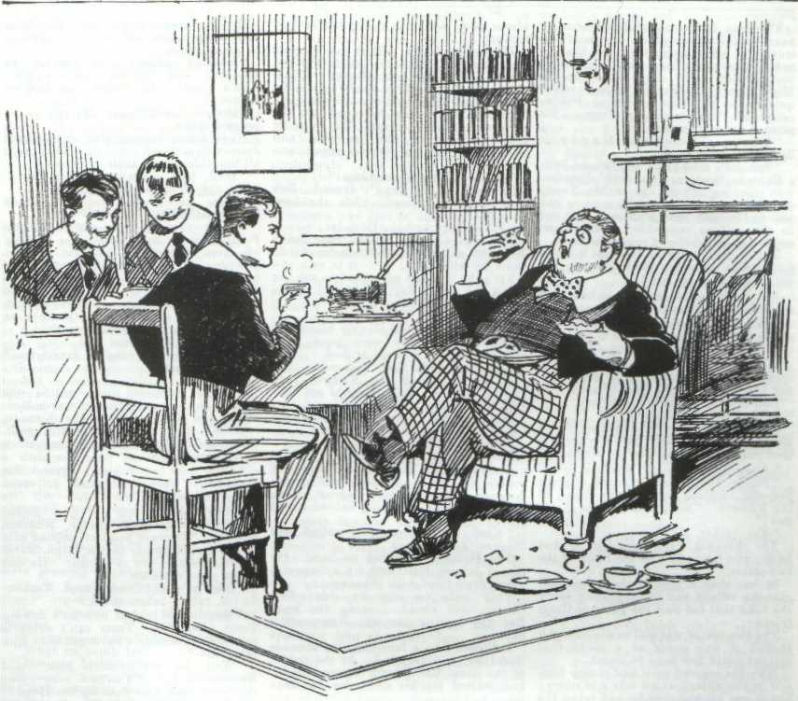
“What utter rot!” said Snoop. “It’s all spoof, from beginning to end—just a fatheaded yarn!”
“It isn’t!” roared Bunter.
“Rats !” said Stott. “It’s Smithy’s own story over again in a more idiotic form!”
“I tell you it really happened !”
“Bosh!”
“Well, I want to hear Bunter tell the story,” said Vernon-Smith. “You fellows ring off and give Bunter a chance to speak.”
Skinner & Co. rang off. They understood now why Smithy had asked Bunter to tea; he wanted to hear his story about Captain Spencer. Nobody in the Remove believed that story, and nobody but Bunter wanted to hear a word about it. But the Bounder’s word was law in Study No. 4, and they gave Bunter his head, so to speak. Skinner & Co. devoted their attention to the comestibles and left the talking to Bunter.
“It was last Saturday afternoon.” Bunter explained, with his mouth full. “Captain Spencer came down to Little Side when games practice was on, and I got away—I was fed up. You see, I don’t need a lot of cricket practice, like some fellows; besides, I never really get a chance to show what I can do. Wharton doesn’t like being put into the shade by a better man.”
“And what happened?”
“That beast, Wingate of the Sixth, spotted me in Friardale Lane,” said Bunter. “He was going to order me back to games practice, but I cut into the wood and pretended not to hear him. He, he, he!”
Bunter paused to help himself to another tart.
“I got out of sight in a thicket,” he went on. “I had some toffee, you know. Well, I’d finished the toffee when somebody came along under the trees and stopped near me. Then I heard Captain
Spencer’s voice. He had come from another direction. He said— These are jolly good tarts, Smithy !”
“Ho said what?” exclaimed Skinner.
“Ha, ha, ha!”
“That isn’t what you told us last time,” chuckled Snoop.
“Oh, really, I said that about the tarts, not Captain Spencer. He said to the other man a lot of things about the hold-up at Lantham, and about being suspected by Smithy, and about having to lie low for a time, and so on. I can’t remember the words.”
“There’s a proverb which says that Bunters ought to have good memories,” remarked Skinner.
“Oh, really, Skinner—”
“Go on, Bunter,” said the Bounder quietly. “You’re awfully interesting, old chap!”
“Smithy knows I’m telling the truth,” said Bunter loftily. “He knows that Captain Spencer is the bank robber, though he was locked in the punishment-room for saying so.”
“Did you see the other man?” asked Smithy.
“No: neither of them.- I heard them both, though, quite distinctly. They’re confederates’
“Did you bear Spencer mention the other man’s name?”
“Yes; he called him Ransome.”
“Ransome ?” repeated the Bounder. “Good! If you fellows had any sense you’d see that Bunter isn’t inventing this. His yarns never hang together like this.”
“He’s made it all up, of course,” said Skinner, with a stare. “You don’t mean to say you believe a word of it, Smithy 7”
“Erery word!”
“Well, you’re glad to hear anything to bolster up your own yarn against Captain Spencer. I suppose that’s it?”
“That’s it,” said Snoop, with a nod.
“Think so, if you like,” said the Bounder carelessly. “But shut up a bit. Just now I’m interested in Bunter.
“Go on, old bean.”
“Well, I didn’t hear all they said, and I don’t remember all I heard,” said Bunter. “But Spencer told the other man to hang about the neighbourhood, got up as a pedlar, to find out whether Inspector Craven was keeping the school watched on his account.”
The Bounder’s eyes gleamed.
Knowing what he did already, he was able to see that this was not, as the Remove fellows supposed, one of Bunter’s fanciful inventions. The story tallied too well with what he knew already.
“And Spencer mentioned that he was awfully short of money, owing to his loot being taken back to the bank after Smithy found it in the hollow oak in Lartham Chase,” said Bunter. “He said he would have to prove a jolly strong alibi next time. I suppose he meant next time he held up a bank. Pass the cake, Skinner.”
Skinner rose to his feet. lie had finished his tea, and he was not disposed to waste his time listening to Bunter.
“See you later, Smithy,” he said, and he left the study, followed by his friends.
The Bounder hardly observed them go. For once, Bunter was the desired guest, and he cared nothing whether the others stayed or went.
Bunter had slowed down now, but he was still eating while he talked. Vernon- Smith lighted a cigarette and leaned back in his chair. He listened while Bunter ran inexhaustibly on. The Owl of the Remove was delighted to find such a. listener. For once, Bunter had been telling the truth, startling as his story was; but in the Remove it had been received with general derision. For the first time Bunter felt that he was being treated with the seriousness that was his due.
Finding his listener so attentive, and having got to the end of the facts, Bunter began to embroider his narrative, in his usual style, drawing upon his fertile imagination. He was very keen to keep Smithy in that attitude of rapt attention.
But the fat junior was disappointed. As soon as his fertile fancy began to wander the Bounder was quite aware of it, and hp very soon cut Bunter short. He realised that he had learned all that the Owl of the Remove could tell him.
“I say, Smithy, I haven’t finished yet,” said Bunter, as Vernon-Smith rose from the table.
‘Stay as long as you like,” said the Bounder.
“I mean I haven’t finished telling you about what happened last Saturday.”
“You have,” said the Bounder coolly, and he walked out of the study.
Bunter frowned after him. He was beginning to develop, in his fat mind, quite a thrilling romance, founded upon the latest American film he had seen at the pictures. It was rather hard to be cut short before he had been able to get it off.
“Beast !” murmured Bunter.
But there was consolation in the stack of good things still remaining on the table. Bunter devoted his attention to them—more and more slowly, as all the available space within his extensive circumference was filled, but steadily and industriously.
The Bounder strolled out into the quad, with a thoughtful frown on his brow and a glint in his eyes. He stopped by the gate of the Head’s garden, and stood leaning on it, gazing towards the Head’s house. Through the leafy trees be had a glimpse of the little balcony, with steps down to the garden, which belonged, as he knew, to Captain Spencer’s room. The captain was seated on the balcony, reading a newspaper and smoking a cigar. The Bounder watched him for several minutes and then walked away, his hands in his pockets, thinking deeply.
Bunter’s story had let fresh light into his mind on the subject, of that “Old Boy” of Greyfriars, who was outwardly an honourable man, a guest of his old headmaster, and secretly a desperate bank-robber. The affair of the footpad had apprised Vernon-Smith that Eric Spencer had a confederate at hand; from Bunter he had learned the confederates’ name. The bank robber had lost the loot he had gained by the holdup at Lantham. It. was very probable that he was in desperate need of money; as indeed, according to Bunter, he had said to his confederate.
The Bounder knew with what intentions the man had come to Greyfriars. Was he likely to leave, a few weeks’ time, with those intentions unfulfilled? It was not likely. Yet, as the Owl of the Remove had heard him say, he had to prove a very strong alibi “next time”; in the circumstances, another bank robbery in the neighbourhood could scarcely fail to point the finger of suspicion at Eric Spencer, unless it was quite plain to all eyes that he had nothing to do with it. Was the spoof attack and rescue that had happened that morning a part of the scheme?
It seemed to the Bounder that he had a glimmering of the scheme, as in a glass darkly. But he had to know more, if he was to show the rascal up in his true colours.
And upon that the Bounder of Greyfriars was determined. All the school, which had looked on him as a reckless traducer, or at best as a reckless fool, should know Captain Spencer as he really was; it would be a tremendous triumph for the Bounder. To that end the Bounder was prepared to devote his whole energy; for that reason he had given up his rebellious recklessness; he could not afford to be placed under detention, or watched by a Form master’s suspicious eye now. He had made one serious mistake did not mean to make another.
“It’s up to me,” the Bounder reflected, as he strolled under the elms.
“It’s up to me, and everythin’ else can wait till I’ve put that scoundrel where he belongs. And by gad, by book or by crook, I’ll show him up !”
The Bounder teiit in early to prep, and that evening his prep was very carefully done. The following morning, when he was called on to construe in the Form-room, the Bounder’s “con” was so good that Mr. Quelch gavc him a very approving look.
The punishment-room apparently, had done Herbert Vernon-Smith good, and he seemed resolved to turn over a new leaf. That was Mr. Quelch’s impression, at least. The Remove master little gued t hat was in the Bounder’s mind.
THE SIXTH CHAPTER.
A Hot Chase!
“THAT’S the man!”
“What !”
“Look !” shouted Bob Cherry.
It was Wednesday afternoon, a half- holiday at Greyfriars, and Harry Wharton & Co. had cycled down to Friardale. They had stopped at Uncle Clegg’s little shop for refreshment in the shape of ginger-beer, and were partaking of the same at the little table under the oak tree in front of the village tuckshop when a two-seater came at a leisurely pace down the winding old High Street.
Bob Cherry’s glance had rested on it carelessly as it came by, but as he noted the driver he jumped up in great excitement, his ginger-beer swamping out of his glass.
There was only one man in the car, and he was a man with a dark complexion, a large, bulbous nose, and a prominent scar on his chin. Bob knew him at once. It was the well dressed footpad who had attacked the headmaster of Greyfriars a few days before.
“Look ! That’s the johnny !”
“Who - what ? ”
“The footpad !”
“Oh, my hat !”
The Famous Five stared at the man in the little two-seater. He was tooling the car along the old High Street it quite a leisurely pace. They had a full view of him, and there was no doubt at all of his identity.
The juniors stared in astonishment.
The man’s description was posted up outside the little police station in Friardale; he was wanted by the police for the attack on Dr. Locke, yet here he was driving a car through the village, as if courting public attention. The nerve of it astounded the schoolboys.
“It’s the same man,” said Wharton.
“The samefulness is terrific.”
“I’d know that beak anywhere,” said Frank Nugent, “and that scar on his chin, too.”
“What a chance for P. C. Tozer, if he were here !” said Johnny Bull.
“The man must be an utter fool to show up here like this,” said Harry Wharton, in wonder. “He must know that his description is known.”
The man in the car did not seem to have perceived the group of schoolboys staring at him from under Uncle Clegg’s oak. His manner was quite casual and unconcerned, as he drove slowly up the High Street. Wharton looked round quickly, in the hope of seeing Police-constable Tozer’s portly form. He uttered an exclamation.
“There’s Tozer—and Captain Spencer !”
“Spencer’s seen him !“ exclaimed Bob. Captain Spencer, at a little distance, was pointing out the car to Mr. Tozer. Obviously, he had seen the man in the two-seater, and was pointing him out to the village constable. Mr. Tozer seemed a little slow to comprehend.
But he caught on at last, as it were, and strode into the road towards the car, holding up his hand.
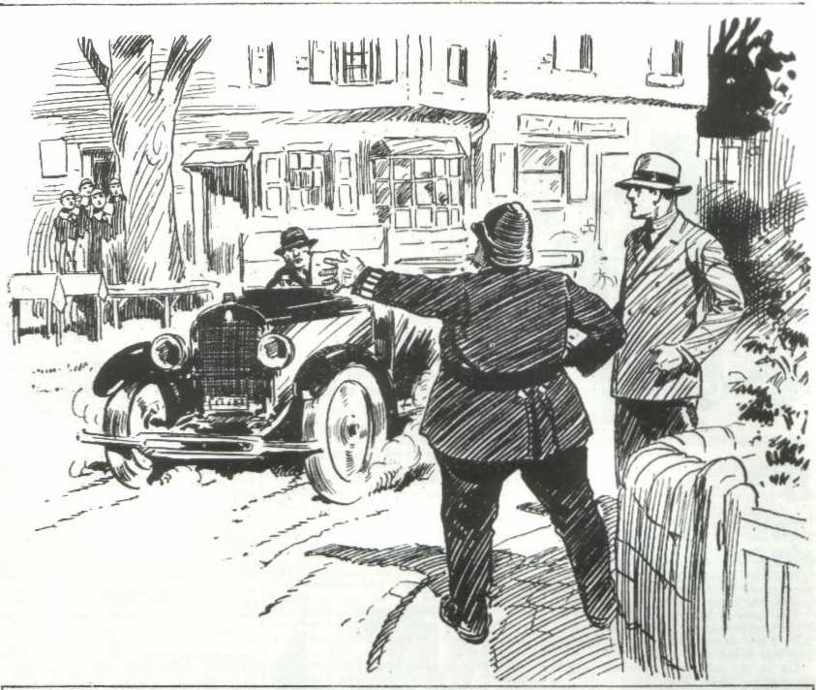
The scarred man glanced at him, and seemed to wake to sudden alarm.
In a twinkling the car accelerated, and shot away like a bullet from a rifle.
It shot ahead, raced past the tuckshop, where the Greyfriars juniors stood, and sped away towards the open lane, leaving Mr. Tozcr staring blankly after it.
Bob Cherry rushed to his bicycle.
“Come on !” he shouted.
The Famous Five’s machines were stacked under the oak. In a few seconds they rushed them out into the street.
“After him!” panted Wharton.
“Follow him, lads !” shouted Captain Spencer, catching sight of the chums of the Remove. “Keep him in sight it you can
“Yes, rather, sir!”
The Famous Five mounted in hot haste, and fairly flew on the track of the two- seater.
In less than a minute they were outside the village and tearing away along the road that led past the gates of Greyfriars.
The two-seater was still easily in sight, though it was going at a speed that cyclists could not hope to equal.
Why the scarred man had shown himself in the village at all was a mystery; but it was evident that he had taken the alarm now, and was doing his best to escape.
Three Greyfriars fellows on bicycles were coming down the road—Vernon- Smith, Skinner, and Snoop. They plunged wildly out of the way as the car whizzed towards them. Skinner and Snoop, in their alarm, plunged into the hedges on their machines. The Bounder jumped down by the roadside, and stared after the car with an angry face, and shouted.
“You confounded road-hog !“
“Join up, Smithy!” roared Bob Cherry, as he passed. “It’s the foot- pad !”
“What?” gasped the Bounder.
Bob was already past. But Harry Wharton called to the Bounder as he came by after Bob.
“It’s the footpad who tried to rob the Head the other day, Smithy! Come on! ‘We’re after him !”
“Great pip !”
Vernon-Smith stood staring blankly.
The Famous Five were gone in a moment more in a cloud of dust.
Vernon-Smith’s first impression was that the chums of the Remove were pulling his leg. But he could see that they were in hot pursuit of the car.
He whirled round hs machine, mounted, and raced after them.
“Smithy !“ shouted Skinner.
But the Bounder did not heed him.
He was riding like the wind, and in a minute or less he overtook and passed Nugent and Hurree Jamset Ram Singh, who were dropping behind in the race.
“Keep it up, Smithy !” called out Nugent, as he passed.
The Bounder pedalled on hard. He passed Johnny Bull, and, by a desperate spurt, drew level with Wharton.
They rode on side by side; Bob Cherry, still ahead, keeping the lead. But the tearing car was disappearing now.
It turned into a lane that led towards Redclyffe, and vanished. At the corner of the lane Bob Cherry jumped down, and waited for his comrades to come up.
His face was crimson, and streaming with perspiration, and he was breathing in great gasps.
“Nothing doing !” he panted, as Wharton and Smithy reached him. “He’s gone! Of course, we had no chance !”
“Rotten luck “ said Harry, as he jumped down.
Nugent and Johnny Bull and Hurree Jamset Ram Singh came up. They were all breathless from their exertions.
“Well, he’s got away,” said Harry. “We did all we could.”
“Here comes old Tozer !” grinned Bob breathlessly.
A car evidently commandeered by P.C. Tozer for the chase---came rushing up from Friardale. Captain Spencer was driving, and the village constable sat beside him, with his truncheon across his fat knees. The juniors waved to the car, and Captain Spencer halted. He had been about to drive straight on past Greyfriars, towards Courtfield.
“This way !” shouted Bob.
“He’s taken the road to Rcdclyffe !” yelled Wharton.
“Right !”
Captain Spencer drove round the corner, and the car flew on towards Redclyffe, and disappeared in the distance.
“They won’t get him,” said Nugent. “The man may have taken any of a dozen turnings.”
“They won’t get him,” agreed the Bounder. “Captain Spencer will take jolly good care of that !”
“What the thump do you mean, Smithy ?” exclaimed Harry Wharton angrily. ‘Captain Spencer pointed him out to the constable in the High Street of Friardale. We saw him. He put Tozer after the nan.”
“Oh, he did?” exclaimed Vernon-Smith, rather taken aback.
“Yes, he did ! And now he’s driving Tozer after him. Tozer can’t drive a car, and he couldn’t have got after him otherwise.”
“Well, he won’t catch him,” said Vernon-Smith. “You’re sure that that’s the man who went for the Head ?”
“Quite sure !”
“1 saw him as he passed me,” said Smithy. “I’d know that chivvy again anywhere. Some nose !”
“A regular corker !” said Bob. “Can’t understand the man showing up in this neighbourhood at all. Must have a nerve !”
“What was he doing in Friardale ?”
“Just driving through.”
“Jolly queer proceeding for a man who’s wanted by the police, and whose description is posted up outside the police-station,” said the Bounder.
“The queerfulness is terrific !” said Hurree Jamset Ram Singh.
“He had some reason for showing up there,” said the Bounder, wrinkling his brows in thought. “I’m blessed if I can get on to the game. But if he is a confederate of Spencer’s, as I think—”
“You utter idiot !” said Bob Cherry, in measured tones. “You’re potty on that subject, Smithy. Think Spencer would point him out to the bobby if he was in league with the man ? ”
“He might have a reason. Anyhow, they won’t catch him—that was clear from the start. The man was in a fast car, and could get away when he liked.”
It doesn’t occur to you that we’ve noted the number of the car, and that a car can be traced by the number,” said Bob.
The Bounder laughed.
“It occurs to me that the man had a false number-plate on the car,” he answered.
“Oh!”
“Well, if they get the man, I’ll take back all I’ve said about Captain Spencer,” said the Bounder, and he remounted his machine, and rode away to look for Skinner and Snoop.
“Rats !”
“Bosh!”
Fathead !”
The Bounder laughed as he pedalled away. His opinion was not likely to be changed by the comments of the Famous Five.
THE SEVENTH CHAPTER.
Drastic Measures !
“COME on, Smithy !”
“We’ve finished, you know.”
Vernon-Smith did not heed.
The Bounder was sitting at the little table under the oak-tree outside the village tuckshop, with Snoop and Skinner. Snoop and Skinner had disposed of refreshments, liquid and solid, at the Bounder’s expense, with considerable satisfaction to themselves. Now they wanted to get a move on. That afternoon’s programme had been intended to include billiards at the Cross Keys; but the Bounder, at least, seemed to have forgotten the programme.
He sat silent under the old oak, staring away down the village street. At a distance could be seen the village police station, which was also the residence of Mr. Tozer. Mr. Tozer was all the constabulary that Friardale possessed, and generally he was quite enough. Bank-robbers had never happened before in Mr. Tozer’s placid career. Vernon-Smith seemed sunk in deep thought, and Skinner and Snoop were growing impatient.
“Look here, Smithy, we’re wasting time!” urged Skinner.
The Bounder made an impatient gesture.
“I’m staying here!” he snapped.
“What on earth for?”
“Because I choose.”
Skinner gave Snoop a glance. Smithy’s manners were never to be depended on for any length of time. Something had happened to cause him to change his plans for the afternoon, that was clear. And that being the case, the Bounder was ready to turn his two companions down without a second thought.
“We came out for a game !” said Snoop sulkily.
“Go and have your game, then !”
“Aren’t you coming”
“No!”
“Go and eat coke, Then, and be blowed to you!” snapped Skinner; and he rose trout the bench and walked away with Snoop, They mounted their bicycles in the street, and departed sulkily.
The Bounder did not heed them.
He remained where he was, still staring along the street towards Mr. Tozer a headquarters.
It was only a few moments later that a car stopped outside the police station, and Mr. Tozer and Captain Spencer alighted. The Bounder watched them with a sarcastic eye.
Obviously, the pursuit of the two had been a fiasco. The man with
the bulbous nose and the scarred chin had got clear. The Bounder was too far away to hear what was said between the captain and the police-constable, but he could guess that Mr. Tozer was thanking Captain Spencer for the assistance he had rendered.
A few minutes later, Captain Spencer walked away, limping slightly as he went. The Bounder’s keen eyes followed him.
Vernon-Smith was not thinking of Skinner and Snoop, or the intended run out of bounds planned for that afternoon. The bank robber occupied his mind, to the exclusion of all other matters. Something was “on” —there was a new development, and the Bounder was cudgelling his brains trying to think it out. That the scarred man was Spencer’s confederate—probably the confederate with whom Bunter had heard the captain talking—was certain to Vernon-Smith’s mind. What had happened in Friardale High Street that afternoon was part of some scheme—the second act, as it were, of the comedy, of which the “spoof” attack on Dr. Locke had been the first act. The Bounder was sure of it.
But what was the game! For what reason was Captain Spencer’s secret confederate making himself prominent in the public eye in the neighbourhood of Greyfriars —for that was what it amounted to.
Was it simply intended to draw attention away from Spencer himself, perhaps to suggest that the scarred man was the raider who, in disguise, had robbed the bank at Lanthan a week ago? That idea had already been mooted, the Bounder knew.
But even ii that was so, there was something more behind it, the Bounder felt assured. It seemed to him that he was trembling on the brink of a discovery, and yet he could not get it clear.
Captain Spencer walked away in the direction of Greyfriars, as if it was his intention to return to the school.
At the end of the village street, he stopped, and looked round in a casual way which would have excited no suspicion in any mind not already on the alert.
Then he walked on again, and disappeared into the leafy lane that led towards the school.
Herbert Vernon-Smith rose to his feet. Leaving his bicycle where it stood against the oak, he walked in the direction in which Captain Spencer had gone.
His heart was beating fast.
He had been waiting and watching for Mr. Tozer’s unsuccessful return from the chase of the scarred man. Mr. Tozer had returned unsuccessful that, as the Bouncier had been sure that he would. But that little comedy had not been played for nothing, the Bounder knew that. The pretended footpad had deliberately shown himself in public, and Captain Spencer had been onthe spot to draw Mr Tozer’s attention to him.
What it all meant, the Bounder could not guess; but he knew that it meant something— there was more to follow. And he was determined to keep Captain Spencer in sight that afternoon. He
did not believe that the captain intended to return to the school, though he had walked away in the direction of Greyfriars.
The Bounder strolled into the lane with a careless air, his hands in his pockets. But his eyes were very keenly about him.
He grinned sardonically as he noted that the road ahead of him was
empty. Captain Spencer had evidently turned off into the footpath that led through the wood. He was not, therefore, going back to Greyfriars.
Vernon Smith reached the stile that gave access to the footpath, and vaulted over it.
He hurried along the path under the thick trees.
Captain Spencer was not to be seen; and the Bounder hurried on, fearing that he had lost him.
“Stop !”
Vernon-Smith halted, in surprise.
Captain Spencer was leaning against a tree near the path, smoking a cigar.
A somewhat ironical smile was on his handsome face, as he looked at the Bounder.
Vernon-Smith faced him, his heart beating hard.
Like a flash it came into his mind that the captain had observed him under the oak in Friardale High Street, and had suspected that he might follow. He had taken the footpath through the wood, and deliberately stepped aside under the trees and waited for Smithy to come up.
Herbert Vernon-Smith had plenty of courage, and his nerve was like iron. But his heart throbbed, as he realised that he was in a lonely wood, in the presence of the man who had reason to fear his suspicions—the man who had shot down the cashier in the bank at Lanthan only a week ago.
“You called me!” said the Bounder, speaking as calmly as he could, and watching Spencer like a cat watches a mouse.
The captain nodded.
“Yes. What are you doing here?”
“This wood isn’t out of bounds,” said Smithy calmly. “I suppose I can walk here if I like.”
“ You were following me.”
“Why should you think so?” said the Bounder.
“ I think it is fairly plain.” said Captain Spencer. “You are the Remove boy who told a cock-and-bull story about me. For some reason you have associated me in your mind with the bank-robber whom you say you saw in Lantham Chase a week ago. You have been punished for telling so preposterous a story about your headmaster’s guest. But your punishment does not seem to have cured you of your ridiculous suspicions”
“No!” said the Bounder grimly.
“I shall not condescend to discuss with a schoolboy a matter affecting my personal honour,” said the captain. ‘But I shall not allow you to spy on me, Master Vernon-Smith, though there is nothing to be discovered, as you imagine by your spying.”
The Bounder flushed hotly.
“I am no spy!” he said savagely.
“What do you call your present conduct, then?”
“Watching a scoundrel who is deceiving his old headmaster, who trusts him,” said Vernon Smith, between his teeth.
“And if I report your words, and your onduuct, to your headmaster, what do you think will be the result!”
“I shall be flogged. Report to him as soon as you like; I’m asking no favours from you.”
“I shall mention the matter to Dr. Locke,” said Captain Spencer, “but I do not think that my old friend and headmaster will blame me if I take the matter into my own hands as well. I shall not allow you to spy on me, Master Vernon Smith; and it is my intention to thrash you for doing so.”
Captain Spencer threw away his cigarette and grasped his walking-cane and made a stride towards the Bounder.
Vernon-Smith eyed him savagely.
He knew he was “for it” now. Certainly Dr. Locke would not blame the captain for laying his cane round the junior who, after all the warnings he had received, persisted in his suspicions, and actually went to the length of dogging the footsteps of the Head’s guest. In fact, there was not a fellow it Greyfriars who would have blamed the captain for taking rather drastic measures in such circumstances. Had Eric Spencer been an innocent man, instead of a guilty one, as the Bounder believed, it was quite probable that he would have acted in precisely the same manner.
There was no escape for the Bounder. He had walked fairly into the trap, and now he was at his enemy’s mercy, he made a backward spring, but the captain was on him in a moment.
His grasp closed like steel on the Bounder’s collar.
“Touch me with that cane and I shall hit out!” hissed the Bounder between his teeth.
“All the worse for you if you do, you impudent young rascal
And the cane rose and fell.
The Bounder was as good as his word. He struck out fiercely. But the next moment he was twisted over in the captain’s powerful grasp and flung into the grass. Then the cane lashed hard, and lashed again and again.
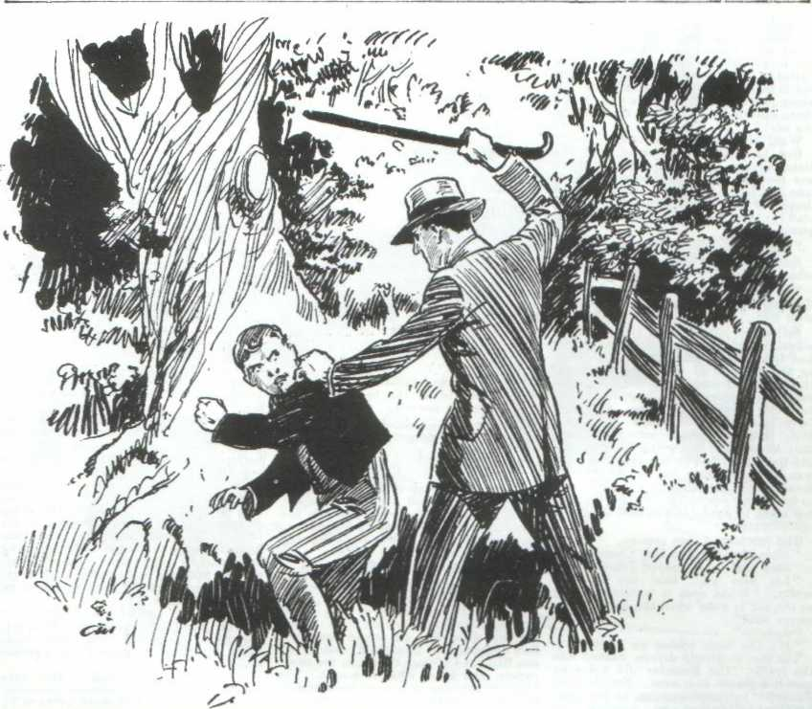
It was a severe thrashing. The Bounder was helpless in the grasp of the powerful man, and he could only set his teeth end endure it. Not a sound of pain escaped his shut lips as the blows fell savagely.
“I think that will do,” said the captain at last, “You had better think twice before you spy on me again.”
And he walked away back to the high road.
The Bounder lay on the grass, panting for breath, aching from the castigation he had received.
He staggered to his feet at last, and stood leaning against a tree, panting for breath. His face was white.
His pursuit of the man he suspected was over now. Captain Spencer was gone; and it would have been futile to shadow him now that he was on his guard. The Bounder’s thoughts and feelings were bitter as he stood leaning on the tree. He had been defeated; and he was more certain than ever that something was planned for that afternoon, The very fact that the man had been so watchful and had taken so effectual a method of stopping his shadower proved, to the Bounder’s mind, that Captain Spencer could not allow his movements to be observed. But the game was up now, and the Bounder, in a bitter mood, limped away at last, sore both in mind and in body.
THE EIGHTH CHAPTER.
Bunter Comes In Useful!
Of BILLY BUNTER stopped at the stile in Friardale Lane, leaned his fat person upon it, and grunted discontentedly.
Bunter was not feeling pleased with things that sunny afternoon.
Lord Mauleverer had gone over to Lantham to cash a cheque at the bank there, and Bunter had fully intended to go with his lordship. For reasons of his own Manly had slipped away without appraising Bunter, and when the Owl of the Remove sought for him he found him not. After which, Bunter had decided to join the Bounder, and Skinner and Snoop on their little excursion that half-holiday. But the three black sheep had left the school ou their bicycles, and Bunter was also “left.”
Bunter’s celebrated postal order, which he was still expecting, had still not arrived, and the Owl of the Remove was in his usual impecunious state. Peter Todd, whose financial resources were reduced to ninepence, had heartlessly refused to lend that ninepence to Bunter. Hazeldene, who was going over to Cliff House to tea, had declined to take Bunter with him—emphatically. Russell and Ogilvy, who were going to the pictures at Courtfield, simply grinned when Bunter suggested that they should stand him a ticket there.
William George Bunter’s luck was out that afternoon, and at last he had rolled out on the road to Friardale, intending to look for Harry Wharton & Co. in the village. But walking never was Bunter’s strong point, and by the time he reached the stile in the lane he was breathless and tired. It was a warm afternoon, and Bunter had an unusual amount of weight to carry.
He rested his weary, fat limbs on the stile and grunted. He was feeling an extremely ill-used youth.
“Shift, you fat fool !”
Bunter blinked round. It was the Bounder’s voice.
Vernon-Smith, white faced and furious, was tramping up the footpath from the wood. He reached the stile, upon which the Owl of the Remove was sitting with his feet on the step.
“Oh, really, Smithy—”
“Get out of the way “ snarled the Bounder.
Bunter decided to get out of the way. The Bounder looked in a humour to send him rolling into the road if he did not.
Vernon-Smith clambered savagely over the stile into the road.
Billy Bunter eyed him curiously. He could see that something had happened to the Bounder.
“I say, Smithy, I’ve been looking for you !” he said amicably.
The Bounder glared at him.
“I’ve nothing to lend you,” he snapped.
“ Oh, really, Smithy—”
“Shut up !”
“You look as if you’ve been through it,” grinned Bunter. “Who’s been grabbing your collar? He, he, he !”
The Bounder clenched his hand, and Bunter prudently backed away. Herbert Vernon-Smith stood leaning on the stile. Bunter, eyeing him warily, climbed on the top bar, at the extreme end. His fat limbs required further rest. The Bounder gave him no heed.
“I say, Smithy, was it Captain Spencer?” ventured Bunter at last.
“Was what Captain Spencer, you fat fool?”
“Well, a cow with half an eye could see that you’ve been licked,” grinned Bunter, “and the Spencer man passed me just before I got to the stile. He came out of the wood, just as you did. Has he walloped you? ”
“Yes!” said the Bounder, between his teeth.
“Cheeky cad, you know,” said Bunter sympathetically. “We know what sort of a rotter he is, Smithy, if the other fellows don’t. I say, you’d feel better for some ginger pop. Let’s get along to Uncle Clegg’s.”
“Go and eat coke !”
Bunter relapsed into silence. The Bounder was evidently not in a mood to stand ginger-pop at the village tuck-shop.
“You saw Spencer, you say ?” asked the Bounder, after a few minutes’ silence.
“Yes; he passed me.”
The Bounder eyed the fat junior.
“You’ve been telling a yarn, Bunter, about Spencer meeting a man in the wood last Saturday. Could you find the place again? ”
Bunter brightened up.
“Easily,” he answered. “I’ll show you the place if you like, Smithy. It’s not far from here, on the other side of the road. Let’s go to Uncle Clegg’s first.”
“Hang Uncle Clegg! I’ll tip you half-a-crown if you show me the place.”
Bunter rolled briskly off the stile. “I’ll show you the place with pleasure, Smithy. Anything to oblige a pal !”
Bunter led the way down the road in the direct ion of Greyfriars. The Bounder followed him with a scowling brow. He remembered Bunter’s description of the secluded spot where Captain Spencer had met the man Ransome—a spot where no chance wayfarer was likely to penetrate. If, as the Bounder suspected, the captain was meeting his confederate again that afternoon, it was likely enough that the same solitary spot would be chosen far the rendezvous. There was a chance, at least, of getting again on the track of the man who had so effectually put an end to his shadowing. The Bounder was not a fellow to leave a stone unturned when he had set his mind to a task.
“Turn off here,” said Bunter.
He led the way into the trees beside the road. At a distance from the road he trees thickened, and the underwoods were dense. Billy Bunter stopped and blinked about him uncertainly. The Bounder watched him with angry impatience. It was soon clear that Bunter was as find his way back to the thicket where he had lain concealed and listened to the talk of the two law-breakers the Saturday before.
“It’s right on from here.” saidBunter at last. “Not more than a few minutes’ walk, I know.”
“You mean you don’t know where the place is,” growled the Bounder.
“There was a big oak tree—”
“Sure it was au oak?”
“Well, it might have been a beech.” said Bunter cautiously,
“You silly owl I”
“Oh, really, Snithy—”
“Are you sure it was either an oak or a beech, you dummy?”
“Yes, quite, unless it wks an elm.”
“ You footling chump !” hissed the Bounder. “You can’t find the place, anyhow. Get off, and bother you !”
I say, Smithy—”
“Oh, clear off !”
The Bounder moved on angrily. Billy Bunter did not clear off. He blinked wrathfully alter the Bounder, and then rolled in pursuit.
“Smithy, old chap—”
Vernon-Smith turned his head to glare at the fat junior.
“Have you remembered the place?”
“Nunno! But—”
“ But what, you born idiot?”
“You’ve forgotten something!” gasped Bunter. “ Something rather important, old fellow.”
“What do you mean, you dummy? What have I forgotten?”
“The—the half-crown—”
“You fat chump !” howled the Bounder. “Trust you to remember that, if you can’t remember anything else. There, you frabjous duffer !‘
“Wow-ow-ow !” spluttered Bunter, as Vernon Smith tossed him the half-crown, which caught him on his fat little nose.
“Now clear out !”
Press “Beast !”
Bunter fielded the halfcrown and rolled back towards the road, rubbing his fat nose with a podgy hand. lie paused by the roadside to shake a fat fist alter the Bounder, who had already vanished in the trees, and then rolled away towards Friardale to call on Uncle Clegg.
The Bounder, dismissing Bunter from his mind, plunged into the thick trees with a scowling brow. He was still feeling painfully the effects of Eric Spencer’s walking-cane, and his temper was at it’s worst. It appeared very probable to his mind that the solitary spot where Bunter had overheard the two rascals in discussion was the accustomed meeting-place of Captain Spencer and his confederate.
Knowing nothing of the discovery Bunter had made, the bank robber would regard it as a safe rendezvous. Had Bunter been able to guide him there, the amateur detective of Greyfriars might have hoped to surprise the rascals in a meeting, perhaps to learn something of their plans. But Bunter, as he might have expected, had failed him.
But he knew that he could not be far from the spot, and he moved among the trees silently, with eyes and ears on the alert. He stopped suddenly, with a throb of excitement. The scent of a strong cigar came to his nostrils, and he knew that someone was close at hand in the silent wood, smoking. He was aware that Eric Spencer smoked strong Havana cigars; and he knew the scent of a Havana. He stood quite still, his heart beating, listening.
The Bounder was a Boy Scout of Greyfriars, and he had not forgotten his scoutcraft. He dropped on his hands and knees, and wormed his way silently and cautiously through the underwoods, the scent of the cigar guiding him.
Deep in a leafy thicket, he caught a glimpse of a man standing under a tree, leaning on the trunk, smoking a cigar. The man was Eric Spencer. He was evidently waiting and smoking while he waited. The Bounder lay quite still, his eyes glittering. Through the foliage he caught only glimpses of Spencer, but he was sure of him. He was waiting for someone; and for whom could he be waiting in that lonely spot? There was a. bitter satisfaction in the Bounder’s face. He was on the track again, and this time the man he was shadowing should not discover him. Silent, still, the Bounder lay and watched, and at last he was rewarded by the sound of a rustling in the thickets, and a man came through the trees and joined Captain Spencer.
THE NINTH CHAPTER
Light at Last!
H ERBERT VERNON-SMITH suppressed his breathing.
His face was pale with excitement now.
He was hardly more Than six or seven feet from the two men standing under the tree, and through the interstices of the foliage he had a view, of both of them, completely hidden himself. The voice of Captain Spencer came clearly to his ears.
“I’ve waited half an hour for you, Ransome.”
“Couldn’t be ‘elped, captain.” answered a husky voice.
The Bounder watched the man who had joined Captain Spencer, surprised and disappointed.
He had expected to see the man with the bulbous nose and scarred chin, who had driven the two seater.
But the man wan quite an ordinary- looking fellow, with a rather hard, coarse face, and shifty eyes set close together. He bore little, if any, resemblance to the man who had driven the car.
He was carrying a valise in his hand, which he laid in the grass and opened.
“You’ve got the stuff there?”
“You bet, captain !”
“Where did you leave the car?”
“Safe enough, t’other side of Courtfield. You’ll want t’other car for the job—the closed car.”
The Bounder barely suppressed a start.
This was the man, after all, who had driven the two-seater. The disfigured nose and the scarred chin had been make-up; the man had been in disguise.
Smithy understood that now.
Ransome was kneeling beside the open bag, sorting out various articles. There was a gleam of reflected light as he fastened a mirror to a trunk. The Bomder watched intently.
Captain Spencer was slipping on a suit of clothes over his own. The suit had been taken from the bag.
Then he stood before the glass, and the Bounder, with beating heart, watched him making up his face, like an actor preparing for the stage.
The whole game was clear to Smithy now.
He was not surprised when he saw the captain adjusting the false nose, darkening his skin, and artistically delineating the scar on his chin.
The man worked quickly; it as plainly a kind of work to which he was well accustomed.
In a very short time Captain Spencer had vanished from all knowledge, and in his place stood an exact representation of the footpad who had attacked Dr. Locke, and who that afternoon had driven the two-seater through the High Street of Friardale.
The Bounder grinned.
He knew now why the pretended foot- pad had made his appearance near Greyfriars; why the man who was wanted had ventured to drive a car through Friardale, with Captain Spencer on the spot to point him out to P.C. Tozer.
It was a carefully prepared alibi for the bank robber.
Obviously, that afternoon was to see the bank raider at work again; but he was to appear in the guise of the manwith the bulbous nose and the scarred chin, thus preventing even the bare possibility of suspicion attaching to Eric Spencer.
P.C.Tozer was an irrefragable witness that Captain Spencer was not the man! Mr. Tozer had seen both Spencer and the scarred man in the High Street of Friardale at the same moment. Obviously, therefore, they were not the same man
It was a cunning scheme; an alibi that coul not be disputed, or even suspected.
The Bounder’s heart was beating fast. What he had learned now could only mean that the desperate man had planned a raid for that afternoon ; his make-up as the scarred man could mean nothing else.
The captain was finished at last.
“All right !” said Ransome, surveying him. He chuckled huskily as he spoke.
“Right as rain, captain.”
“You understand ? ” Captain Spencer spoke in low, tense tones. “You’ll be at the cross-roads on Courtfield Common at three-fifteen, in the closed car.”
“You bet.”
“I can get to Courtfield Common from here by following the footpaths, without coming out into the open at all. I know all this country like a book. I was a schoolboy here once.”
Ransome nodded.
“You pick me up at the crossroads,and drive ne to the bank. I shall probably not be three minutes in the bank.”
“You’re the man for it, captain,” said Ransome admiringly. “There ain’t one man in a thousand got the nerve. But you’ve got it.”
And you haven’t,” said the captain, with a shrug of the shoulders.
Ransome grinned.
“No fear!” ho said. “I’m backing you up, captain; but you don’t see me holding up a bank in broad daylight— not me!”
The captain laughed contemptuously.
Press “It’s child play to what I went through on the Somme ten years ago,” he said.
“I dessay. Too thick for me, all the same.”
“Well, you’ve got an easy part to play, so you needn’t worry.”
“I ain’t worrying,” grinned Ransome. “You’re taking the risk, captain. And you’re all safe at the school press? ”
“Quite.”
The Bounder, silent in the thicket, smiled.
There were a few more muttered words, and then the man Ransome tramped away through the trees knd disappeared.
Captain Spencer remained where ho was a few minutes longer.
The Bounder, tensely silent, watched his disgni.ed face through the interstices of the foliage.
But for the fact that he had watched the man assuming the disguise, he would never have believed that it was Eric Spencer standing there.
Harry Wharton & Co. and P.C. Tozer, had they seen him then, would not have had the slightest doubt that this was the manwho had driven the two seater through Friardale.
The Bounder watched grimly.
The scheme had been so cunningly laid that success was certain, but for the Bounder’s knowledge. After the raid on the Courtfield Bank, the raider would vanish in the closed car driven by Ransome; and in a hidden spot he would strip off his disguise, and walk back to Greyfriars as Eric Spencer.
The police would be seeking for the man with a bulbous nose and a scarred chin, who would be no longer in existence.
The captain lingered for a few minutes under the trees, a thoughtful frown on his disguised face.
Vernon-Smith wondered what his thoughts were.
Perhaps he was thinking of the risk that was inevitable when he made his attempt. on the bank—a risk that no cunning scheme could avoid; or he might have been reflecting upon the depth to which he had fallen since the days when he had been a schoolboy at Greyfriars, and since the later days when he had played an honourable part in the War. The Bounder wondered.
The captain made an impatient gesture at last, as if dismissing haunting thoughts, and strode away through the trees.
His footsteps died away in the distance,
For some time the Bounder did not move. But he rose from his covert at last.
He looked at his watch.
It was a quarter to three.
In half an hour the bank-raider would be picked up in the closed car on Court field Common, to drive to the bank. After that it was a matter of minutes.
Only the Bounder of Greyfriars held the clue to what was intended, and he had little time to act.
His first thought was to communicate with Inspector Craven at Lantham; but he realised at once that there was no time.
He had no more than time to reach Courtlield before the raid on the bank took place.
He hurried back to the Friardale road, and ran into the village at top speed. His bicycle was still where he had left it, leaning against the oak outside Uncle Clegg’s tuckshop.
“Hallo, hallo, hallo!”
Bob Cherry’s cheery, ruddy face was looking out of the doorway of Uncle Clegg’s little establishment. -
He waved his hand to the Bounder.
“Come and have a ginger-pop, Smithy.”
The Bounder’s hand was on his bike. He hesitated a moment, and then, leaving the machine where it was, hurried into the tuckshop.
THE TENTH CHAPTER.
The Bank Raider at Courtfield!
HARRY WHARTON & CO. were sampling Uncle Clegg’s ginger- beer in the little shop. Billy Bunter was perched on a big stool at the counter, with a jammy smear on his fat face. There were two or three other Greyfriars juniors there. All of them glanced curiously at the Bouncier as ho came in breathless, his face mill of excitement.
“You follows busy ?“ asked the Bounder.
“Frightfully!” said Frank Nugent, laughing. “Don’t we look it?”
“Thc busyfulness is terrific,” remarked Hurree Jamset Ram Singh. “The excellent ginger-pop of the esteemed Mr. Clegg is grateful and comfortable on a warm afternoon and the thirstfulness of our esteemed selves is ---”
“Terrific !” chuckled Bob Cherry.
“I want you fellows to come with me.” said the Bounder abruptly.
“What’s on ?” asked Harry Wharton.
“Where are we to come “ asked Nugent. “Don’t suggest the pictures on a hot afternoon! ”
“Courtfield,” said the Bounder, “You’ve got your bikes here.”
“Anything on at Courtfield?”
“ Yes.”
“Well, if there’s anything on, we’ll come,” said the captain of the Remove. “We were going for a spin, anyhow. But what’s on?”
“A bank robbery.”
“What?”
“Which?”
“Draw it mild!”
“Smithy’s got bank robberies on the brain ?” chuckled Bob Cherry. “Trying to pull our leg, old bean ? ”
The Bounder smiled sarcastically.
Eric Spencer was even then on his way to Courtfield, with the intention of “holding-up” the bank as he had held up the bank at Lantham the week before. The Bounder knew it from his own words to his confederate.
But he knew also that if he told what he knew the chums of the Remove would not believe a word of it. They were fed-up with his suspicions of Captain Spencer.
“For goodness sake, Smithy, get off that subject!” said Harry Wharton impatiently. “You make a fellow tired !”
“There’s no time to talk,” said Vernon-Smith quietly. ‘I’d like you fellows to come along and help. You’ll be sorry afterwards if you miss the show. But suit yourselves. I’m going.”
“But what—” began Johnny Bull.
“Will you come?” exclaimed the Bounder impatiently. “I’m not pulling your leg. I give you my word. A ride to Courtfleld won’t hurt you if you’re going for a spin, anyhow. Look here, I’ll race you to Courtfield!”
“Too hot for racing,” yawned Nugent.
“Slacker !”
“Oh, let’s!” exclaimed Bob Cherry at once. “This Co. never refuses a challenge. We’ll race Smithy to Courtfield, and beat him by a dozen lengths!”
“Not in your lifetime !“ said Vernon Smith.
“I suppose you’re trying to pull our leg, Smithy,” said Harry Wharton, with a perplexed look at the Bounder’s face, which was burning with suppressed excitement. “But we’ll race you to Courtfield, if you like.”
“Done, then!”
Herbert Vernon-Smith hurried out on his bicycle. In spite of themselves, the Famous Five could not help being a little impressed by his evident earnestness.
“ What on earth has Smithy got in his noddle now ?“ asked Bob, as they followed the Bounder out.
“Goodness knows !” said Harry. “He seems in earnest.”
“Some more of his rot, I suppose,” grunted Johnny Bull.
“The rotfulness is probably terrific, but the racefulness will do us no harm,” said Hurree Singh.
“Here, start fair, Smithy !” roared Bob Cherry, as the Bounder rushed his bike out into the street and mounted.
“Come on, you slackers !” called back Smithy.
“Go it, you chaps I”
The Famous Five mounted at once and pedalled away after the Bounder.
They swept away in a bunch up the High Street and out into Friardale lane.
The Bounder did not look back.
He was grinding at his pedals as if his life depended on his speed, and his machine fairly flew.
“My hat! Smithy’s putting it on !” exclaimed Bob Cherry. “But he won’t beat this little infant, at any rate.”
And Bob drove hard at his pedals and drew level with the Bounder, fast as Smithy rode.
“Keeping you company, Smithy !” he grinned cheerfully.
Wharton and Johnny Bull, Hurree Jamset Ram Singh and Frank Nugent, were strung out behind, all of them riding their hardest.
Smithy gave Bob a glance.
“ Were taking the short cut,” he panted.
“Just as you like. It’s bumpy,” said Bob.
“That doesn’t matter. We’ve got to get to Courtfield under the half-hour.”
“Quick work” grinned Bob.
“We can do it.”
“Well, I can,” chuckled Bob. “ Don’t know about you. Come on, you men ! Smithy’s going all out to break the giddy record!”
Bob Cherry shot ahead. He was the most powerful rider in the Co., and in ordinary circumstances he would have beaten Vernon-Smith in a race without much difficulty. But the Bounder was riding now as he had never been seen to ride before.
He drew level with Bob again, and passed him. He was the first to turn into the short cut which saved a considerable distance, but led over rutty and bumpy ground. Heedless of ruts and bumps, the Bounder drove fiercely at his pedals and flew on ahead.
“Smithy’s going it, and no mistake !” gasped Frank Nugent. “Keep it up, you fellows, I’ll follow on!”
And Frank tailed off behind.
Hurree Jamset Rant Singh was the next man to tail off.
But Bob Cherry, going all out, kept up with the excited Bounder, and Harry Wharton aand Johnny Bull raced on behind, determined not to be dropped.
They came out on Courtfield Common, all going strong, and tore along the path on the common towards the town. By that time Nugent and Hurree Singh were little more than specks in the distance behind.
The excitement of the race had seized on the chums of the Remove now. They were determined not to be beaten by the Bounder. But they had hard work to keep up with him.
Even when they reached Courtfield High Street, and there was traffic to be considered, Vernon-Smith rode on with reckless haste. Bob Cherry slacked down a little then. He was not prepared to take the risk of knocking over foot passengers, like the Bounder.
The Courtfield Bank was a large corner building, and the Bounder, as he reached it jammed on his brakes and jumped off.
Almost reeling from his exertions, he dragged out his watch and looked at it.
It was a quarter-past three.
“We’re on time !“ gasped the Bounder.
Bob Cherry 3umped down.
“You reckless idiot !” he bawled. “You might have got killed about half a dozen times !”
The Bounder laughed breathlessly.
“Never mind that. Come with me.”
He had stopped on the side of the street opposite the bank. The Courtfleld bun shop stood there, with a row of little tables outside, under a striped awning.
There was time before the bank robber could arrive. The closed car, driven by Ransome, was to pick up the disguised captain at the cross-roads on Courtfleld Common at three-flfteen. It was, therefore, picking him up at the very time thiat the Bounder dismounted outside the bun shop opposite the bank. It could not be on the scene for at least five minutes yet, and more likely ten.
The Bounder stood breathing in gasps, Rob Cherry eyeing him rather grimly. Harry Wharton and Johnny Bull rode up and dismounted at the pavement.
Nugent and Hurree Singh were still far away.
“Let’s sit down here, you men,” said the eounder. “Shove the biks behind that corner. Sit down and have some ices.”
“But—” began Bob.
“Oh, sit down !”
“All serene ! Might as well have had the ices at Uncle Clegg’s, in Friardale, so far as I can see,” remarked Johnuy Bull.
“That isn’t very far,” sneered the Bounder.
“Look here, Snaithy—”
The Bounder did not heed.
He had picked a table a little hidden by the awnings, so that the juniors would be somewhat screened from the street, but still able to see the bank entrance on the opposite side of the road.
The chums of the Remove could see that Vernon-Smith was almost trembling with excitement, and to some extent they caught the infection of it. In spite of their doubt and disbelief, somehow they began to feel that there was “something in it.’
They sat down round the little table, such the Bounder ordered ices, but did not touch his own. His eyes were on the bank opposite.
Harry Wharton followed the direction of his gaze.
He laughed impatiently.
“Still thinking of the bank raid?” he asked.
“Yes!”
“You’ll never see one,” said Bob Cherry. “It happened last week at
Lantham. First time it’s ever been heard of in this part of the country. May happen again in a hundred years.”
“It will happen again within ten minutes.”
“Pile it on!” grinned Bob.
“Keep an eye on the street while you eat your ices,’ said Smithy. “You will see closed car come from the direction of the common and stop at the bank.”
“How do you know?”
“Never mind that now. Too long a story—and you wouldn’t believe it, anyhow, till you see the raid. The bank robber will be in the car.’
“Go it! This is as good as the films, and cheaper.”
“Ha, ha, ha!”
The Bounder did not heed the merriment of the three juniors. His face was almost drawn with suppressed excitement. Feverishly he watched the busy street.
More than one closed car paused, but none stopped at the bank. At the sight of each one the Bounder half rose, and then sank back again on his chair.
But suddeuly his eyes blazed.
In his excitement ho gripped Harry Wharton’s arm.
“There’s the car !” he breathed.
The juniors gazed at it. It was a common looking car enough, closed, and with the windows covered. The man who was driving was a commonplace looking man, with a rather hard face and foxy eyes.
“You’ve seen that man before,” said Smithy.
“Not that I remember,” said Harry.
“He had a fake nose on, and a scar painted on his chin when you saw him last.”
Wharton jumped.
“Wha-a-at?”
“Oh, this is getting too rich !“ said Bob Cherry laughing. “The man is about the same build as that johnny at the two-seater, but he doesn’t look like him a little bit.”
“He was in disguise then—”
“Hem !”
“And the same disguise is now worn by the man sitting inside that car, who will get out when it stops at the bank.”
“What a mix-up,” said Bob. “I said this was as good as the films, but I was under-stating the case. It’s better.”
“The betterfulness is terrific, as Inky would say,” chuckled Wharton.
“And who’s the Johnny in the car who has borrowed the nosy man’s chivvy ?“ akcd Johnny Bull, grinning.
“Captain Spencer.”
“You silly owl! Are you beginning that yarn again?”
“You’ll see in less than a minute.”
“Rats !”
“I don’t suppose the car will stop at the bank at all,” chuckled Bob Cherry. “and what will you say then, Smithy ?”
“Look !”
The car slowed down as Bob was speaking; as the Bounder ejaculated, it stopped just opposite the bank entrance across the road.
Harry Wharton & Co. stared a little.
The Bounder had said that the closed car would stop at the bank. It had stopped! Smithy’s staterment was borne out so far.
“Well, that’s a coincidence,” remarked Bob.
“We can’t see who gets out of the car,” remarked Johnny Bull. “It’s between us and the bank.”
“You’ll see him when he goes up the bank steps.”
“Yes, that’s so.”
Still unbelieving, but decidedly suspicious, Harry Wharton & Co. stared across the road. They were keenly interested now, at least. A man had stepped out of the closed car and crossed the pavement to the bank entrance hurriedly. There were two large granite steps at the entrance, and as the man mounted them the juniors had a view of him. It was only a momentary view, as he pushed open a heavy swing door and disappeared into the building. But that glimpse, brief as it was, electrified them. For they spotted the red, bulbous nose, the dark complexion, and scarred chin of the man who had driven the two seater in Friardale early that afternoon. The Bounder knew that it was not the same man, but to the chums of the Remove he was the same man beyond the shadow of a doubt.
“My hat !“ ejaculated Bob in amazement.
“That’s the man!” rapped out Johnny Bull. “How Smithy knew it all beats me; but that’s the man. After him !”
Tho Bounder was already darting across the street. Harry Wharton & Co. did not need to be called on to follow; they rushed after him. Two panting cyclists jumped down at the same moment as they caught sight of the Greyfriars juniors.
“Hallo, you fellows !“ called out Nugent. “What on earth’s up?”
“The upfulness is terriüc,” remarked Hurree Jamset Ram Singh “Let us follow onfully, my esteemed Franky.”
And, leaving their bikes on the kerb, Hurrec Jamset Ram Singh and Frank Nugent rushed across the street after their comrades.
THE ELEVENTH CHAPTER.
Stop Thief!
HARRY WHARTON & CO. reached the pavement on the opposite side of Courtfield High Street.
They were about to rush across the pavement to the steps of the bank when the Bounder caught Wharton by the arm.
“Hold on !“ he panted.
“Come on, you men!” gasped Wharton. “He’s in there now. It’s a bank raid plain enough!”
“I know that. I know he’s got an automatic, too, and he’s got the bank people with their hands up!”
“But—“
“Don’t be a fool. The man would shoot you down like a rabbit. We’ve got to cut off his retreat, then he’ll be nailed.” hissed the Bounder. That car is waiting for him to escape in. Cut along to the corner—there’s a bobby there.—sharp, while I collar that man in the car !”
Wharton hesitated a second.
But he realized at once that the Bounder was right. It was not much
use for an unarmed schoolboy to rush into the building where an armed and dangerous man was holding up the bank staff at the muzzle of an automatic
“Right !” breathed Wharton.
And he dashed along to the corner, where a constable was on duty.
The Bounder turned to the car, and Bob Cherry turned
with him.
Ransome, sitting at the steering-wheel, stared at the schoolboys. He had heard the Bounder’s excited words to the captain of the Remove. From the bank had come no sound; the staff, and any customers who happened to be in the building, were evidently
terrorized by the raider’s automatic.
Who theee schoolboys were, and how theyknew what was going on, Ransome did not know; but he saw that the game was up. Waiting for his confederate meant arrest for himelf. There is said
to be honour among thieves, but that did not seemto apply to the Captain Spencer’s confederate.
The car leaped into motion.
“Stop him !” yelled Bob Cherry.
“Stop that car!” roared Johnny Bull.
‘Let him go,” said the Bounder “What does it matter, so long as the car is gone when the bank raider comes out?”
“But—”
“It’s the bank robber we want !”
The car, recklessly driven, dashed into the traffic. The Bounder did not even give it a glance as it went. For the man Ransome he cared nothing, or less than nothing. Whether he escaped, or whether he was taken, mattered not a straw to the Bounder of Greyfriars. It was Captain Spencer, now in the bank building, that Herbert Vernon-Smith wanted; and now that his confederate had fled, the bank robber’s retreat was cut off.
Already the Courtfield constable, with a startled and skeptical face, was coming up to the bank entrance with Harry Wharton.
Bang!
It was the sudden report of a firearm within the bank.
The constable’s scepticism vanished as he heard that sharp, startling sound.
A cry followed the shot.
Instantly afterwards the policeman’s whistle rang out a shrill blast, and he grasped his truncheon.
The swing doors flew open, and a man with a red, bulbous nose and a scarred chin dashed down the steps. One of his pockets bulged with the loot hastily jammed into it; in his right hand he grasped an automatic pistol.
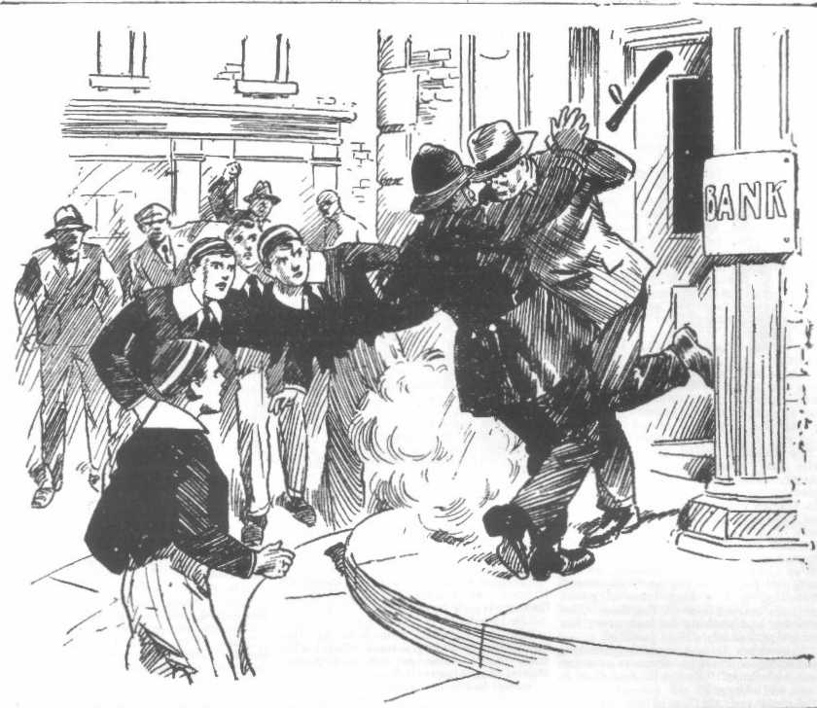
But for the intervention of the Bounder the raid would have been a
success. Only one man in the bank bad attempted to stop the raider,
He had been shot down, and lay wounded and groaning in the building as the robber dashed out. The desperate man required only a second to rush across the pavement to the waiting car and dash away to safety. But the car was no longer there, and the pavement was blocked by a stalwart police-constable, truncheon in hand, and six Greyfriars juniors.
The bank raider was half-across the pabement before he realised how the position had changed.
“Collar him!” roared Bob Cherry. The bank-rider halted, panting.
“Collar him !”
“Don’t let him get away! ”
The automatic swung up,
“Stand back!” panted the desperate man.
Heedless of the levelled pistol, the constable rushed straight at him.
Bang !
To the startled eyes of the Greyfriars juniors it seemed like some terrible dream. They could scarcely believe their eyes as the desperate man fired, and the constable dropped on the pavement, his truncheon crashing to the ground. The bullet was in his leg, and he lay helpless; but his whistle was to his lips, and he was blowing it shrilly.
The bank-raider turned and dashed up the street.
“ After him !”
The juniors had backed away from the automatic; but as the bank-raider ran they rushed in pursuit.
There were wild shouts and cries from every direction now.
“Stop him!”
“Stop thief !”
“After him !”
“Stop him! Stop him!”
A shouting crowd joined in the pursuit. A man made a clutch at the fleeing robber, but jumped back from the threatening pistol, and the desperate fugitive ran on,
“After him !” hissed the Bounder.
Vernon-Smith was hot in pursuit. Besides the Greyfriars fellows, there were now at least forty or fifty people rushing after the desperate man. It was the first time that an armed bank raid had happened in Courtfield; but everyone had read of such things in the newspapers, and knew what it meant. The High Street was in a roar from end to end—every shop and house poured out its occupants. Right in the path of the fleeing man a police-constable appeared, and the automatic barked again, and again, but the hurried shots missed. There was a crash of breaking glass as the bullets shattered a shop-window.
The policeman’s grasp was almost upon the hunted man, when he turned into a side street and escaped once more. But the hot pursuit swept round the corner after him, the constable now, in the lead. Another and another constable appeared, apparently from nowhere, as if by magic. Missiles were flying, and the desperate fugitive was seen to stagger as a stone struck his head.
“We’ll get him !“ panted the Bounder. A man leaped from a shop doorway and grasped the fugitive as he was running past, and brought him to the ground. There was a roar from the chasing mob behind.
But the next moment the man who had seized the bank-raider was rolling on the pavement, half-stunned by the crashing barrel of the automatic, and the fugitive was running again.
“Stop thief !”
“After him!”
The man-hunt was fairly up now. There were hundreds of people running and shouting.
The bank-raider’s case was hopeless. He had lost ground, and the pursuit was close behind. One stalwart constable, running hard, was only two yards behind the fleeing man, and behind him came a yelling mob. A quick-witted grocer’s lad hurled his basket in front of the fugitive and he stumbled over it before he could stop, and fell. But again he was up before he could be seized and furiously speeding on. The end of the street was an open lane, leading out into the country, and it seemed to be the desperate man’s object to reach the open, perhaps with some delusive hope of escaping into the woods But, the chase wa too hot and too close.
He turned suddenly and swung up his pistol. His eyes gleamed and glittered wildly over the weapon.
There was a gasp of alarm from the pursuing mob, and a wild scattering to avoid the coming shot.
Bang!
The policeman nearest the fugitive fell, with the bullet in his shoulder. The man was running again.
“Stop thief !”
The houses were left behind now, save for a few scattered buildings.
There were fences and hedges on either side of the raider as he ran, and behind him whooping hundreds. He stared round again, breathing in great gasps, desperate, hopeless, almost at the end of his tether. A heavy stone whizzed through the air and struck him, and he reeled. The next moment the grasp of a constable was on him, and he went to the ground with a crash, the pistol flying from his hand,
For a moment he struggled. But many hands were instantly upon him, and his resistance ceased. In the grasp of many hands, he was dragged to his feet. His despairing gaze swept the faces of the gathering crowd, thronging triumphantly round him. His eyes fell on the Bounder and blazed with rage. As if by intuition he knew to whom he owed his disaster.
“Got him !” gasped Bob Cherry.
“Got him!” repeated the Bounder, breathless, fatigued, but still cool. “Got him ! Your game’s up, Captain Spencer.”
“You fool!” roared Bob. “How dare you—”
“Look at him!”
In the brief struggle the fake nose had been brushed from the man’s face. A handsome nose was revealed, and its whiteness was in startling contrast to the dark complexion of the rest of the face. Obviously the man had been in disguise.
“That man is Captain Spencer!” said the Bounder in a loud, clear voice. “I watched him making up this afternoon; that complexion will wash off, and so will the scar on his chin. That man is
Captain Eric Spencer, who robbed the bank at Lantham last week.”
“Smithy—”
“ Look at him!” jeered the Bounder.
A passing motor-car was signalled by one of the policemen, and stopped, and the captured bank-raider placed in it, to be taken back to Courtfield. The excited mob followed in a stream. Harry Wharton & Co., scarcely knowing what to think, followed with the rest; it was borne in upon their ninds at last that the Bounder was right.
At Courtfield, Herbert Vernon-Smith went into the police station, where the captured The man had been taken, to make his statement to Inspector Grimes. Harry Wharton & Co., with their minds in a whirl, waited for him to come out.
There was a smile on the Bounder’s face when he emerged. Inspector Grimes came to the door with him, with a very satisfied smile on his plump face. He was treating the Bounder with an air of very great consideration.
“Well done—well done, indeed, Master Vernon-Smith !” said the inspector. “1 shall report your services to your headmaster. This news will be a shock to him, but he will be glad to know that a Greyfriars boy was instrumental in exposing the scoundrel”
“I hope so!” grinned the Bounder.
“As a matter of fact, I had had an eye on the man,” said Mr. Grimes. “Inspector Craven, of Lantham, consulted me about your report to him, Master Vernon-Smith.”
Harry Wharton came forward.
“You’ve found out the name of the bank-robber, Mr. Grimes!” he asked.
Mr. Grimes glanced at him.
“There’s no secret about that, Master Wharton,” he said. “The man does not deny his identity.”
“And his name —“
“Captain Spencer.”
“Oh!”
Harry Wharton & Co. turned away with heavy hearts. They were glad that a desperate law-breaker had been brought to justice; but the news was a terrible shock to them, and they could not share the triumph of the Bounder. They knew, too, that it would be a terrible shock to the Head of Greyfriars. But the Bounder was thinking only of his triumph, and his face was bright, and he seemed to be walking on air as he left the police station.
THE TWELFTH CHAPTER.
The Bounder’s Triumph!
“I SAY, you fellows!”
Billy Bunter met the chums of the Remove as they came into the School house very late for tea.
Harry Wharton & Co. were not looking so merry and bright as usual; but the Bounder, who came in with them, was smiling. Bunter seemed to be full of news.
“1 say, you fellows, have you heard ?” exclaimed the Owl of the Remove. “There’s been another bank raid !”
“Bank raid this afternoon at Court- Reid, just like the one the other day at Lantham !“ said Bunter impressively.
The Famous Five could not help grinning. Evidently the fat junior was not aware that they had been on the scene when the Courtfield Bank had been raided.
“You don’t say so, Bunter !” ejaculated Bob Cherry.
“Fact !” said Bunter. “You fellows never hear the news! Man held up the bank with a gun or something, just the same as at Lantham !”
“Go hon !”
“I tell you it’s so !“ exclaimed Bunter. “I had it from Hobson of the Shell. He was in Courtfield this afternoon, and saw a regular mob chasing theman. Where have you fellows been?”
“In Courtfield !” grinned Bob.
“Did you see anything?”
“The whole show.”
“Oh!” said Bunter. He realised that he was not first with the news this time. I say, you fellows, did they get the man?”
“They did.”
Bunter’s eyes bulged with eager curiosity behind his spectacles.
“Who was it ?” he gasped.
“My only hat !“ ejaculated Bob Cherry. “There must have been some truth, after all, in that yarn Bunter was spinning !”
“I told you it was true, didn’t I?” roared Bunter.
“Yes. That made us think it wasn’t, of course !”
“Oh, really, Cherry—”
“I knew it was true,” said the Bounder, with a grin, “it was partly owing to Bunter that I got on the man’s track this afternoon.”
“Well, a fellow couldn’t be expected to guess that Bunter was telling the truth !” said Bob Cherry argumentatively. “Naturally, that never occurred to anybody.”
“Beast ! But they got the man—who is it ?“ gasped Bunter. “Was it—you know whom, Smithy?”
“It was Captain Spencer,” said the Bounder. “The other man got away—— the man Ransome. Captain Spencer was the bank-raider !”
“Vernon-Smith !”
It was a thunderous voice as Mr. Quelch came striding out of his study. The Remove master’s brow was black with anger.
The Bounder faced him coolly.
“Yes, sir.”
“How dare you ! I repeat, how dare you !” thundered Mr. Quelch. “You were released from the punishment-room on your promise, your word of honour, to cease your slanderous stories concerning the Head’s guest! You were warned in the plainest possible terms that if von broke your word you would be sent away from the school! Yet I hear you repeating your accusations!
How dare you!”
He dropped his hand on the Bounder’s shoulder.
“Come with mc, Vernon-Smith! You have disregarded your promise, and you have repeated your slanderous accusation against Captain Spencer! You will be expelled from the school! I shall take you to the Head at once !”
The Bounder smiled, much to the surprise and exasperation of his Form master. The situation was extremely entertaining to Herbert Vernon Smith. Mr. Quelch so far knew nothing of what had happened in Courtfield that afternoon, and was totally unaware of the fact that Eric Spencer, now completely exposed in his true character, lay in a cell in Courtfield Police Station, on the charge of bank robbing and feloniously wounding, with a long term of penal servitude staring him in the face. The Bounder had nothing to fear now; his accusation was more than justified.
“You think it is a laughing matter. Vernon-Smith !” The Remove master almost choked. “You will find that it is not so! Come!”
“Excuse me, sir !“ said the Bounder politely. “I promised to say nothing further about Captain Spencer, if you remember, unless my charge against him should be proved. In that case—”
“Silence !”
“But, sir—” began Harry Wharton.
“You need say nothing, Wharton! I am surprised that you should think of uttering a word in defence of this unprincipled boy !“
“But—”
“Silence! Come with me, Vernon-Smith !”
“Certainly, sir!” drawled the Bounder.
With a thunderous brow, Mr. Quelch marched the Bounder away to the Head’s study His determination was fixed now. The rebel of the Remove bad gone too far, and he should reap his reward. The cool confidence of the Bounder’s manner perplexed Mr. Quelch, and enraged him further. He kept an angry grip on the Bounder’. shoulder as he marched him away. He knocked at Head’s door, and marched the delinquent in.
Dr. Locke had just laid down the receiver of the telephone, and he was sitting with a stricken, dazed look on his face. Mr. Quelch for the moment did not observe his expression. The Bounder did, and he could guess that the Head had received information from Inspector Grimes.
“Dr. Locke, I have brought this boy to you,” said Mr. Quclch. “1 regret to say that, in spite of all the warnings he has received, he has abused the leniency with which he has been treated. He has repeated in my hearing his wicked accusation against your guest. I trust, sir, that an example will he madc at once of this rebellious and unscrupulous boy!”
Mr. Quelch—”
The Head’s voice faltered. It was obvious that he had had a heavy blow, and that it had deeply disturbed him-
“It is not too late, sir, for Vernon- Smith to leave Greyfriars to-day” said the Remove master. “Surely, sir, his presence in the school can no longer be tolerated ! It is an insult to Captain Spencer !“
The Head sighed.
“There is no question of Vernon- Smith leaving Greyfriars, Mr. Quelch,” he answered. “On the other hand, I owe him my thanks for having been instrumental in bringing an unscrupulous man to justice. His accusations against Captain Spencer were, after all, well founded !”
“Dr. Locke !”
“That unhappy man, Mr. Quelch, was guilty of what Vernon-Smith alleged against him! There is unfortunately now no further doubt !“
“Impossible, sir !“
“It is a blow to me,” said the Head sadly. ‘But the matter is now clear. It is plain that Eric Spencer was using his old school simply as a headquarters while he carried out his lawless proceedings. Mr. Quelch, there has been a raid on the bank in Courtfield this afternoon, and, largely owing to Vernon-Smith, the bank-robber has been captured.”
“That does not concern Captain Spencer, sir.”
“I have just learned front Inspector Grimes, at Courtfield, that Captain Spencer is now under arrest.”
“Dr. Locke !” and and
“He is the man who held up the bank, and wounded a bank official who tried to seize him, as well as two constables in the pursuit.”
“Good Heavens!” and gasped Mr. Quelch.
“That young man has deceived me most unscrupulously, Mr. Quelch. I can scarcely blame myself for having been deceived, for who could have divined his true character? The fact is, however, fully established now, and—and our thanks are due to this boy in your Form who attempted to place us on our guard against him, and to whom& we refused to listen.”
Mr. Quelch stood transfixed.
“Is—is this certain, sir?” he almost babbled at last.
“I have the information from the police. Ii is a terrible disgrace to the school,” said the Head, with a sigh; “yet we must be glad that justice will be done, at least.”
And—and Captain Spencer—”
“He is the bank raider.”
“He may prove —”
“He was caught in the act, Mr. Quelch, and makes no denial.”
“Oh !” gasped Mr. Quelch.
The Bounder smiled.
“May I go now, sir?” he asked demurely.
“ You may go, Vernon-Smith.” said the Head. “ I owe you my thanks, and I regret that I did not believe what you stated to ne”
‘‘ Thank you, sir
Mr. Quelch looked at the Bounder. There was a mocking gleam in Smithy’s eyes. The Remove master breathed hard.
“It—it appears that this boy s statement was justified, then, sir ?” he asked between his set lips.
“ Fully, Mr. Quelch.”
“You have punished me for nothing, sir,” said the Bounder.
“That is not the case, Vernon-Smith,” said Mr. Quelch in a grinding voice. “ Your statement was incredible, coming from a boy of your character. Had such a statement been made by a boy like Wharton, or Cherry, or Todd, it would have been heeded. It was not heeded, coming from you, because you are well known to be untruthful and unscrupulous. You have only yourself to thank. You appear to have rendered a service to the cause of the law, but that does not alter the fact that you have been disobedient, disrespectful, and disregardful of authority. You may go.”
And the Bounder, with a mocking and smile, went. No doubt Mr. Quelch was glad thsat a man who had deceived his old headmaster, and made use of hi old school for nefarious purposes, had been exposed and brought to justice. No doubt he was glad that a member of his Form had been useful in the cause of law and order. But certainly his feelings, just then, towards that member of his Form, seemed more bitter than ever.
But the Bounder cared nothing.
He had beaten Quelchy at the finish, as he regarded it, and that was enough for the rebel of Greyfriars.
He and strolled along to the Rag with his hands in his pockets and a smile on his face.
There was a crowd in the Rag, discussing the amazing news of the arrest of Captain Spencer. Billy Bunter’s fat voice was heard as the Bounder strolled move in.
“I say, you fellows, I told you so all along—.”
“Then don’t tell us again!” suggested Bob Cherry.
“Oh, really, Cherry—”
“Hallo, hallo, hallo! Here’s Smithy! Not licked this time Smithy ? ”
The Bounder laughed move.
“No. I’ve been thanked by the Head ! Rather a new experience for me, and a big improvement on the punishment-room.”
“Ha, ha, ha !”
“Was Quelchy pleased?” grinned Skinner.
“Well, he may have been; but he didn’t look pleased,” grinned the Bounder. “It seemed rather an unpleasant pill for him to swallow. He move didn’t seem to like it at all. He wanted to see me safe home this very afternoon, it’s rather a disappointment for the poor man. I feel for him!”
“Ha, ha, ha!”
“I daresay he will take it out of me in class,” draw led the Bounder. “ I shall have to be jolly careful with prep this evening, and put up a good con to-morrow. What a life!”
It was a nine days’ wonder at Greyfriars. It was a triumph for the Bounder, and he enjoyed it to the full, all the more because it was, to a certain extent, a triumph over his Form master. He had been proved in the right, and his Form-master in the wrong, which was a very unpleasant position for Mr. Quelch, but pleasant enough to the rebel of the Remove.
THE END.

