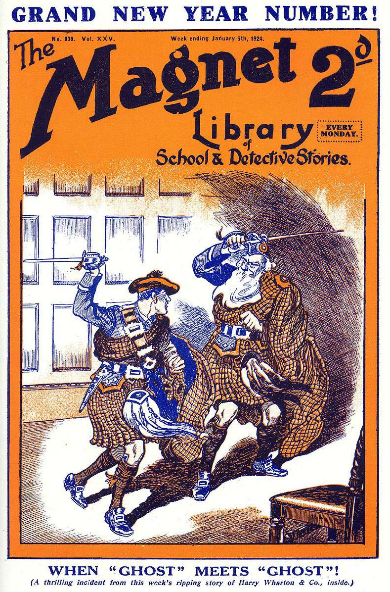
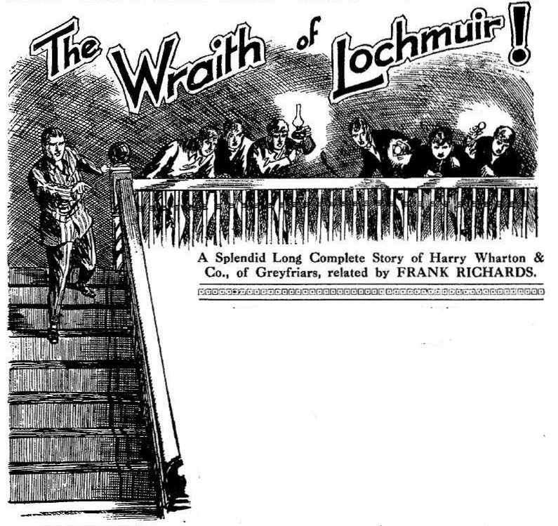
THE FIRST CHAPTER.
The House In the Highlands!
CHRISTMAS night had worn away ; a dim, misty dawn was rising over the Highlands. Harry Wharton stood at his window, in the old house of Lochmuir, and looked out. Frosty, frozen trees, snowy hillsides, and the misty stretch of the loch met his eyes. Not a living thing was in sight; only in the distance a thin spiral of smoke rose from the chimney of Sandy Beans cottage in the glen.
Harry Wharton shivered a little.
His face was pale—pale with watching through the wild night. He turned from the window, and looked at his comrades.
Bob Cherry rubbed his eyes and grinned faintly. Johnny Bull rose from his chair py the fire and stretched himself and yawned. Nugent sat with his head bent forward—he had dozed off. Hurree Jamset Ram Singh was huddled by the fire. Mick Angel had thrown himself on the bed—he was fast asleep
It had been a strange enough Christmas for the chums of Greyfriars, in the haunted house in the Highlands.
Even now, with the daylight stealing in at the frosty casement, Wharton shuddered to recall the happenings of the night—the shadowy figure, half-seen in the gloom, the icy hand that had touched him, like the touch of the dead.
According to the legend of Lochmuir, the old mansion was haunted by its ancient laird, the MacDermid, who had fallen long years ago on the field of Culloden.
And Harry Wharton, in spite of his strong common sense; was almost inclined to believe that the legend was true.
In that strange old house, by the silent waters of the loch, embosomed in the lonely hills, the legend did not seem so incredible as it would have seemed at Greyfriars or at home.
Bob Cherry rubbed his sleepy eyes and blinked. Frank Nugent awoke and yawned.
“Hallo, hallo, hallo!” exclaimed Bob, in less hearty tones than was his wont. “You fellows feel like brekker?”
“Thank goodness it’s daylight!” said Nugent. “I say, I don’t feel much inclined for another night here. What price clearing out of Lochmuir today?”
“I was thinking of that.” said Johnny Bull.
Hurree Jamset Ram Singh looked up from the fire.
“The thinkfulness of my esteemed self has also been terrific.” he remarked. “The ghostfulness of this excellent mansion is too much of a good thing!”
The sound of the Greyfriars juniors’ voices awoke Maurice Angel—Harry Wharton & Co’s host at Lochmuir, whom they had once known at Greyfriars as Mick, the gipsy schoolboy.
“Hallo! I’ve been asleep, I think!” said Mick.
“I think you have.” grinned Bob.
“Where’s Angel?” asked Nugent suddenly.
Bob Cherry whistled. He had forgotten the existence of Aubrey Angel, of the Fourth Form at Greyfriars.
When the alarm had been given in the night by Harry Wharton, his chums had gathered in his room and they had watched for the remainder of Christmas night—watched till the grey dawn put an end to their vigil. But Angel of the Fourth had not joined them,
“I suppose he’s in his room.” said Bob. “Blest If I hadn’t forgotten all about him!”
Mick coloured a little.
“I hadn’t forgotten him.” he said quietly. “I called him, when we turned out in the night. But he wouldn’t turn out.”
“What did he say?” asked Johnny Bull.
“He said it was all rot.”
Harry Wharton compressed his lips. Angel of the Fourth was a late arrival at Lochmuir; and, so far, he had seen nothing of the uncanny apparition that haunted the ancient house.
His mocking disbelief had considerably nettled the Remove fellows.
Phantom or no phantom, they had seen it; trick or no trick, it was, at least, no trick of the imagination. Angel of the Fourth preferred to take the view that it was “nerves “—that the Remove fellows had been scared by some shadow in the old house, and fancied the rest. That view was not likely to please Harry Wharton & Co.
Bob Cherry rose.
“Well, we’d better get down and get some brekker.” he said “We can talk afterwards about what we’re going to do.”
“It’s been a pretty rotten Christmas for you fellows.” said Mick ruefully.
“Well, it’s been exciting, at least,” grinned Bob, “Let’s go and call Angel, and get down.”
The Famous Five and Mick went along to Aubrey Angel’s room. Bob Cherry thumped on the door, and turned the handle. He flung the door wide open and shouted:
“Hallo, hallo, hallo!”
“What---”
Aubrey Angel sat up in bed. He stared sleepily at the group of juniors in the doorway of his room.
“What the thump—” he growled.
“Seen anything in the night?” asked Bob.
“What was there to see, you ass?”
“The giddy host!” Bob Cherry’s spirits were rising; it was seldom that they were depressed for long. “The jolly old spook who jazzes around in the night-time.”
“What rot!”
“Well, Wharton saw something in his room—”
“Rot!“ snapped Angel.
“I did.” said the captain of the Remove quietly.
“You got scared off again?” sneered Angel. “My hat! You Remove fellows really ought not to go about without your nurses!”
“Why, you cheeky ass—” exclaimed Bob Cherry hotly. Then he suddenly remembered that he was speaking to Mick’s brother and stopped.
Aubrey Angel laughed.
“Well, I’m not afraid of ghosts.” He said. “I leave that sort of thing to you fags. What the thump are you turnin’ out so early for?”
“We’ve been watching all night.”
Angel stared.
“Watchin’ all night!” He burst into a roar of aughter. “Ha, ha, ha! That takes the cake! Afraid to go to sleep!”
“We weren’t afraid.” said Johnny Bull angrily, “But after what Wharton told us—”
“Ha, ha, ha!” roared Angel. “I’ll tell them about this when we get back to Greyfriars next term! It will be a toppin’ yarn to tell in the studies! Ha, ha, ha!”
The Famous Five looked at Angel. They were really inclined to collar him and bump him out of bed, as a reward for his mocking laughter. But for Mick presence they would certainly have done so. But Mick was their host, and they couldn’t handle his brother.
“Oh, let’s get down!” said Bob angrily.
And the Famous Five and Mick went downstairs, leaving Aubrey Angel to turn his head on his pillow and sink into slumber again
THE SECOND CHAPTER.
To Go, or Not to Go!
“ARE we going?”
Bob Cherry propounded that query after breakfast.
A keen and bitter wind whistled round the old house, and swept the snow from the battlements of the ruined castle of Lochmuir. From the old hall window the loch could be seen, a sheet of glimmering ice. In the huge stone fireplace of the oak-panelled hall a great log fire roared and crackled.
“Are we going?”
That was the question the juniors had to decide. Their Highland Christmas had been strangely different from what they had anticipated. Sir Philip Angel, almost at the last moment, had been prevented from coming to Lochmuir by political affairs in London ; the Christmas gathering at the old Highland mansion was not, after all, to take place. That would have troubled the Greyfriars juniors little, perhaps; they were, so to pcak, sufticient unto themselves.
But the ghost scare had frightened away the servants; there was not a soul in the house but the juniors themselves. Every preparation had been made for their coming; but, in the midst of plenty they were practically camping out.
There was a certain amount of attraction in that novel and adventurous way of passing Christmastide. But on top of the rest came the affair of the ghost.
Whatsoever might be the explanation of the strange apparition of Lochnuir, the incident was unpleasant and unnerving. Billy Bunter had been with the party, and he had gone.
And undoubtedly the rest of the Greyfriars party felt a strong inclination now to follow Bunter’s example.
They were cool-headed enough, and had plenty of nerve; but they looked forward to the ensuing night with something very like apprehension.
“The gofulness seems to my honourable self the proper caper in the esteemed circumstances!” remarked Hurree Singh.
Mick looked rueful.
“Nothing for you fellows to stick it out for.” he said. “I fancied we were going to have a jolly Christmas up here, but it don’t seem to have worked out like that! That ghost business beats me!”
“It beats us all!” said Johnny Bull. “It’s trickery of some sort—that stands to reason—”
“In the daylight!” grinned Bob Cherry. “But at jolly old midnight things don’t stand to reason somehow !“
“I must say I feel rather fed!” remarked Nugent.
Harry Wharton did not speak.
His brows were knitted in thought. All his comrades looked at him; they felt that it was for the captain of the Remove to decide.
“Give it a name, old man.” said Bob at last. “You’ve got the casting vote, you know.”
“Well, I’m against going,” said Harry Wharton quietly. “In the first place, we can’t let Angel or anybody else say that we were frightened away. We don’t want to be laughed at in all the studies next term !“
“Somethng in that.” admitted Bob Cherry, rubbing his chin thoughtfully. “I can fancy what the fellows would say. Fancy the old Bounder hearing a ghost story!”
“The grinfulness would be terrific!”
“But that isn’t all.” said Harry. “We fixed up to stay here till the New Year, and it’s a bit difficult to make fresh arrangements now. Even the post takes days from here. This isn’t the Christmas holiday we were looking for! Still, it’s a jolly old place, and lots of things to do, and camping out for ourselves is rather fun! And then—”
“Then what?”
“Well, it stands to reason, as Johnny said, that the ghost business is trickery of some sort.” said Harry. “My opinion is that we ought to get to the bottom of it, and give the ghost a high old time when we lay hands on him!”
“Hem!”
“That’s my idea.” said Mick. “Nothing I’d like better, if you fellows are game to stick it out!”
“Oh, we’re game!” said Bob at once. And the Nabob of Bhanipur declared that the gamefulness was terrific. Johnny Bull and Frank Nugent nodded assent.
“Then we’re staying.” said Harry. “And I propose, as a first step, searching the house from top to bottom, and from end to end. We’ve searched it before, but not thoroughly. We’ve go to find out where the ghost comes from, and where he vanishes to. It seems to me pretty certain that he can’t wander about the place without leaving some sign or other behind him.”
“Unless—” said Nugent, and stopped.
“Unless what?”
“Well ” —Frank Nugent coloured— unless he’s a real ghost, you know! Of course, I don’t believe it. But—”
“We’ll chance that.” said Harry. “The figure I touched last; night was solid enough, anyhow!”
“It’s a go!” said Bob Cherry.
Aubrey Angel came yawning into the hall as the juniors arrived at that decision. He was very late for breakfast; but Mick had it all ready for him.
“You fellows packin’ and clearin’ ?” asked Angel, as he sat down to breakfast before the fire.
“No; we’re staying.”
“Stickin’ it out—ghost and all?”
“Yes!”
“You’ll have another fright to-night!” grinned Angel.
“Rats!”
“Perhaps you’ll get the next fright!” growled Johnny Bull.
Angel of the Fourth chuckled,
“Not likely! I’m not nervous, you know!”
“Let’s get out.” said Bob abruptly. “We’ve got to go down to Muirland to-day for some supplies; we can search the house afterwards.”
“Good! Are you coming, Angel?” asked Wharton.
“I’m coming if you’re leaving Lochmuir. I shall be jolly glad to get out, if Mick will come !” returned Angel. “But I’m not lookin’ for a tramp in the snow otherwise.”
“You don’t mind remaining here alone?”
“Why should I?”
“Oh, all right, then!”
And aix juniors put on coats and caps and scarves and left the old house, leaving Aubrey Angel to finish his breakfast, and then to smoke cigarettes, and to ponder over a list of “gee gees” in a sporting paper he had brought with him from London.
But as the party tramped down to the gates Mick paused.
“I don’t like Aubrey being left alone, you fellows.” he said. “He don’t believe in what we’ve seen; but we’ve seen it, all the same. I think a fellow isn’t safe alone in that house!”
And with a nod to his comrades the gipsy schoolboy walked back to Lochmuir.
He found his brother smoking before the fire, with his brows wrinkled in thought. Angel started a little as he came in.
“Back already, Maurice?”
“I ain’t leaving you alone. Aubrey.” answered “It ain’t safe here alone!”
“What rot! Still, I’m glad of a chance to speak to you without those fellows.” said Angel, throwing his cigarette into the fire. “Look here, Mick! I want you to come away with me. We can get to Kenney’s place and have a good time for the rest of the vac, though we’ve had a rotten Christmas!”
“But the other fellows—”
“They can look after themselves, can’t they?” said Angel irritably.
“I asked them here, old man, and I can’t go back on them.” said Mick, with a clouded brow. “I—I thought you’d made friends with them.”
“I’ve tried.” grunted Angel._”I’ve really tried! But oil and water can’t mix!”
“I—I suppose not!” muttered Mick,
“Don’t look down in the mouth, old chap!” said Angel, his hard face softening. “I’ll stand your friends if you won’t leave them, and I’m civil enough to them, I think. They can’t expect me to keep serious when they talk rot about seeing spooks—that’s too thick! But we’ll manage to pull together all right if you make a point of it.”
“You’re jolly good to me, Aubrey, old man!”
“I try to be.” said Angel.
And he spoke sincerely enough. In his false nature there was one thing that was sincerity itself, and that was his affection for his young brother, the gipsy schoolboy who had been so strangely lost and found.
“But if you want to go, Aubrey, I won’t keep you, though I did want to have the holidays with you,” said Mick.
“I’m not goin’ without you!” said Angel.
“I’m bound to stay, Aubrey.”
“Then I stay as long as you do!” Angel’s eyes gleamed in a peculiar way. Perhaps your friends will be willin’ to go when they’ve seen a few more spooks. The jolly old ghost may butt in again and settle the matter. Aren’t you goin’ after your friends?”
“I’d rather stay with you, Aubrey.”
Angel smiled, genially.
“Then let’s get our skates and get out on the loch! It’s frozen hard! We can get some good skatin’ here, if there’s nothin’ else!”
“Good!” said Mick cheerily.
And the gipsy the schoolboys face was very bright as he left the house with his brother.
THE THIRD CHAPTER.
Unexpected!
HARRY WHARTON & CO. tramped cheerily down the snowy path to the side of the loch, where the road ran steeply down to the village of Muirland. On their right lay the loch, a sheet of glimmering ice. On the left the hills rose, ridged with snow. Back from the path, backing against the hillside, lay the cabin of Sandy Bean, the piper. The wild strain of the bagpipes was heard as the juniors approached the lonely cottage.
It was a wild, melancholy strain—the dirge of the dead-and`gone MacDermid. But the pipes ceased as the juniors came abreast of the open doorway, and the figure of the old piper appeared there— a stately figure tall and gaunt, in Highland kilt and plaid and bonnet. The old man was still erect, his eyes full of fire, though at least eighty years had whitened his hair and his flowing beard. The keen winter wind, freezing from the snowy hills, struck full upon him as he stood, but he did not shrink from it. He seemed unconscious of it. His bright, strangely gleaming eyes were fixed on the Famous Five of Greyfriars.
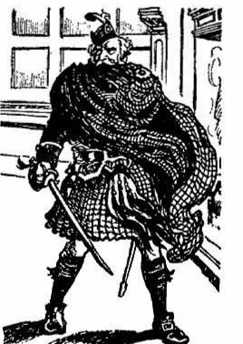
He touched his bonnet in salute and the juniors capped him politely. There was something impressive about the strange old man who lived so strange and solitary a life in the bosom of the wild hills, dreaming of past days, mourning for a clan long forgotten, of which he was the last survivor.
“Top of the morning, Mr. Bean!” called out Bob Cherry in his cheeriest tones.
The old man did not smile. He gazed gravely, fixedly at the juniors.
“You are going?” he asked.
“We’re going down to Muirland for some things.” answered Harry Wharton.
“You are not going—away?”
“ No.”
“Have you seen nothing in the House of Lochmuir that should warn the stranger away from the hall of the MacDermid?” said the old piper sternly.
“Lots!” answered Bob Cherry, with a grin, “We’ve seen a jolly old spook!”
“Is that how you speak of the spirit of the ancient Laird of Lochmuir?”
“That’s just how!” replied Bob Cherry, with undiminished cheerfulness. “You see, we don’t believe for a minute that it’s an ancient laird. We believe it’s a modern japer. And we’re jolly well going to give him beans somehow or other!”
The old man’s face darkened.
“Since the day of Culloden the spirit of the Laird of Lochmuir has haunted his old hall.” he answered. “For generations he has been seen, and strangers who have taken possession of his land have never dared to stay. For generations the old house has been left to the bat and the owl. Who are you to disturb the repose of one who is not of this world?”
“But the house belongs to Sir Philip Angel now,” said Harry Wharton mildly.We are his son’s guests there.”
The old man made gesture of scorn. To his mind, dwelling in the past, amid the forgotten glories of the clan of Dermid, the Angels were newcomers, intruders, trespassers on the domain of the ancient laird.
He turned away, with a black and moody brow, and stared at the silent hills with so intent a gaze that it seemed as though he saw something there more than the ridged snow and the frozen firs. Possibly, to his mind, shaken by solitude and long brooding, the desert hill was peopled by plaided figures, and he saw again the gallant clansmen who, with targe and claymore, had followed their laird to the fatal field of Culloden, to perish under the banner of Prince Charlie.
The juniors pursued their way, and when they glanced back they saw the figure of the old piper, still as if graven in bronze, against the background of the hills.
It was a long tramp down to the village, the rocky path winding by the side of the frozen loch. They reached the village at last, and they noted that the few inhabitants who were to be seen in the windswept street looked at them with curiosity. The fellows who were passing Christmas at the haunted house of Lochmuir were objects of interest to the Muirland folk, none of whom would have ventured to pass near the old mansion after the dusk of night had fallen.
“Here we are again!” said Bob Cherry cheerfully, as they stopped before the inn. “Hallo, hallo, hallo! What’s that?”
“That” was a snowball which caught Bob Cherry’s cap and whirled it from his head.
“Ow! ” ejaculated Bob.
“Why—what—who—”
Whiz!
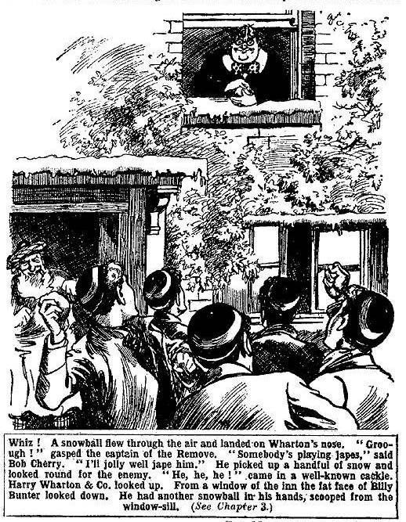
Another snowball flew and landed on Harry Wharton’s nose. The captain of the Remove gave a gasp as the snow squashed over his face.
“Hallo, hallo, hallo!” somebody’s going in for japes!” exclaimed Bob Cherry. “I’ll jolly well jap him!”
He grabbed up a handful of snow and looked round for the enemy. But there was no one to be seen save the ruddy-faced Highland innkeeper standing on the porch of the inn, and an ancient inhabitant plodding sedately along the snowy street.
“Where the thump?” ejaculated Bob.
Squash!”
“Oh, my hat! Groooogh!”
“He, he, he!” came in a well-known cackle.
It was the fat cachinnation of William George Bunter of the Greyfriars Remove, and it came from above. Harry Wharton & Co. looked up.
From a window of the inn the fat face of Billy Bunter looked down, clothed in a fat grin. He had another snowball in his hand, scooped from the wrndow-sill.
“Bunter!” roared Bob Cherry.
“He, he, he!”
“Then he’s not gone!” exclaimed Nugent.
“Is Bunter ever gone?” growled Johnny Bull.
“The gonefulness of the esteemed and digusting Bunter is not terrific— Yarooooh!” roared Hurree Jamset Ram Singh, as the fresh snowball flew and squashed in his dusky face.
“He, he, he!”
Billy Bunter chortled with great enjoyment. But his fat chortle came to a sudden termination. Bob Cherry kneaded a snowball rapidly and hurled it up with unerring aim.
Squash!
It landed fairly in the middle of Bunter’s fat face, which disappeared from the window with remarkable suddenness. A heavy bump was heard from the window, and a loud yell:
“Yooooop!”
“Ha, ha, ha!” roared Bob Cherry.
“Yo-owow! Grooogh!”
Harry Wharton & Co. went into the inn. The sight of Billy Bunter there was a surprise to them, and yet not wholly a surprise. Billy Bunter had shaken the dust of Lochmuir from his podgy feet and departed; but that he was really, wholly, and actually gone seemed, as Bob Cherry remarked, too good to be true.
“I say, you fellows—”
William George Bunter came down the narrow, dusky stairs. He grinned feebly at the Greyfriars party.
“Buzz off, Bunter!”
“Oh, really, Bull! I say, you fellows, it’s jolly decent of you to call and see me,” said Bunter. “I’ve a jolly good mind to punch your head for chucking that snowball at me, Bob—”
“Punch away!” grinned Bob.
“Well, I’ll let you off, as it’s Christmas time.” said Bunter. “ I say, how did you know I was staying on here?”
“We didn’t know, ass!”
“But you’ve come to see me---”
“Not at all. We’ve come to get some eggs and milk from the inn-keeper. Seeing you is just a stroke of bad luck.”
“Ha, ha, ha!”
“Beast!”
The juniors proceeded to get the supplies they had come for. Billy Bunter hovered round them. He had greeted the party with snowballs from his window; but he was evidently bent on being very cordial now.
“Better stay here to lunch, you fellows,” he said. “They do you a jolly decent feed here. I’ve had some.”
“We’re getting back to Lochmuir.” answered Wharton.
“Rot! I’ll stand the lunch.” said Bunter. “The salmon they give you here is just ripping! Come on—it’s my treat!”
“Bow-wow!”
“Why haven’t you gone?” demanded Johnny Bull. “You left Lochmuir for good—or you said so.”
“Well, I was hungry, you know.” said Bunter. “I stopped here for some grub, and the chauffeur wouldn’t wait; he said he had to get his car back. I ordered him to wait, and he took no notice. Cheeky cad, you know. Said I’d have to pay for the car if he waited.”
“Awful cheek!” said Bob sarcastically.
“Yes, wasn’t it? So I treated him with contempt and let him go.” said Bunter. “I’ve been jolly comfortable here—the grub’s really good, and there’s plenty of it.”
“And now you’re going on?”
Bunter coughed.
“Well, not exactly, you know. You see, I’ve run out of money, and I shouldn’t be able to pay my fare home this distance.”
“Then you’re staying here?”
“Well, I don’t know whether the innkeeper will let me stay, if I don’t pay my bills.”
“Ha, ha, ha !“ roared Bob. “I think probably not. I believe it’s not very easy to diddle a Scotsman.”
“If you fellows can lend me a fiver—!”
“Good-bye. Bunter!”
“A couple of pounds—”
“Fare thee well, and if you ever, all the better, fare thee well!” sang Bob Cherry; and the juniors walked out of the inn.
Billy Bunter blinked after them through his big spectacles.
“I say, you fellows, I—I was relying on you, you know!” He toddled after the Greyfriars juniors. “I say, I shall be stony when I’ve settled my bill, and— and that, innkeeper won’t let me go without paying. I can see it in his face.”
“Ha, ha, ha!”
“Well, what am I to do?” demanded Bunter.
“Whom are you to do, you mean?” chuckled Bob. “Do the innkeeper, if he’ll let you. You’ve done us already.”
“Ha, ha, ha!” the
“But I—I say, you fellows——”
“Send a man down to Dingwall to telegraph to some of your titled relations.” suggested Nugent. “Either the duke or the marquis ought to play up, at Christmas-time.”
“Beast!”
“You can come back to Lochmuir, if you like.” said Harry Wharton, laughing. Mick won’t mind.”
“Well, as you’re so pressing, old chap, I’ll come, if you can get a conveyance.” said Bunter. “There’s no car to be had here; but you might be able to get a trap or something, if you pay for it—”
“Go hon!”
“I don’t mind what it is, so long as it’s quite comfortable.” said Bunter. “I say, you fellows, don’t walk away while a chap’s talking. What about that trap?”
“You’re not catching us in any trap!” chuckled Bob. “We’re going back on Shanks’ pony, and so are you, if you come.”
“Do you think I’m going to walk three miles on dashed hills in the blessed snow?” roared Bunter. “I’m jolly well not!”
“Good-bye, then!”
“ Beast!”
The chums of the Remove, chuckling, started on their return to Lochmuir. Billy Bunter did not follow them. The long tramp uphill to Lochmuir did not appeal to him; and perhaps he still nourished a faint hope of “diddling” the Muirland innkeeper. The last the Greyfriars juniors saw of him he was standing in the porch of the inn, glaring after them through his big spectacles and shaking a fat fist.
THE FOURTH CHAPTER.
In Direst Peril!
AUBREY ANGEL slowed down, as he glided the along the smooth ice on the loch, and stared at a plaided figure on the bank. Mick, with a ruddy face, his scarf flying in the wind, shot alongside his brother.
“That’s old Bean.” he said.
“Oh, the piper!” said Aubrey. “I remember seeing him when I came up here in the summer with the pater. I believe he’s more than half-potty!”
“Poor old chap!” said Mick. “I suppose he isn’t quite right in the upper story—living all alone in the hills, with no company but his bagpipes. I believe he doesn’t like us being here.”
“Why not?”
Mick laughed.
“He looks on this land as still belonging to the MacDermid, and he thinks that the ghost of the laird ought to be given a free run.” he answered. “He believes in the ghost, of course—all the country people of this place do.”
“What utter rot!” said Angel. “If I were in father’s place I’d have him turned off the land. He pays no rent for his cottage.”
Mick’s face clouded a little. Every time he had a glimpse of Aubrey’s hard, unfeeling heart it came as a shock to him. His affection for his brother was so strong that, in spite of his own reason and common-sense, he was determined to think well of Angel of the Fourth.
“You don’t mean that, old fellow.” said Mick at last. “It would kill the old fellow, I think, to be turned off; and his little cottage can’t be worth much in the way of rent. Old Bean has always lived here; his ancestors lived here centuries ago; he was the hereditary piper to the MacDermid clan.”
“Well, there aren’t any MacDermids left.” said Angel carelessly. “And the land is ours. It’s about time the old duffer woke up to the fact that we’re in the twentieth century now, not the eighteenth. But what’s he up to now?”
The two juniors slowed down still more, their eyes turned curiously on the old piper.
Sandy Bean was standing high on the rocky bank, looking down at them, with sunken eyes that glowed and burned under his shaggy grey brows.
His right arm was raised, throwing back the thick folds of the plaid, and extended towards the brothers.
He was speaking, and his voice was carried to their ears on the keen wind; but though they heard the words they did not understand, for the old man was speaking in the Gaelic tongue.
Of that old musical tongue the Angels, naturaIly, understood nothing. To the old Highland piper it was his mother tongue; and English came only with difficulty to his lips,
Loud and clear and ringing the voice of Sandy Bean rang across the frozen loch, while his extended right arm seemed to be threatening the brothers, if not invoking a curse upon the heads of the intruders on the domain of the MacDermid.
“Let’s get out of this!” growled Angel. “I believe the old fool is cursing us in that lingo!”
“Sounds like it!” said Mick, with a shiver.
They wheeled round, turning their backs on the piper, and skated away towards the centre of the loch.
Mick glanced over his shoulder as he went.
Sandy Bean’s arm was still raised, as in denunciation, and a strange and terrible expression was on his wrinkled old face. He was silent now, but he was watching the brothers with a curious, grim intenseness.
There was something in his look that struck a chill to Mick’s heart. It was threatening, grim, boding. He slowed down, with half a mind to turn back and speak to the old man.
Aubrey Angel shot ahead of his brother.
“Come on Mick!” he called out.
Crash!
“Oh! Help!”
Mick was looking back at the figure on the shore; but at that cry he spun round towards his brother.
Aubrey Angel was through the ice!
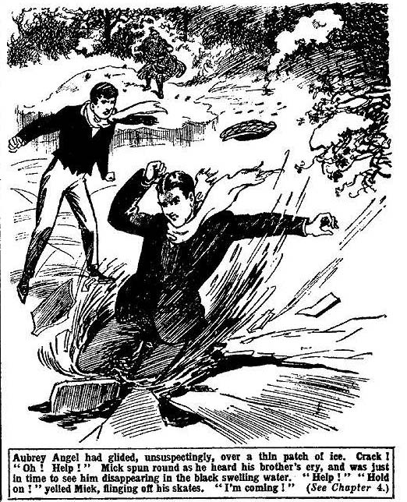
The frozen loch was treacherous. To the eye the ice seemed thick and firm, but where hidden currents barked and whirled it was thin, and it was across one of the danger-spots that Aubrey Angel had glided unsuspectingly.
“Oh, heavens!” panted Mick, his face white.
Then he knew what that look on Sandy Bean’s face had meant. The piper had known that the brothers were going into peril—he knew the loch and all its secrets—and he knew that death awaited them when they left the zone of safety. Had not Mick lingered he would have shot through the broken ice with his brother.
“Help!”
Aubrey Angel was shouting huskily. For a second he had vanished in black swelling water; now he was up again, holding on desperately to the broken edges of the ice.
“I’m coming!”
Mick kicked off his skates and ran towards his brother. The peril was terrible; and he did not hope for help from the half-mad old piper. He cast one wild glance round in the faint hope of seeing something of Harry Wharton & Co. But the Grefriars fellows were far away in Muirland.
Angel, his face white and desperate, clung to the broken ice, with the freezing water chilling his limbs. His eyes were on his brother, and he raised one hand to wave him back.
“Go back! Go back!”
“I’m coming!”!
“Go back!” shouted Angel. It was at that moment that the cad and blackguard of Greyfriars vanished, and all that was best in Aubrey Angel came to the surface. Go back! You can’t help me! Maurice, you fool, keep back!”
Mick did not heed.
That he could save his brother was little likely, but he was going to make the attempt. It was better to perish with him than to desert him.
The ice cracked under his feet. Angel gave a last shriek of desperate warning.
“Go back! You can’t help me! Save yourself, Maurice!”
Crash!”
Mick was crawling to the broken edge to reach his hand to his brother now. But the ice cracked and parted under him, and he struggled in welling water.
“Oh, Maurice!” panted Angel.
“Sink or swim together!” panted Mick. He was swimming beside his brother.
Angel’s wild glance swept the ice. A hundred yards separated them from the bank where the plaided figure of the old highlander stood. Suddenly, like a wraith, the figure of Sandy Bean vanished from sight. He was gone.
“He has left us to die!” groaned Angel. “He was cursing us, the villain! He knew of this danger, and he wanted us to drown, the wretched madman!”
Mick set his teeth.
Keep up, Aubrey, old man! We’ve got to get out of this!”
Angel groaned. He knew that there was no hope. The edges of the ice-gap cracked and crumbled as he clutched them. Once he almost climbed out, but the ice gave, and he rolled back, splashing, amid floating fragments. Mick’s strong grasp on him dragged him up again, panting, dazed, and despairing.
“Help!”
Mick shouted frantically.
His voice rang over the frozen loch and echoed back from the wild hills.
“Help! Help!”
But only the echoes answered.
“It’s all up!” groaned Angel huskily. “Oh, Maurice, old man, if you’d kept back—”
“He’s coming! ” panted Mick.
“What—who?”
“Sandy Bean!”
The plaided figure had reappeared. With whatever intentions the old man had watched the juniors go into danger, it was evident that he meant to help them now. Doubtless, to his crazed mind, that peril had seemed a judgment upon the strangers who had taken possession of the lands of the MacDermid, whose presence in the House of Lochmuir disturbed the wanderings of the old laird’s wraith. But the sight of the two boys struggling in the water had cleared the mists of brooding superstition from Sandy Bean’s brain. The evil spell was gone, and the old Highlander was himself again. A long pole was in his hands as he came out on the ice, gliding along to the gap with amazing swiftness.
“He’s coming to help us!” almost sobbed Mick.
“Help !“ panted Angel huskily.
No word came from the old piper. But in a matter of seconds he was within the pole’s length from the gap.
The end of the pole was thrust within reach of the struggling juniors.
“You first, Aubrey!” whispered Mick. His voice came only in a whisper through his numbed lips, and he helped his brother to a hold upon the pole.
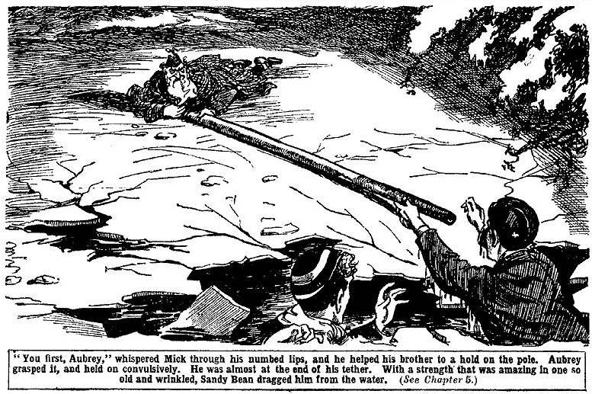
Aubrey Angel grasped it, and held on convulsively. He was almost at the end of his tether.
With a strength that was amazing in one so old and wrinkled, Sandy Bean dragged him from the water.
The ice cracked and crumbled under him for several yards as he was dragged, but Angel held on, and at last he was landed on thick and firm ice.
There he sank down, exhausted; and the pole was thrust out again to Mick.
The gipsy schoolboy grasped it with numbed hands. The bitter cold numbed and dazed hin, but he held on tenaciously
He was dragged out, and fell beside hi brother. Sandy Bean threw down the pole and stood looking at them. He spoke to them now, but unconsciously, the words came in Gaelic, and they did not comprehend. They guessed that he was telling them to hurry to the house; but they were too exhausted to move. And they lay, panting feebly, with the bitter crackled closing on them like the grip of an enemy.
The piper muttered something under his breath, stooped, and lifted the two schoolboys, one under either arm, and carried them towards the bank. As if they had been infants, he bore them up the bank and then up the path to the house. Their weight seemed nothing to the powerful old Highlander.
“I—I can walk now!” panted Mick.
Sandy Bean did not heed.
Without a pause, with the long, tireless stride of the mountaineer, he carried the two juniors onward, and in at the open door of the house of Lochmuir.
There he set them down before the log fire that still blazed and crackled in the ancient chimney of the hall.
Aubrey Angel sank down on the rug, almost fainting. Mick stood unsteadily, his eyes on the grim old piper.
“You’ve saved our lives, Sandy Bean.” he said faintly.
The old Highlander doffed his bonnet. “I crave the pardon of my laird that my hand has served the stranger in this hall.” he said, in a deep voice. His eyes were fixed on the portrait of the Laird of Lochmuir that looked down from the wall, glowing in the firelight. It was as if he were speaking to a living man. Mick shivered. The light of almost insanity was in the old man’s eyes again.
For some minutes Sandy Bean stood, with doffed bonnet, his eyes on the portrait. Then, without a word to the juniors whom he had saved, he turned and strode away. He vanished, and his footsteps died away in the snow.
THE FIFTH CHAPTER.
The Laird!
HARRY WHARTON & CO. came tramping cheerily up the drive two or three hours later. They found Mick in the hall, his face a little pale, but otherwise showing no sign of his late ordeal.
“Hallo, hallo, hallo!” boomed Bob Cherry “Seen any giddy ghosts while we’ve been gone?”
Mick smiled faintly.
“Worse than that.” he answered.
“Why, what’s happened?” asked Wharton quickly.
Mick told of what had happened on the loch.
“Aubrey’s gone to bed.” he said. “I made him turn in. He felt it more than I did. I grew tough among the gipsies, you know. But for old Sandy Bean you fellows would never have seen either of us again!”
“Good man!” said Wharton.
“But all’s well that ends well!” said Mick cheerily. “Aubrey will come down for dinner. And I’ve been doing the cooking. I’ve got the grub ready for you fellows.”
Angel came down and joined the juniors at dinner. He was looking pale and very subdued. The terrible peril he had been through had left its mark on him.
But he did not share Mick’s feeling of gratitude towards the man who had saved his life.
“The old madman knew we were goin’ into danger, and let us!” he said. “He’s as mad as a hatter!”
“Surely not!” said Harry.
“I know it!”
“I think Aubrey’s right there.” said Mick reluctantly. “The poor old chap is half potty, you know. He thinks we’re strangers and intruders here, and disturbing the jolly old laird. But he played up like a little man and got us out, so that’s all right. He can’t help being a little bit off his rocker!”
“The sooner he’s cleared off this place the better!” growled Angel.
“Well, you’d have gone into the danger anyhow, it seems,” said Bob Cherry, “and if Bean hadn’t been there you’d never have come out of it alive.”
Even Aubrey Angel had to admit that. He grunted and was silent.
After dinner Aubrey Angel smoked cigarettes before the fire, and Harry Wharton & Co. proceeded to carry out their search of the old house—to unearth, if possible, trace of the haunting wraith, Angel smiled cynically as they started, and did not offer to help.
The juniors had searched the house before, more than once, but on this occasion the search was very thorough.
The deep, dungeon-like cellars were explored, and every, rambling old passage and recess, and every room. There were several passages that led into the ruined part of the old mansion, and they were closed by thick oak doors, barred and bolted. It seemed impossible that any one could obtain access from without. But it was more than probable that the ancient building contained secret ways of ingress and egress, dating from the days when feuds raged in the Highland country, when any morning might have seen a highland chief’s dwelling surrounded by hostile tartans. But if there was such a secret way the juniors failed to find it.
But they made at least one discovery. In one of the upper rooms were old presses packed with relies of ancient days—all Highland costumes, kilts and plaids and sporrans and plumed bonnets. And one of the presses had been disturbed recently and its contents disarranged.
“What does that mean?” said Bob Cherry. “There’s been a shake-up here since we looked into this room last.”
“Some of the things have gone, I fancy,” said Nugent.
“Blessed if I can make it out!” confessed Harry Wharton. “I’m sure there’s some trickery at the bottom of it all, but it beats me! But it looks as if some spoofer is at work, and he’s borrowed some of this Highland rig for his stunts!”
“It looks like it” said Johnny Bull. “But who—”
“That’s a giddy mystery!”
“There can’t be anybody hidden in the house, surely!” said Frank Nugent, with an uneasy glance round.
Wharton nodded thoughtfully.
“It looks to me like it! There may be a dozen hiding-places in a rambling old house like this, They needed such places in the old days—their lives may have depended on it sometimes. It looks to me as if somebody is hidden in the house, trying to frighten people away!”
“But why?”
“Goodness knows!”
“The whyfulness is terrific!” said Hurree Singh, shaking his dusky head. “But the probability is great. That is how the esteemed servants were scarefully frightened off! If there is not a genuine spook, there is some hidden japer!”
It was an uneasy thought to the juniors that the old roof sheltered some secret and hidden enemy. They looked about them with uneasy glances as they moved along passages and rooms with the lamps. The winter darkness had closed in now, and the House of Lochmuir was wrapped in gloom.
“Found anything?” it was Aubrey Angel’s mocking voice. He joined the search-party, with a glowing cigarette between his lips. “Roused out the jolly old spook?”
“Not yet.”
“About time we chucked it!” said Bob. “I’m getting ready for supper!”
“Same here!”
“I’ll cut off and get the kettle on!” said Nugent,
He left the party and went downstairs. To reach the kitchen he had to cross the old hall, lighted now only by a glimmer from the red, glowing logs in the ancient chimney.
From the wall beside the fireplace the portrait of the old laird, life-size, in the garb of a Highland chief, looked down, his hand on his claymore. The grim face under the Highland bonnet caught the glow of the firelight, and the eyes gleamed as if with the light of life.
Nugent’s glance fell upon it carelessly. Then he gave a sudden start.
The figure moved.
Nugent stopped stone dead, his heart throbbing, the blood racing in his veins. His eyes almost started from his head.
Was it a wild fancy in the playing firelight? Was it a dream? Or was he mad? His staring eyes fixed on the old laird. And the figure of the Highland chief moved in the dim shadows.
A loud shriek broke from Frank Nugent, ringing through the dusky hall. He covered his face with his hands and staggered back.
There was a shout from above. Nugent’s wild cry had reached all his comrades.
In a moment there were thudding feet on the stairs.
“Frank!” shouted Wharton.
“Nugent, what—”
The lamps gleamed in the hall. Wharton caught Nugent by the arm.
“Frank, what is it? ”
Nugent was shuddering from head to foot. His face was like chalk. He gripped Wharton’s arm convulsively.
“It—it’s alive---”
“What---”
“The laird!” said Nugent faintly.
“The portrait?” exclaimed Harry Wharton.
“It—it moved—”
“Frank!”
“ It moved, I tell you!” panted Nugent.
Harry Wharton ran towards the portrait. The great canvas fixed in the huge frame was motionless. The old laird looked down from it, still as ever. In the lamplight his eyes seemed to catch the junior’s, gleaming back the light.
Wharton ran his hand over the surface of the painting. His heart was beating strangely,
“Frank, old man, see for yourself! It’s only a painting! How could it move?”
“It moved!” said Nugent.
“But---”
“It was the light from the fire, old chap.” said Bob. “Firelight plays all sorts of tricks.”
Nugent shook his head.
There was a low laugh from Aubrey Angel. Nugent flushed crimson, and gave Angel of the Fourth a dark look. Then he went into the kitchen, without speaking.
“By gad! This is gettin’ thick!” yawned Angel . “Spoofs of old Highlanders and walkin’ portraits—by gad! You fellows want a nerve rest.”
Nobody anwered Angel of the Fourth. In silence the Greyfriars juniors prepared their supper and it was in a subdued mood that they sat down to it.
THE SIXTH CHAPTER.
A Baffling Mystery!
NIGHT, black and impenetrable, cloaked the old house in the Highlands. Not a star glimmered in the dark heavens; the mountain-tops were hidden in the black void. Round the old house moaned the winter wind, bearing fluttering snowflakes. Silence lay on the house, silence and darkness—save in the old oak hall, where a fire still burned, of logs stacked under the wide old chimney.
But the Greyfriars juniors were not sleeping.
They had gone to their rooms and turned in, and lights were all out. But as midnight drew near Harry Wharton and Bob Cherry quietly left their rooms in felt slippers, making no sound. They met in the old railed gallery that ran round the hall, on the level of the landing at the top of the great staircase. Only a faint whisper passed between them as they met.
“You, Harry!”
“Yes.”
That was all.
Standing by the carved oak rail, above the great space of the hall below, the two juniors watched and waited.
If the ghost of Lochmuir walked again that night they were prepared for it. Each of the two juniors carried a golf club in his hand. It had been agreed that the rest of the Co. should remain in bed, ready, however, to rush on the scene if an alarm should be given. Nothing had been said to Aubrey Angel on the subject. The mocking sneers of the Fourth-Former did not encourage the Co. to take him into their confidence.
Below, in the hall, the firelight flickered and glimmered, casting strange lights and shadows on the walls, adorned with trophies of Highland weapons and of the chase, and tall portraits of dead-and-gone MacDermids. But hardly a glimmer of light reached to the landing above, only now and then a ruddy gleam as the firelight leaped.
An hour passed.
There were many sounds in the silence of the night—the creaking of ancient wood, the scuttling of a rat, the moan of the wind in the frozen trees without.
Another sound came at last to the ears of the watchers
It sent a strange thrill to their hearts.
Wharton set his lips.
There was trickery in the haunted house; he was assured of it. But in the darkness and eerie silence of midnight, he was conscious of a superstitious thrill. He remembered the touch of an icy hand on Christmas night, and the memory brought a shudder with it.
In the deep gloom there was a faint rustle, as of a heavy plaid that brushed by the dark walls and, corners.
Wha——rton heard his companion draw a deep, quick breath. He touched Bob’s arm in the darkness encouragingly.
The sound came nearer.
Something was there—something in the darkness. It was in the passage opening off the gallery, in which were the bed-rooms occupied by the juniors.
The fire in the hall below leapt up in briliant blaze, and for a second there was illumination.
In that second the juniors sighted a figure—such a figure as they had seen before in the house of Loclmuir—a Highland figure, in kilt and plaid, bonnet and sporran, with a claymore by its side.
The next second it was swallowed in darkness, as the blaze died, and was gone from their sight.
“Oh!” breathed Bob Cherry half audibly.
Wharton gripped his golf-club. His heart was beating almost to suffocation. But his purpose held firm.
“Come on!” he breathed
The two juniors, with thumping hearts, trod into the dark passage where the figure had for a moment appeared.
They trod softly, silently.
There was the sound of an opening door ahead. It was the door of Nugent’s room, opened from without; for the next moment Nugent’s voice was heard, with a shake in it:
“Who’s that?”
A light glimmered. Nugent, with a quivering hand, had struck a match and lighted a candle by his bedside.
The flickering light glimmered on a figure in his open doorway—the figure of a Highland warrior, the face almost hidden in a fold of the plaid.
Nugent sat bolt upright in bed, his eyes almost starting as he stared at it.
“Now!” breathed Wharton.
Harry Wharton and Bob Cherry were behind the figure in the doorway.
Throwing aside concealment now, they rushed on.
Evidently their footsteps were heard, for the “ghost” spun round suddenly towards them.
“Down with him!” panted Bob.
He struck right at the phantom figurewith his club . The Hifghlander made a quick leap aside, and the club struck the wall with a crash.
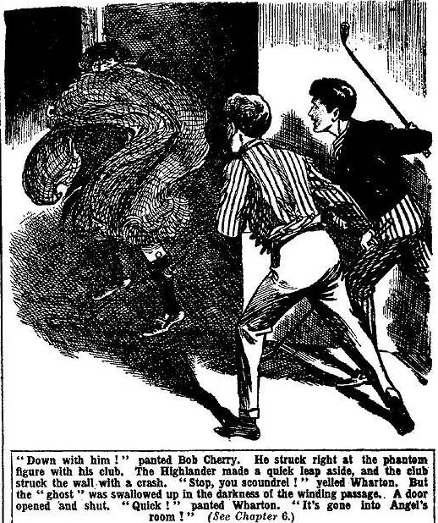
That the “ghost” was of living flesh and blood was fairly clear now. Wharton sprang at it as it darted away.
“Stop, you scoundrel!” panted the captain of the Remove.
The glimmer of Nugent’s candle from the door did not penetrate far. The “ghost” was swallowed up in the darkness of the winding passage.
A door opened and shut.
“It’s gone into Angel’s room!” shouted Wharton; and his voice rang and echoed through the old house. “Comp on !”
“Buck up, Greyfriars!” roared Bob Cherry.
Nugent was out of bed now, and rushing into the passage with the candle. Johnny Bull and Hurree Singh stayed only to light lamps, which were in readiness , before they emerged, and Mick was quickly after them with an electric torch.
Wharton grasped the handle of Angel’s door and turned it.
The door did not open.
“It’s locked!” exclaimed Bob.
“It can’t be locked! The thing went in here—”
“But it is locked.” said Bob, feeling the door. His voice was startled . “Wharton, are you sure—”
“I know it went in here. The door opened!”
Bob hanmered on the panels and shouted:
“Angel!. Angel! Wake up, Angel!”
There was the sound of a yawn within. “What’s the row?” asked the voice of Aubrey Angel of the Fourth.
“Let us in!”
“Oh, leave a chap alone! I’m sleepy!”
“The ghost—”
“Rot!”
“It came into your room!” shouted Wharton. “It’s not a ghost, but a spoofing trickster! Let us in!”
“Rats!“
“Do let us in, Aubrey old man!” said Mick, through the keyhole.
There was an impatient exclamation from the room.
“Oh, all right! Wait till I get a light.”
Aubrey Angel was some minutes getting the light. Aubrey remembered, as he waited, that there was another door to Angel’s room, opening into a disused bed-room. He ran into the further room and found Angel’s door on that side locked also. He rejoined his comrades in the passage.
“Buck up, Angel!”
“Sha’n’t be a minute.” yawned Angel. “If you’re afraid of ghosts, you’d better go back to bed, and put your silly heads under the blankets.”
The juniors made no reply to that. A light glimmered at last, and Aubrey Angel, in his pyjamas, opened the door, yawning and derisive. The juniors crowded into the room.
They looked round in the light, but certainly there was no sign to be seen of the Highland wraith.
Angel of the Fourth watched them, a mocking grin.
“What did you fancy you saw this time?” he asked.
“A figure of a Highlander——the same that we’ve seen before.” answered Bob Cherry.
“What a state of nerves to be in!”
“It came into this room.” said Harry.
“Through a locked door!” chuckled Angel.
“I thought I heard the door open.” said Harry Wharton doubtfully.
“Ha, ha, ha!”
“Look here, Angel—”
“Perhaps ghosts can open locked doors!” chuckled Angel. “But I should have thought that a spook could get through the keyhole! I say, you fellows can’t possibly realise what a silly crowd you look!”
The juniors crowded out of the room, leaving Angel of the Fourth laughing. They moved back, lamp and candle in hand, to the gallery over the old hall. The firelight below leaped out, and Bob, glancing over the rail, gave a shout:
“There it is!”
“What?”
“Look!”
Leaning over the oaken rail, the juniors stared down. In the gleam of the firelight stood the figure of a Highlander in kilt and plaid and claymore.
“Come on!” shouted Wharton desperately.
He raced down the stairs, his comrades at his heels. They tore down into the hall. With lamp and candle they searched it, in every shadowy recess. But it was vacant, and as they searched farther they found no sign of what they had seen. The spectre Highlander had vanished.
THE SEVENTH CHAPTER.
Only Bunter !
HARRY WHARTON & CO. had thoughtful faces at breakfast the next morning. They were utterly puzzled and perplexed.
That the phantom of Lochmuir was a thing of flesh and blood they could not doubt now. And yet—.
Wharton could have sworn that it had passed into Angel’s room; but Angel’s door had been found locked, and no trace of it had been seen in his room. And immediately afterwards it had been seen in the hall downstairs—and if it had been near Angel’s room it could not have reached the staircase unseen by the juniors to descend. If it was of flesh and blood, how had it made the transit from the upper passage is to the ball below unseen, unheard? And where had it vanished to?
It was a strange problem; but, perplexed and a little alarmed as the juniors were, their resolution remained fixed. Aubrey Angel asked them that morning if they had decided to leave, but a general shaking of heads was the response.
“We’re getting to the bottom of this before we go!” said Bob Cherry.
“Yes, rather!”
Angel knitted his brows. It was evident that he had expected the apparition to have the effect of scaring the Greyfriars party away.
“You believe it’s a ghost?” he demanded.
“Well, no,” said Harry.
“You say you saw it down in the hall after it had vanished through the door into my room?”
“We all saw it.”
“Then how did it get there if it’s flesh and blood?”
“I don’t know.” said Harry frankly. “It seems impossible. But if it didn’t go into your room, it went past your room, and that’s directly away from the hall. Yet we saw it in the unit soon after, and it’s never passed us again.”
Angel shrugged his shoulders.
“If you saw it in the hail, it’s a ghost.” he said.
“Well, we did see it.”
“Blessed if you’re not makin’ me feel creepy!” grunted Angel of the Fourth. “It seems to me that the sooner we get out of this show the better!”
“Not till we’ve got to the bottom of it,” answered Harry.
“Oh, rot!” snapped Angel.
Wharton smiled faintly. It seemed that even the mocking Angel was beginning to feel the eerie the influence of the haunted house of Lochmuir.
That morning the juniors searched the house again with great thoroughness, but there was no result. After dinner they set out for a ramble on the moor land, and, rather to their surprise, Angel of the Fourth decided to accompany them. Apparently the Fourth-Former no longer cared to be left alone in the old house.
Thp winter dusk was falling when the juniors turned back to the House of Lochmuir. Their path led them pacd the cottage of Sandy Bean. There was no light in the cottage; but the old piper was evidently there, for the strains of the bagpipes floated out on the wind. The dirge of the MacDermid rang and echoed weirdly through the mountain dusk.
The juniors hurried on, with that wild and melancholy wailing still echoing in their ears.
“Enough to give a fellow the creeps!” growled Angel sulkily.
“Hallo, hallo, hallo! The fire’s still burning!” exclaimed Bob Cherry, as they tramped up through the snow on the drive to the old house.
A ruddy gleam of firelight from within played on the frosted lanes of the hall windows.
The great door had been left on the latch. Harry Wharton pushed it open, and it swung back on its ponderous hinges.
Within was deep gloom, broken only by the gleam of the fire.
“Hark!” breathed Bob Cherry.
A strange, low, rumbling sound came to their ears. Whence it proceeded they could hardly tell, but certainly it was from somewhere within the old hall.
Angel started violently.
“Wha-at’s that? ”
“Listen!”
The sound ceased for a moment, and then it was renewed—low and rumbling like the stertorous breathing of some huge animal.
The juniors stood quite still. Angel’s face had become pale. There was no trace of mockery about him now.
“What—what can it be?” muttered Johnny Bull.
They looked about them uneasily, peering into the shadows. Bob Cherry set his teeth and struck a match. Candles had been left ready on the table, and Bob lighted one after another until a dozen were burning.
The old hall was illumined now, save for dusky corners where the shadows lurked.
And still that strange, rumbling sound was heard, echoing strangely in the hall.
“It—it’s something in here!” muttered Bob
“Some animal—”
“ How could an animal get in with the door shut ?” muttered Johnny Bull. “What, in the name of goodness, is it? It—it seems to come from near the fire!”
“Come on!” said Harry.
He strode towards the great chimney and stirred the the fire to a leaping blaze. Then he gave a shout;
“Bunter!”
“What?” roared Bob Cherry
Harry Wharton pointed to an armchair that was drawn up before the fire.
But In the depths of the huge chair reposed a fat form—that of William George Bunter the Owl of Greyfriars.
Bunter was fast asleep and, to judge by the traces on his fat face and hands and on his well filled waistcoat, he had disposed of a hearty meal before falling asleep.
He had, in fact, fed not wisely, but too well. Now he was reposing, with his extensive mouth wide open, and his deep, resonant snore rumbling forth.
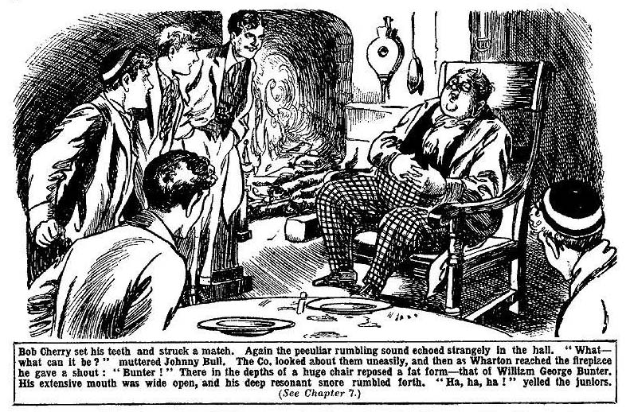
The juniors gazed at him for a moment or two in silence. Then there was a roar of laughter.
“Ha, ha, ha!”
The cause of the peculiar rumbling sound was clear now. It was the snoring of William George Bunter.
“Ha, ha ha!”
Even Aubrey Angel grinned.
Bunter’s round eyes opened. He blinked up in surprise, and then he bestowed a fat grin on the Greyfriars juniors.
“I say, you fellows, you were out when I got here! I’ve had a snack. Did you fellows leave all that stuff in the kitchen ready for supper?”
“Yes.”
There was nearly enough for me!” said Bunter.
“Oh, my hat!”
“You fellows going to get a fresh lot ready?”
“I suppose so.” said Wharton, laughing.
“Good!” Bunter curled up in the chair again. “Call me when it’s ready. I’m getting hungry!”
And the Owl of the Remove went comfortably off to sleep again, and once more the rumbling sound—no longer mysterious—filled the old hall of Lochmuir.
THE EIGHTH CHAPTER.
Not Wanted.
BILLY BUNTER woke up again by the time supper was ready. One supper, however ample, made little difference to the Owl of the Remove; he was always ready for another. As they found the fat junior at Lochmuir, the Greyfriars party supposed that he had returned to stay; and though his company was not yearned for he was made welcome. But it soon transpired that that was not Bunter’s intention.
“I say, you fellows, this ham is good.” he said. “I’ll have some more! Shove it this way, Johnny, old chap! I could do with a few more eggs! But we mustn’t lose time!”
“What’s the hurry? ” asked Bob.
“Well, you fellows don’t want to be too late getting back!”
“Getting back!” repeated Bob. “We have got back, haven’t we?”
“I mean, getting back to Muirland.
“We’re not going to Muirland this evening, fathead!” said Johnny Bull.
Bunter blinked across the table at him
“I suppose you fellows are walking into town with me?” he said. “I couldn’t possibly walk it alone at night!”
“My hat!” ejaculated Nugent.
It was clear now that the Owl of the Remove had not returned to stay. He was planning to get back to the hospitable inn at the village that evening. The chums of Greyfriars chuckled. They were not likely to tramp three miles down the bill to see an uninvited guest home, and three miles back uphill in the darkness of a winter night, when the said guest could walk home perfectly well by himself if he chose.
“If you’re going back to Muirland you’ll go by your jolly old self, Bunter.” grinned Bob Cherry. “I’be done about ten or twelve miles on the hills to-day, and I’m done walking!”
“Oh, really, Cherry---”
“Why can’t you walk back alone?” demanded Nugent.
“Well, its a lonely path, and jolly dark!” said Bunter. And there’s that dotty old piper wandering about, looking like a madman! I passed him coming up, and he glared at me! Besides, there’s something else. You see, I parted on rather bad terms from the innkeeper at Lochmuir!”
“Diddled him?” chuckled Bob.
“I disdain to answer that question, Bob Cherry!” said Bunter, with dignity. “I trust that I am incapable of acting dishonorably towards a social inferior! There was a misunderstanding.”
“There often is where you and money are concerned!” said Johnny Bull sarcastically. “Did you make a mistake about the bill—forget that it had to be paid, or something of that sort?”
“The man’s a beast!” said Bunter. “A little more of that ham, please! And a couple more eggs. And some coffee. Thanks! You see, it’s up to you fellows. You fairly dragged me up to this place for Christmas! I gave up my old pal, D’Arcy, of St. Jim’s, to come with you. And Lord Mauleverer, and Jimmy Silver, of Rookwood, too! I met him early in the vac, and he begged me, almost with tears in his eyes, to come home with him for the holidays. I put all these intimate friends aside to come up here with you fellows!”
And Bunter shook his head reproachfully at the Greyfriars party. They chuckled.
“Then there was that ghost business, and so on, and I cleared.” said Bunter. “I got landed at that inn. And I must say I had a fairly good time there! The grub was good, and there was plenty of it! There was some fun, too! I kissed lots of girls under the mistletoe!”
“Any casualties?”
“Beast! But I ran out of money.” said Bunter sorrowfully. “You see, the postal order I was expecting hasn’t come on here. For some reason—”
“I wonder what the reason could have been?” said Bob Cherry gravely.
“Ha, ha, ha!”
“Blessed if I see anything to cackle at! The money’s run out!” said Bunter crossly. “I’ve had just enough to square if my bill to this morning! Even then I had to take off ten shillings. The innkeeper grumbled. Innkeepers do keep on grumbling; I’ve noticed that. He said he would keep my watch if I didn’t pay in full. I’d mentioned that my splendid gold watch was a present from General Bunter of the Life Guards! But, after looking at it, he said I could keep it. It was clear that he didn’t know its value!”
“Ha, ha, ha !“ yelled the juniors.
“Oh, leave off cackling! The man makes out that I owe him ten shillings.” said Bunter. “Of course, I don’t! But I can’t haggle over money matters with a low person. I shall pay him!”
“Good!”
“One of you fellows will lend me the money!”
“Oh!”
“ThaL will be all right. But you see, it’s quite probable that he won’t let me stay on at the inn unless I pay my bills, and he knows I’ve no money left. So you fellows can come with me, and see me through! He will trust you!”
“Great pip!”
“I’m prepared to remain at the inn as long as you fellows remain here.” said Bunter. “Then I can travel south with you when you go home. You see, I shal1 want you to pay my fare, and there’s grub on the journey to he thought of, too!”
“The thoughtfulness is terrific!” chuckled Hurree Singh.
“ I’ll have a little ham. And you can cut that cake ready for me, if you like, Wharton. It was pretty rotten for me.” continued Bunter. “After my argument with that innkeeper I couldn’t hire a vehicle to bring me up here, and I had to walk.”
“Awful!”
“ Frightful!” said Bunter. “I’m accustomed to travelling in comfort. What’s the good of being wealthy if you don’t have some little comforts? All very well for you fellows with straitened means! Shove the cake this way! I say, you fellows, this is rather good cake! Now, when will you be ready to walk down to Muirland with me?”
“This year, next year, some time, never!” said Bob.
“I shall be ready when I’ve finished this cake! Of course, any cash that you expend for me will be settled later, when —when I receive my postal-order!”
Billy Bunter rose, and brushed the crumbs from his fat waistcoat. He was the last to finish supper, but he had finished at last.
“I may give you a look in another day.” he said. “But I shall expect somebody to be at home. You were all out when I got in this time. Luckily, you had left supper ready in the kitchen. You fellows ready to start?”
“Ha, ha! No! We’re not going out again tonight!”
“How am I to get back, then?” demanded Bunter.
“Just lie down in the snow, and roll down the hill like a barrel!” suggested Bob Cberry.
“Ha, ha, ha!”
“Beast! I’m not going alone! Besides, as I’ve said, I want you fellows to speak to the innkeeper, and explain that you’ll be responsible for the bill run up—”
“I can see us doing it—I don’t think!” chuckled Bob. “You can roll off on your own, or you can stay here, which you like, Bunter!”
Billy Bunter looked alarmed.
“I say, you fellows, I can’t stay here,you know. I’m not going to be woke up by those thumping spooks!”
Harry Wharton & Co. chuckled. William George Bunter had evidently taken a great deal too much for granted in paying his visit that day to the House of Lochmuir. It did not seem to have occurred to his fat mind that the chums of the Remove would not regard him and his affairs as the most important and pressing business in the wide universe.
“I say, you fellows, are you coming or not?” hooted Bunter.
“Not!”
“ The notfulness is terrific.”
“I can’t stay here!” howled Bunter.
“Roll away!”
“The innkeeper won’t take me in unless you fellows come along to foot the bill——”
“Ha, ha, ha!”
“Look here, lend me a tenner, then—”
“I don’t think!”
“Make it a fiver!” howled Bunter. “I can do for a couple of days on a fiver.”
“Anybody want to spend fivers in helping Bunter to burst his waistcoat?” asked Bob Cherry.
“Ha, ha, ha!”
“Beasts!”
William George Bunter realised that there was no escort for him that night, no tenner and no fivers to be borrowed. It was borne in upon his fat brain that he was landed in the haunted house for the night. It was exasperating to William George. For ten minutes he stood before the fire and told the juniors what he thought of them—what time the Greyfriars party chuckled.
“Well, I’m not going to sleep alone!” he growled at last. “I’ll share your room, Wharton,”
“Not unless you leave your snore downstairs.”
“ Beast. I’ll bunk in with you, Johnny.”
“You’l bunk out again fast enough, if you try it on,” said Johnny Hull.
“Rotter! Angel, old chap. I’ll come to your room—”
“Come before I take my boots off, then.” said Angel of the Fourth,
“Yah! I say, Mick, old fellow—”
“Bow—wow!” said Mick.
“Is that how you treat a guest?” roared Bunter. “This isn’t the kind of hospitality I‘m accustomed to at Christmas, I can tell you.”
Bob Cherry yawned.
“Bed-time; you fellows.”
The Greyfriars party went off to bed. Bunter, grumbling loud and deep, followed their example.
THE NINTH CHAPTER.
A Fight with a Phantom!
“WHAT—what’s that?”
Harry Wharton sat up in bed. Each of the juniors had locked his door before turning in, and Wharton was awakened by the sound of a hand fumbling at his door.
He leaped out of bed, and hurriedly threw on his clothes. He lighted a candle and as the light glimmered under the door a voice came from without:
“I say, Wharton—”
“You silly ass!” gasped the captain of the Remove. It was the voice of William George Bunter.
“I—I say, old chap, lemme in! I’ve heard something—”
“Yourself snoring, most likely!” growled Harry; but he unlocked the door.
Billy Bunter rolled into the room and blinked at Wharton in the candlelight.
Wharton frowned at him.
“I—I say, Harry, don’t be a beast!”
“Bother you!” snapped Wharton. “You can bunk in here if you like, you funky barrel!”
“It—it isn’t that.”
“What is it, then, fathead?”
“ I’m hungry.”
“Wha-a-a-t ?“
“I don’t want to go down alone.” mumbled Bunter. “I want you to come down with me, to get some grub, you know.”
Harry Wharton fairly glared at the Owl of the Remove. It was for this important purpose that Billy Bunter had awakened him at midnight.
“You—you fat idiot—”
“Oh, really Wharton—”
“I’ve a jolly good
Harry Wharton broke off suddenly.
His eyes fell upon a figure that passed the open doorway—a gliding figure, in Highland costume, claymore belted on over kilt. Only for a moment was the figure visible, passing the doorway; then it vanished.
Wharton caught his breath.
There was a howl of terror from Billy Bunter,
“Ow! The g-g-ghost! Ow! Wow! Help!”
The Owl of the Remove plunged frantically into Wharton’s bed, and buried his head under the blanket!
Wharton sprang to the door.
The end of the passage gave on to the circular gallery round the old hall, and there was a glimmer of light. Before retiring the juniors had banked up the fire in the hall with logs, and it was burning brightly. In the glimmer Wharton saw the gliding figure ahead of
him.
“Wake up, you chaps!”
Wharton’s voice rang along the passage.
“Hallo, hallo, hallo!”
Bob Cherry was the first out of his room. But the other fellows followed fast. Angel of the Fourth did not appear; but Mick and the Famous Five were quickly gathered.
“I’ve seen it!” panted Wharton.
“It’s gone towards the stairs!”
“Come on!” breathed Bob Cherry.
The juniors ran quickly down the sage and reached the old oak gallery. Below, in the hall, the log fire blazed and crackled, shedding a ruddy light as far as the gallery from which they looked down.
The head and figure had descended the stairs. As the juniors reached the oaken rail and stared down a sudden hand startling sound came to their ears.
Clash, clash, clash!
It was the clash of ringing steel.
“What—”panted Nugent.
“Look!” yelled Bob Cherry, in amazement.
There were two figures below in the hall, clear in the ruddy light of the fire.
Both of them were in Highland costume, one of them towering high over the other.
Clash, clash!”
Each had his claymore in his hand, and they were fighting.
The juniors gazed on the wild scene, spell-bound.
Clash, clash”
Steel rang on steel, echoing through the ancient house. Wild and grotesque the figures looked in the dancing light of the fire.
Clash!
“Help!”
It was a wild yell from one of the fighting figures. The juniors, as they heard it, wondered whether they were dreaming. For the voice was the one of Aubrey angel.
“Angel!” breathed Wharton dazedly.
“ Aubrey!” panted Mick.
Clash, clash!
The shorter of the two figures was backing away towards the stairs, defending himself desperately. Steele rang on steel with echoing clash.
“Come on!” shouted Wharton.
The juniors ran for the stairs and swarmed down. At the same time the slighter Highland figure suddenly dropped his claymore and fled up the stairs, yelling with fear.
Crash!”
The figure crashed into the juniors hurrying down. It rolled on the stairs, the junirs falling over it. Mick caught it by the arm and dragged it up.
“Aubrey!”
“Help!” shrieked the disguised Fourth-former.
“You’re safe now---”
“Help!”
Angel of the Fourth seemed almost out of his senses with fear and horror; He clung to his brother shrieking.
Harry Wharton picked himself up and ran down the rest of the winding staircase into the hall. He had lost only a minute, but that minute had been enough for the phantom of Lochmuir.
The hall was empty. The firelight glimmered only on Harry Wharton as he stared round in search of the figure that had vanished.
THE TENTH CHAPTER.
Enough for Angell!
“AUBREY---”
“Angel, you fool—”
“What---”
Aubrey Angel groaned. He was shaken to the very soul by his terrible experience. Mick helped him down the stairs, and he sank down on an oak settee in the hall, shivering in every limb. His face was chalky white, his eyes staring.
The juniors gathered round him. Angel was in Highland costume, evidently dressed up to play the part of the phantom of Lochmuir. It was clear now who had ransacked the old presses for the Highland relics. It was Angel planning to trick his companions in the haunted house.
He had paid dearly for his trickery. He clung to his brother’s arm, shaking from head to foot. Mick’s face was kind, though puzzled, but the Famous Five looked very grimly at Angel.
“You dummy!” said Bob Cherry. “So you’ve been playing ghost “
“Is it gone?” moaned Angel.
“It’s gone.”
“You—you saw it? ”
“We’ve seen it before!” growled Johnny Bull. “I suppose you believe now that we’ve seen it, as we told yo?”
Angel shuddered,
“I think I catch on now,” said Harry Wharton very quietly. “It was you that I chased last night, Angel. I knew that the thing I saw went into your room. It was you, and you kept us waiting at the door while you were getting out of’ this rig.”
“Rotten trick!” said Nugent.
“Aubrey, old man!” murmured Mick, ashamed for once of his brother. “What —what did you do it for, Aubrey?”
Angel stared wildly round the hall before he replied. The terror of the apparition was still strong upon him.
“I—I wanted to get out of this place!” he muttered. “I wanted you to leave! I—I thought the ghost would scare these fellows away! They believed in it and I—I didn’t—then!”
“And how often have you played ghost?” demanded Wharton sternly.
“Only last night and to-night—I swear!” panted Angel. “I—I meant to scare you away from the place so that Maurice would come away with me “
“I understand that!” said Harry contemptuously. “It’s pretty clear now, you fellows. It was Angel I chased along the passage, and the figure we saw in the hall afterwards was the fellow who has played ghost all along.”
The juniors nodded. That was clear now. One mystery, at least, had been explained.
“I—I never believed in it!” groaned Angel. ‘I—I got myself up like this to scare you! I saw that fool Bunter at your door, and—and let you see me! I was going to let you follow me, and dodge through the— kitchens and back to my room by the back staircase! But--- But here—” he broke off, shivering.
“What happened before we came?” asked Bob.
“ I—I hardly know! It seemed to me that the laird was stepping down from the picture-frame---”
All eyes turned on the picture of the Laird of Lochmuir where the firelight played on it on the wall.
From the great frame the pictured laird looked down on the juniors, the firelight giving a lifelike gleam to the painted eye in the grim old face.
“Then—then it came at me!” gasped Angel, shivering. “I—I thought I must be mad for a moment! But it came at me, and I struck at it with my claymore, hardly knowing what I was doing! Then the---the thing drew its claymore and attacked me. I—I was fighting for my life!”
He stared widly round the hall.
Outside, the wind howled and moaned, echoing in the crannies of the ancient house.
“Where did it go?” breathed Angel.
Wharton shook his head.
“It was gone when I got down from the stairs.” he answered. “Goodness knows how or where!”
“Do you—do you believe it is a ghost—what the Highlanders call a ‘wraith’?”
“No! How the thump could a ghost handle a claymore?” said the captain of the Remove. “It was real enough— solid flesh and blood! Its somebody trying to frighten us away from the place—just as you were doing!”
“But—but why?”
“I can’t even guess that!”
Angel rose from the settee. He was still trembling, and he leaned heavily on his brother.
“I’m going to-morrow!” he said. “I won’t pass another night in this house! Maurice, come to my room with me!”
“Yes, Aubrey,” said Mick in a subdued voice.
His face was flushed as he looked at the juniors. His brother’s wretched trickery had cut the gipsy schoolboy deeply.
“It’s all right, old man!” said Bob Cherry, with a rather forced grin. “Fellows have played ghost before and no harm done!”
“All serene!” said Wharton.
“The serenefulness is terrific, my esteemed Mick!”
“I’m sorry!” said Mick simply.
And he led his brother away up the staircase. Aubrey Angel was in no state to be left to himself, and Mick remained in his room with him.
The Famous Five stayed in the firelit hall, discussing the strange affair in low tones. Harry Wharton stood before the hall picture of the laird, a strange expression on his face.
Strange thought were passing in his mind.
He turned away at last and rejoined his comrades,
“Let’s get back to my room.” he said in a low, altered voice.
Bob Cherry looked at him quickly.
“What—”
“Say nothing here” whispered Harry. “Let’s get away.”
Bob Cherry nodded, and asked no questions. The Famous Five ascended the staircase. In silence they made their way to Harry Wharton’s room, and Wharton set his lamp on the table.
“Ow! Yow! Help!” came a sudden howl from the direction of Wharton’s bed.
“What the thump—”
“Ow! Keep off !”
“Bunter!” gasped Bob.
Two fat feet were visible, sticking out of the bed. The rest of William George Bunter was hidden from sight, under the blankets.
“Keep off!” came a muffled howl. “I haven’t done anything--- Yow-ow! Keep off ! Don’t you come haunting me! Ow! Ow!”
Bob Cherry burst into a chuckle. He grasped the blankets and jerked them off the Owl of the Remove.
“Yooooop!” roared Bunter.
“Ha ha, ha!”
Bunter sat up, jammed his spectacles on his fat little nose, and blinked at the Famous Five.
“Oh; it’s you fellows!” he gasped.
“Little us!” grinned Bob. “Did you take us for spooks, you dummy?”
“Oh dear!” groaned Bunter. “I—I say, you fellows, I thought it was that beastly ghost come back! Oh dear! Ow!”
“That beastly ghost was Angel dressed up in Highland rig!” grinned Bob Cherry. “We’ve bowled him out!”
“Honest injun?” gasped Bunter.
“Yes, you ass!”
“Oh!” Bunter rolled off the bed. “Of course, I wasn’t frightened!”
“Ha, ha, ha!”
“The fact is, I—I knew it was Angel all along!”
“Oh, my hat!”
“Just the kind or rotten trick he would play!” said Bunter. “I really suspected him from the beginning! Of course, you fellows didn’t! I’ve got some brains!”
“You spoofing ass!” roared Johnny Bull. “You never suspected anything of the sort!”
“Oh, really, Bull—”
“ Get out!”
“I—I say, you fellows, I’m hungry!”
“Buzz off, for goodness” sake, Bunter!”
“I want you to-come down with me to get some grub!”
Bob Cherry grasped his golf-club and made a rush at Bunter. The Owl of the Remove leaped into the passage
“Beast! I say—”
Crash! The golf-dub smote the wall a foot from Bunter’s head, and the fat junior, with a howl, fled along the pas+sage. A minute later his door was heard to lock.
“Beasts!” yelled Bunter through the keyhole. “Yah! Beasts!”
And then the dulcet tones of William George were heard no more. Billy Bunter had gone back to bed, resigning himself to the awful prospect of passing the rest of the night without a further supply of “grub.”
THE ELEVENTH CHAPTER.
At Last!
HARRY WHARTON closed his door after Bunter was gone. The lamplight glimmered on his face, showing it grave and thoughtful, and his chums looked at him curiously. They could see that the captain of the Remove had something to say, and they wondered whether he had at long last solved the strange mystery of the haunted house of Lochmuir.
“Give it a name, old chap!” said Bob, with a faint grin.
“I think it’s beginning to get clear.” said Harry, in a low voice.“I wouldn’t speak downstairs—I think I might have been overheard.”
“By whom? The giddy ghost?”
“By the man, whoever he is, who plays ghost to keep strangers away from this house.”
“But how---”
“You remember, Frank, last night you told us that you saw the laird move in the picture in the hall?”
Nugent shivered.
“I did see it.” he said. “I—I’ve tried to think that it was only imagination— a trick of the firelight—but it wasn’t! I don’t pretend to explain it; but I did see the figure move.”
“I think it may be explained.” said Harry; “for to-night Angel says he saw, or thought he saw, the old laird stepping down from the frame of the picture.”
“That was his fancy.” said Bob. “He was in a blue funk, of course!”
“He was afterwards.” said Harry. “But when he went down into the hall he was playing ghost and laughing at us in his sleeve.”
“Yes, that’s so.”
“Well, what are you thinking of ?” asked Johnny Bull, as the captain of the Remove paused.
“I think we may have hit on the way that man—whoever he is—is able to get in and out of the house at his own will.” said Harry, in a low voice, “We’ve hunted for a secret door, and we’ve not found one! But the picture---”
Bob Cherry whistled softly.
“The picture moves!” breathed Nugent.
“Doesn’t it look like it? You thought you saw the Laird moving, but the light was uncertain. It was the picture that moved. Angel thought he saw the laird stepping from the picture. Again, it was the picture that moved!”
“By Jove!” muttered Johnny Bull.
Hurree Jamset Ram Singh nodded his dusky head energetically.
“My esteemed chum has hit the right nail on its excellent head!” he exclaimed. The picture moves! That is the secret door by which the disgusting ghost enters!”
The Greyfriars juniors looked at one another, their faces full of excitement now.
In every mind there was the conviction that Harry Wharton had hit upon the truth.
“By gum! We’re on the track at last!” muttered Bob.
“The trackfulness is terrific!”
“When Nugent thought he saw the laird move,” went on Harry, “it’s likely enough that the trickster was about to enter; but he heard Nugent shout and stopped. And when Angel thought he saw the laird getting out of the frame the rascal was actually coming in. And he did come in and he went the same way
“It looks like a cert!” said Bob.
“Jolly likely, anyhow.” said Johnny Bull. “We’ll jolly well keep a watch on that picture, and if he comes the same way again---”
“That’s the idea!” said Harry Wharon. “My belief is that it is some madman who is playing these tricks! There’s no motive that I can see for a sane man to want to frighten people away from Lochmuir. But, mad or sane, we’re going to stop him!”
“Yes, rather!”
“Are you fellows game to watch?”
“To-night?” asked Bob.
“Yes. There’s no reason to suppose that the man’s cleared off. He was interrupted in his prowling round by coming on Aubrey Angel, and Angel’s going for him with his claymore. We have seen the wraith more than once on the same night while we’ve been here. My idea is to watch till morning, and every night till we hook him. We can get sleep in the daytime.”
“That’s so.”
“Let’s!” said Bob.
“If we don’t land him to-night, we may to-morrow night, or the next.” said Harry. “The man, mad or sane, may be dangerous. He may only have defended himself with his claynore when Angel attacked him. But goodness knows what would have happened if we hadn’t come on the scene! He’s got to be nailed, and we’re going to nail him!”
“Shall we call Mick and Angel?”
Wharton shook his head.
“Angel’s in a blue funk, and Mick’s looking after him.” he said. “The five of us can handle any man in the Highlands, I should think!”
“Especially with a golf-club apiece!” grinned Bob. “Come on!”
“Not a sound!”
“What-ho!”
The lamp was extinguished, and the juniors left the room quietly. They stayed only to put on some warm clothing and soft slippers, and then crept along to the gallery over the hall.
The fire was dying down in the old stone chimney, and faint flickers of blaze cast strange faint lights and shadows. From the oaken rail the juniors looked down on the tall portrait on the wall in the hall below.
Till the last flicker of the fire had died away they remained in the upper gallery watching. When the fire was gone, and all was darkness below, they crept silently down the staircase.
In deep gloom, feeling their way, they crossed the old hall to the wall where the tall portrait of the last Laird of Lochmuir was now hidden in darkness.
Wharton ran his hand over the lower part of the huge projecting frame.
It was firm to the touch—as firm, as immovable, as if built solidly into the wall.
But the captain of the Remove was almost convinced that, on some secret hinge, the great picture moved like a door. That was what remained to be proved. And the chums of the Remove were prepared to watch that night and following nights till it was proved. If the wraith appeared in the house while they were watching the picture it would prove that Wharton’s theory was incorrect. But if the captain of the Remove was right, the next time the phantom came he would step fairly into the arms of the watchers.
There was an eerie thrill in the thought, convinced as they were that they had to deal with a being of flesh and blood.
But their nerve did not fail them.
Silent and watchful they waited, while the weary minutes crawled by on leaden wings.
The moan of the wind was heard without ceasing, and all the eerie sounds of an old house on a windy night. But suddenly, through the roar of the wind, another sound came to their ears. It was a low, indefinable sound, and it came from the picture.
The juniors started and thrilled.
Their eyes were so accustomed now to the deep gloom that they could see dimly and faintly. Faintly, dimly, they could make out the massive frame of the tall picture.
A slight sound, low and faint, and something moved in the darkness close at hand.
Wharton set his teeth. He heard the deep-drawn breath of Bob Cherry at his side.
Like a moving shadow in the darkness the great picture swung out from the wall, and stood open like a door, almost touching the watching juniors as it moved.
From the opening in the wall came a cold, icy breath of air, as from a charnel-house.
Dim, faint, in the opening stood a tall figure—a figure in kift and plaid and plumed bonnet, with sporran and claymore.
The juniors hardly breathed.
There was a step—and another! The Highland figure stepped from the opening. With a long, stately stride it came, moving freely, as if accustomed to the darkness, with the stately stride of a Highland chief of old.
For a second more the juniors hesitated, spell-bound. What was this strange figure that came like a visitant from another world—who was this man, clad in the garb of old Gaul, pacing the deserted hall of Lochmuir in the darkness of the winter night?
But the hesitation lasted only a moment. Harry Wharton pulled himself together, and gritted his teeth, and sprang at the dim figure.
There was a startled cry as his sudden grip fell on the folds of a heavy plaid.
“Back up!”
Wharton panted out the words.
But he did not need to call. His comrades were backing him up. Five pairs of hands grasped the Highland figure almost at the same moment.
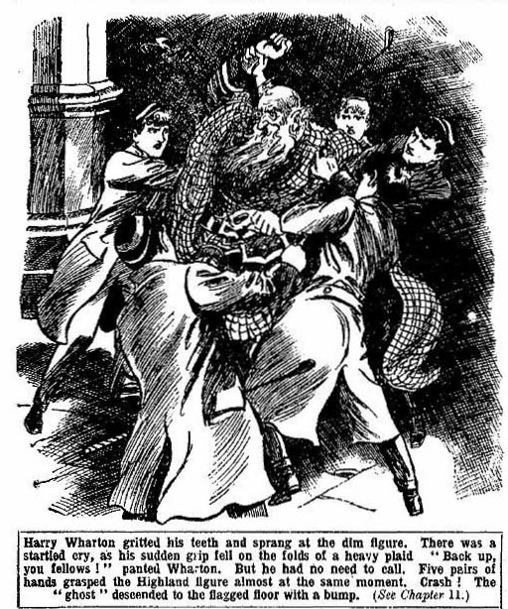
Crash!”
With a heavy crash the figure went down, dragged to the flagged floor by the sudden attack, and the juniors piled on it desperately.
There was a cry again—a cry in words that the schoolboys did not understand. But they knew that it was the Gaelic. Then, with the five figures clinging hard and fast, the powerful frame uprekred itself, struggling up in spite of the heavy odds. For a moment the dim form was upright, struggling, panting, crying out in wild Gaelic. And then the united efforts of the Five pulled it down again, and it crashed to the floor.
There was a thud
The plaided form lay still. The head had struck with terrible force on the stone flap, and the phantom—the man, the madman, whatever he was—lay stunned and senseless.
Wharton staggered to his feet.
“A light!” he panted hoarsely.
Hurree Singh turned on his electric torch. The plaided figure lay still at the feet of the juniors. They turned it to see the unconscious face.
And then, as they recognised it, a cry broke from all the Famous Five.
“Sandy Bean!”
It was Sandy Bean, the ancient piper, the last survivor and mourner of the vanished land of MacDermid, who lay senseless at the feet of the stranger’s in the old hall of Lochmuir.
THE TWELFTH CHAPTER.
A Mystery No Longer!
HARRY WHARTON left the House of Lochmuir at the first gleam of dawn, and tramped
down through the snow to Muirland village. Thence the innkeeper’s son, mounted on a shaggy, swift Highland pony, rode at a gallop by breakneck paths to the nearest town to summon a doctor. But it was late in the day when the doctor arrived at Lochmuir.
Sandy Bean, stretched in a bed in the old house, was conscious, but he was a sick man.
The juniors had taken all the care of him that was possible. The discovery that the old piper was the “ghost” of Lochmuir, that he had played the part of the old laird’s Wraith, had come as a stunning shock and surprise to them.
Yet when they reflected upon it their wonder lessened.
The old man, half crazed by solitude and by incessant dwelling on the past, was scarcely responsible for what he did.
Indeed, from the few words he spoke as he lay on the bed of sickness, his bruised head carefully bandaged, it seemed that he had no recollection of what had passed that wild night.
Half consciously or unconsciously the old man had played the part of the Highland wraith, governed and deluded by his ruling passion—the desire to keep strangers and intruders away from the old hall of the MacDermid.
From his youth, spent in rambling about the old house, then abandoned to the bats, he had known the secret of the moving picture, and doubtless had used the secret door many a time. Possibly in those days he had played ghost, for it was said that earlier tenants of the old house had been scared away, and for long it had stood untenanted. Doubtless old thoughts had stirred in Sandy Bean’s crazed old brain when he learned that the owner of the place was preparing for occupying it. All Sir Philip Angel’s preparations must have seemed a kind of sacrilege to him.
For old Sandy was a firm believer in the wraith of the Highland laird, in spite of the fact that he had played the part himself.
Harry Wharton & Co. understood that the old man was half crazed, and they had only sympathy for him. Even Aubrey Angel was heard to mutter a word of compassion.
By the doctor’s orders, old Sandy was removed from the house of Lochmuir and taken to the hospital in the town; and as soon as Sir Phillip Angel could be communicated with, instructions came from him that the old man was to receive every care.
It was not long before old Sandy was himself again and back in his cottage by the lake. But the picture of the laird in the old hall of Lochmuir was screwed up, and if the uneasy fancy of playing ghost came again into the old piper’s mind, he found his way barred.
The juniors saw him again several times during the remainder of their stay at the house; but he spoke no word of what had happened, and they doubted whether he remembered it.
There were, of course, no more mysterious happenings in the House of Lochmuir. The ghost had been laid for good. Even Billy Bunter had no more apprehensions. Indeed, he told the other fellows that he never had heeded the ghost at all, and had suspected all along that it would turn out to be old Sandy. At which Harry Wharton & Co.
chuckled.
When the time came to leave Lochmuir, the car containing the Greyfriars party rolled down the path by the loch and passed old Sandy’s cottage. From that cottage came the melancholy wailing of the pipes, and the juniors caught their last glimpse of the old man as the dirge of the MacDermid floated out and echoed across the waste waters of the loch.
Old Sandy, in his Highland solitude, was still dreaming of other days.
THE END.

