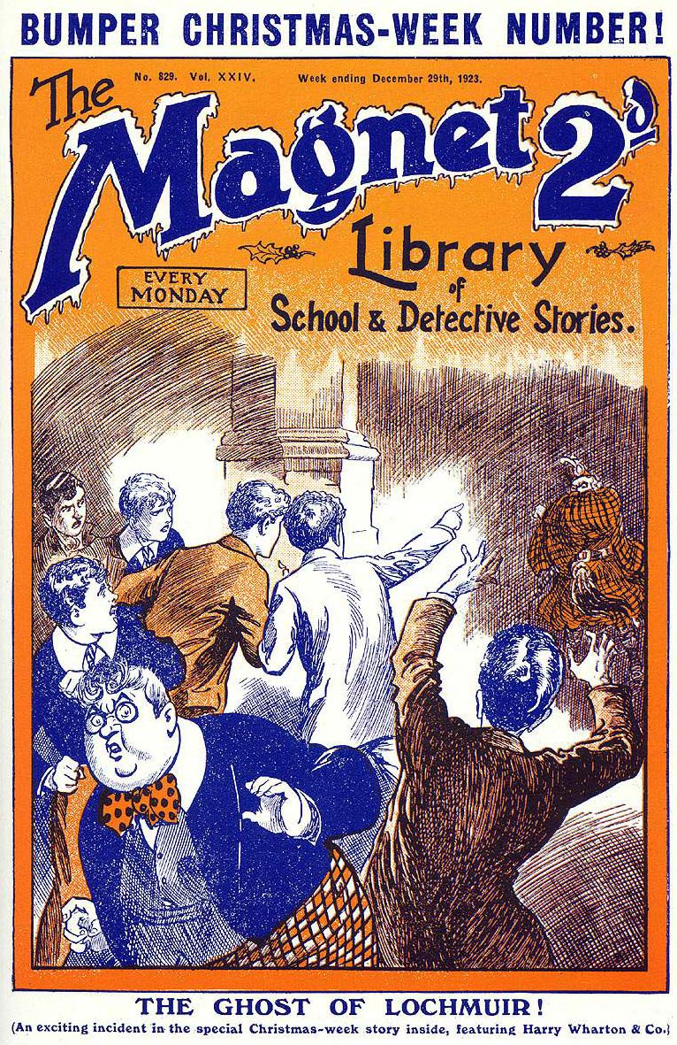

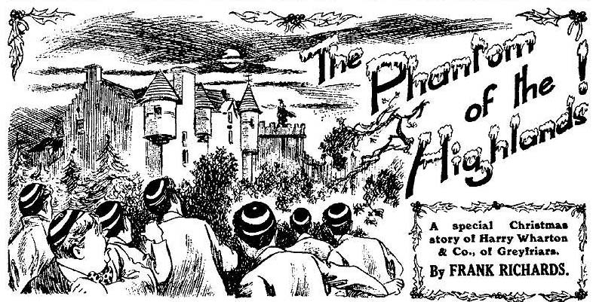
THE FIRST CHAPTER.
Borrowed Plumes!
“Pack’in! ” called out Bob Cherry cheerily.
“The packfulness will be terrific!” grinned Hurree Jamset Ram Singh
It really looked like it.
The brake, standing before the steps of the School House at Greyfriars, was already swarming. It was breaking-up day at the old school, and Greyfriars was beginning to scatter. There were several brakes—quite as many as were needed, in fact, to convey the Greyfriars fellows to the station. But everybody seemed to want to go by the first brake. One had rolled off, crammed; another had followed, swarming. Now there was a scramble for the third, and in that scramble the Famous Five of the Remove were prominent.
“No room!” yelled Skinner.
“Oh, there’s room for a dozen yet!” said Johnny Bull. “Wedge in!”
Harry Wharton & Co. wedged in.
“Now I think we’re full up.” grinned Bob Cherry. Better start. Hallo, hallo, hallo! There’s Mauly! Room for one more, Mauly!”
Lord Mauleverer stepped out of the big doorway. But, he was not yet dressed for travelling. Mauly never was an early starter.
“There isn’t room!” howled Skinner.
“Rats! I’ll make room for you, Mauly, if I have to drop Skinner overboard!” shouted Bob Cherry.
“Why, you cheeky rotter—”
“Thanks, old man!“ drawled his lordship. “ I’m not ready yet. Haven’t finished packin’.”
“You’ll be still be packing when the new term opens, I think.” said Harry Wharton, laughing.
“You see, I can’t find my fur overcoat.” explained Lord Mauleverer. “I can’t go without it. Any of you fellows seen it?”
“Don’t you know where you keep it?” asked Frank Nugent.
“Yaas.”
“Well then, look there for it.”
“I have; but it isn’t there. I suppose I shall have to leave it behind.” said his lordship resignedly.
“Hallo, hallo, hallo! There’s Bunter Get moving, driver!”
“I say, you fellows, stop for me!” roared Bunter.
“ No room!”
“I say—!”
“You want a lorry, old top!” said Bob Cherry. “This brake carries only a ton, You’d better telephone for a special lorry for yourself.”
“Ha, ha ha!”
“I say, you felIows, I’m coming in that brake!” shouted Bunter. “Gimme a hand in.”
“Blessed if he isn’t fatter than ever!” exclaimed Wharton. “Have you been boltin the House-dame’s turkey, Bunter?”
“What a circumference!” chuckled Johnny Bull. Billy Bunter was always plump, not
to say podgy. But on this especial frosty morning he looked plumper and podgier than ever. His girth was, in fact, enormous. He was wearing a roomy ulster, which, roomy as it was, fitted round him very closely. Wide as his natural circumference was, it seemed to have grown amazingly wider quite suddenly. Even the bolting of the housekeeper’s
turkey could not have accounted for the increase
He clambered into the brake, seeming to find some difficulty in moving. Skinner raised fresh expostulations, but the Famous Five cheerily shoved Skinner, and helped the Owl of the Remove on board,
Bunter sat down with a gasp.
“Ow!”
“Now we’re off !” said Bob.
“Bunter!” shouted Lord Mauleverer.
“Eh! Merry Christmas, Mauly! Drive on quick, you fellows!”
“Have you seen my fur coat, Bunter?”
“I didn’t know you had one, old chap: I say, you fellows, make that driver start!”
“Why, you were asking me to lend it to you yesterday!” exclaimed Lord
Mauleverer.
“Wa-a-as I?”
“You told me you were going to spend Christmas in the Highlands, and you’d want a fur
coat.”
“That’s Bunter’s little mistake!” chuckled Bob Cherry. “He isn’t going to spend Christmas in the Highlands.”
“Oh, really, Cherry---”
“Well, have you bagged my fur coat, Bunter?” demanded his lordship.
Billy Bunter blinked at him indignantly through his big spectacles.
“I hope I’m not likely to borrow a coat without permission, Mauly!” he said, with dignity.
“You haven’t packed it?”
“Certainly not!”
“Look in his box and make sure!” suggested Vernon-Smith. “You know Bunter!”
“Oh, really, Smithy—”
“Too much trouble!” sighed his lordship. “I believe he’s bagged it, all the same.”
“Look in my box, if you like!” howled Bunter. “I’ll eat any fur coat you find there!”
“Well, if you haven’t bagged it, all right.” said Lord Mauleverer. “Sorry—but you know what you are, Bunter!”
Bunter waved a fat hand at his lordship.
“Pardon is granted!” he said loftily. “But I must say, I’m surprised at you, Mauly. It’s rather low to be suspicious!”
“Oh, gad!”
“I say, you fellows, make that driver start!” exclaimed Bunter. “What’s he hanging about for?”
“Putting on the extra horse.” saidWharton. “We’ll be off in a minute.”
“Oh, make him start! We shall lose the train at this rate!”
“The esteemed Bunter seems to be in a terrific hurry.” remarked Hurree Jamset Ram Singh, with a curious look at the Owl of the Remove.
“Oh, really, Inky---”
“It occurs to my estimable mind,” continued the Nabob of Bhanipur, that the extreme fatfulness of the esteemed Bunter is a suspicious circumstances, taken conjunctfully with the missfulness of worthy Mauly’s fur coat.”
“Oh, my hat!” exclaimed Bob Cherry. “What have you got on under that ulster, Bunter?”
“ Nothing “
“Nothing” yelled Bob.
“Ha, ha, ha!”
“I mean I—I’ve got my clothes on, of course,” gasped Bunter, “and— an extra waistcoat to keep out the cold. I say, you fellows. do make that man start!”
“Hold on, Mauly!” roared Bob Cherry. “ Inky’s found a clue to the missing coat!”
“Ha, ha, ha!”
“Yaas?” said Lord Mauleverer, turning back.
“Let’s look under that ulster, Bunter!” chuckled Nugent.
“Yah! Keep off! I—I’ve got my own coat on—”
“That wouldn’t make you twice as fat as usual.”
“I—I’ve wrapped a blanket round me to keep out the cold!”
“ A blanket!” yelled the juniors.
“Yes, two blankets, in fact!”
“Ha, ha, ha!”
“Let’s see the blankets!” chortled the juniors. The whole breakload was interested now.
“I—I say, you fellows—”
“Open that ulster!” roared Bob.
“I—I can’t!”
“Why not?”
“The—the buttons won’t come undone!” gasped Bunter. “I say, we shall lose the train. Driver, get off at once.”
“I’ll try my hand on the buttons!” chuckled Bob.
Bob tried his hand—with a tremendous wrench.
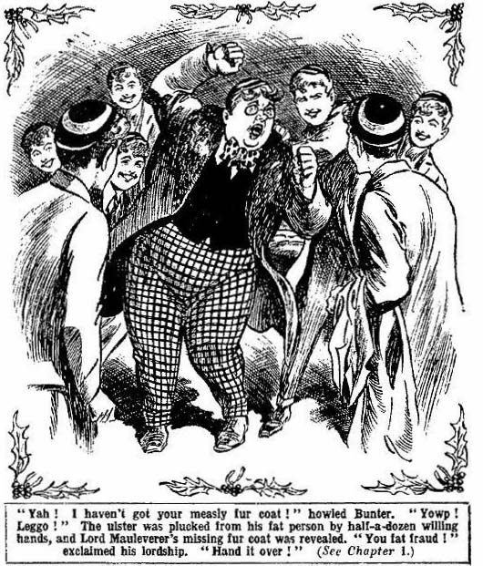
The buttons came undone then effectively. Most of them flew off. There was a roar of laughter as the ulster came open, and a handsome fur coat was revealed underneath.
“Oh gad!” ejaculated Lord Mauleverer. “My coat!”
“Ha, ha, ha!”
“Jerk it off him!”
“I—I say, you fellows, this isn’t Mauly’s coat!” roared Bunter. “It—it’s a coat just like Mauly’s——”
“Ha, ha, ha!”
“It—it was of a Christmas present from my pater!” gasped Bunter. It—it came by post this morning!”
“Yank it off him!”
“Leggo!” roared Bunter. “I—I say—I mean to say, it was sent up specially by Sir Philip Angel, to—to keep me warm at Christmas at his place in Scotland. You can ask Angel of the Fourth!”
“Angel’s started!” said Bob.
“I know—I mean I didn’t know—”
“Ha, ha, ha!”
“Yow! Leggo!” roared Bunter, as the ulster was plucked from his fat figure by half a dozen hands. “I—I say, Mauly, you can have the ulster if you like. I’ll lend it to you with pleasure.”
“Begad! I wouldn’t be found dead in it, old bean!”
“Leggo! Yow-ow-ow!”
The fur coat came off next. It came off with some difficulty. It was an ample coat, but Bunter filled it almost to bursting. Bob Cherry lowered it to Mauly over the side of the brake.
“Here you are, old top! Now, pile in and get your packing finished before Christmas!”
“Yaas! Thanks!”
Billy Bunter blinked after Lord Maiulevever as Mauly walked into the house with the coat over his arm.
Whether Bunter was to spend the Christmas vacation in Scotland at Sir Philip Angel’s place was still a moot question. But it was settIel that if he spent it there, he would not spend it in Mauly’s fur coat. That point was quite decided now.
“Now we’ll get off.” said Harry Wharton, laughing. —
“Beast! Gimme my ulster!”
The brake started at last. Billy Bunter wrapped himself in the ulster, and blinked wrathfully and indignantly at the laughing juniors.
“It will be your fault if I catch cold in the Highlands this Christmas!” he said.
“It won’t be our fault if you go to the Highlands!” grinned Bob Cherry. “ We’ll jolly well see that you don’t!”
“Ha, ha, ha!”
“Yah!”
And with that polished reply William George Bunter relapsed into lofty and dignified silence, while the brake rolled away from Greyfriars school amid a buzz of cheery voices.
THE SECOND CHAPTER.
Off for Christmas!
“HALLO, hallo, hallo! There’s jolly old Aubrey!”
The platform at Courtfield Junction swarmed with Greyfriars fellows of all Forms. Wingate and Gwynne of the sixth could he seen, walking with lofty dignity, towering over the mob of juniors. Coker of the Fifth was there, bawling to a porter—the said porter having committed some sin of commission or omission with regard to the great Coker’s luggage. Hobson of the Shell was chasing a hat that had been knocked off by a snowball, hurled by Tubb of the Third. Temple, Dabney & Co. of the Fourth looked their cheeriest and nuttiest, and talked to one another loftily about the hols they werk going to have. Aubrey Angel, also of the Fourth, stood with his study-mate Kenney, waiting for the train to come in.
“Merry Christmas, Angel!” roared Bob Cherry across about fifty heads.
Angel of the Fourth stared round.
As his glance lighted on Bob’s cheery, ruddy face, and he turned his back.
Bob flushed red.
“By Jove!” he murmured. “ I’ve a jolly good mind to give Angel a thick ear to carry one with him for Christmas.”
“Good egg!” said Johnny Bull.
“The goodfulness of the egg is terrific!” remarked Hurree Singh gently. “But do not forget that we are spending that the esteemed festive season with the Angel family, and a thick ear would not be in the pictur.”
“I say, you fellows—”
“Oh, buzz off, Bunter!”
“I think I’ll speak to Angel.” said Harry Wharton abruptly; and he pushed his way through the throng to the spot where the two Fourth–Formers were standing.
“Angel, old man!” he said quietly.
Aubrey Angel looked at him.
“Well?”
“We sha’n’t see each other till we get to Scotland.” said Harry. “We’re booked to spend Christmas with your father and your brother Mick. We’ve had our rows at school; but it’s Christmas now, and holiday time. We want to be on good terms for the hols.”
Angel did not answer.
“Let’s start friends, and meet as friends.” said Harry. “If we can’t get on together next term at school, let’s leave trouble to it happens. Nothing to row about in the vac.”
“I don’t want to row.” said Angel sulkily.
“That’s all right, then.”
“Fellows who butt in where they’re not wanted---” began Kenney, with an insulting grin.
“It’s not a question of that.” said Harry very quietly. “Sir Philip Angel and Mick asked us, and we agreed to go. Angel said nothing against it then. If he had—”
“My father isn’t a man to argue with.” said Aubrey Angel, with shrug of the shoulders.
“And I think—” went on Kenney.
“You think!”. interrupted Wharton “I’m speaking to Angel, not to you. Is Kenney coming up to Lochmuir with you, Angel?”
“No fear!” sneered Kenney. “I’m not likely to stand your crowd for the vac!”
“Then you’re not concerned in the matter!” Harry Wharton held out his hand to Angel. “Let’s part friends, Angel. I don’t bear any grudge for old troubles, if you don’t. And you know that Mick wants us to be friends.
Angel’s hard face softened a little. There was no doubt of his affection for his brother Mick, once the gipsy schoolboy of Greyfriars. He had an inward struggle for a moment, and then he held out his hand and shook Wharton’s.
“It’s all right.” he said. “I dare say we’ll have a jolly Christmas. Good-bye!”
“Good-bye, Angel!”
Harry Wharton rejoined his friends. The train was signalled, and it came rumbling into the station. There was a rush for carriages. Every one was filled—and overfilled. One carriage held the Famous Five and Vernon Smith and Redwing and Bolsover major and Skinner and Snoop, and then the fat figure of Billy Bunter wedged in.
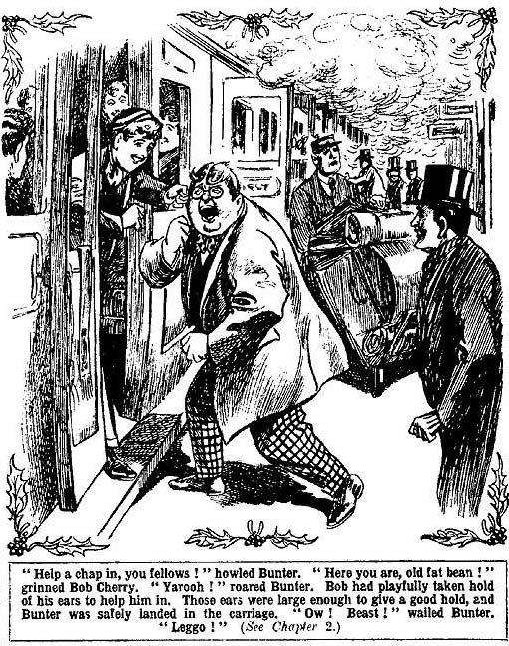
“Help a chap in, old fellow!” he gasped.
“ Here you are, old fat bean!”
“Yarooh!” roared Bunter.
Bob Cherry had playfully taken hold of his ears to help him in. Those years were large enough to give a good hold, and Bunter was safely landed in the carriage; but he did not seem to be satisfied, somehow.
“Ow! Beast! Leggo! Ow!” roared Bunter.
The door slammed.
“ We’re off !”
“I say, you fellows, of you is going to give me a seat?” demanded Bunter, as the express rumbled out of the station.
“The whichfulness is terrific!”
“ Ask us another, old bean!” chuckled the Bounder.
“ If you fellows are going to be selfish—”
“We are—we is!”
“Beasts! I say, Wharton, you’re all meeting Mick at St. Pancras to go up to Scotland, I think?”
“That’s so.” said Harry.
“ In three days’ time?”
“Yes.”
“Well, I shall have time to give old D’Arcy, my pal at St. Jim’s, a look-in before I join you.” said Bunter thoughtfully.
“You’ll have time to give everybody at S. Jim’s a look-in, if you want to, before you join us.” chuckled Bob Cherry. ‘You won’t see us again till next term, Bunty!”
“I couldn’t possibly disappoint Mick Angel.” said Bunter. And then there’s Aubrey—he expects to see me. And old Sir Philip—you know how he looks forward to my coming---”
“Queer that he never mentioned it.”
“Ha, ha, ha!”
“Don’t forget to have a good, big lunch basket put on the train, you fellows.”
“What train?”
“The Scotch express, you ass. I shall get hungry on the journey.”
“Bow-wow!”
The express buzzed on, and Billy Bunter continued to discuss the holiday in the Highlands, amid chuckles from the Fatuous Five. When they changed trains they parted from William George Bunter---and then, as Bob remarked, the holidays really began.
THE THIRD CHAPTER.
At St. Pancras!
“MICK”
“Here we are again!”
A rush of feet and a merry shouting on the crowded platform and Mick was surrounded by his Greyfriars friends, all shaking his hand at once—or nearly at once.
Maurice Angel—once known as Mick, the gipsy schoolboy—fairly beamed with pleasure and satisfaction as he greeted Harry Wharton & Co.
It was a grim December day. Out in the country were clear, cold skies and frosty fields: but in the great metropolis gloom veiled the streets. St. Pancras did not look cheerful in itself; but most of the faces in the hurrying crowds looked cheery. Christmas was coming, and even in these troubled days the spirit of Christmas had not lost its influence.
From their various homes the Famous Five of Greyfriars had met at the London station, and now they had met Mick, with whom they were to travel up to Scotland. They had expected to find his brother Aubrey with him; but Aubrey Angel was not to be seen. That was no disappointment to Harry Wharton & Co.
“It’s jolly to see you fellows!” said Mick, grinning cheerily. “Lots of time for the train—seats booked—we’re all right. The pater’s coming to see us off.
“ Isn’t your father travelling with us?” asked Bob.
“He was: but he’s delayed in London. Hc’s coming on tomorrow or the next day, with Aubrey.”
“That’s all right.” said Bob, with a smile. It was rather a relief not to have Aubrey Angel for a travelling.companion on the long journey.
“Of course, everything’s ready for us at Lochmuir,” said Mick, “and we can look after ourselves on the journey— what?”
“I fancy so.” said Harry Wharton.
“The pater’s made all the arrangements, and you’re under my wing, you know.” said Mick, “I’m sorry Aubrey won’t be with us. But he will be at Lochmuir soon after
us, so that’s all right.”
“As rain!” said Nugent.
“You haven’t seen anything of Bunter?” asked Johnny Bull, with a grin.
“Bunter? ” repeated Mick. No. Were you bringing that fat bounder with you? Of course, I don’t mind.”
“No jolly fear! But I shouldn’t have been surprised to see him turn up.” chuckled Johnny Bull.
“Ha, ha, ha!”
“Hallo, hallo, hallo!” ejaculated Bob Cherry suddenly. “Talk of angels and you hear the rustle of their giddy wings! Look!”
“Oh, my hat!”
At a distance on the big platform a fat figure appeared in sight. Two little round eyes blinked about inquisitively through a pair of big spectacles.
“Bunter!”
“The Bunterfulness is terrific!”
“Oh, my hat!” said Mick.
“ All serene!” said Johnny Bull. “I’ll kick him out of the station, if you like!”
“Cover!” said Harry Wharton, laughing. “He hasn’t seen us yet: Let him wander on!”
“Good egg!”
Billy Bunter was coming along, blinking about him, evidently in search of the Greyfriars party. But the short sighted Owl of the Remove had not sighted them yet.
Harry Wharton & Co. backed behind a great stack of baggage on the platform, and kept cover, with grinning faces.
From their cover they watched Bunter.
The fat junior came rolling along, blinking to left and right, and stopped at last close by the stack of luggage.
There he spoke to a porter was loading a trolley:
“I say, my man have you see some fellows waiting about?”
The porter blinked at him.
It was probable that he had seen seen thousands of fellows waiting about already that day, and that he would see some thousands, or tens of thousands more, before the murky sun set.
“Eh?” he ejaculated.
On the other side of the pile the Greyfriars junior’s grinned and kept close.
“Some fellows.” said Bunter. “Friends of mine—they’re waiting for me. Five or six chaps. Seen them about here?”
“The porter went on loading the trolley. Bunter blinked at him, and then extracted a shilling from his pocket.
“There you are, my man!” said Bunter graciously. “It might have been a pound-note, at least, by the way Bunter handed it over. “ Now do you think you could find my friends for
me?”
“The porter was willing to oblige, but it was not an easy task that Bunter had set him.
“What are they like, sir?” he inquired.
“Well, one of them is an ugly nigger.” said Bunter.
Hurree Jamset Ram Singh, behind the luggage, shook a dusky fist in the air. His comrades grinned.
“Another is a low-down looking sort of gipsy.” added Bunter.
Mick chuckled inaudibly.
Then there’s Cherry—a chap with enormous feet and a face like a ripe tomato.” said Bunter thoughtfully.
Bob Cherry almost emerged from cover as he heard that. But he restrained the desire to kick Bunter.
And Wharton—a rather lanky, swanking sort of cad!” said Bunter.
"Oh!” murmured Harry.
“And a fellow looking like a bulldog, with a jaw like a prizefighter—that’s Bull.”
Johnny Bull breathed hard.
“The other’s a pasty-faced sort of milksop.” went on Bunter, completing his description of the Greyfriars party, and Frank Nugent crimsoned with wrath.
The porter shook his head. As a matter of fact, he had seen the Greyfriars party, but he did not recognise them from Billy Bunter’s flattering description.
“No, sir, I don’t seem to have not noticed that lot.” he said.
“ Perhaps you’ve seen the old johnny——Sir Philip Angel?” said Bunter. “A stiff old blighter with a mastiff face and a scowl.
Mick’s eyes gleamed.
The porter had removed some of the baggage to the trolley, and over what was left, the juniors could see Bunter’s hat. Mick reached over and brought down his fist on top of Bunter’s hat with a heavy thud.
Crunch!
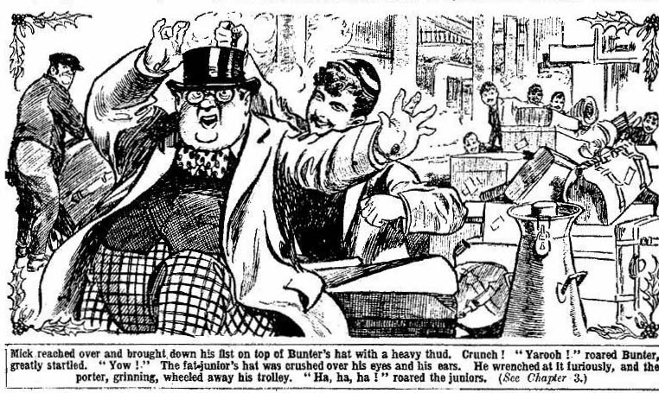
“Yaroooh!” roared Bunter, greatly startled.
“Ha, ha, ha!”
“Yooooop! Ow!”
Bunter’s hat was crushed over his eyes and his ears. He wrenched at it vigorously, and the porter, grinning, wheeled away his trolley.
“Retreat!” grinned Bob.
The juniors moved off among the crowd, leaving Billy Bunter struggling with his hat.
By the time the Owl of the Remove had extracted his bullet head from the crushed topper, the juniors were lost to sight in the crowds on the platforms.
“Adieu to Bunty!” chuckled Bob Cherry. “I wonder if he will ever know what hit him?”
“Ha, ha, ha!”
They did not see Bunter again. Doubtless the Owl of the Remove was still wandering about St. Pancras searching for them. But in the crowd he did not come near them again, fortunately. A little later the party packed into their carriage and Sir Phihp Angel stood at the door to bid them good-bye.
It had been arranged for Sir Philip to travel up to Scotland with the Christmas party, but his affairs detained him in London a couple of days longer. The juniors liked the old gentleman well enough; but they were not sorry to make the journey on their own, without the severe eye of a stiff old gentleman upon them all the time.
“Well, good-bye, my boys!” said Sir Philip. “Mick knows all the arrangements, and you’ll find MacNab at Lochmuir, and everything ready for you. Good-bye !”
“Good-bye, sir!”
The old baronet stood back, and the door closed. As the express moved, Bob glanced over the platform, but there was no sign of Bunter. Apparently the Owl of the Remove had been “left” after all. St. Pancras, and London and its fog sank away behind, and the express rumbled and puffed and blew on its rapid way to the North.
THE FOURTH CHAPTER.
Northward Ho!
“I SAY, you fellows—”
Six juniors jumped at once.
The express had been throbbing on for less than half an hour when a fat face and a large pair of spectacles looked into the carriage from the corridor of the train.
“Bunter!” roared Bob Cherry.
“Oh, my hat!”
“Bunter—on the train!”
Billy Bunter blinked cheerfully. He was dressed in his best, with a necktie warranted to kill at forty rods, and a silk hat which showed curious signs of wear and tear.
“It’s all right.” he said.
“All right, is it?” grunted Johnny.
“Yes, old chap. I nearly missed you at St. Pancras. I don’t think you could have been looking out for me.” said Bunter severely.
“Oh, my hat!”
“But I got on the train all right, and I’ve been hunting up and down the train ever since.” said Bunter. “Lucky I found you——what?”
“The luckfulness is not terrific, my esteemed Bunter!”
Bunter edged into the carriage.
“Look here—” began Mick.
“It’s all right. I’ve got my ticket; said Bunter reassuringly. “But it’s lucky I found you fellows. I’ve lost my purse.”
“Anything in it?” asked Bob Cherry sarcastically.
“Oh, a trifling sum!” said Bunter airily. “A tenner my father gave me, and a couple of fivers I got from my uncle, and a few pound notes—I really forget how many. Not much to me, though I dare say you fellows would think it a lot of money. You will have to stand my exes on this journey; but I’ll settle up at Lochmuir. I’ve given instructions for my letters to be forwarded there, and I’m expecting a postal-order when—”
“A—a—a postal-order—”
“Yes; from one of my titled relations.” said Bunter cheerily. “How are but you getting on. Mick, old man? Jolly glad to see you! We’ll have a good time this Christmas—what!”
Mick simply stared at him. He did not quite know how to deal with William George Bunter.
“You’re looking quite decent,” went on Bunter.
“What?”
“Rather a change from the time when you were with the gipsies—what?” grinned Bunter. “You’re fairly respectable now, Mick, old man.”
“You cheeky ass!”
“Your manners haven’t improved much.” said Bunter calmly. “ But then, that’s to be expected from a fellow brought up practically among savages. I don’t mind. I’m no snob !”
“Oh crumbs!” gasped Mick.
“A bit careless of you fellows, missing me at St. Pancras,” went on Bunter. “I should have found you all right, but I was assaulted by a rough, who smashed my hat.”
“A—a rough!” ejaculated Mick.
“Yes. Some low scoundrel biffed me on the hat! ” said Bunter. “I had no end of a job getting it into shape again. I gave him a jolly good hiding, though.”
“ You gave him a hiding?” roared Bob.
“Yes, rather!”
“The fellow who smashed your hat?”
“Ha, ha, ha!” roared the juniors.
Billy Bunter blinked at them in surprise. He did not see any occasion for merriment.
“What was he like, the fellow who biffed your hat?” gasped Wharton.
“ A great, hulking rough.” said Bunter. “ A fellow you wouldn’t have cared to tackle, I fancy. But I just went for him. One terrible blow stretched him on the platform——”
“Ha, ha, ha!”
“Blessed if I see anything to cackle at; he liked senseless after I had felled him.” said Bunter.
“You spoofing toad!” howled Mick. “It was I who biffed your silly hat over your silly head!”
Bunter jumped.
“You!” he gasped.
“Yes; and I’ve a jolly good mind to biff it again!”
“ Oh crumbs!” gasped Bunter. He backed hurriedly into the corridor. “ I—I say, Mick, old man—”
“Ha, ha, ha!”
“Of—of course, I—I knew it was you all the time, Mick, old fellow!” gasped Bunter. “ Your little joke—what? He, he, he! I say, you fellows, can you crowd up a bit and give me room to it down!”
“No fear!”
“I can’t sit on my bag in the corridor all the way to Carlisle!” howled Bunter.
“Get out at the next stop.” suggested Bob Cherry.
“Yah!”
Billy Bunter remained in the corridor for a time. He was proceeding by degrees, as it were. Having made his presence known, he allowed it to sink in before going further. But at Chesterfield, an enormous lunch-basket was handed in to the Greyfriars party. Bunter somehow contrived to squeeze himself into the carriage and find seating accommodation.
It was fortunate that there was an ample lunch, for Billy Bunter, as usual, distinguished himself as a trencherman.
The express rattled on, and by that time, apparently, Bunter was established as a member of the Greyfriars party.
At Carlisle the party were staying for the night, arrangements having been made at the hotel in advance for them. No arrangements had been made for Bunter, but he was there! Johnny Bull proposed taking him for a walk in Carlisle and losing him there. But that drastic method was not adopted. By sheer cheek William George Bunter hung on, and the next morning he was in the Edinburgh express with the Christmas party.
Having now become a member of the party, Bunter proceeded to demonstrate that he was the most important member of it. He grumbled at the cold, apparently annoyed to find that it was colder in the north than in the south, and referred many times to Lord Mauleverer’s selfishness in declining to lend him his fur coat. He borrowed a rug from Wharton and another rug from Bob to tuck round his fat little legs, and a muffler from Mick.
“Comfy now?” asked Bob Cherry sarcastically.
“No!” grunted Bunter.
“Like to get out and walk?”
“Yah!”
“ You’re in Scotland now.” remarked Bob Cherry, when the train had crossed the Esk. “We’re going through what they call the Waverley country.
“ What the thump do they call it that for?” asked Bunter. “Who’s Waverley?”
“Ha, ha, ha!”
“Ever heard of Sir Walter Scott!” grinned Nugent.
“Of course I have! He’s the chap who wrote the “Absent-Minded Beggar!” said Bunter.
“Ha, ha, ha!”
“I—I mean ‘Paradise Lost’ amended Bunter, “Notleing to cackle at, you silly asses! You haven’t any knowledge of literally matters.”
“Hawick!” said Johnny Bull presently. “If we had time we’d have a look at Branksome Tower.”
“What’s that?” asked Bunter.
“It’s in the Lay of the Last Minstrel, ass!”
“We haven’t had that in class, have we !” asked Bunter. “Still, I know all about it. I know all Shakespeare’s plays.”
“Shakespeare’s plays!” yelled Bob.
“Oh my hat!” It’s a poem by Sir Walter Scott, you fat duffer!”
“Rot!” said Bunter,
“Ha, ha, ha!”
“I know some of that esteemed poem heartfully.” remarked Hurree Jamset Ram Singh. And he proceeded to quote:
“ The way was long, the wind was cold.
The minstrel was infernal old.”
“Infirm and old!” roared Bob Cherry, and the juniors chuckled.
The juniors looked from the windows through clear, frosty air at a country with historical associations. Bunter was not bothering about historical associations, however; he was eating toffee, which he found much more interesting.
“Edinburgh!” said Harry Wharton at last.
“I say you fellows—”
“What?”
“I’m hungry!”
And Billy Bunter repeated that interesting observation in tones of rising indignation about a score of times before he found himself at last sitting down to a substantial meal, after which, for a long time, his jaws were too busy for speech.
— —
THE FIFTH CHAPTER.
In the Highlands!
EDINBURGH, Perth, Inverness—and after Inverness the Highlands. It was a cheery and enjoyable journey to Harry Wharton & Co., though there was an accompaniment of “grousing” incessantly from William George Bunter.
Bunter seemed to take it as a personal injury that it was rather colder in the Scottish Highlands than in the Sussex downs. He did not like it, and he said so. Indeed, he told Mick that he was beginning to regret that he had consented to come—a remark at which Mick chuckled.
“It’s all very well to cackle!” said Bunter, greatly incensed. “ I’ve a jolly good mind to go back! There!”
“Ha, ha, ha!” roared Mick.
“Only I can’t very well desert you fellows in this dashed wilderness!” said Bunter. “Besides, having left my purse at home, I can’t pay my fare back!”
“We’ll club together to buy you a ticket, Bunter!” chorused the Christmas party eagerly.
“Yah!”
Billy Bunter did not accept that munificent offer. Cold as it was in the Highlands in December, apparently Bunter couldn’t make up his fat mind to desert his old pals.
“What’s this place called?” he asked.
“Dingwall.”
“What’s that mist over there?”
“That’s the sea.”
“Where are we going now?”
“Place called Muirland.”
“What is it?”
“A village.”
“How are we going?”
“By car.”
“I hope it’s a good car!” said Bunter.
“Gilt-edged, velvet-lined, check-action, ball-bearing, and jewelled in every hole!” Bob Cherry assured him.
“Yah!”
The Greyfriars party rolled along snowy roads in a big car. They were following a long road, away from the route of the Highland Railway. Wild moors stretched for unnumbered miles round them, and hill-tops clad in white. The scenery was magnificent, though it did not appeal to William George Bunter in the least.
Wilder and wilder it grew, more and more lonely, as the car ate up the miles.
“When the thump do we get to Muirland?” demanded Bunter.
“Ask the driver.”
Bunter tapped on the glass, but the driver did not turn his head. He was on a road that was slippery, and needed careful driving.
Presently there was a stop, and Bunter leaned out.
“Hi, driver!”
The the chauffeur looked at him.
“When shall we get to Muirland?”
“Dinna ken.” said the chauffeur briefly.
Bunter brightened.
“Dinner Do you mean we have dinner here!”
“ Eh?”
“I can’t see any hotel.” said Bunter, looking round at the wild waste. “Where’s the hotel, you fellows?”
“There isn’t any hotel, ass!”
“But the man says we’re going to have dinner.”
“Ha, ha, ha!”
“Dinna ken means don’t know, fathead!” roared Bob Cherry.
“Oh my hat!” gasped Bunter. “Don’t they spekk English here? Do any of you fellows know the language?”
“Ha, ha, ha!”
“How are we going to ask for what we want if you don’t speak the language?” demanded Bunter warmly. “ I hope you know the names of things to eat, at least! That’s important!”
“Well, I think I could ask for a haggis!” chuckled Bob.
“What’s a haggis?”
“Blessed if I know! It’s something to eat, anyhow. Ask chauffeur if he’s got a haggis about him!” suggested Bob.
“Is it fit to eat?” asked Bunter suspiciously.
“It’s said to be really ripping!”
“ Well, I’ll ask him.”
Bunter approached the driver again. The Highlands chauffeur was busy with his engine, and he was a man of few words. He gave Bunter rather a dour look.
“I say, my man, do you speak English?” asked Bunter.
The highlander stared, as well he might.
“I’m hungry.” went on Bunter. “You know what hungry means? H U N G RY—hungry!”
The chauffeur still stared.
“Have you got a haggis about you?” continued Bunter, apparently under the impression that a haggis was some sort of cake, or a biscuit.
“A—a—a what?” stuttered the chauffeur.
“A haggis.” said Bunter. “I say, you fellows, hp seems to understand some English—a few words, I dare say. He looks rather a fatheaded sort of a dummy, but he knows a few words ‘
“Mon, you’re cheeky!” said the Highlander. And hp gave Bunter a gentle push, which sat him down in a snowbank by the roadside. Then he gave all his attention to his engine,
Billy Bunter sat in the snow and roared till the laughing juniors came and extricated him. He did not ask the chauffeur any further questions about the haggis. It dawned upon his powerful brain at last that Bob had been pulling his fat lpg.
The journey was resumed, through wilder and wilder scenery. Dusk was thickening when the car drew up at the inn at Muirland.The little village, shut in by wild hills and moors, was some miles, as the juniors understood, from the old castle of Lochmuir. Lights gleamed from the inn, and a hospitable welcome awaited the juniors there. The chauffeur, having landed his passengers, drove off in the darkness on his return journey. From a window of the inn, Bunter, with his mouth full, watched the disappearing lights of the car twinkle out in the dusky distance
“I say, you fellows, how do you get to Lochmuir from here?” he asked.
“MacNab’s sending the car from the house.” said Mick.
“Who’s MacNab?”
“The butler in charge of the place.”
“When’s the car coming? ”
“It ought to be here now, ready for us.” said Mick. “I daresay there’s snow on the road, and it’s delayed. Anyhow, you can get a good feed here, Bunter, so don’t grouse.”
Bunter grunted.
“I manage these things better when I ask fellow to Bunter Court.” he said.
“Dry up!” said Bob Cherry.
Bunter devoted his attention to his meal. After that the juniors went out to look for the expected car from Lochmuir. They were a little surprised by its non-arrival. Full instructions had been given by Sir Philip Angel, and the Lochmuir car should have been at Muirland to meet the party. But it was not there, and there was no sign of it.
Darkness had closed in on the Highlands; the snowy hill-tops were hidden in gloom. Only from the villagc inn lights still twinkled. Mick was growing worried, and his comrades perplexed.
“I daresay we can get something here to take us to the house.” said Mick at last. “I’ll ask the innkeeper.”
The innkeeper was anxious to oblige. But there was no car of any sort to be had for love or money at Muirland.
“You shouldn’t have let that Dingwall man go back.” growled Billy Bunter.
“Lot of good thinking of that now!” snapped Johnny Bull. “For goodness’ sake dry up, Bunter.”
“If we can’t get a car we can get something else.” said Bob Cherry cheerfully, “Any old thing will do.”
“Any old thing won’t do for me!” snapped Bunter.
“Dry up!” roared Johnny Bull.
An open coach, used in the summertime for excursions, was all the obliging innkeeper could supply. But the party were anxious to get to Lochmuir, and they decided on it. Two horses were traced to the coach, and the baggage piled on it, and then the juniors discovered that the innkeeper was in warm altercation with a brawny Highland man, who was apparently to drive. The altercation was conducted chiefly in Gaelic, and the juniors listened without understanding; but they could guess that there was some difficulty afoot. The innkeeper turned to them at last.
“The mon will take ye as far as the loch.” he said. “Muirland men do not like going to Lochmiur after dark.”
“Why on earth not?” asked Wharton in amazement.
“It’s the old laird!”
“The what? ”
“The old laird who walks the castle at night.”
The juniors blinked. Mick had told them, they remembered now, that there was a ghost story attached to the old castle of Lochmuir. But that it was anything more than a legend they had not imagined. Apparently it was taken more seriously in the vicinity of the place.
“The jolly old Christmas ghost!” chuckled Bob Cherry. “Well, we’re not afraid of jolly old ghosts.”
“The mon will take ye as far us the loch.” said the innkeeper, with a frown. “If you like you can leave your luggage at old Sandy Bean’s cottage by the loch, and walk the rest. Then you can send the servants for your luggage—if they’re there!”
“If they’re there!” repeated Mick. “Of course they’re there.”
The Highland innkeeper shook his head.
“Strange things happen at Lochmuir.” he said. “There’s nae luck to the house since the old laird was killed.”
“Was he killed?” asked Wharton. “When was that?”
“At Culloden moor.”
“Oh, my hat! That was a jolly long time ago; Do you mean that he was one of the rebels?” asked Wharton.
“He was one of the King’s men.” said the inn keeper dourly. “He fought for Prince Charlie and was killed, and then the castle was besieged and harried by the Duke of Cumberland. And ever since the old laird has walked, to keep strangers away from the land of his fathers.”
“Oh, my hat!” said Harry.
To tho Greyfriars juniors Prince Charlie and the battle of Culloden, and the harrying of the Highlands by the Duke of Cumberland, were incidents of the “history class.” It was a little difficult to realize that they were now in a region where such things were memories handed down from father to son. To the Highland innkeeper the old Laird of Lochmuir was no rebel; he was one of the faithful adherents of Bonnie Prince Charlie, who was “out in the forty-five,” and had paid for his loyalty with his life. And in the old laird’s own country the Angel family evidently were regarded as newcomers and intruders, though they had held the land of Lochmuir for more than a hundred years.
“Well, this beats it!” said Frank Nugent. “All the same, we’re going on to Lochmuir.”
“Yes, rather!”
“The ratherfulness is terrific.” said Hurree Jamset Ram Singh. “The esteemed spook will not scare us awayfully.”
“Ha, ha! No fear!”
“Well, will ye go as far as the loch?” asked the innkeeper. “It’s a short walk from Sandy Bean’s cottage to the mansion, if ye care for it.”
“Yes, that’s all right.” said Mick. “By the way, who’s Sandy Bean?”
“The piper.”
“We’re in the land of the piper now.” said Wharton, with a smile. “Is he a Lochmuir man?”
“Is he?”. “The Beans were pipers to the MacDermid, lairds of Lochmuir, before the first Stuart reigned in Scotland.”
“A giddy hereditary piper.” said Bob. “We’ll be jolly glad to see Mr. Bean. I daresay he’s a jolly old bean.”
“Ha, ha, ha!”
“It’s nae’ laughing matter, young sir. But if ye’ll go, ye’ll go, and it’s nae business of mine.”
And a few minutes later the Greyfriars juniors were rolling away on the road to the loch,
THE SIXTH CHAPTER.
A Strange Arrival!
“THAT—what’s that?”
Billy Bunter gasped out the question.
The other fellows started and listened. Round them they could see nothing but blackness, broken here and there by a glimmer of a ridge of snow.
Faintly, glimmering in the bosom of the darkness, the loch appeared, a broad sheet of water washing the bases of great hills swallowed up in the night. The Muirland coach rattled and jolted by a rough stony road at the side of the loch— a narrow way between the water and the abrupt hillsides. Suddenly, through the veil of night and mountain mist, came a low, wailing sound—like the wail of a lost spirit in the mountain solitudes.
The juniors peered at one another with startled faces. Wailing sounds followed, echoing strangely in the hollows of the hills, coming from what direction they could not determine.
“What the dickens is it?” Bob Cherry.
“The wind—!”
“It’s not the wind—there’s hardly any wind. It can’t be some animal crying.”
“I—I say, you fellows, d-d-d-do you think it’s the ghost?” gasped Bunter.
“Fathead!”
Harry Wharton leaned over and touched the driver on the shoulder of his rough frieze coat.
“What’s that noise?” he asked.
The man peered round.
“Noise?” he repeated.
“Yes—you can hear it.”
“I hear nae noise.” retorted the driver. “But, maybe, ye mean the pipes.”
“Oh, my hat!”
“We are nigh Sandy Bean’s sheiling the noo.” added the driver.
The juniors understoid now. The wailing came from the bagpipes, played by Sandy Bean in his cottage by the loch. The juniors had heard sweet music extracted from bagpipes; but Sandy Bean was not discoursing sweet music by any means—he seemed to be set on producing a wild and melancholy wailing, that thrilled strangely on the ear. Possibly it was the ancestral dirge of the MacDermid, whom Sandy’s ancestors had served and piped for since the beginning of Highland history.
The coach stopped.
Faintly, a light glimmered through the darkness. The driver dismounted and moved towards the light. The juniors followed suit. Dimly they made out a little tumble-down cottage, built apparently of the stones from the hillside. The door stood wide open, and cold and bitter as the weather was, there was no trace of a fire in the cottage. No doubt Sandy Bean was hardened to this exacting climate.
The juniors, in silence, looked in at the open doorway.
A single candle glimmered on a rough table. On a bench sat an old man, clad in the Highland costume, very worn and torn. He was playing the bagpipes, and he did not cease or look up as the party arrived at the doorway. He seemed unconscious of their presence. His face was cold, wrinkled and bitten with age, his hair a snowy-white under the Highland cap, his brows like snow; but under them his eyes were keen, alert, almost
fierce.
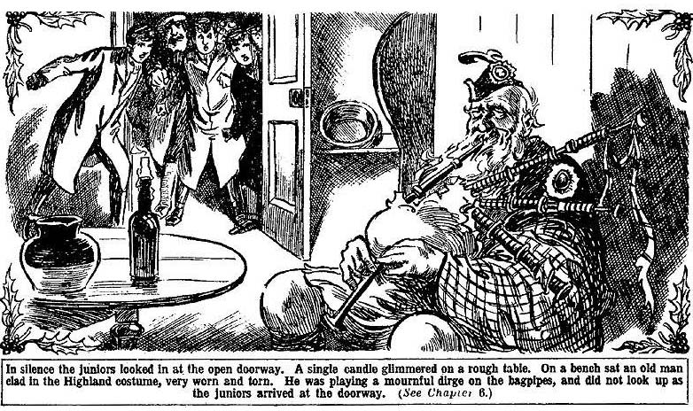
He played on, the pipes wailing wildly, the juniors watching him in silence. Mick made a movement at last but the driver touched his arm quickly. He spoke hurriedly, in Gaelic, and then repeated his words in English.
“Silent, young sir.”
“But—”
“It’s nae lucky to speak to the man when the fit’s on him.” muttered the coachman. Sandy Bean is fey.”
“Fey “ murmured Mick blankly.
“Hoot, say nothing.”
The wailing continued. There was something almost unearthly about the old man, alone in the solitary cottage under the mountain, by the waste waters of the loch, wailing out the dirge of a forgotten clan. Harry Wharton & Co. felt something like a superstitious thrill, as they stood in silence and waited.
The old man laid down the pipes at last, and raised his sunken, fierce old eyes to the visitors.
Then the coachman spoke hurriedly in Gaelic. Sandy Bean rose to his feet, and made a stride towards them, his eyes fixed on Mick. Long he stared at the face of the gipsy schoolboy, and then, turning away without a word, sat down, his face averted. Te Muirland coachman spoke again, in the Gaelic tongue, and the old man answered not a word.
“Well, what does all this mean?” asked Wharton, growing impatient. “Can we leave the baggage here. What does Bean say?”
“Sandy Bean says that he will not close his door to a stranger or to an enemy this dark night.” answered the coachman. “But he will not salute the stranger who enters the hall of the MacDermid.”
“Dash it all, that old chap ought to be in a balld, not in real life.” murmured Bob Cherry. “He looks jolly nearly old enough to have been at the Battle of Culloden himself.”
“His father’s father’s father was slain there.” said the Highland coachman. “He died by the side of the MacDermid, playing the pipes to the last to spur on the clan. In old Sandy’s mind the land still belongs to the MacDermid, though they are dead and gone. But Sir Phihip Angel has been a good man to him—this cottage is on the Lochmuir land, and old Sandy pays no rent.”
“How does he live?” asked Harry, in a low voice.
“They do not let the old piper starve.” said the man, apparently alluding to the few tattered inhabitants of the moorlands.
The juniors looked again at the old man. He sat motionless, his gnarled old face averted from them. They left the cottage, and the coachman transferred their bags from the coach. Then he pointed out the way to the Greyfriars juniors.
“You won’t come on to the house?” asked Mick.
The man shook his head. As he stood he was glancing to right and left fearfully, in the gloom, as if in anticipation of seeing the phantom of the old Laird start up from the shadows.
“There’s a curse on the place, since the old laird was slain.” he said. “No man of the country will walk by it at night, and not by his own will in the day.”
He backed his horses, and turned the old coach in the road. It was evident that nothing would induce him to go on to the house; but he pointed out the way carefully to the juniors. The coach rattled away by the loch, and the Greyfriars party were left alone. From the cottage in the shadows, a fresh wailing burst forth.
“Let’s get on!” said Harry Wharton.
“I say, you fellows, I don’t like this!” mumbled Bunter.
“Like to walk back?”
“Beast!”
“Then dry up, and come on.”
The juniors followed the road. It was a rough and stony road, difficult for travel, and the trend was upward. In ten minutes or so they came in sight of an ancient gateway, of which the stone pillars still stood, though the gate was long gone. From the gateway they followed a winding drive, between stunted snow-laden trees, towards the old castle of Lochmuir.
“That’s the place.” said Mick, at last.
“It was an old stone home, with many windows—on the right was a mass of ruins. shapeless in the gloom. The greater part of the old castle had been battered down by the Duke of Cumberland’s cannon, in the days following the flight of Prince Charlie, after the Battle of Culloden, when the Highlands had been harried with fire and sword by the ruthless victors.
Not a light gleamed from a window. The whole place was wrapped in darkness.
“It looks deserted.” said Nugent.
“Blessed if I can understand it.” muttered Mick. “I’ve never been here before, of course; but this as the place right enough. There are six servants there, with MacNab—or there ought to be. They were sent here from Perth weeks ago, to get the old place ready for Christmas;—nobody in this neighbourhood could be induced to take service there—I suppose on account of the ghosts.” He grinned rather ruefully. “Let’s get on—there must be somebody at home!”
The juniors, with grave faces now, pushed on to the house. There was no light—no sound. To their amazement, they found the great oaken door standing wide open—yet there was not a glimmer of a light within.
The house of Lochmuir was deserted. It was amazing—almost incredible—but it was evidently true. In the lonely house in the Highlands there was not a soul to greet the Christmas visitors.
THE SEVENTH CHAPTER.
Haunted!
“HALLO, hallo, hallo!”
Bob Cherry stood in the dark hall, and shouted. His shout echoed back, in a thousand thunderous echoes, from corridors and staircases and empty rooms. But there was no an+swering voice.
“My hat!” said Wharton. “This is queer! That’s why the car did not come to Muirland—the servants are gone.”
“The gonefulnpss is terrific!”
“I can’t nderstand it.” said Nick.
“It’s a blessed puzzle, and no mistake.”
Billy Bunter’s teeth were chattering, not wholly with cold, though it was very cold.
“I—I say, you fellows, d-d-do you think the ghosts frightened them away?” mumbled Bunter.
“Fathead!”
“Well, they’re gone. I say, how are we going to get any supper?”
“Bother supper,” grunted Johnny Bull, “ you’ve had one supper, you fat bounder.”
“That was an hour ago.” said Bunter, indignantly.
“We’d better look about the place.” said Harry Wharton, “we must get a light somehow,”
Matches were struck, and by the glimmer the juniors peered about the dark, black-oak-walled hall. The walls were adorned with trophies of Highland weapons, targets and dirks and claymores, and huge antlers of stags. They passed through an open doorway into a great room that was evidently the dining-room. The long mahogany table was set for a meal. In the centre of it stood a huge lamp, which the juniors were glad enough to see. It was in excellent order, and Harry Wharton soon had it alight.
Then the juniors explored further. Lighting matches as they went, they found their way into the kitchens. There they discovered lamps and candles, and lighted half-a-dozen of them. In the great fireplace were ashes that were still warm: it was clcar that it was very recently that the house had been abandoned.
Where were the servants gone—and why? It was, at present, an insolvable mystery.
Taking lamps to light their way, the juniors trod up the broad, low stairs to the second floor. There were the bedrooms, and all the rooms were in perfect order. No trouble or expense had been spared to make the old house comfortable for the sojourn of the Christmas party. Fires were laid in the rooms, and the juniors thoughtfully lighted them all, and soon there was a ruddy, cheery glare in half-a-dozen different places. It made the silent old house seem much less desolate.
After exploring the upper regions, Harry Wharton and Co. came downstairs agan. They were utterly mystified.
“Well, this beats it, and no mistake.” said Bob Cherry. “What do you make of it, Mick, old man?”
Mick shook his head.
“It beats me!”he said. “I’m sorry for this, you fellows. Not much of welcome for you fellows.”
“Oh, that’s all right.” said Wharton. “We can look after ourselves. We can’t send down to Sandy Bean’s for the bags, as there’s nobody to send. But we can camp out somehow till tomorrow.”
“Yes, rather!”
“There’s plenty of grub in the house.” said Bunter. “ I looked while you fellows were in the kitchen. Tons of it! Looks as if they laid in enough for a siege before they cleared off. But look here, Mick Angel, I don’t like this! This isn’t the way I treat fellows when they come to Bunter Court for Christmas.”
“Shut up, Bunter!”
“ Something must have happened here to-day.” said Mick. ‘There’s some reason for the servants bolting in this extraordinary way.”
“The giddy ghost—”
“Well, they may have fancied something.” said Mick, or—blessed if I can make it out. Anyhow, we can get supper, and turn in, and we’ll see what’s to be done to-morrow.”
“That’s a good idea.”
The party returned to the kitchen. The fire was raked together and stacked with coal and wood, and was soon roaring away cheerily in the ancient chimney. The larders were well stored, and there was no shortage of provisions. But it was with strange feelings that the Greyfriars party sat down to supper in the haunted house in the Highlands. The wind had risen, and was wailing about the old stone walls, recalling the wild notes of Sandy Bean’s bagpipes to their minds. The hour was late, and after supper the juniors bolted the big door, looked to the windows, and went up to bed.
They were tired with their journey, and in spite of the strangeness of their surroundings they were soon fast asleep.
Harry Wharton was dreaming of Highland pipers and kilted warriors with dirk and claymore, when he awoke suddenly.
A wild yell rang in his ears.
He started up in bed.
The moon had risen, and a pale, ghostly light came in at the casement of his room.
The house seemed full of sound—yell followed yell, rinsing and echoing in the gloomy old mansion.
“Good heavens!” panted Wharton
He leaped out of bed, As he turned from the door, Bob Cherry emerged from another door, half dressed, a lighted lamp in his hand.
“What?” shouted Bob.
“It’s Bunter!”
“Oh! Oh! Ow! Help!” Bunter’s voice was yelling, from the dark staircase. “Help! Oh! Help!”
All the juniors were awake and up.
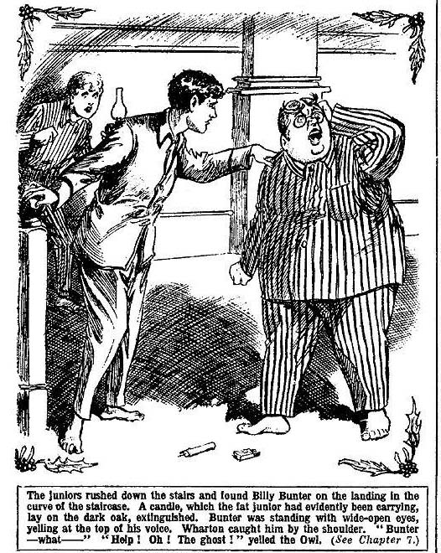
They rushed down the stairs. On the landing, in the curve of the staircase, they found Bunter. A candle, which the fat junior had evidently been carrying, lay on the dark oak, extinguished. Bunter was standing with wide-open staring eyes, yelling at the top of his voice in a frenzy of terror.
Harry Wharton caught him by the shoulder.
“Bunter---what—”
“Help! Oh! The—the ghost!” A heavy weight fell on Wharton—he clutched Bunter and held him. The juniors gathered round with pale, startled faces.
“Bunter! What’s happened?”
But there was no answer from Bunter. His fat face was set, and white as chalk; his eyes were closed. Billy Bunter had fainted.
THE EIGHTH CHAPTER.
The Phantom of the Night!
“FAINTED!”
“But what — what’s happened?”
“Goodness knows!”
Billy Bunter was quite unconscious. Evidently the fat junior had received the scare of his life. What he had seen, or fancied that he had seen, the juniors could not guess. In the flickering candle-light, they stared and peered about them into the shadows of the staircase and the old hall below.
“Give me a hand with Bunter.” said Harry Wharton.
The Owl of the Remove was carried up to his room and laid on the bed. He was breathing stertoriously and mumbling. His fat face was bathed in cold water, and in a few minutes his eyes opened.
“It’s all right, Bunter.” said Harry, as he met the fat junior’s frightened stare.
“Ow! Oh dear!” moaned Bunter.
“Keep still, old chap.”
Bunter’s startled gaze roamed round the room.
“Where is it?”
“ Where’s what?”
“Have you seen it?”
“Never mind now.” said Harry, thinking it better that Bunter should not dwell upon the cause of his fright in the present state of his nerves. “Get to bed, old fellow.”
“I saw it!” gasped Bunter.
“Yes, yes—”
“I tell you I saw it—the—the—the ghost!” stuttered Bunter, with chattering teeth. “I say, you fellows, shut that door!”
Nugent shut the bed-room door.
“Better not talk about it now, Bunter.” said Harry. “You shouldn’t have gone dawn alone in the dark. Why did you go down?”
“Hungry.”
“Wha-a-at?”
“I woke up hungry.” mumbled Bunter. “I thought I’d go down and have a snack. Then—then I saw it!”
“Well, what did you see?” asked Harry, as it was clear that Bunter would not drop the subject.
“The ghost!”
“What sort of a ghost?”
“A Highlander in kilt, and plaid!” gasped Bunter. “Just like that picture of the old laird in the hall. He was stalking along in the hail below when 1 got to the middle landing. I—I just saw the eagle feather in his bonnet first., and—and wondered what it was, and then I saw him! He looked at me—”
Bunter shuddered from head to foot. The juniors exchanged glances.
That Bunter had seen anything of the kind seemed to them impossible. The strange circumstances of their arrival at Lochmuir, the legend of the haunted house, and a heavy supper, accounted for it, to their mind. But the Owl of the Remove was taking it seriously, and was plainly frightened almost out of his fat wits.
“He looked at me!” repeated Bunter, “his eyes were like—like burning coals! His face was nearly hidden in his plaid, and I only saw his eyes—burning!”
He shuddered again.
“Then I think I dropped my candle— it was all dark, and I didn’t see him again. I think I called for help.”
“I think you did !“ sala Bob Cherry, with a faint grin.
“Ow! It was awful!” shivered Bunter. “1—I say, you fellows, I’m not going to sleep alone after this! I say, can’t we get away from this place to-night?”
“Scarcely,” said Harry. “It’s jolly nearly morning. Get to sleep and forget all about it, Bunter.”
“I’m hungry!”
“What? ”
“Hungry!” said Bunter.
The juniors stared at him, and Mick chuckled. The scare of the ghost had not, apparently, affected his appetite.
“Some of you fellows go and get me a snack.” said Bunter. “You say you ain’t afraid of ghosts!”
Bob Cherry laughed.
“I’ll go!” he said.
“I’ll come with you!” said Johnny Bull quickly.
There was a roar from Bunter.
“I say, you fellows, don’t you leave me alone! Yarooooh!”
“I will stayfully remain with the esteemed funky Bunter.” said HurreeJamset Ram Singh. And he sat on the side of the bed. Billy Bunter struggled under the bedclothes.
The other fellows, taking the candles, left the room and went down the staircase. They looked up and down passages and into empty rooms, and scanned shadowy corners and recesses of the old house. But there was no trace to be seen of the ghost that had frightened Bunter. Then they repaired to the kitchen, and secured a supply of provisions for the Owl of the Remove, and returned to the bedroom.
Bunter sat up in bed and ate.
He ate ravenously but evidently not with his usual enjoyment. His eye blinked to right and left and over his shoulders continually. Bob Cherry gave a deep yawn.
“Well, I’m going back to bed.” He remarked.
“I—I say, you fellows, don’t go to bed! All of you sit up to-night and keep me company!” enjoined Bunter.
“Then I shall be able to get some sleep—see?”
“Ha, ha, ha! I don’t think!”
Bob took his candle and walked away to his room, and Nugent and Johnny Bull followed his example.
“I’ll stay if you like, Bunter,” said Mick.
“Why can’t you all stay?” grunted Bunter. “I shouId feel safer. I never saw such selfish fellows!”
Hurree Jamset Ram Singh grinned, and strolled away to bed. Harry Wharton remained .
“We’ll get some blankets here and camp, Mick!” he said. “We don’t want that fat ass to be frightened into a fit.”
“Oh, really, Wharton——”
“Right ho!” said Mick.
There was an immense ancient couch in the room, along one wall, on which three or four fellows could have camped. Wharton and Mick fetched blankets and pillows, and arranged them on the couch.
“Leave the lamp burning.” said Bunter could resume.
The lamp was left burning. In a few minutes more Bunter, replete with a second supper, was sinking into slumber, and his deep and resonant snore echoed through the room.
Mick dropped asleep on the couch, rolled in blankets. Harry Wharton closed his eyes, but sleep came slowly.
Bunter’s snore helped to keep him awake.
He sat up on the couch, and watched the moonlight at the window. The lamp burned low, and Wharton rose and turned it out. The room was dimly lighted now by the glimmering moonlight.
Harry Wharton walked to and fro for a time, hoping to tire himself into drowsiness. Then he went at last to the casement and looked out. From the window the ruined castle of Lochmuir was visible, shattered walls and casements and battlements in the dimness of the moon.
Suddenly Wharton gave a violent start.
On the old battlemented wall, where in ancient days defenders of the castle had looked down on their foes approaching by the road up from the loch, a strange figure appeared. Wharton stared at it blankly.
It was the figure of a tall Highlander, in kilt and plaid and bonnet with eagle plumes. Full in the glimmering light of the moon it appeared, pacing the old battlements.
Wharton rubbed his eyes and looked again. Was he half-asleep and dreaming?
The Moon sailed behind a dark bank of cloud. All was darker now and he could see nothing.
He watched with beating heart till the moon reappeared. Once more the pale, ghostly light gleamed on the crumbling battlements.
But the plaided figure had vanished— if ever it had been there. The moonlight glimmered on crumbling stone and moss and gleaming ridges of snow.
Wharton breathed hard.
What had he seen? Was it a trick of the imagination? Or—he returned to the couch where Mick was sleeping peacefully. But sleep did not visit Wharton’s eyes till the winter sun was glimmering in at the casement.
THE NINTH CHAPTER.
The Mystery!
BOB CHERRY was first up in the morning. Ii as not long before the others followed his example —further sleep would have been difficult, when once the energetic Bob was afoot. Even Billy Bunter, with loud protests, was routed out. But a scent of cooking from the kitchen comforted Bunter; in spite of the number and extent of his suppers, he was more than ready for breakfast.
Bob had constituted himself cook. He turned out a substantial breakfast, and the party disposed of it round the roaring kitchen fire with great comfort and satisfaction. Snow had begun to fall with the dawn, and the white flakes floated down thickly past the old windows. But the Greyfriars party were feeling quite cheery now—even Billy Bunter was cheery. Ghosts or no there was plenty of tuck—and in the daytime, at least, Bunter was not afraid of ghosts.
After breakfast Bunter was left still busy, and the juniors turned out into the frosty air.
“Ripping air, anyone!” said Bob Cherry. “Jolly healthy up here! It’s a queer old show, but 1 like it.”
“If you fellows would like to clear—” began Mick.
“No fear!”
“I mean I shouldn’t mind; this isn’t exactly the kind of Christmas I asked you for.” said Mick ruefully.
“My dear chap,” said Bob “a Christmas without a ghost wouldn’t be the genuine article. I wouldn’t change this show for anything.”
“Hear, hear!”
“Of course, I should have to stick it.” said Mick. “The patpr and Aubrey will be here to-day or to-morrow. They’re bringing some friends with them. But——”
“We’ll get the place ready for them somehow.” said Harry Wharton. “First thing is to get our baggage up from Sandy Bean’s cottage. As there’s nobody to fetch it, we shall have to carry it ourselves.. Then we’ve got to find out where the servants have gone, and get them back if possible.”
The juniors walked down the rough road to the loch. On the broad sheet of water, washing the foot of the hill, the sun gleamed and reflected. Snow was falling in light flakes, but through it was a gleam of winter sunshine. The keen, invigorating air of the mountains made the Greyfriars juniors feel bright and cheerful. On the way down to the loch Wharton told his comrades of what he had seen—or fancied he had seen from the window in the night.
“Half-asleep and dreaming, old chap.” said Bob.
And Wharton wondered whether that was the explanation. Certainly, in the gleaming frosty day, what he had seen seemed fantastically impossible.
They found Sandy Bean’s door on the latch, but the old piper was not to be seen. The next few hours were occupied in conveying their baggage to Lochmuir.
Bunter was set to cooking, and a substantial lunch was produced, aftpr which the party set out to explore the neighbourhood, and to discover, if they could, some clue to the strange disappearance of the servants.
Billy Bunter loudly protested that he wanted a nap after lunch; but he declined to remain alone in the house, so he toddled, grumbling, after the others when they started.
There was no habitation excepting Sandy Bean’s cottage, anywhere near Lochmuir, though in the glen the juniors found traces of ancient habitations long destroyed—the cabins of Highlanders who had been burnt out by Cumberland’s dragoons after the rebellion of 1745. Fire and sword had wasted the land in those old days, and the clan and the chief of the MacDermid had perished together; the lands and the ruined castle had passed into the hands of strangers.
Only old Sandy Bean remained, to mourn over a past forgotten by others, lingering like a phantom in the demesne where his forefathers had dwelt.
In the late afternoon the juniors, returning from a long ramble, came on the old piper.
They found Sandy Bean standng on a rock, looking over the waters of the loch. He was standing like a figure carved in stone, and did not glance at the patty as they came up. It flashed into Wharton’s mind as he looked at the old man that Sandy Bean was not quite in his right senses. There was something strange and unearthly in the old man’s look, and the wild, solitary life he had led for long years could scarcely have failed to affect his intellect. A man who in the twentieth century was still brooding over the events of the ‘45 must be, at least, the victim of an obsession. The piper of the MacDermid was living as it were, not in his own days, but in the days of his father’s grandfather.
“Let’s speak to him.” said Harry in a low voice. “He’s the only chap living anywhere hear Lochmuir, and he may know something of what happened here yesterday. Something must have happened to scare the servants away.”
The juniors stopped.
“Hallo, hallo, hallo!” greeted Bob Cherry cheerily, in a voice that boomed across the glimmering waters of the loch.
The old man turned his head. With a native courtesy he doffed his Highland bonnet, though his gnarled face expressed nothing.
Harry Wharton proceeded to explain to Sandy. The old man listened without a change of a muscle in his face; it almost seemed that he did not hear what was said to him. But when Wharton had finished he spoke.
“They fled!” he said briefly.
“The servants were here yesterday.” said Harry.
Sandy Bean nodded.
“Did you see them go?”
Another nod.
“But why?”
“They dared not remain in the halls of the MacDermid.”
“But why?” said Wharton again. Why did they go?”
A wrinkled smiIe crossed Sandy’s gnarled face for a moment.
“They saw the laird!”
“Oh my hat. The ghost?”
Another nod.
“And that scared them away?”
Nod.
“We were expecting the car to be sent to Muirland to bring us to the house.” Said Harry. “We haven’t found a car in the garage at Lochmuir. Did they go in the car?”
“Yes.”
“Did they leave no message for us!”
“None!”
“The funky asses!” growled Bob Cherry. “Your pater will jolly well sack the lot for this, Mick. If they’re scared so bad as that they won’t be coming back.”
“Not likely!” said Mick ruefully.
Sandy Bean turned away and resumed his contemplation of the loch. He seemed to forget the presence of the juniors.
Harry Wharton & Co. walked on to the house, puzzled and perplexed. What was best to be done in the strange circumstances they did not know. The early winter dusk was falling, and the snow was thickening. They were glad to get into the house again and to build a huge log fire in the spacious fireplace in the old hall.
As the darkness deepened round the house Billy Bunter began to cast uneasy blinks about him. An ample supper cheered up Bunter, but the wail of the rising wind startled and scared him. The ghost of the previous night was fresh in his memory.
“ I say, you fellows, we ought to clear!” he growled. “Call this a Christmas holiday!”
“Shut up, Bunter!”
“I tell you the place is haunted—”
“Bow-wow!”
The juniors stacked logs on the fire and sat round it, chatting, while the night grew older.
“I—I say, you fellows, what— What was that?” exclaimed Bunter suddenly.
“What—”
“Hark!”
From somewhere in the house came a sound—a strange sound. It was a low, faint, echoing wail.
“Was—was that the wind!” muttered Bob.
Wharton shook his head. He knew that it was not the wind. The sound was in the house, echoing faintly, eerily, in the dim old passages and deserted rooms. He rose quickly and took up a candle.
“ Come on!” he muttered.
“I say, you fellows——”
The juniors did not heed Bunter. They followed Wharton. The wailing sound was repeated, and Wharton followed it, holding up the candle, into a dim stone corridor that led towards the ruins.
“Look!” yelled Bob Cherry, startled.
Full before their eyes loomed up a strange figure—the figure of a Highlands chief in kilt and plaid, the heavy fold of the plaid almost covering the face, revealing to view only a pair of strange, burning eyes. In utter amazement and terror the juniors crowded back from the operation. The figure was advancing up on them, and with one accord the juniors rushed back into the lighted hall. There, with pale faces, they stared back; but the figure had not followed.
For some minutes there was a deep silence, broken only by the crackling of the logs.
Wharton set his teeth.
“ It’s a trick— a trick of some sort of some sort!” he panted. “Come on—we’re going to see this through!”
He seized a lamp, and led the way back to the stone passage. From end to end the juniors searched it; but the apparition had vanished. Phantom or not, it was gone, leaving no trace behind.
The juniors gathered in the hall again. They were startled and shaken. Bunter was quivering with terror, and mumbling. Suddenly, in the silence, came a loud sound without.
Hoot! hoot!”
It was a motor-horn.
Wharton rushed to the big oak door and flung it open. Outside, on the snowy drive, gleamed the lights of a motor-car. From the car descended a traveler wrapped in a fur coat, and the lights gleamed on the handsome face of Aubrey Angel.
“Aubrey!” shouted Mick.
And he ran out to greet his brother.
THE TENTH CHAPTER.
A Surprise for Aubrey!
AUBREY ANGEL stood before the leaping fire, a smile on his handsome face. It was rather a cynical smile. Bob Cherry, thoughtfully hospitable, had taken the chauffeur into the kitchen to supply him with refreshments after his arduous drive to Lochmuir. Angel listened to what the juniors had to tell him with scarcely polite attention. It was quite clear, from his look, that he regarded the story of the spectral Highlander as all moonshine, and Harry Wharton and Co. as the victims of an attack of nerves.
The Co. had almost forgotten their dislike of Aubrey Angel; but the mocking look on his handsome face reminded them that he was still Angel of the Fourth, the supercilious cad of Greyfriars.
“Gad! what a story!” drawled Angel at last. “So there’s no servants in the place?”
“Nobody but ourselves!” said Wharton.
“Oh, gad! This looks like a jolly Christmas, and no mistake!”
“We’ve got to fix something up before the pater arrives.” said Mick.
Angel shook his head.
“The pater isn’t arrivin’. he answered. “He’s kept in London by election business. He’s sorry, an’ all that—he sent no end of excuses—but he simply can’t get away from London, after all, for days at a time. There won’t be a gathering here for Christmas after all.”
“Oh!” said Mick, blankly.
Angel smiled again. He was the bearer of rather disconcerting news; but it did not seem to disconcert him at all.
“I say, you fellows, I’m not going to stay, anyhow.” said Bunter. “Now there’s a car here let’s all get out.”
“ Best thing you can do!” said Angel with a nod. The fact is, I came up expectin’ to take Maurice away with me. I suppose you’re fed up with this, Maurice?”
Mick coloured . Angel of the Fourth deliberately ignored his comrades, and brows began to darken among the Greyfriars juniors.
Mick looked at them.
“If the fellows want to go, l’m ready.” he said. ‘That is, I’m ready to let them go, but I don’t want to go.”
“You don’t want to stay on here.” urged Angel.
“I do. I wpnt to get to the bottom of this ghost business.” said Mick. “but I want to know what it means before I leave Lochmuir!”
“ What rot!”
“But I won’t keep you, Aubrey, if you don’t want to stay.” said Mick, with an effort.
Angel shrugged his shoulders.
“It’s understood that we’re spending Christmas together.” he said, “There’s nothin’ goin’ on at home—the pater would be anythin’ but pleased if we turned up there. He’s up to the neck in political business. That’s what comes of bein’ a member of the House of Chinwag, and havin’ election scares sprung on you suddenly by dashed politicians. He’s got to get busy gassing and promising, if he’s to keep his seat. But we can go to Kenney’s place—Paul Kenney will be glad to have us. He’s asked me.”
Harry Wharton set his lips.
He realised that Aubrey Angel would be glad, if he could take his brother sway, and leave the Greyfriars party stranded for Christmas, now that it was too late for other arrangements to be made. The morrow was Christmas Eve. Angel’s old enmity had slept, but it was not dead. Sir Philip Angel’s change of plan gave him his chance, and he was using it.
But Mick was not likely to fall into the trap. Ghosts or no ghosts at Lochmuir, festivities or no festivities, the Greyfriars party could not spend their Christmas in railway travelling, to turn up unexpectedly at their home. Mick had not the faintest idea of following his brother’s lead, and. “letting down” his guests. The thought did not even cross his honest mind.
“We can get away in the car.” resumed Angel lightly. “ I daresay your friends will be glad to go after the scare they’ve had.” He grinned. “The pater won’t come, anyway—he can’t. Of course, he says you’re to stay on here if you like. He thinks the house is staffed and comfortable. I daresay he thinks a set of schoolboys should enjoy a holiday in a place like this.”
“That’s so, too.” said Johnny Bull. “ I want nothing better. There’s plenty to do here.”
Angel sneered.
“Well, I want somethin’ a little more lively.” he said. “The Christmas party bein’ off, I want to be off too. As it turns out that the place is deserted, there’s nothin’ to stay for. Maurice, old chap’—Angel’s voice was kind and affectionate in speaking to hi brothe— “you’ll come back with me? ”
Mick shook his head.
“We’re here for Christmas.” he said. “I won’t keep the fellows if they want to clear; but I want to stay, and I want them to stay if they will.”
“Of course we will.” said Harry “As a matter of fact, its a. bit too late to think of anything else. We could hardly get away from here before Christmas now.”
“And we don’t want to.” said Bob Cherry, coming back from the kitchen.
“We’re all right here, and we’re going to see that jolly old ghost hone before we quit.”
“Maurice—” urged Angel.
“I’m staying!”
Angel bit his lip. He did not want to go without his brother, but it was plain that he did not want to stay. He gave the Greyfriars fellows a rather evil look.
“But you needn’t hang on, Aubrey.” added Mick hastily. “You’ve got the car—”
“I’m stayin’ if you do.”
“I want you to, old chap.” said Mick simply.
“Well, that’s settled, then.” Said Aubrey Angel, more good -humouredly than might have been expected. “I’m certainly not goin’ and leavin’ you here, Maurice. Let’s make the best of it.”
And, having made up his lofty mind to that, Aubrey Angel threw off his disagreeable manner and condescended to make himself pleasant to the Christmas party. That change in his manner was a great relief to Mick— which was probably the reason for the change. Aubrey’s affection for his young brother was the one quality that the Greyfriars fellows liked in him. Bitter as his feelings were towards Harry Wharton and Co., Angel did his best to refrain from distressing Mick by a display of them.
After supper Angel went up to has room—which Mick had repaired for him, lighting a huge log flre. Angel went up first, probably to smoke a cigarette or two before going to bed. The party sat round the fire in the hall, chatting, but their chat was interrupted a couple of minutes later. There was a harried step on the stair, and Aubrey Angel came running down, his face white and startled and furious.
“Who’s playin’ tricks here?” he shouted.
“What’s that?”
“Which of you?”
Angel’s eyes run over the party. They were all present, and it was evident, that Angel had expected to find one of them missing.
“Then—then it wasn’t one of you!” he ejaculated.
“One of us! What do you mean?” exclaimed Wharton.
“There was somebody in my room—somebody dressed up like a Highlander! ”
“Wh-a-at?”
“I know there’s a lot of old Highland rig in the old presses here.” snapped Angel. “I thought one of you fellows had dressed up to startle me. It’s somebody, anyhow. He dodged out of the other door of the room as I went in. Who was it?”
Silence.
“ You must know!” exclaimed Angel angrily. “ Who’s in the house beside yourselves?”
“Only the chauffeur ho brought you here, and he’s in the kitchen.” said Bob Cherry.
Angel knitted his brows.
“There’s somebody else! I saw him, I tell you!”
“Ow ! It’s the—the g-g-ghost!” wailed Bunter. “I say, you fellows, I sha’n’t stay here any longer! Ow!”
“Rot!” snapped Angel.
“It must be the same thing that we saw!” muttered Frank Nugent. “I say, this is getting rather thick!”
“It’s a trick of some sort!” growled Angel.
But he seemed disinclined to go up the stairs again, and he did not go to bed before the others went. Billy Bunter loudly refused to sleep alone, and Mick camped on the couch in his room. But the night passed without further alarm.
THE ELEVENTH CHAPTER.
Bunter’s Goodbye!
“I‘M going!”
Billy Bunter made that announcement the next morning.
The chauffeur who had brought Aubrey Angel up from Dingwall was preparing his car for the return journey. He had stayed the night at Lochmuir. Aubrey Angel would gladly have gone back in the car, if Mick would have gone with him; but Mick was adamant on that point, and Angel had made up his mind to it. Billy Bunter’s announcement that he was going did not excite the dismay in the Christmas party that the Owl of the Remove seemed to expect.
“I’m going!” he repeated firmly, blinking round through his big spectacles after breakfast. “I’m not standing any more of this!”
“Hurrah!” roared Bob.
“Oh, really, Cherry—”
“It’s going to be a merry Christmas, after all!” said Bob heartily, and the juniors chuckled,
“Beast!”
Billy Bunter was in earnest. The party feared that he wasn’t, but he was. He had very little packing to do, having relied on the other fellows for necessary supplies during his Christmas in the Highlands. His bag was put in the car, and Bunter followed it in. Harry Wharton & Co. gathered round with smiling faces to see him off.
“I say, you fellows—”
“Good-bye Bunter!”
“Any message for your uncle?”
“My unclp?” ejaculated Wharton.
“Yes. I shall give him a look-in.”
Harry Whartonlaughed.
“Wish him a merry Christmas for me!” he said, “He’s gone to Cannes for Christmas, with my aunt.”
“Ha, ha, ha!”
“Oh!” said Bunter. “I say, Franky old chap, I’ll look in on your people if you like.”
“I don’t like.” Said Nugent.
“What about your Auntie Bull, Johnny?”
“Nothing about my Auntie Bull!” answered Johnny.
“I say, Aubrey!” shouted Bunter.
“Don’t call me Aubrey, you fat bounder!” snapped Angel of the Fourth, without looking round.
“Hem! I—I’ll take a message to your father in London, if you like.”
“You’ll be kicked out if you do!”
“Ha, ha, ha!”
“If you fellow think I’m fishing for invitations, you’re jolly well mistaken!” said Bunter, with a glare round at the grinning Co. “As a matter of fact, I shall be busy this Christmas. I shall keep an old promise, and look up my old pal D’Arcy of St. Jim’s.”
“Poor chap!” said Nugent.
“Yah!”
That classic monosyllable was Bunter’s good buy. He had borrowed a rug from Wharton, a coat from Mick, a muffler from Bob, and several pounds from several members of the party. Now he had done with them, and he turned up his fat little nose at them as the car rolled away with him.
Billy Bunter disappeared in the misty distance—the first of the Greyfriars party to be scared away by the ghost of the old Laird. It remained to be seen whether any more of the party would follow suit. It was not likely.
Harry Wharton & Co., after Bunter had gone, were busy. There was no longer any possibility that the servants would return, or that further guests would arrive at Lochmuir. The Greyfriars party had the place to themselves for Christmas, and in a way they liked the prospect. There were ample supplies of every kind in the house, and Harry Wharton & Co. were prepared to look after themselves—though Aubrey Angel made it clear that he did not intend to lend a hand. Work of any sort was not in Aubrey’s line.
That day Bob Cherry made the Christmas pudding. He found all the necessary ingredients—and a good many that were not necessary—and, being. rather doubtful as to the exact composition of a Christmas pudding, he put them all in. All the fellows were called upon in turn to stir, and finally the pudding was put on to boil. Bob put it on to boil all night, banking up a huge fire under it. Whether it was overboiled or underboiled did not matter very much, as nobody was likely to eat it.
A ramble on the wild moor in the falling snow was quite an agreeable form of exercise to Harry Wharton & Co., bul Aubrey Angel did not care to join in it. He stayed indoors and smoked cigarettes.
At supper the wild wailing of Sandy Bean’s bagpipes was suddenly heard floating tremulously through the darkness of the night. Aubrey Angel started and stared as he heard it.
“What the thump’s that?” he exclaimed.
Bob Cherry grinned.
“Only the giddy bagpipes.” he said. There’s a jolly old piper, Sandy Bean, lives in a cottage by the loch.”
“I’ve seen him!” grunted Angel. “He must be mad to be out on a night like this, playing the pipes.”
“I think he is a little bit loose in the tiles.” admitted Bob. “A queer old sort, anyhow.”
The juniors listened to the wailing of the pipes. Old Sandy, unseen somewhere out in the darkness, was piping the dirge of the MacDermid. The melancholy wailing came eerily through the wild winter night.
It died away at last.
“Cheerful!” grunted Aubrey Angel, and he sat staring sulkily at the crackling fire, taking no part in the merry buzz of talk that enlivened the old shadowy hall.
But several times he glanced at the cheery faces of the Greyfriars juniors, ruddy in the firelight, with a peculiar expression in his eyes. Strange thoughts were working in the mind of Angel of the Fourth.
THE TWELFTH CHAPTER,
Christmas Night!
“MERRY CHRISTMAS!”
Bob Cherry’s powerful voice awoke every echo of the old house of Lochmuir. It was Christmas Day!
A strange enough Christmas for the Greyfriars party—camping by themselves in the ancient haunted house, shut in by the wild moors and mists of the islands.
Yet from its very strangeness it somehow appealed to them. The mystery of the haunted Highland house had a strange attraction for their imaginations. And there was plenty to keep them occupied that day, in the absence of any assistance “below stairs.” The Christmas dinner had to be prepared— and it was a dinner worthy of the occasion. Aubrey Angel dawdled and smoked while the other fellows were cheerfully buy. Mick, with his old-time experience among the gipsies, proved to be an excellent cook—even as good as Billy Bunter in that line. The turkey was done to a turn; the old panelled hall, decorated with holly and mistletoe, gleamed cheerily in the blaze of the great log fire. Quite a merry party sat down, at last, to the turkey; but merry faces became a little grave when Bob Cherry, with an impressive manner, carried in the Christmas pudding.
Aubrey Angel grinned as it was turned out, but the other fellows seemed to feel a sudden solemnity. Bob Cherry took up the knife to cut it.
He seemed a little puzzled as he stuck the knife into a rather gluey-looking mass.
“You think it boiled long enough?” he asked.
“Hem!”
“It smells nice.” said Bob.
“ Hum
“It—it tastes all right, too.”
“Mummmm.”
“Here you are, old fellows.”
Bob Cherry began to serve. This task prented some diffculties. Nugent suggested using a spoon for it—a suggestion that Bob did not seem to hear.
Certainly there seemed something wrong with that pudding. Bob had been rather afraid that it might be too hard. But it had turned out quite soft—very soft indeed—in fact, almost flowing . Somehow or other portions of the pudding were transferred to the platps. Bob, with rather a heightened colour, began on his portion. The juniors took up their forks—and hesitated,
“Go it!” said Bob.
The juniors went it—slowly. A strange expression came over Mick’s face as he tasted it.
“D-d-did you put any vinegar in this pudding?” he asked.
“I—I think not,”
“Ow!” murmured Johnny Bull.
“Tastes all right to me.” said Bob, with a touch of defiance.
“After that turkey, I—I think I’ll give the pudding a miss.” murmured Wharton. “Enough’s as good as a feast.”
“The enoughfulness is terrific!” murmured Hurree Jamset Ram Singh.
Bob Cherry was the only fellow who was eating the pudding. He was eating slowly—very slowly. He stopped at last.
“It isn’t boiled enough!” he said.
“Something’s wrong with it, certainly.” agreed Nugent.
“I—I’ll shove it back in the cloth and put it on again tomorrow.” said Bob. “We mustn’t lose our Christmas pudding.”
“Hem!”
Five juniors registered a mental vow that on the morrow that pudding would be missing.
But in spite of the pudding the dinner was a great success.
Every face was bright and cheery— after the pudding had disappeared.
The snow fell heavily that day; the early winter darkness clospd in. But in the old hall of Lochmuir the lights gleamed brightly, the log fire roared and crackIed. Even Aubrey Angel unbent and became cheery and good-humoured.
“A merry Christmas, after all.” said Bob.
And Hurree Jamset Ram Singh declared that the merryfulness was terrific.
It was at rather a late hour that the juniors sought their beds, and they were soon fast asleep. The old house was in darkness save for the faint red glow of the dying fire in the hall. Round the old walls and crumbling moss-grown battlements the winter wind howled and roared. It was long past midnight when Harry Wharton awoke suddenly.
What had awakened him he did not know; but he awoke with a strange shiver, and a feeling that he was not alone in his room. There was no glimmer of light—save a pale reflection from the snow at the window.
Wharton sat up in bed.
From the darkness near him came a faint sound of movement—a sound as of almost noiseless gliding feet. He sat in bed, staring before him intensely.
His heart was beating almost to suffocation.
Someone — something — was in his room—within a few feet of him, unseen in the darkness. The phantom—the thing—that haunted the House of Lochmuir was at his side, in the darkness.
As he strove to pierce the gloom, he made out, dimly, faintly, eerily, a figure in kilt and plaid—a shadow among shadows. Two gleaming, burning eyes looked at him, like balls of fire in the darkness.
For some moments Wharton sat frozen.
Then, with a cry, he leaped from the bed.
“ Help!”
He plunged wildly, almost in a frenzy, at the shadowy figure. His hands came into contact with something—he knew that it was the heavy folds of a Highland plaid. He clutched it, and gripped it, and shouted wildly to his comrades.
A hand was laid upon him—a hand that seemed of ice. It sent a shiver through the junior.
“Help!”
“Hallo, hallo, hallo!” Bob Cherry’s answering shout rang through the darkness. “I’m coming!—What—”
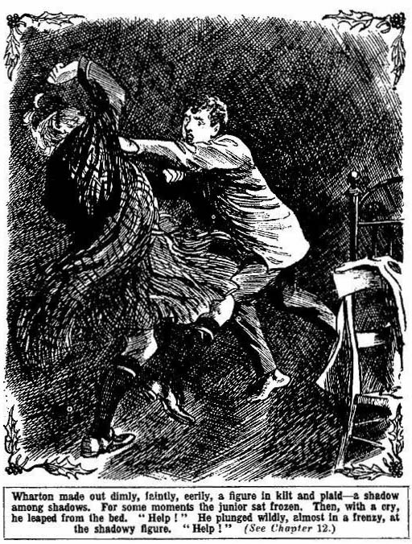
“Help!”
The icy hand pressed Wharton back. He lost his grip on the plaid. He staggered, and then ran forward with arms extended, feeling for his enemy in the darkness. But his hands encountered only emptiness.
A light glimmered in at the door.
Bob Cherry stood there, with a startled face, a candle in his hand.
“Harry—what—”
Wharton stared wildly about the room. Save for himself, and the junior at the door, it was empty. His hands had touched something in the darkness—he knew an icy hand had gripped him—but there was nothing to be seen. Was it a phantom of the night that had touched him—the hand of the dead? Wharton felt that his brain was reeling.
“It—it’s gone!” he panted. His voice was husky and broken. “I—I touched it—it’s gone——”
“ What—what was it?”
But Wharton could not reply to that. What was it that had lurked in the darkness, and touched him with the hand of death?
There was no more sleep at Lochmuir that wild night. Till the winter sun glimmered in at the windows, the Greyfriars juniors watched, and listened to the wailing of the wind, echoing eerily in the nooks and crannies of the ancient house. The night of Christmas wore away, and at last came dawn.
THE END.

