End to end

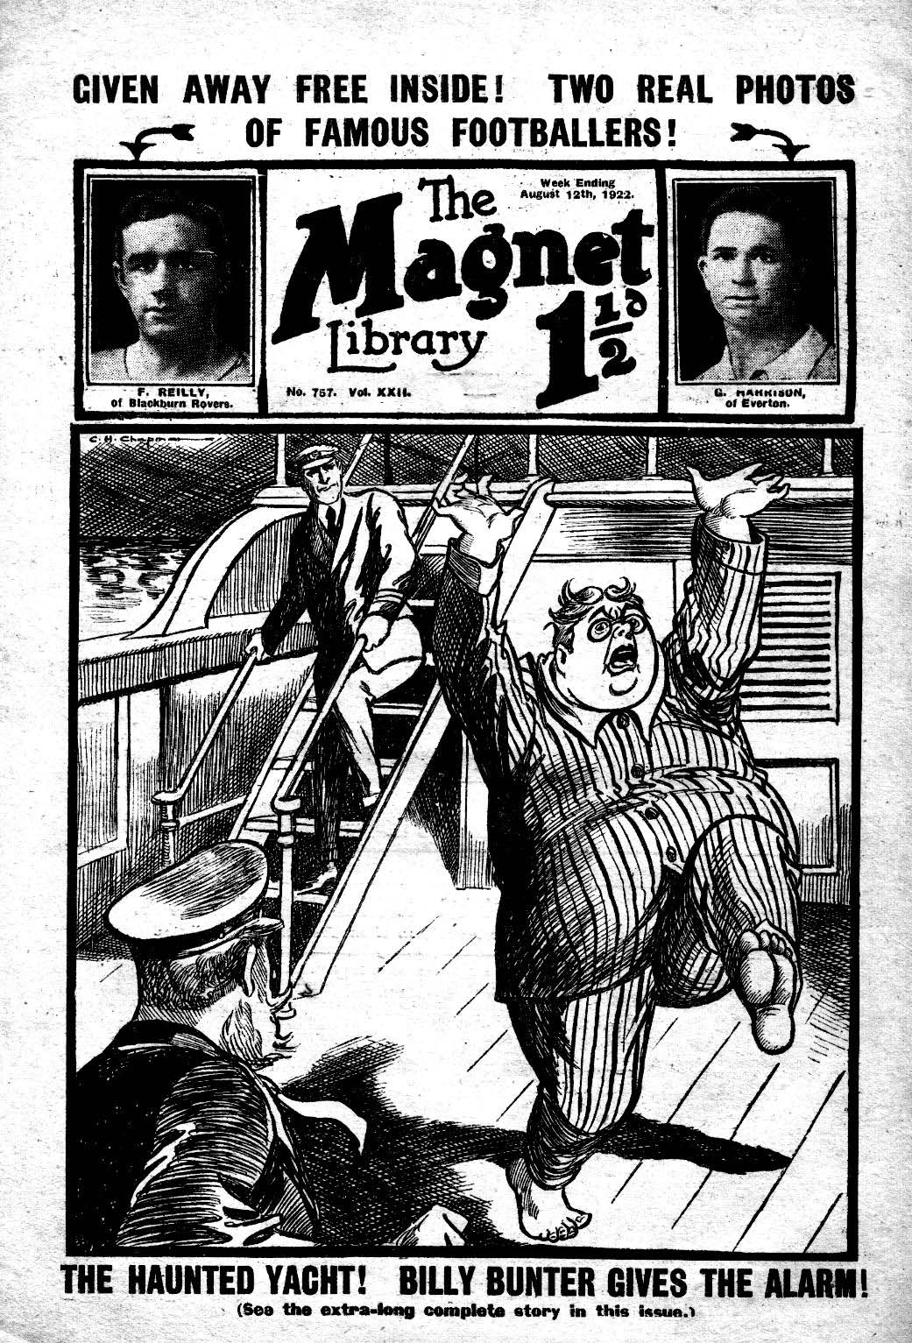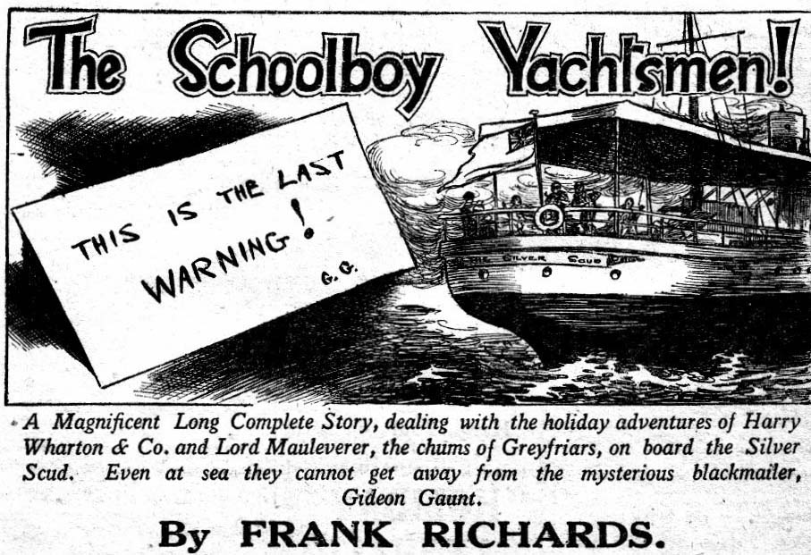
THE FIRST CHAPTER.
A Sudden Alarm!
BOB CHERRY’S powerful voice rendered the following the version of an ancient song in stentorian tones which sounded from stern to stern of the yacht Silver Scud.
“A life on the ocean wave,
A home on the rolling deep!
Where we don’t have to behave,
And Mauly goes to sleep!”
Bob was in great spirits.
When Bob Cherry was in great spirits the fact was generally noticeable and audible.
Lord Mauleverer, taking his ease in a canvas deck-chair, with his elegant legs stretched out, and his hands behind his sleepy head, his Panama hat tilted over his nose, smiled drowsily.
It was a hot summer’s day. There was a blaze of sun on the sea and on the white decks.
Harry Wharton & Co. were taking it easy, with the exception of Bob. Bob was naturally too strenuous to take things easy.
Wharton and Nugent and Johnny Bull leaned in a row on the deck-rail. Hurree Jamset Ram Singh, his dusky face full of lazy delight, fairly basked in the sun, which reminded him of home. It was almost warm enough even for the dusky nabob.
The steam-yacht pulsed her way through the sunlit sea under an almost cloudless sky.
The chums of Greyfriars were enjoying their holiday. By general consent, it was ripping, and Mauly was no end of a brick to have brought them on his yacht. Mauly’s guardian- Sir Reginald Brooke, pacing the deck with slow and sedate pace, glanced sometimes at the happy group of schoolboys and smiled. The old baronet liked to see happy youthful faces round him.
Harry Wharton & Co. agreed that a yachting trip on the vacation was just “it”—that Mauly was a brick, and that everything was ripping, and that it was simply lovely that Billy Bunter wasn’t there. That, indeed, was the best of all!
“Wake up, Mauly!” said Bob Cherry. “Like me to give you a shake, and liven you up a little?”
His lordship winced.
“Begad! No, please ! I’m not dozin’. Pretty hard for a fellow to doze when you’re tootin’ that megaphone.”
“Eh? I haven’t any megaphone.” said Bob.
“ Oh, gad! Was it just your voice?” asked Mauleverer.
“ Why, you silly ass—” began Bob, while his comrades chuckled.
“The esteemed voice is terrific.” remarked Hurree Jamset Ram Singh. “It beats the honourable megaphone hollow!”
“You fellows mustn’t slack just because we’re on a holiday.” said Bob Cherry. “Where’s young Vivian? We’re all here excepting Vivian. Hasn’t he turned up yet?”
“He was seasick last night.” said Harry Wharton. “I think he’s taking an extra spell in bed.”
“Poor old Jinmy!” said Lord Mauleverer. “He hasn’t got his sea-legs yet. Awful fag to be seasick. I told them not to disturb him this mornin’. He wants a rest. Nothin’ like restin’ thoroughly.”
“You can have too much of a good thing.” said Bob. “He’s missed brekker,”
“I fancy he won’t want any brekker.” said Harry Wharton. “He was looking yellow and green when he turned in. But it won’t do him any good slacking in his bunk.”
“I’m goin’ to give him a look-in.” said Lord Mauleverer, with a deep yawn, “after I’ve rested a bit.”
“Do you think you’re equal to it?” asked Bob Cherry, with sarcasm. “ You’d have to walk as far the companion, you know, and go down the stars; and that isn’t all. You’d have to come up again ! You must take care of your health, Mauly!”
The slacker of Greyfriars grinned feebly.
“I’ll give him a look in, if he’s not up yet.” said Bob. “Don’t you over-exert yourself, old man.”
“ Don’t wake him if he’s asleep.” said Mauleverer. “Sleepin’ is a good thing when you feel queer, and I’m afraid poor old Jimmy’s queer.”
“I’ll whisper in at his door as soft as a cooing dove.” assured Bob, as he detached himself from the group.
“ As soft as a cooin’ elephant, more likely!“ yawned Lord Mauleverer.
Bob Cherry went down the companion. He was too full of energy that sunny morning to keep still, if he could help it. In the saloon below he found Mr. Poynings, the mate of the Silver Scud. The young man gave him a nod and a cheery good-morning.
“ You seem in great spirits this morning, Master Cherry.” he remarked.
“Tiptop!” said Bob. “Seen anything of young Vivian?”
“Sir James Vivian? I think he’s still in bed.” said the mate. “ Lord Mauleverer told the steward not to disturb him, I think.”
“Time he was disturbed.” said Bob cheerily. “ Slacking in bed never did anybody any good.”
He tramped along to the door of Sir Jimmy’s state-room, already having forgotten that he was to approach Vivian’s quarters as softly as a cooing dove.
Bang!
Bob Cherry’s knock on the door was heard by the fellows on the deck above, and they grinned.
There was no answer from the room.
“Hallo, hallo, hallo!” called out Bob cherry as he slid back the door. “Are you
awake, Vivian?”
“Oh, gad!” murmured Lord Mauleverer above. “If that’s Bob’s variety of a cooin’ dove, I hope I shall never hear him understudyin’ a screamin’ eagle!”
“Ha, ha, ha!”
“Hallo, hallo, hallo!” roared Bob again. “Still snoozing, Vivian?”
If Sir Jimmy Vivian, of the Greyfriars Remove, was still snoozing after that stentorian hail, he had snoozing powers that exceeded those of Billy Bunter himself.
But there came no reply.
“He must have got up and cleared.” grunted Bob Cherry, but he stepped into the state-room to make sure.
Then his face became grave.
There was an occupant in the bunk; he could see that. But surely Sir Jimmy Vivian could not be asleep, after that powerful hail from the door. Jimmy had looked very queer the evening before, owing to the lack of sea-legs. The schoolboy baronet had not yet begun to enjoy his sea-trip. The thought occurred to Bob that the little fellow was really ill, and his manner became subdued at once.
He stepped quietly to the bunk and bent over Vivian.
“Jimmy, old kid.” he said, softly enough.
There was no a answer from Sir Jimmy Vivian.
But the face that was turned up from the pillow was white, set, seemingly lifeless. The eyes were closed, and the boy seemed hardly to breathe. Bob Cherry gave a violent start. It was not sleep. Sir jimmy was deeply unconscious; but it was not healthy sleep, that was clear.
What had happened to him?
In about two seconds Bob Cherry was out of the cabin, and his head rose into the sunlight at the top of the companion.
“You fellows—”
“What’s up?” exclaimed Harry Wharton, startled by the expression on Bob’s face.
“Something’s happened. Vivian’s ill. It looks serious!” panted Bob. “He’s insensible!”
“My hat!”
“There’s a smell in the cabin like chloroform.” faltered Bob. “Like--like when Manly was attacked by that ruffian at Greyfriar on breaking-up day.”
“Oh, gad!” exclaimed Lord Mauleverer
.
He leaped from the deck-chair as if electrified into action.
Sir Reginald Brooke pulled Bob Cherry aside hurriedly, and descended the stairs. Mr. Poynings met him at the foot of the companion with a startled face.
“There’s something wrong with Vivian, sir. I’ve just looked———”
Sir Reginald Brooke nodded and hurried on to the, state-room, his kind old face was alnost contracted with anxiety—anxiety with which fear was mingled. On board the Silver Scud, with
the blue sea rolling round them, the Greyfriars party had almost forgotten the mysterious foe who had dogged Lord Mauleverer on shore, who had threatened that even at sea Mauleverer would not be beyond his reach. It seemed impossible that here, on the wide sea, with land out of sight, the blow had fallen.
And yet---yet as he stepped into the state- room and saw the set, colourless face that stared from the bunk, the old baronet knew that the blow had fallen.
THE SECOND CHAPTER.
The Unseen Hand!
HARRY WHARTON & C0. gathered in the saloon with grave and serious faces, speaking in hushed tones.
They were waiting.
The brightness of that sunny morning ‘was gone for the chums of Greyfriars; their only feeling now was a fearful anxiety for Jimmy Vivian. Lord Mauleverer—every trace of slackness gone from him now—moved about restlessly, clenching his hands, wrinkling his brows, a prey to deep and torturing anxiety.—
Captain Hawke had come down, Mr. Poynings taking his place on the bridge. The captain and Sir Reginald were in Vivian’s room, tending him. For the present the juniors were excluded.
The chums of the Remove, looking at one another, read in each other’s faces the fear and alarm that were in every heart.
“Poor old Jimmy!” said Frank Nugent softly.
“Oh, the rotter—the rotter!” muttered Lord Mauleverer. He was alluding to Jimmy Vivian’s unknown assailant, for it was certain now that there had been an assailant. It was known Sit’ Jimmy Vivian was under the influence of choloroform, and it was clear that be had been attacked in his bunk during the night.
By whose hand?
That was a mystery—a mystery that baffled all speculation.
“It couldn’t be the same man.” said Bob Cherry in a low voice. “How could it be? It’s impossible!”
“Impossible!” agreed Harry Wharton. But who————”
Lord Mauleverer glanced at the Famous Five with a haggard look.
“It’s the same man.” he said. “The man who called himself Gideon Gaunt; the man with the black beard and the misshapen nose. I’m sure of it!”
“But how could he get on board the yacht last night?” exclaimed Johnny Bull. “We were miles from land.”
“I don’t know. How did he get at me at Mauleverer Towers?” said Mauly between his teeth. “The house was locked up. There was no sign anywhere of an entrance being forced. But he got at me in the night, all the same, and treated me as he’s treated Vivian now.”
“But it’s impossible!” said Bob. “He couldn’t—“
“ He has!” said Lord Mauleverer.
“ Then he must have been hiding on the yacht ever since we left Southhampton reahed ” said Harry Wharton.
“That’s so, I suppose.”
“Then he must be on board now!” exclaimed Bob.
“He must.” said Lord Mauleverer.
“Unless he jumped into the sea he must be on the yacht still.” The schoolboy earl clenched his hands. “ After Jimmy’s been seen to he shall be searched for. And when I get face to face with
him—” he gritted his teeth.
“We’ll make him sorry for himself if we find him,” said Bob Cherry. “But—”
He shook his head.
Unless the blackmailer was a mad-man, he would not have shut himself up in the yacht, from which there was no escape. Bob could not help feeling that. And the black-bearded man’s actions had not been those of a madman, but of a particularly cool and determined criminal.
The mystery was utterly baffling. Indeed, it almost led the juniors to wonder whether Lord Mauleverer’s enemy possessed some strange and supernatural powers beyond their comprehension. There was no man on the yacht who was not well known to Captain Hawke and Mr. Poynings. They were not likely to have included any doubtful characters among the crew. Besides the appearance of Gideon Gaunt with his great misshapen nose, was so striking that he would have been known at a glance anywhere. Certainly the juniors would have noticed him at once among the crew. And the idea of a stowaway was unconvincing; for if Gaunt had stowed himself away on the yacht he must have known that a rigid search would follow his attack on a member of the yachting party, a search that could only result in his discovery.
Yet if that was not the explanation of the mystery, what was the explanation? The Greyfriars juniors were utterly at a loss.
Sir Reginald Brooke came back to the saloon at last, and Harry Wharton & Co. looked at him eagerly. The old baronet’s face was pale and troubled and worn.
“How’s Jimmy, uncle ?” asked Mauleverer eagerly.
“He has recovered consciousness!” said the baronet. “But he will not be able to leave his bed. The same attack that was made upon you, Herbert, has been made on him. But poor Jimmy has not your stamina, and he has not stood it so well. He will be ill, I fear, and it will be necessary for him to go ashore.”
The juniors realised now that the course had already been changed.
They had hardly noticed it before.
“But has be spoken, sir?” asked Harry Wharton eagerly. “Has he told you—”
”The old baronet nodded.
“Yes. He was awakened in the night by an attack. A chloroform pad was pressed over his nose and mouth, exactly as happened to Herbert at the Towers before we sailed.”
“Did he see—”
“ He saw enough.” said Sir Reginald gravely. “ He has told me that the man who attacked him had a black beard and a large, misshapen nose.”
“Gideon Gaunt!” said Bob Cherry.
“Yes. The man made no attempt to keep his face hidden. He turned on an electric torch, and Jimmy saw him only for a moment, but quite clearly.” said Sir Reginald.
“Good gad!” muttered Lord Mauleverer
“But if there was any doubt, this note removes it,” said the old baronet, laying a card on the table.
The juniors gathered round and looked at it eagerly. A message was typewritten on the card. That it had been written before the Silver Scud put to sea was clear, for there was no typewriter on board the yacht. What had happened had been planned before the Silver Scud weighed anchor, and carried out with deadly precision. The note ran ;
“Twice I have warmed Lord Mauleverer that the price of his life was £10,000. The warnings have not been heeded. This is the third warning. If Lord Mauleverer does not value his own life, perhaps he values those of his friends. What has happened now will happen again if this warning is not heeded.
“If it is decided to pay the ransom, let the white ensign be flown half-mast for ten minutes on board the Silver Scud. —GIDEON GAUNT.”
“That was written before we put to sea.” said the old gentleman. “It is a proof that the villain hid himself on board the yacht to carry out this dastardly action. He must be still on board. The captain is about to order a search of the yacht. The rascal must be found, and he will be put in irons and taken ashore at once.’
“You think he is on board sir?” asked Harry.
“There is no alternative to that. He must be!”
Harry did not answer, but he doubted. It seemed impossible that the ruffian was on board after what had happened. And yet, was he mad enough to place himself within reach of easy capture-—capture easy and certain?
“He couldn’t have swum ashore.” said Bob Cherry slowly. “We’ere too far off the land.”
“Unless he was a jolly good swimmer, anyhow.” said Nugent.
“That is scarcely possible.” said Sir Reginald. “it is fairly certain the man is still on board. though where he is concealed is at present a mystery.”
Mr. Poynings looked in from the companion-way.
“The search is beginning, sir!” he said.
“Very good. Two of you boys may sit in the cabin with Jimmy.” said the old baronet. ”Do not let him talk much, and fasten the door in case the rascal we are searching for should appear. Jimmy must not have another shock.”
Lord Mauleverer and Frank Nugent went into Jimmy’s room. The rest of the juniors intended to help the crew in the search now commencing. Harry Wharton and Bob Cherry, Johnny Bull and Hurree Jamset Ram Singh, joined in it eagerly and keenly---though in their minds was a lingering doubt of the possibility of success.
THE THIRD CHAPTER.
A Baffling Mystery!

AHEAD of the Silver Scud, now steaming rapidly, the North Foreland rose against the horizon. While the yacht headed steadily for land, the search for the hidden ruffian began and went on. steadily, thoroughly, patiently.
The whole crew had been piped to the task, and while Captain Hawke remained on the bridge, the mate, Poynings, took charge of the search. The chums of the Remove helped actively, and even the old baronet joined in. The searchers had strict instructions to seize the rascal as soon as he was found, and not to hesitate to damage him if he showed the slightest sign of resistance. Some of the sailormen had bars or boat-stretchers ready for use; the juniors, who had their cricket outfits with them, had taken cricket-stumps in hand.
They searched thoroughly and scientifically from end to end of the Silver Scud. The engineer and his dusky assistants searched their own quarters, though there was little chance of a stowaway being hidden there. The cook’s galley and the lazarette, every cabin and state-room were searched and scanned. Deep down in the hold the seamen and Mr. Poynings ransacked and peered, electric lamps blazing into every shadowy recess. The search was long and arduous.
To most of the searchers it seemed impossible that it should fail in unearthing Vivian’s unknown assailant.
Somewhere on the ship he must be, unless he had jumped overboard in the night and found a grave at the hollow of the North Sea. And that was a theory no one thought of entertaining. The cunning plotter had not plotted to throw away his own life. He was—he must be —on board the Silver Scud; and all through the protracted search they hoped to lay hands on him.
But it was not to be.
If there was any neglected recess where they had forgotten to look, they could not call it to mind. So far as the searchers could tell when they compared notes, they had scanned every nook and cranny of the ship.
And the result was—nothing!
There was no stranger on board the Silver Scud—that seemed to be indubitable fact, astounding as it was.
Mr. Poynings gave it up at last, and returned to the bridge to report the result to Captain Hawke. The skipper gnawed his old grey moustache as he listened. Sir Reginald Brooke joined them, with deep anxiety in his lined face.
“It beats me, sir.” said the skipper. “The man was on board last night. That’s certain. But now—”
“The search seems to have been thorough enough.” said the old baronet despondently.
“I can answer for that.” said Edgar Poynings.
The old gentleman bit his lip.
“Did the villain trust himself to the sea, then, after the attack on Vivian?” he said. “Was there a chance of his reaching the shore by swimming, captain Hawke?”
“A thin chance for a good swimmer.” said the skipper. “ A hundred to one against, I should say.”
“ There seens no other explanation.”
“Ay, ay! But” ---Captain Hawke wrinkled his brows “ you’ve got it in the note from the 1ubber—if you agree to pay the money he demands, fly the white ensign half mast. That means that he would see the signal, if the man’s sane and means anything. How would he see it ashore ?”
“Perhaps he made guess that we should put ashore to get medical aid for Vivian---”
“He couldn’t guess where we should put ashore.”
“That is true. I am utterly mystified.”
The old baronet glanced around him helplessly. He seemed to feel himself involved in a network of baffling mystery.
“Another vessel---“ he hazarded. “Could he have another vessel at hand? He might have swum to it and might now be watching this yacht with a powerful glass——”
The captain shook his head. It was a wild guess, obviously improbable.
There were several sails in sight on the wide waters—a barge hugging the coast, a pleasure-boat bound for Margate or Ransgate—a big steamer far out to sea. There was no vessel that had the remotest appearance of dogging the Silver Scud.
“We changed our course more than an hour ago, to make the land.” said Captain Hawke quietly. “No other vessel in sight changed its course to follow.”
“That seems to settle it, sir!” remarked Poynings.
“It does settle it,” said the skipper.
The old baronet nodded slowly.
“Then what does it all mean?” he asked heavily.
“The man must have got overboard in the night.” said Captain Hawke. “He may have had a craft handy to pick him up.”
“But the signal—the white ensign—if we agree—”
The skipper shook his grizzled head.
“I’m beaten!” he said. “ There’s no working it out. But it seems clear enough that the man isn’t on board. If he isn’t on board, he must have gone over the side in the night.”
“1—I suppse so.”
Harry Wharton & Co., as utterly puzzled and mystified as anyone else on board the Silver Scud, went below to see the invalid. They were tired and dusty from grubbing industriously in hidden corners and recesses, and angry with their failure.
Nugent let them in to the state room.
“How’s Jimmy?” asked Harry.
“Better. He’s taking some grub.”
“Oh, good !“
Sir Jimmy Vivian gave the junior’s a feeble grin. He was sitting up in his bunk, and his face was still pale, almost ghastly. The terrible experience he had been through had told on the schoolboy baronet. He had not the vigour and stamina of the other juniors, and it was clear that his fearful experience had left a deep effect.
“Feeling chippy—what ?” asked Johnny Bull.
“I ain’t!” said Sir Jimmy frankly. “I’m feeling pretty rotten, if you ask me. What with being seasick and then— then that—.——” His voice faltered.
“Better not think about it, kid.” said Lord Mauleverer softIy.
“Can’t help it,” said Sir Jimmy. “My word! I can still feel that brute’s fingers on my throat! I’ll dream of it tonight, I fancy. I—I feel awful bad.”
Sir Jimmy took a spoonful of broth. But it was evident that he had no appetite; he was trying to please the anxious Mauly. Plucky as the little fellow was, it was only too plain that he had been quite knocked out by the fearful experience of the night, and the lingering effects of the drug.
“You ain’t found him?” he asked suddenly. —
“He’s not on the ship.” said Bob.
“Must have jumped overboard, then.” said Sir Jimmy. “well, I shan’t be sorry if he’s gone to the bottom.”
“No such luck, I’m afraid.” said Bob, “By Jove! I’d like to have the villain in reach of my fist! You’re quite sure it was the merchant with the big boko, Jimmy?”
Sir Jimmy nodded.
“Quite sure! I saw the light on his face. I sha’n’t forget that ugly face in a hurry.”
“Is it possible—” began Lord Mauleverer, coming out of a deep brown study.
“Is what possible, Mauly?”
“I can’t imagine that the rotter’s jumped overboard. If he’s not hidden on the ship, is it possiblc——” Mauly paused. “He might have disguised himself somehow, and got among the crew by some trick. Made up to look different, you know.”
“How could he?” said Harry. “He might shave off his beard, but how could he disguise his nose? You remember his nose—”
“Yaas, I’d forgotten that.” said Mauleverer despondently. “He might disguise the rest, but he couldn’t disguise that.”
“The nosefulness was too terrific to be hidden.” remarked Hurree Singh, with a shake of his dusky head.
“We’re getting to land now.” said Bob Cherry, glancing out of the porthole. “That’s the North Foreland away to the left. The skipper must be going to put in at Margate or Westgate, I think”
“Margate,” said Jimmy, with a faint smile. “Guardian told me. I’m to go ashore at Margate. I’m sorry I shan’t be able to calm on the cruise, Mauly, old man but—but I sha’n’t be sorry to get ashore. I—I don’t think I could close my eyes again on the Silver Scud. I—I should think—” He broke off, with a quiver in his voice.
Mauleverer nodded.
“We shall miss you, old kid.” he said.“But it’s better for you to be where you’re safe.”
“Safe enough here now the man’s gone overboard!” said Johnny Bull.
Lord Mauleverer did not reply to that. But Jimmy spoke his lordship’s unuttered thought.
“Has he gone overboard?” he asked.
“It seems beyond a doubt.” said Wharton. “Certainly he is not on the ship now!”
“He ain’t an ordinary man,” said Sir Jimmy slowly. “Look at the way he got at Mauly at home! Every door locked and barred, but he got into the room. Now he’s got at me here! It’s uncanny! He’s got some his own—” He broke off, shuddering.
“The anchor’s going!” said Bob.
“I shall have to help you dress now, Jimmy.” said Lord Mauleverer gently.
“Sooner the quicker, Mauly,” said Sir Jimmy. “I hate to leave you fellows and give up the cruise, but I do want to put my foot ashore- safe, I do! I ain’t a funk, but I couldn’t stand another night on the Silver Scud.”
Harry Wharton & Co. left the stateroom with troubled minds. An hour later Sir Jimmy Vivian was at home with his guardian, and the juniors were landed also, the old baronet judiciously deciding that a few hours in Margate would dispel from their minds the impression — of what had happened in the night.
— — —
THE FOURTH CHAPTER
In Merry Margate!
“JOLLY enough here!” said Bob Cherry.
“Looks like it!” agreed Harry Wharton. And Hurree Jamset Ram Singh remarked that Margate was terrifically jolly.
The chums of Greyfriars had lunched at a restaurant looking on the sea and now they were strolling in a cheery crowd along the Margate front. The sands swarmed with bathers, the promenade swarmed still more thickly, thousands on thousands were coming and going, the buzz of cheerful voices mingled with the blare of more than one band, discoursing sweet music to the sauntering thousands.
Harry Wharton & Co. were recovering their spirits, dashed for the time by their concern for little Sir Jimmy.
Vivian had been taken in a car at once to a nursing home in Cliftonville, kept by an old acquaintance of his guardian’s. There he was to remain, with every care and comfort, till his health was quite restored. It was only a matter of time before he would recover from the shock he had received; but in the meantime he required careful attention, and, above all, the assurance of safety and ease of mind. And it had been evident that, in spite of the rigorous search made on the yacht, Sir Jimmy had been by no means satisfied that the Silver Scud was free of the black-bearded man.
Indeed, the Co. were by no means satisfied of that. Every theory that was started to account for the ruffian’s disappearance from the yacht was more or less unsatisfactory.
After pondering’ over the mystery till their heads almost ached, the chums of Greyfriars had to admit that it was still a mystery to them, that they could think of no certain clue.
But schoolboys’ spirits are elastic, especially in holiday time. Satisfied that Sir Jimmy was well cared for and in comfortable surroundings, where he felt secure and at his case, the chums of Greyfriars ceased to worry.
As for any danger that might threaten themselves on board the Silver Scud, they did not give it a thought.
Only Lord Mauleverer remained in a thoughtful mood.
He had a problem to face.
The unknown blackmailer, calling himself Gideon Gaunt, had demanded a ransom of ten thousand pounds. Neither Mauly nor his guardian dreamed of yielding to his lawless demand. On his own account Mauly would not have entertained for a moment the thought of yielding. Twice he had been attacked by the ruffian, and his firmness had not been shaken. But now the attack had fallen upon another, upon the member of the party least able to bear it.
But for the fact that Sir Jimmy was now in well-watched security on shore Mauleverer would have debated whether br not he should have yielded to the blackmailers demand. What he would not havc done on his own account he might have done for the sake of another.
Upon that it was pretty clear the black-bearded man had calculated.
Sir Jimmy was safe now, even if the ruffian had some mysterious means of access to the yacht, or some remote and well-concealed hiding-place on board. That was a comfort to Mauleverer. But was it likely that the blow would fall next upon some other of his comrades? And what if the ruffian, finding it impossible to strike terror as he undoubtedly designed, what if he proceeded to greater length, even to the length of taking life? That he was dastard enough Mauleverer did not doubt for a moment.
And yet, how could he get at the party at sea? Was it possible, unless he had some strange, superhuman power beyond the powers of normal men?
Such thoughts in Mauleverer’s mind kept a cloud upon his brow, though he smiled and answered cheerily when his comrades spoke to him. As for the Famous Five, they had thrown the worry aside, and were quite their old merry selves as they strolled along the front at Margate.
Finding themselves in Margate they proceeded to “do” Margate with considerable thoroughness, and Lord Mauleverer went wherever his comrades went.
They “did” a concert on the pier for half an hour, they looked in at a cinema for a quarter of an hour, they strolled on the front, and a they listened to the band, and they bathed. With such energetic youths that was not nearly sufficient to fill the afternoon and they had plenty of time before them, as Mauly’s guardian was not going on board the yacht again till sundown, and they were to go with him. Bob Cherry made the discovery that there was a jolly place where there were scenic railways and swing-boats and even a coconut shy, and thitherward the chums of Greyfriars bent their step.
They “did” the scenic railway twice, though it’s a sudden up and downs made Lord Mauleverer gasp. They swung their swing-boats higher than any other swing-boat,and they tried their luck with all sorts of contrivances for bagging prizes—or missing them. The way their money went was really marvellous, though only in threepences and sixpences and shillings at a time. And when they came to the coconut-shy Lord Mauleverer innocently tendered a five-pound note to the coconut merchant for change. The coconut merchant blinked at him.
“Fathead!” remarked Bob Cherry. “Put that away! I’ve found another half-crown. Hand ‘em out, old top!”
The “old top” handed out the wooden balls to the value of half-a-crown. There was a grin on Bob Cherry’s face. He intended to surprise the merchant in coconuts, a rather stumpy gentleman, with a red-spotted neckerchief and a blue chin, and perspiring features apparently modelled on those of a bulldog.
“This is you’re stunt, Inky.” said Bob. “Go in and show them some Greyfriars bowling.
Hurree Jamset Ram Singh smiled. He was the champion junior bowler at Greyfriars, and though the wooden balls were rather different fron cricket-balls, the nabob knew that he could surprise the bulldog merchant with the results.
“The bowlfullness will be terrific, my esteemed Bob!” said the Nabob of Bhanipur.
“Go it, Inky!” encouraged the juniors.
The dusky nabob went it.
He sent down the heavy balls coolly. Scientifically, and with wonderful precision. Each ball knocked down a coconut, and the red-spotted gentleman opened his eyes wider and wider. Hi assistant was kept quite busy setting up new coconuts, and the pile of captured nuts grew quite large.
“‘Ere, this ‘ere won’t do!” said the red-spotted gentleman at last, after some very visible signs of impatience. “You must be a blooming perfessional!”
The nabob beamed on him.
“My most esteemed and ridiculous friend—” he began.
“ Wot!”
“My esteemed and excellent friend, you may keep the coconuts.” said Inky amiably. “This is only a harmless and necessary lark.”
The redspotted man’s bulldog features cleared at once. He grinned the grin of amiability.
“Go a’ead, your ‘Ighness, and keep it up as long as you like.” he said heartily.
‘Ere, you coves, keep back, and leave room for the Injun gentlemen!”
Hurree Jamset Ram Singh grinned.
He continued to send down the balls with marvellous skill, and at every ball a coconut fell, and a crowd gathered round to watch that rather, unusual exhibition. The red spotted gentleman was quite entertained by his customer’s success. As every shot was paid for, and the coconuts were not to change owners, it was quite a pea in proposition for the gentleman in the red neckerchief besides being an advertisement for his show show, and drawing beholders from near and far.
“Bravo, darky!” said several encouraging voices.
And then, to the astonishment of the chums of Greyfriars, a well-known voice squeaked:
“Good old Inky! Topping! I say, you fellows, fancy meeting you hear!”
And six astonished juniors ejaculated:
“Bunter!”
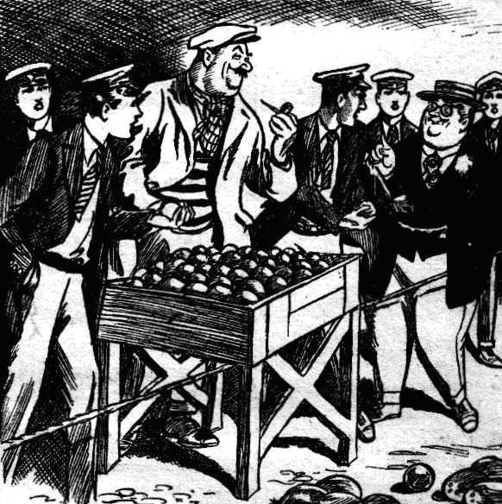
THE FIFTH CHAPTER.
Bunter’s Treat!
BILLY BUNTER rolled up t the chums of the Remove, his fat face beamed with satisfaction, blinking cheerily at them through his big spectacles. Evidently the owl of Greyfriarx was delighted with the unexpected meeting—a delight which was not shared by Harry Wharton & Co. They stared quite blankly at the fat junior.
“I say, you fellows——”
“ Bunter!” exclaimed Bob Cherry.
“Bunter!” groaned Lord Mauleverer.
“The ridiculous and disgusting Bunter!” exclaimed Hurree Singh, and he stopped his wonderful exhibition of bowling at once.
Dismay was in his dusky countenance.
“Fancy meeting you!” said Bunter, with a fat chuckle. “I say, you felIows, go ahead! I’ll carry the coconuts for you. I say, what are you up to? Don’t hurry away! Beasts!”
Harry Wharton & Co. were en route at a good pace. But the crowd was thick, and they could not run for it.
Billy Bunter rolled in hurried pursuit.
“I say, you fellows, hold on!” he roared. “Ain’t you glad to see a Greyfriars chap again? Hold on, Mauly, old bird! Is this what you call manners?”
“Oh, gad!” groaned his lordship.
He weakly allowed Bunter to join him. Mauly hated hurting anybody’s feelings, even Bunter’s. Not that it was easy to get through the thick skin of William George Bunter. A rhinoceros was considerably more sensitive.
“I say, you fellows, you can get jolly good ices here.” said Bunter, catching Mauleverer’s arm and stopping, and dragging his lordship to a halt. “My treat, you know! Come in!”
“Look here—” began Bob Cherry.
“Dash it all, let’s have a little talk, now we’ve met!” said Bunter. “I’m rather surprised at you, Cherry! You oughtn’t to keep up your usual bad manners on a holiday. All very well in the Remove passage at Greyfriars.”
“You fat owl—”
“Simply topping ices here.” said Bunter. “Sit down at this table, and have some ices and watch the crowd. No end amusing! Awful lot of bounders, here, you know.”
“And we’ve got landed with the biggest of them!” said Nugent.
“Oh, really, Franky—”
The Greyfriars chums sat down, and Bunter ordered the ices with a flourish. Evidently the Owl of the Remove was glad of the meeting. Bunter was looking in great form. He had a straw hat on the back of his head; a necktie with more colours in it than Joseph’s famous coat; a flower in his jacket; a prominent rolled gold watch-chain, and a diamond pin. The diamond was of tremendous size, but evidently it had not tempted the pickpockets; it was only too obviously not the product of a diamond-mine. Certainly, there were plenty of “bounder” as Bunter said, in the buzzing crowd, but undoubtedly the most thorough-going bounder there was William George Bunter, the Owl of the Remove.
“Isn’t this just luck?” he said, as he gobbled his ice. “Shouldn’t have dreamed of meeting you fellows here! Shouldn’t have seen you, nost likely, only I came up to see who was knocking down the coconuts in such style.”
Bob Cherry repented deeply of his playful joke on the coconut merchant.
“So you’re having your holiday in Margate, Bunter?” remarked Johnny Bull.
“Well, not exactly.” said Bunter. “ If you think I’ve come here on a cheap trip for the day, you’re quite mistaken. Blessed if I can see anything to cackle at, Bob Cherry! I’m staying in the most exclusive hotel in Cliftonville, you know. I’d ask you there to tea, only—”
“ Only you’re not staying there!” suggested Johnny Bull.
“Oh, really, Bull! I mean, I couldn’t very well take a crowd of young bounders into such a high-class establishment!”
“What?”
“ No offence, you know.” said Bunter, blinking at them. “I’m a plain speaker—always was. I’ll have another ice! They’re good. But fancy you fellows turning up in Margate, after all. Of course, I knew it was all spoof about the yachting trip!”
“By gad ‘ ejaculated Mauleverer.
Bunter gave a fat wink.
“Can’t take me in with your swank; you know.” he said sagely. “ Lots of fellows talk a lot of gas about the vac before school breaks up. Skinner was talking about Switzerland and the Tyrol, but I know jolly well that his people take him to Southend. I admit you Fellows almost took me in with that yarn about it yachting trip, but not quite! He, he, he!”
“You fat rotter!” growled Johnny Bull.
“No need to call a fellow names, Bull, because he doesn’t swallow your swank. Have another ice, Wharton?”
“No, thanks!”
“ Well, I will” said Bunter. “ I’ve had hardly a dozen to-day. Don’t you fellows worry. I won’t give you away at Greyfriars next term. He, he, he! Keep it up about the yachting trip, and I’ll back you up. Ho, ho!”
“Well, my hat!” said Bob Cherry. “Dear old Bunter doesn’t change, does he? Always makes you feel that you want to punch his silly nose when you see him!”
“Oh, really, Cherry——”
“That will be eight-and-six, please.” interposed a waiter at this point.
Bunter ran his hands through his pockets.
“By Jove! I’ve got nothing smaller than a ten-pound note!” he said. “Settle this, will you, Mauly, old top, and I’ll square when I change my tenner.”
Lord Mauleverer silently passed a five pound note to the waiter. It was Bunter’s treat; but nobody expected Bunter to pay for the refreshments.
“Time we got along,” said Bob Cherry, when Mauleverer had received his change.
“Oh, don’t hurry!” said Bunter. “I was just thinking whether I could take you fellows on board my friend’s yacht.”
“Oh! You’ve got a friend here with a yacht?” said Bob.
“Certainly. A relation really—one of my titled relations that I’ve mentioned to you” said Bunter calmly.
“Oh, my hat !”
“And where’s the giddy yacht?” asked Bob Cherry sarcastically. “Not where it can be seen, I suppose?”
“Certainly; it’s anchored about half a mile from the pier.” said Bunter calmly. “I can point it out to you, if you like——but I’m afraid, on the whole, that I sha’n’t be able to take you on board.”
The Famous Five looked at Bunter.
“What’s the yacht’s name?” asked Harry.
“Silver Scud!”
“Great Scott!”
“You’ve seen it there ?” asked Bunter. —
“ Ha, ha ! Yes.”
“It’s any second cousin’s yacht really.” said Bunter. “Sir Cecil Bunter’s you know—I think I’ve mentioned him to you.”
“Great gad!” murmured Lord Mauleverer, staring at Billy Bunter in a kind of fascination. Bunter evidently had no suspicion that the Greyfriars party had landed at Margate from a yacht—above above all from the Silver Scud. Even Bunter would not have laid claim to that handsome vessel, if he had known.
Bunter detached himself from his chair with a grunt.
“Come along to the pier, and I’ll point her out to you.” He said cheerily. I can’t take you on board, because—because—”
“ Because you wouldn’t be allowed on board!” suggested Bob.
“Oh, really, Cherry—”
“You fat chump!” said Harry Wharton, in measured tones. “That yacht, the Silver Scud, is Mauly’s yacht—”
“Eh?”
“And we landed from her a few hours ago—”
“Wha-a-at?”
“And we’re going aboard. again in an hour or two. Now, you fat spoofer, what have you got to say for yourself ?”
Billy Bunter had absolutely nothing to say for himself for a full minute. Even the Ananias of Greyfriars was taken aback. But at length he burst into a feeble giggle.
“He, he, he! Of—of course, I—I knew it was Mauly’s yacht all the time, you know—I--I was just pulling your leg! He, he, he!”
“And now I’ll pull yours!” said Bob Cherry grimly. And he hooked his foot in Bunter’s fat leg, and jerked him, and the Owl of the Remove sat down with a bump and a roar.
By the time the fat junior was on his feet again, the chums of Greyfriars had disappeared in the crowd.
THE SIXTH CHAPTER.

And Bunter!
THE setting sun was turning the estuary of the Thames into a sheet of gold and crimson, when’ did backspace Harry Wharton & Co. came down to the landing-place. The boat from the Silver Scud was there, with Poynings in charge; but Sir Reginald Brooke had not yet appeared. But some one else had appeared, and was waiting.
“Hallo, halo, hallo! Bunter!” exclammed Bob Cherry.
The fat junior greeted the Greyfriars party with a fat grin. They did not grin in response. They had been under the impression---evidently a mistaken one— that they had done with Bunter. They had kept a careful look-out for him during their final stroll about Margate, and they had not seen him.
“How the thump did you get here?” demanded Harry Wharton.
“Easy as falling off a form, old fellow.” said Bunter cheerily. “After you missed me in the crowd——”
“Dodged you, you mean.” said Johnny Bull.
“Hem! After you missed me—I’m not talking to you, Bull, but to any old pal, Mauly—after you missed me, Máuly, I remembered that you’d have to have a boat from the yacht, so I looked round, and spotted this boat when it came in. Rather cute, what?”
“Oh, very!” said Lord Mauleverer dismally.
“The fact is.” continued Bunter, “I’ve decided not to go back to my first-class hotel---”
“Oh, dear ”
“I’ve decided to accept Lord Mauleverer’s invitation to his yacht.”
“Great gad! Mine?”
“Yes, old chap,’ said Bunter affectionately.
His Lordship gave a groan by way of answer.
“I’ve spoken to that chap in the boat” said Bunter, with a nod towards the mate, Poynings. “He says old Brooke is ashore—“
“Are you speaking of my uncle, Bunter?” asked Lord Mauleverer, with unaccustomed sternness in his tone.
“Yes, Mauly---“
“Then you’ll speak of him more respectfully, unless you want to be soused in the water.” said Mauly.
“My dear old chap, of course I will,” said Bunter. “I mean Sir Reginald Brooke, of course. Now, I don’t mind waiting for old—I mean, for Sir Reginald. Where’s Jimmy Vivian? Didn’t he come ashore?”
“Yaas”
“He’s going back with us?”
“Us? ” repeated Lord Mauleverer.
“Us !“ assented Vunter firmly.
“He’s not going back,” said Mauleverer curtly. “He’s givin’ up the trip.”
Then I sha’n’t be putting you to any inconvenience in dropping in.” said Bunter brightly. “You can just give me Jimmy’s cabin. You’ll find me rather better company, what?”
Lord M.uleverer blinked at Bunter. It was settled in the fat junior’s mind that he was going to be one of the yachting party. He had been successfully eluded on breaking-up day at Greyfriars. But he did not mean to be eluded again, if he could help it.
“Shall we run him away by his neck, and kick him along the pier, Mauly?” asked Johnny Bull.
“N-n-no!”
“Anything to oblige.” said Bob. “If it was my party, Bunter would clear out on his neck sharp. But it’s yours, Mauly, and it’s for you to give the word. We’ll kick him out, bump him, or drown him, just as you prefer.”
“Oh, really, Cherry—”
Lord Mauleverer grinned feebly. The tall figure of Sir Reginald Brooke appeared in the offing, and Bunter coolly made a move towards the boat. Poynings brought it close in, ready for the
party to embark, and Billy Bunter cheerfully jumped in.
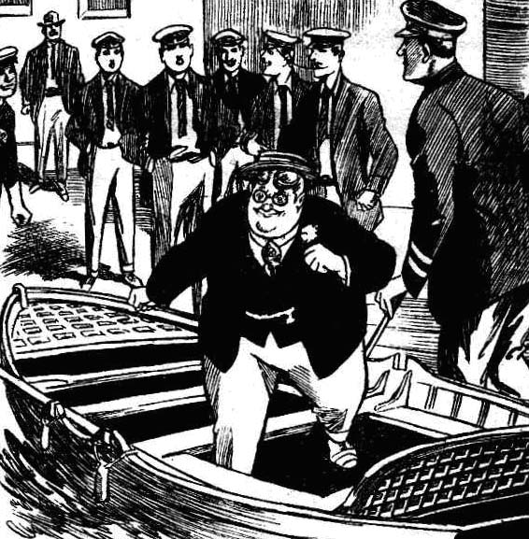
The juniors looked at Lord Mauleverer. It was not for Mauly’s guests to dictate to his lordship; and it was only too clear that Mauly’s easy-going facility was to be taken advantage of. Mauly simply couldn’t make up his noble mind to tell the seamen to toss Bunter out of the boat—and clearly less emphatic measures would not have dislodged Bunter. Before Mauly could make up his mind, the old baronet was on the spot.
“I fear I am a little late.” he said. “But---”
“Left Jimmy all right, uncle?” asked Mauleverer.
“Quite. He will be very comfortable and happy, I think.” said the old gentleman. “Now let us go on board.”
Sir Reginald did not observe Bunter until the party were seated in the boat and the seamen were pushing off. Then he glanced very curiously at the Owl of the Remove, whom he remembered having seen at Greyfriars.
“A friend of yours, Herbert?” he asked.
“ A—a—a Greyfriars chap, uncle.” said Mauleverer.
Bunter chimed in cheerily.
“So glad to see you again. sir! You remember me? Bunter, sir—William George Bunter. Mauly’s old school pal.”
“I think I remember you, Bunter.” said the old gentleman, not looking very much impressed or pleased.
“Mauly was kind enough to ask me to join his little party, sir.” rattled on Bunter. “ I wasn’t able to be in at the start---pressing engagement with some particular friends--- so I had to put it off till now. Meeting old Manly in Margate, he was so pressing—”
“Oh gad !”
“I couldn’t refuse,” said Bunter.
“Is Bunter coming on board the yacht, Herbert?” asked the old baronet in rather a stately way.
“ Looks like it, sir.” mumbled Mauleverer.
“But I was not aware—”
“If you have any objection, uncle---”began Mauleverer, brightening up.
To his disappointment, Sir Reginald shook his head.
“Not at all, Herbert. You know best which of your school friends you desire to have with you on your holiday.”
“Thank you, uncle,” said Lord Mauleverer feebly.
It was not till they were on board the Silver Scud that Lord Mauleverer spoke again, and then he addressed Bob Cherry.
“Kick me!” he said pathetically.
“Eh? What for?” asked Bob.
“I feel I deserve it.”
“ You do!” agreed Bob. “You deserve it— hard! I’ll give you a regular goal kick that will linger in your giddy memory and remind you not to let Bunter spoof you next time. Stand steady!”
Bob drew back a heavy boot, and Lord Mauleverer, evidently changing his mind, dodged. Bob chuckled, and followed him down the companion to supper. At supper the fat face of William George Bunter beamed over the festive board.
And Bunter did justice to the supper to an extent that it was fairly certain there would be serious trouble with the inner Bunter us soon as the yacht was in motion. In which case there was likely to be a plentiful lack of sympathy for the sufferer.
—
THE SEVENTH CHAPTER.
Plotting a Plot!
“THE cheeky worm!”
“The cheeky wormfulness is terrific!”
“ Bother him!” growled Harry Wharton.
It was on the following day, and the sun was sinking over a bright and curling sea. The schoolboy yachtsmen ought to have been looking like cheerfulness itself. But the addition of William George Bunter to the party had wrought a change.
The chums of the Remove agreed that to take notice of Bunter’s “ rot” was far beneath their dignity. They were the Famous Five, the great chiefs of the most important Form in the finest school in the wide world, and Billy Bunter was a fat worm and a silly owl and a nobody and nothing. Therefore Bunter oughtn’t to have had the power to exasperate them. Yet he did!
It really was annoying. Bunter had recovered from a spell of seasickness, and was his happy old self. Bunter had heard on all sides allusions to the mysterious apparition of the man with the misshapen nose, and he could no longer doubt that something had happened On board the yacht that eventful night. But the view Bunter took of what had happened was intensely exasperating.
Bunter’s view was that Sir Jimmy Vivian had had a nightmare which had frightened him, and that the other fellows had taken it seriously because they were nervy and funky.
That being Bunter’s considered view of the case, he did not trouble to keep it a secret. Rather he enjoyed impressing it upon the Greyfriars juniors at every opportunity, in season and out of season.
“Pity I wasn’t here then.” he remarked several times. “I’d have bucked you up! One cool, collected fellow can do wonders with a frightened crowd!”
Harry Wharton & Co. being the frightened crowd alluded to, they did not like Bunter’s view the very least little bit.
They agreed that it. was up to them to ignore the opinion of so very insignificant a personage as Bunter.
But Bunter was not an easy fellow to ignore.
Bunter, in fact, couldn’t be ignored. If he was ignored, he butted in, and whether fellows listened or not, Bunter had always plenty to say.
The rough and ready methods of the Remove passage at Greyfriars could not be applied on board the Silver Scud to any extent.
Under so many eyes, and as the guests of Lord Mauleverer and his grave and sedate uncle, the Famous Five felt that they couldn’t very well “ bump “ Bunter for his cheek, or duck him in the bath, or even give him a dozen with a cricket stump.
Bunter, too, would state his exasperating views in the presence of the elders—of Poynings, or the skipper, or the old baronet, when drastic measures were not to be thought of.
And having observed how excessively annoying his remarks were to the Co., the fat junior persisted in them and amplified them, and gave the topic no rest.
This was, perhaps, Bunter’s way of making himself agreeable. Bunter was convinced that he had a vein of caustic humour, and he gave that caustic vein plenty of exercise.
“The cheeky worm!” said Bob Cherry to his comrades on deck, Bunter being somewhere below just then, scouting for a meal between meals. “The fat, overfed, blubbery blighter calling us funks —us! When the miserable snail is frightened at a shadow himself! I almost wish that beast with the boko was still on board, and would give Bunter a turn!”
“Jolly glad he isn’t!” yawned Lord Mauleverer.
“The gladfulness is terrific!” remarked Hurree Jamset Ram Singh. “It is a delightful reflection that the esteemed villain must have gone to the excellent locker of Davy Jones. But a wheezy good idea has germinated in my brainbox, my esteemed chums.” A glimmer of fun came into the nabob’s dark eyes.
Suppose somebody dropped into the fat and disgusting Bunter’s cabin tonight?”
“Ah!” said Bob Cherry, catching on at once.
“Good!” said Nugent.
“Hear, hear!” chortled Johnny Bull. “Give the fat rotter a scare, and make him shut up.”
Harry Wharton laughed
“Not a bad idea.” he said. “What do you think, Mauly”
“Eh?” Lord Mauleverer started out of a doze. “Yes, certainly! I—I’ve heard all you fellows were saying.”
“Ha, ha, ha!”
“It’s as easy as falling off a form.” said Bob. “About midnight— that’s eight bells, you fellows ---”
“ Go hon!”
“Well, about eight bells one of us turns out and trots into Bunter’s room in the dark, and wakes the fat beast with a tap on the nose---”
“Oh, good!” said Mauleverer.
And says in an awful voice. ‘ Beware!” or something to that effect.”
“Ha, ha, ha!”
“Now, who’s going to do it?” asked Bob. “Not Mauly! He will he fast asleep. Too lacy to turn out!”
“N-n-not really.” protested Mauleverer. “I’d do it like—like a shot. But I can’t rag my guest, you know. Guests can rag one another. See?”
“Leave it to me.” Said Nugent. “I’ll tackle Bunter !”
“I don’t mind,” said Bob. “So long as the fat rotter is shut up somehow. Hallo, hallo, hallo! Here he comes!”
Billy Bunter rolled up, grinning, and joined the group.
“Feeling nervy now night’s coming on?” he asked.
There was no reply to that polite question. Billy Bunter indulged in a fat chuckle.
“I say, you fellows, you must have made the crew chortle at you, giving way to your nerves like that! Don’t you think so?”
“Oh, shut up!” growled Johnny Bull.
“Being rude isn’t an answer.” said Bunter. “The fact is, I’m rather ashamed of you fellows. What would the Remove chaps say at Greyfriars if they knew you’d all been frightened out of your wits by young Vivian having the nightmare?”
“We weren’t. frightened!” hssedi Bob.
“He, he, he!”
“Mauly, do you mind if I squashed that fat animal on your deck?” asked Bob Cherry.
“Any old thing!” yawned Mauleverer.
“Oh, really, Cherry——”
“Roll away, you fat blot on the seascape.”
“He, he. he! I can see you’re getting a bit nervy, now night’s coming on.” said Bunter. “Dash it all, if you’re frightened, I’ll let you sleep in my room, if you like, Bob. Then when you get scared in the night you can call out to me!”
Bob Cherry seemed to be choking.
“I know I shall slaughter him!” he gasped.
“He, he, he!”
Bob rose to his feet. He made a fierce grasp at the Owl of the Remove, and collared him. There was a roar from Bunter, as Bob tapped his head on the planks of the deck.
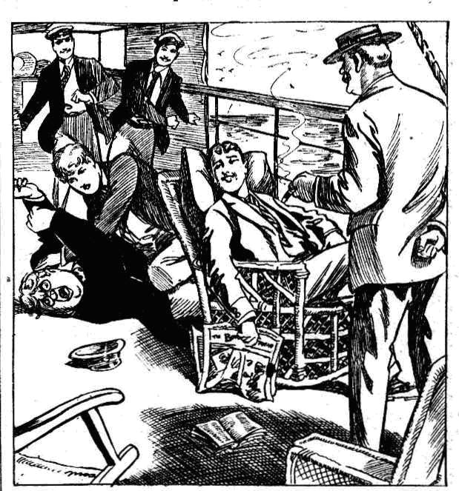
“Yarooooop !”
“Cherry!” said a mild but sightly rebuking voice. Sir Reginald Brooke hovered over the group.
“ Yaroooh ! Make hin leggo!” yelled Bunter.
“Oh, my hat!” gasped fob.
He released Bunter as if that exasperating youth had suddenly become red. hot. Bob’s face was crimson as he looked at the old baronet. Sir Reginald Brooke, with a faint expression of disapproval, passed the juniors, and stood leaning on he deck-rail, looking away towards distant England.
Bunter scrambled up, grinning, and dropped into Bob’s vacated chair.
“ You ought to mend your manners a bit, old chap.” he murmured. “ You’re not in the Remove passage now. Can’t you behave a little less like a bear when you’re in respectable society, old fellow? You ought to try.”
Bob Cherry did not answer. He was quite aware that the Owl of the remove was trying to provoke him into another outbreak, which would cause the old baronet to turn his head with a
disapproving look. Bob bore William George Bunter in silence, but with suppressed fury.
THE EIGHTH CHAPTER.
A Deed in the Dark!
HARRY WHARTON & CO. were in an anticipatory mood that evening, looking forward to the little jape that had been planned for the benefit of William George Bunter’
Billy Bunter went to bed in blissful ignorance of what was intended for him.
Wharton anid Nugent were playing chess when he went to bed, and the other fellows were watching the game; and Bunter paused by the table, not to say goodnight, but to indulge in what. he called his caustic vein of humour.
“Well, I’m off.” he said. “ If you follows get scared in the night you can call me.” .
“Fathead! Roll off! ” grunted Bob Cherry.
“If you have any nightmares, or see any giddy ghosts, you know.” chuckled Bunter. “I’ll come out and look after you! When you got frightened you need a cool, plucky fellow—”
“Buzz off !”
Bunter gave another fat chuckle, and rolled away. His snore was soon heard proceeding from the stateroom that had been Sir Jimmy’s.
The Co. went to bed soon afterwards. Sir Reginald Brooke did not approve of late hours for his youthful charges, and he expected them to keep near the usual school bed-time, which was half-paste-nine. So by ten o’clock the juniors were generally in bed, and the motion of the yacht on the North Sea did not disturb their healthy slumbers.
But on this especial night there was something “on”
Billy Bunter was to have his lesson, and it was arranged for Frank Nugent to turn out for the purpose.
It was at midnight that Nugent was to step across the alley-way to Bunter’s stateroom, and wake him up with a deep, deep voice, which was certain to throw him into a blue funk.
Nugent intended to turn out when the eight bells sounded; but, as a matter of fact, he did not wake promptly to time, as was only to be expected. But his task was on his mind, even as he slept, and he woke up soon afterwards. It was pitch dark in his room, and he groped for his watch, and turned on the light of a little electric torch to see the time.
“Quarter past twelve!” murmured Nugent, with a yawn. “ I suppose I’d better turn out.”
He rather wished he had left the task to Bob Cherry now. Turning out at midnight from his comfortable bunk was not attractive.
However, he was in for it, and he rolled out, and drew on his trousers and a loose jacket that was enough clothing for the purpose. The yacht was throbbing along on an even keel. The sea was calm, and the summer night fine, though dark.
Nugent slid back his door, and stepped out.
Somewhat to his surprise, the passage outside was in darkness. An electric light was generally kept turned on throughout the night. Nugent groped his way.
He knew which was Bunter’s room, and to reach it he had to pass Lord Mauleverer’s door.
He was a guided, in fact, by a deep and resonant snore that proceeded from Bunter’s quarters. The Owl of the Remove was evidently deep in slumber, and his snore was going strong.
A sudden slight sound made Nngent start, as he was groping along in almost impenetrable gloom.
His bare feet made no sound on the polished planks, and he was breathing ferry softly. The sound did not come from himself. But he heard—he was sure that he heard—a sound like the brushing of clothing against the bulkhead, and a low, hurried breathing.
The junior was startled.
Someone as well as himself was in the dark alley-way; and for a moment Frank Nugent felt a strange thrill.
Whoever it was, he was moving with stealthy caution, and, as Nugent could now guess, he had turned off the electric light for concealment.
But in a moment it flashed into the juniors mind that it was one of his comrades. As they had had no alarm from Beinter, and as it was past midnight, it was probable that one of them, awakening, had concluded that Nugent was still fast asleep, and had turned out to carry out the jape on Bunter.
As soon as Nugent thought of that, he felt certain of it, and he smiled in the darkness.
By a slight sound, and by a faint black shadow in the darkness, he made out that the other fellow was near Lord Mauleverer’s door, which Nugent was about to pass.
Nugent was about to whisper, when he heard the faint sound of a door sliding back.
It was Lord Mauleverer’s door; he knew that. Whoever it was that had taken his place for the jape was about to enter Mauly’s cabin by mistake for Bunter’s. So it appeared, at least.
Nugent made a quick step forward.
“Is that you, Bob?” he whispered.
He heard a quick, hurried, almost panting breath. Then there was dead silence.
“That’s the wrong cabin,” whispered Nugent, still under the impression that he was speaking to one of his comrades. “That’s Mauly’s cabin—”
He broke off with a startled gasp.
The figure in the doorway of the state-room—nothing but a black patch in the darkness to his eyes—moved rapidly, and a grip was laid on the junior.
Only that one startled gasp of the skipped Nugent.
Then the grip of cruel, ruthless fingers on his throat silenced him, and he was struggling feebly, ineffectually, in the. grasp of a powerful man.
A feeling of horror chilled the startled junior to his very heart.
It was not one of his comrades, he knew that now; it was a man’s grasp on him----a powerful grasp like an iron vice. He strove to cry out, but the grip on his throat was strangling him.
He struggled and kicked, trying to make some sound that would draw his comrades to the spot.
Close at hand—within a few yards of him—his chums were sleeping, any one of whom would have faced death to help him, and he could not call them—could not wake them. In the hideous grip of his unseen enemy he strolled hopelessly, while his comrades slept. Through it all there came still to his ears the steady snoring of Billy Bunter.
It was like a horrible dream to the junior.
Who was it—what was it—that had eluded him in the darkness—that had been interrupted in stealing into Lord Mauleverer’s cabin in the dead of night?
Even as his brain reeled and his senses swam under the strangling grip, Nugent realised who it was—who it must be—the man with a misshapen nose— the blackmailer, Gideon Gaunt—the dastard who had attacked Sir Jimmy Vivian! He knew it—he realised it. The man—if—man he was—was still on board the Silver Scud, and he had stolen from his lurking-place, wherever it was, for this! It was Nugent who was in his grip instead of his intended victim, Lord Mauleverer, for Nugent had interrupted and alarmed him as he was about to carry out his design on the schoolboy earl.
Nugent’s tongue clove to the roof of his mouth; his eyes seemed to be starting from their sockets. His struggles grew feebler.
Not for an instant did the grip on his throat relax.
The wretch, however he was, dared not let the junior utter a single cry. Overhead there was the sound of steadily pacing feet on the deck. Captain Hawke and four or five of the crew were within hearing of a single cry. Close at hand were the Greyfriars juniors, and at the end of the alley-way was the cabin of Edgar Poynings. One cry meant discovery for the ruffian.
Lights seemed to be dancing before Frank Nugent’s eyes. And then came sudden darkness.
He krew nothing more; but as his senses fled, in the strangling grip of the unseen ruffian, he felt that he was sinking into the shadow of death—all the bitterness of a terrible death was crowded into that moment.
The hapless junior hung a dead weight upon the man who had choked him into insensibility. Alive or dead, Frank Nugent knew nothing more.
THE NINTH CHAPTER.
Brave Bunter!
“LAZYBONES” grunted Bob Cherry.
Bob had awakened, and as he awakened he remembered the jape, which evidently had not come off he struck a match and looked at his watch, feeling that it was long past midnight. It was a quarter to one, and Bob Cherry gave a grunt.
“Lazybones! Fast asleep, and Bunter not japed!” growled Bob. Might as well have left it to me. I shall have to turn out, anyway; and I’ll jolly well yank Frank height of bed, too, bless him!”
Bob turned out of his bed, and threw on a few things, and opened his door.
No light greeted his eyes, but the snore from Bunter’s room greeted his ears.
He grunted again.
“That fat bounder hasn’t been woke all yet!” he murmured. “I’ll jolly soon wake him!”
He stepped softly to Billy Bunter’s door. Then it occurred to him that the light, might have been turned off by Nugent, if he had started out, and he paused and whispered : “You up, Nugent?”
There was no answer.
Little did Bob dream that his chum lay within a few feet of him, outside Lord Mauleverer’s door, still and senseless. The darkness hid him, Bob had no suspicion.
“Still in bed.” grunted Bob. “I’ll jolly well go under yank him out, after I’ve done with Bunter!”
But Bunter came first. Bob opened the door, and the deep snore of the fat junior sounded more loudly.
With a grin on his face, Bob stepped into the state-room.
He groped his way to Bunter’s bunk, and stopped within a foot of the snoring junior.
“Wake up!” said Bob, in a deep bass voice.
Snore!
Bunter did not wake easily.
“Wake!” repeated Bob, more loudly.
Snore!
Bob could not venture to turn on his powerful voic to its full extent at that hour of the night. He did not want to bring the Captain off the bridge, or Mr. Poynings out of his cabin, or the old baronet from the land of Nod. So he stretched out his hand, and felt for Bunter’s face, and gave the fat little nose a tweak.
That awakened Bunter.
The snore stopped, and there was a startled gasp from the bunk.
“Grooogh! Mnmmmmm! Something woke me up!” Bunter mumbled aloud, and Bob grinned in the darkness. “Some beastly wasp, I expect! Just like Mauly to have wasps on his yacht to wake a fellow up! Beast!”
“Beware!” said Bob, in a deep voice.
Bunter jumped.
“Beware! The avenger is at hand!” went on the deep tones, in the best style of a cinema sub-title.
“Good—good gracious!” gasped Bunter. “ Wha-a-a-at’s that? Who’s there? Oh, crumbs! Help!”
“Beware!”
“Yarooooh!” roared Bunter. “Keep off! I haven’t done anything! Help! Yoop! Murder! Fire! Police! Yaroooop!”
“Oh, my hat!” murmured Bob, as Bunter’s terrified howls rang through the yacht.
He backed quickly out of the room.
“Help!” yelled Bunter. “Murder!” Fire! Help!”
In dire terror, the fat junior rolled out of his bunk. He believed in the blackbearded man now. All his mockery of the previous day was quite forgotten. The bare thought of danger at hand made the fat junior palpitate.
“Keep off !” he yelled, as he groped to the door. “ Hands off! Help! Murder! Thieves! Fire!”
He bumped against furniture, and yelled away.
“Let! Leggo! Yooop! Help!” He rolled somehow out of the cabin, and, in a state of frantic panic, scudded for the companion stairs. In the darkness he bumped and rolled, but he reached the companion, and scuttled up the stairs, still yelling with terror.
His yells had alarmed the watch on deck, and Captain Hawke was starting down the companion as Bunter started up. The light that should have been burning was out, and all was darkness. They met midway, and the skipper uttered a sharp exclamation, and Bunter a shriek.
“Let go! Murder! Let go! Yoop! I’m not Lord Mauleverer. He’s in the next cabin! Yarooooh !”
The skipper grasped him.
“What’s the matter?” he snapped.
“Help!”
“Don’t be afraid, you young lubber. It’s me—Captain Hawke—”
“Help, help! Murder!” roared Bunter, who was not in a state to listen to the voice of reason.
He struggled frantically, and the captain let go, and he bolted out on deck in the starlight. He made rather a striking figure there, in his gorgeous pyjamas. Bunter had borrowed some of Mauly’s things, and he had cheerfully selected a very handsome suit of silk pyjamas. Sideways they fitted him like a drum, but lengthwise they hung and flapped. He cut his feet as he scuttled on deck, and rolled over, and roared.
“What’s the matter with the young fool?” muttered the captain testily. “Nightmare, I suppose Hold your tongue, Master Bunter!”
“Yooop! Help!”
“What is it!” came the rather thin and agitated voice of Sir Reginald Brooke from below.
“ Bunter— he seems to be frightened.” answered the captain. “For goodness’ sake hold your tongue, Bunter! You are not hurt.”
“Yow-ow-ow! I’ve been attacked and murdered—I mean, nearly murdered! Yow-ow-w!”
Captain Hawke stooped over him, and grasped him by a fat shoulder, and jerked him to his feet. Sir Reginald Brooke put his head out on deck.
“Captain Hawke, is it possible that— that—” he faltered.
“Something seems to have frightened the boy.” grunted the ciptain. “But he’s not hurt.”
“But my nephew—— I will go and see him, at all events.”
The baronet stumbled down the steps again.
Captain Hawke shook the fat Removite. Bunter was beginning to realize that there was no danger now, at all events, as he recognised the skipper, and caught sight of several grinning faces in the starlight.
“Now, what’s happened?” snapped the captain. “Leave off yelling, and tell me what’s the matter!”
“I’ve been murdered——”
He was interrupted by a loud cry from below.
“Captain Hawke! Help here!” It was the old baronet’s voice. “Nugent has been attacked. I fear—I fear he is dead!”
Bunter went reeling as the captain threw him aside, and in two bounds the skipper of the Silver Scud was down the companion.
— —
THE TENTH CHAPTER.
The Mystery of the Night!
HARRY WHARTON & CO. came crowding out of their rooms, half-dressed, as the old baronet’s cry rang out.
They found the old gentleman leaning on a bulkhead, white as death, and almost overcome with the horror of his discovery.
Sir Reginald Brooke had turned on the light as he came along towards his nephew’s rooms anxious for Mauleverer. And the sudden flooding of the electric light had revealed what had been hidden from Bob Cherry in the dark—the figure of Frank Nugent huddled on the floor, still, with a terrible stillness, and with the black marks of a cruel grip on his throat.
“ Frank!” shouted Harry Wharton. “ Franky!” gasped Bob Cherry dazedly. “ What---what’s happened——”
Wharton was on his knees by his chum’s side in a second. His own face was as white as Nugent’s.
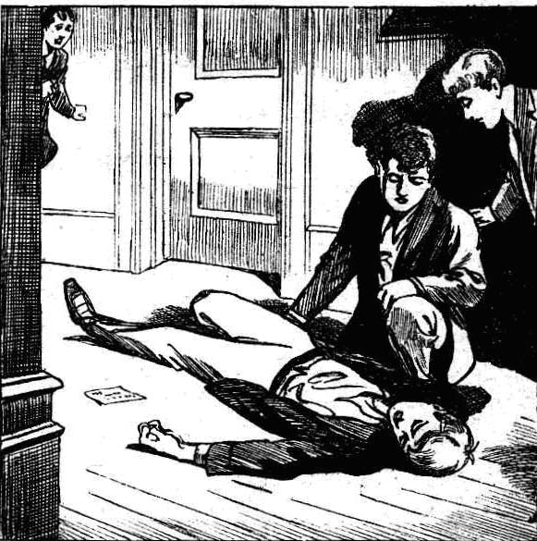
“Frank!” he panted.
Two staring eyes met his, without a sign of recognition or life. Nugent’s head, as Wharton raised it, hung heavy on his hands. A sob of horror shook the captain of the Remove. His chum—his oldest and best chum—was he dead?”
Lord Mauleverer hurried out of his state-room as Mr. Poynings arrived from one direction and Captain Hawke from another. A startled steward and two or three of the crew hovered behind. The alarm was general through the Silver Scudnow.
“Herbert,” exclaimed the old baronet, staring, “you are safe?”
“Yaas, uncle. But what—”
“Something’s happened,” breathed Jonny Bull. “Nugent--he’s hurt! He’s—he’s— He can’t be dead.”
“Leave him to me!” said the captain’s deep voice
Wharton, almost fainting with the horror of the moment, relinquished his chum to the skipper. Bob Cherry caught his arm.
“Buck up, Harry !”
“Frank!” breathed Wharton.
The captain looked up grimly.
“Nugent is not dead.” he said quietly.
“He is insensible. He has been choked. There are marks on his throat. Heaven knows what has happened!”
“Good heavens !” muttered Poynings.
“Go on the bridge, Poynings !”said the captain, as he heard his voice. “ I am wanted here.”
“Yes, sir ; but what is this?”
Poynings stooped and picked up a card that lay by Nugent. He held it up to the captain.
A dozen pairs of eyes read what was scrolled on the card in large capital letters.
“THIS IS THE LAST WARNING.— G. G.”
A hush fell on the startled group. Poynings, handing the card to the captain, went quietly on deck.
“ Gideon Gaunt!” said the old baronet, faintly. “Captain Hawkc, that man he’s still on board the Silver Scud!”
The captain stared at the card dumbfounded. That evidence that the man with the misshapen nose was on the yacht dazed him.
“Still on board!” breathed Lord Mauleverer, white and startled. In Heaven’s name, what does it mean?”
Captain Hawke pulled himself together in a moment.
“Never mind that now!” he said. “This boy is our first care. Make way, there!”
He raised the insensible junior in his strong arms, and carried him into his state-room, and laid him in the bunk. Harry Wharton turned on the light, and lingered .
“He will recover, my lad.” Said the captain kindly. “You need not be afraid of that. He was choked till he became insensible, but his life is not in danger.”
“You—you are sure, sir?” faltered Wharton.
“Quite! You boys had better keep together in the saloon, till we have time to look into this.”
“Very well, sir.”
But Wharton still lingered. A weight seemed to roll from his heart when Frank Nugent stirred, and moaned faintly. His eyes moved in a wild glance and rested on Wharton’s face.
“Harry—”
“ Frank, old man—“whispered Wharton.
“Is he—is he gone?”
“ Who, Frank?”
“That man—that demon—“ Nugent shuddered violently. “He——he collared ne in the dark and choked me. I—I was going to Bunter’s cabin, you know, and—and I came on him in the dark——” He broke off, shuddering from head to foot. “In Mauly’s doorway. He was after Mauly—“
“ You must not talk now, my lad.” said Captain Hawke, making Wharton a sign to leave the cabin. “You are safe now—watched and safe. But you must keep quiet.”
Wharton, with a last look at his chum, left the state-room. His brain was in a whirl. It was clear that Nugent, in going towards Bunter’s room, had fallen in with the ruffian: and the spot where he had been found, just outside Mauleverer’s door, indicated what the ruffian’s purpose had been. Nugent had interrupted on intended attack on the schoolboy earl. It was clear; but it proved that Gideon Gaunt was on board the Silver Scud— and that was a dazing revelation. If he as there, where was he—where was he hidden? There was no recess on the yacht that had not been searched and searched again —there was no remote corner that might have sheltered a rat that had not been scanned.
Was the man something more than earthly? Had the villain supernatural powers at his command? It almost seemed so.
The Greyfriars juniors finished dressing and gathered in the room. Sir Reginald Brooke, looking very worn and old, sat huddled in a chair. Billy Bunter, with a dressing gown over his pyjamas, remained with the rest——no longer full of swank and caustic humour! The knowledge that there was a mysterious hidden enemy on board the yacht was more than enough to take the bounce out of Bunter.
Captain Hawke cane away from Nugent’s cabin at last, his sunburnt face was very grim.
“The boy is sleeping now.” he said, in answer to the old baronet’s anxious look. “ I have given him a sleeping draught, and a steward is watching over him now. He will be better in the morning. And now I want to know just what happened. Master Bunter——”
“I—I was woke up by by a clutching hand—” began Bunter.
Bob Cherry coloured.
“I think I’d better explain, sir.” he said to the old baronet.
“You shut up, Cherry!”, said Bunter peevishly. “You don’t know anything about it. I was awakened—”
“It was I that woke you, you fat idiot!” grunted Bob.
“Wha-a-at?”
“What does this mean?” said the captain sternly. “I cannot imagine why Nugent was out of his cabin. If you know anything about it, Master Cherry, you—”
“We know all about that, sir.” said Harry Wharton. “Was it you who japed Bunter, after all, Bob!”
“Yes!” Bob proceeded to explain. “Of course, we hadn’t the remotest idea that that nosey villain was still on the yacht. We meant to jape Bunter to take the silly swank out of him—”
“Beast!”
“ It was arranged for Nugent to butt into his room at midnight, and give him a scare.” explained Bob. “And I woke up at a quarter to one; and as there hadn’t been any howling from Bunter, I thought Nugent was still fast asleep. So I turned out and went to Bunter’s cabin, and woke the fool up—”
“Yah!”
“Did you see anything of Nugent!” asked the captain.
“No! I thought he was still asleep in his room.
“You saw nothing of his assailant!” asked the old baronet.
Bob Cherry shook his head.
“Nothing, sir! Hadn’t the faintest idea that anything had happened, though poor Frank”—Bob’s voice faltered— poor Frank must have been lying there at that very minute.”
“Then it was you, and nobody else, that frightened Bunter?” demanded the skipper.
“Yes.” said Bob, with crimson cheeks. “I—I jolly well wish now we hadn’t thought of japing him. That was why Nugent was out of the room, of course.”
Captain Hawke knitted his brows.
“I have learned from Nugent.” he said, “that he found someone moving in Lord Mauleverer’s doorway, and fancied it was one of his friends. Then the man seized him and choked him into insensibility. It was very unfortunate for Nugent, but certainly he interrupted an attack upon Lord Mauleverer that was about to take place.”
“Good gad!” murmured Mauleverer. “Poor old Nugent!”
“ Nugent saw nothing of him in the dark.” Resumed the captain. “But the card that was found proves that it was the same man who attacked Sir James Vivian ; besides, no one else could have any motive for doing so. He is still on board the Silver Scud.”
“But where ?” said the old baronet in a faint voice. “The ship was thoroughly searched.”
Captain Hawke nodded.
“I cannot understand it.” he said. “The attack, however, shows that the sea-lawyer is still on board, and he must be found —he shall be found! Until he is found every precaution must be taken against another attack. Nugent will be watched, and you boys had better keep together.”
With that, the captain returned to the deck. There was a long silence, which was broken by Lord Mauleverer.
“If he’s not found—”
“He must be found, Herbert.” said the old baronet. “Heaven knows where he is hiding, but he cannot escape another search.”
“I don’t catch on to it, sir.” said Mauleverer in a low tone. “It looks to me as if there’s something uncanny in it —as if the villain is able to come and go like a phantom. Of course, that’s impossible, but I do not believe he will be found.”
The old baronet made a helpless geture. Deep down in his heart he shared his nephew’s belief, The man with the misshapen nose came and went as he liked, like the wind on the sea. He had been there, and it seemed impossible that he was not still on board; yet everyone present felt an inward conviction that he would not be discovered. It was impossible to believe in the supernatural, and yet it seemed stilt more impossible to disbelieve in it.
“If he’s not found,” resumed Lord Mauleverer, after a pause, “ it’s still open to us to accept his terms—to fly the white ensign half-mast as a signal that the ransom will be paid. I’m ready to give in, if my uncle approves——if you fellows think—”
Lord Mauleverer stopped.
The chums of the Remove read his thoughts. To save his friends from danger, the schoolboy earl was willing to do what he would never have done to save himself. There was painful doubt and indecision in the old baronet’s face.
But there was neither doubt nor indecision in the face of Harry Wharton & Co.
“Never!” said Harry, his eyes flashing. If you want to give in on your own account, Mauly, go ahead; but so far as we’re concerned, we’d run any risk rather!”
“You bet!” said Johnny Bull emphatically.
“The neverfulness is terrific, my esteemed Mauly!” murmured the Nabob of Bhanipur.
“Rot!” said Bob Cherry. “ Utter rot! You’ve no right to give in to the scoundrel, Mauly.”
“Nugent will say the same, too!” said Wharton.
There was a squeak from Billy Bunter.
“I say, you fellows——”
“Shut up, Bunter!”
“I don’t agree!” hooted Bunter. “ I’m not going to be throttled by a beast in the dark, I know that! If Mauly doesn’t get rid of that blighter somehow, I shall jolly well go ashore, I tell you!”
“Good!” said Lord Mauleverer.
“Oh, really, Mauly——”
“I mean, we’ll put you ashore as soon as it can be arranged, Bunter.” said Mauleverer. “That’s all right.”
Even that did not seem to content William George Bunter, somehow. He grunted discontentedly.
“But perhaps the villain will be found and put in irons!” said the old baronet hopefully, after a pause.
And the juniors echoed his hope, though with little expectation that it would prove well-founded.
THE ELEVENTH CHAPTER.
Mauly‘s Bodyguard!
THERE was no more sleep on board the Silver Scud that summer’s night, excepting for Billy Bunter.
That fat youth, having fortified himself with an extra supper, dozed in a comfortable armchair, and his snore reverberated through the saloon and the lounge, and, indeed, farther. The electric light was on all over the vessel while the hidden foe was searched for.
There was little surprise when the search failed to unearth Gideon Gaunt, and some of the seamen were heard to mutter that the ship was haunted.
Morning found the Greyfriars juniors looking pale and tired. Frank Nugent was able to join his comrades at breakfast. His face was very white yet, and his eyes had a sunken look. The cruel finger-marks were clearly visible on his throat. He was very far from being himself yet but he was on the way to recovery, and he was fully in agreement with his chums to see the matter through.
Lord Mauleverer was very thoughtful that morning. His lordship seemed to be thinking out a problem, and at last he unburdened himself.
“It’s pretty rotten, you chaps, to have yur holiday cruise mucked up in this way,” he said. “That villain Gaunt is makin’ a muck of it for us, an’ no mistake. The whole crew have been searchin’ for the beast, and they can’t find him on board.”
“He’s vanished,” agreed Harry Wharton.
“He vanished before, after goin’ for poor little Vivian.” said Lord Mauleverer quietly. “No good thinkin’ that he’s jumped overboard, as we did then. He couldn’t come back out of Davy Jones’ locker whenever be liked. I don’t profess to understand it, but that villain has some way of turnin’ up in the Silver Scud whenever he chooses, and unless he’s laid by the heels we’re not safe from him.”
“That’s so.” said Bob.
“Now, what I’m thinkin’ is this: The rotter has made a mark of me to get hold of money.” said Lord Mauleverer. “I’ve no right to drag you fellows into it.”
“Rot!” interjected Johnny Bull.
“The rotfulness is terrific!”
“Nobody’s safe from him on the Silver Scud. amazin’ as it is.” continued Lord Mauleverer.
“So, if you fellows agree, I rather think we’d better put in at Dover instead of goin’ around the French coast, as we intended, an’—an’ chuck up the cruise. It’s a rotten disappointment, but there you are!”
There was a brief silence.
“But if you go ashore the rascal will still be after you.” said Harry Wharton. “He got at you at Greyfriars School------!”
“ Yaas”
“ And in your room at Mauleverer Towers!”
“Yaas.”
“Then you won’t be any safer than on board; less so, in fact.”
“Yaas. But———”
“But you want to get us out of danger, which will stick to you just the same?” said Harry.
Lord Mauleverer rubbed his noble nose. “I don’t exactly want to.” he said, “but I think it’s my duty. You fellows oughtn’t to run my risks.”
“Fathead!”
“I say, you fellows, I think Mauly’s right.” said Bunter.
“Shut up, Bunter!” Harry Wharton looked round at his comrades. “We’re going to stick to Mauly till that blackmailing villain is bagged and put where he can’t do any harm—what!”
“Hear, hear!” said the Co. heartily.
Lord Mauleverer’s thoughtful face brightened.
“Well, I thought I ought to put it to you.” he said. “ But, of course, I should feel a bit rotten if you left me with that awful villain hanging about in the offing. It’s a go, then.”
“I say, you fellows——”
“ All right for you, Bunter, you’re goin’.”
Billy Bunter glanced at the summer sea and the handsome yacht amid the trim seamen, and thought of the magnificent lunch that was then preparing. In daylight on sunshine the danger of the night seemed remote. Lunch seemed nearer hand nearer, and dinner, too, in prospect. Billy Bunter, on the whole, did not want to go ashore. After all, he could lock his door, he could keep his light burning, he could take all sorts of precautions for his own precious safety And Billy Bunter shook his head at last, and answered in heroic strain :
“Don’t worry, Mauly! I’m not deserting you!”
Billy Bunter blinked round at the chums of the Remove.
“You see.” he remarked, “If there’s danger, what you scared fellows need is a cool, collected chap with no end of courage to pull you together and keep you from panic, and— Yarooooh!”
Bump!
The patience of the Greyfriars chums wore out. The very yacht seemed to quiver as Billy Bunter’s tremendous weight smote the deck in a sounding bump.
THE END.

Hurree Slngh continued to send down the balls with deadly accuracy. Bravo, darky I “ said several of the crowd.. And then, to the astonis)ment of the chums of Greyfriars, a well-known voice squeaked : “ Go4 old Inky! Topping! I say, you fellows, fancy meeting you here I” And Billy Bunter
rolled up to Harry Wharton & Co. I (&t Okapter 4)

.

