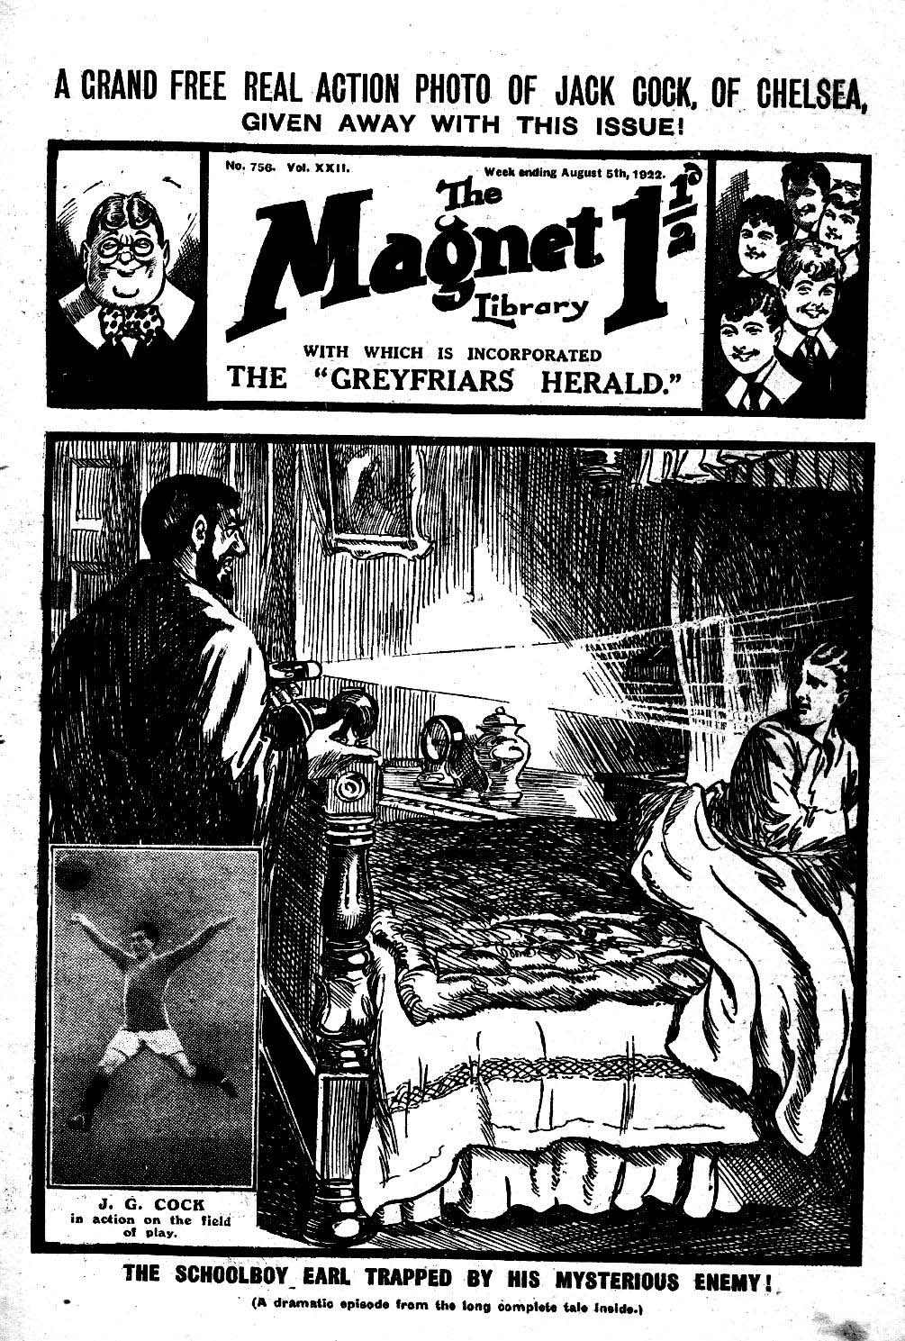
A Magnificent, Long, Complete Story, dealing with the holiday adventures of Harry Wharton & Co., the famous Greyfriars chums, and of the series of “warnings” Lord Mauleverer receives from “The Mysterious Foe.”
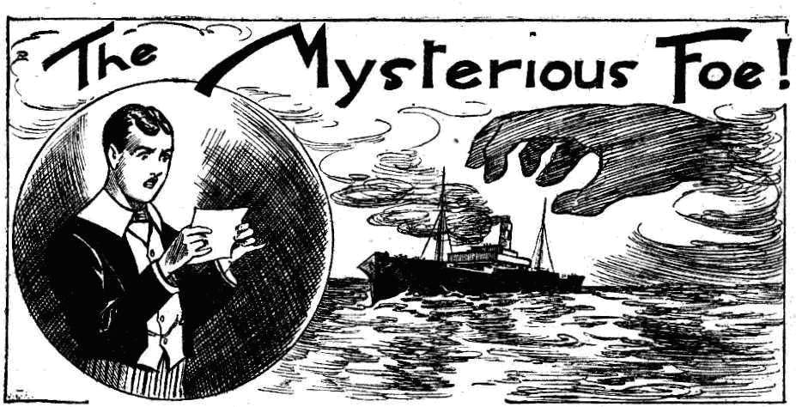
By FRANK RICHARDS.

THE FIRST CHAPTER.
Breaking Up at Greyfriars!
“Don’t come in!”
Lord Mauleverer of the Remove called out hastily as a tap came at his study door.
It was Bob Cherry who tapped! And
as he followed up the tap with a powerful kick on the door, his lordship’s injunction came too late. The door flew open with a crash.
Bob stared into the study.
“Why am I not to come in?” he demanded.
“Busy!“
Lord Mauleverer’s study looked as if he had been busy, but his lordship, who was stretched on the sofa, did not look very busy personally.
Greyfriars School as breaking up that day for the mid-summer holidays. Thoughtful fellows had done a great deal of their packing over-night.
Lord Mauleverer had thought of it, but he had not done it.
His study looked a good deal as if a whirlwind had struck it.
Boxes and drawers were open, shirts and socks were scattered over them and over the table, there were shoes and boots on the mantelpiece and the bookcase, and neckties on the carpet—all sorts and conditions of things in all sorts of unexpected places.
Bob Cherry simply blinked at the scene of havoc.
“Packin’!”
“Looks more like unpacking, to my mind. And what are you doing now?”
“Restin’.”
“And how many hours, or days, or weeks is it going to take you to get all that lumber into order?” asked Bob.
Lord Mauleverer shook his head.
“Don’t ask me!” he answered. “How should I know? I’ve started packin’. I’m tired out! I’ve got all the things ready to pack. I dare say Vivian will lend a hand. Good-bye.”
Bob Cherry grinned.
“Fathead! Get a move on!”
“Why don’t you run away?” said his lordship plaintively. “I told you not to come in. Shouldn’t butt in when a fellow’s busy packin’!”
“I think we’d all better lend a hand with the giddy packing,” said Bob Cherry. “But I came to tell you that somebody’s asking to see you.”
“I couldn’t possibly see anybody!” said Lord Mauleverer. “How can I see fellows when I’m packin’ ?”
“It’s not a fellow, ass! It’s a visitor!”
“Not my merry uncle?” exclaimed Mauleverer.
“No—never seen the chap before.”
“Tell him to go and eat coke, then.” said Lord Mauleverer. “Fancy callin’ on a fellow on breakin’-up day!”
“Trotter’s shown him into the visitors’- room.” said Bob. “I told Trotter I’d tip you the wink. Trotter’s busy collecting tips from the fellows before they go.”
“Well, now you’ve tipped me the wink go and tell the man to travel!” said Lord Mauleverer, stretching his lazy limbs. “I’ve got a lot of packin’ to do.”
“Don’t you want to know his name?” demanded Bob.
“Not at all. I’m not curious.”
“He gave his name as Gideon Gaunt.”
“Ye gods!” drawled Lord Mauleverer. “What a name!”
“Don’t you know it?” asked Bob.
“Never heard it before that I know of.”
“Hadn’t you better step down to the visitors’-room and see him?” asked Bob. “He said it was very important.”
“How can I step down to the visitors’room when I’m up to my eyes in packin’?” demanded Lord Mauleverer. “The car may be here any minute, and you can see there’s lots to be done.”
“Then I’m to tell the Gaunt-bird to go and eat coke?” grinned Bob.
“Yaas.”
“Right-ho!” Bob Cherry turned in the doorway, to carry that message to Lord Mauleverer’s unexpected and unwelcome visitor.
“Hold on a minute!” said Mauleverer. “Don’t put it quite like that. Say that I’m honoured by his call, and that it would be a real pleasure to see him, only that being pressingly engaged at the present moment I find it impossible.”
“My only hat!” said Bob.
“That’s more polite,” explained Mauleverer, “and it comes to the same thing. Shut the door after you, old fellow, in case any other silly ass comes buttin’ in while I’m packin’.”
“Fathead!” said Bob.
Bob Cherry departed from the study, shutting the door with a slam that rang along the Remove passage like thunder, and made Mauleverer jump.
“Oh gad!” murmured his lordship. And the slacker of the Remove settled down on the sofa again, to rest before he tackled the rather extensive task of packing his belongings.
Bob Cherry tramped cheerily along the Remove passage. Bob was in great spirits that morning. Breaking-up day was always a joyful occasion, and the midsummer holidays were going to be specially enjoyable this time. For the Famous Five of the Remove were booked for a holiday cruise with Lord Mauleverer and Sir Jimmy Vivian, on Mauly’s uncle’s yacht, the Silver Scud; and they were envied by half Greyfriars.
A life on the ocean wave—at mid-summer, anyhow—was a joyous prospect, and the chums of the Remove looked forward to it keenly.
Harry Wharton came out of Study No. 1 as Bob tramped along to the stairs.
He called to Bob.
“Come and lend a hand with this strap, Bob! This dashed trunk won’t meet!”
“I’ve nearly done it!” came Frank Nugent’s gasping voice from the study. “It only wants a good pull.”
“I’ll be back in a tick.” said Bob. ‘There’s a giddy visitor downstairs asking for Mauly, and I’m going to tell him to go and eat coke.”
“Buck up, then.”
Harry turned back into the study to help Nugent deal with the refractory strap. Bob descended the stairs by way of the banisters, and he came down like a shell from a mortar. It was sheer ill luck that his chums, Johnny Bull and Hurree Singh, were coning upstairs, and had just reached the middle landing when Bob Cherry shot off the angle of the banisters and landed.
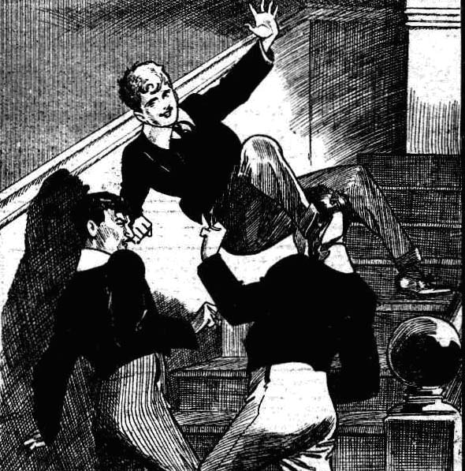
Crash!
“Yooooop!” roared Johnny Bull.
“You potty villain!”
“Wow!” spluttered the Nabob of Bhanipur.
“Oh, my hat!”
Bob Cherry gathcred himself up rather dazedly. He extracted his foot from Johnny Bull’s neck, and his fist from Hurree Singh’s eye.
“Sorry!” he gasped.
“You howling ass!” roared Johnny Bull. “I’ll make you sorrier!”
“Collar the esteemed and ludicrous idiot!” gasped Hurree Singh.
But Bob Cherry was already sailing down the lower banisters. Fortunately, there was no one in the way in the lower hall, and Bob landed there without disaster.
He trotted away cheerily to the visitors’-room, and put his head in at the door. A man who was seated by the window rose quickly to his feet and turned towards him.
“Lord Mauleverer— ” Then he broke off angrily. “You! You are not Lord Mauleverer!”
THE SECOND CHAPTER.
A Surprise for Lord Mauleverer!
BOB CHERRY looked rather cnnously at the visitor.
He was a striking-looking man.
Few would have passed without a second glance.
He was of medium size and strongly built. About his figure there was nothing remarkable. But his face was striking. His eyebrows were of the deepest black, and he wore a jet black moustache, and a pointed, black beard, which gave him a rather foreign look. But his remarkable feature was his nose. It was a large, hooked nose, which looked at least two sizes too large for his face. It was so extremely large that it almost amounted to deformity; and Bob Cherry though he had naturally good manners, could scarcely help giving that striking feature a second look. But he hurriedly averted his eyes from it. A man with a nose like that couldn’t be pleased with it, he thought, and would not like it to he specially observed by strangers.
The man could not be called handsome; and he did not look good-tempered. His eyes had an unpleasant glint in them. He was evidently annoyed by the entrance of Bob Cherry in the place of the junior he wished to see.
He came several steps towards Bob, his black brows contracting.
“You are not Lord Mauleverer!” he exclaimed.
“Not the least little bit in the world!” admitted Bob Cherry. “I’ve got a message from him, though.”
“I must see him.”
“Can’t be done, Mr. Gaunt.”
“Why not?” snapped the black- bearded man.
Bob mentally rehearsed Lord Mauleverer’s polite speech, and proceeded to recite it.
“Lord Mauleverer is honoured by your call —“ he began.
“What ?”
“It would be a real pleasure to him to see you —”
“Well ?”
“ But being pressingly engaged at the present moment he finds it impossible.” concluded Bob.
The man eyed him unpleasantly.
“You will go back to Lord Mauleverer, and tell him that I must see him at once.” he said.
Bob raised his eyebrows.
“ Can’t do anything of the sort.” he answered. “ I’m rather busy with my packing—and, besides, I have to be asked more civilly.”
Mr. Gaunt’s eyes glinted.
“Where is Lord Mauleverer ?” he asked.
“In his study.”
“Will you show me where that is?”
“Visitors aren’t allowed in the studies, unless they’re relations,”
“ It is very important.” The man’s angry manner dropped from him, and he addressed the Greyfriars junior with forced civility. “I have a very important message for him. He must hear it before he leaves Greyfriars.”
“You see, it’s breaking-up day.” said Bob. “ Mauly’s up to the neck in packing. But I dare say there’s no harm in your going to his study. Mr. Quelch is in the hall, and you can ask him.”
“Very good.”
Bob Cherry looked out of the doorway. Mr. Quelch, the master of the Remove, was standing near at hand, saying good-bye to Mr. Prout, the master of the Fifth, who was starting. When he had finished Bob called to him;
“ If you please, sir—”
“Well, Cherry, what is it? ” asked Mr. Quelch genially.
The Remove master was always genial on breaking-up day; perhaps because he found comfort in the reflection that he would not see his hopeful pupils again for some weeks.
“This gentleman would like to speak to you, sir.” said Bob ; and he made his escape, to help Wharton and Nugent with the refractory trunk in Study No 1.
Mr. Quelch glanced at the visitor. There was no sign in his face that he observed the gentleman’s remarkable nose—though two or three thoughtless fags in the hall were exchanging grins and winks.
“ What can I do for you, sir?” asked Mr. Quelch politely.
“ I have called with a message for Lord Mauleverer, from his uncle, sir.” said the visitor. “It is important that it should be delivered before he leaves the school.”
“Very good.” said Mr. Quelch. “Trotter! Where is Trotter?”
The school page had vanished. He was closing Mr. Prout’s taxi door outside the School House in happy anticipation of at least half-a-crown.
“Dear me, Vernon-Smith, do you know where Lord Mauleverer is?”
“Packing in his study, sir!” said the Bounder.
“Please go and tell him that a gentleman has called with a message from his uncle.”
“Certainly, sir.”
“Pray take a seat for a few minutes.” said Mr. Quelch courteously; and he returned to his own study.
Mr. Gideon Gaunt did not take a seat. As soon as Mr. Quelch was gone, the man with the, striking nose followed the Bounder up the staircase.
Two or three fellows glanced after him, but no one offered to interfere. The black-bearded man kept Vernon-Smith in sight and reached the Remove passage.
Smithy knocked at Mauleverer’s door and opened it.
“ Don’t come in!” called out his lordship hastily.
“Man wants to see you—”
“Rats! Tell him to go and chop chips!”
“He says it’s a message from your uncle.”
“Oh, gad! Why couldn’t he say that before? I say, Smithy, old chap, run down and ask him what the message is. I’m simply tired out.”
“ I am sorry to trouble your lordship.” said a voice over the Bounder’s shoulder at the door.
Vernon-Smith started, and looked round. He had not heard the black-bearded man come along the passage; Mr. Gaunt had a tread a stealthy as a cat’s.
“Hallo, here he is!” said the Bounder, and he walked away, leaving Lord Mauleverer to his visitor.
The schoolboy earl detached himself from the sofa.
“Please come in.” he said politely. “‘The fact is, I’m rather busy—packin’, you know. What’s the message?”
Gideon Gaunt entered the study, and closed the door behind him. Lord Mauleverer, a little puzzled, politely waved his hand to a seat. The black-bearded man sat down.
“I’m rather busy—” hinted Mauly.
“You are Lord Mauleverer?”
“Yaas.”
“I have no message from your uncle. That was merely an excuse to gain admittance.” said Mr. Gaunt.
“Great gad !”
“My business is entirely with your lordship.”
Lord Mauleverer stared at his visitor. He was a very good-tempered and patient fellow; but he could not help feeling irritated.
“Dash it all!” he said. “ What the thump do you mean? I’m busy packin’, an’ the school’s breaking up today. What are you botherin’ me for?”
“My business with your lordship is very important.”
“Can’t be important enough to tell a lie about it.” said Lord Mauleverer. “Good-mornin’ !”
“I am not going yet.” said the blackbearded man calmly. “I shall not detain your lordship more than a few minutes.”
“You won’t detain me at all.” said Lord Mauleverer sharply. “There’s the door; and I want you to get on the other side of it !”
“Listen to me---”
“Are you goin’?” snapped Mauleverer.
“I am not going yet.”
“If you don’t clear, my man, 1 shall call in two or three of the fellows to roll you along the passage,” said Lord Mauleverer.
The schoolboy earl made a movement towards the door. He gave a jump as the black-bearded man rose to his feet, and, placing his back against the door, raised his right hand. There was a glimmer of metal in that hand, and the dandy of the Remove, in blank and utter amazement, found himself looking into the barrel of a revolver.
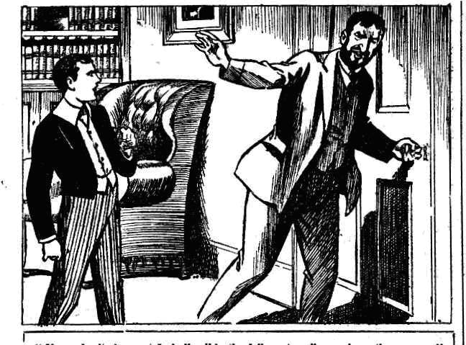
“Stand back!” said the black-bearded man quietly.
“Oh, gad! ”
Lord Mauleverer stood back hastily, and sat down on the sofa quite limply.
THE THIRD CHAPTER.
An Amazing Attack!
“ GREAT GAD!” murmured Lord Mauleverer.
He blinked at his amazing visitor.
His first and natural thought was that he had to do with some escaped lunatic. It seemed the only possible explanation. But a lunatic with a revolver, which might be loaded, required careful handling.
The man with the nose lowered the revolver as Mauleverer sat down.
“That’s better!” he remarked.
“Would you mind puttin’ that thing back in your pocket, dear man?” asked Lord Mauleverer politely. “It might go off !”
“ I do not want to frighten you, Lord Mauleverer——”
“Dear man, you haven’t frightened me.” said his lordship equably. “ But put it away. It’s dangerous, you know.”
Gideon Gaunt slipped the revolver into his pocket. He seemed a little puzzled by the schoolboy’s coolness.
Lord Mauteverer was puzzled, too. The man did not look like a lunatic, though he seemed to act like one. But if he was sane his object in forcing himself into Mauleverer’s study was a mystery. He could scarcely intend robbery in broad daylight in the midst of a swarm of fellows hurrying to and fro in the passages.
“Now, listen to me, Lord Mauleverer!” said Gideon Gaunt in low, level tones. “You need not fear violence so long as you do not call out and draw anybody to this room.”
“Go ahead, old bean.” said his lordship. “It seems I’m booked for a conversazione. Dooce knows when my packin’ will be done! But pile in, an’ don’t mind me!”
“I have only a few words to say, my lord.” said Gaunt. “But you will find them to the purpose. You are an earl, I—”
“Oh, yaas!”
“ And a millionaire?”
“Yaas !“
“ I am neither one nor the other.” said Gaunt.
“You don’t look either.” agreed his lordhip. “ Sorry ! Wish you were, if it appeals to you! But. We can’t all be earls and millionaires, can we? There wouldn’t be enough cash to go round, would there?”
“I am in need of money.”
“Lots in that boat.” said Lord Mauleverer sympathetically. “Five bob any good?”
“I am not here to jest, Lord Mauleverer.”
“ But I’m in earnest, dear man. I’ve got five bob absolutely at your service, if you’ll only go away and let me get on with the packin’.”
“ I require ten thousand pounds.”
“ Eh?”
“Did I not speak plainly?” asked Gideon Gaunt.
Lord Mauleverer rubbed his nose. It came into his mind again that his visitor must be a lunatic.
“ Yaas.” he assented. “ You—you want ten thousand pounds! I’m sure I hope you’ll get it.”
“I think you could spare that sum from your ample fortune, Lord Mauleverer.”
“Well, I don’t know about that.” smiled Mauleverer. “Ten thousand pounds is a goodish lump sum. But I suppose you know that I’m a minor, and haven’t control of my money till I come of age? Call on me the day after my twenty-first birthday, and we’ll have a friendly talk.”
“I do not expect you to be able to hand over the money.” said Gaunt, unmoved. “Your guardian—Sir Reginald Brooke—has control of it.”
“Exactly!”
“You are going on a summer cruise with your uncle, Sir Reginald, in his yacht this vacation.”
“You seem to know my bizney as well as I know it myself.’ assented his lordship.
“You would like to return from that voyage alive, I suppose?”
“By gad! Yaas, I should prefer it, if possible!” assented Lord Mauleverer, with gentle sarcasm.
“ I’m not dashed particular; but I’d rather.”
“This is not a jesting matter. I am here to give you the first warning.” said Gaunt. “ You will ransom your life with ten thousand pounds, or you will meet your death on the high seas.”
“Great pip!”
“You understand me, Lord Mauleverer?”
“Yaas. Are you a lunatic or a blackmailer?” inquired his lordship pleasantly.
“I should be called a blackmailer.” said Gaunt calmly. “But, whatever I am called, I mean business. Ten thousand pounds is the price of your life, Lord Mauleverer.”
“You flatter me!” said the schoolboy earl cheerily. “ I should hardly have fancied that it was worth so much. Now, my dear sir, if you’ve done jesting, will you retire an’ let me get on packin’ ?“
The black- bearded man nodded.
“I will go now!” he said. “I have given you a warning. Your Uncle Brooke has already heard from me. Later you will both hear when and how the money is to be paid.”
Lord Mauleverer laughed.
“Will you have it in gold or notes?” he asked.
“That is all——for the present!” said Gaunt.
“Just a minute!” smiled his lordship. “I suppose you’re a harmless lunatic, or some sort of a practical joker pullin’ my leg. But if you’re neither one nor the other, but a giddy blackmailer after my money, what’s to prevent me from handin’ you over to the police this merry
minute?”
With that word the black-bearded man made a sudden spring at Lord Mauleverer.
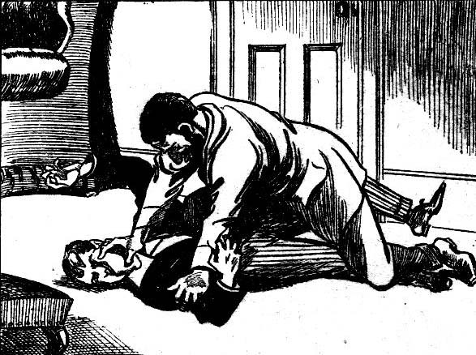
Before Mauly fairly knew what was happening he was down on the study carpet on his back, and a knee was planted on his chest.
The schoolboy earl opened his mouth for a yell, and as he did so a cloth pad was pressed over it.
Lord Mauleverer gasped and struggled.
There was a sickly smell in the pad, and he knew that it was impregnated with chloroform.
He struggled wildly, frantically, his eyes almost starting from his head; but he was held in a grip of iron, and the pad remained pressed immovably on his mouth and nose. In a few moments his senses were reeling. The dark, blackbrowed face over him seemed to float in a mist, the huge nose distended, grew larger, mistily, eerily. Lord Mauleverer’s staring, startled eyes closed.
Then he knew no more.
A minute later Harry Wharton & Co., busy with their baggage in Study No. 1, observed the man with the big nose pass their open doorway. He walked on calmly and sedately to the stairs and disappeared.
“That’s Mauly’s merry visitor !” said Bob Cherry.
“What a jolly boko!” murmured Johnny Bull.
“The bokofulness is terrific.” remarked Hurree Jamset Ram Singh.
The strange visitor’s footsteps died away on the stairs. The chums of the Remove gave him no further thought, little dreaming of what he had left behind him in study No. 12.
“I say you fellows—”
Billy Bunter burst into the study, his fat face white, his eyes fairly bulging from his head, as if they would bulge through his big spectacles.
“Help!” he gasped.
“Hallo, hallo, hallo! What——!”
“ Mauly!” panted Bunter.
“Anything the matter with Mauly?” asked Wharton.
“ Oh dear ! He—he—he—”
“ He’s what “
“Dead!” gasped Bunter. “ Oh dear! M-Mauly’s dead!”
THE FOURTH CHAPTER.
A Villain’s Victim !
“DEAD!”
Five voices gasped out the word.
Bob Cherry grasped the Owl of the Remove by the shoulder and shook him angrily.
“You fat idiot!”
“Grooogh!”
“What do you mean?” roared Bob savagely. “I saw Mauly a quarter of an hour ago! What do you mean? ”
“Grooogh! Leggo! He’s dead!”
“You fat idiot!” snapped Wharton.
“He’s dead!” gasped Bunter. “I—I went into his study—and he was stretched on the floor—white as chalk —dead as a doornail!”
“It’s impossible !” exclaimed Wharton, his face growing pale. “ But— come on, you feIlows!”
He sprang out of the study and rushed up the passage, his chums followed him fast.
Billy Bunter did not follow. He rolled away to the stairs, to spread far and wide the startling news that Lord Mauleverer was dead! Never had Bunter had so startling news to spread, and he fairly thrilled with excitement as he passed it on.
Harry Wharton reached Study No. 12 in about a second. He rushed in, hardly knowing what he expected to find there.
He stopped suddenly, almost stumbling over Lord Mauleverer.
The schoolboy earl lay on his back on the carpet, perfectly still, his face colourless and his eyes closed.
So white, so terribly still was he, that for a moment Wharton had a fearful dread at his heart that Bunter’s news was true.
“Mauly!” he panted.
The captain of the Remove threw himself to his knees on the carpet.
Quickly he felt the schoolboy earl’s heart. A throb of relief ran through him as he found that it was beating steadily, though faintlv.
“What on earth’s happened?” exclaimed Bob Cherry. Wharton’s chumswere in the study, only a moment behind him.
“He’s not—not—” stammered Nugent.
“No!” Wharton breathed hard. “He’s not dead—fainted or something. But his heart’s beating—he’s breathing.”
“Poor old Mauly !”
“Must be a faint!“ said Harry. “Blessed if I thought Mauly was the fainting sort! The heat, per aps. He’s quite unconscious!”
“Mauly!” shouted Bob. “Mauly, old man!”
But no movement came from the insensible junior. It was obvious that he was utterly senseless.
“Better call Mr. QueIch!” said Johnny Bull. ‘“A doctor will have to be sent for”
“Yes, rather! You fellows stay with him while I cut down.” said the captain of the Remove.
“We’ll put the poor chap on the sofa,” said Bob. “Poor old Mauly!”
Harry Wharton hurried from the study. His comrades lifted Lord Mauleverer, tenderly enough, and laid him on the sofa, and Nugent removed his collar and tie to give him more freedom in breathing. A low, faint sound came from Mauleverer’s lips, a sign of returning consciousness. But his eyes remained closed, his breathing faint and low.
Wharton was downstairs almost in a twinkling, and dashing to the Remove master’s study. But Bunter’s startling news had already spread; and a chorus of inquiring shouts greeted Wharton.
“What’s happened to Mauly?”
“Is he ill?”
“Bunter says he’s dead!”
“He’s ill!” answered Wharton briefly, over his shoulder, as he knocked at Mr. Quelch’s door. He entered the study without ceremony.
Dr. Locke was in the study, talking with the master of the Remove. Both the masters gave Wharton severe glances as he burst into the study.
“ Wharton!” began Mr. Quelch sharply.
“Excuse me, sir!” gasped Wharton. “Mauleverer’s ill——I think it’s serious. He’s insensible in his study.”
“Bless my soul!” exclaimed the Head, startled.
Mr. Quelch rose quickly to his feet.
“ Insensible!” he repeated.
“Insensible on the floor, sir.” said Harry. “I suppose the heat’s too much for him; anyhow, he’s fainted, and hasn’t come to.”
“That is very surprising.” said Mr. QueIch. “He appeared in his normal health at breakfast-time this morning. If you will excuse me, sir, I will go to Mauleverer at once.”
“I will accompany you.” said the Head.
The two masters, with unaccustomed hurry, left the study and ascended the stairs to the Remove passage. Harry Wharton followed them. A crowd of the Remove had already gathered in the passage, and they made way respectfully for their form master and the Head.
There was a buzz of excitement in the passage. A good many of the Remove had already left the school if; but of those that remained, nearly all had gathered on the spot on the news of Mauleverer’s mishap. His lordship was a general favourite in the Remove ; not by any means wholly on account of his worldly advantages. Even Skinner was sorry to hear that he was ill.
Vernon-Smith caught Wharton by the arm.
“What’s the matter with Mauly?” he asked.
“Fainted, I think.”
“Had that nosey man anything to do with it ?”
“Wha-a-t? ”
“He can’t be ill.” said the Bounder; “he was right as rain when I saw him ten minutes ago, when that fellow came to the study after me. Has that chap done anything to him?”
Wharton started.
For the first time it crossed his mind that there was foul play in the affair.
“My hat!” he muttered. “ Why, the man had only left him a minute or two when Bunter found him ; if Mauly was ill then, he would have told someone— and he didn’t!”
“Looks like foul play!” said the Bounder.
Wharton nodded, and went on to the study. His comrades were still there, and the Head was leaning over Lord Mauleverer on the sofa. Mr. Quelch, with a strange expression on his face, was sniffing.
“This is not an ordinary faint.” said Dr. Locke. “There is something very unusual the matter with this boy, Mr. Quelch.”
The Remove master sniffed again.
“Do you notice a peculiar odour in the room, sir?” he asked.
“Now that you mention it, I do.” said the Head, sniffing too. “Surely it cannot be—cannot be— —”
“Chloroform!” said Mr. Quelch. “ It certainly is!”
“Upon my word “
The juniors exchanged startled glances. They had noticed the faint, lingering, sickly smell, though without heeding it in the excitement.
“Chloroform!” whispered Bob Cherry, ‘My only hat!”
Wingate of the Sixth appeared in the doorway.
“Can I do anything, sir? he asked. “I hear that———”
“Yes, Wingate!” said the Head. Mauleverer has had an accident; kindly telephone for Dr. Pillbury as quickly as possible. Tell him that a boy has somehow fallen under the influence of chloroform, and beg him to hasten here as rapidly a possible.”
“Certainly, sir “
The Sixth-former hurried away.
Dr. Locke looked at the white, still form of Lord Mauleverer, and then glanced at the Famous Five.
“Do you juniors know anything about this?” he asked.
“Nothing, sir!” said Harry. “Bunter ran into our study saying that Mauly was dead, and we hurried here and found him insensible on the floor. That’s all we know—unless——”
“Unless what?”
“A man was here speaking to him a few minutes before Bunter found him—”
“ A man!” exclaimed the Head. “ What man ?”
“ He gave his name to the page as Gideon Gaunt,” said Bob Cherry. “A man with a black beard and a big boko —I mean nose, sir.”
Mr. Quelch uttered an ejaculation.
“ I saw the man, Dr. Locke.” he said. “He stated that he had a message from Lord Mauleverer’s uncle, and I requested Vernon-Smith—”
“ The man followed me upstairs, sir.” said the Bounder.
“ He had no right to do so.” said the Remove master, frowning. “ I was not aware—”
“Well, he did so, sir!” said Vernon-Smith.
“I lost sight of him after speaking to him, sir.” Mr. Quelch explained to the Head. “There were several relations of my boys in my study who had stopped to speak to me, and I was busy. I supposed that Mauleverer had been told to come down and see the man.”
“You left this man with Mauleverer, Vernon-Smith?” asked the Head.
“Yes, sir. Mauleverer certainly wasn’t ill then.” answered Vernon-Smith. “ I’m sure of that, though I only just looked in to tell him the man had come, that is my father was waiting downstairs for me.”
“This is most extraordinary!” said the Head. “Mauleverer is undoubtedly under the influence of chloroform, Mr. Quelch.”
“It certainly appears so. Can it be that this stranger—”
“Why should a stranger commit such an objectless outrage, sir?” said the Remove master. “It is more probable that the foolish boy has obtained some chemicals from the laboratory, without knowing their danger, and that this is the result.”
“Yes, yes; that is possible.”
There was a moan from the still figure on the sofa. Sir Jimmy Vivian, who was kneeling beside him, uttered an exclamation.
“but He’s coming to, sir.”
Dr. Locke turned quickly to Mauleverer.
“Mauleverer! My poor boy—”
Lord Mauleverer’s eyes had opened. He cast a wild glance round him, evidently not quite himself.
“Keep him off!” he moaned.
“My boy——”
“He’s mad—keep him off !” moaned Mauleverer.
And he relapsed into unconsciousness again. The Head met Mr. Quelch’s startled glance.
“Mauleverer is the victim of an attack.” he said quietly. “There is no further doubt about that, Mr. Quelch. The description of the man calling himself Gaunt must be sent to the police at
once.”
______
THE FlFTH CHAPTER.
Mysterious!
BREAKING-UP day at Greyfriars was always a dayof excitement, especially the breakup for the
midsummer vacation. But never in the mystery of the old school had so much excitement been crammed into one day, as on the present occasion.
Lord Mauleverer had been removed to his bed in the dormitory, which he had not expected to occupy again till the next term. But he was in no state to travel at present.
His uncle, Sir Reginald Brooke, was expected at the school in the family car to take him away, and startling news awaited him. The baronet had not been able to arrive early in the day for the speeeh and other ceremonies—possibly the old gentleman did not enjoy such occasions, and Mauly was not a member of the prize list—but he was expected in the afternoon.
Dr. Pilbury, the school doctor, had arrived in haste, and in attendance on the schoolboy earl—Mauly’s young friends being excluded from the dormitory. Sir Jimmy Vivian haunted the dormitory passage with a white and almost tearful face, filled with anxiety for his noble relative. Harry Wharton & Co. wandered disconsolately in the quad.
Inspector Grimes had come over from Courtfield in response to an urgent telephone message from the Head. The Co. saw him enter the dormitory, where the doctor was with Mauly, and they concluded that the dandy of the Remove was now in a condition to give a description of the attack upon him. They watched the inspector when he left—his face was grave, and they could see that it was perplexed. After his interview with Mauleverer, Mr. Grimes had interviewed Mr. Quelch and the Bounder and Trotter, the page, for a complete description of MauIy’s assailant. It was fairly obvious that the mysterious affair puzzled Mr. Grimes, has indeed it had puzzled and perplexed all Greyfriars.
Many of the Greyfriars fellows lingered for a later train than the one they had intended to take, in order to hear the latest news of Mauly’s state before they went; and they were comforted by the information that his lordship’s condition was not serious. He had had a severe shock, but he would be able to travel later in the day.
Vehicle after vehicle departed, the old school grew more silent and deserted.
Most of the crowd were gone when a big car arrived with a white-whiskered old gentleman sitting bolt upright in it; and the chums of the Remove recognised Mauleverer’s guardian.
They capped him respectfully as the car passed, and Sir Reginald Brooke gave them a nod and a kind smile.
At the doorway he was met by Dr. Locke, who conducted him into the house, and doubtless explained to him what had happened to his nephew. The old gentleman was taken to the dormitory at once to see Mauleverer, The doctor was gone, and Sir Jimmy Vivian was installed by the bedside of his relative; but it was not yet allowed for the rest of Mauly’s friends to come in.
As the last wheels rumbled on the gravel drive, and Gosling collected his last trip, Harry Wharton & Co. were left with the deserted school almost to themselves. The Head’s departure had been delayed, but his car was waiting for him now. But there was another who lingered, and that was William George Bunter of the Remove. Bunter was prepared to be installed by Mauly’s bedside, in the character of devoted friend and pal and nurse, to soothe the invalid’s feverish pillow, and to whisper into his ear irrefragable reasons why he, Bunter, really must be included in the yachting-party. But for the present Mauly had to be left to his relatives, and the Owl of the Remove was turned away from the dormitory door.
Harry Wharton & Co. strolled in the deserted quadrangle, in a rather troubled frame of mind, in the late afternoon. They could not help feeling worried about “old Mauly,” though they were relieved by the doctor’s assurance that his lordship would soon be himself again.
Inspector Grimes had assured the Head that he would lose no time, and that he had little doubt about laying the black-bearded gentleman by the heels very shortly, if they rascal was still within the of the county.
Dr. Locke hoped to hear a message on the telephone, before he left, to the effect that the man calling himself Gideon Gaunt was under arrest; and Harry Wharton & Co. were very eager to hear that the ruffian was laid by the heels.
But there was no news of it so far.
The man, evidently a cool and determined scoundrel, had calmly walked out of Greyfriars after the outrage, and had not been seen again. Gosling, the porter, had exchanged a word or two with him at the gates, as it transpired, and it came out that Gosling had actually been speaking to the man at the very moment that Bunter made the startling discovery in Study No. 12. Yet, though discovery was so close behind him, the man had chatted pleasantly with Gosling, and sauntered away up the road as if he had not a care in the world. He was, as Bob Cherry observed, a cool customer—there was no doubt on that point.
The man’s appearance was so striking, with his black foreign beard and mis-shapen nose, that it seemed certain he would be observed, and that news of him would not be long in coming forward. But, so far from that being the case, Gideon Gaunt seemed to have sunk into the earth after leaving the school gates.
He had not been seen at any railway station within a radius of ten miles, no one had observed him on the roads or in the lanes, and Inspector Grimes was driven to the conclusion that he had had a fast closed car in waiting near at hand.
That was all the information Mr. Grimes was able to give the Head by telephone. It was little enough.
Harry Wharton & Co. were walking rather dismally in the quad when the Head’s car left, and they “capped” their headmaster respectfully as he departed with his family Mr. Quelch still remained ; he was to see the last of the Remove off the premises before he went. The Famous Five strolled round the deserted playing-field, and then roamed back into the quadrangle, waiting for word from their Form-master that they might see Mauleverer.
“Poor old Manly!” said Bob Cherry for about the hundredth time.
“ Wouldn’t I like to have that villain’s big nose within reach just now?”
“I’d make it a size larger still!” growled Johnny Bull.
“It’s dashed queer.” said Harry Wharton, wrinkling his brows. “I should think the man must be mad.”
“Method in his madness, then.” said Nugent. “ From what Mauly said, the man was after a big sum of money. A filthy blackmailer!”
“But he must have known he couldn’t get it from Mauly.”
“ Mauly will hear of him again!” said Frank quietly. “ What he’s done to-day is to scare Mauly and his guardian into shelling out. He’s done it to show what he could do if he liked.”
Harry Wharton nodded.
“ Perhaps it’s lucky that we’re going on the vac with Mauly.” he said. “We shall be able to look after him.”
“Yes, rather!” agreed Bob.
“The ratherfuluess is terrific!”
“The rotter couldn’t get at Mauly on the yacht, though.” said Bob. “ That would be impossible.”
“That’s what he said, according to what Mauly’s told the inspector.”
“ Gammon!” said Bob. “ He was trying to scare Mauly. How could be get at him when we’re at sea?”
“ But if he doesn’t, he seen to have taken all this trouble and risk for nothing.” said the captain of the Remove thoughtfully. “He’s an utterly unscrupulous ruffian—after Mauly’s money, that a cert. It looks to me as if we shall have more adventures than we expected this vac.”
“I say, you fellows!”
“Hallo, hallo, hallo! Are you still here, Bunter?”
“Oh, really, Cherry—”
“What about your train, fatty?” asked Johnny Bull.
Billy Bunter blinked reproachfully at the Famous Five.
“Oh, really, you fellows, you don’t think I would desert my old pal, Mauly, now he’s down on his luck, do you? Some fellows might. Not me. By the way, have you fellows seen my box?” asked Bunter. “Has it been put on old Brooke’s car along with your things?”
Johnny Bull grinned.
“You’ll find it at the station.” he said.
“Eh? How can it be at the station?”
“It went in the brake with Ogilvy and the other fellows.”
“How do you know?”
“Because I shoved it on,” answered Johnny Bull coolly. “I asked Ogilvy to see it dropped at the station for you.”
“Ha, ha, ha! ”
“Why, you — you — you—” gasped Bunter, glaring at Johnny Bull, “you —you cheeky chump, I shall want my things on board the yacht, sha’n’t I?”
“I think not—as you won’t be there.”
“Yah !”
Billy Bunter rolled away, apparently to seek an interview with Sir Reginald Brooke, leaving the Famous Five grinning. A few minutes later there was a hail from a window above. Harry Wharton & Co. looked up, to see Sir Jimmy Vivian at the window of the Remove dormitory.
“Come up, you fellows!” called out Sir Jimmy.
“Right-ho!”
And the Famous Five hurried into the School House.
— —
THE SIXTH CHAPTER.
Bunter Is Alarmed!
LORD MAULEVERER was sitting in bed when the chums of the Remove arrived in the dormitory. His face was still a little pale, but otherwise he looked his old self. He nodded and smiled to the juniors.
“Awf’ly sorry to muck up things in this way, you fellows.” he said. “I’ve kept you hangin’ about, I suppose ?”
“That doesn’t matter, fathead.” answered Bob Cherry. “Hew do you feel now?”
“A bit limp.” confessed Mauly. “I’ve never been under chloroform before. I don’t want it again. It’s worse than speeches.
“ Ha, ha, ha !”
“Nunky is no end cut up.” continued Mauleverer. “Jolly queer bizney, isn’t it, altogether? I feel in rather a moultin’ state at present, but I shall be all serene when we get goin’ in the car. I suppose they haven’t nailed that fellow Gaunt yet—the fellow with the proboscis?”
“No,” said Harry. “He seems to have vanished into thin air.”
“It’s no end queer.” said Mauleverer. “The merry merchant must be off his rocker, 1 think. But he’s a deep card. Nunky heard from him before he came to Greyfriars today. After he had started in the car, he unfolded his giddy ‘Times’ to read on the journey, and a note fell out of the newspaper, he’s told me.”
“My hat! Not a note from the man with the boko?”
“So it seems.” Answered Mauleverer. “Dashed queer, isn’t it? The note said —what did it say, Jimmy? I’ve forgotten. Nunky read it to me.”
“It said that Mauly would have news for Sir Reginald a soon as he reached the school.” said Sir Jimmy Vivian, “and that Sir Reginald had better advise Mauly to do as G.G. had asked him.”
“G.G. is Gideon Gaunt, of course.” said Lord Mauleverer. “Now, isn’t it thumpin’ mysterious, what? How did the man who called on me here get that note into nunky’s newspaper this mornin’ ?”
“Goodness knows!” said Harry, utterly perplexed..
“How did he know nunky was in the habit of takin’ his giddy ‘ Times ‘ with him in the car?” continued Mauleverer. “ What?”
“He must know something about the inside of your uncle s house, Mauly.” said Wharton. “He’s got a footing there, or he’s in communication with somebody there.”
Mauleverer’s nodded.
“ Looks like it.” he said, “ or else he’s a giddy wizard. And that’s not all. When he came here to-day to see me, he must have known that nunky wasn’t comin’ down early for the prize-givin’ and speechifyin’. If nunky had been here I would most likely have been with him, and the rotter couldn’t have got at me, could he ? Now, how did he know that?”
“ Beats me hollow.” said Harry. “ But it shows he’s a dangerous man. He seems to know as much about your affairs as you know yourself.”
“The knowfulness is terrific,” remarked Hurree Jamset Ram Singh. “The esteemed rotter means business, my worthy Mauly, and we shall have to keep the watchful and fatherly eye upon you in the holidays. A stitch in time saves the cracked pitcher from going to the well, as the English proverb says. Press”
Lord Mauleverer grinned at the English proverb.
“I’m jolly glad you fellows are comin’ with me!” he confessed. “If the man’s mad, he’s dangerous; and if he’s sane, he’s a giddy desperate character and more dangerous still. In any case, he’s after the cash, and he’s not goin’ to finger any of it!” The schoolboy earl’s face set grimly for a moment. “I fancy he thinks he can frighten me and uncle into shellin’ out the dibs, you know— that’s his game. He could have polished me off in the study to-day if he’d liked; and now he’s leavin’ that giddy knowledge to sink in, till I hear from him again.”
“You wouldn’t think of buying the rascal off, Mauly!” exclaimed Johnny Bull.
“Not at sixpence-halfpenny,” said Lord Mauleverer quietly “ I’m goin’ to let him see that it’s not easy to scare me. Next time I hear from him I hope I shall have some pals handy who’ll help me deal with him.”
“Yes, rather!” said Bob Cherry.
The dormitory door opened and Billy Bunter blinked in. The Owl of the Remove had not succeeded in interviewing Sir Reginald Brooke. So he had come to the Remove dormitory to try the effect of a final burst of eloquence upon Mauleverer.
“ Oh, gad!” murmured Mauly. “There’s Bunter! I say, tell him I’m dead—ask him to the funeral—keep him away, anyhow!”
“I’ll kick him out!” said Sir Jimmy Vivian, getting off the bedside.
“Hold on!” whispered Bob Cherry. “ I’ve got a wheeze. Play up, you fellows!”
Billy Bunter stood in the doorway, blinking into the dormitory with a rather uncertain blink. He had hoped to find Maulevorer alone, and he discerned six juniors gathered round the bed. What ever effect his eloquence might have had upon the soft-hearted Mauly, it as cerlain that it would produce no effect whatever upon Harry Wharton & Co. Bunter stood irresolute, and as he stood, wondering whether he should postpone his visit, Bob Cherry’s voice came clearly to his ears from along the dormitory.
“Diphtheria! Isn’t it awful !”
“Wha-a-t!” stammered Nugent.
But Wharton caught on at once, and he answered, in grave tones, with a face of preternatural solemnity:
“Horrible! Poor old Mauly!”
Lord Mauleverer blinked at them for a moment in astonishment, and then he understood.
At the terrible word diphtheria Bunter stood rooted to the floor, blinking with a startled blink, ander listening. He was under the impression that the group round the bed had not observed him, and that he was listening to a talk not intended for his ears. But he was wrong.
Lord Mauleverer played up cheerily.
“Yaas, it’s fearful, you chaps! But —but it’s barely possible that I may recover!”
“ It’s awfully dangerous!” said Bob Cherry.
“ Dangerous for us to be here if it’s diphtheria!” said Harry Wharton. “The doctor would kick up a fuss if he knew fellows were hanging round a diphtheria patient. It’s so infectious.”
“ Better keep a safer distance.” exclaimed Nugent with an exaggerated expression of alarm.
“Just a breath from the patient is likely to do the trick.” said Wharton. “You don’t mind if we’re careful, Mauly?”
“My dear chap, I want you to be careful!” said Mauleverer. “Stand farther back, and keep handkerchiefs to your mouths.”
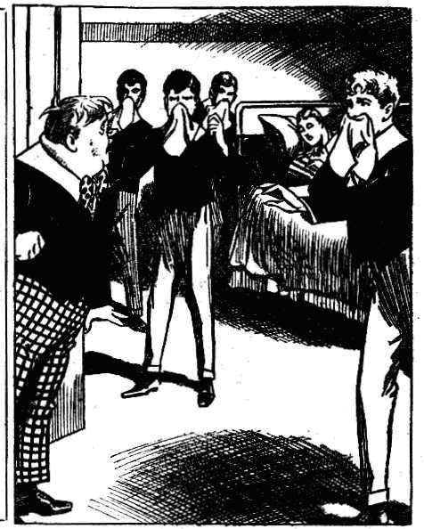
“That’s safer!”
The juniors backed away from the bed and held their handkerchiefs to their mouths.
Billy Bunter blinked at the scene with wide-open eyes.
He had been dubious, a moment before, whether he should advance into the dormitory or not. That debt was settled now. Wild horses would not have dragged Bunter into the room if there was diphtheria there—dear old pal as Mauly was!
Lord Mauleverer leaned back on his pillows and coughed. He thought that a diphtheria patient ought to cough a little.
“C-c-can you speak, Mauly?” asked Bob in a muffled voice through his handkerchief.
“Gug-gug-gug!”
“Poor old Mauly! He’s choking!”
“Call the doctor!”
“Groogh! Gug-gug! Wooooooh! All serene now.” gasped Lord Manleverer. ‘Only a bit of a—a—a choke! All right again for a minute or two!”
“This as awfully hard lines.” said Harry Wharton gravely. “Of course, a case of diphtheria knocks a holiday on the head. But you will have to have somebody with you, Mauly. A nurse is all very well ; but you want a pal to look after you. I suggest Bunter!”
“Bunter’s the bird!” said Bob Cherry. “Bunter’s quite keen to go with Mauly! Besides, we won’t mention to him that its’s diptheria!”
“I say, you fellows—!”
“Hallo, hallo, hallo! Here he is!”
“I say, Bunter---”
Billy Bunter turned an alarmed blink on the Famous Five.
“You were rather keen on going home with Mauly.” said Bob Cherry affably.
“Nothing of the kind!”
“Wha-a-t?”
“Mauleverer omitted to ask me for the holidays.” said Bunter, with a great deal of dignity. “ I hope I’m not the kind of fellow to edge in where I’m not wanted.”
“My only hat!”
“The fact is, I couldn’t have gone with Mauleverer, in any case, much as he wanted me to.” said Bunter.
“But Manly——” said Harry Wharton.
“I really can’t help what Mauly wants.” said Bunter, “I’m not at Mauly’s beck and call, I suppose. I’m sorry, but it can’t be done. I can’t disappoint a whole crowd of wealthy and titled friends for Mauly’s sake. It’s not to be expected.”
“Mauly isn’t quite well.” murmured Nugent.
“Sorry !” said Bunter coolly.
“If anything should happen to prevent as from going with him, you really ought to be at his side, Bunter.” urged Wharton.
And all the Famous Five looked at Bunter very seriously.
“I say. Bunter——” began Mauly weakly.
“The fact is, I’ve too many engagements,” said Bunter. “When a fellow’s so sought after as I am, he can’t please everybody. Even as it is, I’ve had to ration my friends-—my time’s so taken up this vac.”
“Great pip!”
“I’m sorry!” said Bunter loftily, “ but that’s how it is. I had you on my list, Mauly, and I’d have done my best to give you a week or so, but I find it can’t be done.”
‘Oh gad !”
“I think we had better keep Bunter in the dormitory to look after poor old Mauly.” said Bb Cherry.
“Rather!”
“The ratherfulness is terrific, my esteemed Bunter.”
“Come on, Bunter!” said Wharton.
“Collar him and keep him here !” said Bob.
“Good!
The Famous Five came round one side of the dormitory towards Bunter. Billy Bunter retreated round the other side, towards the door.
“Stop!” shouted Wharton.
“Stop him—he’s going to bolt!”
Bunter made a jump for the doorway. He was through it in a twinkling, and bolting down the Remove passage towards the stairs.
“ After him!” roared Bob Cherry.
The Famous Five trampled in pursuit. They were very careful not to overtake Bunter--their idea was to keep the fat junior on the run. But the trampling footsteps behind him filled Bunter’s fat mind with terror of immediate capture—to be followed by a forced visit to a diphtheria’ patient, and the danger of infection! Bunter fairly flew down the stairs,
“Collar him!” bawled Johnny Bull.
“Put it on!”
“Yaroooh!” gasped Bunter, as he lost his footing at the middle landing, and rolled over.
But he was up again with amazing activity, and fleeing down the lower staircase.
Billy Bunter was only too glad to go. His box was at the station already, owing to Johnny Bull’s thoughtfulness; and Bunter only had to follow it. He grabbed his hat and bolted.
Whether there was a train ready for him at the station or not, he neither knew nor cared. But he knew that he wanted to get out of danger of infection as rapidly as he possibly could. He fairly bolted down to the gates, and— perhaps owing to his hurry—forgot to tip Gosling as he went. And he sprinted down the road for a good hundred yards before he dropped into a walk.
After all William George Bunter’s machinations and maneuvers to get his worthy self included in the yachting-party, he was breathlessly anxious to get as far as possible from that yachting-party in the shortest possible space of time!
Seven faces watched his flight from the window of the Remove dormitory— and Lord Mauleverer and Sir Jimmy and the Famous Five roared with laughter as he fled.
THE SEVENTH CHAPTER.

Off for the Holidays!
“OFF at last!” said Bob Cherry.
The big car glided away from the gates of Greyfriars. Gosling, hat in hand, bowing it off, as it were. Gosling’s crusty face was irradiated with smiles—he had not collected his tips yet, but he knew that they were handsome—the whole party in the big car had “done” him well. Gosling, for the first time in his life, revised his opinion that all boys ought to be drowned at birth.
Lord Mauleverer settled back comfortably on the cushions.
It was a big car—in fact, what Bob called a whacking car—but it was fairly well filled. Sir Jimmy Vivian was seated beside the chauffeur; but the Famous Five were in the car, with Mauly and his uncle.
Sir Reginald Brooke sat stiffly upright, a somewhat stiff old gentleman, but his face was kind and good-natured, and had a smile for the merry schoolboys.
Lord Mauleverer seemed almost to have forgotten the startling episode of breaking-up day. He was looking quite his old self now—indeed, shocking as the attack upon him had been, it had its consoling side--for while Manly was recovering from it, his chums had done his packing for him. Being chloroformed was, true, worse than packing—but it was not very much worse, in Manly’s opinion.
The big car took the road through Friardale, at a good rate.
Sir Reginald Brooke’s face was a little thoughtful; the mysterious foe who had molested his nephew troubled him, and the episode lingered in his mind. But Lord Mauleverer and his friends were thinking chiefly of the topping holiday that was to come. There was a ceaseless buzz of cheery chat as the car ran down the green lane and entered the old High Street of Friardale.
As it passed the railway-station, Bob Cherry burst into a chuckle.
“Last view of Bunter!” he said.
“Ha, ha, ha !”
A fat figure adorned the station entrance; that of William George Bunter, waiting for his train. The Owl of the Remove had an hour to wait— and he was still waiting.
He blinked at the car in surprise.
He spotted Lord Mauleverer sitting cheerily among the chums of the Remove, and it amazed Bunter to see a victim of that deadly disease, diphtheria, looking so merry and bright. And it was amazing that an infectious patient should be sitting in a crowded car at all.
Bunter blinked and stared, and blinked again as it dawned upon his fat mind that his leg had been pulled.
The Famous Five waved their caps to Bunter merrily, and Lord Mauleverer gently waved a glove. Sir Jimmy Vivian gave him a cat-call.
Billy Bunter made a jump into the roadway, and raced at the car as fast as his podgy legs could go.
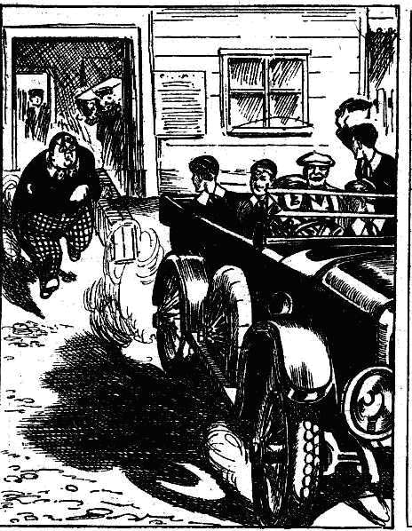
“I say, you fellows!” he yelled.
“Ha, ha, ha!”
“Good-bye, Bunter!”
“Stop!” yelled Bunter.
“Dear me.” said Sir Reginald Brooke, “who s that? Some friend of yours, Herbert?”
“Lord Mauleverer promptly shook his head.
“ No fear!” he answered. “it’s the Bunter bird !“
“The —the what ?”
“ A very fat specimen of the Bunter species, sir.” said Bob Cherry. “No use to anybody outside the Zoo.”
“Dear me !” said the puzzled old gentleman.
“Stop for me!” roared Bunter.
“Ha, ha, ha!”
Billy Bunter put on the biggest spurt of his life; but he dropped behind the car and was soon lost to sight. The last view of him showed him brandishing his fist furiously.
The big car rushed on, by road and lane, by hill and dale, and chums of Greyfriars enjoyed the run immensely.
It was, a Bob Cherry remarked, a distinct improvement on prep in the Remove studies.
The July sunset faded away in a blaze of crimson and gold, and the summer dusk fell, while the car rushed on by dale and hill.
The party should have arrived at Mauleverer Towers for dinner at seven but for the untoward incident at Greyfriars. Now it was certain that they would arrive late. Nobody cared— excepting perhaps the old baronet. But the old gentlemen remained cheerful and good-humoured, though irregular meals were a more serious matter to a staid gentleman of sixty than to a merry schoolboy of fifteen.
Certainly, if Billy Bunter had been in the car there would have been at least one complaining voice. But fortunately William George Bunter was not in the car.
“Begad!” yawned Lord Mauleverer at length. “Here we are at last, dear men!”
In the deep dusk the juniors sighted great gates that opened at their approach. The car glided up a vast drive between rows of oaks and beeches.
“ Home at last!” said Sir Reginald, with a smile.
“By gad, I shall be glad of a rest!” remarked Lord Mauleverer. . “We’re goin’ to hang on here a couple of days before we go to sea, you fellows. You don’t mind?”
“Dear man!” said Bob, with a grin. It looks as if a chap could make himself quite comfy here.”
“Yaas, I hope so. And you’ll meet some of the johnnies we’re goin’ to sail with.” said Lord Mauleverer. “Captain What’s-his-name and—and the other chap, Thingummy. They’re stayin’, uncle?”
“Yes,” said the old baronet. “Captain Hawke and Mr. Poynings, the mate of the Silver Scud, are here, my boys. You will find them both very agreeable gentlemen-—Mr. Poynings especially, he is an old public-school boy, and his people were once wealthy. He is an excellent sailor, I believe, and has very agreeable manner.”
The car stopped at the great doorway of Mauleverer Towers.
A stout and stately gentleman, who ought to have been a Duke at least, but was really a butler, met the party as they landed. Harry Wharton & Co. entered, and passed through an array of footmen with grave faces and splendid calves. They found themselves in a vast hall, with a double staircase, and adorned with pictures and statues. Lord Mauleverer took the juniors away to their rooms at once.
Harry Wharton & Co. did full justice to a magnificent supper, which, as Bob declared, beat hollow the finest spread that had ever been laid in the Remove studies at Greyfriars
And then the juniors went to bed—in beds much softer than those in the Remove dormitory—and slept soundly, and awakened in the morning with a joyous realisation of the fact that there was no rising-bell, and no “construe” in the Form-room to look forward to.
THE EIGHTH CHAPTER.
The Warning!
“JOLLY, isn’t it?”
“ Tip-top!”
“The tiptopfulness is terrific!”
“Who wouldn’t be a giddy belted earl and a merry millionaire? said Bob Cherry, laughing.
“Lucky bargee, old Mauly!”
Harry Wharton & Co. were taking a stroll after breakfast, in the magnificent park of Mauleveier Towers.
Nobody would have judged from Lord Mauleverer’s manner that he had a home on so tremendous a scale. But the realities of Manleverer Towers exceeded the imaginary glories of Bunter Court.
Mauly did not join in the stroll. He was adorning a hammock. He remembered that he was no longer in the Remove at Greyfriars. Here his lordship was monarch of all he surveyed —or was to be when he came of age. So he was allowed to slack, Bob determining to move him to greater activity when they were on board the Silver Scud. Lord Mau1everer therefore rested happily in the hammock, and Sir Jimmy Vivian found entertainment about the stables, while the Famous Five roamed far and wide to their heart’s content.
At breakfast the juniors had met Captain Hawke, the skipper of the Silver Scud, a bluff old seaman whom they rather liked at once, though he was a man of few words. They had not yet met Mr. Poynings, the mate of the yacht, who was also a guest at the Towers. But as they strolled through the park they came in sight of a young man, whom they guessed to be Mr. Poynings.
He was a rather handsome young man, with well-cut, features, and very penetrating eyes. H e was strolling along a “ride” in the park, smoking a cigarette, when the juniors met him.
He glanced at them and stopped.
“Lord Mauleverer’s young friends, what? ” he asked, with a pleasant smile.
“Yes.” said Harry Wharton.
“Then we are going to sail together to-morrow,” said the young man.
“You are Mr. Poynings, then?” asked Harry.
“Edgar Poynings” said the mate of the Silver Scud, with a nod and a smile. “ I hope we shall have a pleasant Cruise together.”
“The hopefulness of a pleasant cruise togetherfully is terrific, my esteemed sir.” said Hurree Jamset Ram Singh politely.
Poynings blinked at the nabob for a moment
People who heard Hurree Singh’s variety of English, for the first time, often did blink.
Bob Cherry regarded the young man rather curiously.
“Haven’t we met before somewhere, Mr. Poynings?“ he asked.
“Possibly.” said Poynings. “I don’t seem to remember your face, however. But you may have seen me at Highcliffe; that is very near your school.”
“Highcliffe!” repeated Bob.
“Of course, I was at Highcliffe long before you ever went to Greyfriars.” said Poynings, with a smile. “I am an old Highcliffe boy. But, when I get the opportunity, I run down to my old school on festive occasions. I was there yesterday as a matter of tact, for the break-up, and have only just returned here. I have a relative there—possibly you know him —a Fourth-Form boy named Ponsonby.”
“Oh, Ponsonby !“ said Bob.
As this cheery young gentlemen was a relative of Ponsonby of Highcliffe, the juniors did not state the terms they were upon with Pon. Certainly he looked more agreeable than his schoolboy relative, the cad of Highcliffe.
“Yes, we’ve net him sometimes.” said Harry Wharton.
“A good many times.” said Bob blandly, suppressing the fact that he had punched Pon’s nose on the last occasion. “But I wasn’t any here near Highcliffe yesterday, so 1 couldn’t have met you there, Mr. Poynings. But I can’t help thinking I’ve heard your voice before.”
Poynings smiled.
“Voices are sometimes alike.” he said carelessly. “If we have met, I do not remember your name, I am sorry to say.
“Bob Cherry.” answered Bob. “As we re going to sail together, I’ll perform the introductions. Harry Wharton, captain of the Remove, and no end of a big gun in the Lower Fourth at Greyfriars.
“Fathead !“ said Harry.
“The chap with the feet is Johnny Bull—”
“Look here —“ began Johnny warmly.
“The bloke with the lily-and-rose complexion is Frank Nugent—”
“You silly ass— ”
And the gentleman with the snowy complexion is his Highness Hurree Jamset Ram Singh. Nabob of Bhanipur, and Lord High Lots-of-Things.”
“My esteemed fatheaded Bob—“
Poynings laughed.
“I am very happy to meet you young gentlemen!” he said. “I will do my best, so far as I can, to make your voyage an agreeable one.”
And raising his cap slightly, the mate of the Silver Scud walked on. The juniors continued their walk.
“Looks a rather jolly fellow!” remarked Frank Nugent. “A bit of a dandy, I should say; but we shall get on with him.”
“He wasn’t slow to let us know that he was an old Public School chap.” said Bob, with a grin. “But he must be a decent sort, or Mauly’s uncle wouldn’t have him here as a guest. Looks too jolly decent to be a relation of Ponsonby’s, really. I rather like him; and I’m sure I’ve met him before somewhere, though I can’t remember where.”
The juniors arrived at the house, where they found Lord Mauleverer still stretched luxuriously in his hammock. His lordship sat up and nodded to them.
“Uncle out yet?” asked Harry.
“Here he comes now. said Lord Mauleverer; and tired as he was, the slacker of the Remove turned out of his hammock to greet Sir Reginald Brooke with polite respect.
The old baronet gave his nephew an affectionate smile, and greeted the juniors cordially. Bob Cherry wheeled forward a long cane chair for the old gentleman, and he sat down and opened his “Times.”
A strip of cardboard fluttered from the leaves of the newspaper as he opened it.
Sir Reginald Brooke glanced at it in surprise.
“What—” he ejaculated.
Wharton picked up the card, and handed it to the baronet. Sir Reginald stared at it, and the colour wavered in his face. The juniors could not help regarding him curiously. Evidently the old gentleman was strangely startled by what was written on the card. Lord Mauleverer, who was settling his lazy limbs into the hammock again, started towards his uncle.
“Not somethin’ from that rotter, uncle?” he exclaimed.
“ Yes.”
“Good gad!”
The old baronet compressed his lips, and handed the card to Lord Mauleverer. All the juniors looked at it, with startled faces.
The writing on the card was in capital letters, evidently for the purpose of disguising the writer’s hand. It ran:
“THIS IS THE SECOND WARNING.
“£10,000 is the price of Lord Mauleverer’s life.
“GIDEON GAUNT.”
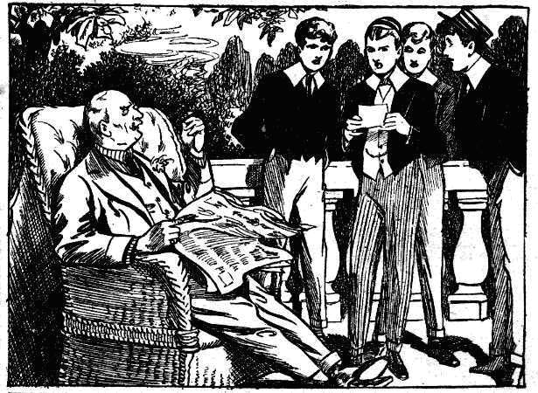
THE NINTH CHAPTER.
The Enemy of the Night!
THERE was a dead silence in the party on the sunny terrace.
The chums of Greyfriars stared at the card blankly. Lord Mauleverer was startled out of his usual placidity. Sir Reginald Brooke’s kind old face was quite pale.
An adder dropping from the leaves of his newspaper could not have startled the old gentleman more than that message from the unknown and mysterious blackmailer.
“ Upon my word!” said the old baronet, at last, breaking the silence. “This — this impudence passes all bounds!”
“But how—how the dooce did it get there, uncle?” exclaimed Lord Mauleverer.
“ I shall question the servants at once.”
Harry Wharton & Co. looked at one another. Mauly still held the card in his hand.
“ This beats me hollow, you fellows.” he said. “ That chap with the prize nose is a sticker—what ?“
“ Looks like it !“ said Bob.
“The stickfulness is terrific!” remarked Hurree Singh. “But the howfulness is a deep mystery.”
Mauleverer dropped into the hammock again.
“Of course, he’s tipped one of the servants to play this trick.” he said. “He can’t have got into the house himself. But it s odd—very odd. So far as I know, all the servants have been here for years. Uncle wouldn’t take any that weren’t reliable. It’s doocid odd——”.
“ You seem to have about three or four dozen,” grinned Bob Cherry. “ Might be a black sheep in such a big flock.”
“ The rotter means business,” said Harry Wharton. “But he doesn’t say how and when he wants the money to be paid. This is only intended to frighten.”
“Begad! It’s not so jolly easy to frighten a fellow!” yawned Lord Mauleverer. “Too warm to-day to be frightened. Waste of energy. Hallo! There’s our merry captain and first lieutenant! Show them the card, and ask what they think!”
At that moment Captain Hawke and Poynings joined the group on the terrace, and the baronet explained the strange situation to them.
“It is evident,” he concluded “that a desperate and reckless criminal has made my nephew his mark, and I shall be relieved when we are on board the Silver Scud, where Herbert will be quite safe from any attempt on his part. Meanwhile, I shall communicate with Scotland Yard on the subject. No expense shall be spared bringing thjs blackmailing scoundrel to justice!”
Captain Hawke nodded.
“ His lordship will be safe on the yacht, at least, sir.” he said. “ Not that I think this sea-lawyer, Gaunt, would be likely to go beyond threats.”
Poynings shook his head thoughtfully. “ He seems to have gone to action, on the occasion at the school.” he said. “But Lord Mauleverer is safe here. But if it should prove that the scoundrel is able to reach him—”
“That is impossible, in this house.” said the old baronet.
“I suppose so. Probably the man will do nothing further, on finding that his threats take no effect.” said Poynings.
“I hope so; but at the same time, every effort shall be made t discover him and send him to prison.” said Sir Reginald. “Such a character at large is a danger to society.”
The old baronet glanced rather anxiously at his nephew when the latter came in to lunch with his friends.
“You are not feeling disturbed, my dear Herbert?” he asked.
“Yaas!”
“Are you letting it trouble you!”
“Can’t help it,” said Mauleverer.
“My dear boy, you must surely know that every means will be used to protect you from possible danger.”
Lord Mauleverer opened his eyes.
“Danger!” he repeated. “Is there any danger? What’s happened?”
The old baronet blinked at him.
“I was alluding to the threat of the blackmailer
“Oh.” Lord Mauleverer chuckled. “I’d forgotten about that! I thought you wee speaking of the way Bob Cherry has been makin’ me chase about this mornin’, exhaustin’ me, you know, and wearin’ me out.”
Sir Reginald Brooke smiled, much relieved. It was obvious that the threats of the mysterious foe were not troubling the repose of Mauly’s noble mind, after all.
During the afternoon there were other visitors at Mauleverer Towers, and Mauly and his school chums had plenty to think about, without worrying over the mysterious foe. That matter, indeed, passed from their minds, and when bed-time came they were thinking about anything but the man with the hooked nose. Lord Mauleverer had had what he called an “exhaustin’” day, and he was glad to lay his head that night upon a pillow of the softest down.
Mauly was a good sleeper; with good health and a clear conscience, he never found it, necessary to woo slumber. As a rule, he hardly opened his eyes from bed-time till rising-bell. But on this special night he was not fated to rest undisturbed in the embrace of Morpheus.
What awakened him he did not know—perhaps it was a light touch. His eyes opened, and blinked into the darkness of the room.
Something moved in the darkness, and in an instant more the schoolboy earl was wide awake, every nerve tense. Somebody, or something, was in the darkness by his bedside; and steady and strong as Mauly’s nerves were, they thrilled and quavered.
“What—who—” he muttered.
“Silence!”
It was a whispered voice from the darkness, so close that it made Mauleverer start back.
“Oh gad!” he muttered.
“Silence! One call—and it will be your last!” said the low, hissing vice, strangely like the hissing of a serpent in the gloom.
Lord Maueverer tried to still the hurried thumping of his heart.
“Who—what—who are you?” he stammered, trying to pierce the darkness with his eyes.
“I am Gideon Gaunt!”
“Great gad!”
Lord Mauleverer shrank farther back, the beating of his heart almost stiled.
He knew the voice now: the sibilant tone in it was familiar to his ears. For the moment it seemed that his heart had ceased to beat., as he strained his eyes into the darkness. A shapeless, hovering shadow was all that he could see, till a sudden white gleam of light cut through the gloom. A tiny electric torch had been turned on close by the bedside of the schoolboy earl.
He started and blinked in the sudden glitter.
The torch moved, and then the light showed him the man who stood by his bedside.
The figure was hidden in a long, black garment, hardly distinguishable. But the face, with the light glittering upon it, was clear to Mauly’s startled gaze.
It was the face of the man who had chloroformed him in his study at Greyfriars—the face of the blackmailer calling himself Gideon Gaunt. The black hair and eyebrows and beard, the huge misshapen nose—Mauly knew that hideous and threatening face at a glance.
The light went suddenly out and all was blackness again.
“You know me?”
“I know you!” said Mauleverer, and, in spite of himself, his voice shook.
He knew that he was at the man’s mercy. There was a bellpush and an electric light switch close to the bedhead. But he had no chance to reach them with that threatening figure standing over him in the dark. Even if he could have rung the bell, help could not have come in time to save him if violence was intended.
Lord Mauleverer thought of the iron grip that had been laid on him in the study at Greyfriars—of the noxious fumes of the chloroform —and shuddered.
“You remember me, Lord Mauleverer?”
“I remember you.”
“Have you heeded my warnings?”
Mauleverer did not answer. He was trying to think how the ruffian could possibly have entered his room. His bed-room door, certainly, was never locked. But all outer doors and windows of Mauleverer Towers were secured at night. Was the ruffian a cunning and skilful cracksman, to whom bolts and bars meant nothing? Even so, how had he found his way in the dark to Lord Mauleverer’s room? How did he know which of the almost innumerable rooms was occupied by Mauleverer?
It was a baffling mystery. It gave the unfortunate schoolboy a feeling that the nan had some strange, unearthly power; that he came almost like a phantom of the night.
He wondered, indeed, in the silence that followed the black-bearded man’s muttered words, whether he was not dreaming. Surely it was a dream! Surely there was no threatening figure leaning over his bed! But the low, sibilant voice brought him back to sharp reality.
“You have not heeded my warnings, Lord Mauleverer! I have told you that ten thousand pounds is the price of your life. Listen to me! Will you gave your word of honour to persuade your guardian——”
“No.”
“Silence! To induce your guardian to take the money on board the Silver Scud, and to hand to the agent who shall get into touch with him at an agreed place—”
“No.”
“Not to save your life?” came in a deep, menacing whisper.
“Not to save a hundred lives, if I had them.” answered Lord Mauleverer steadi1y. “ I don’t know how you’ve got in here, you scoundrel, but care will be taken that you don’t do it again. You can’t scare me.”
“Do you think that my words are only an idle threat?”
“Yaas.”
Lord Mauleverer answered quietly and calmly ; he was master of his nerves again now. Slacker the schoolboy earl might be, but his courage was unbounded.
“ You shall see.” muttered Gideon Gaunt.
There was a movement in the darkness, and the sickly scent he knew so well came to Lord Mauleverer’s nostrils. He knew that the chloroform pad was approaching his face, and he made a desperate spring to escape.
But the bedclothes tangled him, and before he could free himself the iron grasp was upon him and he was crushed down.
One loud cry escaped his lips, however, before he was overcome.
“Help.”
That cry rang through the lofty room and echoed and re-echoed. The next instant the pad was over the schoo1boy’s mouth and pressed there, and his senses were swinming.
He struggled, but feebly, and as he struggled, more and more feebly, consciousness left him, and he lay helpless and inert in the grasp of the man with the black beard.
THE TENTH CHAPTER.
The Last Warning!
“HELP!”
Bob Cherry wondered for a moment whether he was drowning as that startling cry came to his cars in the silence of the night.
But it was no dream.
Bob started up in bed, but blinking round him. His hand caught the switch of the electric light and turned it on.
His spacious bed-room was flooded with light at once. Bob sat up in bed and stared round him.
He had heard a cry—a cry for help! He was certain of that. Whence had it come? And from whom?
The room next to his on one side was Lord Mauleverer’s, he knew; on the other side Harry Wharton’s—all opening upon the same corridor. Had one of his friends suddenly called?
“What the merry dickens?” muttered Bob, in bewilderment.
He was amazed, and, still half sleepy, he listened for a repetition of the cry. But it was not repeated.
“Was I dreaming?” he muttered. “Or—”
He jumped out of bed.
It was possible that that cry had been part of a dream. But Bob meant to know for certain whether anyone had called. It seemed impossible that any one could be in danger—in need of help—in the well-guarded house. But the remembrance flashed into Bob’s mind of the threats of the mysterious blackmailer. It seemed, even at that excited moment, wildly impossible that the ruffian could have penetrated into Mauleverer Towers in the dead of night, there to seek his victim. But the bare possibility was enough for Bob.
In his pyjamas, without stopping to throw on a single garment, Bob ran to his door and threw it open.
The broad corridor without was in black darkness.
The Greyfriars junior ran out into the deep gloom and hurried towards the door of Lord Mauleverer’s room. He groped his way blindly along in the darkness.
Surely if it was Mauleverer, and he was in danger he would call again! But no sound broke the stillness of the great house.
Bob groped along, and reached Mauleverer’s door. Something dark and shadowy moved there; his hands, outstretched, touched something in the darkness.
“ Mauly!” pantcd Bob.
Crash!
He went spinning as a savage, sudden blow reached him, and crashed on the floor. The impalpable shadow was gone ill an instant without sound.
Bob Cherry sprawled on the floor, dazed by the blow. He staggered unsteadily to his feet, shouting:
“Help! Help! Burglars! Help!”
Bob Cherry’s voice was a powerful one : it rang along the corridor and echoed almost like thunder.
Dazed as he had been by the savage blow, and though he felt the blood trickling from a cut in his face, Bob did not pause a moment. He groped into Mauleverer’s room, still shouting, and groped for the light switch near the door, and turned it on.
“ Mauly!” he exclaimed breathlessly. He ran towards the bed. Other voices were calling now, lights flashed in the corridor. Bob reached Mauleverer’s bed, and gave a cry. On the tangled bedclothes the schoolboy earl was stretched, insensible, and the sickly odour about him told the cause of his unconsciousness. But that was not all!
Driven to the hilt in the pillow, where Mauleverer’s head had pressed it in slumber, was a knife. The metal haft gleamed in the bright light.
“Mauly.” groaned Bob.
Harry Wharton appeared in the door-way.
“You, Bob! What---”
“ Mauly ! He’s been attacked!” panted Bob.
“Good heavens !”
“ What has happened ? What---”
It was the startled voice of Sir Reginald Brooke. “ My nephew! Good heavens! Herbert ! Herbert !”
The old man hung over the boy, his face white as a sheet. The great house was in an uproar now. All the Greyfriars juniors crowded into the room, and a few moments later Captain Hawke appeared, with Poynings, both half-dressed. A crowd of startled servants brought up the rear.
“What has happened?” exclaimed Poynings. “Can I be of any assistance, Sir Reginald?”
“The telephone! A doctor!” groaned the old baronet.
“At once!” Poynings rushed for the stairs.
Sir Reginald Brooks, with a shaking hand, drew out the knife that was planted in the pillow, within a foot of the schoolboy earl’s unconscious head. For the first few moments the dreadful thought was in his mind that the weapon had been intended for Mauleverer, and had only just missed him. But he observed a slip of paper attached to the haft of the knife.
Two words were written upon it in capitals, and two initials.
TAKE WARNING.
G.G
It was a threat—the last and most terrible threat of the desperate scoundrel. Mauleverer had been at the ruffian’s mercy—the knife that had been driven into the pillow might as easily have found his defenceless breast.
“Gideon Gaunt!” murmured the old baronet with trembling lips. “He has been here—here in this well-guarded house—here in my boy’s room. Good heavens!” Ho turned quickly and shouted: “Search the house! Search from cellars to attics!”
It was a night of excitement at Mauleverer Towers.
Lord Mauleverer had recovered consciousness before the doctor arrived, and was able to tell what had happened. The local police were at the Towers very soon after the doctor.
But in spite of the rigorous search, no trace was found of the man with the black beard and the misshapen nose. That he had come was certain, and that he had gone; but he had left no trace.
Like a phantom of the night he had come and gone, no one knew how.
The next morning there were grave faces in the Greyfriars party. Lord Mauleverer was pale, but he exerted himself to be calm and cheerful. But in spite of his nerve, it was obvious that the fearful experience of the night had told upon him.
That morning Captain Hawke and Poynings left the Towers to proceed to Southampton; but on the doctor’s advice, Lord Mauleverer remained a couple of days longer at the Towers. It was arranged for Harry Wharton and Bob Cherry to share his room at night, and during the day he did not quit the house without the company of some of his chums.
What step the desperate blackmailer might next take could not be guessed, but that he was determined to gain his purpose could not be doubted. And Harry Wharton & Co. could not help feeling, with a shudder, that he had the power, as it seemed, of carrying out his dastardly threats, and they looked forward anxiously to stepping aboard the Silver Scud where the wide sea would roll between Lord Mauleverer and his mysterious foe. And when the day same at last and the party went on board the yacht at Southampton, all the juniors breathed more freely, and Sir Reginald Brooke looked as if a load had fallen from his shoulders.
“All serene now!” said Bob Cherry, looking back at the widening waters of the Channel in the wake of the yacht. “All serene now, Mauly!”
Lord Mauleverer nodded, but he did not reply. There was a haunting thought in his mind that even on the yacht-even in the midst of the blue waters—he had not yet done with his mysterious
foe.
THE END.

“Better keep a safer distance!” said Nugent with an exaggerated expression of alarm. “Just a breath from the patient Is likely to do the trick.” The juniors backed away from the bed and held their hand-kerchiefs o v e r their mouths. Billy Bunter blinked at the scene with wide- open eye..
——

