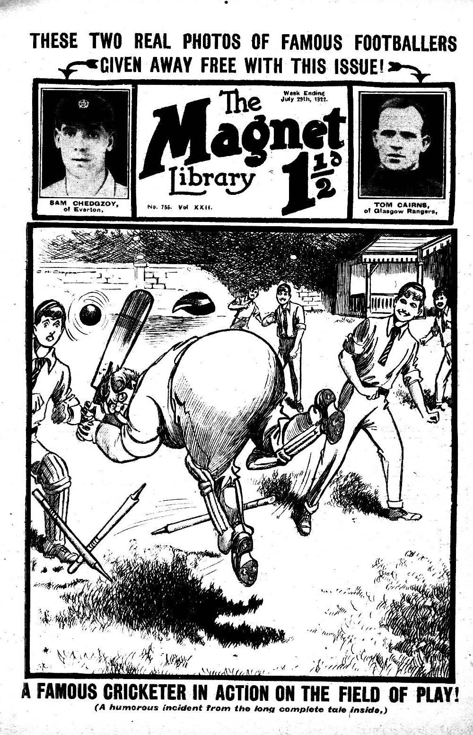
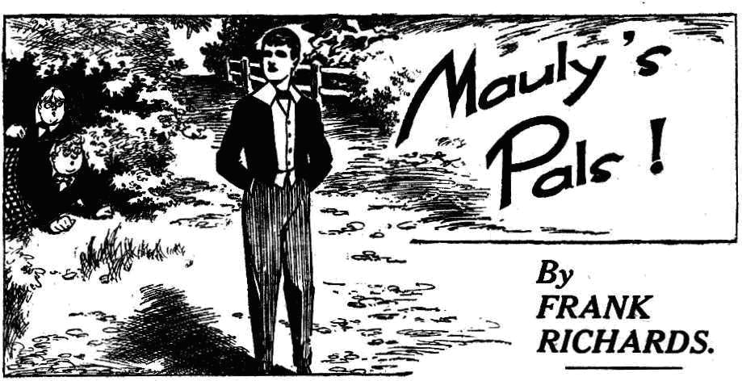
A Magnificent, Long, Complete Story, dealing with the Holiday Adventures of Harry
Wharton & Co., the famous chums of Greyfriars, telling how Lord Mauleverer makes
his list of guests for his Yachting Tour for the Summer Vac,
THE FIRST CHAPTER.
A Very Desirable Acquaintance!
“MAULY, old man!”
Lord Mauleverer groaned.
The sight of Billy Bunter never gave him delight. On the present occasion it seemed to fill him with dismay.
His lordship was sauntering at ease under the old elms in the Greyfriars quad. But as Billy Bunter appeared in the offing and hailed him, his lordship’s easy saunter was changed into a rapid walk—not towards Bunter.
“Mauly!” shouted Bunter.
Lord Mauleverer walked more quickly, still with his back to Bunter. He seemed to be deaf that afternoon. There were occasions when Billy Bunter’s acquaintances found it convenient to be deaf. This was one of the occasions.
“ Beast!” murmured Bunter.
The Owl of the Remove rolled in pursuit. He had a most particular engagement with Lord Mauleverer just then, and Mauly seemed to have a most particular engagement somewhere else— anywherc else so long as Bunter was not there!
“Mauly!” yelled Bunter.
Still his lordship was deaf. He walked still more quickly, and Bunter had to break into a run to keep pace.
Lord Mauleverer broke into a trot. He hated exertion, but he was capable of it in on emergency, and it seemed that was an emergency. He trotted past the elms and dodged into the Cloisters.
There he paused and looked back. Billy Bunter was not in sight, and his lordship breathed a sigh of relief.
“Thank goodness!” he murmured.
“I say, Mauly!” It was the voice of Skinner of the Remove, and Skinner spoke in his most dulcet tones.
“Oh dear!” said Mauleverer.
“Looking for you!” said Skinner affably. “Come for a stroll in the Cloisters, old man. Cooler than in this dashed heat.”
“I—I’m just goin’--”
“Come on !” said Skinner, unheeding, and he took Mauly’s arm and led him
on.
Mauleverer succeedcd in detaching his arm, but he walked on with Skinner. There was an apprehensive expression on his face, but Mauly suffered from a constitutional inability to say “No” to anybody. He resigned himself to his fate.
“I hear you’re making up a party for the vac, old man.” said Skinner.
“ It’a made up!” said Mauleverer hastily.
“Cruise in your uncle’s yacht, what ?” said Skinner.
“Yaas”
“Jolly lucky bargee to get a yacht to cruise in for the midsummer holiday, old nan.”
In quotes Yaas.”
“Taking a good many friends, what?”
“Only six.”
“Whartons crowd, I hear.”
“Yaas.”
“They’re five.” said Skinner. “Wharton, and Nugent and Bull, and Cherry and Inky, what?”
“Yaas.”
“And one more to make six!” said Skinner. “Now, this is really kind of you, Mauly.”
“Is it?” ejaculatet his lordship.
“Yes. The fact is, I shall like it immensely.
“Eh?”
“It’s jolly good of you to keep the sixth place for me,” said Skinner heartily. “Ever so much obliged.”
“But---”
“Not a word, old fellow; I’ll come!” said Skinner. “We’ll have no end of a good time. A life on the ocean wave, what? And a home on the giddy rolling deep. When do we start?”
Lord Mauleverer looked at Skinner. Harold Skinner was famed for his “neck,” but this was rather too cool, even for Skinner. Mauleverer nerved himself to resistance.
“The fact is, my relation Vivian is the sixth, Skinner.” he said.
“ Oh, is Jimmy Vivian coming?”
“Yaas.”
“That will make seven, then?”
“It won’t !” said Lord Mauleverer,
“Look here, Mauly---” began Skinner persuasively.
“ Oh dear, here comes Bunter!” Lord Manleverer departed at a rapid walk before Skinner could get any further.
“Mauly!” howled Bunter.
But his lordship was in full flight. Skinner was left scowling, but Bunter rolled in pursuit. His lordship escaped from the Cloisters, and in the quad he came on Snoop and Stott, who were looking for him. They barred his path at once, with smiling faces.
“Mauly, old man——”
“ I say, Mauly---”
“Sorry, got an engagement!” gasped Mauleverer. And he rounded the two juniors and hurried on.
The persecuted nobleman sought refuge in the School House. On the steps he was slopped by Bolsover major, who caught him by the arm as he washastening past.
“ Hold on a minute, Mauly!” said Bolsover, his usually surly manner changed for a sweet affability.
“ I—I’m in rather a hurry!” murmured Lord Mauleverer with a hasty glance behind. Bunter was in full pursuit, and coming up hand-over-hand, so to speak.
“ Well, you can spare me a minute, old chap.’ said Bolsover major good-humouredly. “I hear that you’re having the vacation on your uncle’s yacht.”
“Yaas.” groaned Mauleverer.
“Cruising around, and touching at places on the French coast ?”
“Yaas.”
“If you’d like a chap to come along who speaks good French and could act as interpreter —”
“Yaas. Wharton’s goin’ to.”
Bolsover major frowned.
“I wasn’t thinking of Wharton. The fact is, Mauly, I’d like to come.”
“Would you really?” said his lordship.
“I would, really! Is it a go?”
“No, dear boy, it isn’t a go!” said Lord Mauleverer, making an effort. “ I’m takin’ six, and the six are settled. Awfly sorry. Otherwise delighted, of course.”
“Look here——” began Bolsover, his sweet affability dropping from him like a cloak.
But Lord Mauleverer did not “look there.” He scudded into the House, and escaped into the remove passage. Just as he entered a bony hand clutched him by the shoulder, and Fisher T. Fish greeted him with an effusive smile upon his bony face.
“I guess you’re the very galoot I’ve been searching for, Mauly! ” said Fisher T. fish joyfully. “I hear that you are taking a leetle party——”
Fisher T. Fish got no further, because Mauleverer did. Mauly jerked his shoulder away and fled.
THE SECOND CHAPTER.
A Liberal Helping!
HARRY WHARTON looked out of the window of Study No. 1 in the Remove the following day, and smiled.
It was a half-holiday at Greyfriars; the last before the school broke up for the summer holidays. The July sunshine blazed down on the old quadrangle and the playing fields.
There were five juniors in the study— the Famous Five of the Remove. There were also a soda syphon and a bottle of limejuice. The Famous Five were refreshing themselves with those cool and comforting beverages, preparatory to proceeding to Little Side for the last cricket-match of the term. It was not an important match —only a little fixture with the Fourth Form, whom the heroes of the Remove were accustomed to beat. It was not an occasion when, as Bob Cherry put it, it was necessary for the Remove to pull up their socks.
“What’s on?” asked Bob Cherry, catching the smile on Wharton’s face, as the captain of the Remove stood at the study window.
“ Bunter!” said Harry, laughing.
His chums joined him at the window, and looked down. Lord Mauleverer was in view—and so was Billy Bunter. His lordship had been coming out of the house when Bunter was about to enter, and the Owl of the Remove had fastened on him at once. It was really rough on Mauly, who hated saying “ No.” that Bunter was a fellow who could not take “No” for an answer. Bunter apparently was prepared to listen to any number of “Noes” in the hope of hearing an ultimate “Yes.”
“Poor old Mauly!” grinned Bob Cherry. “His hair will be turned grey before the school breaks up, at this rate. Looks as if Manly will break up first.”
“Ha, ha, ha!”
“He could take half the Remove with him on the giddy yacht, if his uncle would stand it!” chuckled Johnny Bull. “Some of the Sixth, too! Loder has been awfully polite to Mauly the last few days.”
Coker of the Fifth called him ‘old chap’ this morning !” remarked Frank Nugent.
“Ha, ha, ha !”
“Mauly could never have known before how jolly popular he was !” said Harry Wharton, laughing.
“The popularity is terrific!” grinned Hurree Jamset Ram Singh.
“Nice for little us that Mauly has such jolly good taste in picking out his shipmates.” remarked Bob Cherry. “It will be ripping to have a jolly good cruise; and lovely not to see Bunter again till next term “
“Hear, hear!”
“Oh, really, Cherry—”
“Hallo, hallo, hallo!” ejaculated Bob, as the Owl of the Remove rolled into Study No. 1. “Has Mauly escaped already?”
Bunter frowned.
“Some Fifth Form cads have collared him, and cut off our conversation,” he said. “I was having a pleasant chat with Mauly when Coker and Potter and Greene came up. Cheeky cads butting in when old pals are having a talk, you know: I was telling Coker what I
thought of him when the beast kicked me—me, you know And Manly only laughed!”
“Ha, ha ! That wasn’t very pally, was it?” chuckled Bob.
“I say, you fellows, I’ll have some of that lime-juice.” said Bunter. “But I say, do you know, there seems to be some sort of misundertanding. Mauly forgot to mention to me that I was to come with the yachting-party.”
“What a memory !” said Bob.
“Of course, I’m coming. ” said Bunter. “Only, Mauly doesn’t seem somehow to understand—”
“Ha, ha, ha !”
“Blessed if I can see anything to cackle at! I hope you fellows haven’t been making
mischief between me and my old pal!” said Bunter, shaking his head seriously at the Famous Fite.
“Why, you fat chump ---”
“Some sort of a misunderstanding has arisen,. Anyhow.” said Bunter. “You know how attached Mauly is to me——”
“Only semi-attached, I should think.” said Bob. “ You don’t think enough of others, Bunter! Just think how a fellow will enjoy not seeing you again till next term!”
“Beast! Help me to that soda.” said Bunter. “ I suppose you don’t want the whole syphon, Cherry !”
Bunter pushed his glass of limejuice across, for Bob to put in the soda.
Bob Cherry’s rugged face was a study.
“I’ll help you!” he gasped.
And he did—but the soda-water was not directed towards Bunter’s glass. It was directed towards Bunter’s fat countenance.
Swish ! Splash ! Sploooosh!
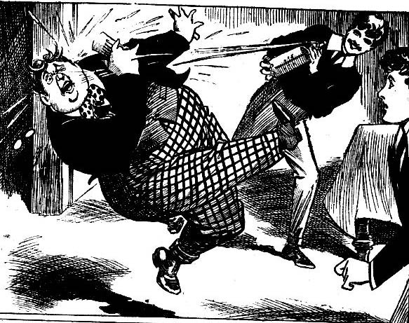
“Whooooooop !”
There was a wild yell from Bunter, as the soda stream caught him on his fat little nose, and cascaded over his podgy features.
“Hold on ; you’re wasting that soda !“ exclaimed Johnny Bull.
“The esteemed Bunter asked for it.” grinned the Nabob of Bhanipur. “ The askfulness was terrific !”
Swish! Splash!
“Yoop! Leave off—gerraway!” yelled Bunter, staggering away. Bob Cherry followed him up vengefully with the syphon. “Groogh! Ooooch! Beast! I’m soaked! Groooh! Gug-gug-gug--leggo! Leave off—beast! Wooooooch!”
The Owl of the Remove fairly fled from the study, streaming. Bob Cherry jumped to the door after him, and gave him the final squirt of soda in the back of the neck as he fled. Bunter travelled along the Remove passage to the stairs at a terrific rate.
“There!” gasped Bob, as he slammed down the empty syphon on the table “It was a waste; but---”
“Well, he distinctly asked for it.” said Harry, laughing. “Now you’ve done helping Bunter, and there’s no soda left, we may as well get down to the cricket.”
And the Famous Five picked up their bats, and strolled out of the study, and the School House, and headed for Little Side.
THE THIRD CHAPTER.
A Consolation for Bunter !
“I SAY you Fellows---”
Harry Wharton & Co. were on the junior cricket ground, waiting for Temple & Co. of the Fourth to turn up, when Billy Bunter joined them outside the pavilion.
Bob Cherry made a motion with his bat.
Bunter’s face had a newly washed appearance, doubtless due to his liberal allowance of soda water. But instead of looking wrathful— as might have been expected— William George Bunter wore a reproachful look. He gave Bob Cherry a dignified blink.
“I say, you fellows, don’t be beastly, you know.” said Bunter. “The fact is, I want you to put in a word for me.”
“Hallo, hallo, hallo! What’s the trouble now?” asked Bob, letting his bat drop again.
“ About Mauly ---”
“ Fathead!” said Wharton. “Mauly invited his guests himself; we can’t do it for him!”
“And we wouldn’t!” growled Johnny Bull.
“But you might put in a word.” urged Bunter. “you can explain to Mauly that you won’t enjoy the trip unless I come along---”
“Couldn’t tell such a thumping whopper as that!” said Bob Cherry, shaking his head.
“Tell him you’ll feel insulted if he leaves your best pal behind!” urged Bunter. “After all I’ve done for you fellows, you know —”
“What have you ever done for anybody, you fat fraud?” demanded Johnny Bull.
“Oh, really, Bull---”
“ You see, Bunter,” said Harry Wharton, “you’re such a dashed unpleasant sort of a bounder —”
“Oh, really, Wharton— ”
“ You spoil a holiday for everybody else concerned, you see. If you wouldn’t be such a selfish little fat beast---”
“ Pile it on!” said Bunter, with dignified resignation. “ When a chap’s down, pile on him!”
“Ass!” said Wharton uneasily. “Mauly couldn’t stand you on the holidays, and you know it, and it’s your own fault. But—look here—if you’d like to play for the Remove eleven for once, we’ll give you the chance, as—as a consolation prize.
Billy Bunter brightened up wonderfully.
Certainly he did not abandon his intention of “planting” himself on Lord Mauleverer for the vacation, if that could possibly be contrived. But he was glad to bag whatever was going, as it were. It was Bunter’s great ambition to “swank” as a fellow who played for his Form in big matches and he had long felt that he was a deeply-injured youth in being excluded from the Remove eleven.
“Done!” he said at once.
Harry Wharton’s comrades gave him grim look. Tempering the wind to the shorn Iamb was all very well; but cricket was cricket. And Billy Bunter played cricket about as well as he did everything else—which was not quite good enough for the Remove.
“You ass——” began Johnny Bull.
“Oh, draw it mild, Wharton!” chimed in Vernon-Smith. “We don’t want the Fourth to wind up the term by beating us!”
“Look here---” said Bob.
“Peace, my infants!” said the captain of the Remove soothingly. “ We can beat the Fourth playing a man short!”
“Yes,” said Bob ; “ but—” “You’re not going to play a man short? ” said Bunter, in surprise.
“Playing you becomes the same thing,” explained Wharton.
“ Oh, really, you know———”
“ Oh, give him his head!” said Frank Nugent. “We can beat the Fourth, any how. Here they come.”
Temple & Co. sauntered on to the field.
The two skippers tossed for innings, and it fell to the Remove to bat first. The innings opened with Bob Cherry and Vernon-Smith. Both these batsmen were well above the weight of the Fourth Form bowling, and they proceeded to knock up runs at a rate that would have made it safe to play two or three Bunters.
Cecil Reginald Temple, who patronised cricket in a lofty way, and did not believe in making work of it, was not likely to wind up the term by beating the Remove —much as he hoped to do so.
The Remove fellows were watching Bob and Smithy making the fur fl, when Billy Bunter entered the pavilion arrayed for cricket, with his bat under his arm.
The fat junior blinked at the field of play disapprovingly through his big glasses.
“Hallo! There goes Smithy!” exclaimed Peter Todd as the fat junior joined the cricketers by the pavilion.
The bounder was out for twenty seven runs. He cane cheerily back to the pavilion, and Wharton passed him, going in. Billy Bunter began to put on his pads. The fat junior was very keen on showing the Remove that afternoon what real batting was like, and he passed unheeding the grins of the other cricketers.
As soon as he was ready to go in he watched eagerly for a wicket to fall. But Temple, Dabney & Co. were kept busy leather hunting, and they did not seem able to touch either Bob Cherry or Harry Wharton. It was not till the score stood at 55 that Bob Cherry was caught out, and cane strolling back to the pavilion.
“Hallo hallo, hallo! Where’s Bunter going?” exclaimed Bob, as the Owl of the Remove started for the wickets.
“I’m going in!” snorted Bunter. And he went.
Might have kept the idiot for the the end of the innings, anyhow!” Bob commented. “ Still, it will encourage the Fourth a little. They want a little encouraging .”
In quotes And Bunter’s always worth watching with a bat in his paws!” grinned the Bounder.
And the Remove fellows watched, quite interested in billy Bunter as a cricketer.
THE FOURTH CHAPTER.
Bunter, the Cricketer!
BILLY BUNT probably felt himself the cynosure of all eyes, as he rolled to his wicket. He held his fat little nose high, and blinked the blink of self-importance. He paused as he passed Wharton, who was at the pavilion end.
“ Just a word.” he said.
“Get to your wicket.” said Harry.
“ I’m going to tell you what I want!” said Bunter, blinking at him. “ I don’t want any of your showing off, Wharton.”
“What!”
“Leave the run-getting to me ---”
“Eh?”
“What I want is some good, steady stone-walling.” said Bunter calmly. ‘ You can do that ! Just stop the leather and keep up your wicket, and leave the rest to me. I’ll pile up the runs. See?”
“So that’s what you want?” gasped the captain of the Remove, staring at his valuable new recruit.
“Yes, that’s just it,” as.5ented Bunter.
“Well, what you’ll get is something quite different, if you don’t shut up,” said Harry. “You’ll get a tap fron my bat! Catch on?”
“Yah !”
With that scornful monosyllable, Billy Bunter marched on to his wicket, loftily indifferent to the fact that, he was keeping the field waiting. They could wait for on important person like Bunter, and if they didn’t like it they could lump it. That was how William George Bunter looked at it.
However, he took up his stand at last. Harry Wharton had the bowling in the new over, and he received the ball from Temple of the Fourth, and drove it well away. he started running. Billy Bunter didn’t. He blinked round him and blinked at Harry Wharton, and stood his ground. Wharton was half-way along the pitch before he realised that his fat partner at the wickets did not intend to run.
He was powerfully moved to complete the run, and lay his bat about William George Bunter ; but instead of that, he turned and ran back. But for once a Fourth Form fieldsman sent in the ball smartly, and the wicket-keeper rapped the bails.
“How’s that? ”
“Out !”
Billy Bunter smiled serenely.
Perhaps he felt that, with a fellow like himself in the game, one wicket more or less did not matter very much.
Harry Wharton’s feelings were too deep for words as he carried out his bat.
Frank Nugent gave him a sympathetic grin as he went in to take his place. Frank took a single for the next call, Bunter condescending to stir from his wicket on this occasion, and rolling along the pitch like a very active snail. However, he got home in time.
Then he stood up to face the next ball.
“Now look out for fireworks!” murmured Bob Cherry.
Temple of the fourth grinned as he prepared to deliver the ball. He had not had much luck with his bowling so far, but Cecil Reginald felt that he could deal with a batsman like William George Bunter.
“The fireworkfulness will be terrific!” remarked the Nabob of Bhanipur.
Temple took a little run, and sent down the ball like a bullet.
Bunter was ready for him.
He made a terrific swipe at the ball. He put all his beef into that terrific swipe.
Crash!
What happened next Bunter hardly knew.
His bat seemed to get mixed with the wicket, and himself with the bat, and where the ball went Bunter did not even begin to think of trying to discover.
All he knew for certain was that he came down upon the solid earth with a terrific bump—and never had the earth felt so solid!
“Yoooop!” roared Bunter.
“Ha, ha, ha !” yelled the whole field.
“Yarooh! Oh, my hat! Wow!”
“How’s that?“ shrieked Temple.
“Ha, ha, ha!”
Bunter sat up and blnked round him dazedly. His wicket was a wreck, and he felt like a wreck himself.
“I say, you fellows!” he gasped.
“Out!”
“ I’m not out!” gasped Bunter. “ My foot caught in something---”
“Ha, ha, ha!”
“Out!”
“Clear off, Bunter!” said Johnny Bull coming out to take the place of the Owl of the Remove.
Bunter scrambled up indignantly.
“I’m jolly well not clearing off !” he exclaimed hotly. “You get out of the way, Bull!”
“You silly ass, you’re out!” roared Johnny.
“Rats! That was only a trial ball, anyhow!”
Johnny Bull did not argue the point with Bunter. He trusted the matter to his bat. Billy Bunter gave a ferocious yell as the end of the bat collided with his fat ribs.
“Yah! Ooooop!”
“Is that out, or will you have some more?” asked Johnny Bull.
“ Beast !”
One lunge in the ribs was enough to convince Bunter that he was out. He rolled back to the pavilion, gasping with indignation, followed by a roar of laughter.
Billy Bunter retired from the cricket field in indignant wrath. He left the match to go to pieces without him, as he confided to his minor, Sammy of the Second Form. He admitted that he was sorry, but, in the circumstances, he felt that he was justified in letting the match go to pot.
But as it happened, Bunter’s valuable aid was not missed by the Remove cricketers. They succeeded in beating the Fourth by a comfortable margin of 40 runs— a result which was surprising to Cecil Reginald Temple and to William George Bunter.
THE FIFTH CHAPTER.
Tea In Loder’s Study!
“LODER!”
“Yes.”
“Oh dear.”
Lord Mauleverer sighed, and Sammy Bunter grinned. Sammy of the Second had brought the message to Study No. 12 in the Remove, and evidently it was not a welcome message.
“ Don’t worry!” grinned Sammy. “Loder of the Sixth looked quite good-tempered—for him. It ain’t a licking.”
“I know it isn’t!” mumbled Lord Mauleverer.
“Then what’s the worry!” asked the fat fag. “ I say, I believe Loder is going to ask you to tea, Mauleverer!”
Another sigh from his lordship.
It was rare for Remove fellows to be asked to tea in Sixth Form studies, but in the present circumstances it was not surprising.
Since it had leaked out that Mauleverer was taking a party of fellows on a yachting cruise for the vacation, Maulevérer had not only become the most popular fellow at Greyfriars, but he had discovered friends—indeed, bosom pals—in all Forms--- even the Sixth!
Lord Mauleverer sat up, with a dismal countenance. His study-mate and relative, Sir James Vivian, looked at him across the table.
“What’s the worry, Mauly?” asked Sir Jimmy.
“Lots! I suppose I’ve got to go.”
“Well, I,oder will come and look for you. with a cane if you don’t!” grinned Sir Jimmy “But if it’s tea, it s all right. You don’t often get asked to tea with the Sixth.”
“Thank goodness !” mumbled Lord Mauleverer. “Bother his tea! Bother Loder! Bother the yacht! Oh dear!”
Sir Jimmy chuckled.
“Oh, that’s it, is it?” he said. “Mind you don’t say ‘ Yes,’ Mauly! I couldn’t stand Loder on a holiday. You nearly said ‘Yes’ to Coker of the Fifth yesterday.”
“It’s so beastly to say ‘ No ‘ to a chap!” groaned Lord Mauleverer; “and some chaps won’t take ‘ No’ for an answer. Bunter, f’rinstance.”
“Shall I come and say ‘No’ for you? ” asked Sir Jimmy.
“ Begad, no! Loder would lay into you with a cane. I suppose I must go.”
“Oh, here you are!” came Billy Bunter’s voice from the doorway.
But Lord Mauleverer hurried past Bunter before that fascinating youth could proceed further.
With slow and lingering steps, after he had reached the Sixth Form passage, his lordship approached the door of Loder’s study. But he arrived there at last, and tapped.
“Come in!” called out Loder, and the geniality of the tone showed that he knew who was at the door.
The schoolboy earl entered. Loder and Carne were in the study, and Loder’s fag had spread the table for T. The two Sixth-Formers nodded to Mauleverer in a very genial way. Geniality was the last thing that Loder and Carne, as a rule, thought of wasting on the Remove. The motive was only too apparent to his lordship.
“Oh, it’s you, kid!” said Loder. “Trot in! Sit down! Give Mauleverer a comfy chair, Carne.”
“Here you are, kid” said Carne.
“Thanks!”
His lordhip sat down. He was glad to sit down, at all events. He always preferred sitting to standing.
“You’re going to have tea with us,” said Loder jovially. “The truth is, Mauly—I mean, Mauleverer—we haven’t seen enough of you. To my mind, there’s too big a gulf between the Upper Forms and the Lower. Prefects and juniors ought to come a bit more into contact—in a social way, I mean.”
“Good for both sides, you know.” said Came.
“That’s what I mean.” said Loder. “Good for the school in every way. Of course, it isn’t every junior with whom a prefect of the Sixth could be friendly. But there are exceptions.”
“Mauleverer is one.” remarked Carne.
“Exactly. Do you take sugar, Mauleverer?”
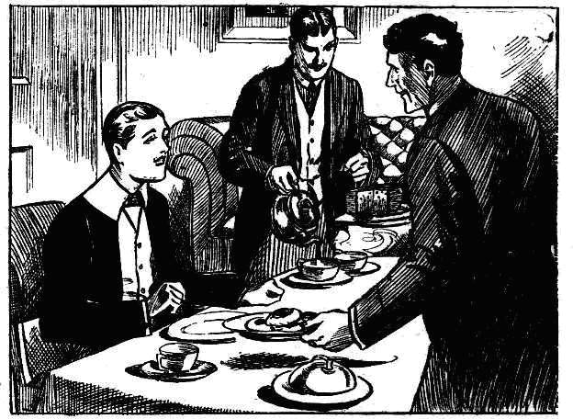
“Yaas, please !”
Lord Mauleverer resigned himself to his fate. There was no getting out of tea in Loder’s study, at all events. He did not object to tea, so far as that went.; but he could not help feeling that he was getting a “whack “ in a Sixth Form spread under false pretences. For he had no intention whatever of issueing the invitation for which the two seniors were fishing. Refusing anything to anybody was painful to Mauly; but having Loder and Carne on his uncle’s yacht during the holidays would have been more painful still. Better anything than that!
But he couldn’t very well say so, before the fishers had approached the subject. So he sat down to tea with a worried brow.
Loder and Came looked after Lord Mauleverer during tea as if his lordship had been the apple of their combined eyes.
They helped him to everything, and would not let him raise a finger to help himself, if they could prevent it. And every kind of delicacy that the school tuckshop could provide was on the table. Loder and Carne had gone to quite a little expense. It was a sprat to catch a whale, ant they did not know yet that the whale was not to be caught.
So genial were the two prefects that Mauly cheered up a little, and even began to hope that Loder and Carne would not approach the dreaded subject. It was barely possible that these two seniors had been misjudged, and that they were really very nice fellows at bottom, and that their unsuspected niceness was now displaying itself. Lord Mauleverer fervently hoped so, but he could not help feeling a lingering doubt.
Tea was nearly over, and Manly was nearly at his ease, when Loder came to the subject of the vacation. Lord Mauleverer pricked up his ears, rather like a rabbit that hears a dog at hand.
“You’ll be coming up to Scotland with ne for the vac, Carne?” Loder remarked.
“Oh, yes, old fellow!”
Lord Mauleverer smiled with relief. If Loder and Carne were going up to Scotland for the vac, he was safe.
“Now, I was thinking that Mauleverer might come!” said Loder. “‘What do you say, kid? We should be glad if you’d be our guest.”
“Pleased !” said Carne. “Mauleverer would have a good time, no doubt about that. And we’d like his company.”
“It’s settled,” said Loder. “You’ll come, kid?”
“Thanks awfly!” said Mauleverer. “It’s jolly kind of you to ask me !”
“Not at all. You see, we like your company.”
“That’s it!” observed Carne.
“But you see, I’m booked for the vacation,” explained Lord Mauleverer, “otherwise I should be delighted.”
“Booked?” said Loder, with a glance at his comrade. “Is that really so, Mauleverer?”
“Yaas! Sorry!”
“Couldn’t you cry off?” asked Came.
“Not very well—you see, I’ve invited a little party.” said his lordship.
“Well, that alters the case. said Loder thoughtfully. “But I’d really like to see more of you during the vac, kid. Perhaps we could manage it the other way round?”
“That’s an idea!” remarked Carne. “Instead of Mauleverer comin’ with us, we could go with Mauleverer, if he cared for it.”
“Not a bad idea !“ said Loder.
Lord Mauleverer sat down his tea-cup. It had come at last, and he realised it. Without being unduly suspicious, he could not help being pretty well aware that Loder and Carne had arranged that little chat about taking him to Scotland for the holidays in order to bring in their real aim a little less obtrusively. Mauly was a slacker, and he was not very keen ; but he was no fool.
“Might be arranged,” said Loder, in a reflective sort. of way. “ I should have to put in some time in Scotland. but no doubt we could fix it up. Where will you be on the vac, Mauleverer?”
“At sea.” answered Mauly, quite aware that Loder knew that already. Otherwise, why had Loder been so gracious for the past few days?
“At sea!” repeated Loder, as if it were news to him. “I don’t quite catch on! Goin’ abroad?”
“My uncle’s takin’ me on his yacht,” said Mauly.
“You’ve got so many uncles.” said Loder, with a smile, “ Which uncle is this?”
“Sir Reginald Brooke.’
“Ah! I think I’ve met him—he came down here once or twice.” said Loder. “Well, I think I could put in a few weeks on the yacht, if it comes to that.”
“I think I could manage it.” said Carrie thoughtfully. “But Mauly hasn’t asked us yet, old fellow,” he added, with a genial smile.
Loder laughed pleasantly.
“I forgot that! I suppose. Manly is goin’ to ask us. That is, of course, if he cares for our society.
Lord Mauleverer blinked across the table at the two seniors. It was an awkward position. Mauly hated to hurt anybody’s feelings; and now that the two Sixth-Formers had fished so openly, it would have been humiliating for them to meet with a refusal. But the slacker of the Remove could be firm—and he did not think of yielding. He did not want Loder and Carne for the holidays, and he was not going to have them—fished they ever so palpably.
“I’m sorry— “ began Mauleverer.
“The fact is, the party’s made up,” said Mauleverer uncomfortably. “It’s limited to six—all juniors ; otherwise——”
Loder set his lips, and Carne scowled. After their genial condescension to a mere junior,a fag of the Lower Fourth - that was a facer for the Sixth-Formers. Besides, they wanted a yachting cruise for the vacation. A few weeks on Sir Reginald Brooke’s superb steam-yacht attracted Loder and Carne very much.
“Come, kid,” said Loder, with determined good-humour, “you don’t mean that you prefer fags’ society to ours. That’s not very complimentary, is it?”
“You—you see ---“
“Bring the fags too, if you like.” said Loder generously. “Now, shall we call it settled, old chap?”
“I’m afraid not.” said Mauleverer. “You see, I—I—the fact is—ahem—I can’t add to the party. Awf’ly sorry, and all that. Otherwise, I—I should be delighted.”
He rose to his feet, feeling that it would be prudent to be prepared for a hurried departure.
Loder and Carne looked at him. Probably they had expected to wind the easy-going Mauly round their fingers without difficulty. The honour of Sixth Form society on the vacation ought to have overwhelmed him—he ought to have jumped at this chance. The disappointment and the annoyance that they felt showed only too plainly in the seniors’ faces. Loder rose to his feet and made a sign to Carne. That youth strolled across the study and leaned his back against the door.
“Oh, gad !“ murmured Lord Mauleverer, in disnay.
“So you’ve taken our little joke seriously, you young ass?” said Loder, changing his tones quite suddenly.
“Oh, you were jokin’ !” ejaculated Mauleverer.
“Do you think we’d really spend a vac with a Remove fag?” snapped Loder
contemptuously.
“Yaas!”
“What?” roared Loder.
“I—I mean—”
“Cheeky cub!” said Carne. “Amusin’ to pull his leg, and all that, but I can’t stand cheek from a fag, Loder.”
“Same here!” said Loder “Have you done your lines, Mauleverer?”
“My——my lines?”
“Yes! Have you done them?”
“I’—I haven’t any lines!”
“Didn’t I give you fifty lines yesterday for sliding down the banisters ?” asked Loder pleasantly.
“Begad, I never slide down the banister. ! Too much fag !”
“Did I give you lies or not?” roared Loder.
“Nunno !”
“Your memory’s bad, my boy.” said Loder, taking up his cane. “I’m sorry to have to lick you after a pleasant tea-party, but duty must be done. Can’t let fags kick over the traces just because we’re at the end of the term.”
Wouldn’t do at all.” remarked Carne. “Hold out your hand, Mauleverer!”
“Oh, gad! Look here, you’re not goin’ to cane me because I won’t take you on my hands for the vac!” exclaimed Lord Mauleverer indignantly.
“You cheeky young scoundrel.” roared Loder, “I’n going to cane you for not doing your lines! I’ll give it to you extra stiff for your cheek, too. Hold out your hand!”
“Look here—”
Loder strode round the table, cane in hand. Lord Mauleverer made a jump for the door. Carne seized him by the collar and spun him back.
Whack! whack! whack!
Loder started in with the cane, and the voice of Lord Mauleverer was raised in tones of woe.
“Wow, wow, wow!”
“Hallo, hallo, hallo! They’re going it!” roared a voice in the passage. “Come in, you fellows!”
The next moment the door of Loder’s study was hurled open from without, and Harry Wharton & Co. rushed in.
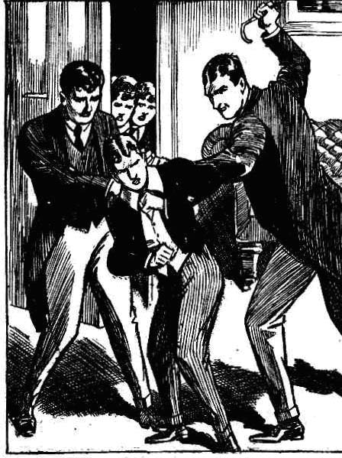
— — —
THE SIXTH CHAPTER.

Looking After His Lordship !
“RESCUE!“ roared Lord Mauleverer.
“Pile in!” roared Bob Cherry.
“Get out of my study!” roared Loder.
“Hands off Mauly!” exclaimed Harry Wharton.
“You cheeky fag!”
“You rotten bully!” retorted the captain of the Remove undauntedly. “Let Mauly alone Hands off, I tell you !”
Loder brought the cane down with a slash: Harry Wharton caught his arm in time, and dragged it aside.
Having captured the Sixth-Former’s arm, he hung on to it. Frank Nugent captured Loder’s other arm.
Lord Mauleverer wriggled away, gasping.
Carne ran at the juniors, and the next moment was struggling with Johnny Bull and Bob and Hurree Singh. The struggle landed on the carpet, with the three juniors sprawling on him.
“Let go!” roared Loder furiously, struggling with Wharton and Nugent.
The powerful Sixth-Former had almost succeeded in shaking them off, when Sir Jimmy Vivian obtained a grasp on his collar behind. Loder went over backwards with a crash.
“Oh, gad!” gasped Lord Mauleverer, blinking at the exciting scene, almost unprecedented in a Sixth Form study at Greyfriars.
“Gerroff!” roared Carne.
“Yow-ow-ow!” shrieked Loder. “I’ll smash you! I’ll scrag you!” I’ll—I’ll—I’lI—yoooooop !”
“Ha, ha, ha!”
Loder and Carne rolled on the study carpet, with six juniors scrambling over them.
Chairs went flying right and left, and the table rocked as the combatants crashed against it. There was a clatter as cups and saucers shot to the floor.
Loder and Carnc were helpless now, in the grasp of so many assailants. Harry Wharton jumped up.
“Hook it!” he said briefly.
“ Come on, Mauly!” grinned Vivian.
He caught the schoolboy earl by the arm and dragged the dazed youth out of the study.
The Famous Five covered the retreat, backing to the door in a solid phalanx, ready for an attack in the rear if it came.
But Loder and Carne were not thinking of attack. They felt too used-up for that. They sat on the floor, dazed, and dizzy, pumping in breath. They only gasped and blinked as the chuns of the Remove retreated.
Harry Wharton was the last to leave, and he slammed the door, after waving his hand in farewell to the Sixth-Formers.
Then the Removites hurried away to their own quarters, anxious to get out of the Sixth Form passage. Lord Mauleverer was in a breathless and dizzy state when he arrived in the Remove passage.
“Thanks awf’ly, you chaps!” he gasped. “I—I was goin’ through it, you know! Oh dear! Oh gad ! But—but how did you come to be near Loder’s study just then, what?”
Harry Wharton laughed.
“Vivian gave us the tip. he explained.
“Little me!” chuckled Sir Jimmy. “ I knew what Loder wanted, and that he would cut up rusty if he didn’t get it. So I hiked along to these chaps and told them, and we all waited in the Sixth Form passage till the row began. Savvy?’
“ Jolly lucky for me!” gasped Mauleverer. “But, I say, there’ll be a row about this. You can’t handle a Sixth Form prefect in his own study, you know!”
“Oh, we’ll chance that!” said Harry. “You haven’t asked Loder for the vac on the yacht, I gather from what happened.”
Lord Mauleverer grinned.
“No, Loder isn’t comin’!”
“Good!” said the Famous Five, with one voice. “If you’d let him plant himself on the party, Mauly, we’d have scragged you!”
“Scalped you bald-headed !” said Sir Jimmy. “And, look here, if Loder kicks up a row about that scrap, we’ll let everybody know what the row was about. I fancy he will keep off the grass if he thinks of that.”
“Let’s hope so.” said Bob Cherry. As a matter of fact, Sir Jimmy Vivian was right. Loder’s first thought, when he got his second wind, was to seize his ash-plant and rush instantly to the Remove passage and wreak vengeance. Fortunately he had second thoughts, which are proverbially the best, in time to stop him. He realised that it would not do. Not that Loder was inclined to forgive. He was prepared to let the sun go down on his wrath any number of times, and his wrath, like wine, would grow more potent with age. But for the present Loder, like Brer Fox, lay down and said ‘nuffin’. And Carne followed his example.
Lord Mauleverer, as he stretched his weary limbs on his study sofa and watched Sir Jimmy at tea, was greatly relieved not to see Loder come visiting. But his lordship was not left without visitors.
Coker of the Fifth dropped in to speak to him, with a genial grin on his rugged face. Lord Mauleverer sighed, and Sir Jimmy grinned ; and Coker, apparently puzzled both by the sigh and by the grin, looked from one to the other.
“I’ve been thinking about the vac, Mauleverer, he said in his lofty, patronising way. “Steam-yacht—cruising around for weeks— that’s your program, I understand?”
“ Mauly isn’t asking any of the Fifth.” put in Sir James Vivian.
Coker stared at him.
“I suppose a Remove fag wouldn’t have the cheek to ask a Fifth Form chap to come on a holiday with him,” replied Coker. “Jolly likely to get a thick ear if he did, I think.”
“Oh, my eye !“ said Sir James.
“But,” continued Coker, turning his attention to Mauleverer again, “although it would be cheeky of you to ask a Fifth Form chap, there’s no reason why a Fifth Form chap shouldn’t condescend to come with you, if he fancied the idea. Now, I’ve thought about it, and I rather like the idea, Mauleverer, and, in short, I’ll come.”
Coker made that statement with much graciousness of manner. Apparently he expected to see Lord Mauleverer overwhelmed with thankfulness at his condescension.
“I’m not askin’ any of the Fifth! I wouldn’t be found dead on a vac with anybody named Coker, see ?” said Mauly.
“Catch on ?” chuckled Sir Jimmy. Coker did not seem to catch on immediately. He blinked at Lord Mauleverer blankly, as if doubting the evidence of his ears.
“You cheeky young sweep!” he roared at last. “Are you asking me to give you a thundering good hiding?”
Five grinning faces looked in at the doorway. The Famous Five had spotted Coker on his way to Study No. 12, and they understood that they might be wanted. So they were cruising in the offing, as it were, prepared to deal with Horace Coker even as they had dealt with Lodr of the Sixth.
Coker did not see them, as his back was to the door. But Mauly saw them from the sofa, and he beckoned.
“Trot in, you fellows!” ho yawned. “Would you mind chuckin’ Coker out on his neck? As a special favour.
“Any old thing,” grinned Bob Cherry.
Coker of the Fifth spun round.
“Now then, you grubby fags—” he began truculently.
“Are you going out on your feet or your neck, Coker?” inquired Harry Wharton politely. “Take your choice.”
Coker’s answer was a rush at the captain of the Remove. The next moment Coker was mixed up almost inextricably with the five juniors, and the whole party struggled and rolled through the doorway. The next that Coker knew, he was rolling down the Remove staircase, feeling as if he were in several pieces.
Lord Mauleverer settled down on the sofa for a rest. He felt that he deserved a rest.
THE SEVENTH CHAPTER.
A Deep-laid Scheme!
“ SAMMY, old fellow———”
“Can it!” said Bunter minor
Bunter minor’s response to this majors affectionate greeting was short, if not sweet.
Sammy knew his major. Brotherly love was not a distinguishing characteristic in the Bunter family. When Billy had guessed Sammy has “ old fellow, “ it meant that Billy wanted something. And Sammy Bunter’s reply was in the negative, even before he knew what was wanted.
“Look here, old chap——” said Billy.
“Can it !“ said Sammy again tersely.
“Bottle it! Wrap it up and bury it!”
Billy Bunter breathed hard.
“I want you——” he recommenced.
“I know!” said Sammy, with a nod.”
“Nothing doing! The fact is I was going to borrow something of you, only you’re so jolly mean. Nothing doing, Billy! So can it!”
With that answer Sammy Bunter rolled away. But Bunter major followed him, and caught him by a podgy shoulder.
“ Hold on, you fat bounder!” said Bunter. “I’ve got something to say.”
“Well, you can say anything you like.” said Bunter minor. “I‘m not going to lend you anything.”
“I don’t want you to. In fact, I’m going to put you on a good thing,” said Billy Bunter impressively.
“I don’t think!” remarked Sammy.
“I’ve got an idea ---!”
“Draw it mild !”
“You know Mauly’s going on a yachting cruise this vac, Sammy.” said Billy Bunter, on heeding his minor’s disrespectful manner.
Bunter minor chortled.
“I fancy the whole school knows it.” he said.
Bunter did not answer that.
“Of course, I’m going on the yacht,” said Billy. “I couldn’t possibly think of deserting a pal like Mauly, because of fellows he hardly knows butting in. Don’t cackle when I am speaking to you, you little fat beast! Now, as Mauly has been influenced against me, I’m going to work it.”
Sammy looked interested at last.
“You generally manage to squeeze in, if there’s anything going,” he admitted. “ I say. could you work it for me, too?”
“ Mauly couldn’t take a Second Form fag. Besides, it‘s impossible.”
“Then what the dickens does t matter to me whether you work it?” asked Sammy discontentedly,
“Well, as my brother, you’re bound to back me up——”
“Rats!” was Sammy’s brotherly reply.
“I want you to help me work it.” explained Bunter.
“And where do I come in?”
“Eh? You don’t come in at all!”
“Then you can jolly well leave me out of your precious scheme, whatever it is.” said Sammy promptly. “Nothing doing.”
“Well, look here, I’ll do what I can, if I wedge in---I mean, if 1 get Manly to —to treat me as a pal, as he really would like to do,” said the Owl of the Remove. “Besides, if I don’t come home for the vac, I’ll lend you my bike for the holidays.” —
Sammy Bunter seemed to relent.
“Well, it would be nice not to have you home for the holidays!” he observed. “That’s worth a little trouble. What’s the stunt?
Billy Bunter blinked round him cautiously. Evidently what he had to say was for Sammy Bunter’s ears alone.
Having made sure that there were no eavesdroppers, he drew his minor to a seat under one of the old elms.
“ Now, you listen.” he said. “ I’m going to touch Mauly’s heart and make it practically impossible for him to treat me in this scurvy way. You can help, old chap. I’ve thought it out carefully, and it’s bound to go without a hitch, if you play up. Mauly’s going to the bank at Courtfield to—morrow.”
“What about it?” yawned Sanmy.
“He will have a lot of money on him when he comes back.” said Bunter. “Now it’s rather lonely where the road goes over the common between here and Courttield. Mauly might be attacked on the road.”
Sammy Bunter jumped.
“ You—you’re thinking of robbing Mauly!” he gasped .
“You silly ass!” roared Bunter. “Of course not!”
“Oh! Then what’s the game?”
“He’s attacked by a footpad, you thundering idiot!” said Bunter. “I’m on hand, and run up and save him. See?”
“More likely to run the other way, I think.”
“It won’t be a real footpad.” said Bunter impatiently. “ It’s a spoof to take Mauly in, of course. He’ll let m knock him down and rescue Mauly all right.”
“Oh, I see! You’re getting a chap to do it?”
“That’s it.”
And who’s the chap ?”
“You!” said Billy Bunter.
“No jolly fear !” said Sammy emphatically. “Cut it out ! Catch me playing a silly mug’s game like that! Why, Mauly could knock me into a cocked hat!”
“He wouldn’t dare.” said Bunter. “I can fix you up in disguise, of course.”
“I know where they keep the dramatic society things.” urged Bunter. “I can get at the ‘ box in Wibley’s study and bag a false beard and moustache and some rough clothes. I’ll make you up on the common, and Mauly won’t know you from Adam. You brandish a big bludgeon at him——”
“Oh, my hat!”
“And say, “Stand and deliver——”
“Real footpads don’t say “Stand and deliver!” objected Sammy.
“Well, say anything you like.” said Bunter impatiently. “ It won’t last a minute, anyhow. I run up and knock you down—”
“Do you?” said Sammy warmly.
“I must keep up appearances, of course.
“I know I shalI pitch into you if you knock me down.” said Sammy, unconvinced.
“Look here, Sammy, if you’re going to spoil the whole thing—”
“You ain’t going to knock me down, unless you jolly well want a dot in the eye!” said Bunter minor obstinately.
Bunter gave an angry grunt. It was really exasperating, for trifling objections like this to be raised, when he was outlining a masterly scheme.
“Well, we might leave out the knocking-down part.” he said reluctantly. “Only it ought to be lifelike.”
“Make it a lifelike as you can without that!” suggested Sammy. “Mind, I haven’t said yet that I’ll do it at all !”
“Well, you fall over when I push you,” said the Owl of the Remove. “ Yell as if you were hurt, you know.”
“I could do that!” assented Sammy. “I get off lickings that way in the Form-room. That’s easy.”
“Then you bolt and leave Mauly with his brave rescuer,” said Bunter. “After that he can’t help asking me for the vac, can he? Common decency, you know, and gratitude, and so on.”
“ It might work!” said Sammy.
“It will work all right if you back me up!” said Billy Bunter confidently.
“And where do I come in? ”
“Now, look here, Sammy, if you going to be selfish and mercenary—”
“Can it!” said Sammy. “Is it worth ten bob?”
“I---I haven’t ten bob.”
“ It it works you can touch Mauly for ten bob easily enough” said Sammy brightly.
Bunter considered.
“Yes, there’s something in that.” he assented. “He could scarcely refuse to cash a postal-order for me after I’d rescued him at the risk of his life. If it’s a success I’ll make it ten bob, at least. There!”
“And your bike for the holidays, anyhow, whether it’s a success or not?” asked Sammy
“I’ll do it.” said the fat fag. “Mind, I don’t think there’s much in it. You’re such a silly ass, Billy. But I’ll do my part all right, and you can do your best.”
He rose from the seat under the tree. “I say, Billy, can you lend me a tanner off the ten bob”
“No!” growled Bunter.
“Now I come to think of it, I’ve got an engagement for to-morrow afternoon!”
“Look here, Sammy——”
“Look here, Billy——”
Billy Bunter groped in his pocket, and produced a sixpence, which he dropped into his minor’s fat palm. And so the affectionate brothers parted.
THE EIGHTH CHAPTER.
In Deep Disguise!
AFTER dinner on the following day Billy Bunter disappeared,
He was not missed.
Fellows who were honoured with Billy Bunter’s acquaintance never missed him when he wasn’t present. If they thought about him at all at such times, it was only to hope that he wouldn’t turn up.
So it was quite easy for the fat junior to abstract himself from Greyfriars without anybody taking the trouble to observe the fact.
Sammy of the Second found it equally easy .
Both the Bunters were gone after dinner, secretly and mysteriously, and Greyfriars School went on the even temper of its way, knowing it not.
Certainly, Lord Mauleverer, knowing nothing of the Bunter’s kind intentionstoward him, did not think of them. Besides, his lordship had plenty of food for thought just then.
He had to go to Courtfield to visit the bank, for the purpose of collecting a handsome little sum of ready cash. Plenty of fellows would have been pleased to take the task off his noble hands, and would not have regarded it as an infliction. But Mauly had never been short of money, and, to him, the visit to the bank was one more trouble added to the already innumerable troubles of existence.
Still, he nerved himself for the effort. The debate in his mind was on the perplexing problem, whether to walk or to bike it.
Biking it was swifter; the infliction would be over all the sooner. On the other hand, there was a fairly steep hill on the road to Courtfield, and Mauly hated driving a bike uphill, and had another hatred for pushing it up on foot.
Walking was a slower means of conveyance, but a fellow could sit down at intervals and rest, and take the hill by easy degrees.
After bestowing upon this important problem a great deal of cogitation, which its it’s importance deserved, Lord Mauleverer decided to walk.
So he walked.
At an easy rate of progress, his lordship strolled out of gates, and followed the road across the common.
His leisurely pace gave the Bunters plenty of time to get ready for him.
Bunter major and minor were not rapid in their movements, as a rule; the weight they had to carry was against it. But on this occasion they bestirred themselves with great activity.
They arrived on the common, and halted among the thickets that fringed the road in the loneliest spot.
There Billy Bunter deposited the bag he carried in his fat hand, and sat down to gasp.
Bunter had a considerable amount of gasping to do before he was ready for exertion after his walk. He was still gasping, when the slim and elegant figure of Lord Mauleverer appeared on the road, and sauntered by going on towards Courtfield.
The two Bunters blinked at the unsuspicious youth from the thicket, and grinned.
“There he goes!” murmured Sammy.
“He won’t be back for half an hour,” said Billy. “We’ve got half an hour to get ready, Sammy.”
“Lots of time.”
Lord Mauleverer disappeared in the distance towards Courtfield. Then William George Bunter dragged himself reluctantly from the grass.
“ Better get on with it.” he said.
He opened the bag, which contained a selection of the “ properties” belonging to the Remove Dramatic Society, skilfully purloined from Wibley’s study. Bunter had found it quite easy to raid those properties. When a fellow had a cake or a bag of tarts, he was on his guard against Bunter. But, naturally, he was not suspected of designs on the Remove Dramatic Club’s properties. Bunter rolled out the contents of the bag.
Sammy eyed them disapprovingly. The first article that came to light was a loud check suit, which Wibley was accustomed to wear when representing a sporting character in the Remove plays.
“Think I could wear that?” grunted Sammy.
“You’ll to, fathead! Think you can be a footpad in Etons?”
“It’s too big!”
“Not sideways!” grinned Bunter. “You’re so jolly fat.”
“Well, I like that! Not so fat as you are, anyhow.”
“Don’t argue, Sammy, and don’t be disrespectful. Shove these things on outside your own clobber, and let’s see.”
Sammy, who was not so enthusiastic on the scheme as his major, reluctantly insinuated himself into the checks.
He filled them sideways, as Bunter had predicted, and, indeed, there was some tightness. But lengthwise the sporting clothes were undoubtedly on the large side. The trousers came down eleven inches or so beyond Sammy Bunter’s feed, and the coat brushed his fat calves behind. Billy Bunter eyed him disparagingly.
“You’re so stumpy!” be grunted.
“Not so stumpy as you are snorted Sammy. “ I told you it was a rotten idea from the start. Let’s chuck it!”
“Oh, dry up!” said Bunter crossly.
He tucked up the trousers, and pinned them up carefully.
The check clothes were adjusted—not satisfactorily but as satisfactoriy as possible in the circumstances a red necktie was added, and a pair of rough, muddy boots over Sammy’s shoes. Then Bunter proceeded to the makeup.
A false beard and a mustache, and a red wig made a startling change in Sammy Bunter’s appearance. He was transformed suddenly from a fat fag into a man of fifty.
“Better rub some mud on your face.” said Billy Bunter. “ Your complexion won’t do.”
“Then I shall have to wash before cases.” objected Sammy.
“Well, a wash will do you good, anyhow.”
“Yah !”
“Now, look here, Sammy—”
“Oh, give us a rest!” said Sammy. “I’ll do it. I was a silly ass to have anything to do with your stunts at all. Rub on some earth—not much, mind. Then I can rub it off with a handkerchief afterwards, and needn’t wash.”
Sammy, apparently, had a rooted objection to washing.
Bunter gathered up a handful of earth and rubbed. He was much more liberal with it than Sammy desired—perhaps considering that an extra wash afterwards would be good for his hopeful young in minor.
“That’s enough !” growled Sammy, jerking his head back.
“I shall pass all right now!”
Bunter looked at him, and grinned. It was hard to say what Sammy Bunter exactly looked like. Certainly he did not look like a Second Form fag of Greyfriars.
“Now, what about a stick?” said Bunter. “You’ll have to have a big stick to frighten Mauly.”
“You haven’t brought one, you ass.”
“Cut one in the thicket,” said Bunter.
Sammy sat down.
“You cut it!” he suggested.
“Look here. you lazy little beast—”
“Yah!”
“You can’t be a footpad without a bludgeon!”howled Bunter.
“Well, cut one!” grinned Sammy. “ I don’t mind !”
Billy Bunter again restrained himself from assault and battery. He proceeded to cut a cudgel from the thicket.
Now all was ready, and Bunter looked at his watch.
“Pretty nearly time he was back.” he said. “Mind, you rush out on him, waving that stick, and demanding his money or his life. Nay as well give him a crack with the stick. It will look better, and it doesn’t matter if you hurt him, after all. Mind you don’t give me a crack when I go for you, though. Hallo, there’s somebody coming! If its Mauly—”
Bunter blinked cautiously heard of the thicket into the road. But it was not Mauleverer. It was Loder of the Sixth, coming from the direction of the school.
Bunter frowned. He did not want a Greyfriars prefect on the scene when the sham attack took place. He watched for Loder to pass on.
To his dismay and annoyance, Loder of the Sixth did not pass on. He stopped in the road, and stood gazing for some moments in the direction of Courtlield.
Then, turning from the road, he sat down on a little grassy hillock, within two yards of the spot where the Bunters crouched in cover.
Billy and Sammy exchanged startled glances of dismay. They could not even move without attracting attention, and they crouched as still as mice. This was an utterly unlooked-for intervention.
They could only hope that Loder, when he had rested, would walk on. But Loder did not move.
He was, apparently, not merely resting; he was waiting for someone. He had a light walking-cane in his hand, and he twirled it occasionally as he waited. And his eyes were on the road towards Courtfield.
Billy Bunter glared at the back of Loder’s head, with a glare that bade fair to crack his spectacles. But glaring had no effect on Loder of the Sixth. He sat tight, and the two hapless schemers crouched in the thicket, scarcely daring to breathe, and in momentary terror of discovery.
THE NINTH CHAPTER.
The Famous Five to the Rescue!
“YOU fellows busy?”
Vernon-Smith of the Remove asked the question, as he came on the Famous Five in the
school shop at Greyfriars.
The chums of the Remove did not look very busy ; they were dealing with some of Mrs. Mimble’s ices, and looked quite at their ease.
“Very!” said Bob, with a grin. “ Have an ice, Smithy!”
“Thanks!” I was thinking you might like to take a walk along the Courtfield road.” said the Bounder.
“Too jolly hot!” said Nugent.
“The hotfulnes is terrific, my esteemed Smithy!” remarked the nabob of Bhanipur. “And what is there to walk on the Courtfield road for?”
“ Loder!”
“ Eh? What about Loder?” asked Harry Wharton.
“He’s started walking to Courtfleld.”
“Well, we don’t want Loder’s company, do we?” said the captain of the Remove. “What are you getting at, Smithy?”
“Might wind up the term by giving Loder a ragging.” observed Johnny Bull. “ But it’s too hot for ragging.”
“I thought I’d give you the tip.” explained the Bounder. “Mauleverer went into Courtfield after dinner.”
“Did he ?”
“He did. And Loder is quite interested in his movements. He’s been asking questions. He asked me. But I knew nothing. He asked Skinner, and Skinner mentioned—innocently, of course —that Manly had gone to the Bank in Courtfield.”
“ Well?” said Harry.
“Wasn’t there some trouble between Mauly and Loder?” grinned the Bounder. “Loder went to his study for a cane, and started for Courtfield. I fancy he’s going to meet Mauly. So if you fellows wanted a walk in this nice hot sun, you might take it towards Courtfield.”
And the Bounder, having finished his ice, stroIIed out of the tuckshop.
Harry Wharton& Co. looked at one another.
“That’s a tip.” said Harry. “ I think we’d better get along. Loder is looking for Mauly, of course. A chap ought to have an exeat to go to Courtfield, except on a half-holiday, and Mauly’s certain to have forgotten to ask for one. That will give Loder a chancc. Let’s get going!”
“Right, O king!” yawned Bob Cherry. The Famous Five detached themselves from Mrs. Mimble’s ices and the dusky tuck-shop, and walked out into blazing July sunshine. As the specially invited guests of Lord Mauleverer, they felt obliged to stand by his lordship, and they knew that the bully of the Sixth meant mischief. Loder had not forgotten. He had let the sun go down on his wrath and was only waiting for a chance.
If Lord Mauleverer, with his usual carelessness, had forgotten to ask for leave to visit Courtfield, loder had a right to punish him, as a prefect finding him out of bounds. But even if Mauly, with unusual thoughtfulness, had armed himself with the required exeat, Loder was not likely to let him off. There would be no witnesses on the lonely road over the common and Mauly was booked for a licking in any case—if Loder had his way.
So the Famous Five, in spite of the blaze of sunshine, started in a trot for Courtfield.
They sighted a straw hat by the roadside at quite a distance, shining in the sun.
Wharton stopped, and shaded his eyes with his hand, and looked.
“That’s Loder!” he said. “He’s sitting down and staring towards Courtfleld. He’s waiting for somebody.”
“For the esteemed and ridiculous Mauly!” remarked Hurree Jamset Ram Singh.
“Not much doubt about that.” said Johnny Bull. “Shall we rush him ?”
Harry Wharton laughed.
“Not quite!” he said. “ Handling a prefect is a bit too serious, unles he puts himself in the wrong.”
“But if we wait till he’s licked Mauly, it——”
“Our helpfulness will not be of much use to the esteemed Mauileverer in that case.” remarked the nabob.
“Keep off the road, and we can get to the spot without Loder seeing us.” said Wharton. “He may be waiting for somebody else, or just taking a rest. We can be on the spot to chip in if we’re wanted. No need to hunt for trouble with a prefect otherwise.”
“Right-ho!”
The Famous Five left the road, and followed the common, keeping a fringe of trees between themselves and Loder. They lost sight of the prefect, and did not see that he had risen to his feet and stepped out into the road. Lord Mauleverer’s elegant form had appeared on the road in the distance, and Loder’s wait was over.
Loder stood with a smile on his face, and his cane under his arm, waiting for Mauleverer to come up.
Lord Mauleverer did not smile as he sighted Loder. He looked extremely serious.
“Oh, gad!” groaned his lordship. “More trouble!”
He thought of turning on to the common and making a wide detour to avoid the prefect. But if Loder was on his track, it was certain that Loder would follow. And the road was the line of least resistance, as it were. Mauleverer walked on, hoping for the best.
Loder waited for him to come up, and then held up his hand.
“Stop!”
Lord Mauleverer stopped. He eyed Loder warily.
“Anythin’ up ?” he asked.
“Where have you been?”
“Courtfield.”
“Have you an exeat?”
“ N—no.’’
“Loder’s eyes glinted.
“You know that Courtfield is out of bounds for the Lower School, excepting on half-holidays?”
“Yaas.”
“I am afraid I shall have to punish you, Mauleverer.”
“Oh, gad! How the thump did you know I was gone to Courtfield?” mumbled his lordship. “You’ve been watching me, Loder.”
“Naturally. I keep an eye on unruly fags who go out of bounds and get into mischief.” said Loder cheerfully. “That is my duty as a prefect.”
“Lot you think of your duty as a prefect!” grunted Mauleverer. “Look here, Loder—”
Loder dropped his cane into his hand.
“Hold out your hand, Mauleverer!” he said smoothly.
“I forgot to ask for an exeat!”urged Mauleverer. “Mr. Quelch would have given me leave if I’d asked him!”
“You must learn to remember, my boy.”
“I’ll go to my Form-master as soon as I get in.” said his lordship, backing away as Loder advanced.
“Please yourself about that.” smiled Loder. “You’re going to be licked now. Hold out. your hand !“
Lord Mauleverer backed farther away. A single “lick “ with the cane would not have mattered much, such as any other prefect would have given him for the offence. But he knew that he was booked for a thrashing quite out of proportion to that offence. The neglect to obtain an exeat was only the peg, as it were, that Loder was to hang the thrashing on.
Mauly backed off the road, eyeing Loder, and the prefect followed him up, cane in hand.
“Stop, you young rascal!” rapped out Loder.
He made a jump forward, and Lord Mauleverer made a jump backwards which landed him in the thickets where the two Bunters crouched in cover.
There was a fearful yell as Mauleverer landed there.
Not having the faintest idea that anybody was hidden in the thicket, Mauly had jumped back into it, intending to dodge Loder there, and then take to his heels across the common But, as it happened, somebody was hidden there, and Mauleverer landed on a fat leg belonging to Samuel Bunter of the Second Form.
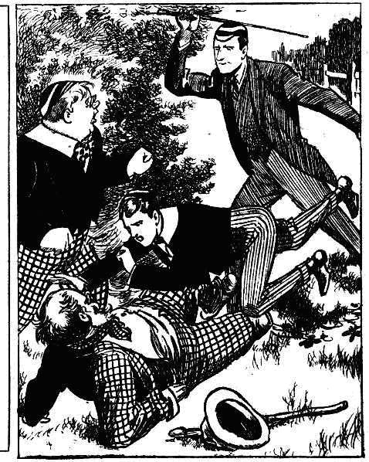
“Oh, gad!” gasped his lordship.
“Oh, crumbs!” murmured Billy Bunter.
“Yoooop!“ roared Sammy.
Lord Mauleverer was not a heavy-weight, fortunately, but he could not jump on Sammy’s fat leg without hurting Sammy. And when Sammy Bunter was hurt, he was accustomed to making the fact known to all within hearing.
He leaped up, yeling.
Loder, coming with a rush into the thicket, found himself face to face with a fearful-looking ruffian, in beard and moustache and red hair, with a muddy face, and a cudgel in his hand.
If Loder had known that that fearful ruffian was Sammy Bunter, with a collection of the Remove club’s “properties” on his fat person, Loder would not have been alarmed.
But Loder did not know it.
He saw a fearful, ferocious-looking tramp, as he supposed, and Loder jumped back out of the thicket. with a gasp of alarm, without waiting for a second look at the dreadful apparition.
He was in so great a hurry that he caught his foot in a root, and went sprawling in the grass beside the road.
“Whoop!” roared Sammy.
If Loder had come on, Sammy would have fled incontinently. But the terrified retreat of the prefect reassured him. Sammy had been hurt, and he had a natural inclination to pass it on. And it was evident that Loder did not know him. So Sammy, like a prudent youth, made the most of his opportunities. Many a cuff had he received from Loder of the Sixth ; and now it was his chance. As Loder sprawled in the grass. Sammy made a rush at him with his cudgel upraised.
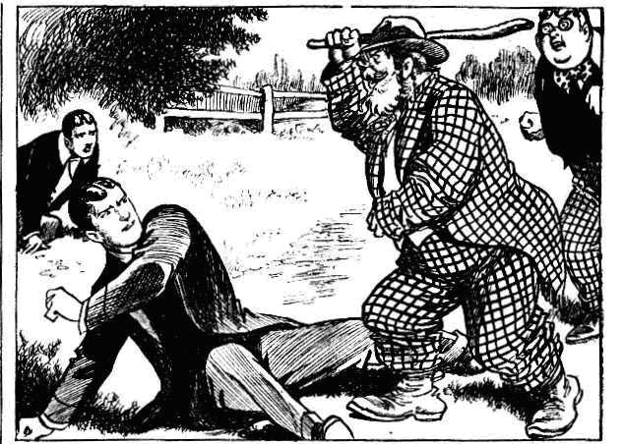
Loder caught a glimpse of the horrid-looking ruffian coming on, and scrambled up wildly.
Whack!
The cudgel came down across his shoulder as he rose.
“Oh !” roared Loder.
The next whack missed, as Loder leaped out frantically into the road. Without another glance behind, Loder took to his heels. He went down the road towards Greyfriars as if he were on the cinder-path. Loder had no taste for tackling ferocious tramps on a lonely common: and he did not give even a thought to Mauleverer, whom he left at the mercy of the horrid ruffian. He vanished in a cloud of dust.
THE TENTH CHAPTER.
Mysterious!
“HALLO, hallo, hallo! They’re going it!”
“Come on!” panted Harry. The Famous Five were close at hand, but they were on the other side of the thicket when they heard the uproar. Knowing nothing of the Bunters and their remarkable stunt, the Co. naturally supposed that Lord Mauleverer was in the hands of he bully of the Sixth, and they came to the rescue with a rush, heedless of bush and bramble, they tore on to the scene of action. Frank Nugent caught his foot and went over, but four juniors arrived on the scene breathlessly.
The scene that met their eyes was amazing.
Lord Mauleverer was lying in the grass, gasping for breath and looking dazed. Billy Bunter was leaning on a tree, gasping and trying to collect his fat wits. And a fearful-looking character was brandishing a club after the fleeing figure of Loder of the Sixth.
“What the merry thump?” ejaculated Bob Cherry.
“Where’s Loder?”
“Bunter—here’s Bunter.”
“Who—what’s that?”
“Mauly! What——”
“I—I say, you fellows.” gasped Bunter. “ I—I say—”
“What are you doing here, Bunter?”
“N-n-nothing! I—I’m not here. I— I mean—” spluttered the Owl of the Remove, utterly confounded and nonplussed by the sudden turn of events, “I mean, I wasnt—that is—I didn’t—oh, dear!”
“I thought Loder was here!” exclaimed Nugent, hurrying up.
“There he goes!” said Bob Cherry, pointing after the vanishing prefect. “That tramp seems to have frightened him off.”
“That tramp!” ejaculated Wharton.
“That’s a queer-looking tramp! Where did he bag those trousers? ”
“The trouserfulness is terrific!”
“Oh, gad!” stuttered Lord Mauleverer. “I—I jumped on something. It—it was alive—gave me a start. I tumbled over —rolled into Bunter! How did Bunter get here? I say, what on earth’s happened? Has there been an earthquake or anythin’?”
“I—I say, you fellows---”
“Well, Loder’s gone.” said Harry Wharton. “Did he lick you, Mauly?”
“He was goin’ to. Hadn’t an exeat, you know. As if a chap could think about exeats on a hot day! But that person jumped on seemed to give him a start as well as me.”
“Gave him a good start, I should think!” chuckled Bob Cherry. “He’s out of sight now. The tramp seems tame enough, far as I can see. Do you know him, Bunter?”
Bunter jumped.
“ I? No! Oh, no! Of course not!”
“You were making faces at him.”
“W-w-w-was I?”
“You were.” said Bob, staring at the Owl of the Remove. “What’s up? What’s the little game? What were you doing with a giddy tramp in his grandfather’s bags?”
“I—I—I——”
All the juniors looked at the tramp. The hapless Sammy Bunter stood in the grass by the thickets, simply not knowing what to do.
The programme was “off,” that was clear. He could not play the footpad, and let Mauly be rescued by his major, in the unexpected presence of the five Removites.
That, evidently, was out of the question. Loder’s unfortunate appearance on the scene, and its results, had completely knocked Bunter’s masterly scheme on the head.
But what Sammy was to do was a mystery. A tramp might have been expected to slouch off. But Sammy of the Second couldn’t slouch off in his present rig.
He blinked inquiringly at Billy, hoping for guidance, and Bunter could only make surreptitious signs to him to clear.
Sammy did not feel disposed to wander from the shelter of the thickets, clad in his present attire, with a false beard and moustache and a red wig. He was far too striking-looking a character to wander on the public roads at present.
Bunter’s surreptitious signs were not so surreptitious as he supposed. In fact, they were observed by all the juniors.
Even Lord Mauleverer blinked at him in surprised inquiry, wondering what secret there was between Bunter and the tramp.
“This is jolly fishy.” said Harry Wharton. “Tell us what the game is, Bunter. You seem to have been in ambush here with that queer-looking customer.”
“Not at all!” stammered Bunter. “I’ve never seen him in my life before.”
“ What are you winking at him for, then?”
“ I---I wasn’t.’
“And making faces.” sait Bob.
“Oh, really, Cherry! It—it, was a gnat on my nose!”
“Why, there you are making signs to him again!” exclaimed Wharton.
“Oh, really, you know—”
Harry Wharton stepped out of the thicket into the grass by the road, to take a closer view of the supposed tramp. The ruffian’s aspect struck him a very odd and suspicious. He was remarkably short for a man with beard and moustaches, and the trousers, turned up about his knees, would have attracted a second glance anywhere. And there was something familiar in the glimmering spectacles on his fat little nose.
“I—I say, Wharton, keep away from him!” exclaimed Billy Bunter, in alarm. “He’s—he’s dangerous. you know.”
“Bow-wow !“ said Harry
“I—I believe he’s got a—a—a revolver.”
“Fathead !”
The fat fellow in beard and checks backed away from Wharton, as the captain of the Remove cane towards him. Sammy felt that he was in for it; but he made a desperate attempt to keep his assumed character. He whirled up the cudgel with a threatening air.
“Keep orf, guv’nor!” he said, in the deepest tones he could command.
“Who are you?” demanded Harry.
“Find out!”
“I’m jolly well going to!” said the captain of the Remove, laughing. “You silly owl, do you think I can’t see you’re made up, now I look at you? ”
“Oh crumbs !” murmured Sammy.
“Hallo, hallo, hallo! Is it a Greyfriars chap ?” exclaimed Bob Cherry. “ I thought those giddy whiskers looked jolly queer. What’s this lark, Bunter?”
“I —1 say, you fellows.” gasped Bunter, “D-d-don’L go near him. I think he’s an escaped lunatic!”
“ You cheeky rotter!” roared Sammy, forgetting prudence in his indignation at that aspersion.
“ I know that toot. “ exclaimed Bob. “It’s young Bunter!”
“Sammy!” roared Wharton.
“Might have guessed it, from his width.” chuckled Bob. “ What on earth is he got up like this for?”
The Famous Five surrounded Sammy Bunter. Wharton jerked off his beard, and Bob his moustache, and Johnny Bull his wig. Then Sammy of the Second was revealed plainly enough, in spite of the mud rubbed on his fat face. He grinned sheepishly at the Removites.
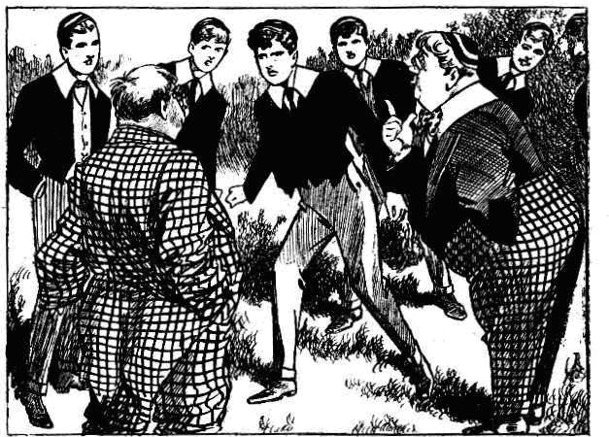
“Where did you get these props?” demanded Wharton. “I know these bags. I’ve seen Wib in them. You’ve been raiding our props!”
“I—I haven’t !”
“Borrowing the Remove props!” exclaimed Bob Cherry indignantly; “and coming out of gates in that rig! You young ass, are you off your rocker? Suppose a prefect saw you !“
“Loder did see me!” chuckled Sammy.
“If he hadn’t been too scared to take a second look, he would have spotted you.” said Harry. “But what does it mean? What game are you up to?”
Billy Bunter made frantic signs to his minor. It did not seem to dawn upon his fat brain that all the Famous Five could see those frantic signs quite as well as Sammy could.
“ Only a lark!” stammered Sammy. “You see, Billy---”
“Shut up!” hissed the Owl of the Remove.
“Blessed if I know what this stunt means.” said Bob Cherry. “ But I know that you cheeky little fat rascal, you’re going to be jolly well bumped for bagging our props
“I—I say—”
“Bump him!”
“Yarooh!” roared Sammy, as the Famous Five seized him. “Leggo! Twasn’t me; it was Billy! You know you did, Billy. Don’t make faces at me—own up, you fat rotter! Oh crumbs!”
Bump !
Sammy Bunter sat in the grass and roared.
THE ELEVENTH CHAPTER.
Not a Success!
BILLY BUNTER blinked at his minor, and blinked uneasily at the Famous Five. His wonderful scheme had been knocked sky-high. Whether it would have succeeded or not was a mystery; but the Owl of the Remove had had no chance. He was now only concerned with keeping his precious scheme a secret. Lord Mauleverer, rescued from a ferocious tramp, might have extended a kind invitation to Bunter as a reward. But certainly he was not likely to do so if he became acquainted with the scheme. His lordship was looking on with interest as well as surprise.
“I—I say, you fellows, let him off!” urged Bunter, in terror of what Sammy might say next, “It—it was only a fag lark, you know. I—I’ll lick him myself for borrowing the props—there !”
“Will you?” yelh’d Sammy. “You borrowed them. Leggo, you rotters! Yoop!”
“Bump him!”
“Yoop! Leggo! Oh crumbs!”
“Well, what was the little game,Sammy?” asked Wharton. “You’re going to be bumped till you explain.”
“Ow! Leggo! It was Billy’s fat-headed idea!” yelled Sammy of the Second. “He got this rubbish, and stuck it on me! Ow! I was going to———”
“Dry up “ yelled Bunter.
“Shut up Billy!”
“He’s only going to tell you a lot of whoppers!” gasped Bunter. “He’s untruthful—he is, really !”
“I was going to—”
“Shut up, Sammy !“
“Sha’n’t!” yelled Sammy. “Think I’m going to be ragged, you fat rotter? Why don’t you own up?”
“By gad ! What on earth is it all about?” asked Lord Mauleverer an amazement.
“Bump Sammy till he tells us!” grinned Bob.
“Yaroooh!”
“Let’s bump Billy instead.” suggested Nugent. “Billy’s at the bottom of it. Collar him !”
“I—I say, you fellows—”
“Bump him!”
“Hold on!” yelled Bunter. “it—it was only a lark! I mean, I—I came here to—to rescue Mauleverer—”
“What? ”
“That— that young vilIain——” Bunter pointed to his hopeful minor. “That young —young scoundrel was waylaying Mauleverer, and I—I came to stop him——”
“Oh, gad!” ejaculated Mauleverer.
“It was all spoof!” yelled Sammy, in great indignation. “Just a spoof to frighten Mauly, and—”
“Of course, I knew nothing of it.” said Bunter. “I—I hope you fellows believe me. I—I dropped in here purely by chance, and was—was astonished to see Sammy—”
“Oh, what a fibber!” howled Sammy.
“You promised me ten bob if you could squeeze it out of Mauly.”
‘‘Ha, ha, ha!”
The chums of the Remove roared. Lord Mauleverer laughed till the tears ran down his cheeks. Many and various had been the ways by which quite numerous fellows had sought to be included in the yachting party for the holidays. But Billy Bunter’s way had at least the merit of originality. It was a really wonderful scheme, which could only have originated in Bunter’s fat brain.
“You can shut up, Sammy.” said Bunter. “My friends take my word! You believe me, don’t you, Manly?”
“Oh, gad!” was all his lordship could say.
“Believe you?!” stuttered Bob Cherry. “Oh, my hat! So you were going to rescue Mauly when the ferocious Sammy held him up on the road—”
“ Exactly. I—I mean, nothing of the kind. That is, 1—I thought he was a real tramp, you know. If you think I sneaked into Wibley’s study and—and collared those things out of the property-box, you’re quite mistaken. As for waiting here with Sammy, I never thought of anything of the kind. Sammy is untruthful!” said Bunter, shaking his head sadly. “It’s rotten; but there you are! He’s untruthful !”
“Oh, my eye!” said Sammy.
“Gentlemen, chaps, and fellows,” said Bob Cherry, “I think we must agree with Bunter that Sammy is untruthful—”
“Ha, ha! Just a little.”
“But that he isn’t a patch on his major in that line——”
“Hear, hear!”
“And I suggest bumping the pair of them, as a warning
“Good !”
“Yaas, begad “ said Lord Mauleverer, with a nod.
And the Bunters, major and minor, were duly bumped, and then the Famous Five and Lord Mauleverer started for Greyfriars, leaving Billy Bunter and Sammy of the Second gasping for breath and glaring at one another.
—
Two juniors were late for class that afternoon—Bunter of the Remove, and Bunter minor of the Second.
Both of them seemed very cross, too. On the following day Greyfriars broke up for the holidays. Lord Mauleverer’s yachting party was still limited to six in number—and Billy Bunter, sadder if not wiser, mourned over the hapless failure of his masterly scheme, which was to have—but hadn’t—included him in the honoured list of Mauly’s Pals !
THE END.

If

—-

As Loder sprawled in the grass, Sammy made a rush at him with his cudgel upraised. The prefect caught a glimpse of the horrid-!ooking ruffian coming on, and scrambled up wIldly. Whack I The cudgel came down across his shoulders
as he rose. (See Chapfrr 9.)
“THE MYSTERIOUS FOE!” l— “
A SPLENDID TALE OF THE JUNIORS O CREYFRIARS. By FRANK RICHARDS. ::
‘rifE MA(NET LIBRARY. ‘No. 755.

.—If if if if

Mauleverer made a jump backwards as Loder came at him with the cane. lie landed In the thickets, where the two Bunters were crouched in cover. There was a yell from Sammy Bunter as the schoolboy earl landed feet foremost on his chest. “Oh, gad!” gasped his lordship. (See Chapter 9.)

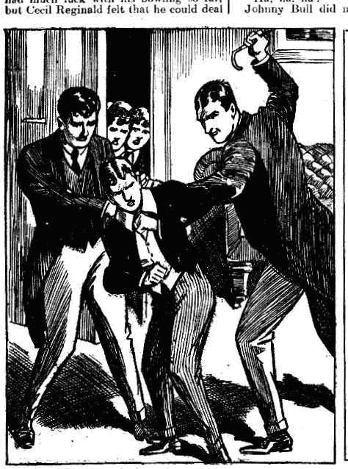

“THE MYSTERIOUS FOE!”
There was no help for It. Mauly had to stay to tea, so he sat down to the table
with a worried brow. Loder and Came looked alter auly during tea II his !
lordship had been the apple of their combined eye. Every kind of delicacy that;’ the school tuekshop could provide was on the table. (See Chzpfrr5.)
A SPLENDID TALK OF THE JUNIORS OF GREYFRIAR$. : By FRAt4 RICHARDS. :i
. THE MAGNET LIBitAity. —No. 755.

— —

