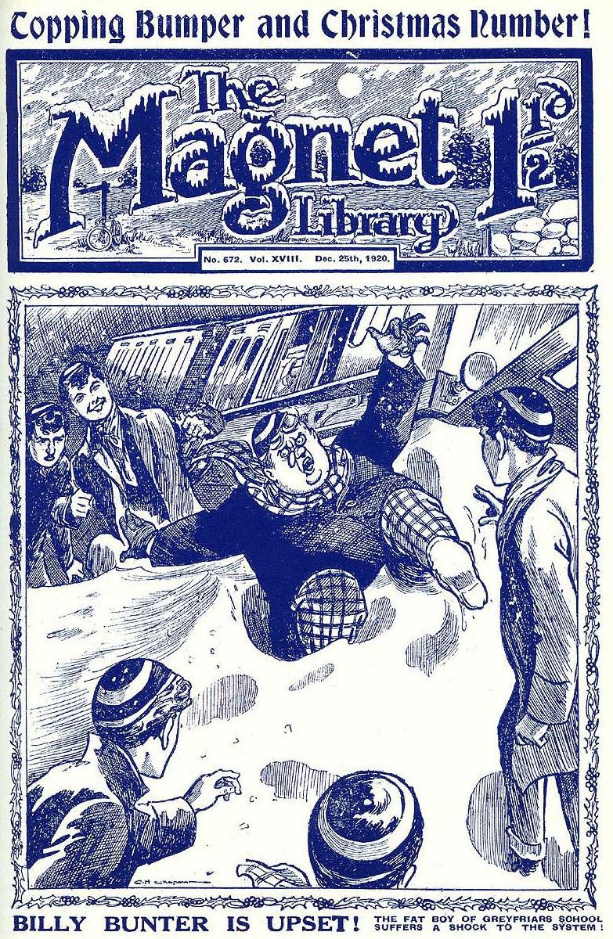
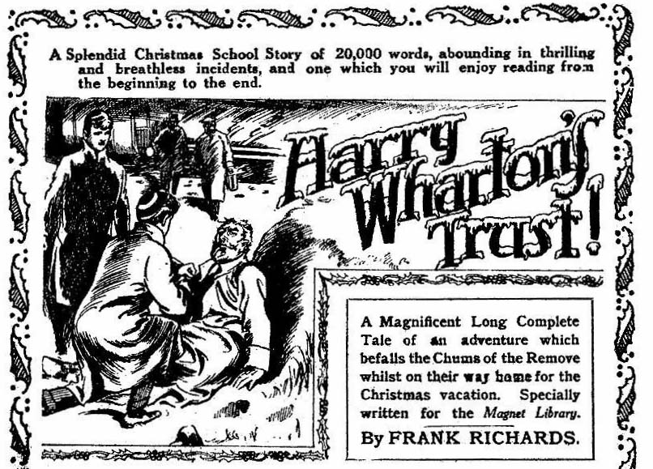
THE FIRST CHAPTER.
Off for Christmas!
I SAY, you fellows—”
Nobody heeded Billy Bunter.
Five merry voices were raised in me1ody—more or less melodious—and Bunter voice
was drowned. Greyfriars School had broken up for Christmas, and Harry Wharton & Co. were homeward bound for the holidays. They seemed to be enjoying themselves. Their voices could be heard at a considerable distance along the train.
There was snow banked along the railway-track, and light flakes fluttered against the blurred windows. A mist hung over the landscape. Through the mist, trees, leafless and gaunt, flitted by the rushing train. It was cold, there was no mistake about that, but the Famous Five of the Greyfriars Remove were in great sprits.
Bob Cherry was beating time with his boots, partly to keep his feet +warm, partly to add to the merry din. Frank Nugent did his bit with a pair of castanets. Johnny Bull chimed in with his concertina—occasionally a little early. The result was, as Hurree Jamset Ram Singh justly remarked, terrific.
Billy Bunter wasn’t worrying about carol-singing. He was searching round about him for something to eat. It was a quarter of an hour since he had eaten, so Bunter was feeling hungry.
“I say, you fellows---”
Harry Wharton paused, to ejaculate: “Shut up. Bunter”
“Where’s the sandwiches?”
“You’ve wolfed them!”
“Aren’t there any more?”
“No. Shut up!”
“Where’s the cake?”
“The esteemed and greedy Bunter has scoffed all the cake?’ said Hurree Jamset Ram Singh. Billy Bunter snorted.
“You fellows got any toffee?”
“Shut up!”
Billy Bunter did not shut up; he went on speaking, in wrath and indignation. But “Good King Wenceslas” filled the carriage, with all the strength of five healthy pairs of youthful lungs, and Bunter’s voice was drowned again.
A man in a thick overcoat, with a cap with flaps pulled down over his ears, came along the train corridor, and glanced into the carriage. He appeared to be looking for a seat.
The train was crowded, and the flrst-class carriage occupied by the chums of Greyfriars was full. But Harry Wharton & Co. were hosphable. They gave “Good King Wenceslas” a rest, and Harry addressed the stranger in the doorway.
“Looking for a seat, sir?” We can make room, if you like!”
“We can’t!” squeaked Billy Bunter. “I’m not going to be crowded, Wharton!”
“Dry up, Bunter!”
The man in the doorway glanced over the carriage. He was not a prepossessing-looking gentleman. He had narrow, ferrety eye, and a scar across his rather prominent nose, and a mouth that seemed to shut like a vice. He shook his head in response to Harry Wharton’s cheery address.
“Thanks, no! I’m looking for a—a friend. I think he’s on the train. Perhaps you’ve seen him—a tall man with a red beard, in an ulster——”
“I don’t think I’ve noticed——”
“I saw the chap.” said Bob Cherry. “He came along the corridor a few stations back. I don’t know if he’s on the train now.”
“Good!”
Without stopping to thank Bob for his information, the man with the scarred nose turned away, and disappeared along the corridor,
“I say, you fellows, have you got any bullseyes?” asked Bunter, taking advantage of the pause in the carolling. “It’s a long run to the next station, and I’m hungry!”
“You must be!” said Johnny Bull, with deep sarcasm. “You’ve scoffed nearly all the grub we got for the journey!”
“I’ve had a morsel or two.” said Bunter. “I really think you might have provided a bit better for your guests, Wharton!”
“Eh?”
“I suppose you don’t want me to arrive at Wharton lodge in a famished condition, do you?” demanded Bunter, with dignity.
Harry Wharton hughd.
“Mydear porpoise, I don’t want you to arrive there at all!” he answered.
“Oh, really, Wharton——”
“Is Bunter coming to the Lodge then?” asked Nugent.
“Not that I know of.”
“If that’s the way you treat a fellow, Wharton, after giving him pressing invitations——”
“Bow-wow!”
“I’ve refused several other invitations for this.” said Billy Bunter loftily. “Lord Mauleverer wanted me to go home with him—”
“I don’t think!” chuckled Bob Cherry.
“Vernon-Smith begged me——”
“Bow-wow!”
“D’Arcy of St. Jim’s wrote me a long letter, urging me to come and spend Christmas with him——”
“That’s jolly odd!” said Harry Wharton.
“It may seem odd to you, Wharton. Not being a popular fellow yourself, you don’t understand my popularity——”
“I mean it’s odd because D’Arcy is coming to me for Christmas,” explained Wharton. “So—”
“Ha, ha, ha!”
“That—that—that’s what I mean!” stammered Bunter, taken aback for just one moment. “He—he wanted me to— to meet him at your place, I mean. That’s why I accepted your invitation.”
“But I didn’t——”
“There was Kerr, too,” said Bunter warmly. “Kerr, of St. Jim’s, sent me a telegram, begging me to go up to Scotland with him. I jolly nearly went— I believe Edinburgh is a ripping place—only—only——”
“Only Kerr doesn’t know he invited you?” suggested Bob Cherry.
“Ha, ha, ha!”
“Nothing of the sort!” roared Bunter. I mean I should have gone to Scotland with Kerr, only I felt that I couldn’t very well leave Wharton in the lurch.”
“My dear man, you needn’t have worried.” said Harry Wharton, laughing. “You took us to Bunter Court, you fat fraud, so you never thought of being invited anywhere! And Bunter Court turned out to belong to somebody else!”
“Oh, really, Wharton——”
Billy Bunter was interrupted.
There was a sudden fearful crash, and the train staggered, and shook, and stopped, and the next moment the scene was one of wild confusion.
—-—
THE SECOND CHAPTER.
Harry Wharton’s Trust!
HARRY WHARTON dragged himself out of a bank of snow, and gasped.
He stared round him dazedly.
He was half-stunned by the shock, but he knew there had been a smash, and his first thought, on realising that he was not injured himself, was to help the others. He dashed the snow from his eyes with his hand, and shouted:
“Bob! Frank——”
“Hallo, hallo, hallo!”
“Here!” came Nugent’s gasping voice.
“Johnny, are you hurt?”
“No fear! You all right, Inky?”
‘ The rightfulness is terrific, my esteemed Johnny!”
“Where’s Bunter?”
“Yaroooooh!”
That dismal howl told where Bunter was.
In the thick mist that hung over the railway-track, carriages were rolled on their sides; men tramped through the mist, appearing and disappearing; voices shouted and echoed.
“It’s a collision!” gasped Nugent. “An empty goods-wagon on the line, somebody says—”
“Anybody hurt?”
“Yow-ow-ow! Help!”
“I’m afraid Bunter’s hurt.” said Bob Cherry with a grave facc.
The fat junior was lying in thick snow beside the line. He was groaning deeply. All the juniors were bruised and scratched; the carriage in which they had been seated was a wreck. They had escaped very luckily; but it looked as if Bunter had fared worse.
They gathered round him anxiously. All Billy Bunter’s irritating ways were forgotten at that moment.
“What is it, Bunter——”
“Where’s the pain, old chap?”
“M-m-my legs are broken!” said Bunter faintly. “Get an ambulance! I—I may hold out long enough to get to Wharton Lodge—”
Bob Cherry made a rapid examination of Bunter’s legs—which, excepting for an excess of fat, were in quite a healthy condition. There was a growl of wrath from him. It was exasperating for Bunter to begin malingering, whpn probably others were really hurt.
“Your legs are all right, you fat chump—just a bruise—”
“I—I mean, my arms---”
“What?”
“Both broken! I---I think I could be carried as far as Wharton Lodge---”
“Pinch his arms and see if they’re broken!” growled Johnny Bull.
“Yaroooh! I —I mean my neck!”
“Your neck?” howled Harry Wharton.
“Yes— my neck’s dislocated---”
“I’ve a jolly good mind to dislocate it, anyhow---” exclaimed Bob Cherry.
“You shamming porpoise, you can go and eat coke! Let’s go and see if we can be of any use, you chaps.”
“Help!”
The cry came from the mist close at hand, down the slope from the railway track.
“Come on!” shouted Wharton.
He rushed through the clinging mist and falling flakes, which hid from his eyes the man who called for help.
He came upon him in a few seconds, however.
A tall man, with a red beard, was stretched in the snow, in a crumpled ulster, and the deadly paleness of his bearded face showed that he was injured.
To Wharton’s astonishment, a man was kneeling with one knee on the injured man’s chest, his clenched fist threatening the sufferer. It was the man with the scarred nose.
“Give me the papers, or---” he was hissing out hoarsely from his set lips,
Wharton’s eyes blazed with indignation.
An act of robbery at such a time was so base as to be almost incredible; but it was evident that the ruffian was bent upon robbing the injured man.
With a rush, Harry Wharton came on the scene.
He did not stop to speak,
He struck fiercely at the man with the scarred nose, and his clenched fist came with a crash on the rascal’s jaw, sending him spinning away from his victim,
The man rolled in the snow with yell of surprise and pain.
“You coward!” shouted Wharton. “You villain!”
“What on earth—” gasped Bob Cherry, dashing up breathlessy.
“That villain—he was robbing this chap—”
“Collar him!” shouted Bob.
Harry Wharton dropped in the snow beside the injured man. Bob Cherry ran at the sprawling ruffian with the scarred nose; but the rascal was on his feet in a twinkling, and dashing away in tho mist.
The red-bearded man gazed up at Wharton.
“Thank you!” he panted. “You---you’ve saved the—the papers—”
“You’re hurt—”
“My leg—you can’t help me—I can’t move. But—but keep that villain off—”
“Rely on me!” said Harry.
He made the injured man as comfortable as he could; but there was evidently nothing to be done till a doctor arrived. The man’s face was deathly white and drawn with pain; once his eyes closed, but they opened again with a wild stare.
“The papers—” he panted. “I’ve been robbed—”
“It’s all right,” said Harry soothingly.
“The man’s gone—we’re here—”
“I—I— Feel in my breast-pocket and see if the papers are safe there!” Harry Wharton did as he was bid.
He drew out of an inner pocket a bulky envelope of thick cartridge paper, sealed in several places.
“Is that it?”
The white face lighted up.
“That’s it—it’s safe—safe—”
“Quite safe!” said Harry. “Shall I put it back?”
The glistening eyes searched his face.
“You are a schoolboy?”
“Yes—my name’s Wharton—of Greyfriars---”
“You have a face to be trusted.” ‘The man’s voice was low and husky, and Wharton had to bend his head to catch the words. “Listen to me! I shall faint soon—I can feel myself going! I —I’m badly hurt—I shall be in hospital and—”
“A doctor’s coming—” said Bob Cherry.
“Let me speak! The papers—the papers must be made safe before I—I—before my senses go! You, Wharton, you---”
“Yes, said Harry gently.
“Can I trust you? When I’m unconscious, that villain will get hold of them—and if they fall in the hands of Jerrold Drew, all is lost—the secret will be gone and---” He groaned. “Any risk—rather than that—any risk! But you’ve an honest face---”
“I hope so,” said Harry.
“Listen to me! I may lie for days unconscious—Heaven knows—will you take the papers—take them—”
“Yes, yes!”
“Take them to the address on the envelope--take them—your expenses will be paid by the man they’re addressed to. Swear to me that you will take them— faithfully—” he broke off, gasping.
For a single instant Wharton paused. He was on his way home for Christmas, with his friends; his uncle and aunt were expecting him.
But the pause was only an instant. The man before him was in a serious condition, that was clear—and Wharton could not think of refusing.
“I will do as you wish.” he said.
“At once?”
“At once!” said Harry.
“On your honour?”
“Yes, yes!”
But “Put the papers in your pocket—quick---and—and beware of Jerrold Drew------” He broke off and groaned. “Tell him— tell him---”
“Tell whom?”
“You’ll find the name—and the address—on the paper—” The voice was husky and low. “Tell him what’s happened to me—he’ll know my name—Angus McAlpine—tell him—tell him—tell————”
The broken voice died away.
The red-bearded man’s eyes closed
“Poor chap!” muttered Bob Cherry. McAlpine’s eyes opened again wildly.
He motioned to Wharton to place the envelope in his pocket, and the Greyfriars junior obeyed, buttoning his coat over it.
A glimmer of satisfaction came over the white face.
The pallid lips moved, and Wharton bent low to catch the whispered words.
“Beware of him—Jerrold Drew—the man—the man who—who tried to get the papers. He—he will try——”
He shuddered, and was silent. His eyes closed, and did not open again. He was insensible.
“Is this the man?” The doctor came up with the railway guard, and the Greyfriars juniors stepped back, leaving the insensible man in the doctor’s care.
The passengers were already tramping away down the line towards the nearest station. Harry Wharton & Co. followed them. Wharton’s face was very thoughtful. In an inside pocket, under his buttoned coat, reposed the mysterious papers to which the injured man attached so strange an importance. He was not sorry that he had accepted the trust; but it made a great difference to his plans. He could not go on to Wharton Lodge with his friends now.
“I say, you fellows—” Bunter’s voice came howling through the mist as the juniors started.
“Come on, Bunter!”
“I can’t walk, you know! You fellows will have to carry me!”
“Rats!”
The juniors tramped on, and the next moment there was a thudding of heavy footsteps in the snow as Billy Bunter came scudding after them. The Owl of Greyfriars had found that he could walk, after all.
______
THE THIRD CHAPTER.
The Start!
“THIS is something like!”
Thus William George Bunter, with his mouth full.
The juniors had reached the station at last, after a long a+nd weary tramp through snow and missed, and they were lunching—a very late lunch. They were all hungry, especially Bunter. And Bunter attacked the good things that were placed before him, and did not utter a word until he had disposed of enough for three fellows. Then he remarked that this was something like. And then he went on.
Harry Wharton & Co. made a good meal, but their thoughts took a wider range than Bunter’s. They were thinking of the injured man—McAlpine—conveyed to hospital, to spend his Christmas on a sick-bed, and of the strange trust he had reposed in Harry Wharton’s hands. The long, thick envelope was still in Wharton’s pocket; he had not looked at it yet since placing it there.
“I can telephone him from here” Harry Wharton observed thoughtfully. “I must get rid of this packet before I go home. But you fellows——”
“Can’t we come and see you through?” asked Bob Cherry.
Wharton reflected.
“I don’t know yet where I’ve got to go.” he said. “I’d better look at the thing.”
He glanced round.
The juniors had a corner table to themselves in the refreshment-buffet, but the room was crowded. There were many stranded passengers from the wrecked train there, and a good number of Greyfriars fellows.
“That chap with the busted nose isn’t here.” said Bob Cherry, looking round. “He wouldn’t dare to show up, I think; we could give him in charge for trying to rob the injured man.”
“McAlpine thought he would try to get hold of the papers again, whatever they are.” said Harry. “Keep your eyes open, anyhow.”
He drew the long envelope from his pocket.
The name and address were typed on it, and Harry Wharton uttered an exclamation of surprise as he looked at them.
For the packet was addressed:
“G. F. Kerr, Esq.,
24. Castlegate Street,
Edinburgh.”
“Kerr!” ejaculated Bob Cherry. “Is that a relation of Kerr of the Fourth Form at St Jim’s, I wonder?”
“Must be.” said Harry. “The initials are the same, and Kerr lives in Edinburgh. I remember he wrote once in the vac, and his address was Castlegate Street.”
“His father, then ?”
“Most likely—in fact, pretty certain.”
“What a dashed curious thing!” said Johnny Bull. “I suppose Kerr’s gone home from St. Jim’s before this.”
“I believe they break up a day earlier than we do at St. Jim’s.” said Harry. “Anyhow, I couldn’t hand this packet to Kerr; I’ve undertaken to deliver it myself. But——”
“It’s a jolly long run up to Edinburgh.” said Frank Nugent, with a whistle.
Harry Wharton nodded.
“It had not occurred to him, when he accepted the trust from the injured man, that he was called upon to make a journey almost from one end of the kingdom to the other.
But he felt that he could not have refused it, in any case. His Christmas holiday could be sacrificed for the sake of kindness to one who was stricken helpless.
“I say, I’ll come if you like.” said Bunter, blinking up through his big spectacles, as he refilled his plate. “I’ll protect you. I shall want a sleeping-car, of course, and good grub—and plenty of it. I’ll settle later for the expense.”
“Fathead!”
“I’ve given directions at Greyfriars for any letters to be sent on to Wharton Lodge, you know—”
“The dickens you have?”
“So when my postal-order comes—”
“Your what?”
“Postal-order! When my postal-order comes I’ll settle up for the expense of my run up t Scotland.”
“Ass!”
“Oh, really, Wharton—”
“We can’t all go.” said Harry. “The expense would be a bit too steep and though I suppose Mr. Kerr will foot the bill, we can’t very well stick him for a small fortune. But I’d like one of you fellows to come with me. In case—”
“You sha’n’t go alone, that’s certain.” said Bob Cherry decidedly. “That chap with the boko may get on your track. You’d better take the Fighting Editor of the ‘Greyfriars Herald’ with you— little me, you know. I should be useful in a scrap.
Wharton smiled.
“I’d like you to come, Bob. Will you other fellows go on to the Lodge—”
“Certainly,” said Bunter.
“We’ll go on, and explain to Colonel Wharton.” said Johnny Bull. “Better than telephoning--save time.”
“Good!”
“Better telephone for the colonel’s car.” suggested Bunter. “I should prefer to travel in a car.”
“Do dry up, Bunter!”
“If that’s what you call hospitality to a Christmas guest, Wharton—”
Harry Wharton rose from the table.
“You fellows are finished?”
“Yes.”
“I’m not finished.” said Bunter. “I shan’t be finished for some time yet .”
“Well, keep on as long as you like. My bill, please, waiter.”
“How can I keep on if you’re going to pay the bill now?” demanded Bunter warmly. “Do you think I’m going to pay bills myself when I’m your guest, Wharton?”
Harry Wharton paid the bill unheeding, and the juniors went out. Billy Bunter grunted with dissatisfaction, and rolled after them. He did not feel inclined to continue his feed at his own expense. As a matter of fact, he could not have continued it much longer without danger to his buttons.
Harry Wharton made an inquiry at the booking-office for trains. In one direction the line was blocked by the wreck; in the other there was a train soon to start which would carry the Christmas party within some distance of Wharton Lodge. At an adjoining inn, Harry found he was able to hire a trap to take him and Bob Cherry to the junction, where he could get a train for London. The chums parted, Billy Bunter going on with the party for the Lodge. Having accepted his own invitation there for Christmas, William George Bunter was not to be deterred.
Johnny Bull was the bearer of a note from Harry to his uncle, Colonel Wharton, explaining the curious circumstances.
“Best of luck, old chap!” said Frank Nugent, leaning out of the carriage window. “Keep an eye open for that chap with the boko!”
“You bet!” said Bob.
“I say, you fellows—Nugent, let a chap speak! I say, Wharton---” BilIy Bunter’s fat face blinked from the train. “1 say, have you got plenty of money for your journey—”
“Quite enough.” said Harry.
“You ought to have a bit over, in case of accident.”
“Are you going to offer to lend us some?” grinned Bob Cherry. “Oh, what a surprise? ”
“The surprisefulness is terrific!” chuckled Hurree Janset Ram Singh.
“Nunno! Not exactly. But you ought to have a bit over.”
“Well, we’ve got a bit over.” said Harry
“Sure?”
“Yes, ass!”
“More than you’re likely to spend?” asked Bunter anxiously.
“I think so.”
“Good.! Then you can lend me a quid.”
“What?”
“A quid. I’ll settle up when you come back. I expect to find several postal-orders waiting for me at the lodge.”
“You silly ass!” roared Bob.
“Oh, really, Cherry------ Yaroooogh!”
Bunter disappeared from the carriage window. There was a sound of Johnny Bull’s heavy foot coming into contact with Bunter”a podgy person, and loud roars from the Owl of the Remove.
“Good-bye!”
“Terrific luckfulness, my esteemed chums!”
The train steamed out.
Then Harry Wharton and Bob Cherry turned away, and hurried to the inn for the trap.
— —
THE FOURTH CHAPTER.
A Desperate Attack!
“WERE being followed!”
Bob Cherry uttered that exclamation suddenly.
The trap was bowling on through falling flakes, the two juniors sitting with their coats up about their ears. The driver was muffled up to the eyes, with his cap drawn down. A bitter wind swept along the snowy lane. The chums of Greyfriars were fairly started on their strangc Christmas journey.
More than once they glanced back through the falling flakes and the clinging mist.
Both of them were thinking of the man with the scarred nosc----Jerrold Drew, as McAlpine had called him.
They wondered whether they would see him before they reached their long journey’s end. The’y were aware that the man could easily have spied upon them at their starting-out. And Bob Cherry uttered a sudden exclamation as a cyclist came into view behind, driving on his machine hard through the snow.
Harry Wharton fixed his eyes on the rider instantly.
The man was muffled in a waterproof cape, and his cap, with flap, was drawn down about his ears; but Harry recognised the long, scarred nose at a glance,
It was the man who had sought to rob McAlpine of the mysterious papers.
Wharton set his teeth.
“Drive faster.” he muttered to the driver.
The latter shook his. head.
“She’s going as fast as is safe on this ‘ere road, sir.” he answered. “We don’t want any blooming accident, sir!”
“Very well.”
The juniors watched the cyclist, their hearts beating.
In spite of the snow on the road, wet and slippery, the rider was coming on at a good pace, and rapidly overhauling the trap.
Closer and closer, till he was only a few yards behind, and his shkrp, ratty eyes were fixed on the juniors, evidently recognising them at a glance.
“Stop!” he shouted.
“Go and eat coke!” answered Bob Cherry.
The flakes were still falling thickly, and a good deal of snow had fallen into the trap. Unseen by the cyclist, Bob Cherry had gathered up several handfuls and was kneading a hard snowball.
The rider drew closer.
“ Stop the trap at once!” Drew hissed. “I know you have the papers, Wharton, I was there, watching. I heard you give him your name. I saw you take the papers!”
Wharton set his teeth.
“You scoundrel!” he said. “If you dare to follow us as far as the town, I shall give you into charge of the police!”
Jerrold Drew sneered.
“I order you to stop!”
“Rats!”
“ Throw out the papers, then!”
Harry Wharton laughed contemptuously.
The driver glanced round for a moment curiously. The man with the scarred nose did not heed him. His glittering eyes were fixed upon the two juniors.
“Will you stop?” he shouted.
“No!”
“Then I’ll make you!”
He released one hand from his handlebars, and fumbled under his cape.
The next moment it flashed into view, and a revolver glimmered among the falling snow flakes.
“ Stop, or I’ll shoot!”
Whizz!
Even as the revolver came up Bob Cherry hurled the snowball with unerring aim.
It struck the pursuer full upon his scarred nose.
The cyclist went over with a crash.
With only one hand holding, on slippery snow, the pursuer was utterly unable to withstand that sudden and unexpected attack.
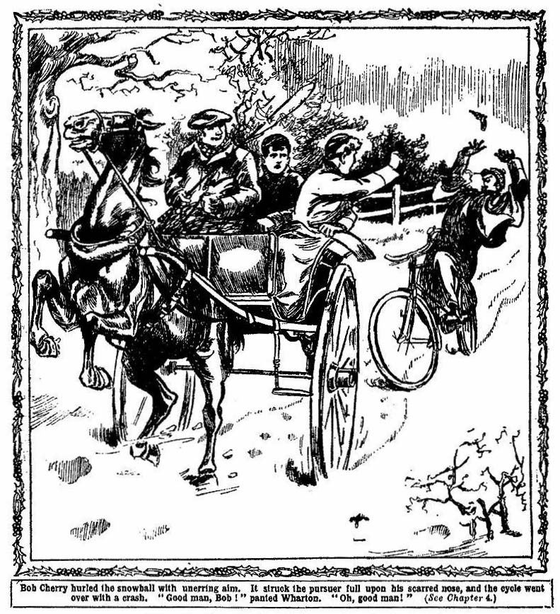
The revolver flew from his hand, and the bicycle whirled over and crumpled up, sending its rider crashing into the snow.
The trap rattled on.
“Good man, Bob!” panted Wharton. “Oh, good man !”
They watched back breathlessly.
For a full minute the dazed ruffian was scrambling helplessly in the snow, while the trap increased it’s distance. Then they saw him stagger to his feet, his face livid with rage, and drag up the bicycle and essay to mount. Even at the distance they heard his shout of rage as the machine buckled up.
“Damaged!” shouted Bob Cherry. “Hurray!”
The man made a savage effort to get the machine right, but it was evident that the crash had serionsly injured it. With a curse, he let it whirl over into the snow again.
He stood shaking a savage fist after the trap for a moment, and then groped in the snow frantically.
Wharton’s heart thumped.
He knew that the ruffian was seeking the fallen revolver. But the figure was growing dim in the mist now. A minute more——
The distant figure rose upright again; the revolver glimmered in his hand. He threw up the weapon and fired. Crack!
The bullet came nowhere near the trap. If the ruffian was a good shot, his spill had shaken him enough to spoil his marksmanship.
Before he could fire again, the mist was too thick for aim to be taken, though as he was swallowed from sight the chums of the Remove heard another distant report.
The trap bowled on.
“My hat!” murmured Bob Cherry breathlessly. “That—that was rather a narrow shave, Harry. I---I say, Harry, we’ve taken on rather a big contract to get those papers to Scotland. He’s desperate.”
Harry Wharton nodded.
“No doubt about that.” he said. “I suppose the packet is very valuable; but we’ve got it safe. He won’t dare to try a game like that again when we’re out of the lanes..
“He can’t follow us now!” chuckled Bobs “ His bike’s crocked. That was the luckiest snowball I ever chucked!”
Half an hour later the trap was rattling into a street. The juniors drove at once for the railway station. There was a quarter of an hour to wait for the express .
The puzzled driver was paid and dismissed—puzzled because his fare did not go at once to the police-station with information of the attack. But they had no time for that. They had a very shrewd idea that Jerrold Drew would know how to keep clear of the police, and the express for London had to be caught. Glad enough were the chums of Greyfriarx when the train came in, and they cut across the misty platform and jammed into a carriage, and found themselves whirling away towards the distant metropolis.
As the train began to move, Bb Cherry caught Wharton by the arm and pointed to the platform.
A hurried figure dashed on, and stopped, staring at the train. The glint of two ratty eyes caught the eyes of the Greyfriars juniors. The man with the scarred nose rushed across the platform and a porter caught him by the arm and swung him back.
“Too late, sir---”
“Let me go---”
The train gathered speed. The misty station vanished behind, and the man with the scarred nose was seen no more. Bob Cherry dropped back into his seat.
“He’s a sticker, Bob!”
“So are we.” said Bob Cherry. “Je sui sticker, tu es s+ticker, nous sommes stickers—” —“
Harry Wharton laughed.
“We’ll beat him, yet, though.”
“Yes, rather!”
In the grey fog of London the juniors kept a wary look-out for the scarred man. But they did not see him, and they had begun to hope that he was off the scent when they boarded the great express for the North.
THE FIFTH CHAPTER.
The fight in the Express!
The the the the end of is
BUMP, bump, bump! —
The rhythmic beat of the train had a lulling effect on the tired juniors.
It seemed to them that they had been travelling for days on end already. They had had a grey glimpse of London under a fog and the mat clung to the landscape as they sped northwards. It was weather to make a bright fire in a cosy room particularly welcome; and they thought of Wharton Lodge, and the holly, rather dismally. But they had their duty to do, and they did not regret that they were doing it. Through a landscape veiled in night and mists the great express roared on.
The two juniors had the carriage to themselves, and they were nodding. They had arranged that both should not sleep at the same time on the journey; always one or the other was to wake. But the motion and hum of the train lulled them, and they dozed.
They did not hear a soft footfall in the corridor of the train, nor see the glint of ratty eyes that turned upon them.
Jerrold Drew set his teeth sharply, as he looked into the carriage.
Both the juniors were dozing as the train bumped on through the wintry night.
“At last!”
Drew muttered the words inaudibly.
He glanced up and down the corridor. A passenger came strolling along, lighting a cigarette as he came. Drew turnedfrom the doorway, and became deeply interested in the lights that flashed by the train in the night.
The passenger smoked his cigarette in a leisurely way in the corridor, little dreaming of the fury his leisurely movement caused in the breast of the muffled man who stared from the dark window.
The cigarette finished, he returned to his carriage in the same leisurely way, yawning.
Then Jerrold Drew moved.
The train corridor was deserted now, save by himself. He moved softly and stealthily into the doorway of the compartment occupied by the dozing juniors of Greyfriars.
The Scottish express roared and bumped on, and the juniors still dozed.
Jerrold Drew was bending over Wharton now.
In the pocket of the junior, he knew, reposed the long envelope McAlpine had handed to him; in a minute more the preciouspapers would have been in his theivish fingers.
At that moment Wharton’s eyes opened.
He had only been dozing; but the hot breath of the ruffian on his face had been sufficient to startle him back into wakefulness.
He gave a sharp cry at the sight of the scarred face within a foot of his own.
“You!”
He started up, so suddenly that his head came into contact with Drew’s chin, and the man lurched back with a howl of pain.
“Bob!” yelled Wharton.
But Bob Cherry we already awake and on his feet.
“Give me the papers!” panted Drew.
“Back up, Harry!”
The ruffian’g grasp was now on Wharton, and they went to the floor of the carriage together, struggling.
The man’s savage hands tore at Wharton’s coat.
Bob hurled upon the scarred man recklessly.
Drew gave a howl, as Bob’s grasp fastened on his throat, dragging him fiercely away from his victim.
He turned on Bob Cherry like a tiger.
A furious blow on the chest sent Bob staggering, his knees caught a seat, and he sat down with a crash.
In a second the ruffian was struggling with Wharton again.
The junior fought desperately; but his coat was dragged open, and a thievish hand was seeking for the papers.
Help!
Bob staggered up, winded, breathless, and grabbed at the communication cord.
“Give me the papers!”
“Never!”
“Your life—”
“Help!”
Wharton struck up furiously at the enraged face over him, as the man dragged at the long envelope in his pocket.
Drew reeled aside. with an aching jaw, as the junior’s clenched fist struck him like a lump of iron.
But the long envelope was in his hand.
Bob Cherry dragged the cord, and then turned on the ruffian and grasped him. There was a buzz in the corridor; the shouts had been heard along the train.
The express was already slackening speed.
The ruffian struggled to his feet.
Both the juniors had hold of him, and he could not shake them off; they clung to him like hounds to a stag.
“Hold him!” panted Wharton. “Hold him—help’s coming---”
“Help! Help!”
Two or three faces stared in, in amazement, from the corridor. Harry Wharton snatched at the long envelope.
Crash!
The man’s elbow went through the window, and the glass shattered and splintered.
Through the opening he flung the packet.
Harry Wharton gave a cry as the precious envelope vanished into the night.
“You villain! Stop—stop the train!”
Jerrold Drew shook himself free. He flung open the carriage door as the train slowed.
“Hold him, Harry!”
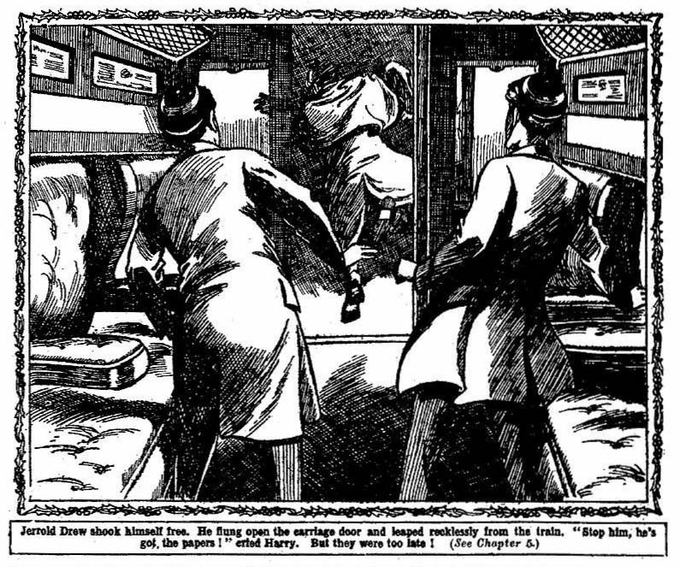
But the ruffian had leaped recklessly from the train.
With staring eyes, the juniors watched him, and saw him roll down a bank of snow; then, as the train glided on, he vanished.
With a groan and a clatter, the express came to a halt.
A dozen voices demanded to know what had happened; but the junior did not heed.
The precious packet, entrusted to Harry Wharton by the man who now lay in hospital, was lost—lost! They were thinking only of that. Without a word in reply to the excited questions that were showered on them, Harry and Bob Cherry sprang from the halted train. The guard shouted after them angrily.
They did not heed.
They ran, trampling through the snow, back along the track. The bitter wind lashed their faces; flakes of snow whirled about them.
“We’ve got to find it, Bob!” panted Wharton.
“Come back!” came a roar from the train.
They plunged on in the darkness.
Harry Wharton glanced back a few minutes later. The tail-lights of the express were disappearing in the night. The train was whirling on again towards its next stop at Crewe. leaving behind the two juniors and he man with the scarred nose, and the packet of papers addressed to George Kerr’s father in Edinburgh, lying somewhere in the snow under the falling flakes.
THE SIXTH CHAPTER.
Baffed!
A RUDDY gleam of light wavered in the darkness .
Harry Wharton dashed the flakes of whirling snow from his eyes, and looked. On the snow-covered stretch beside the railway-track was a little building—a hut—and from the opening the ruddy gleam danced and wavered against the darkness. It came from a coke fire burning in a tin bucket.
“It’s a platelayer’s hut!” gasped Bob Cherry. “Let’s ask him; he may have seen—”
“Good!”
They tramped on.
Two or three miles had passed under their feet, and they had seen nothing of the man with the injured nose.
They wondered whether he had been injured in his desperate leap from the train.
So far as they could calculate, they were now somewhere about the spot where the envelope had been thrown from the tram, and every moment they feared to see the ruffian engaged in the search for it. He was armed, they knew, and they were not: but they did not pause or falter. Harry Wharton’s trust was to be fulfilled, whatever the danger.
But the man did not appear.
They were tired and utterly cold, and they were glad to arrive in the warm glow of the platelayer’s hut.
A burly man was seated there, half asleep.
He started up at the sight of the two schoolboys, evidently astounded to see them there, at that hour, by the railway track.
“What the thunder are you kids doin’ here?” he demanded. “Bont you know you ain’t allowed near the line?”
Harry Wharton smiled faintly.
“We’re looking for something that was thrown from a train.” he said.
“You saw the Scotch express pass, I suppose? ”
The man stared at him curiously.
“I ‘spose so.” he assented.
“A rascal tried to rob me on the train.” explainod Wharton. “He got a letter from my pocket, and threw it out of the window—”
“By gum!”
“Perhaps you’ve seen something of it!”
The plate-layer turned a quid of tobacco in his cheek, and appeared to reflect.
“P’r’aps I ‘ave!” he.
Harry Wharton’, face lighted up.
“Thank goodness! Give it to me——”
The man chuckled.
“Not so fast!” he remarked. ‘P’r’aps you think I’m green?”
“No, no—”
“P’r’aps you think I believe every yarn a schoolboy comes along and spins me?” suggested the platelayer, who appeared to be a gentleman of humorous tendencies.
“My dear chap—”
“You says as how bloke robbed you of a letter in the express——”
“Yes, yes.”
“And chucked it out of winder!”
“Yes, some were about here, I think.”
“P’r’aps it might hit a bloke on nose as it came down.” said the plate-layer.
“You’ve got it?” exclaimed Bob Cherry.
“P’r’aps.” continued the plate-laying gentleman, with irritating calmness—“p’r’aps you could describe that there letter which you says belongs to you?”
Wharton drew a breath of relief.
“Easily!” he exclaimed. “It’s a long, cartridge-envelope---”
“Anything else?”
“With a typewritten address---”
“Ear, ear! Go on.”
“The address is ‘G. F. Kerr, 24, Castlegate Street, Edinburgh.”
“We’ll see about that,” said the burly man coolly. “You stand off and don’t snatch. If you snatches, I gives you a oner on the boko. You catch on to that?”
Wharton smiled.
“I won’t snatch,” he said.
To his immense relief, the platelayer turned into his hut, and drew from some recess a long cartridge-envelope, bulky with its contents.
“That’s it!” shouted Bob.
“Jest you wait a minute!”
The platelayer examined the envelope sedulously, reading the address on it with great care. Then, with a cheery grin he handed it to Harry Wharton.
“Your property, I reckon.” he said. Wharton breathed more freely when the precious packet was in his hands. He put it into the inside-pocket where it had reposed before, and buttoned his coat.
“Thanks, thanks!” he exclaimed.
“All right, guv’nor. It fair hit me on the nose as it came flying out of the train,” said the man, grinning. “I ‘eard the winder break, and then it came —fair catching me on the conk. Never so s’prised in my life. Thank you kindly, sir” he said, as Ilarry Wharton pressed a ten-shilling note into his hand.
“Like to warm your feet ere, afore you go on?” he asked. “You’ll ‘ave to walk to Crewe, I reckon.”
The chums of Greyfriars were glad enough of the shelter of the warm hut from the wind and the snow,
They sat down to warm their feet in a mood of thankful of relief. The precious letter was safe once more; and Harry Wharton was determined that it should never leave his posession again.
The railwayman gave them a tin each of coffee to sip from, and the hot beverage warmed and cheered them.
“I wonder what that thief is doing ?” Bob Cherry said presently. “If he wasn’t hurt in jumping out, he’s bound to come nosing along here.”
“Hallo; here’s somebody else,” said the platelayer. “it’s raining visitors this blessed night ”
A figure loomed up in the glow of the coke fire.
“Jerrold Drew!” breathed Wharton.
The man was limping..
The thick snow had saved him from severe injury, after his desperate leap from the express, but evidently his leg was hurt, for he dragged it as he tramped; his late appearance on the scene was accounted for now. He stopped in the glow of the coke fire, and spoke to the workman.
“Have you seen—”
Then he stopped as his eyes fell upon the two juniors in the hut.
“I’ve found you!”
“You’ve found us, you scoundrel!” exclaimed Wharton, springing up. “And we’ve found you!”
“Have you got the letter?” exclaimed Drew hoarsely.
“Yes, you villain! Try to take it if you dare!”
“Give it to me!”
The man advanced into the hut with glittering eyes.
“Old ‘ard there”
A burly form interposed. The ruddy platelayer grinned good-hurnonredly at the furious face of the scarred man.
“No good scowling at me!” he said cheerfully. “You can’t scare Bill with an ugly face—though if you could, I reckon yours is ugly enough to do the trick.”
“Let me pass, you fool!”
“You calling me names?” said Mr. Williams. “I reckon—” He broke off as a revolver fIashed out in the ruffian’s hand. “By gum, is that your game?”
“Stand back, or—”
Swish!
Bill Williams had the coffee in his hand, and it was still hall-full of hot liquid. With a jerk of his arm, he sent the hot coffee in a sudden stream full into the scarred face.
Jerrold Drew staggered back with a choked yell.
In an instant the platelayer had knocked the revolver from his hand, and it fell into a corner of the hut.
“Pick that up, you kids!” said Mr. Williams.
In a secondHarry Wharton had the deadly weapon in his hand.
Drew was gouging savagely at his face, where the coffee was streaming. He was blinded for a moment or two. A string of fierce curses poured from his lips.
“ Save your breath, old bird!” suggested Mr. Williams. “You’ll want it to cool your porridge,you know.”
“Collar him!” breathed Bob Cherry. “Now’s our chance. This chap will help us arrest him. We’ll give him in charge, and—”
“Good! Lend a hand, Williams!” exclaimed Harry Wharton. “That thief ought to be handed over to the police to——”
“I’m your man. I reckon.”
Jerrold Drew sprang back.
For a moment his ratty eves glinted and glittered at the three, as if he meditated a desperate attack, in spite of the odds against him.
But he thought better of it, and sprang back into the darkness.
“After him!” roared Bob.
The two juniors and the platelayer rushed out of the hut. But Jerrold Drew was springing away into the darkness, and in a few seconds the night had swallowed him up.
Mr. Williams stopped.
“I reckon I can’t leave my ‘ut” he said. “ You’ll ‘ave to leave it to the coppers. You can give information at Crewe.”
The juniors stopped reluctantly.
It evidently was not of much use to search for the man in the darkness in the falling snow, and they returned to the warmth of the hut, to rest before resuming their way. But the precious documents were safe in Harry Wharton’s inner pocket; and they were very cheer
ful as they sat by the coke fire and chatted with the cheery platelayer.
THE SEVENTH CHAPTER.
Harry Wharton’s Device!
A WINTRY dawn glimmered over Crewe when Harry Wharton and Bob Cherry tramped into the town of railways and railway works, Mist wrapped the distant Welsh hills, and hung over the town, and the L.N.W. works with their thousands of busy hands. Harry Wharton had been thinking as he tramped through the snow. An idea was working in his mind which had occurred to him during the rest in the platelayer’s hut. The chums breakfasted at the Crewe Arms, and after breakfast Harry inquired for a stationers shop, and they proceeded to it at once.
“What’s the game?” asked Bob. “Not stopping to send picture-postcards?”
Harry laughed.
“No: no time for that.”
If we had time we could have a look at the potteries while we’re here,” said Bob. “I’d like to no end. But we’ve got to catch the Carlisle train, old top.’
“We’ve got time, Bob. Come in!”
In the stationers Harry Wharton selected a cartridge paper envelope of the same size as that containing the precious papers. He asked the shop man where he could get an address typed onit.
“Here, sir!” was the answer. “I’ll type it on my machine, if you like.”
“Thanks!” said Harry. “The address is 24, Castlegate street, Edinburgh.”
The shopman typed the address in a few minutes, and Harry paid for his purchase. bought a copy of the “Daily Mail.” and left the shop.
He glanced up and down the street. The snow was falling, and there were plenty of wayfarers tramping through it, but no sign of the man with the scarred nose.
Harry backed into a narrow entry.
“You’ve got some wax vestas, Bob?”
“Lots!”
“And sealing wax?”
“Sealing? I don’t generally carry sealing-wax. What the thump—”
“Go and get a stick of it, then—red!”
“Oh, all right! I think I catch on.” said Bob.
In the seclusion of the narrow entry Harry Wharton carefully folded the “Daily Mail” into the same size as the envelope, and pushed it inside the letter. It made a packet about as bulky as the one entrusted to him by Angus McAlpine.
Bob returned in a few minutes with the sealing-wax.
He understood the scheme now, and he held a succession of wax vestas burning, while Harry melted the wax and sealed the new envelope carefully, using a shilling seal to press on the hot wax.
In a very short time a new packet had been produced, an exact facsimile of the original one.
The original packet Harry took from his pocket, and passed to his chum.
“You’ve got a safe inside pocket, Bob?”
“You bet!”
“Shove it in, then!”
Bob carefully deposited the precious letter in an inside pocket, and buttoned coat and jacket over it.
The new letter remained in Harry’s hand.
He rubbed it on the ground for a minute to give it the stained look of the old one, which had been considerably soiled by what it had gone through since it came into Harry’s keeping.
Then he placed it in the pocket where he had kept the original letter.
Bob chuckled softly.
“Cute!” he remarked,
“One never knows!” said Harry, “I feel sure that that villain will follow us to Edinburgh. He knows we are going there of course.”
“Plain enough.”
“Henearly bagged the letter last time. He may quite bag it next time. One never knows.”
Bob chortled.
“And if he should succeed and bag it—”
“He will bag a copy of the ‘Daily Mail,’ said Harry Wharton, laughing, “while you keep the real letter safe.”
“Ha, ha, ha!”
“He will be welcome to it. He can console himself by reading the news in the ‘Daily Mail.’ He will find the latest news there, if that’s any comfort to him.”
Harry Wharton glanced out of the entry, and the chums proceeded to the railway-station.
The adventure of the night had delayed their journey northward, but they had cause to congratulate themselves on their good luck so far.
They had to wait for the train to Carlisle and during their wait they kept a wary look-out for Jerrold Drew.
That the man with the scarred nose would not abandon the pursuit, they felt certain.
He had come near to success once, and it was evident that he knew the value of the papers he was seeking, a value which was a mystery to the chums of Greyfriars. Not that they were inquisitive on the subject. They were thinking only of the packet’s safe delivery at Mr. Kerr’s house in Edinburgh.
They took their places in the train at last.
It was with great relief that they heard the engine scream, and felt the express moving under them.
Their eyes were on the platform, which was pretty well crowded, as the train moved. Bob uttered a sudden suppressed exclamation.
“There he is!”
“Where?”
“Back of that automatic machine. Look!”
“Keep out of sight!” whispered Harry. For a moment he caught a glimpse of a dark face, with a scar on the prominent nose. It was Jerrold Drew.
The man’s eyes flashed at the train as it rolled by.
Harry and Bob kept back out of sight as well as they could. Whether the rascal had seen them they could not be sure.
At all events, he was left behind on the platform at Crewe, and they had gained a start upon their relentless pursuer.
Harry settled back comfortably in his seat as the express rushed on to the northward.
“We’ve cleared him, Bob.” he whispered. There were other passengers in the carriage, and he spoke in a whisper. “He can’t overtake us now. We’re going on without a stop.”
“Good luck!” said Bob.
“If he guesses we’re going by Carlisle he—”
“He’s bound to!”
“He will come on by the next express, I suppose. But we shall be over the border by the time he gets to Carlisle. I hope, at least.”
“He’s beat!” said Bob.
“Looks like it!”
The chums of Greyfriars felt their spirits rise. The snow was no longer falling, but from the carriage window they looked out on a country clad in white.
Cheshire—Lancashire—Westmorland— under a winter sun, through glimmering sheets of snow—the express raced on.
The chums of Greyfriars were tired, but in good spirits, when the train boomed, at last, into Carlisle.
Had they shaken off the man with the scarred nose?
It seemed so.
But at the bottom of their hearts they did not believe so; and they felt, they knew, that deadly danger was to dog their steps until they reached the Scottish capital.
THE EIGHTH CHAPTER.
Over the Border—the Enemy!
CARLISLE was a town where the chums of Greyfriars would have liked to linger—with its memories of olden times, of ancient days when there was a kingdom of Strathclyde, before the English came to England—of later days of Border warfare. But there was no time for lingering. Harry and Bob Cherry saw little but the railwaystation, and a glimpse of the cathedral. The train bore them on past the ancient Roman Wall, and they ran on through the “Waverley” region—in Scotland now. And still they had seen nothing of their pursuer.
Snow was falling in Roxburghshire Eildon Hill was a mass of white as they sighted it—or, rather, three masses of white—it was the hill that, according to ancient legend, was split in three by the command of the wizard Michael Scots. It was cold enough, and thick flakes. of snow were driven on the train by the bitter wind. The juniors drew their coats about them, as they looked out on the white landscape.
“Real Christmas weather, anyhow.” said Bob Cherry cheerily. “But I shall be glad to get into the giddy Athens of the North, and stick my toes into a fire!”
“Yes, rather!” assented Harry.
“We shall be in Melrose soon.”
“The train’s slowing.”
“Blow it!” said Bob. “What’s the row now?”
The chums rose to their feet, and peered out into the misty snow.
The train had stopped.
Dozens of voices, from the windows, demanded to know what was the matter. A guard came along with a lantern in his hand.
“Snow blocked on the line.”
“Oh, rotten!” growled Bob.
“Beastly luck!” said Harry. “But—” He called out to the guard. “How long before we get on?”
“Dunno. Some hours, perhaps.”
“Can we walk into Melrose from here?”
“If you choose!”
Some passengers were already alighting from the train. Melrose was not distant, but the train was at a standstill. Harry and Bob Cherry left their carriage. They debated whether to wait, or to walk—as some of the passengers were already doing.
“If we wait, it gives that rotter Drew a chance to overtake us” said Harry. “‘In fact—” He paused.
“What?” asked Bob, pulling up his coat-collar against the wind and the snow.
“We had a wait in Carlisle. It’s possible—it’s not likely, but it’s possible, he’s somewhere on this train.”
“Not very likely, old chap.”
“No; but we want to get on, Bob. Let’s walk into Melrose. There may be a train ready to take us on to Edinburgh. It will be all right if we keep with the crowd — there’s a couple of dozen walking.”
“Right-ho!” assented Bob.
And they started on.
“Chance to view the abbey.” mumbled Bob, as they started. “You know what Scott says ‘If thou wouldst view fair Melrose aright, go visit it by pale moonlight.’ ”
“But there isn’t any moon—or if there is, it’s hidden in the mist.” said Harry. “Never mind Melrose Abbey now; but we might give it a look-in coming back. I suppose that river’s the Tweed. Groogh! lt’s cold!”
“Often is, in December.” grinned Bob. “ Put it on—only a mile or two to go! Here’s the road! Follow the crowd!”
The juniors tramped on through the falling flakes.
They had intended to keep in touch with the other passengers who were walking but after a short distance had been covered they broke into a trot to keep themselves warm.
They were out of sight of the rest when Wharton halted suddenly.
“We ought to see the lights by this time, Bob!” he exclaimed.
“I should have thought so—”
“Hold on a minute! I suppose we’re going right?”
“We haven’t turned—”
“It might have been necessary to turn—”
“Oh, my hat! Let’s wait for the others to come up.”
“More haste, less speed. ” said Harry ruefully. “Anyhow, we can’t be far wrong. But for the mist we should see the lights of Melrose. I’m sure of that. There’s a sort of glimmer yonder—”
“That’s Melrose.” said Bob, staring through the dusk and the falling flakes. “But how to get to it—”
“The others will be up soon.”
“Not if we’ve missed the road.”
“Wait and see, anyhow. Here comes somebody.”
From the dusk behind loomed a figure, muffled in a thick ulster, and with cap with flaps drawn down over the ears. Harry had noticed that ulster when he alighted from the train.
“That’s one of the passengers, Bob.”
“Good! Then we’re right. Let’s ask him.”
“Good!”
The juniors waited for the man in the ulster to come up. Harry Wharton stepped towards him.
“Is this right for Melrose, sir— Great Scott!”
He sprang back.
From under the drawn-down cap a pair of gleaming, ferrety eyes glinted at him; he caught a glimpse of a fleshy nose with a scar.
“Drew!” he panted.
“Drew!” yelled Bob.
“Stop !” shouted Jerrold Drew. His hand was in ulster. They knew for what. “Stop, or—”
“Hook it, Harry!”
The juniors dashed on down the snowy road.
“Stop!”
Jerrold Drew’s shout rang behind them.
They did not heed.
As fast as thpir active limbs could carry them, they dashed on through the snow.:
Crack!
There was a flash in the dusk, and a sharp report. A bullet knocked up the snow a few yards from the racing juniors.
Harry Wharton set his teeth.
“Keep it up, Bob!”
“You bet!”
They ran on hard.
It was only too clear that Jerrold Drew had been in the same train from Carlisle, though the fact that the juniors were in a crowded carriage hat kept him at a distance.
The snow-block on the line had given him his opportunity.
They had missed the direct road into Melrose, and the pursuer was on their track, and he had followed them. Fate had thrown them almost into the hands of the man with the scarred nose.
But not quite—yet. As he ran on, slipping and tumbling in the snow, Harry remembered, with a throb of relief, the packet he had made up at Crewe, in imitation of that addressed to Mr. Kerr. He drew closer to his chum as he ran.
“Bob!”
“Yes, old scout?” panted Bob.
“If he gets me, you keep on. You understand?”
“Yes, but—”
“Do as I tell you, Bob. The letter’s got to be saved. If we can’t both get clear, you’re to save it!”
Bob breathed hard.
“Right!” he said laconically.
Harry looked back.
A dozen yards behind was the ulstered figure, in hot pursuit. The man with the scarred nose was not gaining, but he was not losing ground. The revolver rang out a second time, but the bullet did not come near the flitting figures in the mist.
“Keep on your hardest, Bob!” muttered Harry. “Get into Melrose, and to the station. I’ll join you later,”
“But—”
“Do as I tell you, old chap. If there’s a train north, take it, and I’ll come on to Edinburgh later. Don’t jaw, old fellow. We can’t both get away—another shot may do it!”
“You’re leader, old chap. I’ll do as you say.”
Crack!
Again the revolver rang.
Thp bullct knocked up the snow a yard from Harry’s feet. It was at Harry Wharton that the ruffian was firing. To Bob Cherry he gave no thought. Harry was the bearer of the precious packet—at all events, so Jerrold Drew still believed.
Harry Wharton slackened down.
He knew that this race could not go on—that the revolver turned the scales against them. And Bob must get away with the precious letter.
“Go it, Bob!” he breathed, as he slowed.
For an instant Bob Cherry hesitated.
It went right against the grain to leave his chum—to leave him alone, in the hour of danger.
But he knew that Harry was right.
He gritted his teeth, and ran on in the dusky gloom and the snow, with all his strength and speed while his chum dropped behind. And from Jerrold Drew, racing in pursuit, there came an exclamation of triumph. He was sure of his prize now.
THE NINTH CHAPTER.
Jerrold Drew’s Prize!
“STOP!”
The man with the scarred nose came panting up.
His eyes had been on Harry Wharton all the time, since Harry had spoken to him on the road. He knew that it was Harry who had slowed down, and he gave no thought to the other junior who was vanishing in the gloom.
Harry turned back, his heart beating.
He knew the terrible risk he ran. But he did not falter. Only as a last desperate resource was Drew prepared to shed blood. He would not, if he could help it, put his worthless neck in the knees. If the junior gave up the packet he would not use the revolver. That was pretty certain but the risk was great. The weapon was glimmering in the man’s hand as he came panting up.
He levelled it at the Greyfriars junior as he stopped, and for a moment it seemed to Harry that the ruffian was about to pull the trigger
But he did not.
“You young hound!” gasped Jerrold Drew. “You’ve given me a chase!”
“Your own fault!” said Harry, as coolly as he could. “What do you want?”
“You know what I want, you young scoundrel!”
“Scoundrel yourself!” retorted Harry.
The ruffian made a motion with the revolver. His ferrety eyes blazed over it at the Greyfriars junior.
“I’ve a mind to shoot you dead where you stand!” he said, between his teeth. “Why shouldn’t I?”
“Because there’s a rope ready for you, if you do!” replied Harry Wharton coolly. “ But for that, I’ve no doubt you would!”
Jerrold Drew gritted his teeth.
But he lowered the revolver.
“Don’t bandy words with me, you young hound! Give me the packet!”
“What packet?”
Bob Cherry had already vanished in the distance. Harry Wharton was seeking to gain time—to give Bob time to get clear. At any risk the precious letter had to be saved.
“You know what packet I mean!” hissed Drew. “The letter that Angus McAlpine gave you after the accident!”
“You’ve no right—”
Drew laughed savagely.
“ Give it to me!”
“I won’t!”
The ruffian came closer. He had taken the revolver by the barrel now.
“ Listen to me!” he said, his eyes glittering at the junior. “I’d have shot you down like a dog, rather than lose that letter, and taken the risk of my neck. But now, if you don’t hand over the letter at once, I shall stun you with my revolver-butt, and take it from you! Do you think I’m not in earnest? ”
There was no doubt on that point, and Harry Wharton knew it. But hp faced thp ruffian calmly.
“I promised to take that letter to Edinburgh.”.
“You can’t keep that promise now.” grinned Drew. “But never mind—I shall take it to Edinburgh.”
“You!” exclaimed Harry.
“I!” said Jerrold Drew, with a chuckle. “I shall see Mr. Kerr, at 24, Castlegate Street, instead of you. Possibly he won’t bp so pleased to see me!” The ruffian chuckled again. “But he will see me, never fear. And he can have his letter—if he pays for it! It will cost him twenty thousand pounds, that is all! Now hand it over to me, before I crack your head and take it from you!”
Harry threw open his coat.
“I can’t prevent your taking the letter from my pocket!” he said.
“Right—you can’t!”
“Take it, then,” said Harry. “I shall not give it to you. Take it, if you are a thief!”
Drew laughed.
Keeping the revolver in his right hand, he thrust his left into the coat, and felt in the inside pocket.
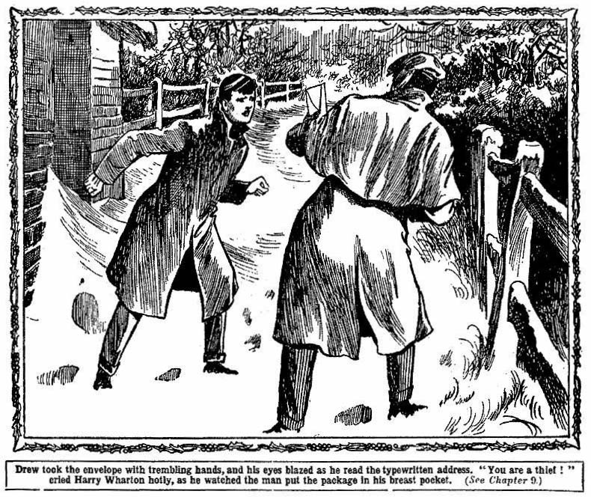
His eyes glittered, as he felt the thick cartridge envelope, and drew it out from the pocket.
Harry Wharton stepped back.
“Are you done, you thief?”
“Wait a minute! Strike a match!”
Harry Wharton felt for a matchbox, and struck a match, while the ruffian glanced at the long cartridge envelope.
The wind extinguished the match in a moment; but the brief glimmer had been sufficient for Drew t read the typed address on the envelope.
His eyes blazed as the match went out.
“Good!”
Harry Wharton turned away.
The man gave him no further heed.
He turned in the opposite direction. But he swung back in a moment.
“Boy! Wharton!”
“Well?” called out Harry, keeping his distance.
“You’ll go on to Edinburgh——”
“Tell Mr. Kerr he can expect a call from me before Christmas.”
“Very well!”
The ruffian chuckled again, and tramped away, the sealed letter in his pocket. He disappeared in a few moments.
Harry Wharton hurried on, his heart throbbing.
The ruffian was gone, with the imitation letter; and copy of the “Daily Mail” to reward him when he opened it!
Harry laughed silently at the thought.
When would he open it?
Not out of doors, probably, in the wind and the snow, when it contained valuable papers. He would wait till he was in shelter somewhere before he opened the envelope and examined his prize. It was evident that he had not the faintest glimmering of suspicion of the trick that had been played on him.
Before he discovered it, the Greyfriars juniors would be for out of the reach of his pursuit.
Harry ran on through the falling snow. The thick flakes had obliterated Bob Cherry’s footprints. Where his chum was Harry did not know but he was safe. He saw the light of a wayside inn at last, and stopped to inquire his way.
He found that it was a five-mile walk into Melrose from the inn, but the good-natured Scottish innkeeper came out, and pointed out the way to him carefully.
Harry tramped on in great spirits, in spite of the cold and the snow; he had defeated his relentless pursuer, and that was enough for him.
He arrived in Melrose at last, and hurried to the railway-station. There were a good number of people there waiting for trains, and as Harry Wharton came along the platform, looking for Bob Cherry, a voice he knew called out his name.
“Hallo, Wharton! You here!”
He turned, and met a smiling face and an outstretched hand. Three juniors of St. Jim’s smiled at him, and he recognized Kerr and Figgins and Fatty Wynn, of the St. Jim’s Fourth.
“Well met, old top!” grinned Figgins.
“Fancy meeting you!” said Fatty Wynn.
Harry Wharton shook hands with the St. Jim’s fellows. He was glad enough to meet them—especially Kerr.
“Have you seen Bob Cherry?” he asked. “I expected to find him here somewhere.
“No I haven’t seen him. What are you doing up here?”
Harry smiled.
“I think I shall surprise you, Kerr.” he answered.
“How’s that ?”
“ I’m going to your father’s house in Edinburgh.”
“Good man!” said Kerr. “ So are we. We’ve had a day out, scouting round Walter Scott’s country, and we’re going back, as soon as there’s a train. We’ll travel together. But what’s on?”
“ I’ll explain— !”
“Hold on,” said Fatty Wynn. “Let’s go into the buffet; you can explain thpre. I’m sure you want some thing to eat—”
“Quite true, I do.”
“1 thought so.” said Fatty Wynn, with satisfaction. “And I know I do. Come on.”
“Our train’s signaled, though,” said Figgins.
“I can’t go on without Bob.” said Harry. “If he’s not here yet—”
“Next train will do for us.” said Kerr. ‘I want to know what the game is, Wharton. Come on.”
“Nothing like laying a solid foundation.” said Fatty Wynn, with an air of great wisdom.
“You’ve laid about fifteen solid foundations to-day, Fatty,” grinned George Figsgins. “but come and lay another.”
And the St. Jim’s juniors marched Harry Wharton into the refreshment department, where, over ham and eggs and hot coffee, he explained the state of affairs—much to the astonishment of Figgins &. Co
“Hallo, hallo, hallo!” A stentorian voice interrupted the juniors, as a newcomer arrived, and stamped snow from his boots beside the table. “Here we are again.”
“Bob!” exclaimed Harry, jumping up.
“Same, old bean!” grinned Bob Cherry. “How do you do, you fellows? Quite a pleasant surprise to run on some pals in the middle of Caledonia stern and wild. So you got here first after all, Harry! I’ve been tramping around, and found myself viewing Melrose Abbey in the snow at the finish; after that it was plain sailing, and here I am. If Wynn hasn’t finished the available supplies, I’ll have something to bite.”
And Bob Cherry had something to bite---quite a large and extensive bite it proved.
“All safe?” said Harry.
“What do you think?” grinned Bob, with his month full. “Safe and sound— all serene—A1 at Lloyds—nothing the matter but a first-class hunger, and I’m curing that. And that chap with the book---”
“Probably enjoying the ‘Daily Mail’ by this time.” said Harry Wharton, laughing.
“Ha, ha , ha!”
Whether Jerrold Drew was enjoying the “Daily Mail “ or not, the chums did not see anything more of him before they boarded the train for Edinburgh with Figgins & Co. Fatigued, but in great spirits, they ran into the “Modern Athens”——but winter darkness hid the most beautiful city of Northern Europe from their eyes.
“I’ll show you some of our sights to-morrow,” said Kerr. “But just now— what we want is a taxi,”
And they rolled away through the streets of Edinburgh—at their journey’s end at last; and with the precious document still safe. Harry Wharton had fulfilled his trust.
THE TENTH CHAPTER.
Something Like a Surprise!
“Y0U’RE late!”
Mr. Kerr was seated at the telephone, in his study, at the house in Castlegate Street, when there came a tap at the door. The rest of the household was in bed. The door opened to admit George Francis Kerr and his companions.
Mr. Kerr glanced at Harry and Bob Cherry curiously.
He spoke cheerfully to his son; but all the juniors could see a deep shadow of trouble and anxiety on his brow. He placed the receiver on the hooks as the juniors came in.
“Yes, father,” said Kerr, “but—“
“You see—” said Figgins.
“I think I know who those young gentlemen are.” said Mr. Kerr.
“Harry Wharton, and Bob Cherry, of Greyfriars.” Kerr presented the two juniors. “We fell in with them at Melrose—my pater, you fellows.”
The old gentleman shook hands courteously with the two Greyfriars juniors, and bade them welcome to his house; but come on and courteous as his manner was the trouble in his face was only too visible. The juniors could guess that he had just received some bad news over the telephone.
“You don’t know why Wharton and Cherry are in Edinburgh, father.,” Kerr began.
“I think I do.” said Mr. Kerr quietly.
“You do?” exclaimed Harry.
“Were you not bringing a letter to me!”
“Yes—but—how do you know?” exclaimed Harry Wharton, in astonishment. “We came straight on—”
“McAlpine—is he seriously hurt?” asked Mr. Kerr.
“He is injured, sir, and will lie in hospital a few weeks, I think. But there is no doubt about his recovery, I believe.”
“Thank heaven for that. After all there is much to be thankful for,” said Mr. Kerr. “My dear boys, you, have tried to do me a service—a greater service than you can possibly imagine. If you have failed, it is not by your own fault, and I am as much obliged to you as if you had succeeded. I fear that you have been in danger.”
“That’s nothing, sir.” said Harry. “But why should you think we have failed?”
Mr. Kerr made a gesture towards the telephone.
“I have just heard.”
“But—I don’t understand!” said Harry, in bewilderment, while Bob Cherry blinked amazedly at the old gentleman.
Mr. Kerr smiled patiently. It was evident that he had received a blow; but he bore it with the quiet fortitude of the Scottish nature.
“I will explain.” he said. “I was expecting McAlpine—he was to bring me the papers. They relate to a new process in dyeing, and embody the results of a long series of experiments, carried out by him at his laboratories in Kent. He had succeeded in bringing the process to successful results — the secret is worth a huge sum. But some time ago he found that a spy is lurking about the laboratories---a rival named Jerrold Drew.”
“That’s the man!”
“I warned him to be on his guard— poor fellow. He was to come here to spend Christmas with us, and bring the papers. I was already more than anxious about him. I received the telephone call; a few minutes before you arrived.”
“But—”
“From Jerrold Drew!” said Mr. Kerr.
“He is in Edinburgh?” exclaimed Harry.
“Yes”
“He must have come straight on from Melrose, while we---”
“No doubt. Please understand, my dear boy, that I know you were not to blame for losing the papers. You did your best.”
“Losing the papers!” said Harry dazedly. “But—in Heaven’s name, Mr. Kerr, what has that villain told you on the telephone?”
“The whole story: that McAlpine was injured in a railway accident in Kent, and---”
“That is true.”
“That he entrusted the papers to some schoolboys who were in the train, going home for their Christmas holidays.”
“Correct!” said Bob Cherry. ‘“Little us!”
Mr. Kerr smiled fantly.
“He followed the two boys who started northward, and at Melrose, owing to a block on the line, the one who carried the papers fell into his hands, after leaving the train.”
“Yes but—”
“He has the papers, and he is coming here——”
“Coming here?” Harry.
“Yes. It is blackmail.” said Mr. Kerr quietly. “The value of the papers is immense—the new process will revolutionise dyeing in this country. By its means we hope to beat the German dyers out of competition. Drew’s fee for tin papers is twenty thousand pounds.”
“ But, father——” ejaculated Kerr.
“I shall not deal with a blackmailer.” said Mr. Kerr. “But if I do not buy the papers from him, he will sell them in Germany—instead of crushing our competitors, they will be armed against us with the new process.” He pressed his hand to his brow for a moment. “It is a bitter blow, but we must bear it. The man is coming here to make terms—I have given him permission to come. He may be here in a few minutes. Until I have seen McAlpine, I cannot decide how to deal with him.”
“He dares to come here!” exclaimed Harry, in amazement,
“You forget he has the security of the papers.” said Mr. Kerr. “if he is seized, and charged with the robbery, the papers will be taken direct to Germany by an accomplice. That is his security; and without McAlpine’s consent, I cannot venture to deal with him as he deserves. Poor McAlpine has spent ten years on his work. Can I let him lose it all at the finish! Yet to make terms with a blackmailer---” He bit his lip hard. “I can only temporise with the villain for the present.”
“But, sir, do you mean to say that he thinks he has the papers? He hasn’t examined them!”
Mr. Kerr smiled again.
“Unless he delivers the envelope into my hands, unopened, sealed as he found it, he knows that he cannot expect a penny.” he answered, “If he dared to open the envelope, he’d defeat his own scheme of blackmail. If his eyes had seen the actual papers, the secret would be known, and it would not be worth while to pay him—I should have him arrested instead.”
“Oh!” exclaimed Harry.
He understood now
“Then he hasn’t opened the envelope?”
“Certainly not. He will not bring it here, of course; he would not risk that. It will be left in a safe place while he comes to bargain with me. But he will leave it unopened; he knows I should pay him nothing unless it can be delivered unopened into my hands, the secret safe. He knows I should have to see it, and examine the seals, before I paid him his price—if I agreed to pay.
Harry Wharton’s eyes danced.
“Then he doesn’t know—of course, he can’t know! Oh, how good! Mr. Kerr, let him come—let the scoundrel come, and telephone for the police. The papers are here.”
Mr. Kerr jumped.
“What ?“ he stammered.
“Hand them out, Bob.”
Bob Cherry was already fumbling in his pocket for the precious envelope. Mr. Kerr stared at it blandly as Bob held it out.
“But—but what—”
Harry Wharton explained hastily, and the old gentleman listened in deep astonishment, relief flushing over his troubled face.
“Then—then he has the imitation envelope—” he stuttered.
“That’s it!”
“With nothing in it!”
“Only a ‘Daily Mail!’ ” chortled Bob Cherry.
“And—and as it is unopened, he still believes that he has the prize he became a thief to obtain!” gasped Mr. Kerr.
“Exactly!”
“Ha, ha, ha!” shouted the juniors, in great glee. The thought that Jerrold Drew was about to arrive, to demand twenty thousand pounds in ransom for a copy of the “Daily Mail” was very entertaining.
With a trembling hand Mr. Kerr opened the envelope Bob Cherry had handed to him.
He drew out the papers, and examined them by the shaded electric lamp over his desk.
For some minutes there was silence.
But the juniors read the relief, the joy, and satisfaction that dawned in the face of Kerr’s father.
After a hasty examination of the papers, the old gentleman unlocked a safe, thrust them inside, and locked the safe again.
His kind old face was beaming as he turned to the juniors.
“All serene, sir?” asked Bob Cherry.
“Quite!”
“Good egg!”
There was a discreet tap at the door. A manservant looked in, and announced that a Mr. Drew had called to see Mr. Kerr by appointment.
“Show him in!” said Mr. Kerr quietly.
Harry Wharton & Co. looked at one another.
“Now for the merry circus!” murmured Bob Cherry.
And there were five smiling Faces in the room a Mr. Jerrsold Drew was shown in to keep his appointment..
— —
THE ELEVENTH CHAPTER.
In the Toils !
JERROLD DREW came into room with a swaggering gait.
His hard face wore a grin of triumphant satisfaction; he was in high feather, and he did not take the trouble to conceal the fact.
He started at the sight of the juniors.
Then he grinned.
At the sight of Harry Wharton Bob Cherry he concluded—naturally enough in the circumstances—that the schoolboys had come on to Edinburgh to report their loss of the precious papers.
He gave them a mocking nod as he crossed the room towards Mr. Kerr.
The old gentleman eyed him sternly.
Matter had changed since Mr. Kerr had received the insolent, triumphant message on the telephone. Jerrold Drew did not know yet how they changed. But he was soon to know. “Good-evening, Mr. Kerr! A merry Christmas!” said the rascal, with a grin. “You won’t shake hands? Never mind---”
“ I am hardly likely to touch the hand of a blackmailer and a thief!” said Mr. Kerr drily.
Drew shrugged his shoulders.
“Well, I am here to talk business.” he remarked. “The social amenities can pass. I see that McAlpine’s messengers have arrived.”
“As you see.”
“No doubt they have told you what has happened.”
“That is so.” said Mr. Kerr, eyeing the rascal quietly.
“Substantiating what I explained the telephone,” said Jerrold Drew.
A smile flickered on the Scottish gentlemen’s face for a moment.
“Not wholly!” he aanswered.
“I gave you the facts!” said Jerrold Drew. “If they have given you facts, their story agrees with mine. Do you intend to send these youngsters out of the room before we talk business?”
It is not necessary.”
“You mean that you want witnesses? I care little. Two of the boys, at least, know all the circumstances already.” said Jerrold Drew carelessly. “My safety is in the secret I hold, and which you dare not allow me to disclose!”
“Are you sure of that?”
“Quite. MeAlpine has spent years of time, and thousands of pounds, on discovery of this process. I think it would kill him if the secret passed into the hands of the German dyers.”
“It is possible.”
“You would lose hundreds of thousands, probably---”
“ Probably.”
“I am moderate in asking twenty thousand for the papers which have been—ahem !—lost---”
“Stolen!”
“Put it as you like.” Drew shrugged his shoulders again. “I am not here to bandy terms with you. The papers are in a safe place.”
“Unopened?”
“Naturally. If I saw the papers, the secret would be mine, as I understand as much of chemistry as McAlpine does. In that case the papers would be so much waste-paper, so far as you are concerned.”
“I do not expect you to pay me twenty thousand pounds for nothing.” said Drew coolly. “I offer you your money’s worth. The envelope is intact—so far. Before you pay me a penny, I will allow it to be placed in your bands for examination—in a safe place, of course, where you cannot seize upon it. You shall satisfy yourself that it is intact; and you will ransom it to the tune of twenty thousand pounds. Gad! It’s worth that, I should say!”
“More than that!” said Mr. Kerr calmly.
“You agree?”
“Are you aware, Jerrold Drew, that you can be sent to prison for robbery and attempted blackmail?”
Drew laughed.
“I am quite aware of it.”
“What is to prevent me from seizing you where you stand, and handing you over to the police?”
“Only the fact that the papers will be handed over at midnight to a German agent who is exceedingly anxious to get hold of them, if I do not return before that hour.” answered Drew coolly.
“I am afraid that the papers will be handed over, then—such as they are.” said Mr. Kerr sedately. “1 wish the German agent joy of them—quite an agreeable little Christmas-box for him, in fact.”
Drew’s lip curled in a sneer.
“Bluff is no use with me.” he said. “I am not here to make terms. Twenty thousand pounds is the price of the papers; if we come to no terms, the price to-morrow will be twenty-five thousand. It will pay you to come to business this evening, Mr. Kerr!”
“I intend to do so.”
Mr. Kerr made a sign to the juniors, who had drawn close. They were waiting for the signal.
With one accord they sprang at the ruffian as Mr. Kerr signed.
Before Jerrold Drew had the remotest chance of getting at a concealed weapon he was down on the floor, in the grasp of five vigorous pairs of hands.
Bump!
The rascal rolled over on the carpet, with a furious howl.
Figgins’ knee crashed on his chest, and pinned him down; Harry Wharton and Bob Cherry had a wrist each, and they held on to them grimly; Fatty Wynn stood on the thrashing legs, and Kerr took the rascal round the neck.
It was as complete and effective a “tackle” as could have been desired. Mr. Kerr looked on, with a smile.
“You have him safe?”
“Ha, ha! Rather!”
“Just a few, sir!” chuckled Bob Cherry.
“Keep him so!”
“You bet!”
Jerrold Drew struggled madly.
“Let me go---let me— A thousand curses---”
“Quiet, old top!” said Kerr, giving the ruflian’s head a tap on the floor, which elicited a fiendish yell from him.
“Mustn’t swear, you know.”
“I—I—!”
“Quiet, dear boy!”
“We’ve got you by the short hairs, old beauty!” said Bob Cherry. “It’s our turn now, you know. Got anything to tie the brute’s paws with, Kerr?”
“Here!” said Mr. Kerr.
He drew a coil of thick string from a drawer of his desk. Bob Cherry took it, uncoiled it, and folded the string till it was nearly as thick as a rope, and then bound the ruffian’s wrists together.
Mr. Kerr then took up the receiver from the telephone, and gave a number.
The blackmailer gasped; he knew that number. Mr. Kerr was ringing up the police.
The old gentleman spoke a few crisp sentences into the transmitter, and replaced the receiver on the hooks.
“The police will be here in five minutes!” he said.
“You dare not!” breathed Drew, grinding his teeth. “If I do not return the—”
“You will not return!”
“The envelope will be handed over at midnight—”
“To a German agent?” smiled Mr Kerr.
“1 have said so. You dare not—”
“The German agent is welcome to it, and I trust he will find consolation and entertainment in a copy of the ‘Daily Mail’!”
“The latest news, you know!” grinned Bob Cherry. “All the winners!”
“Ha, ha, ha!”
Jerrold Drew glared from one to the other with the look of a caged tiger. Mr. Kerr held up the envelope from which he had taken the precious papers, and Drew started as he looked at it.
The papers are here!” said Mr. Kerr coldly. “They have been placed in my hands by McAlpine’s messengers. The packet you stole was a dummy packet containing a copy of the ‘Daily Mail,’ addressed and sealed. Do you understand now, you scoundrel?”
Drew’s jaw dropped.
It was evident that he understood.
His eyes blazed at Harry Wharton.
“You—you—it was you—” He choked with rage.
Wharton nodded coolly.
“Little me.” he answered cheerfully. “While you were robbing me, my chum was taking away the real packet to safety. There’s many a slip, you know, ‘twixt cup and lip!”
“I’ll remember this I—I—I’ll——”
“You’ll have plenty of time to think of it, on the merry treadmill.” said Bob Cherry.
“You’ll do well to remember, at the same time, that honesty is the best policy. Next time you want a ‘Daily Mail.’ better buy one at a bookstall. Comes cheaper in the end!”
“Ha, ha, ha!”
There was a heavy tread without.
Five minutes later the man with the scarred nose was led away between two stalwart officers, with handcuffs on his wrists.
Harry Wharton and Bob Cherry were speeding homeward, the next day, as fast as an express could carry them, for Wharton Lodge and Christmas festivities. Kerr and his father had pressed them to stay over Christmas, but they were expected at home; and Wharton, too, had to gather in Jack Drake and Dick Rodney, of the “Benbow,” for his Christmas party. But it was necessary for them to appear at the trial of the man with the scarred nose, and they promised to return for the latter part of the vacation—a promise that was duly kept.
And then they had the opportunity of “doing” Edinburgh—the castle and Calton Hill, Old Town and New Town, Holyrood Palace and Arthur’s Seat; and they “did” it with great enjoyment.
Harry Wharton’s Trust had been fulfilled, and on Christmas Day at Wharton Lodge, around the blazing log fire, the chums of Greyfriars heard the story of the perilous journey, and Hurree Jamset Ram Singh justly remarked that it was terrific. And Billy Bunter expressed great surprise that the perilous mission had been carried through successfully without his valuable assistance. But the perils were over now, and the recollection of them only gave in added zest to a Merry Christmas.
THE END.

If

