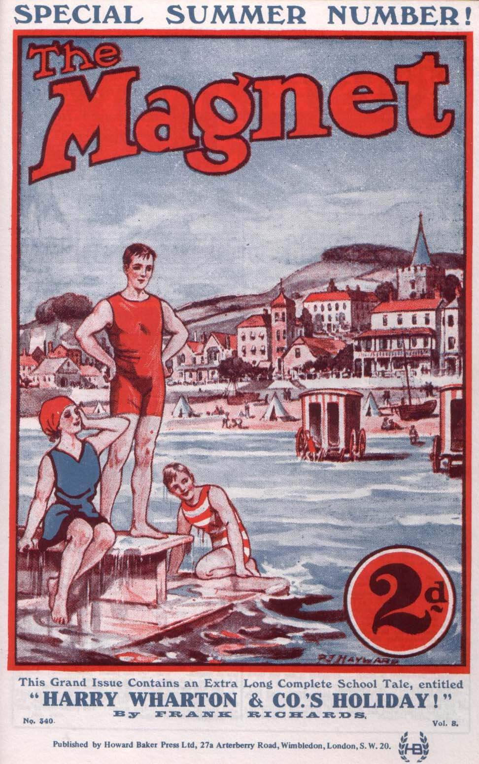
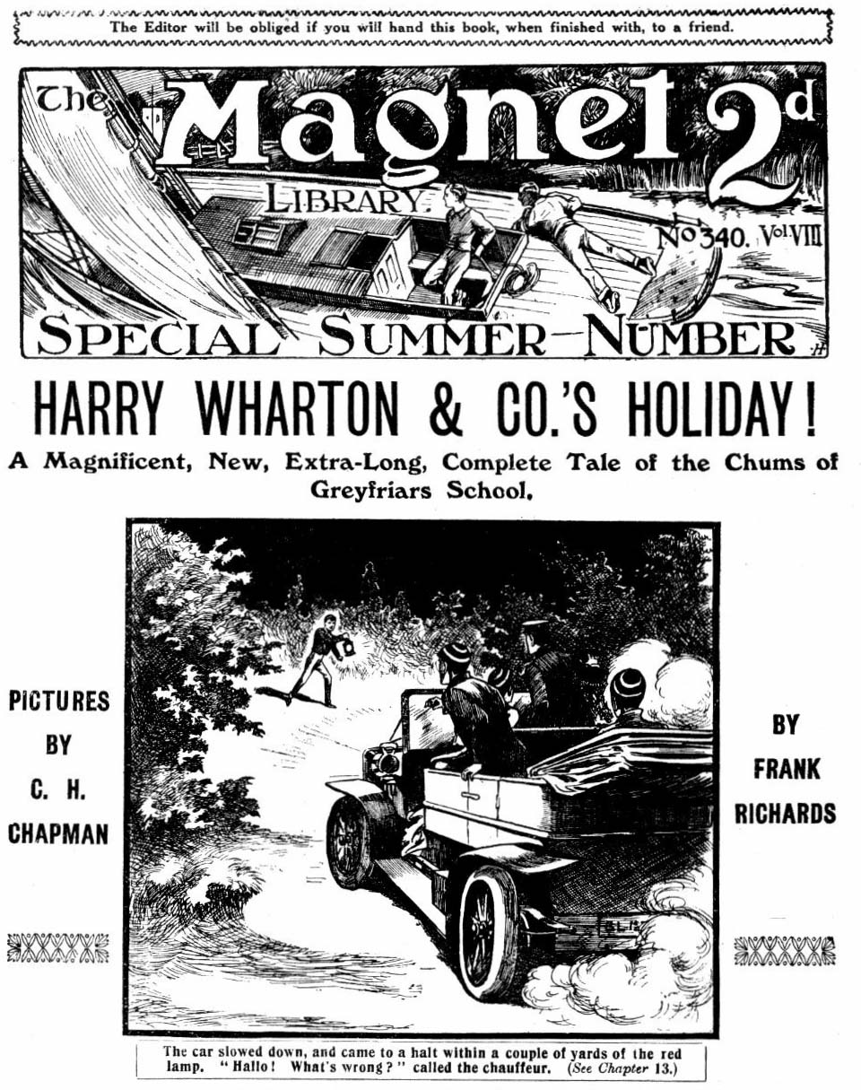
THE FIRST CHAPTER.
Not In Request!
“‘TAIN’T easy to decide!”
Billy Bunter of the Remove made that remark in the junior common-room at Greyfriars.
There was a buzz of cheery voices in the crowded room.
All the fellows had something to talk about. Most of them were making plans. For it was the last day of the term at Greyfriars; and on the morrow the school was breaking up for the holidays.
Hence the general cheerfulness.
There was no “prep” to be done on the last night of the term. The time generally spent in prep was spent in chatting, in packing, or in lounging about the School House with one’s hands in one’s pockets. Which the Greyfriars fellows regarded as a much more agreeable way of spending it.
In one corner of the common-room, Harry Wharton & Co. of the Remove were deep in discussion. The Famous Five had very special plans for that vacation. Lord Mauleverer, the dandy of the Remove, was yawning in an armchair, apparently the only fellow who was totally unexcited by the near approach of the holidays. Temple, Dabney & Co. of the Fourth were discussing a forthcoming motor-car trip, in quite loud tones—making it quite impossible for anybody not to know that they were going on a motor-car trip. Tom Brown, the New Zealander, was solemnly explaining to Hoskins of the Shell his intention of going home to Taranaki for the holidays in an aeroplane— needless to say, for th sole purpose of pulling the leg of the simple Hoskins, who listened with wide open eyes and mouth.
Billy Bunter had been sitting in a state of deep thoughtfulness. The fat brow of the fattest junior at Greyfriars wrinkled with reflection. Peter Todd, his study- mate in the Remove, was watching him curiously. He was wondering what great plans William George Bunter was making for the holidays— that is to say, upon whom the fat junior was scheming to “plant” himself.
“Tain’t easy!” repeated Bunter, with a shake of the head.
“What isn’t easy?” asked Todd genially. “Trying to think out what’s become of the postal order you’ve been expecting all the term?”
Bunter blinked at him through his big spectacles, in an absent minded sort of way.
“Eh? Oh, no! But ‘tain’t easy!”
“Selecting a victim?” asked Todd, with a grin.
Bunter sniffed. He was really thinking out who should have the honour of his company for that vacation; but he didn’t like to hear it described as “selecting a victim.”
“You see, there’s such a lot of places a chap can go to.” said Bunter loftily. “When a fellow’s very much sought after. he can’t go everywhere—but it’s up to him to be careful not to hurt people’s feelings.”
“Quite so!” agreed Todd. “But that needn’t worry you, surely?”
“Oh, really, Todd! Now, there’s Mauly!” said Bunter, ticking off the names on his fat fingers. “Mauly has a splendid place and a chap could depend on getting a good feed there. And then, as he’s a lord, one will meet all sorts of nobs there. I should feel quite at home among Mauly’s people.”
“Just as if you were among your own titled relations?”
suggested Peter Todd gravely.
Bunter nodded.
“Exactly. I really think I ought to give Mauly a chance. But then there’s Wharton—I hear he’s arranging some tour or other for the vac—and I think I should like that. I like the seaside.”
“You mustn’t forget Wharton!” agreed Todd. “ Wharton’s No. 2. Who’s the next victim?”
“The next pal,” said Bunter, with dignity. “The next pal I am thinking of is Vernon-Smith. I hear that Smithy always has a high time on his holidays—biing the son of a millionaire, of course, he would! I think I should like it all right with Smithy!”
He ticked Smithy off on the third fat finger.
“No. 3.” said Todd, with a grin. “ Who’s No. 4?”
“Well, there’s Coker of the Fifth. I’ve always been very friendly with Coker of the Fifth, and I don’t like quite to pass him over.”
“My hat!”
“But I mustn’t forget my friends out of Greyfriars.” said Bunter thoughtfully. “There’s that chap D’Arcy of St. Jim’s, you know. I’m awfully pally with him, and I must manage to give him a week-end, at least.”
“He must have a weak end if he has you with him for a holiday,” agreed Todd, “and his weak end would be his head, I should say.”
Bunter sniffed, but otherwise disdained to notice Todd’s humorous remark.
“Then there’s that other chap at Rylcombe Grammar School—Gordon Gay. I met him once at St. Jim’s, and rather took to him. I feel that I ought to give him a look in this vacation.”
“You ought!” said Todd. “He doesn’t know you from know you from Adam, of course—but give him a look-in. He made give you a kick-out in return. But don’t be bashful!”
“Then you, Toddy—there’s you!”
“Oh!” said Todd. “There’s me, is there?”
“Yes,” said Bunter calmly. “I might manage to give you a week. I don’t promise it, but I’ll do my best.”
“Will you, by thunder?” gasped Todd.
“Then there’s Temple of the Fourth—I rather like the idea of a motor-car trip. I must try to find tine for Temple.”
“Oh!”
“As I said, ‘tain’t easy to decide!” said Bunter thoughtfully. “I’ve got a good many more on my list. Still, you can count on me for a week, Todd! Now your Uncle Benjamin and your Cousin Alonzo are away, I think I could stand that. Yes, I’ll give you a week.”
“You’ll give me a week! You—you—”
“Which part of the vac would suit you best?” asked Bunter. “I can only make it a week, as have so many other engagements. Tell me which time you’d like best, and I’ll try to fix it in. Of course, these things have to be wangled.”
“I suppose they do,’’ agreed Todd. “Lemme see; could you come on the 30th of February?”
“Eh?”
“In the year 1990?”
“I say, Toddy—”
“That’s the only possible date I can give you.” explained
Todd. “If you can’t manage that, I’m afraid it will have to fall through.”
“Look here, Todd——”
“Better scratch my name off the list.” grinned Todd. “I ain’t worthy of the honour. In other words, I’m not taking any. Savvy?”
“On second thoughts, I don’t think I could spare you a week. I want to be decent to a chap who’s my study-mate here, but there are circumstances — I shouldn’t have much of a time in a country solicitor’s house, anyway—hardly up to my style—”
“Why, you cheeky porpoise—!”
“Besides, there’s Hazeldene,” said Bunter. “ I must find time for him somehow. His sister Marjorie will expect to see me during the holidays. It will be a bit of a squeeze, finding time for them all; but I mustn’t forget Marjorie— I don’t want to spoil her holiday. I’m sorry, Todd, but I shan’t be able to stay with you after all.”
“You—you—”
“ No good talking,” said Bunter, rising from his chair. “I’ve
said I’m sorry, and I am sorry, Todd; but it can’t be helped. With so many engagements, something will have to go— and I’m afraid it’s my week with you that will have to go. Sorry!”
And Billy Bunter rolled away, leaving Todd simply gasping.
Bunter stopped by Lord Mauleverer’s armchair. Lord Mauleverer was yawning, and he yawned more portentiously than ever as the Owl of the Remove joined him. But Bunter blinked at him very genially through his enormous spectacles.
“It’s all right, Mauly!” he remarked.
“Begad, is it?” said Lord Mauleverer.
“Yes.”
“Glad to hear it.” yawned his lordship “Good-bye!”
“Ahem! What I mean to say is, that I’ve been thinking out my engagements for the vacation, and I find I can give you a week.”
“Begad!”
“Might as well make it the first week in the vac.” said Bunter. “Then I can leave with you to-morrow, and come directly down to your place. The other fellows will have to wait, that’s all.’’
“Begad!”
“Are you going by train or motor-car, Mauly?”
“Eh?”
“If you’re going by train, I want to know which, so that I can be ready in time, you know.”
“Yaas.”
“I’d rather go by car, if it’s all the same to you, though.”
“My dear man, I don’t mind how you go—so long as you do go.” said Lord Mauleverer.
“Well, which are you going by?”
“That depends, begad!”
Bunter looked puzzled.
“I don’t see. What does it depend on, Mauly?”
“It depends on you, my dear fellow. If you go by train, I shall go by car—”
“Eh?”
“And if you go by car, I shall go by train—”
“Oh, really, Mauly—”
And in either case I sha’n’t see you till we get back to Greyfriars!” said Lord Mauleverer calmly; and not then if I can help it, begad!”
Billy Bunter glared at the schoolboy earl.
“You silly ass—”
“Thanks!”
“I jolly well won’t come now.”
“Many thanks!”
“I shouldn’t care to pass a week with a silly chump, anyway—”
“Hear, hear!”
Bunter snorted and rolled away again. His list, extensive as it was, was not panning out very well so far. He joined the Famous Five, who were still deep in discussion. Harry Wharton and Bob Cherry, Frank Nugent and Johnny Bull, and Hurree Jamset Ram Singh were making extensive plans, which did not include William George Bunter. They went on talking cheerfully, apparently unconscious of the existence of the Owl of the Remove.
“I say, you fellows—”
“There’s us five.” Bob Cherry was saying. “ And I suppose Smithy would come, and Tom Brown, and, of course, Hazeldene. What about three more?”
“I say, Cherry—”
“We must have eleven, if we can fix it.” said Harry Wharton. “ Unluckily, some of the fellows we want are booked. Bulstrode is going home, and Penfold can’t come, and Mark Linley’s going home to Lancashire. Fisher T. Fish would come, but he’s no good at cricket, and he’s a worry, anyway. Bolsover major might do, but he’s booked. What about your minor, Franky? He plays a rather good game for a Second Form fag.’’
Nugent nodded.
“Dicky will be glad to come.” he said. “1 was thinking of suggesting it. That will make nine of us.”
“I say, Nugent—”
“We’ll ask Todd. If Todd comes that will be ten, anyway. And I dare say we could pick up an eleventh chap somewhere.”
“I say, Wharton—”
“Ten, anyway.” agreed Johnny Bull. “It’s simply a ripping idea—simply ripping! How many fixtures have you got so far?”
“Three, so far. And we can get some more, too. I—”
“I say, you rotters, I’m talking to you!” roared Bunter.
“Hallo, halo, hallo!” exclaimed Bob Cherry, apparently
becoming aware of Bunter’s existence for the first time.
“Did you speak, Bunty”
Billy Bunter glared.
“You jolly well know I did, you beast! Look here, you
fellows, I’ve decided——”
“Have you?” yawned Wharton. “Right-ho! Never mind telling us what you’ve decided—go and tell somebody else. We’re busy. Why, you chaps, there’s Mauly! We’ll make Mauly eleventh man!”
“He can’t play cricket.”
“We’ll make him!”
“Ha, ha, ha!”
“I say, you fellows, I hear you’re arranging a tour for
the vac.!” said Bunter.
“Yes, yes! Buzz off!”
“Visiting seaside places, and fixing up cricket-matches en route, and so on?”
“Yes. Don’t bother.”
“Sounds like being a good time.” said Bunter.
“Well, we hope so. Run along!”
“Well, I’ve decided what I’m going to do.” said Bunter. “ I’m coming with you.”
The Famous Five stared at him.
“You?”
“Yes.” said Bunter, with a nod. “I can’t waste any time on Todd. I’m sorry about it; but I shouldn’t have much of
a time in a country solicitor’s house—his pater is only a
solicitor, you know. I was thinking of Mauly; but on second
thoughts I can’t stand a yawning ass like that. Bcsides, I
should like a tour.”
“Go hon!” murmured Bob Cherry.
“And if you’re thinking of playing cricket you can’t do better than play me. You know what kind of a cricketer I am.”
“Ha, ha! We do—we does!”
“Well, it’s settled?” said Bunter.
“Quite settled!” said Harry Wharton, laughing. “ We’re making up a cricket team, not a freak exhibition, and you’re superfluous, Bunty, old man. I recommend you to bestow yourself on some of your titled relations. We’re not taking any.”
“Oh, really, Wharton—”
“Buzz off!”
“Now, look here,” said Bunter, his little round eyes gleaming determinedly through his spectacles, “ I’m coming! Hazel’s coming with you, ain’t he?”
“Yes.”
“And so you’ll be meeting Hazel’s sister Marjorie—”
“Quite so!”
“That settles it, then. You know how pally I am with Marjorie.”
Bob Cherry began to glare. But the Owl of the Remove did not observe the danger-signal. He rattled on cheerfully:
Marjorie will naturally expect me to be in the party. It will spoil it all for her if I’m not there. I’m jolly well going to take her for little moonlight walks on the sands, and all that! He, he, he! Yow-ow-ow!”
Billy Bunter’s fat chuckle was suddenly cut short. Five pairs of hands descended on him at once, and he was whir1ed off hiq feet.
“Yarooh! Leggo! Wharrer yer doing? Ow! Ow!”
Bump!
Bunter descended on the floor of the common-room, gasping. The Famous Five walked away and left him there still gasping. He groped for his spectacles, and set them straight on his little fat nose, and blinked round at the grinning crowd of fellows.
“Ow! Ow! Ow! Ow! Beasts!” roared Bunter.
“Ha, ha, ha!”
“I say, you fellows, I’m coming, all the same! Where are those beasts gone? Ow! Ow! I’m coming, all the same! Grooh!”
And Billy Bunter picked himself up, snorting, and rolled away in search of the Famous Five, fully determined that he was coming all the same!
THE SECOND CHAPTER.
Left Out!
PETEA TODD came into his study with a cheery whistle. Billy Bunter was there, with a far from cheery expression on his face. The Famous Five were celebrating the break-up of the term with a final feed in No. 1 Study, on an unusually large scale. Quite an army of fellows had been asked to it—more than the study would hold, as a matter of fact—but William George Bunter was not one of them. Troublesome as the Owl of the Remove generally was the Co. would have relented towards him on the last night of the term, with the happy prospect of not seeing him again for a good many weeks. But his unfortunate remarks on the subject of Marjorie Hazeldene in the common-room had hardened their hearts.
Impertinence was the leading trait in Billy Bunter’s character; but on the subject of Marjorie impertinence was not permitted. And when he had put his fat face into No. 1 Study a loaf had caught him upon the chest and bowled him over into the passage, and Bunter had beaten a discomfited retreat. He was glowering when Peter Todd came in.
“Hallo! You’re not at the feed, then!” said Bunter, glad that someone else was left out.
Todd grinned.
“I’m just going.” he said. “ Everybody in the eleven will be there. As you’re not in the eleven you’ve nothing to grumble at.”
“So you’re going with those beasts? ”
“Exactly!”
Todd began to select the best of the crockery from the study cupboard. On the occasion of a feed of unusual dimensions crockeryware was at a premium and had to be borrowed up and down the passage.
Bunter watched him through his big spectacles, with a very injured expression.
“I say, Toddy, you might put in a word for me, you know. We’re good pals, you know!”
“Go hon!”
“And Marjorie will be in the party—”
Todd held up a warning finger.
“Chuck it!” he said peremptorily.
“Oh, really, Todd, I hope you’re not getting jealous of
mp like Bob Cherry! It’s not a fellow’s own fault if girls take
to him—”
“Shut up, you silly fathead!” said Todd. “The party will be meeting Marjorie and Miss Clara at Shoremouth, and, therefore, you are out of it. Marjorie can’t stand you at any
price.”
“Look here, you know jolly well—”
“Besides, every fellow has to stand his own exes.” said Todd. “We shall be weeks on this trip, and we can’t afford to carry a passenger. If you hadn’t the cheek of Old Nick himself you wouldn’t expect it.”
“If I get some postal-orders I’m expecting to-morrow morning—”
“Oh, rats!”
“Besides, Mauleverer’s going to be there, and he’s got lots of money. Mauly and I are great pals.”
“Br-r-r-r-r!”
“And Smithy, too—Smithy’s rolling in money!”
“He wouldn’t let you roll in his money, I fancy!” grinned Todd. “This is where you shut up! They’d have let you come to the feed if you hadn’t spoken familiarly of Marjorie in the common-room. Why can’t you learn not to be such rotten cad?”
“Why, you—you——”
“Oh, cheese it!” said Todd, making up a pile of crockery ready to carry along to No 1 Study.
“I say, Todd, old man, I really ought to come along, you know. If Wharton’s been fixing up cricket matches, he’ll want a good player—”
“Bow-wow!”
“Anyway, I’d umpire!” said Bunter desperately. “ The team ought to take an umpire along.”
“Umpires are supposed to know something about cricket, fat head!”
“Well, don’t I know something about it?” roared Bunter, exasperated.
“You’ve kept it jolly secret if you do!”
“Besides, you know what an entertaining chap I am. I’ll make the railway journeys lively, you knew. You know, I’m a splendid ventriloquist—”
“I know you bother people with rotten ventriloqial tricks!” growled Peter Todd. “ No ventriloquists wanted on this journey. Go and eat coke!”
Todd lifted the little pile of plates, cups, and saucers, and turned to the door. Billy Bnnter’s eyes gleamed behind his spectacles. He was in a state of the greatest exasperation. After the list he had made up of the fellows to stay with over the holidays, he had made the painful discovery that he was not at all in request. He had even ventured to hint t Coker of the Fifth that he’d go home with Coker, and Coker, after an astonished stare, had cuffed him for his cheek. He had told Vernon-Smith that he would come along with him, and Smithy had bidden him go and eat coke. Even Skinner and Snoop and Stott had declined the honour of Bunter’s company over the holidays.
And although Bunter often gave great descriptions of wonderful doings at home, it was to be noted that he did not show any great keenness to spend his holiday under the parental roof. And never had a fisher for invitations failed so lamentably to get a single catch!
Even his great gift of ventriloquism stood in his way now. The Remove chaps were fed up with it, for Bunter’s little tricks were not always good-natured, and his wonderful gift had led to many severe thumpings.
But it came into his mind now, as Todd walked away with the pile of crockery, that his gift of ventriloquism had its uses, if only to make the fellows “sit up” for leaving him out of that holiday excursion.
He cleared his throat with a fat little grunt, his eyes following Todd to the door.
Todd had just stepped into the passage with his load of crocks when there came a sudden growl of a dog under his very feet.
Gr-r-r-r-r!
Peter Todd gave a jump.
The pile of crockery in his arms tottered, and the next moment there was a terrific crash as it shot down on the passage floor.
Smash!
“Oh, my hat!”
“Hallo!” exclaimed Vernon-Smith, coming out of the next study with a pile of crockery. “ Well, you are clumsy! Ha, ha, ha!”
Peter Todd stared at the ruin in dismay.
“There’s a blessed dog here!” he exclaimed. “The beast growled right under my feet, and startled me. Mind you don’t tread on him.”
The Bounder of Greyfriars peered about the dusky passage.
“Can’t see any dog.” he remarked.
“Well, he’s here. I nearly—”
Gr-r-r-r-r!
Vernon-Smith uttered a sharp exclamation and jumped away, as he heard that savage growl close behind him.
Crash!
“Ha, ha, ha!” roared Peter. “Who’s clumsy now?”
“My hat! I—I thought the beast was going to bite me! Where’s that blessed dog?” roared the Bounder, glaring round wrathfully.
“Hallo, hallo, hallo! Breaking up the happy home?” called out Bob Cherry. “Crocks cheap where you come from, you fellows?”
“There’s a beastly dog here—”
“Can’t see him.’
Peter Todd uttered a yell. There evidently wasn’t a dog in the passage, but he was mystified only for a moment.
“That ass, Bunter!”
He rushed back into his study. Billy Bunter was grinning all over his fat face, but his grin vanished as Todd rushed upon him.
“I say, Toddy — Ow! Yow! Leggo! Yaroooh! Ooooooch!”
Peter Todd did not let go. He smote Billy Bunter hip and thigh. Bunter rolled on the study carpet and roared. But Peter was not finished yet. He brought his boots into play, and dribbled Bunter round the study like a football. ‘The fat junior squirmed under the table at last, yelling.
“Ow! Yow! Help! Murder! Fire!. Yah!”
“There!” gasped Peter. “Now, perhaps you’ll give your giddy ventriloquism a rest!”
“Ow! Yow, yow, yow! Yaroooh !“
Peter Todd stalked out of the study. His contribution of crockery was in fragments on the floor, and he had to forage along the passage seeking further supplies. Billy Bunter crawled out from under the table, dusty and gasping.
“Ow! Yow! The beasts! But I ain’t jolly well going to be left out of that feed, all the same, or I’ll make ‘em sit up if I am! Ow! Yow! After all I’ve done for them, too! Ow!”
THE THIRD CHAPTER.
The Last Feed of the Term!
HARRY WHARTON & CO. were in high feather.
No. 1 Study in the Remove passage was crowded— not to say crammed.
It had been Wharton’s idea to spend a part of the
vacation in an excursion, combining cricket with the pleasures of the seaside. And his idea had been backed up heartily by the Co. Bob Cherry and Johnny Bull, Frank Nugent and Hurree Jamset Ram Singh, hailed the idea with enthusiasm. Tom Brown, the New Zealander, whose home was so far away, had joined in the scheme with great keenness. Peter Todd, whose services as a cricketer were highly valued, had assented at once. Vernon-Smith, the Bounder of Greyfriars, now on the best of terms with the Famous Five, and a pillar of strength in the Remove eleven. gave in his adhesion most cordially. Nugent minor was glad enough to join his major’s party, and to have a chance of playing cricket with the Remove players. Hazeldene, whose chief qualification was that he was Marjorie Hazeldene’s brother, and Lord Mauleverer, the dandy of the Remove, made up the rest of the eleven.
And all the eleven were crowded into No. 1 Study for that final feed; and although No. 1 was a good size for a junior study, it certainly was a cram.
But the juniors did not mind that. Those who could not sit down, stood up, and good-humour prevailed on all sides.
The feed was ample, most of the juniors being in funds, and all of them having stood their “whack” to supply the festive board.
Crockery, borrowed from all sides, glistened on the table among piles of good things.
Bob Cherry looked round over the crowded study when all the eleven fellows were inside. The door had been left open, likewise the window, for coolness.
“Room for one more?” asked Bob.
Harry Wharton laughed.
“We’ll make room.” he said.
“Then I’ll fetch Marky.”
Mark Linley was Bob’s study-mate in No. 14. Bob strode along the Remove passage, and found the Lancashire lad packing up his books. Mark looked round with a smile.
“Come on!” said Bob cheerily.
“Eh? Where?”
“Final blowout to wind up the term.” said Bob. “ I wish you were coming with us to-morrow, Marky. But you can come to the feed, anyway.”
And Bob marched the scholarship boy along the passage, and into No. 1 Study.
“Standing room only!” grinned Nugent. “Trot in!”
“Rather a squeeze.” said Wharton; “ but—”
“But what’s the odds so long as you’re ‘appy?” said Bob Cherry. “ Mauly, my son, gather up some of your legs. No room to sprawl, old chap.”
“Begad!”
“I say, you fellows—”
“Blessed if there isn’t Bunter again!” exclaimed Bob, exasperated. “ Give me a cricket-stump, somebody.”
“Here’s the poker.” said Hazeldene.
“Thanks! Now, Bunter—”
But Bunter had vanished. He had not waited for the poker.
The crowd in No. 1 Study were soon busy with the feed, and the clatter of knives, and forks, and crockery, and
popping corks made a merry din. Fisher T. Fish, the
American junior, came along the passage and looked in.
“I guess I‘m on in this scene.” he remarked.
And Fish squeezed in somehow. Hospitality was unbounded in No. 1 Study on that special evening.
“I say, you fellows—”
“Get out!” roared Bob, as the fat face and glistening spectacles of Billy Bunter appeared again at the open door way. He made a clutch at the poker, and Bunter vanished like a ghost at cock-crow.
“Ha, ha, ha!”
Most of the juniors were talking at once, and there was a considerable amount of noise from the crowded study. In the midst of the joyous din, there came a sharp, metallic voice from the passage—the well-known, incisive voice of Mr. Quelch, the master of the Remove.
“Stop that disturbance instantly! Every boy here is to go to his own study at once
“Oh, my hat!”
“Begad!”
“Oh, sir!”
Dismay fell upon the merry party. Certainly they were making some noise, but unusual freedoms were allowed on the last night of the term, and they had not expected Mr. Quelch to chip in like this.
“Rotten !“ towIed Johnny Bull.
But Fisher T. Fish had looked out of the doorway, and he gave a yell:
“‘Tain’t Quelchy!”
“What?”
Bob Cherry bounded into the passage. A fat figure was scudding away at the other end; but there was no sign of the master of the Remove.
Bob turned back into the study, breathing wrath.
“It’s all right, you chaps! ‘Tain’t the Quelch-bird! It’s that fat beast again with his beastly ventriloquism.”
“Oh, good!” said Vernon-Smith. “Here’s to us!”
“Hurrah!”
And the feast went merrily on. Fisher T. Fish posted himself just inside the door, with a syphon of soda-water close by him.
“I guess that fat galoot will be back here again.” he remarked, “and I kinder reckon I shall catch him on the hop—some!”
“Ha, ha, ha!”
Ten minutes later, when the noise in No. 1 Study was waxing fast and furious, there was a step in the passage.
Fisher T. Fish winked at the juniors, and picked up the syphon, grinning
“I kinder guess there’s going to be a surprise—just a few!” he murmured.
“Not so much noise, please!”
It was the voice of Mr. Quelch from the direction of the head of the stairs. But for the previous trick of Billy Bunter, the juniors could have been certain that it was the genuine voice of the Remove-master.
Fish held the syphon ready.
“Oh, rats!” he replied.
“What?”
“Come off !”
“Fish! How dare you address me in that manner!”
“Don’t he do it well?” murmured Johnny Bull. “I’d swear it was Quelchy talking, if I didn’t know it was that ventriloquial beast!”
“Yes, rather.”
“The ratherfulness is terrific.” murmured Hurree Jamset Ran Singh. “ But the esteemed Bunter is going to have a surprise.”
Fish made a sudden jump through the doorway, pressing the nozzle of the syphon as he jumped to catch the ventriloquist before he fled.
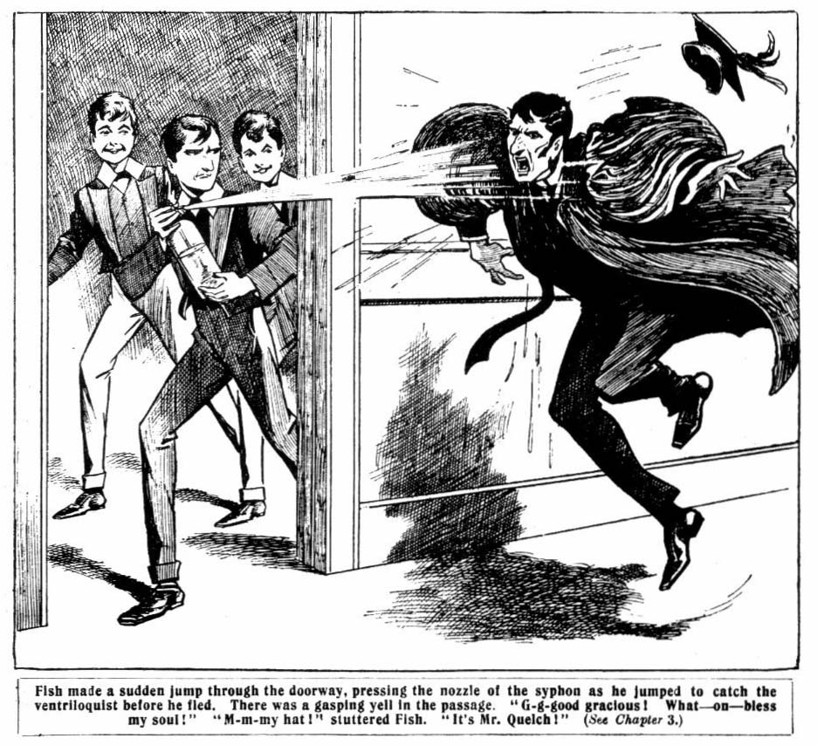
The soda-water streamed out in a blinding flood.
There was a gasping yell in the passage.
“G-g-g-good gracious! What—oh— Bless my soul!”
With a roar of laughter the juniors crowded out of the study. But their roar of laughter died away suddenly.
The severe figure of their Form-master in his gown met their eyes, and he was staggering against the wall— drenched!
Fish, utterly dumbfounded and terror-stricken by his mistake, stood rooted to the floor, his jaw dropping, and his hand still unconsciously compressing the nozzle of the syphon, so that the stream of soda-water was still shooting out.
Wharton grasped his arm and dragged him aside, and gave a whoop as the stream caught him in the face.
“Oh! Ow! Groogh!”
“Look out!” roared Bob Cherry, who had also caught some of the soda-water. “Oh, you ass!”
“M-m-m-my hat! stuttered Fish. “It—it’s Mr. Quelch!
“Oh, sir!”
“Awfully sorry, sir!”
“Quite a mistake, sir!”
“Yaas, begad!”
“The mistakefulness is terrific!”
Mr. Quelch was gasping for breath. That too hurried stream of soda-water had caught him full in the face, to began with, and then it had drenched his gown. His face was running with it; and he was crimson with anger.
“Fish! Are you mad?” panted the Form-master. “How dare you—how dare you, sir?”
“I—I—I——guess——”
“You—you—you—”
“It was a mistake, sir!” gasped Wharton. “Fish thought it as Bunter, sir, playing a ventriloquial trick on us.”
Mr. Quelch had heard of Billy Bunter’s exploits in that line, and, fortunately, he understood.
But the wrathful frown did not leave his majestic brow.
“Fish should not have madp such a mistake. You are an utterly stupid boy, Fish. You will take two hundred lines, and go to your study at once and write them out!” but
“Oh, I swow!”
“Go!” thundered Mr. Quelch, and the dismayed Fish went—glad, however, to escape so cheaply.
“I came to tell you not to make so much noise!” snapped Mr. Quelch. Even on the last night of the term, it is unnecessary to turn the school into a bear-garden.”
And the Remove-master, mopping his face with his handkerchief, stalked away.
The juniors looked very solemn till Mr. Quelch was gone. But when they crowded back into No. 1 Study they were grinning. They had never seen a Form-master drenched with soda-water before, and it struck them as funny.
The feast proceeded with a little less noise; but ten minutes 1ater Billy Bunter’s voice as heard again.
“I say, you fellows—”
Bob Cherry laid hold of another syphon.
“This way, Bunter. Here’s something for you.”
“Oh, good! What is it?”
“Soda-water!” said Bob cheerfully, as Bunter’s fat face came peering in. “Here you are, as much as you like!”
Sizzzzzzzzzz!
“Ow, ow! Gerrooogh! Yaroooggggh! Gr-r-r-r-r-r!”
“Ha, ha, ha!”
Bunter was fairly bowled over by the sudden stream. He disappeared into the passage and the feasters sent a yell of laughter after him; and after that the feed proceeded without any further interruptions from the Greyfriars ventriloquist.
THE FOURTH CHAPTER.
Quick March!
BRIGHT and sunny the morning dawned upon Greyfriars school.
All the fellows were up at the first clang of the rising-bell.
There were final preparations, final packings, final goodbyes and au revoirs. Harry Wharton & Co. were catching th+e morning express from Courtfield. The Famous Five were going to Wharton’s home for a few days, and the rest of the travelling team were to join them there after seeing their people. Tom Brown was going with Wharton, and Billy Bunter fully intended to so as well. Bunter relied
fully upon his on abilities to such an extent that he had already written to his people not to expect him, as he was passing the first part of the vacation with his schoolfellows and friends.
The juniors, having taken leave of their comrades, started walking to Courtfield; their luggage being left with Gosling the porter to be despatched.
Lord Mauleverer was starting home in a magnificent motor-car, and the juniors said good-bye to him, and he buzzed off. Vernon-Smith dashed away in a trap. Harry Wharton & Co. contented themselves with “Shanks’ pony,” as Bob Cherry expressed it, to reach Courtfield Junction. Hazeldene walked to Courtfield with them; he was then going on to Cliff House to take his sister Marjorie home.
“I say, you fellows, don’t walk so fast.”
The juniors paused, and looked round in astonishment.
“Hallo, hallo, hallo! Bunter!”
Billy Bunter, in a shining topper, and with a light coat over his arm, was hurrying down the road after them.
The Owl of the Remove came up panting, and with perspiration glistening upon his fat forehead. It was a warm morning, and Bunter was not accustomed to exercise.
“You going from Courtfield station?” asked Frank Nugent.
“Yes, of course.”
“What train?”
“Same as yours”
“But our train doesn’t go in your direction!” said Harry Wharton. “You want one going the opposite way.”
Bunter grinned feebly.
“Of—of course, I knew you were only joking yesterday, Harry, old chap.”
“If you call me Harry, old chap, I’ll bump you!”
“Oh, really, Harry!”
Wharton frowned and made a movement towards the fat junior. Billy Bunter dodged behind Johnny Bull.
“I say, Harry, don’t start the vac with a row when we’re going to have such a jolly good time together.” he remonstrated.
“But we’re not going to be together.” said Wharton, puzzled .
“Oh, yes, we are! I knew you were only joking, you know, when you said you wanted to leave your old pal Bunter out of the party. You’ll need an umpire with you, if you’re going to play cricket. I’m going to be your umpire.”
“You—you cheeky owl!”
“I don’t mind a joke,” said Bunter. “ I can take a joke with anybody. He, he, he!”
“The Removites stared blankly at Bunter. Billy Bunter was about as thick-skinned as a rhinoceros, and the extent of his nerve was colossal. But that he should have the extraordinary “cheek” to plant himself upon the party after their exceedingly plain speaking on the subject almost took their breath away.
“Well,” murmured Bob Cherry, “ this takes the giddy cake!”
“The wholefulness of the esteemed cake!” said Huree Jamset Ram Singh.
Wharton raised his hand.
“Cut off!” he said.
“Oh, really, Harry—”
“Don’t call me Harry; I don’t like it from you!” snapped Wharton. “Clear off, or we’ll chuck you in the ditch. Buzz!”
“You know that Marjorie will want me—”
Hazeldene made a stride towards the fat junior. Bunter hadl to dodge again.
“You fat rotter!” growled Hazel. “If you mention my sister
again—”
“Walk sharp!” said Bob Cherry.
The juniors walked quickly towards Courtfield. Billy Bunter rolled after them, not in the least discouraged. He was determined to look upon their refusal of his company as a joke; nothing, in fact, would convince him that it wasn’t a joke.
Three fellows came in sight on the road, and the juniors recognised Trunper and Grahame and Wickers, of Courtfield Council School. Trumper & Co. were the old rivals of the Removites, and they seldom met; without “slanging” or ragging, but on this occasion all was good-fellowship. Harry Wharton & Co. greeted them warmly.
“Off for the holidays?” asked Trumper. “ Best of luck.”
“Thanks! We’ll give you no end of walloping when we come back next term!”
Trumper grinned.
“I don’t think!” he remarked.
“I say, Trumpy, old man.” exclaimed Bob Cherry, “ will you do us a little favour?”
“A big one, if you like!” said Trumper cheerily.
“We’re being haunted by a fat ghost.”
Trumper & Co. glanced at Billy Bunter, who was puffing on up the road, and chuckled.
Will you collar him, and walk him back to Greyfriars— you’re going that way! Doesn’t matter if you hurt him!”
“Ha, ha, ha!”
“Any old thing!” said Trumper. “Good-bye!”
“Good-bye!”
Harry Wharton & Co. walked on toward towards Courtfield.
Trumper and Grahame and Wickers continued on their way
till they came up with the fat junior, and then they stopped.
Billy Bunter would have passed them, but they stopped
directly in his path, and the Owl of the Remove had to halt.
“I say, you fellows, get out of the way!” snapped Bunter.
“We’re going to talk to you!” chuckled Wickers.
Bunter sniffed.
“I don’t care to be seen talking to fellows of your class.” he said loftily. “I draw the line at County Council schools myself. Let me pass!”
Trumper & Co. exchanged grins. Harry Wharton & Co. never seemed to see any difference in “class “ between Greyfriars and Courtfield County Council School. But Billy Bunter, among his other enticing qualities, was a snob of the first water.
“Sorry, Bunter, but we’re going to disgrace you!” grinned Trumper. “I’m going to take your noble arm, and Grahame
is going to take the other, and we’re going to walk with you to Greyfriars!”
“I’m not going back to Greyfriars!” roared Bunter.
“Your mistake; you are paste
“Look here— Leggo—”
“March!” said Trumper.
Billy Bunter had no choice about marching. Trumper had taken one fat arm, and Grahame had taken the other, and they marched Billy Bunter back towards the school. Wickers walked behind, helping Bunter with an occasional lunge of his boot when the fat junior slacked down. Bunter blinked at the Courtfield fellows in helpless rage. Any one of them could have made rings round Bunter in the matter of fisticuffs, and with the three together he was quite powerless.
“I—I say, you fellows.” gasped Bunter, as they marched him on. “I say, you’ll make me lose my train, you know!”
“Sorry!”
“I’ve got to take the same train as my pals, you know!”
“Your pals don’t seem anxious for you to do it!” grinned Trumper.
“Ha, ha, ha!”
“Oh, the beasts! Do you mean to say they’ve asked you to—to keep me back! Oh, the rotters! After all I’ve done for these fellows! Leggo! Do you hear?’’
“I hear!” agreed Trumper. “I’m not deaf. Kim on!”
“Leggo!” shrieked Bunter.
“This way!”
Billy Bunter, writhing with rage, was marched on willy- nilly. They reached the gates of Greyfriars, where Trumper & Co. politely bade him good-bye, and strolled on towards Friardale. Billy Bunter, completely out of breath from his rapid walk, leaned on the stone pillar of the gateway, and gasped.
“Ow, the beasts! Ow, the rotters! Yow-ow-ow!”
The fat junior looked at his watch. He was fatigued and out of breath, and to catch that train at Courtfield he would have required to run all the way at a good rate. The game was up!
But Bunter’s luck was in, as it happened. The carrier’s cart came trotting by from the direction of Friardale. Bunter’s eyes gleamed behind his glasses, and he jumped into the road and held up his fat hand.
“Give me a lift to Courtfield, will you, Cripps? I’ll make it a bob!”
Cripps pulled in his horse.
“Jump in, Master Bunter!”
Master Bunter did not jump in; he hadn’t a jump in him. But he clambered in, and sank down in the cart with a gasp of relief. Cripps whipped up hi. horse, and the cart rolled on towards Courtfield.
And Bunter grinned.
THE FIFTH CHAPTER.
Goodbye, Bunter!
HARRY WHARTON & Co. walked on the platform at Courtfield Junction. They were in good time for the express, which e yet come in. Hazeldene took his leave of his companions, and departed for Cliff House. The Famous Five and Tom Brown strolled along the platform, and went into the buffet for liquid refreshment in the shape of ginger-beer.
“Hallo, hallo, hallo! Highcliffe rotters!” murmured Bob Cherry, as they entered.
Highcliffe School was breaking up on the same day, and Ponsonby & Co. of the Fourth Form at Highcliffe were evidentily catching tho same train as the Greyfriars chums. They were in the buffet—Ponsonby and Gadsby and Vavasour. Frank Nugent gave Ponsonby a dark look. There had been trouble between them, and Nugent had not forgotten it. However, the Greyfriars fellows were not looking for trouble on the first day of the vacation, so they walked farther along, and ordered their ginger-beer, without appearing to notice the existence of Ponsonby & Co.
The Highcliffe fellows, however, looked at them, and exchanged glances, and whispered. Ponsonby extracted an eyeglass from his pocket and jammed it in his eye, and surveyed the group of juniors with a supercilious stare. Bob Cherry grew a little restive.
“Suppose we bump those silly asses, just to wind up the term?” he suggested.
Wharton shook his head.
“They’re not worth the trouble.”
“I don’t like that idiot Ponsonby looking at me with his silly eyeglass!”
“Never mind. Don’t let’s have a rag now.”
And Bob Cherry grunted and contained his wrath. The Highcliffians evidently intended to make themselves disagreeable, and Bob would have been very pleased to knock some of the conceit out of them. However, he agreed to keep the peace, and the Greyfriars fellows assumed an elaborate unconsciousness of the supercilious looks of their old enemies.
The swing doors of the buffet were pushed open again, and a fat junior, gasping for breath, came in, and blinked round through his big spectacles. Johnny Bull saw him first, and uttered an exclamation.
“Bunter, by gum!”
“My only hat! Bunter!”
Billy Bunter sighted them, and bore down upon them with a cheerful grin.
“All serene, you fellows!”
“How did you get here?” demanded Nugent.
“It’s all right! I don’t mind a joke.” said Bunter. “I had quite a pleasant walk with Trumper, and then got a lift in the carrier’s cart coming here. He, he, he!”
“You can he, he, he as much as you like!” growled Wharton, “but if you get into the train, I’ll jolly well pitch you out again!”
“Oh, really, Harry!”
“What is it?” said Ponsonby, of Highcliffe, loud enough for the juniors to hear, turning his eyeglass upon Billy Bunter. “Something escaped from the Zoo, do you think?”
“Absolutely!” grinned Vavasour.
Fat Jack of the Bonehouse!” said Gadsby.
Billy Bunter blinked across at the Highcliffe fellows. There
was a gleam in his eye. Miss Jummer, the young lady who presided over the bar, had just come in reply to a rap on the counter from Ponsonby.
“What are you going to have, you chaps?” drawled Ponsonby. “Make it fizz, what?”
“Yaas!” said Vavasour.
“Good egg!” said Gadsby. “Make it fizz, old chap!”
Ponsonby ordered champagne, with a flourish. Ponsonby was blessed with more money than brains, and he prided himself upon being a nut of the knuts.
“Silly asses!” growled Bob Cherry, in disgust.
Miss Jammer brought the champagne. Billy Bunter cleared h+is throat with a little cough. The Greyfriars fellows knew that cough, and they grinned. They knew that the Remove ventriloquist was clearing for action, so to speak.
Vavasour set down the 1ong stemmed glass, after drinking, with a flush in his face, a little out of breath after the champagne.
“What rotten stuff!”
“Eh?” said Ponsonby, not at all pleased to hear his expensive treat characterised as rotten stuff. “ What’s that, Vav!”
“Eh? I didn’t speak.”
“ Didn’t you?” growled Ponsonby. “ If you don’t like the fizz, don’t drink it.”
“Oh, go and eat coke!”
“What?”
“I—I didn’t——”
“If you want to start the vac with a thick ear, Vavasour, you’ve only got to say so!” exclaimed Ponsonby angrily. e’
“I—I swear I didn’t!” exclaimed Vasour in astonishment. “ It must have been Gaddy.”
“Don’t talk rot!” growled Gadsby. “ Do you think I don’t know your voice? There ain’t another voice like it outside a Punch-and-Judy show.”
“I tell you——”
“Oh, rats!” said Ponsonby.
“You’re drunk, Pon!”
“Oh, I’m drunk, am I?” said Ponsonby savagely, glaring at his chum. “Look here, Vav——”
“I didn’t say you were drunk.” yelled Vavasour.
“Yes, you did!”
“I tell you I didn’t. Somebody else did!”
“Look here——”
“Don’t make a noise here, little boys.” came a voice apparently from Miss Jummer, who was serving the Greyfriars fellows with ginger-beer. “You silly little fellows should not drink champagne at all!”
The three Highcliffe fellows glared at Miss Jummer.
“What business is that of yours, Miss Jummer?” rapped out Ponsonby angrily.
The young lady of the bar turned round as she heard her name.
“I beg your pardon.”
“I say, what business is it of yours whether we drink champagne or not?” demanded Ponsonby angrily.
He was excited by the “ fizz,” and annoyed by the altercation with Vavasour, and his temper was rising.
Miss Jummer stared at him.
“None at all.” she said. ‘ Why——”
“Well, then, keep your opinion to yourself.” said Ponsonby rudely.
Miss Jummer flushed.
“I did not give you my opinion, but I will now.” she snapped. “You are very silly to drink champagne at your age—very silly indeed! It is making you excited. And I will not serve you any more. Go away, and be quiet!”
Ponsonby & Co. glared. Ponsonby paid for the champagne with a sovereign, received his change, and the three juniors walked towards the door, all of them extremely bad tempered. They had not reached the door when a voice exactly like Miss Jummer’s rapped out:
“Stop! This isn’t a good sovereign!”
Ponsonby swung back angrily.
“Rot! It’s a good sovereign!” he said. “Let’s see
Miss Jummer had gone to serve another customer, but she looked round as Ponsonby spoke, loudly and angrily.
“What is it now?” she asked.
“Let’s see that sovereign.”
“I have put it in the till.” said Miss Jummer in surprise.
Wasn’t your change all right?”
“Yes, it was; but you said the quid was a bad one.”
“I did not!’’
“What! Why, you did!”
“I did not!” said Miss Jummer, with asperity. “ And I request you to leave the buffet at once, Master Ponsonby. Your conduct is disorderly!”
Ponsonby ground his teeth, and turned to the door again.
The bullet waiter was standing near the door, and there was
a grin on his face. The grin irritated Ponsonby, but he strode on; and as he turned his baek on the waiter he heard a voiee
“ Precious young rascals!”
Ponsonby turncd furiously on the waiter.
“Begad, I’ll report your insolence to your manager!” he exclaimed. “How dare you speak to me?”
The waiter stared at him.
“I ain’t spoken.” he said.
“You liar! You called us names.”
“Somebody did.” said the waiter. “I ‘eard it ; but it wasn’t me. But don’t you call me a liar, young gent! You jest get out. You’ve drunk too much!”
“It was you!” howled Ponsonby. “And I won’t leave here till I’ve told your manager of your insolence.”
The waiter, at a glance front Miss Jummer, opened the door.
“You’ll go hout, and you’ll go hout at once.” he said,
“and if you don’t go hout, you’ll be put hout. Now, then!”
“Come on, Pon.”said Vavasour, catching his companion
by the arm. “Don’t get into a row with a waiter, for goodness’ sake!”
The waiter shepherded the Highcliffians out of the buffet, and they departed in a towering rage. Billy Bunter grinned at his companions.
The Greyfriars fellows chuckled. Ponsonby & C. had no suspicion of the cause of their trouble in the buffet.
“I say, you fellows, there’ll be lots of fun having a ventriloquist in the party——”
“Only we’re jolly well not going to have a ventriloquist in the party!” said Wharton.
“Oh, really, Harry——”
“Shut up!”
“We’ll have some whisky.” went on Wharton’s voice—at least, it sounded like Wharton’s voice.
His chums stared at him aghast
“Harry!”
“They won’t serve us with whisky.” said Nugent; “and we don’t want any if they would. Have you gone off your rocker, Harry?”
Wharton gasped. For a moment he was dumbfounded. But the next moment he made a jump at Billy Bunter.
“You—you spoofing rotter!”
Bunter dodged among the little tables.
“Only a j-j-joke.” he gasped. “I—I was only showing you how funny it would be!”
“Oh, it was Bunter!” exclaimed Nugent, in reliecf.
“Of course it was Bunter!” snapped Wharton. “Do you think I should suggest having whisky, you fathead! I’ll— I’ll——”
He made another rush at Bunter.
The fat junior stepped out of the buffet. He had not improved his chance of accompanying the party by that little joke.
“Trains in!” exclaimed Bob.
The juniors paid for their ginger-beer—and Billy Bunter’s ginger-beer—and left the buffet. The train was beside the platform now, and passengers were hurrying to take their seats. The six juniors entered a carriage which was fortunately empty, just filling the number of the seats. But another passenger wanted to get in—it was William George Bunter. His fat hand grasped the handle of the door. Bob Cherry held the handle on the inside, and grinned at him cheerfully through the window.
“Good-bye, Bunter!”
“Oh, really, Bob, I’m coming!”
“Full inside!”
“You can make room for one more.”
“Got your ticket?” chuckled Bob.
“No. One of you fellows can pay.”
“Ha, ha, ha!”
“Let me in, you beast!”
“Ha, ha, ha!”
“Stand clear!” shouted the guard.
“Buzz off, Bunter! Good-bye!” roared the juniors.
“Oh, you rotters——”
“Good-bye, Bunter! Ha, ha, ha!”
Bunter released the handle of the door, and disappeared among the passengers on the platform. Bob Cherry dropped into his seat with a chuckle
“Shaken off, by Jove!”
“Ha, ha, ha!”
And the Greyfriars juniors began their journey in great spirits, enlivened by the prospect of the holiday before them, and the prospect of having at last shaken off Bunter.
THE SIXTH CHAPTER.
Not Quite Left!
“FIRST stop Lantham.” said Harry Wharton, and they
settled down for the journey.
The time passed quickly enough in cheery chat on the inexhaustible subject of the forthcoming holiday tour. Besides the joys of the seaide, the juniors had three cricket matches booked for their excursion. One of them was with Gordon Gay, of Rylcombe Grammer School, who was to spend part of his vacation at Shoremouth, with some of his friends from the Grammar School. Another was with a party of St. Jim’s fellows who were staying near that seaside town. But the first was with the local team at Wharton Magnus, near Harry’s home. And the captain of the Remove intended to book some more fixtures, if the tour extended longer. The Remove chums were looking forward to the matches, and to the holiday generally. Shoremouth was a merry place, with any amount of boating and bathing, and there they were to meet the Hazeldenes.
“Lantham!” said Johnny Bull. “Hallo! There go the Highcliffe bounders!”
Ponsonby & Co. were seen alighting from th next carriage. They scowled at the merry faces of the Greyfriars fellows at their window, and walked down the platform to change trains. Then Bob Cherry uttered an exclamation:
“Bunter!”
“My only hat!”
“The only-hatfulness is terrific!”
There he was, coming along the platform, with the train guard walking by his side. There was a very severe expression on that guard’s face, and it looked as if Bunter was in trouble. He was scanning the windows of the train as he came along, and the Greyfriars juniors promptly backed out of sight. But Bunter knew the carriage, and the guard opened the door.
“Excuse me, gentlemen.” said the guard, touching his cap. “ This young person has been found travelling without a ticket. He says he has friends on the train who will pay his fare. Otherwise, he will get into trouble for swindling the company.”
“Don’t you be uncivil, my man, or I’ll report you to the station-master.” said Bunter loftily. “These chaps are my friends.”
The guard grunted.
“Well, if somebody doesn’t pay there will be trouble.” he said. “Do you young gentlemen know him?”
The chums of the Remove glared at Bunter. His cheek was astounding. He had got into the train after all at Courtfield. and had had the amazing nerve to leave it to them to pay for his ticket. They did not believe for a moment that he had any money about him, but Bunter had a way of looking after his own money. He was never reckless with it excepting when he was in the tuckshop. Then he spent it like water.
“We know him.” growled Bob Cherry. “ But we’re jolly well not going to pay his fare.”
“No fear!”
“The no-fearfulness is terrific!”
“I say, you fellows, I’ve left a banknote in my 8tudy at Greyfriarss.” explained Bunter. “ I’ll write for it immediately we get to Wharton Lodge.”
“You’re jolly well not going to get to Wharton Lodge.”
“Oh, really, Harry—”
“You kim along!” exclaimed the guard, grasping Bunter by the shoulder. “The young gents say they ain’t paying your fare. This way with you!”
Bunter struggled.
“I say, you fellows, I’m stony—I am, really! You’re not going to let a Greyfriars chap be hauled up for a paltry half-crown, I suppose?”
Wharton frowned angrily.
“Hold on, guard!” he said. “We’ll pay it. Here you are.”
The guard released the fat junior.
“Werry well, sir.”
“Pay the full fare to Wharton Magnus.” said Bunter.
“Pah! I’ll pay your fare here, and not a brown over. Don’t let him get into the train again without a ticket, guard.”
“I’ll see he don’t!” grunted the guard.
“I say, Wharton—”
Slam!
The carriage door closed, and Bunter stood on the platform, blinking wrathfully at the juniors. The train glided out of the station, leaving him standing there. He shook a fat fist after the grinning faces at the carriage window.
“Really left him behind at last!” chuckled Tom Brown.
“He’s not in the train. There he is, ornamenting the platform.”
“Ha, ha, ha!”
And the juniors, satisfied that they had got rid of the Owl of the Remove at last, settled down to resume the discussion of the coming holiday.
They had to change again for Wharton Magnus, but at the junction there was no sign of Bunter. The Owl of the Remove had evidently been left behind.
The local train took them on to the village near Wharton’s home. It was a short journey, and ere long the six juniors turned out at the little country station.
“Wharton Magnus!”
“Here we are!” said Harry. “My uncle may be here to meet us. Yes, here he is!” the
Colonel Wharton, a kindly-looking gentleman, with white moustaches, came across the platform to greet the juniors. He extended a hearty greeting to Harry’s companions, and they walked out of the station in the best of spirits.
The Colonel’s car awaited them outside.
“You’re not all here?” said the colonel.
“No; the others are coming down later, when they’re been home to see their people, uncle.” said Harry. “They’ll all be here in a few days.”
“Right!”
The car bore them rapidly to Wharton Lodge. There Miss Wharton, the colonel’s sister and Harry’s aunt, greeted them affectionately.
After removing the dust of travel the juniors descended to a late lunch in the old oak-panelled dining-room of the Lodge.
Miss Wharton had taken special care of that lunch. She had had the honour of entertaining in her nephew’s friends before, and she knew their tastes. The lunch was, as Bob Cherry declared, ripping. It was half over when the colonel looked in, with a smile on his bronzed face.
“One of your friends has arrived, Harry!” he said.
Wharton looked surprised.
“Good!” he said. “I suppose it’s your minor, Franky. But he’s had hardly time to get home first before coming on, surely?”
“This way, my lad!” said the colonel to the junior in the hall.
The new arrival walked in.
There was a shout from the juniors.
“BUNTER!”
Billy Bunter grinned amiably at the party.
“Sorry I missed getting in at Lantham, Wharton.” he said. in the most genial manner. “ But it was all right. I found I had some cash about me, after all, and I caught the next train. Only an hour behind you. I’ll help you with that lunch.”
Bunter drew a seat to the table and started.
Harry Wharton & Co. looke at him fixedly.
They were too astounded to do anything but stare for some moments. Then Wharton made a sign to his comrades to keep the peace. He did not want a row in the presence of his uncle. But Bunter did not seem to notice the freezing silence of the Remove fellows. He was tucking into the lunch, and it absorbed all his attention just then.
THE SEVENTH CHAPTER.
Bunter, Too!
BUNTER stayed.
Bob Cherry said he deserved it for his cheek. Wharton thought that he deserved something else for his cheek, but he did not desire to inflict that something else in his uncle’s house.
The Co. decided to make the best of Bunter, and Bunter made himself at home at once. He persisted in regarding Wharton’s many refusals of his company as a joke, and he said he could take a joke with anybody.
He was installed at the Lodge as one of the party, and Harry, having made up his mind to make the best of it, let it pass without many words.
Billy Bunter made himself very comfortable.
A hearty welcome was not necessary to his comfort; but at the Lodge nothing else was lacking.
That day, and the next, Bunter talked at considerable length of the good time they were going to have on their tour at Shoreniouth.
But the Co. had their own opinion about that.
“We won’t have the fat bounder at Shoremouth.” Harry Wharton remarked in private. “ It wouldn’t be fair to Marjorie. She can’t stand him!”
“Hear, hear!” said Bob Cherry. murmured
“But how are we going to shake him off?” grinned Tom Brown. “Blessed if he doesn’t stick like a limpet to rock, or like grim death to a nigger.”
Wharton wrinkled his brows in thought.
“I don’t want my unclc or aunt to see that there’s any trouble.” he said. “ But I’ll tell you what. We’ll leave Bunter here.”
“Leave him here!” murmured Nugent. “Rough on uncle and auntie.”
“Ha, ha, ha!”
“Well, he can’t very well stay after were gone. We won’t tell him what train we’re catching, you see, and we’ll leave
him in bed when we go!” “Ha, ha, ha!”
“Talk of angels!” murmured Johnny Bull, as Billy Bunter came into the room.
The fat junior blinked at them.
“I say, you fellows, when are you leaving?” he asked.
“Monday.” said Wharton.
“What train?”
“A railway train.”
“I mean, what time does it start?”
“When it begins its journey.”
“Look here, Wharton!” said Bunter, as the juniors chuckled. “I don’t want to risk missing that train. I understand that you’re not going direct to Shoremouth. You’re stopping somewhere to play a cricket match.”
“Exactly.”
“Well, where are you stopping?”
“At a place.”
“But what place?”
“The place where we’re going to play a match.”
“But where are you going to play the match?” hooted Bunter.
“At the place we stop at.”
Bunter blinked at him wrathfully.
“If you call this politeness to a visitor, Wharton, I don’t After the way you practically forced me to come here—”
“Wha-a-a-at?”
“There was Mauly wanted me to go to him.” said Bunter loftily, “and Toddy begged me, almost with tears in his eyes, to go to his place. It was hard to refuse Todd, but I thought I’d come with you chaps, as you wanted me so much. Todd was very cut up.”
The door had opened again, and Peter Todd came in. He had just arrived. He grinned as he heard the fat junior’s remarks.
The other fellows grinned too. Bunter had his back to the door, and he had not seen Todd yet.
“If you fellows hadn’t been so pressing I shouldn’t have refused Todd.” he went on; “ And Todd owes me some money, too. I lent him a quid to get home with.”
“What!”
“I suppose you could let me have it now, Wharton, couldn’t you, and I’ll tell Toddy to hand my quid over to you. I’m rather short of monpy. I really don’t believe in lending money, only I felt I couldn’t refuse Toddy, as I had already told him I couldn’t possibly spare him any time this vac— Yarooh ! Who’s that?”
Peter Todd had advanced quietly behind the fat junior, and he now laid an iron grip on his ear. Bunter yelled, and swung round in alarm.
“Oh! Is that you, Todd, old chap? Leggo my ear!”
“Ha, ha, ha!”
“What’s that about my owing you a quid?” asked Todd, compressing his grip on Billy Bunter’s ear, till the fat junior howled, and shaking him vigorously.
Ow! Yow! I was only j-j-joking! Yow! Ow! What I really meant to say was— Yow! Ow! Ow!”
“Well, you’re saying it now!” grinned Bob.
“Ha, ha, ha!”
“Grooh! Oh! Don’t shake me like that, Todd, you beast You’ll make my glasses fall off, and if they g-g-g-et b-b-broken—yow—ow —you’ll have to pay for ‘em! Yaroooh!”
“Do I owe you a quid?” demanded Todd, still shaking.
“Ow! No!” !”
“Are you a fat lying toad?”
“Grooh!”
“Are you a fat, lying toad?” repeated Peter, shaking harder than ever.
Bunter gasped.
“Ow! Yes! Yes! Leggo !“
“Good! I’ve shaken some truth out of him, at all events!” grinned Todd. And with whirl of his arm he sat Bunter on the floor. “I didn’t know you fellows were going to have Bunter here.”
“And we didn’t either.” said Wharton ruefully. Bunter settles those things for himself.”
Peter Todd shook hands all round with the juniors.
“Any of the others arrived?” he asked.
“Not yet! Nugent minor will be here to-morrow. Mauly and the rest come along later. Jolly glad to see you, Toddy.”
“I say, Wharton, I—I was only j-j-joking about Toddy owing me a quid. It was really Nugent minor.”
“What!” exclaimed Frank Nugent.
“And I think that as your minor owes me a quid, Nugent, you ought to square up for him, and—and Gerroff ! Hands off! Yarooh!”
Bunter fled.
The next day Dicky Nugent arrived. And the day after Vernon-Smith put in an appearance.
The match with the local team was fixed for Saturday, and by that time all the Greyfriars eleven should have been at Wharton Lodge. Lord Mauleverer arrived on Friday, but only a letter came from Hazeldene. He was at Shoremouth, and he asked Wharton to excuse him, as his uncle was there. He promised to join the team in time for the match with the St. Jim’s fellows at Headland.
Wharton received the letter on Saturday morning, when the party were at breakfast. He gave a whistle.
“Hazel won’t be there.” he remarked. “We shall be a man short for the match to-day.”
Bunter looked up quickly from his sixth rasher
“I’ll play, Wharton.”
“Oh, don’t be funny!”
“You’re a man short.” remarked Colonel Wharton. “Why not play Bunter, Harry?”
“Oh, he can’t play for toffee.” said Harry.
“Oh, really, Wharton! If you leave me out I shall really have to consider whether I can remain your guest any longer !” said Bunter, with a great deal of dignity.
Colonel Wharton looked at the fat junior rather curiously. During the past few days he had observed some things, though he had said nothing about it. Harry Wharton frowned.
“After all, it’s only a village team we’re playing this time.” Bob Cherry remarked. “Might as well put Bunter in. He won’t do any good, but he won’t do any harm.”
Wharton nodded.
“All serene. You’ll play, Bunter.”
Billy Bunter grinned with satifaction. He had a full conviction that he was a cricketer, and that only envy kept him out of the Remove team at Greyfriars.
“Right-ho!” he said. “I’ll show you some cricket! Of course, the team here ain’t up to our form. Better put me on to bowl, and put ‘em out of their misery—what!”
“You might put some of us out of our misery, too!” grinned Bob Cherry. “Anybody within range night be put out of his misery if you have the ball!”
“Ha, ha, ha!”
Billy Bunter only snorted, and helped himself to another rasher. And when the Greyfriars cricketers went down to the village for the match on the village green, Billy Bunter rolled along with them, looking as if he were on the point of bursting out of his flannels.
THE EIGHTH CHAPTER.
Bunter Plays Cricket!
VERNON-SMITH had had a letter that morning from Hazeldene, as well as Harry Wharton. He had looked very thoughtful over it, but he did not offer to read any of it out, as the juniors rather expected he would. They would have been glad of news from Marjorie. The Bounder of Greyfriars still wore a thoughtful look as he walked down to the village with the cricketers. Bob slapped him on the back.
“Penny for ‘em!” he said jovially.
The Bounder started.
“Eh? What?”
“Penny for your thoughts, old man!”
Vernon-Smith coloured a little.
“Oh, I—I was just thinking!” he remarked. “Is there time for me to get to the post-office, Wharton, before we play?”
“Lots!” said Harry. “It faces the green.”
“Good!”
They reached the village green, and the Bounder hurried across at once to the post-office. Billy Bunter gave a fat chuckle.
“Well, what’s the cackle about?” demanded Bob Cherry brusquely.
“Poor old Smithy!” grinned Bunter.
“What’s the matter with Smithy, then?”
Bunter chuckled again.
“He’s so jolly anxious to keep friends with Marjorie.” he explained. “I fancy it comes a bit expensive to him. He, he, he!”
“What do you mean?” growled Bob. “Why should it come expensive to him?”
“Because he has to be chummy with her brother: you see. Marjorie hasn’t forgotten that it was Smithy who used to be a wild beggar, and led Hazel into it.” said Bunter. “Smithy is awfully keen to make her believe that he has reformed.”
“Well, he has reformed, you fat rotter!”
Bunter sniffed.
“Oh, I don’t take that in!” he said. “Smithy can tnke you chaps in, but he can’t take me in. No fear! And if Smithy’s reformed, Hazel jolly well hasn’t! I know what Smithy’s gone to the post-office for, and I know what Hazel’s letter was about. He, he, he! I wonder how much he’s going to send him?”
“Oh, shut up!” said Bob.
But the juniors could not help feeling a little disturbed.
It was only too probable that Billy Buntpr, with his usual cunning, had hit on the facts of the case. Hazeldene was one
of those fellows who arc born to look for trouble, and to find it. Every time he came a “mucker” his repentance was sincere, and he made the best of resolves for the future, but when the effect of his lesson had worn off he would drop into his old ways again. It was as a companion of the Bounder of Greyfriars that he had learned most of his reck- less ways, and when the Bounder had reformed Hazel had not followed his example, or, rather, he had reformed a good many times—every time he was in difficulties owing to his recklessness—but his reformations never lasted. And now that Hazel was away from the comrades who had helped to keep him straight, it was only too likely that he was getting reckless again. It occurred to Wharton—he could not help it—that perhaps it was not only Hazel’s uncle who kept the wayward lad from joining the party at Wharton Lodge. It was only too possible that he had fallen among bad companions at Shorermouth, now that he was “on his own.”
Vernon-Smith came back from the post-office without saying a word as to why he had been there. The juniors asked him no questions. It was no business of theirs, after all.
The local team had arrived on the ground now. Their captain, Tomlinson, was an old acquaintance of Wharton’s. He was the son of the village solicitor. The team was composed of village lads. The Remove team of Greyfriars would have beaten them easily, but with Bunter and Lord Mauleverer and a fag like Dicky Nugent in the team the result was by no means so certain. Dicky was a good player for his age, but he was only a Second Form fag, and Lord Mauleverer was too lazy to live, as Bob Cherry expressed it ; and as for Bunter, he was an out-and-out duffer.
Wharton won the toss, and elected to bat first. Billy Bunter came up, blinking.
“I suppose you’re starting the innings with me, Harry?”
“Then your supposer is out of gear,” said Wharton tartly. “ You’re last man in.”
“Better begin with a good core,” urged Bunter. “ It will encourage the others, you know.”
“Oh, rats!” said Wharton. “ Come on, Bob!”
The Remove captain opened the innings with Bob Cherry. Tomlinson went on to bowl the first over. Then the Removites met with a surprise. They had been inclined to look upon the match as a walk-over, as they were meeting a country village team, but cricket was well played at Wharton Magnus. Harry Wharton found it difficult to stop the bowling, and the fourth ball of the over found his wicket. Wharton retired with 2 runs to his credit, and with a some- what elongated face. As it was a single innings match, there was no chance of retrieving his bad fortune. And Frank Nugent, who followed him in, was bowled the next ball. Nugent minor replaced his major at the wickets, and the last ball of the over knocked his wicket to pieces. A loud cheer from the villagers greeted the performance of the hat trick.
“Three down for two!” grunted Johnny Bull. “ We shall have to wake up!”
“He, he, he!”
“What are you cackling at?” roared the exasperated Johnny. “Anything funny in seeing our wickets go down?”
“He, he, he! I warned Wharton to put me in first— you can’t say I didn’t, Wharton!”
Wharton did not reply. He was watching the batting anxiously. Vernon-Smith had gone in. But Bob Cherry was getting the bowling now from another bowler. Bob made 6 on the over, and the Co. were a little encouraged.
But the form of the villagers was very good, and, after a hard innings, the Greyfriars score stood at only 46 when Wharton called out
“Last man in!”
Johnny Bull was at the wickets now, and it was for Billy Bunter to join him there. The fat junior drew on his gloves with a swagger.
“Do your best, for goodness’ sake!” said Harry. “Don’t hit out, but let Bull do the batting. Save your wicket if you can.”
Bunter sniffed. He was far too good a cricketer to need advice from his skipper—at all events, he was satisfied that he was.
“Rot!” he said tersely.
“Eh?”
“Johnny Bull’s not a bad stone-waller.” said Bunter patronisingly. “ Let him keep the innings open, and I’ll take the runs.”
Wharton dropped his hand heavily on the shoulder of the Owl of the Remove.
“Look here, Bunter——”
“Oh, rot!” said Bunter. “I know how to play cricket. I’m going to give you fellows an eye-opener, and you’ll see what you’ve lost by not playing me in the Remove team at Greyfriars.”
“You silly ass—”
“‘Nuff said.” said Bunter, with dignity. “You watch me, that’s all.” And the Owl of the Remove rolled on to the pitch.
“ N.G. !” growled Bob Cherry. “If the silly ass tried to keep his wicket up, he might give Johnny a chance to pile on a few more runs. But the chump is as conceited as he is fatheaded. We go out for forty-six!”
“Looks like it!” growled Wharton. “Unluckily, that fat duffer has the bowling.”
Billy Bunter was quite aware that the eyes of all the team were anxiously upon him, and he swaggered considerably a he went on, swinging his bat. He paused to speak to Johnny Bull as he passed him at the wicket.
“Stick to stone-walling.” he said.
Johnny Bull stared at him.
“What?” he ejaculated.
“You stick to stone-walling, and leave the batting to me.” said Bunter. “What I want is some steady stone-walling at your end, to keep the innings open, and give me a chance.”
“What you—you want!” gasped Bull, almost overcome.
“Exactly. I want to make a century if possble.”
“You—a century! You silly chump—”
“You mind you don’t let me down, that’s all!” said Bunter, and he walked on to his wicket.
Perhaps it was just as well he walked on, for Johnny Bull was gripping his bat in a businesslike manner, a if he meant to lay it about the fat person of the Owl of the Remove
Bunter stood his stand at the wicket with an exaggerated straddle. He blinked along the pitch towards Tomlinson, who had the ball.
Tomlinson grinned. He did not think it would take him long to capture that wicket, from the way Bunter shaped.
Whiz! The ball came down. If Bunter had been contented to play a cautious game and save his wicket, and leave the scoring to his partner, he might have kept the innings alive but. But nothing was further from Bunter’s thoughts. He swiped at the ball, fully intending it to be a boundary. Unfortunately, his bat missed the ball by a foot or more.
The impetus of that wild swipe made Bunter spin round like a humming-top, and he lost his footing, and sat down on the crease with a gasp. There was a yell of laughter from the crowd.
“Ha, ha, ha!”
“Ow!”
“How’s that?” grinned Tomlinson.
“Out!” said Colonel Wharton, who was umpire at the batting end. The middle stump was on the ground.
Billy Bunter sat and gasped, and blinked round him dazedly.
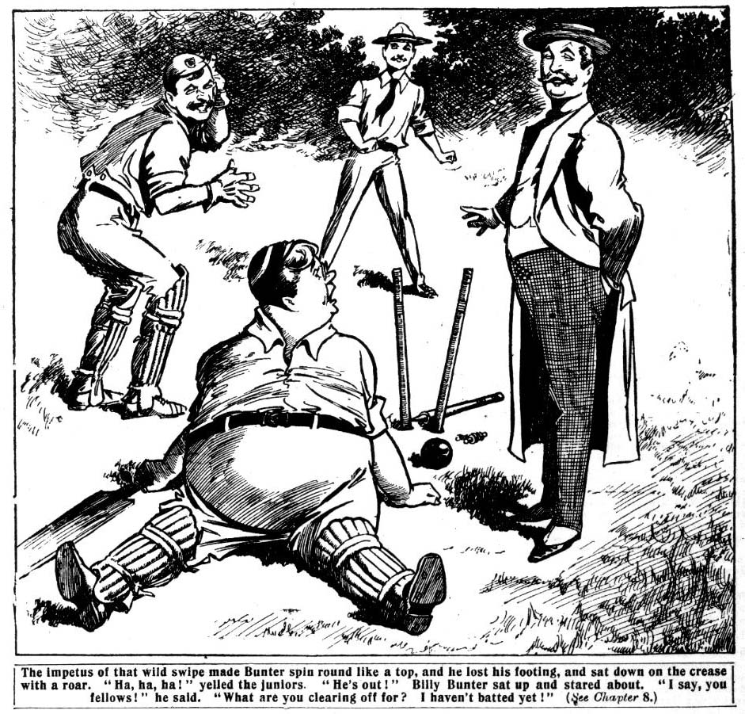
“Ow—ow! I say, you fellows, what are you clearing off for? I haven’t batted yet.”
“Ha, ha, ha!”
“The innings is over.” said the colonel with a smile. “You are out. “All down for forty-six.”
Bunter staggered to his feet.
“I—I say, that was a trial ball!”
“Ha, ha, ha!”
Bunter snorted and rolled off the pitch. Johnny Bull gave him a glare.
“You silly ass, what did you swipe at the ball for? Any silly owl ought to have known better than that!”
“Oh, really, Bull—”
“Bump the silly chump!” growled Vernon-Smith.
“Here, I say—”
“Can’t be helped.” said Harry Wharton, as cheerfully as he could. “We know Bunter was only a passenger, anyway.”
“Oh, really, Harry—”
“Oh, shut up!”
“I’ve had bad luck.” said Bunter, glowering at the disgusted cricketers. “ But wait till you see me bowling, that’s all !“
“We shall wait a jolly long time before we see you bowling.” said Harry. “You’re not going to bowl, you ass!”
“If you choose to leave out your best bowler, Wharton, you’ll have to take the consequences. It’s throwing the
match away.”
“Scat!”
“Well, where am I to field?” growled Bunter discontentedly.
“Anywhere you like, so long as you don’t get in the way.
The villagers started their innings in great spirits. Grey- friars were all down for an unexpectedly small total, and the home team had no doubt about winning now. But Harry Wharton & Co. were bucking up. Three of their bats were
next door to useless, but in bowling they were as strong as ever. Hurree Jamset Ram Singh, and Tom Brown the New Zealander, shared most of the bowling, Nugent and Todd going on as change bowlers. And the wickets went down at a good rate.
Six down for 22 encouraged the Removites. Hurree Singh had performed the hat-trick, Tom Brown had taken two, and one had been caught out by Wharton in the slips. It was not going to be a walkover, at all events. Nugent captured the next wicket. Then another fell to the deadly bowling of the Nabob of Bhanipur, with the score at 34. Then Tomlinson came in, and he proceeded to hit out, and the score jumped to 40. His partner was caught out by Peter Todd, and the Removites breathed more freely when the last man went in.
But Tomlinson had the bowling, and he knocked the next ball away for four. Hurree Jamset Ram Singh sent down his very best ball next time, and Tomlinson swiped it away into the long-field. There was a yell.
“Look out, Bunter!”
“Catch! Catch!”
Bunter blinked round him.
The batsmen were running, and the ball was sailing fairly into Billy Bunter’s fat hands—if the aforesaid fat hands had been ready for it.
But they weren’t.
The ball almost touched Bunter’s fingers, and he muffed the easiest catch of the match; and the batsmen ran, and ran, and ran again; and there was a yell from the village crowd. The match was won!
And there was a yell from the disgusted Greyfriars fellows, too.
“Fathead!”
“Butter—fingers!”
“Yah!”
“I say, you fellows, I jolly nearly had that ball!” said Bunter. “Any of you chaps would have missed it by yards, but I nearly had it!”
But that was too much for the juniors. They made a rush at Bunter. For a moment the fatuous Owl of the Remove thought the fieldsmen were going to “shoulder” him, in recognition of his topping play. He soon discovered his mistake. They grasped him on all sides, and whirled him off his feet with rough-and-ready hands.
“Frogs march!” shouted Bob Cherry.
“Yes, rather!”
Bump, bump, bump
“Yarooh! Help! Murder! Oh, my hat!”
“Ha, ha, ha!”
And Billy Bunter was frog’s marched off the cricket ground and dumped down heavily on the grass. He sat and gasped, and groped for his spectacles, and blinked furiously at the indignant juniors.
“Oh! Yow! You rotters! This is the last time I’ll play for you! Yow—Ow! The very last! Mind that—the last time! Yaroooh!”
“You can bet on that.” said Harry Wharton.
And Bunter was right; it was the last time.
THE NINTH CHAPTER.
Left in the Lurch!
HARRY WHARTON & CO. were up very early on Monday morning.
They were to catch the train at eight-thirty, and they did not mean Billy Bunter to catch it. If anything had been needed to make them feel thoroughly “fed-up” with the Owl of the Remove, it was his combined swank and stupidity in the match with the villagers. In the match with the St. Jim’s fellows at Headland, Wharton would rather have played a man short than have had Bunter in the team.
When Harry Wharton & Co. turned out that morning Billy Bunter was sleeping like a top. His room was shared by Tom Brown and Peter Todd, there being three beds in the room; but Bunter did not hear them rise, and they made their toilet without disturbing him.
It wasn’t necessary to be very cautious; probably a cannon would hardly have disturbed the fat junior. Billy Bunter could do with a great deal of sleep. At Greyfriars the rising bell did not always awaken him, and he was always the last down. On holiday, he frequently did not come down till ten o’clock in the morning. The Co. had always been down hours before Bunter put in an appearance.
The juniors breakfasted early. Colonel Wharton was down, and he did not make any remark on the subject of Billy Bunter. It was highly probable that by this time the veteran understood how matters were between Bunter and the res of the party. He did not seem to observe that the Owl of the Remove was not there.
Todd went up for his bag, and grinned at the sight of Billy Bunter fast asleep in bed. Bunter was muttering in his sleep, and Todd caught the words “jam-tarts—-twopenny ones.” He chuckled, and carried away his bag.
Colonel Wharton accompanied the juniors to the station. and they started on their journey to Headland, a seaside place only a few miles from Shoremouth. George Figgins of St. Jim’s was staying there, with several of his school- fellows—Wynn and Kerr and Redfern and several more. Some of them the Greyfriars juniors had met in the school matches.
The match at Headland was likely to be a harder one than that with the village team at Wharton Magnus, but the Removites, though they had registered a defeat to begin with, felt confident enough. Hazel was to join them at Headland, and they would not be bothered with Billy Bunter, which made a considerable difference to the strength of the team.
While the train was bearing the juniors rapidly away Billy Bunter snored on comfortably in bed.
The fat junior had more than a suspicion that Harry Wharton & Co. intended to depart without him, owing to the fact that they had declined to tell him where their stopping-place was to be. That they were going later to Shoremouth he knew, but he did not know that Figgins and his friends were at Headland. So when the fat junior awoke and found that they were gone, the Co. felt pretty certain that he would not be able to track them down.
But Bunter did not waken very early. He had intended to keep his eyes very wide open that day lest the Co. should attempt to escape, so to speak. But his eyes had not started opening yet.
It was ten o’clock before he awoke. Then he yawned, and turned over for another nap. But at half-past ten he was more hungry than sleepy, and he decided to get up.
“I say, you fellows, are you awake?” he yawned. There was no reply, and Bunter sat up, and blinked at the other beds. He grunted. He was not accustomed to seeing the other beds empty when he awoke.
“Beasts! Couldn’t call me!” he grunted.
He turned out, and performed his ablutions—which did not take him long. They never did! Then he dressed and went down.
The house seemed very silent.
As a rule, with so many of the cheery juniors of Greyfriars there, Wharton Lodge was far from quiet, but now it seemed silent as the tomb.
Bunter blinked into the breakfast-room. It was empty.
“Rotters all gone out without me, I suppose!” he growled.
“Well, I’ll have breakfast, anyway!”
He rang, and his breakfast was served. He was too shortsighted to notice that there was a lurking smile on the face of Wilkinson, the butler. Mr. Wilkinson was not quite in the dark as to Master Harry’s reason for departing without awakening Bunter.
“The fellows gone out?” asked Bunter.
“Yes, sir.”
“Where are they gone?”
“Ahem! I think they went to the village.”
“Oh! Colonel Wharton about?” but
“The Colonel has gone to London to-day.”
Bunter grunted, and settled down to breakfast. Breakfast lasted him a considerable time, and then, surprised that he saw nothing of the juniors, he strolled out into the grounds.
But the Co. had not yet come back.
At lunch-time Bunter came in, and found his companions still absent. He was growing a little suspicious by this time.
“Look here, Wilkinson, are they coming in to lunch?” he demanded.
“I think not, sir.” said the butler demurely.
“Where have they gone?”
“Ahem! They went to the village!”
“Not further than that?”
“Ahem! I think they have taken a train, Master Bunter.”
Master Bunter jumped up.
“Where to, Wilkinson?”
“Master Harry did not tell me.”
“Are they coming back today?” howled Bunter.
“Ahem! I think not.”
“To-morrow—”
“Ahem! I think Master Harry is not coming home again
till nearly the end of the vacation.” said Mr. Wilkinson calmly.
Bunter gave a howl.
“The rotters! They’ve done me! Where are they going? What station have they taken tickets to?”
“I’m sure I don’t know, sir.”
“You do know, and you’re keeping it dark!” snarled Bunter. “Look here my man, tell me where they’re gone, and I’ll hand you a shilling!”
Mr. Wilkinson did not move a muscle.
“Ahem! I am afraid I cannot give you any information, Master Bunter. Doubtless Master Harry would have informed you, if he had wished you to know. And I really could not accept a shilling from you, sir! I really could not! Ahem! You are very, very generous, sir, but I could not reconcile it with my conscience, sir, to take such an advantage of your generosity—I really could not, sir!”
And Mr. Wilkinson retreated with a solemn brow.
“Look here, you—you rotter!” howled Bunter. “ You know where they’re gone, and I insist on your telling me. How dare you argue with a gentleman!”
For once a faint flush crept into Mr. Wilkinson’s impassive face.
“I am sure I should not do such a thing, sir.”
“You’re arguing with me!” snorted Bunter.
“That is quite a different matter, sir.”
“Wha-at! What! You—you— Serve me my lunch, and shut up!” growled Bunter.
Mr. Wilkinson breathed hard, and shut up. But for his personal attachment to the Wharton family he would have boxed Billy Bunter’s ears just then, and it was only because Bunter was Harry’s guest that he refrained. In the servants’ hall he confided to the other members of the household
“below stairs” his opinion of Bunter, and it was not a flattering opinion. And all the ladies and gentlemen below stairs fully agreed with Mr. Wilkinson’s opinion of William George Bunter.
Bunter ate his lunch. He was undecided what to do, but his state of indecision did not affect his appetite. He made a remarkably good lunch, and thought the matter over. The Co. had disappeared, and he did not know where they had gone. Colonel Wharton had gone to London, and Bunter wondered savagely whether the old gentleman had purposely gone to avoid him. But Miss Wharton remained, and she was such a kind and gentle lady that Bunter felt he would be able to deal with her. So after lunch he made his way to Miss Wharton’s presence.
“You did not go with Harry, then?” asked Miss Wharton, whose simple mind had not discerned anything amiss.
“No; they forgot to wake me.” said Bunter. “I‘m to catch the next train. It’s all right, Miss Wharton. But I’ve forgotten where they‘re going. Harry told me last night—ahem!—but I was sleepy, and I’ve forgotten.”
“Dear me! That is very unfortunate!”
“You know, of course!” asked Bunter.
Miss Wharton shook her head.
“Indeed I do not. Harry did not mention the name of the place to me that I remember. I have not asked him.”
Bunter ground his teeth. He knew very well why Wharton had avoided mentioning the name of the place to his aunt.
“Well, I dare say I shall remember.” he remarked. “ Of course, I can ask them at the station. I’ll pack my bag now, and be off. They’ll be awfully disappointed if I don’t rejoin them today. By the way, I sha’n’t have time to stop for a letter I’m expecting from home—a letter with a postal-order in it. And I happen to be out of money. Perhaps you would be so kind as to lend me a sovereign, ma’am, and I’ll send a postal-order for it.”
“Certainly, my dear boy!” said the innocent old lady.
A quarter of an hour later Billy Bunter was on his way to the station, with Miss Wharton’s sovereign in his pocket. When he reached the station he inquired what station Harry Wharton & Co. had taken tickets for. He staggered when the booking-clerk, who knew Wharton well, of course, informed him that Master Wharton had taken no tickets there that but morning.
“But—but they’ve gone by train!” howled Bunter.
“Then they must have gone without tickets.” .
“What train did they go by?”
“I really do not know. I have not seen them!”
Bunter rolled away in a state of breathless fury. He made inquiries up and down the station, but it did not seem to occur to him to expend any of his cash in tips. And the old porter who had seen Harry Wharton & Co. into the train— minus tickets—had a five-shilling piece in his waistcoat pocket, and a strict injunction to tell Bunter nothing. So he shook his head solemnly in reply to all the fat junior’s furious questions. Billy Bunter gave it up at last
“Beasts!” he murmured. “Rotters! They’ve gone without tickets, so as to throw me off the track! Where the dickens have they gone to? And where the dickens am I to go to?”
It was a knotty question.
But suddenly Bunter brightened up.
“Anyway, they’re going to Shoremouth afterwards! Jolly lucky I saw Hazel’s address on Smithy’s letter the other morning! Hazel knows where they are, and I know where Hazel is; they’ll see me again sooner than they think, the rotters!”
And the Owl of the Remove was soon en route.
THE TENTH CHAPTER.
Hazel’s Friends!
HARRY WHARTON & CO. smiled as they stepped out of the train at Headland.
By the simple precaution of travelling without tickets, they had succeeded in throwing Billy Bunter off the track. As Wharton was well-known in the village near his home, it had been quite easy for the party to enter the train ticketless, and at the first stop which allowed sufficient time, Wharton had slipped from the train and bought tickets for the party, of course, paying at the same time for the distance already covered. Bunter would probably guess that he had done that ; but he could not very well inquire at every station along the line for traces of the vanished juniors. Yet the chums of the Remove knew so well the pertinacity of William George Bunter, that they glanced round the platform at Headland, and would not have been at all surprised to see him there.
But he was not there fortunately.
But some other fellows were there to meet the juniors. A long-legged, rugged, good-humoured-looking junior came across the crowded platform as soon as he spotted them, followed by an extremely fat youth, whose proportions rivalled those of Billy Bunter, and a slim-built junior, with keen grey eyes. Wharton knew them at once—Figgins and Wynn and Kerr of the Fourth Form at St. Jim’s. All three of them had played in the St. Jim’s junior team at Greyfriars, captained by Tom Merry.
“Here you are!” said Figgins, shaking hands warmly with Wharton. “Had your wire in good time to get here and meet you.”’
“Jolly glad to see you again!” said Fatty Wynn. “This way to the buffet!”
“Blow the buffet!” said Figgins
“Now, Figgy, the chaps are boun to be rather peckish after a long journey.” said Fatty argumentatively. “I know I’m peckish, and I haven’t had a journey. And they’ve got beautiful sausage-rolls at this station.”
“Rats!” said Figgins cheerfully. “Come on to the hotel, it’s just on time for lunch.’’
The Greyfriars fellows had engaged quarters at the Headland Hotel, where Figgins & Co. were staying, and they left the station together; Fatty Wynn with a regretful expression upon his plump face. Evidently he found it difficult to tear himself away from the sausage-rolls.
Figgins led the way, chatting cheerfully with Wharton. The strains of a band fell upon their ears as they left the station. A few minutes walk, and they were in sight of the bright blue sea, dotted with boats and white sails. Bathing- machines were ranked along the foreshore, and in the distance the heads of swimmers could be seen dotting the waters.
There was a thick crowd on the “front,” and a ceaseless buzz of voices. Arrived at the big hotel, the Greyfriars fellows met some more of Figgins’ party—Redfern and Owen and Lawrence of the Fourth Form, and an Indian junior whom Figgins presented as Koumi Rao, the Jam of Bundelpore— who immediately began talking to Hurree Singh in a weird language of which the other fellows did not understand a word.
They had lunch on a wide terrace looking over the sunny sea. Fatty Wynn’s performance at lunch quite interested the Greyfriars juniors. It reminded them of Billy Bunter.
“There are seven of us here.” said Figgins. “But we’ve got four fellows joining us for the match, coming from different parts. I’ve arranged that. We’re all new house chaps at St. Jim’s—all the eleven. It was a bit of luck being able to fix up this match with you fellows in the vac. We’ve got permission to use the local pitch here on Wednesday— that’ll suit you?”
“Any day you like.” said Wharton cheerfully. “That’ll leave plenty of time for our other man to gt here from Shoremouth .”
“I’ve noticed you’re a man short.” said Kerr. “If your man doesn’t turn up, we can find you a man here.”
“He’ll turn up all right. I’ll wire him the date after lunch.”
Wharton despatched the telegram to Hazeldene in the afternoon. Then the juniors went down to bathe and to ramble about Headland. It was dusk when they came in, and Harry expected to find a reply from Hazeldene awaiting him. But there was no telegram. But the next morning, at breakfast, there was a letter from Hazel.
Harry Wharton felt a slight misgiving, he hardly knew why, as he opened it. And as he read Hazel’s letter, he frowned.
“Oh, the silly ass!” he murmured.
“Hallo, hallo, hallo! What’s the news from Hazel?” asked Bob Cherry.
Wharton threw the letter to him.
“Read it!” he said, his frown deepening.
Bob Cherry read it, and whistled. It was a short letter, but there was a good deal of information in it, especially reading between the lines.
“Dear Wharton,—I had your wire rather late yesterday when I came in. Did you know that some of the Highcliffe chaps are staying here in Shoremouth? I’ve met them— Ponsonby and Gadsby and Vavasour. I know we’re not on very good terms with them at Greyfriars, but as they seemed inclined to forget all about it, of course I was agreeable. We have been having a very good time together. I suppose you don’t mind if they come over with me on Wednesday? No good keeping up school rags on a holiday, you know. Ponsonby is staying with his uncle here, who has a car, and he’s going to bring me over in the car on Wednesday morning. The train would be too late, if stumps are pitched early.
Ta-ta! HAZEL.”
Bob Cherry read the letter out, for the benefit of the other fellows. Vernon-Smith compressed his lips as he listened.
“That accounts!” he murmured.
Wharton looked quickly at the Bounder.
“Accounts for what?” he asked.
The Bounder coloured a little.
“Oh, nothing!”
But after breakfast, when the juniors went out, Wharton made it a point to walk with the Bounder, and ask for information.
“Look here, Smithy, is Hazel up to his old tricks again?” he asked abruptly.
Vernon-Smith looked uneasy.
“How should I know, Wharton?”
“I think you do know, all the same. You know what kind of fellow Ponsonby is. You know his idea of a good time on a holiday. Hazel is a silly ass, and those cads would like to help him make a fool of himself. He wrote to you at my place. Was he asking you for money? Out with it. I’ve got to know about it. The silly duffer has got to be looked after, if he can’t look after himself!”
“Well, yes.” said the Bounder. “He wanted a couple of quids.”
“And you sent them?”
“Well, yes.”
“He had plenty of money to begin the holiday.” said Harry, frowning angrily. “His people are paying his exes there, and I know he had a fiver from his uncle. It looks to me like the old game—and Ponsonby is at the bottom of it.”
“I thought so, as soon as I knew that Ponsonby was there.” said Vernon-Smith. “Hazel had a pretty severe lesson the time we went to Boulogne, on Founders’ Day. But a lesson never lasts him long.” The Bounder’s lip curled.
Wharton bit his lip.
“It’s rotten if he’s beginning again.” He said restlessly. “ Rotten for Marjorie, too—and for all of us. He ought to be kept away from those chaps, and now he’s proposing to bring them over here for the match.”
“I don’t see what we can do. It’s his own bizney.” said the Bounder. “We can’t take it on ourselves to act in loco parentis, you know. And Hazel wouldn’t stand it from us.”
“He ought to have a jolly good licking!” growled Wharton.
“That wouldn’t improve matters.”
“ I suppose it wouldn’t. But how are we going to be civil to his precious friends. Ponsonby played Nugent a rotten trick not long ago, and Nugent certainly won’t speak to him. And they’re only coming to nake themselves unpleasant— they want to get at us somehow through that silly ass Hazel.’’
“I suppose so. Still, it will only be one day—we can put U with them for that long. Looks to me as if we shall have to, unless you write to Hazel not to come.”
“I’d do that—only—only—”
“Only it would hurt Marjorie.” said the Bounder quietly.
“Yes ; that’s the rub !“
“We shall have to make up our minds to grin and bear it.” said the Bounder. “After all, the Highcliffe chaps may try to be decent for once.”
Wharton had very strong doubts on that point; still, there was evidently nothing to do but to grin and bear it, as the Bounder suggested.
But during the day, he could not help thinking with troubled mind of Hazel and his undesirable friends. However, the juniors spent a very merry day by the sea, in company with Figgins & Co. That evening the rest of Figgins’ team arrived—four fellows belonging to the New House of St. Jim’s—Thompson, Dibbs, Pratt, and Jameson. And the next morning, at an early hour, the rival elevens prepared for the match. But at the time fixed for starting from the hotel, Hazel had not arrived. But
“Your man hasn’t come!” remarked Figgins, when the juniors were gathered with their cricket-bags, ready to start for the ground.
“He seems to be late.” said Harry, biting his lip. He wondered whether it was a trick of Ponsonby’s. As he was bringing Hazel over in a car he could make him as late as he chose, and Wharton was pretty certain that Ponsonby was far from having any goodwill towards the Greyfriars party.
“He may be coming straight to the ground.” Vernon-Smith suggested. “He knows where we are playing.”
Wharton nodded.
“Well, we won’t wait. If he doesn’t turn up we’ll get a substitute.’’
And the party started for the Headland Cricket Ground. Figgins & Co. had already played a match there with the local team, and they had many acquaintances there. The cricketers changed in the pavilion, but there was still no sign of Hazel.
It was time for stumps to be pitched, and Wharton’s exasperation was increasing. There had been ample time for Hazel to arrive, but he had not arrived.
“Well, shall we wait a bit for your man?” Figgins asked politely. “Or if you like I’ll get you an extra man here, quite easy.”
“I think you’d better.” said Harry. “ Hazel is rather unreliable, and he mayn’t turn up till midday.”
“Hallo, hallo, hallo!” exclaimed Bob Cherry. “ Here comes a car, anyway.”
Zip-zip-zip!
A handsome car stopped outside the gates. Four fellows descended from it, and walked in, and the juniors recognised Ponsonby & Co. of Highcliffe, and Hazeldene. Hazel was not looking good-humoured, and he came up and shook hands with Wharton in a very perfunctory manner.
“You’re late.” said Harry.
“I’ve been to the hotel for you, and found you’d left.” said Hazel. “I’m in time to play, I suppose?”
“Yes, it’s all right. We were just going to start without you.”
Hazel looked sullen.
“You can start without me, all the same, if you like.” hp said.
Wharton made an effort to be genial.
“Oh, it’s all right!” he said. “ Get into the pavilion and change. Figgins won’t mind waiting a few minutes more.”
“Not a bit.” said Figgins, though he had given Hazeldene a very curious look.
And we’ll watch the game.” said Ponsonby, with a drawl. “I suppose you’re not in want of another man, Wharton?”
“No; we’ve got eleven.”
“I’d have played for you with pleasure.” said Ponsonby calmly. From his manner it would never have been guessed that the Highcliffe fellows were on the worst of terms with Harry Wharton & Co. And the Co. who, of course, did not want to show any signs of disagreement before Figgins and his friend, did their best to be civil. “But I’ll tell you what I’ll do. I’ll umpire for you.”
“Good egg!” said Gadsby. “ So will I.”
Wharton hesitated. He did not want to have anything at all to do with the Highcliffo fellows, but he could not very well make a display of his dislike. As they had come there as friends of Hazel, he was bound to be civil to them, and the simple minded Figgins never guessed for a moment that there was anything amiss. Ponsonby was looking at him inquiringly, and Figgins chimed in at once:
“Right you are!”
“But—” began Harry, rather at a loss.
“It’s all right.” said Figgins; “we were going to ask some fellows here to umpire, but as your friends are here, and they’re willing—”
“Very glad.” said Ponsonby.
“Certainly!” said Gadsby.
“Then it’s a go.” said Figgins.
“But you’ve got a right to select an umpire yourself,” began Wharton.
“Oh, I’m quite satisfied!”
As Figgins was satisfied, there was nothing more to be said. And much as Wharton disliked the Highcliffians, he did not suspect them of any intention to “wedge” themselves in where they were not wanted. Well as he knew Ponsonby & Co., he was far from suspecting what was passing in their minds.
THE ELEVENTH CHAPTER.
Foul Play!
HARRY WHARTON won the toss, and the Greyfriars side started to bat. Wharton opened the innings with Vernon-Smith. Figgins led his merry men into the field, and Fatty Wynn was put on to bowl the first over to Wharton. The fat Fourth-Former was the champion junior bowler at St. Jim’s, and Wharton was very careful. Harry was in great form, however, and he punished the bowling severely. The over gave him eight runs, and then Koumi Rao went on to bowl to Vernon-Smith.
Koumi Rao’s bowling was knocked all over the field by the Bounder, and the score jumped to sixteen. It was a good beginning for Greyfriars, and they were looking very cheerful. Kerr bowled the next over to Wharton.
The Scottish junior was a good change bowler; but Wharton was quite able to deal with his bowling. He cut the first ball away for two, and the second for another two. The third he drove away into the country, and the vatsmen ran—once, twice, thrice—and the ball was not yet in. There was time for a fourth run, and Wharton and the Bounder crossed the pitch like lightning.
But the ball was coming in then, from the hand of Figgins, not to the wicket-keeper, but straight as a die for the batsman’s wicket. Ponsonby, who was umpire at Wharton’s end, waited and watched. Wharton felt, as it were, the ball coming in, and he put on a desperate spurt, and his bat clacked down on the crease.
Crash! But
The wicket flew to pieces!
But Wharton’s bat was on the crease a good second before the fall of the wicket, and he breathed relief. But he was satisfied too soon.
“OUT!”
Ponsonby rapped out the verdict.
Wharton started.
“What!”
“Out!” said the umpire.
Wharton flushed. His face was already red with running, but the unfair verdict of the umpire made his face quite crimson with anger.
“Out?” he repeated “My bat was on the crease.”
Ponsonby shook his head. His face was perfectly cool and calm, but there was a mocking light in his eye.
“I thought———” began Lawrence, who was at slip, with a rather queer look at the umpire.
Lawrence had certainly thought that the bat was on the crease in time.
“I know!” said Ponsonby crisply. “Out!”
Wharton controlled his rage with a great effort. He knew that he was not out, but he knew, too, that it was useless to dispute the sentence of the umpire. Like a flash he realised now why Ponsonby had come there.
It was the meanest and rottenest trick that the cad of Highcliffe had ever thought of playing on his old enemies, and Wharton realised that he had walked directly into a trap with his eyes open.
He had never thought of anything of this kind. That
Ponsonby would be base enough to offer his services as umpire, with the deliberate intention of giving unfair verdicts against the fellows he disliked, was a suspicion that was not likely to cross an honourable mind. It was too late to remedy the matter. The St. Jim’s fellows supposed that Ponsonby was there as a friend of the Greyfriars team, so they were certainly not likely to believe that he was acting with deliberate unfairness towards them. Wharton’s teeth came hard together, and for a moment Ponsonby was in danger of being stretched on the pitch with a good left— hander straight from the shoulder. But it would never have done. Wharton knew that. Calming himself as well as he could, the captain of the Remove carried out his bat.
“Man in Bob!” he said, scarcely able to control his voice.
Bob Cherry gave him a curious look.
“Hard cheese, old chap!” he said. “It was a close thing. I really thought you were home in time.”
“I was home in time.” said Harry, in a low voice.
“But the umpire—”
“That’s what he’s umpiring for.” muttered Wharton.
“You understand—now?’’
Bob Cherry gave a start.
“My hat! He couldn’t be such a cur, not even Ponsonby! He must have made a mistake, Harry. We’re all human, you know.”
Wharton shrugged his shoulders.
“Look out for him, that’s all!” he said. “ Don’t give him a chance! We’ve got to play the umpires in this match, as well as the other team.”
“I can hardly believe he would—”
“I couldn’t have believed it if it hadn’t happened,” said Harry bitterly. “But we ought to have known those cads! Look out for him, that’s all.’’
“Oh, I’ll look out!” said Bob.
Harry Wharton watched the batting very anxiously after that. He knew now that both the umpires would be hand-in-glove to give decisions against the Greyfriars side wherever it was possible. At the same time, to complain of the umpire was not “the game.” Wharton felt that he was caught, and that be was helpless, and his feelings towards the Higheliffe fellows were not amiable. Figgins & Co. did not understand that there was an old feud at work, and fault-finding with the umpires would seem to them simply due to chagrin at being given “out.”
The St. Jim’s bowling, however, accounted for Bob Cherry’s wicket, and then for Frank Nugent’s. The score was at 40 at that time. Then Hazeldene went on. Wharton did not expect much of Hazel.
At Greyfriars, lately, Hazel had improved very much as a cricketer, and Wharton had played him in the Remove (cain. But since the beginning of the vacation, Hazel looked very much off colour. His complexion was less healthy, and there were dark circles under his eyes that seemed to hint of late hours. He had not taken the trouble to keep himself fit, and perfect fitness was required to face a team like Figgins’s.
Wharton was not surprised when Hazel was clean bowled for a duck’s egg. Hazel came off the pitch with a sullen expression on his face, as if he fully expected reproaches from his skipper, with a consciousness of having deserved them. But Wharton did not speak to him. Reproaches were useless. A duck’s egg was a duck’s egg, and any amount of talking would not have made it better.
“Man in, Johnny!”
Johnny Bull went to the wicket. Between them, the Bounder and Johnny made the fur fly. The score was going up in jumps, when Vernon-Smith lost his wicket. The bats— men had run four, and Smithy’s bat was easily over the crease before the bails were off, when Gadsby’s “out” fell upon his ears like a thunderclap.
Wharton met the Bounder as he came off. Vernon-Smith’s face was dark with passion, and all the field had noticed it. It gave them the impression that he was a bad loser. But this time Smithy had reason to feel furious. Nugent minor went on in his place,
“Were you out?” Wharton asked, in a low tone.
The Bounder gave him a quick look.
“So you noticed it?” he asked.
“I noticed it in my own case.”
“You, too? I wasn’t out!” muttered the Bounder, gritting his teeth. “They’ve taken us in. They came here for the specia1 purpose—”
“I know that now.” said Wharton.
“What fools—what asses we were, not to think—”
“It’s too late now. The St. Jim’s chaps wouldn’t understand.
“No. I know what they’d put it down to. Can’t be helped. But afterwards—I’ll have something to say to those cads later.”
The Bounder flung down his bat savagely. Even the Bounder, keen and suspicious as he generally was, had not divined Ponsonby’s little game, and he felt more annoyed at his own obtuseness than at the loss of his wicket.
Nugent minor did unexpectedly well, knocking up ten runs before he was stumped. Todd captured only three, and came off with a set face. He, too, had been given out leg-before-wicket when he knew very well that he was not out. But he bore it philosophically. A quarrel with the umpire in the middle of a game was not to be thought of. Greyfriars stood at 70 when “last man in” was called. Lord Mauleverer was last man in, Ton Brown being at the other end.
“Do your best, Mauly, old man.” said Wharton, not very hopefully.
“Yaas.”
“Back up Tommy as much as you can.”
“Yaas.”
Lord Mauleverer showed unexpected form. The slacker of the Remove was bucking up for once. With the New Zealand junior at the other end, his lordship did remarkably well. The runs went up and up, and Wharton’s face brightened when the board registered 86. In spite of foul play from the Highcliffe umpires, Greyfriars were not doing so very badly.
1t was Tom Brown’s wicket that went down—after Tom’s bat was on the crease, but the verdict came:
“Out!”
The New Zealander stared at Ponsonby.
“That wasn’t out!” he said.
Ponsonby smiled.
“Out!” he repeated.
“Look here—”
“Who’s umpire? ” asked Ponsonby sweetly
“You are, but—”
“Well, you’re out.”
“Why, you rotten cad—”
“Ahem!” said several of the fieldsmen.
Tom Brown made an effort, and controlled himself. It was not the “game” to go for the umpire; and besides, it would not have altered the decision. Out or not, he was given out, and he had to get off.
“ All down for 86!” said Bob Cherry, with a sigh.
“Now you know—” began Tom Brown, as he joined his comrades at the pavilion.
“Yes, we know.” said Wharton grimly. “Can’t be helped
—now.”
The New Zealand junior ground his teeth.
“But this means a licking for us. We’ve got no chance against this kind of thing.”
“We’ve got to stand it; can’t complain. The St. Jim’s chaps wouldn’t understand. We don’t want to pose as a set of duffers who can’t take a licking.”
“I—I suppose not; but—”
“Not a word, Tommy.”
Tom Brown nodded.
“Not a word now.” he agreed; “ but I’ll have something to say to those cads later.”
A good many of the Greyfriars fellows intended to “say things” to Ponsonby & Co. later.
Unless, by miraculous good luck, the match was already lost. Hurry Wharton & Co. were playing a losing game from the start. But they still hoped.
The St. Jim’s innings started, and they were three down for 30, when the cricketers knocked off for lunch.
THE TWELFTH CHAPTER.
Beaten to the Wide!
FIGGINS & Co. were “standing” a very handsome
lunch to the visiting team, to which Fatty Wynn did most justice. Hazel was very silent, apparently being busy with his thoughts, and not wholly pleasant ones. But Ponsonby & Co. chatted pleasantly, making themselves very agreeable, especially to Figgins & Co. Figgins, indeed, remarked to Wharton what exceedingly agreeable fellows his Highcliffe friends were—a remark to which Harry found it difficult to reply.
“By the way, we saw a friend of yours in Shoremouth when we came away this morning, Wharton.” Ponsonby remarked.
“A friend of mine?” said Harry.
“Yes, a fat chap—what is his name?—Punter, or some- thing!” drawled Ponsonby.
“Bunter? Oh, Bunter!”
“Yes. Bunter; that’s it.”
“My hat!” ejaculated Bob Cherry. “Is Bunter there?”
Hazel looked up.
“H e spotted us as we were coming away.” he growled. “Had the nerve to want to come over in the car with us. We shook him off.”
“Did you tell him where you were going?” asked Harry.
“Oh, yes.”
“Oh! Then we shall sec him before long.”
Wharton’s surmise proved well-founded. Before lunch was over a fat figure came rolling in, and the Owl of the Remove blinked agreeably at the crowd of cricketers.
“I say, you fellows——”
“Scat!” growled Bob Cherry.
“Awfully duffy of you to forget to tell me where you were playing this match!” said Bunter. “If I hadn’t met Hazel in Shoremouth, I shouldn’t have found you to-day—really!”
“Beastly bad luck your meeting Hazel, then.”
“Oh, really, Bob!”
“Rats!”
“I haven’t had lunch.” said Bunter, taking a seat. “Hazel wanted me to come over in the car, but I declined to travel with those friends of his. I don’t approve of those Highcliffe chaps.” The short-sighted Owl of the Remove did not see the Highcliffe chaps within six feet of him. “Having a good time is all very well, but for fellows to go to the races, and all that—I don’t approve of it. You needn’t make faces at me, Hazel. There ain’t any masters here, you know, and I suppose it doesn’t matter if the fellows know that you’ve been going to the races with Ponsonby and that set.”
“Oh, shut up!” growled Hazeldene, reddening.
Wharton compressed his lips. He was not surprised to hear it; indeed, he had expected to learn something of the sort. Billy Bunter tucked into the lunch, easily rivalling the exploits of Fatty Wynn.
“I haven’t seen Marjorie yet.” he remarked. “I say, you fellows, I like this place. I think I shall stay here till you go to Shoremouth. If you want any help this afternoon, I’m quite at your service. How’s the match going?”
“All down for eighty-six!” grunted Bob.
“ H’m! Sorry I wasn’t here to bat for you.” said Bunter. “ I suppose you can look forward to a licking? Well, I must say it’s your own fault. If you hadn’t forgotten to tell me where the match was taking place, I’d have been here, and I’d have batted for you with pleasure.”
Harry Wharton & Co. glared at the fat junior. But Bunter s eyes were on his lunch, and he did not see the glares, which were almost ferocious.
“I’ll tell you what.” went on Bunter, with his mouth full. “ Ask Figgins to let you make a change in the team. I’m sure Figgins wouldn’t mind, just to give you a chance.”
“Any old thing.” said Figgins, with a smile.
“There you are, Wharton. Now you can put me in—”
“Fathead!”
“Oh, really, Wharton, after getting licked by a village team, you ought to make an effort this time. Pass the pepper, somebody.”
“Here you are!” said Bob Cherry ferociously. He passed the pepper, with a jerk of his arm, which sent a shower of it over Bunter.
“Groogh! You clumsy ass! Atchoo-choo-choo!”
“Ha, ha, ha! Sorry!”
“Yow-ow ! Atchoo-atchoo-atchoooooooh !“
“Ready when you are, you chaps,” said Figgins.
“Atchoo-choo-chooh! Oh, you beast! Groogh! Atchooh!”
Leaving Billy Bunter still sneezing, the cricketers returned to the field.
Figgins & Co. resumed their innings in great spirits. Billy Bunter, as soon as he had recovered from the pepper, resumed his lunch. He had a companion in Fatty Wynn, who had not finished yet. The two fat juniors seemed to be rivalling one another, but Billy Bunter was an easy winner. He was still going strong when Fatty Wynn rolled away to see how the match was getting on.
The match was getting on well for St. Jim’s. They were already 80 for four wickets. Figgins was still batting, though he had had a narrow escape; but the umpire had given him
“not out,” and Figgy accepted the verdict, though his own idea had been that his wicket was lost. Figgins could almost have sworn, as he said afterwards, that the stumps went down from a smartly-returned ball before his bat was on the crease; but the umpire held that he had got home in time, and, of course, Figgins could not dispute that decision. Still less could the Greyfriars fellows dispute it.
Figgins was still batting when last man in was announced, and Fatty Wynn rolled on the pitch. The score was at 120. Fatty Wynn had had a rest since lunch, but he was still feeling the effect of his injudicious exploits at the table, and his pace was slow as he ran. At his first run he laboured along heavily, and the ball came in and knocked his bails down, and then Fatty’s bat clumped on the crease. He knew that he was too late, and he gave an apologetic grin along the pitch to Figgins, and started walking away without waiting for the umpire’s verdict.
“Hold on!” exclaimed Gadsby. “Where are you going?”
Fatty Wynn looked round in surprise. “Out!” he replied.
“You’re not out.”
“Wha-a-at!”
Fatty Wynn clumped his bat back quickly enough, but he looked astonished.
“I say, you know, my wicket was down.” he said.
Gadsby shook his head.
“You were home in time.”
“Well, my hat! I could have jolly well sworn that the wicket was down before I grounded my bat.” said Wynn in amazement.
“Not at all! You’re in.”
“He was out!” said Torn Brown fiercely.
“If you’re going to complain of the umpire, Brown—” began Gadsby.
“I say, I—I think I was out,” said Fatty Wynn uneasily. He wanted to play a fair game, and had no desire to take advantage of a mistake of the umpire. But Gadsby raised his hand.
“Not out!” he said finally.
“What’s up, Fatty?” called out Figgins from the other end.
“Umpire says I’m not out.”
“Well, duffer, you’re not out, then. Blessed if I ever heard of a chap grumbling because an umpire gave him not out!” said Figgins in astonishment. “Don’t play the giddy goat.”
“Oh, all right!”
And Fatty Wynn continued his innings. Many more runs had been taken before Fatty Wynn was unmistakably “out,” and the St. Jim’s innings closed for 130. The feelings of the Greyfriars fellows were indescribable; and their remarks to one another were not loud, but deep.
“Are we going to stand this?” Tom Brown muttered fiercely to his captain.
Wharton set his lips.
“What can we do? We agreed to the umpires, and Figgins thinks they are friends of ours. We can’t have a scene here.’’
“I—I suppose not. But—but—but. “ Tom Brown relapsed into furious silence; his feelings were too deep for words.
Greyfriars batted again. Ponsonby had been talking to Gadsby in low tones. Perhaps the cad of Highcliffe thought that that last unfair decision had been a little too palpable.
In the Greyfriars second innings there was less of it, at all events. But the knowledge that they were “playing the umpire” had taken a good deal of the verve out of the Remove cricketers. Greyfriars finished their second innings for 60.
Bob Cherry almost groaned.
“Total 146,” he muttered, “and the ‘Saints have knocked up 130 for their first innings. Oh, my only aunt!”
“They want seventeen to win, and the wickets to do it with.” said Vernon-Smith. “ Where do we come in?”
“Echo answers where!” groaned Bob.
“The wherefulness is terrific.” said Hurree Jamset Ram Singh dolefully. “But later on there will be a terrific smashfulness of those esteemed skunks!”
“Yes, rather; that’s one comfort.”
St. Jim’s started their second innings with smiling faces. Wanting only seventeen runs to win, they were quite confident of winning with wickets to spare. But the Remove fellows made a tremendous effort.
Hurree Jamset Ram Singh bowled his very best in the first over. And luck helped him, and the Removites cheered the performance of the hat trick. Inky had done very well indeed; St. Jim’s were three down for 4 runs.
But it was only a flash in the pan, as it were.
It showed the Removites what they could have done but for foul play from Ponsonby. But that was all.
With six wickets down, St. Jim’s tied. Then, as Bob Cherry lugubriously remarked, it was all over bar shouting. Redfern ran a single, and Figgins & Co. had won the match with five wickets in hand.
“Hard luck on you chaps.” Ponsonbv remarked to Wharton, as the field went off. Wharton did not reply; he could not.
“Playing again at Shoremouth, I understand from Hazel,” Ponsonby went on.
“Yes.” muttered Wharton.
“Good; we’re staying there. We’ll umpire again for you, if you like.”
Wharton gave the cad of Highcliffe a look. He could not say what he thought, as the St. Jim’s fellows were round them. Ponsonby knew that.
“Certainly.” chimed in Gadsby. “We’ll be happy to oblige.”
“Absolutely.” grinned Vavasour.
Wharton turned his back on them.
When the cricketers had changed, he tapped Hazel on the shoulder as he was about to walk away with his Highcliffe friends.
“You’re staying here with us, Hazel?”
Hazel shook his head.
“No; I’m going back in the car now.”
“We shall be here a couple of days longer. You might as well—”
“Thanks, I can’t. As a matter of fact, I’ve got some engagements for to-morrow.”
“With the Highcliffe fellows, I suppose?” said Harry.
“Well, yes.”
“Probably the races?”
“That’s my business.”
Hazel walked away with his friends. Harry Wharton & Co. returned to the hotel with the St. Jim’s fellows. Vernon- Smith was a little late in rejoining them there. When he came in he drew Wharton aside.
“I’ve been speaking to Hazel.” he said.
“Hang Hazel!” growled Wharton.
“The Highcliffe fellows are going round the town. They don’t leave here to get back to Shoremouth till eight.”
“Well?”
“I know which way they’re going!” said the Bounder, his eyes gleaming. “I suppose you’re not going to take it lying down—the rotten trick they’ve played on us to-day? We can’t say anything to Figgins and the rest, but we can say something to those cads. They’re chuckling over the way they’ve done us; and I believe Hazel knows too. What price having a little talk with them on the way home? You know it’s a jolly lonely road from here to Shoremouth along the coast, and—!”
Wharton’s eyes gleamed. He was only too keen to have a little talk with Ponsonby & Co. away from the St. Jim’s fellows.
“I’m on!” he said promptly.
“Half a dozen of us will do.” said the Bounder. “We’re all going to the cinema to-night. Half a dozen of us can slip out without saying a word, and then—”
“Good egg!”
And the prospect of prompt retaliation upon Ponsonby & Co. cheered up the Remove fellows wonderfully.
THE THIRTEENTH CHAPTER.
Held Up!
LORD MAULEVERER had taken a whole sheaf of tickets for the cinema that evening. His lordship had booked the best seats available, and the whole party started in great spirits. Billy Bunter had attached himself especially to Lord Mauleverer. Mauly was the one least likely to treat him as he deserved; and, indeed, the noble youth’s patience was very long-suffering. When Bunter slipped his fat arm through Mauly’s, however, even Lord Mauleverer struck. He couldn’t stand that.
It had not been possible to obtain so many seats all together at the cinema, which rendered it more easy for some of the Greyfriars fellows to slip out during the performance without attracting special attention.
The Famous Five, the Bounder, Tom Brown, and Peter Todd were those who left quietly after the show had fairly started.
They walked quickly out of the town to the dusky coast road that ran towards the distant town of Shoremouth. On that road the Ponsonby party had to pass on their return; and before they departed the incensed juniors intended to have something to say to them.
“But they’ll be in the car.” said Bob Cherry. “ How are we going to stop them, Smithy, old man? Have you thought of that?”
The Bounder grunted.
“Of course I have. I’ve got a lantern, and they’ll stop when I show the red light. They’ll think the road’s up, or something. Anyway, they’ll stop.”
“Good egg! But it’s pretty dark along here, and a good many cars pass. Not going to stop every blessed car that comes out of Headland this evening, I suppose?” grinned Bob.
“No, fathead! There’s a light every hundred yards or so. One of you can watch for the car under the light, and whistle when it passes. I shall hear you here, and then I’ll hop into the road, and show the red light.”
The Bounder had thought of everything. Harry Wharton took up his post under the electric light standard to watch for the car. Fifty yards down the road the rest of the juniors waited in the deep gloom. The Bounder had his lantern ready. It was a dark lantern, and the light was shut off at present.
Ponsonby and his friends did not seem to be in a hurry to leave headland. Several cars passed Wharton, but Ponsonby’s was not among them. It was past nine o’clock when Wharton heard the zip-zip of Ponsonby’s car, and recognised it as it swung into the radius of the electric light.
The car was much like other cars, but he recognised the chauffeur. And the car was open, and four juniors could be seen seated in it. As it came closer he recognised Hazel and the Highcliffians.
Phip!
Wharton stepped back at once into the shadows and whistled.
The car rushed on.
But less than a minute later, the chauffeur put on his brakes. A red light was gleaming out ahead in the darkness of the road. Ponsonby started up in his seat.
“What are you stopping for, Jones?”
“Road’s up, I think, sir.”
“It wasn’t up when we came by this morning.”
“Well, there’s a red light right in the middle of the road.” The car had slowed down, and it came to a halt within a couple of yards of the red light. Who was holding the light could not be seen. He was buried in the gloom, made denser by the light gleaming in front of him.
“Hallo!” called out the chauffeur. “What’s wrong?” There was a sudden rush of footsteps in the darkness.
“Nothing wrong, cocky.” said Bob Cherry cheerfully. “We’ve stopped you to speak to our dear friends here.”
“Yes, rather!”
“The ratherfulnes.s is terrific, my esteemed chauffeurful friend.”
“Greyfriars cads!” exclaimed Ponsonby, as the juniors surrounded the car.
Peter Todd and Johnny Bull had laid hold of the chauffeur, who was almost stuttering with astonishment.
Bob Cherry grinned into the car.
“Will you kindly step out, clear boys?” he asked. “I have to say with you, as somebody or other remarks in Shakespeare ”
Ponsonby gave him a fierce look.
“You’ve no right to stop us on the road like this!” he exclaimed.
“What’s the trouble, Bob?” asked Hazel uneasily. “I suppose you’re not thinking of ragging my friends while they’re with me.”
“You’ve hit it,” said Bob.
“Look here, Cherry——”
“‘Nuff said! Are you getting out, Ponsonby?”
“No!” roared Ponsonby. “Drive on, chauffeur! If they gpt run over it’s their own look-out.”
But the chauffeur was not willing to risk a fatal accident to oblige Ponsonby. And there were two pairs of sinewy hands upon him, too.
“I say, gentlemen, you mustn’t do this, you know.” the chauffeur expostulated.
“Of course we mustn’t.” agreed Bob. “But we’re going to, all the same. These fellows played a dirty trick on us to-day, and this is where we get even—see?”
Harry Wharton came up breathlessly.
“Yank them out!” he exclaimed.
“Look here, Wharton—” began Hazel savagely.
“Rats! Have them out on their necks, if they won’t get out! You can stay in, Hazel. Those three cads are going through it !”
“The police will hear of this.” said Ponsonby fiercely. “You are breaking the law. Hold on! We’ll get out.”
“You’d better buck up, then.”
Ponsonby and Gadsby and Vavasour stepped unwillingly out of the car. They were almost white with rage and apprehension, but they realised that there was no help for it. They had “done” the Greyfriars fellows that day in the meanest possible manner. Now their turn had come.
Press “If you rag my friends, I’m done with you, Wharton!” exclaimed Hazel passionately. “How dare you!”
“Bosh! You planted them on us to-day, and you know they swindled us by umpiring against us. It was a trick to spoil our match, and you know it. I’m willing to believe you didn’t know they intended it but you know it now.”
Hazel was silent. He knew it well enough. Wharton turned to the chauffeur.
“Drive on.” he said.
“Don’t go without us, Jones.” called out Ponsonby.
Hazel, you rotter, get out, and stand by us!” growled Gadsby.
Hazel made a movement to step from the car, and Johnny Bull grasped him and pitched him back into it. The three Highcliffians were already in the grasp of the Greyfriars juniors, and quite helpless. The chauffeur looked on, amazed and undecided.
“You can drive a car, Smithy.” said Wharton.
“I’m ready. What’s the little game?”
“If that chap doesn’t drive off, pitch him out, and take the car. We’ll take these fellows twenty miles into the country, and leave them a walk home.”
“You mustn’t——” began the chauffeur.
“That’s all right. We’re going to. Order your man to drive home, Ponsonby, or we’ll do as I’ve said—and I give you one second.”
Ponsonby knew that the captain of the Remove meant what he said. In a voice choking with rage, he ordered Jones to drive on to Shoremouth. The chauffeur obeyed, and the car vanished up the road, with Hazel gasping in it. Johnny Bull had not handled him gently. Ponsonby glared at his captors with fury in his eyes.
“Now, you hounds, what are you going to do?” he hissed.
“You’ll see soon enough. Bring them off the road, you fellows.”
“I tell you——” yelled Gadsby.
“Shut up!”
And the three Highcliffians, almost foaming with rage, were marched off the road into the shadows of the cliffs by the victorious juniors of Greyfriars. They had had their innings that day, and they had done their worst, and now it was the turn of the juniors they had betrayed—and there was trouble ahead for Ponsonby & Co.
THE FOURTEENTH CHAPTER.
Rough Justice!
PONSONBY & CO. were hurried away in the grasp of the Greyfriars juniors, furious and apprehensive. What was going to happen to them they did not know, but they were quite sure it was going to be something extremely unpleasant.
A couple of hundred yards from the road the juniors halted on the sands. It was dusky there, but the stars glimmering in the blue vault of heaven afforded sufficient light for the juniors’ purpose. They were at a good distance from the town, and the shore was silent and deserted.
“Here we are.” said Harry Wharton. “Keep hold of those cads. They’ll bolt if they get half a chance. We know how plucky they are.”
“What-ho!”
“Very plucky of you, more than two to one.” sneered Ponsonby. “If there were as many of us as there are of you——”
“There are—for what we’re going to do.” said Harry Wharton quietly. “Now, you played a dirty trick on us to-day. You got that howling ass Hazeldene to bring you along, because we couldn’t make a row with the St. Jim’s fellows there. You wedged yourselves in as umpires, with the deliberate intention of giving unfair decisions and cheating us out of the match.”
Ponsonby’s lips curled.
“Rotten players always go for the umpire.” he said. “You were beaten because you couldn’t play cricket.”
“Why, you rotter—” began Bob Cherry hotly.
But Wharton made a gesture, and the indignant Bcb relapsed into silence.
“We won’t argue with the cads.” said Harry. “They know very well that they acted like beastly blackguards. We might have been beaten, anyway; but we hadn’t a chance with those two swindlers against us. Now they’re going through it.”
“Eight to three!” sneered Gadsby. “ is this what you call fair play?”
“Quite. You fellows can either fight, or take a ragging, whichever you prefer. Three of us to three of you. And the rest of us won’t interfere. They’ll see fair play, and see that you don’t bolt.”
“Hear, hear!”
The Highcliffe fellows exchanged glances. They had expected a merciless ragging, such as they would have bestowed if the odds had been upon their side. But they had only fair play to expect from the Greyfriars juniors. But the prospect was not agreeable. They were not fond of fisticuffs on fair lines.
“Pick out your men!” added Wharton. “We’ll give you an example of fair play, though you don’t deserve it. Choose which you like.”
“I don’t want to fight——” began Vavasour.
“Naturally. But it isn’t a case of what you want, but of what you’re going to get.”
Ponsonby gritted his teeth.
“And if we don’t——”
“If you don’t,” said Wharton grimly, “ we’ll duck you in the sea to begin with, and then give you the frog’s march, and then make you run the gauntlet, and some more nice things
to follow. Take your choice.”
Ponsonby’s choice was soon made. As much against the grain as it was, it was better than a ragging.
“We’ll fight you, hang you!” he said sullenly
“Choose your men, then!”
“Oh, I don’t care! You, if you like!”
“Right-ho!” said Wharton, cheerfully enough. “ It’s me against Ponsonby, you fellows. Now, Gadsby and Vavasour, buck up!”
“I’ll take Nugent!” muttered Vavasour unwillingly, after running his eye over the grinning faces round him.
“I’m your man!” grinned Nugent.
“Take me, Gaddy!” implored Peter Todd. “ I’ll promise you a really high old time. Be a good chap and take me!”
“You sheer off!” exclaimed Tom Brown indignantly. “ Gaddy is going to choose me, ain’t you, Gaddy? Say the word!”
“ Me, me, me!” exclaimed Johnny Bull. “ Make it me, Gaddy; there’s a good chap! By Jove, I’ll forgive you all your dirty tricks if you’ll give mc chance of giving you a good hiding!”
“Ha, ha, ha!”
“I choose Vernon-Smith.” said Gadsby sullenly.
The Bounder smiled grimly. He knew the reason of Gadsby’s choice. Smithy, in his wild days, had been hand-in-glove with the Highcliffe “ nuts.” Gadsby probably thought that the Bounder would go easy for the sake of old times. Never had he made a greater mistake. The Bounder was the angriest of all at the trick the Highcliffians had played, and the most determined of all to exact a summary vengeance for it.
“That’s settled, then!” said Harry Wharton. “As skipper, I claim to begin. When you’re ready, Ponsonby—”
“I’m ready!” growled Ponsonby, throwing his jacket on the sand.
“I’ll keep time for you!” said Johnny Bull, taking out his watch. There was light enough from the stars to see the dial.
Wharton stepped forward, and Ponsonby faced him sullenly. Ponsonby was the pluckiest of the three, but he was extremely unwilling to face the stalwart captain of the Greyfriars Remove. But as there was no help for it, he resolved to do his best.
“Time!” said Johnny Bull.
And they started. Ponsonby put up an unexpectedly good fight. Savage rage and hatred supplied to some extent the place of courage. There was a good deal of punishment given and received in the first round. The other fellows stood round in a ring, looking on; Bob Cherry and Peter Todd keeping their arms linked in those of Gadsby and Vavasour. They did not intend to give the latter a chance to bolt while Ponsonby was occupied with Wharton.
“Time!”
Ponsonby was gasping at the end of the round. Late hours and cigarettes did not improve his wind. But he came up determinedly for the second round.
In that round Wharton let himself go. His fists hammered upon Ponsonby right and left, on face and chest, till Ponsonby was fairly swept off his feet. He fell with a heavy bump, and Johnny Bull began to count. Ponsonby did not attempt to rise.
“Buck up!” said Johnny Bull. “ You’ll be counted out!”
“Stop counting, Johnny!” said Wharton quietly.
“Eh—what?’’
“The rotter wants to be counted out. He’s not done yet. You can lie there as long as you like, Ponsonby, but you’re going to be licked all the same.”
Ponsonby, snapping his teeth, leaped to his feet. Johnny Bull put away his watch with a snort of disgust.
“No good keeping time for a rotter like that. Pile in!”
They were at it again, hammer and tongs. Rounds were no longer observed. The juniors looked on keenly; Vavasour and Gadsby with troubled faces, anticipating what was to come to them in their turn.
Ponsonby went down several times, and each time Wharton gave him ample time to get up. But malingering did not serve his turn; he had to go on till he was fairly licked. He was licked at last, and lay upon the sand, gasping.
“Done?” asked Harry.
“Yes, hang you!” groaned Ponsonby.
“Clear off, then. Now, Smithy, you and Gadsby “
The Bounder stepped up cheerfully. Ponsonby sat on the sand, mopping a streaming nose, and caressing damaged eyes. Never had he had so tremendous a licking, and he was likely to remember it for a very long time.
If Gadsby hoped that Vernon-Smith would spare him for old time’s sake, he was woefully disappointed. The Bounder sailed in with a will. Gadsby was knocked right and left, and he had less chance than his leader had had.
“Go it Gaddy!” quavered out Vavasour, rather with the hope of putting off his own punishment as long as possiblp than in the hope that Gadsby would succeed in getting the better of the Bounder.
Gadsby fought his hardest, and the Bounder had a good many hard knocks; but he did not seem even to notice them. The tussle lasted ten minutes, and at the end of it Gadsby lay panting on the sand. He was evidently “done.”
Vernon-Smith slipped on his jacket quietly. He was satisfied.
“Now, Vavasour—”
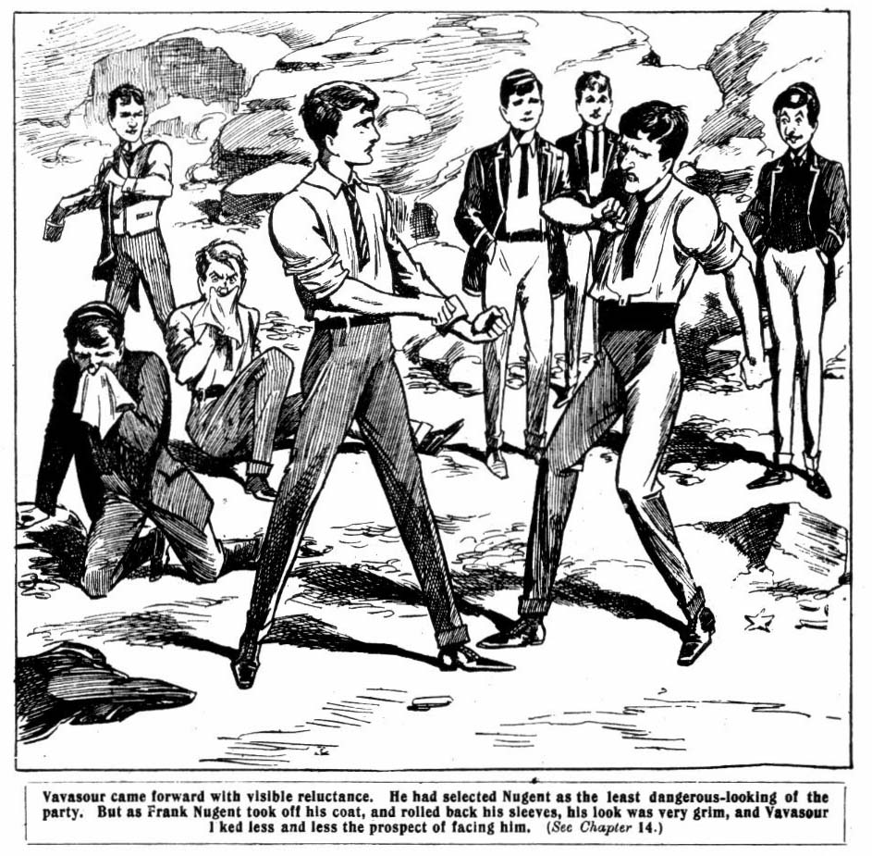 Of
Vavasour came forward with visible reluctance. He had selected Nugent as the least dangerous-looking of the party. But, as Frank Nugent took off his jacket and rolled back his cuffs, his look was very grim, and Vavasour liked less and less the prospect of facing him. He cast a hunted look round him, and made a sudden bolt, and broke through the ring of juniors and ran.
“Bolted!” roared Bob Cherry. “After him!”
“After him!” yelled Todd.
The juniors dashed in pursuit. Vavasour ran his hardest, but he was not in condition. In a couple of minutes he was run down, and he threw himself on the sand, quivering and yelling.
“Lemme alone! Hands off! I’ll yell for help! Yah! Oh, lemme alone!”
Wharton’s lip curled with disgust.
“Did you ever see such a rotten funk?” he exclaimed scornfully. “ Get up, you worm, and take your licking!”
“I—I won’t! Lemme alone!”
“You’ll be licked or ragged!” said Nugent. “ Rag the rotter, for goodness’ sake! I should be ashamed to lay a finger on such a rotten funk!”
“Let me alone!” yelled Vavasour. “I—I—I didn’t do anything, did I? I haven’t umpired for you. It was Ponsonby’s idea, and Gadsby helped him. I—I was down on it all the time. I—I told Pon it wasn’t fair play, I give you my word!”
“What’s that worth?” sniffed Bob Cherry.
“Oh, let the rotten funk alone!” said Wharton. “He’s not worth licking. Bump him ant let him sneak off.”
“Yaroooh—leggo—oh, oh, oh!”
Bump, bump, bump!
The juniors left Vavasour gasping on the sand, and returned to the spot where they had left Ponsonby and Gadsby. The latter two were putting on their jackets, their discoloured faces furious with wrath. They had heard Vavasour’s confession, and could no longer even pretend that they hadn’t plotted to cheat the Greyfriars fellows in the cricket match.
“Now cut off !” said Wharton. “You can walk back to Shoremouth; it’s only twenty miles or so, and it will do you good. It will be a lesson to you to keep clear of us in the future!”
“I’ll make you sorry for this!” snarled Ponsonby.
“Oh, rats!”
Ponsonby and Gadsby limped away. Vavasour joined them in the road. Harry Wharton & Co., quite satisfied, walked back to Headland. The Highcliffe fellows dragged weary and limping limbs towards the distant town of Shoremouth.
“Oh, my hat!” groaned Gadsby. “We’ve had an awful time! Who’d have thought those rotters would have had the cheek to waylay us like this? I wish you’d never thought of that rotten scheme, Ponsonby!”
Ponsonby ground his teeth.
“I’ll make ‘em smart for it!” he said savagely.
“I don’t see how. I’ve had enough of them.” said Gadsby, with a groan. “I know I’ve got two black eyes. Ow, ow! I’m jolly well going to leave the beasts alone! They’re not safe to go for! Ow, ow! Yow!”
“It’s safe enough, what I’m thinking of.” said Ponsonby, with a dark look. “I’m going to get at them through Hazeldene. They’ve set out to be a sort of Dutch uncle to that fool, on account of his sister Marjorie. The more he plays the giddy goat, the more it will make them squirmni. Especially that villain Smithy. Marjorie knows he first led her brother into gambling, or she thinks so. And the more Hazel goes to the dogs, the more she will dislike Smithy, and he’s mighty keen to get into her good graces. That’s the way we’re going to pay them out.”
“Jolly easy way, I should say, if they care what becomes of Hazel.” grunted Gadsby. “I never saw a chap more inclined to look for trouble than that silly chump.”
“Exactly; and that’s where we come in. If he doesn’t come a mucker, it won’t be my fault.” said Ponsonby, his eyes glinting.
“I say, I can’t walk to Shoremouth, you know.” groaned Vavasour. “I can’t absolutely. I’m fagged already.”
“Oh, rats! We shall meet the car on the road.” said Ponsonby. “ Jones wouldn’t be idiot enough to leave us quite in the lurch. We shall find him on the road.”
“There’s the light!” said Gadsby.
The chauffeur was waiting for them on the road. The three Highcliffians climbed into the car, and Hazeldene grinned a little at the sight of their damaged faces.
“You look as if you’ve had a rough time.” he remarked. “If you really did play it low down on them, as they say, I can’t say I’m surprised, Ponsonby. It was a rather rotten trick!”
“Was it?” snarled Ponsonby.
“Yes, it was”, said Hazel. “I hadn’t any idea that you intended anything of the kind. I think it was rotten, and you deserve what you’ve got.”
“Somebody else is going to get something, to make up for it, you can take my word for that!” said Ponsonby through his set teeth. He did not add that the “ somebody else” was Hazeldene himself.
THE FIFTEENTH CHAPTER.
Bunter Sticks!
HARRY WHARTON & CO. came back into their places at the cinema entertainment some time before the finish. They had lost no time in returning after dealing with the Highcliffe fellows. Vernon-Smith and Wharton showed in their faces some pretty plain signs of the combat, but they had the consolation of knowing that Ponsonby and Gadsby were in a much worse plight. As they dropped into their seats Billy Bunter blinked at them through his big spectacles.
“I say, you fellows, where have you been?” Bunter always wanted to know.
“Find out!” said Bob Cherry politely.
“Oh, really, Cherry
But the light went out then for a new film to come on, and Billy Bunter had to leave off asking questions.
When the show was over, and the juniors left, the St. Jim’s fellows could not help glancing at Wharton’s and Vernon-Snith’s damaged faces.
“Been looking for trouble, you chaps—what?” asked Figgins.
“Yes—and finding it!” said Harry, with a smile. But he did not make any further explanation; and the St. Jim’s fellows, not being blessed with Billy Bunter’s inquisitiveness, did not ask any further questions. But
They returned to the hotel to supper, and went up to bed.
Billy Bunter followed Harry Wharton & Co. up to their
quarters.
“I say, you fellows, where am I going to sleep?” he inquired.
“Anywhere you like!” growled Bob. “On the floor or on the roof or in the coal-cellar. Take your choice!”
Bunter blinked at him indignantly.
“You don’t mean to say that you haven’t engaged a room for me?” he exclaimed.
“Well, of all the cheek—”
“If you call this treating a visitor decently, I don’t!” said Bunter. “I call it rotten! If it wasn’t so late I should certainly go back to Shoremouth. Ponsonby begged me to go back in the car with him, and I stayed with you fellows instead. The question is—where am 1 going to sleep?”
“I suppose we must put the fat bounder up.” said Todd.
“You can share my bed, Bunter.”
“Oh, really, Todd, I don’t like sleeping double. If I can’t have a bed to myself—”
Todd glared at him.
“You don’t like sleeping double?” he snapped.
“Certainly not!” said Bunter loftily. “I’m accustomed to comfort.”
“Then you don’t want half my bed?”
“No, I don’t! I want—”
“All serene! I’ll give you a blanket, and you can sleep on the floor.” said Peter Todd grimly.
“I say, Toddy, of course I can’t do that. Now I come to think of it, I really don’t mind whacking out your bed.”
“But I mind,” said Todd coolly; “and you can sleep on the floor, or clear out!”
“I refuse—”
“Or you can go down and book a room for yourself.” said Todd. “I dare say the landlord has another room or two.”
“Very well, I will do so. Lend me half-a-quid—”
“Rats!”
“Will you lend me half-a-quid, Smithy?”
“No, I won’t!”
“I say, Harry, old chap——”
Wharton went into his room.
“I say, Bob Cherry—”
Bob followed Wharton and slammed the door.
“Franky, old man—”
Nugent walked away.
Billy Bunter blinked round furiously, and followed Peter Todd into his room. It was a small room, with a single bed in it, and Bunter blinked round it disparagingly.
“I say, Toddy, you have got pretty cheap quarters here.”
“Dear enough for me.” said Todd. “If you don’t like ‘em you can get out.”
“I happen to have left my purse at Shoremouth. As you are determined to be mean about that half-quid I shall have to share your bed.”
“You jolly well won’t share it!” said Todd, getting into bed. “There’s a blanket for you, and there’s the floor.”
“I can’t sleep on the floor, you beast!” roared Bunter.
“Then stay awake!”
Bunter blinked at him furiously. Peter Todd turned over to go to sleep. Bunter approached the bed.
“I say, Toddy, old man, I know you’re j-j-joking—”
“Shut up! I’m tired, and I want to sleep!”
“I say, old fellow—”
Swish!
Todd’s bolster swept through the air, and Bunter sat down on the floor with a tremendous concussion.
“Now shut up!” said Todd, glaring at him. “If you jaw any more I’ll get out of bed and start on you with the pillow.”
“Ow ! Ow ! Ow !”
“Shut up!” roared Todd.
And Billy Bunter shut up. With a furious face he rolled himself in the blanket to sleep on the floor. But the Owl of the Remove could sleep anywhere—he was a first-rate sleeper—and he was soon buried in slumber, and making night hideous with a deep and unmusical snore.
He was still fast asleep when Peter Todd awoke in the morning. Todd sat up in bed and grinned. He awoke Bunter by the simple process of hurling a pillow at him.
“Yarooh! Oh!” Bunter sat up on the floor and blinked.
“Wharrer that? Oh, Todd, you beast! What did you wake me for? I—I haven’t slept a wink!”
“Time to get up, porpoise!”
“If you’re getting up now, Toddy, I’ll have your bed. I don’t want to come down to brekker till about ten.”
“If you get into that bed.” said Todd, who was already up “ I’ll empty the water-jug over you! You’re not going to slack here!”
And Bunter had to come down very early that morning. But he consoled himself by making a tremendous breakfast, easily putting Fatty Wynn into the shade. The large party of juniors had a big table to themselves, and they kept a waiter very busy. And the Greyfriars ventriloquist, who was feeling very “edge-wise” towards his study-mate, kept him a little busier.
“Waiter,” said a voice that ought to have been Peter Todd’s, “what do you mean by bringing me rotten eggs?”
William, the waiter, hurried to the table. In expectation of tips, William was taking great care of the juniors—indeed, looking after them in quite a fatherly manner.
“Sorry, sir! What’s the matter with the heggs?” asked William, quite distressed. “They was quite fresh.”
“Don’t talk nonsense!”
“Oh, sir!” gasped William.
“Dash it all, draw it mild, Toddy!” expostulated Harry Wharton. “What the dickens are you ragging William for?”
Todd looked up from his breakfast.
“Eh? Who’s ragging William?” he demanded.
“If the eggs ain’t fresh—” began William.
“The eggs are all right.” said Todd, in surprise. “ Never better.”
“Then what for did you say they was rotten, sir?” demanded William, nettled.
“Eh? I didn’t! I heard somebody—”
“It was your voice, sir, at any rate, sir.” said William, looking quite grieved ; “ and really, sir—really—”
“Oh, my voice, was it?” said Peter, glaring at Bunter. “ We’ve got a ventriloquist in the party, William. He plays rotten tricks, William. So I chuck a cup of tea over him, William. Like that, William!”
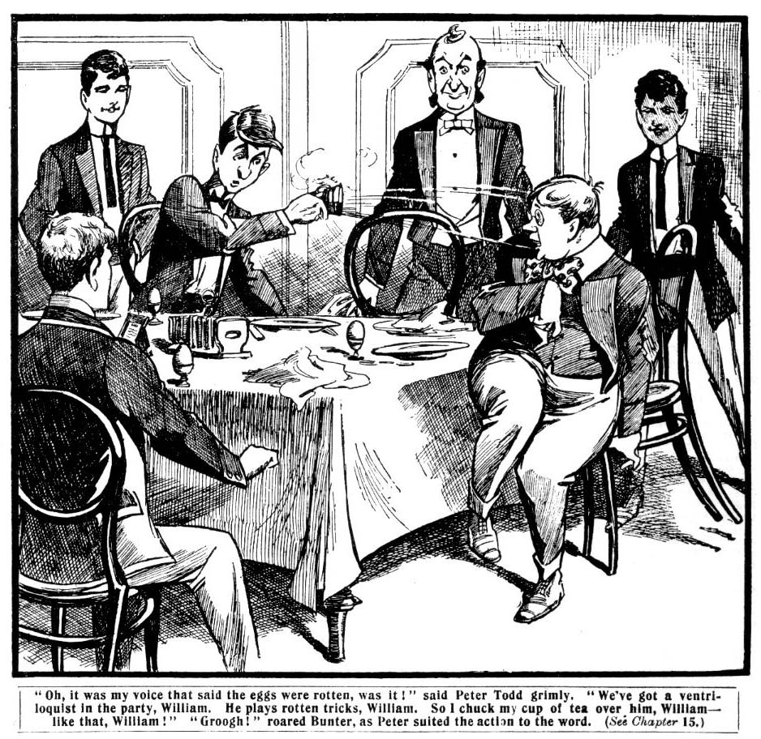
“Groooogh!” roared Bunter, as Peter suited the action to the word.
“And I follow it up with an egg, William! Like that, William!”
Squash!
“Yarooogh! Todd, you beast—groogh——”
“And then I let him have the pepper, William. Like that, William!”
“Grooh—hohhoh! Atchoo—atchoo—-atchoooh!”
“Ha, ha, ha!”
Billy Bunter jumped up from the table. William, the waiter, retreated, grinning. But Billy Bunter did not grin. He was smothered with tea and egg and pepper, and he was furious.
“Yow-ow! You rotter! Groogh! I’ll— I’ll——”
“You won’t play any more ventriloquial tricks in a hurry.” chuckled Peter. “ Better go and get a wash. You can’t have brekker in that state. I won’t allow it!”
“Beast! Yow-ow! I—I’ll—”
“Buzz off!” said Peter, taking up another egg. “ I give you two seconds!”
The two seconds were enough for Billy Bunter, and he disappeared.
When he came back the juniors had finished breakfast and had gone out. Bunter consoled himself with a second break- fast, in the comfortable assurance that Harry Wharton & Co. would have to pay the bill. But he did not see the juniors again that day till evening. They had gone on a steamer excursion, and with extraordinary forgetfulness had not mentioned to Bunter that they were going.
Bunter blinked at them indignantly when they came in to a rather late dinner.
“Nice sort of pals, you are, leaving me in the lurch!” he growled. “I had a good mind to clear off before you came back.”
“Pity you changed it!” said Bob Cherry unsympathetically.
“However, I’ve had a good time to-day!” said Bunter. “ They do you jolly well at this hotel! I’ve told them to put all the things on your bill, Wharton. 1 suppose that’s all right? I’ll settle up later.”
“You cheeky fat rotter—” but
“It’s not much.” said Bunter, with dignity. “I had a good many ices, but only about three dozen tarts—they had to be specially sent for. But the people here are really very obliging. And a dozen ginger-beers and lemonades, and some cakes, and some other things. It won’t be more than a couple of pounds.”
“A—a couple of pounds!”
“That’s all! I’ll settle up at Shoremouth. I’m expecting a postal order there.”
“I’ll jolly well tell the manager not to put anything more on our bill for you!” Harry Wharton exclaimed, in dismay.
“If you’re going to be mean, Wharton—”
“Oh, shut up!”
I dare say some of my friends among the St. Jim’c chap. vill lend me a quid or two,” said Bunter, with dignity. “Figgins will—”
Wharton took the Owl of the Remove by the neck, and shook him till his teeth rattled.
“Is you borrow a single tanner of the St. Jim’s chaps, we’ll squash you!” he said.
“Ow! Wow! Yow! If you sh-sh-shake me like that—”
“Do you understand?”
“M-m-my glasses will fall off,” gurgled Bunter, “ and if they get broken—”
“Do you understand?” roared Wharton.
“You—you’ll have to pay for ‘em! Grooogh!”
Wharton released the fat junior as Figgins & Co. came on the scene. Billy Bunter scored, for during the remainder of their stay in Headland the juniors did not let him go out of their sight, lest he should carry out his threat of “squeezing” the St. Jim’s fellows for a loan. Bob Cherry suggested taking him out in a boat and dropping him overboard as the best way of getting rid of him, but as that was not feasible, they had to make the best of the Owl of the Remove.
And when the stay came to an end, and the Greyfriars party started for Shoremouth, Billy Bunter was with them. Figgins & Co. saw them off at the station, and they parted on the best of terms.
Billy Bunter settled himself down comfortably in a corner
“We’re going to have a good time at Shoremouth, he remarked. “If you like, Wharton, I’ll play for you in the match here. I can overlook what you’ve done, and—”
“Oh, cheese it!”
“Or rather, on second thoughts, I’m afraid I sha’n’t have time to play for you.” went on Bunter calmly. “After all,
you fellows are scarcely up to my form, and I shall be busy looking after Marjorie. Marjorie and I are going to be a very great deal together, I can tell you, and I — Yah! Oh, you beast, Cherry! Yow! Ow!”
Bunter roared as Bob Cherry’s big fist smashed his hat down over his eyes. And for the rest of the journey Bunter did not deign to talk to the juniors any more, for which relief they were duly thankful.
THE SIXTEENTH CHAPTER.
Trouble Ahead!
“MARJORIE!”
“Clara!”
“Here we are again!” chuckled Bob Cherry.
It was a warm greeting. Glad enough were Harry Wharton & Co. to see their girl chums of Cliff House School once more.
The two girls had come to the station with Hazeldene to meet the party. Hazel was not looking very joyful. Apparently the meeting did not afford him any extraordinary amount of pleasure. But Marjorie and Clara looked very sweet and charming and very pleased. They had been looking forward to the arrival of their old friends of Greyfriars.
“Jolly glad to see you again, Marjorie.” said Bunter, rolling forward at once. “How topping you look!”
Marjorie was talking to Wharton, and did not seem to hear, and the Owl of the Remove turned his kind attentions to Miss Trevlyn.
“Quite sunburnt, Miss Clara.” he remarked. “Jolly place this, ain’t it? I’m going to look after you here, and see that you have a really good time, you bet!”
“We saw a cricket match here yesterday.” Miss Clara was saying to Bob Cherry, and she, too, seemed deaf to Bunter’s dulcet tones. “Some of your friends were playing—the Grammar School boys, you know—”
“I say, Miss Clara—”
And Gay was very clever,” went on Mi Clara, determinedly deaf. “We shall be very glad to see your match when it comes off. You didn’t have good luck with your last!”
“No, our luck was out.” said Bob, owing to—to circumstances. But we took it out of the circumstances afterwards.” a remark which puzzled Miss Clara somewhat.
Bunter grunted, and turned to Hazeldene.
“I say, Hazel—”
“Oh, don’t bother!” said Hazeldene.
“Ahem! You’re not looking very fit, Hazel, old chap!”
“Oh, rot!”
“A giddy time by the giddy sea—what?” said Bunter, with a wink. “Oh, you’re a sad dog, Hazel! I know you!”
“Don’t be an ass!” said Hazel, with an uneasy glance towards his sister.
“Ahem! How’s Ponsonby—eh? I intend to see a good deal of those chaps while I’m here!”
“Bosh!”
Hazel’s manner could not be called courteous. Billy Bunter’s little round eyes gleamed behind his spectacles.
“Any luck on the gee-gees?” he asked. “Quite a good thing there’s a racecourse near this place, ain’t it ? How did they use you?”
“Shut up, you fool!” said Hazel in a fierce whisper. But it was Billy Bunter’s turn to be deaf.
“Ripping to be on a vac, and able to do as you like without a rotten prefect dropping on you, ain’t it?” he said confidentially. “Have you made anything on the gee-gees?”
“Cheese it, you fat idiot! I—I haven’t been betting!”
Bunter winked knowingly.
“Oh, draw it mild, Hazel! I know——”
“You fellows will excuse me.” said Hazel, turning his back on the Owl of the Remove without ceremony. “Marjorie wanted me to come here, but I’ve got an engagement this afternoon. See you later.”
And Hazel lifted his straw hat to the girls and walked away, and disappeared at once into the crowd.
Wharton saw a shade come over Marjorie’s face, and the girl looked very thoughtful as they left the station. Outside, Shoremouth was shimmering in up to the the blaze of the sun. It was sultry afternoon.
“How is Hazel getting on here?” asked Harry, who saw what subject was uppermost in Marjorie’s mind.
Marjorie coloured a little.
“I am afraid his holiday is not doing him much good.” she said frankly. “He has met some friend here whom—whom I don’t like very much.’’
“The Highcliffe fellows?”
“Yes. And—and I think Hazel has been very reckless in their company. We have seen very little of him; he is hardly ever at home. When he comes in to a meal he generally brings Ponsonby with him. Father and mother like Ponsonby; he can be very agreeable. But—but I can’t like him. I can’t help thinking that his friendship is bad for Hazel, and—and I wish they were not so much together. But now you are here it will be different. Hazel will be with
you.”
Wharton nodded, but he had his doubts about it. With Hazel in his present humour, Ponsonby & Co. were more in his line.
The Hazeldenes had a bungalow near the sea, where Mis Clara was staying with her friend. Wharton and Bob Cherry walked with the two girls as far as the bungalow, and there they parted, and the two juniors went to their hotel, where the other fellows had already arrived. They found Billy Bunter in a very bad humour. The fat junior had fully intended to walk home with Marjorie and Clara, but Peter Todd and Johnny Bull had taken his arms and walked him away, deaf to his expostulations. But Bunter cheered up over tea—a “high” tea, which Bob Cherry had ordered on a lavish scale.
“I say, this is all right.” said Bunter. “Pass the cake, Peter. If you keep this up I sha’n’t be sorry I’ve come along with you chaps, instead of accepting Ponsonby’s pressing invitation. Ponsonby’s people have a very decent place here— rather better than sticking in a blessed hotel—but—”
“So you’re staying here, are you?” growled Johnny Bull.
Bunter blinked at him.
“That’s all right, Johnny, old chap. I’m not going to desert you, depend on me. Pass the jam, young Nugent. I hope you’ve booked a decent room for me, Peter.”
“If you’re going to stay I’ll have an extra bed shoved in my room for you.” said Todd. “ I suppose it’s up to me to stand you.”
“Ahem! Pass the biscuits, Franky. I shall have to ask you fellows to stand the exes here for a day or two until I’ve sent the address, you know. If you fellows had let me know where you were going to stay I should have had a remittance waiting for me. But I want you to keep a very careful account, Wharton, so that 1 can settle up in full.”
“Oh, rats!” said Wharton.
“Look here, Wharton, I insist upon your keeping an account, otherwise it will be quite impossible for me to remain.”
Br-r-r-r-r!
“Well, if you insist upon my remaining as a guest, of course I can’t refuse, as you’re so pressing.” said Bunter gracefully. “Pass that other cake, will you? I like cake. I say. Smithy, you’ve not finished tea yet.”
A waiter had brought in a note for Vernon-Smith, and the Bounder rose from the table. Bunter blinked at him inquisitively, but the Bounder did not deign to satisfy his curiosity. He quitted the room quietly.
In the vestibule Hazeldene was waiting for him. There was an anxious expression on Hazel’s face, and a grim look on Vernon-Smith’s.
“Well?” said the Bounder tersely.
“I—I haven’t had a chance of thanking .you for sending me that—that little loan, you know.” said Hazel nervously.
“That’s all right—two quid.” said the Bounder, apparently understanding that Hazeldene had come to return the loan.
Hazel flushed.
“I—I haven’t come to settle!” he muttered. “ I don’t mean that.”
“Come up and have tea with us,” said Vernon-Smith.
. “Thanks! I’ve had tea. I wanted to ask you——”
“About our plans?” asked the Bounder calmly. “The match isn’t fixed yet. Wharton’s got to see Gordon Gay about that.”
“Hang the match!” muttered Hazel.
“We’re going bathing in the morning.” went on the Bounder. “There’s jolly good bathing here. Your people are coming down, too. I suppose you’ll be with us?”
“I—I don’t know. Look here, Smithy, I—I believe you know what I wanted to see you for. Can you lend me a few quids?” blurted out Hazel, “till—till—”
“Till doomsday?” asked the Bounder ironically. “Well, if you won’t ——”
“Look here, Hazel,” said the Bounder quietly, “you’re playing the giddy ox again. I know that.”
Hazel looked sullen.
“I suppose I can amuse myself my own way?” he snapped.
“Yes, I suppose you can, so long as you foot the bill yourself.” agreed Vernon-Smith, “I’m not made of money, you know, and you owe ne a good many quids. I’ve told you before that I won’t lend you any money to gamble with, and I’ll tell you again. Nothing doing.”
“I must have a few quids to-day!” said Hazel.
“What for?”
“Oh, never mind what for. I’m stony. But if you won’t lend it to me, I know where to go for it. So-long!”
“Hold on!” said the Bounder, as Hazel was turning sullenly away. “I suppose you mean you are going to your sister for it?”
“That’s my business.” said Hazel angrily.
“Marjorie will suspect what you are up to.”
“Thanks; but I don’t want your opinion about that!”
The Bounder bit his lip.
“How much do you want?” he asked.
“Three quid.”
“Will you spend to-morrow with us!”
“I—I can’t. I’ve promised Pon—”
“Never mind Pon. You can change your mind if you
like. Dash it all, Hazel, we’re your friends, you know. Come with us to-morrow, there’s a good chap!”
“All right.” said Hazel, “I’ll come. Now——”
Vernon-Smith quietly extracted three sovereigns from his pocket, and Hazel’s fingers closed on them. He hardly stayed to thank the Bounder, and hurried away. Vernon-Smith returned to the tea-room with a very thoughtful expression on his face.
“Hallo, hallo, hallo! There goes Hazel!” said Bob Cherry, who was looking out of the window. “ Has Hazel been here ? Why didn’t he come up?”
“I’ve just seen him.” said Vernon-Smith briefly. “ He’s arranged to come along with us to-morrow.”
“Oh good!”
Wharton gave the Bounder a quick look; but Vernon-Smith avoided his glance. Harry had never felt so friendly towards the Bounder as at that moment. It was a new role for the Bounder, that of guardian angel to a reckless youth, and it showed how complete had been the change in him. Vernon-Smith, with his hard and resolute character, had thrown his own reckless past behind him when he had once made up his mind to do so; but in reclaiming Hazeldene he had a harder task.
“Good for you, Smithy!” Wharton said later, when they were together. “Hazel is spoiling the holiday for Marjorie by playing the giddy goat. If you can keep him from making a fool of himself—”
“I’m going to try.” said the Bounder.
“I hope you’ll succeed.”
The Bounder shrugged his shoulders. He hoped so, too; but he could not help having his doubts about it.
THE SEVENTEENTH CHAPTER.
By the Sunny Sea!
A STURDY, good-looking youth came in while the Greyfriars party were at breakfast the next morning. It was Gordon Gay, of the Fourth Form at Rylcombe Grammar School, the fellow with whom Wharton had arranged a match at Shoremouth. The Greyfriars juniors greeted him warmly, and Gay joined them at breakfast,
“I hear you’ve been playing cricket here already.” Harry Wharton remarked.
But Gordon Gay nodded.
“Yes. Carboy’s people live here, you know. You know Carboy of the Fourth? He’s got six of us staying with him here. There’s a Shoremouth junior cricket club, and Carboy s a member, so we all squeezed in while we were here.” said Gay, laughing. “They’re lending us the ground for our match. There are seven of us, with Carboy, and we’re going to play four Shoremouth chaps to make up the eleven. One day next week suit you?”
“Any day you like.” said Harry.
“Make it Wednesday, then. Stumps pitched at ten—what?”
“Right-oh!”
“What luck did you have with the St. Jim’s chaps?”
“Rotten!” said Wharton, with a smile. He did not explain that the bad luck was chiefly due to the peculiar umpiring of Ponsonby and Gadsby. Billy Bunter blinked across the table at Gordon Gay.
“If you’re short of men, Gay, I’ll play for you with pleasure.” he said. “I’m rather a dab at cricket, and I’m not playing for Wharton.”
Gordon Gay looked at him with a smile. Billy Bunter might be a dab at cricket, but he certainly did not look as if he were a dab at anything but eating. At that he was certainly a great dab, to judge by his present performance.
“Thanks!” said Gay politely. “But we’ve arranged with the Shoremouth chaps — four of them.”
“Oh, you can leave one of them out.” persisted Bunter. “The fact is, I should like a game.”
“Shut up!” said Johnny Bull. “The fat duffer can’t play cricket, Gay!”
“Oh, really, Bull—”
“Ring off!” said Johnny Bull, who h an almost ferocious way of speaking plainly at times. “You make me tired!”
Bunter blinked at him angrily.
“Oh, you’re an ass, Johnny Bull!” came a voice that appeared to be Gordon Gay’s.
Johnny Bull started.
“I tell you he can’t play, Gay!” he exclaimed sharply. “And I don’t like being called names.”
Gay looked at him in surprise.
“Keep your wool on!” he said good humouredly. “Who’s calling you names!”
“You called me an ass.”
“I did!” exclaimed Gay, in surprise. “My dear chap, you’re dreaming dreams— Hallo, what on earth’s the matter?”
“Yaroooh!”
Bob Cherry had suddenly jumped up, caught Bunter by the collar, and yanked him over the back of his chair. The Owl of the Remove landed on the floor with a terrific bump. Bob proceeded to roll him over with his boot.
“Is that a game?” asked Guy, in astonishment.
“Yes.” said Bob. “A little game we’ve invented for Bunter’s special benefit. Bunter is a ventriloquist, and he has a trick of imitating voices, and we always show our appreciation like this.”
“Yow-ow-ow! Leave off! It was only a j-j-joke!” howled Bunter.
“Oh!” ejaculated Johnny Bull, turning red. “I—I beg
your pardon, Gay! It was that fat ass ventriloquising again.”
“Yow-ow! Bob Cherry, you beast —”
“That’ll do, Bob.” exclaimed Harry Wharton, laughing. “ You’re astonishing the natives, old chap. Chuck it!”
“A painful but necessary duty, Gay.” Bob explained as he returned to the table. “Necessary for me, and painful for Bunter.”
“Ha, ha, ha!”
Billy Bunter scowled ferociou1y as he returned to the breakfast-table. Ventriloquism was evidently at a discount now. After breakfast Gordon Gay took his leave, and the juniors prepared for their morning excursion. Lord Mauleverer prepared for it by stretching himself upon a lounge on the terrace and closing his eyes. When the party gathered in the hall his lordship was missing.
“Slacking somewhere.” said Bob Cherry. “ Wait a minute. I’m looking after Mauly.”
Bob looked for the noble youth and found him. Lord Mauleverer opened one eye apprehensively at Bob’s heavy footsteps. But he did not rise.
“We’re starting, Mauly!” said Bob.
“Yaas.”
“We’re just going, fathead!”
“Hope you’ll have a good time, begad!” yawned Lord Mauleverer.
“You’re coming with us!” shouted Bob.
Lord Mauleverer shook his head.
“Can’t, my dear fellow.”
“Why can’t you?”
“Tired.”
“I see!” said Bob, with a cheerful grin. “ You’ve got a sort of tired feeling—feel as if you’d better spend the morning slacking—what?”
“Yaas.”
“Don’t feel as if you could get off that lounge by yourself—?”
“Exactly, dear boy.”
“That’s all right. I’ll give you something to cure all that.” said Bob cheerfully, and he laid hold of Lord Mauleverer’s ankles and had him off the lounge in a twinkling. “ Feel better now?”
“Oh! Ow! My hat! Begad!”
“Feel as if you can walk?” asked Bob, with friendly solicitude. “If you don’t, I haven’t the least objection to pulling you along by your feet.”
“Oh, begad! I—I’ll walk!” gasped Lord Mauleverer.
“No, you won’t; you’ll run!” grinned Bob.
And he took the noble youth’s arm, and ran him downstairs at top speed. Lord Mauleverer arrived in the vestibule in a breathless state.
“Here he is,” said Bob. “He thought he was going to slack to-day, and I thought he wasn’t. Second thoughts are best. Kim on!”
And Lord Mauleverer resigned himself to his fate. In a merry party, the juniors proceeded to the beach, where they met Mr. and Mrs. Hazeldene, and Marjorie and Clara and Hazel. The shining waters were already dotted with bathers, and Harry Wharton & Co. were not long in joining them. Marjorie and Clara were both swimmers, and most of the juniors could swim and Bunter especially assured the girls that there would be no danger, as he would be there.
Hazel did not join them. He remained with his parents for a while, and then strolled away. The Bounder had also remained out of the water, and when Hazel walked away in the crowd. Vernon-Smith disappeared too, keeping an eye on Hazel as he threaded his way among the crowd of merrymakers on the front.
THE EIGHTEENTH CHAPTER.
The Bounder’s Way!
“HALLO, dear boy!”
Ponsonby of Highcliffe greeted Hazeldene cheerily, at the same time winking at Gadsby and Vavasour with the eye that was furthest from Hazel.
The three cheerful young blackguards were seated on the rocks, under the shade of the big cliffs at the end of the bay. Excepting for the swimmers in the sea, they were out of sight—it was quite a secluded spot. And in that secluded spot Ponsonby & Co. were enjoying themselves after their own fashion.
Ponsonby had thoughtfully brought a pack of cards with him, and the young rascals were using a flat rock for a card table, and they sat round the cards, smoking cigarettes. Ponsonby & Co. were “seeing life,” as they called it, on their holiday.
They welcomed Hazeldene as he came up, quite effusively. They had already won all his available cash from him, but he had evidently obtained a new supply. His eyes glistened at the sight of the cards.
“Glad you were able to join us!” drawled Gadsby. “We fancied the excellent Wharton would be keeping too sharp n eye on you.”
Hazel scowled.
“Wharton’s not my master, I suppose!” he exclaimed, touched on his weakest spot, as the cad of Highcliffe fully intended he should be.
“I hope not; but I fancy the great man thinks he is.” said Gadsby lazily. “However, here you are! You want your revenge—what?”
“That’s it.” said Hazel.
“Well, squat down!”
Ponsonby gathered up the cards, and slipped them into his pocket. The Highcliffians had been playing nap, but Ponsonby had another set of cards for use with Hazel. The foolish and reckless lad had no suspicion that he was in the hands of a gang of young sharpers.
It was not only his money the young rascals wanted, though that was very useful to them. Their own little flutter on the races had not ended well, for there they came in contact with shapers who were sharper than themselves. Hazel was very useful for the purpose of replenishing a depleted exchequer.
But, besides that, the Highcliffe trio intended to score off Harry Wharton & Co. by leading Hazel into their own rascally ways. The deeper they plunged him into the mire the more they were pleased.
“Of course, it’s understood that we play only for the ready.” Gadsby remarked.
Hazel’s I O U’s were no use to the Highcliffians, as they were worth exactly the value of the paper they were written on, and no more.
“I’m in funds.” sad Hazel.
“Oh, good!”
They began to play. Hazel’s luck was decidedly bad. He had not the steady head that was required for card-playing; but if he had been ever so good a player, his skill would not have helped him much, considering the cards that were being used. Hazel had four or five pounds, and the Highcliffians wondered where he had obtained it not guessing that the greater part of it came from the Bounder.
The juniors were too busy with their game to notice a
light footfall on the rocks. Vernon-Smith, leaning against the cliff at a little distance, almost out of sight, watched them with a moody brow. He had guessed that something of the sort was on, and for that reason he had followed Hazel. But now he was there, it was not easy to decide what to do. Hazel was his own master, and it was quite certain that he would not listen to a word of advice, and that he would not leave his precious friends while he had a coin left. The fever of gambling was in his veins.
Hazel’s money did not last long. It passed into the keeping of Ponsonby and Gadsby and Vavasour. The white, set look in his face showed the sharpers when he was “stony.”
“Not finished, dear boy?” yawned Gadsby.
“I—I’m stony!” muttered Hazel. “I suppose an I O U—”
Ponsonby laughed.
“We’re not collectin’ wastepaper!” he remarked. “ You’ll excuse us, Hazel, old chap, but you are a bad payer!”
Hazel crimsoned.
“Look here, I’ve got something else.” he said, drawing a gold watch from his pocket. “That’s worth five quid!”
Ponsonby took up the watch, and examined it curiously.
“That’s a lady’s watch,” he said.
“My sister gave it to me.”
The Highcliffe fellows exchanged glances.
“Well, if you really want to go on!” murmured Ponsonby.
“You’re bound to give me my revenge!” said Hazel bitterly. “You’ve won all my money, anyway!”
“All serene! I’ll give you four quid for the giddy ticker!”
Ponsonby slipped the watch into his pocket, and threw down four sovereigns. Hazel caught the money up eagerly.
The Bounder was still watching, with a hard, bitter look on his face. This was the fellow he was trying to save from himself. It looked a hopeless task.
The new supply of cash lasted Hazel about twenty minutes.
When it was gone, he sat with a white and stunned look on his face. Ponsonby looked at him curiously.
“Pretty near time to get back, I think.” he drawled.
“I—I——” Hazel stammered. “I—I say, Pon—”
“ Stony?”
“Yes. But that doesn’t matter. Only—only that watch—” Hazel almost choked. “ My—my sister lent it to mee! She—she didn’t mean—”
Ponsonby rose with a yawn. Then he caught sight of the Bounder. Vernon-Smith was advancing towards them. The black look was gone from the Bounder’s face. His manner could not have been more agreeable. He gave the Highcliffians a cordial nod.
“Having a good time—what?” he asked.
Hazel looked guiltily at the Bounder. He was ashamed of being caught thus occupied, after the promises he had made. But his chief thought was that he might possibly screw a fresh supply of money from Vernon-Smith.
“I say, Smithy, lend me a quid!” he muttered.
“What do you say to a little game, Smithy?” asked Ponsonby, surprised and pleased by the friendly manner of the Bounder.
A little game with the millionaire’s son, with marked cards, was a pleasant prospect for the three young sharper, and they were quite willing to forget old troubles for the sake of it.
The Bounder nodded.
“Just what I was thinking of.” he said.
“So you’ve given your goody-goody friends the go-by!”grinned Gadsby.
“Oh, a chap can’t keep up to concert-pitch all the time!” said the Bounder coolly, as he sat down. If you fellows want a little game, I’m your man! I haven’t any cards—”
“I suptose our cards are all right?”
“Of course! There’s a quid for you, Hazel!”
Hazel clutched the coin eagerly. Ponsonby & Co. exchanged glances of satisfaction. Gadsby reflected that this was a really topping way of repaying the Bounder for the black eye he had given him a week before. The young rascal intended that the son of Samuel Vernon-Smith, the millionaire, should pay very dearly for that little game.
Vernon-Smith opened a little leather purse, which simply bristled with sovereigns and half-sovereigns, and the Highcliffians’ eyes gleamed with greed. There was a wad of banknotes in the purse, too. Certainly the Bounder was a pigeon worth the trouble of plucking—if he could be plucked. And with marked cards to play with, Ponsonby & Co. had no doubt on that point.
Vernon-Smith took up the cards and shuffled them. Not by the flicker of an eyelid did he show suspicion. Ponsonby did not dream for a moment that the Bounder knew as well as he did that the cards were marked—that he knew the marks better than Ponsonby himself, and was far better skilled in the noble art of card-sharping. Not for a moment did it occur to him that Vernon-Smith had stepped into the game with the simple intention of “skinning” the young rascals as they had skinned Hazel, and with a complete confidence that he could do it without the slightest difficulty. For Ponsonby & Co., sharp as they believed themselves to be, were little better than infants in dealing with the Bounder of Greyfriars.
The three Highcliffe fellows began cheerfully enough. But their cheerfulness gradually faded away. When they had the dealing they won, but the Bounder was carefully biding his time. When the deal came to him, he shuffled the cards carelessly, and yawned.
“This is a bit of a bore, playing for bobs!” he remarked. “Make it half-quids!”
“Done!” said Ponsonby at once. “Quids, if you like!”
“Right-ho! Quids, then!” said the Bounder. “I don’t mind—luck must turn sooner or later!”
Hazel’s money was already gone, and he sat looking on without speaking. If he could not play, it was next best to watch the play.
Ponsonby found himself with a good hand. The Bounder appeared to reflect and hesitate.
Ponsonby grinned.
“Make it nap!” he suggested. “You used to be a sport, Smithy.”
“Hum!” said Vernon-Smith, still seeming to hesitate. “Well, all right! In for a penny, in for a pound! Nap!”
“Get it!” grinned Ponsonby.
The Bounder proceeded to get it. And when he had got it the Highcliffe fellows looked blank and blue.
“You owe me five quid each, please.” said the Bounder calmly.
And with sickly looks the young rascals paid up. They were well supplied with money, but it very nearly cleared them out. Hazel gave the Bounder an envious look.
“Rotten that you should have so much luck!” he growled.
“I never get a hand like that, somehow.”
Vernon-Smith collected up fifteen sovereigns with a
smile. Ponsonby & Co. exchanged looks. With sovereign points they would not be long in winning it back, and a great deal more with it. But they did not know the Bounder.
“So you’ve had bad luck, Hazel,” said Vernon-Smith.
“Yes, rotten.”
“Lost much?”
“About ten pounds altogether, I suppose.”
“And your sister’s watch?”
“Never mind that,” said Hazel, flushing.
“I’ll take that watch off you, Pon.” said the Bounder. “I saw you give Hazel four quid for it. I’ll make it five.”
“Right-ho! I want some cash to go on with.” said Ponsonby, very readily. As a matter of fact, he was down to his last sovereign.
Vernon-Smith handed over the five pounds, and took Marjorie’s watch, and slipped it into his pocket. Then he rose to his feet.
“Hallo!” exclaimed the three Highcliffe fellows together.
“You’re not going?”
Vernon-Smith nodded calmly.
“Yes, I’m going.”
“You’ve got to give us our revenge.” howled Gadsby angrily. “You’re not going to walk off with our cash like that.”
“Not with these cards!” said the Bounder, with a smile.
“I chipped in here for a reason. Hazel, old man, look at this card. It’s an ace—see?”
“Yes,” said Hazel, in wonder.
“Now look at the back of it. Do you see that pink spot?”
“ Ye-e-es.”
“Look at the other cards, and you’ll find the same spot on all the aces. Look at the kings, and you’ll find that the corner of each card is extra rounded.”
“Wha-a-at!”
Ponsonby leaped to his feet, red with rage.
“You—you dare to insinuate—” he yelled.
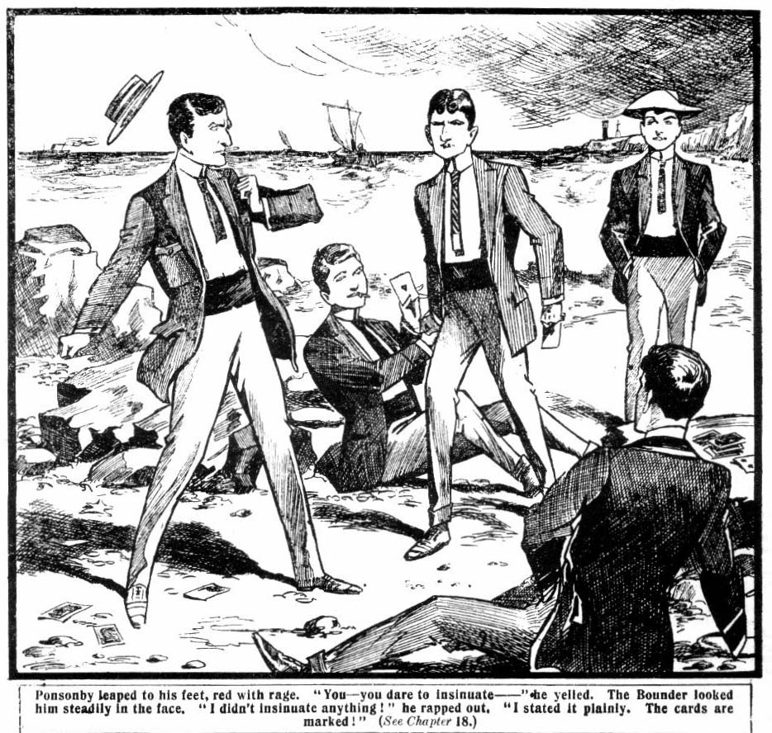
The Bounder looked him steadily in the face.
“I don’t insinuate anything.” he rapped out. “I state it plainly. These cards are marked.”
“Liar!”
“You—you rotters!” yelled Hazel furiously. “Why I can see it now. You’ve been cheating me all the time! You— you swindlers!”
“Of course they’ve been cheating you, Hazel,” said the Bounder quietly, “and I chipped in to play their own game on them. I’ve had marked cards played on me often enough to know the ropes. You can scowl as much as you like Ponsonby. I fully intended to get back what you’ve robbed Hazel of, and I’ve done it. Put that in your pipe and smoke it!”
Hazel was clenching his fists with fury. The discovery that he had been cheated made him almost beside himself. The three Highcliffians drew together, whispering. Ponsonby looked bitterly at the Bounder.
“You’re mighty clever, Smithy.” he said, between his teeth, “awfully clever! But there’s one thing you’ve forgotten.”
“What’s that?” smiled the Bounder.
“That we’re three to one. And if you don’t hand back that money at once we’ll pile on you, and take it, and give you the ragging of your life into the bargain!” hissed Ponsonby.
“Absolutely!” said Vavasour.
Vernon-Smith laughed.
“I didn’t forget that.” he said,.
“You—you didn’t!”
“ No. I’m quite ready for you to pile on me. If I couldn’t handle three bunny rabbits like you fellows I’d hang myself.” said the Bounder contemptuously. “Come on, as soon as you like. I’m waiting.”
“Three to two, not three to one.” said Hazel, as the High. cliffians came on. “I’m with you, Smithy!”
“Good for you, Hazel!”
Hazel, in fact, started the attack. He rushed straight at Ponsonby, and closed with him, and they rolled on the rocks. Vavasour and Gadsby rushed upon the Bounder, but they had reason to repent it. A terrific righthander between the eyes sent Vavasour rolling a dozen feet away, and Vernon- Smith followed it up with an upper-cut that laid Gadsby on his back with a bump.
And the two fallen juniors decided to stay where they were. They had had enough of the Bounder.
Ponsonby and Hazel were fighting furiously. Hazel was not a great fighting-man, as a rule; but the discovery of the swindle had enraged him so much that he seemed to have the strength of two or three fellows. Ponsonby was knocked right and left, and he went down at last with a closing eye and a streaming nose, and remained on the ground.
“Get up!” shouted Hazel. “You swindler, you thief, get up !”
Ponsonby only groaned.
“That’s enough,” chuckled the Bounder. “Hazel, old man, I didn’t know you were such a giddy prizefighter. Let him off now. You don’t want to kill him! Come along.”
Hazel panted. He would willingly have given Ponsonby some more, but Vernon-Smith took is arm, and drew him away. And the two juniors walked away from the scene, leaving Ponsonby & Co. groaning in chorus, the three young rascals having made the discovery that the way of the transgressor is hard.
THE NINETEENTH CHAPTER.
In Peril of His Life!
HAZEL breathed hard as he walked away with the Bounder. Vernon-Smith did not take the path back to Shoremouth. He did not wish Hazel to be seen until he had had time to calm himself. They walked along in silence by the cliff-path over the bay. On their left, rough and precipitous, the cliff descended almost sheer to the shining waters. Hazel came to a halt abruptly.
“I—I say, Smithy—” he faltered.
The Bounder stopped, and looked at him with a smile.
“Well?” he said.
“I—I say, I’ve been an awful ass!” said Hazel remorsefully. The Bounder smiled again. Hazel was in one of his moods of repentance, and the cynical Bounder only hoped that it would last as long as the vacation. “I’ve acted rottenly. Of course, I never suspected those fellows of being such awful cads, or I wouldn’t have had anything to do with them. I—I— Will you do me a favour, Smithy? I know I don’t deserve it.”
“You don’t!” agreed the Bounder.
“But—but that—that watch—”
“Here it is.” said Vernon-Smith, handing it over. “Did you think I was going to keep it, you donkey? It’s your sister’s.”
“She lent it to me. Goodness knows what she’d have thought if I hadn’t been able to take it back to her!” said Hazel, colouring. “I—I was an ass and a brute! I’ll pay for it, Smithy, as much as you gave Pon.
“Fathead!” said the Bounder, “Do you think I’m going to keep what 1 won from those cads? I’m not a welsher, if they are. I played their own game on them, to make them disgorge. That watch belongs to your sister, and you’ll hand it back to her, and you won’t say a word. Marjorie mustn’t know anything about it.”
“You’re a good chap, Smithy.” said Hazel gratefully. “ But—”
“And here’s your ten quid.”
“What!”
“Take it, it’s yours. It’s certainly not mine.” said Vernon- Smith. “If I kept it I should be a swindler. I was only making them shell out, so that I could give you back what you’ve been swindled of.”
Hazel’s hand trembled as he took the money.
“Only remember,” said the Bounder, “no more fluttering here. I want you to promise to run straight this vac.”
“Honour bright!” said Hazel. “ There—there isn’t much fun in it, either. It’s only playing the giddy goat. I haven’t had an hour’s peace of mind since I met Ponsonby here. But—but I don’t like to keep this.”
“What rot! It’s yours, isn’t it?”
“Well, yes.”
“Shove it in your pocket!” but said the Bounder. “And now we’ll trot back to the others. Your sister will miss you.”
Hazeldene drew a deep breath.
The discovery that Ponsonby & Co. had been cheating him at cards had cured him of any desire for their company, and after the way he had handled Ponsonby it was scarcely possible that they could be friends again, and he was glad of
it. And for the time, at least, his desire to play had vanished. Now that he was out of the toils there was the prospect of a healthy and happy holiday before him, and his face brightened up, and his heart grew very light.
“Let’s get back to the others.” he said, with a cheerfulness he had not displayed for a long time past.
“Right-ho!”
They moved along the cliff-path. A sudden step on the rocks near them made Hazel turn his head. He caught sight of the face of Ponsonby looking over a rock, and a raised hand with a stone in it.
“Look out!” exclaimed Vernon-Smith.
Hazel started back.
A sudden cry rang from his lips as he staggered on the verge of the precipitous path. He had forgotten his dangerous position. Ponsonby’s red and savage face went white, and he lowered the hand that grasped the stone as he saw Hazel’s danger.
“Look out!” he shrieked.
Vernon-Smith sprang to his comrade’s assistance. But he had no time to reach him. Hazel had lost his footing on the edge of the cliff, and he shot downwards while the Bounder’s outstretched hand was still a foot away.
Splash!
Twelve or fifteen feet below, Hazel struck the water and vanished from sight. The water was deep close up to the high cliff. Vernon-Smith knew there was at least twenty feet of water there, and Hazel was a poor swimmer.
He did not look at Ponsonby. That wretched youth, overcome with horror at what he had caused, stood rooted to the rocks. The Bounder tore off his jacket and threw it down and knelt on the edge of the cliff-path, looking downwards, watching for Hazel’s head to appear. There was a shout from the distance. The spot where the Bounder knelt was in full view of the bathing beach, and a score of eyes had seen the accident. Marjorie had recognised her brother and the Bounder together at the distance, and she had seen Hazel’s fall. Her face was white as death.
“Save him—save him!”
The girl’s voice came from the distance to the Bounder’s cars. He did not turn his head, but it nerved him, if he needed nerving, to what he was going to do. Between the spot where Hazel had fallen and the bathing beach great masses of rocks jutted into the sea, and the swimmers were barred off from rendering help.
A head appeared on the water below the cliff; a hand was thrown up. Hazel’s white face glimmered in the waves.
The fall seemed to have dazed him; he was not swimming. The Bounder gave him one glance, and dived.
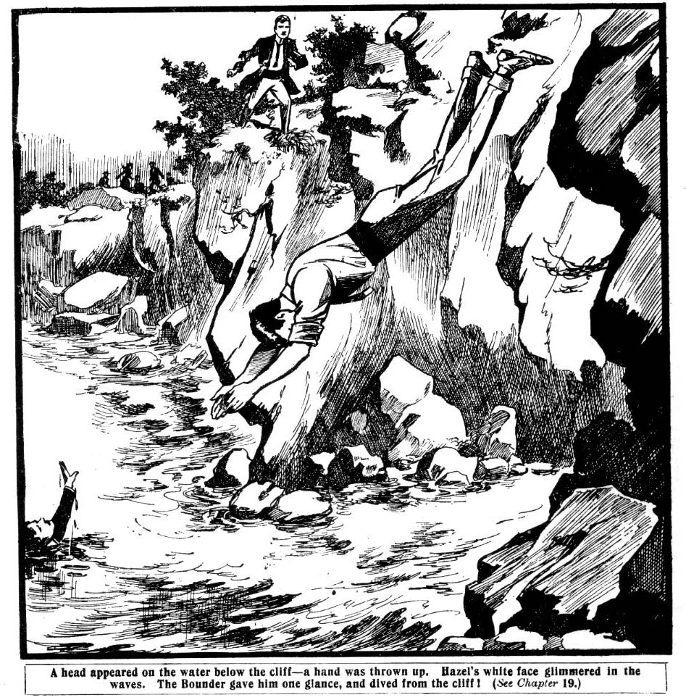
It was a dangerous dive, for under the smiling waters there were sharp points of rock, and if the diver had dashed upon them he would have dived to his death.
But the Bounder’s luck held good. He cleaved down through the waters, and came up within six feet of Hazel.
The unfortunate junior had gone under again, and the Bounder, dashing the water from his eyes, looked round for him in vain.
Ponsonby shouted from the cliff.
“There—there he is!”
Vernon-Smith caught a glimpse of wet hair in the water. He struck out for it, and grasped Hazel’s collar a he was sinking again.
His powerful grasp brought the sinking junior to the surface.
Hazel’s eyes were half-closed; he was incapable of helping himself. But the Bounder’s grasp was strong and firm, and he was a splendid swimmer.
“Hold on, Hazel! Buck up, old chap! I’ve got you.”
Hazel looked at him dazedly, and then his eyes closed. He was insensible now. The Bounder held him fast, keeping his head above water, and struck out, keeping himself and Hazel afloat.
A few strokes brought him to the cliff; but it rose sheer from the water. There was not even a crevice upon which he could gain a hold.
With set teeth, the Bounder swam along the cliff, seeking for a hold. But he found none. He looked about him almost despairingly. There was nothing for it but to strike out for the ridge of rocks running out into the bay, and it was more than doubtful it he would reach it alive with his burden. But it never crossed his mind for a moment to let go.
Hazel’s eyes opened again, and he began to struggle feebly.
“Quiet!” muttered the Bounder. “Keep still!”
He swam on powerfully, keeping Hazel afloat. The junior’s feeble struggles incommoded him. With failing strength he pushed on towards the distant rocks. Like music to his ears came a shout ringing across the waters:
“Hold on! We’re coming!”
A boat was dashing towards him from the open sea. Gordon Gay was standing up in it, his eyes on the brave swimmer. Four juniors were tugging at the oars, rowing as if for their lives.
“Help!”
“We’re coming! Hold on!”
The boat dashed up, and as it swept past the swimmer Gay was on his knees, and, reaching out, he grasped the Bounder. A few moments more and Vernon-Smith and Hazel were dragged into the boat.
They sank down exhausted in a pool of water. But the Bounder sat up almost immediately, cool and composed as ever.
“Thanks!” he said. “That was a near thing.”
“We saw Hazeldene drop.” said Gay. “We were a good distance, but we came up as quick as we could. It was jolly plucky of you to go in for him like that!”
The Bounder shrugged his shoulders in his old way.
“Well, I couldn’t very well watch him drown, you know.” he remarked. “But I fancy we should have gone down together if you hadn’t come up. Hallo, Hazel! How do you feel? Safe as houses now, old chap.”
Hazel gasped.
“Smithy, you—you’ve saved my life!”
“These chaps have saved both of us, you mean.” said the Bounder lightly. “We were jolly near gone, old chap. Gay, would you mind pulling round to the bay? I think Hazel’s people saw him fall from the cliff, and they must be jolly anxious. They can’t see us from here.”
“Row like thunder!” said Gordon Gay.
The Grammar School juniors were good oarsmen. In a few minutes the boat was dashing into the bay. Vernon-Smith helped Hazel cut on to the beach. His father and mother were there, and Marjorie.
“It’s all right.” said Hazel. “ I’m not hurt, mater. All serene, dad. Smithy fished me out. Jolly lucky he was with me, Marjorie.”
“Jolly lucky!” exclaimed Harry Wharton. “Smithy, old
man, you’re a giddy hero!”
“The herofulness of the esteemed Smithy is——”
“Terrific!” said Bob Cherry, slapping the Bounder on the shoulder.
“Hurrah!”
The Bounder coloured.
“For goodness’ sake, don’t make a fuss——” he began.
“We’ll jolly well make a fuss!” grinned Bob Cherry. “Get into this bathing-machine, and get that wet clobber off.”
Marjorie pressed the Bounder’s hand.
“It was brave of you—noble,” she said in a low voice. “ You risked your life to save him, and—and you might—” Her voice broke.
“All’s well that ends well.” said the Bounder lightly. And he went into the bathing machine with a light heart. The Bounder was the hero of the hour, and Hazeldene’s people did not seen to be able to make enough of him. There was only one disentient voice in the chorus of acclamation. Billy Bunter was heard to remark, with a sniff, that any fellow—especially himself—would have done what the Bounder had done. But Bunter had no sooner made that remark than he was seized by three or four pairs of hands, and bumped on the sand, and he did not make the remark again.
— ——
THE TWENTIETH CHAPTER.
Playing to Win!
HARRY WHARTON & CO. were thoroughly enjoying their stay in Shoremouth. The one cloud on the horizon had vanished. Hazel gave them no more trouble. Nothing more was seen of Ponsonby & Co. They were careful to give the Greyfriars fellows a wide berth.
And Marjorie’s heart was lightened by the lifting of the cloud from her brother’s face. She knew that his connection with the cads of Highcliffe was ended; and, although she did not know all the circumstances, Hazel had told her enough for her to know that it was due to the Bounder. And she was very kind to the Bounder; and, for reasons best known to himself, Vernon-Smith attached a great deal of importance to Miss Marjorie’s opinion of him. Hazel was very much on his good behaviour now. He joined heartily in all the sports and excursions of the Greyfriars party, and began to enjoy his holiday as he had certainly not enjoyed it while he was playing the “giddy goat.” He joined heartily, too, in the cricket practice, of which the juniors did as much as possible, in preparation for the match with the Grammarians.
He was looking unusually fit and well when the day of the cricket match came round. Harry Wharton & Co. were determined to pull off a victory, and they were all very fit and in great spirits that day. Even Lord Mauleverer bucked up wonderfully, and announced his intention of playing the game of his life.
Harry Wharton & Co. were early on the cricket ground, but they found Gordon Gay and his team already there. They had already chummed up with the Grammarians, and were
quite old friends by this time. Hazel arrived with his people
and Clara.
“ Feeling fit—eh?” asked Wharton cordially.
“ Fit as a fiddle.” said Hazel cheerfully. “I shall play
a better game this time. We’ll give them a tussle, at all
events.”
“We’ll give ‘em a 1icking!” said Bob Cherry. “ Gay, old chap, you’re going to have the time of your life!”
Gordon Gay laughed.
“Exactly what we intend for you.” he aid.
Both teams were in great form. Gordon Gay won the toss, and the Grammarian team batted first. They batted well, too; but the bowling of Hurree Jamset Ram Singh and Tom Brown was “terrific,” as Bob described it, and the Grammarians were all down in their first innings for a total of 70.
But the Grammarian bowling was also well up to the mark. and the Greyfriars first innings totalled only a couple more
—72.
“Doesn’t look much like a win does it?” Billy Bunter remarked to Marjorie. They want a chap who can really play that bowling, you know. Now, if I were at the wicket, you’d have seen a score a bit different from that.”
“I’m sure we should!” said Marjorie, laughing.
Yes, I suppose a duck’s egg would have made a difference.” remarked Miss Clara.
“I don’t mean a difference that way.” said Bunter, exasperated by that wilful misunderstanding of his meaning.
“I mean— Look how that duffer Bob Cherry batted, for instance!”
“Eh?” said Bob Cherry’s voice close to the fat junior. Billy Bunter blinked round in alarm.
“I—I mean Bob Cherry batted remarkably well. But that ass Bull—”
“Well, what about me?” asked Johnny Bull, laying an iron hand on the shoulder of the Owl of the Remove from behind.
“Ahem! I—I mean that I was just going to congratulate you on your splendid batting, Johnny, old man.” said Bunter feebly. “That—that’s what I man.”
“The meanness of the esteemed Bunter is terrific.”
“Ha, ha, ha!”
Gordon Gay & Co. went on to bat again in the sunny afternoon. The score was bigger this time. Hazel had the good luck to catch Gay out, and his comrades gave him a cheer; but the total for the innings was 110. And Gordon Gay & Co. wore satisfied smiles. They flattered themselves that that was a figure that the Greyfriars team would not find it easy to beat.
“Total hundred and eighty.” said Bob Cherry. “We shall have to look lively, my infants.”
“The liveliness will be—”
“Yes, I know—terrific. If you go to sleep at the wicket, Mauly—”
Lord Mauleverer grinned cheerfully.
“Begad, I’m going all out this time!” he declared.
“You haven’t an earthly.” said Billy Bunter. “I’m sorry to say it but really, you know, you haven’t an earthly. Perhaps they would be willing to let you make a change in the team, Wharton, if you wanted to play me.”
“Gay might be willing.” grinned Wharton. “It would make it a walk-over for him. But I shouldn’t be willing, my fat tulip. You stick to the buns and the ginger-beer, Bunter; that’s your line.”
Billy Bunter grunted; but he took the advice, and he stuck to the buns and the ginger-beer most faithfully.
The second innings opened badly for Greyfriars. Gordon Gay, who was nearly as good with the ball as with the willow, took three wickets in the first over; and Bob Cherry, Nugent, and Hurree Jamset Ram Singh came out ruefully one after another. As Bunter remarked, in the intervals of ginger-beer and buns, it was quite a procession. But with Harry Wharton and Tom Brown at the wicket, a change came over the scene, and the score began to go up. At fifty, however, Wharton was clean-bowled by the Australian junior, and a few minutes later Tom Brown was caught out.
“Five down for 50!” sniffed Bunter. “This is where—”
“This is where you shut up!” growled Johnny Bull. And Bunter sniffed and shut up.
Nugent minor and Peter Todd were batting now. Dicky Nugent did very well, and the Greyfriars fellows gave the fag a cheer for 10 runs. Six down for 60. Johnny Bull joined Todd, and the score went up again by leaps. When Johnny Bull fell to a deadly ball from Wootton major of the Grammar School the board marked 90. Todd was caught out in the following over. Herbert Vernon-Smith was at the wickets with Lord Mauleverer. The Greyfriars fellows were a little anxious now. Vernon Smith was a pillar of strength to his side, the but Lord Mauleverer had the bowling, and the juniors watched him with all their eyes. Greyfriars wanted 18 to tie—19 to win! There was a cheer as Mauleverer ran a single. It gave the bowling to the Bounder, knd the junior knew what the Bounder could do.
But the Bounder did not have his usual good luck. He had brought the score to 99 when he was caught out by Gordon Gay.
“Phew!” murmured Bob Cherry, as the Bounder carried out his bat. “Last man in, Hazel. This is where you play up like a giddy Trojan, or we’re beaten to the wide!”
Hazeldene nodded without replying, and went to the wicket. Ten wanted to win, and Hazeldene and Lord Maul- everer to get them. His lordship had promised to buck up, and it was needed now. Harry Wharton & Co. looked on with keen anxiety. The smiles of the Grammarians in the field showed that they intended to make short work of the tail of the innings.
Space space But Hazeldene stopped the bowling very carefully, and lived through the over. Then Wootton major went on to bowl against Lord Mauleverer. And Bob Cherry gave a shout:
“ Buck up, Mauly.”
“ Yaas.”
Lord Mauleverer’s sleepiness had vanished; he was keen and alert at the wicket. He knocked away the first ball for 2; and the second ball for another 2; and the third ball for a single. Hazeldene was facing the bowling now, and the excitement was very keen. The Co. could not help remembering Hazel’s last exhibition of batting against Figgins & Co. But Hazel soon showed that he was in quite different form now.
He stopped one ball, and then another. Then he hit out, and the batmen ran 3 before the ball came in a couple of seconds too late!
One wanted to tie—2 to win! The field crossed over, and Hazel still had the bowling. He stopped a ball, and then another and another, and then away flew the leather, and the batsmen were running again!
End to end, and the scores had tied. But they were running again, and the ball was coming in from Gordon Gay’s sure hand—dead and straight for the batsman’s wicket.
Hazel ran his hardest. The juniors watched him breathlessly.
Clump!
Crash!
The wicket was in pieces; but the bat had touched the crease in time, and the umpire shook his head.
“Not out!”
“Hurrah!”
“Bravo, Hazel!”
“Hip-pip!” said Miss Clara joyously, and Marjorie clapped her hands. Hazel had scored the winning run and the Greyfriars Remove were the victors in a hard-fought match. The batsmen received quite an ovation as they came off.
“Begad, you know!” said Lord Mauleverer, with a yawn, and dodged Bob Cherry’s thump aimed at his shoulder.
“Begad, it was a jolly good game, though rather exhaustin’! Anybody got ginger-pop to save a chap’s life?”
And Bob Cherry jerked away a glass Billy Bunter had just filled, and passed it to his lordship, heedless of Bunter’s howl of expostulation.
* * * *
Harry Wharton & Co. were elated over the result of the match with Gordon Gay’s team; but there was still better to come, as Bob Cherry remarked when Bunter announced that he was departing. Bunter explained that his old pal D’Arcy of St. Jim’s was simply yearning for his company, and so he was bound to cut short his visit at Shoremouth and the Owl of the Remove seemed to anticipate a general falling of faces when he made that announcement. But the faces did not fall—quite otherwise.
In fact, in spite of the loss of William George Bunter’s esteemed company, the Greyfriars party contrived to have a very good time; and the golden summer days passed quickly and merrily for the Greyfriars juniors by the sunny seaside.
THE END.

