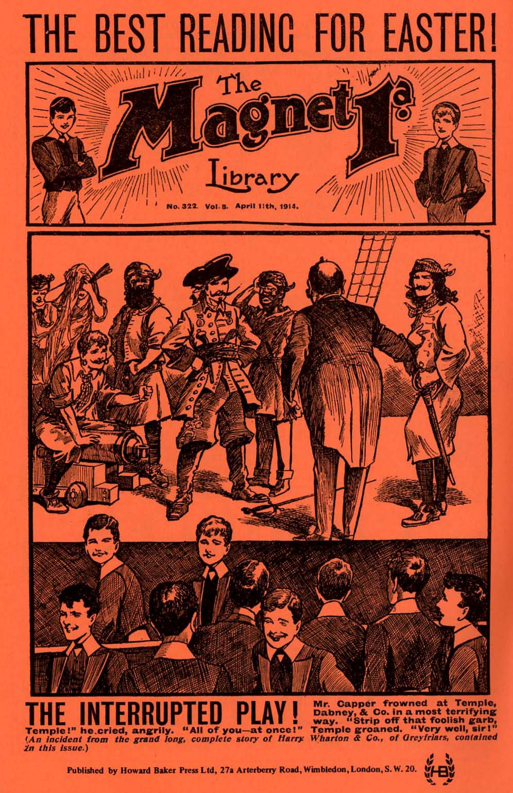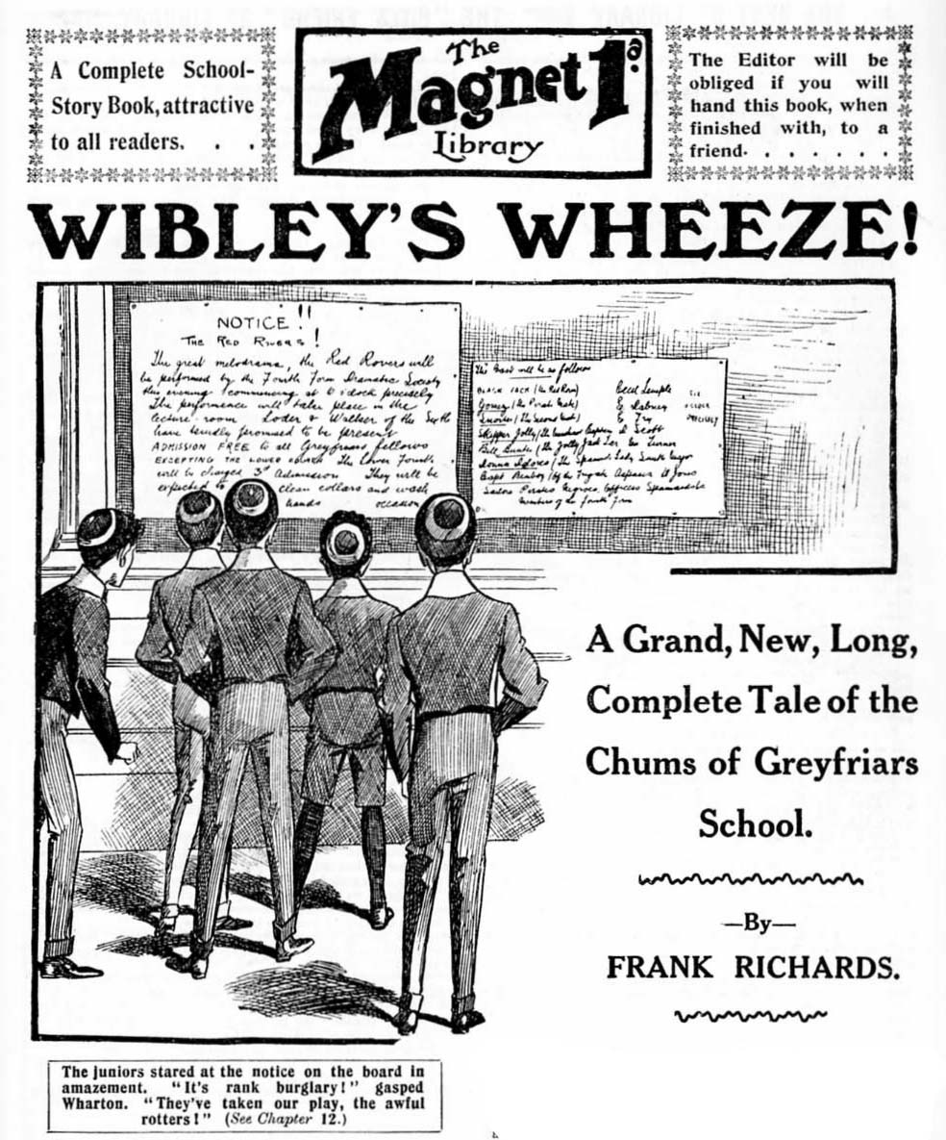

THE FIRST CHAPTER.
To the Rescue!
MERCY!”
“Talk not to me of mercy! You die!”
“Spare my life!”
“Bah Bah-hah! Hand me the dagger, and his blood shall flow!”
A youth in Etons, who had just come into the School House at Greyfriars from the sunny Close, simply jumped as he heard those ferocious words.
Certainly they were extraordinary words to overhear at Greyfriars School. They sounded much more suitable for the deck of a pirate schooner in the good old days, or for the stage of the Adelphi in these modern times And the youthwho had just come in stopped dead, his eyes opening wide.
The excited voices proceeded from a room on his right, a large room on the ground-floor, with windows overlooking the Close. The room was known, for some mysterious reason, as the “Rag,” perhaps on account of the disturbances that sometimes took place there, the room being used by the Lower School for their meetings. Meetings of the Junior Debating Society, rehearsals of the Amateur Dramatic Club, and so on, took place there, and rags were not at all infrequent.
“My hat!” murmured the new boy. “What on earth’s going on?”
Excepting for the voices in the Rag the School House was very quiet. It was a half-holiday, and nearly everybody was out of doors.
“Oh, spare me—oh, spare me!”
It was an agonised voice from the Rag, the voice of Frank Nugent of the Remove Form. But the new boy did not, of course, know the voice. He had only just arrived at Greyfriars, for the first time.
With an expression of great alarm upon his face, he turned the handle of the door of the Rag.
The door was locked on the inside.
And as the new fellow released the handle the deep and threatening voice within was heard again, in response to that heartrending appeal for mercy.
“Die!”
“Here, open this door!” said the new boy, pounding on the panels with his fist. What are you up to in there? Open the door at once!”
There was no reply from within.
But the murderous work was evidently proceeding, for a deep groan was heard in the silence of the Rag.
The new boy turned quite pale.
He thought for a second, and then whipped out of the School House, and rushed along to the big, wide windows which he had noticed as he came in, and which he knew belonged to that room.
The windows of the Rag were open, to let in the fresh spring air from the Close.
The new boy clambered upon the sill, and stared into the room.
The scene that met his gaze might have horrified anybody.
Nugent of the Remove was on his knees, his hands extended in wild appeal. Before him stood another junior, brandishing a tremendous dagger.
The dagger was uplifted to deal the fatal blow.
Like an arrow the new boy bounded in at the open window. He landed in the room with a bump, and rolled over.
He was upon his feet again in an instant.
The junior with the dagger paused, on the point of delivering the murderous blow, and stared at him.
“What the—” he began.
He had no time to finish.
The new boy was upon him with the spring of a tiger. His fist smote the junior on the chin, and sent him reeling. The dagger went with a clatter to the floor, and the junior dropped on his back with a sounding bump, and a loud roar. The new boy dropped on him the next moment, and pinned him down.
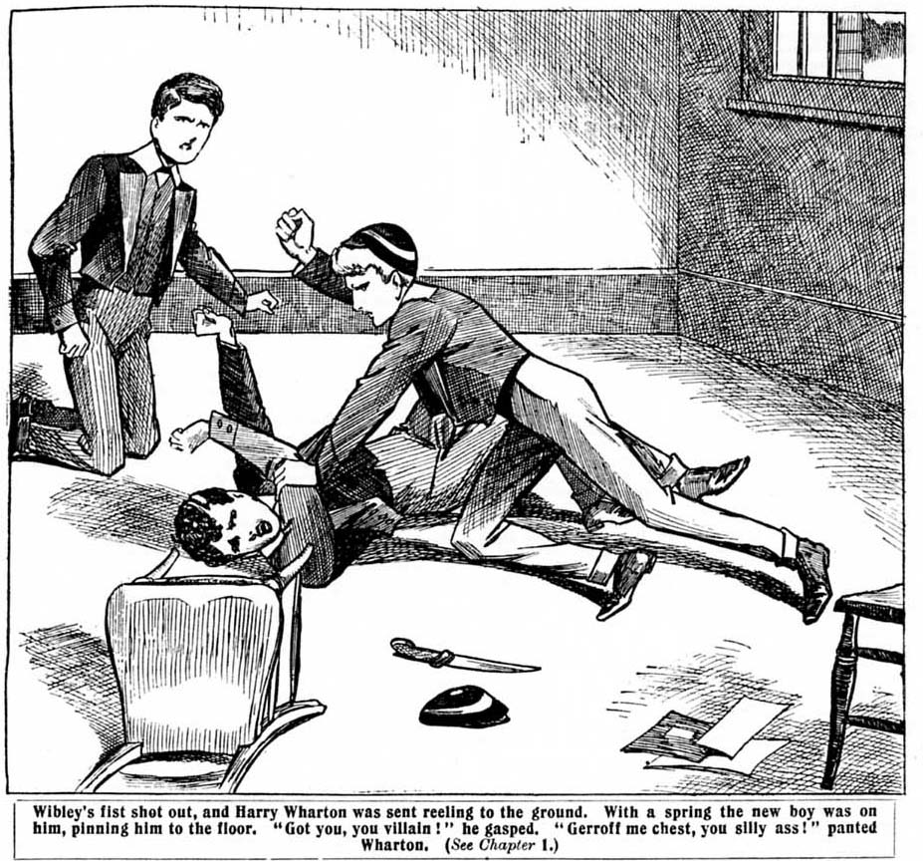
“Got you, you villain!”
“What the—who the—— Ow-ow-ooww—”
“Lend me a hand!” yelled the new boy to the kneeling junior, who was staring at him with blank surprise. “Come and collar him !”
The floored junior was struggling furiously, and the new boy had all his work cut out to hold him down.
But the fellow who was kneeling, instead of coming to the aid of his gallant rescuer, burst into a wild yell of laughter.
“Ha, ha, ha! Oh, crumbs! Ha, ha, ha!”
The new boy blinked at him in amazement. He could only suppose that terror had turned Nugent’s head, and that he was hysterical. Meanwhile, he had to struggle hard to keep down the Removite he was holding.
“Help me!” he panted.
“Ha, ha, ha!”
“He’ll get loose in a minute!”
“Ha, ha, ha!”
Drag him off, Frank!” yelled the floored junior. “Drag the silly idiot off!”
“Ha, ha, ha! All right, Wharton! Ha, ha, ha!”
Frank Nugent jumped up from his bended knees, and rushed towards them.
He did not help his rescuer.
Instead of that, he grasped his rescuer by the shoulders, and swung him off the floored junior, and sent him spinning.
The new boy staggered against the wall, and Harry Wharton jumped to his feet, his face red with rage.
“You silly ass!” he roared. “Who are you, and what did you biff me for? Are you dotty?”
The new boy gasped.
“You—you—you were going to commit a murder!” he stuttered, realising now that there was a mistake somewhere, but not quite seeing where it was. “I—I came in to stop you!”
“Ha, ha, ha!” shrieked Nugent.
He threw himself into a chair, and roared.
Harry Wharton put his hand to his chin and rubbed it. It had had a very hard knock, and it had rattled every tooth in his head. But he could not help grinning.
“You—you unspeakable ass!” he ejaculated. “Who are you?
“My name’s Wibley. I’m a new boy.”
“You unspeakable chump! Do you see the lump you’ve put on my chin?”
“Ye-es.”
“Well, I’m going to shove one to match it on your nose. Put up your paws.”
And Harry Wharton, the captain of the Remove—the Lower Fourth Form at Greyfriars—advanced upon the gasping new boy with his hands up.
“I—I say!” gasped Wibley. “I—I seem to have made a mistake.”
“Ha, ha, ha!” shrieked Nugent. “Don’t bash him, Harry. The silly ass! He’s saved my life, saved me from being—ha, ha —murdered! Oh, my only Aunt Jemima Jane!”
Wharton burst into a laugh.
“The awful ass!” he ejaculated. “The silly chump! Did you think we were in earnest, Squibley, or whatever your silly name is?”
“I—I— Of course, I did,” stammered Wibley, in bewilderment. “I heard you talking as I was passing the door, and I thought—”
“Ha, ha, ha!”
“Then what’s the little game?” demanded Wibley indignantly. What were you talking all that rot for if you didn’t mean it?”
Wharton grinned, and then winced and rubbed his chin again. The new boy’s knuckles had smitten him there like a hammer, and it hurt.
“Oh, you frabjous chump!” he said. “We were rehearsing, of course.”
“Rehearsing?”
“Yes, ass! We belong to the Junior Dramatic Society, and we were rehearsing the big murder scene in our new play, “The Red Rover, ass!”
“Oh!” murmured Wibley. “Then—then I’m sorry!”
“Thanks awfully for saving my life!” grinned Nugent.
“Did he hurt your chin, Harry? Ha, ha, ha!”
“Yes, he jolly well did,” growled Wharton; “and I’ve a jolly good mind to wipe up the floor with him, too.”
“I say, I’m awfully sorry.” said Wibley. So you’ve got a dramatic society here, have you?”
“Yes, ass.”
“I’m rather good at acting.” said the new boy. “I’ll join if you like, and take a part in the play.”
Wharton stared at him.
“Well, for a new kid, I must say you’ve got plenty of cheek.” he exclaimed. “ I won’t wallop you, as you are only a harmless idiot. I’ll only chuck you out of the window. You came in that way, and you can go out the same way.”
“Here, I say, hold on!”
“That’s all right; I’m holding on!” chuckled Wharton. He was. His strong grasp had closed upon the new boy, and Wibley was whirled towards the window.
He was swung through the window like a sack, and like a sack he dropped upon the ground outside, and he gasped as he sat there.
“Now buzz off, and don’t interrupt any more,” said Wharton, and he slammed the window down.
Wibley rose to his feet, somewhat dazed, and limped into the School House. As he passed the door of the Rag he heard the voices again. The rehearsing had evidently restarted after the interval, so to speak.
“Mercy!”
“Talk not to me of mercy! You die!”
Wibley grinned faintly and went on his way, a sadder and wiser new boy.
THE SECOND CHAPTER.
The Ambitious New Boy!
HARRY WHARTON & Co. were at tea in No. 1 Study. All the Co. were there—Harry Wharton, Frank Nugent and Bob Cherry and Johnny Bull and Hurree Jamset Ram Singh, who constituted the celebrated alliance known as the Famous Five; and Tom Brown, the New Zealander, Mark Linley, Dick Penfold, Bulstrode, Hazeldene, and Micky Desmond. The study was crowded—more crowded than was usual for a junior tea—but the occasion was important; for all the juniors present were members of the Junior Dramatic Society, and just now the Junior Dramatic Society was going strong. Harry Wharton & Co. were preparing to take the cake, as it were, with a really wonderful representation of that great and thrilling play. “The Red Rover,” and the representation was to be got up regardless of expense. The principal scene being laid on the pirate ship, the staging would he more than usually difficult but the heroes of the Remove had risen to the task. The play, as Wharton said, was a ripper—a regular topper. And Wharton should certainly have known whether it was a ripper and a topper or not, as he had written it himself.
It was not up to Shakespeare; Wharton himself admitted that. He did not claim to turn out dramas equal to those of the great and immortal William, being more modest in that respect than some modern playwrights. But it was more suited to the taste of the prospective audience. As Wharton said, the fellows had got fed up on Shakespeare. They were tired of hearing Mark Antony “orate”; they didn’t want to hear Hubert order the two murderers to heat him those irons hot; and they didn’t care a brass farthing whether to be or not to be was the question, or whether it wasn’t.
They wanted something new, something original, and something thrilling.
And they were going to get it. Harry Wharton was going to provide it.
Hence “The Red Rover.”
Of course, all the members of the Junior Dramatic Society claimed the right of putting in a line or two. Every fellow who was playing a part thought he ought to be allowed to lick his own part into shape a little. The play, therefore, was contributed to by many hands. The only thing Wharton insisted upon was that the number of lines allotted to each fellow should not be increased. For if every player had been allowed to give himself as much “fat “ as he wanted, the play would have reached an inordinate length, and instead of occupying one evening, it would probably have dragged its weary length over a couple of weeks, which, of course, was not to be thought of.
The prime object of the representation was to raise funds for the Remove Cricket Club, to start the season with a bang, as Bob Cherry called it.
If “ The Red Rover” was a success—and why shouldn’t it be?—and fellows flocked from near and far to see it, and paid to come in, then the fund for the cricket club would reach considerable dimensions, and there would be no difficulty whatever in starting the cricket season with the required bang.
There had been a good many rehearsals lately. Besides the regular rehearsals, when the junior actors turned up in force, there were many partial rehearsals, two or three fellows getting together to go over scenes and lines, as on the occasion when the new boy, Wibley, had so gallantly saved Nugent’s life.
Fellows would be found in all sorts of unexpected corners, threatening death or pleading for mercy, or practicing walking the plank.
For, of course, there was plenty of walking the plank in the play. Wharton believed in plenty of action, and the others heartily agreed with him.
Nearly half the Remove—the Lower Fourth—were in the cast in one capacity or another, and Wharton had had many flattering offers from fellows in other Forms.
Coker of the Fifth had generously offered to play the part of the pirate chief, and there had been quite a warm dispute when his offered services were gratefully, respectfully, but firmly declined.
Temple of the Fourth Form had made the same offer; and when his offer was gently refused he had made all sorts of personal remarks about young asses, and cheeky fags, and silly chumps who thought that they could act, and couldn’t. And the result had been that Temple of the Fourth had departed from No. 1 Study “on his neck.”
Temple of the Fourth was exceedingly “ratty” about that. For there was a dramatic society in the Fourth Form, and Temple was the leading light in it, and the Fourth Form players looked on the Remove fellows’ little efforts with a patronising eye.
Indeed, Temple had gone so far as to threaten to bring the Fourth Form along in great force on the night of the
representation and to muck up the whole show, so deep was his indignation. But the Removites did not care for Temple of the Fourth, still more than they did for Horace Coker. They went on
their way regardless, so to speak.
The Co. were in great funds just now, and they were spending quite a sum of money on the staging of “The Red Rover,” determined to make it a much bigger thing than anything the Fourth Form had ever been able to display.
Lord Mauleverer, the dandy of the Remove, who was rolling in money and always ready to contribute to anything, had been allowed to stand a very handsome “ whack” towards the expenses of the staging, and Vernon-Smith,who had the advantage of being the son of a millionaire, also came down very handsome. Harry Wharton & Co had “put up” to a very handsome extent, and altogether there were quite enough funds to see the thing through in the best style.
Hence the smiles of satisfaction that marked the faces of
the juniors gathered in No. 1 Study for tea on this especial afternoon. But there was a slightly thoughtful expression upon the handsome face of Harry Wharton.
“Wherefore that worried brow, O chief?” asked Bob Cherry, falling unconsciously into the mode of address used in “The Red Rover. “Pass the Jam, captain.”
Wharton passed the jam.
“I saw Temple as I came up,” he remarked. “The Fourth are awfully ratty about this. I don’t really see why; we don’t interfere with their giddy shows. When they gave ‘King John’ at the beginning of the term, we all went to see it, didn’t we?”
“I should think we did.’’ said Bob—with a chuckle. “And
we took our pea-shooters, didn’t we?”
“Ha, ha, ha! Well, that only livened them up a bit.” said Wharton. “They were awfully slow.”
“The slowfulness was terrific.” remarked Hurrce Jamset Ram Singh.
“Only we don’t want them to play any little game like that on us.” went on Wharton. “You see, we’re not playing the giddy goat, as they were; ours is going to be really a dramatic performance, not rot at all.”
“Hear, hear!”
“Only Temple, Dabney & Co. mean to muck it up, if they can, and we’ve got to see that they don’t.” Wharton added. “My hat, we’ll scalp them if they do!”
“Scalping them afterwards won’t do much good if they spoil the play.”
“True, O king! Suppose we refuse admittance to the Fourth to see the play?” Johnny Bull suggested. Wharton shook his head.
“We want their admission money, you see. Every bob counts when you’re making up a fund. Besides, how could we keep them out?’’
“But if the whole gang of them come in they can kick up a row and spoil the show.” said Mark Linley.
“That’s what I’m afraid of.” And the juniors looked very thoughtful. It was quite true that they had taken their pea-shooters when they went to see the dramatic performance given by Temple & Co., and pea-shooting in the most tragic moments could never improve a Shakespearean drama. The Removites had enjoyed that evening immensely, but the Fourth had seemed ratty at the time. If the Fourth played the same game when “The Red Rover” was produced, certainly it would be awkward and utterly inexcusable—from the Remove point of view.
The Red Rover, stalking the deck of the pirate schooner, bristling with pistols and daggers would be a most imposing figure: but with peas rattling about his ears all the time, the
imposing part of the business would be gone
“Well, we shall have to put the kybosh on anything of that kind, somehow.” said Boh Cherry. “Suppose we give Temple a small part in the play?”
“He wants to play the Red Rover—my little bit!” grinned
Wharton. “He’s the fifteenth chap who’s offered to play that part for me.”
“Ha, ha, ha!”
“Of course, that’s all rot!” said Bob. “But we could give
him a show as extra pirate, or something.”
“A few extra prisoners to walk the plank wouldn’t come
amiss.” Nugent remarked thoughtfully.
“They wouldn’t take super parts; they want all the fat.” said Wharton.
“Then they can go and eat coke!”
There was a tap at the study door, and the new boy, Wibley, looked in. The study was so crowded that there wasn’t much room for him to come in, but he came in. The Co. looked at him inquiringly.
“Well, what do you want, young shaver?” asked Nugent.
Wharton rubbed the lump on his chin.
“Just looked in to see you.” said Wibley. “I hear you’ve got a meeting of the Junior Dramatic Society here.”
“Chief members.” said Wharton. “Nothing to do with new kids. Buzz off!”
Wibley remained where he was.
“I suppose any chap in the Remove can join the society?” he asked.
“Are you in the Remove then?”
“Yes: same Form as you chaps.”
“Well, you can join, if you like. You have to pay the
subscription in advance,” said Harry. It will come in
handy now, for the matter of that. Nugent’s the secretary.
Take his subscription. Frankie, and push him out.”
“Certainly.” said Frank.
Wibley ascertained the amount of the subscription, and paid
up cheerfully.
“That’s all right.” said Nugent. “Here’s your receipt. And there’s the door.”
“I want to speak to you—”
“No time, now. This is an important meeting. Clear off.”
“Who’s president of the society?” asked Wib1ey.
“I am!’ said Harry.
“You give out the parts, I suppose?”
“Yes.”
“And you’re doing a play now—the “Pink Pirate,” or
something.”
There was a chuckle from some of the juniors, and Wharton
frowned severely.
“ ‘The Red Rover’ !” he said.
“Yes, I knew it was something of the kind.” assented Wibley. “ Well, I want to tell you that I’m a ripping amateur actor.”
“Go hon!”
“Blessed is he that bloweth his own trumpet!” murmured Bob Cherry.
“Ha, ha, ha!”
The new boy smiled genially, quite unmoved by the laughter of the Removites. He struck the Co. as being a
considerably cool customer.
“I’m willing to show you what I can do, if you like.” he
suggested. “I don’t ask you to take me on trust, you know.
Give me a chance——”
“Will you show us how quickly you can get through that
door?” said Harry Wharton politely. “Otherwise, we shall
give you a chance of going out head first.”
“I’m willing to take a part in this play—”
“Well, of all the blessed cheek—when you haven’t been
in Greyfriars a couple of hours!”exclaimed Bulstrode.
“But I’m a good actor—and I don’t suppose you chaps
really amount to very much. Schoolboy actors don’t, as a
rule.”
The amateur actors stared at him blknkly. For sheer, cool,
unadulterated “cheek,” the new boy seemed to take the whole biscuit.
“Well, my hat!” Bob Cherry ejaculated.
“When you see how I can act, you’ll want to give me the
principal part,” said Wibley, with refreshing coolness. “I
tell you, I’ve done lots of this kind of thing. I’m really A. 1.
and quite topping. Put me down for ‘The Red Rover’, and
I tell you, I’ll make the audience open their eyes.
“Great Scott!”
“Is it a go?” asked Wibley.
“Yes, it s a go—for you—you’re going! said Harry Wharton,
rising to his feet in towering wrath. “ I won’t slaughter you, as you’re a new kid, and seem to have come here by mistake
instead of going to a home for idiots—the proper place for you. Get on the other side of that door—quick!”
“But I tell you—”
“Buzz off!” roared Wharton.
“Yes, but—”
Wharton did not wait for anything more. He collared the new boy, and ran him out into the passage, bumped him down on the linoleum, and left him gasping.
Then he returned into the study, breathing rather hard, and closed the door.
“Of all the blessed cheek!” said Bob Cherry, with a whistle. “A blessed new boy, too! I wonder what Greyfriars is coming to?”
“I fancy I’ve nipped him in the bud, though.” said Harry, as he sat down. “ Now, we were saying——”
“Hallo, hallo, hallo! Here he is again!”
The door opened, and Wibley looked in, rather breathlessly.
“I say, you know—”
Squelch!
A fat jam tart, unerringly hurled, smote the new boy fairly on the nose and mouth. He staggered back into the passage, spluttering wildly.
“Ha, ha, ha!”
“Well bowled, sir!”
Tom Brown kicked the door shut, and it was not opened again. The meeting of the Junior Dramatic Society continued the discussion of business without any further interruption from the ambitious new boy.
THE THIRD CHAPTER.
Not Appreciated!
“HEARTS of oak are our ships!
Jolly tars are our men!
We always are—— Hallo! What do to you want, you silly ass?”
Morgan of the Remove was suddenly interrupted. He was in his study, which he shared with Micky Desmond. Morgan was in the great play—he took the part of a jolly British tar, who was destined to walk the plank from the deck of the Red Rover. It had occurred to the fertile brain of Harry Wharton that it would be an excellent “wheeze” to introduce a song into the play—and Morgan, being a Welshman, could sing—so he was chosen
for that ‘ little bit.’ He was to sing “Hearts of Oak” as a sort of defiance to the pirate chief before he walked the plank. True, in the case of real pirates, those lawless persons would hardly be
likely to suspend business operations while a doomed prisoner sang “Hparts of Oak” from end to end. But on the stage anything
is possible, and it would make a good scene, and quite as convincing as many things that occur on the modern stage.
Morgan was standing by the study table, going over “ Hearts of Oak.” while Micky Desmond sat in the armchair and furnished an obligato on the tin whistle.
It was just then that the study door opened, and Wibley, the new boy, came in, with a pile of books under one arm, and a box under the other.
Morgan gave him a far from welcoming look. He was not pleased at being interrupted in his singing. He
“Don’t come bothering here, you fathead!”. Didn’t you hear me singing?”
“Well, I heard something.”admitted Wibley. “Was it singing?”
Morgan glared at him.
“Was it singing?” he howled. “Don’t you know singing when you hear it?”
“Yes—when I hear it!” assented Wibley.
Micky Desmond chuckled. Morgan did not chukle. He pushed back his cuffs.
“I suppose you’ve come here to look for a thick ear, look you,” he remarked. “ Well’ I’m the very chap you want.”
“But I haven’t.” protested Wibley. “ I’ve come here because thins is my study.”
“Your study?”
“Yes; Mr. Quelch sent me here-”
“Jolly rotten of Quelch to plant a silly new kid on us like this!” growled Morgan.
“Thanks!” said W ibley.
“Don’t jaw—I’m going to sing.”
And Morgan restarted.
Wibley put his books down on the table, and laid the box beside them. Morgan went on with his singing, and Micky Desmond with his obligato. Morgan really sang very well, in spite of the new boy’s humorous remarks on the subject. Wibley occupied himself in opening the box while Morgan was finishing.
“I think that’s all right, look you.” Morgan remarked at last.
“Faith, and it’s ripping!” said Micky Desmond. “ Sure, and it will knock the audience intirely!”
“We ought really to introduce a Welsh song into the play.” Morgan remarked, in a thoughtful sort of way. “ ‘ Clyichau Aberdovey,’ or something like that.”
“But sure nobody would understand it.”
“What would that matter? It would be like going to the opera, you know—nobody ever understands what they sing in the opera—you’re not really supposed to. I suggested it to Wharton. but he wouldn’t hear of it.” said Morgan.
“Shows his sense.” remarked Micky.
“Eh!”
“ I mean, it’s hard cheese intirelay,” said Micky Desmond pacifically. “ Faith, and phwat is it ye’ve got in that box, Wibley ?”
“My grease-paints.” said WibIey.
“Grease paints?”
“Look!”
“Sure, and is it an actor ye are, then?”
“Yes, I am,” said Wibley, with a frown. “I’ve done quite a lot—and I could do a part in ‘The Red Rover’ topping. I think it’s rotten to leave me out!”
“And sure this is your first day at Greyfriars. It’s too modest ye are, intirely.” said the Irish junior sarcastically.
Wibley grunted.
“I could knock spots off some of them,” he said, “ I suppose the thing’s wanted to be a success, isn’t it? I could make up so that you wouldn’t know me— Hamlet or Othello, or Sir Peter Teazle, or Tony Lumpkin—any old thing. I offered to show Wharton what I could do.”
And he booted you out of the study.” grinned Micky. “Sure, and if ye give us too much of your gas, we’ll boot you out of this study, too. Won’t we, Morgan?”
“We jollv well will!” growled Morgan, who had by no means forgotten Wibley’s remarks on his singing.
“I’ll tell you what.’’ said Wibley. “If you fellows like, I’ll give you some character sketches now—”
“Sure and you won’t. I’m going through my part now, and you’re going to shut up.’’ said Micky Desmond. “I’m an Irish sailor, and I slang the Red Rover awfully when he orders me to walk the plank.” Sure it’s a good part intirely. Got the scrip, Morgan?”
“I’ve got it here.” said Morgan, taking a sheet of scribbled papers from his pocket. “Pile in, Micky.”
Micky Desmond piled in, going through his part with great verve. Wibley sat and listened to it with an expression of discontent on his face.
”Who wrote that stuff ?” he asked, when Micky had finished.
“That what?” demanded Micky.
“Stuff!” said Wibley innocently.
“Is it the play ye mane.”
“Yes. Who on earth did it?”
“Sure, Wharton wrote the lines, and I improved them for meself.’’ said Micky. “I knocked them into shape, you know. And, sure, I’ll knock you into shape if you criticise the play. Don’t you like it, ye gossoon?”
Wibley shook his head,
“ Seems to me awful rot!” he said cheerfully,
“ Phwat!”
“And the way you do it, too—”
“Phwat’s the matter with the way I do it?” asked Micky, with a deadly and ominous calmness.
“You want a lot of training,” explained Wibley. “ Now, I’ll take you in hand if you like, and give you some really valuable tips.”
“You—you’ll take me in hand!” said Micky, seeming to breathe with difficulty. “You’ll give me some—some tips?”
“Yes,” assented Wibley. “I’ve had a lot of practice, stage-managing, and so on, you know. We used to do a lot of it at home. Now, the way you stand when you deliver your lines is quite wrong.”
“Eh?”
“And the way you deliver them—it won’t do at all!”
“Phwat!”
“Now, let me show you.” Wibley took the amazed and almost speechlessly indignant Micky by the shoulders and placed him in position. “Now, stand like that, and— ow!”
Micky’s temper failed him. An altogether unwritten and unrehearsed part of the performance came in. Micky’s right fist shot out straight from the shoulder and Wibley staggered across the study and fell into the fender. He roared.
“Ow! You ass! Yow! What did you do that for? Yow!”
Micky glared down at him.
“Do you want some more?” he asked. “Sure, if you do, you’ve only got to give me some more instruction. It’s grateful I am for it intirely!”
“Ow! Ow!”
Wiblev staggered to his feet, holding his nose.
“Perhaps you’d like to give Morgan some instruction too?” said Micky.
“I’m ready.” said Morgan.
“Grooh!” he needs some.” said Wibley, rubbing his nose. Look here, Morgan, the way you produce your lower notes is quite wrong. You should— Here, get off— Yah! Yarooooh!”
Morgan hit out, and Wibley reposed in the fender once more.
“Any more instructions going?” asked Micky Desmond, with a chuckle.
“Groo-oooh! No!”
“No more tips about my position and delivery, and so on?”
“Ow! No!”
“Nothing more to tell me about producing my lower notes, look you?” asked Morgan.
“Yow-ow! No! Oh!”
“Good! Don’t mind saying anything, you know. We’ll always testify our gratitude—in the same way.” said Morgan.
“Ow ! Ow!”
Micky Desmond and Morgan left the study, grinning, their private rehearsal being over. Wibley picked himself out of the fender, still rubbing his nose.
“Ow!” he murmured. “Grooh! There doesn’t seem to me to be much chance for a fellow here —not a fellow who can really do things. Ow!” But I’ll show them—IT’ll show them, somehow, that I’m a jolly good actor, and I’ll make them want me— only how?”
And Wibley—with his handkerchief to his nose—sat down to think out that problem.
THE FOURTH CHAPTER.
Simply Stunning!
TEMPLE of the Fourth came into his study with a clouded brow. Dabney and Fry, his study mates, were having tea. Temple was late for tea—perhaps thinking about more important things.
“You’re late,” said Fry, looking up. “There’s some of the poached eggs left.”
“Oh, rather!” said Dabney. “We’ve left two for you, Temple, old man.”
Temple grunted.
“Only thinking of gorging, as usual!” he said ungratefully.
“Well, it’s tea-time, ain’t it?” said Fry.
“Blow tea-time!”
“And the eggs are topping—”
“Blow the eggs!”
“And the toast is ripping—”
“Dash the toast!”
“What’s the matter with you?” asked Fry. “ Have you been rowing with those Remove kids again? How is their silly play going on?”
“It’s going on first-rate, and it’s going to be a big success, from what I can see.” growled Temple, as he threw himself into a chair. “They’re going to put our nose out of joint. They’re going to have the grin of us. After this we may as will dissolve the Fourth Form Dramatic Society and hide our diminished heads. We’re done.”
“Oh, rats!” said Fry uneasily.
“You know how they mucked up our ‘King John,’ ” said Temple. “That would have been a really ripping performance, only we let the Remove in and they mucked it up. Now they’re going to score a howling success, and we can’t touch them. And all you fellows think of is poached eggs and toast. The honour of the Fourth Form and the prestige of the study don’t matter a hang !” said Temple bitterly.
“Well, we’re going to muck up their play, ain’t we?” said Fry. The whole blessed Fourth will turn up, and we shall take peashooters and mouth-organs and things. What sort of a play will it be, with a regular Hampstead Heath Bank Holiday performance going on at the same time?”
“Oh, rather!” said Dabney, absent-mindedly helping himself to one of the poached eggs that had been left for Temple.
“That shows all you know!” growled Temple. “While you’ve been stuffing I’ve been keeping my eyes and ears open. And they’ve done us. You know they booked the lecture-room for the performance next Wednesday? Well, now they’ve booked Quelchy too!”
“Booked Quelchy!”
“ Yes. I think it was Wharton’s idea, They’ve been holding a council of war in No. 1 Study. Anyway, they’ve asked Mr. Quelch, as a special favour, to attend the performance, and he’s consented.’’
“Oh, my hat!”
“How do you know?” asked Fry.
“It’s on their blessed notice in the hall—‘Under the special patronage of Mr. Quelch’!” said Temple bitterly. And they add that he will be present at the representation. That’s for us, of course, to show us that it’s no good thinkiing of kicking up a row. We can’t make a hullaballoo with Mr. Quelch there.”
Fry and Dabney looked very grave. Their scheme of repaying the Remove in their own coin was evidently knocked on the head. With a Form-master present at the performance of “ The Red Rover.” it was only too clear that there could be no disturbance, and that the most orderly order would have to be kept.
Mr. Quilch had been very obliging. Their own Form-master, Capper, had declined with thanks the offer of a free seat for their celebrated performance of ‘King John’.” Mr. Quelch had been more amenable. They felt bitterly that Capper hadn’t played the game, though really to sit for about three hours watching a junior performance of Shakespeare would have been rather a trial for Mr. Capper, or any other gentleman.
“Then that’s all up!” said Fry at last, gloomily.
“Yes,” said Temple. “If we go we shall simply be paying shillings into their blessed cricket fund and helping them make it a success.”
“We can stay away.” suggested Dabney.
Temple snorted.
“What difference will that make? It will only look as if we’re jealous and sulky.”
“H’m! I suppose it would look like that—or as if we couldn’t raise the admission money.’’ agreed Dabney.
“It wouldn’t be much good, anyway. They’ll get an audience. They’re going to admit people from outside the school. I hear that a crowd of Courtfield fellows are coming over—Trumper and that lot, and some people from Friardale. They’ve been selling off their tickets like anything.”
“Wharton’s a businesslike chap.” remarked Fry. “He can do those things.”
“And we can’t!” sniffed Temple. “We may as well dissolve the Dramatic Society and give up the whole bizney, and admit that the Remove is cock of the walk. There’s nothing else for us to do.”
Cecil Temple was evidently in a pessimistic mood.
“We’ll think of something better than that.” said Fry, as cheerfully as he could. “ What about giving a rival show on the same night, and getting their audience away?”
“Rot!”
“Look here, Temple—”
“Rot!” repeated Temple, with more emphasis. “We could give the rival show—to empty seats. We couldn’t get the audience away. I tell you they’re selling tickets; and fellows will go to get their money’s worth. Do you think they’ll throw their tickets away and pay over again to see us?”
“Well, I suppose they won’t.” admitted Fry.
“And besides that, they’ve got a dodge of reserving seats for the payment of twopence down.” said Temple. “ You pay two ‘ d,’ and your seat is reserved and numbered, and you pay the rest at the door. You see, they nail down the audience like that.’’
“Awfully deep beasts!” said Dabney, in disgust.
“Oh, they’re up to snuff! It’s going to be a regular triumph all along the line—unless we can think of a dodge.”
“We’ve got to think of one!” said Fry desperately. “We shall look a set of silly jays if they score over us like this!”
“Thats what they want, of course. Half their fun will be in doing us in the eye like this!” said Temple savagely. “Can’t you fellows think of anything? I don’t see why I should have to do all the thinking that’s done in this study.”
Dabney and Fry corrugated their brows, in an effort of hard thinking.
They realised the awful importance of the matter.
If the Lower Fourth were allowed to triumph over them in this way the prestige of the Fourth Form would be simply knocked sky-high. And, as Temple bitterly reminded them, there hadn’t been a dramatic society in the Remove at all until Wharton came to the school. The Fourth-Formers had had that kind of thing to themselves among the Juniors. They had been cocks of the walk, and had sometimes allowed Remove fellows to take small parts, in a condescending sort of way. Harry Wharton had changed all that. He had coolly “lifted” the idea of having a dramatic society. He had made a success of it, completely overshadowing the original society in the Upper Fourth. Now the Remove Players we’re at their zenith, and unless the Fourth could somehow or other scheme a scheme for giving them the kybosh, there was nothing for it but to admit that they couldn’t keep their end up. and give in to the Remove all along the line, which would have been too terrible a blow to the pride of Temple, Dabney, & Co.
Suddenly Fry’s frowning, thoughtful face broke into a grin, and he smote the table with his clenched fist with a terrific bang. The crockeryware danced, and the tea in Dabney’s teacup shot out in a stream over Dabney’s trousers, and there was a yell of surprise and wrath from Dabney.
“Oh, you ass! What do you mean? You—”
“I’ve got it!” yelled Fry.
“I’ve got it, you mean!” howled Dabney. “Look at my bags!
“Confound yeur silly bags!” said Fry impatiently. “Is this time to talk about bags? I tell you I’ve got the idea!”
“Well, if you have, it’s all right.” growled Dabney, mopping his trousers with his handkerchief; “but if you haven’t, I’ll jolly well punch your silly head for slopping tea over my trucks!”
“I’ve got it!”
“Out with it!” said Temple, not very hopefully.
Fry’s eyes were blazing with excitement. He jumped up from the tea-table.
“I’ve got it—the way to do them—right in the eye!”
“Well?”
“They’re going to perform ‘The Red Rover’ on Wednesday evening.”
“We know that!”
“They’ve booked the lecture-room for Wednesday evening.”
“Yes, ass! Tell us something we haven’t heard hundreds of times !”
“Suppose”—Fry lowered his voice cautiously—“suppose we booked the lecture-room for Tuesday evening?”
“We could do that.” said Temple, with a stare. “But what on earth good would it do, you frabjous ass?”
“And give a performance—”
“Fathead ! Even if we got an audience, it wouldn’t interfere with their show the next evening. And I tell you the chaps prefer ‘The Red Rover’ to ‘Hamlet’ or ‘Macbeth’. It’s jolly bad taste, but there you are! Wharton knew what the fellows liked when he wrote that it stuff. It will simply knock them!”
“I’m not thinking of a Shakespearean performance this time.
“What then?”
“The Red Rover.” said Fry mysteriously.
Dabney and Temple stared at him as it they doubted whether he had taken leave of his senses all of a sudden.
“Is the tea getting into your head?” asked Temple, with satirical concern. “Did you make it too strong?”
“Can’t you see?” howled Fry excitedly. “They’ve boned our wheeze of a dramatic society; they’ve beaten us in selecting a play the fellows would like to see; they’re going to give it on Wednesday evening. But who will go and see them play ‘The Red Rover’ on Wednesday if they’ve already seen us play it on Tuesday?”
“Oh!”
“As for the audience, we can get that easily enough by having free admission. We don’t want their blessed money. We only want to give the Remove the kybosh.’’
“Oh!”
“You see the scheme? We’ve got, somehow or other, to get hold of their scrip. They’re keeping it to themselves, but we must manage to get hold of a copy and learn up the parts—dead secret, of course. Suddenly on Tuesday we announce our production of a play—‘The Red Rover’, you know. They can’t stop us. We’ll manage to get a master or a prefect present so that they can’t make a row. We’ll play their giddy ‘ Red Rover,’ and make a success of it, too! We’re better actors than they are, anyway. And after we’ve performed the Red Rover on Tuesday evening, how do you think their performance will come on Wednesday? It will fall too flat, and they’ll simply have to give it up.”
“Ha, ha, ha!”
Temple jumped up knd fairly hugged Fry to his manly bosom. He almost wept.
“Oh, my hat! What a stunning wheeze! Fry, old man, you’re worth your weight in gold! My only sainted aunt! Why, it will simply give them the kybosh! It will knock them sky-high! They’ll be weeping and wailing and gnashing their teeth. Ha, ha, ha!”
“We’ve only got to bone the scrip, somehow, and learn it up in dead secret.” said Fry, his eyes dancing. “Then we spring it on them suddenly on Tuesday—”
“Ha, ha, ha!”
“And if that doesn’t make the Remove sing small nothing will!”
“Hurrah!”
And the chums of the Fourth executed a wild wardance round the study table, in the exhilaration of anticipated triumph over their old rivals.
THE FIFTH CHAPTER.
Billy Bunter Is Quite Useful!
MR. QUELCH paused in surprise.
It was morning, and the Remove-matster was a few minutes late in the Form-room. That was quite unusual for Mr. Quelch, who was generally as punctual and reliable as the clock in the tower. However, on this morning he was a few minutes late, and he was
hurrying down the passage to the Form-room, his gown
Rustling behind him, when he pawed in surprise, not to say
amazement at the alarm.
The Form-room door was ajar, and Mr. Quelch had expected
to hear a buzz of voices there, for while the cat is away the +mice will be festive. But he had certainly not expected to hear what he did hear. What he did hear, was, in Wharton’s ringing tones, much louder than usual—
“Die!”
“Goodness gracious!” exclaimed Mr. Quelch.
And he fairly jumped as Nugent’s voice responded, in tones of terror:
“Spare me, oh, spare me!”
Mr. Quelch simply bounded into the Form.room.
Most of the Remove fellows were in their places, but Nugent was on his knees in the middle of the Form-room, and Harry Wharton was standing before him, brandishing a ruler.
Mr. Quelch caught Wharton by the shoulder and jerked him back.
“What does this mean, Wharton? Put that ruler down at once!”
“Oh!” ejaculated Wharton.
“Get up, Nugent!”
Nugent got up, turning rather red.
There was a chuckle from the juniors at the desk. It was
Mr. Quelch’s first experience of “The Red Rover,” and he
evidently did not know what to make of it.
“What were you going to do with that ruler, Wharton?”
demanded the Form-master sternly. “Is it possible that you were going to strike Nugent with such a dangerous thing!”
Wharton grinned involuntarily.
“Oh, no, sir! That’s all right!”
“Then why Nugent in such a state of fear?”
“He—he wasn’t, sir.”
“What! I distinctly heard—”
“It’s all right, sir.” murmured Nugent. “ We were only rehearsing, sir.”
“Rehearsing! In the Form-room!”
“Yes, sir.”
“It’s the play, sir,” explained Wharton. “The play you’ve promised to see next Wednesday, sir—‘The Red Rover’, sir,”
“‘The Red Rover’ !” repeated Mr. Quelch crossly. “I understood that you were playing some classic work! You certainly did not say so, but I took it for granted. I do not approve of this bloodthirsty nonsense!”
“It’s rather a good play, sir.” said Wharton diffidently.
“We wrote it ourselves, so as to make sure of having a really good thing.”
Mr. Quelch smiled slightly.
“Well—well, that is an affair for yourselves.” he said. “ But the Form-room is not a place for rehearsing. You will take fifty lines each, and next time I am a few minutes late you will kindly behave yourselves.”
“Ye-es, sir.”
And the amateur actors went to their desks, and morning lessons proceeded.
The enthusiasm in the Remove for that great play was very keen. At every odd moment the amateur actors were going over their lines, determined to be word-perfect on the night of the representation. Indeed, some of them were so keen on the subject that the lines ran in their heads during lessons, and caused some confusion.
But morning lessons were safely over at last, and the Remove streamed out of the Form-room. The Fourth Form were coming out at the same time, and Temple of the Fourth came up to Wharton in the passage, with his most agreeable smile on.
“Getting on all right with the play?” he asked cordially.
“Ripping!” said Harry.
“Quite a big audience coming, I suppose?”
“Yes. We’re getting ready a ‘ Standing Room Only’ board, in case it’s wanted.” said Wharton cheerfully.
“I suppose you want the Fourth to come!”
“Everybody’s welcome, so long as he pays for admission. No admission on the nod. All complimentary seats are off. Fourth Form bobs are as good as any other bobs.”
“1—I suppose so.” agreed Temple. “ But I’ll tell you what! Chaps who are coming to see the play would like to have some idea in advance what it’s like.”
“Oh, that’s all right! We assure them that it’s a first-chop play and a first-chop performance.” said Wharton reassuringly . “They can rely on that. Any fellow who doesn’t like the play is at liberty to clear off before the end—without extra charge!”
Temple grinned in a sickly way.
“Ye-es. of course; but I suppose we can see the book of words before the play ?”
“There isn’t any book of words—we wrote the play ourselves.”
“But you’ve got the scrip you rehearse from?”
“Every fellow’s got his part written out, of course, and I have the complete thing.” said Harry,with a nod.
“Can’t we see it?”
“No fear! You’ll see it when it’s performed. What more do you want?”
“Well, it would make it more—more interesting, you know, if we had some idea of what was coming?” Temple suggested.
“Blessed if I see it! Seems to me, it would take the interest away.”
“Well, we should like—”
Wharton looked at him sharply.
“Look here, Temple, what’s the little game?” he demanded. “What do you want to see the scrip of ‘The Red Rover’ for?”
Temple coloured.
“Well, I’d like to.” he said.
“Can’t be did!”
“I suppose we can come in to see a rehearsal ?”
“No, you can’t. We’re keeping this thing to ourselves until it’s performed!”
“I don’t see why—”
“I do,” said Wharton cheerfully. “Hallo, there’s Bob Cherry calling me! I must be off, Temple. Ta-ta!”
And Wharton nodded to the captain of the Fourth, and walked out of the School House.
Temple gazed after him with a peculiar expression, and then rejoined his chums, who were waiting for him down the passage.
“Well?” said Fry and Dabney and Scott, in one breath.
Temple shook his bead.
“It’s no go!” he said. “No chance of seeing the scrip!”
“Does he suspect anything?” asked Fry anxiously.
“Oh, no, I don’t think so: it’s just caution! He’s an awfully cautious beast, you know—never takes any chances!”
“Well, never really expected him to show it.” said Fry thoughtfully. “It was only a chance. And they keep their rehearsals jolly dark, too. We’ve simply got to get at the scrip some other way—bone it, and make a copy of it!”
“But how?”
“Find out where he keeps it, and go for it.” said Fry coolly. “It’s all in the game, you know—all’s fair in war. They’d do the same to us; and what’s sauce for the goose is sauce for the gander.”
“Oh, rather!” said Dabney.
“I say, you fellows—” Billy Bunter of the Remove joined the Fourth-Formers in the passage, and blinked at them through his big spectacles. “I say—”
“Oh, buzz off, fatty!” said Temple impatiently.
“Hold on!” said Fry. “Bunter, old man, would you like to come and have a ginger-pop at the tuckshop?”
Bunter’s fat face was irradiated with smiles at once.
“What-ho!” he said.
“Come on, then!”
Temple and Dabney and Scott stared at Fry in astonishment and impatience. They did not want to be bothered with the Owl of the Remove just then, and they could not understand Fry at all.
But Fry linked his arm in Bunter’s, and walked him off, and the other fellows followed, not understanding.
“I know you had a postal-order this morning, Fry.” said Bunter. “I happened to see you open your letter. I’ll stand you something, too, when I get a postal-order I’m expecting shortly.”
“Oh, good!” said Fry.
They entered the tuckshop. Temple and Dabney and Scott were looking irritated. Bunter had “planted” himself upon them, because he knew that Fry had had a postal-order—Bunter had an almost unearthly instinct for finding out when a fellow had any money. But why Fry submitted to Bunter’s “planting” himself on him was a mystery. But it was explained as Fry chatted to the Owl of the Remove over the ginger-beer.
“I suppose you’re in the play, Bunter?” he remarked,
Billy Bunter grunted discontentedly.
“I’m not.” he said
“Not!” said Fry in surprise. “Why, who’s going to play the leading part, then?”
“Wharton.”
“Wharton’s got the title-role, when there’s a fellow like you to be had!” said Fry incredulously. “Come off! You’re pulling my leg!”
“It’s a fact.” said Billy Bunter. “Of course, I can act better than any of those chaps. I could act their heads off! And I’ve got just the figure to play a pirate chief—don’t you think so?”
Fry surveyed the fat, unwieldy form of the Owl of the Re’move, and could not help grinning. But he nodded his head.
“Quite so!” he assented. “But they’re leaving you out of it?”
“Yes; the rotters! It’s personal jealousy, of course! They don’t want to be put in the shade by a really good actor!” Bunter explained. “I say, I’m jolly dry this afternoon! Is there any more ginger-beer going?”
“Certainly! Another ginger for Bunter, Mrs. Mimble, please!”
“Yes, Master Fry.”
“It’s too bad for you to be left out!” said Fry, with a shake of the head. “It will spoil the whole thing.”
“Of course it will! I told Wharton so!”
“And what did he say?”
“Well, he said I was a fat duffer!” said Bunter.
“Quite so—I—I mean, that was rotten! It would serve them right if you played some trick on them in return for this—this insult!”
“So I would, if I could!” said Bunter.
“I mean it would cause them a lot of trouble if they lost the scrip. There’s only one copy, I believe?”
“That’s so. Too much jolly trouble to write it out more than once!” said Bunter. “But every fellow has his part, of course, so it would be easy enough to make another copy.”
“Still, it would bother them a lot.”
“I suppose it would.”
“Well, then, why not find out where Wharton keeps the copy, and hide it somewhere—for a joke—eh?”
Bunter grinned.
“What a jolly good idea!” he said. “I never thought of that. It would serve them right, after they’ve left me out of the play, considering what a jolly good actor I am!”
“Just so! Where does Wharton keep the copy?”
“He generally has it about him,” said Bunter unsuspiciously. “keeps it in his inside-pocket, you know, in case of accidents.”
“In the Form-room as well?”
“Yes; he never leaves it about. If he changes his jacket, he shoves the copy into his pocket at the time. He seems awfully careful with it.”
“H’m! Not much chance of getting at it, then?” said Fry.
Billy Bunter shook his head
“I’m afraid not. Still, if he does leave it about any time, I’ll jolly well remember your tip, and I’ll shove it up the chimney or somewhere. Any more ginger?”
“No.”
“ I’d like some tarts—”
“Pile in!” said Fry, who had done with Bunter now. “You can have all you can pay for!”
And the Co. chortled.
“Oh, really Fry—”
“And you can stand me some if you like.” added Fry. Billy
Bunter gave an indignant sniff, and rolled out of the tuckshop. The Fourth Form chums exchanged glances. Temple and his comrades understood now why Fry had wasted two good ginger-beers on Billy Bunter of the Remove. He had extracted valuable information from the unsuspicious Bunter.
“We’ve got on to something.” said Fry, in a low voice. “You see the game? Wharton keeps the copy of ‘The Red Rover’ always in his pocket. I dare say he knows we should play him some trick if we could get at it.”
“I dare say he does.” agreed Temple. “ But if he carries the blessed thing round with him, and never parts with it for a moment, how the deuce are we to get at it at all?”
“Looks pretty hopeless to me.” said Scott.
“Oh, rather!”
Wharton doesn’t wear his giddy jacket twenty-four hours a day !” said Fry coolly, “He takes it off when he goes to bed, I suppose?”
“Oh!” said Temple.
“There’s such a thing as a dormitory raid.” said Fry. “Such a thing us whisking a paper out of a pocket, and clearing off with it ! See?”
“But then they’ll know—”
“Not if we’re careful. What’s to prevent one of us from sneaking into the Remove dorm to-night, and lifting the scrip? We can get it away, make a copy of it, and return it to Wharton’s pocket—while he’s fast asleep!”
“Oh, my hat!”
“If they should wake up and spot us, we’ll go for them with pillows, and they’ll think it was just a Form raid, and never think about the scrip.” said Fry, grinning.
“Ha, ha, ha !“
“They ain’t up to our Form.” said Scott, with great satisfaction. “We shall do them in the eye all along the line. We’ll try it on to-night—what?”
“Oh, rather!”
And so it was agreed.
THE SIXTH CHAPTER.
Cousin George!
“I’LL jolly well prove it!” said Wibley.
“Rats!”
Harry Wharton & Co. made that reply with great unanimity.
They were inh tile common-room in the evening, discussing the never-ending matter of the play, when Wibley wedged himself, as Bob Cherry termed it, into the conversation.
The new junior was firmly under the impression that the dramatic society really couldn’t afford to leave him out, and the dramatic’ society were firmly convinced that they could leave him out with great advantage to the play and to things generally. It was a point upon which they could not agree; but, as Wharton said, it wasn’t necessary for them to agree about it. Wibley was at liberty to keep his own opinion, if he wanted to—only there wasn’t any room for him in the cast of “The Red Rover.” And Wibley’s assertion thereupon that he could act their heads off, if he tried, was met with derisive laughter, and his assertion that he would prove it only elicited the ancient and polished reply of— “
“Rats!”
“Look here’” said Wibley. “I tell you, I’ve done lots of this kind of thing——”
“What kind of thing!” asked Johnny Bull. “Gassing, do you mean?”
“Ha, ha, ha!”
“Acting!” said Wibley.
“Acting the giddy goat, I suppose?”
“What you fellows call acting isn’t up to my mark.”Wibley pursued. “Why, I can make up so that none of you fellows would know me.”
“Rats!”
“Well, if I do it—”
“Then we’ll believe it!” grinned Bob Cherry.
“If I do it, will you make room for me in the dramatic society?” demanded Wibley.
“I’m afraid all the parts in ‘The Red Rover’ are booked.” said Wharton blandly. “Still, if you prove that you can act, we’ll let you into something some time’. Might give you a part as extra pirate this time, perhaps.”
“Well, that’s better than nothing.” grunted Wibley. “You see, I’m such a dab at acting that I really can’t let my people know there’s a play going on here with me left out of it. I generally take the lead in these things.”
“No leads vacant at present in the Remove Dramatic Society,” said Wharton, laughing.
“Well, anyway, I’ll prove to you fellows that I can act, and you’ll see!” growled Wibley.
“Go ahead!”
Wibley grunted again, and walked out of the common-room,
evidently in high dudgeon, If he had been, as he said, accustomed to taking the lead in such affairs, it was perhaps a little hard on him in to be left out; but, on the other hand, the dramatic society could hardly be expected to let in a new fellow who had been only a couple of days at Greyfriars. Their opinion was that he was sufficiently honoured by being made a member of the society at all, without wanting to act.
“Time for prep,” Bob Cherry remarked presently, and the juniors adjourned to their studies.
Preparation had to be done, whatever important business the
juniors might have on hand; though really preparing
the next day’s lessons seemed a sinful waste of time to young
actors whose thoughts were glued upon their business,
Harry Wharton and Frank Nugent settled down to work in their study, No.1 in the Remove, and plunged into prep, and forgot all about Wibley, if not all about “The Red Rover.”
“What a blessed row they’re making in the passage!” growled Nugent after a time, looking up from his work.
Wharton nodded, with, equal irritation.
It was bad enough to have to postpone all consideration
of the play for a time, while they did their preparation,
without being bothered by noisy juniors in the passage. They were not always the quietest fellows themselves, but that was a detail,
There was a sound of voices and laughter in the Remove
passage, and it was evident that something was going on
there.
Wharton rose at last, and opened the door of No. 1 Study.
“What’s all this blessed row about?” he demanded.
“Ha, ha, ha!”
“It’s somebody for you, Wharton.”
“Somebody for me!” exclaimed Wharton, in surprise.
“Yes.” grinned Bolsover major. “One of your poor relations.”
“I don’t know that I have any poor relations.” said Harry, in wonder. “ Who is it?”
“Your Cousin George!” chuckled Skinner.
“Rot! I haven’t a Cousin George.”
“Ha, ha, ha!” roared Bolsover, “He won’t own him!”
“Ha, ha, ha!”
“Yah! Snob!” said Snoop “Why don’t you own your
poor relation?”
Wharton flushed angrily.
“If you want a thick ear, Snoop, you’re going the right way to get it.” he said.
Sidney James Snoop promptly backed away behind the burly form of Bolsover major.
“Well, why don’t you own up?” he demanded.
“Own up to what?”
“Your poor cousin. He, he, he!”
“I say, you fellows, I do think it’s rotten!” said Billy Bunter , “ Wharton oughtn’t to be ashamed of his own people.”
“Even if they’re people to be ashamed of.” grinned Skinner,
“After all, blood is thicker than water, and a chap oughtn’t to be a snob.”
“You silly asses!” roared Wharton. “I tell you I haven’t got a Cousin George! What the dickens are you talking about?”
“Ha, ha, ha!”
“Draw it mild!”
“Cheese it! Own up!”
Wharton glared along the crowded passage. He could see no stranger there, and he supposed that it was some scheme to “pull his leg,” though he did not understand it.
“Own up!” chortled Bolsover major. “After all, there’s nothing to be ashamed of in having poor relations. Everybody’s got some, though they don’t all pay visits to a chap at a public school. H a, ha, ha!”
“Do you mean to say that somebody has come here calling himself my Cousin George?” asked Wharton, puzzled.
“Yes, rather.” Press?
“Where is he, then?”
Totter’s taken him into the common-room. He wouldn’t let him in at first, he looked so seedy.” grinned Hazeldene. “Didn’t look much like a cousin of Wharton’s, did he, you chaps?”
“Ha, ha! No.”
“You never know what a chap’s people are like till you see them, you know.” remarked Ogilvy. But I must say this was a surprise.”
“Rather rotten of such a ragged robin to turn up here.” said Skinner. “Of course, he didn’t let Wharton know he was coming.”
“I guess not!” chortled Fisher T. Fish, “ I kinder reckon Wharton would have staved him off somehow—just a few!”
Frank Nugent had followed his chum out of the study. He looked at Wharton with puzzled inquiry.
“I suppose there’s nothing in this?” he asked
“Of course there iin’t!” said Harry angrily. “ It’s some idiotic jape, of course. I don’t believe anybody has come for me at all”
“Ask Trotter —here he is!” said Bolsover major.
Trotter, the page, was coming upstairs, with an exceedingly peculiar expression upon his face. He came towards Wharton.
“Master Wharton—”
“Well?” snapped Wharton.
“There’s a pusson to see you.” said Trotter.
Not a persen—a gentleman!” said Vernon-Smith severly , and there was a fresh howl of laughter from the juniors. Trotter evidentlv didn’t consider the visitor a gentleman.
“A pusson!” repeated Trotter firmly. “He says he’s your cousin, Master Wharton; and he wanted to come up to your study to see you. I’ve took him to the common room, so—”
Trotter paused awkwardly.
“So that he shouldn’t be seen, and disgrace you, Wharton!” grinned Skinner. “I must say that it was very thoughtful of Trotter.”
“Ha, ha, ha!”
“I—I thought it better to keep him outer sight, sir.” stammered Trotter, colouring. “He—he don’t look like wot I call a respectable pusson, sir.”
Wharton frowned angrily.
“I’ll go down and see him,” he said “I tell you, it’s all +rot, you fellows, I haven’t a cousin named George, that I’ve ever heard of.”
“Been kept out of sight, I suppose,” said Bolsover major. “No wonder, considering what he looks like.”
“Ha, ha, ha!”
“Wharton strode angrily down the stairs. The whole crowd of Removites followed him. They were eager to see the fun, as they regarded it. Wharton’s own chums went with the crowd, looking puzzled and worried. They certainly did not believe Harry to be the kind of fellow who would be snobbish about poor relations; and yet it seemed incredible that a fellow should come there calling himself Wharton’s cousin if such were not really the case.
Quite an army marched into the junior common-room with Harry Wharton. Some of the Remove were already there, and a good many of the Fourth. Temple, Dabney, & Co. of the Fourth were on the scene, evidently enjoying themselves. They were gathered round a forlorn figure sitting by the fire.
Temple looked round as Wharton came in, and called to him
“Here’s your cousin, Wharton.”
“Oh, rather!” chuckled Dabney.
“Ha, ha, ha!” roared Fry. “Here”s your giddy cousin!”
Wharton strode towards the fire with a clouded, angry brow, and the forlorn figure there rose to face him. Forlorn indeed did the boy look. He was dressed in shabby, old clothes, his boots were down at the heels, and looked muddy and dusty. There was dust on his clothes, as if he had tramped a long way, and dust on his face. His face was very pale, and his hair untidy. He held a rag of a cap in his hand.
His face, though pale, was dark, his eyebrows large and
bushy, and his eyelashes jet black, giving him a slightly foreign appearance. He looked like a tramp—or, at least, a person who had been on the tramp for some time. He looked tired and worn, too—a pathetic figure, which really moved compassion in the breasts of some of the fellows.
Wharton stared at him blankly.
“Who are you?” he exclaimed.
The stranger gave a little cry, that choked into a sob.
“Harry! Won’t you speak to your own cousin?”
He made a step towards Wharton, holding out both his dirty hands.
Wharton stepped back sharply, waving him off.
“Rot!” he exclaimed, “You’re an impostor, or else you’re mad You’re no cousin of mine, anyway!”
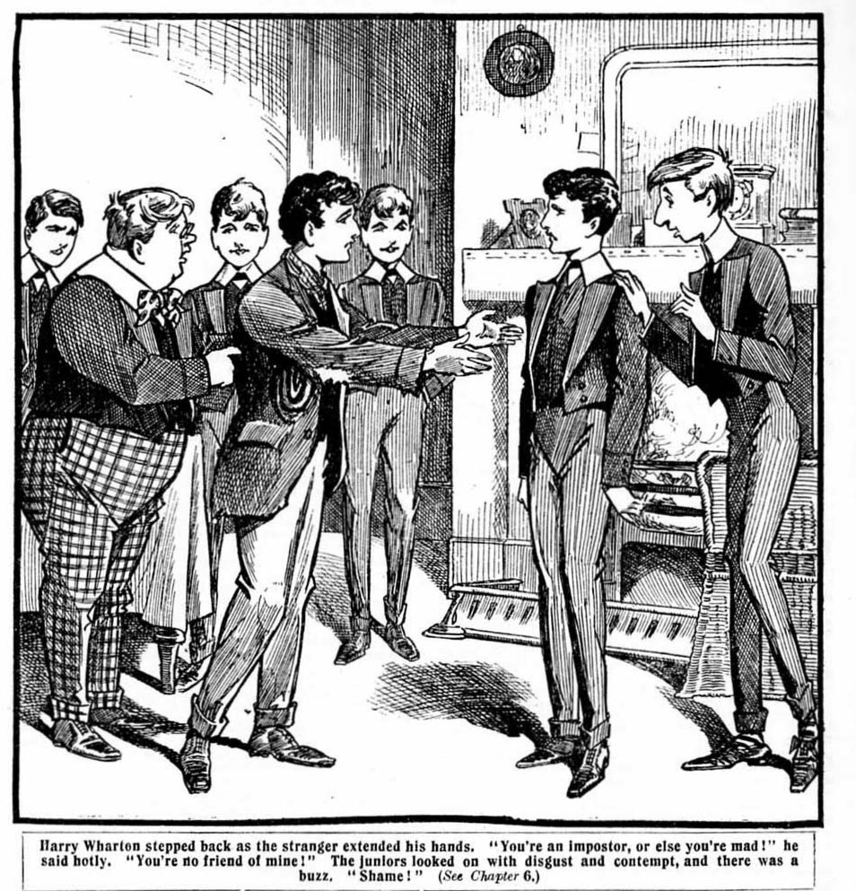
The boy opened his lips, as if to speak, but a sob choked his voice. He flung himself into the chair again, and covered his face with his hands, still sobbing. And looks of deep compassion were cast at him by the juniors, who were no longer laughing, and towards Wharton their glances went with disgust and contempt, and there was a buzz:
“Shame!”
THE SEVENTH CHAPTER.
A Very Painful Scene!
“SHAME!”
Harry Wharton started, as if a whip had stung him, as that cry fell upon his ears,
He gazed round furiously at the condemning faces of the juniors.
“I tell you——” he began.
“Shame!”
“But I—”
“Shame! Shame!”
“Speak to the poor chap!” exclaimed Russell. “Can’t you see he’s worn out—hungry, very likely. After all, he’s your cousin!”
“He’s not my cousin!” shrieked Wharton, in bewilderment. “ I tell you, I’ve never seen the fellow before, and he doesn’t know me!”
“He knew you the instant you came into the room!” said Temple. “How could he call you Harry if he doesn’t know you? ”
That was a poser!
“ Well, I—I suppose he knows me, but I don’t know him!” said Wharton. “I haven’t set eyes on the chap in my life!”
“Draw it mild!”
“Rats!”
“Bosh!”
“Piffle!”
“Speak to him!”
“Give him something to pat!”
“Give him some tin, anyway. You’ve got plenty!”
“It’s disgraceful!” said Snoop. “Just remember the things Wharton said about me when I had my uncle here, and wasn’t proud of him! Snob, and rotter, and things like that! And now look at him!”
“So you were a snob and a rotter!” said Wharton fiercely.
“And what are you—now?” demanded Snoop. “You won’t speak to your own cousin or own him as a relation, just decause he’s down on his luck!”
“Shame!”
“I tell you he’s not my cousin! I don’t know him!”
“Shame !“ eb
Wharton looked round almost wildly. There was unbelief in almost every face. Even his own chums were looking very queer.
“Frank! Bob!” exclaimed Harry, his voice almost hoarse. You don’t think that of me? You don’t think I’d deny it if the fellow were my cousin, do you?”
“I—I know you wouldn’t!” said Bob Cherry; but his voice was halting.
“Of—of course not!” said Nugent slowly. “But—but it’s jolly queer! There must be some—some mistake. Only—only there isn’t another chap here named Wharton, you see. And—and how did he recognise you, anyway? ”
“I don’t know. But I don’t know him. He’s an impostor, and I suppose this is some trick to get something out of me!” saitb Wharton fiercely.
The sobbing boy in the armchair rose to his feet. His cheeks
were wet as he removed his hands from his face.
Those signs of tears went straight to the hearts of the Remove fellows.
“Poor chap!” said Bolsover major, with unaccustomed compassion. “ No wonder he feels it! Look here, you chaps, we’ll make a collection for him, if Wharton won t help him!”
“Hear, hear!” said Hazeldene.b
“We’ll pass round the hat for Wharton’s cousin!”said Fry.
“And I’ll begin it with half-a-crown, blessed if I don’t!” said Temple generously.
“And here’s a bob!” said Bulstrode.
“And here’s a tanner!”
“Same here!”
“Shut up! roared Wharton furiously. “You sha’n’t give him anything! I tell you he’s an imtpostor, and he’s on the make
“Harry!”
“Don’t call me Harry, you rotter!”
“Harry!” The ragged boy’s voice was broken and husky. “I—I didn’t know you’d receive me like this! I’d have stayed away if I’d known!”
“You rotter! You know you’re not my cousin, and you shan’t get anything out of this trick, either!”
“Harry——”
“If you call me Harry again, I’ll punch your head!” shouted Wharton.
“Harry—”
Wharton made a stride forward, his fists clenched, and his eyes blazing. But Bolsover major and Skinner and several other fellows grasped him, and dragged him back.
He turned upon them fiercely: but he dropped his hands when he saw that Bob Cherry and Nugent were amongst those who held him.
“You fellows, too!” he muttered.
“Thou, too, Brutus!” chortled Snoop; and there was a laugh.
“Better hold on, old pal.” said Bob Cherry quietly. “This thing can’t be settled by punching a fellow’s head. If he’s lying, it will be easy enuough to prove it.’’
“If he’s lying! I tell you he’s lying!”
“Let’s hear what he’s got to say, anyway!”
“Yes, give him a chance to speak.” said Tenfold.
“Give the chap a chance, Wharton !“
“Keep your hands off your own cousin !“
Wharton breathed hard.
“He can say what he likes.” he said thickly. “ But he’s no t my cousin—he’s a lying impostor, and he’s on thbe make, I suppose !”
“I’m not out the make!” said Cousin George sorrowfully.
“I’ve tramped here to see you, Harry, because I’m pretty hard
up, and I thought you might help me to pay my passage
to Canbada. I know you’re ashamed of a poor relation, and
I don’t want to disgrace you. I didn’t think all these fellows would see me, or I wouldn’t have come. I asked the servant
to show me up quietly to your room.”
“Yes: I heard him.” said Bulstrode.
“A lot of us heard him!” remarked Peter Todd. “ Perhaps he intended us to hear him, if he’s an impostor!”
“Rot!” said Skinner. “He’s genuine enough. “I always considered Wharton a snob!”
“I say, you fellows, we ought to make Wharton do something for him. I think this disgraceful, you know!” said Billy Bunter. wagging his head sagely,
“Oh, rotten!” said Russell.
“Faith, and it’s bastely of ye, Whartin !“ said Micky Desmond sorrowfully. “ I niver thought ye were that sort of a spalpeen intirely!”
“Let him speak!” said Mark Linley.
“Go it, kid!”
“I—Ib haven’t much to say!” stammered the unfortunate youth, “ I—I hoped Harry might help me out, that’s all. After I got to Canada, I shouldn’t disgrace him any more. I can’t help being poor!”
“Of course you cannot, my friend,” said Alonzo Todd, with deep compassion. “ Wharton, your conduct is really very hard-hearted. My Uncle Benjamin would be shocked at you— nay, disgusted.
“I think were all jolly well disgusted!” said Temple, with a sniff. “ Blessed if I ever came on anything quite so disgusting!”
“Oh, rather!”
“And I’m not on the make!” pursued the forlorn youth. “I came here for help, I admit: but, as Harry has received me like this, I certainly shall not accept anything from him!”
“I wouldn’t.” said Bolsover major, with a nod, “We’ll help you out!”
The boy shook his head.
“Thank you very kindly,” he said; “but I cannot accept it, sir. I am not a beggar. I—I—” His voice broke again: “I—I thought I’d a right to ask my own cousin for help, as he’s rich but I couldn’t accept help from anybody else. I can’t beg!”
“Oh, that’s all right!” said Bolsover. “We’ll make it a collection, you know. We can make up a couple of quid for you!”
“No, no! Thank you most kindly, but I could not take it!”
The juniors looked at one another. This certainly was the right spirit, and it proved the genuineness of Cousin George, if anything could. For if the boy was not “on the make,” what had he come to Greyfriars at all for, claiming to be Wharton’s cousin? If he were an impostor, on the make, he would certainly take all he could get, especially as it was clear that he would get nothing from Harry Wharton himself.
“By Jove,” said Bob Cherry uneasily, “do you mean that, young ‘un?”
“I certainly mean it. I couldn’t acccpt charity.”
“Well, perhaps you’re right.” said Temple, putting his half-crown back into his pocket. “But if that doesn’t prove he’s genuine, you fellows, I don’t know what would. He’s quite right not to accept charity, but Wharton ought to help him.”
“He ought to be made to.” said Skinner.
“Oh, rather!”
“I won’t give him any thing, unless it’s a hiding.” said Harry Wharton, between his teeth. “He’s a lying impostor, and I don’t know him.”
“Shame !”
The ragged boy raised his head proudly.
“I’m going” he said. “ I won’t trouble you any longer, Harry. But you’ve called me a liar and an impostor. Tht these
young gentlemen have been very kind to me, and I think
I ought to prove to them before I go that I’ve told the truth.
I owe it to them!”
“Certainly.” said Temple “If you can prove that your Wharton’s cousin, we shall know what to think of him.”
“He can’t prove a lie!” said Harry.
“Let him speak!” Harry
“I can prove it.’’ said the boy miserably. “It’s easy enough. Harry says I do not know him. I could tell you about our early times, if I liked, but Harry would deny it all, I suppose so. How he used to work in the wood-yard with me before his uncle took him up.
“In the wood yard!” said Skinner, with a whistle. “My hat, that is news! The noble and aristocratic Wharton has worked in a wood-yard, has he?”
“Oh! crumbs! That’s news!” said Bolsover major.
“It’s a lie!” exclaimed Wharton.
“Of course you’d say so, you want to forget all about the wood-yard now!” said Snoop, with a sneer.
Wharton drew a hard breath.
“If I’d worked in a wood-yard, I shouldn’t be silly idiot enough to be ashamed of it.” he said, “ I suppose anybody might work in a wood-yard if he had to earn his living. Linley here worked in a factory, and he knows that I never thought any the worse of him because of that.”
“Quite true!” said Mark Linley.
“But the fellow is lying.” said Harry. “I shouldn’ t be ashamed of it, only I haven’t done it, that’s all. It’s a falsehood!”
“He said he could prove it!” said Peter Todd. “Go ahead with the proving.”
“It’s easy enough.’’ said the ragged lad. “Harry says I don’t know him. “Well, I can tell you he’s got a scar on his arm just above the elbow. If I don’t know him, how do I know that?”
There was a buzz at once. A good many of the juniors had seen that scar on Wharton’s arm—in the dormitory or in the swimming bath. There was no secret about that. But this ragged lad—how did he know— unless what he said was true? Wharton was wearing an Eton jacket, and certainly the ragged boy had had no opportunity of seeing his arm since he came into the common-room.
Wharton himself looked almost stupefied.
That statement, which convinced every other fellow in the room, staggered him. How did the fellow know that!
He looked at his chums almost wildly. Bob Cherry turned his head away. Nugent’s glance dropped to the floor. So they believed it, too!
“Bob.” Muttered Harry. “You—you—”
“How does the chap know that?” asked Bob.
“I—I don’t know.”
The ragged lad made a movement.
“I’m, going!” he said. “I shall get to Canada somehow, Harry, and I shall never trouble you again. Good-bye!”
“You—you lying rascal!”
“Let’s part friends, Harry!” said the boy softly, holding out his hand. “ I’m not asking you for money now. I wouldn’t take it now. Shake hands with me before we part for good.”
Wharton struck the outstretched hand fiercely aside. There was a shout of “Shame!” from nearly every fellow in the room and the ragged boy, with a sigh, turned towards the door.
Then he stopped. Mr. Capper, the master of the Upper Fourth, was standing in the doorway, and his eyes seemed almost to start through his spectacles as he looked at the ragged, forlorn figure of the boy who claimed to be Harry Wharton’s cousin.
THE EIGHTH CHAPTER.
Clear Proof!
MR. CAPPER’S portly form blocked the doorway, and the boy had to stop.
Mr. Capper was an important little gentleman, not much taller than the juniors themselves, but much broader, of course, and very imposing in his gown. He wore a pair of gold-rimmed glasses, perched on the bridge of his nose; and the name of the glasses, “pince-nez,” was cruelly true in their case, for they certainly did pinch Mr. Capper’s nose, imparting a bulbous appearance to it, and causing it to glow with the glow of a warm sunset.
Mr. Capper stared at the ragged youth in blank amazement.
His astonishment at seeing such a figure in the common room of Greyfriars caused his jaw to drop, and he was quite open-mouthed as he stared at Cousin George.
The latter looked decidedly uneasy. He could not pass Mr. Capper in the doorway, and he had to stop; but plainly he did not like it.
Mr. Capper spoke at last. His voice had a rumble like distant thunder.
“Who is this? Who are you, sir? What does your presence here mean? Explain yourself at once.”
But Cousin George seemed at a loss to explain himself. He looked nervously past Mr. Capper towards the doorway, as if turning over in his mind the possibility of making a bolt for it.
But there were plenty of fellows there who were quite willing to make the necessary explanation for him. Quite a chorus broke out:
“It’s Wharton’s cousin, sir.”
“His cousin George, sir.”
“One of Wharton’s relations, sir.”
“He’s come here to see Wharton, sir.”
“Wharton won’t own him, sir; but he’s his cousin.” Mr. Capper seemed more astounded than ever.
“Whartons cousin!” he exclaimed. “Really, Wharton, you should not have your relations here in this—this unfortunate, state of—of attire.”
“He’s not my cousin!” shouted Wharton. “I haven’t a Cousin George at all. He’s some rascal, sir, pretending to be a relation of mine.”
“Shame!” roared Bolsover.
Harry Wharton turned on him fiercely, with clenched fists.
“You cad!”
“Silence!” exclaimed Mr. Capper angrily. “Keep order, please. This matter must be seen into. Wharton, you say that this—this person has come here claiming to be your cousin, and that he is nothing of the kind.”
“Yes, sir.’’
“Boy”—Mr. Capper fixed his eye again upon the ragged youth—” you say that you are Wharton’s cousin?”
“I said so, sir.” faltered the boy.
“Ah, you admit now that it is not the case?” exclaimed Mr. Capper.
“Ye-es, sir.”
“What!” howled Bolsover.
“Why, you rotter!” yelled Bob Cherry, in surprise and relief. His faith in his friend had wavered, and he was ashamed of it now. He pressed Wharton’s arm. “I—I’m sorry, old man. I—I was taken in.”
“Ah, you are an impostor, then?” said Mr. Capper magisterially.
“Oh, no, sir!”
“What! You claimed to be Wharton’s cousin, and now youn admit that you are not his cousin. Why have you done this?”
“It was a joke, sir.”
“It was a kind of joke that will get you into trouble, then!” said the Fourth Form-master grimly. “You are evidently an impostor. and I shall detain you here, and telephone for the police.”
“Oh!” murmured the juniors.
All eyes were fixed upon the ragged lad.
He had completely taken in the whole crowd; indeed, Harry Wharton himself had almost wondered, in his bewilderment, whether he really had a cousin George or not. But the impostor had not ventured to keep up the deception to the Form-master; and the fellows expected him to look scared at the mention of the police. But he did not look scared. He was grinning! The juniors could scarcely believe their eyes. But there was no doubt about it—he was grinning—and Mr. Capper, as he noted it, frowned Jove-like.
“You understand!” he rapped,out sternly. “You will not be permitted to leave this building.”
“Please, sir, I don’t want to.”
“Ah, you don’t want to?” said Mr. Capper sarcastically.
“You are willing to remain and abide by the result of your conduct, then?”
“Oh, yes, sir! I don’t want to leave Greyfriars. You see, sir, I belong to Greyfriars.”
“What!”
“What the dickens—”
“My hat!”
“He’s dotty!”
“It’s some escaped lunatic!”
“Faith, and he’s off his chump intirely!”
“Boy!” thundered Mr. Capper. “ Who are you!”
“If you please, sir, I’m Wibley of the Remove!”
“Wha-a-at!”
“Wibley!”
“Great Scott!”
“Begad!”
“Howly Mothar av Moses!”
The disguised junior looked round at the amazed crowd with a grin. Even yet they did not recognize him; but now they knew his voice. While hie had been playing the part of Cousin George it had been quite different—utterly unrecognisable. Now he was speaking in his natural voice and they knew Wibley’s tones at once. But the skilful make up on his face still baffled them.
“What—what does this mean?” stuttered the astounded Mr. Capper. “ What is the meaning of this—this ridiculous masquerade, Wibley—if you are Wibley!”
“If you please, sir, it’s only amateur theatricals.” said
Wibley meekly. “ Wharton thought I couldn’t act, sir, and
I undertook to prove to him that I could, sir. That’s all.
I think Wharton will admit now that I can act, sir,”
“Oh!” murmured Wharton.
“My hat!” gasped Bob Cherry. “So that’s it. Oh, my hat!”
“There’s no harm done, sir.” said Wibley. “I was
to keep it up a bit longer, as a joke on Wharton, sir, but of course I couldn’t keep it up with you. I was afraid of being impertinent, sir.”
Wibley evidently understood the efficacy of a soft answer in turning away wrath.
Mr. Capper’s face broke into a smile.
“Well, well, if it’s only a joke there is no harm done.” he said. “ Certainly it was very cleverly done. I did not recognize you myself, Wibley. But you must not play these jokes. However, as you are not in my Form I will not concern myself about the matter.”
And Mr. Capper retired from the common-room, still smiling.
Wibley was surrounded by the Removites the next moment. Some of them shook their fists at him, very sore over the way they had been taken in. Bolsover major was very much inclined to wipe the floor with him. But most of the fellows enjoyed the joke on Harry Wharton. Even his faithful followers didn’t really object to seeing him “floored” every now and then. And he had undoubtedly been floored this time.
“Oh, you spalpeen!” said Micky Desmond. “Ye took me in intirely!”
“And all of us!” said Mark Linley laughing.
“Yaas, begad!” said Lord Mauleverer. “ But it was rather a rotten joke on old Wharton, don’t you know.”
“Ha, ha, ha!”
“So Wharton didn’t work in a woodyard, after all, in his giddy youth!” grinned Skinner.
“Ha, ha, ha!”
Wibley grinned at Harry Wharton. The latter’s face was a study. He was greatly relieved to find that it was only Wibley, but he hardly knew whether to be angry or rot. He was feeling decidedly “edgewise” over the jape. For a time, at least, he had been made to look like a snob, and his word had been doubted, and he could not get over that very easily.
“Well,” said Wibley cheerfully, “do you believe that I can act now. Wharton ?”
“My hat!” said Nugent. “I think he can, Harry!”
“I think he ought to be bumped for his cheek!”
“The bumpfulness ought to be terrific!” said Hurree Singh.” This sort of jokefulness is past the esteemed limit.”
“Are you satisfied, Wharton?” asked Wibley, still grinning. “ Do you think I’m up to taking part in ‘ The Red Rover ?‘
Wharton frowned.
“I don’t!” he said curtly. “The parts are all allotted, and you can go and eat coke! I won’t hammer you, but if you play any more of your rotten japes on me, I’ll wring your silly neck!”
And Wharton strode out of the common-room and went up to his study to finish his interrupted prep. He was followed by a yell of laughter. However Wharton took Wibley’s peculiar
proof of his abilities as an actor, there was no doubt that the Remove and the Fourth thoroughly enjoyed the joke against the
“high and mighty.” as Skinner & Co.
called Wharton.
Wibley had proved his case—he certainly could act.
But he had chosen his victim rather
unfortunately in selecting the president of the dramatic society. It certainly did not improve his chances of getting into the cast of “The Red Rover.”
THE 9th CHAPTER.
The Raiders!
THE juniors were still grinning over “Cousin George” when the
Remove went up to their dormitory that night.
Wibley came in for a good deal of attention. He was only a new boy, but had made his mark in the Remove.
A good many fellows — especially those who formed
the opposition to the Famous Five— declared that Wibley
ought to have a good part in “The Red Rover.” Some of them tackled Wharton on the subject in the dormitory.
“I suppose you admit now that Wibley can act first rate, Wharton?” Bolsover major remarked, as he kicked his boots off.
“Yes!” snapped Wharton.
“Don’t you think he ought to have a bit in the play, then?”
“What bit?”
“What about the title role?” said Bolsover insolently.
Wharton looked at him.
“That’s my part.” he said.
“Yes; but if Wibley can do it better—”
“Oh, shut up, Bolsover!” said Bob Cherry, anxious to avoid a row. “ There isn’t any part open in the play for Wibley, anyway, and you know it. It was all fixed up before he came to Greyfriars.”
“A part could be given to him.” persisted Bolsover. “ If he can do it better than the chap who’s cast for it, he ought to have it.”
“Very well,” said Wharton; “I agree to that.”
“Oh, good!” said Bolsover. “You’re going to hand him over your part?”
“No; yours!”
Bolsover jumped.
“Mine!” he shouted.
“Yes. You’re cast for the mate of ‘The Red Rover,’ ” said Wharton coolly. “ I’ll hand that part over to Wibley.”
“You—you—you—” Bolsover simply stuttered. The look on his face elicited a yell of laughter from the juniors. Wharton had turned the tables very neatly upon the aggressive Bolsover.
“He can do it better than you, so he ought to have it,” said Wharton. “He ought to have it, on your own showing. So it’s a go.”
“It’s not a go!” roared Bolsover, “If you give Wibley my part, I’ll hammer him to a jelly!”
“Ha, ha, ha!”
“But if he can do it better—”
“He can’t do it better!”
“But you said yourself if he’s a better actor than I am.” said Wharton, “and I’m a better actor than you, any day. So he must be better than you, and he ought to have your part.
“Would you like Bolsover’s part, Wibley?”
Wibley looked at Bolsover’s furious face and his big, clenched fists, and decided that he wouldn’t like to have Bolsover’s part.
“Ahem ! No, thanks!” he said, “I don’t want to shift Bolsover out.”
“You’d better not!” said Bolsover between his teeth.
“Well, what about Skinner’s?” chuckled Bob Cherry. “Skinner is second mate of ‘The Red Rover,’ and he’s been saying that Wibley ought to have a part—”
“I didn’t suggest my part for him, though!” said Skinner very quickly. “I don’t think he’s so very much of an actor, either, if you come to that.”
“Ha, ha, ha!”
“Make him an extra pirate, and have done with him!” said Vernon-Smith hastily. Vernon-Smith was a merchant captain in the play, and he didn’t want the merchant captain to be passed on to Wibley.
Harry Wharton laughed.
“So nobody wants to hand his part over to Wibley, though he’s a giddy marvellous actor?” he demanded.
There was silence. Evidently nobody did.
“Then you can shut up!” said Harry. “I’ll make him an extra pirate, if you like. One pirate more or less won’t matter. Now cheese it!”
And the fellows who had parts in the play promptly “cheesed” it. It was only the fellows who were not included in the cast who still thought that a good part ought to be found for Wibley.
Loder, the prefect, came in to see lights out, and the juniors turned in.
For half an hour or so there was a buzz of talk in the Remove dormitory, chiefly on the interminable subject of “The Red Rover,” and then one by one the juniors dropped f to sleep.
When half-past ten rang out from the clock-tower slumber reigned in the dormitory, and a silence only broken by the steady, unmusical snore of William George Bunter.
At eleven o’clock another sound might have been heard— the faint creak of an opening door.
The dormitory door opened softly, and a dim figure stood and looked in.
There was a faint whisper.
“All serene, Dab?”
“Oh, rather!”
“Quiet! You stay here, I’ll get in and do the trick.”
“Right-ho!”
Dabney remained on the watch at the doorway. Temple stole on tiptoe into the dormitory. He made no sound in his socks.
Starlight glimmered in faintly at the windows of the long, lofty room. Temple paused near the beds and looked about him. He soon spotted Wharton’s bed, with the clothes of the Remove captain neatly folded up on a chair beside it.
Temple bent over the chair, hardly daring to breathe lest he should awaken the sleeper.
His fingers ran through the pockets of the folded jacket. In the inside pocket was a somewhat bulky package, and Temple’s fingers closed on it like steel.
It was what he sought.
He carefully drew the package out, and backed away from the bed, his eyes fixed upon Harry Wharton’s unconscious face.
Wharton had not awakened.
Temple reached the door, breathing hard, his heart thumping with excitement. He bumped on the door in the dark and there was a sound, and a muffled exclamation from Dabney
“Quiet, you ass!” whispered Temple.
There was a sound from Wharton’s bed. He was seen to half rise, and glance sleepily about him. The noise, slight as it was, had awakened him. The two Fourth-Formers waited, with thumping hearts. Fortunately for them, the door was in deep shadow, and Wharton could not see that it was open. His sleepy glance did not come towards them.
He settled down to sleep again.
Temple waited several minutes, and then carefully and cautiously drew the door shut. He breathed more freely when it was closed.
“Safe!” he murmured.
“Got it?” muttered Dabney.
“Yes.”
“Oh, what luck!”
Fry and Scott were waiting for them down the passage. As Temple and Dabney joined them, both whispered the same question:
“Got it?”
“I’ve got it,” sad Temple. “Come on!”
And they crept softly downstairs to Temple’s study.
THE TENTH CHAPTER.
Very Wet!
TEMPLE & CO. tip-toed down the passage and entered the study.
The House was very silent; everybody was in bed with the exception of some of the masters and two or three of the Sixth.
But all lights were out in the Fourth-Form quarter, and it was not likely that anyone would come in that direction at that hour of the night.
“Safe as houses!” said Temple, as he closed the door of the study. “Wait a minute with that match, Dab, you ass!” Mustn’t let the light be seen.”
“Oh, rather!”
Temple placed the rug carefully along the door, to shut out every gleam of light from the passage, and then drew the
blind. Then he allowed Dabney to strike the match and light the gas. Don’t turn it full on.” he said. “ We don’t want much light; the less the better. If we were spotted here it would mean trouble. And you never know when some nosey prefect is mooching about.”
If Capper should happen to look in at the dorm!” muttered Scott.
“He’s not likely to.”
“He does sometimes.”
“Well, we’ve made up dummies in the beds, and we can’t
do more than that. We’ve got to take the risk. Only, let’s
get back as soon as we can. All hands to the mill!” said Temple. “There’s a lot of this stuff, and it’s got to be copied out from end to end.’’
He laid the scrip on the table.
It was composed of impot paper, pinned together at the corner, and was covered with writing in Harry Wharton’s small, firm hand. The title, “ The Red Rover,” was scrawled across the top. It was the complete copy of the play—the scrip of “The Red Rover,” which Wharton had so carefully guarded. The Fourth- Formers grinned joyfully as they looked at it. They had their old rival in the hollow of their hand now.
No time was wasted. Impot paper was produced, and four pens were dipped into the ink. Temple unpinned the sheets, and separated them into four parts, and each of the plotters began his work of copying out his “whack.”
The pens raced ever the paper.
The juniors were quite aware of the risk that they were running. It would have been a serious matter for them if they had been discovered out of their dormitory at that hour.
“The Red Rover.” however, was a play of considerable dimensions, and there was so much interlining, and so many corrections and alterations, that the task of copying out was not an easy one.
Midnight had tolled out before the juniors had finished their work. Temple was the first to finish, and he threw down his pen with a sigh of relief.
“Thank goodness, that’s done!” he said.
“Same here.” said Fry. “Blessed if it isn’t a bad as an impot, or worse! Did you ever read such piffle?”
“Don’t run down our own play!” grinned Temple”
And the Fourth-Former chuckled. it was undoubtedly “ their” play now.
When the copying was finished, Temple pinned the original scrip together again, and rose to his feet.
He locked the copy in the table drawer.
Now this has got to go back to Wharton’s pocket.” he said, “ then we can get back to bed. I’m jolly sleepy.”
“It was worth it.” grinned Scott.
“Oh, rather!”
They put out the light, and left the study on tiptoe.
There was not a light or a sound in the house. All masters and boys were in bed now.
You fellows, cut off to the dorm, and I’ll follow.” Temple whispered.
“Right-ho!”
Dabney and Fry and Scott hurried off in their own quarters,
and Temple paused at the door of the Remove dormitory .
It was important, of course, that the Removites should not suspect that the play had been copied and “boned.” If they knew it too soon, they would have time to make arrangements for another play, or to take some measures for “dishing” the Fourth-Formers in their turn. Right up to the last moment the Remove must remain in ignorance of the secret plan of Temple & Co. And for that reason It was necessary to return the scrip to Whkrton’s pocket where he would find it the next day, without suspecting that it had been borrowed during the night.
All depended upon the next few minutes. Temple opened
the door with great caution, and peered into the room.
In the glimmering starlight from the high windows the row
of white beds looked very peaceful and still.
But Wharton had awakened once, and he might awaken again.
Temple’s steps were very light as he crept towards the Remove captain’s bed.
Wharton was breathing steadily, his face turned upon the pillow towards Temple. His face was in the shadow, and his eyes might have been open for all Temple knew.
But he did not move, and it was clear that he was asleep. If he had seen Temple standing by his bed he certainly would have moved.
The captain of the Fourth bent over the chair, and slipped the scrip back into the pocket he had taken it from.
He straightened up again with a sigh of relief. That was over, at all events; even if he was discovered in the dormitory, the Removites would not know what he had come there for.
Perhaps, in his satisfaction, he allowed himself to depart from his caution. As he moved away from the bed, his foot knocked against the chair, and there was a sound.
He paused, hardly breathing.
Wharton’s eyes were open.
He saw the captain of the remove it raised his head from the pillow. Wharton’s eyes fell upon him the next moment. The starlight was clear upon Temple, and showed him standing there, still as a statue.
Wharton uttered a slight cry. He was startled.
“What—who—oh! Temple!”
Temple acted quickly.
He jumped towards the bed, whipped the pillow from under Wharton’s head, and brought it down upon him with a heavy biff!
“Yah!” gasped Wharton. “Yow! Wake up, you fellows! Rescue!”
He jumped to the conclusion at once that it was a Fourth-form raid—just as Temple intended that he should.
Biff, biff, biff!
Wharton struggled out of bed under a rain of blows from the pillow, and Temple scudded to the door, hurling the pillow at Wharton before he fled. The pillow caught Wharton under the chin, and flung him back on the bed. Temple almost reached the door, but the other fellows were awake now—and Bob Cherry had awakened very alert. He saw the fleeing form of the captain of the Fourth, and his pillow whizzed through the air, and caught Temple in the small of the back. Temple gasped and fell forward on his knees.
Before he could rise to his feet, Bob Cherry was upon him. He grasped Temple by the shoulders, and yanked him back into the middle of the room.
“Got him!” chuckled Bob.
There were exclamations frem all the bed..
“ What is it ?“
“Who is it?”
“What the dickens—”
“It’s Temple!” gasped Wharton. “He’s been biffing me with a pillow! Hold him! Where are the others?”
Nugent struck a match.
“There don’t seem to be any others!” he exclaimed, looking round in the flickering light. “The cheeky beast has come here alone!”
“And we’ll make him sorry he’s come!” said Johnny Bull.
“Yes, rather!”
“Ow!” gasped Temple, who was pinned to the floor with Bob Cherry’s heavy knee in his chest. “Ow! Lemme gerrup!”
“No hurry!” grinned Bob. “You came here to please yourself, and you’ll stay to please us. Does my knee in your chest bother you at all? ”
“Groo! Yes!” gasped Temple.
“Sorry, but it’s staying there.”
“Groo-hooh—ow!”
“Not so much row, or you’ll have a prefect here.” said Nugent. “You shouldn’t play larks of this kind in the middle of the night, Temple. It’s naughty.”
“Ow—ow!”
“We can’t bump him!” said Wharton meditatively. “It would wake the house. I think cold water will meet the case.”
“Ha, ha, ha!”
Shush! Temple, are you fond of cold baths?”
“Groogh!”
Wharton picked up his water-jug. It was full of cold water. Temple twisted his head round, and gazed up at it with apprehensive eyes.
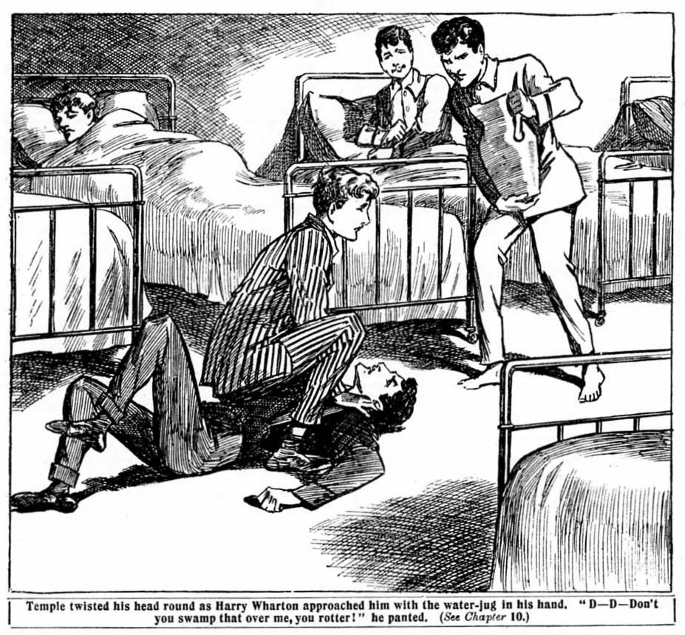
“D-d-don’t you swamp that over me, you beast!” he panted.
“Are you fond of cold baths?” repeated Wharton.
“Grooh! N-n-no!”
“They’re good for some things.” said Harry. “A cold bath in the morning will buck up the circulation. A cold bath in the middle of the night will keep a chap from paying late lalls and biffing other chaps with pillows. See?”
“Groo! I—ow—ow—ow—ow!”
Swoosh!
The contents of the water-jug swamped down over Temple’s head. Bob Cherry jumped up. He had received some splashes too. Temple rolled on the floor, choked and blinded by the sudden flood.
“Ow—ow! Groo-hooh!” he gasped. “Yow-ow! Yoop!”
“Ha, ha, ha!”
Temple made a blind rush for the door, leaving a watery trail behind him. The Removites chuckled, and turned in again, pretty certain that Temple would not return for any more fun that night.
Temple certainly had no intention of returning. He reached his own dormitory, and grasped a towel, and began to towel his head furiously.
“What on earth’s happened?” demanded Dabney, staring at him. “You didn’t let them catch you, did you?”
“Grooh! Ass! Grooh! Fathead! Do you think I let them catch me on purpose?” stuttered Temple. “Groo! Wharton woke up! Ow! And they drenched me!”
“Oh, crumbs! But the scrip?”
Temple chuckled through the towel.
“That’s all right. I’d put that back first, you see.”
“Then they don’t smell a rat?”
“Of course they don’t! They think I came there to pillow Wharton, and they’re quite satisfied.”
“So are we!” grinned the Co.
Temple, as a matter of fact, wasn’t quite satisfied: he was very wet. But he dried himself and turned in. The Fourth-Formers were chuckling, as were the Removites at the same moment. Temple knew they were: but he comforted himself with the reflection that he laughs best who laughs last, and Temple, Dabney & Co. were fully convinced that they were going to have the last laugh.
THE ELEVENTH CHAPTER.
Mum’s the Word!
THE Fourth seem to be letting us severely alone!” Frank Nugent remarked the next day, when the Remove players met in the Rag for rehearsal.
It was a fact. The exasperation of the Fourth on the subject of that great play had been extreme. They had made themselves quite unpleasant. They interrupted rehearsals when they had an opportunity; they chipped fellows whom the found in odd corners going over their lines, and generally caused the amateur actors as much trouble as possible.
But on this day, following Temple’s raid on the Remove dormitory, the Fourth Form seemed as quiet as lambs.
No more chipping—no more mocking, no more interruptions. When the rehearsers came into the Rag, they fully expected to have to “chuck out” several of the Fourth before they could get to business. But there was not a solitary member of the Fourth Form in the room. Hence Nugent’s remark.
“They’ve got something on.” said Wibley, who had come in to the rehearsal in his part of extra pirate.
“How do you know?”
“They’re in their Form-room now, and the door’s locked. I fancy they’re doing some rehearsing themselves, or something of the sort.”
Harry Wharton laughed.
“Getting up a rival play.” he remarked. “I shouldn’t wonder. Well, they’re welcome. They can’t play for toffee.”
“They couldn’t touch us, anyway,” said Bob Cherry. “They might be thinking of giving it on the same night to draw our audience away.”
“They’re welcome to try.”
Fancy the fellows cutting ‘The Red Rover’ to hear Temple & Co. doing ‘Macbeth’ or ‘Hamlet’” grinned Johnny Bulld
And the Removites laughed at the idea.
They had a cheerful feeling that they had the “pull” over their old rivals, and that Temple, Dabney & Co. simply hadn’t got a look-in against them.
“Let ‘em rehearse till they’re black in the face.” said Tom’ Brown. “They can go on rehearsing ‘Hamlet ‘ and ‘ King John.’ ‘The Red Rover’ will knock them sky-high. Besides, our audience is fixed already. Half the fellows have taken seats, and most of the others have paid something, and booked their seats.”
“Oh, we’re all right.” said Wharton. “Now to business.”
And the Removites rehearsed.
But they would probably not have rehearsed so cheerfully if they had known exactly what was going on in the Fourth-Form room at that very time.
Temple, Dabney & Co. had gone there for a preliminary rehearsal, as Wibley suspected; but it was not “King John.” or “Hamlet,” or ‘‘Othello,” or’” Macbeth,” that occupied the attention of the heroes of the Fourth. They had given Shakespeare the go-by. Temple had allotted the parts of “The Red Rover” to his friends, and it was “The Red Rover” that the Fourth-Formers were now rehearsing.
Temple was the pirate chief. Dabney was the first mate, and Fry the second mate of “The Red Rover.” Scott was the merchant captain, the other parts were distributed among the Fourth, more than half the form being in the numerous cast. The parts had been written out from the copy possessed by Cecil Temple, and every fellow had been hard at work in every spare moment of the day “mugging” up his lines by heart. That was the reason why the Fourth-Formers had had no time to spare for ragging the Remove.
Temple had asked Mr. Capper, his Form-master, to get him permission to use the lecture-room as a theatre for the play on Tuesday evening—the evening preceding the Remove performance.
Mr. Capper fully approved of the Shakespearean effort of the juniors, though he was disinclined to attend the performances. He could not carry his kindness quite so far as that. He willingly obtained the required permission for Temple: and, indeed, he was so kind that Temple ventured to request himn to attend the performance. Mr. Capper replied to that request that he was sorry, but he had an engagement to play chess on Tuesday evening with the Vicar of Friardale. So Temple had to be satisfied, and to cast about in his mind for some other authoritative personage to bie present at the play, to keep the audience in order.
That the audience would need keeping in order was undoubted.
As soon as the Remove learned that the Fourth had “pinched” their play, there was no doubt that they would turn up at the performance in strong force to muck it up, as the juniors elegantly expressed it.
Temple did not mean to have the play “mucked up.”
But he was in luck there, too. He bethought himself of the fact that Loder, the prefect, was very much down on Harry Wharton & Co. It required only a word to Loder. Temple called on the prefect, explained that he was giving a play on Tuesday evening, and that he feared a disturbance by the Famous Five and their pals. That was enough for Gerald Loder. He cordially promised to be present, and to bring another prefect with him. Loder, of course, did not anticipate much pleasure from the performance, but he expected a good deal of satisfaction from baulking the desire of the Famous Five to muck up the performance. In the presence of the prefects, of course, a row would be impossible. Strict ordr would have to be kept. And Loder grinned as he thought of the feelings of his old enemies in the Remove, when they came on the scene, and, after paying for admission found that they would have to keep as orderly as if in chapel.
Temple, Dabney & Co. were in high featlier now.
They had “boned” the play, they had booked the lecture-room, they had secured the presence of two prefects to keep order. There was nothing for them to do now but to go ahead and triumph over their old rivals.
They plunged into the last rehearsal of “The Red Rover” with great zest.
“They stuck at it for a couple of hours, too, with unflagging energy. When it was over Temple professed himself satisfied with their progress for a start.
You fellows will have to mug the thing up, and get letter-perfect.” he said. “ You have time to do it before Tuesday, if you slog at it.”
“Oh, rather!” said Dabney, his usual remark.
“Besides, we can gag, if we forget the lines.” observed Fry. “It’s such blessed piffle that gagging will be as good as the real lies. It doesn’t matter if a pirate says: ‘Blow my top-sails!’ instead of ‘Shiver my timbers!’ ”
“Ha, ha, ha!”
“And mind you keep your parts dark.” went on Temple.
“Don’t let anybody outside the Fourth get a squint at them, or the game will be given right away.”
“What-ho!”
“I put in every spare minute learning up the lines. I’m seeing abont the costumes, now.” said Temple. “ We shall have to hire them from the costumier in Courtfield: we’ve never done a pirate play before, and we haven’t the stuff among our props. But we can get the things at a reasonable rate on hire—no need to buy them. We sha’n’t ever be giving ‘Thc Red Rover’ again.”
“Ha, ha! No!”
And some of the things we used in the ‘Tempest’ will do for the ship scene in ‘The Red Rover.’ “ said Temple. “We can easily manage the staging, and we need only hire the rig-out. I’ve been down to Courtfield to look over the things already, and we can select them to-morrow afternoon and get them into the school—secretly, of course.”
“Mum’s the word!” chuckled Fry.
And the Fourth-Formers streamed out of the Form-room, quite satisfied with themselves and their prospects, and chuckling gleefully.
They met the Removites coming away from the Rag. The Remove rehearsal was also over. Temple nodded pleasantly to Wharton & Co.
“Been rehearsing?” he asked.
“Yes.” said Harry; “another whack at ‘The Red Rover.’ It’s coming off next Wednesday, you know. What have you fellows been doing?”
“Oh, we’ve been rehearsing, too!”
“Some more Shakespeare?” asked Bob Cherry, with a grin.
“Well, no; we’re giving Shakespeare a rest this time,” said Temple airily, “Can have too much of a good thing, you know. Lemme see—if you chaps have booked the lecture-room for Wednesday, we can’t have it that night.”
“That you jolly well can’t!” said Johnny Bull.
“Well, I suppose Tuesday will do us. I suppose you fellows will come?”
“I don’t know.” said Wharton. “You see, we’re jolly busy with our rehearsals, and we’re having a final dress-rehearsal on Tuesday evening. I don’t quite see how we can fix it.”
“Sorry.” said Temple. “we shall miss you—we really want you to come. But, of course, if you can’t fix it up, that settles it. Perhaps you will change your minds later, though. And Temple, Dabney & Co. chuckled as they walked away. Harry Wharton looked a little puzzled.
“Seems to be a sort of a joke on.” he remarked. “I don’t quite see it.”
“Silly asses!” said Bob. “They’re going to give some heavy classic drama, and they think it will put ‘The Red Rover’ in the shade, that’s all! Bet you they won’t get half an audience.”
“They won’t get us, anyway; we’ve got the dress-rehearsal
on.
“Yes, rather!”
And the Famous Five dismissed Temple & Co. from their minds.
THE TWELFTH CHAPTER.
A Sudden Surprise!
NEVER had there been such peace and quietness between the Fourth Form and the Remove, as might have been observed during the next few days.
It was a case of the lion and the lamb reposing in amity together—only the Fourth-Formers and the Removites were very little together.
They seemed mutually anxious to keep away from one another.
Every spare moment, on both sides, was devoted to rehearsing; and the Removites were keeping their rehearsals dark from the Fourth—and the Fourth were still more keenly anxious to keep their rehearsals dark from the Remove.
If Harry Wharton & Co. had not been quite so busy, they might have tumbled to the fact that Temple, Dkbney & Co. were scheming a great scheme for their especial benefit.
But “The Red Rover” claimed all their attention.
They were ony too glad to leave the Fourth severy alone, and to be alone by the Fourth. Consequently, Temple, Dabney & Co. pursued their plan without interruption and without suspicion.
On Saturday afternoon, the costumes were selected and hired in Courtfield, and were conveyed in big bundles to the school. But the Removites did not suspect anything. ‘The Red Rover’ cast were in the Rag at the time, busy with a dress-rehearsal.
Temple’s consignment of costumes was conveyed to the Fourth Form dormitory without the Remove fellows even knowing that it existed.
It was in the Fourth Form dorm, with the door locked, that Temple & Co. had their first dress-rehearsal.
It was a great success.
The Fourth Form players had slogged at their lines with a vengeance, and they were getting on famously with their parts.
After the dress-rehearsal in the dormitory, the gear was safely locked away from possible prying eyes.
By Tuesday, Temple felt that his company were quite ready to face the performance of “The Red Rover” in the evening. As Fry had suggested, “gagging’ would fill up the blanks if the fellows forgot their lines. It wasn’t as if they were performing Shakespeare.
After morning lessons, Temple spent some time in his study preparing the notice to put on the board, which was to astonish Greyfriars, and enrage the Remove.
There was much chuckling in Temple’s study over the preparation of that famous notice. The Fourth-Formers anticipated the looks of the Remove when they should read it on the notice-board, and they roared with laughter at the thought.
Even now, at the eleventh hour, there was no suspicion on the part of Harry Wharton & Co. The sudden discovery would burst upon them with the shock of a thunderbolt.
Temple & Co. went in to afternoon lessons with cheerful faces.
Just before lessons were over for the day, Temple obtained permission to get out of the Form-room, and he left ten minutes before the others.
He wanted to have the notice on the board in time to greet the eyes of the Removites as they came out after lessons.
Harry Wharton & Co. little dreamed of the surprise that was awaiting them, as they finished lessons that day in the Remove-room. As a rule, lamb-like innocence was not a distinguishing trait of the famous Co. They had quite as much of the wisdom of the serpent as of the innocence of the dove.
But they were fairly caught napping this time. They came out of the Remove-room without a suspicion in their inunlels.
“Hallo, hallo, hallo! There’s a new notice up.” said Bob Cherry, as he caught sight of Coker & Co. of the Fifth staring at the board and chuckling. The Fifth Form were already out, and some of them seemed to be highly amused by the paper that was pinned on the board.
A little curious, but still unsuspicious, the Removites bore down on the notice-board, to see what it was that interested Coker and Potter and Greene so much. Coker turnpd to them with a grin.
“Ain’t you Remove kids doing a play called ‘The Red Rover’ tomorrow?” he asked.
“Yes.” said Harry. Press?
“My hat ! It will come a bit stale after the other performance, won’t it?”
“What other performance?”
“Oh! Don’t you know!”
“Know what, you ass?” asked Harry. “Shift yourself and let me see the board!”
“Ha, ha, ha!”
Coker moved aside, and the Removites looked at the paper pinned on the board.
Then they gasped.
For the moment they could scarcely believe their eyes. They crowded round the board, craning over one another’s shoulders to see the notice and read it. For the moment their breath was quite taken away. For this is what they read:
“NOTICE!
“THE RED ROVER.”
The great melodrama, “ The Red Rover.” will be performed by the Fourth Form Dramatic Society this evening, commencing at six o’clock precisely.
The performance will take place in the lecture-roon. Loder and Walker of the Sixth have kindly promised to be present.
Admission free to all Greyfriars fellows excepting the Lower Fourth. The Lower Fourth will be charged threepence each for admission. They will be expected to wear clean collars, and to wash their hands for the occasion.
The cast will be as follows:
BLACK JACK, The Red Rover CECIL TEMPLE.
GOMEZ, the Pirate Mate E. DABNEY.
SNORTER, the Second Mate E. FRY.
SKIPPER JOLLY, the Merchant Captain.
D. SCOTT.
BILL BUNTING, the Jolly Jack Tar M. TURNER.
DONNA DOLORES, the Spanish Lady
SMITII MAJOR.
CAPTAIN BENBOW, of the frigate H. JONES.
aspasia
Sailors, Pirates, Negroes, Officer. Spaniards, etc.—
Members of the Fourth Form.
Six o’clock precisely. (Signed) CECIL TEMPLE.
A
There it was, in black and white staring them in the face— and the thunderbolt of the Fourth Form had been launched at last. Harry Wharton & Co., and the rest of the Remove, stared blankly at the notice. It seemed like a bad dream,
“‘The Red Rover!’” stuttered Wharton, at last.
“Our play!” murmured Bob Cherry.
To-night—at six!” gasped Nugent. “And—and the Fourth Form !”
“Black Jack—Cecil Temple!” ejaculated Johnny Bull. It must be a giddy dream—a blessed nightmare! How do they know anything about it?”
“They jolly well know about it—all about it!” said Wibley. “Why, they’ve got all the names, every one of them!”
“The rotters!”
“The spoofers!”
“They sha’n’t do it!”
“We’ll stop them!”
“We’ll slaughter them!”
“We’ll muck up the show!”
“Why, it’s rank burglary!” gasped Wharton. “It’s our play—didn’t we write it ourselves, every blessed line of it?”
“It’s thaving intirely!” howled Micky Desmond.
“I’m Bill Bunting, the Jolly Jack Tar!” roared Morgan. “That ass Turner isn’t going to take my part and sing my song, look you!”
“And I’m Black Jack!”
“And I’m Gomez!”
“And I—”
“Oh, the rotters!”
“You ass, Wharton, to let them see the play!”
“But I didn’t!” shouted Wharton, who was crimson with rage. “ I’ve had the copy in my own pocket all the time. I never left it anywhere for a minute. I had a sort of feeling they might play some trick. I’ve had it in my pocket all the time. Some of you fellows must have left your parts about.”
“I didn’t!” growled Johnny Bull.
“And I didn’t!”
“Nor I!”
“Well, they’ve got on to it somehow,” said Wibley, beginning to grin. “What’s written there shows that they’ve got the whole bizney from start to finish. They’ve managed to get a copy of the play somehow, and they’re going to give it!”
“Give our play! They sha’n’t!”
“We’ll advance the date by at day, and give it to-night ourselves !” exclaimed Tom Brown.
“They’ve booked the lecture room!” said Nugent.
“Oh, my hat!”
“We’ll go in a crowd and smash up the show, then!” roared Bolsover major.
“They’ve got a couple of prefects to come!” groaned Wharton. “ We can’t do that, Loder and Walker would only turn us out, and be glad of the chance.’’
“Oh, the beasts!”
“The swindlers!”
“The burglars!”
“The rotters!”
“We’ve got to nip it in the bud soehow!” said Wharton, between his teeth. “Why, the blesse+d thing begins in an hour. We’ve got no time to get our play going, even if we could find a place to play it to-night instead of to-morrow. But we’ve got to stop it somehow. Let’s go and see Temple!”
“Yes, rather! He sha’n’t be fit to play tonight, anyway.” said Bolsover major, clenching his big fists, “unless he plays with two black eyes and a pair of thick ears.”
“Yes, rather!”
“Come on!”
And the Removites, in an excited and whooping crowd, rushed away to Temple’s study, to see Temple of the Fourth. It was not likely to be a peaceful visit!
THE THIRTEENTH CHAPTER.
What’s To Be Done?
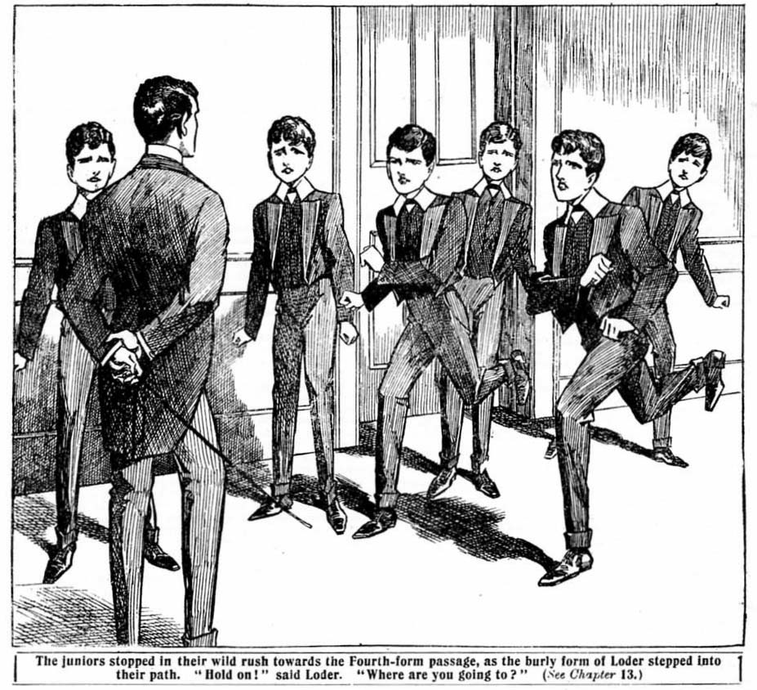
“HOLD on! Where are you going?”
It was the voice of Loder, the prefect.
The juniors stopped their wild rush towards the Fourth-Form passage, as the burly form of the big Sixth-Former slipped into their path.
“It’s all right, Loder!” gasped Bob Cherry. “Let us pass!”
“Stop, I tell you!”
“Look here, Loder—”
“Where are you going?”
“We’re going to see Temple in his study,” said Harry Wharton angrily. “ You’ve no right to stop us, Loder. I suppose we can go and see Temple if we like.”
“That depends.” said Loder grimly. “You’re not going to kick up a row, you unruly young blackguards! What are you going to see Temple for?”
“We—we want to speak to him.”
“We—er—want to explain something to him.”
“Quite—quite peaceable, you know.” murmured Johnny Bull, clenching his fasts with almost frantic energy. “ Quite
—quite peaceful and—and quiet.”
“There’s a little mistake about a play, and we’re going to explain it to Temple, that’s all.” said Wharton.
“You’ll stay where you are.” said Loder coolly. “ Mind, I’m going to keep an eye on you. I’m not going to have this endless ragging among you fags.”
“Look here—”
“We’re jolly well—”
“Rush him!” roared Bolsover major belligerently. “Rush the cad!”
Mr. Quelch, the Remove-master, was looking out of his study. Loder raised his voice, and called to him.
Mr. Quelch, would you kindly step here?”
“What is the matter?” asked the Remove-master, coming along the passage. The juniors were quiet at once. They might cheek Loder, thought he was a prefect; but not the most reckless among them thought of cheeking Mr. Quelch.
“These kids are going to kick up a row in the Fourth Form studies.” said Loder. “They refuse to obey me!”
Mr. Quelch’s eyes glistened.
“If any boy in this Form enters the Fourth-Form passage he will he caned!” he said. “Go away quietly at once— quietly, do you hear?”
There was nothing for it but to obey. The Removites moved off quietly, with glowering looks at Loder. They repaired to the Rag, there to hold a sort of indignation meeting. They were debarred from raiding the Fourth, and bringing Temple to reason by the simple but drastic process of bumping him on the floor of his study. But perhaps it was a relief to “blow off steam” in the Rag. There they could talk to their hearts’ content, if they could do nothing more.
“Well, this is a go!” said Bob Cherry ruefully. “I believe Temple gave Loder the tip to keep an eye on us. Loder was glad of the chance of dropping on us, I know that.”
“Just like the beast!”
“But what’s going to be done?” exclaimed Bulstrode heatedly.
“We are!” said Johnny Bull grimly. “We’re going to be done—done brown; hopelessly diddled, dished, and done!”
“The donefulness will be terrific!” said Hurree Singh lugubriously.
“Something’s got to be thought of.” said Harry Wharton desperately. “ They’re getting the lecture room ready now, I suppose. It starts at six. Temple’s fixed it early on purpose, so that we sha’n’t have time to think of a dodge.”
“He’s got to be stopped. There won’t be any Form-master present. Capper’s gone out, and he can’t stand their acting, anyway,” said Bolsover major. “We can risk the prefects, and make a regular hullabaloo!”
“Loder would call Quelchy in at once!” said Nugent, with a shake of the head. “That won’t do.”
“But we can’t let them give our play. How can we give it to-morrow night if they give it to-night? It would fall flat.”
“The flatfulness would be———”
“Terrific!” groaned Bob Cherry.
“We should be the giddy laughing-stocks of the school.” said Wharton. “We can’t give it to-morrow if they give it to-day. There wouldn’t, be any novelty in it. My hat! They’d even make out that we’d borrowed their play—copied them, you know!”
“They would the rotters!”
“If they perform it to-day our giddy performance is off, right off
No two ways about that.” Mark Linley observed.
“They sha’n’t perform it!”
“We’ll bottle ‘em up somehow.”
“What’s to be done?”
“They begin in about half an hour now.”
“I know.” exclaimed Skinner. “Why not appeal to old Capper, their Form-master? Tell him they’ve borrowed our play, and ask him to stop ‘em.”
There was a general shaking of heads. The idea of dragging a master into the affair did not commend itself to the Removites, enraged as they were.
“No fear!” said Bob Cherry promptly. “ No calling in the master.”
“It would be much the same thing as sneaking.” said Vernon-Smith. “They’d have the laugh of us all the same, if we could only stop them doing us by appealing to a master.” said Harry Wharton. “That’s no good “
“Besides, Capper’s gone out.” said Nugent, “He goes down to the vicarage at half-past five every Tuesday to play chess.”
“That settles it, anyway.”
“Then what’s going to be done?” said Skinner sulkily. “I
suppose we’re not going to let the Fourth gloat over us like this?”
“Not if we can help it.” said Wharton. “But what the deuce we’re to do I don’t know. We must think of something. Hasn’t anybody got an idea in his head?”
“I have!” said Wibley
“Oh, you!” growled Bolsover major. “ You shut up, you new kid! Don’t jaw!”
“Let him jaw, if he’s got any idea what to do.” said Harry. “ Anything is better than nothing, though I don’t
suppose Wibley can think of anything that we can’t. Anyway,
pile in, kid! What’s your idea?”
“I think I know how to stop them.” said Wibley coolly.
“Well, get on!”
“No hurry. I think I can stop them. You fellows can’t but I can !” said Wibley, with a coolness that made some of the juniors want to bump him. “ But, look here; unless they’re stopped our play’s mucked up and done for, isn’t it?”
“Yes, fathead!”
“Well, then, if I find a way of stopping them there ought to be a quid pro quo,” said Wibley. “I don’t, want to be Extra Pirate when I can play the head off any chap here—”
“Oh, cheese it!”
“I’m not conceited, and if I couldn’t act I wouldn’t ask for a part.” said Wibley. “You fellows know I can act. Wharton’s
Cousin George—”
“Oh, ring off!” said Wharton crossly.
“Well, you know I can act. Look here, make it a go! If I stop them from playing ‘The Red Rover’ this evening will you give me a good part?”
“You can’t do it.”
“I think I can. If I can’t, then it’s off,” said Wibley. “But if I succeed in doing it, will you give me a good part in the play?” The Co. looked at one another. There was something impressive in Wibley’s manner and, in spite of themselves, they began to think that he might have something by which the cunning enemy might be outwitted. In their desperate extremity the chums of the Remove were ready to catch at a straw.
“Well, that’s only fair.” said Wharton. “ If you could nip it in the bud, and make it possible for us to bring our play off after all, you’d be entitled to a good part in the cast, certainly. If you could do it—”
“Is it a go?” asked Wibley.
“Well, yes.”
“What part?” asked Wibley, in a businesslike manner.
Wharton hesitated.
“Well, all the parts are allotted, you see. Perhaps Bolsover—“
“He’s not going to have my part!” said Bolsover major, with great promptness. “Perhaps Bob Cherry——”
“ Ahem!” said Bob. Perhaps Bull——”
“ Oh, don’t be funny!” said Johnny Bull.
“It’s up to Wharton.” said Skinner.
“What!”
“You’re the giddy captain of the Remove, ain’t you?” said Skinner, with a sniff. “It’s up to you to find a way out of a fix like this; and if Wibley finds it for you, give him your part, that’s all.”
“Hear, hear!” said the juniors.
Skinner’s suggestion seemed to them fair enough. It certainly was up to Wharton, as leader, to find a way out; and, equally certain, Wharton couldn’t find a way.
“Oh, that’s all rot!” said Wharton uneasily.
“I don’t think it’s rot.” said Wibley—“in fact, the Red
Rover’s part is the part I want. The fact is, I’ve been mugging up your part, Wharton, in case you fellows should come to understand that you want a really good actor for the title-role.”
“The dickens you have?” exclaimed Harry indignantly.
Wibley nodded coolly.
“I’ve got your part quite pat,” he said, “and I really think I should make a better Black Jack than you would.”
“You cheeky ass—”
“You needn’t be afraid to let me have the part. I should
do it justice.”
“Hear, hear!” said Balsover major. “We all know that Wibley can act. If he finds a way to dish the Fourth he ought to have the part. It’s only cricket.”
Wharton hesitated. But the general feeling of the Removites was evidently in favour of Wibley’s claim. Their point of view was that Wharton couldn’t expect Wibley to lead for him in one way and not in another. If Wibley succeeded in dishing the Fourth, he was entitled to play the title-role in “The Red Rover” as a reward. The juniors did not doubt that he would play it quite as well as
Wharton.
“Is it a go?” Wibley repeated.
“Yes.” said Wharton at last. “If you dish the Fourth, and we bring off our play, you shall play the Red Rover.”
“Done!”
“And now, what’s the wheeze?”
And the juniors gathered round eagerly to hear the “wheeze.”
THE FOURTEENTH CHAPTER.
Wibley’s Great Wheeze!
“OUT with it!”
“Buck up!”
Wi bley grinned serenely.
“I think it’s a dead cert,” he said—” anyway, we can try it. Listen here. Suppose when the Fourth Form duffers are beginning their giddy play, Capper should come back—”
“He won’t!”
“And it wouldn’t make any difference if he did!” growled
Johnny Bull.
“And suppose,” pursued Wibley calmly—” suppose he
should look into the lecture room and find them playing a
pirate play, and drop on them for playing such rot—”
“It isn’t rot, you ass!”
“It’s a topping play, you fathead!”
“Yes, yes, I know! But Capper would think it rot, as he’s dead nuts on Shakespeare and the heavy classic drama and things,” said Wibley. “ Suppose he should get his rag out, and order them to stop at once—make them chuck it up right there on the spot, and order them to their studies for the rest of the evening—what would happen?”
“They’d have to go, I suppose.”
“Wouldn’t that nip it right in the bud and dish them?”
“Of course it would. But—”
“But Capper won’t do anything of the sort, you silly chump!” roared Bolsover majoc.
“He will.” said Wibley.
“Why will he, ass?”
“Because I shall fix it.”
“Wha-a-at!”
“Do you mean to say that you can make Capper do that?” exclaimed Harry Wharton, looking at the new boy as though doubting whether he had taken leave of his senses.
Wibley nodded,
“Then you’re dotty!”
“Balmy—quite balmy!” said Bob Cherry.
“Don’t waste time listening to the silly ass!” said Tom Brown impatiently. “It will be six soon. Let’s think what’s to be done.”
“We know what’s to be done, and I’m going to do it.” said Wibley. “ You remember Cousin George—”
“ Hang Cousin George
“You remember that I took you all in? Why couldn’t I
take the Fourth in just as easily?”
“Blow the Fourth!”
“In another character, I mean.” explained Wibley.
“What on earth do you mean?” said Wharton testily.
“Have you ever looked at Capper?” said Wibley, with a
grin. “He seems to be specially designed by Nature to be
impersonated.”
“Impersonated!” gasped Bob Cherry.
“Oh, my hat!”
“Yes. He’s short—not much taller than I am—and I could make that up with high-heeled shoes. He’s fat; I can make that up with padding. I can get clothes just like his in Courtfield; it won’t take long to buzz down there on a bike. I know where he keeps his gown; I can bone it quite easily. His whiskers: they’re the very thing that’s imitated most easily. His gold-rimmed glasses—easiest thing in the world! Don’t you see, Capper’s safe out of the way, playing chess at the vicarage. I’m going to walk into the lecture-room as Capper——”
“Oh, great Scott!”
“And stop the performance.” said Wibley.
“Great pip!”
“But—but his voice?” gasped Wharton. “They’d know your voice!”
“Did you know my voice when I was playing Cousin George?”
“Well, no!” Vharton admttd,
“I can do old Capper’s squeak a treat. Listen.”
“Pile in!”
“H’m—h’m! What is this I see?” exclaimed Wibley, with an exact imitation of Mr. Capper’s somewhat squeaky, high-pitched voice that made the juniors gasp. “What is this—this absurd play you are performing? I cannot approve of anything of the kind! I am shocked, Temple, to see—”
“Ha, ha, ha!”
“Ripping!”
“Hurrah!”
The Removites were growing enthusiastic. They could hardly believe that it was not Mr. Capper who was speaking, so well did Wibley render his voice. Harry Wharton’s face lighted up. He began to believe in Wibley’s powers now. He was not keen to give up his part as the Red Rover, of course. But the first and most important thing was to dash the Fourth, and he believed now that Wibley could dish the Fourth. And that consideration came before everything else.
“My hat!” said Bob Cherry. “I believe he can do it. You remember he took in old Capper himself as Cousin George?”
“And Capper’s simply built for imitation.” grinned Wibley. “ I tell you I’ve done lots of this kind of thing. I’m an old hand. I’ve played more difficult parts than a fat Form-master.”
Wharton drew a deep breath.
“It’s a go!” he said. “Let’s try it.”
“Hear, hear!”
“If we buck up, we can chip in before they’re through the first act.” said Harry. “Come on; we’ll bike down to Courtfield for the things. Hurry up! It’s the last chance, anyway, and we’ll try it.”
“Good egg!” said Bob Cherry. “If it fails, we’re no worse off. And it will be a jolly good jape, anyway. And if it succeeds, we’ll let the Fourth know about it to-morrow, and laugh them to death.”
“Ha, ha, ha!”
“Come on!” said Harry. And he fairly dragged Wibley out of the Rag.
Three minutes later they were speeding down to Courtfield on their bicycles. No time was to be wasted, and no money was to be spared.
When they came back half on hour later they were shut up in Wharton’s study with the rest of the Co. for some time; and the suppressed laughter that proceeded from No. 1 Study told that the process of disguising Wibley was proceeding satisfactorily.
Meanwhile the audience was pouring into the lecture-room for the play.
The announcement of “The Red Rover,” to be played by the Fourth Form Dramatic Society, had caused loud laughter among all the Greyfriars fellows with the exception of the Remove.
Admission being free, there was no reason why all the fellows shouldn’t go—and they went.
Coker & Co. came along with a large party of the Fifth.
They knew that Temple and his friends had boned the Remove play, and they were glad to see the famous Co.
done in so complete a manner, and they were prepared to enjoy themselves.
The Fourth-Formers, all who were not in the cast, swelled the audience, and the Third and Second came almost to a man, or, rather, to a fag. The lecture-room was crowded. Loder and Wklker, the two prefects, came in to keep order, and several more of the Sixth came with them. There was, in fact, no lack of audience. Temple, Dabney & Co. watched the incoming stream of spectators with great satisfaction.
There was an endless ripple of laughter in the crowded room. It seemed a first-class joke to the Greyfriars fellows to come there to see the Remove play played by the Remove’s bitter rivals.
Removites began to stream in later, close upon six o’clock. They had to pay for admission, but they parted with their threepences cheerfully enough. Charging the Remove for admission to see their own play was really insult added to injury. It was the finishing stroke, and the Fourth expected to see their rivals simply writhing with rage. But they weren’t. The Remove fellows were taking it quite calmly. Temple was a little puzzled: he did not know the great wheeze that had been planned at the meeting in the Rag.
But Temple & Co. had little time now to think of the Remove fellows or how they took it. They were busy with their play. The room was crowded when the curtain rose on the first act of “The Red Rover.” A buzz of applause greeted Temple when he strode on the scene in the impressivp garb of Black Jack, the pirate chief. In No. I Study the chums of the Remove were equally busy.
THE FIFTEENTH CHAPTER.
Thoroughly Done!
CLAP! Clap! Clap!
“Bravo!”
“The audience were cheering. The scene on the stage
represented the deck of the pirate ship. The jolly Jack Tar had made a telling speech about British pluck, and walked the plank with great fortitude. And the audience cheered. There was no doubt that it was most thrilling.
The Red Rover paused for the clapping and buzzing to die away, and then restarted:
“Bring forth the next prisoner
Skipper Jolly, otherwise Scott of the Fourth, was dragged
forward by two heavily-bearded and most villainous-looking Fourth-Formers .
At that moment the door of the Lecture-oom opened.
Harry Wharton & Co. entered, and went quietly to places at the back of the room. The performance went on. Skipper Jolly defied the Red Rover in thrilling terms, and walked the plank amid applause.
Just as he disappeared from the deck of the pirate ship, the door opened once more and an imposing figure came in
The Red Rover glanced round from the stage.
“My hat! Capper’s come to the show after all!” he murmured
to the chief mate.
“Good old Capper!” murmured Dabncy.
Two or three fellows in the front seats jumped up to make
room for the master of the Fourth.
“Will you take my seat, sir?” said Loder,
The Form-master blinked at him through his gold-rimmed glasses.
“No, Loder, I will not take your seat.” he said snappishly: “and I may say—h’m!—that I am surprised, Loder, to see you giving countenance to this—this nonsense. ”
The prefect looked a little taken aback.
“I—I came here to keep order, sir.” he stammered. “Some of the juniors were going to make a row, I understood, and interrupt the performance.’’
“The sooner such a performance is interrupted the better, I should say.”
“Mr. Capper——”
“That will do, Loder! I repeat that I am surprised to see you giving support to the juniors in representing such an absurd and bloodthirsty play. I think that you should leave immediately.’
Loder coloured with vexation.
“If you think that, sir, I will go at once.” he said.
“You had better.”
Loder strode angrily towards the door, followed by Walker. Tse other Sixth-Formers promptly followed suit. They were all looking vexed; it was not pleasant to be called over the coals in this manner in public.
The rest of the audience exchanged uneasy glances. “Old Capper,” as they disrespectfully termed him, was evidently in a “wax.”
Mr. Capper—if it was Mr. Capper—cast a stern glance over the crowd of boys, before which their eyes fell.
Then he rustled on towards the stage.
The play had stopped.
Mr. Capper’s strident tones had reached the actors, and they had come to a dead pause, in great dismay. The first sight of their Form-master had pleased them; they had supposed that he was coming as a spectator. They began to understand now what he had come for, and they were stricken with dismay and apprehension.
The Form-master reached the stage. There was a dead silence in the lecture-room now. Some of the Removite; were grinning, but all the rest of the audience looked serious and uneasy.
“Temple!”
Temple started. His name was rapped out like a pistol shot.
“Yes, sir.” he faltered.
“What is this you are doing?”
“It—it—it’s a play, sir.” stammered Temple. He did not look much like a bold pirate chief now.
“You are, I suppose, Temple?” said the Form-master, blinking at hin through his glasses. “I hardly know you in that absurd attire, Temple.”
I’m Temple, sir.”
“And this—this play, as you call it—what is it?”
“It’s—it’s—it’s a play, sir.”
“What is it called?”
“The—The Red Rover,’ sir.”
The’ Form-master snorted.
“Ridiculous!” he exclaimed.
“We—we—I—that is——” Temple was at a loss for words.
“And who is the author of this bloodcurdling nonsense?” asked the master sternly. “You do not pretend that it is a real drama, Temple!”
“Nunno, sir.”
“I have never objected to representations of the classic drama, Temple. I have had great pleasure in knowing that my boys liked to represent Shakespearean plays. But this kind of thing! Temple, I am shocked!”
“Oh, sir!”
“I am disgusted!”
“Mr. Capper!”
“I repeat I am shocked and disgusted. I supposed that you had better taste, Temple. It appears that I was mistaken.”
“The—the fellows like a melodrama, sir.” said Dabney feebly.
Another snort.
“I hope there is no one here who likes such nonsense.” said Mr. Capper, glancing round at the audience. “Cherry, you are laughing! Take a hundred lines!”
“Oh, my hat!” gasped Bob Cherry.
“Wharton, you are laughing, too! I shall report you to your Form-master for disrespect. Do you hear?”
“Yes, sir.” murmured Wharton, alnost overcome.
“Now, Temple, of course you understand that now this matter has come to my knowledge I cannot possibly allow this ridiculous nonsense to proceed?”
“Oh, sir!” gasped Temple. “We—we’re fairly started, sir. “Some—some of the fellows have paid for admission, sir.”
“Indeed! All the money paid for admission will be put into the school poor-box, Temple—every penny! Do you understand ?”
“Ye-es, sir.”
“You will strip off that ridiculous garb at once—now, under my eyes!” rappc-d out the Form-master.
“Yes, sir. But—but——”
“Don’t argue with me. Temple, or I shall cane you. Strip off that foolish garb! All of you, and at once!”
“Very well, sir,” groaned Temple.
There was no help for it. Pirates and jolly Jack Tars and merchant captains and Spaniards and negroes all piled in, taking off their costumes—or, at least, part of them. In public it was not possible to obey Mr. Capper thoroughly, of course.
Plumed hats, laced jackets, swords and daggers and_pistols were piled on the stage by the dismayed and unhappy Fourth- Formers.
Temple’s face was a study.
He had dished the Remove in the completest manner; but he was dished now more thoroughly that he had dished his old rivals, and by his own Form-master! It was a bitter pill to swallow. But there was no help for it. Mr. Capper’s word was law to the boys in his Form: there could be no thought of disobedience. Under the stern eyes of the Form-master, blinking through the gold-rimmed glasses, the unhappy amateur actors obeyed his orders, and they were soon looking sadly moulted.
Some of the audience were filing out now. Others remained to see the finish of the peculiar scene. Never had any enterprise come down with such a heavy bump. There were almost tears in Temple’s eyes as he stood with nothing left of his dashing piratical costume but his velvet trousers and sea-boots.
“Take that rubbish away!” said Mr. Capper’s double sternly. “And then go to your studies. You will remain in your studies for two hours, as a punishment for this ridiculous freak, and each of you will write out two hundred lines of Virgil.”
“Yes, sir.” said Temple, fervently wishing at that moment that he were a real pirate captain and could order Mr. Capper to walk the plank.
“Ahem! On, second thoughts you need not do the lines.” said the Form-master rather hastily. “But you will remain in your studies for two hours.”
“Very well, sir.”
And the forlorn actors departed.
Mr. Capper watched them out, frowning. The last of the Fourth disappeared from the lecture-room. The audience were going fast now, whispering to one another. Only the Removites remained. They had a reason for remaining.
And when only the Remove were left, Bob Cherry closed the door of the lecture-room, and the Removites broke into a long-suppressed yell of merriment and triumph.
“Ha, ha, ha!”
Mr. Capper’s stern face relaxed into a grin. He jerked off his whiskers, and chuckled.
“Well,” he said—and Mr. Capper’s voice was now that of Wibley of the Remove—” well, you chaps, how did it go?”
“Ha, ha, ha!”
Harry Wharton rushed at Wibley and fairly hugged him.
“Oh, ripping!” he gasped. “Splendid! Topping! You can play the title-role, or any other role—any old thing you like! Hurrah!”
Hurrah!”
“Ha, ha, ha!”
And Wharton and the pseudo Mr. Capper—the latter holding his whiskers in his hand—danced a wild tango round the lecture-room, in the exhilaration of their triumph, while the Remove laughed and cheered, and cheered and laughed, till they were hoarse.
Temple, Dabney, & Co. remained confined to their studies for two hours that evening.
Those two hours were not pleasant ones to them.
The Fourth-Formers were furious. After their splendid success, up to a certain point, it was exasperating in the extreme to come down with such a bump.
Their representation of “The Red Rover” had been nipped in the bud with a vengeance. And on the following evening the Removites were to give it—without any danger of interference from their Form-master—indeed, sanctioned by their Form-master’s presence. The feelings of Temple, Dabney & Co. towards Mr. Capper were almost homicidal. Wild schemes of vengeance were hatched and discussed in the Fourth Form studies that evening during the two long hours of detention.
It was not till that detention was over, and the Fourth-Formers came down to the common-room, that they discovered anything.
Then they made a discovery.
When they came into the common-room, looking glum and black and downcast, a yell of laughter greeted them from the fellows there.
The Remove were there in force, waiting for them—and they had by that time imparted the story to the other fellows—and all the juniors enjoyed it thoroughly. Temple frowned at the laughing crowd.
“There’s nothing to cackle at!” he said savagely. “We couldn’t help old Capper coming down on us like that, could we, you silly duffers?’
“Ha, ha, ha!”
“Capper’s at the vicarage!” roared Bob Cherry.
“It wasn’t Capper, you ass!”
“Wasn’t Capper?” said Temple, with a jump. “ What are you talking about? Do you think I don’t know my own Form-master, you chumps?”
Wibley held up a pair of gold-rimmed glasses and a set of whiskers.
“Know these?” he asked.
Temple stared at them blankly.
“Why—what—what—” he stammered.
“I am shocked at you, Temple!” said Wibley, in the high-pitched voice of Mr. Capper. “I am disgusted—shocked and disgusted, and also disgusted and shocked!”
“Ha, ha, ha!”
“You will be detained in your studies for two hours.” resumed Wibley in the same tones. “On second thoughts, you needn’t do any lines, as they’d be rather a surprise to the real Capper when he comes home.”
“Ha, ha, ha!”
Temple staggered.
“You!” he gasped.
“Wibley!” yelled Bob Cherry. “ Oh, you asses, it was Wibley all the time! And you think you can keep your end up against the’ Remove! Ha, ha, ha!”
Temple, Dabney, & Co. looked at one another with sickly expressions. They understood now how completely, hopelessly, and egregiously they had been done.
“Oh!” murmured Temple. “If we’d known!”
And the Removites roared again, and Wibley dangled the glasses and whiskers before Temple’s enraged eyes. It was too much! Temple & Co. made a wild rush, and in a moment a free fight was raging in the common-room, which was only ended by three or four prefects rushing in with canes, and laying about them heartily till all the Juniors, Remove and Fourth alike, fled yelling.
And the next evening the Remove Dramatic Society gave that great representation of “The Red Rover” with tremendous success, Wibley acting the part of the Red Rover himself to great applause.
As for the Fourth, there was nothing for them to do but to hide their diminished heads. They had been completely outwitted and done by Wibley’s Wheeze
THE END.

